Maintenance Change Request
for the update of ISO 20022 financial repository items

- Name of the request:

“ISO 20022 Payments Maintenance 2017/2018”

- Submitting organisation(s):

SWIFT, on behalf of SWIFT, TWIST and OAGi (ISTH), and SABS
Standards Department,
Avenue Adele, 1
1310 La Hulpe - Belgium

- Related messages:

Under this project, below existing ISO 20022 messages will be maintained (resulting from the impact analysis performed on each CR).

- Payment Clearing And Settlement message set:
- pacs.002.001.08 | FIToFIPaymentStatusReportV08
- pacs.004.001.07 | PaymentReturnV07
- pacs.007.001.07 | FIToFIPaymentReversalV07
- pacs.008.001.06 | FIToFICustomerCreditTransferV06
- pacs.009.001.06 | FinancialInstitutionCreditTransferV06
- pacs.028.001.01 | FIToFIPaymentStatusRequestV01

- Bank to Customer Cash Management message set:
- camt.052.001.06 | BankToCustomerAccountReportV06
- camt.053.001.06 | BankToCustomerStatementV06
- camt.054.001.06 | BankToCustomerDebitCreditNotificationV06
- camt.060.001.03 | AccountReportingRequestV03

- Exceptions and Investigations message set:
- camt.026.001.05 | UnableToApplyV05
- camt.027.001.05 | ClaimNonReceiptV05
- camt.028.001.07 | AdditionalPaymentInformationV07
- camt.029.001.07 | ResolutionOfInvestigationV07
- camt.035.001.03 | ProprietaryFormatInvestigationV03
- camt.037.001.05 | DebitAuthorisationRequestV05
- camt.055.001.06 | CustomerPaymentCancellationRequestV06
- camt.056.001.05 | FIToFIPaymentCancellationRequestV05
- camt.087.001.04 | RequestToModifyPaymentV04

Additionally, depending on the decisions taken by the SEG based on this document, following messages might be impacted as well:

- Payment Initiation message set:
- pain.002.001.08 | CustomerPaymentStatusReportV08
- pain.007.001.07 | CustomerPaymentReversalV07

- Exceptions and Investigations message set:
- camt.030.001.04 | NotificationOfCaseAssignmentV04
- camt.031.001.04 | RejectInvestigationV04
- camt.032.001.03 | CancelCaseAssignmentV03
- camt.033.001.04 | RequestForDuplicateV04
- camt.034.001.04 | DuplicateV04
- camt.036.001.03 | DebitAuthorisationResponseV03
- camt.038.001.03 | CaseStatusReportRequestV03
- camt.039.001.04 | CaseStatusReportV04

- Commitments of the submitting organisation:

The submitting organisations confirm that they can and will:
- undertake the development of the new version of the candidate ISO 20022 message models that it will submit to the RA for compliance review and evaluation. New valid Message Definition models will be made available to the RA by December 1.
- provide a new version of part 1 of the related Message Definition Reports (MDR) by December 1, and new examples of valid message instances of each candidate message (only when valid samples were published for current version) by May 1 at the latest.
- address any queries related to the description of the new models and messages as published by the RA on the ISO 20022 website.

SWIFT intends to implement most of the above new versions on its SWIFTNet network once the related documentation has been published by the RA.

The submitting organisations confirm their knowledge and acceptance of the ISO 20022 Intellectual Property Rights policy for contributing organisations, as follows.
“Organisations that contribute information to be incorporated into the ISO 20022 Repository shall keep any Intellectual Property Rights (IPR) they have on this information. A contributing organisation warrants that it has sufficient rights on the contributed information to have it published in the ISO 20022 Repository through the ISO 20022 Registration Authority in accordance with the rules set in ISO 20022. To ascertain a widespread, public and uniform use of the ISO 20022 Repository information, the contributing organisation grants third parties a non-exclusive, royalty-free license to use the published information”.

- Contact persons:
Vincent Kuntz – SWIFT Standards, vincent.kuntz@swift.com
Andrew Muir – SWIFT Standards, andrew.muir@swift.com

Table of Contents
CR0666: Add/modify elements to support the SEPA exception processing scenarios 5
CR0679: Externalise modification and cancellation reasons and confirmation codes 19
CR0685: Add additional transaction elements in the payment return 25
CR0687: Add new return chain to include all parties involved in the return transaction 34
CR0688: Modify/align and/or correction element definitions 41
CR0689: Add three previous instructing agents 45
CR0690: Modify cardinality of Entry elements to avoid duplicates 51
CR0691: Modify RelatedParties and RelatedAgents to support additional scenarios. 55
CR0692: Externalise BalanceTypeCode and Status in reporting messages 66
CR0693: Modify cardinality of TransactionSummary to allow reporting per date 72
CR0694: Modify ReportingPeriod to support the request for a sequence range 76
CR0695: Modify cardinality of the Case identification in the investigation messages 81
CR0696: Modify cardinality and definition of the CreationDateTime 85
CR0697: Modify cardinality of Credit Line to multiple occurrences 89
CR0698: Add new optional element LocalInstrument in TransactionDetails 94

CR0666: Add/modify elements to support the SEPA exception processing scenarios

- Origin of the request:
A.1 Submitter:
European Payments Council
Cours Saint Michel 30a
B-1040 Brussels
Belgium

A.2 Contact person:
Mr. Christophe Godefroi
Senior Business Analyst
Tel: +32.2.739.16.93
e-mail: Christophe.godefroi@epc-cep.eu

A.3 Sponsors: The banking community of SEPA (Single Euro Payments Area)

- Related messages:
camt.087.001.04 - RequestToModifyPayment
camt.029.001.07 – ResolutionOfInvestigation
camt.027.001.05 - ClaimNonReceipt

- Description of the change request:
- Addition of elements in the camt.087.001.04, camt.027.001.05 and camt.029.001.07 to transport information from underlying payment instructions
- In the camt.029, include Claim Non Receipt Details, Compensation (value date compensation on customer account) and Charges.
- Create additional block “ModificationDetails” in the camt.029 to specify that the Resolution of Investigation may also relate to a Modification (not only to a cancellation)
- In the camt.029, rename Rejected Modification (under Status) into Rejection in order to be able to reject a Claim Non Receipt

- Purpose of the change:
The EPC 2017 SCT Rulebook v1.0 requires that the Request to Modify Payment message (camt.087) and the ResolutionOfInvestigation (camt.029) and the ClaimNonReceipt (camt.027) contain the complete set of information transported in the underlying payment instruction that is being modified.
Additionally, the camt.029 which must confirm or reject the Request to Modify Payment must also transport compensation and charges information which are currently missing.
Camt.087 /Camt.027:
- Under Underlying/Interbank/, add an optional element called OriginalTransactionReference to contain below elements:
  - Debtor: PartyIdentification43 (Optional)
  - Ultimate Debtor: PartyIdentification43 (Optional)
  - Debtor Account: CashAccount24 (Optional)
  - Debtor Agent: BranchAndFinancialInstitutionIdentification5 (Optional)
  - Creditor: PartyIdentification43 (Optional)
  - Creditor Account : CashAccount24 (Optional)
  - Ultimate Creditor: PartyIdentification43 (Optional)
  - Creditor Agent: BranchAndFinancialInstitutionIdentification5 (Optional )
  - PaymentTypeInformation: PaymentTypeInformation21 (Optional)
  - Purpose: Purpose2Choice (Optional)
  - Remittance Information: RemittanceInformation11 (Optional)
Camt.029
- Under CancellationDetails/TransactionInformationAndStatus /OriginalTransactionReference, add a new optional element:
  - Purpose
- Create a new message building block “ModificationDetails”
  - Same structure as “CancellationDetails”
  - In this structure rename all “Cancellation” related elements in “Modification” related elements.
  - Insert also Purpose in ModificationDetails/TransactionInformationAnd
Status/OriginalTransactionReference,
- At the same level as “CancellationDetails” and “ModificationDetails” and right below add a new element “ClaimNonReceiptDetails” to contain:
When positive:
  - Date Processed: date the instruction was processed
  - Original Next Agent: next party the original payment instruction was sent to
When Negative:
  - Reason: Code (New External Code List – see below)
Proprietary

Note: A new External ISO Code List is required: “ExternalClaimNonReceiptRejection1Code”. The new required codes are:

Code | Name | Definition
NOOR* | No Original Transaction Received | Original credit transfer never received
RNPR | Original Transaction Received but Not Processable | Original credit transfer was received but is not processable.
*Note: Code “NOOR” already exists in external code list ExternalReturnReason1Code.
- Under ResolutionRelatedInformation:
  - New optional element, called “Compensation” to contains below :
    - CompensationAmount (Currency & Amount)
    - DebtorAgent (Usage must specify that the Debtor Agent is the payer of the compensation)
    - CreditorAgent (Usage must specify that the Creditor Agent is the payee of the compensation)
    - Reason:
      - Code (New ISO External Code List)
      - Proprietary
Note: A new External ISO Code List is required: “CompensationReason1Code”. The new required code is:

Code | Name | Definition
VADA | Value Date Adjustment | Compensation requested for value date correction.

- Under ResolutionRelatedInformation:
  - New component, called Charges to contain:
    - ChargeInformation: Charges2

ISO 20022 Illustrations:

Camt.087

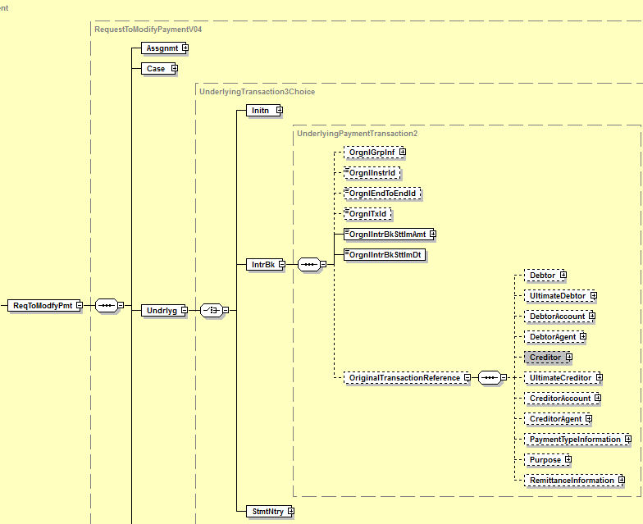

- Similar illustration also applies to the camt.027 since message structure is identical
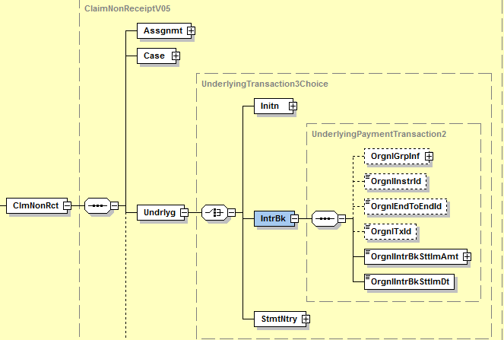

Camt.029
- Addition of new message building block “ModificationDetails” with same structure as “CancellationDetails”:

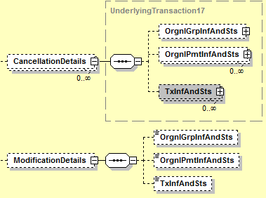

All “Cancellation” related elements of “OrgnlGrpInfAndSts”, “OrgnlPmtInfAndSts” and “TxInfAndSts” must be renamed to “Modification” (see illustration for “OrgnlGrpInfAndSts”)
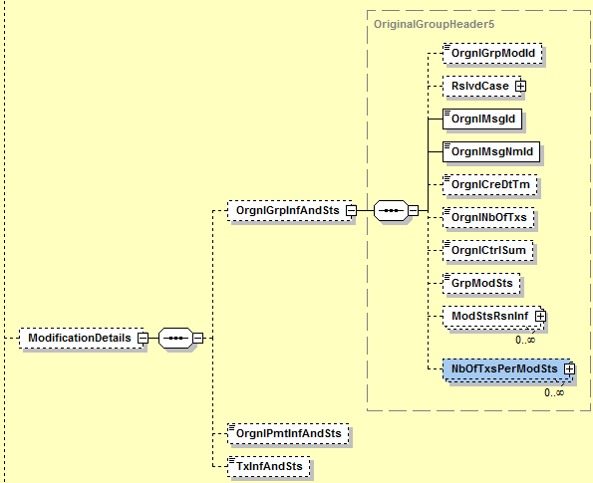

Same applies to “OrgnlPmtInfAndSts” and “TxInfAndSts”

- Addition of element “Purpose” in MC OriginalTransactionReference present in message building blocks “CancellationDetails” and “ModificationDetails”
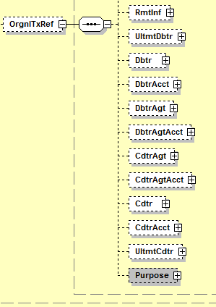
- Addition of a new element “ClaimNonReceiptDetails”:

Choice component: Positive or Negative
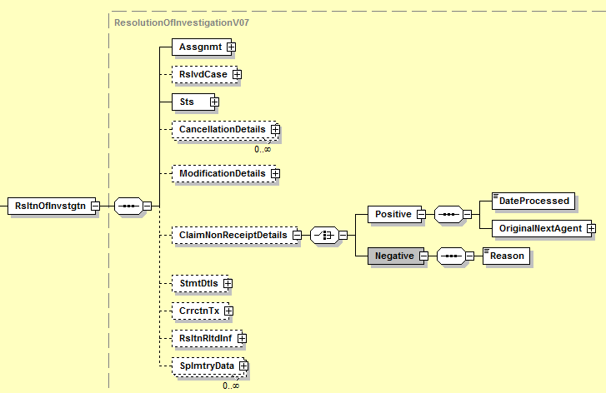

- Addition of two new optional elements “Compensation” and “Charges” Under ResolutionRelatedInformation:

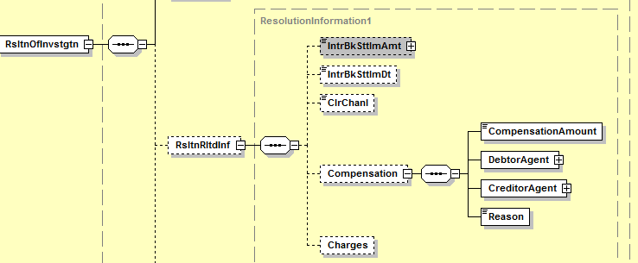

- Business example
A credit transfer is made from agent A (the payer’s agent) to agent B (the payee’s agent). Upon complaint from the payee, the payer requests its agent to ask the payee’s agent for a value date correction.
A request for value date correction (camt.087 RequestToModify) is then sent from agent A to agent B. If the cause for the value date correction does not fall within the responsibility of agent B, then agent B has the right to receive interest compensation from agent A.
This compensation is a variable amount, being the interest calculated for the number of calendar days between the original value date and the corrected value date of the original Credit Transfer. The calculation of such compensation is made according to the rules of the credit transfer scheme used.
When answering to the request (camt.029 ResolutionOfInvestigation), agent B indicates the amount of the compensation it asks for according to the above mentioned calculation in order to apply good value on the customer’s account.
Upon receipt of the answer, agent A transfers the compensation amount to agent B according to the scheme rules, through a pacs.008 in this case.

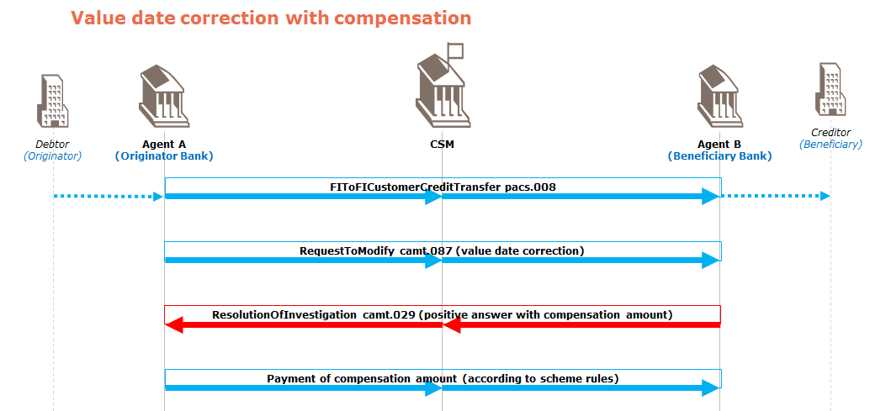

- Urgency of the request:
EPC must publish in November 2017 the Implementation Guidelines for these 3 “revised” messages. The implementation guidelines will become effective in November 2018.
- SEG recommendation:

Consider |  | X | Timing
 |  |  | - Next yearly cycle: 2017/2018  (the change will be considered for implementation in the yearly maintenance cycle which starts in 2017 and completes with the publication of new message versions in the spring of 2018) |  | X
- At the occasion of the next maintenance of the messages
(the change will be considered for implementation, but does not justify maintenance of the messages in its own right – will be pending until more critical change requests are received for the messages)
- Urgent unscheduled
(the change justifies an urgent implementation outside of the normal yearly cycle)
 |  |  | - Other timing:
Comments:
Decision made at the Payments SEG meeting on June 12th, 2017.

Reject
Reason for rejection:

- Impact analysis:

Addition of the OriginalTransactionReference component in the camt.027/camt.087:
Following the detailed analysis of the impact of the changes to the existing messages, we identified further impacted messages, as already proposed by the change request submitter. The below list provides the full list of impacted messages (from the Exception and Investigation Message Set):

- camt.026.001.05 - UnableToApplyV05
- camt.027.001.05 - ClaimNonReceiptV05
- camt.028.001.07 - AdditionalPaymentInformationV07
- camt.037.001.05 - DebitAuthorisationRequestV05
- camt.087.001.04 - RequestToModifyPaymentV04
Furthermore, if we want to keep a consistent component throughout all payments messages for the original transaction reference component, the change request will also impact the OriginalTransactionReference24 component. This component is used in following additional messages, that will also be impacted:
- camt.029.001.07 - ResolutionOfInvestigationV07
- camt.055.001.06 - CustomerPaymentCancellationRequestV06
- camt.056.001.06 - FIToFIPaymentCancellationRequestV06
- pacs.002.001.08 - FIToFIPaymentStatusReportV08
- pacs.007.001.07 - FIToFIPaymentReversalV07
- pacs.028.001.01 - FIToFIPaymentStatusRequestV01
- pain.002.001.08 - CustomerPaymentStatusReportV08
- pain.007.001.07 - CustomerPaymentReversalV07

Addition of the Claim Non Receipt Details, Compensation, Charges and modificationDetails and rename of the Rejection element
Following the detailed analysis of the impact of the changes to the existing messages, we have not identified further impacted messages. For those updates, following message is therefore only impacted.
- camt.029.001.07 - ResolutionOfInvestigationV07

- Proposed implementation:

Updates to the OriginalTransactionReference component:
We support the proposed implementation, but propose to extend the updates to all impacted messages, with a single identical component to be used in all messages, as following:
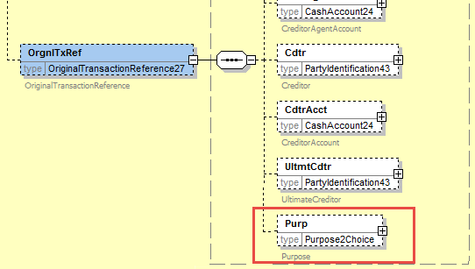
The message component OriginalTransactionReference will be updated in all impacted messages with the new component, extended with the Purpose element from the original payment instruction.

Question to the SEG: Shall we update all impacted messages with the new component across all payments messages? This will result in a consistent and unique implementation of the same OriginalTransactionReference message, but impacts more messages as highlighted in the impact analysis.
The SEG suggests aligning the messages in applying the same structure.
Inclusion of “Claim Non Receipt Details”, Compensation and Charges:
We support the proposed implementation with following comments:
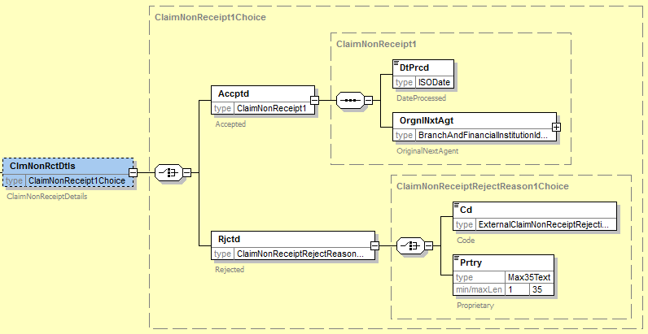
Please note that we propose to use more specific terms Accepted/Rejected instead of Positive/Negative.

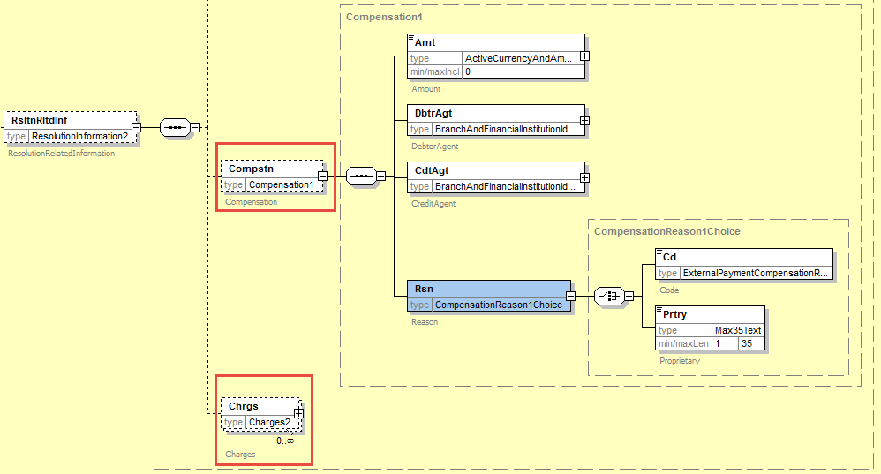
Remark: we support the request of the submitter to define the compensation reason (resp. claim non receipt rejection reason) as a choice between an external compensation reason (resp. claim non receipt rejection) codes set element and the proprietary element (Max35Text).

Addition of “ModificationDetails”:
We reject the proposed implementation, to duplicate the cancellation details block, since the RequestToModifyPayment is restricted to a single payment instruction occurrence, contrary to the payment cancellation request messages which are both multi-instructions. We have therefore constructed the ModificationDetails, based on the single transaction references required to fully identify the RequestToModifyPayment and the underlying payment instruction for which the request has been initiated.
The resulting component has been illustrated below:
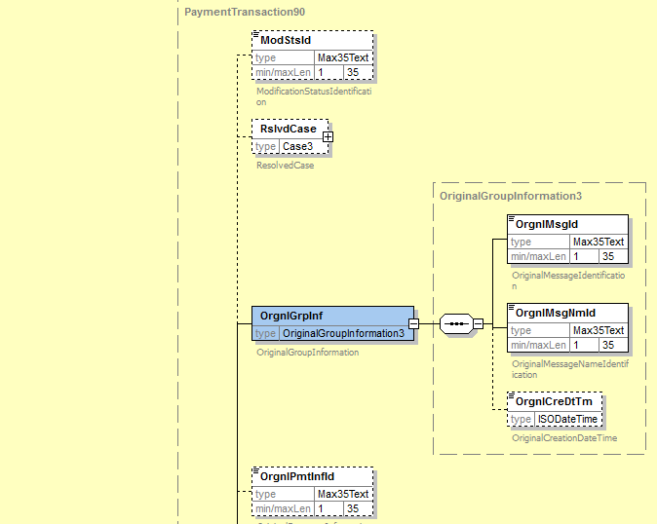
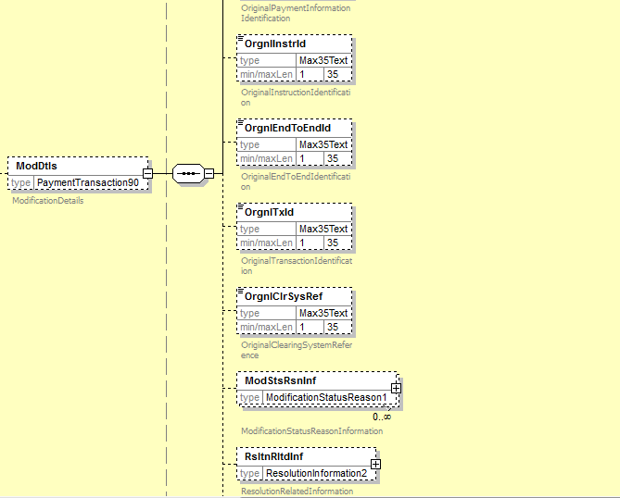
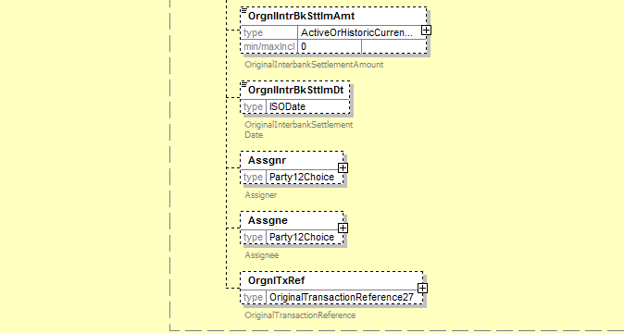

Rename Rejected Modification (under Status) into Rejection
We reject the proposal to rename “Rejected Modification” (under Status) into Rejection to support the reject of a Claim Non Receipt, as a dedicated message exists in the current Exception and Investigation flow, which support this case: the RejectInvestigation message.
An alternative could be to add a new code in the Confirmation element, to indicate that the Claim Non Receipt has been rejected, and provide the details in the new Claim Non Receipt details block, as the RejectInvestigation message requires the Case element.
Question to the SEG on the Rejection Modification element: If the SEG approves the inclusion of the Modification Details element (see above), the Rejection Modification element is duplicating information also provided in the Modification Status Reason Information element. Should we therefore keep the Rejection Modification element in the message (having the risk of conflicting data) or should we fully remove it with the addition of a new code in the Confirmation element, to indicate that the Modification has been rejected, and provide the details in the new Modification details block?
The SEG agrees with the implementation proposal.

- Proposed timing:
The submitting organisation confirms that it can implement the requested changes in the requested timing.

Timing | As requested

- Final decision of the SEG:

Approve | X
Comments: Payments SEG meeting on September 4th, 2017.

Reject
Reason for rejection:

CR0679: Externalise modification and cancellation reasons and confirmation codes

- Origin of the request:
A.1 Submitter
The High Value Payments Plus Group
A.2 Contact person:
Isabelle Bouille
Avenue Adèle 1
1310 La Hulpe/Belgium
Tel : +32.2.655.44.20
e-mail : isabelle.bouille@swift.com
A.3 Sponsors:
The European Payments Council
The Clearing House
GPI Community

- Related messages:
camt.029.001.07

- Description of the change request:
The camt.029.001.07 contains several lists of codes which are currently embedded in the message itself. This change request aims at transforming all of these lists into ISO 20022 external code sets.
- Purpose of the change:
The camt.029 is to be implemented by several additional Market Infrastructure communities. In order to facilitate addition of new codes, it is requested to transform the code lists into ISO 20022 external code sets.
Impacted elements in the camt.029:
- Under Status:
  - Confirmation
  - RejectedModification
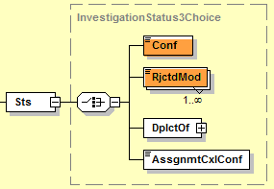
- Under CancellationDetails:
  - OriginalGroupInformationAndStatus:
    - CancellationStatusReasonInformation/Reason
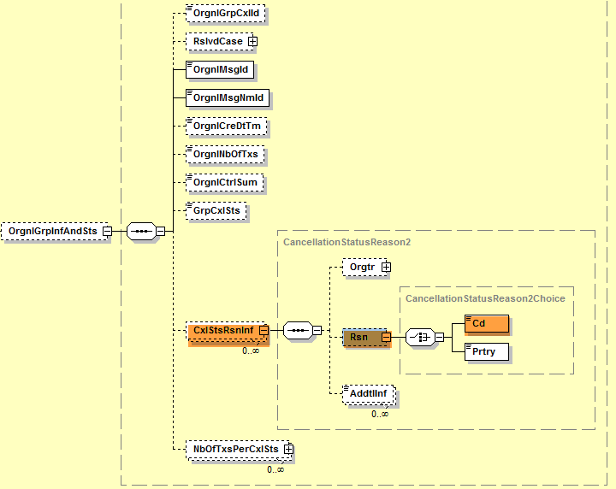
  - OriginalPaymentInformationAndStatus:

    - CancellationStatusReasonInformation/Reason
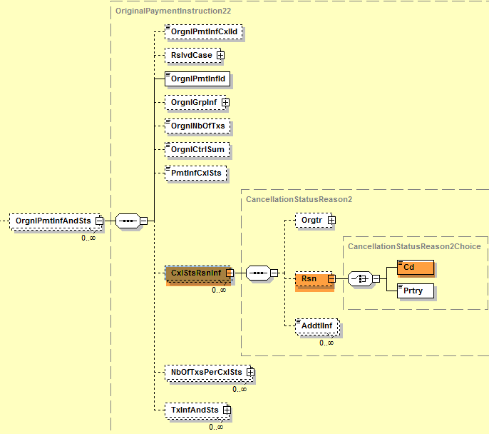
  - TransactionInformationAndStatus:
    - CancellationStatusReasonInformation/Reason
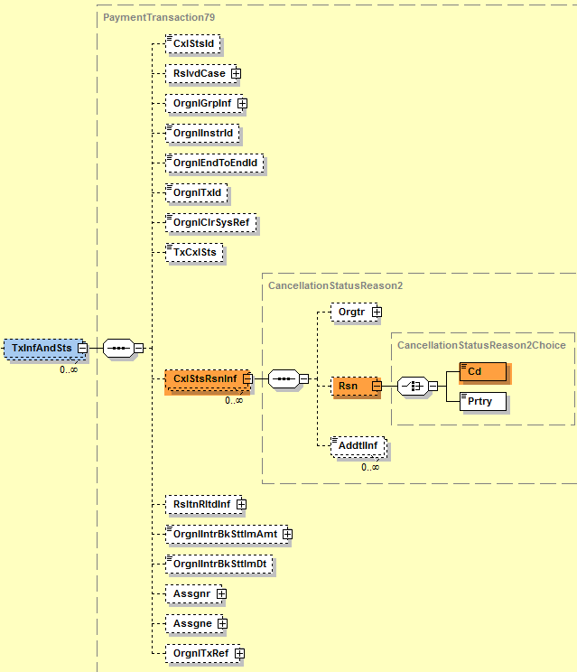

Requested additional codes to the already existing codes that will be moved into the external code set:
Under CancellationStatusReasonInformation, new codes are requested:

ADAC Awaiting Debit Authority From Customer
RQDA Requesting Debit Authority From Customer
ARPL Awaiting Reply
NARR Narrative
WSEQ Wrong Sequence
PTNA Passed To The Next Agent

- Urgency of the request:
Several Market Infrastructures are currently working on their ISO 20022 implementation work – the camt.029 is part of the payments portfolio of messages to be implemented. It is therefore requested to implement this change with the next release in 2018.

- Business examples:

- SEG/TSG recommendation:

Consider |  | X | Timing
 |  |  | - Next yearly cycle: 2017/2018  (the change will be considered for implementation in the yearly maintenance cycle which starts in 2017 and completes with the publication of new message versions in the spring of 2018) |  | X
- At the occasion of the next maintenance of the messages
(the change will be considered for implementation, but does not justify maintenance of the messages in its own right – will be pending until more critical change requests are received for the messages)
- Urgent unscheduled
(the change justifies an urgent implementation outside of the normal yearly cycle)
 |  |  | - Other timing:
Comments:
Decision made at the Payments SEG meeting on June 12th, 2017.

Reject
Reason for rejection:
- Impact analysis:
Following the detailed analysis of the impact of the changes to the existing messages, we have not identified further impacted messages. The below list provides the full list of impacted messages:
- camt.029.001.07 – ResolutionOfInvestigationV07
No further messages are impacted by this change request.

- Proposed implementation:

We support the proposed implementation as requested, with the externalisation of the confirmation codes, the modification rejection codes and the cancellation status codes.
Current implemented codes with be replaced with following external code sets:
- Confirmation: ExternalInvestigationExecutionConfirmation1Code
- Modification Rejection: ExternalPaymentModificationRejection1Code
- Cancellation Rejection: ExternalPaymentCancellationRejection1Code

Question to the SEG: do we really want to externalise the InvestigationExecutionConfirmationCode or should we implement below alternative which would keep the current investigation code internal, but introduce a choice component between the current code set and a proprietary code (typed by Max35Text)?
The SEG has no objections against the externalization of the code set.
Remark: in the Exception and Investigation flow, some of the new codes which have been added are normally processed with a RejectInvestigation message, as per the current flows. This means that through the introduction of those new codes, some of the Exception and Investigation flows will need to be adjusted as well.

- Proposed timing:
The submitting organisation confirms that it can implement the requested changes in the requested timing.

Timing | As requested

- Final decision of the SEG:

Approve | X
Comments: Payments SEG meeting on September 4th, 2017.

Reject
Reason for rejection:

CR0685: Add additional transaction elements in the payment return

- Origin of the request:
A.1 Submitter
The Clearing House
1114 Avenue of the Americas
New York, NY 10036
U.S.A.
A.2 Contact person:
Mr. Bob Pepitone
CHIPS Product Manager and Strategy
e-mail : robert.pepitone@theclearinghouse.org

- Related messages:
Pacs.004.001.07 – Payment Return

- Description of the change request:
Within some communities, a Payment Return message is considered as a new Payment Instruction message – as such, for regulatory and processing reasons, it has to transport additional information which would typically be found in the pacs.008 message (FIToFI CustomerCreditTransfer).
- Purpose of the change:
The pacs.004 will be implemented by The Clearing House and The Fed. In order to meet regulatory and processing requirements it is requested to add some additional elements under PaymentReturn/TransactionInformation and PaymentReturn/TransactionInformation/OriginalTransactionReference:

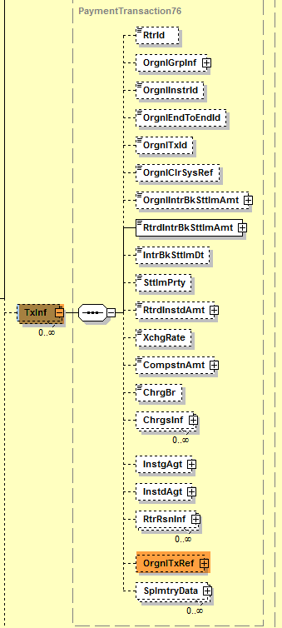

- Addition of a new element under PaymentReturn/TransactionInformation: ClearingSystemReference:
The ClearingSystemReference field is completed by some Market Infrastructures before the payment or return instruction is sent to the next agent in the payment chain (after settlement). It is then transported up to the Creditor Bank. Currently, only the OriginalClearingSystem Reference is available (ClearingSystemReference of the underlying payment instruction: pacs.008/pacs.009.

- Addition of a new element under PaymentReturn/TransactionInformation: OriginalInterbankSettlementDate:
The PaymentReturn/TransactionInformation currently transports the InterbankSettlementDate and ReturnedInstructedAmount (of the Payment Return) and the OriginalInterbankSettlementAmount (transported from the underlying payment instruction). The OriginalInterbankSettlementDate is currently located under PaymentReturn/TransactionInformation/OriginalTransactionReference. Because the Amount and SettlementDate are usually transported together, it is requested to move the OriginalInterbankSettlementDate under PaymentReturn/TransactionInformation, together with the OriginalInstructedAmount.

Illustrations:

- Payment Return/TransactionInformation/ ClearingSystemReference
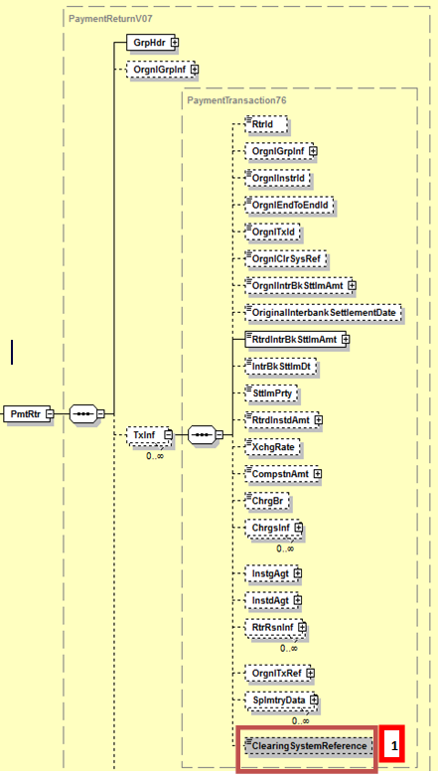

- PaymentReturn/TransactionInformation/OriginalTransactionReference

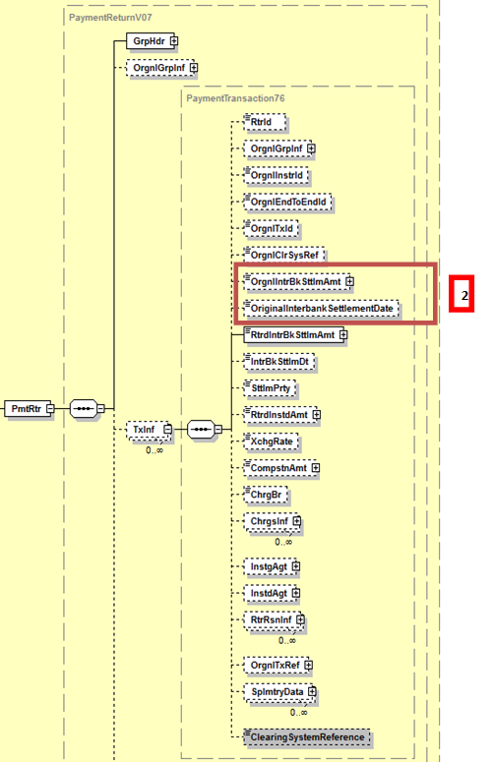

- Urgency of the request:
Several Market Infrastructures are currently working on their ISO 20022 implementation work – the pacs.004 is part of the Payments Portfolio of messages to be implemented. It is therefore requested to implement this change with the next release in 2018.
- Business examples:
Examples illustrating the change request: no examples provided
- SEG/TSG recommendation:

Consider |  | X | Timing
 |  |  | - Next yearly cycle: 2017/2018  (the change will be considered for implementation in the yearly maintenance cycle which starts in 2017 and completes with the publication of new message versions in the spring of 2018) |  | X
- At the occasion of the next maintenance of the messages
(the change will be considered for implementation, but does not justify maintenance of the messages in its own right – will be pending until more critical change requests are received for the messages)
- Urgent unscheduled
(the change justifies an urgent implementation outside of the normal yearly cycle)
 |  |  | - Other timing:
Comments:
Decision made at the Payments SEG meeting on June 12th, 2017.

Reject
Reason for rejection:
- Impact analysis:
Following the detailed analysis of the impact of the changes to the existing messages, we didn’t identify further impacted messages.
The below list provides the full list of impacted messages:
- pacs.004.001.07 – PaymentReturnV04

- Proposed implementation:
Remark: the purpose of the change request mention the change in the OriginalTransactionReference element, but the requested changes do not impact this element and only require the addition of 2 elements in the TransactionInformation element.
We support the proposed implementation for the two new elements; however we have modified the order of the elements as following:
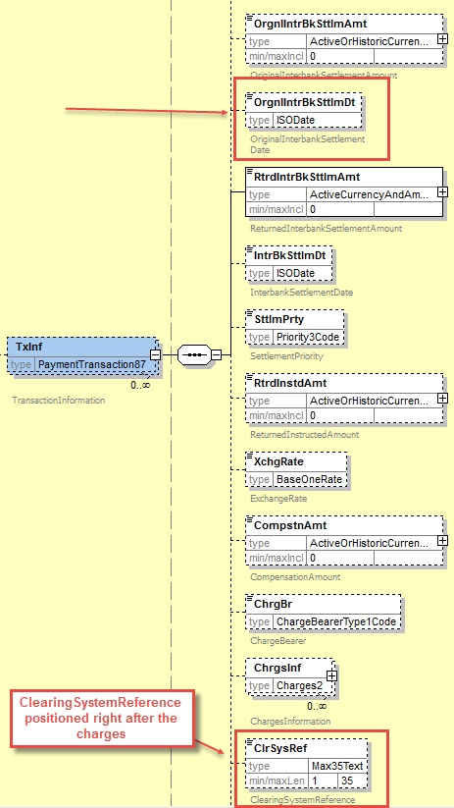

- Proposed timing:
The submitting organisation confirms that it can implement the requested changes in the requested timing.

Timing | As requested

- Final decision of the SEG:

Approve | X
Comments: Payments SEG meeting on Septembre 18th, 2017.

Reject
Reason for rejection:

CR0687: Add new return chain to include all parties involved in the return transaction
- Origin of the request:
A.1 Submitter:
Federal Reserve Bank of New York (on behalf of the US Federal Reserve Banks)
33 Liberty Street
New York, NY 10045
U.S.A.
A.2 Contact person:
Federal Reserve Bank of New York Wholesale Product Office
Ms. Gina Russo (gina.russo@ny.frb.org)
Ms. Leslie Lee (leslie.lee@ny.frb.org)
A.3 Sponsors:
US Format Advisory Group

- Related messages:
pacs.004.001.07 – Payment Return
(For consistency reasons, the change should also be considered in the pacs.007.001.07 - FIToFIPaymentReversalV07)

- Description of the change request:
The request is to add a new optional component (ReturnChain) to cater for the inclusion of all parties (agents and non-agents) involved in a return transaction under the TransactionInformation (TxInf) block as shown below.
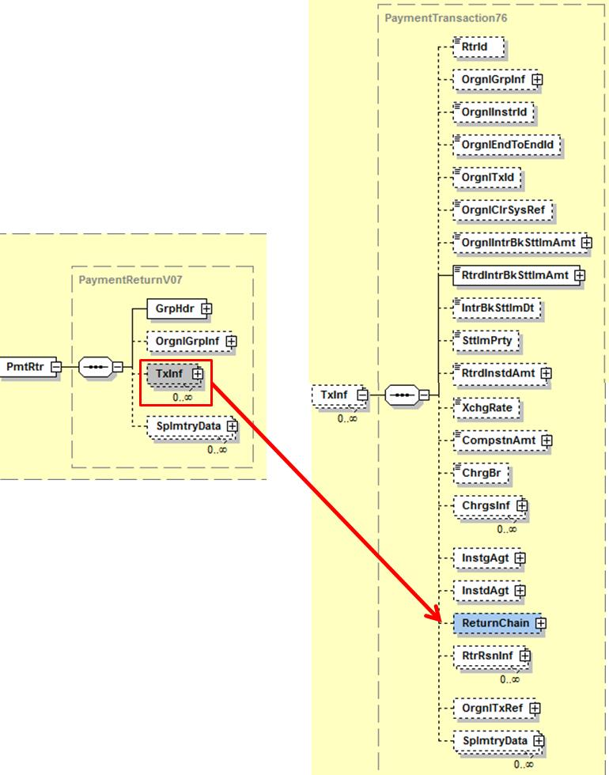

More specifically, the component should cater for the inclusion of all financial institution and non-financial institution parties that can be involved in a return transaction as shown in the below. Most of the parties will be optional with the exception of the Debtor and Creditor of the return payment.

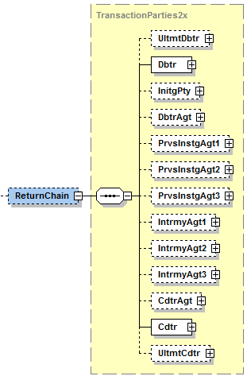

As for the data type of (Ultimate) Debtor, Initiating Party and (Ultimate) Creditor, we suggest reusing the (latest version of) the Party12Choice component shown below to cater for both cases of returning customer and financial institution transfers. For all the other agents (i.e., DebtorAgent, PreviousInstructingAgents, IntermediaryAgents and CreditorAgent) involved in the processing of the return, we suggest reusing only the (latest version of) BranchAndFinancialInstituionIdentification5 as shown in the same picture below.
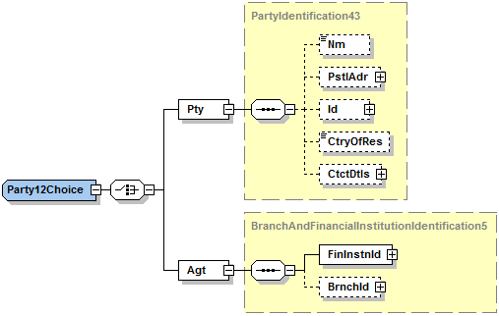
- Purpose of the change:
The change is of regulatory/compliance nature.
In certain communities, for example, the US, the return of a payment is considered a new payment instruction that needs to be processed under the same legal requirements as an ‘original’ payment instruction, i.e., the payment return must provide full transparency on all parties involved in the return.
The current payment return message (pacs.004.001.07) only allows referring to the parties (agents and non-agents) for their involvement in the original payment instruction that is being returned, but it does not allow specifying their role in the actual return. The requested change will address this shortcoming.
During the March 2017 meeting of the HVPS+ group, the represented communities recognized that although it might not be a regulatory requirement in all communities, that the explicit inclusion of the return chain will reduce confusion and increase transparency of payment returns, thereby enabling financial institutions to perform the required regulatory controls in more automated ways.

- Urgency of the request:
Request to include the change in the next maintenance cycle.

- Business examples:

- SEG/TSG recommendation:

Consider |  | X | Timing
 |  |  | - Next yearly cycle: 2017/2018  (the change will be considered for implementation in the yearly maintenance cycle which starts in 2017 and completes with the publication of new message versions in the spring of 2018) |  | X
- At the occasion of the next maintenance of the messages
(the change will be considered for implementation, but does not justify maintenance of the messages in its own right – will be pending until more critical change requests are received for the messages)
- Urgent unscheduled
(the change justifies an urgent implementation outside of the normal yearly cycle)
 |  |  | - Other timing:
Comments:
Payments SEG meeting on 26 June 2017.

Reject
Reason for rejection:

- Impact analysis:
Following the detailed analysis of the impact of the changes to the existing messages, we confirm that no further messages are impacted by this change.
The below list provides the full list of impacted messages:
- pacs.004.001.07 – PaymentReturnV04

- Proposed implementation:

We support the proposed implementation with no additional comments. The resulting message will therefore have the following structure:
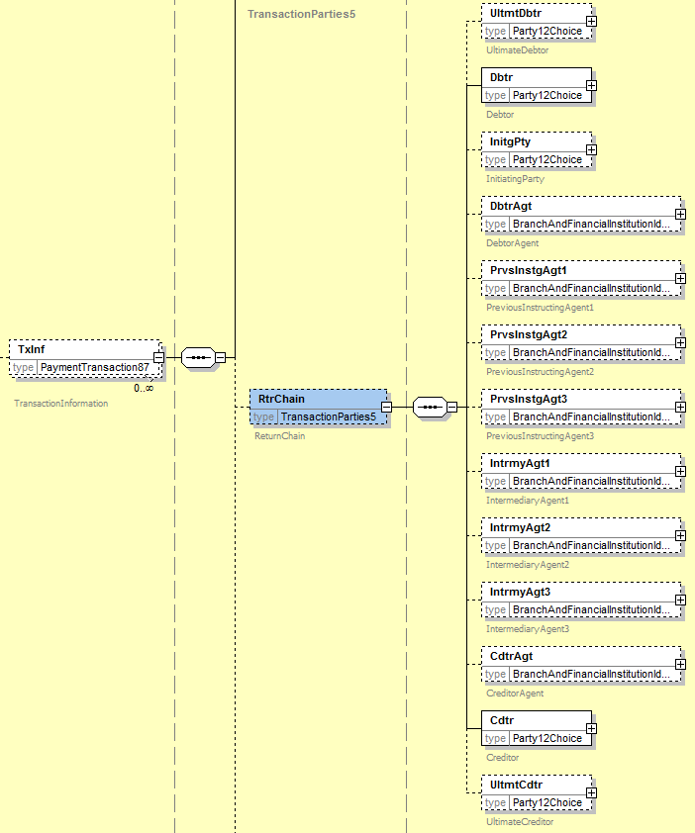

- Proposed timing:
The submitting organisation confirms that it can implement the requested changes in the requested timing.

Timing | As requested

- Final decision of the SEG:

Approve | X
Comments: Payments SEG meeting on Septembre 18th, 2017.

Reject
Reason for rejection:

CR0688: Modify/align and/or correction element definitions
- Origin of the request:
A.1 Submitter:
Federal Reserve Bank of New York (on behalf of the US Federal Reserve Banks)
33 Liberty Street
New York, NY 10045
U.S.A.
A.2 Contact person:
Federal Reserve Bank of New York Wholesale Product Office
Ms. Gina Russo (gina.russo@ny.frb.org)
Ms. Leslie Lee (leslie.lee@ny.frb.org)
A.3 Sponsors:
US Format Advisory Group

- Related messages:
pacs.004.001.07 – PaymentReturn
For consistency reasons, the changes should also be considered for the following “R” messages:
- pacs.002.001.08 – FIToFIPaymentStatusReport
- pacs.007.001.07 – FIToFIPaymentReversal
- camt.056.001.06 – FIToFIPaymentCancellationRequest
And more in general, the change request should apply to all messages where the component OriginalGroupInformation3 is used.

- Description of the change request:
The request is to update, align, and/or correct the definitions of the following ISO 20022 elements:

C1 – OriginalMessageIdentification
The OriginalMessageIdentification element appears with slightly different definitions across and within the listed messages. In the 2016/2017 Message Definition Report (MDR) for the pacs message portfolio, the element is documented as follows:

4.4.2.1 OriginalMessageIdentification <OrgnlMsgId>
Definition: Point to point reference, as assigned by the original instructing party, to unambiguously identify the original message.

10.1.8.3.1 OriginalMessageIdentification <OrgnlMsgId>
Definition: Point to point reference assigned by the original instructing party to unambiguously identify the original group of individual transactions.

The change request is to align the wording to read Point to point reference, as assigned by the original instructing party, to unambiguously identify the original message.

C2 – OriginalInterbankSettlementAmount
In the 2016/2017 Message Definition Report (MDR) for the pacs message portfolio, the OriginalInterbankSettlementAmount element appears with the below definition:

OriginalInterbankSettlementAmount <OrgnlIntrBkSttlmAmt>
Definition: Amount of money, as provided in the original transaction, to be moved between the instructing agent and the instructed agent.
In the payment return message, the ReturnedInterbankSettlementAmount element is documented as follows:

ReturnedInterbankSettlementAmount <RtrdIntrBkSttlmAmt>
Definition: Amount of money moved between the instructing agent and the instructed agent in the returned transaction.

The change request is to align the wording style for the definitions to read:

- OriginalInterbankSettlementAmount: Amount of money to be moved between the instructing agent and the instructed agent, as provided in the original transaction instruction.
- ReturnedInterbankSettlementAmount: Amount of money to be moved between the instructing agent and the instructed agent in the returned transaction instruction.

- Purpose of the change:
The change is of a cosmetic nature, i.e. to correct, align or remove ambiguity from the definitions.

- Urgency of the request:
Request to include the change in the next maintenance cycle.

- Business examples:
NA.

- SEG/TSG recommendation:

Consider |  | X | Timing
 |  |  | - Next yearly cycle: 2017/2018  (the change will be considered for implementation in the yearly maintenance cycle which starts in 2017 and completes with the publication of new message versions in the spring of 2018) |  | X
- At the occasion of the next maintenance of the messages
(the change will be considered for implementation, but does not justify maintenance of the messages in its own right – will be pending until more critical change requests are received for the messages)
- Urgent unscheduled
(the change justifies an urgent implementation outside of the normal yearly cycle)
 |  |  | - Other timing:
Comments:
Payments SEG meeting on 26 June 2017.

Reject
Reason for rejection:

- Impact analysis:
Following the detailed analysis of the impact of the changes to the existing messages, we identified further impacted messages, using the same OriginalGroupInformation3 component. The below list provides the full list of impacted messages:
- camt.026.001.05 -UnableToApplyV05
- camt.027.001.05 -ClaimNonReceiptV05
- camt.028.001.07 -AdditionalPaymentInformationV07
- camt.029.001.07 -ResolutionOfInvestigationV07
- camt.037.001.05 -DebitAuthorisationRequestV05
- camt.055.001.06 -CustomerPaymentCancellationRequestV06
- camt.056.001.06 -FIToFIPaymentCancellationRequestV06
- camt.087.001.04 -RequestToModifyPaymentV04
- pacs.002.001.08 -FIToFIPaymentStatusReportV08
- pacs.004.001.07 -PaymentReturnV07
- pacs.007.001.07 -FIToFIPaymentReversalV07
- pacs.028.001.01 -FIToFIPaymentStatusRequestV01

- Proposed implementation:

We support the proposed implementation with no additional comments. Definitions will be updated in the new message definitions accordingly.
As part of the alignment requested, we will ensure that all definitions are fully aligned with those new proposals, specifically in the ReturnPayment message definition

- Proposed timing:
The submitting organisation confirms that it can implement the requested changes in the requested timing.

Timing | As requested

- Final decision of the SEG:

Approve | X
Comments: Payments SEG meeting on Septembre 18th, 2017.

Reject
Reason for rejection:

CR0689: Add three previous instructing agents

- Origin of the request:
A.1 Submitter:
Federal Reserve Bank of New York (on behalf of the US Federal Reserve Banks)
33 Liberty Street
New York, NY 10045
U.S.A.
A.2 Contact person:
Federal Reserve Bank of New York Wholesale Product Office
Ms. Gina Russo (gina.russo@ny.frb.org)
Ms. Leslie Lee (leslie.lee@ny.frb.org)
A.3 Sponsors:
US Format Advisory Group
HVPS+ Group

- Related messages:
pacs.008.001.06 – FIToFICustomerCreditTransfer
pacs.009.001.06 – FinancialInstitutionCreditTransfer
The change might also need to be considered in messages that currently refer to the PreviousInstructingAgent element used in the above payment messages.

- Description of the change request:
The request is to allow for multiple previous instructing agents with a maximum of 3.
However, in line with the decision made for intermediary agents at the time of creation of the pacs messages, the proposal is to explicitly name the 3 individual agents with their accounts instead of making the existing element repetitive, i.e., PreviousInstructingAgent1 with PreviousInstructingAgent1Account, PreviousInstructingAgent2 with PreviousInstructingAgent2Account, and PreviousInstructingAgent3 with PreviousInstructingAgent3Account).
The proposed implementation is shown below.

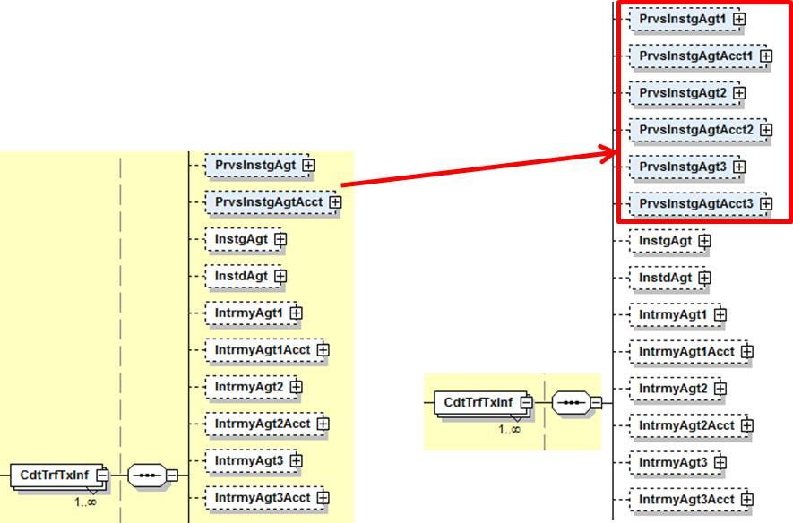

The datatypes of the new elements are to inherit those of the existing PreviousInstructingAgent (currently BranchAndFinancialInstitutionIdentification5) and PreviousInstructingAgentAccount (currently CashAccount24).

- Purpose of the change:
The nature of the change is of regulatory/compliance nature.
In case of more complex payment chains, financial institutions might not be in a position to convey complete information from incoming payments into their outbound messages in a structured and transparent manner.
The current payment messages (pacs.008.001.06 and pacs.009.001.07) only cater for a single previous instructing agent, whereas proprietary standards have been amended to include more (for example, repetitive use of code /INS/ in field 72 of SWIFT MTs).
Not only will the change allow full transparency on the end-to-end payment chain, it will also facilitate payment error processing, for example, payment returns or rejects by providing the possibility to include all previous senders of the payment instruction.

- Urgency of the request:
Request to include the change in the next maintenance cycle.
- Business examples:
The below graphic shows how the change will enable financial institutions to remain fully transparent as all parties involved in the processing of the payment instruction are identified and carried across the end-to-end payment chain.

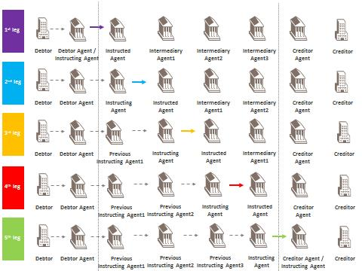

- SEG/TSG recommendation:

Consider |  | X | Timing
 |  |  | - Next yearly cycle: 2017/2018  (the change will be considered for implementation in the yearly maintenance cycle which starts in 2017 and completes with the publication of new message versions in the spring of 2018) |  | X
- At the occasion of the next maintenance of the messages
(the change will be considered for implementation, but does not justify maintenance of the messages in its own right – will be pending until more critical change requests are received for the messages)
- Urgent unscheduled
(the change justifies an urgent implementation outside of the normal yearly cycle)
 |  |  | - Other timing:
Comments:
Payments SEG meeting on 26 June 2017.

Reject
Reason for rejection:
- Impact analysis:
Following the detailed analysis of the impact of the changes to the existing messages, we identified further impacted messages. The below list provides the full list of impacted messages:
- pacs.008.001.06 – FIToFICustomerCreditTransferV06
- pacs.009.001.06 – FinancialInstitutionCreditTransferV06
- camt.028.001.07 – AdditionalPaymentInformationV07
No other messages are impacted by this change.
- Proposed implementation:
We support the proposed implementation with the following additional clarifications:
- Replace of the PreviousInstructingAgent and PreviousInstructingAgentAccount, with the 3 numbered elements as requested: PreviousInstructingAgent1, PreviousInstructingAgent2 and PreviousInstructingAgent3 for the agents and PreviousInstructingAgentAccount1, PreviousInstructingAgentAccount2 and PreviousInstructingAgentAccount3 for the agent accounts, as following:
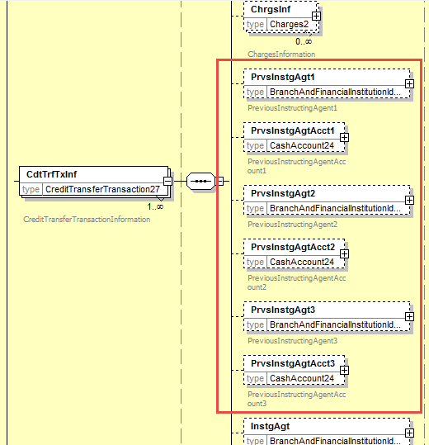

- Together with the additional messages that was identified during the impact analysis, we have identified that this change must be applied in 4 different locations:

  - In the pacs.008 – FIToFICustomerCreditTransfer message, in the CreditTransferTransactionInformation block
  - In the pacs.009 – FinancialInstitutionCreditTransfer message, in the CreditTransferTransactionInformation block, but also in the CreditTransferTransactionInformation/UnderlyingCreditTransfer block
  - In the camt.028 – AdditionalPaymentInformation message, in the Information block.

- PreviousInstructingAgentAccountRule must be adjusted and duplicated for all 3 new elements
- We suggest also adding ordering rules similar to the IntermediaryAgent(s), to specify in which order the PreviousInstructingAgent(s) must be used in the message, following the flow provided in section C of the change request, which is described as following: DebtorAgent -> PreviousInstructingAgent1 -> PreviousInstructingAgent2 -> PreviousInstructingAgent3 -> InstructingAgent.
- Proposed timing:
The submitting organisation confirms that it can implement the requested changes in the requested timing.

Timing | As requested

- Final decision of the SEG:

Approve | X
Comments: Payments SEG meeting on Septembre 18th, 2017.

Reject
Reason for rejection:

CR0690: Modify cardinality of Entry elements to avoid duplicates
- Origin of the request:
A.1 Submitter:
Federal Reserve Bank of New York (on behalf of the US Federal Reserve Banks)
33 Liberty Street
New York, NY 10045
U.S.A.
A.2 Contact person:
Federal Reserve Bank of New York Wholesale Product Office
Ms. Gina Russo (gina.russo@ny.frb.org)
Ms. Leslie Lee (leslie.lee@ny.frb.org)
A.3 Sponsors:
US Format Advisory Group

- Related messages:
camt.052.001.06 – BankToCustomerAccountReport
camt.053.001.06 – BankToCustomerAccountStatement
camt.054.001.06 – BankToCustomerDebitCreditNotification

- Description of the change request:
The request is to make some changes to the Entry component to avoid duplication of the same information.
The change could be implemented either by making a structural change to the messages (although this would impact all current users), or by changing some of the mandatory elements that appear at multiple levels into optional ones (and thereby avoiding any impact on current users).
For the latter option, the graphic below shows the elements that would be candidate for a change in cardinality (Amount, DebitCreditIndicator and BankTransactionCode).

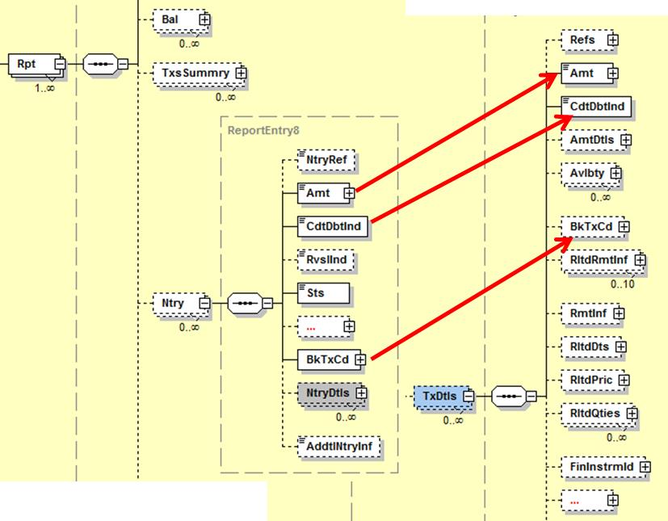
- Purpose of the change:
Currently the structure works for users that report single entries that result from multiple underlying transactions. However, for those communities that consider implementing the message to report single transaction entries, the standard will impose users to duplicate the same information (i.e., Amount, DebitCreditIndicator) at multiple levels (i.e., at Entry and EntryDetails/TransactionDetails level). Next to duplication of the information, there is also the risk that conflicting information will be provided at the different levels. If the elements were to be made optional, then how to use them to meet the specific community reporting needs can be defined at implementation guideline level.

- Urgency of the request:
Request to include the change in the next maintenance cycle.

- Business examples:
- SEG/TSG recommendation:

Consider |  | X | Timing
 |  |  | - Next yearly cycle: 2017/2018  (the change will be considered for implementation in the yearly maintenance cycle which starts in 2017 and completes with the publication of new message versions in the spring of 2018) |  | X
- At the occasion of the next maintenance of the messages
(the change will be considered for implementation, but does not justify maintenance of the messages in its own right – will be pending until more critical change requests are received for the messages)
- Urgent unscheduled
(the change justifies an urgent implementation outside of the normal yearly cycle)
 |  |  | - Other timing:
Comments:
Payments SEG meeting on 26 June 2017.

Reject
Reason for rejection:

- Impact analysis:
Following the detailed analysis of the impact of the changes to the existing messages, we did not identify further impacted messages. The below list provides the full list of impacted messages:
- camt.052.001.06 – BankToCustomerAccountReport
- camt.053.001.06 – BankToCustomerAccountStatement
- camt.054.001.06 – BankToCustomerDebitCreditNotification

- Proposed implementation:

Following further clarifications with the submitter of the change request, we agreed that the cardinality of the elements at the entry level will remain unchanged, but that the amount and credit/debit indicator at transaction level will be made optional.
Therefore we propose the below revised implementation:
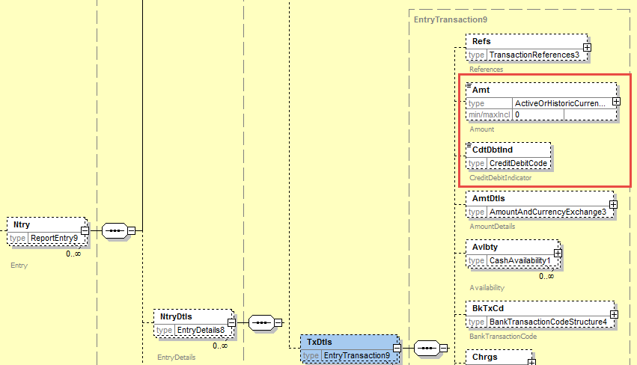

- Proposed timing:
The submitting organisation confirms that it can implement the requested changes in the requested timing.

Timing | As requested

- Final decision of the SEG:

Approve | X
Comments: Payments SEG meeting on Septembre 18th, 2017.

Reject
Reason for rejection:

CR0691: Modify RelatedParties and RelatedAgents to support additional scenarios.
- Origin of the request:
A.1 Submitter:
Federal Reserve Bank of New York (on behalf of the US Federal Reserve Banks)
33 Liberty Street
New York, NY 10045
U.S.A.
A.2 Contact person:
Federal Reserve Bank of New York Wholesale Product Office
Ms. Gina Russo (gina.russo@ny.frb.org)
Ms. Leslie Lee (leslie.lee@ny.frb.org)
A.3 Sponsors:
US Format Advisory Group

- Related messages:
camt.052.001.06 – BankToCustomerAccountReport
camt.053.001.06 – BankToCustomerAccountStatement
camt.054.001.06 – BankToCustomerDebitCreditNotification

- Description of the change request:
The request is to make changes to the existing components RelatedParties (described under C1) and RelatedAgents (described under C2), both part of the TransactionDetails component as shown below.
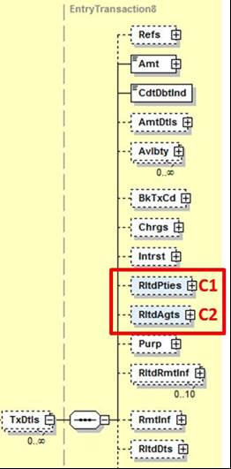

C1 – Related Parties
The request is to change the data type of the party elements in the existing RelatedParties component shown in the graphic below.
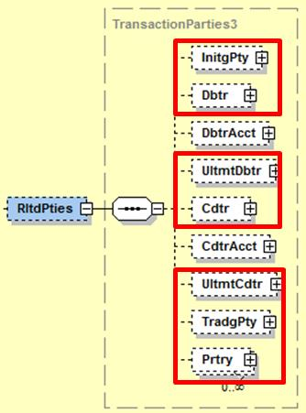

To enable reporting of account entries where a financial institution was acting as an InitiatingParty, (Ultimate) Debtor, (Ultimate) Creditor, TradingParty, or any other Proprietary party, the data type should offer the choice between identifying these parties as a financial institution next to the current non-financial institution option.
The suggestion is to reuse (the latest version of) the Party12Choice component shown below.

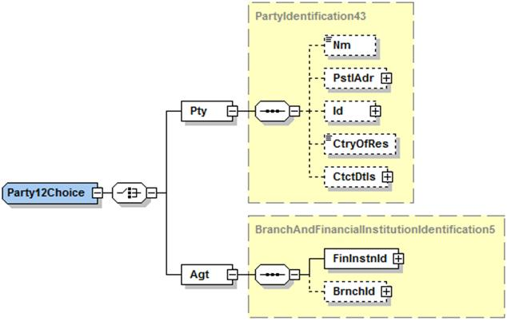
C2 – Related Agents
The request is to add two additional optional elements InstructingAgent and InstructedAgent to the existing RelatedAgents component as shown below. The data type should be aligned with the one used for the other elements already present in the component today (i.e. BranchAndFinancialInstituionIdentification5).

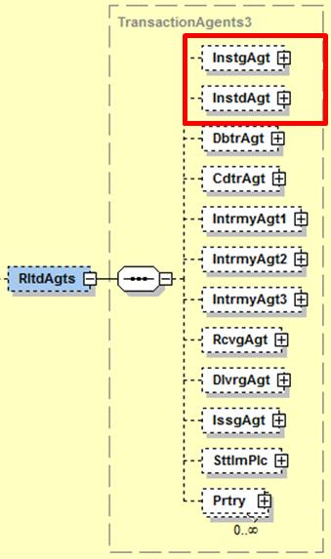

- Purpose of the changes:
Both C1 and C2 change requests will enable the inclusion of complete and structured information on all parties that were involved in a transaction that caused an account entry reported in any of the camt messages referenced above. Furthermore, change request C2 will provide a stable place for financial institutions as direct market infrastructure participants, i.e. sender or receiver of transactions.

- Urgency of the request:
Request to include the change in the next maintenance cycle.

- Business example:

If the account of a financial institution serviced by one of its correspondents or by a market infrastructure is credited as a result of a financial institution credit transfer (e.g. pacs.009 or MT 202), then in today’s camt.052 the financial institution Debtor of that transaction would need to be identified in a component that is traditionally used for non-financial institution debtors (for example, by using name and address). By offering the choice component, financial institutions will be identified with, for example, their BIC or domestic clearing code in a structured way.

- SEG/TSG recommendation:

Consider |  | X | Timing
 |  |  | - Next yearly cycle: 2017/2018  (the change will be considered for implementation in the yearly maintenance cycle which starts in 2017 and completes with the publication of new message versions in the spring of 2018) |  | X
- At the occasion of the next maintenance of the messages
(the change will be considered for implementation, but does not justify maintenance of the messages in its own right – will be pending until more critical change requests are received for the messages)
- Urgent unscheduled
(the change justifies an urgent implementation outside of the normal yearly cycle)
 |  |  | - Other timing:
Comments:
Payments SEG meeting on 26 June 2017.

Reject
Reason for rejection:

- Impact analysis:
Following the detailed analysis of the impact of the changes to the existing messages, we di not identify further impacted messages. The below list provides the full list of impacted messages:
- camt.052.001.06 – BankToCustomerAccountReport
- camt.053.001.06 – BankToCustomerAccountStatement
- camt.054.001.06 – BankToCustomerDebitCreditNotification

Should we consider aligning also the OriginalTransactionReference data types for the requested Party elements, present in the related messages, following message would be impacted as well:
- camt.029.001.07 - ResolutionOfInvestigationV07
- camt.055.001.06 - CustomerPaymentCancellationRequestV06
- camt.056.001.06 - FIToFIPaymentCancellationRequestV06
- pacs.002.001.08 - FIToFIPaymentStatusReportV08
- pacs.007.001.07 - FIToFIPaymentReversalV07
- pacs.028.001.01 - FIToFIPaymentStatusRequestV01
- pain.002.001.08 - CustomerPaymentStatusReportV08
See further details on the “indirect” impact of the change request on those messages in the implementation proposal.

- Proposed implementation:

We support the proposed implementation, which will result in the following implementation:
- Related Parties:
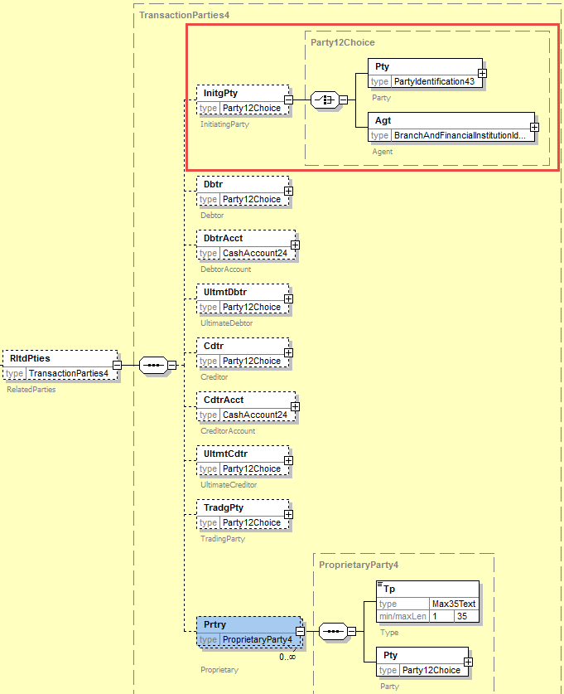
All parties have been updated with the registered component Party12Choice, as requested, and including the Proprietary party element.

- Related Agents:
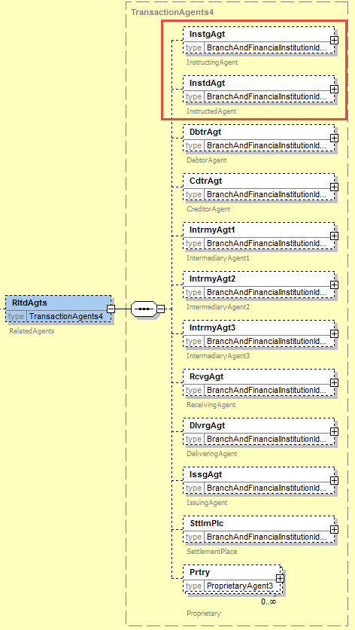
The two new elements InstructingAgent and InstructedAgent have been added to the structure.

- Possible impact on the OriginalTransactionReference element:
As indicated in the impact assessment, the update to the Related Parties could also be considered in the OriginalTransactionReference element defined in the related messages. This element contains the same parties, as in the RelatedParties, as illustrated below:

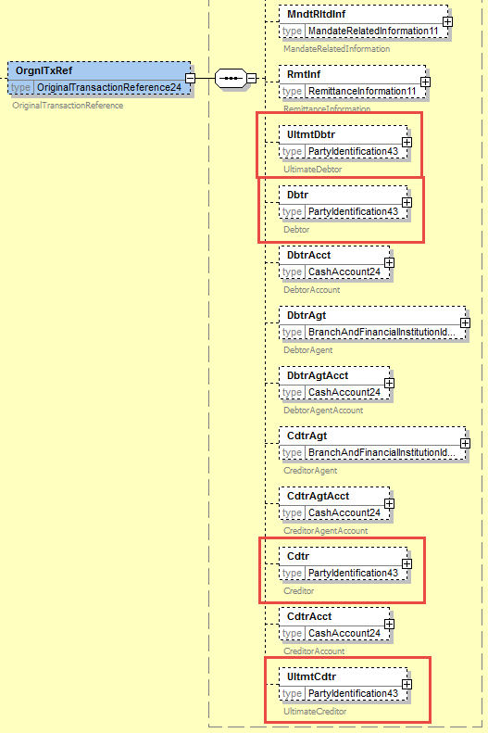

Question1 to the SEG: Should we apply the same changes to the Original Transaction Reference element ?

Question2 to the SEG: In case this change should be applied to the Original Transaction Reference element in all related messages identified in the impact analysis, and since this change is only intended for the interbank space, shall we apply the change both on the Payment Initiation messages (pain) and the Payments Clearing and Settlement messages (pacs), or only on the interbank space (pacs) ?
Remark: the Original Transaction Reference component is already modified through other change request as part of this maintenance cycle.
The SEG decides that the changes should be applied to pain and pacs as well.
- Proposed timing:
The submitting organisation confirms that it can implement the requested changes in the requested timing.

Timing | As requested

- Final decision of the SEG:

Approve | X
Comments: Payments SEG meeting on September 18th, 2017.

Reject
Reason for rejection:

CR0692: Externalise BalanceTypeCode and Status in reporting messages
- Origin of the request:
A.1 Submitter:
Federal Reserve Bank of New York (on behalf of the US Federal Reserve Banks)
33 Liberty Street
New York, NY 10045
U.S.A.
A.2 Contact person:
Federal Reserve Bank of New York Wholesale Product Office
Ms. Gina Russo (gina.russo@ny.frb.org)
Ms. Leslie Lee (leslie.lee@ny.frb.org)
A.3 Sponsors:
US Format Advisory Group

- Related messages:
camt.052.001.06 – BankToCustomerAccountReport (BalanceType and Status elements)
camt.053.001.06 – BankToCustomerAccountStatement (BalanceType and Status elements)
camt.054.001.06 – BankToCustomerDebitCreditNotification (Status element)

- Description of the change request:
The request is to change the data types of the balance Type (Report/Balance/Type) and Status (Report/Entry/Status) elements from a restricted code list explicitly embedded in the schema, to a choice component with Code vs Proprietary options (as implemented for a majority of code lists in the payment message portfolio). The Code element will be reserved for codes that have been published on an ISO 20022 externalized code lists, and the Proprietary element is available for use of any community or user specific codes.
More in general, we suggest that the principle of externalizing code lists should be consistently applied across all ISO 20022 messages.
In the below graphic the impacted elements of the Balance structure are highlighted in red: currently the balance Type still has the codes embedded in the schema, whereas the code list for the Subtype element has already been externalized. We suggest aligning the structure and externalizing both lists.
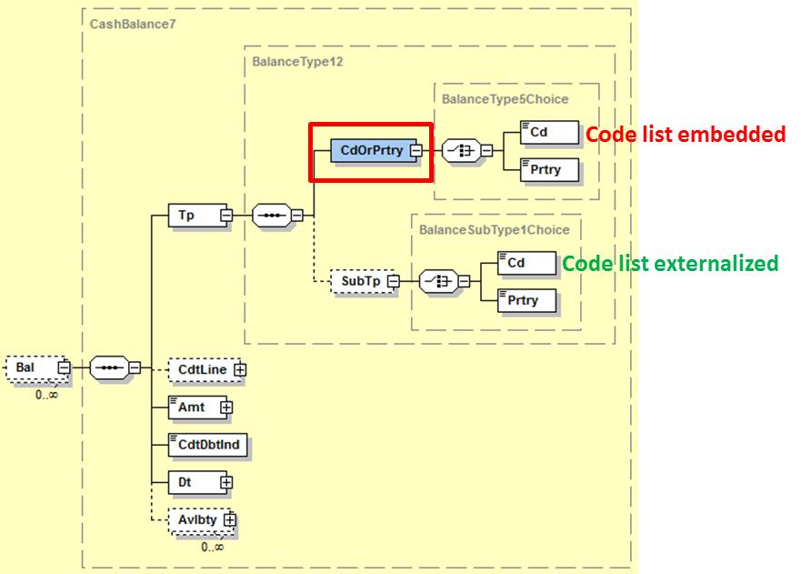

In the below graphic the impacted element is Status that currently has three codes embedded in the schema (BOOK, PDNG, INFO). The request is to change the data type to a choice element where the 3 current codes and potentially more will be added to an externalized code list, published on the ISO 20022 website. The Proprietary element is available for use of any community or user specific statuses.
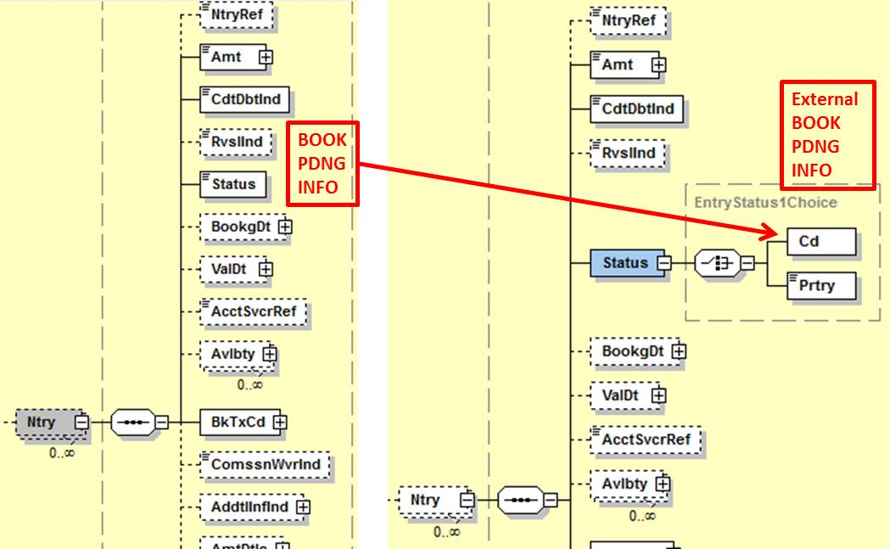

- Purpose of the change:
The change will increase the usability of the messages as an ever increasing number of communities is adopting them. Historically, the messages were developed for use in the corporate-to-bank space, but most of the adoption initiatives today focus on the interbank space where the reporting messages will be rolled out to report on accounts owned by financial institutions and serviced by other financial institutions or market infrastructures. As more players look at using the reporting messages, it is likely that the need for more specific codes, e.g. for the interbank space, will increase. Externalizing the lists will therefore bring flexibility to accommodate those needs in the shortest time-to-market way, while at the same moment it will bring stability to the standard as the addition of new codes to an externalized list does not cause for changes to the schemas.

- Urgency of the request:
Request to include the change in the next maintenance cycle.

- Business examples:
N/A

- SEG/TSG recommendation:

Consider |  | X | Timing
 |  |  | - Next yearly cycle: 2017/2018  (the change will be considered for implementation in the yearly maintenance cycle which starts in 2017 and completes with the publication of new message versions in the spring of 2018) |  | X
- At the occasion of the next maintenance of the messages
(the change will be considered for implementation, but does not justify maintenance of the messages in its own right – will be pending until more critical change requests are received for the messages)
- Urgent unscheduled
(the change justifies an urgent implementation outside of the normal yearly cycle)
 |  |  | - Other timing:
Comments:
Payments SEG meeting on 26 June 2017.

Reject
Reason for rejection:

- Impact analysis:
Following the detailed analysis of the impact of the changes to the existing messages, we confirm those following messages are impacted, as initially identified by the submitter of the change request.
- camt.052.001.06 – BankToCustomerAccountReportV06
- camt.053.001.06 – BankToCustomerAccountStatementV06
- camt.054.001.06 – BankToCustomerDebitCreditNotificationV06
However, through the impact analysis, we identified an additional message that is impacted by the externalisation of the Balance Type Code:
- camt.060.001.03 – AccountReportingRequestV03

Additionally, the BankToCustomerDebitCreditNotificationV06 message is not impacted by the externalisation of the Balance Type Code, as it does not contain any balance information

- Proposed implementation:

We support the proposed implementation as described in Description of the change request section.
For the externalisation of the Balance Type Code:
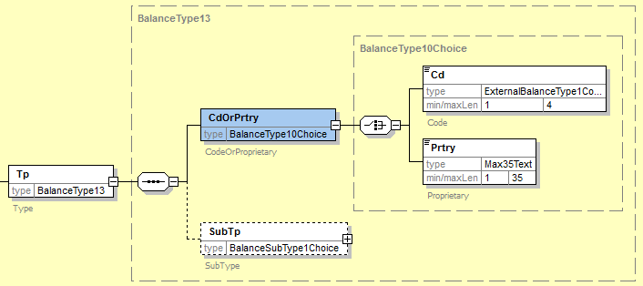

For the externalisation of the Entry Status Code:
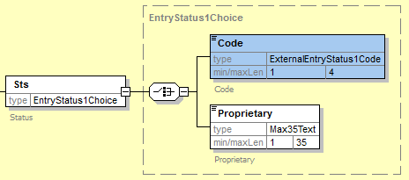

Question to the SEG: do we really want to externalise the status of the entry (Entry/Status) as requested by the submitter or should we implement below alternative which would keep the status code internal, but support the submitter’s request through a choice component between the current code set and a proprietary code (typed by Max35Text) as following?
The SEG decides that the BalanceType code set should be externalised.
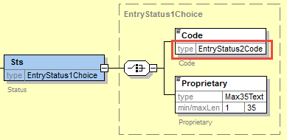

- Proposed timing:
The submitting organisation confirms that it can implement the requested changes in the requested timing.

Timing | As requested

- Final decision of the SEG:

Approve | X
Comments: Payments SEG meeting on September 18th, 2017.

Reject
Reason for rejection:

CR0693: Modify TransactionSummary to enable multiple reporting at bank transaction code level with a date/time indication Modify cardinality of TransactionSummary to allow reporting per date
- Origin of the request:
A.1 Submitter:
Federal Reserve Bank of New York (on behalf of the US Federal Reserve Banks)
33 Liberty Street
New York, NY 10045
U.S.A.
A.2 Contact person:
Federal Reserve Bank of New York Wholesale Product Office
Ms. Gina Russo (gina.russo@ny.frb.org)
Ms. Leslie Lee (leslie.lee@ny.frb.org)
A.3 Sponsors:
US Format Advisory Group

- Related messages:
camt.052.001.06 – BankToCustomerAccountReport
camt.053.001.06 – BankToCustomerAccountStatement
camt.054.001.06 – BankToCustomerDebitCreditNotification

- Description of the change request:
The request is to add optional CreditEntries and DebitEntries components at TotalEntriesPerBankTransactionCode level (aligned with TotalCreditEntries and TotalDebitEntries components at the higher TransactionsSummary level) make the TransactionsSummary component repetitive (under the Report component) and add a new optional Date element (offering a choice between Date and DateTime, aligning it with the Date element in the Balance component) as shown below.

- Purpose of the change:
To enable the inclusion of multiple transaction summaries and include the time for each of these in line with current business practices as described with a real business example under section E below.
In the current version of the standard if a user wants to include multiple credit and debit transaction summaries, the Report component at higher level would need to be repeated, indirectly forcing the user to also repeat elements like Identification, CreationDateTime and Account for which the summaries are provided.
The change will not impact current users of the message as usage of the CreditEntries, DebitEntries, and Date elements at TotalEntriesPerBankTransactionCode are optional.

- Urgency of the request:
Request to include the change in the next maintenance cycle.

- Business examples:
The Fedwire Funds Service participants receive an account balance report that can contain up to 7 transaction summaries to report a summary of 1/Fedwire funds transfers, 2/National Settlement Service entries, 3/Fedwire securities transfers, 4/ACH related entries, 5/any other entries that have posted to the account, 6/any other entries that have not yet posted to the account, and 7/memo post entries. Each of the transaction summaries have a date (or date and time) associated with the summary.
- SEG/TSG recommendation:

Consider |  | X | Timing
 |  |  | - Next yearly cycle: 2017/2018  (the change will be considered for implementation in the yearly maintenance cycle which starts in 2017 and completes with the publication of new message versions in the spring of 2018) |  | X
- At the occasion of the next maintenance of the messages
(the change will be considered for implementation, but does not justify maintenance of the messages in its own right – will be pending until more critical change requests are received for the messages)
- Urgent unscheduled
(the change justifies an urgent implementation outside of the normal yearly cycle)
 |  |  | - Other timing:
Comments:
Payments SEG meeting on 26 June 2017.

Reject
Reason for rejection:

- Impact analysis:
Following the detailed analysis of the impact of the changes to the existing messages, we confirm that all impacted messages have been listed by the submitter:
- camt.052.001.06 – BankToCustomerAccountReportV06
- camt.053.001.06 – BankToCustomerAccountStatementV06
- camt.054.001.06 – BankToCustomerDebitCreditNotificationV06
No other messages are impacted by this change.

- Proposed implementation:
We support the proposed implementation as following:
Revised implementation proposal
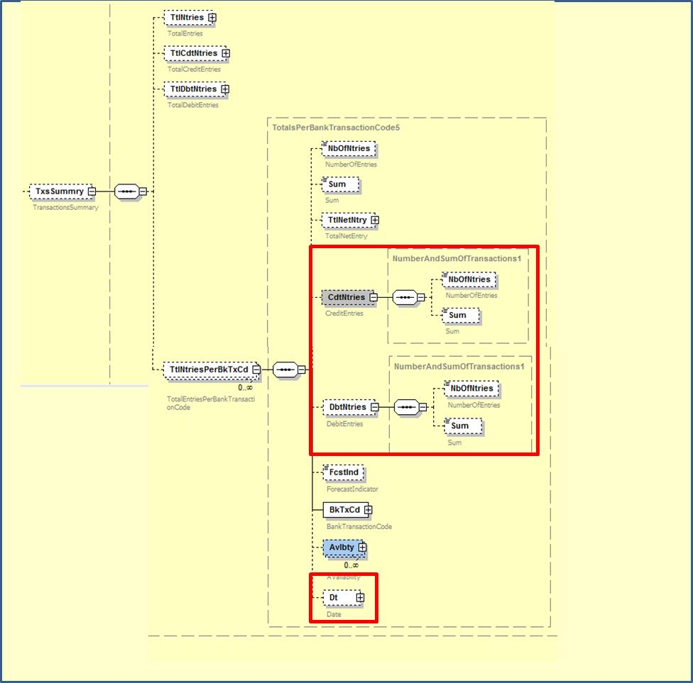

Compared to the original implementation proposal:
- The TransactionsSummary component is no longer made repetitive, but the (already existing) capability of repeating the TotalEntriesPerBankTransactionCode will be reused
- Granular debit and credit transaction reporting will be enabled within that TotalEntriesPerBankTransactionCode component by adding optional CreditEntries and DebitEntries components
At the end, this has been identified as the preferred approach for the following reason:
- At highest level in the TransactionsSummary component, the account servicer will refer to the TotalEntries, TotalCreditEntries and TotalDebitEntries, and at the lower TotalEntriesPerBankTransactionCode component the account servicer can provide further detailed information to show individual CreditEntries and DebitEntries per BankTransactionCode, that however, will no longer refer to “totals” thereby eliminating any possible confusion.
Original implementation proposal (for reference only)
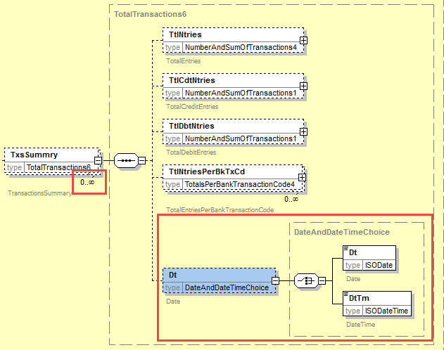

- Proposed timing:
The submitting organisation confirms that it can implement the requested changes in the requested timing.

Timing | As requested

- Final decision of the SEG:

Approve | X
Comments: Payments SEG meeting on October 2nd, 2017.

Reject
Reason for rejection:

CR0694: Modify ReportingPeriod to support the request for a sequence range

- Origin of the request:
A.1 Submitter:
Federal Reserve Bank of New York (on behalf of the US Federal Reserve Banks)
33 Liberty Street
New York, NY 10045
U.S.A.
A.2 Contact person:
Federal Reserve Bank of New York Wholesale Product Office
Ms. Gina Russo (gina.russo@ny.frb.org)
Ms. Leslie Lee (leslie.lee@ny.frb.org)
A.3 Sponsors:
US Format Advisory Group

- Related messages:
camt.052.001.06 – BankToCustomerAccountReport
camt.060.001.03 – AccountReportingRequest

- Description of the change request:
The request is to update the ReportingPeriod component in the account reporting request and account report messages to enable to (request a) report a sequence range of messages.
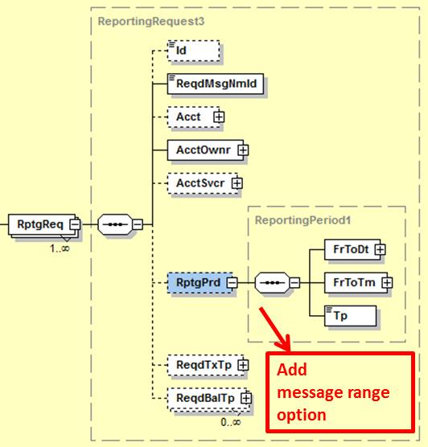

The detailed implementation proposal will need to cater for flexibility in selecting the actual message sequence ranges, i.e. From, To, FromTo, EqualTo, etc.
This can probably be achieved by using a FromToRange component that is aligned with the current FromToDate and FromToTime components, i.e., a “From” that is mandatory in combination with an optional “To” (to cater for open-end ranges) and make the overall component repetitive to enable singling out of a selection of specific messages by their sequence number.

- Purpose of the change:
The change will increase the flexibility and value for users in (requesting) account reports by adding the capability to select a sequence range of messages -a widespread practice within market infrastructures-, complementing today’s mechanism where reporting is based on date and time ranges only.

- Urgency of the request:
Request to include the change in the next maintenance cycle.

- Business examples:
- SEG/TSG recommendation:

Consider |  | X | Timing
 |  |  | - Next yearly cycle: 2017/2018  (the change will be considered for implementation in the yearly maintenance cycle which starts in 2017 and completes with the publication of new message versions in the spring of 2018) |  | X
- At the occasion of the next maintenance of the messages
(the change will be considered for implementation, but does not justify maintenance of the messages in its own right – will be pending until more critical change requests are received for the messages)
- Urgent unscheduled
(the change justifies an urgent implementation outside of the normal yearly cycle)
 |  |  | - Other timing:
Comments:
Payments SEG meeting on 26 June 2017.

Reject
Reason for rejection:
- Impact analysis:
Following the detailed analysis of the impact of the changes to the existing messages, we confirm that below message is impacted:
- camt.060.001.03 – AccountReportingRequestV03
However, we could not find any impact of this change in the
- camt.052.001.06 – BankToCustomerAccountReportV06

- Proposed implementation:

Based on the requested change description and following clarifications with the submitter on the business needs, we agreed to the following implementation:
- Reporting Period: no structural change, except that the FromToTime element will be made optional
- ReportingSequence: new element added right after the Reporting Period element in the ReportingRequest block to provide a choice between a FromSequence (all message sequences from this specific value included), ToSequence (all message sequences up to the specific value include), a repetitive From/ToSequence, a repetitive Equal Sequence or a repetitive NotEqual Sequence.

The ReportingSequence element will be implemented through a new SequenceRange1Choice component. The adjusted ReportingRequest block will result in the following implementation as illustrated below:

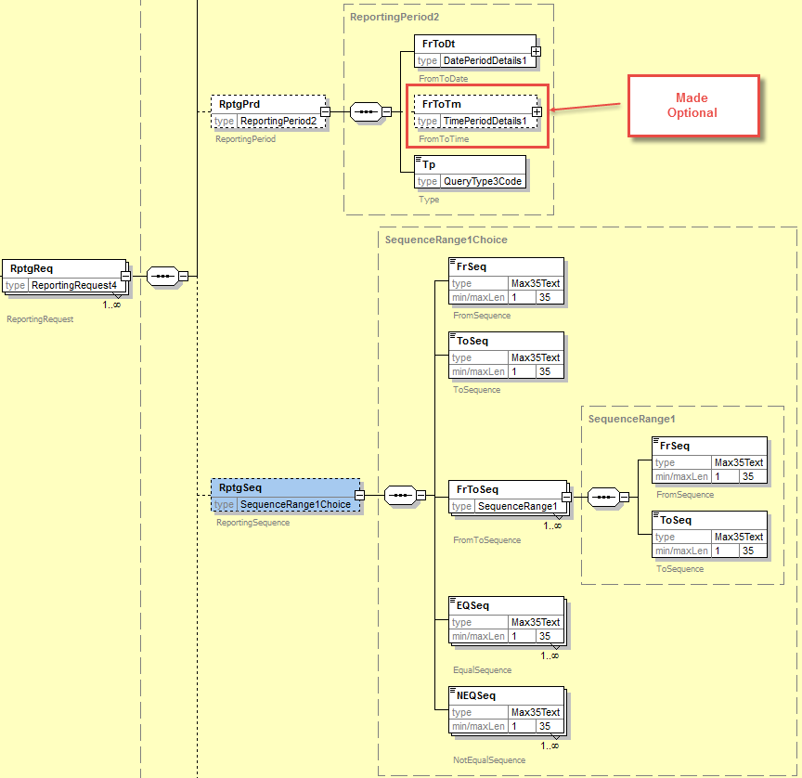

- Proposed timing:
The submitting organisation confirms that it can implement the requested changes in the requested timing.

Timing | As requested

- Final decision of the SEG:

Approve | X
Comments: Payments SEG meeting on September 18th, 2017.

Reject
Reason for rejection:

CR0695: Modify cardinality of the Case identification in the investigation messages

- Origin of the request:
A.1 Submitter:
Federal Reserve Bank of New York (on behalf of the US Federal Reserve Banks)
33 Liberty Street
New York, NY 10045
U.S.A.
A.2 Contact person:
Federal Reserve Bank of New York Wholesale Product Office
Ms. Gina Russo (gina.russo@ny.frb.org)
Ms. Leslie Lee (leslie.lee@ny.frb.org)
A.3 Sponsors:
US Format Advisory Group

- Related messages:
camt.035.001.03 – ProprietaryFormatInvestigation
(The same change could be considered for all messages in the E&I portfolio).

- Description of the change request:
The request is to change the cardinality of the Case component from mandatory to optional as shown below.

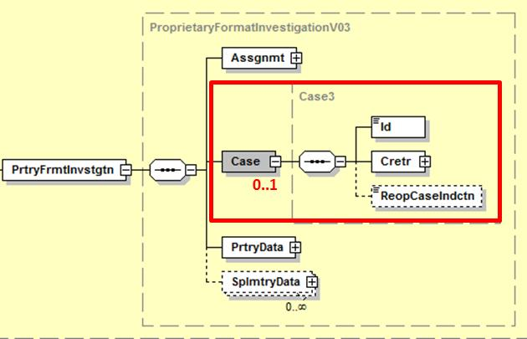

Furthermore, the scope of the message should be updated to reflect the actual usage of the message and not only the conditions under which the message is sent.

- Purpose of the changes:
The use of the Exceptions & Investigation message portfolio has not yet reached critical mass. Although in the long term the mechanism of assigning a case to an investigation might make sense, at this time the concept might be an inhibitor to broader adoption, potentially even driving the industry towards the use of pure free format options. Changing the cardinality to optional might ease the initial adoption of the E&I message portfolio and will not impact current or future users that are familiar with the case concept.
Similar reasoning was applied when the Case component was made optional in the camt.056 (FIToFIPaymentCancellationRequest).

- Urgency of the request:
Request to include the change in the next maintenance cycle.

- Business examples: /

- SEG/TSG recommendation:

Consider |  | X | Timing
 |  |  | - Next yearly cycle: 2017/2018  (the change will be considered for implementation in the yearly maintenance cycle which starts in 2017 and completes with the publication of new message versions in the spring of 2018) |  | X
- At the occasion of the next maintenance of the messages
(the change will be considered for implementation, but does not justify maintenance of the messages in its own right – will be pending until more critical change requests are received for the messages)
- Urgent unscheduled
(the change justifies an urgent implementation outside of the normal yearly cycle)
 |  |  | - Other timing:
Comments:
Payments SEG meeting on 26 June 2017.

Reject
Reason for rejection:

- Impact analysis:
Following the detailed analysis of the impact of the changes to the existing messages, we identified further impacted messages, as already proposed by the change request submitter. The below list provides the full list of impacted messages (i.e. the full Exception and Investigation Message Set is impacted):
- camt.026.001.05 - UnableToApplyV05
- camt.027.001.05 - ClaimNonReceiptV05
- camt.028.001.07 - AdditionalPaymentInformationV07
- camt.029.001.07 - ResolutionOfInvestigationV07
- camt.030.001.04 - NotificationOfCaseAssignmentV04
- camt.031.001.04 - RejectInvestigationV04
- camt.032.001.03 - CancelCaseAssignmentV03
- camt.033.001.04 - RequestForDuplicateV04
- camt.034.001.04 - DuplicateV04
- camt.035.001.03 - ProprietaryFormatInvestigationV03
- camt.036.001.03 - DebitAuthorisationResponseV03
- camt.038.001.03 - CaseStatusReportRequestV03
- camt.039.001.04 - CaseStatusReportV04
- camt.037.001.05 - DebitAuthorisationRequestV05
- camt.087.001.04 - RequestToModifyPaymentV04
Please note that this change has already been implemented in the two cancellation messages in which the Case component has been defined as an option element:
- camt.055.001.06 - CustomerPaymentCancellationRequestV06
- camt.056.001.06 - FIToFIPaymentCancellationRequestV06

- Proposed implementation:

We support the proposed implementation to have the Case component optional.
However, we would rather propose to add a rule in each message, stating following:
“The Case component must be present, when the message is sent in response to an exception and investigation message which contains the Case component”

Question to the SEG: do you support the implementation of this change in all of the messages of the Exception and Investigation Message Set?
The SEG decides that the changes should be applied to the entire Exceptions and Investigations message set.

- Proposed timing:
The submitting organisation confirms that it can implement the requested changes in the requested timing.

Timing | As requested

- Final decision of the SEG:

Approve | X
Comments: Payments SEG meeting on September 18th, 2017.

Reject
Reason for rejection:

CR0696: Modify cardinality and definition of the CreationDateTime

- Origin of the request:
A.1 Submitter:
Federal Reserve Bank of New York (on behalf of the US Federal Reserve Banks)
33 Liberty Street
New York, NY 10045
U.S.A.
A.2 Contact person:
Federal Reserve Bank of New York Wholesale Product Office
Ms. Gina Russo (gina.russo@ny.frb.org)
Ms. Leslie Lee (leslie.lee@ny.frb.org)
A.3 Sponsors:
US Format Advisory Group

- Related messages:
camt.052.001.06 – BankToCustomerAccountReport (Report component)
camt.053.001.06 – BankToCustomerAccountStatement (Report component)
camt.054.001.06 – BankToCustomerDebitCreditNotification (Notification component)

- Description of the change request:
C1 – Change definitions
The request is to change the definitions of the CreationDateTime elements in the Report and Notification components. The quoted definitions are extracts from the 2016/2017 Message Definition Report (MDR) for the camt messages.
Report
The definition should be changed to reflect the creation date and time of the report, not the message.

2.4.2.5 CreationDateTime <CreDtTm>
Presence: [1..1]
Definition: Date and time at which the message report was created.

Notification
The definition should be changed to reflect the creation date and time of the notification, not the message.

4.4.2.5 CreationDateTime <CreDtTm>
Presence: [1..1]
Definition: Date and time at which the message notification was created.

C2 – Change cardinality
The request is to change the cardinality of the CreationDateTime elements from mandatory to optional in the Report and Notification components.

- Purpose of the change:
The changes described under C1 are of a cosmetic nature, i.e. to correct, align or remove ambiguity from the definitions.
As CreationDateTime is already mandatory at the message GroupHeader level, the change described under C2 will avoid duplication of information in case a single account report or account notification is sent, or if systems are not capable of generating multiple dates and times.

- Urgency of the request:
Request to include the change in the next maintenance cycle.

- Business examples:
NA.

- SEG/TSG recommendation:

Consider |  | X | Timing
 |  |  | - Next yearly cycle: 2017/2018  (the change will be considered for implementation in the yearly maintenance cycle which starts in 2017 and completes with the publication of new message versions in the spring of 2018) |  | X
- At the occasion of the next maintenance of the messages
(the change will be considered for implementation, but does not justify maintenance of the messages in its own right – will be pending until more critical change requests are received for the messages)
- Urgent unscheduled
(the change justifies an urgent implementation outside of the normal yearly cycle)
 |  |  | - Other timing:
Comments:
Payments SEG meeting on 26 June 2017.

Reject
Reason for rejection:
- Impact analysis:
Following the detailed analysis of the impact of the changes to the existing messages, we confirm that all impacted messages have been listed by the submitter:
- camt.052.001.06 – BankToCustomerAccountReportV06
- camt.053.001.06 – BankToCustomerAccountStatementV06
- camt.054.001.06 – BankToCustomerDebitCreditNotificationV06
No other messages are impacted by this change.

- Proposed implementation:

We support the proposed implementation with following comments:
- Definitions will be updated as requested
- The submitter has not requested to update the definition of the statement, which will be updated also as following:
Definition: Date and time at which the message statement was created.
Below is an example of the resulting schema and documentation, once the change has been applied for the B2CAccountReport message:

<xs:element name="CreDtTm" type="ISODateTime" minOccurs="0" maxOccurs="1">
<xs:annotation>
<xs:documentation source="Name"
xml:lang="EN">CreationDateTime</xs:documentation>
<xs:documentation source="Definition" xml:lang="EN">Date and time at which the report was created.</xs:documentation>
</xs:annotation>
</xs:element>

- Proposed timing:
The submitting organisation confirms that it can implement the requested changes in the requested timing.

Timing | As requested

- Final decision of the SEG:

Approve | X
Comments: Payments SEG meeting on September 18th, 2017.

Reject
Reason for rejection:

CR0697: Modify cardinality of Credit Line to multiple occurrences
- Origin of the request:
A.1 Submitter:
Federal Reserve Bank of New York (on behalf of the US Federal Reserve Banks)
33 Liberty Street
New York, NY 10045
U.S.A.
A.2 Contact person:
Federal Reserve Bank of New York Wholesale Product Office
Ms. Gina Russo (gina.russo@ny.frb.org)
Ms. Leslie Lee (leslie.lee@ny.frb.org)
A.3 Sponsors:
US Format Advisory Group

- Related messages:
camt.052.001.06 – BankToCustomerAccountReport
camt.053.001.06 – BankToCustomerAccountStatement

- Description of the change request:
The request is to increase the multiplicity of the CreditLine component (in the Balance component) and add a new optional Type element to the component as shown below.

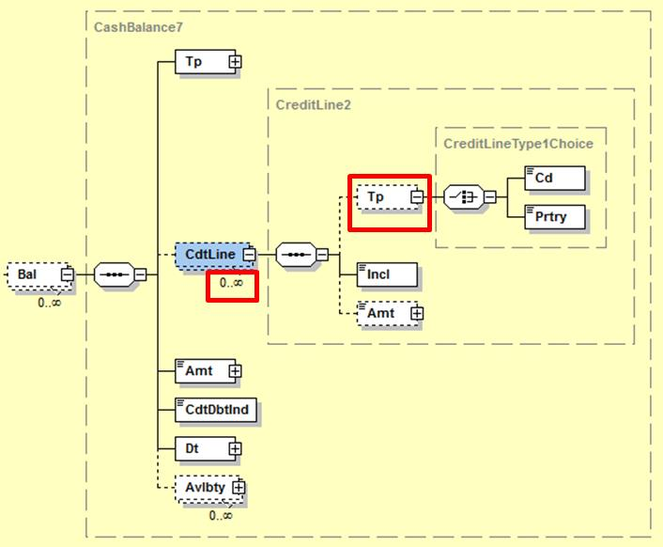

- Purpose of the change:
The change will enable the inclusion of multiple credit lines and allow specifying the type of credit line in line with current business practices as described with a real business example under section E.
The change will not impact current users of the messages as usage of the CreditLine component can be restricted to a single occurrence and the new Type element is optional.

- Urgency of the request:
Request to include the change in the next maintenance cycle.

- Business examples:
The Fedwire Funds Service participants receive an account balance report that typically contains 4 balances: opening balance, daylight overdraft balance, account balance, and available funds balance.
The available funds balance can include up to 2 credit lines, i.e. a net debit cap, and a collateralized capacity.
- SEG/TSG recommendation:

Consider |  | X | Timing
 |  |  | - Next yearly cycle: 2017/2018  (the change will be considered for implementation in the yearly maintenance cycle which starts in 2017 and completes with the publication of new message versions in the spring of 2018) |  | X
- At the occasion of the next maintenance of the messages
(the change will be considered for implementation, but does not justify maintenance of the messages in its own right – will be pending until more critical change requests are received for the messages)
- Urgent unscheduled
(the change justifies an urgent implementation outside of the normal yearly cycle)
 |  |  | - Other timing:
Comments:
Payments SEG meeting on 26 June 2017.

Reject
Reason for rejection:

- Impact analysis:
Following the detailed analysis of the impact of the changes to the existing messages, we confirm that all impacted messages have been listed by the submitter:
- camt.052.001.06 – BankToCustomerAccountReportV06
- camt.053.001.06 – BankToCustomerAccountStatementV06
No other messages are impacted by this change.

- Proposed implementation:

We support the proposed implementation as following:

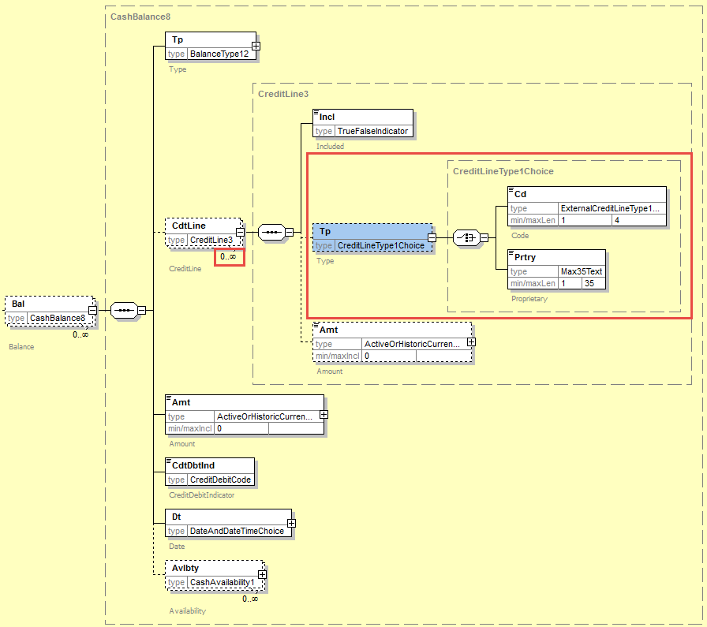

Remark: the order of the elements has been modified compared to the requested implementation, to keep the mandatory “Included” element in first position in the component.

Remark2: Following consultation with the submitter, we confirmed that the credit line types should be defined as an external code set, and the submitter will have to provide the list of initial codes to the SEG prior to the finalisation of the messages.

- Proposed timing:
The submitting organisation confirms that it can implement the requested changes in the requested timing.

Timing | As requested

- Final decision of the SEG:

Approve | X
Comments: Payments SEG meeting on September 18th, 2017.

Reject
Reason for rejection:

CR0698: Add new optional element LocalInstrument in TransactionDetails
- Origin of the request:
A.1 Submitter:
Federal Reserve Bank of New York (on behalf of the US Federal Reserve Banks)
33 Liberty Street
New York, NY 10045
U.S.A.
A.2 Contact person:
Federal Reserve Bank of New York Wholesale Product Office
Ms. Gina Russo (gina.russo@ny.frb.org)
Ms. Leslie Lee (leslie.lee@ny.frb.org)
A.3 Sponsors:
US Format Advisory Group

- Related messages:
camt.052.001.06 – BankToCustomerAccountReport
camt.053.001.06 – BankToCustomerAccountStatement
camt.054.001.06 – BankToCustomerDebitCreditNotification

- Description of the change request:
The request is to add a new optional element LocalInstrument to the TransactionDetails component (Entry/EntryDetails/TransactionDetails) as shown in the graphic below.
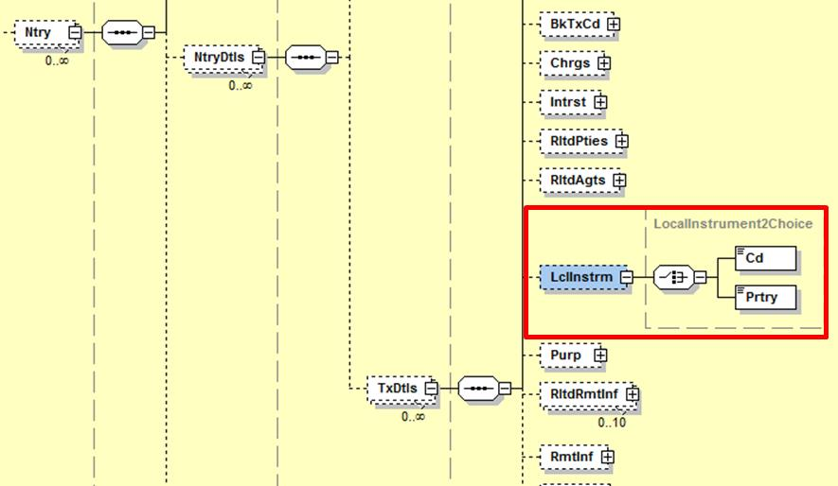

- Purpose of the change:
Many communities that are implementing ISO 20022 use the LocalInstrument element in the payment messages to differentiate between the different types of transactions, for example, domestic vs foreign credit transfers. The change will allow reporting those local payment types with the transaction details.

- Urgency of the request:
Request to include the change in the next maintenance cycle.

- Business examples:
A list with 12 specific Fedwire Funds Service codes will be submitted for inclusion in the ISO 20022 externalized LocalInstrument code list. The above change will allow reporting, for example, that a transaction settled across the Fedwire Funds Service was a normal Customer Credit Transfer (code CTR0), a Customer Drawdown Transfer (code DRW0), or a Bank Transfer (code BTR6).

- SEG/TSG recommendation:

Consider |  | X | Timing
 |  |  | - Next yearly cycle: 2017/2018  (the change will be considered for implementation in the yearly maintenance cycle which starts in 2017 and completes with the publication of new message versions in the spring of 2018) |  | X
- At the occasion of the next maintenance of the messages
(the change will be considered for implementation, but does not justify maintenance of the messages in its own right – will be pending until more critical change requests are received for the messages)
- Urgent unscheduled
(the change justifies an urgent implementation outside of the normal yearly cycle)
 |  |  | - Other timing:
Comments:
Payments SEG meeting on 26 June 2017.

Reject
Reason for rejection:

- Impact analysis:
Following the detailed analysis of the impact of the changes to the existing messages, we confirm that all impacted messages have been listed by the submitter:
- camt.052.001.06 – BankToCustomerAccountReportV06
- camt.053.001.06 – BankToCustomerAccountStatementV06
- camt.054.001.06 – BankToCustomerDebitCreditNotificationV06
No other messages are impacted by this change.

- Proposed implementation:

We support the proposed implementation as following:
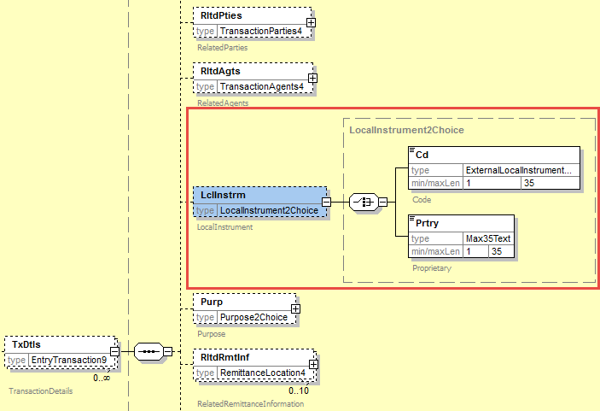

- Proposed timing:
The submitting organisation confirms that it can implement the requested changes in the requested timing.

Timing | As requested

- Final decision of the SEG:

Approve | X
Comments: Payments SEG meeting on September 18th, 2017.

Reject
Reason for rejection:

The Format Advisory Group is jointly chaired by the Federal Reserve Bank of New York and The Clearing House and includes 14 global and regional banks. All institutions are Fedwire Funds Service participants and 10 are also CHIPS participants. The members are Bank of America, Bank of New York Mellon, Citibank, Deutsche Bank, HSBC, JPMC, Key Bank, MUFG Union Bank, PNC Bank, State Street, SunTrust, Wells Fargo, UBS, US Bank.
The High-value Payment Systems Plus (HVPS+) is a SWIFT convened group of high-value market infrastructures and banks to establish suggested practices for implementing ISO 20022 messages across high-value payment systems with enhanced features that are not supported today in legacy formats. Members includes representatives from Australia, Canada, the European Union, Japan, Hong Kong, South Africa, the UK, and the US.
The Format Advisory Group is jointly chaired by the Federal Reserve Bank of New York and The Clearing House and includes 14 global and regional banks. All institutions are Fedwire Funds Service participants and 10 are also CHIPS participants. The members are Bank of America, Bank of New York Mellon, Citibank, Deutsche Bank, HSBC, JPMC, Key Bank, MUFG Union Bank, PNC Bank, State Street, SunTrust, Wells Fargo, UBS, US Bank.
The Format Advisory Group is jointly chaired by the Federal Reserve Bank of New York and The Clearing House and includes 14 global and regional banks. All institutions are Fedwire Funds Service participants and 10 are also CHIPS participants. The members are Bank of America, Bank of New York Mellon, Citibank, Deutsche Bank, HSBC, JPMC, Key Bank, MUFG Union Bank, PNC Bank, State Street, SunTrust, Wells Fargo, UBS, US Bank.
The High-value Payment Systems Plus (HVPS+) is a SWIFT convened group of high-value market infrastructures and banks to establish suggested practices for implementing ISO 20022 messages across high-value payment systems with enhanced features that are not supported today in legacy formats. Members includes representatives from Australia, Canada, the European Union, Japan, Hong Kong, South Africa, the UK, and the US.
Similar to the reasoning for the IntermediaryAgent1, IntermediaryAgent2 and IntermediaryAgent3 elements, this will avoid confusion around the exact place of the agents in the end-to-end payment chain. The suggestion is that the documentation would clarify that the highest number would be closest to the current InstructingAgent (for an example, please refer to section E.
In practice this means the currently existing PreviousInstructingAgent and PreviousInstructingAgentAccount elements will be renamed.
The Format Advisory Group is jointly chaired by the Federal Reserve Bank of New York and The Clearing House and includes 14 global and regional banks. All institutions are Fedwire Funds Service participants and 10 are also CHIPS participants. The members are Bank of America, Bank of New York Mellon, Citibank, Deutsche Bank, HSBC, JPMC, Key Bank, MUFG Union Bank, PNC Bank, State Street, SunTrust, Wells Fargo, UBS, US Bank.
The Format Advisory Group is jointly chaired by the Federal Reserve Bank of New York and The Clearing House and includes 14 global and regional banks. All institutions are Fedwire Funds Service participants and 10 are also CHIPS participants. The members are Bank of America, Bank of New York Mellon, Citibank, Deutsche Bank, HSBC, JPMC, Key Bank, MUFG Union Bank, PNC Bank, State Street, SunTrust, Wells Fargo, UBS, US Bank.
The Format Advisory Group is jointly chaired by the Federal Reserve Bank of New York and The Clearing House and includes 14 global and regional banks. All institutions are Fedwire Funds Service participants and 10 are also CHIPS participants. The members are Bank of America, Bank of New York Mellon, Citibank, Deutsche Bank, HSBC, JPMC, Key Bank, MUFG Union Bank, PNC Bank, State Street, SunTrust, Wells Fargo, UBS, US Bank.
In case the change request would not be accepted by the SEG, then we will request the addition of additional new codes to the Balance Type code list.
In case the change request would not be accepted by the SEG, then we will request the addition of additional new codes to the Status code list.
The Format Advisory Group is jointly chaired by the Federal Reserve Bank of New York and The Clearing House and includes 14 global and regional banks. All institutions are Fedwire Funds Service participants and 10 are also CHIPS participants. The members are Bank of America, Bank of New York Mellon, Citibank, Deutsche Bank, HSBC, JPMC, Key Bank, MUFG Union Bank, PNC Bank, State Street, SunTrust, Wells Fargo, UBS, US Bank.
The Format Advisory Group is jointly chaired by the Federal Reserve Bank of New York and The Clearing House and includes 14 global and regional banks. All institutions are Fedwire Funds Service participants and 10 are also CHIPS participants. The members are Bank of America, Bank of New York Mellon, Citibank, Deutsche Bank, HSBC, JPMC, Key Bank, MUFG Union Bank, PNC Bank, State Street, SunTrust, Wells Fargo, UBS, US Bank.
The Format Advisory Group is jointly chaired by the Federal Reserve Bank of New York and The Clearing House and includes 14 global and regional banks. All institutions are Fedwire Funds Service participants and 10 are also CHIPS participants. The members are Bank of America, Bank of New York Mellon, Citibank, Deutsche Bank, HSBC, JPMC, Key Bank, MUFG Union Bank, PNC Bank, State Street, SunTrust, Wells Fargo, UBS, US Bank.
The Format Advisory Group is jointly chaired by the Federal Reserve Bank of New York and The Clearing House and includes 14 global and regional banks. All institutions are Fedwire Funds Service participants and 10 are also CHIPS participants. The members are Bank of America, Bank of New York Mellon, Citibank, Deutsche Bank, HSBC, JPMC, Key Bank, MUFG Union Bank, PNC Bank, State Street, SunTrust, Wells Fargo, UBS, US Bank.
The Format Advisory Group is jointly chaired by the Federal Reserve Bank of New York and The Clearing House and includes 14 global and regional banks. All institutions are Fedwire Funds Service participants and 10 are also CHIPS participants. The members are Bank of America, Bank of New York Mellon, Citibank, Deutsche Bank, HSBC, JPMC, Key Bank, MUFG Union Bank, PNC Bank, State Street, SunTrust, Wells Fargo, UBS, US Bank.
The Format Advisory Group is jointly chaired by the Federal Reserve Bank of New York and The Clearing House and includes 14 global and regional banks. All institutions are Fedwire Funds Service participants and 10 are also CHIPS participants. The members are Bank of America, Bank of New York Mellon, Citibank, Deutsche Bank, HSBC, JPMC, Key Bank, MUFG Union Bank, PNC Bank, State Street, SunTrust, Wells Fargo, UBS, US Bank.

