Maintenance Change Request
for the update of ISO 20022 financial repository items

- Name of the request:

“ISO 20022 Payments Maintenance 2016/2017”

- Submitting organisation(s):

SWIFT, on behalf of IFX Forum, SWIFT, TWIST and OAGi (ISTH), and the CBI Consortium

Standards Department,
Avenue Adele, 1
1310 La Hulpe - Belgium

- Related messages:

Under this project, below existing ISO 20022 messages will be maintained (resulting from the impact analysis performed on each CR).

- Payment Initiation messages set:
- pain.001.001.07 | CustomerCreditTransferInitiationV07
- pain.002.001.07 | CustomerPaymentStatusReportV07
- pain.007.001.06 | CustomerPaymentReversalV06
- pain.008.001.06 | CustomerDirectDebitInitiationV06

- Payment Mandates messages set:
- pain.009.001.04 | MandateInitiationRequestV04
- pain.010.001.04 | MandateAmendmentRequestV04
- pain.011.001.04 | MandateCancellationRequestV04
- pain.012.001.04 | MandateAcceptanceRequestV04

- Payment Clearing And Settlement messages set:
- pacs.002.001.07 | FIToFIPaymentStatusReportV07
- pacs.003.001.06 | FIToFICustomerDirectDebitV06
- pacs.004.001.06 | PaymentReturnV06
- pacs.007.001.06 | FIToFIPaymentReversalV06
- pacs.008.001.05 | FIToFICustomerCreditTransferV05
- pacs.009.001.05 | FinancialInstitutionCreditTransferV05

- Bank to Customer Cash Management messages set:
- camt.052.001.05 | BankToCustomerAccountReportV05
- camt.053.001.05 | BankToCustomerStatementV05
- camt.054.001.05 | BankToCustomerDebitCreditNotificationV05

- Exceptions and Investigations messages set:
- camt.026.001.04 | UnableToApplyV04
- camt.027.001.04 | ClaimNonReceiptV04
- camt.028.001.06 | AdditionalPaymentInformationV05
- camt.029.001.06 | ResolutionOfInvestigationV05
- camt.037.001.05 | DebitAuthorisationRequestV05
- camt.055.001.05 | CustomerPaymentCancellationRequestV04
- camt.056.001.05 | FIToFIPaymentCancellationRequestV04
- camt.087.001.04 | RequestToModifyPaymentV02

- Customer Payment Activation Request message set:
- pain.013.001.05 | CreditorPaymentActivationRequestV05
- pain.014.001.05 | CreditorPaymentActivationRequestStatusReportV05

- Stand-Alone Remittance Advice message set:
- remt.001.001.02 | RemittanceAdviceV02

Please note that although below messages are under the responsibility of other submitting organisations, SWIFT has agreed to implement the required changes on behalf of those organisations. Therefore no separate MCR will be created for the implementation of the changes in those messages:

Messages submitted by the CBI Consortium:
- pain.013.001.04 | CreditorPaymentActivationRequestV04
- pain.014.001.04 | CreditorPaymentActivationRequestStatusReportV04

Messages submitted by the IFX Forum:
- remt.001.001.02 | RemittanceAdviceV02

- Commitments of the submitting organisation:

The submitting organisations confirm that they can and will:
- undertake the development of the new version of the candidate ISO 20022 message models that it will submit to the RA for compliance review and evaluation. New valid Message Definition models will be made available to the RA by December 1.
- provide a new version of part 1 of the related Message Definition Reports (MDR) by December 1, and new examples of valid message instances of each candidate message (only when valid samples were published for current version) by May 1 at the latest.
- address any queries related to the description of the new models and messages as published by the RA on the ISO 20022 website.

SWIFT intends to implement most of the above new versions on its SWIFTNet network once the related documentation has been published by the RA.

The submitting organisations confirm their knowledge and acceptance of the ISO 20022 Intellectual Property Rights policy for contributing organisations, as follows.
“Organisations that contribute information to be incorporated into the ISO 20022 Repository shall keep any Intellectual Property Rights (IPR) they have on this information. A contributing organisation warrants that it has sufficient rights on the contributed information to have it published in the ISO 20022 Repository through the ISO 20022 Registration Authority in accordance with the rules set in ISO 20022. To ascertain a widespread, public and uniform use of the ISO 20022 Repository information, the contributing organisation grants third parties a non-exclusive, royalty-free license to use the published information”.

- Contact persons:
Vincent Kuntz – SWIFT Standards, vincent.kuntz@swift.com
Karin de Ridder – SWIFT Standards, karin.deridder@swift.com

Table of Contents
CR0574: Add elements to support Real Time Payments scenarios 5
CR0576: Update mandate messages 17
CR0628: Add AdditionalInformation in UnableToApply 38
CR0635: Add new cancellation reason code FRTR 45

CR0574: Add elements to support Real Time Payments scenarios

- Origin of the request:
A.1 Submitter:
SWIFT
Avenue Adèle 1
1310 La Hulpe
Belgium

A.2 Contact person:
Isabelle Bouille, e-mail: Isabelle.bouille@swift.com, Tel: +32 2 655 44 20

- Related messages:
- pacs.008.001.06 – FIToFICustomerCreditTransfer
- pacs.009.001.06 – FinancialInstitutionCreditTransfer
- pacs.002.001.07 – FIToFIPayment Status Report
- pain.001.001.07 – Customer CreditTranferInitiation
- pain.002.001.07 - CustomerPaymentStatusReport
- camt.056.001.05 – FIToFIPaymentCancellationRequest
- camt.029.001.06 – Resolution of Investigation

- Description of the change request:
This change request document relates to changes aiming at complying with the Real Time business requirements:
- Addition of several new elements to the existing Payment Status Report and Payment Cancellation Request messages
- Adaptation of the scopes in order to meet specific requirements of Real Time Payments business. Indeed, in Real Time Payments scenarios, it is key to be able to measure the end to end processing time of the payment transactions (from the ordering party account to the beneficiary party account), in order to confirm the timely credits on the beneficiaries accounts or eventually launch investigations and/or rejections of the transactions. This confirmation needs to be sent both on the sending and receiving side of the payment transaction.
- Include an ISOTime to the existing RequestedExecutionDate (pain.001, pain.002, pacs.002)
- Transform the “Status” element in the pain.002 and pacs.002 to transport an ISOExternalCode set instead of a list of fixed codes in the messages itself.

- New elements:

Impacted Messages | Location in the message structure | Element |  | Purpose for change and definition
pacs.008, pacs.009 | GroupHeader | TimeStamp  ISOTime | [0,1] | Purpose: in a Real Time scenario, it is the responsibility of the first sending bank to make sure that it receives a confirmation of credit on the beneficiary account, or a rejection message, within a Scheme pre-defined maximum amount of time. Based on this information, the first sending bank will either confirm the finality of the payment transaction to the ordering client, or eventually launch an exception (Cancellation) or Investigation (Enquiry).  Definition: Time by when the first sending bank has conducted all mandatory check for the processing of the message/transaction(s) and sends the payment instruction.
pacs.002/pain.002/camt.056/camt.029 | TransactionInformationAndStatus | OriginalTime Stamp | [0,1] | Purpose: Because the first sending agent of the original instruction (e.g. pacs.008) must measure the processing time in case of a Real Time Payments scenario (i.e. Credit on the beneficiary’s account), this information must also be transported, unchanged, in all messages relating to the original instruction, i.e. in the Payment Status Report message.  Definition: Original Time by when the first sending bank has conducted all mandatory check for the processing of the original message/transaction(s) and sent the payment instruction.
Camt.056 | GroupHeader | RequestFor RefundIndicator  True/False | [1,1] | Purpose: In a Real Time Payments scenario the funds are credited to the beneficiary within a very short timeframe (i.e. within seconds). Because the Request for Cancellation should be sent prior to the settlement, it would make more sense to send a Request for Refund instead in case the originating party wishes to cancel the payment instruction. A Request for Refund message does not exist today. As a Request for Refund message would be identical to a Request for Cancellation message and in order to avoid creating a new message, it is requested to add a flag in the Request for Cancellation message to indicate whether it should be considered as a Request for Refund (note: the scope would need to be adapted to reflect this, as described below).  Definition: Indicates whether the message should be considered as a Request for Refund.

- Revised scopes:
Impacted Messages | Scope change description
Camt.056 | In a Real Time Payments scenario and because the funds are credited to the beneficiary within a very short timeframe (i.e. within seconds), a Request for Refund would be required in case the transaction would need to be cancelled. Because the message content would be equivalent to a Request for Cancellation, it is requested to amend the scope of this message so that it caters for both the Request for Cancellation and the Request for Refund scenarios.
Pacs.002/Pain.002 | The current scope of the Payment Status Report (interbank and Bank to Customer) foresees that the Status of a transaction is sent solely to the sender side of the original transaction. In a Payments Real Time scenario, both sides of the transactions must be informed of the status of the transaction (e.g. either the beneficiary is credited, or the transaction is rejected). It is therefore requested that the scope of the message is amended to reflect that the Payments Status Report can optionally be sent to the sending and receiving sides of a transaction.

- Revised DataType for element RequestedExecutionDate and OriginalRequestedExecutionDate:
Impacted Messages | Scope change description
Pain.001 | PaymentInformation/RequestedExecutionDate: change the ISO Date DataType into ISODateTime in order to transport the Date and Time at which the payments should be processed by the Debtor Bank
Pain.002 | TransactionInformatonAndStatus/ OriginalTransactionReference/RequestedExecutionDate: change the ISO Date DataType into ISODateTime in order to transport the Date and Time at which the payments should be processed by the Debtor Bank
Pacs.002 | TransactionInformatonAndStatus/ OriginalTransactionReference/RequestedExecutionDate: change the ISO Date DataType into ISODateTime in order to transport the Date and Time at which the payments should be processed by the Debtor Bank

- “Status” element to transport an ISO External Code List (pacs.002/pain.002):

In order to allow addition of Status Codes for new types of business such as Real Time Payments, without impacting the message content resulting in additional versions, it is requested to transform the existing “Status” Element to transport ISO ExternalReasonCode set. The existing codes which will be part of the new ISOExternalCodeList (currently part of the messages) are:
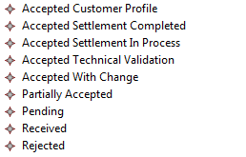
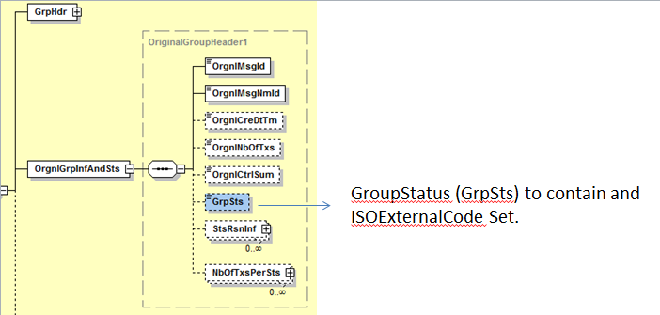

- Purpose of the change:
Several communities are currently working on implementation of their Payments Real Time solutions – Moreover, the work conducted by some groups such as the Real Time Payments Group (RTPG), the CGI-MP WG1 Real Time Subgroup or the European Payments Council (EPC) indicates that the current set of messages lack some functionalities that are specific to the Payments Real Time business, such as a Time Stamp. Also, in order to avoid the development of new messages due to limitations imposed by some message scopes, these scopes need to be revised and enhanced/complemented.

- Urgency of the request:
Next yearly ISO 20022 maintenance cycle 2016/2017
Several communities worldwide are currently working on their implementation for Real Time Payments and intend to start their testing early 2017.

- Business examples:
N/A

- SEG recommendation:

Consider |  | X | Timing
 |  |  | Next yearly cycle: 2016/2017  (the change will be considered for implementation in the yearly maintenance cycle which starts in 2016 and completes with the publication of new message versions in the spring of 2017) |  | x
- At the occasion of the next maintenance of the messages
(the change will be considered for implementation, but does not justify maintenance of the messages in its own right – will be pending until more critical change requests are received for the messages)
- Urgent unscheduled
(the change justifies an urgent implementation outside of the normal yearly cycle)
 |  |  | - Other timing:
Comments:
- None

Reject
Reason for rejection:

- Impact analysis:
Following the detailed analysis of the impact of the changes to the existing messages, we identified further impacted messages. The below list provides the full list of impacted messages:

- New elements:

- TimeStamp:
This change request impacts pacs.008, pacs.009, pacs.002, pain.002, camt.056 and camt.029 messages as specified in section B.

- Request for Refund:
This change request impacts the camt.056 message as specified in section B.

- Revised scopes:

This change request impacts the camt.056, the pain.002 and pacs.002 messages as specified in section B.

- Revised DataType for element RequestedExecutionDate and OriginalRequestedExecutionDate:

This change request impacts the pain.001, the pain.002 and pacs.002 messages as specified in section B, but further messages have been identified based on the impact analysis as follows (full list):
camt.026, camt.027, camt.028, camt.029, camt.037, camt.055, camt.056, camt.087, pain.001, pain.002, pain.007, pain.013, pain.014, pacs.002, pacs.004, pacs.007, remt.001

- “Status” element to transport an ISO 20022 External Code List (pacs.002/pain.002):

This change request impacts the pain.002 and pacs.002 messages as specified in section B, but further messages have been identified based on the impact analysis as follows (full list):
pain.002, pain.014 and pacs.002.
- Proposed implementation:

- New elements:
- TimeStamp:
We support the proposed implementation, however we propose to better align the name of the timestamp with its proposed definition and name the element as ProcessingStartDate, in the pacs.008 and pacs.009, and OriginalProcessingStartDate in the pacs.002, pain.002, camt.056 and camt.029 messages.
Implementation in the pacs.008 and the pacs.009:
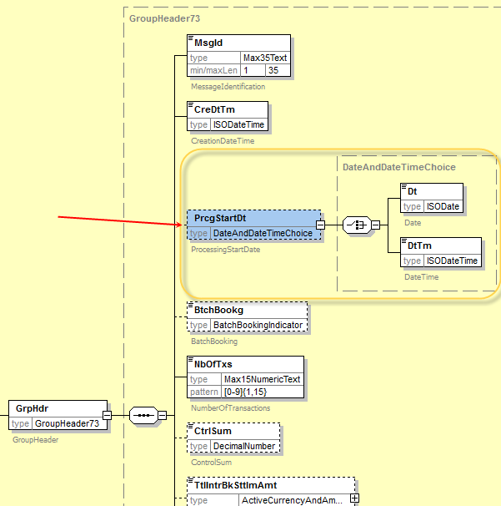
Implementation in the pacs.002 and the pain.002:
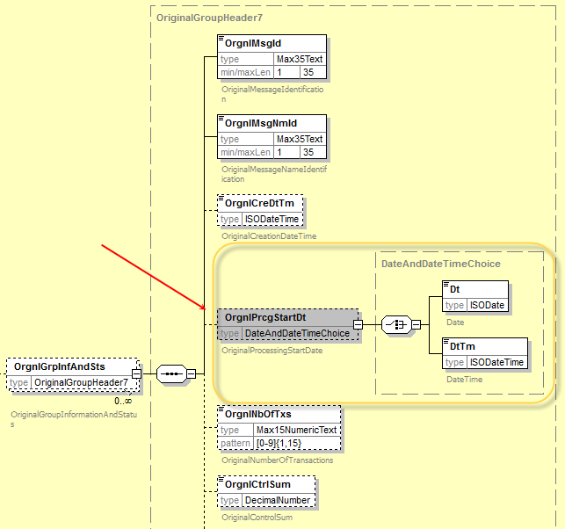
Implementation in the camt.056:
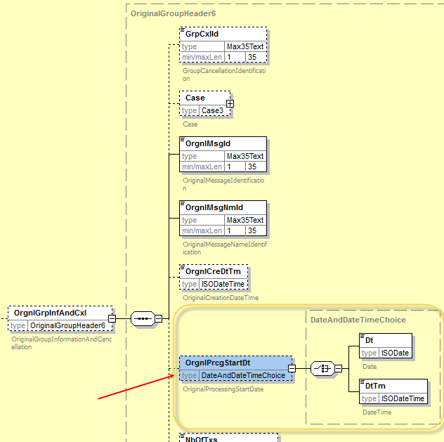
Implementation in the camt.029:
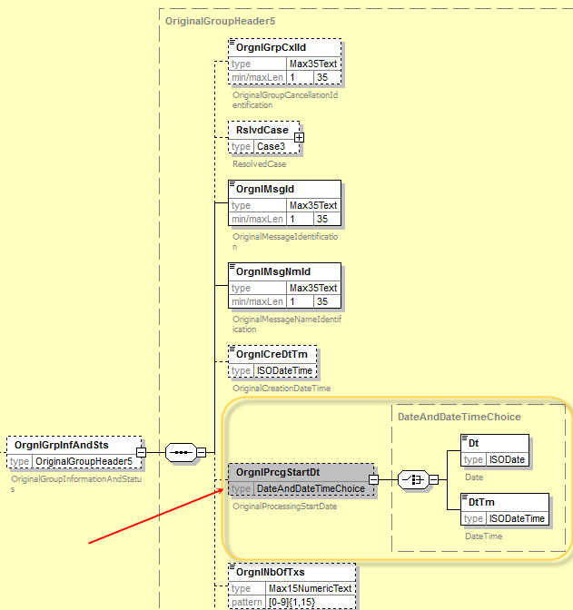

- Request for Refund:
This change request requires adding the RequestForRefundIndicator in the GroupHeader element. However, this element does not exist in the camt.056 message, and to keep consistency of the Assignment element throughout all of the messages defined in the Exceptions & Investigation message set, we propose to add a new building block in the message as following, containing the RequestForRefundIndicator element:

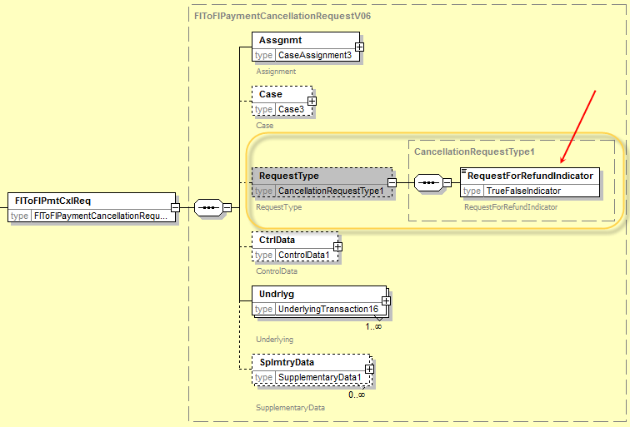
Remark: the additional nesting level is required as it is not recommended through the modelling rules to put elements without complex structures as message building blocks.

- Revised scopes:

Impacted Messages | Proposed new scope  (changes in Italics) | Comment
FIToFIPaymentCancellationRequest (camt.056) | The FIToFIPaymentCancellationRequest message is sent by a case creator/case assigner to a case assignee.  This message is used to request the cancellation of an original payment instruction. The FIToFIPaymentCancellationRequest message is exchanged between the instructing agent and the instructed agent to request the cancellation of an interbank payment message previously sent (such as FIToFICustomerCreditTransfer, FIToFICustomerDirectDebit or FinancialInstitutionCreditTransfer).  The FIToFIPaymentCancellationRequest supports for both the Request for Cancellation (the instructed agent has not yet processed and forwarded the payment) as well as the Request for Refund (payment has been full processed already by the instructed agent). | Although the 2 scenarios are already covered today through the FIToFIPaymentCancellationRequest, the 2 scenarios requested, the current scope did not explicitly specify the two scenarios, in the scope. However some guidance is already present today in the Usage section of the message scope. The new scope will fully clarify that both scenarios are covered.
FIToFIPaymentStatusReport (pacs.002)  CustomerPaymentStatusReport (pain.002) | No change to the Scope section  Extend the Usage section with following usage:  The FIToFIPaymentStatusReport (resp. the CustomerPaymentStatusReport) may also be sent to the receiver of the payment in a real time payment scenario, as both sides of the transactions must be informed of the status of the transaction (e.g. either the beneficiary is credited, or the transaction is rejected).

- Revised DataType for element RequestedExecutionDate and OriginalRequestedExecutionDate:
The original request was to replace, in the RequestedExecutionDate element of the pain.001, pain.002 and pacs.002 message, the ISODate data type with the ISODateTime data type.
In order to support backward compatibility of the implementation only supporting ISODate, we propose to define the new RequestedExecutionDate with a choice between a Date element type by ISODate and a DateTime element typed by ISODateTime.
Implementing this change will result in the following definition of the RequestedExecutionDate:
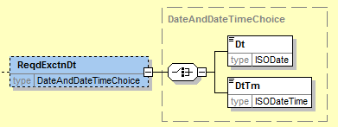

However as already indicated in the impact analysis (Section G), the update of the data type also impacts following messages as the same or derived message components are used in the messages, and we recommend aligning the data type of the RequestedExecutionDate in all of those messages:
Exceptions and Investigations message definitions:
- camt.026, camt.027, camt.028, camt.029, camt.037, camt.055, camt.056, camt.087,
Payments Initiation message definitions:
- pain.007
Customer Payment Activation Request message definitions
- pain.013, pain.014
Payments Clearing and Settlement message definitions
- pacs.004, pacs.007
Stand-Alone Remittance Advance message definitions
- remt.001

- “Status” element to transport an ISO 20022 External Code Set (pacs.002/pain.002):

As per request in section C, the code set will be replaced by the new ExternalPaymentGroupStatus1Code in the schema.
The resulting structure is as following:
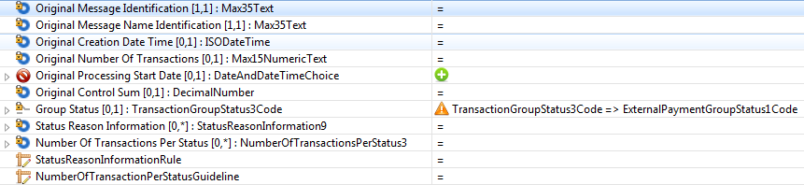
Following new message components defined in the new version of the message definitions are using the new PaymentCancellationReason3 message component with the new structure as illustrated above:

In the CustomerPaymentStatusReportV08 message definition (1 occurrence):
- OriginalGroupHeader7
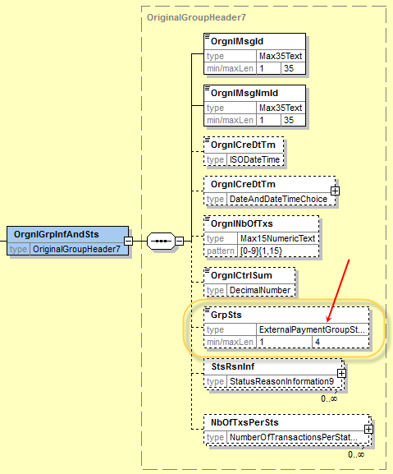

In the FIToFIPayment StatusReportV08 message definition (1 occurrence):
- OriginalGroupHeader7

Remark: the code set ExternalPaymentGroupStatus1Code which has been externalised must be registered in the list of external code sets, once the change request is approved.
Following codes/definitions will be registered in the new ExternalCancellationReason1Code:

For alignment purpose, we also recommend that the code set typing the TransactionStatus in the above messages is externalised as the ExternalPaymentTransaction1Code.

Remark: please note that during the update of the messages, we identified that the element NumberOfElementsPerStatus in both the pacs.002 and the pain.002 was also impacted, as following (TransactionIndividualStatus3Code replaced by ExternalPaymentTransactionStatus1Code):
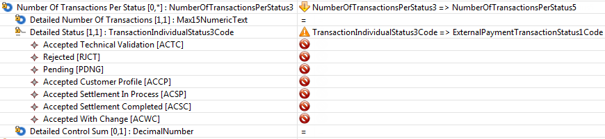

- Proposed timing:
The submitting organisation confirms that it can implement the requested changes in the requested timing.

Timing | As requested

- Final decision of the SEG:

Approve | X
Comments:
Payments SEG Meeting (September 12th, 2016):
Request for Refund: The addition of a RequestForRefundIndicator element proposal has been rejected by the SEG. A new proposal has been made which is to revise the scope of camt.056 (FIToFIPaymentCancellationRequest) instead of adding a new message element to the message (originally requested). The updated scope will allow/clarify the usage of the message for refunding purpose as well. Both the Request for Cancellation and the Request for Refund scenarios will then be covered in the scope. Lauren Jones and Stig Korsgaard (on behalf of the RTPG) agree with this implementation proposal. Decision: approved.
Please note that the Payments SEG meeting on the 22nd of September, 2016 reviewed and agreed to change the Request for Refund part of the CR574 decision from “Approved” to “Rejected” as the addition will not be needed.
- RequestExecutionDateTime: Isabelle said that this element is needed to optimize the liquidity management as it allows corporate to agree with the bank(s) on the best time for transfers. Decision: approved.
- Transform the “Status” element in the pain.002 and pacs.002 to transport an external code set instead of a list of fixed codes in the messages itself. The new external code set will be applied at Group and Transaction level. The SEG believes that one single code set should be used. Decision: approved.
- RequestProcessingStartDateTime(TimeStamp): this element allows the first bank in the payment chain to indicate when the processing starts (Date or DateTime) – this is information that must remain unchanged till it reaches the beneficiary bank– it is needed because there is a limitation of time imposed by schemes to execute a RT payment. If the processing time exceeds the limitation, then there is what is called a ‘time-out’ which will lead to the rejection of the payment instruction. This element would be optional in the schema
Stig Korsgaard said that there is a need for such element but it should be discussed with the other communities of users to collect their requirements. Lauren Jones suggests that this item is discussed at the RTPG meeting in November 2016 and reported to November 2016 ISO 20022 RMG meeting in case that the change will be still requested that there should be exceptional urgent inclusion to 2016/2017 maintenance cycle.
This part of CR0574 will be separate and introduced in a new CR with an urgent (outside schedule) implementation request and the existing CR 574 to be updated with the decisions made. Decision: on hold.
Final decision (November 2016): Since the RTPG requested further time to investigate on the actual implementation of the RequestProcessingStartDateTime(TimeStamp), this part of the CR574 decision has been changed from “Approved” to “Rejected”, and the change will be reconsidered once the RTPG has provided its conclusions.

Reject
Reason for rejection:

CR0576: Update mandate messages
- Origin of the request:
A.1 Submitter:
SABS (South African Bureau of Standards)

A.2 Contact person:
Sean Mouton, e-mail: smouton@absa.co.za, Tel +27 11 350 8114
Isabelle Bouille, e-mail: Isabelle.bouille@swift.com, Tel: +32 2 655 44 20

- Related messages:
Payments Mandate message set:
pain.009.001.04 – Mandate Initiation Request
pain.010.001.04 – Mandate Amendment Request
pain.011.001.04 – Mandate Cancellation Request
pain.012.001.04 – Mandate Acceptance Report
and
pacs.002.001.07 – FI to FI Payment Status Report
pacs.003.001.06 – FI to FI Customer Direct Debit
pacs.004.001.06 - Payment Return
camt.056.001.05 – FI to FI Payment Cancellation Request
camt.029.001.06 – Resolution of Investigation

- Description of the change request:
This change request document is for the addition of several new elements and components to the existing Payments Mandate messages and Direct Debit messages (pacs.003 and “R” messages) in order to allow a Debtor/Debtor Agent Mandate Flow on top of the Creditor/Creditor Agent Mandate Flow. Some other new elements allow additional functionalities required for a Straight Through Processing of mandate information and an efficient mandate management. A couple more changes relate to the multiplicity of existing elements/components (mandatory to optional).

- New components/elements

Impacted Messages |  |  | Location in the message structure | Element |  | Purpose for change and definition
For all Payments Mandate messages (pain.009, pain.010, pain.011, pain.012) |  |  |  | All elements |  | Review definitions for all elements to also cover the Debtor/Debtor Agent Mandate flow scenarios.
For all Payments Mandate messages (pain.009, pain.010, pain.011, pain.012) |  |  | Under Mandate/Type/ | CategoryPurpose:  Data Type:  CategoryPurpose1Choice  or  Proprietary: Max35Text | [0,1] | Transports the type of Direct Debit (note: South Africa will ask for 16 new codes in ExternalCategoryPurpose1Code relating to Direct Debits)
For all Payments Mandate messages (pain.009, pain.010, pain.011, pain.012) |  |  | Under Mandate/ | Adjustment/ (component) | [0,1] | Information relating to the Adjustment applied to the collection amount of a direct debit collection
 |  |  |  | DayAdjustmentRuleIndicator  Data Type:  True/False | [1,1] | Indication whether an adjustment is to be applied on the pre-agreed collection day.
 |  |  |  | AdjustmentCategory  Data Type:  Code: Exact1Text  or  Proprietary: Max35Text | [0,1] | Type of Adjustment  N for Never  Q for Quarterly  A for Annually  B for Bi-annually  R for Rate
 |  |  |  | AdjustmentRate  Data Type:  PercentageRate | [0,1] | Pre-agreed increase or decrease rate that will be applied to the collection amount, per information under “Adjustment Category”
 |  |  |  | AdjustmentAmount  Data Type:  ActiveCurrencyAndAmount | [0,1] | Pre-agreed adjustment Amount to increase or decrease be per information under “Adjustment Category”
For all Payments Mandate messages (pain.009, pain.010, pain.011, pain.012) | Under Mandate/Type/ |  |  | MandateClassification  Data Type:  Code: Exact3Text  or  Proprietary: Max35Text | [0,1] | Type of Direct Debit as indicated by the Creditor/Creditor Agent
For all Payments Mandate messages (pain.009, pain.010, pain.011, pain.012) | Under Mandate/ |  |  | Authentication/ (Component) | [0,1] | Transport Authentication Information
 |  |  |  | MessageAuthenticationCode  Data Type:  Max16Text (As per ISO20038) | [0,1] | Message Authentication Code (MAC) as provided by the Debtor Agent
 |  |  |  | AuthenticationDate  Data Type:  ISODate | [0,1] | Date when the Authentication was conducted
 |  |  |  | AuthenticationChannel  Data Type:  New External code List: Exact4Text  or  Proprietary: Max35Text | [0,1] | Channel used to transmit Authentication Information, e.g. Mobile, Internet Banking, Card, ATM, USSD (mobile communication)
For all Payments Mandate messages (pain.009, pain.010, pain.011, pain.012) | Under Mandate/ |  |  | TrackingIndicator  Data Type:  True/False | [1,1] | Indicates whether the Direct Debit Instructions should be automatically re-submitted periodically as bilaterally agreed
 |  |  |  | FirstCollectionAmount  Data Type:  ActiveCurrencyAndAmount | [0,1] | Amount different from the collection amount, e.g. that contains costs associated with the first debited amount
For all Payments Mandate messages (pain.009, pain.010, pain.011, pain.012) |  | Mandate/Occurrences/Frequency/Type |  | Transform the available codes (9 in total) into elements, to themselves transport frequency information.  Example:  Week/01:  The Collection must happen on a weekly basis, on Monday. | [0,1] | Provides exact information relating to the direct debit day on which collection should take place
For all Payments Mandate messages (pain.009, pain.010, pain.011, pain.012) |  | Mandate/ReferredDocument/ |  | CreditorReference  Data Type:  Max35Text | [0,1] | Reference of the Contract the Direct Debit relates to for the Debtor
All messages containing a Creditor, Ultimate Creditor, Debtor/Ultimate Debtor - Note: Similar change will apply to the Debtor/Debtor Agent |  | Creditor/ContactDetails/ |  | ShortName  Data Type:  Max35Text | [0,1] | Creditor/Ultimate Creditor Abbreviated Name
 |  | Creditor/ContactDetails/ |  | Reference  Data Type:  Max35Text | [0,1] | Reference Assigned by a Creditor/Ultimate Creditor for internal usage
pacs.003/pain.008/camt.055/pain.007, camt.056/pacs.007/pacs.002/pacs.004/camt.029 |  | MandateRelatedInformation/ |  | TrackingDays  Data Type:  Codes: 00 to 21 | [0,1] | Indicates the number of days the Direct Debit instruction must be tracked, i.e. 00 (no tracking) up to 21 (21 days).

- Renaming of element:

Impacted Messages | Location in the message structure | Rename request | Justification
For all Payments Mandate messages (pain.009, pain.010, pain.011, pain.012) | Mandate/Type/ | Rename Type to MandateType | This is in line with Mandate Identification and Mandate Request Identification under the Mandate block.

- Change in Multiplicity:

Impacted Messages | Location in the message structure | Rename request | Justification
pain.012, pain.009 | UnderlyingAcceptanceDetails/OriginalMandateIdentification  and  UnderlyingAcceptanceDetails/OriginalMandate/MandateIdentification | Make Optional instead of Mandatory | In case of Debtor Mandate Flow, if the Mandate request is not accepted, the Mandate will not be granted an identification – thus no information is available to transport in the pain.012
All messages where applicable | OriginalMessageIdentification  and  OriginalMessageNameIdentifiation | Make Optional instead of Mandatory | Whenever files are received by the ACH, new files are created and new references allocated, thus these field should be made optional as the original references may be changed in the course of the payment chain in certain communities.
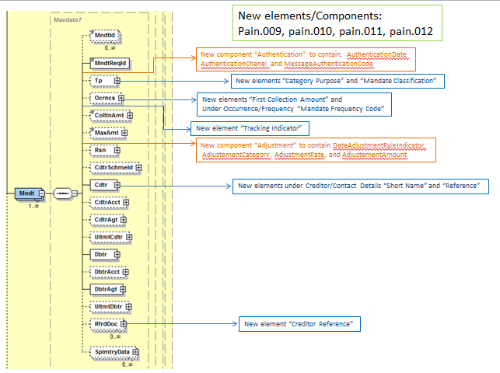

- Purpose of the change:
The South African community is currently preparing its migration onto ISO 20022 for the Authenticated Direct Debits business and will be heavily using the Payments Mandates set of messages as a basis for this business.
Implementation work has shown that the current set of messages cannot be used as such as they do not comply with the Debtor/Debtor Bank Mandate flow applied in South Africa. The messages can also be improved from an STP processing. All of these requested elements/components can also be of benefit for other communities, i.e. they are not to be considered as pure South African specifics.
Please note that, independently of this Change Request document, SABS will also introduce a Business Justification document for the development of two additional Payments Mandate messages to Request a Copy of a Payment Mandate and to Request Suspension of a Payment Mandate. However, the changes requested in this CR are totally independent of the new messages.

- Urgency of the request:
Next yearly ISO 20022 maintenance cycle 2016/2017
The South African community is currently working on their migration plans, and intend to start their testing early 2017.

- Business examples:

- Under Mandate
Authentication (new component)
- AuthenticationDate (new element)
- AuthenticationChannel (new element)
- MessageAuthenticationCode (new element)

The Payment Mandate message transports information relating to the Authentication relating to the Direct Debit Collection, that is:
- The date on which the Authentication took place: 11 May 2016
- The channel through which the Authentication took place: Card
- The Message Authentication Code (MAC): XN1234X7
Authentication
 | AuthenticationDate | ISODate | 2016-05-11T16:00:00
 | AuthenticationChannel | Code: Exact4Text | CARD
 | MessageAuthenticationCode | Max16Text | XN1234X7

Adjustment (new component)
DateAdjustmentRuleIndicator
AdjustmentCategory
AdjustmentRate
AdjstumentAmount
The Payments Mandate message foresees the possibily to adjust the pre-agreed collected amount through the use of the Adjustment component:
- The DateAdjustmentRuleIndictor: True
- The AdjustmentCatetegory: Quartlery
- The AdjustmentRate: 1,5 % of the previous collected amount
- The AdjustmentAmount: The previous collected amount will be increased by ZAR 200 – the new amount will be valid till its new Adustment to take place at the next Quarter.

Adjustment
 | DayAdjustmentRuleIndicator | True/False | True
 | AdjustmentCategory | Code: Exact1Text | Q
 | AdjustmentRate | PercentageRate | 1.5
 | AdjustmentAmount | ActiveCurrencyAndAmount | ZAR200

Tracking Indicator (new element):
The Payments Mandate message foresees that the mandate request may be automatically re-submitted, as pre-agreed between the Creditor bank and the Debtor Bank
- The TrackingIndicator: True

Mandate
 | TrackingIndicator | True/False | True

- Under Mandate/Type
CategoryPurpose (new element)
MandateClassification (new element)
The Payments mandate message foresees to indicate the type of Direct Debit it relates to, but also to indicate the classification of the mandate:
- Category Purpose: Medical Aid Fund Contribution
- MandateClassification: Variable

Mandate/Type
 | CategoryPurpose | CategoryPurpose1Choice | MAFC
 | MandateClassification | Code: Exact3Text | VAR

- Under Mandate/Occurrence
RequestedCollectionDay (new element)
FirstCollectionAmount (new element)

The Payments mandate message foresees to indicate on which day of a week the direct debit collection must occur but also a first collection amount (amount different from the pre-agreed collection amount because it might include charges relating to a first collection)
- FirstCollectionAmount: ZAR3800

Occurrence
 | FirstCollectionAmount | ActiveCurrencyAndAmount | ZAR3800

- Under Mandate/Occurrence/Frequency/FrequencyDescription
FrequencyDescription (new element)
The Payments Mandate message foresees to indicate the frequency of the Direct Debit Collection, together with further information on the point in time the collection should take place.
- Mandate Frequency (Element): Weekly – Frequency Information: Monday

Occurrence/Frequency |  | Code: Exact4Text | WEEK
Occurrence/Frequency/Information |  | Exact2Numeric | 01

- Under Mandate/Creditor/ContactDetails
ShortName (new element)
Reference (new element)
The ISO20022 messages allows to transport short names for all parties (non FIs) but also a reference to be assigned by this party.
- ShortName: JobaKlein
- Reference: XBZBJ45693DNC

Creditor/ContactDetails | ShortName | Max35Text | JobaKlein
 | Reference | Max35Text | XBZBJ45693DNC

- Under Mandate/ReferredDocument
CreditorReference (new element)
The Payment Mandate message foresees to transportation of a contract reference under ReferredDocument
- CreditorReference: Contract MAN2016-2567

ReferredDocument/ | CreditorReference | Max35Text | Contract MAN2016-2567

- SEG recommendation:

Consider | X | Timing
 |  | Next yearly cycle: 2016/2017  (the change will be considered for implementation in the yearly maintenance cycle which starts in 2016 and completes with the publication of new message versions in the spring of 2017) |  | X
At the occasion of the next maintenance of the messages
(the change will be considered for implementation, but does not justify maintenance of the messages in its own right – will be pending until more critical change requests are received for the messages)
Urgent unscheduled
(the change justifies an urgent implementation outside of the normal yearly cycle)
 |  | Other timing:
Comments:

Reject
Reason for rejection:

- Impact analysis:
We confirm that this change request impacts the aforementioned messages, as identified in section B.
Furthermore, we identified several additional messages impacted by the change request. Below is the updated list of all impacted messages.
 | CustomerPaymentStatusReportV07 | pain.002.001.07
 | CustomerPaymentReversalV06 | pain.007.001.06
 | CustomerDirectDebitInitiationV06 | pain.008.001.06
 | MandateInitiationRequestV04 | pain.009.001.04
 | MandateAmendmentRequestV04 | pain.010.001.04
 | MandateCancellationRequestV04 | pain.011.001.04
 | MandateAcceptanceReportV04 | pain.012.001.04
 | FIToFIPaymentStatusReportV07 | pacs.002.001.07
 | FIToFICustomerDirectDebitV06 | pacs.003.001.06
 | PaymentReturnV06 | pacs.004.001.06
 | FIToFIPaymentReversalV06 | pacs.007.001.06
 | ResolutionOfInvestigationV06 | camt.029.001.06
 | CustomerPaymentCancellationRequestV05 | camt.055.001.05
 | FIToFIPaymentCancellationRequestV05 | camt.056.001.05

- Proposed implementation:

- Under Mandate
We support the requested implementation, and propose to add the requested elements as following:
- ReferredDocument/CreditorReference:
Addition of a new element CreditorReference (typed by Max35Text) after Number :
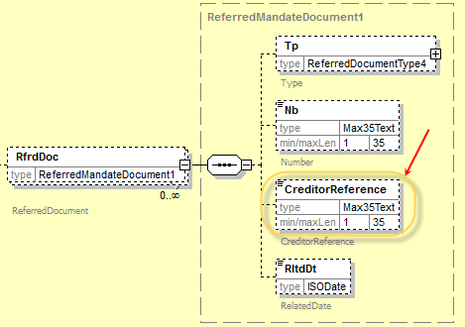

- Authentication (typed by a new component MandateAuthentication1)
Addition of a new optional element and new message component composed of following elements:
- MessageAuthenticationCode (Max16Text)
- AuthenticationDate (ISODate)
- AuthenticationChannel (new choice component
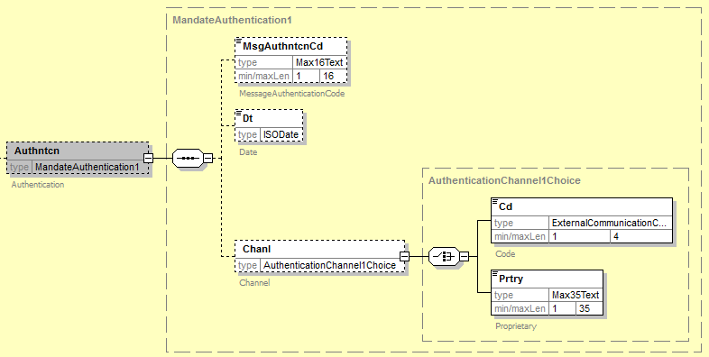
Question to the SEG: ABSA has requested to type the MessageAuthenticationCode (MAC) as a Max16Text data type, referring to the ISO 20038. However, in the ISO 20038 standard, the MAC is specified as a binary data type of minimum 16 bytes up to 64 bytes. ABSA further confirmed that a Max16Text is sufficient for their own use. We however believe that the element should be typed with the data type as defined in ISO 20038, as all characters of the Max16Text can be full supported by a binary equivalent data type, but the reverse in not correct. Therefore we required a decision from the SEG on which data type to use.
Or are the two items different concepts (MAC vs. Authorisation Code)

- Adjustment (typed by a new component MandateAdjustement1)
Addition of a new optional element and message component composed of following elements:
- DateAdjustmentRuleIndicator (True/False Indicator)
- Category (new frequency choice component)
- Amount (ActiveCurrencyAndAmount)
- Rate (PercentageRate)
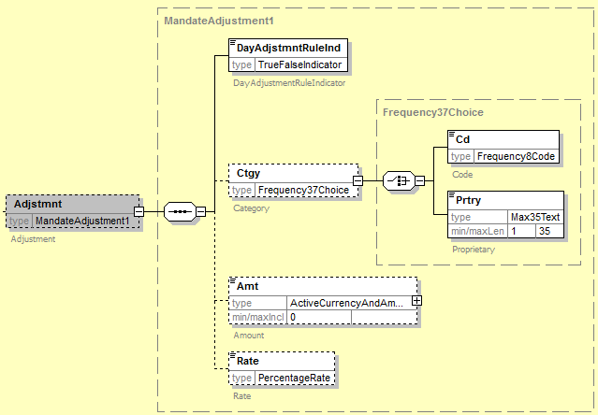
- Frequence8Code is composed of following elements:
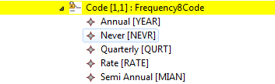
- Tracking Indicator (new element):
Addition of a new mandatory element:
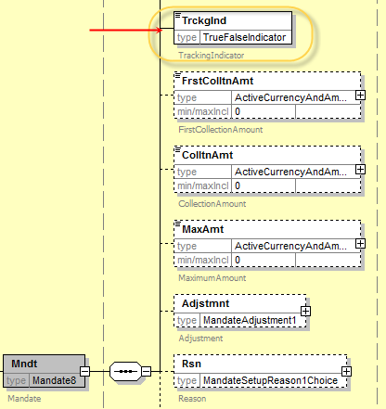

- Under Mandate/Type
We support the requested implementation, and propose to add the two elements as suggested:
- CategoryPurpose (typed with the existing CategoryPurpose1Choice component)
- MandateClassification (typed with a new MandateClassification1Choice component)
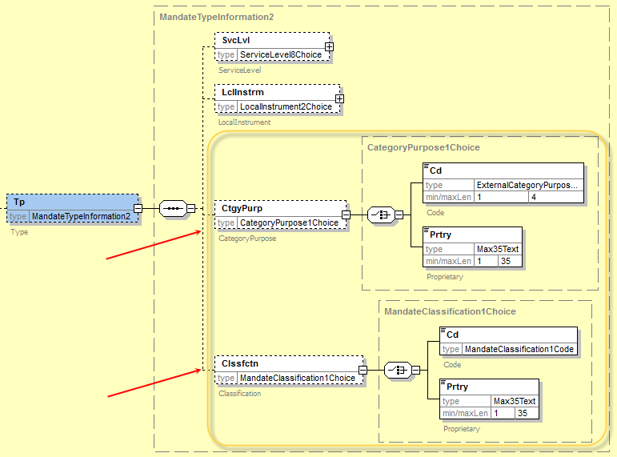

The MandateClassification1Code has been defined as following:
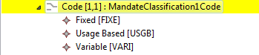

- Under Mandate
We support the requested implementation, and propose to add the element as suggested:
- FirstCollectionAmount (typed by ActiveCurrencyAndAmount)
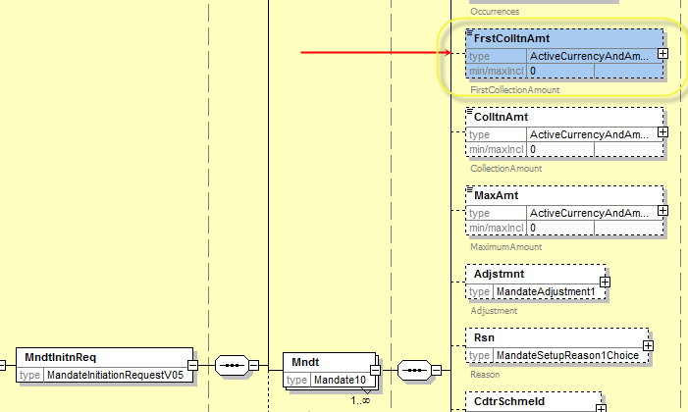

- Under Mandate/Occurrence/Frequency
The requested change suggests replacing the current frequency type element with a new extended type.
- Frequency/Type (new choice option element)
In order to reduce the impact on existing implementations of the messages and to support the new requirement, based on the detailed analysis, we would rather propose implementing this new element through the update of the Frequency21Choice to contain one additional choice element as following:
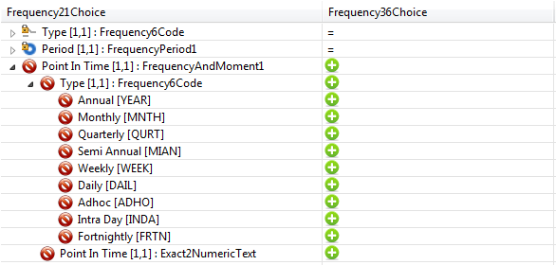
The Frequency element in the Mandate (used in 8 messages) will therefore contain the existing choice with a new additional choice element PointInTime defined with two elements:
- The Frequency Type
- The PointInTime, which corresponds to the new required element.
The resulting structure supports the new requirements, without impacting any of the current implementations.
Based on the information received from ABSA, following values will be available in the new PointInTime element:

 |  | Mandate
 |  | Pain.009 - Mandate Initiation  Creditor bank --> Debtor bank | Pain.010 - Mandate Amendment  Creditor bank --> Debtor bank | Pain.012 - Mandate Acceptance Report  Debtor Bank --> Originator
Frequency Codes | Frequency Description | Yes | Yes | Yes
WEEK | Weekly: Event takes place once a week | X | x | x
 | 01(Monday) | X | x | x
 | 02 (Tuesday) | X | x | x
 | 03 (Wednesday) | X | x | x
 | 04 (Thursday) | X | x | x
 | 05 (Friday) | X | x | x
 | 06 (Saturday) | X | x | x
 | 07 (Sunday) | X | x | x
FRTN | Fortnightly: Event takes place once every two weeks
 | (01 Monday to 07 Sunday (1st week); 08 Monday to 14 Sunday (2nd week)) | X | x | x
MNTH | Monthly Event: Event takes place once every month or once a month.
 | 01-30 (31 must be equal to 13, Monthly by rule) | X | x | x
 | (for February date is 28 if previously indicated 29th)
QURT | Quarterly Event: Event takes place once every three months or four times a year.
 | 01-30 (31 must be equal to 13, Monthly by rule) | X | x | x
 | (for February date is 28 if previously indicated 29th)
MIAN | Bi Annual: Event takes place once every six months or two times a year.
 | 01-30 (31 must be equal to 13, Monthly by rule) | X | x | x
 | (for February date is 28 if previously indicated 29th)
YEAR | Annual Event: Event takes place once every year or once a year. | X | x | x
ADHO | Monthly By Rule
 | 01 - Last Monday | X | x | x
 | 02 - Last Tuesday | X | x | x
 | 03 - Last Wednesday | X | x | x
 | 04 – Last Thursday | X | x | x
 | 05 - Last Friday | X | x | x
 | 06 - Last Saturday | X | x | x
 | 07 - First Monday | X | x | x
 | 08 - First Tuesday | X | x | x
 | 09 - First Wednesday | X | x | x
 | 10 – First Thursday | X | x | x
 | 11 - First Friday | X | x | x
 | 12 - First Saturday | X | x | x
 | 13 - Last Day | X | x | x
 | 14 - 2nd Last Day | X | x | x
 | (N.B if MNTH/QURT/MIAN (31 must be equal to 13, Monthly by rule; for February date is 28 if previously indicated 29th)

- Under Mandate/Creditor/ContactDetails
Following further analysis of the requirements, we propose not to update the ContactDetilas element, as this would impact every single Payments messages, through the update of PartyIdentification43 message component, consistently used throughout all messages.
We propose implementing this change as following:
- ShortName (new element)
This element can be covered through the OtherIdentification, with a new external scheme name code (scheme name in the identification allows to specify the type of identification, and does not refer to the direct debit scheme) for the identification through a ShortName and is not an element of the contact details
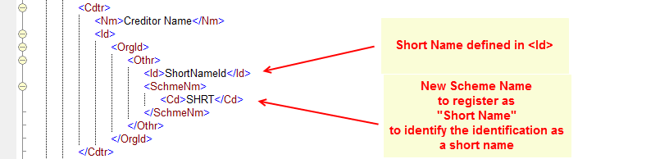

- Reference (new element):
Following further clarification with ABSA, this is not a creditor contact detail element, but a reference for the mandate; we therefore propose to add a new element to the Mandate component just before the ReferredDocument as MandateReference (typed by Max35Text)

- Under Mandate/ReferredDocument
We support the requested implementation, and propose to add a new element CreditorReference (typed by Max35Text) after Number as following:

- Under MandateRelatedInformation
We support the requested implementation, and propose to add a new element TrackingDays (typed by Exact2NumericText) at the end of the component as following:
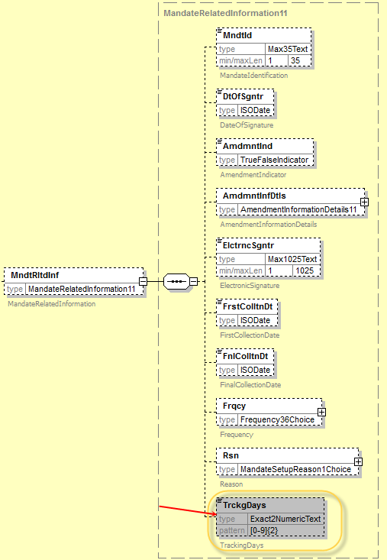
For consistency reasons, we also propose to add an OriginalTrackingDays element in the amendment details element present in the MandateRelatedInformation component, as following:

2. Renaming of elements:
- Rename of Mandate/Type to Mandate/MandateType
This request is against the ISO 20022 modelling rules, and we propose to reject the requested change.

3. Change in Multiplicity:
- UnderlyingAcceptanceDetails/OriginalMandate/OriginalMandateIdentification and UnderlyingAcceptanceDetails/OriginalMandate/OriginalMandate/OriginalMandateIdentification
Change the cardinality of the elements to optional.
Following the analysis, the first element which is an element of a choice component cannot be made optional as per the modelling rules.
We however support the proposal with following approach: in the scenario described in the change request, when the mandate is not accepted in the Debtor Mandate Flow, no mandate identification is defined.
In this case the OriginalMandate/OriginalMandateIdentification element must not be present. Therefore we recommend that the following change should be implemented:
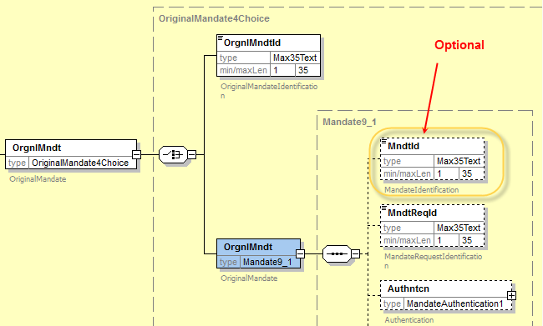
However in order to ensure that the OriginalMandateIdentification is always present, when the mandate exists, we propose to add following rule, under the UnderlyingAcceptanceDetails:
“When AcceptanceResults/Accepted is “true”, then OriginalMandate/OriginalMandateIdentification must be present.”

- OriginalMessageIdentification and OriginalMessageNameIdentifiation:
change cardinality from mandatory to optional.
The two elements are defined in an optional message component (OriginalMessageInformation), therefore there is no need to change the cardinality of the two elements as optional. When the elements are not available (that is there is no reference to to an original message), the full block OriginalMessageInformation should be dropped. Moreover, this component is reused in many response messages throughout the ISO 20022 catalogue of ISO 20022 messages, and has been defined to ensure full identification of an original message.
Below is an illustration of the current implementation:
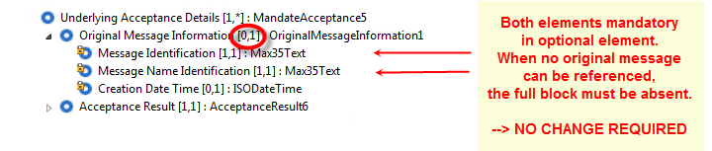
We recommend therefore not changing the cardinality of the two elements, and recommend ABSA to drop the full block OriginalMessageInformation when no original message may be referenced.
- Proposed timing:
The submitting organisation confirms that it can implement the requested changes in the requested timing.

Timing | As requested

- Final decision of the SEG:

Approve | X
Comments:
Question raised by SWIFT (V.Kuntz) to the SEG: ABSA has requested to type the MessageAuthenticationCode (MAC) as a Max16Text data type, referring to the ISO 20038. However, in the ISO 20038 standard, the MAC is specified as a binary data type of minimum 16 bytes up to 64 bytes. ABSA further confirmed that a Max16Text is sufficient for their own use. We however believe that the element should be typed with the data type as defined in ISO 20038, as all characters of the Max16Text can be full supported by a binary equivalent data type, but the reverse in not correct. Therefore we required a decision from the SEG on which data type to use.
Or are the two items different concepts (MAC vs. Authorisation Code)?
Reply from the SEG (Sep 22nd, 2016): MessageAuthenticationCode (MAC) should be implemented as requested by submitter (SABS), meaning as a Max16Text data type but could be implemented as required by ISO 20038, meaning as a binary data type of minimum 16 bytes up to 64 bytes, depending on ABSA feedback on this item.

Reject
Reason for rejection:

CR0628: Add AdditionalInformation in UnableToApply

- Origin of the request:
A.1 Submitter: The Clearing House, LLC
A.2 Contact person:
Michael Thomas
212-612-9205
Michael.thomas@theclearinghouse.org
A.3 Sponsors:
VocaLink

- Related messages:
camt.026.001.04 UnableToApplyV04

- Description of the change request:
To create an updated version of the message with an additional tag that allows for additional justification information in a 140 character free text.
As is
Structure | XML Tag | Field format
+Justification | <Id>
++AnyInformation | <AnyInf> | YesNoIndicator
++MissingOrIncorrectInformation | <MssngOrIncrrctInf>
+++AntiMoneyLaunderingRequest | <AMLReq> | AMLIndicator
+++MissingInformation | <MssngInf> | UnableToApplyMissingInformation2Code
+++IncorrectInformation | <IncrrctInf> | UnableToApplyIncorrectInformation3Code
++PossibleDuplicateInstruction | <PssblDplctInstr> | TrueFalseIndicator

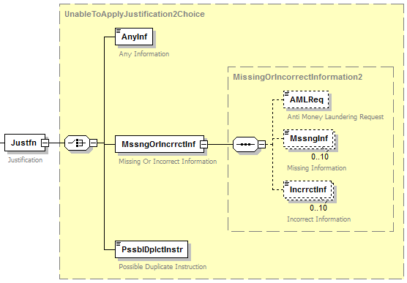

To be
Structure | XML Tag | Field format
+Justification | <Id>
++AnyInformation | <AnyInf> | YesNoIndicator
++MissingOrIncorrectInformation | <MssngOrIncrrctInf>
+++AntiMoneyLaunderingRequest | <AMLReq> | AMLIndicator
+++MissingInformation | <MssngInf> | UnableToApplyMissingInformation2Code
+++IncorrectInformation | <IncrrctInf> | UnableToApplyIncorrectInformation3Code
+++AdditionalJustificationInformation | <AddtlJustInf> | Max140Text
++PossibleDuplicateInstruction | <PssblDplctInstr> | TrueFalseIndicator

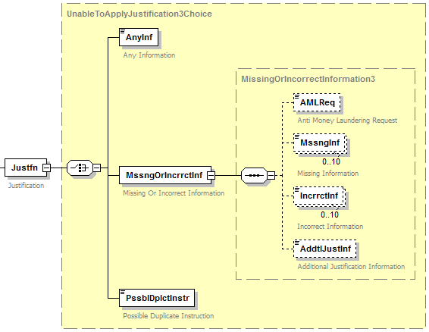

- Purpose of the change:
The TCH Real Time Payment system provides the capability for the receiver of a payment to request additional information from the sender in order to apply a payment if the original payment is sent with either missing or incorrect information. This field will provide additional information regarding the code used in the Missing Information or Incorrect Information field. The data within this field may be provided to the end-user recipient to assist the end-user in determining why additional information is necessary to apply a particular transaction, and may avoid a situation in which the recipient resends information that cannot be processed by the sender of the camt.026. Please see example of the proposed field below.

Additional Justification Information
Justfn  +MssngOrIncrrctInf  ++AddtlJustInf | ISO Definition: | Specifies a character string with a maximum length of 140 characters.
 | Product Usage: | This field is being used to provide additional information to the code used in the element MissingInformation or IncorrectInformaiton field.
 | Index: | 4.6
 | XML Tag: | <AddtlJustInf>
 | Occurrences: | [0..1]
 | Example: | <AddtlJustInf>Unstructured Information</AddtlJustInf>

- Urgency of the request:
The Clearing House’s implementation of a real-time payments system leveraging ISO 20022 standards is expected to go live in Q1 2017. As such, TCH requests that this change be incorporated into the specification by the 2017 maintenance cycle or earlier if possible.

- Business examples:
See section D above
- SEG recommendation:

Consider |  | X | Timing
 |  |  | - Next yearly cycle: 2016/2017  (the change will be considered for implementation in the yearly maintenance cycle which starts in 2016 and completes with the publication of new message versions in the spring of 2017) |  | X
- At the occasion of the next maintenance of the messages
(the change will be considered for implementation, but does not justify maintenance of the messages in its own right – will be pending until more critical change requests are received for the messages)
- Urgent unscheduled
(the change justifies an urgent implementation outside of the normal yearly cycle)
 |  |  | - Other timing:
Comments:

Reject
Reason for rejection:
- Impact analysis:
This change request impacts the UnableToApplyV04 (camt.026.001.04) message only as specified in section B.
No other messages have been identified

- Proposed implementation:
Although the new element is required to be added at the same level as the IncorrectInformation or MissingInformation elements, the additional information is provided to complement the code provided for the incorrect and/or missing information (which may be both present and repetitive elements)
Additional Justification Information
Justfn  +MssngOrIncrrctInf  ++AddtlJustInf | ISO Definition: | Specifies a character string with a maximum length of 140 characters.
 | Product Usage: | This field is being used to provide additional information to the code used in the element MissingInformation or IncorrectInformaiton field.
 | Index: | 4.6
 | XML Tag: | <AddtlJustInf>
 | Occurrences: | [0..1]
 | Example: | <AddtlJustInf>Unstructured Information</AddtlJustInf>

This would mean that additional information may only be provided with one single code
In order to link the additional justification information to each specific code, we propose to implement this change as following:
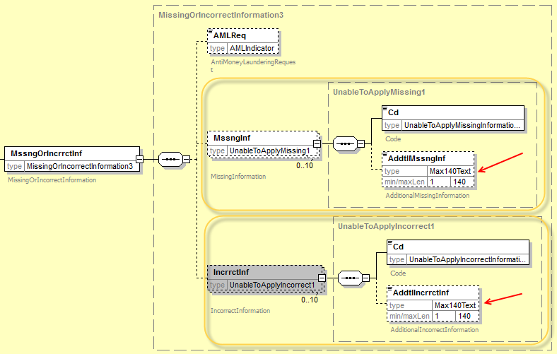

To complement the list of codes already defined and to allow for a generic request for any missing information or incorrect information, we propose to add following code in the two code sets:
- NARR : Narrative, with a rule that when code NARR is used, Additional<Incorrect,Missing>Information element must be present.

- Proposed timing:
The submitting organisation confirms that it can implement the requested changes in the requested timing.
Timing | As requested

- Final decision of the SEG:

Approve | X
Comments:
SEG meeting (Sep 22nd, 2016): Vincent Kuntz, SWIFT, said that TCH representative has been informed of the proposed implementation in preparation of the meeting and it has been approved. No comments/objections from the group.

Reject
Reason for rejection:

CR0635: Add new cancellation reason code FRTR

- Origin of the request:
A.1 Submitter:
SABS (South African Bureau of Standards)

A.2 Contact person:
Sean Mouton, e-mail: Seancm@absa.co.za , Tel +27 11 350 8114
Isabelle Bouille, e-mail: Isabelle.bouille@swift.com, Tel: +32 2 655 44 20

- Related messages:

- camt.056.001.05 – FI to FI Payment Cancellation Request

- Description of the change request:
Addition of one new code to the existing code set for Cancellation Reason: “FRTR”
Definition: Final Response/Direct Debit Tracking recalled as Mandate Cancelled
Purpose for this new code: This code relates to the tracking requested in the initial mandate initiation request which needs to be cancelled, as the mandate it refers to is now cancelled.
In order to align the CancellationReasonInformation code set with other similar messages, it is proposed to transform the existing CancellationReasonInformation/Reason/code into an ExternalCancellationReason code set:

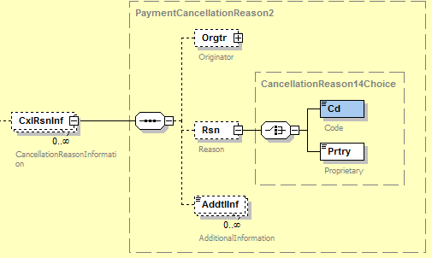
Make Code an
ExternalCodeSet

The new ExternalCancellationReason code set will contain existing codes:
- CUTA – Cancel Upon Unable To Apply
- DUPL – Duplicate Payment
- FRAD – Fraudulent Origin
- AGNT – Incorrect Agent
- CURR – Incorrect Currency
- CUST – Requested By Customer
- TECH – Technical Problem
- UPAY – Undue Payment
and would contain one additional code:
- FRTR – Final Response/Direct Debit Tracking recalled as Mandate Cancelled

- Purpose of the change:
The South African community is asking for 1 additional Code to be added to the CancellationReason code relating to Direct Debits. This code could be used by any community using Direct Debits together with Mandates Messages. This code is requested for automated processing of mandates and direct debit instructions.
The FIToFIPaymentCancellationRequest, contrarily to other exception handling messages such as the PaymentReturn message, includes a set of error codes which is part of the Message Definition itself. This makes it difficult to update the existing code set of error codes. More importantly, adding or deleting a code requires the creation of a new message version. In order to minimise the impact of future code requests, it is proposed to transform the current code set into an ExternalCancellationReason code set to be part of the ISO 20022 ExternalCodeSets spreadsheet document maintained quarterly and posted on the ISO 20022 website.

- Urgency of the request:
Next yearly ISO 20022 maintenance cycle 2016/2017
The South African community is currently working on their migration plans, and intend to start their testing early 2017.

- SEG recommendation:

Consider |  | X | Timing
 |  |  | - Next yearly cycle: 2016/2017  (the change will be considered for implementation in the yearly maintenance cycle which starts in 2016 and completes with the publication of new message versions in the spring of 2017) |  | X
- At the occasion of the next maintenance of the messages
(the change will be considered for implementation, but does not justify maintenance of the messages in its own right – will be pending until more critical change requests are received for the messages)
- Urgent unscheduled
(the change justifies an urgent implementation outside of the normal yearly cycle)
 |  |  | - Other timing:
Comments:

Reject
Reason for rejection:

- Impact analysis:
This change request impacts the message, as indicated in section B.
In performing the impact analysis, we also identified that the message component is also used in the camt.055 and the camt.037 under the same element.
We therefore suggest that both messages have the element externalized to ensure alignment in the customer to bank space with the interbank space.
Final list of impacted messages following the impact analysis results:
- CustomerPaymentCancellationRequestV05 (camt.055.001.05)
- FIToFIPaymentCancellationRequestV05 (camt.056.001.05)
- DebitAuthorisationRequestV04 (camt.037.001.04)

- Proposed implementation:
As per request in section C, the code set will be replaced by the new ExternalCancellationReason1Code in the schema.
The resulting structure is as following
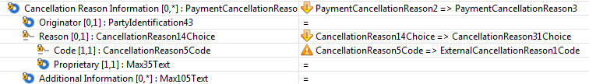
Following new message components defined in the new version of the message definitions are using the new PaymentCancellationReason3 message component with the new structure as illustrated above:

In the CustomerPaymentCancellationRequestV06 message definition (3 occurrences):
- OriginalGroupHeader6
- UnderlyingTransaction15
- OriginalPaymentInstruction20
- PaymentTransaction70

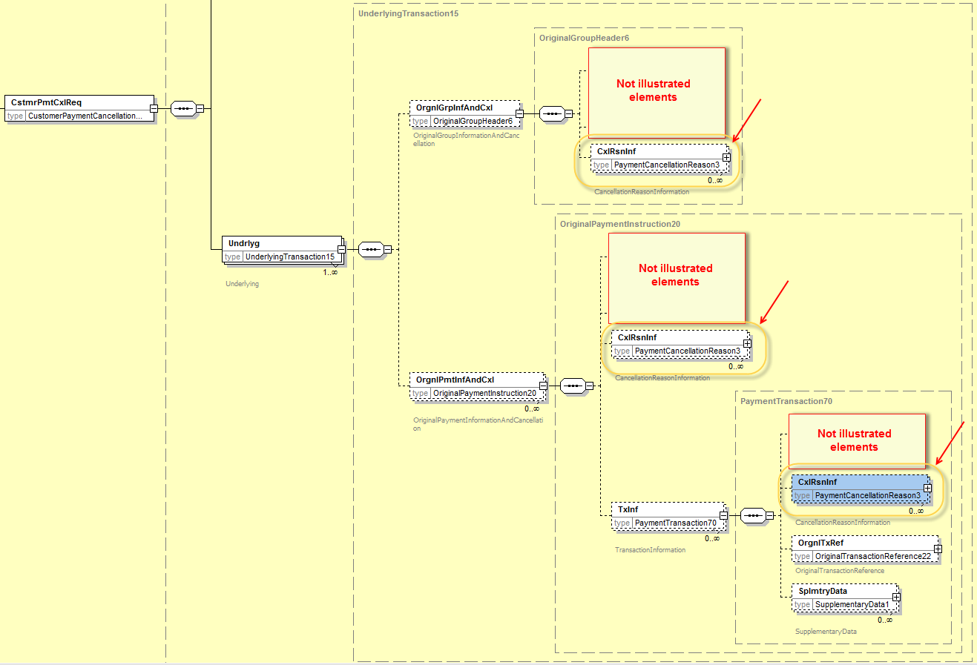

In the FIToFIPaymentCancellationRequestV06 message definition (2 occurrences):
- OriginalGroupHeader6
- UnderlyingTransaction16
- PaymentTransaction71
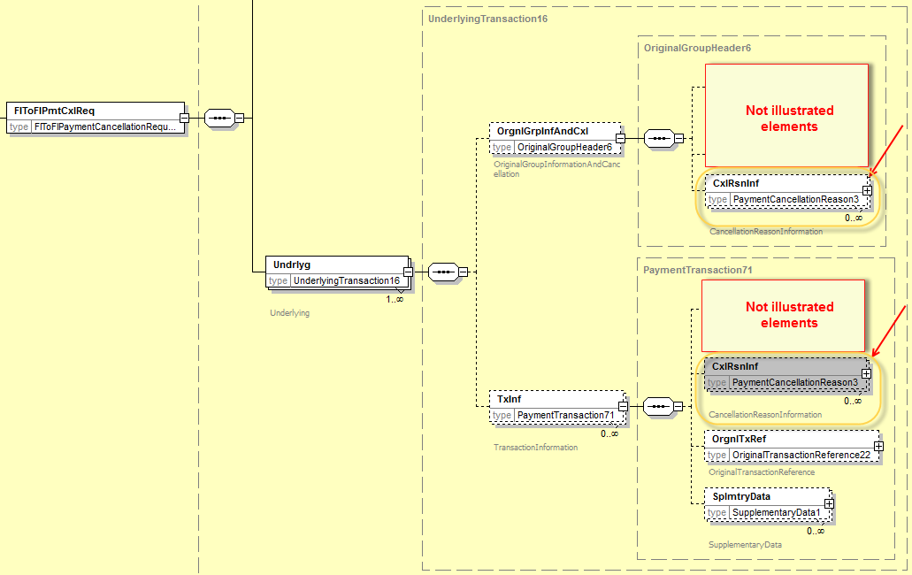

In the DebitAuthorisationRequestV05 message definition (1 occurrence):
- DebitAuthorisation2

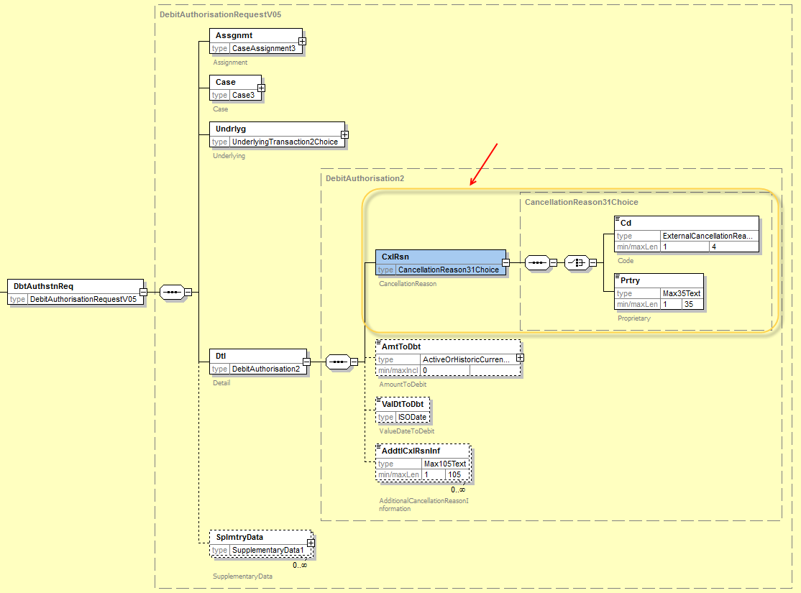

Remark: the code set ExternalCancellationReason1Code which has been externalised must be registered in the list of external code sets, once the change request is approved.
Following codes/definitions will be registered in the new ExternalCancellationReason1Code:
- CUTA – Cancel Upon Unable To Apply
- DUPL – Duplicate Payment
- FRAD – Fraudulent Origin
- AGNT – Incorrect Agent
- CURR – Incorrect Currency
- CUST – Requested By Customer
- TECH – Technical Problem
- UPAY – Undue Payment
- FRTR – Final response - direct debit tracking recalled as mandate is cancelled

- Proposed timing:
The submitting organisation confirms that it can implement the requested changes in the requested timing

Timing | As requested

- Final decision of the SEG:

Approve | X
Comments:
SEG meeting (Sep 22nd, 2016): No comments/objections from the group.

Reject
Reason for rejection:

