BUSINESS JUSTIFICATION FOR THE DEVELOPMENT OF NEW ISO 20022 FINANCIAL REPOSITORY ITEMS

- Name of the request:
Secure Tokenised Asset Transfer (STAT)

- Submitting organisation(s):
Digital Transfer Solutions Ltd

- Scope of the new development:
Proposed message set: Secure Tokenised Asset Transfer (STAT)
Number of candidate messages definitions to be developed: 9 message definitions
Business area for the candidate messages: Secure Tokenised Asset Transfer (stat)
For evaluation by Payments, Securities SEGs, as this protocol supports the transfer of tokenised assets including currencies and securities.
The Business Application Header may be used with this protocol but is not required.
There are no elements in the messages that would duplicate elements from the BAH.
Deployment is expected to use XML syntax.

Business processes and information flows for the message set to be created: Asset Issuance
  - A Client selects a Notary’s ledger onto which the first transfer of their assets will be notarised.
  - A Client requests the withdrawal of assets from their Bank or Custodian, which may be a combination of quantities of various denominations.
  - The Bank or Custodian request issuance of the assets from the Mint or Issuer, against reserves and/or in exchange for other redeemable assets in the request.
  - The Mint or Issuer signs the denominated assets.
  - The Bank or Custodian provides the assets to their client.
Asset Transfer
  - The Recipient gets the Ledger header of their Next Notary, who will notarise the next transfer, subsequent to this one.
  - The Recipient requests the Sender to transfer denominated assets.
  - The Sender notarises the transfer with their Notary.
  - The Sender sends the notarised asset to the Recipient, completing the transfer.
Notary Supervision
  - Ledger headers indicate the start of records used to verify asset provenance. Each Notary provides a ledger header to a Supervisory Authority at regular intervals, to ensure integrity of long-term records.
  - Supervisory Authority returns proof that the Ledger Headers have been recorded.
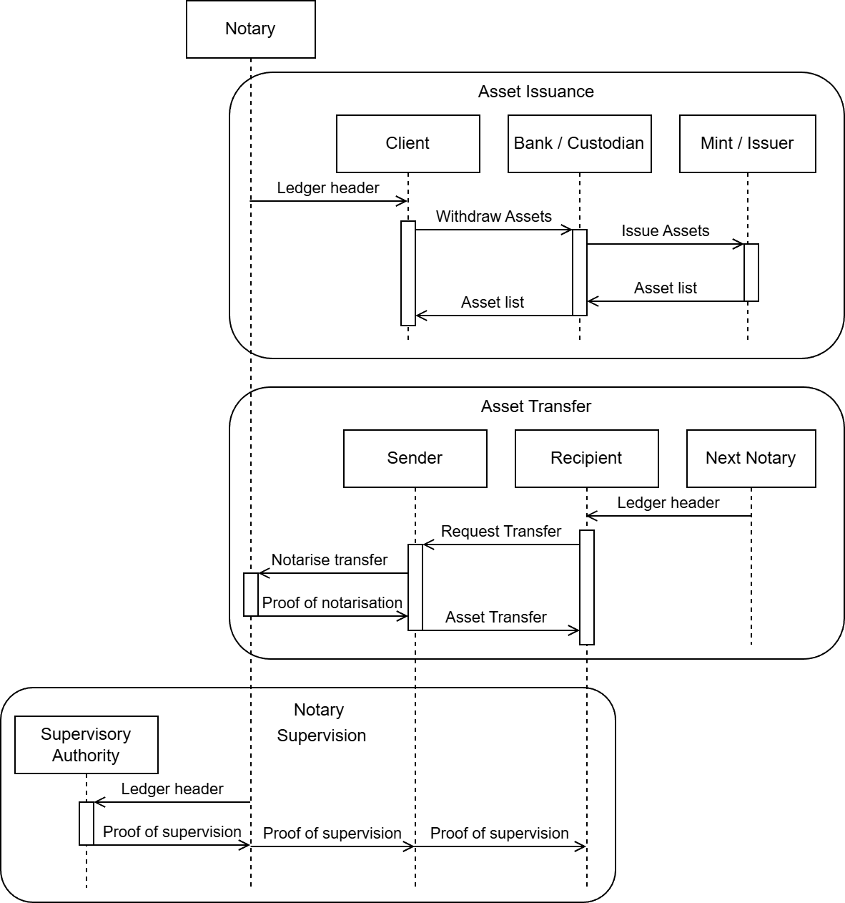

- Purpose of the new development:
The Secure Tokenised Asset Transfer (STAT) message set is intended to:
  - Enable secure, unambiguous transfer of tokenised assets between participants
  - Express rights, authority, and transfer conditions independently of ledger technology
  - Support both custodial and non-custodial holding models
  - Facilitate interoperability between distributed ledgers and traditional FMIs
  - Preserve legal clarity and auditability in regulated environments
These objectives align with the principle that digital asset systems must minimise implicit trust assumptions by making rights and authority explicit and verifiable.
The protocol ensures integrity and uniqueness of a digital asset that has been transferred from one party to another, such that control rests uniquely and directly with the recipient.
The protocol is compatible with the use of single use keys and zero knowledge proofs which can be made resistant to attacks by quantum computers. Single use keys and ZKP can be implemented without the use of asymmetric cryptography.
This protocol supports business processes using non-custodial wallets, which differ significantly from existing registered business processes and messages for payments and securities that rely on the use of accounts. No changes to those messages (such as CR1627) are relevant as they are for different business processes.
  - Our most salient value proposition is support for self-custody assets in non-custodial wallets, subject to (a) separating issuance, settlement finality, and accounting functions so that they can be performed by different actors, possibly subject to different regulatory requirements, and (b) eliminating economic externalities, for example, those that result from requirements for data availability or multiparty execution of software code, that in turn must be subsidised or recovered by end-users. The current reality of tokenised asset transfers falls into two categories: account-based transfers, which fall outside our domain, and transfers of self-custody assets, which are currently monolithic and suffer from economic externalities.
  - For account-based transfers: Transactions of digital assets involve a state change on a distributed ledger technology (DLT) system. Assets are typically represented as immutable objects representing "unspent transaction output" (UTXO, as in Bitcoin), or balances associated with addresses (as in Ethereum). Settlement finality is generally near-instantaneous (a matter of seconds or minutes, for practical purposes). Tokenised asset transfers reconcile compliance requirements with the programmability of digital assets. Resources are being directed toward standardisation of protocols, regulatory alignment, and collaboration between government and private-sector actors, with the result that DLT-based transfers of tokenised assets are increasingly used by financial institutions, with fastest adoption in wholesale contexts [1, 2, 3].
Relevant international standards include ISO 22739 (Blockchain and DLT -- Vocabulary), ISO 23257 (Blockchain and DLT -- Reference architecture), IEC 63088 (Digital Asset Management Interoperability), IOSCO FR/17/2025 Guidance, and the FATF Guidance on Virtual Assets. These standards address various technical and operational aspects for the transfer of tokenised assets, including guidance for custody and interoperability between jurisdictions [4, 5, 6].
  - For self-custody assets in non-custodial wallets: Tokenised asset transfer depends on both protocol-level standards and regulatory-compliant designs. Most existing non-custodial wallets are designed primarily for use with assets that are represented directly on-ledger (in contrast to our design, wherein the ledger is used only for verification of state changes). The key elements include on-chain transfer mechanisms, token standards, smart contract rules, and interoperability layers.
Self-custody rights in existing systems are typically enforced via wallet signature verification, with wallets acting as a mechanism for accessing and managing account-based funds. Wallets may include support for carrying and transacting "non-fungible tokens", which are unique digital assets. Tokenised vault standards, such as EIP-4626, can ensure that transfers satisfy compliance rules in cases wherein assets are consummated in the absence of financial institutions.
In most existing self-custody designs, the self-custody component relates to keys that control the movement of assets that are represented on a ledger, rather than the assets themselves. Our system differs significantly from this approach, using the ledger as a way to validate asset transfers that take place off-ledger, with assets held as data objects directly by end-users. See references for more information [7, 8, 9, 10].
One notable exception to the aforementioned approach to self-custody is the zero-knowledge issuance of tokens that can be transacted once and redeemed by the recipient, This approach, first described by David Chaum [11] and later elaborated [12], is the basis for several protocols that have realised some commercial adoption, including GNU Taler [13] and Privacy Pass [14]. However, these designs assume that the issuer is the same party that processes transactions and implements any requisite compliance functions. Our design systematically separates the functions of token issuance, settlement finality, and compliance operations, so that these roles can be performed by distinct parties.
  - [1] McKinsey, "Tokenized financial assets: From pilot to scale" https://www.mckinsey.com.br/industries/financial-services/our-insights/from-ripples-to-waves-the-transformational-power-of-tokenizing-assets
  - [2] World Economic Forum, "Asset Tokenization in Financial Markets" https://reports.weforum.org/docs/WEF_Asset_Tokenization_in_Financial_Markets_2025.pdf
  - [3] Barclays Investment Bank, "Tokenisation: The next chapter of money's evolution" https://www.ib.barclays/our-insights/tokenisation-the-next-chapter-of-moneys-evolution.html
  - [4] https://www.iosco.org/library/pubdocs/pdf/IOSCOPD809.pdf
  - [5] https://www.bis.org/publ/bisbull72.pdf
  - [6] https://brettonwoods.org/wp-content/uploads/2026/03/A-Global-Framework-for-Tokenized-Assets.Final_.pdf
  - [7] UK FCA PS26/7, Digital Securities Sandbox (DSS): Regulated DLT-transfer models, direct-to-fund self-custody.
  - [8] EU MiCA & DLT Pilot Regime: Licensing, token standards, investor protection for on-chain asset transfer.
  - [9] US SEC & SPV-backed security tokenisation: Legal wrappers enabling self-custody transfer.
  - [10] ERC Token Standards (ERC-20, ERC-721, ERC-1155, ERC-1400): Smart contract protocols for self-custody atomic transfer.
  - [11] D Chaum. “Blind Signatures for Untraceable Payments.” Advances in Cryptology: Proceedings of Crypto 82(3), 1983, pp. 199-203.
  - [12] D Chaum, C Grothoff, and T Moser. “How to issue a central bank digital currency.” Swiss National Bank Working Paper 3/2021, January 2021.
  - [13] GNU Taler.
  - [14] A Davidson, I Goldberg, N Sullivan, G Tankersley, F Valsorda. “Privacy Pass: Bypassing Internet Challenges Anonymously.” Proceedings on Privacy Enhancing Technologies 3, pp. 164-180. https://www.petsymposium.org/2018/files/papers/issue3/popets-2018-0026.pdf
- why existing ISO 20022 messages can’t be used (extended) and what are the gaps identified
  - There is no currently registered business process, business transaction nor message definitions that serve this purpose.

- Community of users and benefits:
For the community of asset providers and holders:
- Benefits/savings:
  - Risk Reduction — Explicit rights and authority semantics reduce ambiguity and operational risk
  - Interoperability — Standardised messages enable cross platform asset transfer.
  - Regulatory Compatibility — Clear semantics support compliance, audit, and legal enforceability.
  - Operational Efficiency — Reduced reconciliation and manual intervention.
  - Future Proofing — Ledger agnostic design accommodates evolving tokenisation.
- Adoption scenario:
  - Expect early adoption over the course of 2027, with significant adoption following in 2028;
- Volumes:
  - Early adoption by several projects in 2027, with wider rollout over 2028.
  - Estimated number of messages of several billion per year. We cannot specify the specific projects, because they are commercially sensitive.
- Sponsors and adopters:
  - Digital Asset issuers and digital currency test beds.
- Timing and development:
  - Urgency of the development: Regular schedule. This is not considered an urgent development.
  - Expected Timing: We plan to have the messages available for submission by end of Q4 2026.
  - Submitting organisations involved: No other parties are involved in the initial development. We are open to working with any party that would like to volunteer.
  - Other known standards initiative(s) involved in an effort to address the same requirements: none.

- Commitments of the submitting organisation:
The submitting organisation confirms that it can and will:
  - undertake the development of the candidate ISO 20022 business and message models that it will submit to the RA for compliance review and evaluation. The submission must be compliant with the ISO 20022 Master Rules and include a draft Part 1 of the Message Definition Report (MDR) compliant with the template for MDR part 1 provided by the RA, the ISO 20022 Message Transport Mode (MTM) that the submitting organization recommends to consider with the submitted message set, and, optionally, examples of valid and invalid instances of each candidate message. The submission may also include a Message User Guide (MUG) to complement the MDR and describe in further details how to use the different possibilities/options of the proposed candidate messages;
  - address any queries related to the description of the models and messages as published by the RA on the ISO 20022 website.
The submitting organisation confirms that it will promptly inform the RA about any changes or more accurate information about the number of candidate messages and the timing of their submission to the RA. If the submitting organisation does not submit the candidate messages within the timing announced in section F and does not inform the RA beforehand, the business justification may lapse and require re-submission of a new business justification for approval by the RMG.
The submitting organisation confirms it does not intend to organize any testing of the candidate messages once they have been reviewed and qualified by the RA and before their submission to the SEG(s) for approval. As part of any implementation of the messages, once approved, testing will be carried out. Schema valid examples will be included in the MDR Part 1.
The submitting organisation confirms that it will promptly inform the RA about any changes or more accurate information about the timing of this re-submission to the RA. If the submitting organisation does not re-submit the candidate messages as announced and does not inform the RA beforehand, the business justification may lapse and require resubmission of a new business justification for approval by the RMG.
The submitting organisation confirms it is committed to undertake the future message maintenance.
The submitting organisation confirms its knowledge and acceptance of the ISO 20022 Intellectual Property Rights policy for contributing organisations, as follows.

- Contact persons:
Geoffrey Goodell goodell@dts-ltd.co.uk
Jason Polis jason@iso20022.plus
- Comments from the RMG members and relevant SEG(s) or SubSEG(s) and disposition of comments by the submitting organisation:
This section will include the comments received from RMG members and the SEG(s) or SubSEG(s), if any, and the response given to each of these comments by the submitting organisation.
Comments submitted by Rainer Vogelgesang (rainer.vogelgesang@six-group.com) on behalf of the Swiss community, Swiss Association for SWIFT and Financial Standards (SASFS) (received on 25/09/2026):
The Swiss Association for SWIFT and Financial Standards (SASFS) is the representative organisation for financial standardisation in the financial centre of Switzerland and Liechtenstein.
The SASFS welcomes the initiative of Digital Transfer Solutions Ltd to develop ISO 20022 messages for the tokenised asset transfer business processes.
When reviewing BJMS 292, there are number of details for which we would appreciate further clarifications as follows.
Before being able to consider the appropriateness of BJMS 292, we would appreciate feedback on the points raised hereafter. In the meantime, we remain available for further considerations.
- Clarification of message names
The BJ proposes the development of 9 ISO 20022 messages:
As the number of messages is already known it would be conducive to state the (draft) message names.
Reply from DTS:
The sequence diagram in Section C shows the information flows as Message Transmissions between Participants with short names. Draft names for corresponding MessageDefinitions are:
- Ledger Header
- Proof Of Supervision
- Withdraw Asset Tokens
- Issue Asset Token
- Asset Token List
- Request Transfer Asset Token
- Notarise Transfer Asset Token
- Proof Of Notarisation
- Transfer Asset Token

- Definition of new Business Area ‚stat‘
The BJ proposes to create a new ISO 20022 business area entitled ‘Secure Tokenised Asset Transfer (stat):
To this end, it would be useful to have a draft or proposed definition for this business area.
Reply from DTS:
Issuance and secure transfer of asset tokens. Supervision of notaries to transfers of asset tokens.
- Clarification re modelling of messages in view of use of the BAH
The BJ indicates that the proposed messages may be used with the BAH in both the payments and securities domain:
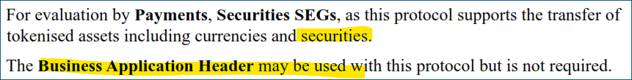
As the ISO 20022 messages in the securities domain are predominantly modelled for the use with the BAH (i.e. BAH message elements are not duplicated in the ISO 20022 securities messages) and, furthermore, as messages in the payments domain have witnessed the extended use of the BAH with the payments messages of the CBPR+ global market practice, it would be preferrable if the messages could be modelled for the use of the BAH, i.e. without duplication of BAH elements in the messages themselves. The SO therefore should explicitly state how it intends to model the proposed messages, i.e. with or without duplication of BAH elements in the messages themselves.
Reply from DTS:
The messages will be modelled without duplication of BAH elements.
There are no elements in the messages that would duplicate elements from the BAH.
Users are free to use the BAH if they want, as the BAH could contain additional information that is not required by the protocol.
- Categories of messages
It should be clarified whether, next to ‘Asset Issuance & Redemption’ and ‘Asset Transfer’, ‘Transfer Supervision’ is intended to be a third group of proposed messages.
There may be a formatting issue in the current version of the BJ:
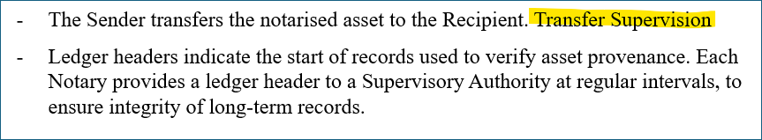
Reply from DTS:
Have updated diagram and description to clarify this, and the relationship to other processes.
- Definitions of the actors in the business process diagram
It would be conducive if the actors in the business process diagram could be more precisely defined. Some actors seem to have business-related roles such as ‘bank’ and ‘custodian’. Some other actors seem to have messaging-related roles such as ‘sender’ and ‘receiver’. In the case of the latter, it would be preferable additionally to indicate the business roles of such senders and receivers.
Reply from DTS:
Agree.
- Supervisory Authority – A ledger system that notarises the headers of Notary’s ledgers.
- Notary – A ledger system to notarise the current transfer.
- Next Notary – A ledger system to notarise the subsequent transfer.
- Client – A customer of a Bank/Custodian.
- Bank / Custodian – An organisation that distributes endorsements of Asset Tokens to clients, and that has a relationship with a Mint/Issuer.
- Mint / Issuer – An endorser of Asset Tokens, analogous to currency mints or securities issuers.
- Sender – Sender of the Asset Token
- Receiver – Receiver of the Asset Token
Other terms for Sender and Receiver were considered such as Transferor and Transferee,
but considered too close to be easily distinguished in conversations. We are open to suggestions.
- Definitions for the business process terms used
It would be useful, if definitions for the business process terms used (such as custodial/non-custodial, account-based transfers/transfers of self-custody assets) and their interdependencies could be provided.
Reply from DTS:
custodial wallet: wallet provided by a third party that controls or manages private keys, or other digital assets, held in the wallet on behalf of their owners
non-custodial wallet: wallet that is not a custodial wallet
account-based transfer: transfer that is effected by a change in records representing assets and liabilities of account holders
transfer of self-custody assets: transfer wherein a sender relinquishes control over specific assets for which a recipient gains direct, exclusive control.
- Significance of the attribute ‘secure’ in the designation of the business process
The proposed ISO 20022 message set for tokenised asset transfer is characterised by the designation as ‘secure’ tokenised asset transfer.
It should be clarified to what aspects of being ‘secure’ or security this label/attribute refers, such as ‘authentication’, ‘integrity’, ‘encryption’ and so on.
Furthermore, it should be indicated whether any of these aspects could alternatively be realised by employing the signature facility inherent to the BAH or whether security facilities of underlying network services could be employed to provide such security features.
Reply from DTS:
The BAH uses the signature of the sender to sign the entire contents of a message.

The signatures in the payload of the STAT messages do not have that function. The messages in STAT contain signatures that cover only part of the message, or that are made by parties other than the sender.
The protocol ensures integrity and uniqueness of a digital asset that has been transferred from one party to another, such that control rests uniquely and directly with the recipient.
The protocol is compatible with the use of single use keys and zero knowledge proofs which can be made resistant to attacks by quantum computers. Single use keys and ZKP can be implemented without the use of asymmetric cryptography.
- Identity of the submitting organisation
In view of the indicated contact persons from two distinct organisations, it should be clarified whether the submitting organisation only consists of Digital Transfer Solutions Ltd or whether it is rather a consortium of Digital Transfer Solutions Ltd and ISO20022.plus:
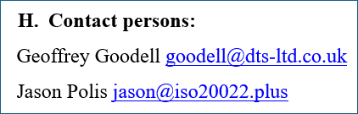
Without such precision, it is not sufficiently clear which organisation will support the maintenance processes for future message versions.
Reply from DTS:
Digital Transfer Solutions Ltd is the submitting organisation, supported by ISO20022.plus.
Comments received from Aurelie Steeno (aurelie.steeno@swift.com) on behalf of the Securities SEG (received on 02 October 2026)
The Securities SEG would like to organise a call with the submitting organisation to discuss and clarify certain aspects of the business justification. For example, the SEG would like to better understand why the existing ISO 20022 message definitions are not considered suitable for addressing the identified requirements. The SEG would also welcome the opportunity to learn more about the project and its objectives, in order to gain a broader understanding of the proposed initiative.
Reply from DTS:
Noted. We look forward to working with the Securities SEG and the Payments SEG.
Comments received from Jeevan Sidhu (jeevan.sidhu@swift.com) on behalf of the Payments SEG (received 2nd October 2026)
Comments made by the Payments SEG:
- Is there any relationship between these proposed new messages and ISO 20022 change request 1627, that sought to update ISO 20022 pacs messages to support transfer of digital assets such as stablecoin and bitcoin? This CR was rejected but expected to be resubmitted.

- Is this business justification proposing the creation of brand new ISO 20022 messages and a brand new business area for transferring digital assets between two parties?
Reply from DTS:
1. No.
This protocol supports business processes using non-custodial wallets, which differ significantly from existing registered business processes and messages for payments and securities that rely on the use of accounts. No changes to those messages (such as CR1627) are relevant as they are for different business processes.

2. Yes.

