Business Justification
for the development of new ISO 20022 API resources as ISO 20022 financial repository items)
Note: the purpose of this document is to give guidelines to organisations that want to develop new candidate ISO 20022 API resource definitions. Such requests are subject to the approval of a business justification by the ISO 20022 Registration Management Group (RMG). Please consult the iso20022.org website for additional details on the registration process. The business justification must include the following captions, as described.

- Name of the request:

Remita Payment Services Limited (RPSL) Payment Switch Services API Resource

- Submitting organisation(s):

Organization Name: Remita Payment Services Limited (RPSL)
Country: Nigeria
Business Type: Payment Service Provider / Financial Technology Company
Regulatory Status: Licensed Payment Service Provider by the Central Bank of Nigeria
Contact Information:
Address: Plot B22, Chief Yesufu Abiodun Oniru, Oniru, Lagos, Nigeria
Email: info@remita.net
Telephone: +2348141376868
Organization Information: RPSL operates Nigeria's leading payment infrastructure, processing millions of transactions annually for government agencies, ﬁnancial institutions, and private sector entities. Our payment switch connects over 40 Nigerian banks and facilitates domestic and cross-border payment processing across West Africa.
- Scope of the new development:

The financial instruments in scope: RPSL Payment Switch API Resource will cover domestic fund transfer services, cross-border payment services, and value-added services using the ISO 20022 messaging standards.

Relationship with Existing Business Justifications
This submission has been reviewed against existing ISO 20022 API resource developments to ensure complementarity rather than duplication:

Existing BJAP | Scope | RPSL Differentiation
BJAP 220 – SWIFT Credit Transfers | Defines API resources for customer and FI credit transfers between two parties | RPSL addresses the switch/orchestration layer that coordinates credit transfer flows between multiple institutions. Our APIs manage routing, settlement coordination, and multi-party transaction state—functions not covered by point-to-point transfer APIs.
BJAP 245 – Account Validation | Defines API resources for account verification between two parties | RPSL integrates account validation as part of an end-to-end payment orchestration flow, including Nigeria-specific validation requirements (BVN verification, Account Tier validation, regulatory checks) that extend beyond basic account validation
BJAP 78 – Access to Account | Defines API resources for third-party provider (TPP) access to customer account information under open banking frameworks (PSD2, etc.) | RPSL provides switch-mediated account enquiry services (Balance Enquiry, Name Enquiry) for payment validation purposes—not third-party open banking access. Our account enquiry APIs operate within the trusted interbank switch network, not for external TPP consumption. The use case, security model, and participant roles differ significantly from BJAP 78

Information Flows: Target Implementations
We confirm that this submission does not propose converting ISO 20022 XML messages into identical API resources. In accordance with ISO 20022 API best practices, our approach uses RESTful API endpoints that support business flows rather than mirror XML message structures.
Specifically:
- Our APIs (e.g., POST /api/credit-transfer, POST /api/name-enquiry) represent business operations, not message formats
- ISO 20022 messages (pacs.008, pacs.002, acmt.023, etc.) are used as the payload format within API requests/responses
- The API layer handles orchestration concerns (routing, state management, settlement coordination) that are separate from message content
- This approach aligns with the Bank Guarantees API model illustrated by the Registration Authority
The attached sequence diagrams demonstrate this flow-based approach, showing how API calls orchestrate message exchanges between multiple parties.
.
Business Transaction and Message sets related to the requested ISO 20022 API resources: Primary Messages
- Credit Transfer: pacs.008, pacs.002, pacs.028
- Debit Services with mandate validation: pacs.003, pacs.002
- Name Enquiry (Account Validation): acmt.023, acmt.024
- Balance Enquiry: camt.004, camt.005
- OTP Authentication Services: admi.007, admi.002

Proposed ISO 20022 Registration Body for evaluation - SWIFT (Registration Authority)

A High-Level Diagram of the Business Process (indicating the actors and their roles):

Name Inquiry (Account Validation)
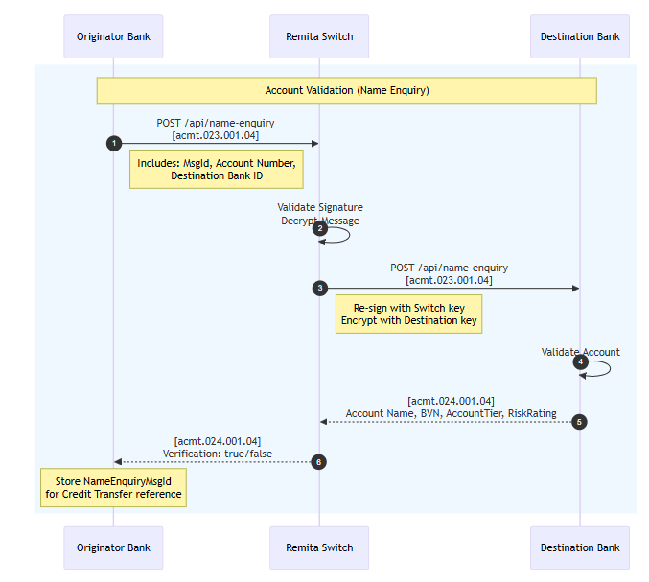

Credit Transfer: Phase 1 - Initiation and Provisional Acceptance

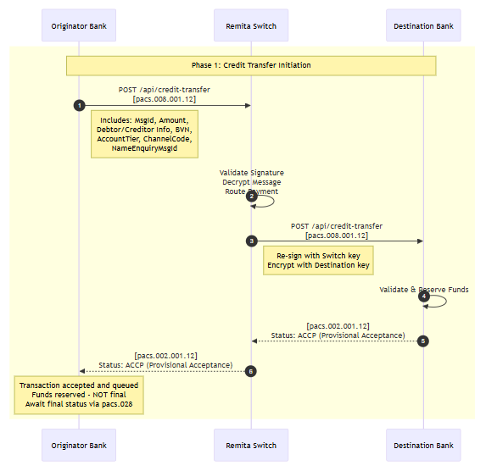

Credit Transfer: Phase 2 – Final Settlement Confirmation
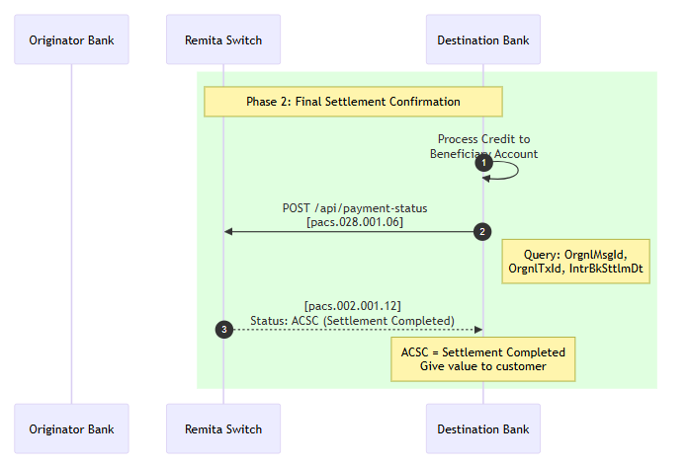

Final Status to Originator
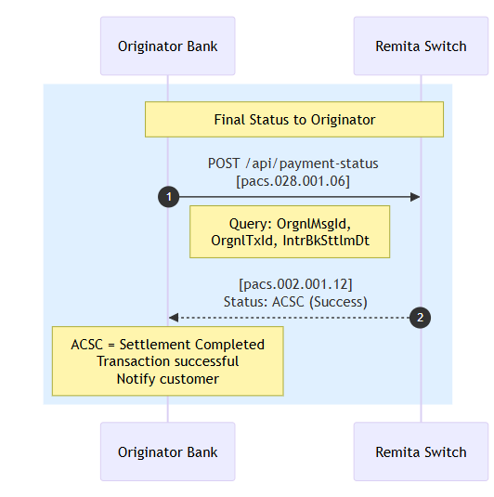

Status Inquiry (Query at any time)

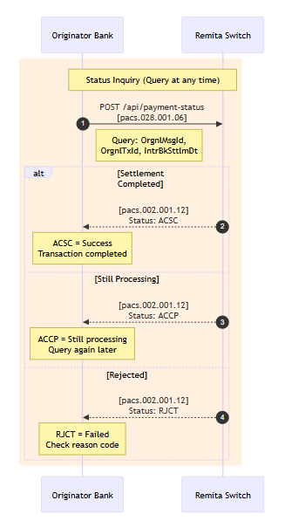

Timeout/Rejection Scenario

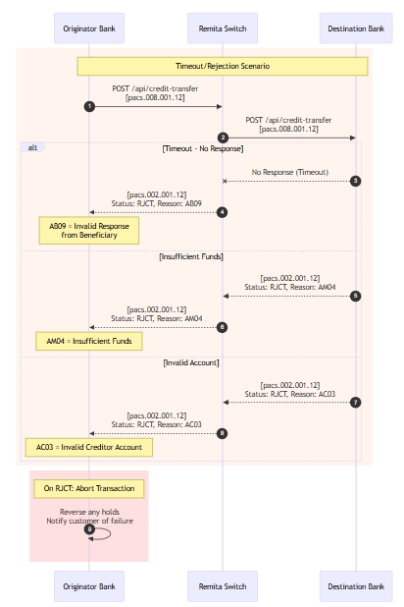

The information exchange flows in which the requested ISO 20022 API resources are intended to be employed:
Domestic Fund Transfer Services:

Account-to-account transfers within the Nigerian banking system
Real-time settlement capabilities
Support for retail and corporate payment volumes
Integration with the Nigeria Instant Payment (NIP) system

Cross-Border Payment Services:

Nigeria-Ghana corridor payments
Nigeria-Kenya payment ﬂows
Multi-currency transaction processing
FX rate management and settlement

Value-Added Services:

Account name veriﬁcation
Transaction status inquiry and tracking
Payment investigation and resolution
Real-time notiﬁcation services

- Purpose of the new development:

The purpose of this submission is to establish standardized ISO 20022 API resources for payment switch orchestration in the Nigerian and West African financial ecosystem.

Problem Statement: Currently, payment switches in the region use proprietary, non-standardized interfaces for multi-bank coordination. This creates:
- High integration costs for banks connecting to multiple switches
- Inconsistent transaction handling across different switch providers
- Limited interoperability for cross-border payment corridors
- Difficulty in regulatory reporting due to non-standard data formats

Proposed Solution: The RPSL Payment Switch API Resource will provide:
- Standardized Switch Orchestration APIs – Common interface definitions for payment routing, settlement coordination, and status management that any compliant switch can implement.
- ISO 20022 Message Alignment – API resources that utilize ISO 20022 message types (pacs, acmt, camt, admi), ensuring rich, structured data flows compatible with global standards.
- Regional Interoperability – A foundation for connecting West African payment infrastructures using consistent API patterns, facilitating cross-border payment growth.
- Regulatory Enablement – Standardized data structures that simplify compliance reporting to the Central Bank of Nigeria and other regional regulators.
Expected Outcomes:
- Reduced integration time for banks connecting to payment switches (target: 75% reduction)
- Improved transaction success rates through standardized error handling
- Enhanced cross-border payment capabilities within West Africa
- Template for other emerging markets implementing ISO 20022 payment switch infrastructure

- Community of users and benefits:
This section is critical. It will be used by the RMG to determine the business case and priority of the proposed development, independently of whether the Business Justification relates to a new Business Area, or not. Even if the benefits of the project may have already been described to some extent in the previous sections, submitting organisations are invited to repeat them here and to spend the time necessary to collect requested information for each of the captions below. If a caption cannot be completed, the submitting organisation is requested to explain why.

Banks and Financial Institutions

Reduced Integration Costs: Standardized APIs eliminate custom development
Faster Time-to-Market: Pre-built, certiﬁed API resources accelerate service deployment
Enhanced Interoperability: Seamless connection with multiple payment service providers
Regulatory Compliance: Built-in support for regulatory reporting requirements

Fintech Companies
Market Access: Simpliﬁed integration with established banking infrastructure
Scalability: Proven APIs capable of handling enterprise-level transaction volumes
Innovation Enablement: Standardized foundation for developing new payment services

Market and Ecosystem
Nigeria and West Africa:

Financial Inclusion: Standardized APIs enable broader access to payment services
Cross-Border Trade: Facilitated regional commerce through simpliﬁed payment ﬂows
Economic Growth: Reduced payment friction supports business development and trade
Technology Leadership: Positions Nigeria as a leader in payment system standardization
Global ISO 20022 Ecosystem:

Emerging Market Implementation: Demonstrates ISO 20022 viability in developing economies
Regional Network Eﬀects: Establishes template for other African markets
Standards Evolution: Provides real-world feedback for continuous improvement

Adoption Scenario
Proven Market Impact:

Successfully processing 50,000+ transactions through 8 pilot banks
Demonstrated 75% reduction in bank integration time (from 6 months to 6 weeks)
Achieved 98.7% transaction success rate in production pilot
Validated cross-border payment capabilities between Nigeria, Ghana, and Kenya
Demonstrated Business Beneﬁts:

Interoperability: Proven standardized messaging reduces integration complexity for banks
Cost Reduction: Pilot banks report signiﬁcant development cost savings
Market Expansion: Successfully facilitating cross-border payment ﬂows within West Africa
Regulatory Compliance: Validated compliance with Central Bank of Nigeria requirements
Strategic Alignment with ISO 20022 Core Objectives

Global Standardization: Provides standardized payment messaging for Nigerian and West African markets
Rich Data Enablement: Supports enhanced transaction data for regulatory reporting and customer service
Future-Ready Infrastructure: Establishes a foundation for advanced payment services and ﬁnancial crime prevention
Ecosystem Connectivity: Enables seamless

Completed Development Phases

Phase 1: Foundation (Completed)

API resource design and speciﬁcation development
Core message mapping from ISO 20022 schemas
Security framework implementation
Development environment setup
Phase 2: Core Services (Completed)
Domestic payment API implementation
Account veriﬁcation services
Status inquiry and notiﬁcation services
Internal testing and validation
Phase 3: Advanced Services (Completed)
Cross-border payment capabilities
Enhanced security features
Performance optimization
Comprehensive testing and certiﬁcation
Phase 4: Current Status - Pilot Deployment
Production environment deployed
CURRENT: Pilot testing with select bank partners
Monitoring and performance validation
Final optimization based on pilot feedback

Achieved Milestones

Milestone | Completion Date | Status
API Specification Complete | January 2025 | Completed
Sandbox Environment Live | February 2025 | Completed
Core APIs Developed | April 2025 | Completed
Bank Integration (ISO20022) | Q1 2026 | In Progress
Production Pilot Launch | April 2026 (2 weeks) | Planned

Volume, Sponsors and Adopters
Two (2) Nigerian banks are actively testing. Target is over forty (40) Banks and Fintechs.
Pilot Transaction Volumes:

50,000+ test transactions processed successfully
Domestic Transfers: 45,000+ transactions
Cross-Border Payments: 3,200+ transactions
Name Enquiry Services: 12,000+ veriﬁcation requests
Status Inquiries: 8,500+ status checks
Performance Metrics Achieved:

Response Time: Average 1.8 seconds for domestic transfers
System Availability: 99.95% uptime during pilot period
Transaction Success Rate: 98.7% successful completion
API Compliance: 100% ISO 20022 speciﬁcation adherence.

- Timing and development:

The RPSL Payment Switch API Resource is ready for use. Four (4) major banks have committed to full production deployment. A Fintech company has also requested integration access. The new Payment Switch API Resource will eliminate the complex integration with existing banking systems.

Delay in getting the RPSL Payment Switch API Resource submitted for approval will affect the go-to-market as a trusted Payment Switch API Resource.

- Commitments of the submitting organisation:

RPSL is willing to submit the RPSL Payment Switch API Resource to the Registration Authority (RA) for compliance review and evaluation.
RPSL is willing to address any queries related to the description of the models and ISO 20022 API resources as published by the RA on the ISO 20022 website.
RPSL is committed to undertake the future maintenance of the ISO 20022 API resources.
RPSL understands and accepts the ISO 20022 Intellectual Property Rights policy for contributing organisations, as follows:
“Organizations that contribute information to be incorporated into the ISO 20022 Repository shall keep any Intellectual Property Rights (IPR) they have on this information. A contributing organization warrants that it has sufficient rights on the contributed information to have it published in the ISO 20022 Repository through the ISO 20022 Registration Authority in accordance with the rules set in ISO 20022. To ascertain a widespread, public and uniform use of the ISO 20022 Repository information, the contributing organization grants third parties a non-exclusive, royalty-free licence to use the published information”.

- Contact persons:

Name: Mujib Ishola
Email: ishola@remita.net
Telephone: +2348141376868

Name: Ayodeji Ajibade
Email: a.ajibade@remita.net
Telephone: +2348034930062

Name: Abidemi Akinola
Email: akinola@remita.net
Telephone: +2348082000047

- Comments from the RMG members and relevant SEG(s) or SubSEG(s) and disposition of comments by the submitting organisation:
This section will include the comments received from RMG members and the SEG(s), SubSEG(s), API SEG, BMST and/or TSG, if any, and the response given to each of these comments by the submitting organisation.

Comments submitted by Jason Polis (jason@x-x.net) on behalf of the API SEG (received on 07/05/2026):
Link to Responses Exchange - Clarifying-correspondence-for-Payment-Switch-Services-BJAP_286.docx . Comments Extracted
- I’d like to understand a bit more about what you want to register.

The Message Definitions in the payloads are already registered. Do you want to register an API that use those Message Definitions ? The revised ISO 20022:2026 standard published last week, supports registration of an API as an Interface Definition with Operations having Parameters that use either a Message Definition, Message Component Type or Data Type. See 20022-1_ed3fig8

The http method and URI template can be recorded in semantic markup on the Operation.
I’d expect a RESTful API to have Operations on the same URI template to have the same Parameter type.
The sequence diagrams in the BJ show reply messages without an http method, so I interpret these as http responses to the POST requests.

It’s more like a protocol transported over http, rather than a RESTful API. That’s ok, either can modelled in the revised ISO 20022:2026.
Each request response pair could be modelled as an Operation, with one Parameter IN and another OUT of two different Message Definitions.
Mojaloop API Resource /transfers provides an example of a RESTful API, where the responses are PUT via a new http request.

- We had a brief discussion at the API resources SEG today. I’d like to attach this correspondence to the comments form: BJAP-286-Remita-Payment Switch Services-Submission-of-Comments | ISO20022. With my comments: “I support the progression of this business justification to a registration submission.
Clarification by correspondence is attached.”

Would that be ok with you ?
Disposition of comments from the submitting organisation:

- Hi Jason,
Thank you for the detailed review and for flagging the modelling options under the revised ISO 20022:2026 standard. Your interpretation of our submission is correct on all points, and we'd like to respond to each before the SEG meeting on 30th April.

    - Scope of registration
The Message Definitions in our payloads (pacs.008.001.12, pacs.002.001.12, pacs.003.001.12, pacs.028.001.06, acmt.023/024.001.04, camt.004/005.001.09, admi.007/002.001.01) are indeed already registered, and we are not seeking to register new Message Definitions. Our intention is to register the Remita Account Switch API itself as an Interface Definition under the new ISO 20022:2026 framework, with Operations that reference the existing Message Definitions as Parameters.

    - Architectural pattern
You are right that this is better characterised as a protocol transported over HTTP rather than a RESTful API in the Mojaloop /transfers sense. Specifically:
  - Each service is exposed as a POST (or GET for OTP generation) to a dedicated URI, and the business response is returned synchronously in the same HTTP response body (HTTP 200 with an embedded pacs.002, acmt.024, camt.005, or admi.002 payload).
  - We do not use PUT callbacks on the same URI template; there is no asynchronous server-to-client response leg.
  - The two-phase credit transfer is not an asynchronous callback pattern — it is two separate synchronous request/response exchanges. Phase 1 is a pacs.008 that returns a provisional pacs.002 (ACCP). Phase 2 is a subsequent pacs.028 that returns a final pacs.002 (ACSC or RJCT). Both are initiated by the client.
We are comfortable having this modelled as a protocol-over-HTTP in the ISO 20022:2026 registration, which we understand is fully supported alongside the RESTful pattern.

    - Operation modelling
Your proposal to model each request/response pair as an Operation with one Parameter IN and one Parameter OUT fits our architecture cleanly. We would map the API as follows:

Operation | HTTP Method | URI Template | Parameter IN | Parameter OUT
CreditTransfer | POST | /api/credit-transfer | pacs.008.001.12 | pacs.002.001.12
CreditTransferStatus | POST | /api/payment-status | pacs.028.001.06 | pacs.002.001.12
DebitService | POST | /api/debit-service | pacs.003.001.12 | pacs.002.01.12
NameEnquiry | POST | /api/name-enquiry | acmt.023.001.04 | acmt.024.001.04
BalanceEnquiry | POST | /api/bals-enquiry | camt.004.001.09 | camt.005.001.09
OTPGeneration | POST | /api/otp-generation | admi.007.001.01 | admi.002.001.01
OTPValidation | POST | /api/otp-validation | admi.007.001.01 | admi.002.001.01

The HTTP method and URI template would be captured as semantic markup on each Operation, as you described. The operational endpoints in our specification — /api/get-participants and /Remitaswitch/health — are administrative in nature, and we do not propose to include them in the ISO 20022 registration scope.

Please let us know how you would like us to proceed.

Comments submitted by Michael Richards (mrichards@mojaloop.io) on behalf of The Mojaloop Foundation & API Resources Sub-group (received on 21/05/2026):
It has generally been the policy of the API Resources sub-group to concentrate on the content of API-based resources and not on the process flows which use these resources. Process flows may be used as illustrations in Resource Definition Reports; but they are normally intended to provide illustrations of how resources might be used in practice, rather than themselves forming content which can or should be approved.
One might think of them as analogous to Market Practice Documents, which state how resources are used in a particular business context and may be reviewed for proper use of the resources; but which are not intended to imply that the usage should be regarded as a standard.
This proposal states that the proposer intends to use the content of existing messages without conversion, but does not go into detail about the form in which those messages will constitute the content of the process flows described (for instance, will the resources be XML messages in the form of blobs, or JSON versions of the messages, and, if the latter, how are they to be produced?); or about any restrictions that might be placed on them (for instance,about whether intermediary agents are permitted or not); or about the thinking behind message selection (for instance, about why a payment status request (pacs.028) uses the POST verb (RESTfully typically used to create a document) rather than a GET (return the current content of a document). I would like to discuss the purpose and content of this Business Justification with the submitters in more detail before it is accepted for consideration.

Disposition of comments from the submitting organisation:
Pending.

Comments submitted by Rainer Vogelgesang (rainer.vogelgesang@six-group.com) on behalf of Switzerland (received on 22/05/2026):
Please see the Swiss comments as per the separate feedback file attached.
Link to file: 2026-05-22-Swiss-comment-to-BJ-286-RPSL-final.pdf
Comments extracted from the PDF File:
The Swiss Association for SWIFT and Financial Standards (SASFS) is the representative organisation for financial standardisation in the financial centre of Switzerland and Liechtenstein.
The SASFS welcomes the initiative of Remita Payment Services Limited (RPSL) to enable the domestic and cross-border payments community in its region to benefit from ISO 20022-based business processes.
When reviewing BJ 286, there are number of details for which we would appreciate further clarifications as follows:

  - Clarification of API resources
BJ 286 indicates that it is intended to develop ISO 20022 API resources that utilise several ISO 20022 messages:
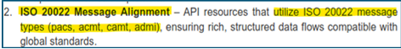
It should be confirmed whether this is to be understood that BJ 286 proposes to identify message components of existing pacs, acmt, camt and admi messages as baseline for developing ISO 20022 API resources that are in close alignment with these message components.

The following two statements should be clarified as, without further detail, they could be construed to be contradicting.
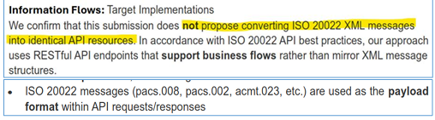

BJ 286 furthermore indicates that the business processes of previous BJs BJ 178 (Access to Account Resource), BJ 220 (Customer and Financial Institution Credit Transfers API Resources) and BJ 245 (Account Validation API resources) have been evaluated. As a result, it has been concluded that the business processes of these BJs do not sufficiently fulfil the requirements addressed by BJ 286. We would appreciate an additional clarification whether any of the ISO 20022 API resources of the three BJs 178/220/245 are applicable to the business processes addressed by BJ 286 and could therefore be potential ISO 20022 API resources to be re-used by BJ 286. It would be hoped that, by such re-use, the number of remaining ISO 20022 API resources, still to be developed by BJ 286, could be reduced.

  - Non-limiting terminology
BJ 286 uses designations that are particular to their own implementation such as ‘Remita’ Switch:
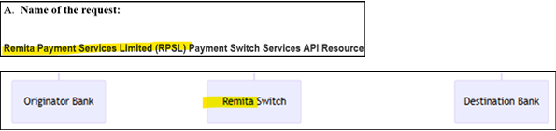

In view of the general nature which such ISO 20022 API resources should have and, consequently, their potential versatility and re-use in similar contexts on a global scale, we would recommend coming up with and using, in the BJ, terms that do not contain proprietary designations.

When the ISO 20022 API resources become available, there would be an opportunity to define domestic and/or regional market practices and related implementation specifications that then could contain proprietary designations as referred to in BJ 286, for instance, as regards a template for other African markets:

  - Applicable evaluation committee
BJ 268 indicates, next to the payments domain, the foreign exchange domain as a potential area of application for the proposed ISO 20022 API resources:
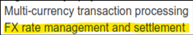
Therefore, we would propose to foresee an evaluation by the corresponding SEGs, i.e. the Pay SEG and the FX SEG. The ISO 20022 RA, as indicated in BJ 286, is typically also involved in the SEG reviews:
As BJ 286 requests the development of ISO 20022 API resources, the API SEG should, by default, also be formally requested to evaluate BJ 286.

  - Alignment of business terminology
BJ 286 uses some terminology that is derived from its own community such as ‘payment switch’:
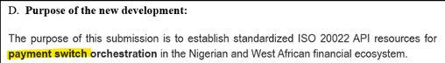
To avoid that, in other communities, other designations might be known for such terms, it should be confirmed whether these terms have been cross-checked with other payment and FX communities. There may be an opportunity to align the terms used in BJ 286 with the terminology in other communities such as ‘payment settlement’ or ‘payment clearing and settlement’. Otherwise, the proposed term ‘payment switch’ should be well-defined and delineated from similar terms in other markets.

Before being able to consider the appropriateness of BJ 286, we would appreciate feedback on the points raised above. In the meantime, we remain available for further considerations.

Kind regards Swiss Association for SWIFT and Financial Standards (SASFS)
Disposition of comments from the submitting organisation:
Pending.

