Business Justification
for the development of new ISO 20022 API resources as ISO 20022 financial repository items
- Name of the request:
nexo A.I.S.B.L. Protocols API proposal

- Submitting organisation(s):

nexo A.I.S.B.L. (nexo standards)
Rue Montoyer 25
B-1000 Brussels
Belgium

nexo standards is the association dedicated to removing the barriers present in today’s fragmented global payment acceptance ecosystem.
It enables fast, borderless, and global payments acceptance by standardizing the exchange of data between all payment acceptance stakeholders.
The nexo standards specifications and messaging protocols adhere to ISO 20022 standards, are universally applicable and fully open.
nexo standards is a not-for-profit, open association; its membership represents the full spectrum of payment stakeholders including merchants and other payment acceptors, processors, card schemes, payment service providers and vendors.

- Scope of the new development:
The goal of the new development is to allow publication of all nexo standards protocols using the
ISO 20022 API Resources approach
The following example is for the Retailer Protocol – Sale to POI CASP API based on
ISO 20022 messages using JSON notation, with specifically a first objective to support the exchanges as illustrated in D1.3 arrow below.
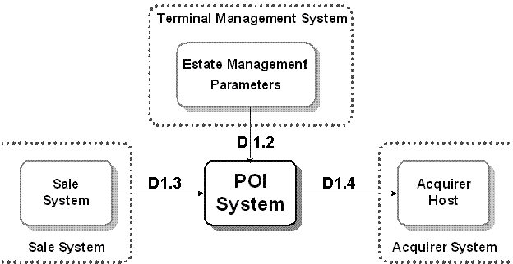

Other payment messages (caaa, caam, catp, catm) also require supporting API & JSON notation.
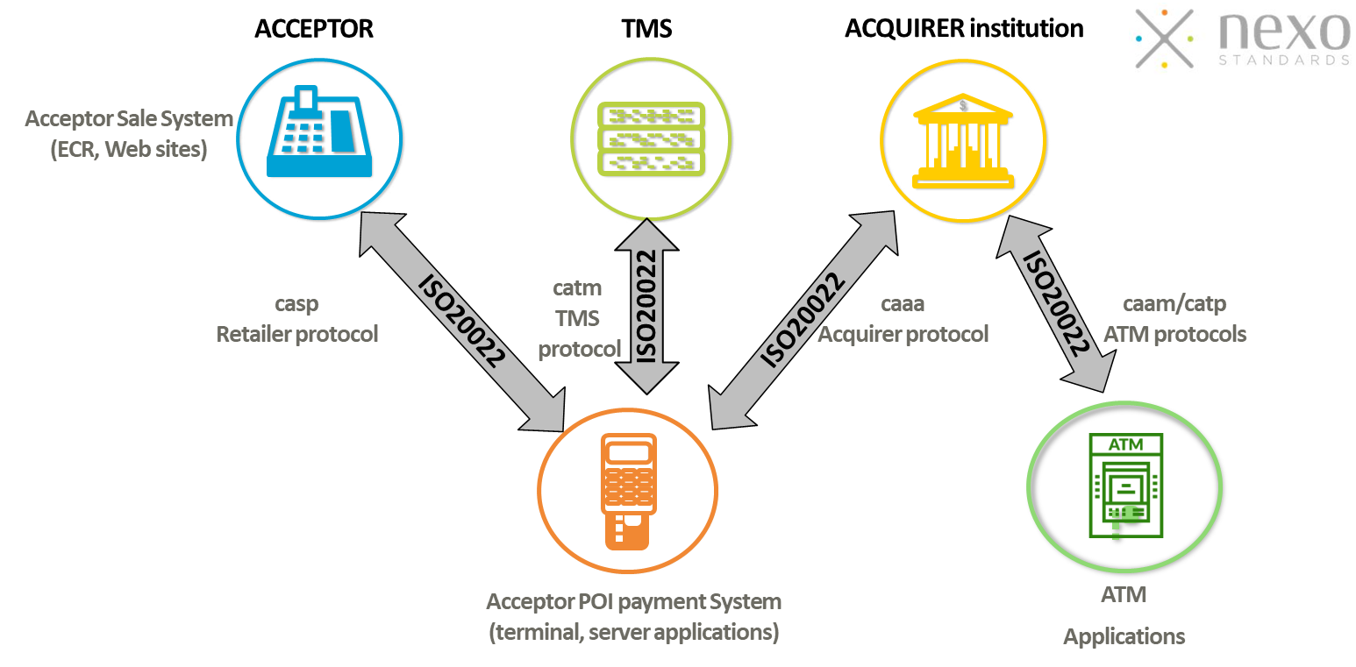
nexo standards requests ISO 20022 Registration Authority (RA) to consider this submission of the CASP messages in JSON encoding as “ISO 20022 compliant using a domain specific syntax” being in line with the interoperability approach already approved by the RA on June 4th, 2008, for previous nexo A.I.S.B.L. Business Justification.

Use cases: No new use cases or message definitions are required.

Responsible SEG: The evaluation of the nexo standards candidate ISO 20022 messages, once developed, will still be done by the Cards and Related Financial Services Standards Evaluation Group, as usual.

Schemas in scope: schemas for Sale to POI protocol are required in JSON notation as well as in XML notation. Once published, all new CRs impacting these schemas should result in enhancement in both notations.

Technical characteristics (based on Draft ISO 20022 Resource Definition Report v1)
Transport protocol: HTTP version 1.1
TLS version 1.2 or higher
Applicative Protocol: REST
Characterset: UTF-8
Data formats: JSON
Data model Origin: ISO 20022
Identifier naming convention: ISO 20022 abbreviation
nexo standards API – URI structure
- https://<domain>/<ISO message name>/<MUG version>/<Automatic Resources>[/<resourceId>]
Note that <resourceId> is optional and will be used to retrieve the data of the resource itself.
Examples
- Example 1: loging to a POI in CASP would be:
https://<domain>/CASP.005.001.02/5.1/LoginRequest
- Example 2: retrieving the entered data on a sale system or POI in CASP would be:
https://<domain>/CASP.005.001.02/5.1/InputRequest/<resourceId>
Full URI example : https://api.vendor.com/casp.001.001.07/10/PaymentRequest

nexo standards API Resource Listing
CASP
casp.001.001.07/2025/PaymentRequest
casp.001.001.07/2025/ReversalRequest
casp.001.001.07/2025/LoyaltyRequest
casp.001.001.07/2025/BatchRequest
casp.001.001.07/2025/BalanceInquiryRequest
casp.001.001.07/2025/EnableServiceRequest
casp.001.001.07/2025/LoyaltyRequest
casp.001.001.07/2025/CardAcquisitionRequest
casp.003.001.07/2025/ReconciliationRequest
casp.005.001.07/2025/SessionManagementRequest
casp.007.001.07/2025/AdministrativeRequest
casp.009.001.07/2025/ReportRequest
casp.011.001.07/2025/Abort
casp.012.001.07/2025/EventNotification
casp.013.001.02/2025/Reject
casp.014.001.07/2025/StatusRequest
casp.016.001.07/2025/DisplayRequest
casp.016.001.07/2025/InputRequest
casp.016.001.07/2025/PrintRequest
casp.016.001.07/2025/PlayResourceRequest
casp.016.001.07/2025/SecureInputRequest
casp.016.001.07/2025/InitialisationCardReaderRequest
casp.016.001.07/2025/CardReaderAPDURequest
casp.016.001.07/2025/PowerOffCardReaderRequest
casp.016.001.07/2025/TransmissionRequest
- Purpose of the new development:
In today’s card or payment industry, many stakeholders already have, provide or use interfaces and connections to various entities that are part of the payment value chain.
From the relationship or the exchanges between a merchant and its payment processor (PSP, Processor or Acquirer), being the electronically exchange of data / messages between a Point of Sale system and a payment Point of Interaction (POI), multiple interfaces or connections’ types are used and available, today, complicating the life of all parties having to support multiple interfaces, connections, and format.
The Sale to POI protocol has been designed to ease these exchanges, provide a common ground, and fulfil the interoperability needs. Such interaction can occur on Sale System (ECR/POS) to POI or by eCommerce/mCommerce to POI as well.
Our association outreach in several markets to gather input on ISO 20022 implementation has identified that most of both the point-of-sale systems providers and payment processors (PSP, Processors, Acquirers) prefer to use JSON over XML when they convert to
ISO 20022.
We have seen advantages of using JSON including the prevalence of use by developers and all the tools available. Today, nexo standards’ members report an increase in the use of JSON notation in the implementation of ISO 20022 protocols delivered by nexo standards (Cards Standard).
This is specifically the case for Sale to POI protocol (CASP) where JSON notation was supported as an alternative to XML before the Sale to POI protocol (CASP) was converted in ISO 20022 messages. JSON notation has been adopted by large payment processors and software vendors, implementing the previous version of Sale to POI protocol (not ISO 20022). Without the support of JSON notation/API in ISO 20022 format, these companies might not migrate to the new version of the protocol. If no guidance is given on the use of JSON, there is a risk that these companies develop their own JSON version of the protocol, which may end up with interoperability challenges.
As nexo standards’ protocols using ISO 20022 are used by both Acquirers and Retailers POS System, we recommend keeping interoperability facilitated by using the same tag name in both JSON and XML messages. We want to use the abbreviation name for both messages and API system to ensure interoperability and harmonization.
API and JSON notation are topics now considered by many participants of the ISO 20022 ecosystem, nexo A.I.S.B.L. is now seeking the approval of this Business Justification by the ISO 20022 community, the RA, RMG and Cards and Related Financial Services to enhance all or most of its published ISO 20022 messages as well of future’s one.

- Community of users and benefits:
Parties who require and or are candidate users include:
- Merchants and their point-of-sale systems vendors, merchant’s payment processors (PSP, Processors, Acquirers).
- Point of interaction software vendors (e.g. terminal software vendors)
- All other stakeholders as soon as the market requires JSON notation.

Community of users:
Basically, there may be no difference in the typology of users supporting XML or JSON encodings (merchants and acceptors). Some communities of users have expressed a clear preference for API & JSON, while some others have requested the possibility to rely preferably or even exclusively on XML.
As far as the Sale to POI Protocol is concerned (casp messages), and taking into account the current competitive environment, one could even anticipate that major payment processors could propose to their merchants the possibility to support both XML and JSON encodings in their commercial offer.

- Benefits/savings:
  - Access to a set of standards meeting current technology requirements and making use of standards (ISO 20022 schema) shared within and across the payment industry. Benefits would accrue to all market participants and would be the result of broad market uptake and reach.
  - A global solution – based on a robust methodology - which will ease the further certification process of protocol components.
  - The proposed standard will contribute, to a large extent, to the creation of a worldwide level playing field, among point-of-sale systems and payment service providers and will increase competition (or implementation).
- Adoption scenarios:
Participants would have a universal, standards-based alternative to the current state.
- Volumes:
For the Sale to POI protocol, the current volume is already significant, due to JSON support in previous (not ISO 20022) versions of the protocol. So that volumes would likely reach credible levels within 3 years of schema introduction. nexo standards’ latest member survey has found that its specifications and protocols are powering over 5 billion payment transactions per year, representing over 416 million payments per month.
The survey also revealed the scale of nexo standards’ global presence, with live deployments in over 26 countries across APAC, Africa, Europe and North and South America.
We could assume these volumes could apply to API & JSON notation in the future or by supporting an API approach, implementation and deployment would be eased and volume would mostly increase.

- Timing and development:
The urgency of the development:
- There is an immediate need for the availability of ISO 20022 schema in JSON notation. Deferring action will result in market inefficiencies from competing standards and propriety alternatives.
The expected consequences of a delay:
- Companies keeping use of previous version of Sale to POI protocol and deciding to make the previous version evolve in a proprietary and non-interoperable way, for their own purpose.
- Companies providing their own version of ISO 20022 messages with JSON notation, without considering interoperability.
- Reduced standardization in the payment acceptance markets (Cards) and divergence from ISO standards.
Dates:
- Publication of the next version, of the Sale to POI protocol schema, version “10.0” or “2025” -millesimal version being the new standard at nexo- (version 7 in ISO repository) related to CAPE maintenance 2024-2025, is requested, in JSON and XML. The JSON notation version of these schemas should be made available for pre-publication pilot at Q1 2026.
- We are in the process of socializing this with other card industry participants and would welcome involvement by RMG members and others.
Involvement of organisations in the development process:
nexo standards is an international not-for-profit, open association; its membership represents the full spectrum of payment stakeholders including merchants and other payment acceptors, processors, card schemes, payment service providers and vendors.
Protocols and specifications enable a consistent user experience at the point of interaction between multiple payment types, delivering a fast and familiar payment service to customers. The nexo standards ecosystem was and will be involved in the development process as we are being doing for the last years as a Submitting Organization.
This development would be integrated into the roadmap of the association Technical Working Groups delivery and would follow ISO 20022 Development and Change Request process and governance.
Other standards initiative addressing the same requirements:
nexo standards is not aware of any other initiatives in the ISO 20022 ecosystem (TC68/SC 9) looking to support API & JSON Sale to POI payment acceptance exchanges and hope this Business Justification would be viewed as a good proposal to make this approach possible.

- Commitments of the submitting organisation:
The submitting organisations commit to provide resources to support these developments and maintain the resulting schema. As the request is to produce existing schema in an alternative notation, we would expect the submitters to retain ownership.
nexo standards confirm that it can and will:
- Support development of Sale to POI API as well as protocol schema in XML and JSON syntax.
- Test the results to confirm they are fit for purpose
- Address any queries related to the description of the models and messages as published by the RA on the ISO 20022 website

nexo standards confirm that:
- It intends to organise testing of the candidate messages once they have been reviewed and qualified by the RA and before their submission to the SEG(s) for approval.
- Is committed to undertake any future message maintenance related to application of this new syntax.
- It confirms knowledge and acceptance of the ISO 20022 Intellectual Property Rights policy for contributing organisations, as follows:
  - “Organizations that contribute information to be incorporated into the ISO 20022 Repository shall keep any Intellectual Property Rights (IPR) they have on this information.
  - A contributing organization warrants that it has sufficient rights on the contributed information to have it published in the ISO 20022 Repository through the ISO 20022 Registration Authority in accordance with the rules set in ISO 20022.
  - To ascertain a widespread, public and uniform use of the ISO 20022 Repository information, the contributing organization grants third parties a non-exclusive, royalty-free license to use the published information”.

- Contact persons:
- Catherine Boundjia – nexo standards – email:
catherine.boundjia@nexo-standards.org
- Normand Provost – nexo standards – email:
normand.provost@nexo-standards.org

- Comments from the RMG members and relevant SEG(s) or SubSEG(s) for disposal of comments by the submitting organisation:
This section will include the comments received from RMG members and the SEG(s), SubSEG(s), API SEG, BMST and/or TSG, if any, and the response given to each of these comments by the submitting organisation.

Comments submitted by Martin Walder (martin.walder@six-group.com) on behalf of the TSG (received on 30/12/2025):
1.) From the submission, it is not always clear if and when the respective messages are translated into JSON as messages or as API resources (only one or both). This should be clarified and explicitly stated.
2.) The TSG assumes that the submitter will use the “Generation of JSON Schema Draft 2020-12 for ISO 20022:2013” white paper for the syntax definition, published on https://www.iso20022.org/iso-20022-whitepapers
This should be clearly stated. Furthermore, the TSG expects the submitter to provide feedback and discuss potential changes with the TSG.
3.) The TSG assumes that the submitter will also use the “ISO 20022 and Web APIs: An Implementation Best Practices White Paper” and asks the submitter to provide feedback and input for a potential next version.
Disposition of comments from the submitting organisation:

Comments submitted by Rainer Vogelgesang (rainer.vogelgesang@six-group.com) on behalf of Switzerland (received on 08/01/2026):
Please find our Swiss comments in the separate file attached.
Link to file: 2026-01-08-Swiss-comment-to-BJ-281-API-Resources-for-Sales-to-POI-final.pdf
Comments extracted from the PDF File:
The SASFS welcomes the initiative of nexo A.I.S.B.L. (nexo standards) to propose, by means of BJ 281, the development of ISO 20022 API resources in order to base the nexo standards protocols on ISO 20022 API resources. Although the SASFS supports the intent of the BJ, there are a number of details for which we recommend further clarification as follows:
- Clarification of the type of request
The BJ is classified as a request for development of ISO 20022 API resources. Nevertheless, there are several mentions of requests for development of messages. See highlighted in yellow below: page 2: Other payment messages (caaa, caam, catp, catm) also require supporting API & JSON notation. page 2: nexo standards requests ISO 20022 Registration Authority (RA) to consider this submission of the CASP messages in JSON encoding as “ISO 20022 compliant using a domain specific syntax” being in line with the interoperability approach already approved by the RA on June 4th, 2008, for previous nexo A.I.S.B.L. Business Justification. page 2: The evaluation of the nexo standards candidate ISO 20022 messages, once developed, will still be done by the Cards and Related Financial Services Standards Evaluation Group, as usual. Page 5: As far as the Sale to POI Protocol is concerned (casp messages), and taking into account the current competitive environment, one could even anticipate that major payment processors could propose to their merchants the possibility to support both XML and JSON encodings in their commercial offer. Page 7: It intends to organise testing of the candidate messages once they have been reviewed and qualified by the RA and before their submission to the SEG(s) for approval. Is committed to undertake any future message maintenance related to application of this new syntax. If, contrary to expectations, the development of ISO 20022 messages is intended, such request should be submitted as a separate business justification and all mention of ISO 20022 message development should be removed from BJ 281 or explicitly marked as out-of scope of BJ 281.
- Physical syntax JSON
The BJ makes reference to the alternative syntax JSON as a message syntax. The current edition of ISO 20022 natively supports XML and ASN.1 only. Page 2: nexo standards requests ISO 20022 Registration Authority (RA) to consider this submission of the CASP messages in JSON encoding as “ISO 20022 compliant using a domain specific syntax” being in line with the interoperability approach already approved by the RA on June 4th, 2008, for previous nexo A.I.S.B.L. Business Justification. Page 6: Publication of the next version, of the Sale to POI protocol schema, version “10.0” or “2025” -millesimal version being the new standard at nexo- (version 7 in ISO repository) related to CAPE maintenance 2024-2025, is requested, in JSON and XML. The JSON notation version of these schemas should be made available for prepublication pilot at Q1 2026. Page 7: The submitting organisations commit to provide resources to support these developments and maintain the resulting schema. As the request is to produce existing schema in an alternative notation, we would expect the submitters to retain ownership. Page 7: It intends to organise testing of the candidate messages once they have been reviewed and qualified by the RA and before their submission to the SEG(s) for approval. Is committed to undertake any future message maintenance related to application of this new syntax. If the development of new (or existing) ISO 20022 messages in JSON as a domain-specific syntax is intended, the SO should create a separate business justification to request the development of the proposed messages. It should be clarified in such a separate BJ whether the SO intends to develop, submit and subsequently own the transformation rules for JSON as a domain-specific syntax. If however the SO intends to submit the request to develop ISO 20022 messages in JSON notation (i.e. not as a domain-specific syntax), it should await the publication of the next version of ISO 20022 which is understood to support such alternative syntax notations as well as the pertinent registration procedures that are to support development requests for alternative message syntaxes.
- Significance of the term ‘protocol schema’
Throughout the BJ, the term ‘protocol’ and ‘protocol schema’ is extensively used. It would be helpful, if, in a next version of the BJ, it could be outlined whether such protocol schema designates ISO 20022 messages or otherwise.
- Proposed evaluation committees
The BJ proposes the Cards SEG to review the BJ and the proposed ISO 20022 API resources. Page 2: Responsible SEG: The evaluation of the nexo standards candidate ISO 20022 messages, once developed, will still be done by the Cards and Related Financial Services Standards Evaluation Group, as usual. In view of the request to develop API resources and the interdependency with existing messages in XML syntax and future messages proposed to be developed in JSON as an alternative syntax, it is recommended to add the API SEG and the TSG in the review of the BJ and the proposed API resources.
We look forward to the responses of the SO to the points raised above and remain available for further considerations in relation to this BJ.

Disposition of comments from the submitting organisation:

--oOo--

