Business Justification
for the development of new ISO 20022 financial repository items

- Name of the request:
Bilateral Securities Market Claims

- Submitting organisation:
Securities Market Practice Group (SMPG)

- Scope of the new development:
This Business Justification aims at requesting a suit of ISO 20022 messages to support bilateral market claims whereby the entitled party (or its asset servicer) can instruct the other party (or its asset servicer) a new or replacement market claim and being informed if its counterparty has alleged/matched the claim. The sender is the account holder, and the receiver is the account servicer.
The SMPG Corporate Actions (CA) Working Group (WG) has identified the below business needs:
- to instruct a new or replacement market claim;
- to provide the details of an alleged market claim;
- to cancel/remove an allegement of a market claim;
- to request the list of all outstanding market claims (report) – the intention is to have a generic request for CA related reports;
- to provide the list of all outstanding market claims (report).

We believe these needs can be addressed by creating a series of five new messages.

Actors and Roles:
- Executing/Servicing Party
The party reporting the creation and settlement of claims
- Instructing Party
The party instructing the cancellation or creation of claims.

Instructing Party | Executing/Servicing Party
Central Securities Depository (CSD) participants (custodian/asset servicer) and their underlying clients | Central Securities Depository, any CSD participant (custodian/asset servicer)

We have summarised the communication flow between the instructing party and the executing/servicing party to:
- instruct a bilateral claim
- provide the status of such bilateral claim instruction (existing message)
- provide the details of an alleged bilateral claim instruction once the executing party has alleged it to the other party
- remove an alleged bilateral claim instruction once the other party has sent its instruction or to cancel an alleged bilateral claim instruction once the instructing party has subsequently cancelled its instruction
- OPTIONAL – request a list of all outstanding market claims
- OPTIONAL (based on subscription) – to provide the list of all outstanding market claims (report).

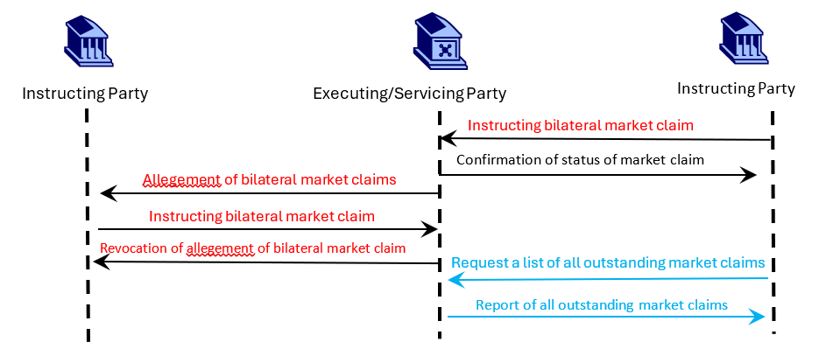

In view of the scope, we propose that the new message definitions be part of the ‘seev’ Business Area and be evaluated by the Securities SEG.

- Purpose of the new development:
According to the European standards for transaction management as per the Corporate Actions Joint Working Group (CAJWG) and T2S Corporate Actions Sub-Group (T2S CASG), CSDs and CCPs are to generate market claims for affected settlement transactions, starting after close of business on record date and continuing for a period of 20 business days.

In case the CSD doesn’t offer an automated market claim functionality or, for whatever reason, the claims haven’t been automatically raised, the two counterparties must have the option to instruct the claim in the CSD using an ISO message (once available). The counterparty also needs to be informed that a claim has been alleged against them so to action accordingly.

- Community of users and benefits:
The categories of parties/actors that would use/benefit from the new messages are:

Instructing Party | Executing/Servicing Party
CSD participants and their underlying clients | CSD, any CSD participant (custodian/asset servicer)

- Benefits/savings: There is currently no message support for bilateral market claims processing and it needs to be done manually. These new messages would enhance STP.
- Adoption scenario: the new messages would be introduced on SWIFTNet FINplus as of SWIFT Standards Release 2027 (SR 2027), if possible.
- Volumes: The exact number in Europe cannot be determined, however, both in Euroclear UK & International and T2S, daily volumes are significant.
- Sponsors and adopters: SMPG CA WG member countries in the EEA, Switzerland and the UK sponsor the request. The adoption will be left to each CSD in the relevant country.

- Timing and development:
The intention is to submit the models to the RA as soon as the business justification is approved.
The development will be based on the requirements collected by the SMPG CA WG and will involve the CA experts of the joint ISO 15022/ISO 20022 maintenance working group.

- Commitments of the submitting organisation:
SMPG confirms that they can and will:
- undertake the development of the candidate ISO 20022 business and message models that it will submit to the RA for compliance review and evaluation. The submission will be compliant with the ISO 20022 Master Rules and include a draft Part 1 of the Message Definition Report (MDR) compliant with the ISO 20022 Master Rules provided by the RA, the ISO 20022 Message Transport Mode (MTM) that the submitting organisation recommend to consider with the submitted message set, and examples of valid instances of each candidate message;
- address any queries related to the description of the models and messages as published by the RA on the ISO 20022 website.
The submitting organisation confirms that they will promptly inform the RA about any changes or more accurate information about the number of candidate messages and the timing of their submission to the RA. If the submitting organisations do not submit the candidate messages within the timing announced in section F and do not inform the RA beforehand, the business justification may lapse and require re-submission of a new business justification for approval by the RMG.
The submitting organisations do not intend to organise any testing of the candidate messages once they have been reviewed and qualified by the RA and before their submission to the SEG for approval.
The submitting organisations confirm that they are committed to undertake the future message maintenance.
The submitting organisations confirm their knowledge and acceptance of the ISO 20022 Intellectual Property Rights policy for contributing organisations, as follows.
“Organizations that contribute information to be incorporated into the ISO 20022 Repository shall keep any Intellectual Property Rights (IPR) they have on this information. A contributing organization warrants that it has sufficient rights on the contributed information to have it published in the ISO 20022 Repository through the ISO 20022 Registration Authority in accordance with the rules set in ISO 20022. To ascertain a widespread, public and uniform use of the ISO 20022 Repository information, the contributing organization grants third parties a non-exclusive, royalty-free licence to use the published information”.

- Contact persons:
Miriam Ortseifen, SMPG CA-WG facilitator
Email Address: miriam.ortseifen@swift.com

Mariangela Fumagalli, co-chair SMPG CA-WG
Email Address: mariangela.fumagalli@bnpparibas.com

Christine Strandberg, co-chair SMPG CA-WG
Email Address: christine.strandberg@seb.se

- Comments from the RMG members and relevant SEG(s) and disposition of comments by the submitting organisation:
This section includes the comments received from RMG members and the SEG(s), if any, and the response given to each of these comments by the submitting organisation.

Comments submitted by the Swiss community
To ease the reading of the comments, it has been kept in a separate document because it includes diagrams. 2 options to access the file:
- Double-click on the icon below to open the PDF file.
- Access the file using a separate url: here
Reply from the submitting organisation:

