Business Justification
for the development of new ISO 20022 financial repository items
Note: the purpose of this document is to give guidelines to organisations that want to develop new candidate ISO 20022 message definitions. Such requests are subject to the approval of a business justification by the ISO 20022 Registration Management Group (RMG). Please consult the iso20022.org website for additional details on the registration process. The business justification must include the following captions, as described. Business justifications are to be sent via e-mail to iso20022ra@iso20022.org

- Name of the request:
Consolidated tape provider data reporting (transmission and dissemination)
- Submitting organisation(s):
European Securities and Markets Authority (ESMA)
201-203 rue de Bercy
75012 Paris
France
- Scope of the new development:
According to the Regulation (EU) No 600/2014 of the European Parliament and of the Council on markets in financial instruments (MiFIR), Consolidated Tape Providers (CTPs) are entities authorized to provide the service of collecting market data from trading venues and approved publication arrangements (APAs), and of consolidating those data into a continuous electronic live data stream. This service is intended to improve market transparency, by allowing market participants to access a comprehensive and real-time view of financial instruments' details across different exchanges and platforms. However, several barriers prevented the effective establishment of CTPs, including the lack of commercial incentives for potential applicants, insufficient quality in terms of harmonization of market data and lack of clear reporting instructions. The latest legislative amendment to MiFIR, here after referred to as the “MiFIR review”, was published in the Official Journal of the European Union on 8 March 2024 and entered into force on 28 March 2024. The MiFIR review changed several provisions with the aim to remove the obstacles preventing the establishment of CTPs. It requires ESMA to develop several new Regulatory Technical Standards (RTS) and to revise existing ones.
Regarding the definition of clear reporting instructions and data quality requirements for CTPs and their data contributors, Article 22b of MiFIR mandates ESMA to define:
- minimum requirements for the quality of the transmission protocol for the transmission of data to the CTPs;
- measures to address erroneous trade reporting and enforcement standards in relation to data quality;
- what constitutes the transmission of the data as close to real time as technically possible;
- the data needed to be transmitted to and disseminated by the CTP in order for it to be operational, including their substance and formats, in accordance with prevailing industry standards and practices.
Further details on the definitions and legal aspects of the proposed reporting requirements are specified in the draft Regulatory Technical Standards (RTS) and related Annex provided in the Final Report published by ESMA in December 2024. However, at the time of submitting this Business Justification, these RTSs have not yet entered into force. They are still subject to the endorsement of the European Commission, followed by a review by the European Parliament and the Council, before they can become legally binding.
A single CTP will be selected by ESMA for each of the three asset classes: bonds, equities - covering both shares and Exchange-Traded Funds (ETFs) -, and OTC derivatives.
It is expected for the bond CTP to be authorised in the second half of 2025, for the equity CTP to be authorised in the first half of 2026 and for the OTC derivatives CTP to be authorised between Q4 2026 and Q1 2027.
All CTPs will disseminate two sets of data:
- Core market data, i.e. post-trade data useful for market participants to make informed investment decisions (e.g. price and quantity of a given instrument traded on a given exchange), with the equity CT also providing some pre-trade data (e.g. EU best bid and offer of a given instrument).
- Regulatory data, i.e. information on the status of the financial instrument (e.g. suspension or trading halt) and the status of the exchange (e.g. market outage).
While regulatory data are newly developed, core market data largely rely on existing fields currently prescribed by existing technical standards about transparency requirements (Commission Delegated Regulation (EU) 2017/587 (RTS 1) for equity and Commission Delegated Regulation (EU) 2017/583 (RTS 2) for non-equity), with certain fields to be developed. However, while core market data largely already exists in practice before the MiFIR Review, it has not yet been published in a consolidated way so far and has been done so by individual Trading Venues (TVs) and Approved Publication Arrangements (APAs).
MiFIR Review is therefore introducing a new reporting process that has not previously existed in the EU. The CTP framework represents a significant structural change to the way market transparency data is reported and disseminated, requiring the participation of a large number of market entities, including TVs, APAs, CTPs, and market participants who will consume the consolidated data.
To ensure the success and efficiency of this new reporting framework, it is essential to standardize the transmission of data between data contributors, CTPs, and end users. Given the scale of market participants affected and the critical importance of accurate, high-quality and fast data transmission and dissemination, the submitting organisation proposes the development of new ISO 20022 logical messages specifically designed to support the CTP data exchange process.
The submitting organisation expects to develop a number of logical messages for CTP input and output data including:
  - Core market data consisting of dynamic data to be updated continuously and consisting of pre-trade (only for equities) and post-trade data
  - Regulatory market data consisting of static data, to be submitted only when there is change and consisting of the status of individual instruments and of a system matching order

The proposed business area for the various sets of logical messages is “auth”.
Furthermore, the existing auth.031 logical message can be used to transmit the acknowledgement and feedback related to transmitted data.
The new logical messages will use the ISO 20022 Business Application Header (BAH) without repeating header elements within the logical message.
The submitting organisation supports the ability to transform the logical messages into more than the default ISO 20022 XML syntax. This approach is based on the principle of ensuring flexibility and interoperability across a diverse range of market participants expected to transmit data to the CTP with varying technical infrastructures. Prescribing only one specific syntax, such as XML, may impose unnecessary constraints on certain market participants, particularly those with high-frequency and low-latency trading environment. Indeed, as the draft RTS on Consolidated Tape input and output data does not prescribe a specific syntax for input and output data but does require these data to be to be standardised and aligned with ISO 20022 methodology. Thus, the future logical messages would also be expected to be interoperable with other industry standard syntaxes.
Based on the scope, the submitting organisation proposes to assign the Securities Standards Evaluation Group (SEG) for the evaluation of the new logical messages and potential changes to the ISO 20022 Business Model that may be required to support the transmission and dissemination of data.
- Purpose of the new development:
The CTP framework has yet to be established, and there are currently no standardized logical messages for the transmission of data between data contributors (i.e., Trading Venues and APAs) and the CTP, nor for the dissemination of consolidated data by the CTP to market participants. To ensure efficient and structured communication, ISO 20022 logical messages need to be developed.
Data contributors will be required to provide the CTP with core market data and regulatory data. Some core market data elements already exist under the transparency requirements and are already produced by data contributors. Other core market data elements, along with all regulatory data, need to be newly developed, as there are no existing reporting standards or structured logical message syntaxes for them.
Since no operational CTP exists today in the EU, there is no established model for transmitting the required data by EU market participants. In current market practice, data contributors use different syntaxes (including other industry standards and proprietary formats) when reporting market data, leading to fragmentation and inconsistencies across trading venues and APAs. The absence of a common and non-proprietary messaging standard (as would be one derived from the ISO 20022 Business Model) creates risks of misalignment, inefficiencies, and delays in delivering accurate, real-time information to market participants. Experience from other regulatory reporting regimes, such as MiFIR transaction reporting, EMIR (European Market Infrastructure Regulation), and SFTR (Securities Financing Transactions Regulation), has demonstrated that the adoption of ISO 20022 messages significantly improves implementation efficiency and data quality. In these frameworks, the use of standardized messages has facilitated data integration, automated validation, and enhanced comparability of data reported by multiple reporting entities. As mentioned in the Section C, the MiFIR Review RTS on Consolidated Tape input and output data does not mandate a specific syntax but requires the data to be standardized and aligned with ISO 20022 methodology. Indeed, given the varying market practices and their level of maturity across different asset classes, adherence to a single syntax when transmitting the data to the data center of a CTP is not necessary where well-established market practice already exists, e.g. in the case of the equity asset class. Therefore, the ability to transform ISO 20022 logical messages into alternative syntaxes should be possible to accommodate for data contributors deploying the logical messages in different syntaxes according to existing market practices.
- Community of users and benefits:
The development of ISO 20022 logical messages for the CTP framework will have a broad impact on multiple categories of market participants, including data contributors, the CTP itself, and CTP users.

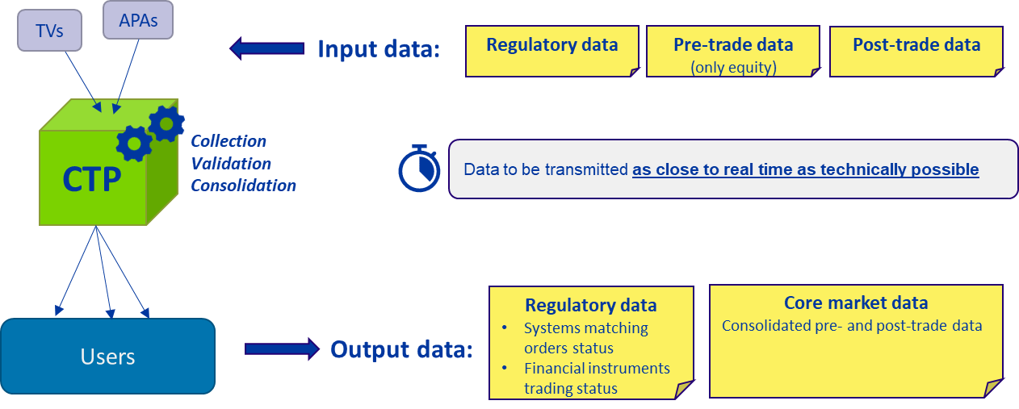
Figure 1: Schematic representation of CTP input and output data flows
As illustrated in the Figure 1, the CTP plays a central role in aggregating and disseminating financial market data from multiple sources, including Trading Venues (TVs) and Approved Publication Arrangements (APAs). The CTP is responsible for the collection, validation, and consolidation of market data, ensuring it is transmitted to users as close to real time as technically possible.
This structured data exchange process ensures that market participants—including investors, ESMA, National Competent Authorities (NCAs), researchers, and data vendors—can access accurate, high-quality, and harmonized financial information in a timely manner. The development of ISO 20022 logical messages is essential to support this process, ensuring standardization, efficiency, and interoperability across market participants.

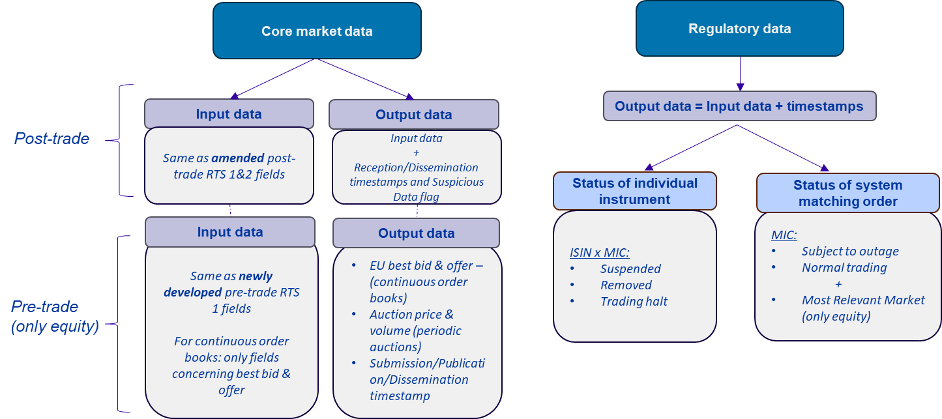
Figure 2: Types of data processed by the CTP
The data processed by the CTP can be broadly categorized into core market data and regulatory data, each with distinct input and output specifications.

Core Market Data
Core market data consists of both post-trade and pre-trade data (with pre-trade data applicable only to equity instruments).
Post-trade data is mainly derived from amended versions of existing RTS 1 and RTS 2 fields, which regulate transparency requirements for equity and non-equity instruments, respectively. Data contributors, including TVs and APAs, will provide post-trade information according to these updated standards. The CTP, in turn, validates, consolidates from multiple contributors, enriches with timestamp information, and disseminates this data, attaching a timestamp to indicate when the data was received and published, as well as a flagging any suspicious data quality issue.

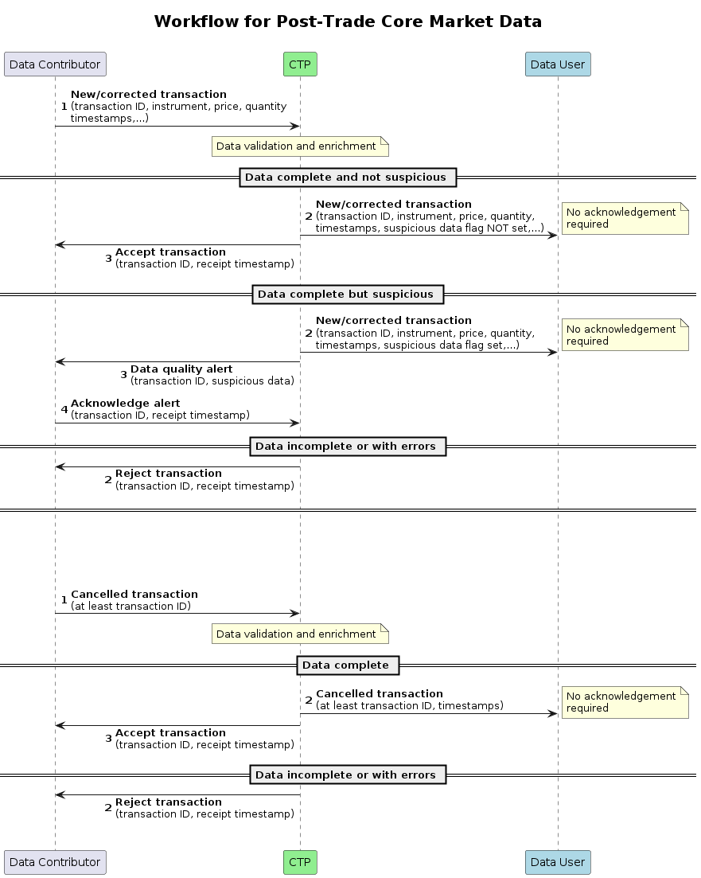
Figure 3: Workflow for post-trade core market data

Pre-trade data applies exclusively to equity instruments and is based on newly developed pre-trade RTS 1 fields. For continuous order books, the CTP will collect only data elements that relate to the best bid and offer, ensuring that the most relevant price level (i.e., “Top of the Book”) are available to market participants. The output from the CTP will include consolidated EU best bid and offer (BBO) information, as well as details from periodic auctions, such as auction price and traded volume. Additionally, the CTP will ensure transparency by including timestamps for submission, publication, and dissemination of the data.

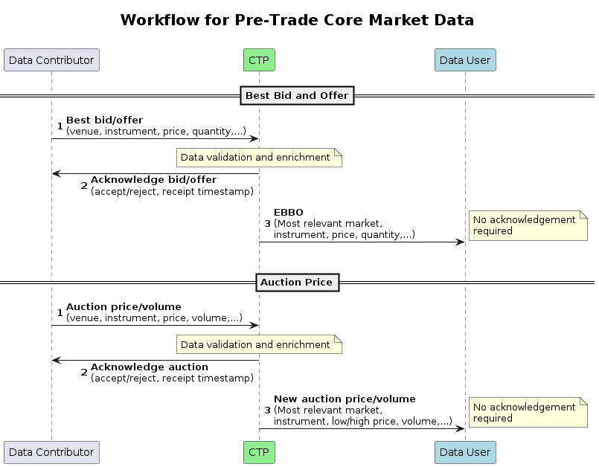
Figure 4: Workflow for pre-trade core market data

Regulatory Data
In addition to core market data, the CTP will also process regulatory data, which is essential for informing market participants about trading conditions and potential disruptions. Unlike core market data, regulatory data follows a one-to-one transmission model, meaning that the input data received from trading venues and APAs is transmitted directly back as output data by the CTP, including only enrichment with timestamps.
Regulatory data will cover two key areas:
- The status of individual financial instruments, providing updates on whether a given instrument has been suspended, removed from trading, or is subject to a trading halt. This information is structured using ISINs (International Securities Identification Numbers) and Market Identifier Codes (MICs) to specify the affected instruments and trading venues. Additionally, for equity instruments, this dataset will identify the most relevant market for trading under prevailing conditions.

- The status of system matching orders, offering transparency on the operational status of trading systems. This includes notifications on whether a trading venue is experiencing an outage or operating under normal trading conditions.
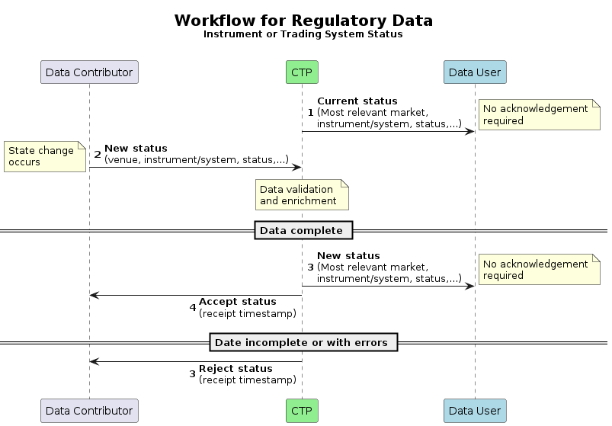
Figure 5: Workflow for regulatory data

To ensure efficiency in the transmission, processing, and dissemination of data, the input and output data exchanged within the CTP framework must adhere to standardised formats that align with the principles set out in a dedicated Regulatory Technical Standards (RTS).
On the input side, data contributors are required to transmit data in a format that adheres to the ISO 20022 methodology. This approach facilitates efficient reception and processing of input data, streamlining the CTP’s ability to consolidate and disseminate market data while maintaining cost efficiency. Given that ISO 20022 is already widely adopted in regulatory reporting, its implementation within the CTP framework will further enhance data comparability and consistency across asset classes. However, recognising that market practices and levels of technological maturity differ across asset classes, the requirement to adhere to a single syntax at the physical level is not necessary in cases where well-established market practices already exist. Additionally, considering that CTPs must process and disseminate data in real time, the choice of syntax should also be appropriate for low-latency transmission needs. Supporting multiple syntaxes, including those optimised for speed and efficiency, ensures that the CTP framework can handle the high-volume nature of market data without introducing unnecessary bottlenecks or delays.
On the output side, the dissemination of consolidated data must cater to varied user needs by ensuring that data is accessible in both machine-readable and human-readable formats. To achieve this, the CTP will be required to provide output data in multiple channels, ensuring accessibility across different levels of technological capability. Specifically, the data must be made available in:
- An ISO 20022 methodology-compliant format, enabling advanced data analysis and seamless integration into automated systems;
- CSV format, catering to users with less advanced technological capabilities who require structured but easily readable data;
- A Graphical User Interface (GUI), ensuring that human users can easily interpret and interact with the data in a visually accessible format.
By harmonizing input data transmission and offering diverse output formats, the CTP framework enhances data consistency, accessibility, and usability across the financial industry, ensuring that all market participants—from institutional investors to regulatory bodies and retail users—can effectively leverage the consolidated data.
The benefits, adoption expectations, volumes, and sponsorship details for each group of stakeholders involved in the CTP framework are outlined below.

Data Contributors (TVs and APAs)
Benefits and expected savings
The availability of standardized ISO 20022 logical messages offers data contributors multiple benefits:

- Operational efficiency: By adopting a common data reporting standard, data contributors can streamline workflows and reduce manual processing efforts, by reducing inefficiencies associated with managing multiple proprietary data formats. This would lead to faster data transmission and automated processing.
- Better data quality: A harmonised reporting framework reduces the risk of data inconsistencies, duplication, and errors by ensuring that information is structured, validated, and standardized across all contributors. The use of ISO 20022 logical data elements and validation rules enhances data integrity, helping to detect and flag potential reporting discrepancies early in the process.
- Cost reduction: Standardisation lowers IT maintenance costs, by eliminating the need to support multiple regulatory formats. It minimizes system complexity, lowers compliance costs, and reduces the financial burden of maintaining customized data transformation processes.

Adoption scenario
The adoption or integration of messaging standards that adhere to ISO 20022 by trading venues and APAs will require updates to their existing data transmission infrastructure. Given that many contributors already comply with other MiFIR reporting obligations using various structured formats, transitioning to ISO 20022 offers synergies that can be leveraged, though it will still require dedicated implementation efforts.
It is expected for the bond CTP to be authorised in the second half of 2025, for the equity CTP to be authorised in the first half of 2026 and for the OTC derivatives CTP to be authorised between Q4 2026 and Q1 2027.
Since compliance with CTP reporting obligations will be mandatory for data contributors once CTPs are designated, adoption rates are expected to be high.

Estimated volume
The number of message instances generated by data contributors will depend on market activity and asset class coverage. Estimated volumes include:
- Post-trade data submissions: several millions of message instances per day, given the high transaction volume in equity and bond markets.
- Pre-trade data (for equities): high-frequency order book updates, especially for venues with significant trading activity.
- Regulatory data: a lower volume compared to trade data but critical for market operations, particularly for suspensions, trading halts, and system outage notifications.
Given the real-time nature of CTP reporting, trading venues and APAs will need to process and transmit data within milliseconds, making efficiency and reliability essential.

Sponsors and expected adopters
The adoption or integration of messaging standards that adhere to ISO 20022 by data contributors will be closely monitored by ESMA and NCAs, as they are responsible for overseeing compliance with MiFIR transparency requirements and CTP reporting obligations. Their role as supervisors ensures that data contributors’ implementation of the standardised reporting framework stays within the required timeline, facilitating a smooth implementation process.
Given that reporting to CTPs will be a mandatory requirement, adoption is expected to reach 100% coverage among eligible data contributors following full CTP implementation.

Consolidated Tape Providers
Benefits and expected savings
The availability of standardized ISO 20022 logical messages brings CTPs several key benefits:
- Operational efficiency: a harmonized messaging standard will enable CTPs to process and consolidate data more efficiently, reducing complexity in handling multiple proprietary formats from different trading venues and APAs. Standardisation will also streamline data validation and normalisation, leading to higher quality outputs.
- Cost reduction: implementing a uniform data format minimizes IT and operational costs by reducing the need for custom data transformation processes. Indeed, standardization will also provide an opportunity for CTPs to no longer need to develop and maintain multiple data ingestion pipelines, lowering infrastructure expenses.
- Improved data quality: by requiring structured input and output formats, the ISO 20022 standard ensures greater consistency in market data, reducing errors, and improving traceability.

Adoption scenario
CTPs will need to fully integrate ISO 20022 messaging standards into their operational frameworks. Given that each CTP will be designated for a specific asset class (bonds, equities, OTC derivatives), adoption will occur in alignment with the CTP authorization timeline for each asset class.
The timeline for CTP implementation by asset class is outlined in previous sub-sections
Since compliance with ISO 20022 messaging standards will be a core requirement for CTPs, adoption will be universal among designated providers.

Estimated volume
The three designated CTPs - one for bonds, equities, and OTC derivatives - will each handle large-scale data transmission as they collect, consolidate, and disseminate market data in real time.
Since CTPs will process the same number of message instances as received from data contributors, their input message volume will mirror the submissions made by these entities. However, unlike data contributors, CTPs will also generate output message instances, distributing consolidated data to market participants. As a result, the total message instances volume handled by each CTP will be approximately double that of data contributors.

Sponsors and expected adopters
The adoption of ISO 20022 messaging standards by CTPs will be mandated by regulatory requirements, ensuring full implementation once CTPs are designated. ESMA, by performing its role of supervisor of CTPs, will oversee compliance and integration of the standardized format within each CTP’s operations.

Since CTPs will be selected through a competitive designation process, each appointed provider will be required to support ISO 20022 standards from the outset. Adoption will therefore be universal among all designated CTPs.

Users of the CTP data
Benefits and expected savings
The adoption of ISO 20022-based messaging standards within the CTP framework will provide significant advantages to a wide range of users, including investors (both retail and professional), ESMA and NCAs, researchers, and data vendors.
- Improved market transparency: users will have access to consolidated, high-quality market data, reducing fragmentation and enabling better-informed investment decisions.
- Regulatory oversight: ESMA and NCAs will be able to access real-time, harmonized market data, allowing them to monitor market conditions and compliance of supervised entities more effectively.
- Enhanced research and data analysis: Researchers and academic institutions will benefit from standardized, structured datasets, making financial market analysis more efficient and comparable across different asset classes.
- Streamlined data integration for data vendors: Market data vendors will be able to ingest and redistribute CTP data in a standardized format, reducing the need for complex data transformations and enabling faster integration into trading platforms, risk management systems, and analytics tools.
However, only users with advanced analytical capabilities, such as institutional investors, data vendors, and regulatory authorities, are expected to rely on ISO 20022 messages directly. These entities typically rely on structured, machine-readable data for automated data analysis.
For other user groups—such as retail investors and less technologically sophisticated institutions—the preferred means of accessing CTP data will be simpler formats like CSV files and graphical user interfaces (GUI), which do not require specialized data processing capabilities.

Adoption scenario
CTP users will progressively integrate standardised market data into their existing systems as each CTP becomes operational. Given the diverse nature of users, adoption patterns will vary based on technological readiness and specific use cases.
Institutional investors, regulators and data vendors will likely adopt ISO20022-compliant formats early on. Retail investors and less advanced users will benefit from CSV and GUI-based data access.

Estimated volume
Since users will consume the same consolidated data produced as output data by CTPs, the total volume of message instances delivered to users will be equivalent to the number of logical messages processed by CTPs in the context of its output data.
Sponsors and expected adopters
While there is no legal obligation for users of CTP data to develop systems to ingest the ISO 20022 methodology-compliant messages disseminated by the CTPs, users who use large amount of this data will have an interest to do so. Furthermore, the new Regulatory Technical Standard (RTS) for the MiFIR review on input and output data of CTPs, once endorsed by the European Commission, will enforce the obligation for the CTPs to make instructions available to the public explaining how to easily access and use the data. Additionally, the targeted users of CTP data are either industry participants or supervisors and regulators. These types of actors are already well acquainted by ISO 20022 and should have systems already geared towards these types of messages, facilitating the adoption of these new messages. Finally, the RTS is expected to enter into force 6 months before the first CTP (bond CTP) will be authorised giving users of CTP data enough time to prepare their systems towards these new messages.
These three points will ensure a large-scale adoption of the messages by the targeted category of users.

- Timing and development:
The submitting organisation is expecting to submit the logical messages by end of Q2 / early Q3 2025 to allow some time for market participants to gear their systems to incorporate these logical messages. The submitting organisation has already started involving standards organisation (ISO) and industry representatives in this process.
With the expected authorisation of the first CTP (for bonds), by the end of year 2025, any delay beyond that would put at risk the capacity of market actors to gear their systems towards transmitting data to the CTP and for and thus the functioning of the CTP as a whole.
There are no other known standards initiatives involved in an effort to address the same requirements.
- Commitments of the submitting organisation:
The submitting organisation confirms that it can and will:
- undertake the development of the candidate ISO 20022 business and logical message models that it will submit to the RA for compliance review and evaluation. The submission must be compliant with the ISO 20022 Master Rules and include a draft Part 1 of the Message Definition Report (MDR) compliant with the template for MDR part 1 provided by the RA, the ISO 20022 Message Transport Mode (MTM) that the submitting organization recommends to consider with the submitted logical message set, and, optionally, examples of valid and invalid instances of each candidate logical message. The submission may also include a Message User Guide (MUG) to complement the MDR and describe in further details how to use the different possibilities/options of the proposed candidate logical messages;
- address any queries related to the description of the models and logical messages as published by the RA on the ISO 20022 website.
The submitting organisation confirms that it will promptly inform the RA about any changes or more accurate information about the number of candidate logical messages and the timing of their submission to the RA.
The submitting organisation confirms it will inform the relevant market participants on the CTP logical messages but it does not intend to organise any testing of the candidate logical messages once they have been reviewed and qualified by the RA and before their submission to the SEG(s) for approval.
The submitting organisation confirms it is committed to undertake the future logical message maintenance.
The submitting organisation confirms its knowledge and acceptance of the ISO 20022 Intellectual Property Rights policy for contributing organisations, as follows.
“Organizations that contribute information to be incorporated into the ISO 20022 Repository shall keep any Intellectual Property Rights (IPR) they have on this information. A contributing organization warrants that it has sufficient rights on the contributed information to have it published in the ISO 20022 Repository through the ISO 20022 Registration Authority in accordance with the rules set in ISO 20022. To ascertain a widespread, public and uniform use of the ISO 20022 Repository information, the contributing organization grants third parties a non-exclusive, royalty-free licence to use the published information”.

- Contact persons:
Lukasz Popko
Email lukasz.popko@esma.europa.eu
Tel: +33635458585

Stefano Marotta
Email stefano.marotta@esma.europa.eu

- Comments from the RMG members and relevant SEG(s) or SubSEG(s) and disposition of comments by the submitting organisation:

Comments submitted by Clearstream:
Topic 1. Fast Track route
Questions to ESMA:
- Since ESMA has applied for ISO 20022 certification on a fast-track application, kindly elaborate on the reason(s) to apply the fast-track process for ISO registration? Please elaborate on the background for its speedy processing and why has a standard processing not taken into account?
Reply from submitting organization:
We would like to clarify that ESMA has not submitted this ISO 20022 message development request under the fast-track procedure. Instead, the application has followed the standard ISO 20022 registration process.
As understood at the last Securities SEG meeting (17/July/2025) this question may stem from a misunderstanding linked to the update of another message (auth.044), which was also performed by ESMA and indeed it did go through a fast-track process under different governance and context. The question was discussed at the SEG meeting where the other message was reviewed.

Topic 2. Timeline and impact on market participants
We understand that ESMA’s business justification refers to a “new ISO standard for real-time data contributions to CTP’s under MiFIR”, such as for Equities (shares and EFTs), Bonds, and OTC derivatives. It would affect data contributors (Trading Venues – TVs - and Approved Publications Arrangements – APAs) and Consolidated Tape Providers (CTPs) alike, and this already for implementation in early 2026.

- While the document remains slightly unclear in some areas, it seems that from an IT perspective TVs and APAs would have to completely convert their market data feeds and platforms to this new standard, aiming to standardize the “communication” between "TVs/APAs and CTP" and "CTP and CTP users" (see p. 3, point D.) in a way currently not existing to the best of our knowledge, other than between APAs and investment firms (bi-directional set-up, including public data feeds). It is questionable why trading venues would need to be integrated here as well.
- The proposal that for more developed markets, such as equity markets, syntax does not need to change, but ISO 20022 logical messages should be implemented for flexible usage, will still create a significant impact on the industry, both in relation to cost as well as in time.
- This may be even more so the case as equity and bond data are often being disseminated via the same technical set-up of a trading venue.
- Real-time data feeds are only one-directional, but not bi-directional as proposed by ESMA on page 6 and/or page 8 of ESMAs Business Justification for the development of new ISO 20022 Financial Repositories.
- Special hardships should be expected for smaller players in the market.
- The timeline for implementation seems extraordinarily short for the industry, even under an ISO fast-track application.
Reply from submitting organization:
The entire proposal underpinning ESMA’s request to develop a new ISO standard for CTP data transmission is based on a clear legal mandate. The concept of CTP is introduced in MiFIR, and the new requirements regarding data transmission stem from the MiFIR review concluded in 2024. Specifically:
- Article 22a sets out the obligation for trading venues and APAs to provide real-time data to CTPs in a harmonised format;
- Article 22b mandates ESMA to develop regulatory technical standards for the format and quality of such data.
The draft technical standards were developed by ESMA following a public consultation and finalised in December 2024 (presented in its Final Report) and have been adopted by the European Commission in June 2025 (RTS on CTP data and Annexes). Following the scrutiny of European Parliament and Council, the publication of the technical standards in the Official Journal is expected in October 2025.
Please find below a reply for each of the RWG comments:

Trading venues as data contributors
Trading venues are explicitly included as data contributors under Article 22a(1) of MiFIR. Their inclusion is not discretionary, but a direct consequence of the legal obligation established in Level 1 legislation.

Format requirements and flexibility
In developing the message format proposal, ESMA aimed to strike a balance between the need for flexibility advocated by industry participants and the requirement for harmonised data formats mandated under Article 22a. This is detailed in Section 3.2.2 of ESMA’s Final Report on the Consolidated Tape, which outlines the rationale for using ISO 20022 logical structures while allowing flexibility in physical encoding formats.

Bi-directional communication
Article 10(4) and 10(7) of the RTS on CTP data foresee that CTPs shall acknowledge receipt of data from data contributors, and flag any data quality issues to them.
For this reason, the data exchange model described in the Business Justification correctly includes a bi-directional communication layer, not for market data publication, but for operational and data quality-related feedback between CTPs and data contributors.

Impact on small players
While the requirements stem from regulation, Article 22a(2) and (3) of MiFIR introduce specific proportionality measures for small trading venues, i.e. for such venues, reporting to the CTP is optional. Additionally, under Article 27h(6), small trading venues that choose to report to the equity CTP benefit from priority in CTP revenue redistribution.

Timeline
The implementation timeline is not defined by ESMA, but by the MiFIR legislative framework. The first CTP (i.e. the bonds CTP) is expected to become operational in early 2026, as per the deadlines established in the Regulation. For more details about the envisaged timeline, please read ESMA’s reply to the last comment submitted by RMG.
As the implications for the industry might be significant, if not major, both in cost and time required, have all affected parties been consulted / informed upfront and made aware about these comprehensive requirements and the impact by this?
Reply from submitting organization:
The industry has been extensively consulted by ESMA on this topic, throughout the finalisation of the MiFIR review and the development of the related technical standards.
First, in preparation for the policy mandates to be assigned to ESMA, an external study was commissioned by ESMA on the assessment of the suitable data formats and transmission protocols for the purpose of the CTPs, which evaluated also the implementation feasibility and the level of adoption of each proposal. This study included targeted consultations with future data contributors (trading venues and APAs) as well as potential CTP applicants.

Additionally, before the official publication of the proposed draft technical standards, ESMA organised dedicated workshops with future data contributors and potential CTP applicants. These workshops collected technical and operational feedback on various requirements, including those related to data transmission formats and protocols.
In line with ESMA’s standard process, a Consultation Paper on the draft technical standards was published in May 2024, followed by an open hearing in June 2024.
All feedback received during this public consultation was thoroughly analysed and summarised in the Final Report, published in December 2024.
These multiple phases of engagement ensured that the affected parties were informed and able to contribute meaningfully to the development of the requirements, including those impacting cost and implementation timelines.

Trading venues public real-time data feeds are already highly standardised and only submit surveilled market data. However, they are not set-up in a bi-directional manner, as in case of APAs (due to their different nature). Any changes to such a set-up would be major, timely and costly. Has this been considered by ESMA, and if yes, why are these changes required?
Reply from submitting organization:
As noted previously, all those requirements are the result of regulatory changes introduced by the MiFIR review, in particular Article 22a, which mandates that data from trading venues and APAs be transmitted to the CTP in a harmonised manner.
The study commissioned by ESMA on data formats and transmission protocols identified a high degree of fragmentation across the market in terms of architecture, content, and technical interfaces. This fragmentation makes it challenging to consolidate data effectively and reliably.
The requirement for harmonisation is not only aimed at improving data, but also reflects economic and technical considerations. As highlighted in Recital 16 of the MiFIR review, the hypothetical current system, where CTPs must negotiate separate licensing and technical arrangements with each data contributor, has proven to be costly, time-consuming, and a major barrier to the emergence of a consolidated tape.
Implementation costs were considered by ESMA during the development of the proposals. Both the external study on suitable data formats and ESMA Final Report on the RTS for CTP evaluated implementation options based on feasibility, market adoption, and associated cost implications for stakeholders. At the same time, it is necessary to strike a balance between minimising industry burden and meeting the regulatory requirements introduced by the MiFIR review.

Has ESMA estimated as well any impact on current data users in terms of cost and time challenge, and if so, what has been the result of the exercise?
Reply from submitting organization:
Specific CTP data users have not been identified at this stage, as the CTP framework is currently being established and not yet operational. As such, the actual users of CTP data, their profiles, and their technical integration needs are not yet clearly known.
Nevertheless, during the consultation process on the draft technical standards, ESMA explicitly welcomed input from all segments of the market, including potential future data users such as investment firms, buy-side participants, and data vendors. While only a limited number of such stakeholders submitted feedback, their input has been analysed and is reflected in the Final Report published in December 2024.
The individual responses received are publicly available at the following link: MiFIR Review Consultation Package (Consolidated Tape Providers and Data Reporting Service Providers)

Has an impact and cost/benefit analysis been made by ESMA on all these points, and could that analysis be made available to relevant stakeholders?

Reply from submitting organization:
In addition to the previously mentioned external study on suitable data formats and transmission protocols, where implementation cost, feasibility, and the current level of market adoption were key evaluation criteria, ESMA also conducted a Cost-Benefit Analysis (CBA) as part of the development of the draft technical standards.
The detailed CBA is publicly available in Section 7.2.1 of the Final Report, published in December 2024.

How has the proposed reporting been considered in its implementation timeframe, in light of the expected MiFIR readiness compliance expected from the data contributors?
Reply from submitting organization:

The implementation timeline for the CTP is not determined by ESMA, but is defined directly in MiFIR as amended by the MiFIR Review, particularly in relation to the selection and authorisation of CTPs.
According to Article 27da of MiFIR, ESMA was required to launch the selection procedure for the bond CTP by the end of 2024.
ESMA must then select a CTP within six months, and invite the selected entity to submit a formal application for authorisation without undue delay.

Under Article 27db, ESMA must assess the completeness and compliance of the application within three months of receipt, and notify its decision on granting authorisation within five working days thereafter.

Following this timeline, a CTP applicant for bonds was successfully selected in July 2025. Depending on the duration of the authorisation process, it is therefore reasonable to expect that the bond CTP will become operational around early 2026.

MiFIR foresees an identical process for the equity CTP, to be selected by the end of 2025, and the derivatives CTP, to be selected by mid-2026.

Comments submitted by FIX:
- In section C (page 3 of pdf) ESMA details that there will be 6 logical messages to be developed, we recommend that the exact number of messages should be left to the definition phase.
Reply from submitting organization:
We agree with this suggestion, and we have amended the Business Justification accordingly.

- In section E on top of page 8, second "-" point has the sentence "Additionally, for equity instruments, this dataset will identify the most relevant market for trading under prevailing conditions. " - Our understanding is this is not the case for trading systems and only for individual instruments, thus this statement should be part of the bullet point above (end of page 7).
Reply from submitting organization:
Your understanding is correct. We have corrected the typo in the Business Justification accordingly.

- In section E top of page 9, with regards to the output format allowing CSV format, does ESMA intend to define the layout of the CSV file or leave it up to the CTP provider to do that in a manner that they see fit as long as all the stipulated data elements are included? Or does ESMA expect that the CSV format to mirror the flat RTS tables?
Reply from submitting organization:
ESMA believes that this question falls outside the scope of the current request for the development of ISO 20022 messages.
If needed, ESMA may provide separate guidance at a later stage regarding the CSV format to be used by CTP for data dissemination.

- In section E middle of page 12, the second paragraph under "Adoption scenario" has duplicative "and less advanced users" text in the 2nd sentence.
Reply from submitting organization:
Thanks for your comment. We have corrected the typo in the Business Justification accordingly.

Comments submitted by the Securities SEG:
The Securities SEG acknowledges the need for new message definitions to support CTP data reporting and notes that the messages will follow ISO 20022 methodology with support for alternative syntaxes. The SEG confirms the initiative is within its evaluation scope and will be reviewed by its experts.
Reply from submitting organization: N/A

CL2014R0600EN0090010.0001.3bi_cp 1..1 – Article 2(35)
Regulation (EU) 2024/791 of the European Parliament and of the Council of 28 February 2024 amending Regulation (EU) No 600/2014 as regards enhancing data transparency, removing obstacles to the emergence of consolidated tapes, optimising the trading obligations and prohibiting receiving payment for order flow
ESMA74-2134169708-7768_-_MiFIR_review_-_Final_Report_on_CTPs_and_DRSPs.pdf
https://eur-lex.europa.eu/legal-content/EN/TXT/?uri=CELEX%3A02017R0587-20240101
https://eur-lex.europa.eu/legal-content/EN/TXT/PDF/?uri=CELEX:02017R0583-20240101

