Business Justification
for the development of new ISO 20022 financial repository items
Note: the purpose of this document is to give guidelines to organisations that want to develop new candidate ISO 20022 message definitions. Such requests are subject to the approval of a business justification by the ISO 20022 Registration Management Group (RMG). Please consult the iso20022.org website for additional details on the registration process. The business justification must include the following captions, as described. Business justifications are to be sent via e-mail to iso20022ra@iso20022.org

- Name of the request:
“Primary Bond Markets”
ISO 20022 Extension for Primary Bond Markets based on the ICMA Bond Data Taxonomy
- Submitting organisation(s):
- International Capital Market Association,
110 Cannon Street,
London EC4N 6EU, UK
- SWIFT SCRL,
Avenue Adèle 1,
1310 La Hulpe, Belgium
- Scope of the new development:
Background
Primary bond markets are used by governments, financial institutions and companies in raising capital and issuing debt in the form of a security that can be purchased by investors. The participants involved include a wide range of banks, investors, agents, clearing firms, law firms and service providers that collaborate and engage in structuring the issuance of a new bond to be offered to investors in global capital markets.
In 2021 ICMA formed the Bond Data Taxonomy (BDT) working group of industry participants to identify the primary data elements that are typically used for bond issuance. The working group brings together stakeholders across the spectrum of international debt capital markets including public sector and private sector issuers, banks, investors, market infrastructures, law firms, data providers and technology vendors. The working group engaged in a process spanning two years to establish a consensus on over 100 data elements including the element data type, restrictions, and pre-defined lists of acceptable inputs.
The key data elements defined by the working group were converted into a xsd/XML format to enable integration with systems and applications across participants. The initial release, v1.0, was delivered in March 2023. Enhancements to support DLT bond issuance were added and released in v1.2 in January 2024.
More information on the BDT including a user guide, reference spreadsheet and XML schemas is available on ICMA’s website:
https://www.icmagroup.org/market-practice-and-regulatory-policy/fintech-and-digitalisation/fintech-advisory-committee-and-related-groups/bond-data-taxonomy.

Primary bond market participants and exchange of issuance information

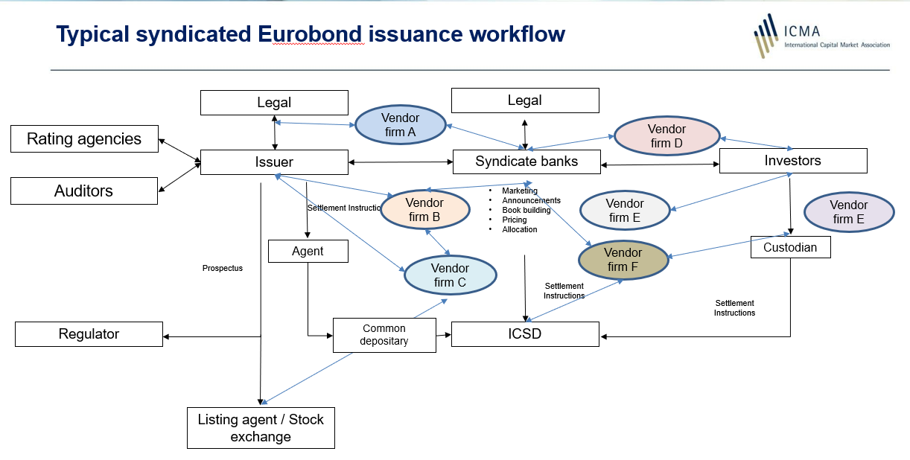

Scope
The scope of the new messages will cover workflows of origination, announcement, bookbuilding, allocations, pricing, closing, registration, clearing and settlement.

Workflow | Initiator | Recipients | Description
Origination | Underwriters | Agents, Service Providers, ICSDs | Available draft content of the offering as would be included in a prospectus including currency, nominal amount, maturity and other issuance and security information.
Announcement | Underwriters | Investors, potentially other parties such as agents, ICSDs, services providers | Initial distribution of the offering absent of final pricing.
Bookbuilding, Allocations and Pricing | Underwriters | Investors | Invitation to bid sent to dealers and investors and publication of bids.
Closing, Registration/  Clearing/Settlement(see note below) | (I)CSDs, Agents | Agent, (I)CSD, Registrar, Investors. | Acceptance of the offering, assignment of bond identifiers, payment, registration and delivery of the bond.

Proposed Message Definitions
1. Origination Message: sent to and from underwriters, law firms, agents, service providers and ICSDs to share details of the bond offering and support updates and approvals through the origination process.
2. Announcement Message: sent by underwriters to agents, service providers, dealers, investors, and (I)CSDs on the final details, ex pricing, of the new issuance.
3. Bookbuilding: sent to and from underwriters and investors to get bids and allocate the offering.
4. Closing and settlement: Registration of the security and transfer of the securities and cash (delivery vs payment) between issuer, ICSD or equivalent function, and investors.

Note: ICMA acknowledges that existing solutions, especially related to clearing and settlement, have been implemented using different data content, message standards and protocols, as such, ICMA is not proposing to replace all existing solutions but to work with industry participants and service providers to align, consolidate and standardise where possible.
ISO 20022 Business Areas:
The ISO 20022 Business Areas that may be affected and enhanced by this proposal will be:
- Securities Issuance: seis

Financial Instruments Covered:
The initial instruments covered under this proposal, as currently defined in ISO 20022,
BondTypeCode, will be:
- EUSB SovereignBond
- NESB NonEuropeanSovereignBond
- OEPB OtherPublicBond
- CVTB ConvertibleBond
- CRPB CorporateBond
- CVDB CoveredBond
- ONEP OtherNonEuropeanPublicBond

Business Roles:
- Issuers
- Underwriters
- Agents
- Law Firms
- (I)CSDs
- Investors

Business Headers:
ICMA and Swift proposeto use ISO 20022 Business Application Header. The exact number of messages is not yet known. Wherever possible ICMA will reuse existing ISO 20022 defined fields.
XML Syntax:
ICMA and Swift propose to deploy the messages in default ISO 20022 XML syntax only.
Standards Evaluation Group(s):
ICMA and Swift propose to have the Securities Standards Evaluation Group assigned to assist in evaluating the candidate ISO 20022 messages.

- Purpose of the new development:
ICMA has been setting standards in the international bond markets for more than 50 years. The Primary Market Handbook comprises ICMA Recommendations, guidance and standard language and documentation, generally relating to offers of syndicated international bonds in the primary market and is used by underwriters internationally.
While there are many software products and service providers with solutions for preparing and sharing primary issuance documents, there is no interoperable standard in a machine-readable format that encompasses all parties involved in a transaction, the details of the issuance and the attributes of the bond being offered. Most market participants still create custom forms and documents using MS Word and other similar programs.
ICMA’s Bond Data Taxonomy (BDT) provides a standardised and machine-readable language of key economic terms of a bond (such as amounts, currency, maturity, interest), key dates (such as pricing, settlement) as well as other relevant information (such as governing law, relevant parties, ratings, selling restrictions) typically included within a term sheet. Where relevant, the BDT incorporates existing ISO data definitions and formats.
The BDT as a ‘common language’ seeks to:
- Promote straight-through-processing (STP) and interoperability, from issuance, trading, settlement to distribution
- Be vendor agnostic, facilitating the exchange of data between multiple solutions and systems
- Lay a common foundation for leveraging new technologies, such as distributed ledger, and developing new services.
The BDT has been implemented or is in the process of being implemented by a range of market stakeholders both for traditional debt securities as well as tokenised debt securities.
ICMA’s BDT Working Group participants have indicated that many of their systems and applications will move to implementing ISO 20022 for other workflows and primary issuance would benefit from an ISO 20022 standard if one existed. ICMA proposes to implement the BDT model for issuance workflow using ISO 20022 message definitions.
Adoption of the proposed set of BDT primary market issuance messages would allow issuers, agents, investors and service providers to communicate in a standardised machine-readable format and allow for:
- Issuers and underwriters to communicate a new proposed bond offering to agents, law firms, investors, and (I)CSDs.
- Distribution of final offering, receiving indications of interest, allocations and final pricing.
- Posting the new offering to markets, (I)CSDs, settlement agents and registrars.
- Standardising processing of issuance by vendors and other service providers.
- Elimination of manual rekeying of issuance information across platforms.
- Straight through processing of messages from issuance to back-office systems.
- Notification of changes, events, or other actions.

Reference: ICMA Primary Market Handbook

- Community of users and benefits:
Benefits and savings for the parties:
The ICMA BDT ISO 20022 message will facilitate electronic data exchange across the primary bond markets by providing a machine-readable format that can be distributed and shared across desktop applications, back-office systems and industry clearing and settlement systems.
Banks, issuers, investors, market infrastructures and service providers will be able to improve efficiency and reduce operational costs by streamlining communication throughout the issuance process. Greater efficiency by issuers will come from not having to copy and paste data across systems and the ability to quickly share updates across the enterprise.
The BDT ISO 20022 issuance messages will bring benefits to global bond market participants:
- Issuers and banks will benefit from the ISO 20022 BDT issuance messages by having a standardised format to send issuance information to investors, agents and other service providers.
- Agents will benefit from the ISO 20022 BDT issuance messages by being able to receive issuance data and share data with banks and other agents without having to rekey data from different formats and documents.
- Service providers will benefit from the ISO 20022 BDT issuance messages by being able to aggregate and process issuance data from many different issuers across many different regions in a standardised format.
- All participants will benefit from the ISO 20022 BDT issuance messages by using standardised terminology and data formats of a debt security.
Expected volumes:
It’s estimated that annual global issuance exceeds 300,000 new bonds and over $3 trillion in par value. In the process of issuing new bonds, issuers, banks, agents, investors, market infrastructures and service providers distribute hundreds of messages related to each new issue, projecting that annually millions of messages are sent among participants.

Sponsors and adopters
It is expected that ICMA’s Bond Data Taxonomy Working Group, which brings together over 70 firms including issuers, banks, investors, market infrastructures including the ICSDs, law firms and service providers, will participate in the design, development and deployment of the new messages.

Adoption scenario:
Adoption by market participants will take place in parallel with existing systems and message formats. Participants can immediately make use of the new message for internal platforms and with service providers that have adopted the new BDT message.

User Group | Adoption Scenario
Issuers | Integration with term sheet application.  Assignment of underwriters and law firms.  Sharing updates with underwriters.
Underwriters | Communicating to service providers, investors and ICSDs.
Agents | Receiving notifications and updates from banks and other agents.
(I)CSDs | Receiving registration information.
Investors | Receiving machine-readable announcements and term sheets.
Service Providers | Receiving new issue term sheets and sharing with relevant stakeholders.

- Timing and development:

- ICMA and Swift plan to begin message development and registration in 2025.
- ISO 20022 message models and message definitions are due to be submitted 2025.

- Commitments of the submitting organisation:
ICMA and Swift confirm that it can and will:
- undertake the development of the candidate ISO 20022 business and message models that it will submit to the RA for compliance review and evaluation. The submission must be compliant with the ISO 20022 Master Rules and include a draft Part 1 of the Message Definition Report (MDR) compliant with the template for MDR part 1 provided by the RA, the ISO 20022 Message Transport Mode (MTM) that the submitting organization recommends to consider with the submitted message set, and, optionally, examples of valid and invalid instances of each candidate message. The submission may also include a Message User Guide (MUG) to complement the MDR and describe in further details how to use the different possibilities/options of the proposed candidate messages;
- address any queries related to the description of the models and messages as published by the RA on the ISO 20022 website.
ICMA and Swift confirm that it will promptly inform the RA about any changes or more accurate information about the number of candidate messages and the timing of their submission to the RA. If the submitting organisation does not submit the candidate messages within the timing announced in section F and does not inform the RA beforehand, the business justification may lapse and require re-submission of a new business justification for approval by the RMG.
ICMA and Swift confirm that it intends to organize any testing of the candidate messages once they have been reviewed and qualified by the RA and before their submission to the SEG(s) for approval. In such a case, the submitting organisation must indicate when the testing is expected to complete, and the candidate messages be re-submitted to the RA for SEG(s) approval. The submitting organisation must confirm that it will promptly inform the RA about any changes or more accurate information about the timing of this re-submission to the RA. If the submitting organisation does not re-submit the candidate messages as announced and does not inform the RA beforehand, the business justification may lapse and require re-submission of a new business justification for approval by the RMG.
ICMA and Swift confirm that it is committed to undertake the future message maintenance.
ICMA and Swift confirm its knowledge and acceptance of the ISO 20022 Intellectual Property Rights policy for contributing organisations, as follows.
“Organizations that contribute information to be incorporated into the ISO 20022 Repository shall keep any Intellectual Property Rights (IPR) they have on this information. A contributing organization warrants that it has sufficient rights on the contributed information to have it published in the ISO 20022 Repository through the ISO 20022 Registration Authority in accordance with the rules set in ISO 20022. To ascertain a widespread, public and uniform use of the ISO 20022 Repository information, the contributing organization grants third parties a non-exclusive, royalty-free license to use the published information”.

- Contact persons:

ICMA Contacts:

Gabriel Callsen
Senior Director
Fintech and Digitalisation
110 Cannon Street, London EC4N 6EU
phone: 020 7213 0334 I M: +44 7387 411 100
email: gabriel.callsen@icmagroup.org

Tom Healey
Consultant
FINXIS LLC
445 Park Avenue, Suite 958
New York, NY 10022
email: tom.healey@icmagroup.org

Swift Contacts:

Karin De Ridder
Swift Product
Avenue Adèle 1, 1310 La Hulpe, Belgium
email: Karin.deridder@swift.com

Christopher Bredin
Swift
Standards
The Corn Exchange, 55 Mark Lane, London, EC3R 7NE
Email: Christopher.Bredin@swift.com

- Comments from the RMG members and relevant SEG(s) or SubSEG(s) and disposition of comments by the submitting organisation:

Comment1 from FIX:
ICMA acknowledged that existing solutions in the market today use "different data content, message standards and protocols" and ICMA "is not proposing to replace all existing solutions but to work with industry participants and service providers to align, consolidate and standardise where possible." FIX asks that ICMA and SWIFT reconsider the requirement that the messages will be in "ISO 20022 XML syntax only". The requirement that this BJ produce ISO 20022 XML message syntax only gives an impression that contradicts the statement "not proposing to replace all existing solutions". It is unclear the motivation for "ISO 20022 XML syntax only" given existing standards and protocols are in use.
FIX is used today to facilitate clients/investors indicating their interest in a new issue to the underwriter/syndicate, and allocation of the issue to the investor once priced. FIX is the predominant standard implemented by Order Management Systems typically used by investor front offices and middle offices. FIX proposes alignment and standardization at the business/conceptual model and logical model where the ICMA workflows overlap with where FIX is used today, and where existing conceptual business components and elements exists that they are reused.
Interoperability is key to ensure cost to the industry is not increased by recommending a certain syntax for the entire bond issuance process when investments have already been made to use other protocols by the market participants.
It should also be noted that several ICMA members are also FIX members.
Answer from the submitter:
We want to thank the FIX organization for their consideration and comments on the business justification proposal to incorporate ICMAs Bond Data Taxonomy into the ISO 20022 standard.

In response to your comments, our intention is not to exclude other standards but to clarify the scope of the ISO 20022 initiative that will support the XML format and not ASN.1 format for ISO 20022. At the same time ICMA will continue to support the BDT in separate XML and json formats. We intend to also work with other standards organization to incorporate the BDT as would be the case with FIX or other standards. We agree that supporting the BDT in other standards will further increase adoption and facilitate automation end-to-end. As noted in your comments many FIX components could be reused to expand FIX for bonds and primary issuance. We would like to suggest organizing a meeting with the FIX committee to discuss incorporating the BDT into the FIX standard.

We hope this addresses your concerns and are open to any further comments. We look forward to engaging with FIX on this initiative.

