Business Justification
for the development of new ISO 20022 financial repository items
Note: the purpose of this document is to give guidelines to organisations that want to develop new candidate ISO 20022 message definitions. Such requests are subject to the approval of a business justification by the ISO 20022 Registration Management Group (RMG). Please consult the iso20022.org website for additional details on the registration process. The business justification must include the following captions, as described.
Business justifications are to be submitted through the ISO 20022 website through following e-request, in which this template must be attached.
- Name of the request:
“Order Book Data Exchange”
- Submitting organisation(s):
European Securities and Markets Authority (ESMA)
201-203 rue de Bercy
75012 Paris
France
- Scope of the new development:
Background
During the November 2015 meeting, members of MDSC discussed the issue of order data access and exchange under MiFIR Article 25(2). At that meeting it was concluded that priority should be given to the preparatory work for transaction reporting and this issue should be considered later on. Members of MDSC resumed the discussion on the preparation for the implementation of MiFIR Article 25(2) in September 2016.
At the September 2016 meeting, MDSC agreed that more clarity on the legal framework was needed before a new system for the exchange of order data can be developed. It was agreed that ESMA Legal should be involved in the assessment of the requirements under Article 25(2) on the basis of key questions identified by MDSC in cooperation with MISC.
At a meeting in 2017, a MISC/MDSC note defining the outstanding legal questions that would set the boundaries of possible arrangements for the exchange of order data was reviewed by ESMA’s legal departments and approved by both committees.
During the DSC in May 2021, AFM presented a new project. An informal working group was established by interested NCAs with the aim to study and set up a mechanism for order book data exchange. AFM, AMF, DFSA, FIN FSA and FSMA are part of this group.
Scope:
This new development is based on
Regulation (EU) No 600/2014 of the parliament and the of the council of 15 May 2014 on markets in financial instruments and amending Regulation (EU) No 648/2012 amended by:
- Regulation (EU) 2016/1033 of the European Parliament and of the Council of 23 June 2016
- Regulation (EU) 2019/2033 of the European Parliament and of the Council of 27 November 2019
- Regulation (EU) 2019/2175 of the European Parliament and of the Council of 18 December 2019
- Regulation (EU) 2021/23 of the European Parliament and of the Council of 16 December 2020
and specifically to
Article 25 (Obligation to maintain records)
2. The operator of a trading venue shall keep at the disposal of the competent authority, for at least five years, the relevant data relating to all orders in financial instruments which are advertised through their systems. The records shall contain the relevant data that constitute the characteristics of the order, including those that link an order with the executed transaction(s) that stems from that order and the details of which shall be reported in accordance with Article 26(1) and (3).
ESMA shall perform a facilitation and coordination role in relation to the access by competent authorities to information under this paragraph.
3. ESMA shall develop draft regulatory technical standards to specify the details of the relevant order data required to be maintained under paragraph 2 of this Article that is not referred to in Article 26.
Those draft regulatory technical standards shall include
• the identification code of the member or participant which transmitted the order
• the identification code of the order
• the date and time the order was transmitted
• the characteristics of the order, including the type of order
• the limit price if applicable
• the validity period
• any specific order instructions
• details of any modification
• cancellation
• partial or full execution of the order and
• the agency or principal capacity.
The new message will use the ISO 20022 Business Application Header (BAH) without repeating header elements within the message. This message could be complemented with additional messages in the future based on potential need needs.
The submitting organisation wants to deploy the future message in the default ISO 20022 XML syntax only.
The submitting organisation expects to develop one message for OBOOK data exchange between NCA’s
The proposed business area for the message is “auth”.
Based on the scope, the submitting organisation proposes to assign the Securities Standards Evaluation Group(s) (SEG) for the evaluation of the candidate ISO 20022 messages, once developed.
List of abbreviations:

Term | Definition
AFM | France NCA
AMF | Netherlands NCA
BAH | Business Application Header
DFSA | Danish NCA
ESMA | European Securities and Markets Authority
FIN FSA | Finland NCA
FSMA | Belgium NCA
ITMG | IT Management and Governance group
MDR | Message Definition Report
MDSC | Market Data Standing Committee
MiFIR | Regulation of the European Parliament and of the Council on markets in financial instruments
MISC | Market Integrity Standing Committee
MTM | Message Transport Modes
NCA | National Competent Authority
OBOOK | Order Book
TV | Trading Venue (covering RM, MTF and OTF).

- Purpose of the new development:
ESMA has conducted open public consultations on the draft regulatory technical standards on which this Regulation is based, analysed the potential related costs and benefits, and requested the opinion of the Securities and Markets Stakeholder Group established by Article 37 of Regulation (EU) No 1095/2010 of the European Parliament and of the Council.
Produced RTS 24() clarifies the templates to be used by TVs to maintain the details of orders covering among others the identification of the relevant parties, of the order, prices and events affecting the order as well as the standards/formats in which the details should be represented (even though it was not possible to impose a specific obligation to maintain the details according to ISO 20022 methodology, the standards/formats prescribed in the template should be compatible with such methodology).
The Guidelines are meant to support TVs in the compliance with the order record keeping provisions by providing construction of order data records field by field for various scenarios that can occur.
- Community of users and benefits:
The community of users for these new messages are the NCA’s and ESMA.
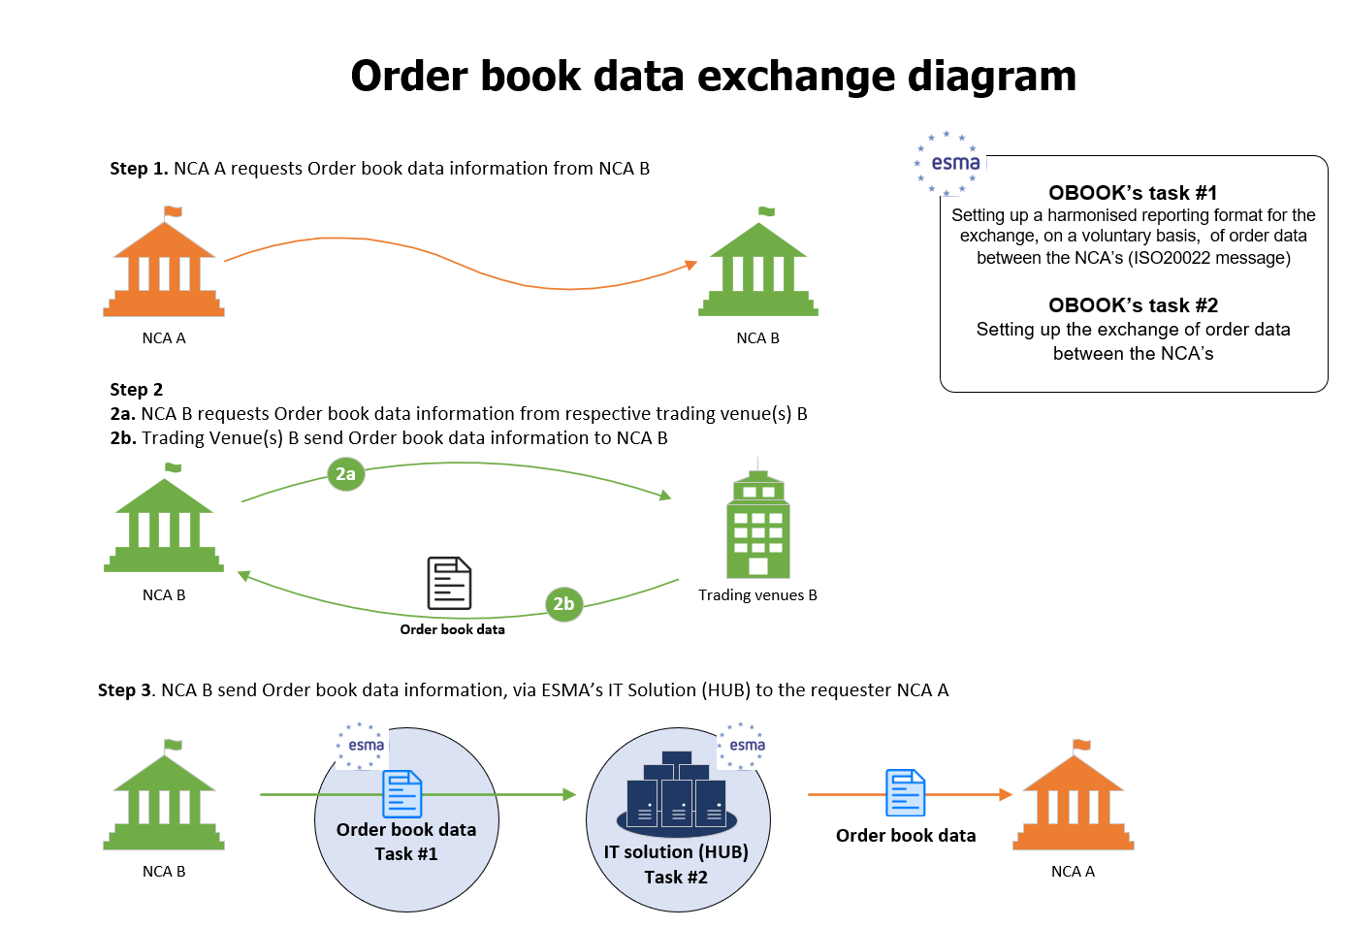
- Benefits/savings:
The proposed messages will improve the efficiency of the data to be exchanged between NCA’s as it will make use of existing ISO 20022 business concepts. At the same time ESMA will profit from the adoption of these messages as the usage of business concepts from the ISO 20022 standard will allow to apply consistent definitions and a potential future processing of the received data.
Additionally, the usage of standards is likely to improve data quality and ensure global semantic interoperability with all other ISO 20022 based systems.
- Adoption scenario:
The adoption of the new message will take place, following the implementation of OBOOK project on Q3 2023.
- Volumes:
Based on an EU survey, contacted in July 2022, the respective order book data volume, on a daily basis and per record are as follow:
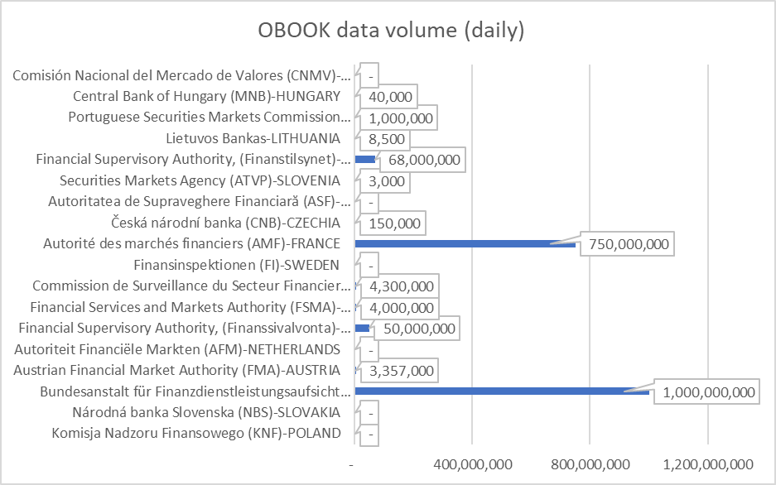

However, the actual number of OBOOK records to be exchanged will be much less than the numbers shown above, due to a limited data subset required rather than the full data set.
- Sponsors and adopters:
The OBOOK message will be used by NCA’s
- Timing and development:
The submitting organisation expect to have the message for the OBOOK, on Q1 2023.
- Commitments of the submitting organisation:
The submitting organisation confirms that it can and will:
- undertake the development of the candidate ISO 20022 business and message models that it will submit to the RA for compliance review and evaluation. The submission must be compliant with the ISO 20022 Master Rules and include a draft Part 1 of the Message Definition Report (MDR) compliant with the template for MDR part 1 provided by the RA, the ISO 20022 Message Transport Mode (MTM) that the submitting organization recommends to consider with the submitted message set, and, optionally, examples of valid and invalid instances of each candidate message. The submission may also include a Message User Guide (MUG) to complement the MDR and describe in further details how to use the different possibilities/options of the proposed candidate messages;
- address any queries related to the description of the models and messages as published by the RA on the ISO 20022 website.
The submitting organisation confirms that:
- it will inform and consult the market on the transaction reporting messages but it does not intend to organize any testing of the candidate messages once they have been reviewed and qualified by the RA and before their submission to the SEG(s) for approval.
- It is committed to undertake the future message maintenance.
The submitting organisation confirms the knowledge and acceptance of the ISO 20022 Intellectual Property Rights policy for contributing organisations, as follows:
“Organizations that contribute information to be incorporated into the ISO 20022 Repository shall keep any Intellectual Property Rights (IPR) they have on this information. A contributing organization warrants that it has sufficient rights on the contributed information to have it published in the ISO 20022 Repository through the ISO 20022 Registration Authority in accordance with the rules set in ISO 20022. To ascertain a widespread, public and uniform use of the ISO 20022 Repository information, the contributing organization grants third parties a non-exclusive, royalty-free licence to use the published information”.
- Contact persons:

- Kalomoiris Konstantinos
konstantinos.kalomoiris@esma.europa.eu

- Gosso Stephanie
stephanie.gosso@esma.europa.eu

- Comments from the RMG members and relevant SEG(s) or SubSEG(s) and disposition of comments by the submitting organisation:
This section will include the comments received from RMG members and the SEG(s) or SubSEG(s), if any, and the response given to each of these comments by the submitting organisation.

Official document - COMMISSION DELEGATED REGULATION (EU) 2017/580 of 24 June 2016 - CELEX_32017R0580_EN_TXT https://eur-lex.europa.eu/legal-content/AUTO/?uri=CELEX:32017R0580&qid=1652779142831&rid=1

