Business Justification

for the development of new ISO 20022 API resources as ISO 20022 financial repository items
Note: the purpose of this document is to give guidelines to organisations that want to develop new candidate ISO 20022 API resource definitions. Such requests are subject to the approval of a business justification by the ISO 20022 Registration Management Group (RMG). Please consult the iso20022.org website for additional details on the registration process. The business justification must include the following captions, as described. Business justifications are to be sent via e-mail to iso20022ra@iso20022.org

- Name of the request:
“Pay Later API Resources”
- Submitting organisation(s):

- SWIFT
- Berlin Group
Sponsors:
- Citi
- Google

- Scope of the new development:
The “Pay Later” API resources specify a simple instalment loan product based on ISO 20022.
The customer journey in scope for the first version of the resources would be as follows:
User selects ‘Pay by Bank’ as the method of payment during the checkout (note that this may be stored as part of the Merchant’s profile for the User)
- User authenticates with their bank
- User selects between ‘Pay Now’ and ‘Pay Later’
- User selects instalment loan terms
- User confirms instalment loan terms and accepts terms and conditions
- Merchant receives payment authorisation
- Merchant completes order with User
- Merchant receives payment from Bank, e.g. through Instant Payment scheme
- Bank services loan with User
- Also defined are basic Void and Refund flows.

Here is the technical flow illustrating the different steps:
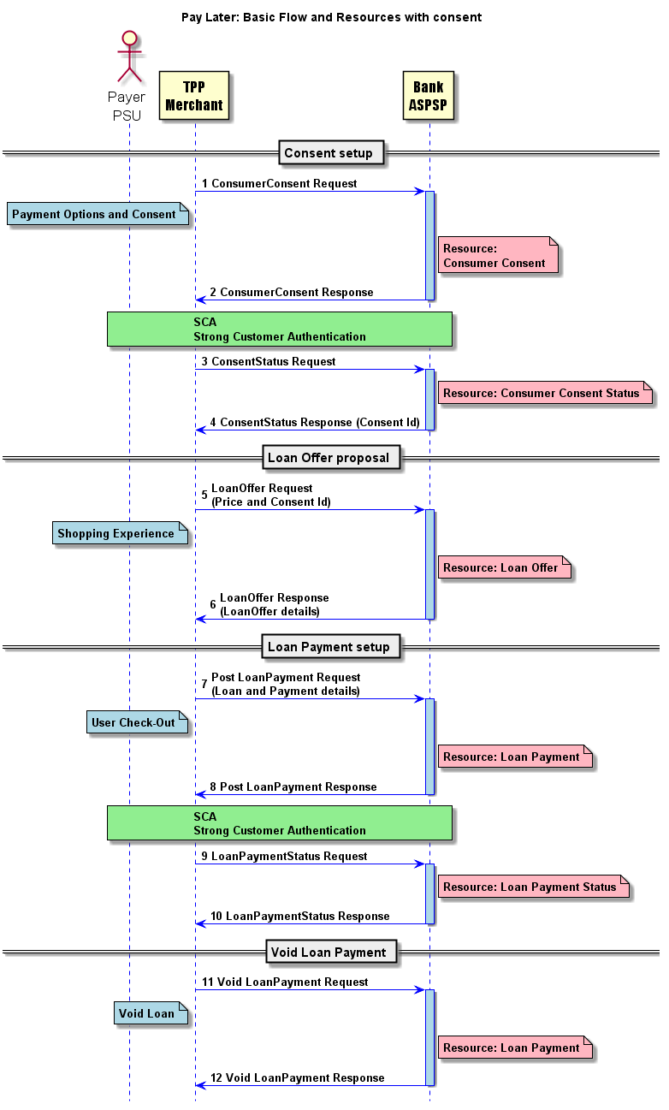

The exchanges between the customer and the bank for the Strong Customer Authentication step and for the actual loan contractual agreements remain under the bilateral relationship between the customer and its bank and are outside the scope of these resources. These could be the same authentication step as used for payment initiation.

The required API resources for the Pay Later flows have been defined as following, as already highlighted in the technical flow above:
- ConsumerConsent
- ConsumerConsentStatus
- LoanOffer
- LoanPayment
- LoanPaymentStatus

As we enter the era of ‘Banking as a Service’ delivered through APIs, Pay Later is only one piece of the puzzle. Other value added developments could be considered, in future version, for example:
- Pay Later at physical Point of Sale (POS)
- Credit line exclusively for use in one or more merchants
- Integration with Fintech wallets
- Embedded Purchase Insurance as a separately charged service
- Embedded Loyalty scheme
- Embedded multi-currency offering
- Enhanced basket level data being made available to banks
- Customer experience enhancements, such as those related to strong customer authentication
- B2B Pay Later (for buyers on an Ecommerce marketplace)
- B2B Pay Early (for suppliers on an Ecommerce marketplace)

Since the process to register ISO 20022 API resources was not yet defined when work started on Pay Later, initial development of the resources is already.
However, the submission of the resources welcomes feedback to further finetune them for truly global standardisation.
The Pay Later initiative was originally kicked-off with an initial development back in 2018, using the existing ISO 20022 elements and complementing them with new elements to fully support the Pay Later flows, and has been implemented by a number of participants of this initial development.
Since the process to register ISO 20022 compliant API resources has now been defined under ISO 20022, the submitting organisations have decided to submit those resources for registration.
Although the proposed API resources fully support the Pay Later business requirements, the intent of the submission is also to gather feedback for additional improvements to further finetune those resources for a truly global Pay Later standardisation.
We recommend that the payments standards evaluation group should evaluate the current version of the resource.
The Pay Later flows would precede payment initiation (via bank transfer of credit card) and cash reporting flows – with messages or APIs, and the ISO 20022 alignment of the core information enables this interoperability.
The current scope of the resource is not applicable to other ISO 20022 business domains (securities, FX, cards, trade finance), though it is an alternative to credit card flows and is a precedent to flows of payment initiation or credit card payment.
While the use of Pay Later is truly for APIs, several components such as the account are reusing ISO 20022 messages components, and newly created components, for example the loan, could well be reused as message components, if required in ISO 20022 message definitions.

Acronyms | Definition
PSD2 | Payments Systems Directive 2: Provides the necessary legal platform and changes to the payments framework in order to better serve the needs of an effective European payments market, fully contributing to a payments environment which nurtures competition, innovation and security to the benefits of all stakeholders and consumers in particular.
PSU | Payment Service User: The end-user (the real customer) of PSD2 services.
SCA | Strong Customer Authentication: Defined by the EBA (European Banking Authority) in its RTS (Regulatory Technical Standard) on SCA as an authentication based on the use of two or more elements categorised as knowledge (something only the user knows), possession (something only the user possesses) and inherence (something the user is) that are independent, [so] the breach of one does not compromise the others, and is designed in such a way as to protect the confidentiality of the authentication data.
AISP | Account Information Service Provider: Any (financial) provider that wishes to aggregate online account information of one or more accounts held at one or multiple ASPSPs (banks). This service can be used in accounting or generation of dashboards for a single customer.
ASPSP | Account Servicing Payment Service Providers: Provides and maintains (current, savings and card) accounts, traditionally the core business of a bank.
PISP | Payment Initiation Service Provider: Any organization (like a retailer) that can initiate credit transfers on behalf of the client.
TPP | Third Party Provider: Third party provider is the collective name for AISPs and PISPs.

- Purpose of the new development:
Pay Later aims for frictionless payments, reduced fraud and maximum buying power at point of purchase. It also allows the banks to position a solution that is at risk of being disintermediated by Fintech lenders.

- Community of users and benefits:
The Pay Later functionality can potentially be implemented by any PSP provider and thus made available on any ecommerce website that would traditionally offer other payment options.
The global buy now pay later market size was valued at $90.69 billion in 2020, and is projected to reach $3.98 trillion by 2030, growing at a CAGR of 45.7% from 2021 to 2030. (source: Allied Market Research)
Pay Later aims for frictionless payments, reduced fraud and maximum buying power at point of purchase, which is a benefit for merchants. The benefit for banks is that it allows the banks to position a solution that is at risk of being disintermediated by Fintech lenders.
The benefit of having a global standard ISO 20022 resource is less implementation variety and complexity vs many separate efforts.
Adoption scenario: Several non-ISO 20022 based implementations are live and this initiative makes a global harmonisation possible.
We expect the interest in and uptake of the ISO 20022 Pay Later resource to increase widely upon registration (Q1 2023).
- Timing and development:
While a first version of the resources is in use, having feedback from more parties will ensure registration Q1 2023 – to raise interest in the globally aligned resource vs all the separate initiatives.
- Commitments of the submitting organisation:
The submitting organisations confirm that they can and will:
- undertake the development of the candidate ISO 20022 API resource models that it will submit to the RA for compliance review and evaluation. The submission must be compliant with the ISO 20022 Master Rules and include a draft Part 1 of the ISO 20022 Resource Definition Report (RDR) compliant with the template for RDR part 1 provided by the RA and, optionally, examples of valid and invalid instances of each candidate ISO 20022 API resource.
- address any queries related to the description of the models and ISO 20022 API resources as published by the RA on the ISO 20022 website.
- promptly inform the RA about any changes or more accurate information about the number of candidate ISO 20022 API resources and the timing of their submission to the RA.
- commit to undertake the future maintenance of the ISO 20022 API resources.
- confirm their knowledge and acceptance of the ISO 20022 Intellectual Property Rights policy for contributing organisations, as follows: “Organizations that contribute information to be incorporated into the ISO 20022 Repository shall keep any Intellectual Property Rights (IPR) they have on this information. A contributing organization warrants that it has sufficient rights on the contributed information to have it published in the ISO 20022 Repository through the ISO 20022 Registration Authority in accordance with the rules set in ISO 20022. To ascertain a widespread, public and uniform use of the ISO 20022 Repository information, the contributing organization grants third parties a non-exclusive, royalty-free license to use the published information”.

Since the current version is in live production, it will not test before submission. However, feedback will be incorporated and then the updated resource will be resubmitted.
- Contact persons:
Vincent Kuntz – Vincent.kuntz@swift.com - +32 2655 3353
Tom Alaerts – tom.alaerts@swift.com +852 2107 8715
- Comments from the RMG members and relevant SEG(s) or SubSEG(s) and disposition of comments by the submitting organisation:
This section will include the comments received from RMG members and the SEG(s), SubSEG(s), API SEG, BMST and/or TSG, if any, and the response given to each of these comments by the submitting organisation.

From UK:
The scope is unclear. Please clarify the business scenario and the nature of each resource.
1)Who’s lending to whom in the Pay Later business scenario?
a) Bank to Customer, with Merchant receiving full payment on loan arrangement, and possibly receiving commission.
b) Merchant to Customer, with Bank making loan payments to merchant over time.
c) Bank to Merchant and Merchant to Customer, so that Customer has loan from merchant funded by bank.
d) Other?
Response: the loan is triggered through the PayLater flow, but the loan is established between the customer and its own bank (in the consent process, the customer will indicate which banks he is a customer of). Loans will only be proposed by the bank, is the customer is a customer of the bank.
2)Please pick one term consistently for customer/consumer/User/Payer/PSU, assuming they are one and the same, so that it is consistent with its principal role in the scenario as either a Buyer or a Borrower.
Response: we will harmonise the use to consistently define it as the customer.
3)PSU, TPP, ASPSP are PSD2 specific acronyms and should be explained and could be added to definition or semantic markup.
Response: the PayLater API resources have been developed as extensions to PSD2 requirements. We will add those acronyms in this business justification and in the RDR (Resource Definition Report) as required.
4)What is the consumer consenting to in Consent Setup?
Response: The consent is for the acceptance by the customer to allow the merchant to contact the customer’s banks to propose a loan (with maximum amount, purpose for the loan, maybe even the list of banks authorised to contact, merchant specific only or merchant’s whole consortium consent)

5)Is a Loan Payment a demand for or a receipt of payment?
Response: The LoanPayment is the request to setup the loan with all payments details for the bank to be able to pay the merchant, once the loan has been established between the customer and its bank.
6)Why request a separate status resource, when the status can be part of the same resource?
Response: we have aligned with the PSD2 resources, where the status resources are defined as separate API resources, even though they are a sub-resource of the actual resource.
7)Is this really only for use by banks and not Fintech lenders, as Section D & E implies?
Response: Correct, the current scope as an extension of PSD2, we only considered ASPSP as a bank, but other types lenders could be implemented.

From EBA CLEARING:
To avoid fragmentation and enable harmonization / interoperability, the present request for ISO20022 API resources should be based on and compatible with the ISO20022 XML resources supporting the same use cases (request to pay), in particular the pain.013/014 and other relevant messages in line with the EPC SRTP Rulebook.
Response: the request to pay is not covering the same business flows. The PayLater is to setup a loan between the customer and the bank for differed payments, through instalments. Additionally the payments elements required in the LoanPayment will contain all required message components to format a possible request to pay or payment initiation. In the current flow, this is illustrated in the diagram in step 7, the elements for the RequestToPay will be provided.

However, alternative solutions are possible to the current specific scenario. Once the loan has been granted, the merchant might issue a request to pay to the bank to initiate the payment. Or the bank may define the details in the actual confirmation of the loan (which is also outside of the scope of the current flow - the loan is established directly between the customer and the bank without intervention of the merchant – during this process, the bank could agree with the customer to directly pay the merchant after confirmation of the loan).

From STET:
I would suggest renaming the API as Pay by Loan which is more precise than Pay Later. Moreover, some actors may propose a Pay later service without any loan subscription.
Response: we should keep the known terminology “PayLater” used everywhere.
I would welcome a hierarchy of all foreseen resources. For instance I understand that a consentStatus is a subresource of the consent.
Response: agree, but this is part of the implementation, the business justification aims to provide the description of the API resources only.
By the way, the consent resource seems to be not explicit enough. I guess it is a paymentConsent but a clarification would be nice.
Response: The consent is not given for a payment, but for the acceptance by the customer to allow the merchant to contact the customer’s banks to propose a loan (with maximum amount, purpose for the loan, maybe even the list of banks authorised to contact, merchant specific only or merchant’s whole consortium consent)
Another clarification would be on multiplicity of resources. For instance, after a LoanOfferRequest, is the response embedding one or more loanDetails sets?
Response: yes – multiple responses may be coming from multiple banks if selected by the customer or one bank may provide multiple offers (different number of instalments, different durations of the loan)
What is the purpose of a void Loan? I guess its only purpose is a pretty landing of the whole process but this should be clarified.
Response: the void is to cancel a PayLater request to the bank when the loan is not confirmed by the customer within the agreed time. Additionally, not illustrated on the flow, we have also foreseen the possibility for a refund (in case of partial returns of the goods – but excluding any payments flow here). This will be further detailed in the design of the resources

From Payments SEG:
From my end the question would be if submitters envisage a new ISO 20022 (set of) message(s) for a pay later type of flow – or do they intend to re-use the data model from existing ISO 20022 messages?
Response: the PayLater resources are modelled reusing the existing ISO 20022 message definitions and components as much as possible to ensure full interoperability. There has currently been no consideration to create equivalent ISO 20022 messages, as the group was focused on the implementation for merchant websites. The API resources and the components they contain defined for the PayLater could be largely reused to develop equivalent ISO 20022 messages.
Since the loan confirmation flow is set before payment initiation, I am interested to understand which messages are being proposed for this part.
Response: the payment initiation itself is outside of the scope of the PayLater API resources (see previous answer), however the Payment Loan request will provide the required elements to initiation a payment to credit the merchant.
Do we agree that for ISO 20022 API registration, we register messages that may not be ISO 20022 linked or compliant?
Response: Registering ISO 20022 API, we do not register ISO 20022 message definitions. However, all components within the ISO 20022 API resources will be fully ISO 20022 compliant and may be reused as such in ISO 20022 message definitions.

From Norwegian banking community:
There are several overlapping initiatives going on, both in EPC and Berlin Group, and we suggest that this proposed initiative should be coordinated with these other initiatives.
Response: we will welcome any additional co-submitting organisation that wants to participate in the initiative. The Norwegian This can only improve the quality and global adoption of the API resources that will be ISO 20022 registered in the end. We already confirmed that Berlin Group is welcomed to join the effort, during the SEG review call in November 2022.

