Business Justification
for the development of new ISO 20022 API Resource
Note: the purpose of this document is to give guidelines to organisations that want to develop new candidate ISO 20022 resource definitions. Such requests are subject to the approval of a business justification by the ISO 20022 Registration Management Group (RMG). Please consult the iso20022.org website for additional details on the registration process. The business justification must include the following captions, as described. Business justifications are to be uploaded at www.iso200222.org

- Name of the request:
C2B* Bank Guarantee** API resources

- Submitting organisation(s):
Swift

- Scope of the new development:
The proposed API resource encompasses the full lifecycle of a trade finance bank guarantee in the corporate to bank space. This includes the application, amendments, extensions or pay, demands and final release.
The ISO 20022 business area is Trade services and the TSEG should be aware of evaluation.
There are four resources foreseen:
- BankGuarantee (includes application, issuance, amendments)
- Demand
- ReductionRelease
- Events which users can poll to retrieve new updates for information or for request for action
The customer journey of interacting with the BankGuarantee resource encompasses the full lifecycle of a bank guarantee in the corporate to bank domain, as follows:
- Applicant applies for a bank guarantee
- Applicant can update bank guarantee data before issuance
- Applicant can retrieve bank guarantee data after issuance
- Applicant can update bank guarantee for amendment(s) request
- Beneficiary can request for extension(s) or pay
- Beneficiary can demand(s)
- Beneficiary can accept or refuse amendments
- Applicant can accept or refuse extension or pay request
- Applicant can accept or refuse demands
- Applicant can request reduction or release

Here is the technical flow illustrating the different steps:

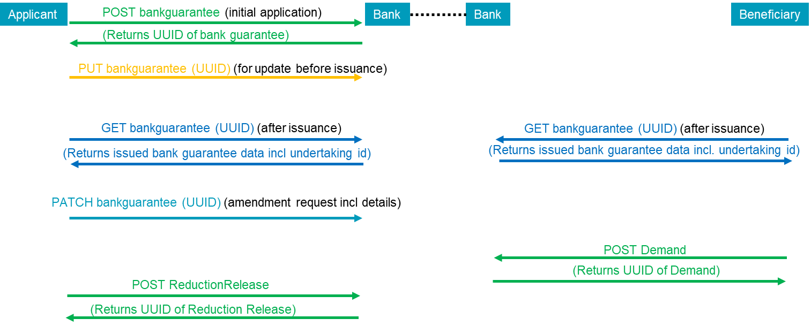

The Events resource will be used to poll for new bank guarantee events for information or that require a response. This is illustrated as follows:

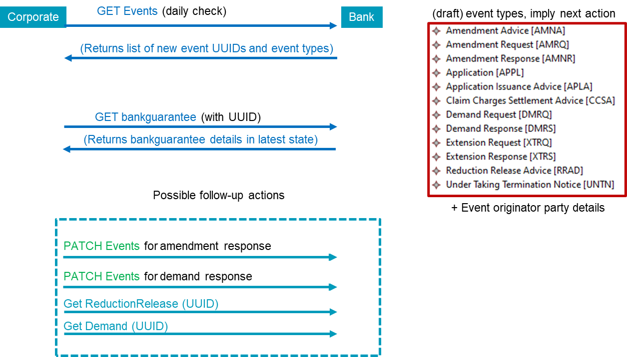

The resources have been created with input from members of the Swift Global Trade Based API working group which comprises of global banks and customers. The functionality and data richness encompass largely what could be captured in the Swift MT 798 message (with some streamlining) and were built using various, flattened ISO 20022 components that were previously created for the already registered as ISO 20022 messages for bank guarantees, such as tsin.005, and tsrv.001 – 019. There is more space for extra information than in the MT 798 but aligned with the ISO 20022 messages. While the resource has already been created and is in a pilotable state, we welcome requests from the review committee to fill any remaining content gaps to make it truly global in usability.
This is an illustration of the top-level components of the bankguarantee resource:
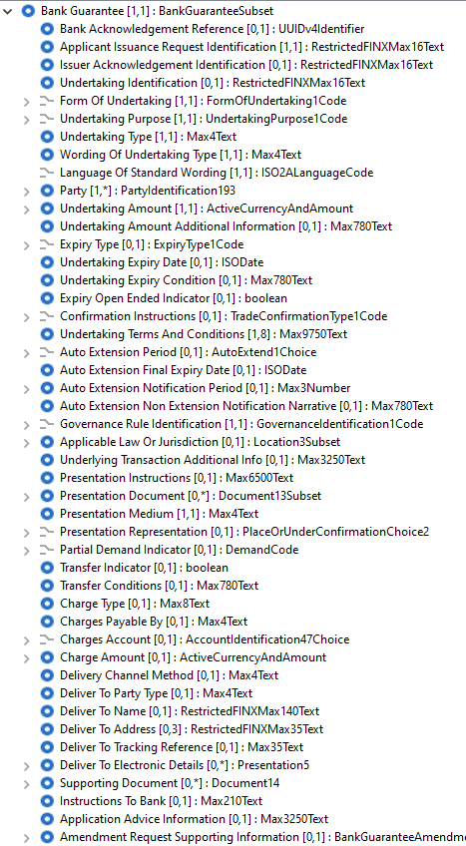

In the above picture, the Party component is repeatable and contains all codes to identify different parties involved in a bank guarantee life cycle.
The aim is to pilot the resource on the Swift network in H1 2023, and after registration it will be available on the ISO 20022 website for use anywhere. The resource does not include security features, these are specific to the implementation channel.
There are no upstream flows, these C2B flows are part of the initial bank guarantee process. Downstream in the interbank space the data can be seamlessly mapped to ISO 20022 messages for bank guarantees, or -possibly with narrative truncation- to interbank trade MT messages.
The BankGuarantee resource is not applicable to other business processes such as Documentary Letters of Credit, though a number of the elements and components might be reused in future trade finance-related ISO 20022 messages or APIs.
The BankGuarantee resource is not applicable to other ISO 20022 business domains.

- Purpose of the new development:
The current solution in the corporate to bank space is based on the use of Proprietary Swift’s MT 798 unvalidated envelope messages for which a set of bank guarantee message definitions were created.
The unvalidated MT 798 envelope message, coupled with its restricted space for additional supporting information, causes significant friction and reduces STP.
There is an appetite from corporates to replace the MT 798s with APIs rather than XML messages. However, the upmost importance is for the data to be easily integrated into the current back-office systems/setups.
Therefore, these API resources re-use many elements from bank guarantee related interbank ISO 20022 messages. In addition, attention was also spent to align party information with CBPR+.
The supporting Events resource can in the future be extended to include other trade related events like documentary letters of credit.

- Community of users and benefits:
The global bank guarantee market was valued at $20.28 billion in 2020 and is projected to reach $41.48 billion by 2030 (source: Allied market research)
Swift traffic of relevant MT798 messages has doubled in the last 3 years, growing even quicker than the market.
The above observations show the increasing importance of the bank guarantee market which can benefit from these APIs no matter the channel.
It is timely to offer this modern, scalable solution using formal structures instead of envelope messages.
In the interbank space, to forward the data, currently MT messages can continue to be used, however this can be the push/incentive to move interbank bank guarantee messages to the already registered ISO 20022 messages which are well aligned with the API resource; or envisage an ISO 20022-aligned interbank API solution.

- Requested additional deliverables from the Registration Authority
The submitting organization proposes to deliver on top of the API resources a sample implementation in the form of an OAS3 contract for better understanding.

- Commitments of the submitting organisation:
The submitting organisation must confirms that it can and will:
- undertake the development of the candidate ISO 20022 Resource(s) that it will submit to the RA for compliance review, registration and publication. The submission must be compliant with the ISO 20022 Master Rules. Once approved by the RA, the new resource(s) will be registered in the ISO 20022 Repository and published by the RA together with the RDR (generated by the RA).
- undertake the development of a web service API solution based on ISO 20022 Resources and using the ISO 20022 API modelling guidelines; the RA will not review, register or publish the API calls, but provides a page on iso20022.org where ISO 20022 API solutions can be referred to.
- address any queries related to the description of the Resource as published by the RA on the ISO 20022 website.
The submitting organisation confirms its knowledge and acceptance of the ISO 20022 Intellectual Property Rights policy for contributing organisations, as follows.
“Organizations that contribute information to be incorporated into the ISO 20022 Repository shall keep any Intellectual Property Rights (IPR) they have on this information. A contributing organization warrants that it has sufficient rights on the contributed information to have it published in the ISO 20022 Repository through the ISO 20022 Registration Authority in accordance with the rules set in ISO 20022. To ascertain a widespread, public, and uniform use of the ISO 20022 Repository information, the contributing organization grants third parties a non-exclusive, royalty-free licence to use the published information”.

- Contact persons:
Mukta Kadam – mukta.kadam@swift.com
Tom Alaerts – tom.alaerts@swift.com

- Comments from the RMG members and relevant SEG(s) or SubSEG(s) and disposition of comments by the submitting organisation:
This section will include the comments received from RMG members and the SEG(s) or SubSEG(s), if any, and the response given to each of these comments by the submitting organisation.

