Business Justification

for the development of new ISO 20022 API resources as ISO 20022 financial repository items
Note: the purpose of this document is to give guidelines to organisations that want to develop new candidate ISO 20022 API resource definitions. Such requests are subject to the approval of a business justification by the ISO 20022 Registration Management Group (RMG). Please consult the iso20022.org website for additional details on the registration process. The business justification must include the following captions, as described. Business justifications are to be sent via e-mail to iso20022ra@iso20022.org

- Name of the request:
“Pay Later API Resources”
- Submitting organisation(s):
- Citi
- SWIFT
- Google
- Lloyds
- Nordea
- Scope of the new development:
The “Pay Later” API resources specify a simple instalment loan product based on ISO 20022.
The customer journey in scope for the first version of the resources would be as follows:
User selects ‘Pay by Bank’ as the method of payment during the checkout (note that this may be stored as part of the Merchant’s profile for the User)
- User authenticates with their bank
- User selects between ‘Pay Now’ and ‘Pay Later’
- User selects instalment loan terms
- User confirms instalment loan terms and accepts terms and conditions
- Merchant receives payment authorisation
- Merchant completes order with User
- Merchant receives payment from Bank, e.g. through Instant Payment scheme
- Bank services loan with User
- Also defined are basic Void and Refund flows.

Here is the technical flow illustrating the different steps:
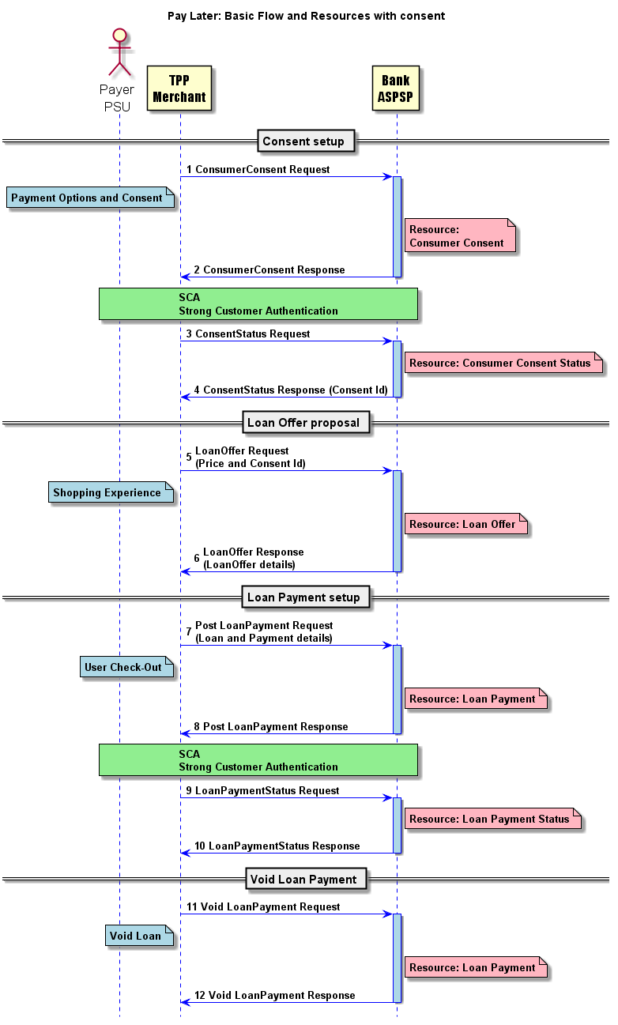

The exchanges between the customer and the bank for the Strong Customer Authentication step and for the actual loan contractual agreements remain under the bilateral relationship between the customer and its bank and are outside the scope of these resources. These could be the same authentication step as used for payment initiation.

The required API resources for the Pay Later flows have been defined as following, as already highlighted in the technical flow above:
- ConsumerConsent
- ConsumerConsentStatus
- LoanOffer
- LoanPayment
- LoanPaymentStatus

As we enter the era of ‘Banking as a Service’ delivered through APIs, Pay Later is only one piece of the puzzle. Other value added developments could be considered, in future version, for example:
- Pay Later at physical Point of Sale (POS)
- Credit line exclusively for use in one or more merchants
- Integration with Fintech wallets
- Embedded Purchase Insurance as a separately charged service
- Embedded Loyalty scheme
- Embedded multi-currency offering
- Enhanced basket level data being made available to banks
- Customer experience enhancements, such as those related to strong customer authentication
- B2B Pay Later (for buyers on an Ecommerce marketplace)
- B2B Pay Early (for suppliers on an Ecommerce marketplace)

Since the process to register ISO 20022 API resources was not yet defined when work started on Pay Later, initial development of the resources is already.
However, the submission of the resources welcomes feedback to further finetune them for truly global standardisation.
The Pay Later initiative was originally kicked-off with an initial development back in 2018, using the existing ISO 20022 elements and complementing them with new elements to fully support the Pay Later flows, and has been implemented by a number of participants of this initial development.
Since the process to register ISO 20022 compliant API resources has now been defined under ISO 20022, the submitting organisations have decided to submit those resources for registration.
Although the proposed API resources fully support the Pay Later business requirements, the intent of the submission is also to gather feedback for additional improvements to further finetune those resources for a truly global Pay Later standardisation.
We recommend that the payments standards evaluation group should evaluate the current version of the resource.
The Pay Later flows would precede payment initiation (via bank transfer of credit card) and cash reporting flows – with messages or APIs, and the ISO 20022 alignment of the core information enables this interoperability.
The current scope of the resource is not applicable to other ISO 20022 business domains (securities, FX, cards, trade finance), though it is an alternative to credit card flows and is a precedent to flows of payment initiation or credit card payment.
While the use of Pay Later is truly for APIs, several components such as the account are reusing ISO 20022 messages components, and newly created components, for example the loan, could well be reused as message components, if required in ISO 20022 message definitions.

- Purpose of the new development:
Pay Later aims for frictionless payments, reduced fraud and maximum buying power at point of purchase. It also allows the banks to position a solution that is at risk of being disintermediated by Fintech lenders.

- Community of users and benefits:
The Pay Later functionality can potentially be implemented by any PSP provider and thus made available on any ecommerce website that would traditionally offer other payment options.
The global buy now pay later market size was valued at $90.69 billion in 2020, and is projected to reach $3.98 trillion by 2030, growing at a CAGR of 45.7% from 2021 to 2030. (source: Allied Market Research)
Pay Later aims for frictionless payments, reduced fraud and maximum buying power at point of purchase, which is a benefit for merchants. The benefit for banks is that it allows the banks to position a solution that is at risk of being disintermediated by Fintech lenders.
The benefit of having a global standard ISO 20022 resource is less implementation variety and complexity vs many separate efforts.
Adoption scenario: Several non-ISO 20022 based implementations are live and this initiative makes a global harmonisation possible.
We expect the interest in and uptake of the ISO 20022 Pay Later resource to increase widely upon registration (Q1 2023).
- Timing and development:
While a first version of the resources is in use, having feedback from more parties will ensure registration Q1 2023 – to raise interest in the globally aligned resource vs all the separate initiatives.
- Commitments of the submitting organisation:
The submitting organisations confirm that they can and will:
- undertake the development of the candidate ISO 20022 API resource models that it will submit to the RA for compliance review and evaluation. The submission must be compliant with the ISO 20022 Master Rules and include a draft Part 1 of the ISO 20022 Resource Definition Report (RDR) compliant with the template for RDR part 1 provided by the RA and, optionally, examples of valid and invalid instances of each candidate ISO 20022 API resource.
- address any queries related to the description of the models and ISO 20022 API resources as published by the RA on the ISO 20022 website.
- promptly inform the RA about any changes or more accurate information about the number of candidate ISO 20022 API resources and the timing of their submission to the RA.
- commit to undertake the future maintenance of the ISO 20022 API resources.
- confirm their knowledge and acceptance of the ISO 20022 Intellectual Property Rights policy for contributing organisations, as follows: “Organizations that contribute information to be incorporated into the ISO 20022 Repository shall keep any Intellectual Property Rights (IPR) they have on this information. A contributing organization warrants that it has sufficient rights on the contributed information to have it published in the ISO 20022 Repository through the ISO 20022 Registration Authority in accordance with the rules set in ISO 20022. To ascertain a widespread, public and uniform use of the ISO 20022 Repository information, the contributing organization grants third parties a non-exclusive, royalty-free license to use the published information”.

Since the current version is in live production, it will not test before submission. However, feedback will be incorporated and then the updated resource will be resubmitted.
- Contact persons:
Vincent Kuntz – Vincent.kuntz@swift.com - +32 2655 3353
Tom Alaerts – tom.alaerts@swift.com +852 2107 8715
Comments from the RMG members and relevant SEG(s) or SubSEG(s) and disposition of comments by the submitting organisation:
This section will include the comments received from RMG members and the SEG(s), SubSEG(s), API SEG, BMST and/or TSG, if any, and the response given to each of these comments by the submitting organisation.

