**Maintenance Change Request**

*Note: the purpose of this document is to give guidelines to submitting organisations that will develop a new version of existing ISO 20022 messages based on change requests screened by the Standards Evaluation Group(s). Such development is subject to the approval of a Maintenance Change Request which must include a detailed description of the impact of each change on the related messages. The Maintenance Change Request must start with a general chapter covering topics related to the whole maintenance effort and a specific chapter for each change request, as described below. Please consult the iso20022.org website for additional details on the* [*maintenance process*](http://www.iso20022.org/maintenance.page)*.*

## Name of the request:

General Meeting Messages Maintenance for year 2021/2022

1. **Submitting organization(s):**

SWIFT, SMPG

1. **Related messages:**

Under this project, the following ISO 20022 General Meeting messages would be maintained depending upon the approval of the proposed modeling solutions:

|  |  |  |
| --- | --- | --- |
|  | **Message Name** | **Identifier** |
| 1 | MeetingNotificationV08 | seev.001.001.08 |
| 2 | MeetingCancellationV07 | seev.002.001.07 |
| 3 | MeetingEntitlementNotificationV07 | seev.003.001.07 |
| 4 | MeetingInstructionV07 | seev.004.001.07 |
| 5 | MeetingInstructionCancellationRequestV07 | seev.005.001.07 |
| 6 | MeetingInstructionStatusV07 | seev.006.001.07 |
| 7 | MeetingVoteExecutionConfirmationV07 | seev.007.001.07 |

The following message is not impacted by the proposed CRs:

|  |  |  |
| --- | --- | --- |
| 8 | MeetingResultDisseminationV07 | seev.008.001.07 |

1. **Commitments of the submitting organization:**

SWIFT and SMPG confirm that it can and will:

* undertake the development of the new version of the candidate ISO 20022 message models that it will submit to the RA for compliance review and evaluation by September 2021.
* provide a new version of part 1 of the Message Definition Report (MDR) and new examples of valid message instances of each message by October 2021 at the latest.
* address any queries related to the description of the new models and messages as published by the RA on the ISO 20022 website.

SWIFT confirms that it intends to organize the actual implementation of the new version of the messages on its SWIFTNet network once the related documentation has been published by the RA.

The submitting organisations confirm their knowledge and acceptance of the ISO 20022 Intellectual Property Rights policy for contributing organisations, as follows.

*“Organisations that contribute information to be incorporated into the ISO 20022 Repository shall keep any Intellectual Property Rights (IPR) they have on this information. A contributing organisation warrants that it has sufficient rights on the contributed information to have it published in the ISO 20022 Repository through the ISO 20022 Registration Authority in accordance with the rules set in ISO 20022. To ascertain a widespread, public and uniform use of the ISO 20022 Repository information, the contributing organisation grants third parties a non-exclusive, royalty-free license to use the published information”.*

1. **Contact persons:**

Christine Strandberg – [christine.strandberg@seb.se](mailto:christine.strandberg@seb.se) – phone: +46 8 763 6074

Mari Fumagalli – [mariangela.fumagalli@bnpparibas.com](mailto:mariangela.fumagalli@bnpparibas.com) – phone: +44 207 595 4988

Jacques Littré – [jacques.littre@swift.com](mailto:jacques.littre@swift.com) – phone: +32 2 655 43 35

**ISO 20022 General Meeting Messages Maintenance 2021/2022**

**Table of Contents**

1 CR1025: Add Pagination Mechanism for Notification 4

2 CR1023: Add new URL for Specific Additional Information for Next Party in the chain 7

3 CR1028: Add new URL and Narrative for Specific Additional Information for Next Party in the chain 10

4 CR0995: Add new Neutral Proxy Type 15

5 CR1010: Add new Indicator Element Necessity of Specific Confirmation of Holding 20

6 CR1011: Issuer Deadline for the notification of Participation - WITHDRAWN 24

7 CR1012: Enable Specification of Deadlines for Each Vote Method - WITHDRAWN 29

8 CR1013: Changes for Voting via Email considered as Vote By Mail 33

9 CR1032: Account Servicer Support for Participation Method and Associated Deadlines 39

10 CR1033: Enable Different Threshold basis for "Voting Right Thresholds for Approval" 43

11 CR0994: Add new Balance Type for Registered Beneficial Owner – REJECTED by ET 47

12 CR0993: Add Company Register Shareholder Identification for Registered Shares 51

13 CR1024: Set Meeting Reference and FIIdentification elements mandatory 56

# CR1025: Add Pagination Mechanism for Notification

**A. Origin of the request:**

*A.1 Submitter*: Euroclear

*A.2 Contact person:* Jean-Paul Lambotte (jean-paul.lambotte@euroclear.com)

*A.3 Sponsors*:

1. **Related messages:**

seev.001.001.08

1. **Description of the change request:**

Add a pagination element in the seev.001 meeting notification message containing 2 sub-elements: the “Page Number” and the “Last Page Indicator” (similar to seev.031)

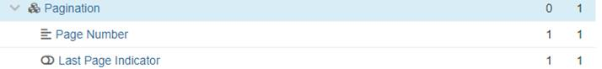

1. **Purpose of the change:**

A meeting notification can contain a large set of resolutions expressed as free text in multiple languages. This can result in a message with a size larger than the size supported by the network. A pagination mechanism must be used to split the message but there is currently no pagination field in the seev.001.

1. **Urgency of the request:**

SR2022

1. **Business examples:**

A meeting with an announcement larger than 100Kb (maximum size on the swift network) has been announced on the French market. As a work-around, the descriptions of the resolutions were reduced to cope with the network limitation.**SEG/TSG recommendation:**

*This section is not to be taken care of by the submitter of the change request. It will be completed in due time by the SEG(s) in charge of the related ISO 20022 messages or the TSG for changes related to the BAH.*

|  |  |  |  |
| --- | --- | --- | --- |
| **Consider** | | X | **Timing** |
|  | | - **Next yearly cycle: 2021/2022**  (the change will be considered for implementation in the yearly maintenance cycle which starts in 2021 and completes with the publication of new message versions in the spring of 2022) | | X |
|  | | - **At the occasion of the next maintenance of the messages**  (the change will be considered for implementation, but does not justify maintenance of the messages in its own right – will be pending until more critical change requests are received for the messages) | |  |
|  | | - **Urgent unscheduled**  (the change justifies an urgent implementation outside of the normal yearly cycle) | |  |  |
|  | | - **Other timing:** | | |  |

Comments:

|  |  |
| --- | --- |
| **Reject** |  |

Reason for rejection:

1. **Impact analysis:**

This change request impacts only the following messages:

seev.001.001.08 MeetingNotificationV08

1. **Proposed implementation:**

**In the seev.001** (MENO – MeetingNotification) message, add the new optional and non-repetitive ***Pagination*** building block typed with the ***Pagination1*** MC as illustrated below:

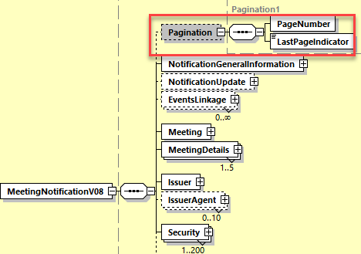

## Proposed timing:

The submitting organization confirms that it can implement the requested changes in the requested timing

|  |  |
| --- | --- |
| Timing | * As requested |

## Final decision of the SEG(s):

|  |  |
| --- | --- |
| Approve | X |

Comments:

|  |  |
| --- | --- |
| Reject |  |

Reason for rejection:

# CR1023: Add new URL for Specific Additional Information for Next Party in the chain

1. **Origin of the request:**

*A.1 Submitter*: Euroclear

*A.2 Contact person:* Jean-Paul Lambotte : [jean-paul.lambotte@euroclear.com](mailto:jean-paul.lambotte@euroclear.com)

*A.3 Sponsors*:

1. **Related messages:**

seev.001.001.08

1. **Description of the change request:**

Similar to the existing MtgNtfctn/Mtg/AddtlDcmnttnURLAdr field that should carry the URL to the issuer website as per SMPG recommendations, add an element to specifically carry the URL address to the intermediaries website for documentation purpose, i.e. MtgNtfctn/Mtg/AddtlDcmnttnAccountServicerURLAdr.

It should be an optional element.

Possible alternative would be to have a narrative field ‘Account Servicer Additional Information’ under Additional Information.

1. **Purpose of the change:**

There is a need to clearly and unambiguously distinguish between issuer information to be sent all the way down the chain of intermediaries to the final beneficial owner and information on “how to instruct” or any other information added to the event by an account servicer and destined only for the immediate clients of such an account servicer.

The existing MtgNtfctn/Mtg/AddtlDcmnttnURLAdr field allows to pass on the URL to the issuer website provided by the issuer/agent in a straight-through-processing way and the information can be passed on similarly through the entire chain of intermediaries until the final beneficial owner.

The new field will be used when an intermediary is to pass their own documentation URL address to their clients and that this information is not to be passed on further. It will allow account owner:

* To easily spot the specific intermediary information
* Not to pass on meaningless information to their own underlying clients

1. **Urgency of the request:**

For SR2022.

1. **Business examples:**

For numerous meetings announced, the account servicer refers their clients to the account servicer Website where they can find all documentation related to the meeting and more: the documentation provided by the agent and also additional documentation that could be useful to clients (i.e. any document that is provided to the account servicer outside of 20022, POA document, additional information on how to instruct the account servicer, any additional document requested by the agent to be completed, etc.).

**SEG/TSG recommendation:**

*This section is not to be taken care of by the submitter of the change request. It will be completed in due time by the SEG(s) in charge of the related ISO 20022 messages or the TSG for changes related to the BAH.*

|  |  |  |  |
| --- | --- | --- | --- |
| **Consider** | | X | **Timing** |
|  | | - **Next yearly cycle: 2021/2022**  (the change will be considered for implementation in the yearly maintenance cycle which starts in 2021 and completes with the publication of new message versions in the spring of 2022) | | X |
|  | | - **At the occasion of the next maintenance of the messages**  (the change will be considered for implementation, but does not justify maintenance of the messages in its own right – will be pending until more critical change requests are received for the messages) | |  |
|  | | - **Urgent unscheduled**  (the change justifies an urgent implementation outside of the normal yearly cycle) | |  |  |
|  | | - **Other timing:** | | |  |

Comments:

|  |  |
| --- | --- |
| **Reject** |  |

Reason for rejection:

1. **Impact analysis:**

This change request impacts only the following messages:

seev.001.001.08 MeetingNotificationV08

1. **Proposed implementation:**

As this CR is identical to the first part of the CR 1028 (see next section), the proposed implementation is illustrated in that CR.

## Proposed timing:

The submitting organization confirms that it can implement the requested changes in the requested timing

|  |  |
| --- | --- |
| Timing | * As requested |

## Final decision of the SEG(s):

|  |  |
| --- | --- |
| Approve | X |

Comments:

|  |  |
| --- | --- |
| Reject |  |

Reason for rejection:

# CR1028: Add new URL and Narrative for Specific Additional Information for Next Party in the chain

1. **Origin of the request:**

*A.1 Submitter*: Swiss Association for SWIFT & Financial Standards (SASFS) -   
Sub-committee Corporate Events

*A.2 Contact person:* Michael Blumer, [michael.blumer@credit-suisse.com](mailto:michael.blumer@credit-suisse.com) , +4144 332 7407

*A.3 Sponsors*: Sub-committee Corporate Events of the Swiss Association for SWIFT & Financial Standards (SASFS)

**Related messages:**

seev.001.001.08

1. **Description of the change request:**

In the seev.001 meeting notification message, add a new optional and repeatable text element to Additional Information, allowing the account servicer or service provider to capture information destined solely for their immediate clients, i.e. account owners, to enable or facilitate event processing between parties.

Under the above new text element add an additional non-repeatable URL Address element, allowing the account servicer or service provider to capture a link destined solely for their immediate clients, i.e. account owners, to enable or facilitate event processing between parties.

Naming:  
As we will request the same to new elements in SR2022 for ISO 15022 MT564/MT568 messages and thus, SWIFT will request them also for seev.031.001.xx and seev.035.001.xx in support of the coexistence, the naming of the new elements is provisional and needs to be coordinated.

Name: Event Processing

Type: SpecifiedNarrativeX is_choice: false

Documentation:

Provides additional information by the account servicer or a service provider solely destined for the next immediate account owner to enable or facilitate event processing between parties

XML Tag : EvProc

Multiplicity: [0..*]

Path: /Document/MtgNtfctn/AddtlInf/EvProc

Name: Text only for the next intermediary

Type: Max8000Text (based on string)

* maxLength: 8000
* minLength: 1

Documentation:

Provides additional text information in the specified language by the account servicer or a service provider solely destined for the next immediate account owner to enable or facilitate event processing between parties.

XML Tag : IntermedTxt

Multiplicity: [1..1]

Path: /Document/MtgNtfctn/AddtlInf/EvProc/IntermedTxt

Name: Event Processing URL Address

Type: Max2048Text (based on string)

* maxLength: 2048
* minLength: 1

Documentation:

Address to use over the www (HTTP) service belonging to the account servicer or a service provider containing information solely destined for the immediate account owner to enable or facilitate event processing between parties.

XML Tag : EvProcURLAdr

Multiplicity: [1..1]

Path: /Document/MtgNtfctn/AddtlInf/EvProc/EvProcURLAdr

1. **Purpose of the change:**

A majority of account servicers, most prominently (I)CSDs, inform/instruct their direct participants/clients on how to interact with them regarding a meeting event.

These instructions may vary from providing a text description on how to instruct to providing dedicated URL links for such purposes.

At present, this information is provided in the Additional Information block under Disclaimer.

Such information is not destined to be passed STP down the chain of intermediaries, as account owners which are not direct participants of the (I)CSD must not/can not follow the same procedure.

As the Additional Information may also contain information by the issuer which is forwarded down the chain of intermediaries, the scrubbing/differentiation is very difficult and breaks STP processing.

1. **Urgency of the request:**

For SR2022.

1. **Business examples:**

**SEG/TSG recommendation:**

*This section is not to be taken care of by the submitter of the change request. It will be completed in due time by the SEG(s) in charge of the related ISO 20022 messages or the TSG for changes related to the BAH.*

|  |  |  |  |
| --- | --- | --- | --- |
| **Consider** | | X | **Timing** |
|  | | - **Next yearly cycle: 2021/2022**  (the change will be considered for implementation in the yearly maintenance cycle which starts in 2021 and completes with the publication of new message versions in the spring of 2022) | | X |
|  | | - **At the occasion of the next maintenance of the messages**  (the change will be considered for implementation, but does not justify maintenance of the messages in its own right – will be pending until more critical change requests are received for the messages) | |  |
|  | | - **Urgent unscheduled**  (the change justifies an urgent implementation outside of the normal yearly cycle) | |  |  |
|  | | - **Other timing:** | | |  |

Comments:

|  |  |
| --- | --- |
| **Reject** |  |

Reason for rejection:

1. **Impact analysis:**

This change request impacts only the following messages:

seev.001.001.08 MeetingNotificationV08

1. **Proposed implementation:**

The proposed implementation illustrated below is similar to the implementation proposed for the SR2022 SWIFT CR001785 for the seev.031 (Corporate Action Notification) and for the seev.035 (Corporate Action Movement Preliminary Advice) messages.

**1) In the seev.001** (MENO – MeetingNotification) message, add the new optional and non-repeatable ***EventProcessingWebSiteAddress*** element typed by the data type ***Max2048Text*** and the following definition:

*“Provides web address of an account servicer (or of a service provider) that contains information solely intended for the immediate account owner to enable or facilitate event processing between parties.”*

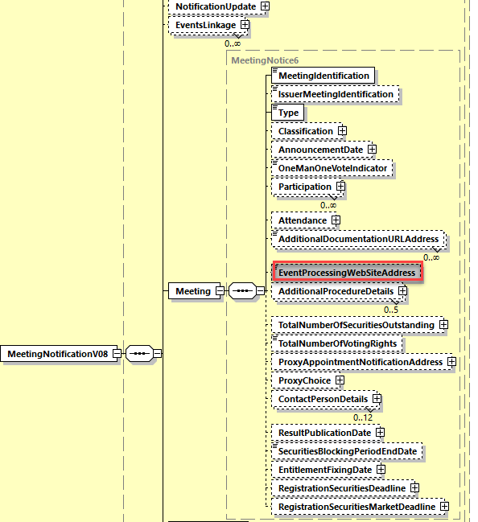

**2) In the seev.001** (MENO – MeetingNotification) message, in the ***AdditionalInformation*** building block, add the new optional and repetitive ***ProcessingTextForNextIntermediary*** element typed by the data type ***Max8000Text*** and the following definition:

*“Provides additional information from the account servicer or a service provider solely intended for the next immediate account owner to enable or facilitate event processing between parties.”*

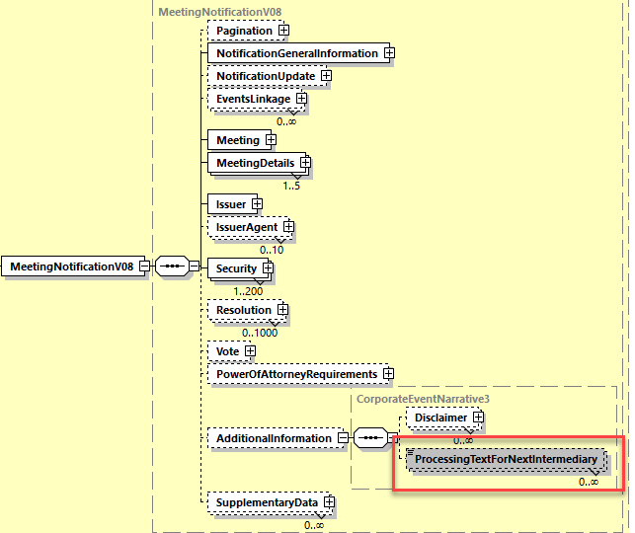

## Proposed timing:

The submitting organization confirms that it can implement the requested changes in the requested timing

|  |  |
| --- | --- |
| Timing | * As requested |

## Final decision of the SEG(s):

|  |  |
| --- | --- |
| Approve | X |

Comments:

|  |  |
| --- | --- |
| Reject |  |

Reason for rejection:

# CR0995: Add new Neutral Proxy Type

1. **Origin of the request:**

*A.1 Submitter*:

DESSUG CA – PSG (Deutsche SWIFT Securities Market User Group - Corporate Actions - Proxy Subgroup Germany)

This group represents more than 20 different institutions including domestic and global proxy providers and registrars with a key role in the German General Meeting process.

*A.2 Contact person:*

PSG Chair - Hendrik Melchior (employer change to Clearstream Banking Frankfurt in July)

PSG Deputy Chair - Daniel Schäfer, [Daniel.Schaefer@hsbc.de](mailto:Daniel.Schaefer@hsbc.de), Phone +49 211 910-2362

Sabine Wolff, [Sabine.Wolff@clearstream.com](mailto:Sabine.Wolff@clearstream.com), Phone +352-243-3 66 40

SEG GM-ET Member (Germany) - Sven Gunkel, [sven-a.gunkel@db.com](mailto:sven-a.gunkel@db.com), Phone +49 69910-60715

SEG GM-ET Member (Germany) - Rainer Prior, [Rainer.Prior@linkmarketservices.de](mailto:Rainer.Prior@linkmarketservices.de), Phone +49 6196 8870 514

*A.3 Sponsors*:

German Market - including domestic and global proxy providers with a key role in the German General Meeting process.

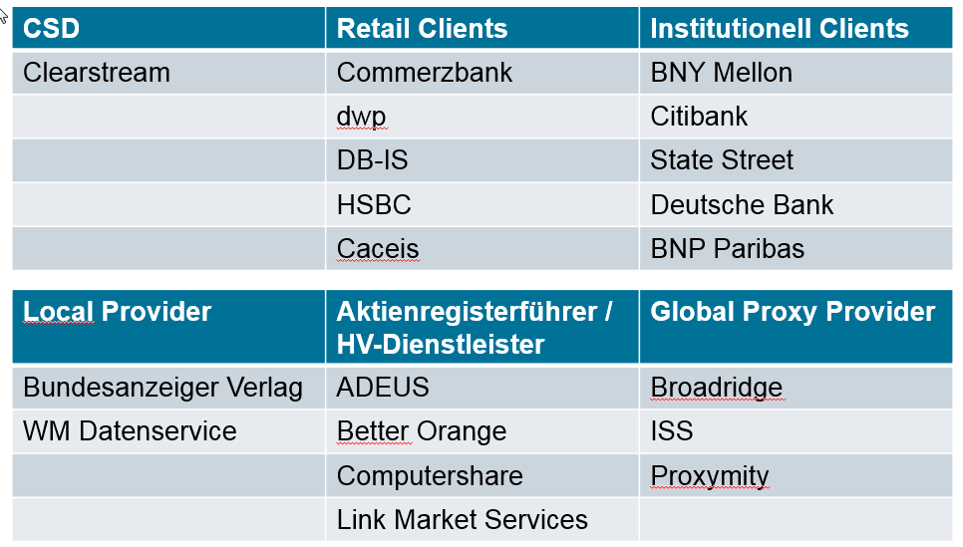

1. **Related messages:**

Seev.001.xxx.xxx

Seev.004.xxx.xxx

1. **Description of the change request:**

Add new Proxy Type; Neutral Proxy [NEPR]

Definition: Neutral proxy nominated by the issuer to execute votes on behalf of investors at the meeting.

1. **Purpose of the change:**

In Germany it is common market practice that the issuer nominates one or more neutral Proxy persons (names are often not known to the shareholders) to execute votes on behalf of investors at the meeting.

To ensure the execution of the received votes, the Neutral Proxy person can sub-delegate the proxy role to another person in case of non-availability, e.g. sickness.

This “Neutral Proxy [NEPR]” is not the Chairman [CHRM] nor can be Discretionary [DISC], because the name of the Proxy is not known, but it is specified that the person has been nominated by the issuer to execute shareholder votes at the meeting.

1. **Urgency of the request:**

N/A

1. **Business examples:**

Seev.001.xxx.xxx

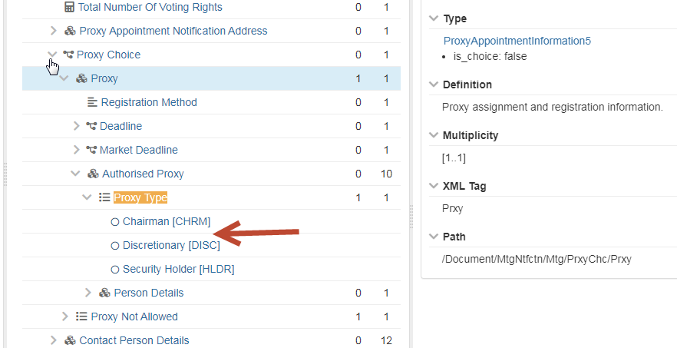

Proxy Type

1 1

* Chairman [CHRM]
* Neutral Proxy [NEPR]
* Discretionary [DISC]
* Security Holder [HLDR]

Seev.004.xxx.xxx

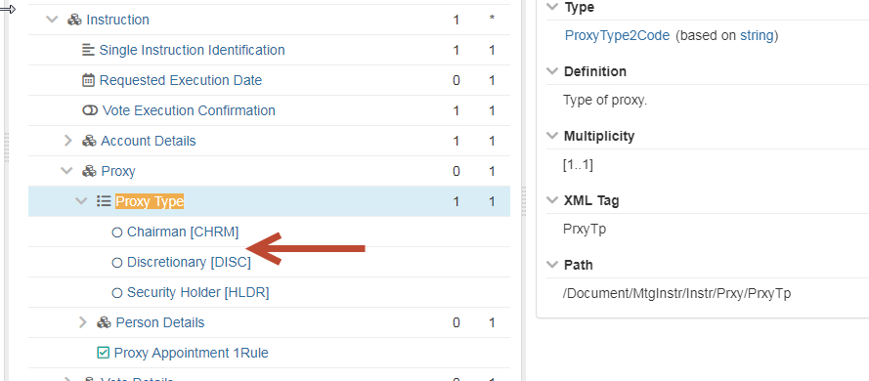

It is not required to add “Neutral Proxy [NEPR]” in the vote details (e.g. Vote Per Agenda Resolution, Vote For All Agenda Resolutions, Vote Instruction For Meeting Resolution) of the seev.004.xxx.xxx instructions message. The “Neutral Proxy [NEPR]” can’t amend received votes or can be instructed to decide on their own how the votes should be executed.

Proxy Type

1 1

* Chairman [CHRM]
* Neutral Proxy [NEPR]
* Discretionary [DISC]
* Security Holder [HLDR]

1. **SEG/TSG recommendation:**

*This section is not to be taken care of by the submitter of the change request. It will be completed in due time by the SEG(s) in charge of the related ISO 20022 messages or the TSG for changes related to the BAH.*

|  |  |  |  |
| --- | --- | --- | --- |
| **Consider** | | X | **Timing** |
|  | | - **Next yearly cycle: 2021/2022**  (the change will be considered for implementation in the yearly maintenance cycle which starts in 2021 and completes with the publication of new message versions in the spring of 2022) | | X |
|  | | - **At the occasion of the next maintenance of the messages**  (the change will be considered for implementation, but does not justify maintenance of the messages in its own right – will be pending until more critical change requests are received for the messages) | |  |
|  | | - **Urgent unscheduled**  (the change justifies an urgent implementation outside of the normal yearly cycle) | |  |  |
|  | | - **Other timing:** | | |  |

Comments:

|  |  |
| --- | --- |
| **Reject** |  |

Reason for rejection:

1. **Impact analysis:**

This change request impacts only the following messages:

seev.001.001.08 MeetingNotificationV08

seev.004.001.07 MeetingInstructionV07

1. **Proposed implementation:**

In the **seev.001** (MENO – MeetingNotification) message, in the ***Meeting*** message building block, in the sequence ProxyChoice/Proxy/AuthorisedProxy for the element ***ProxyType*** and

In the **seev.004** (MEIN – MeetingInstruction) message, in the ***Instruction*** message building block, in the sequence Proxy for the element ***ProxyType***,

add a new code value “Neutral Proxy” (**NEPR**) to the data type ***ProxyType2Code*** defined as *“Neutral proxy nominated by the issuer to execute votes on behalf of investors at the meeting.”* as illustrated below for the seev.001:

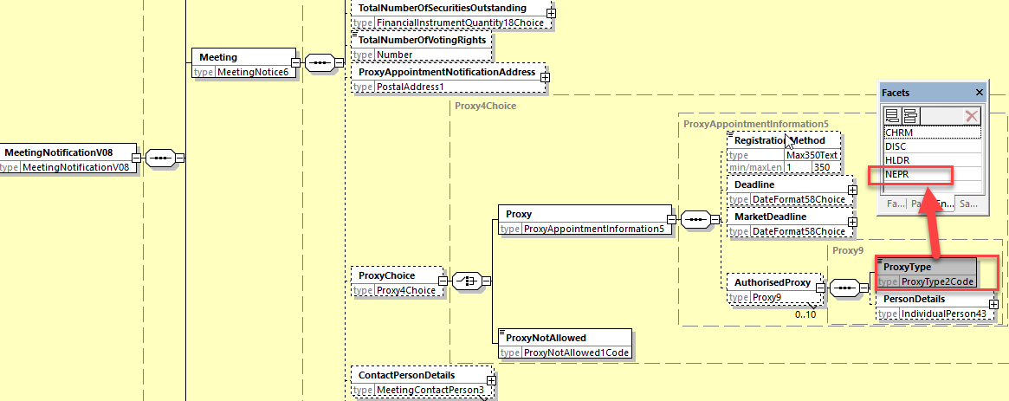

and for the seev.004:

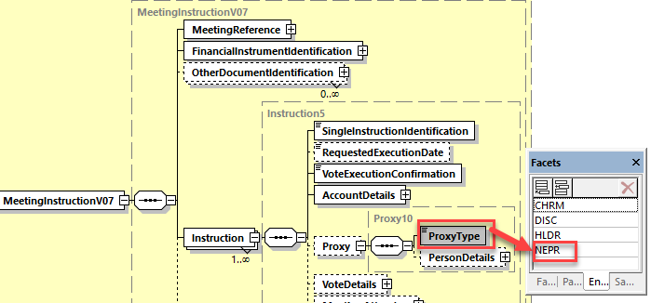

## Proposed timing:

The submitting organization confirms that it can implement the requested changes in the requested timing

|  |  |
| --- | --- |
| Timing | * As requested |

## Final decision of the SEG(s):

|  |  |
| --- | --- |
| Approve | X |

Comments:

|  |  |
| --- | --- |
| Reject |  |

Reason for rejection:

# CR1010: Add new Indicator Element Necessity of Specific Confirmation of Holding

1. **Origin of the request:**

*A.1 Submitter*:

DESSUG CA – PSG (Deutsche SWIFT Securities Market User Group - Corporate Actions - Proxy Subgroup Germany)

This group represents more than 20 different institutions including domestic and global proxy providers and registrars with a key role in the German General Meeting process.

*A.2 Contact person:*

PSG Chair - Hendrik Melchior (employer change to Clearstream Banking Frankfurt in July)

PSG Deputy Chair - Daniel Schäfer, [Daniel.Schaefer@hsbc.de](mailto:Daniel.Schaefer@hsbc.de), Phone +49 211 910-2362

Sabine Wolff, [Sabine.Wolff@clearstream.com](mailto:Sabine.Wolff@clearstream.com), Phone +352-243-3 66 40

SEG GM-ET Member (Germany) - Sven Gunkel, [sven-a.gunkel@db.com](mailto:sven-a.gunkel@db.com), Phone +49 69910-60715

SEG GM-ET Member (Germany) - Rainer Prior, [Rainer.Prior@linkmarketservices.de](mailto:Rainer.Prior@linkmarketservices.de), Phone +49 6196 8870 514

*A.3 Sponsors*:

German Market - including domestic and global proxy providers with a key role in the German General Meeting process.



1. **Related messages:**

seev.001.xxx.xxx

1. **Description of the change request:**

Necessity of specific confirmation of holding <NecSpeConfHold>

Multiplicity: optional [0..1]

Value: blank or Yes

Path: /Document/MtgNtfctn/NtfctnGnlInf/NecSpeConfHold

Description: Indicates whether a specific confirmation of holding together with a participation/ vote instruction is required. (e.g. Germany §67c(3))

The German Stock Corporation Act was adopted to include SRD II requirements. This includes the update of paragraph 67c Section3 referring to Confirmation of Holding in line with Article 5 of the Implementation Regulation (EU) 2018/1212.

The Implementing Regulation assumes that a confirmation of entitlement and, where applicable, a notice of participation in the general will enable shareholders to exercise their rights at the general meeting.

The requirement to provide such a confirmation is part of the AoA (Articles of Association) of the company and usually announced in the convocation of the meeting. This confirmation is a prerequisite to participate and vote and needs to be provided to the issuer/agent/registrar together with the participation/vote instruction. In case is not provided, instructions will not be processed.

This is not a general rule to the German market nor limited to SRD II relevant securities and therefore needs to be captured case by case in the meeting notification.

1. **Purpose of the change:**

This is a regulatory requirement for the German market to indicate if the specific confirmation of holding together with a participation/ vote instruction is required.

The field should be populated by the issuer.

1. **Urgency of the request:**

N/A

1. **Business examples:**

…

Notification General Information < NtfctnGnlInf> 1 1

Notification Type < NtfctnTp> 1 1

Notification Status < NtfctnSts> 1 1

Shareholder Rights Directive Indicator <ShrhldrRghtsDrctvInd> 0 1

Necessity of specific confirmation of holding <NecSpeConfHold> 0 1

….

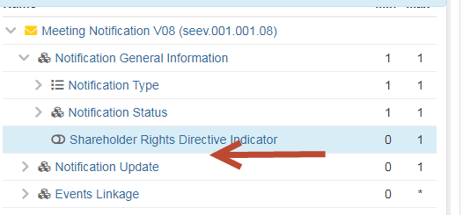

1. **SEG/TSG recommendation:**

*This section is not to be taken care of by the submitter of the change request. It will be completed in due time by the SEG(s) in charge of the related ISO 20022 messages or the TSG for changes related to the BAH.*

|  |  |  |  |
| --- | --- | --- | --- |
| **Consider** | | X | **Timing** |
|  | | - **Next yearly cycle: 2021/2022**  (the change will be considered for implementation in the yearly maintenance cycle which starts in 2021 and completes with the publication of new message versions in the spring of 2022) | | X |
|  | | - **At the occasion of the next maintenance of the messages**  (the change will be considered for implementation, but does not justify maintenance of the messages in its own right – will be pending until more critical change requests are received for the messages) | |  |
|  | | - **Urgent unscheduled**  (the change justifies an urgent implementation outside of the normal yearly cycle) | |  |  |
|  | | - **Other timing:** | | |  |

Comments:

|  |  |
| --- | --- |
| **Reject** |  |

Reason for rejection:

1. **Impact analysis:**

This change request impacts only the following messages:

seev.001.001.08 MeetingNotificationV08

1. **Proposed implementation:**

In the **seev.001** (MENO – MeetingNotification) message, in the ***NotificationGeneralInformation*** message building block, add a new optional and non repeatable indicator element ***ConfirmationOfHoldingRequired*** typed by the data type ***YesNoIndicator*** and defined as follows: “*Indicates whether a specific confirmation of holding together with a participation and/or vote instruction is required by the issuer (for instance as required in the German Stock Corporation Act paragraph 67c Section3)”.*

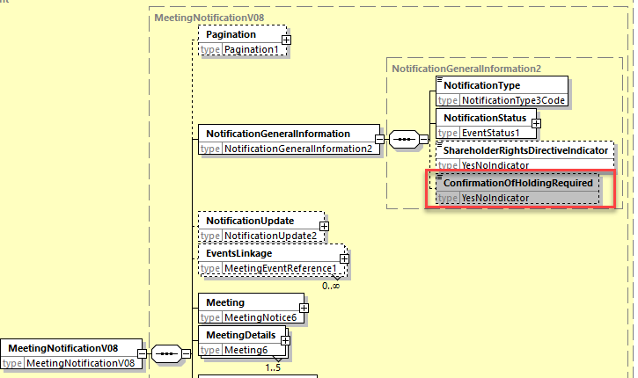

## Proposed timing:

The submitting organization confirms that it can implement the requested changes in the requested timing

|  |  |
| --- | --- |
| Timing | * As requested |

## Final decision of the SEG(s):

|  |  |
| --- | --- |
| Approve | X |

Comments:

|  |  |
| --- | --- |
| Reject |  |

Reason for rejection:

# CR1011: Issuer Deadline for the notification of Participation - WITHDRAWN

1. **Origin of the request:**

*A.1 Submitter*:

DESSUG CA – PSG (Deutsche SWIFT Securities Market User Group - Corporate Actions - Proxy Subgroup Germany)

This group represents more than 20 different institutions including domestic and global proxy providers and registrars with a key role in the German General Meeting process.

*A.2 Contact person:*

Chair - Hendrik Melchior (employer change to Clearstream Banking Frankfurt on July 1)

Deputy Chair - Daniel Schäfer, [Daniel.Schaefer@hsbc.de](mailto:Daniel.Schaefer@hsbc.de), Phone +49 211 910-2362

Sabine Wolff, [Sabine.Wolff@clearstream.com](mailto:Sabine.Wolff@clearstream.com), Phone +352-243-3 66 40

SEG GM-ET (Germany) - Sven Gunkel, [sven-a.gunkel@db.com](mailto:sven-a.gunkel@db.com), Phone +49 69910-60715

SEG GM-ET (Germany) - Rainer Prior, [Rainer.Prior@linkmarketservices.de](mailto:Rainer.Prior@linkmarketservices.de), Phone +49 6196 8870 514

*A.3 Sponsors*:

German Market - including domestic and global proxy providers with a key role in the German General Meeting process.



1. **Related messages:**

seev.001.xxx.xxx

1. **Description of the change request:**

This is Change Request #1 of 3 ParticipationMethod/Deadline+VoteDeadline

Issuer Deadline for Voting is captured under Participation methods and does not allow to distinguish different deadlines applicable to different participation methods, i.e. electronic voting can be up to and during the meeting whereas votes per mail need to be processed manually and hence, afford a buffer before the meeting takes place.

The Implementation Regulation (EU) 2018/1212, better known as SRD II, clearly distinguishes

* Issuer Deadline for the notification of participation (table 3 D2) and
* Issuer Deadline for Voting (table 3 D3)

Description and Definition Change:

Rename “Issuer Deadline for Voting” under Participation Method to

“Issuer Deadline for the notification of Participation” according to the Implementation Regulation, because the current description is misleading.

Current Description of Issuer Deadline for Voting: Deadline for voting on agenda resolutions at the general meeting.

New Description of Issuer Deadline for the notification of Participation: Deadline for participation at the general meeting.

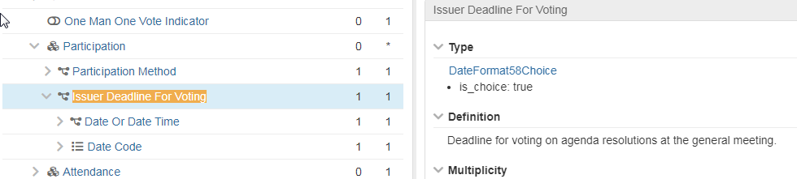

As per page 13 of the SMPG_MP_Final_v1.1 from August 28, 2020, the “IssuerDeadlineForVoting“ that refers to table 3 – D3 of the Implementation Regulation (EU) 2018/1212, appears to be incorrect for a STP notification and processing.

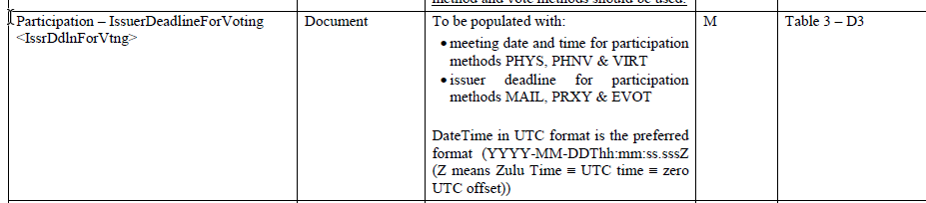

The SMPG recommendation on page 19 referring to table 3 – D2 of the Implementation Regulation (EU) 2018/1212 seems to be incorrect as well.

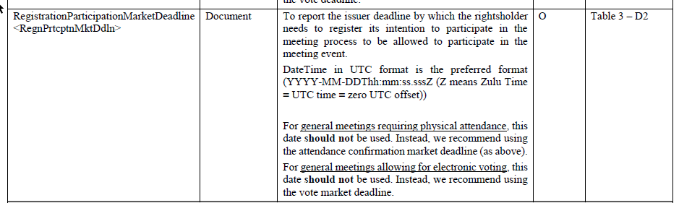

The Issuer Deadline for Voting (table 3 D3) of the Implementation Regulation (EU) 2018/1212 should be populated in Section Vote – Vote Market Deadline (Path: /Document/MtgNtfctn/Vote/VoteDdln)

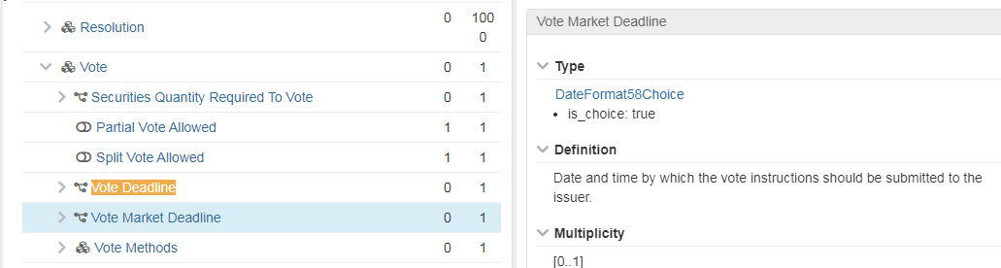

1. **Purpose of the change:**

The participants of the German User Group agreed that the naming shall be changed as creates uncertainty on how to distinguish specific deadlines, i.e. participation deadline versus vote market deadline.

Risk: The current set up may lead to late votes received that cannot be processed and hence, is not in line with the SRD II requirement.

1. **Urgency of the request:**

N/A

1. **Business examples:**

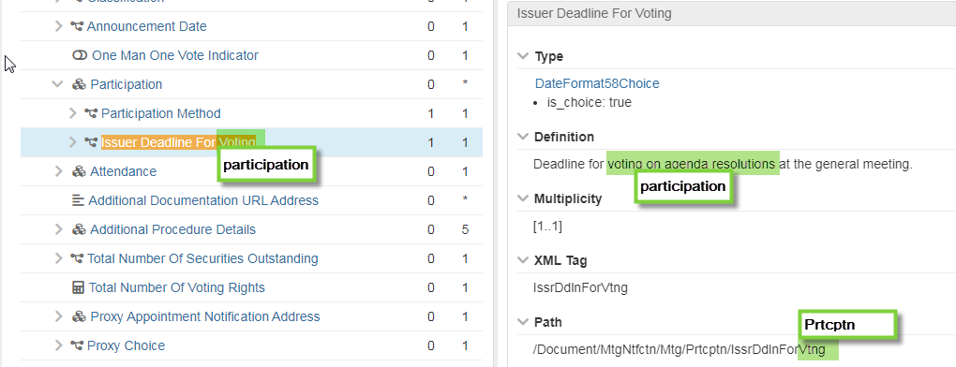

1. **SEG/TSG recommendation:**

*This section is not to be taken care of by the submitter of the change request. It will be completed in due time by the SEG(s) in charge of the related ISO 20022 messages or the TSG for changes related to the BAH.*

|  |  |  |  |
| --- | --- | --- | --- |
| **Consider** | | No | **Timing** |
|  | | - **Next yearly cycle: 2021/2022**  (the change will be considered for implementation in the yearly maintenance cycle which starts in 2021 and completes with the publication of new message versions in the spring of 2022) | |  |
|  | | - **At the occasion of the next maintenance of the messages**  (the change will be considered for implementation, but does not justify maintenance of the messages in its own right – will be pending until more critical change requests are received for the messages) | |  |
|  | | - **Urgent unscheduled**  (the change justifies an urgent implementation outside of the normal yearly cycle) | |  |  |
|  | | - **Other timing:** | | |  |

Comments:

|  |  |
| --- | --- |
| **Reject** |  |

Reason for rejection:

1. **Impact analysis:**

N/A

1. **Proposed implementation:**

**N/A**

This change request has been withdrawn by the submitters on July 14, 2021.

## Proposed timing:

The submitting organization confirms that it can implement the requested changes in the requested timing

|  |  |
| --- | --- |
| Timing | * As requested |

## Final decision of the SEG(s):

|  |  |
| --- | --- |
| Approve |  |

Comments:

|  |  |
| --- | --- |
| Reject |  |

Reason for rejection:

# CR1012: Enable Specification of Deadlines for Each Vote Method - WITHDRAWN

1. **Origin of the request:**

*A.1 Submitter*:

DESSUG CA – PSG (Deutsche SWIFT Securities Market User Group - Corporate Actions - Proxy Subgroup Germany)

This group represents more than 20 different institutions including domestic and global proxy providers and registrars with a key role in the German General Meeting process.

*A.2 Contact person:*

PSG Chair - Hendrik Melchior (employer change to Clearstream Banking Frankfurt in July)

PSG Deputy Chair - Daniel Schäfer, [Daniel.Schaefer@hsbc.de](mailto:Daniel.Schaefer@hsbc.de), Phone +49 211 910-2362

Sabine Wolff, [Sabine.Wolff@clearstream.com](mailto:Sabine.Wolff@clearstream.com), Phone +352-243-3 66 40

SEG GM-ET Member (Germany) - Sven Gunkel, [sven-a.gunkel@db.com](mailto:sven-a.gunkel@db.com), Phone +49 69910-60715

SEG GM-ET Member (Germany) - Rainer Prior, [Rainer.Prior@linkmarketservices.de](mailto:Rainer.Prior@linkmarketservices.de), Phone +49 6196 8870 514

*A.3 Sponsors*:

German Market - including domestic and global proxy providers with a key role in the German General Meeting process.



1. **Related messages:**

seev.001.xxx.xx

1. **Description of the change request:**

This is Change Request #2 of 3 ParticipationMethod/Deadline+VoteDeadline

Different vote deadlines can be set by the issuer. E.g. electronic voting can be received until the end of the meeting whereas votes per mail need to be processed manually before the meeting.

In the current setup only one deadline can be specified which applies for all voting methods. Therefore the two voting deadlines

* Vote deadline < VoteDdln>
* Vote market deadline < VoteMktDdln>

should be different for each vote method.

Field Structure Change :

Allow distinct vote deadlines and vote market deadlines for individual vote methods.

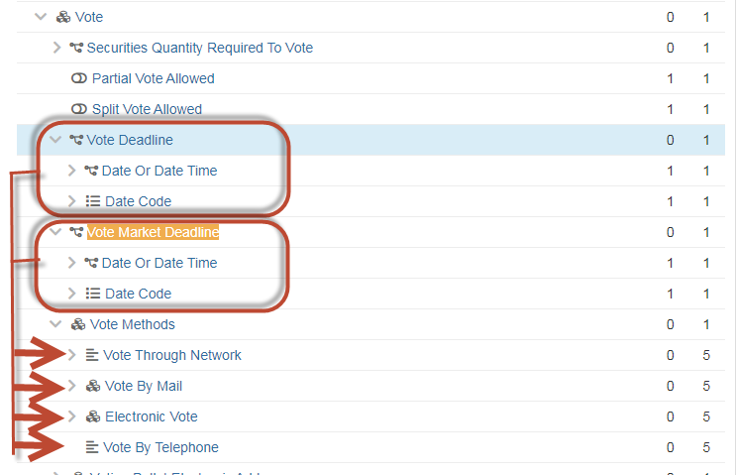

*Note; this change request is similar to the MT564 Date/Time harmonization several years ago. Deadlines were removed from general details level (Seq. D) to option level (Seq. E).*

1. **Purpose of the change:**

To clearly differentiate between the Deadline for the notification of participation (table 3 D2) and Deadline for Voting (table 3 D3).

These deadlines should be used differently for participation methods and vote methods.

1. **Urgency of the request:**

N/A

1. **Business examples:**

AGM date: 28.04.2021

Applicable participation methods: MAIL/EVOT/VIRT

Deadline for the notification of the participation: 21.04.2021 21:59 UTC-Z

Vote Market Deadline:

Vote by Mail 26.04.2021 21:59 UTC-Z

Vote through Network 21.04.2021 21:59 UTC-Z

Electronic Voting 28.04.2021

1. **SEG/TSG recommendation:**

*This section is not to be taken care of by the submitter of the change request. It will be completed in due time by the SEG(s) in charge of the related ISO 20022 messages or the TSG for changes related to the BAH.*

|  |  |  |  |
| --- | --- | --- | --- |
| **Consider** | |  | **Timing** |
|  | | - **Next yearly cycle: 2021/2022**  (the change will be considered for implementation in the yearly maintenance cycle which starts in 2021 and completes with the publication of new message versions in the spring of 2022) | |  |
|  | | - **At the occasion of the next maintenance of the messages**  (the change will be considered for implementation, but does not justify maintenance of the messages in its own right – will be pending until more critical change requests are received for the messages) | |  |
|  | | - **Urgent unscheduled**  (the change justifies an urgent implementation outside of the normal yearly cycle) | |  |  |
|  | | - **Other timing:** | | |  |

Comments:

|  |  |
| --- | --- |
| **Reject** |  |

Reason for rejection:

1. **Impact analysis:**

N/A

1. **Proposed implementation:**

This Change request has been withdrawn by the submitters on July 14, 2021.

## Proposed timing:

The submitting organization confirms that it can implement the requested changes in the requested timing

|  |  |
| --- | --- |
| Timing | * As requested |

## Final decision of the SEG(s):

|  |  |
| --- | --- |
| Approve |  |

Comments:

|  |  |
| --- | --- |
| Reject |  |

Reason for rejection:

# CR1013: Changes for Voting via Email considered as Vote By Mail

1. **Origin of the request:**

*A.1 Submitter*:

DESSUG CA – PSG (Deutsche SWIFT Securities Market User Group - Corporate Actions - Proxy Subgroup Germany).

This group represents more than 20 different institutions including domestic and global proxy providers and registrars with a key role in the German General Meeting process.

*A.2 Contact person:*

PSG Chair - Hendrik Melchior (employer change to Clearstream Banking Frankfurt in July)

PSG Deputy Chair - Daniel Schäfer, [Daniel.Schaefer@hsbc.de](mailto:Daniel.Schaefer@hsbc.de), Phone +49 211 910-2362

Sabine Wolff, [Sabine.Wolff@clearstream.com](mailto:Sabine.Wolff@clearstream.com), Phone +352-243-3 66 40

SEG GM-ET Member (Germany) - Sven Gunkel, [sven-a.gunkel@db.com](mailto:sven-a.gunkel@db.com), Phone +49 69910-60715

SEG GM-ET Member (Germany) - Rainer Prior, [Rainer.Prior@linkmarketservices.de](mailto:Rainer.Prior@linkmarketservices.de), Phone +49 6196 8870 514

*A.3 Sponsors*:

German Market - including domestic and global proxy providers with a key role in the German General Meeting process.



1. **Related messages:**

seev.001.xxx.xxx

1. **Description of the change request:**

This is Change Request #3 of 3 ParticipationMethod/Deadline+VoteDeadline

*Please consider the description and definition change requested as #1 of 3 of Issuer Deadline for Voting under Participation to Issuer Deadline for the notification of Participation.*

The Issuer Deadline for Voting under Participation method Electronic Vote does not allow to distinguish different deadlines applicable to voting via Email versus voting via STP-connected applications, i.e. electronic voting can be up to and during the meeting whereas votes per (e-) mail need to be processed manually and hence, afford a buffer before the meeting takes place.

Definition Change:

Votes received via Email need to be processed manually and hence, afford a buffer before the meeting takes place. Therefore, we request to capture voting via Email under voting via Mail (/Document/MtgNtfctn/Vote/VoteMthds/VoteByMail) and not under Electronic Vote (/Document/MtgNtfctn/Vote/VoteMthds/ElctrncVote).

Therefore the description for participation method EVOT should be changed to: Vote participation is through electronic means like dedicated standards messaging or web based voting applications.

*(current definition: Vote participation is through electronic means like email or dedicated standards messaging or web based voting applications.)*

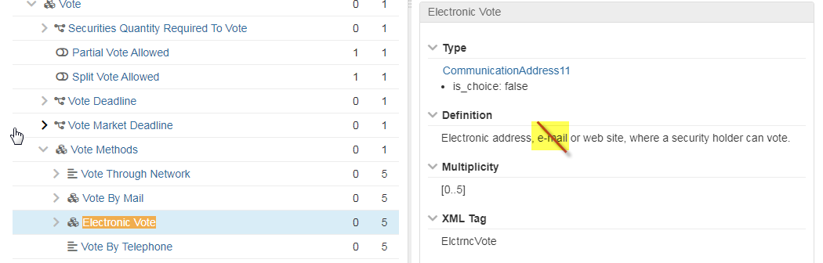

Field Structure Change:

In addition the email address should be moved from “Electronic vote” in the vote methods into “Vote by Mail” incl. definition change to remove the word e.mail in Vote Method – Electronic Vote as below.

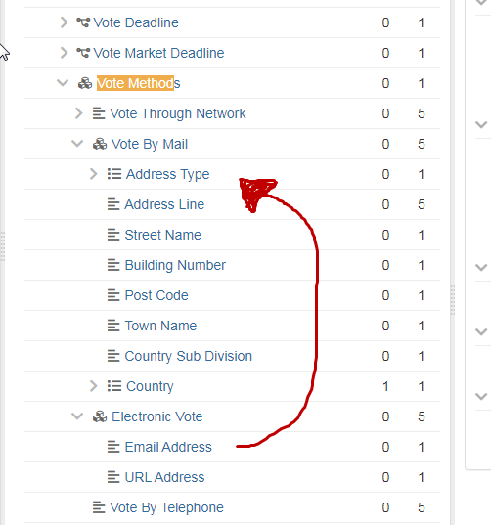

1. **Purpose of the change:**

The requested change is based on processing that differs for votes received via Email versus votes received via voting platform which does not need to be the same as the virtual attendance.

It is understood that an URL may refer to a voting platform for which the deadline shall be closer to the meeting than Email.

1. **Urgency of the request:**

N/A

1. **Business examples:**

AGM date: 28.04.2021

Applicable participation methods: MAIL/EVOT/VIRT

Deadline for the notification of the participation: 21.04.2021 21:59 UTC-Z

Vote Market Deadline:

Vote by Mail 26.04.2021 21:59 UTC-Z

Vote through Network 21.04.2021 21:59 UTC-Z

Electronic Voting 28.04.2021

1. **SEG/TSG recommendation:**

*This section is not to be taken care of by the submitter of the change request. It will be completed in due time by the SEG(s) in charge of the related ISO 20022 messages or the TSG for changes related to the BAH.*

|  |  |  |  |
| --- | --- | --- | --- |
| **Consider** | | X | **Timing** |
|  | | - **Next yearly cycle: 2021/2022**  (the change will be considered for implementation in the yearly maintenance cycle which starts in 2021 and completes with the publication of new message versions in the spring of 2022) | | X |
|  | | - **At the occasion of the next maintenance of the messages**  (the change will be considered for implementation, but does not justify maintenance of the messages in its own right – will be pending until more critical change requests are received for the messages) | |  |
|  | | - **Urgent unscheduled**  (the change justifies an urgent implementation outside of the normal yearly cycle) | |  |  |
|  | | - **Other timing:** | | |  |

Comments:

|  |  |
| --- | --- |
| **Reject** |  |

Reason for rejection:

1. **Impact analysis:**

This change request impacts only the following messages:

seev.001.001.08 MeetingNotificationV08

1. **Proposed implementation:**
2. In the **seev.001** (MENO – MeetingNotification) message, in the ***Meeting*** message building block in the sequence ***Participation/ParticipationMethod***,for the ***Code*** element, change the definition of the “ElectronicVoting” (EVOT) code value in the ***VotingMethodParticipation1Code*** data type as follows:

“*Vote participation is through electronic means like dedicated standards messaging or web based voting applications”*

replacing the current definition

*“Vote participation is through electronic means like email or dedicated standards messaging or web based voting applications”.*

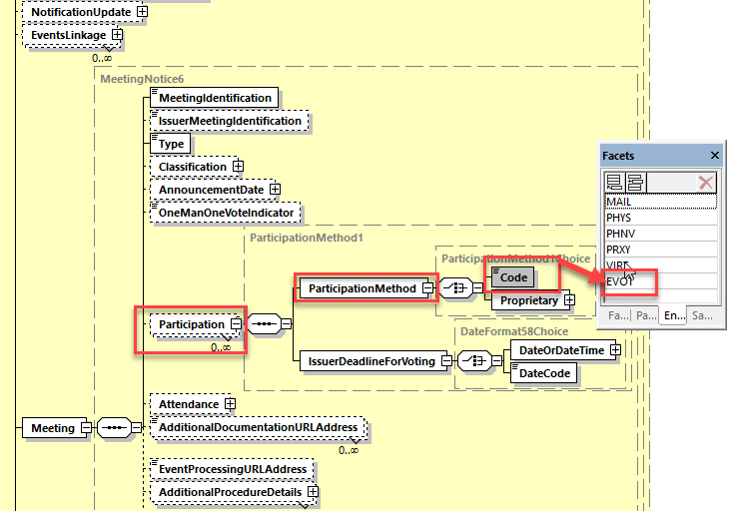

1. In the **seev.001** (MENO – MeetingNotification) message, in the ***Vote*** message building block, in the sequence **Vote*Methods***, remove the element ***EmailAddress*** from the ***ElectronicVote*** sequence and change the ***VoteByMail*** sequence data type PostalAddress1 by a new sequence with the new optional and repeatable element ***EmailAddress*** [0..5] and the new optional and repeatable element ***Correspondence*** [0..5] typed by ***PostalAddress1***.

Change the multiplicity of the ***VoteByMail*** sequence to [0..1].

Also, change the definition of the ***ElectronicVote*** sequence as follows: “*Electronic address or web site where a security holder can vote*.”.

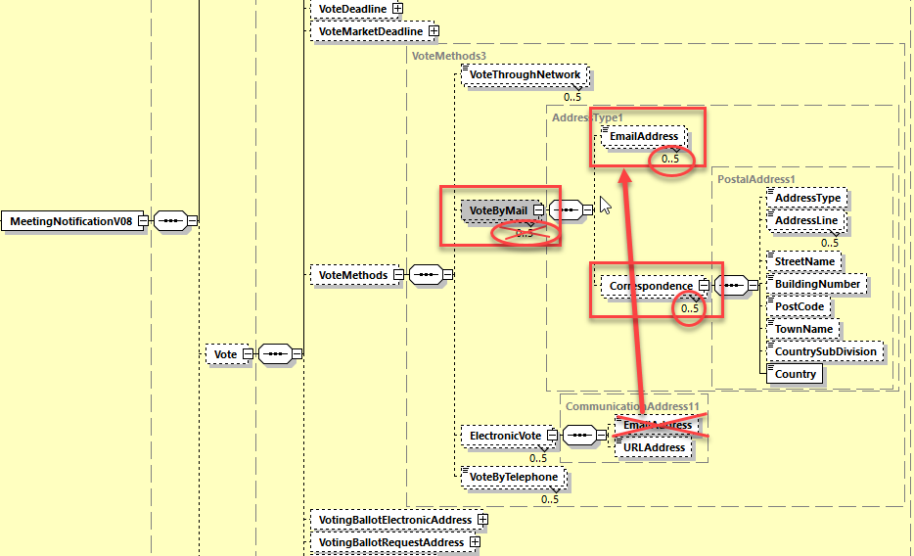

## Proposed timing:

The submitting organization confirms that it can implement the requested changes in the requested timing

|  |  |
| --- | --- |
| Timing | * As requested |

## Final decision of the SEG(s):

|  |  |
| --- | --- |
| Approve | X |

Comments:

|  |  |
| --- | --- |
| Reject |  |

Reason for rejection:

# CR1032: Account Servicer Support for Participation Method and Associated Deadlines

1. **Origin of the request:**

*A.1 Submitter*: Securities Market Practice Group

*A.2 Contact person:*

*A.3 Sponsors*:

1. **Related messages:**

seev.001.001.08

seev.006.001.07

1. **Description of the change request:**

In the seev.001 meeting notification message, add a new optional YesNoIndicator "Supported by account servicer" in the /Meeting/Participation/ block to indicate if the participation method specified in the block is supported by the account servicer.

In the seev.001 meeting notification message, add a new optional deadline “ResponseDeadlineForVoting” in the /Meeting/Participation/ block to provide the account servicer’s deadline for sending voting instructions to the account servicer for the particular participation method.

In the seev.006 meeting instruction status message, add a new rejection reason code “Participation method not supported” in the /InstructionTypStatus/InstructionStatus/Rejected to indicate that the account servicer has rejected an instruction referring to a non-supported method of participation.

1. **Purpose of the change:**

It must be possible to announce all the methods of participation announced by the issuer (this is an obligation under SRDII) but the account servicer can offer services only on a subset of methods (for instance, an intermediary would usually not offer any service on the “mail” method and therefore reject instructions with method “mail”) .

The new element will allow the account servicer to define which methods of participation are supported by it while still forwarding all the methods announced by the issuer.

The new response deadline will allow the account servicer to define its deadline for the participation method, in addition to the existing IssuerDeadlineForVoting in the block.

The new rejection status in the seev.006 will be used in case an account owner would instruct on a method of participation not supported by the account servicer.

1. **Urgency of the request:**

For SR2022.

1. **Business examples:**

Some methods of participation (e.g. mail) do not require to send a vote instruction to the account servicer but must be handled directly between the shareholder and the issuer.

Other example could be an account servicer providing limited service on some markets. For instance, if the account servicer provides notification service only, the "Supported by the account servicer" field will contain the value “no” for all method of participations.

The addition of response deadline would make it clear what the account servicer’s deadline is for each supported participation method. The response deadline should only be used for methods supported by the account servicer, but in case an account servicer supports more than one participation method, a response deadline for each such method may be included – thus enabling more granularity in the meeting notification than the current VoteDeadline which cannot be repeated.

1. **SEG/TSG recommendation:**

*This section is not to be taken care of by the submitter of the change request. It will be completed in due time by the SEG(s) in charge of the related ISO 20022 messages or the TSG for changes related to the BAH.*

|  |  |  |  |
| --- | --- | --- | --- |
| **Consider** | | X | **Timing** |
|  | | - **Next yearly cycle: 2021/2022**  (the change will be considered for implementation in the yearly maintenance cycle which starts in 2021 and completes with the publication of new message versions in the spring of 2022) | | X |
|  | | - **At the occasion of the next maintenance of the messages**  (the change will be considered for implementation, but does not justify maintenance of the messages in its own right – will be pending until more critical change requests are received for the messages) | |  |
|  | | - **Urgent unscheduled**  (the change justifies an urgent implementation outside of the normal yearly cycle) | |  |  |
|  | | - **Other timing:** | | |  |

Comments:

|  |  |
| --- | --- |
| **Reject** |  |

Reason for rejection:

1. **Impact analysis:**

This change request impacts only the following messages:

seev.001.001.08 MeetingNotificationV08

seev.006.001.07 MeetingInstructionStatusV07

1. **Proposed implementation:**
2. In the **seev.001** (MENO – MeetingNotification) message, in the ***Meeting*** message building block in the ***Participation*** sequence, add a new optional and non-repeatable element “***SupportedByAccountServicer***” typed by the “***YesNoIndicator***” data type defined as “*Indicates whether the specific participation method proposed by the issuer is supported by the account servicer.”.*

Add also a new optional and non-repeatable element ***ResponseDeadlineForVoting***” typed by ***DateFormat58Choice*** and defined as “*Account servicer deadline for voting on agenda resolutions at the general meeting*.”

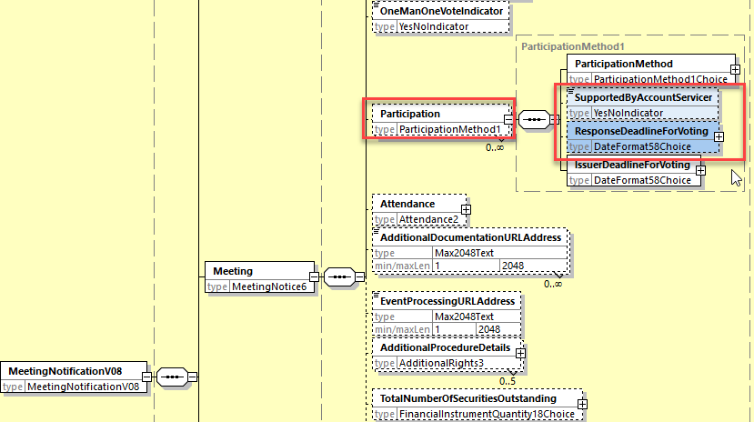

1. In the **seev.006** (MEIS – MeetingInstructionStatus) message, in the ***InstructionTypeStatus*** message building block, add the new code value “*Participation Method Not Supported*” (PMNS) into the ***RejectionReason58Code*** data type typing the element ***Code*** in the sequence *InstructionStatus/ InstructionStatus/Rejected/Reason/ReasonCode* with the following definition “*Instruction rejected due to the method of participation not supported by the account servicer*”.

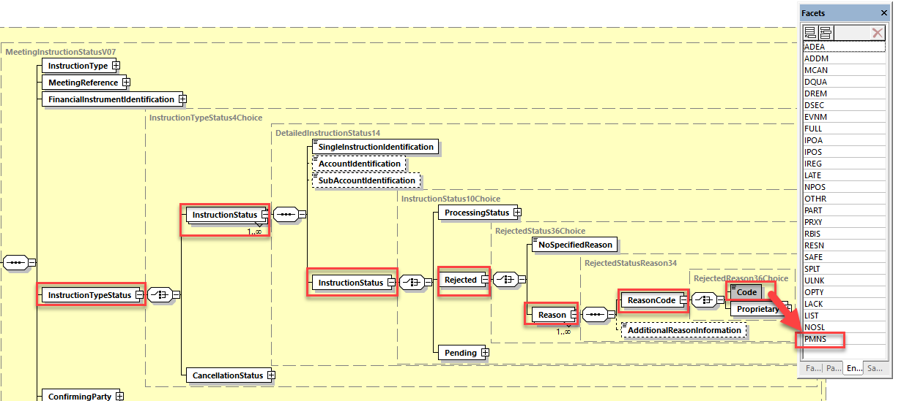

## Proposed timing:

The submitting organization confirms that it can implement the requested changes in the requested timing

|  |  |
| --- | --- |
| Timing | * As requested |

## Final decision of the SEG(s):

|  |  |
| --- | --- |
| Approve | X |

Comments:

|  |  |
| --- | --- |
| Reject |  |

Reason for rejection:

# CR1033: Enable Different Threshold basis for "Voting Right Thresholds for Approval"

1. **Origin of the request:**

*A.1 Submitter*: Securities Market Practice Group

*A.2 Contact person:*

*A.3 Sponsors*:

**Related messages:**

seev.001.001.08

1. **Description of the change request:**

In the seev.001 meeting notification message, the optional, non-repetitive element VotingRightsThresholdForApproval in the Resolution block may be used to indicate if there is a threshold, either expressed in percentage or in quantity, required for approval of the resolution. The basis of the threshold, i.e. to what the percentage/quantity applies, is not specified.

In some markets, e.g. Denmark and Sweden, there are types of threshold or qualified majority rules that cannot be expressed using the existing element. The qualified majority rule may be that

* at least two-thirds of the share capital are represented by persons entitled to vote at the general meeting AND at least two-thirds of the votes are cast in favour of adoption of the proposal (Denmark), or
* the resolutions must be supported by shareholders holding at least two-thirds of the votes cast AND holding at at least two-thirds of the shares represented at the general meeting (Sweden).

Such rules may or may not be related to different voting rights for different share types.

We propose to amend the VotingRightsThresholdForApproval element to include an optional sub-element, ThresholdBasis, to specify the basis for the threshold, using codes from a new code list. This code list should include codes such as ‘All issued shares, ‘All shares represented at meeting’ and ‘All votes cast’.

We also propose to amend the VotingRightsThresholdForApproval element to make it repeatable. If repeated, the ThresholdBasis must be included in each VotingRightsThresholdForApproval element, and the TresholdBasis must have a different code for each repeated element.

1. **Purpose of the change:**

It must be possible to announce in formatted elements the key details of a general meeting, including types of threshold or qualified majority rules that cannot be expressed using the existing element. Issuers are required by law to include this information in the meeting announcement, and hence should be able to include it in the seev.001.

1. **Urgency of the request:**

For SR2022.

1. **Business examples:**

As described above, in some markets, e.g. Denmark and Sweden, there are types of threshold or qualified majority rules for resolutions that cannot be expressed using the existing VotingRightsThresholdForApproval element. The qualified majority rule may be that

* at least two-thirds of the share capital are represented by persons entitled to vote at the general meeting AND at least two-thirds of the votes are cast in favour of adoption of the proposal (Denmark), or
* the resolutions must be supported by shareholders holding at least two-thirds of the votes cast AND holding at at least two-thirds of the shares represented at the general meeting (Sweden).

Such rules may or may not be related to different voting rights for different share types.

Recent examples include the 2021 annual general meetings of Eniro AB (Sweden), Atlas Copco AB (Sweden), Novo Nordisk A/S (Denmark), AP Møller Maersk A/S (Denmark) and Ålandsbanken Abp (Finland).

1. **SEG/TSG recommendation:**

*This section is not to be taken care of by the submitter of the change request. It will be completed in due time by the SEG(s) in charge of the related ISO 20022 messages or the TSG for changes related to the BAH.*

|  |  |  |  |
| --- | --- | --- | --- |
| **Consider** | | X | **Timing** |
|  | | - **Next yearly cycle: 2021/2022**  (the change will be considered for implementation in the yearly maintenance cycle which starts in 2021 and completes with the publication of new message versions in the spring of 2022) | | X |
|  | | - **At the occasion of the next maintenance of the messages**  (the change will be considered for implementation, but does not justify maintenance of the messages in its own right – will be pending until more critical change requests are received for the messages) | |  |
|  | | - **Urgent unscheduled**  (the change justifies an urgent implementation outside of the normal yearly cycle) | |  |  |
|  | | - **Other timing:** | | |  |

Comments:

|  |  |
| --- | --- |
| **Reject** |  |

Reason for rejection:

1. **Impact analysis:**

This change request impacts only the following messages:

seev.001.001.08 MeetingNotificationV08

1. **Proposed implementation:**
2. In the **seev.001** (MENO – MeetingNotification) message, in the ***Resolution*** message building block, set the ***VotingRightsThresholdForApproval*** sequence as repeatable and change the data type ***NumberOrPercentage1Choice*** by a new data type which is a sequence of 2 elements:

* a mandatory non-repeatable ***Threshold*** element typed by ***NumberOrPercentage1Choice*** type;
* an optional non repeatable ***ThresholdBasis*** element typed by a Choice component ***ThresholdBasis1Choice*** which is a choice between a ***Code*** element typed by ***ThresholdBasis1Code*** and a ***Proprietary*** element typed by ***GenericIdentification30***

The ***ThresholdBasis1Code*** will contain 3 code values defined as follows:

* **ALSH** - All Issued Shares
* **ALSM** - All Shares Represented At Meeting
* **ALVO** - All Votes Cast

1. Add the following new textual rule in the ***Resolution*** sequence :

“*If VotingRightThresholdForApproval is present more than once, then ThresholdBasis is mandatory in each occurrence and the value of the Code element must be different in each occurrence as well*.”

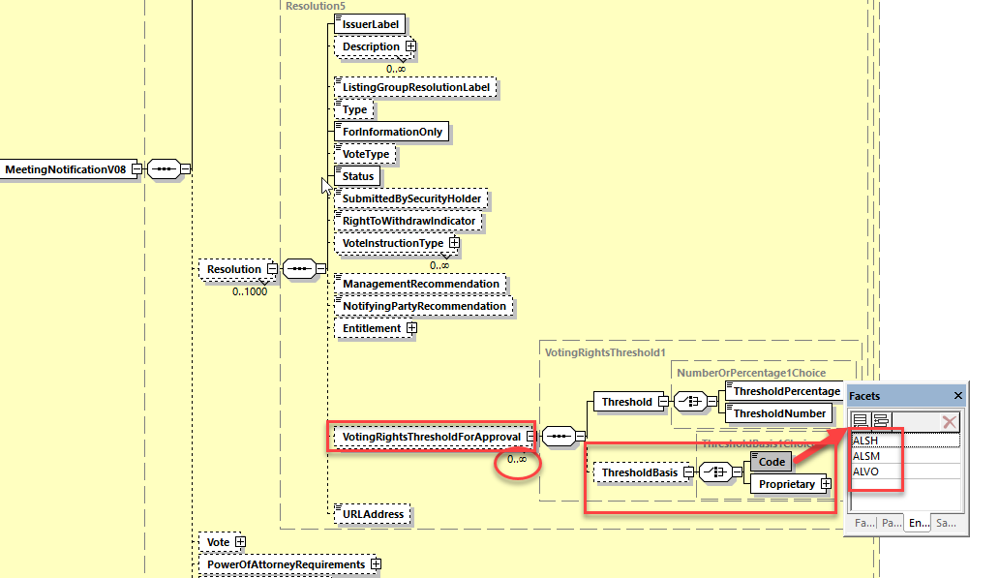

## Proposed timing:

The submitting organization confirms that it can implement the requested changes in the requested timing

|  |  |
| --- | --- |
| Timing | * As requested |

## Final decision of the SEG(s):

|  |  |
| --- | --- |
| Approve | X |

Comments:

|  |  |
| --- | --- |
| Reject |  |

Reason for rejection:

# CR0994: Add new Balance Type for Registered Beneficial Owner – REJECTED by ET

1. **Origin of the request:**

*A.1 Submitter*:

DESSUG CA – PSG (Deutsche SWIFT Securities Market User Group - Corporate Actions - Proxy Subgroup Germany)

This group represents more than 20 different institutions including domestic and global proxy providers and registrars with a key role in the German General Meeting process.

*A.2 Contact person:*

PSG Chair - Hendrik Melchior (employer change to Clearstream Banking Frankfurt in July)

PSG Deputy Chair - Daniel Schäfer, [Daniel.Schaefer@hsbc.de](mailto:Daniel.Schaefer@hsbc.de), Phone +49 211 910-2362

Sabine Wolff, [Sabine.Wolff@clearstream.com](mailto:Sabine.Wolff@clearstream.com), Phone +352-243-3 66 40

SEG GM-ET Member (Germany) - Sven Gunkel, [sven-a.gunkel@db.com](mailto:sven-a.gunkel@db.com), Phone +49 69910-60715

SEG GM-ET Member (Germany) - Rainer Prior, [Rainer.Prior@linkmarketservices.de](mailto:Rainer.Prior@linkmarketservices.de), Phone +49 6196 8870 514

*A.3 Sponsors*:

German Market - including domestic and global proxy providers with a key role in the German General Meeting process.



1. **Related messages:**

Seev.003.xxx.xxx

1. **Description of the change request:**

Two types of share classes are represented on the German market.. Bearer Shares and Registered Shares. The market working group has identified a limitation of the current messages to support Proxy services for Registered Shares.

The Balance Type <BalTp> Registered [NOMI] should be split into two different types to distinguish between a registration in the name of a nominee and in the name of the beneficial owner.

Current: Description of Balance Type “Registered NOMI”

Balance of securities that are registered (in the name of a nominee or of the beneficial owner).

Definition Change Request: Description of Balance Type <BalTp> “Registered Nominee - NOMI” should be Balance of securities that are registered in the name of a nominee.

New Balance Type <BalTp>: “Registered Beneficial Owner - BENE” with description

Balance of securities that are registered in the name of the beneficial owner.

Change to Holding Balance <HldgBal>: The repetition will increase by 1 to 0..16.

Holding Balance <HldgBal> [0..16]

Balance <Bal> [1..1]

Balance Type <BalTp> [1..1]

Blocked BLOK

Eligible ELIG

Pending Delivery PEND

Pending Receipt PENR

Registered Nominee NOMI

Registered Benefical Owner BENE

Settled SETD

Borrowed BORR

On Loan LOAN

Street Position SPOS

Traded TRAD

Collateral In COLI

Collateral Out COLO

Uninstructed Balance UNBA

Instructed Balance INBA

Out For Registration REGO

1. **Purpose of the change:**

The shareholder in a German company share register can be registered in the name of the beneficial owner or in the name of a Nominee. A registration by the end of a day is mandatory.

As per German law the registered name in the company share register has the shareholder rights against the issuer. The Nominee registration (custodian bank on behalf of the account holder of the shares) are allowed, but in this case the Nominee execute the shareholder rights on behalf of the beneficial holder of the shares.

If no registration request has been sent to the company share register, an automatic registration of the German custodian (CSD securities account owner) as Nominee will be performed. In Germany this will be performed by the local CSD application CASCADE-RS.

Especially in case of complex sub-custodian structures, the final beneficial owner details of the settlement transaction are not known to the CSD securities account owner and therefore often just the account owner of the German custodian can be registered in the German company share register.

1. **Urgency of the request:**

By default, valid change requests introduced by June 1 and subsequently approved by the SEG/TSG will be included in the following yearly maintenance cycle which completes with the publication of new message versions by April/May of the following year, unless decided otherwise by the SEG/TSG.

If there is a need to have the new version of the related messages published earlier, the reason for the urgency of the maintenance and the expected consequences of a delay should be described here. Acceptance of such an unscheduled maintenance for the BAH is subject to approval by TSG. Acceptance of an unscheduled maintenance for messages other than the BAH is subject to the approval of the SEG and availability of a submitting organization to develop the new version of the messages.

*Note: the ISO 20022 maintenance results in the publication of a new version of an ISO 20022 message. The actual implementation of such new version on networks and in user installations is not within the purview of ISO.*

N/A

1. **Business examples:**

German custodian A holds 10,000 shares of company XYZ AG for 3 different clients

Client 1 = 500 shares, natural person Mr. Max Mustermann

*Registered in the company share register in the name of the beneficial owner.*

Client 2 = 6,000 shares, investment fund ABC

*Registered in the company share register in the name of the beneficial owner.*

Client 3 = 3,500 shares, Omnibus account of a non-German bank B

*Registered in the company share register in the name of the German custodian as Nominee.*

*Registration in the company share register in the name of the beneficial owner is not possible, because the non-German bank B cannot be registered as beneficial owner when the shares are held in an omnibus account. Presumably bank B deposits the shares for multiple investors.*

1. **SEG/TSG recommendation:**

*This section is not to be taken care of by the submitter of the change request. It will be completed in due time by the SEG(s) in charge of the related ISO 20022 messages or the TSG for changes related to the BAH.*

|  |  |  |  |
| --- | --- | --- | --- |
| **Consider** | |  | **Timing** |
|  | | - **Next yearly cycle: 2021/2022**  (the change will be considered for implementation in the yearly maintenance cycle which starts in 2021 and completes with the publication of new message versions in the spring of 2022) | |  |
|  | | - **At the occasion of the next maintenance of the messages**  (the change will be considered for implementation, but does not justify maintenance of the messages in its own right – will be pending until more critical change requests are received for the messages) | |  |
|  | | - **Urgent unscheduled**  (the change justifies an urgent implementation outside of the normal yearly cycle) | |  |  |
|  | | - **Other timing:** | | |  |

Comments:

|  |  |
| --- | --- |
| **Reject** | X |

Reason for rejection:

Changes on balance types will impact many CA and SnR MT/MX messages. Changes in all impacted securities messages must be synchronised. The ET recommends to DESSUG to submit a new common CR for securities messages for SR 2023.

# CR0993: Add Company Register Shareholder Identification for Registered Shares

1. **Origin of the request:**

*A.1 Submitter*:

DESSUG CA – PSG (Deutsche SWIFT Securities Market User Group - Corporate Actions - Proxy Subgroup Germany)

This group represents more than 20 different institutions including domestic and global proxy providers and registrars with a key role in the German General Meeting process.

*A.2 Contact person:*

PSG Chair - Hendrik Melchior (employer change to Clearstream Banking Frankfurt in July)

PSG Deputy Chair - Daniel Schäfer, [Daniel.Schaefer@hsbc.de](mailto:Daniel.Schaefer@hsbc.de), Phone +49 211 910-2362

Sabine Wolff, [Sabine.Wolff@clearstream.com](mailto:Sabine.Wolff@clearstream.com), Phone +352-243-3 66 40

SEG GM-ET Member (Germany) - Sven Gunkel, [sven-a.gunkel@db.com](mailto:sven-a.gunkel@db.com), Phone +49 69910-60715

SEG GM-ET Member (Germany) - Rainer Prior, [Rainer.Prior@linkmarketservices.de](mailto:Rainer.Prior@linkmarketservices.de), Phone +49 6196 8870 514

*A.3 Sponsors*:

German Market - including domestic and global proxy providers with a key role in the German General Meeting process.



1. **Related messages:**

Seev.003.xxx.xxx

Seev.004.xxx.xxx

Seev.005.xxx.xxx

Seev.006.xxx.xxx

Seev.007.xxx.xxx

1. **Description of the change request:**

Two types of share classes are represented on the German market. Bearer Shares and Registered Shares. The market working group has identified a limitation of the current messages to support Proxy services for Registered Shares.

An additional Rights Holder information field should be created to provide the Company Share Registration ID to the investor and vice versa allow this ID to be reported in the instruction from the investor to the issuer.

This identification should be optional and be provided in addition to the name/address of the rights holder.

Company Register Shareholder ID <ComRegShID> [0..1] text{1,35}

*Note; The Company Register Shareholder ID in Germany can be up to 12 digits, but the most ISO20022 text fields have a length of 35 characters.*

For message Seev.005.xxx.xxx this information is not required, but for consistency purposes of the ISO20022 standard, we think it could be beneficial to add this data as well.

1. **Purpose of the change:**

Each shareholder entry in a German company share register has a unique reference. This ID is mandatory to place valid voting instructions. Without the Company Register Shareholder ID it is not possible submit instructions.

*If this CR will not be granted, a Proprietary Identification <PrtryId> must be used, but may not be accepted by the company if it doesn’t specify exactly what ID has been reported.*

1. **Urgency of the request:**

N/A

1. **Business examples:**

German custodian A holds 10,000 shares of company XYZ AG for 3 different clients

Client 1 = 500 shares, natural person Mr. Max Mustermann

*Registration in the company share register in the name of the beneficial owner with ID 111222333000*

Client 2 = 6,000 shares, investment fund ABC

*Registration in the company share register in the name of the beneficial owner with ID 444555666000*

Client 3 = 3,500 shares, Omnibus account of a non-German bank B

*Registration in the company share register in the name of the German custodian as Nominee with ID 777888999000*

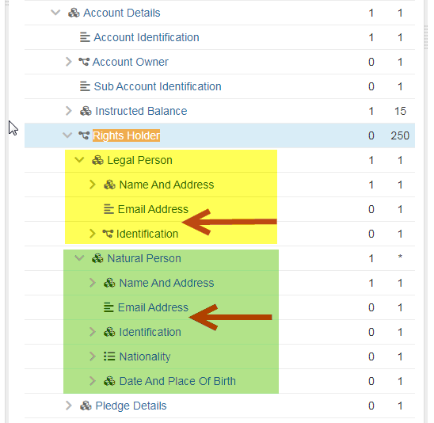

…

Legal Person <LglPrsn> [1..1]

Name And Address <NmAndAdr> [1..1]

Name <Nm> [1..1] text{1,350}

Address <Adr> [0..1]

Email Address <EmailAdr> [0..1] text{1,256}

Company Register Shareholder ID < ComShRegID > [0..1] text{1,35}

…

…

Natural Person <NtrlPrsn> [1..1]

Name And Address <NmAndAdr> [1..1]

Name Prefix <NmPrfx> [0..1] text

First Name <FrstNm> [1..1] text{1,350}

Surname <Srnm> [1..1] text{1,350}

Address <Adr> [0..1]

Email Address <EmailAdr> [0..1] text{1,256}

Company Register Shareholder ID <ComRegShID> [0..1] text{1,35}

…

1. **SEG/TSG recommendation:**

*This section is not to be taken care of by the submitter of the change request. It will be completed in due time by the SEG(s) in charge of the related ISO 20022 messages or the TSG for changes related to the BAH.*

|  |  |  |  |
| --- | --- | --- | --- |
| **Consider** | | X | **Timing** |
|  | | - **Next yearly cycle: 2021/2022**  (the change will be considered for implementation in the yearly maintenance cycle which starts in 2021 and completes with the publication of new message versions in the spring of 2022) | | X |
|  | | - **At the occasion of the next maintenance of the messages**  (the change will be considered for implementation, but does not justify maintenance of the messages in its own right – will be pending until more critical change requests are received for the messages) | |  |
|  | | - **Urgent unscheduled**  (the change justifies an urgent implementation outside of the normal yearly cycle) | |  |  |
|  | | - **Other timing:** | | |  |

Comments:

|  |  |
| --- | --- |
| **Reject** |  |

Reason for rejection:

1. **Impact analysis:**

This change request impacts only the following messages containing the RightsHolder components:

seev.001.001.08 MeetingNotificationV08

seev.002.001.07 MeetingCancellationV07

seev.003.001.07 MeetingEntitlementNotificationV07

seev.004.001.07 MeetingInstructionV07

seev.005.001.07 MeetingInstructionCancellationRequestV07

seev.006.001.07 MeetingInstructionStatusV07

seev.007.001.07 MeetingVoteExecutionConfirmationV07

1. **Proposed implementation:**

In the **seev.001** (MENO – MeetingNotification) message, in the ***Security*** message building block, in the ***Position*** sequence,

In the **seev.002** (MECN – MeetingCancelletion) message, in the ***Security*** message building block, in the ***Position*** sequence,

In the **seev.003** (MENT – MeetingEntitlementNotification) message, in the ***Security*** message building block, in the ***Position*** sequence,

In the **seev.004** (MEIN – MeetingInstruction) message, in the ***Instruction*** message building block, in the ***AccountDetails*** sequence,

In the **seev.005** (MEIC – MeetingInstructionCancellationRequest) message, in the ***ToBeCancelledInstruction*** message building block, in the ***InstructedPosition*** sequence,

In the **seev.006** (MEIS – MeetingInstructionStatus) message, in the ***Rightsholder*** message building block,

In the **seev.007** (MECO – MeetingVoteExecutionConfirmation) message, in the ***VotingInstructions*** message building block,

Add the optional and non-repeatable element ***CompanyRegisterShareholderIdentification*** typed by Max35Text in the ***LegalPerson*** and ***NaturalPerson*** sequence with the following definition:

*“Identification of the shareholder in the company share register.”*.

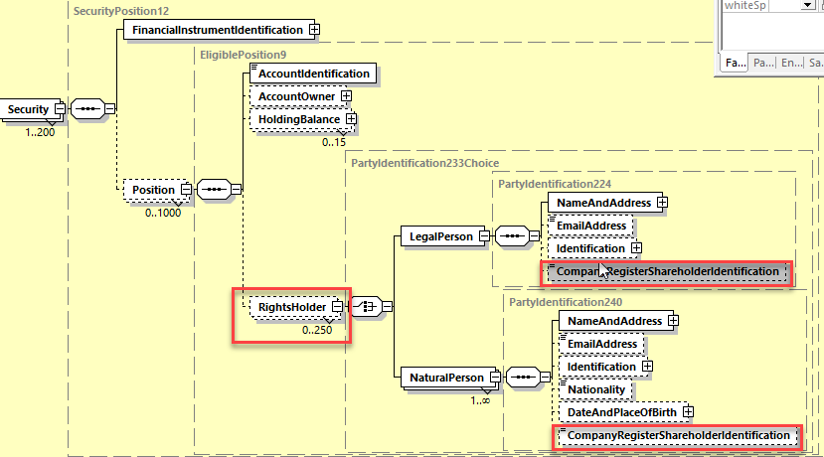

## Proposed timing:

The submitting organization confirms that it can implement the requested changes in the requested timing

|  |  |
| --- | --- |
| Timing | * As requested |

## Final decision of the SEG(s):

|  |  |
| --- | --- |
| Approve | X |

Comments:

|  |  |
| --- | --- |
| Reject |  |

Reason for rejection:

# CR1024: Set Meeting Reference and FIIdentification elements mandatory

1. **Origin of the request:**

*A.1 Submitter*: Euroclear

*A.2 Contact person:* Jean-Paul Lambotte (jean-paul.lambotte@euroclear.com)

*A.3 Sponsors*:

1. **Related messages:**

seev.005.001.07

1. **Description of the change request:**

Make the “Meeting Reference” and “FinancialInstrumentIdentification“ elements mandatory in the seev.005.

1. **Purpose of the change:**

In the seev.005, the “Meeting Reference” and “FinancialInstrumentIdentification“ elements are optional (when the “Meeting Reference” element is present, the sub-elements MeetingReference, MeetingDateAndTime and Type are mandatory).

In the seev.006, the “Meeting Refence” and “FinancialInstrumentIdentification ” are mandatory (in the “Meeting reference” element, the sub-elements MeetingReference, MeetingDateAndTime and Type are mandatory).

If the account servicer receives an seev.005 making reference to an unknown original instruction (MeetingInstructionIdentification field contains an unknown reference), it is not possible to retrieve any meeting information and populate correctly the fields mentioned above in the seev.006 (dummy value/fake isin must be used).

The proposal is to align seev.005 with seev.006 and with seev.004 and make those fields mandatory.

1. **Urgency of the request:**

SR2022

1. **Business examples:**

See case describe above.

1. **SEG/TSG recommendation:**

*This section is not to be taken care of by the submitter of the change request. It will be completed in due time by the SEG(s) in charge of the related ISO 20022 messages or the TSG for changes related to the BAH.*

|  |  |  |  |
| --- | --- | --- | --- |
| **Consider** | | X | **Timing** |
|  | | - **Next yearly cycle: 2021/2022**  (the change will be considered for implementation in the yearly maintenance cycle which starts in 2021and completes with the publication of new message versions in the spring of 2022) | | X |
|  | | - **At the occasion of the next maintenance of the messages**  (the change will be considered for implementation, but does not justify maintenance of the messages in its own right – will be pending until more critical change requests are received for the messages) | |  |
|  | | - **Urgent unscheduled**  (the change justifies an urgent implementation outside of the normal yearly cycle) | |  |  |
|  | | - **Other timing:** | | |  |

Comments:

|  |  |
| --- | --- |
| **Reject** |  |

Reason for rejection:

1. **Impact analysis:**

This change request impacts only the following messages:

seev.005.001.07 MeetingInstructionCancellationRequestV07

1. **Proposed implementation:**

In the **seev.005** (MEIC – MeetingInstructionCancellationRequest) message, set the ***MeetingReference and FinancialInstrumentIdentification*** message building blocks as mandatory.

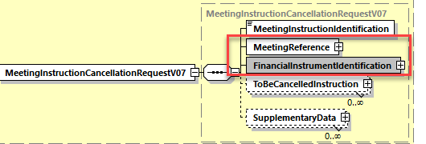

## Proposed timing:

The submitting organization confirms that it can implement the requested changes in the requested timing

|  |  |
| --- | --- |
| Timing | * As requested |

## Final decision of the SEG(s):

|  |  |
| --- | --- |
| Approve | X |

Comments:

|  |  |
| --- | --- |
| Reject |  |

Reason for rejection: