Maintenance Change Request
for the update of ISO 20022 financial repository items
The following CRs have been approved for implementation in 2021/2022:
CR0984 - Minor Changes fixes separated in CR0984-xy
CR0979 - Critical Fixes separated in CR0979-xy
CR0981 - Enhancements-New Field separated in CR0981-xy
CR0982 - Enhancements-New Message

- Name of the request:
Acquirer to Issuer Card Messages (ATICA) update to v3

- Submitting organization(s):
ISO TC68 / SC09 / TG01.

- Related messages:
caad.005.001.03 | ReconciliationInitiationV03
caad.006.001.03 | ReconciliationResponseV03
cafc.001.001.02 | FeeCollectionInitiationV02
cafc.002.001.02 | FeeCollectionResponseV02
cafm.001.001.02 | FileActionInitiationV02
cafm.002.001.02 | FileActionResponseV02
cafr.001.001.02 | FraudReportingInitiationV02
cafr.002.001.02 | FraudReportingResponseV02
cafr.003.001.02 | FraudDispositionInitiationV02
cafr.004.001.02 | FraudDispositionResponseV02
cain.001.001.03 | AuthorisationInitiationV03
cain.002.001.03 | AuthorisationResponseV03
cain.003.001.03 | FinancialInitiationV03
cain.004.001.03 | FinancialResponseV03
cain.005.001.03 | ReversalInitiationV03
cain.006.001.03 | ReversalResponseV03
cain.014.001.02 | RetrievalFulfilmentInitiationV02
cain.015.001.02 | RetrievalFulfilmentResponseV02
cain.016.001.02 | InquiryInitiationV02
cain.017.001.02 | InquiryResponseV02
cain.018.001.02 | VerificationInitiationV02
cain.019.001.02 | VerificationResponseV02
cain.020.001.02 | AmendmentV02
cain.021.001.02 | RetrievalInitiationV02
cain.022.001.02 | RetrievalResponseV02
cain.023.001.02 | CardManagementInitiationV02
cain.024.001.02 | CardManagementResponseV02
cain.025.001.02 | AddendumInitiationV02
cain.026.001.02 | AddendumResponseV02
cain.027.001.02 | ChargeBackInitiationV02
cain.028.001.02 | ChargeBackResponseV02
canm.001.001.03 | NetworkManagementInitiationV03
canm.002.001.03 | NetworkManagementResponseV03
canm.003.001.03 | KeyExchangeInitiationV03
canm.004.001.03 | KeyExchangeResponseV03
casr.001.001.02 | SettlementReportingInitiationV02
casr.002.001.02 | SettlementReportingResponseV02

- Commitments of the submitting organization:
ISO TC68 / SC09 / TG01 confirms that it can and will:
- undertake the development of the new version of the candidate ISO 20022 message models that it will submit to the RA for compliance review and evaluation. For the ISO 20022 yearly maintenance cycle, new valid Message Definition models must be available to the RA by December 1.
- provide a new version of part 1 of the Message Definition Report (MDR) by December 1, and, optionally, new examples of valid and invalid message instances of each candidate message by May 1 at the latest.
- address any queries related to the description of the new models and messages as published by the RA on the ISO 20022 website.
If the submitting organization cannot develop all or part of the changes included in this Maintenance Change Request in the timeframe agreed by the SEG, it must propose an alternative solution for the change requests it cannot develop in time (eg postpone to a later date or to the next yearly maintenance cycle).
The submitting organization does not intend to organize any testing or the actual implementation of the new version of the messages once the related documentation has been published by the RA.
The submitting organization confirms its knowledge and acceptance of the ISO 20022 Intellectual Property Rights policy for contributing organizations, as follows.
“Organizations that contribute information to be incorporated into the ISO 20022 Repository shall keep any Intellectual Property Rights (IPR) they have on this information. A contributing organization warrants that it has sufficient rights on the contributed information to have it published in the ISO 20022 Repository through the ISO 20022 Registration Authority in accordance with the rules set in ISO 20022. To ascertain a widespread, public and uniform use of the ISO 20022 Repository information, the contributing organization grants third parties a non-exclusive, royalty-free license to use the published information”.

- Contact persons:
Douglas Frantz
DFrantz@visa.com
+1 (650) 432-4591

Table of Contents
Change Key: 7
ATICA MCR-V3 CR0984 – Minor Fixes 7
CR0984-1: Update elements which use ISO2Or3ACountryCode and ISO3NumericCurrencyCode 13
CR0984-2: Processing Result 44
CR0984-3: Update Transaction Sub Type description to indicate its use more clearly 54
CR0984-4: Add foreign merchant to sponsored merchant 59
CR0984-5: FuelInd alignment 61
CR0984-6: Update Period Unit/ Frequency with additional Code 63
CR0984-7: Message ReconciliationTypeCode 65
CR0984-8: Legal Corporate Name 67
CR0984-9: AccountIdentification <AcctId> 74
CR0984-10: TravelAgency 76
CR0984-11: Tax33 Enhancement 79
CR0984-12: ProductQuantity 83
CR0984-13: Misc. Spelling Errors within ATICA ISO 20022 v2 85
CR0984-14: AdditionalCardData 87
CR0984-15: Error details and source in Processing Results 92
ATICA MCR-V3 CR0979 – Critical Fixes 116
CR0979-1: AddendumData2 122
CR0979-2: Tax within AncillaryPurchase2 129
CR0979-3: Customer Credential 130
CR0979-4: Plan2 structure 133
CR0979-5: Reconciliation Activity type 134
CR0979-6: POI Component Enhancement 136
CR0979-7: Consolidate TransactionIdentification elements 140
CR0979-8: Result within VerificationResult1 structure 142
CR0979-9: Customer Device Code 145
CR0979-10 : DataType for Entity inside of Environment PartyIdentification240 158
CR0979-11: Customer7 enhancement 162
CR0979-12: CreditIndicator element 165
CR0979-13: Shipping Pack1 Container 172
CR0979-14: VerificationEntity1Code 174
CR0979-15: Cardholder17 177
CR0979-16: Settlement Service Enhancement 179
CR0979-17: Amount15 and FeeAmount3 184
CR0979-18: AdditionalIdentification 189
CR0979-19: Sales Context Enhancement 196
CR0979-20: Alternate Message Reason Structure 198
CR0979-21: ISOResponseCode 200
CR0981-1: CardProgrammeApplied add additional identification 238
CR0981-2: Add new Deferred Instalment and Deferred Settlement Indicators 242
CR0981-3: Detail Amount Type and additional Amount Type 247
CR0981-4: Verification Type 252
CR0981-5: Fee Collection Message 256
CR0981-6: File Action Size 260
CR0981-7: Dispute Data 262
CR0981-8: Dispute Additional Data 265
CR0981-9: POS Context Additional Data 271
CR0981-10: Adding Dispute related structures in Financial messages 274
CR0981-11: ICC Fallback 278
CR0981-12: POS Data Code 281
CR0981-13: Reversal Message Function 294
CR0981-14: Processing Result – add Local Data for additional information 296
CR0981-15: Transit Flag 325
CR0981-16: New Codes for e-commerce 331
ATICA MCR-V3 CR0982 – Enhancement-Messages 353
CR0982-1.1: Caad.008.001.01 AdministrativeInitiationV01 353
CR0982-1.2: Caad.009.001.01 AdministrativeResponseV01 358

Change Key:

Items in blue have changed
Items in red to be removed
Items in green are new

ATICA MCR-V3 CR0984 – Minor Fixes
for the update of ISO 20022 financial repository items
Note: the purpose of this document is to give guidelines to parties who want to introduce a request to change an existing ISO 20022 message(s), or update other items of the ISO 20022 financial repository. Such change requests are subject to the approval of the ISO 20022 Standards Evaluation Group(s) in charge of the related message/item or to the approval of the Technical Support Group (TSG), if the requested change relates to the Business Application Header (BAH). Please consult the iso20022.org website for additional details on the maintenance process. Change requests are to be sent to iso20022ra@iso20022.org. All change requests conforming to this template received by June 1st will be considered for development in the following yearly ISO 20022 maintenance cycle which completes with publication of new message versions in April/May of the following year.
- Origin of the request:
A.1 Submitter: ISO TC68/SC9/TG1
A.2 Contact person:
Douglas Frantz
DFrantz@visa.com
+1 (650) 432-4591
A.3 Sponsors: ISO TC68/SC9/TG1
- Related messages:
caad.001.001.02 BatchManagementInitiationV02
caad.002.001.02 BatchManagementResponseV02
caad.003.001.01 BatchTransferInitiationV01
caad.004.001.01 BatchTransferResponseV01
caad.005.001.03 ReconciliationInitiationV03
caad.006.001.03 ReconciliationResponseV03
caad.007.001.03 ErrorV03
cafc.001.001.02 FeeCollectionInitiationV02
cafc.002.001.02 FeeCollectionResponseV02
cafm.001.001.02 FileActionInitiationV02
cafm.002.001.02 FileActionResponseV02
cafr.001.001.02 FraudReportingInitiationV02
cafr.002.001.02 FraudReportingResponseV02
cafr.003.001.02 FraudDispositionInitiationV02
cafr.004.001.02 FraudDispositionResponseV02
cain.001.001.03 AuthorisationInitiationV03
cain.002.001.03 AuthorisationResponseV03
cain.003.001.03 FinancialInitiationV03
cain.004.001.03 FinancialResponseV03
cain.005.001.03 ReversalInitiationV03
cain.006.001.03 ReversalResponseV03
cain.014.001.02 RetrievalFulfilmentInitiationV02
cain.015.001.02 RetrievalFulfilmentResponseV02
cain.016.001.02 InquiryInitiationV02
cain.017.001.02 InquiryResponseV02
cain.018.001.02 VerificationInitiationV02
cain.019.001.02 VerificationResponseV02
cain.020.001.01 AmendmentV01
cain.021.001.02 RetrievalInitiationV02
cain.022.001.02 RetrievalResponseV02
cain.023.001.02 CardManagementInitiationV02
cain.024.001.02 CardManagementResponseV02
cain.025.001.02 AddendumInitiationV02
cain.026.001.02 AddendumResponseV02
cain.027.001.02 ChargeBackInitiationV02
cain.028.001.02 ChargeBackResponseV02
canm.001.001.03 NetworkManagementInitiationV03
canm.002.001.03 NetworkManagementResponseV03
canm.003.001.03 KeyExchangeInitiationV03
canm.004.001.03 KeyExchangeResponseV03
casr.001.001.02 SettlementReportingInitiationV02
casr.002.001.02 SettlementReportingResponseV02

.
- Description of the change request:

The following changes provide corrections or minor modifications to existing structures and components. The types of change include, but are not limited to:

- Field size changes to match 8583 or other needs
- Updating elements or components cardinality
- New codes or data elements to existing components
- Definition updates / corrections

These changes provide alignment with current market practices. These changes were brought forth from stakeholders as a result of internal reviews and feedback to TG1.

- Purpose of the change:
These changes include corrections to support existing and evolving business practices, payment methods and services, inclusion of additional data to support these processes, regulatory requirements and compatibility with existing standards and implementations.
The card industry is evolving rapidly. These changes will enhance the ATICA message set to better support use of ISO 20022 ATICA messages within the card industry.
- Urgency of the request:
Normal Maintenance Cycle
- Business examples:
- Field size expansion for an existing data element.
  - Field Size Expansion - In AccountDetails Expand the length of AccountIdentification. Some Account Identifiers are larger than Max35text.
- New element for an existing component.
  - Acceptor1 - Add "Legal Corporate Name". Currently the model supports only one name (DBA Name). For regulatory purposes ATICA also needs to include Legal Corporate Name.
- New code added to an existing data element.
  - Adding an additional code for taxable amount.
- Updated definition for a data element / component.
  - Change definition of InstalmentAmountDetails1/Type for additional and expanded use of the component.
- SEG/TSG recommendation:
This section is not to be taken care of by the submitter of the change request. It will be completed in due time by the SEG(s) in charge of the related ISO 20022 messages or the TSG for changes related to the BAH.

Consider |  | X | Timing
- Next yearly cycle: 2021/2022
(the change will be considered for implementation in the yearly maintenance cycle which starts in 2021 and completes with the publication of new message versions in the spring of 2022)
- At the occasion of the next maintenance of the messages
(the change will be considered for implementation, but does not justify maintenance of the messages in its own right – will be pending until more critical change requests are received for the messages)
- Urgent unscheduled
(the change justifies an urgent implementation outside of the normal yearly cycle)
 |  |  | - Other timing:
Comments:
Card SEG Meeting on 29/09/2021
Cards SEG Participants:
- Duvall Richard
- Groves Ian
- Herwig Reinhard
- Karsten Pierre
- Morelli Vince
- Powell Glenn
- Sasor Tomasz
- Vanobberghen William

and
- Philippe Cece for nexo
- Frantz Douglas for TG1 (apologized)
- Pierre Moura for nexo

The change requests are approved by the participants.

Reject
Reason for rejection:

CR0984-1: Update elements which use ISO2Or3ACountryCode and ISO3NumericCurrencyCode

Description
Update elements which use ISO2Or3ACountryCode with descriptions to include ISO 3166 and ISO3NumericCurrencyCode with descriptions to include ISO 4217 where appropriate.

Existing component
Existing Descriptions of Elements using ISO3NumericCurrencyCode but does not list ISO 4217:
- Balance16:
  - Currency: “Currency of the account”
- RentalDetails2:
  - Currency: “Currency code applied for the rental.”
- FeeAmount3:
  - Currency: “Currency for the type of amount.”
- Location4:
  - Local Currency: “Local currency.”
- ExchangeRateDetail1:
  - Counter Currency Code: “Identifies the counter currency used for currency conversion for the transaction party.”
- ExchangeRateDetail1:
  - Base Currency Code: “Identifies the base currency used for currency conversion for the transaction party.”
- CardData9:
  - Card Currency Code: “Currency code assigned to the card by the card issuer.
ISO 8583:2003 bit 6.”

Existing Descriptions of Elements using ISO2Or3ACountryCode but does not list ISO 3166.
- Wallet2:
  - Wallet Account Country: “Country of the wallet account.”
- TerminalIdentification1:
  - Country : “Country of the terminal.”
- DrivingLicense1:
  - Country : “Country issuing the driver license.”
- TravelDocument1:
  - Country: “Country issuing the travel document.”
- TelecomCallDetails1:
  - Country: “Country from which or to which the call was made.”

Existing Descriptions of Elements which do not reference ISO 3166-2 or local authority:
- Authority1:
  - Country Sub Division Major: “Identifies a major subdivision of a country, for instance state, province.”
- Authority1:
  - Country Sub Division Minor: “Identifies a minor subdivision of a country, for instance county, prefecture.”

Existing Address2:
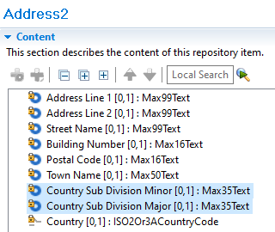
Descriptions of Address2: Country Sub Division Minor/ Major currently references ISO 3166-2.

Existing Authority1:
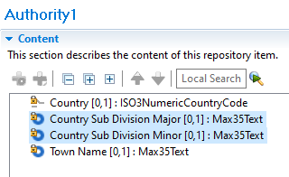

Existing Address3, used for local data and contains extended sizes of address elements:
We do not need 70 text for subdivision major and minor. The code will be the same so can be removed from local data.
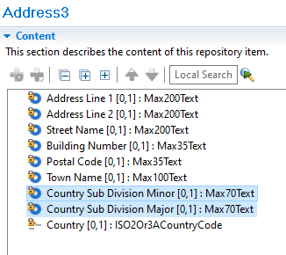
Some still contain (Min2Max3AlphaText) to change to ISO2Or3ACountryCode:
- GenericIdentification172: Country
- TerminalIdentification1: Country
- DrivingLicense1: Country
- TravelDocument1: Country
- VehicleRentalCompany2: Country
- LodgingProperty2: Country
- TelecomCallDetails1: Country
- ApprovalEntity1: Country

Component modification

Update the descriptions of the following elements:
ISO3NumericCurrencyCode: “...In accordance with ISO 4217”
- Balance16:
  - Currency: “Currency of the account. In accordance with ISO 4217”
- RentalDetails2:
  - Currency: “Currency code applied for the rental. In accordance with ISO 4217”
- FeeAmount3:
  - Currency: “Currency for the type of amount. In accordance with ISO 4217”
- Location4:
  - Local Currency: “Local currency. In accordance with ISO 4217”
- ExchangeRateDetail1:
  - Counter Currency Code: “Identifies the counter currency used for currency conversion for the transaction party. In accordance with ISO 4217”
- ExchangeRateDetail1:
  - Base Currency Code: “Identifies the base currency used for currency conversion for the transaction party. In accordance with ISO 4217”
- CardData9:
  - Card Currency Code: “Currency code assigned to the card by the card issuer.
ISO 8583:2003 bit 6. In accordance with ISO 4217”

ISO2Or3ACountryCode: “...In accordance with ISO 3166-1.”
- Wallet2:
  - Wallet Account Country: “Country of the wallet account. In accordance with ISO 3166-1”
- TerminalIdentification1:
  - Country : “Country of the terminal. In accordance with ISO 3166-1”
- DrivingLicense1:
  - Country : “Country issuing the driver license. In accordance with ISO 3166-1”
- TravelDocument1:
  - Country: “Country issuing the travel document. In accordance with ISO 3166-1”
- TelecomCallDetails1:
  - Country: “Country from which or to which the call was made. In accordance with ISO 3166-1”

ISOCountrySubDivisionCode: “…In accordance with ISO 3166-2 or the local authority.”
- Authority1:
  - Country Sub-Division Minor: “Identifies a minor subdivision of a country, for instance county, prefecture. In accordance with ISO 3166-2 or the local authority”
- Authority1:
  - Country Sub-Division Major: “Identifies a major subdivision of a country, for instance state, province. In accordance with ISO 3166-2 or the local authority”

New MXCode Set:

Name: ISOCountrySubDivisionCode
Description: Code to identify an area of geopolitical interest, based on names obtained from the United Nations ISO 3166-2 or the local authority.
Pattern: [A-Z]{1-3}

Updated Component Data types

Address2 | Occurs | Type
Address Line 1 | [0..1] | Max99Text
…
Country Sub Division Minor | [0..1] | ISOCountrySubDivisionCode
Country Sub Division Major | [0..1] | ISOCountrySubDivisionCode
Country Sub Division Minor Name | [0..1] | Max50Text
Country Sub Division Major Name | [0..1] | Max50Text
…

Authority1 | Occurs | Type
Country | [0..1] | ISO3NumericCountryCode
…
Country Sub Division Minor | [0..1] | ISOCountrySubDivisionCode
Country Sub Division Major | [0..1] | ISOCountrySubDivisionCode
Country Sub Division Minor Name | [0..1] | Max50Text
Country Sub Division Major Name | [0..1] | Max50Text
…

GenericIdentification172 | Occurs | Type
Identification | [1..1] | Max35Text
…
Country | [0..1] | ISO2Or3ACountryCode
…

TerminalIdentification1 | Occurs | Type
Identification | [1..1] | Max16Text
…
Country | [0..1] | ISO2Or3ACountryCode
…

DrivingLicense1 | Occurs | Type
Type | [0..1] | Max70Text
…
Country | [0..1] | ISO2Or3ACountryCode
…

TravelDocument1 | Occurs | Type
Type | [1..1] | OfficialDocumentType1Code
…
Country | [0..1] | ISO2Or3ACountryCode
…

VehicleRentalCompany2 | Occurs | Type
Name | [0..1] | Max70Text
…
Country | [0..1] | ISO2Or3ACountryCode
…

LodgingProperty2 | Occurs | Type
Type | [0..1] | LodgingActivity1Code
…
Country | [0..1] | ISO2Or3ACountryCode
…

TelecomCallDetails1 | Occurs | Type
Type | [1..1] | TelephonyCallType1Code
…
Country | [0..1] | ISO2Or3ACountryCode
…

ApprovalEntity1 | Occurs | Type
Identification | [1..1] | Max35Text
…
Country | [0..1] | ISO2Or3ACountryCode
…

Fix elements from Component Data types:
- Remove as this data does not change when used for local data.
Address3 | Occurs | Type
Address Line 1 | [0..1] | ISO3NumericCountryCode
…
Country Sub Division Minor Name | [0..1] | Max100Text
Country Sub Division Major Name | [0..1] | Max100Text
…

Impacts
- ApprovalEntity1
Message Definition | Message Components
Authorisation Initiation V03 | ProcessingResult9.  ApprovalData1.ApprovalEntity1
Authorisation Response V03 | ProcessingResult10.  ApprovalData1.ApprovalEntity1
Card Management Initiation V02 | ProcessingResult9.  ApprovalData1.ApprovalEntity1
Card Management Response V02 | ProcessingResult9.  ApprovalData1.ApprovalEntity1
Charge Back Initiation V02 | OriginalTransaction2.ProcessingResult10.  ApprovalData1.ApprovalEntity1
Financial Initiation V03 | ProcessingResult9.  ApprovalData1.ApprovalEntity1
Financial Response V03 | ProcessingResult10.  ApprovalData1.ApprovalEntity1
Network Management Initiation V03 | ProcessingResult9.  ApprovalData1.ApprovalEntity1
Network Management Response V03 | ProcessingResult9.  ApprovalData1.ApprovalEntity1
Retrieval Fulfilment Initiation V03 | OriginalTransaction2.ProcessingResult10.  ApprovalData1.ApprovalEntity1
Retrieval Initiation V02 | OriginalTransaction2.ProcessingResult10.  ApprovalData1.ApprovalEntity1
Reversal Initiation V03 | ProcessingResult9.  ApprovalData1.ApprovalEntity1
Reversal Response V03 | ProcessingResult10.  ApprovalData1.ApprovalEntity1
Verification Initiation V02 | ProcessingResult12.  ApprovalData1.ApprovalEntity1
Verification Response V02 | ProcessingResult12.  ApprovalData1.ApprovalEntity1

- TelecomCallDetails1
Message Definition | Message Components
Addendum Initiation V02 | AddendumData3.TelecomServices1.  TelecomServicesLineItem1.TelecomCallDetails1
Authorisation Initiation V03 | AddendumData3.TelecomServices1.  TelecomServicesLineItem1.TelecomCallDetails1
Financial Initiation V03 | AddendumData3.TelecomServices1.  TelecomServicesLineItem1.TelecomCallDetails1

- LodgingProperty2
Message Definition | Message Components
Addendum Initiation V02 | AddendumData3.Lodging3.LodgingSummary2.LodgingProperty2
Authorisation Initiation V03 | AddendumData3.Lodging3.LodgingSummary2.LodgingProperty2
Financial Initiation V03 | AddendumData3.Lodging3.LodgingSummary2.LodgingProperty2

- VehicleRentalCompany2
Message Definition | Message Components
Addendum Initiation V02 | AddendumData3.VehicleRentalService2.VehicleRentalCompany2
Authorisation Initiation V03 | AddendumData3.VehicleRentalService2.VehicleRentalCompany2
Financial Initiation V03 | AddendumData3.VehicleRentalService2.VehicleRentalCompany2

- TravelDocument1
Message Definition | Message Components
Addendum Initiation V02 | AddendumData3.FleetData2.FleetSummary1.Driver1.TravelDocument1
Authorisation Initiation V03 | AddendumData3.FleetData2.FleetSummary1.Driver1.TravelDocument1
Financial Initiation V03 | AddendumData3.FleetData2.FleetSummary1.Driver1.TravelDocument1

- DrivingLicense1
Message Definition | Message Components
Addendum Initiation V02 | AddendumData3.FleetData2.FleetSummary1.Driver1.DrivingLicense1
Authorisation Initiation V03 | AddendumData3.FleetData2.FleetSummary1.Driver1.DrivingLicense1
Financial Initiation V03 | AddendumData3.FleetData2.FleetSummary1.Driver1.DrivingLicense1

- TerminalIdentification1
Message Definition | Message Components
Authorisation Initiation V03 | Environment17.Terminal4.TerminalIdentification1
Authorisation Response V03 | Environment26.Terminal2.TerminalIdentification1
Card Management Initiation V02 | Environment18.Terminal4.TerminalIdentification1
Card Management Response V02 | Environment25.Terminal2.TerminalIdentification1
Charge Back Initiation V02 | Environment21.Terminal2.TerminalIdentification1
Charge Back Response V02 | Environment29.Terminal2.TerminalIdentification1
File Action Initiation V02 | Environment22.Terminal4.TerminalIdentification1
File Action Response V02 | Environment22.Terminal4.TerminalIdentification1
Financial Initiation V03 | Environment17.Terminal4.TerminalIdentification1
Financial Response V03 | Environment26.Terminal2.TerminalIdentification1
Inquiry Initiation V02 | Environment18.Terminal4.TerminalIdentification1
Inquiry Response V02 | Environment24.Terminal2.TerminalIdentification1
Retrieval Fulfilment Initiation V03 | Environment21.Terminal2.TerminalIdentification1
Retrieval Fulfilment Response V03 | Environment21.Terminal2.TerminalIdentification1
Retrieval Initiation V02 | Environment21.Terminal2.TerminalIdentification1
Retrieval Response V02 | Environment21.Terminal2.TerminalIdentification1
Reversal Initiation V03 | Environment19.Terminal2.TerminalIdentification1
Reversal Response V03 | Environment29.Terminal2.TerminalIdentification1
Verification Initiation V02 | Environment31.Terminal4.TerminalIdentification1
Verification Response V02 | Environment32.Terminal2.TerminalIdentification1

- GenericIdentification172
Message Definition | Message Components
Addendum Initiation V02 | Header48.Traceability7
Addendum Response V02 | Header48.Traceability7
Amendment V01 | Header46.Traceability7
Authorisation Initiation V03 | Header42.Traceability7
Authorisation Response V03 | Header42.Traceability7
Batch Management Initiation V02 | Header38.Traceability7
Batch Management Response V02 | Header38.Traceability7
Batch Transfer Initiation V02 | Header39.Traceability7
Batch Transfer Response V02 | Header39.Traceability7
Card Management Initiation V02 | Header39.Traceability7
Card Management Response V02 | Header39.Traceability7
Charge Back Initiation V02 | Header40.Traceability7
Charge Back Response V02 | Header40.Traceability7
Custom Report V01 | Header46.Traceability7
Error V03 | Header45.Traceability7
Fee Collection Initiation V02 | Header48.Traceability7
Fee Collection Response V02 | Header48.Traceability7
File Action Initiation V02 | Header39.Traceability7
File Action Response V02 | Header39.Traceability7
Financial Initiation V03 | Header42.Traceability7
Financial Response V03 | Header42.Traceability7
Fraud Disposition Initiation V02 | Header48.Traceability7
Fraud Disposition Response V02 | Header48.Traceability7
Fraud Reporting Initiation V02 | Header48.Traceability7
Fraud Reporting Response V02 | Header48.Traceability7
Inquiry Initiation V02 | Header39.Traceability7
Inquiry Response V02 | Header39.Traceability7
Key Exchange Initiation V03 | Header43.Traceability7
Key Exchange Response V03 | Header43.Traceability7
Network Management Initiation V03 | Header43.Traceability7
Network Management Response V03 | Header43.Traceability7
Reconciliation Initiation V03 | Header39.Traceability7
Reconciliation Response V03 | Header39.Traceability7
Retrieval Fulfilment Initiation V02 | Header48.Traceability7
Retrieval Fulfilment Response V02 | Header48.Traceability7
Retrieval Initiation V02 | Header55.Traceability7
Retrieval Response V02 | Header55.Traceability7
Reversal Initiation V03 | Header42.Traceability7
Reversal Response V03 | Header42.Traceability7
Settlement Reporting Initiation V02 | Header48.Traceability7
Settlement Reporting Response V02 | Header42.Traceability7
Verification Initiation V02 | Header39.Traceability7
Verification Response V02 | Header39.Traceability7

- Authority1
Message Definition | Message Components
Authorisation Initiation V03 | Environment17.PartyIdentification239.Customer7.Credentials2.Authority1  Environment17.Cardholder17.Credentials2.Authority1
Card Management Initiation V02 | Environment18.Cardholder17.Credentials2.Authority1
Charge Back Initiation V02 | Environment21.PartyIdentification239.Customer7.Credentials2.Authority1
File Action Initiation V02 | Environment22.PartyIdentification239.Customer7.Credentials2.Authority1  Environment22.Cardholder17.Credentials2.Authority1
File Action Response V02 | Environment22.PartyIdentification239.Customer7.Credentials2.Authority1  Environment22.Cardholder17.Credentials2.Authority1
Financial Initiation V03 | Environment17.PartyIdentification239.Customer7.Credentials2.Authority1  Environment17.Cardholder17.Credentials2.Authority1
Fraud Disposition Initiation V02 | Environment28.Cardholder17.Credentials2.Authority1
Fraud Disposition Response V02 | Environment28.Cardholder17.Credentials2.Authority1
Fraud Reporting Initiation V02 | Environment28.Cardholder17.Credentials2.Authority1
Fraud Reporting Response V02 | Environment28.Cardholder17.Credentials2.Authority1
Inquiry Initiation V02 | Environment18.Cardholder17.Credentials2.Authority1
Retrieval Fulfilment Initiation V02 | Environment21.PartyIdentification239.Customer7.Credentials2.Authority1
Retrieval Fulfilment Response V02 | Environment21.PartyIdentification239.Customer7.Credentials2.Authority1
Retrieval Initiation V02 | Environment21.PartyIdentification239.Customer7.Credentials2.Authority1
Retrieval Response V02 | Environment21.PartyIdentification239.Customer7.Credentials2.Authority1
Reversal Initiation V03 | Environment19.PartyIdentification239.Customer7.Credentials2.Authority1
Verification Initiation V02 | Environment31.PartyIdentification239.Customer7.Credentials2.Authority1  Environment31.Cardholder17.Credentials2.Authority1

- Wallet2
Message Definition | Message Components
Authorisation Initiation V03 | Environment17.Wallet2
Authorisation Response V03 | Environment26.Wallet2
Card Management Initiation V02 | Environment18.Wallet2
Card Management Response V02 | Environment25.Wallet2
Charge Back Initiation V02 | Environment21.Wallet2
File Action Initiation V02 | Environment22.Wallet2
File Action Response V02 | Environment22.Wallet2
Financial Initiation V03 | Environment17.Wallet2
Financial Response V03 | Environment26.Wallet2
Inquiry Initiation V02 | Environment18.Wallet2
Inquiry Response V02 | Environment24.Wallet2
Retrieval Fulfilment Initiation V02 | Environment21.Wallet2
Retrieval Fulfilment Response V02 | Environment21.Wallet2
Retrieval Initiation V02 | Environment21.Wallet2
Retrieval Response V02 | Environment21.Wallet2
Reversal Initiation V03 | Environment19.Wallet2
Verification Initiation V02 | Environment31.Wallet2
Verification Response V02 | Environment32.Wallet2

- Address3
Message Definition | Message Components
Authorisation Initiation V03 | Environment17.PartyIdentification237.LocalData4.Address3  Environment17.PartyIdentification237.SponsoredMerchant2.LocalData5.Address3  Environment17.PartyIdentification239.FinancialInstitution7.LocalData2.Address3  Environment17.PartyIdentification239.Customer7.LocalData3.Address3  Environment17.Cardholder17.LocalData7.Address3
Card Management Initiation V02 | Environment18.PartyIdentification237.LocalData4.Address3  Environment18.PartyIdentification237.SponsoredMerchant2.LocalData5.Address3  Environment18.Cardholder17.LocalData7.Address3
Charge Back Initiation V02 | Environment21.PartyIdentification237.LocalData4.Address3  Environment21.PartyIdentification237.SponsoredMerchant2.LocalData5.Address3  Environment21.PartyIdentification239.FinancialInstitution7.LocalData2.Address3  Environment21.PartyIdentification239.Customer7.LocalData3.Address3
Fee Collection Initiation V02 | Environment23.PartyIdentification237.LocalData4.Address3  Environment23.PartyIdentification237.SponsoredMerchant2.LocalData5.Address3
Fee Collection Response V02 | Environment23.PartyIdentification237.LocalData4.Address3  Environment23.PartyIdentification237.SponsoredMerchant2.LocalData5.Address3
File Action Initiation V02 | Environment22.PartyIdentification236.LocalData4.Address3  Environment22.PartyIdentification236.SponsoredMerchant2.LocalData5.Address3  Environment22.PartyIdentification239.FinancialInstitution7.LocalData2.Address3  Environment22.PartyIdentification239.Customer7.LocalData3.Address3  Environment22.Cardholder17.LocalData7.Address3
File Action Response V02 | Environment22.PartyIdentification236.LocalData4.Address3  Environment22.PartyIdentification236.SponsoredMerchant2.LocalData5.Address3  Environment22.PartyIdentification239.FinancialInstitution7.LocalData2.Address3  Environment22.PartyIdentification239.Customer7.LocalData3.Address3  Environment22.Cardholder17.LocalData7.Address3
Financial Initiation V03 | Environment17.PartyIdentification237.LocalData4.Address3  Environment17.PartyIdentification237.SponsoredMerchant2.LocalData5.Address3  Environment17.PartyIdentification239.FinancialInstitution7.LocalData2.Address3  Environment17.PartyIdentification239.Customer7.LocalData3.Address3  Environment17.Cardholder17.LocalData7.Address3
Fraud Disposition Initiation V02 | Environment28.Cardholder17.LocalData7.Address3
Fraud Disposition Response V02 | Environment28.Cardholder17.LocalData7.Address3
Fraud Reporting Initiation V02 | Environment28.Cardholder17.LocalData7.Address3
Fraud Reporting Response V02 | Environment28.Cardholder17.LocalData7.Address3
Inquiry Initiation V02 | Environment18.PartyIdentification237.LocalData4.Address3  Environment18.PartyIdentification237.SponsoredMerchant2.LocalData5.Address3  Environment18.Cardholder17.LocalData7.Address3
Inquiry Response V02 | Environment24.PartyIdentification237.LocalData4.Address3  Environment24.PartyIdentification237.SponsoredMerchant2.LocalData5.Address3
Retrieval Fulfilment Initiation V02 | Environment21.PartyIdentification237.LocalData4.Address3  Environment21.PartyIdentification237.SponsoredMerchant2.LocalData5.Address3  Environment21.PartyIdentification239.FinancialInstitution7.LocalData2.Address3  Environment21.PartyIdentification239.Customer7.LocalData3.Address3
Retrieval Fulfilment Response V02 | Environment21.PartyIdentification237.LocalData4.Address3  Environment21.PartyIdentification237.SponsoredMerchant2.LocalData5.Address3  Environment21.PartyIdentification239.FinancialInstitution7.LocalData2.Address3  Environment21.PartyIdentification239.Customer7.LocalData3.Address3
Retrieval Initiation V02 | Environment21.PartyIdentification237.LocalData4.Address3  Environment21.PartyIdentification237.SponsoredMerchant2.LocalData5.Address3  Environment21.PartyIdentification239.FinancialInstitution7.LocalData2.Address3  Environment21.PartyIdentification239.Customer7.LocalData3.Address3
Retrieval Response V02 | Environment21.PartyIdentification237.LocalData4.Address3  Environment21.PartyIdentification237.SponsoredMerchant2.LocalData5.Address3  Environment21.PartyIdentification239.FinancialInstitution7.LocalData2.Address3  Environment21.PartyIdentification239.Customer7.LocalData3.Address3
Reversal Initiation V03 | Environment19.PartyIdentification235.LocalData4.Address3  Environment19.PartyIdentification235.SponsoredMerchant2.LocalData5.Address3  Environment19.PartyIdentification239.FinancialInstitution7.LocalData2.Address3  Environment19.PartyIdentification239.Customer7.LocalData3.Address3
Verification Initiation V02 | Environment31.PartyIdentification237.LocalData4.Address3  Environment31.PartyIdentification237.SponsoredMerchant2.LocalData5.Address3  Environment31.PartyIdentification239.FinancialInstitution7.LocalData2.Address3  Environment31.PartyIdentification239.Customer7.LocalData3.Address3  Environment31.Cardholder17.LocalData7.Address3

- Address2
Message Definition | Message Components
Addendum Initiation V02 | AddendumData3.Invoice2.InvoiceSummary2.PartyIdentification241.Address2  AddendumData3.TravelAgency3.PartyIdentification243.Address2  AddendumData3.PassengerTransport2.PassengerTransportSummary2.Customer8.Address2  AddendumData3.PassengerTransport2.HiredVehicle2.Destination3.Address2  AddendumData3.VehicleRentalService2.VehicleRentalCompany2.Address2  AddendumData3.VehicleRentalService2.DriverInParty2  AddendumData3.VehicleRentalService2.VehicleRentalAgreement2.  RentalDetails2.ServiceStartEnd2.Address2  AddendumData3.VehicleRentalService2.VehicleRentalAgreement2.  LoyaltyProgramme3.LoyaltyMember2.Address2  AddendumData3.VehicleRentalService2.VehicleRentalInvoice2.Address2  AddendumData3.Lodging3.LodgingSummary2.LodgingProperty2.Location4.Address2  AddendumData3.Lodging3.LodgingSummary2.Customer8.Address2  AddendumData3.ShippingData2.ShippingPackage2.PartyIdentification242.Address2  AddendumData3.ShippingData2.ShippingPackage2.DeliveryInformation4.Address2
Authorisation Initiation V03 | Environment17.PartyIdentification237.Address2  Environment17.PartyIdentification237.SponsoredMerchant2.Address2  Environment17.PartyIdentification239.FinancialInstitution7.Address2  Environment17.PartyIdentification239.Customer7.Address2  Environment17.Cardholder17.Address2  AddendumData3.Invoice2.InvoiceSummary2.PartyIdentification241.Address2  AddendumData3.TravelAgency3.PartyIdentification243.Address2  AddendumData3.PassengerTransport2.PassengerTransportSummary2.Customer8.Address2  AddendumData3.PassengerTransport2.HiredVehicle2.Destination3.Address2  AddendumData3.VehicleRentalService2.VehicleRentalCompany2.Address2  AddendumData3.VehicleRentalService2.DriverInParty2  AddendumData3.VehicleRentalService2.VehicleRentalAgreement2.  RentalDetails2.ServiceStartEnd2.Address2  AddendumData3.VehicleRentalService2.VehicleRentalAgreement2.  LoyaltyProgramme3.LoyaltyMember2.Address2  AddendumData3.VehicleRentalService2.VehicleRentalInvoice2.Address2  AddendumData3.Lodging3.LodgingSummary2.LodgingProperty2.Location4.Address2  AddendumData3.Lodging3.LodgingSummary2.Customer8.Address2  AddendumData3.ShippingData2.ShippingPackage2.PartyIdentification242.Address2  AddendumData3.ShippingData2.ShippingPackage2.DeliveryInformation4.Address2
Card Management Initiation V02 | Environment18.PartyIdentification237.Address2  Environment18.PartyIdentification237.SponsoredMerchant2.Address2  Environment18.Cardholder17.Address2
Charge Back Initiation V02 | Environment21.PartyIdentification237.Address2  Environment21.PartyIdentification237.SponsoredMerchant2.Address2  Environment21.PartyIdentification239.FinancialInstitution7.Address2  Environment21.PartyIdentification239.Customer7.Address2
Fee Collection Initiation V02 | Environment23.PartyIdentification237.Address2  Environment23.PartyIdentification237.SponsoredMerchant2.Address2
Fee Collection Response V02 | Environment23.PartyIdentification237.Address2  Environment23.PartyIdentification237.SponsoredMerchant2.Address2
File Action Initiation V02 | Environment22.PartyIdentification236.Address2  Environment22.PartyIdentification236.SponsoredMerchant2.Address2  Environment22.PartyIdentification239.FinancialInstitution7.Address2  Environment22.PartyIdentification239.Customer7.Address2  Environment22.Cardholder17.Address2
File Action Response V02 | Environment22.PartyIdentification236.Address2  Environment22.PartyIdentification236.SponsoredMerchant2.Address2  Environment22.PartyIdentification239.FinancialInstitution7.Address2  Environment22.PartyIdentification239.Customer7.Address2  Environment22.Cardholder17.Address2
Financial Initiation V03 | Environment17.PartyIdentification237.Address2  Environment17.PartyIdentification237.SponsoredMerchant2.Address2  Environment17.PartyIdentification239.FinancialInstitution7.Address2  Environment17.PartyIdentification239.Customer7.Address2  Environment17.Cardholder17.Address2  AddendumData3.Invoice2.InvoiceSummary2.PartyIdentification241.Address2  AddendumData3.TravelAgency3.PartyIdentification243.Address2  AddendumData3.PassengerTransport2.PassengerTransportSummary2.Customer8.Address2  AddendumData3.PassengerTransport2.HiredVehicle2.Destination3.Address2  AddendumData3.VehicleRentalService2.VehicleRentalCompany2.Address2  AddendumData3.VehicleRentalService2.DriverInParty2  AddendumData3.VehicleRentalService2.VehicleRentalAgreement2.  RentalDetails2.ServiceStartEnd2.Address2  AddendumData3.VehicleRentalService2.VehicleRentalAgreement2.  LoyaltyProgramme3.LoyaltyMember2.Address2  AddendumData3.VehicleRentalService2.VehicleRentalInvoice2.Address2  AddendumData3.Lodging3.LodgingSummary2.LodgingProperty2.Location4.Address2  AddendumData3.Lodging3.LodgingSummary2.Customer8.Address2  AddendumData3.ShippingData2.ShippingPackage2.PartyIdentification242.Address2  AddendumData3.ShippingData2.ShippingPackage2.DeliveryInformation4.Address2
Fraud Disposition Initiation V02 | Environment28.Cardholder17.Address2
Fraud Disposition Response V02 | Environment28.Cardholder17.Address2
Fraud Reporting Initiation V02 | Environment28.Cardholder17.Address2  Transaction130.CardNotReceivedDetails2.Address2
Fraud Reporting Response V02 | Environment28.Cardholder17.Address2
Inquiry Initiation V02 | Environment18.PartyIdentification237.Address2  Environment18.PartyIdentification237.SponsoredMerchant2.Address2  Environment18.Cardholder17.Address2
Inquiry Response V02 | Environment24.PartyIdentification237.Address2  Environment24.PartyIdentification237.SponsoredMerchant2.Address2
Retrieval Fulfilment Initiation V02 | Environment21.PartyIdentification237.Address2  Environment21.PartyIdentification237.SponsoredMerchant2.Address2  Environment21.PartyIdentification239.FinancialInstitution7.Address2  Environment21.PartyIdentification239.Customer7.Address2  Transaction136.RetrievalFulfilmentInstructions2.DeliveryInformation5.Address2  OriginalTransaction2.Environment20.PartyIdentification236.Address2  OriginalTransaction2.Environment20.PartyIdentification236.SponsoredMerchant2.Address2  OriginalTransaction2.Environment20.PartyIdentification239.FinancialInstitution7.Address2  OriginalTransaction2.Environment20.PartyIdentification239.Customer7.Address2  OriginalTransaction2.Environment20.Cardholder17.Address2
Retrieval Fulfilment Response V02 | Environment21.PartyIdentification237.Address2  Environment21.PartyIdentification237.SponsoredMerchant2.Address2  Environment21.PartyIdentification239.FinancialInstitution7.Address2  Environment21.PartyIdentification239.Customer7.Address2  Transaction136.RetrievalFulfilmentInstructions2.DeliveryInformation5.Address2
Retrieval Initiation V02 | Environment21.PartyIdentification237.Address2  Environment21.PartyIdentification237.SponsoredMerchant2.Address2  Environment21.PartyIdentification239.FinancialInstitution7.Address2  Environment21.PartyIdentification239.Customer7.Address2  Transaction136.RetrievalFulfilmentInstructions2.DeliveryInformation5.Address2
Retrieval Response V02 | Environment21.PartyIdentification237.Address2  Environment21.PartyIdentification237.SponsoredMerchant2.Address2  Environment21.PartyIdentification239.FinancialInstitution7.Address2  Environment21.PartyIdentification239.Customer7.Address2  Transaction136.RetrievalFulfilmentInstructions2.DeliveryInformation5.Address2
Reversal Initiation V03 | Environment19.PartyIdentification235.Address2  Environment19.PartyIdentification235.SponsoredMerchant2.Address2  Environment19.PartyIdentification239.FinancialInstitution7.Address2  Environment19.PartyIdentification239.Customer7.Address2
Verification Initiation V02 | Environment31.PartyIdentification237.Address2  Environment31.PartyIdentification237.SponsoredMerchant2.Address2  Environment31.PartyIdentification239.FinancialInstitution7.Address2  Environment31.PartyIdentification239.Customer7.Address2  Environment31.Cardholder17.Address2

- Balance16 - Update description of Currency to list “In accordance with ISO 4217”
Message Definition | Message Components
Authorisation Response V03 | AuthorisationResponse2.Transaction119.AccountBalance2.Balance16.Currency
Financial Response V03 | FinancialResponse2.Transaction119.AccountBalance2.Balance16.Currency
Inquiry Response V02 | InquiryResponse2.Transaction132.AccountBalance2.Balance16.Currency
Verification Response V02 | VerificationResponse2.Transaction140.AccountBalance2.Balance16.Currency

- RentalDetails2 - Update description of Currency to list “In accordance with ISO 4217”
Message Definition | Message Components
Addendum Initiation V02 | AddendumInitiation2.AddendumData3.VehicleRentalService2.  VehicleRentalAgreement2.RentalDetails2.Currency
Authorisation Initiation V03 | AuthorisationInitiation2.AddendumData3.VehicleRentalService2.  VehicleRentalAgreement2.RentalDetails2.Currency
Financial Initiation V03 | FinancialInitiation2.AddendumData3.VehicleRentalService2.  VehicleRentalAgreement2.RentalDetails2.Currency
- FeeAmount3 - Update description of Currency to list “In accordance with ISO 4217”
Message Definition | Message Components
Addendum Initiation V02 | AddendumInitaition2.Transaction117.AdditionalFee2.  FeeAmount3.Currency
Addendum Response V02 | AddendumResponse2.Transaction118.AdditionalFee2.  FeeAmount3.Currency
Authorisation Initiation V03 | AuthorisationInitiation2.Transaction142.AdditionalFee2.  FeeAmount3.Currency
Authorisation Response V03 | AuthorisationResponse2.Transaction119.AdditionalFee2.  FeeAmount3.Currency
Batch Management Initiation V02 | BatchManagementIntiation2.Transaction120.AdditionalFee2.  FeeAmount3.Currency
Batch Management Response V02 | BatchManagementResponse2.Transaction120.AdditionalFee2.  FeeAmount3.Currency
Card Management Initiation V02 | CardManagementInitiation2.Transaction121.AdditionalFee2.  FeeAmount3.Currency
Card Management Response V02 | CardManagementResponse2.Transaction122.AdditionalFee2.  FeeAmount3.Currency
Charge Back Initiation V02 | ChargeBackInitiation2.Transaction123.AdditionalFee2.  FeeAmount3.Currency  ChargeBackInitiation2.Transaction116.AdditionalFee2.  FeeAmount3.Currency
Charge Back Response V02 | ChargeBackResponse2.Transaction123.AdditionalFee2.  FeeAmount3.Currency
Error V03 | Error3.Transaction124.AdditionalFee2.  FeeAmount3.Currency
Fee Collection Initiation V02 | FeeCollectionInitiation2.Transaction125.AdditionalFee2.  FeeAmount3.Currency
Fee Collection Response V02 | FeeCollectionResponse2.Transaction125.AdditionalFee2.  FeeAmount3.Currency
File Action Initiation V02 | FileActionInitiation2.Transaction126.AdditionalFee2.  FeeAmount3.Currency
File Action Response V02 | FileActionResponse2.Transaction127.AdditionalFee2.  FeeAmount3.Currency
Financial Initiation V03 | FinancialInitiation2.Transaction114.AdditionalFee2.  FeeAmount3.Currency
Financial Response V03 | FinancialResponse2.Transaction119.AdditionalFee2.  FeeAmount3.Currency
Fraud Disposition Initiation V02 | FraudDispositionInitiation2.Transaction128.AdditionalFee2.  FeeAmount3.Currency
Fraud Disposition Response V02 | FraudDispositionResponse2.Transaction129.AdditionalFee2.  FeeAmount3.Currency
Fraud Reporting Initiation V02 | FraudReportingInitiation2.Transaction130.AdditionalFee2.  FeeAmount3.Currency
Fraud Reporting Response V02 | FraudReportingResponse2.Transaction129.AdditionalFee2.  FeeAmount3.Currency
Inquiry Initiation V02 | InquiryInitiation2.Transaction131.AdditionalFee2.  FeeAmount3.Currency
Inquiry Response V02 | InquiryResponse2.Transaction132.AdditionalFee2.  FeeAmount3.Currency
Key Exchange Initiation V03 | KeyExchangeInitiation2.Transaction133.AdditionalFee2.  FeeAmount3.Currency
Key Exchange Response V03 | KeyExchangeResponse2.Transaction133.AdditionalFee2.  FeeAmount3.Currency
Network Management Initiation V03 | NetworkManagementInitiation2.Transaction134.AdditionalFee2.  FeeAmount3.Currency
Network Management Response V03 | NetworkManagementResponse2.Transaction134.AdditionalFee2.  FeeAmount3.Currency
Reconciliation Initiation V03 | ReconciliationInitiation2.Transaction135.AdditionalFee2.  FeeAmount3.Currency
Reconciliation Response V03 | ReconciliationResponse5.Transaction135.AdditionalFee2.  FeeAmount3.Currency
Retrieval Fulfilment Initiation V02 | RetrievalFulfilmentInitiation2.Transaction136.AdditionalFee2.  FeeAmount3.Currency
Retrieval Fulfilment Response V02 | RetrievalFulfilmentResponse2.Transaction136.AdditionalFee2.  FeeAmount3.Currency
Retrieval Initiation V02 | RetrievalInitiation2.Transaction136.AdditionalFee2.  FeeAmount3.Currency
Retrieval Response V02 | RetrievalResponse4.Transaction136.AdditionalFee2.  FeeAmount3.Currency
Reversal Initiation V03 | ReversalInitiation2.Transaction142.AdditionalFee2.  FeeAmount3.Currency
Reversal Response V03 | ReversalResponse2.Transaction137.AdditionalFee2.  FeeAmount3.Currency
Settlement Reporting Initiation V02 | SettlementReportingInitiation2.Transaction138.AdditionalFee2.  FeeAmount3.Currency
Settlement Reporting Response V02 | SettlementReportingResponse2.Transaction139.AdditionalFee2.  FeeAmount3.Currency
Verification Initiation V02 | VerificationInitiation2.Transaction115.AdditionalFee2.  FeeAmount3.Currency
Verification Response V02 | VerificationResponse2.Transaction140.AdditionalFee2.  FeeAmount3.Currency

- Location4 - Update description of Currency to list “In accordance with ISO 4217”
Message Definition | Message Components
Addendum Initiation V02 | AddendumInitiation2.AddendumData3.Lodging3.LodgingSummary2.  LodgingProperty2.Location4.LocalCurrency
Authorisation Initiation V03 | AuthorisationInitiation2.AddendumData3.Lodging3.LodgingSummary2.  LodgingProperty2.Location4.LocalCurrency
Financial Initiation V03 | FinancialInitiation2.AddendumData3.Lodging3.LodgingSummary2.  LodgingProperty2.Location4.LocalCurrency

- ExchangeRateDetail1 - Update description of Currency to list “In accordance with ISO 4217”
Message Definition | Message Components
Authorisation Initiation V03 | AuthorisationInitiation2.Context10.TransactionContext7.  ExchangeRateInformation2.ExchangeRateDetail1.CounterCurrencyCode  AuthorisationInitiation2.Context10.TransactionContext7.  ExchangeRateInformation2.ExchangeRateDetail1.BaseCurrencyCode
Card Management Initiation V02 | CardManagementInitiation2.Context11.TransactionContext7.  ExchangeRateInformation2.ExchangeRateDetail1.BaseCurrencyCode
Charge Back Initiation V02 | ChargeBackInitiation2.OriginalTransaction2.Context12.TransactionContext7.  ExchangeRateInformation2.ExchangeRateDetail1.BaseCurrencyCode
Financial Initiation V03 | FinancialInitiation2.Context10.TransactionContext7.  ExchangeRateInformation2.ExchangeRateDetail1.BaseCurrencyCode
Inquiry Initiation V02 | InquiryInitiation2.Context11.TransactionContext7.  ExchangeRateInformation2.ExchangeRateDetail1.BaseCurrencyCode
Retrieval Fulfilment Initiation V02 | RetrievalFulfilmentInitiation2.OriginalTransaction2.Context12.TransactionContext7.  ExchangeRateInformation2.ExchangeRateDetail1.BaseCurrencyCode
Retrieval Initiation V02 | RetrievalInitiation2.OriginalTransaction2.Context12.TransactionContext7.  ExchangeRateInformation2.ExchangeRateDetail1.BaseCurrencyCode
Verification Initiation V02 | VerificationInitiation2.Context11.TransactionContext7.  ExchangeRateInformation2.ExchangeRateDetail1.BaseCurrencyCode

- CardData9 - Update description of Currency to list “In accordance with ISO 4217”
Message Definition | Message Components
Authorisation Response V03 | AuthorisationResponse2.Environment26.CardData9.CardCurrencyCode
Card Management Response V02 | CardManagementResponse2.Environment25.CardData9.CardCurrencyCode
Financial Response V03 | FinancialResponse2.Environment26.CardData9.CardCurrencyCode
Inquiry Response V02 | InquiryResponse2.Environment24.CardData9.CardCurrencyCode
Verification Response V02 | VerificationResponse2.Environment32.CardData9.CardCurrencyCode

CR0984-2: Processing Result

Change Result Data from optional to mandatory in Processing Result Component

Description
Change Result Data from Optional to Mandatory in ProcessingResult component when ProcessingResult is mandatory in a message, refer below for details.
Change AddtionalData from [0..1] to [0,*] in Action11

Existing Component
Action11
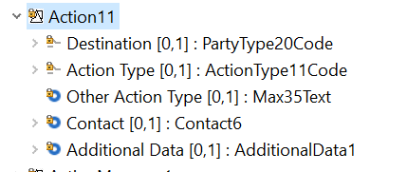
ProcessingResult7
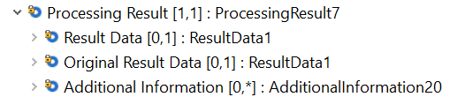
ProcessingResult9 &ProcessingResult10
Note: ProcessingResult 9 and ProcessingResult10 are same, they should be combined to one.
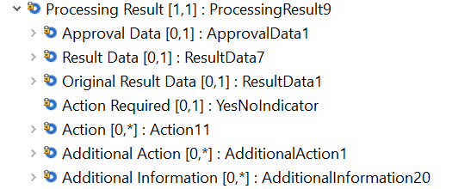
ProcessingResult10
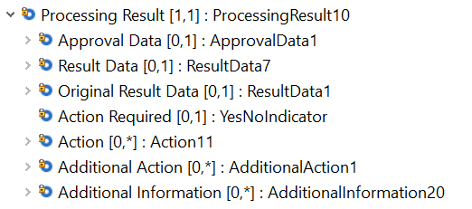
ProcessingResult11
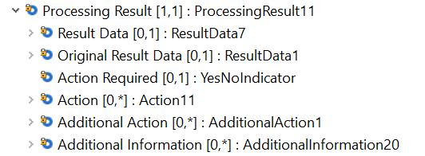
ProcessingResult12
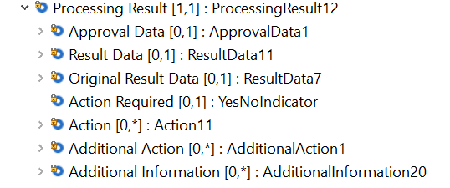
ProcessingResult14
Note: ProcessingResult14 and ProcessingResult7 are same because ResultData1 and ResultData10 are same.
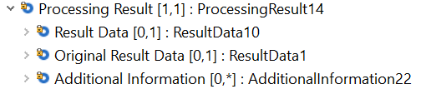

Component modification & impact

Modified component that will replace all instances of Action11 with ActionXX:
ActionXX | Occurs
Destionation< <Dstn> | [1..1] | PartyType20Code
ActionType <ActnTp> | [0..1] | ActionType11Code
OtherActionType <OthrActnTp> | [0..1] | Max35Text
Contact<Ctct> | [0..1] | Contact6
AdditionalData< AddtlData> | [0..*] | AdditionalData1

Modified component that will replace all instances of ProcessingResult7 when ProcessingResult7 is mandatory:
ProcessingResultXX | Occurs
ResultData <RsltData> | [1..1] | ResultData1
OriginalResultData <OrgnlRsltData> | [0..1] | ResultData1
AdditionalInformation <AddtlInf> | [0..*] | AdditionalInformation20

Impact
ProcessingResult7 is mandatory used in:
Component Trace Path | Messages
ProcessingResult7/ChargebackResponse2 | Chargeback Response V02 (cain.028.001.02)

Modified component that will replace all instances of ProcessingResult9 or 10 when ProcessingResult9 or 10 is mandatory:
ProcessingResultXX | Occurs
ApprovalData <ApprvlData> | [0..1] | ApprovalData1
ResultData <RsltData> | [1..1] | ResultData7
OriginalResultData <OrgnlRsltData> | [0..1] | ResultData1
ActionRequired <ActnReqrd> | [0..1] | YesNoIndicator
Action <Actn> | [0..*] | ActionXX
AdditionalAction <AddtlActn> | [0..*] | AdditionalAction1
AdditionalInformation <AddtlInf> | [0..*] | AdditionalInformation20

Impact
ProcessingResult9 or 10 mandatory used in:
Component Trace Path | Messages
ProcessingResult10/AuthoisationResponse2 | Authorisation Response V03 (cain.002.001.03)
ProcessingResult10/FinancialResponse2 | Financial Response V03 (cain.004.001.03)
ProcessingResult10/ReversalResponse2 | Reversal Response V03 (cain.005.001.03)
ProcessingResult9/NetworkManagementResponse2 | Network Management Response V03 (canm.002.001.03)

Modified component that will replace all instances of ProcessingResult9 or 10 when ProcessingResult9 or 10 is Optional:
ProcessingResultXX | Occurs
ApprovalData <ApprvlData> | [0..1] | ApprovalData1
ResultData <RsltData> | [0..1] | ResultData7
OriginalResultData <OrgnlRsltData> | [0..1] | ResultData1
ActionRequired <ActnReqrd> | [0..1] | YesNoIndicator
Action <Actn> | [0..*] | ActionXX
AdditionalAction <AddtlActn> | [0..*] | AdditionalAction1
AdditionalInformation <AddtlInf> | [0..*] | AdditionalInformation20

Impact
ProcessingResult9 or 10 is optional used in:
Component Trace Path | Messages
ProcessingResult9/AuthoisationInitiation2 | Authorisation Initiation V03 (cain.001.001.03)
ProcessingResult9/CardManagementInitiation2 | Card Management Initiation V02 (cain.024.001.02)
ProcessingResult9/FinancialInitiation2 | Financial Initiation V03 (cain.003.001.03)
ProcessingResult9/NetworkManagementInitiation2 | Network Management Initiation V03 (canm.001.001.03)
ProcessingResult9/ReversalInitiation2 | Reversal Initiation V03 (cain.005.001.03)
ProcessingResult10/OriginalTransaction2/ChargebackInitiation2 | Chargeback Initiation V02 (cain.027.001.02)
ProcessingResult10/OriginalTransaction2/RetrievalFulfilmentInitiation2 | Retrieval Fulfilment Initiation V02 (cain.014.001.02)
ProcessingResult10/OriginalTransaction2/RetrievalInitiation2 | Retrieval Initiation V02 (cain.021.001.02)

Modified component that will replace all instances of ProcessingResult11 when ProcessingResult11 is mandatory:
ProcessingResultXX | Occurs
ResultData <RsltData> | [1..1] | ResultData7
OriginalResultData <OrgnlRsltData> | [0..1] | ResultData1
ActionRequired <ActnReqrd> | [0..1] | YesNoIndicator
Action <Actn> | [0..*] | ActionXX
AdditionalAction <AddtlActn> | [0..*] | AdditionalAction1
AdditionalInformation <AddtlInf> | [0..*] | AdditionalInformation20

Impact
ProcessingResult11 mandatory used in:
Component Trace Path | Messages
ProcessingResult11/InquiryResponse2 | Inquiry Response V02 (cain.017.001.02)

Modified component that will replace all instances of ProcessingResult11 when ProcessingResult11 is Optional:
ProcessingResultXX | Occurs
ResultData <RsltData> | [0..1] | ResultData7
OriginalResultData <OrgnlRsltData> | [0..1] | ResultData1
ActionRequired <ActnReqrd> | [0..1] | YesNoIndicator
Action <Actn> | [0..*] | ActionXX
AdditionalAction <AddtlActn> | [0..*] | AdditionalAction1
AdditionalInformation <AddtlInf> | [0..*] | AdditionalInformation20

Impact
ProcessingResult11 optional used in:
Component Trace Path | Messages
ProcessingResult11/InquiryInitiation2 | Inquiry Initiation V02 (cain.016.001.02)

Modified component that will replace all instances of ProcessingResult12 when ProcessingResult12 is mandatory:
ProcessingResultXX | Occurs
ApprovalData <ApprvlData> | [0..1] | ApprovalData1
ResultData <RsltData> | [1..1] | ResultData11
OriginalResultData <OrgnlRsltData> | [0..1] | ResultData7
ActionRequired <ActnReqrd> | [0..1] | YesNoIndicator
Action <Actn> | [0..*] | ActionXX
AdditionalAction <AddtlActn> | [0..*] | AdditionalAction1
AdditionalInformation <AddtlInf> | [0..*] | AdditionalInformation20

Impact
ProcessingResult12 mandatory used in:
Component Trace Path | Messages
ProcessingResult12/VerificationResponse2 | Verification Response V02 (cain.019.001.02)

Modified component that will replace all instances of ProcessingResult12 when ProcessingResult12 is optional:
ProcessingResultXX | Occurs
ApprovalData <ApprvlData> | [0..1] | ApprovalData1
ResultData <RsltData> | [0..1] | ResultData11
OriginalResultData <OrgnlRsltData> | [0..1] | ResultData7
ActionRequired <ActnReqrd> | [0..1] | YesNoIndicator
Action <Actn> | [0..*] | ActionXX
AdditionalAction <AddtlActn> | [0..*] | AdditionalAction1
AdditionalInformation <AddtlInf> | [0..*] | AdditionalInformation20

Impact
ProcessingResult12 mandatory used in:
Component Trace Path | Messages
ProcessingResult12/VerificationInitiation2 | Verification Initiation V02 (cain.018.001.02)

Modified component that will replace all instances of ProcessingResult14 when ProcessingResult14 is mandatory:
ProcessingResultXX | Occurs
ResultData <RsltData> | [1..1] | ResultData10
OriginalResultData <OrgnlRsltData> | [0..1] | ResultData1
AdditionalInformation <AddtlInf> | [0..*] | AdditionalInformation20

Impacts
- ProcessingResult14 is mandatory used in
Component Trace Path | Messages
ProcessingResult14/AddendumResponse2 | Addendum Response V02 (cain.026.001.02)
ProcessingResult14/FeeCollectionResponse2 | Fee Collection Response V02 (cafc.002.001.02)
ProcessingResult14/ FraudDispositionResponse2 | Fraud Disposition Response V02 (carp.005.001.01)
ProcessingResult14/ FraudReportingResponse2 | Fraud Reporting Response V02 (carp.003.001.01)
ProcessingResult14/ KeyExchangeResponse2 | Key Exchange Response V03 (canm.004.001.03)
ProcessingResult14/ ReconciliationResponse5 | Reconciliation Response V03 (caad.006.001.03)
ProcessingResult14/ RetrievalFulfilmentResponse2 | Retrieval Fulfilment Response V02 (cain.015.001.02)
ProcessingResult14/ RetrievalResponse2 | Retrieval Response V02 (cain.022.001.02)

CR0984-3: Update Transaction Sub Type description to indicate its use more clearly

Description
Currently Transaction Sub Type is meant to refine the type of transaction, and Business purpose needs to be updated to be larger and clarify its purpose is to be used as a description field rather than identification type.

Existing component
Existing Transaction114/115/116/119/121/122/125/131/132/137/140/142:
Transaction Sub Type Description:
“Provides further granularity of purpose of TransactionType”

Existing TransferService1:
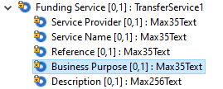
Existing Business Purpose Description:
“Purpose of the transfer. For example: person to person, business-to-business and mobile top-up.”

Component modification
Existing Transaction114/115/116/119/121/122/125/131/132/137/140/142:
Transaction Sub Type Description:
“Further breakdown of the transaction type being performed.”

TransferService1
Funding Service | Occurs | Type
Service Provider | [0..1] | Max35Text
…
Business Purpose | [0..1] | Max500Text
…
Business Purpose Description:
“Purpose of the transfer.”

Impacts
TransferService1 component used in
Message Definition | Message Components
Authorisation Initiation V03 | AuthorisationInitiation2.Transaction142.  FundingService2.TransferService1.BusinessPurpose
Charge Back Initiation V02 | ChargeBackInitiation2.OriginalTransaction2.Transaction116.  FundingService2.TransferService1.BusinessPurpose
Financial Initiation V03 | FinancialInitiation2.Transaction114.  FundingService2.TransferService1.BusinessPurpose
Retrieval Fulfilment Initiation V02 | RetrievalFulfilmentInitiation2.OriginalTransaction2.Transaction116.  FundingService2.TransferService1.BusinessPurpose
Retrieval Initiation V02 | RetrievalInitiation2. OriginalTransaction2.Transaction116.  FundingService2.TransferService1.BusinessPurpose
Reversal Initiation V03 | ReversalInitiation2.Transaction142.  FundingService2.TransferService1.BusinessPurpose
Verification Initiation V02 | VerificationInitiation2.Transaction115.  FundingService2.TransferService1.BusinessPurpose

Transaction114 component used in
Message Definition | Message Components
Financial Initiation V03 | FinancialInitiation2.Transaction114.TransactionSubType

Transaction 115 component used in
Message Definition | Message Components
Verification Initiation V02 | VerificationInitiation2.Transaction115.TransactionSubType

Transaction 116 component used in
Message Definition | Message Components
Charge Back Initiation V02 | AddendumInitiation2.OriginalTransaction2.  Transaction116.TransactionSubType
Retrieval Fulfilment Initiation V02 | RetrievalFulfilmentInitiation2.OriginalTransaction2.  Transaction116.TransactionSubType
Retrieval Initiation V02 | RetrievalInitiation2.OriginalTransaction2.  Transaction116.TransactionSubType

Transaction 119 component used in
Message Definition | Message Components
Authorisation Response V03 | AuthorisationResponse2.Transaction119.TransactionSubType
Financial Response V03 | FinancialResponse2.Transaction119.TransactionSubType

Transaction 121 component used in
Message Definition | Message Components
Card Management Initiation V02 | CardManagementInitiation2.Transaction121.TransactionSubType

Transaction 122 component used in
Message Definition | Message Components
Card Management Response V02 | CardManagementResponse2.Transaction122.TransactionSubType

Transaction 125 component used in
Message Definition | Message Components
Fee Collection Initiation V02 | FeeCollectionInitiation2.Transaction125.TransactionSubType
Fee Collection Response V02 | FeeCollectionResponse2.Transaction125.TransactionSubType

Transaction 131 component used in
Message Definition | Message Components
Inquiry Initiation V02 | InquiryInitiation2.Transaction131.TransactionSubType

Transaction 132 component used in
Message Definition | Message Components
Inquiry Response V02 | InquiryResponse2.Transaction132.TransactionSubType

Transaction 137 component used in
Message Definition | Message Components
Reversal Response V03 | ReversalResponse4.Transaction137.TransactionSubType

Transaction 140 component used in
Message Definition | Message Components
Verification Response V02 | VerificationResponse2.Transaction140.TransactionSubType

Transaction 142 component used in
Message Definition | Message Components
Authorisation Initiation V03 | AuthorisationInitiation2.Transaction142.TransactionSubType
Reversal Initiation V03 | ReversalInitiation2.Transaction142.TransactionSubType

CR0984-4: Add foreign merchant to sponsored merchant

Description
Update SponsoredMerchant2.PartyIdentification240 to include a new truefalseindicator for foreign merchant to identify when the retailer is not located in the same country as the marketplace or sponsor.

Existing component
Existing SponsoredMerchant2 component:
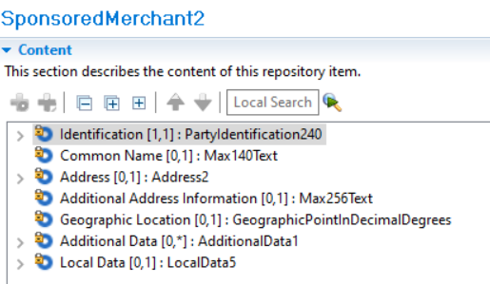

Component modification
SponsoredMerchant2
SponsoredMerchant2 | Occurs | Type
Identification | [1..1] | PartyIdentificationX
Identification | [0..1] | Max35Text
Assigner | [0..1] | Max35Text
Country | [0..1] | ISO3NumericCountryCode
Foreign Merchant | [0..1] | TrueFalseIndicator
…
Common Name | [0..1] | Max140Textt
…

Impacts
- SponsoredMerchant2 component used in

Message Definition | Message Components
Authorisation Initiation V03 | Environment17.PartyIdentification237.SponsoredMerchant2.PartyIdentification240
Card Management Initiation V02 | Environment18.PartyIdentification237.SponsoredMerchant2.PartyIdentification240
Charge Back Initiation V02 | Environment21.PartyIdentification237.SponsoredMerchant2.PartyIdentification240
Fee Collection Initiation V02 | Environment23.PartyIdentification237.SponsoredMerchant2.PartyIdentification240
Fee Collection Response V02 | Environment23.PartyIdentification237.SponsoredMerchant2.PartyIdentification240
File Action Initiation V02 | Environment22.PartyIdentification237.SponsoredMerchant2.PartyIdentification240
File Action Response V02 | Environment22.PartyIdentification237.SponsoredMerchant2.PartyIdentification240
Financial Initiation V03 | Environment17.PartyIdentification237.SponsoredMerchant2.PartyIdentification240
Inquiry Initiation V02 | Environment18.PartyIdentification237.SponsoredMerchant2.PartyIdentification240
Inquiry Response V02 | Environment24.PartyIdentification237.SponsoredMerchant2.PartyIdentification240
Retrieval Fulfilment Initiation V02 | Environment21.PartyIdentification237.SponsoredMerchant2.PartyIdentification240
Retrieval Fulfilment Response V02 | Environment21.PartyIdentification237.SponsoredMerchant2.PartyIdentification240
Retrieval Initiation V02 | Environment21.PartyIdentification237.SponsoredMerchant2.PartyIdentification240
Retrieval Response V02 | Environment21.PartyIdentification237.SponsoredMerchant2.PartyIdentification240
Reversal Initiation V03 | Environment19.PartyIdentification237.SponsoredMerchant2.PartyIdentification240
Verification Initiation V02 | Environment31.PartyIdentification237.SponsoredMerchant2.PartyIdentification240

CR0984-5: FuelInd alignment

Description
Update FuelInd in FleetLineItem2 (Authorisation and Financial Response) to match in data type to FuelInd in FleetLineItem1 (Authorisation and Financial Initiation). One is a true false indicator, the other is a code list. The code list is an error we are correcting.

Existing component
Existing FleetLineItem1 component:

Existing FleetLineItem2 component:

Component modification
FleetLineItem2
Line Item | Occurs | Type
Allowed Item Indicator | [0..1] | TrueFalseIndicator
Fuel Indicator | [1..1] | TrueFalseIndicator
…

Impacts
- FleetLineItem2 component used in

Message Definition | Message Components
Authorisation Response V03 | AuthorisationResponse2.AddendumData2.FleetData.FleetLineItem2
Financial Response V03 | FinancialResponse2.AddendumData2.FleetData.FleetLineItem2

CR0984-6: Update Period Unit/ Frequency with additional Code

Description
Update Period Unit used in Instalments to add an additional code to Frequency12Code to have an interval that represents twice a week.

Existing component
Existing Frequency12Code component:
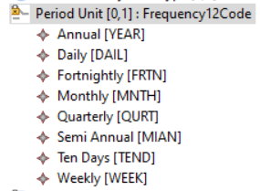

Component modification
FrequencyXCode
FrequencyXCode | Occurs | Type
Annual [YEAR] | Code
Daily [DAIL] | Code
Fortnightly [FRTN] | Code
Monthly [MNTH] | Code
Quarterly [QURT] | Code
Semi Annual [MIAN] | Code
Ten Days [TEND] | Code
Weekly [WEEK] | Code
Twice a Week [TWWK] | Code

Plan2
Plan | Occurs | Type
Plan Identification | [0..1] | Max35Text
Plan Owner | [0..1] | PlanOwner1Code
…
Period Unit | [0..1] | FrequencyXcode
…

Impacts
- PeriodUnit component used in

Message Definition | Message Components
Addendum Initiation V02 | AddendumData3.Instalment4.Plan2.PeriodUnit
Addendum Response V02 | AddendumData3.Instalment4.Plan2.PeriodUnit
Authorisation Initiation V03 (cain.001.001.02) | AddendumData3.Instalment4.Plan2.PeriodUnit
Authorisation Response V03 (cain.001.001.03) | AddendumData3.Instalment4.Plan2.PeriodUnit
Financial Initiation V03 | AddendumData3.Instalment4.Plan2.PeriodUnit
Financial Response V03 | AddendumData3.Instalment4.Plan2.PeriodUnit

CR0984-7: Message ReconciliationTypeCode

Description
Under the Transaction/Reconciliation Totals/ structure, the Reconciliation message type code is shown as either an initiation or a response. The type code for Retrieval is currently listed as “request” and should be updated as “initiation” to match the other messages.

Component modification

ReconciliationInitiationVXX03
Or | Message Root | Occurs | Type
 | Body | [1..1] | ReconciliationInitiation2
 | Transaction | [1..1] | Transaction135
 | Reconciliation Totals | [0..*] | TransactionTotals12
 | Message Reconciliation | [0..*] | MessageReconciliation1
 | Type | [1..1] | ReconciliationMessageTypeX1Code

ReconciliationResponseVXX03
Or | Message Root | Occurs | Type
 | Body | [1..1] | ReconciliationResponse5
 | Transaction | [1..1] | Transaction135
 | Reconciliation Totals | [0..*] | TransactionTotals12
 | Message Reconciliation | [0..*] | MessageReconciliation1
 | Type | [1..1] | ReconciliationMessageTypeX1Code

ReconciliationMessageType X1Code
Addendum Initiation [ADDI]
Addendum Response [ADDR]
Amendment [AMDT]
…
Retrieval Request [RTRR]
Retrieval Initiation [RTVI]
Retrieval Response [RTRI]
…

Impacts
- ReconciliationInitiationV03 (caad.005.001.03)
- ReconciliationResponseV03 (caad.006.001.03)

CR0984-8: Legal Corporate Name

Description
Purpose of this change request: Add data element “Legal Corporate Name” to the Acceptor and Sponsored merchant structure, and corresponding localData
Acceptor <Accptr>
Add LegalCorporateName After ShortName in PartyIdentification 235, 236, 237, 238, 240 (acceptor only) structure and Local Data1 (Acceptor only) LocalData4
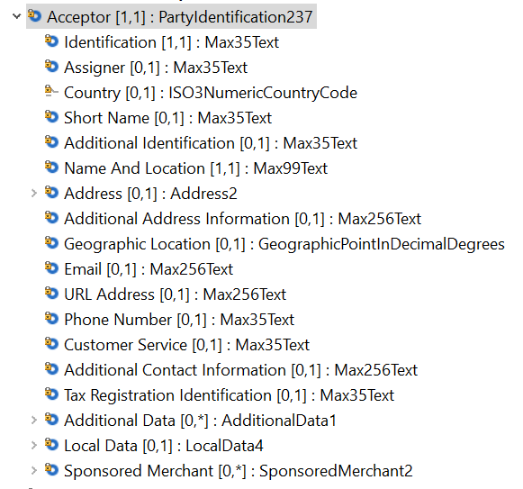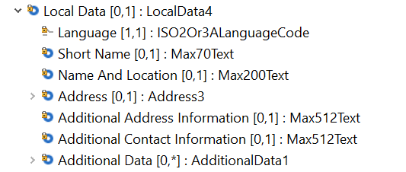
PartyIdentificationXXX235
Message Root | Occurs | Type
Identification <Id> | [1..1] | Text
Assigner <Assgnr> | [0..1] | Text
Country <Ctry> | [0..1] | CodeSet
ShortName <ShrtNm> | [0..1] | Text
LegalCorporateName <Lglcrptnm> | [0..1] | Max99Text
…
Local Data | [0..1] | LocalDataX4
Language | [1..1] | ISO2Or3ALanguageCode
ShortName | [0..1] | Max70Text
LegalCorporateName <Lglcrptnm> | [0..1] | Max198Text
Name and Location | [0..1] | Max200Text
…

PartyIdentificationXXX236
Message Root | Occurs | Type
Identification <Id> | [1..1] | Text
Assigner <Assgnr> | [0..1] | Text
Country <Ctry> | [0..1] | CodeSet
ShortName <ShrtNm> | [0..1] | Text
LegalCorporateName <Lglcrptnm> | [0..1] | Max99Text
….
Local Data | [0..1] | LocalDataX4
Language | [1..1] | ISO2Or3ALanguageCode
ShortName | [0..1] | Max70Text
LegalCorporateName <Lglcrptnm> | [0..1] | Max198Text
Name and Location | [0..1] | Max200Text
…

PartyIdentificationXXX237
Message Root | Occurs | Type
Identification <Id> | [1..1] | Text
Assigner <Assgnr> | [0..1] | Text
Country <Ctry> | [0..1] | CodeSet
ShortName <ShrtNm> | [0..1] | Text
LegalCorporateName <Lglcrptnm> | [0..1] | Max99Text
…
Local Data | [0..1] | LocalDataX4
Language | [1..1] | ISO2Or3ALanguageCode
ShortName | [0..1] | Max70Text
LegalCorporateName <Lglcrptnm> | [0..1] | Max198Text
Name and Location | [0..1] | Max200Text
…

PartyIdentificationXXX238
Message Root | Occurs | Type
Identification <Id> | [1..1] | Text
Assigner <Assgnr> | [0..1] | Text
Country <Ctry> | [0..1] | CodeSet
ShortName <ShrtNm> | [0..1] | Text
LegalCorporateName <Lglcrptnm> | [0..1] | Max99Text
…
Local Data | [0..1] | LocalDataX4
Language | [1..1] | ISO2Or3ALanguageCode
ShortName | [0..1] | Max70Text
LegalCorporateName <Lglcrptnm> | [0..1] | Max198Text
Name and Location | [0..1] | Max200Text
…

Add LegalCorporateName after Common Name in SponsoredMerchant2, and LocalData5,
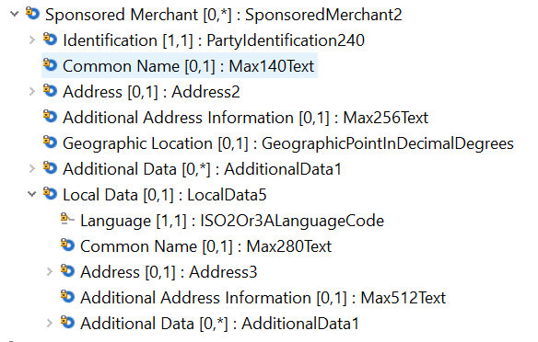
SponsoredMerchantXX2
Identification <Id> | [1..1] | PartyIdentification240
Common Name | [0..1] | Max140Text
LegalCorporateName <Lglcrptnm> | [0..1] | Max99Text
Address |  | Address2
Additional Address Information | [0..1] | CodeSet
…
Local Data | [0..1] | LocalDataX5
Language | [1..1] | ISO2Or3ALanguageCode
Common Name | [0..1] | Max280Text
LegalCorporateName <Lglcrptnm> | [0..1] | Max198Text
Name and Location | [0..1] | Max200Text
…

Impact
Component Trace Path | Messages
PartyIdentification237/Environment17/AuthorizationInitiation2 | Authorization Initiation V03 (cain.001.001.03)
PartyIdentification240/Environment26/AuthorizationResponse2 | Authorization Response V03 (cain.002.001.03)
PartyIdentification237/Environment17/FinancialnInitiation2 | Financial Initiation V03 (cain.003.001.03)
PartyIdentification240/Environment26/FinancialnResponse2 | Financial Response V03 (cain.004.001.03)
PartyIdentification237/Environment18/InquiryInitiation2 | Inquiry Initiation V02 (cain.016.001.02)
PartyIdentification237/Environment24/ InquiryResponse2 | Inquiry Response V02 (cain.017.001.02)
PartyIdentification237/Environment18/CardManagementInitiation2 | Card Management Initiation V02 (cain.023.001.02)
PartyIdentification238/Environment25/ CardManagementResponse2 | Card ManagementResponse V02 (cain.024.001.02)
PartyIdentification235/Environment/ReversalInitiation2 | Reversal Initiation V03 (cain.005.001.03)
PartyIdentification240/Environment29/ReversalResponse2 | Reversal Response V03 (cain.006.001.03)
PartyIdentification236/Environment20/OriginalTransaction2/RetrievalFulfilmentInitiation2  PartyIdentification237/Environment21/RetrievalFulfilmentInitiation2 | Retrieval Fulfilment Initiation V02 (cain.014.001.02)
PartyIdentification236/Environment20/OriginalTransaction2/RetrievalInitiation2  PartyIdentification237/Environment21/RetrievalInitiation2 | Retrieval Initiation V02 (cain.021.001.02)
PartyIdentification236/Environment20/OriginalTransaction2/ ChargebackInitiation2  PartyIdentification237/Environment21/ChargebackInitiation2 | Chargeback Initiation V02 (cain.027.001.02)
PartyIdentification240/Environment29/ ChargebackResponse2 | Chargeback Response V02 (cain.028.001.02)
PartyIdentification237/Environment21/ RetrievalFulfilmentResponse2 | Retrieval Fulfilment Response V02 (cain.015.001.02)
PartyIdentification237/Environment21/ RetrievalResponse2 | Retrieval Response V02 (cain.022.001.02)
PartyIdentification236/Environment22/ FileActionInitiation2 | File Action Initiation V02 (cafm.001.001.02)
PartyIdentification236/Environment22/ FileActionResponse2 | Retrieval Response V02 (cafm.002.001.02)
PartyIdentification237/Environment23/ FeeCollectionInitiation2 | Fee Collection Initiation V02 (cafc.001.001.02)
PartyIdentification237/Environment23/ FeeCollectionResponse2 | Fee Collection Response V02 (cafc.002.001.02)
PartyIdentification240/Environment31/ VerificationInitiation2 | Verification Initiation V02 (cain.018.001.02)
PartyIdentification240/Environment32/ VerificationResponse2 | Verification Response V02 (cain.019.001.02)

CR0984-9: AccountIdentification <AcctId>

Description
Purpose of this change request: Expand the length of the AccountIdentification <AcctId> from Max35Text to Max70text in AccountDetail3

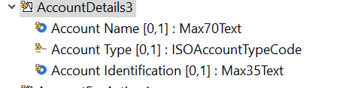
AccountDetailsX3 | Occurs | Type
Account Name | [0..1] | Max70Text
Account Type | [0..1] | ISOAccountTypeCode
Account Identification | [0..1] | Max70Text

Impact
AccountDetail3 used in:
Component Trace Path | Messages
AccountDetail3/Transaction142/AuthorizationInitiation2 | Authorization Initiation V03 (cain.001.001.03)
AccountDetail3/Transaction119/AuthorizationResponse2 | Authorization Response V03 (cain.002.001.03)
AccountDetail3/Transaction114/FinancialnInitiation2 | Financial Initiation V03 (cain.003.001.03)
AccountDetail3/Transaction119/FinancialnResponse2 | Financial Response V03 (cain.004.001.03)
AccountDetail3/Transaction131/InquiryInitiation2 | Inquiry Initiation V02 (cain.016.001.02)
AccountDetail3/Transaction132/ InquiryResponse2 | Inquiry Response V02 (cain.017.001.02)
AccountDetail3/Transaction121/CardManagementInitiation2 | Card Management Initiation V02 (cain.023.001.02)
AccountDetail3/Transaction142/ReversalInitiation2 | Reversal Initiation V03 (cain.005.001.03)
AccountDetail3/Transaction137/ReversalResponse2 | Reversal Response V03 (cain.006.001.03)
AccountDetail3/Transaction116/OriginalTransaction2/RetrievalFulfilmentInitiation2 | Retrieval Fulfilment Initiation V02 (cain.014.001.02)
AccountDetail3/Transaction116/OriginalTransaction2/RetrievalInitiation2 | Retrieval Initiation V02 (cain.021.001.02)
AccountDetail3/Transaction116/OriginalTransaction2/ ChargebackInitiation2 | Chargeback Initiation V02 (cain.027.001.02)
AccountDetail3/Transaction115/ VerificationInitiation2 | Verification Initiation V02 (cain.018.001.02)
AccountDetail3/Transaction140/ VerificationResponse2 | Verification Response V02 (cain.019.001.02)

CR0984-10: TravelAgency

Description
Change presence of TravelAgency from [0..1] to [0..*] In AddendumData3
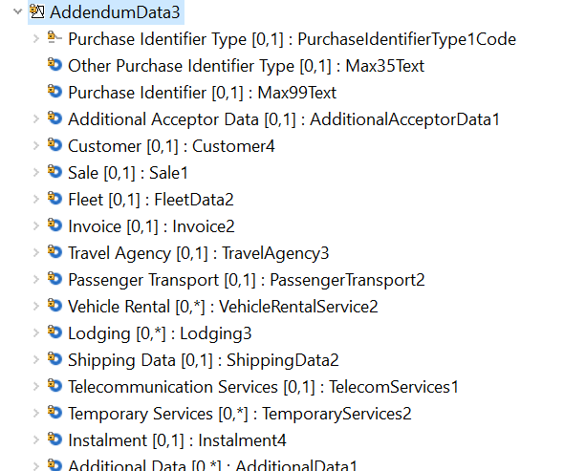

MessageElement<XML Tag> | Mult. | Type
PurchaseIdentifierType <PurchsIdrTp> | [0..1] | CodeSet
OtherPurchaseIdentifierType <OthrPurchsIdrTp> | [0..1] | Text
PurchaseIdentifier <PurchsIdr> | [0..1] | Text
AdditionalAcceptorData <AddtlAccptrData> | [0..1] | ±
Customer <Cstmr> | [0..1] | ±
Sale <Sale> | [0..1] | ±
Fleet <Fleet> | [0..1] | ±
Invoice <Invc> | [0..1] | ±
TravelAgency <TrvlAgcy> | [0..*] | TravelAgency3

Impact
Component Trace Path | Messages
TravelAgency/AddendumData3/AuthorisationInitiation2 | Authorization Initiation V03 (cain.001.001.03)
TravelAgency/AddendumData3/FinancialnInitiation2 | Financial Initiation V03 (cain.003.001.03)
TravelAgency/AddendumData3/AddendumInitiation2 | Addendum Initiation V02 (cain.025.001.02

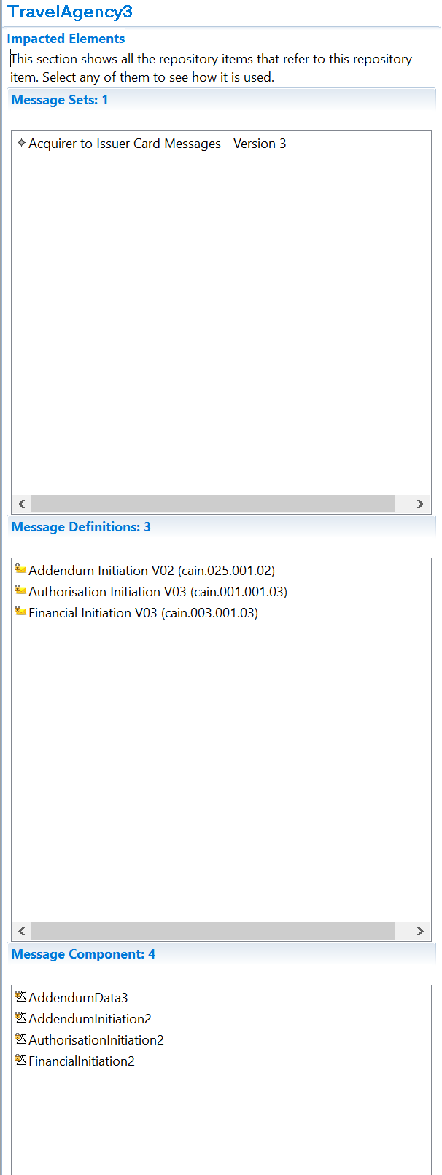

CR0984-11: Tax33 Enhancement

Description
This change request is in two parts.
- Part 1 is to add two new data elements to the Tax 33 structure IncludedInTotalIndicator and CreditDebit.
- Part 2 is to add a new code TNRT Add Code (TNRT - Total Non-Room Tax) to /Type of Tax"

Tax33XX
MessageElement<XML Tag> | Mult. | Type
Type <Tp> | [1..1] | CodeSet
OtherType <OthrTp> | [0..1] | Text
Description <Desc> | [0..1] | Text
TaxExemption <TaxXmptn> | [0..1] | Indicator
TaxExemptReason <TaxXmptRsn> | [0..1] | Text
Amount <Amt> | [1..1] | Amount
Rate <Rate> | [0..1] | Rate
IncludedInTotalIndicator | [0..1] | TrueFalseIndicator  Indicate whether the Tax amount is included in total transaction amount
CreditDebit | [0..1] | CreditDebit3Code

AddendumTaxType1XCode
Codename | Name | Definition
CTAX | TaxCredit | Direct reduction of an individual's tax liability.
TDDT | TDDServiceExciseTax | Excise tax levied to recover the cost of providing Telecommunications Device for the Deaf (TDD) Equipment.
TELT | TelecommunicationsTax | Tax levied on telecommunications  companies for the right to provide  services. May be a usage or excise tax.
THTX | ThresholdTax | Threshold Tax
TNRT | Total Non-Room Tax | Tax levied on non-room expenditures.
TRAX | TransactionTax | Tax levied on a transaction.
TRAN | TransferTax | Tax levied on a transfer.
UNSP | Unspecified | Unspecified tax type

Impact

- Authorization Initiation V03 (cain.001.001.03)
- Financial Initiation V03 (cain.003.001.03)
- Addendum Initiation V02 (cain.025.001.02
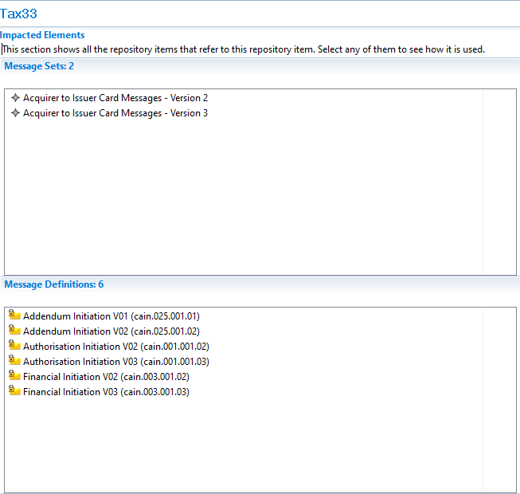
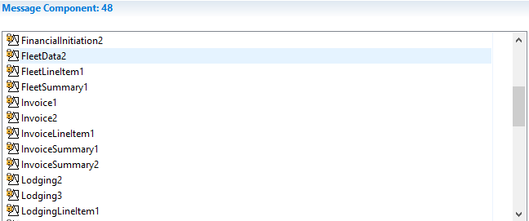

CR0984-12: ProductQuantity

Description
Change Datatype for Product quantity to DecimalNumber.
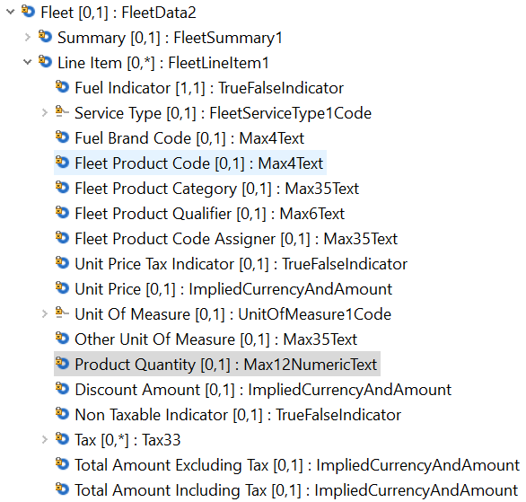

Impact
- Authorization Initiation V03 (cain.001.001.03)
- Financial Initiation V03 (cain.003.001.03)
- Addendum Initiation V02 (cain.025.001.02
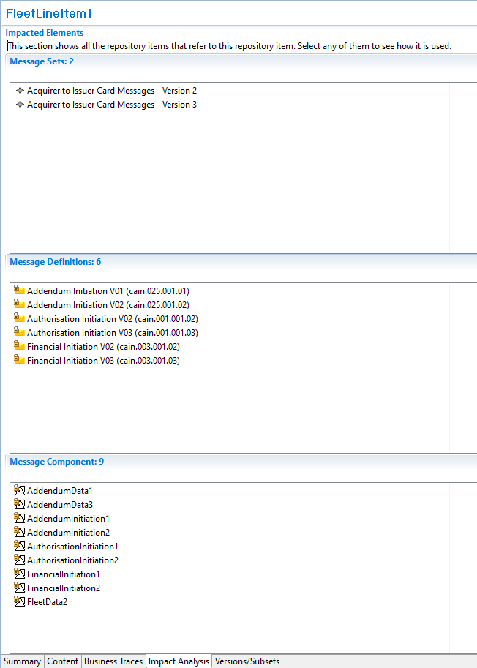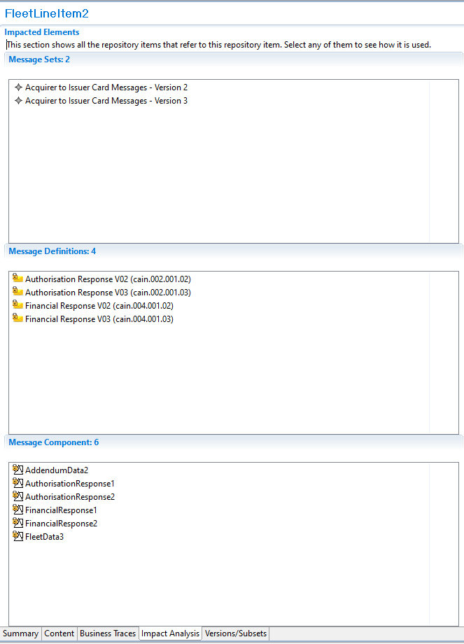

CR0984-13: Misc. Spelling Errors within ATICA ISO 20022 v2

Description
Fix spelling errors in standard for FinancialReconciliation1 & MessageReconciliation1 the current way they are spelled within the standard is inconsistent with the ISO standards.

Fix spelling of
FinancialReconcillation1 & MessageReconcillation1 to
FinancialReconciliation1 & MessageReconciliation1
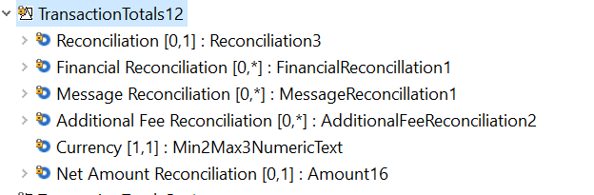

Impact
Component Trace Path | Messages
TransactionTotal12/Transaction135/ReconcilationInitiation2 | ReconcilationInitiation V03 (caad.005.001.03)
TransactionTotal12/Transaction135/ReconcilationResponse5 | ReconciliationResponse V03 (caad.006.001.03)
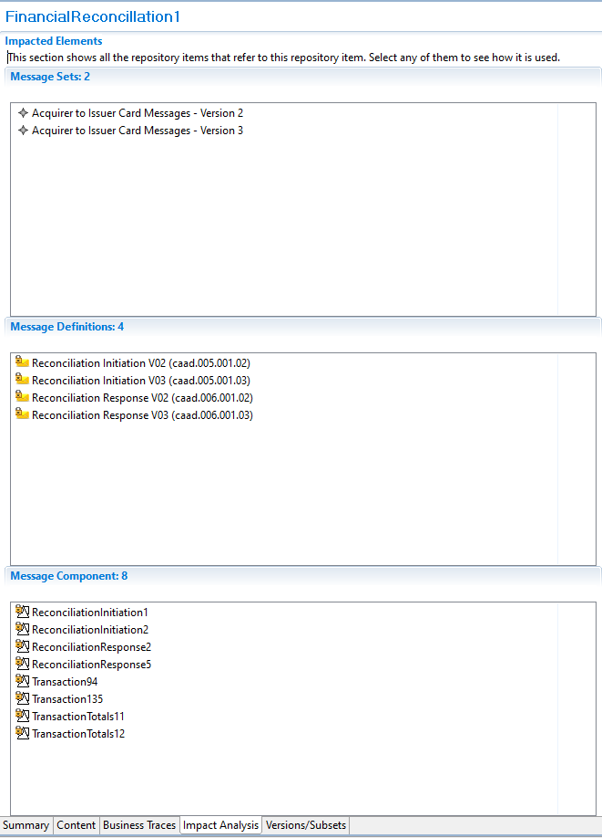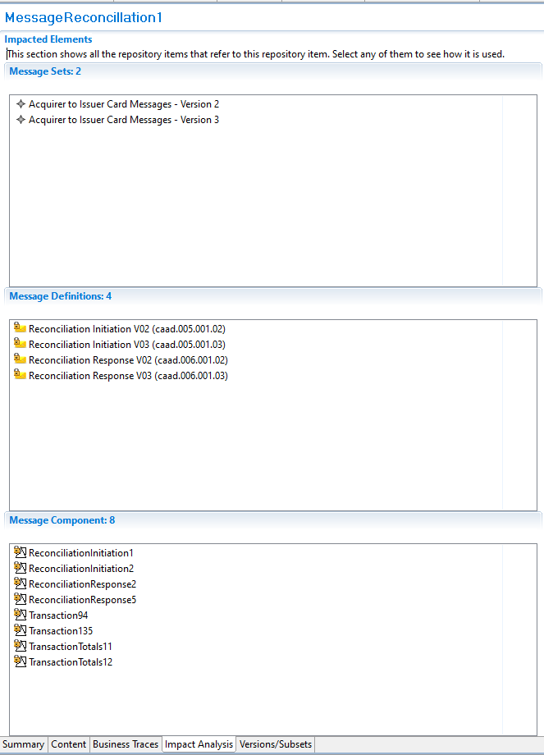

CR0984-14: AdditionalCardData

Description
Change the current data element “AdditionalCardData” <AddtlCardData> [0,1] Max70Text" to "Additional Data [0,*]:AdditionalData1 in CardData5, 6, 7, 8, 9 component, and PlainCardData20
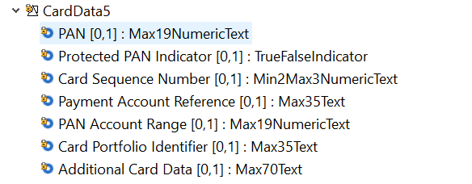
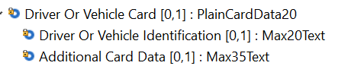

Component Modification
Modify AdditionalCardData in CardData5-9 and PlainCardData20 as below
Additional Card Data | [0..1] ->;[0..*] | Max35Text -> AdditionalData1

Impact
Component CardData5, 6, 7, 8, and 9 used in all message related to Cardholder Transaction.
- Authorization Initiation V03 (cain.001.001.03)
- Authorization Response V03 (cain.002.001.03)
- Financial Initiation V03 (cain.003.001.03)
- Financial Response V03 (cain.004.001.03)
- Inquiry Initiation V02 (cain.016.001.02)
- Inquiry Response V02 (cain.017.001.02)
- Card Management Initiation V02 (cain.023.001.02)
- Card ManagementResponse V02 (cain.024.001.02)
- Reversal Initiation V03 (cain.005.001.03)
- Reversal Response V03 (cain.006.001.03)
- Chargeback Initiation V02 (cain.027.001.02)
- Retrieval Fulfilment Initiation V02 (cain.014.001.02)
- Retrieval Initiation V02 (cain.021.001.02)
- Chargeback Initiation V02 (cain.027.001.02)
- Chargeback Response V02 (cain.028.001.02)
- Retrieval Fulfilment Initiation V02 (cain.014.001.02)
- Retrieval Fulfilment Response V02 (cain.015.001.02)
- Retrieval Initiation V02 (cain.021.001.02)
- Retrieval Response V02 (cain.022.001.02)
- File Action Initiation V02 (cafm.001.001.02)
- Retrieval Response V02 (cafm.002.001.02)
- Fee Collection Initiation V02 (cafc.001.001.02)
- Fee Collection Response V02 (cafc.002.001.02)
- Fraud Reporting Initiation V02 (carp.002.001.01)
- Fraud Reporting Response V02 (carp.003.001.01)
- Fraud Disposition Initiation V02 (carp.004.001.01)
- Fraud Disposition Response V02 (carp.005.001.01)
- Verification Initiation V02 (cain.018.001.02)
- Verification Response V02 (cain.019.001.02)

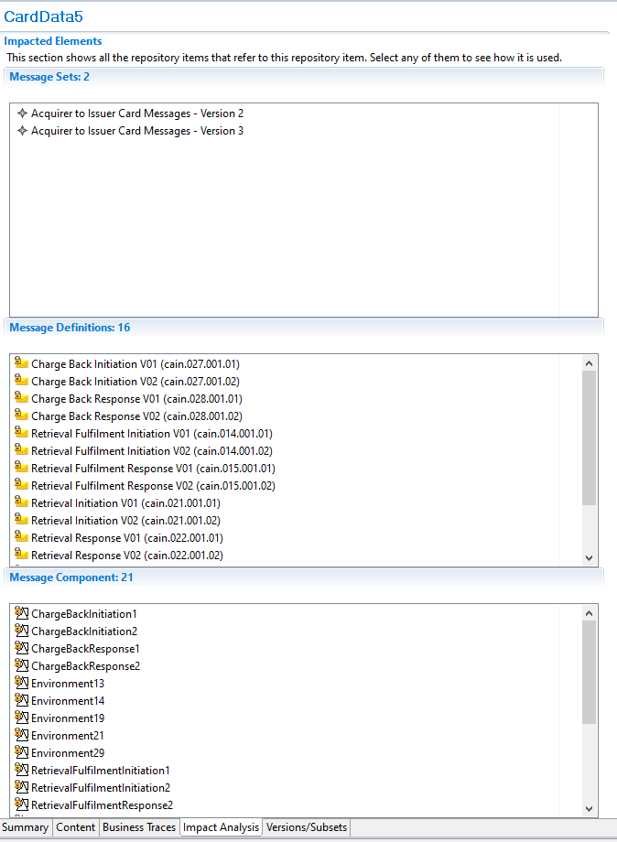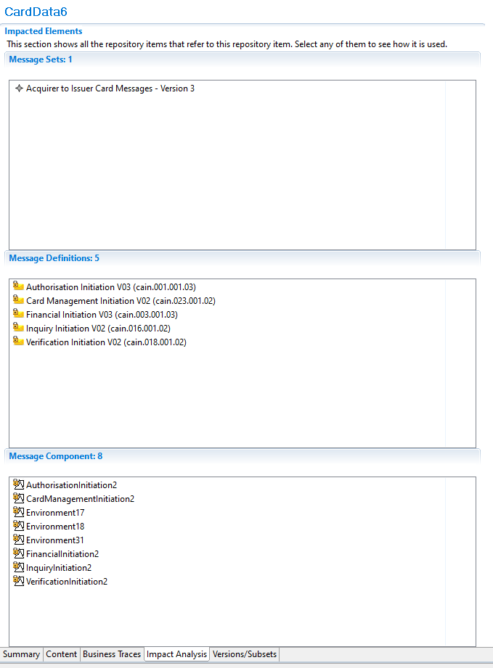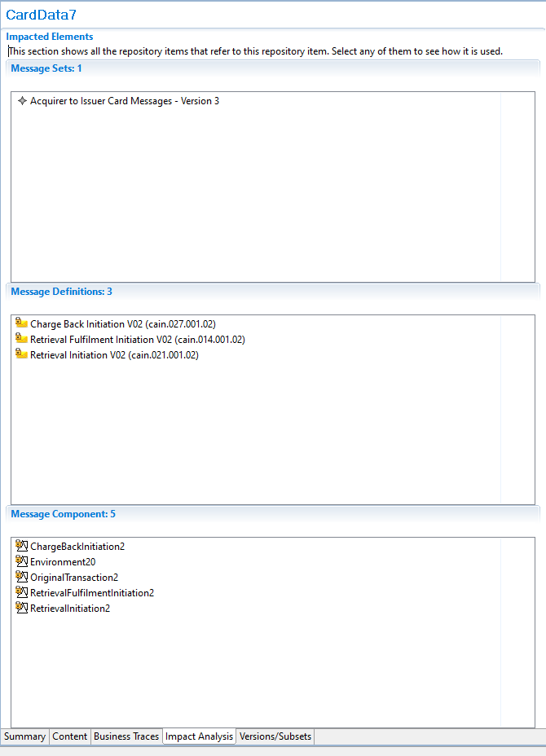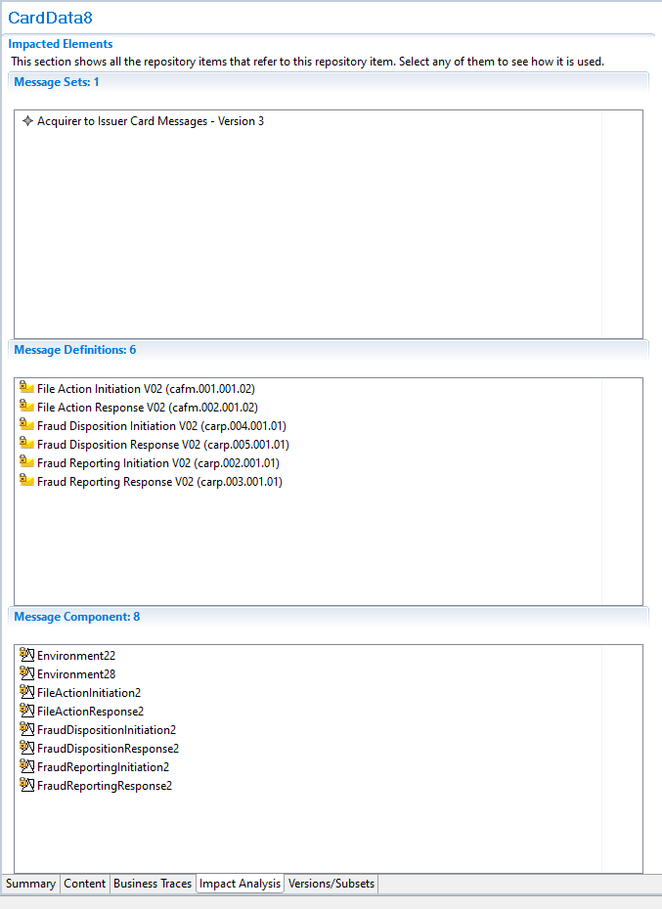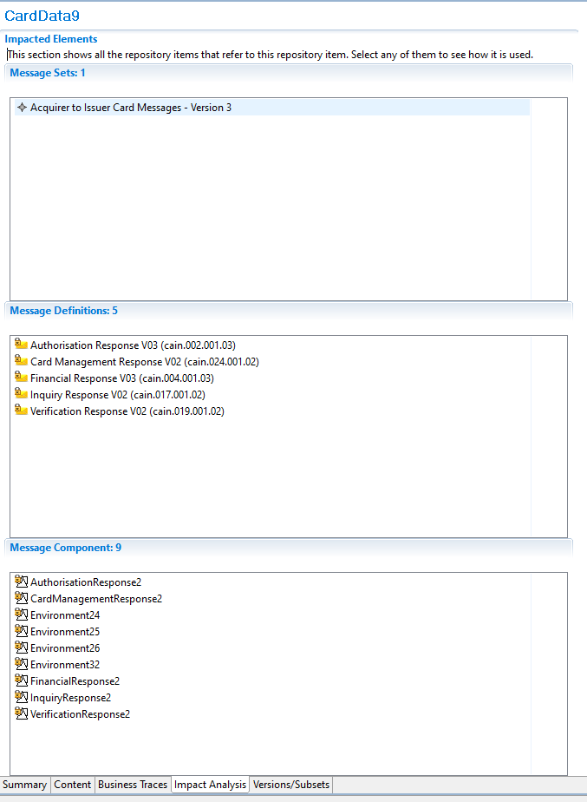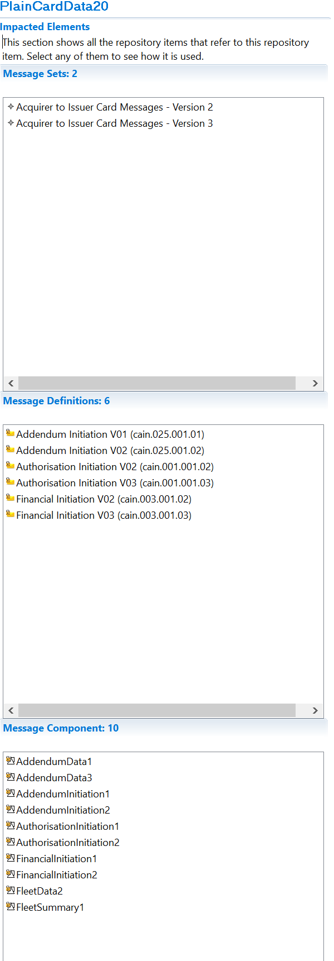

CR0984-15: Error details and source in Processing Results

Description
Existing ProcessingResult component is updated
- Error details structure is added to all the responses messages and to all the initiation messages that contain StatusAdvice or StatusResponse as MessageFunction
- ApprovalData component content is splitted into two separate fields (ResponseSource and ApprovalCode) and these two data replace the previous component
- ResponseSource is added to all response message

Message Root | Occurs | Type
AddendumResponseV03 | [1..1]
Body | [1..1] | AddendumResponse3
ProcessingResult | [0..1] | ProcessingResult14  ProcessingResultXX
ResponseSource | [0..1] | ApprovalEntity1
ResultData | [0..1] | ResultData10
OriginalResultData | [0..1] | ResultData1
AdditionalInformation | [0..*] | AdditionalInformation22
Error Detail | [0..*] | ErrorDetails2
Message Error Type | [1..1] | MessageError1Code
Other Message Error Type | [0..1] | Max35Text
Error Code | [0..1] | Max35Text
Error Description | [0..1] | Max500Text
Data Element In Error | [0..*] | Max4000Text

Message Root | Occurs | Type
FeeCollectionResponseV03 | [1..1]
Body | [1..1] | FeeCollectionResponse3
ProcessingResult | [0..1] | ProcessingResult14  ProcessingResultXX
ResponseSource | [0..1] | ApprovalEntity1
ResultData | [0..1] | ResultData10
OriginalResultData | [0..1] | ResultData1
AdditionalInformation | [0..*] | AdditionalInformation22
Error Detail | [0..*] | ErrorDetails2
Message Error Type | [1..1] | MessageError1Code
Other Message Error Type | [0..1] | Max35Text
Error Code | [0..1] | Max35Text
Error Description | [0..1] | Max500Text
Data Element In Error | [0..*] | Max4000Text

Message Root | Occurs | Type
FraudDispositionResponseV03 | [1..1]
Body | [1..1] | FraudDispositionResponse3
ProcessingResult | [0..1] | ProcessingResult14  ProcessingResultXX
ResponseSource | [0..1] | ApprovalEntity1
ResultData | [0..1] | ResultData10
OriginalResultData | [0..1] | ResultData1
AdditionalInformation | [0..*] | AdditionalInformation22
Error Detail | [0..*] | ErrorDetails2
Message Error Type | [1..1] | MessageError1Code
Other Message Error Type | [0..1] | Max35Text
Error Code | [0..1] | Max35Text
Error Description | [0..1] | Max500Text
Data Element In Error | [0..*] | Max4000Text

Message Root | Occurs | Type
FraudReportingResponseV03 | [1..1]
Body | [1..1] | FraudReportingResponse3
ProcessingResult | [0..1] | ProcessingResult14  ProcessingResultXX
ResponseSource | [0..1] | ApprovalEntity1
ResultData | [0..1] | ResultData10
OriginalResultData | [0..1] | ResultData1
AdditionalInformation | [0..*] | AdditionalInformation22
Error Detail | [0..*] | ErrorDetails2
Message Error Type | [1..1] | MessageError1Code
Other Message Error Type | [0..1] | Max35Text
Error Code | [0..1] | Max35Text
Error Description | [0..1] | Max500Text
Data Element In Error | [0..*] | Max4000Text

Message Root | Occurs | Type
ReconciliationResponseV04 | [1..1]
Body | [1..1] | ReconciliationResponse4
ProcessingResult | [0..1] | ProcessingResult14  ProcessingResultXX
ResponseSource | [0..1] | ApprovalEntity1
ResultData | [0..1] | ResultData10
OriginalResultData | [0..1] | ResultData1
AdditionalInformation | [0..*] | AdditionalInformation22
Error Detail | [0..*] | ErrorDetails2
Message Error Type | [1..1] | MessageError1Code
Other Message Error Type | [0..1] | Max35Text
Error Code | [0..1] | Max35Text
Error Description | [0..1] | Max500Text
Data Element In Error | [0..*] | Max4000Text

Message Root | Occurs | Type
RetrievalFulfilmentResponseV03 | [1..1]
Body | [1..1] | RetrievalFulfilmentResponse3
ProcessingResult | [0..1] | ProcessingResult14  ProcessingResultXX
ResponseSource | [0..1] | ApprovalEntity1
ResultData | [0..1] | ResultData10
OriginalResultData | [0..1] | ResultData1
AdditionalInformation | [0..*] | AdditionalInformation22
Error Detail | [0..*] | ErrorDetails2
Message Error Type | [1..1] | MessageError1Code
Other Message Error Type | [0..1] | Max35Text
Error Code | [0..1] | Max35Text
Error Description | [0..1] | Max500Text
Data Element In Error | [0..*] | Max4000Text

Message Root | Occurs | Type
KeyExchangeResponseV04 | [1..1]
Body | [1..1] | KeyExchangeResponse4
ProcessingResult | [0..1] | ProcessingResult14  ProcessingResultXX
ResponseSource | [0..1] | ApprovalEntity1
ResultData | [0..1] | ResultData10
OriginalResultData | [0..1] | ResultData1
AdditionalInformation | [0..*] | AdditionalInformation22
Error Detail | [0..*] | ErrorDetails2
Message Error Type | [1..1] | MessageError1Code
Other Message Error Type | [0..1] | Max35Text
Error Code | [0..1] | Max35Text
Error Description | [0..1] | Max500Text
Data Element In Error | [0..*] | Max4000Text

Message Root | Occurs | Type
RetrievalResponseV03 | [1..1]
Body | [1..1] | RetrievalResponse3
ProcessingResult | [0..1] | ProcessingResult14  ProcessingResultXX
ResponseSource | [0..1] | ApprovalEntity1
ResultData | [0..1] | ResultData10
OriginalResultData | [0..1] | ResultData1
AdditionalInformation | [0..*] | AdditionalInformation22
Error Detail | [0..*] | ErrorDetails2
Message Error Type | [1..1] | MessageError1Code
Other Message Error Type | [0..1] | Max35Text
Error Code | [0..1] | Max35Text
Error Description | [0..1] | Max500Text
Data Element In Error | [0..*] | Max4000Text

Message Root | Occurs | Type
AuthorisationResponseV04 | [1..1]
Body | [1..1] | AuthorisationResponse4
ProcessingResult | [1..1] | ProcessingResult10  ProcessingResultXX
ApprovalData | [0..1] | ApprovalData1
ResponseSource | [0..1] | ApprovalEntity1
Approval Code | [0..1] | Exact6AlphaNumericText
ResultData | [0..1] | ResultData7
OriginalResultData | [0..1] | ResultData1
ActionRequired | [0..1] | YesNoIndicator
Action | [0..*] | Action11
AdditionalAction | [0..*] | AdditionalAction1
AdditionalInformation | [0..*] | AdditionalInformation20
Error Detail | [0..*] | ErrorDetails2
Message Error Type | [1..1] | MessageError1Code
Other Message Error Type | [0..1] | Max35Text
Error Code | [0..1] | Max35Text
Error Description | [0..1] | Max500Text
Data Element In Error | [0..*] | Max4000Text

Message Root | Occurs | Type
FinancialResponseV04 | [1..1]
Body | [1..1] | FinancialResponse4
ProcessingResult | [1..1] | ProcessingResult10  ProcessingResultXX
ApprovalData | [0..1] | ApprovalData1
ResponseSource | [0..1] | ApprovalEntity1
Approval Code | [0..1] | Exact6AlphaNumericText
ResultData | [0..1] | ResultData7
OriginalResultData | [0..1] | ResultData1
ActionRequired | [0..1] | YesNoIndicator
Action | [0..*] | Action11
AdditionalAction | [0..*] | AdditionalAction1
AdditionalInformation | [0..*] | AdditionalInformation20
Error Detail | [0..*] | ErrorDetails2
Message Error Type | [1..1] | MessageError1Code
Other Message Error Type | [0..1] | Max35Text
Error Code | [0..1] | Max35Text
Error Description | [0..1] | Max500Text
Data Element In Error | [0..*] | Max4000Text

Message Root | Occurs | Type
ReversalResponseV04 | [1..1]
Body | [1..1] | ReversalResponse4
ProcessingResult | [1..1] | ProcessingResult10  ProcessingResultXX
ApprovalData | [0..1] | ApprovalData1
ResponseSource | [0..1] | ApprovalEntity1
Approval Code | [0..1] | Exact6AlphaNumericText
ResultData | [0..1] | ResultData7
OriginalResultData | [0..1] | ResultData1
ActionRequired | [0..1] | YesNoIndicator
Action | [0..*] | Action11
AdditionalAction | [0..*] | AdditionalAction1
AdditionalInformation | [0..*] | AdditionalInformation20
Error Detail | [0..*] | ErrorDetails2
Message Error Type | [1..1] | MessageError1Code
Other Message Error Type | [0..1] | Max35Text
Error Code | [0..1] | Max35Text
Error Description | [0..1] | Max500Text
Data Element In Error | [0..*] | Max4000Text

Message Root | Occurs | Type
BatchManagementResponseV03 | [1..1]
Body | [1..1] | BatchManagementResponse3
ProcessingResult | [0..1] | ProcessingResult13  ProcessingResultXX
ResponseSource | [0..1] | ApprovalEntity1
ResultData | [0..1] | ResultData8
OriginalResultData | [0..1] | ResultData1
Error Detail | [0..*] | ErrorDetails2
Message Error Type | [1..1] | MessageError1Code
Other Message Error Type | [0..1] | Max35Text
Error Code | [0..1] | Max35Text
Error Description | [0..1] | Max500Text
Data Element In Error | [0..*] | Max4000Text

Message Root | Occurs | Type
BatchTransferResponseV03 | [1..1]
Body | [1..1] | BatchTransferResponse3
ProcessingResult | [0..1] | ProcessingResult13  ProcessingResultXX
ResponseSource | [0..1] | ApprovalEntity1
ResultData | [0..1] | ResultData8
OriginalResultData | [0..1] | ResultData1
Error Detail | [0..*] | ErrorDetails2
Message Error Type | [1..1] | MessageError1Code
Other Message Error Type | [0..1] | Max35Text
Error Code | [0..1] | Max35Text
Error Description | [0..1] | Max500Text
Data Element In Error | [0..*] | Max4000Text

Message Root | Occurs |  | Type
SettlementReportingResponseV03 | [1..1]
Body | [1..1] |  | SettlementReportingResponse3
ProcessingResult | [0..1] |  | ProcessingResult13  ProcessingResultXX
ResponseSource |  | [0..1] |  | ApprovalEntity1
ResultData | [0..1] |  | ResultData8
OriginalResultData | [0..1] |  | ResultData1
Error Detail | [0..*] |  | ErrorDetails2
Message Error Type | [1..1] |  | MessageError1Code
Other Message Error Type | [0..1] |  | Max35Text
Error Code | [0..1] |  | Max35Text
Error Description | [0..1] |  | Max500Text
Data Element In Error | [0..*] |  | Max4000Text

Message Root | Occurs | Type
CardManagementResponseV03 | [1..1]
Body | [1..1] | CardManagementResponse3
ProcessingResult | [0..1] | ProcessingResult9  ProcessingResultXX
ApprovalData | [0..1] | ApprovalData1
ResponseSource | [0..1] | ApprovalEntity1
Approval Code | [0..1] | Exact6AlphaNumericText
ResultData | [0..1] | ResultData7
OriginalResultData | [0..1] | ResultData1
ActionRequired | [0..1] | YesNoIndicator
Action | [0..*] | Action11
AdditionalAction | [0..*] | AdditionalAction1
AdditionalInformation | [0..*] | AdditionalInformation20
Error Detail | [0..*] | ErrorDetails2
Message Error Type | [1..1] | MessageError1Code
Other Message Error Type | [0..1] | Max35Text
Error Code | [0..1] | Max35Text
Error Description | [0..1] | Max500Text
Data Element In Error | [0..*] | Max4000Text

Message Root | Occurs | Type
NetworkManagementResponseV04 | [1..1]
Body | [1..1] | NetworkManagementResponse3
ProcessingResult | [0..1] | ProcessingResult9  ProcessingResultXX
ApprovalData | [0..1] | ApprovalData1
ResponseSource | [0..1] | ApprovalEntity1
Approval Code | [0..1] | Exact6AlphaNumericText
ResultData | [0..1] | ResultData7
OriginalResultData | [0..1] | ResultData1
ActionRequired | [0..1] | YesNoIndicator
Action | [0..*] | Action11
AdditionalAction | [0..*] | AdditionalAction1
AdditionalInformation | [0..*] | AdditionalInformation20
Error Detail | [0..*] | ErrorDetails2
Message Error Type | [1..1] | MessageError1Code
Other Message Error Type | [0..1] | Max35Text
Error Code | [0..1] | Max35Text
Error Description | [0..1] | Max500Text
Data Element In Error | [0..*] | Max4000Text

Message Root | Occurs | Type
ReversalInitiationV04 | [1..1]
Body | [1..1] | ReversalInitiation4
ProcessingResult | [0..1] | ProcessingResult9  ProcessingResultXX
ApprovalData | [0..1] | ApprovalData1
ResponseSource | [0..1] | ApprovalEntity1
Approval Code | [0..1] | Exact6AlphaNumericText
ResultData | [0..1] | ResultData7
OriginalResultData | [0..1] | ResultData1
ActionRequired | [0..1] | YesNoIndicator
Action | [0..*] | Action11
AdditionalAction | [0..*] | AdditionalAction1
AdditionalInformation | [0..*] | AdditionalInformation20
Error Detail | [0..*] | ErrorDetails2
Message Error Type | [1..1] | MessageError1Code
Other Message Error Type | [0..1] | Max35Text
Error Code | [0..1] | Max35Text
Error Description | [0..1] | Max500Text
Data Element In Error | [0..*] | Max4000Text

Message Root | Occurs | Type
VerificationResponseV03 | [1..1]
Body | [1..1] | VerificationResponse3
ProcessingResult | [0..1] | ProcessingResult12  ProcessingResultXX
ApprovalData | [0..1] | ApprovalData1
ResponseSource | [0..1] | ApprovalEntity1
Approval Code | [0..1] | Exact6AlphaNumericText
ResultData | [0..1] | ResultData11
OriginalResultData | [0..1] | ResultData7
ActionRequired | [0..1] | YesNoIndicator
Action | [0..*] | Action11
AdditionalAction | [0..*] | AdditionalAction1
AdditionalInformation | [0..*] | AdditionalInformation20
Error Detail | [0..*] | ErrorDetails2
Message Error Type | [1..1] | MessageError1Code
Other Message Error Type | [0..1] | Max35Text
Error Code | [0..1] | Max35Text
Error Description | [0..1] | Max500Text
Data Element In Error | [0..*] | Max4000Text

Message Root | Occurs | Type
InquiryResponseV03 | [1..1]
Body | [1..1] | InquiryResponse3
ProcessingResult | [0..1] | ProcessingResult11  ProcessingResultXX
ResponseSource | [0..1] | ApprovalEntity1
ResultData | [0..1] | ResultData7
OriginalResultData | [0..1] | ResultData1
ActionRequired | [0..1] | YesNoIndicator
Action | [0..*] | Action11
AdditionalAction | [0..*] | AdditionalAction1
AdditionalInformation | [0..*] | AdditionalInformation20
Error Detail | [0..*] | ErrorDetails2
Message Error Type | [1..1] | MessageError1Code
Other Message Error Type | [0..1] | Max35Text
Error Code | [0..1] | Max35Text
Error Description | [0..1] | Max500Text
Data Element In Error | [0..*] | Max4000Text

Message Root | Occurs | Type
ChargeBackInitiationV03 | [1..1]
Body | [1..1] | ChargeBackInitiation3
ProcessingResult | [0..1] | ProcessingResult8  ProcessingResultXX
ResultData | [0..1] | ResultData1
AdditionalInformation | [0..*] | AdditionalInformation20
Error Detail | [0..*] | ErrorDetails2
Message Error Type | [1..1] | MessageError1Code
Other Message Error Type | [0..1] | Max35Text
Error Code | [0..1] | Max35Text
Error Description | [0..1] | Max500Text
Data Element In Error | [0..*] | Max4000Text

Message Root | Occurs | Type
ChargeBackResponseV03 | [1..1]
Body | [1..1] | ChargeBackResponse3
ProcessingResult | [0..1] | ProcessingResult7  ProcessingResultXX
ResponseSource | [0..1] | ApprovalEntity1
ResultData | [0..1] | ResultData1
OriginalResultData | [0..1] | ResultData1
AdditionalInformation | [0..*] | AdditionalInformation20
Error Detail | [0..*] | ErrorDetails2
Message Error Type | [1..1] | MessageError1Code
Other Message Error Type | [0..1] | Max35Text
Error Code | [0..1] | Max35Text
Error Description | [0..1] | Max500Text
Data Element In Error | [0..*] | Max4000Text

Message Root | Occurs | Type
FileActionResponseV03 | [1..1]
Body | [1..1] | FileActionResponse3
ProcessingResult | [0..1] | ResultData9  ResultDataXX
ResponseSource | [0..1] | ApprovalEntity1
Result | [0..1] | FileActionResult1Code
OtherResult | [0..1] | Max35Text
ResultDetails | [1..1] | ISOResponseCode
OtherResultDetails | [0..1] | ResultData1
Error Detail | [0..*] | ErrorDetails2
Message Error Type | [1..1] | MessageError1Code
Other Message Error Type | [0..1] | Max35Text
Error Code | [0..1] | Max35Text
Error Description | [0..1] | Max500Text
Data Element In Error | [0..*] | Max4000Text

Message Root | Occurs | Type
RetrievalInitiationV03 | [1..1]
Body | [1..1] | RetrievalInitiation3
ProcessingResult | [0..1] | ProcessingResultXX
ResponseSource | [0..1] | ApprovalEntity1
Error Detail | [0..*] | ErrorDetails2
Message Error Type | [1..1] | MessageError1Code
Other Message Error Type | [0..1] | Max35Text
Error Code | [0..1] | Max35Text
Error Description | [0..1] | Max500Text
Data Element In Error | [0..*] | Max4000Text

Impacts
ProcessingResult9 component is modified in the following messages :
Message Definition
CardManagementResponseV02 (cain.024.001.02)
NetworkManagementResponseV03 (canm.002.001.03)
ReversalInitiationV03 (cain.005.001.03)

ProcessingResult10 component is modified in the following messages :
Message Definition
AuthorisationResponseV03 (cain.002.001.03)
ChargeBackInitiationV02 (cain.027.001.02)
FinancialResponseV03 (cain.004.001.03)
RetrievalInitiationV02 (cain.021.001.02)
ReversalResponseV03 (cain.006.001.03)

ProcessingResult11 component is modified in the following messages :
Message Definition
InquiryResponseV02 (cain.017.001.02)

ProcessingResult12 component is modified in the following messages :
Message Definition
VerificationResponseV02 (cain.019.001.02)

ProcessingResult13 component is modified in the following messages :
Message Definition
BatchManagementResponseV02 (caad.002.001.02)
BatchTransferResponseV02 (caad.004.001.02)
SettlementReportingResponseV02 (carp.007.001.01)

ProcessingResult14 component is modified in the following messages :
Message Definition
AddendumResponseV02 (cain.026.001.02)
FeeCollectionResponseV02 (cafc.002.001.02)
FraudDispositionResponseV02 (carp.005.001.01)
FraudReportingResponseV02 (carp.003.001.01)
KeyExchangeResponseV03 (canm.004.001.03)
ReconciliationResponseV03 (caad.006.001.03)
RetrievalFulfilmentResponseV02 (cain.015.001.02)
RetrievalResponseV02 (cain.022.001.02)

ATICA MCR-V3 CR0979 – Critical Fixes
for the update of ISO 20022 financial repository items
Note: the purpose of this document is to give guidelines to parties who want to introduce a request to change an existing ISO 20022 message(s), or update other items of the ISO 20022 financial repository. Such change requests are subject to the approval of the ISO 20022 Standards Evaluation Group(s) in charge of the related message/item or to the approval of the Technical Support Group (TSG), if the requested change relates to the Business Application Header (BAH). Please consult the iso20022.org website for additional details on the maintenance process. Change requests are to be sent to iso20022ra@iso20022.org. All change requests conforming to this template received by June 1st will be considered for development in the following yearly ISO 20022 maintenance cycle which completes with publication of new message versions in April/May of the following year.
- Origin of the request:
A.1 Submitter: ISO TC68/SC9/TG1
A.2 Contact person:
Douglas Frantz
DFrantz@visa.com
+1 (650) 432-4591
A.3 Sponsors: ISO TC68/SC9/TG1
- Related messages:
caad.001.001.02 BatchManagementInitiationV02
caad.002.001.02 BatchManagementResponseV02
caad.003.001.01 BatchTransferInitiationV01
caad.004.001.01 BatchTransferResponseV01
caad.005.001.03 ReconciliationInitiationV03
caad.006.001.03 ReconciliationResponseV03
caad.007.001.03 ErrorV03
cafc.001.001.02 FeeCollectionInitiationV02
cafc.002.001.02 FeeCollectionResponseV02
cafm.001.001.02 FileActionInitiationV02
cafm.002.001.02 FileActionResponseV02
cafr.001.001.02 FraudReportingInitiationV02
cafr.002.001.02 FraudReportingResponseV02
cafr.003.001.02 FraudDispositionInitiationV02
cafr.004.001.02 FraudDispositionResponseV02
cain.001.001.03 AuthorisationInitiationV03
cain.002.001.03 AuthorisationResponseV03
cain.003.001.03 FinancialInitiationV03
cain.004.001.03 FinancialResponseV03
cain.005.001.03 ReversalInitiationV03
cain.006.001.03 ReversalResponseV03
cain.014.001.02 RetrievalFulfilmentInitiationV02
cain.015.001.02 RetrievalFulfilmentResponseV02
cain.016.001.02 InquiryInitiationV02
cain.017.001.02 InquiryResponseV02
cain.018.001.02 VerificationInitiationV02
cain.019.001.02 VerificationResponseV02
cain.020.001.01 AmendmentV01
cain.021.001.02 RetrievalInitiationV02
cain.022.001.02 RetrievalResponseV02
cain.023.001.02 CardManagementInitiationV02
cain.024.001.02 CardManagementResponseV02
cain.025.001.02 AddendumInitiationV02
cain.026.001.02 AddendumResponseV02
cain.027.001.02 ChargeBackInitiationV02
cain.028.001.02 ChargeBackResponseV02
canm.001.001.03 NetworkManagementInitiationV03
canm.002.001.03 NetworkManagementResponseV03
canm.003.001.03 KeyExchangeInitiationV03
canm.004.001.03 KeyExchangeResponseV03
casr.001.001.02 SettlementReportingInitiationV02
casr.002.001.02 SettlementReportingResponseV02

.
- Description of the change request:

The following changes provide corrections or critical modifications to existing structures and components. The types of change include, but are not limited to:

- Field size changes to match 8583, other ISO standards, or other marketplace needs
- Updating elements or components cardinality
- New codes or data elements to existing components
- Addition of a new actor in the ATICA standard

Without these critical changes, actors in card payments would be prevented from implementing ATICA or would cause deviations from the standard. These changes were brought forth from stakeholders as a result of internal reviews and feedback to TG1.

- Purpose of the change:
These changes include corrections to support existing and evolving business practices, payment methods and services, inclusion of additional data to support these processes, regulatory requirements and compatibility with existing standards and implementations.
The card industry is evolving rapidly. These changes will enhance the ATICA message set to better support use of ISO 20022 ATICA messages within the card industry.
- Urgency of the request:
Normal Maintenance Cycle
- Business examples:
- Field size expansion for an existing data element.
  - Field Size Expansion - Expand length of terminal serial number for local markets that have large terminal serial numbers.
- Updating existing data elements cardinality.
  - Change to AdditionalIdentification.
- New code added to an existing data element.
  - Add Codes to verification Entity to cover Card or Card Acceptance Device perform the verification.
- Insertion of a new actor within the ATICA model.
  - This addition will provide more details of all parties involved in the transaction for KYC/AML and other regulatory purposes.
- SEG/TSG recommendation:
This section is not to be taken care of by the submitter of the change request. It will be completed in due time by the SEG(s) in charge of the related ISO 20022 messages or the TSG for changes related to the BAH.

Consider |  | X | Timing
- Next yearly cycle: 2021/2022
(the change will be considered for implementation in the yearly maintenance cycle which starts in 2021 and completes with the publication of new message versions in the spring of 2022)
- At the occasion of the next maintenance of the messages
(the change will be considered for implementation, but does not justify maintenance of the messages in its own right – will be pending until more critical change requests are received for the messages)
- Urgent unscheduled
(the change justifies an urgent implementation outside of the normal yearly cycle)
 |  |  | - Other timing:
Comments:
The change requests are approved by the participants (see list above).

Reject
Reason for rejection:

Key:
Items in blue have changed
Items in red to be removed
Items in green are new

CR0979-1: AddendumData2

Description
Update AddendumData2 to fix critical bugs and missing data.
- Include Instalment data in response messages
- Fix fuel indicator inconsistency in request and response messages.
- Create new AddendumDataX which has Instalment data and additional data to Inquiry and Verification initiation and response.
- Update Period Unit used in Instalments to add an additional code to Frequency12Code to have an interval that represents twice a week.

Existing component
Existing AddendumData2 component:
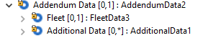

Existing FleetLineItem1 component in Request (Correct):

Existing FleetLineItem2 component in Response (Incorrect):

Existing VerificationInitiation2 component:
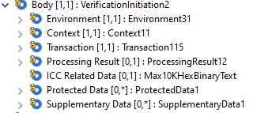

Existing VerificationResponse2 component:
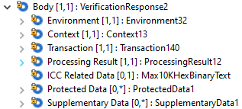

Existing InquiryInitiation2 component:
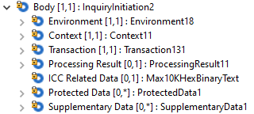

Existing InquiryResponse2 component:
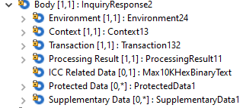

Existing Frequency12Code component:

Component modification
Modified component of AddendumData2
Addendum Data | Occurs | Type
Fleet | [0..1] | FleetData3
Instalment | [0..1] | Instalment4
Additional Data | [0..*] | AdditionalData1

Modified component of VerificationInitiation2/VerificationResponse2/InquiryInitation2/InquiryResponse2
Body | Occurs | Type
Environment | [1..1] | Environment31
…
Addendum Data | [0..1] | AddendumDataX
Instalment | [0..1] | Instalment4
Additional Data | [0..*] | AdditionalData1

FleetLineItem2
Line Item | Occurs | Type
Allowed Item Indicator | [0..1] | TrueFalseIndicator
Fuel Indicator | [1..1] | TrueFalseIndicator
…

FrequencyXCode
FrequencyXCode | Occurs | Type
Annual [YEAR] | Code
Daily [DAIL] | Code
Fortnightly [FRTN] | Code
Monthly [MNTH] | Code
Quarterly [QURT] | Code
Semi Annual [MIAN] | Code
Ten Days [TEND] | Code
Weekly [WEEK] | Code
Twice a Week [TWWK] | Code

Plan2
Plan | Occurs | Type
Plan Identification | [0..1] | Max35Text
Plan Owner | [0..1] | PlanOwner1Code
…
Period Unit | [0..1] | FrequencyXcode
…

Impacts
- AddendumData2 component used in

Message Definition | Message Components
Authorisation Response V03 | AuthorisationResponse2.AddendumData2
Financial Response V03 | FinancialResponse2.AddendumData2

- Add AddendumDataX component to the following Messages
Message Definition | Message Components
Verification Initiation V02 | VerificationInitiation2.AddendumDataX
Verification Response V02 | VerificationResponse2.AddendumDataX
Inquiry Initiation V02 | InquiryInitiation2.AddendumDataX
Inquiry Response V02 | InquiryResponse2.AddendumDataX

- FleetLineItem2 component used in

Message Definition | Message Components
Authorisation Response V03 | AuthorisationResponse2.AddendumData2.FleetData3.FleetLineItem2
Financial Response V03 | FinancialResponse2.AddendumData2.FleetData3.FleetLineItem2

- PeriodUnit component used in

Message Definition | Message Components
Addendum Initiation V02 | AddendumData3.Instalment4.Plan2.PeriodUnit
Addendum Response V02 | AddendumData3.Instalment4.Plan2.PeriodUnit
Authorisation Initiation V03 (cain.001.001.02) | AddendumData3.Instalment4.Plan2.PeriodUnit
Authorisation Response V03 (cain.001.001.03) | AddendumData3.Instalment4.Plan2.PeriodUnit
Financial Initiation V03 | AddendumData3.Instalment4.Plan2.PeriodUnit
Financial Response V03 | AddendumData3.Instalment4.Plan2.PeriodUnit

CR0979-2: Tax within AncillaryPurchase2

Description
New AncillaryPurchaseX which does not set Tax as required

Existing component
Existing AncillaryPurchase2 component:
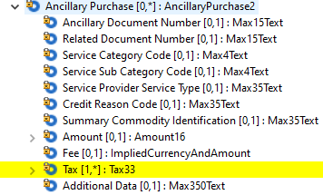

Component modification
Modified component that will replace all instances of AncillaryPurchase2
Ancillary Purchase | Occurs | Type
Ancillary Document Number | [0..1] | Max15Text
…
Tax | [0..*] | Tax33
…

Impacts
- AncillaryPurchase2 component used in

Message Definition | Message Components
Addendum Initiation V02 | AddendumIntiation2.AddendumData3.PassengerTransport2.AncillaryPurchase2
Authorisation Initiation v03 | AuthorisationInitiation2.AddendumData3.PassengerTransport2.AncillaryPurchase2
Financial Initiation V03 | FinancialInitiation2.AddendumData3.PassengerTransport2.AncillaryPurchase2

CR0979-3: Customer Credential

Add Expiration Date to Credential2

Description
Add Expiration Date to credential2 which is used in Customer7 to indicate the date that the customer’s credential identification ID is expired. Also change the type of Sub Division Major to Max3Text

Existing component
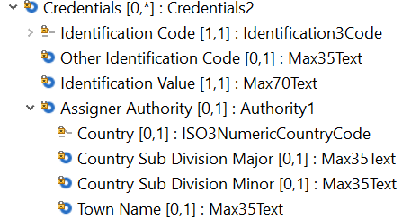

Component modification
Modified component that will replace all instances of Credential2 with CredentialX:
CredentialX | Occurs | Type
IdentificationCode <IdCd> | [0..1] | Identification3Code
OtherIdentificationCode <OthrIdCd> | [0..1] | Max35Text
IdentificationValue <IdVal> | [0..1] | Max70Text
IdentificationExpiryDate<IdXpryDt> | [0..1] | ISOYearMonth
AssignerAuthority<AssgnrAuthrty> | [0..1] | AuthorityX
Country<Ctry> | [0..1] | ISO2Or3ACountryCode
CountrySubDivisionMajor<CtrySubDvsnMjr> | [0..1] | ISOCountrySubDivisionCode
CountrySubDvisionMinor<CtrySubDvsnMnr> | [0..1] | ISOCountrySubDivisionCode
Name<TwnNm> | [0..1] | Max50Text

Impacts
- Credential2 component used in
Component Trace Path | Messages
Credential2/Customer7/PartyIdentification239/Environment17/AuthorisationInitiation2 | Authorization Initiation V03 (cain.001.001.03)
Credential2/Customer7/PartyIdentification239/Environment17/FinancialnInitiation2 | Financial Initiation V03 (cain.003.001.03)
Credential2/Customer7/PartyIdentification239/Environment31/VerificationInitiation2 | Verification Initiation V03 (cain.018.001.02
Credential2/Customer7/PartyIdentification239/Environment21/ChargebackInitiation2 | Chargeback Initiation V02 (cain.027.001.02)
Credential2/Customer7/PartyIdentification239/Environment22/FileActionInitiation2 | File Action Initiation V02 (cafm.001.001.02)
Credential2/Customer7/PartyIdentification239/Environment22/FileActionResponse2 | File Action Response V02 (cafm.002.001.02)
Credential2/Customer7/PartyIdentification239/Environment21/RetrievalFulfilmentInitiation2 | Retrieval Fulfilment Initiation V02 (cain.014.001.02)
Credential2/Customer7/PartyIdentification239/Environment21/RetrievalFulfilmentResponse2 | Retrieval Fulfilment Response V02 (cain.015.001.02)
Credential2/Customer7/PartyIdentification239/Environment21/RetrievalInitiation2 | Retrieval Initiation V02 (cain.021.001.02)
Credential2/Customer7/PartyIdentification239/Environment21/RetrievalResponse2 | Retrieval Response V02 (cain.022.001.02)
Credential2/Customer7/PartyIdentification239/Environment19/ReveralInitiation2 | Reversal Initiation V03 (cain.005.001.03)

CR0979-4: Plan2 structure

Description
New PlanX structure to be used for Plan data type that will contain updated Plan Identification Length

Existing component
Existing Plan2 component:
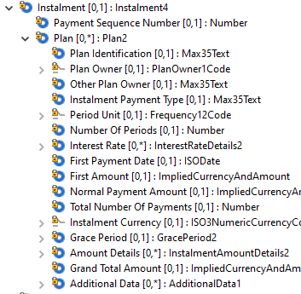

Component modification
Modified component that will replace all instances of Plan2
Plan | Occurs | Type
Plan Identification | [0..1] | Max70Text
…

Impacts
- Plan2 component used in

Message Definition | Message Components
Authorisation Initiation V03 | AuthorisationInitiation2.AddendumData3.Instalment4.Plan2
Financial Initiation V03 | FinancialInitiation2.AddendumData3.Instalment4.Plan2
Addendum Initiation V02 | AddendumInitiation2.AddendumData3.Instalment4.Plan2

CR0979-5: Reconciliation Activity type

Add Reconciliation activity type to Reconciliation Transaction

Description
Add Reconciliation activity type to Transaction135 to indicate the activity type to be reconciled in the Reconciliation Initiation and Response message.

Existing component
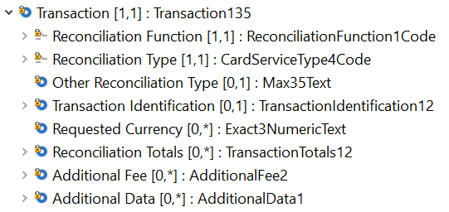

Component modification
Modified component that will replace all instances of Transaction135 with TransactionXXX:
Transaction XXX | Occurs
ReconciliationFunction <RcncltnFctn> | [1..1] | CodeSet
ReconcilationActivityType<RcncActvtyTp> | [1..1] | CodeSet  ACQG – Acquiring  ISSG – Issuing  CNSD – Consolidated  OTHP – Other Private  OTHN – Other National
OtherReconciliationActivityType<OthrActvtyTp> | [0..1] | Max35Text
ReconciliationType <RcncltnTp> | [1..1] | CodeSet
OtherReconciliationType <OthrRcncltnTp> | [0..1] | Max35Text
TransactionIdentification <TxId> | [0..1] | TransactionIdentification12
RequestedCurrency <ReqdCcy> | [0..*] | Exact3NumericText
ReconciliationTotals <RcncltnTtls> | [0..*] | TransactionTotal12
AdditionalFees <AddtlFees> | [0..*] | AdditionalFee2
AdditionalData <AddtlData> | [0..*] | AdditionalData1

Impacts
- Transaction135 component used in
Component Trace Path | Messages
Transaction135/ReconcilationInitiation2 | ReconcilationInitiation V03 (caad.005.001.03)
Transaction135/ReconcilationResponse5 | ReconciliationResponse V03 (caad.006.001.03)

CR0979-6: POI Component Enhancement

Extend the length of serial number POI Identification

Description
Extend the length of serial number of POI component Identification from Max35Text to Max70Text.

Existing component
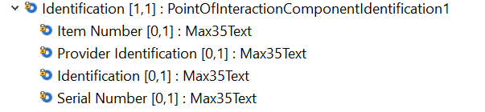

Component modification
Modified component that will replace all instances of PointOfInteractionComponentIdentification1:
PointOfInteractionComponentIdentification1 | Occurs | Type
ItemNumber <ItmNb> | [0..1] | Max35Text
ProviderIdentification <PrvdrId> | [0..1] | Max35Text
Identification <Id> | [0..1] | Max35Text
SerialNumber <SrlNb> | [0..1] | Max70Text

Impacts
- PointOfInteractionComponentIdentification1 component used in
Component Trace Path | Messages
PointOfInteractionComponentIdentification1/PointOfInteractionComponent8/Terminal4/Environment17 | - AuthorizationInitiation1  - FinancialInitiation1  - VerificationInitiation1  - InquiryInitiation1  - CardManagementInitiation1

Correct Errors related to iterative fields in Terminal.Capability

Description
Currently, some iterative fields relate to another iterative field – it is not possible to tie specific iterations of each field together. Each pair must be grouped inside of its own repeating structure inside of Capabilities (similar to CardholderVerificationCapability). Create two components (iterative structure) for CardReadingCapability and CardWritingCapability in Cap

Existing Component
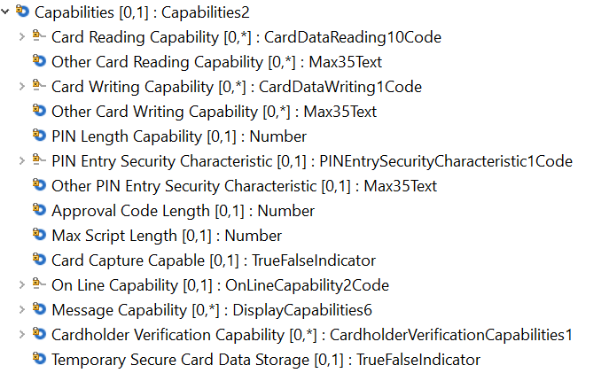

Component modification
Modified component that will replace all instances of Capability2
CapabilityXX | Occurs | Type
CardReadingCapability <CardRdngCpblty> | [0..*] | CardReadingCapability1
Capability<Cpblty> | [1..1] | CardDataReading10Code (existing data type)
OtherCapability<OthrCpblty> | [0..1] | Max35Text
CardWritingCapabilities <CardWrtgCpblties> | [0..*] | CardWritingCapability1
Capabilities <Cpblties> | [1..1] | CardDataWriting1Code (existing data type)
OtherCapabilities <OthrCpblties> | [0..1] | Max35Text
PINLengthCapabilities <PINLngthCpblties> | [0..1] | Quantity
PINEntrySecurityCharacteristic<PINNtrySctyChrtc> | [0..1] | PINEntrySecurityCharacteristic1Code
OtherPINEntrySecurityCharacteristic<Othr PINNtrySctyChrtc> | [0..1] | Max35Text
….
CardholderVerificationCapability <CrdhldrVrfctnCpblty> | [0..*] | CardholderVerificationCapabilites1
TemporarySecureCardDataStorage<TempScrCardDataStorg> | [0..1] | TrueFalseIndicator

Impact
- Capability2 component used in
Component Path | Messages
Capability2/Terminal4/Environment17/AuthorizationInitiation2 | Authorisation Initiation V03(cain.001.001.03)
Capability2/Terminal4/Environment17/FinancialInitiation2 | Financial Initiation V03(cain.003.001.03)
Capability2/Terminal4/Environment18/CardManagementInitiation2 | Card Management Initiation V02(cain.023.001.02)
Capability2/Termina5/Environment20//OriginalTransaction2/ChargebackInitiation2 | Chargeback Initiation V02(cain.027.001.02)
Capability2/Termina4/Environment22/FileActionInitiation2 | File Action Initiation V02(cafm.001.001.02)
Capability2/Termina4/Environment22/FileActionResponse2 | File Action Response V02(cafm.002.001.02)
Capability2/Terminal4/Environment18/InquiryInitiation2 | Inquiry Initiation V02(cain.016.001.02)
Capability2/Termina5/Environment20//OriginalTransaction2/RetrievalFulfilmentInitiation2 | Retrieval Fulfilment Initiation V02 (cain.014.001.02)
Capability2/Termina5/Environment20//OriginalTransaction2/RetrievalInitiation2 | Retrieval Initiation V02 (cain.021.001.02)
Capability2/Terminal4/Environment31/VerificationInitiation2 | Verification Initiation V02(cain.018.001.02)

CR0979-7: Consolidate TransactionIdentification elements

Description
Fixes for Transaction Identification
- Addendum response does not use the correct Transaction Identification. Consolidate TransactionIdentification19 to TransactionIdentification20.

Existing component
Existing TransactionIdentification19 component:
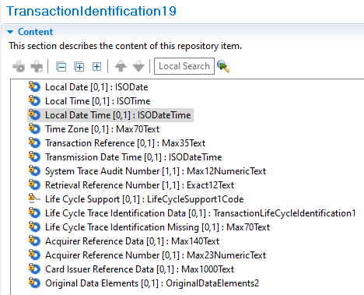
Existing TransactionIdentification20 component:
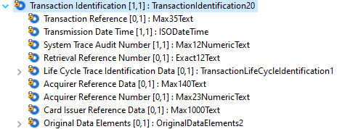

Component modification
Modified component of Transaction118 used in Addendum Response
Transaction118 | Occurs | Type
Transaction Type | [1..1] | ISOTransactionTypeCode
…
Transaction Identification | [1..1] | TransactionIdentification20
…

Impacts
- TransactionIdentification19 component used in
Message Definition | Message Components
Addendum Response V02 | Addendumresponse2.Transaction118.TransactionIdentification19

CR0979-8: Result within VerificationResult1 structure

Description
New VerificationXCode codelist to be used for Result data type that will be added to VerificationResult1 structures

Existing component
Existing VerificationResult1 component:
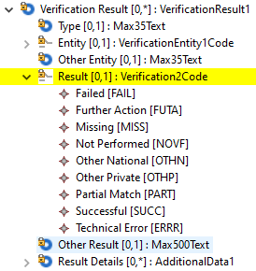

Component modification
Modified component that will replace all instances of VerificationResult1
Verification Result | Occurs | Type
Type | [0..1] | Max35Text
…
Result | [0..1] | VerificationXCode
[FAIL] Failed | Code
[FUTA] Further Action | Code
[MISS] Missing | Code
[NOVF] Not Performed | Code
[OTHN] Other National | Code
[OTHP] Other Private | Code
[PART] Partial Match | Code
[SUCC] Successful | Code
[ERRR] Technical Error | Code
[NOSP] Not Supported | Code
…

Impacts
- Verification2Code component used in

Message Definition | Message Components
Authorisation Initiation V03 | AuthorisationInitiation2.Context10.Verification3.VerificationResult1.Verification2Code
Authorisation Response V03 | AuthorisationResponse2.Context13.Verification4.VerificationResult1.Verification2Code
Card Management Initiation V02 | CardManagementInitiation2.Context11.Verification3.VerificationResult1.Verification2Code
Card Management Response V02 | CardManagementResponse2.Context13.Verification4.VerificationResult1.Verification2Code
Charge Back Initiation V02 | ChargeBackInitiation2.Context12.Verification4.VerificationResult1.Verification2Code
Financial Initiation V03 | FinancialInitiation2.Context10.Verification3.VerificationResult1.Verification2Code
Financial Response V03 | FinancialResponse2.Context13.Verification4.VerificationResult1.Verification2Code
Inquiry Initiation V02 | InquiryInitiation2.Context11.Verification3.VerificationResult1.Verification2Code
Inquiry Response V02 | InquiryResponse2.Context13.Verification4.VerificationResult1.Verification2Code
Retrieval Fulfilment Initiation V02 | RetrievalFulfilmentInitiation2.OriginalTransaction2.Context12.Verification4.VerificationResult1.Verification2Code
Retrieval Initiation V02 | RetrievalInitiation2.OriginalTransaction2.Context12.Verification4.VerificationResult1.Verification2Code
Verification Initiation V02 | VerificationInitiation2.Context11.Verification3.VerificationResult1.Verification2Code
Verification Initiation V02 | VerificationResponse2.Context13.Verification4.VerificationResult1.Verification2Code

CR0979-9: Customer Device Code

Description
Add additional customer device codes used for a card payment transaction to the message component CustomerDevice3, code set CustomerDeviceType2Code
The codes to be added are:
- KFOB = key fob
- JEWL= jewlery
- STIC=sticker
- GAMB=gaming device
- WATC = watch

Component modification
Key:
CustomerDeviceTypeX2Code
CodeName | Name
EMBD | Embedded
MOBL | Mobile
NSCR | Non Secure Card Reader
OTHN | Other National
OTHP | Other Private
PECR | Personal Computer
SECR | Secure Card Reader
TBLT | Tablet
VHCL | Vehicle
WRBL | Wearable
KFOB | Key Fob
JEWL | Jewelry
STIC | Sticker
GAMB | Gaming Device
WATC | Watch

AuthorisationInitiationVXX03
Message Root | Occurs | Type
Body | [1..1] | AuthorisationInitiation2
Environment | [1..1] | Environment17
Customer Device | [0..1] | CustomerDevice3
Device | [0..1] | Device2
…
Type | [0..1] | CustomerDeviceTypeX2Code
Embedded [EMBD] | Code
Mobile [MOBL] | Code
…
Key Fob [KFOB] | Code
Jewelry [JEWL] | Code
Sticker [STIC] | Code
Gaming Device [GAMB] | Code
Watch [WATC] | Code

CardManagementInitiationVXX02
Message Root | Occurs | Type
Body | [1..1] | CardManagementInitiation2
Environment | [1..1] | Environment18
Customer Device | [0..1] | CustomerDevice3
Device | [0..1] | Device2
…
Type | [0..1] | CustomerDeviceTypeX2Code
Embedded [EMBD] | Code
Mobile [MOBL] | Code
…
Key Fob [KFOB] | Code
Jewelry [JEWL] | Code
Sticker [STIC] | Code
Gaming Device [GAMB] | Code
Watch [WATC] | Code

CardManagementResponseVXX02
Message Root | Occurs | Type
Body | [1..1] | CardManagementResponse2
Environment | [1..1] | Environment25
Customer Device | [0..1] | CustomerDevice3
Device | [0..1] | Device2
…
Type | [0..1] | CustomerDeviceTypeX2Code
Embedded [EMBD] | Code
Mobile [MOBL] | Code
…
Key Fob [KFOB] | Code
Jewelry [JEWL] | Code
Sticker [STIC] | Code
Gaming Device [GAMB] | Code
Watch [WATC] | Code

ChargeBackInitiationVXX02
Message Root | Occurs | Type
Body | [1..1] | ChargeBackInitiation2
Environment | [1..1] | Environment21
…
Original Transaction | [1..1] | OriginalTransaction2
Environment | [0..1] | Environment20
Acquirer | [0..1] | PartyIdentification198
…
Customer Device | [0..1] | CustomerDevice3
Device | [0..1] | Device2
…
Type | [0..1] | CustomerDeviceTypeX2Code
Embedded [EMBD] | Code
Mobile [MOBL] | Code
…
Key Fob [KFOB] | Code
Jewelry [JEWL] | Code
Sticker [STIC] | Code
Gaming Device [GAMB] | Code
Watch [WATC] | Code

FileActionInitiationVXX02
Message Root | Occurs | Type
Body | [1..1] | FileActionInitiation2
Environment | [1..1] | Environment22
Customer Device | [0..1] | CustomerDevice3
Device | [0..1] | Device2
…
Type | [0..1] | CustomerDeviceTypeX2Code
Embedded [EMBD] | Code
Mobile [MOBL] | Code
…
Key Fob [KFOB] | Code
Jewelry [JEWL] | Code
Sticker [STIC] | Code
Gaming Device [GAMB] | Code
Watch [WATC] | Code

FileActionResponseVXX02
Message Root | Occurs | Type
Body | [1..1] | FileActionResponse2
Environment | [1..1] | Environment22
Customer Device | [0..1] | CustomerDevice3
Device | [0..1] | Device2
…
Type | [0..1] | CustomerDeviceTypeX2Code
Embedded [EMBD] | Code
Mobile [MOBL] | Code
…
Key Fob [KFOB] | Code
Jewelry [JEWL] | Code
Sticker [STIC] | Code
Gaming Device [GAMB] | Code
Watch [WATC] | Code

FinancialInitiationVXX03
Message Root | Occurs | Type
Body | [1..1] | FinancialInitiation2
Environment | [1..1] | Environment17
Customer Device | [0..1] | CustomerDevice3
Device | [0..1] | Device2
…
Type | [0..1] | CustomerDeviceTypeX2Code
Embedded [EMBD] | Code
Mobile [MOBL] | Code
…
Key Fob [KFOB] | Code
Jewelry [JEWL] | Code
Sticker [STIC] | Code
Gaming Device [GAMB] | Code
Watch [WATC] | Code

InquiryInitiationVXX02
Message Root | Occurs | Type
Body | [1..1] | InquiryInitiation2
Environment | [1..1] | Environment18
Customer Device | [0..1] | CustomerDevice3
Device | [0..1] | Device2
…
Type | [0..1] | CustomerDeviceTypeX2Code
Embedded [EMBD] | Code
Mobile [MOBL] | Code
…
Key Fob [KFOB] | Code
Jewelry [JEWL] | Code
Sticker [STIC] | Code
Gaming Device [GAMB] | Code
Watch [WATC] | Code

RetrievalFulfilmentInitiationVXX02
Message Root | Occurs | Type
Body | [1..1] | RetrievalFulfilmentInitiation2
Environment | [1..1] | Environment21
…
Original Transaction | [1..1] | OriginalTransaction2
Environment | [0..1] | Environment20
Acquirer | [0..1] | PartyIdentification198
…
Customer Device | [0..1] | CustomerDevice3
Device | [0..1] | Device2
…
Type | [0..1] | CustomerDeviceTypeX2Code
Embedded [EMBD] | Code
Mobile [MOBL] | Code
…
Key Fob [KFOB] | Code
Jewelry [JEWL] | Code
Sticker [STIC] | Code
Gaming Device [GAMB] | Code
Watch [WATC] | Code

RetrievalInitiationVXX02
Message Root | Occurs | Type
Body | [1..1] | RetrievalInitiation2
Environment | [1..1] | Environment21
…
Original Transaction | [1..1] | OriginalTransaction2
Environment | [0..1] | Environment20
Acquirer | [0..1] | PartyIdentification198
…
Customer Device | [0..1] | CustomerDevice3
Device | [0..1] | Device2
…
Type | [0..1] | CustomerDeviceTypeX2Code
Embedded [EMBD] | Code
Mobile [MOBL] | Code
…
Key Fob [KFOB] | Code
Jewelry [JEWL] | Code
Sticker [STIC] | Code
Gaming Device [GAMB] | Code
Watch [WATC] | Code

VerificationInitiationVXX02
Message Root | Occurs | Type
Body | [1..1] | VerificationInitiation2
Environment | [1..1] | Environment31
Customer Device | [0..1] | CustomerDevice3
Device | [0..1] | Device2
…
Type | [0..1] | CustomerDeviceTypeX2Code
Embedded [EMBD] | Code
Mobile [MOBL] | Code
…
Key Fob [KFOB] | Code
Jewelry [JEWL] | Code
Sticker [STIC] | Code
Gaming Device [GAMB] | Code
Watch [WATC] | Code

Impacts
  - AuthorisationInitiationV03 (cain.001.001.03)
  - CardManagementInitiationV02 (cain.023.001.02)
  - CardManagementResponseV02 (cain.024.001.02)
  - ChargeBackInitiationV02 (cain.027.001.02)
  - FileActionInitiationV02 (cafm.001.001.02)
  - FileActionResponseV02 (cafm.002.001.02)
  - FinancialInitiationV03 (cain.003.001.03)
  - InquiryInitiationV02 (cain.016.001.02)
  - RetrievalFulfilmentInitiationV02 (cain.014.001.02)
  - RetrievalInitiationV02 (cain.021.001.02)
  - VerificationInitiationV02 (cain.018.001.02)

CR0979-10 : DataType for Entity inside of Environment PartyIdentification240

Create new PartyIdentificationXXX

Description
The following Components under Environments are using PartyIdentification240, but the datatype of PartyIdentification240/Identification is wrong, currently is Max35Text, it should be Max11NumericText to align with ISO 8583. And follow the rules defined by TC68/SC9.
- Acquirer
- Sender
- Receiver
- Originator
- Destination

Existing component
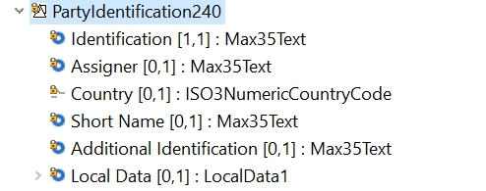

Component modification
Create component PartyIdentificationXXX:
PartyIdentificationXXX | Occurs | Type
Identification <Id> | [0..1] | Max11NumericText
Assigner <Assgnr> | [0..1] | Max35Text
Country<Ctry> | [0..1] | ISO3NumericCountryCode
ShortName<ShrtNm> | [0..1] | Max35Text
AdditionalIdentification <AddtlId> | [0..*] | AdditionalData1
LocalData<LclData> | [0..1] | LocalData1

Replace PartyIdentification240 component in the following with PartyIdentificationXXX in the environments
Environment 17-33
EnvironmentXX | Occurs | Type
Acquirer <Acqrr> | [1..1] | PartyIdentification240  PartyIdentificationXXX
Originator<Orgtr> | [0..1] | PartyIdentification240  PartyIdentificationXXX
Sender <Sndr> | [0..1] | PartyIdentification240  PartyIdentificationXXX
Receiver <Rcvr> | [0..1] | PartyIdentification240  PartyIdentificationXXX
Acceptor <Accptr> | [1..1] | PartyIdentification237
Destination<Dstn> |  | PartyIdentification240  PartyIdentificationXXX
… | … | …

Impacts
- Environment 17-33 used in:
Component Trace Path | Messages
Environment17/AuthorizationInitiation2 | Authorization Initiation V03 (cain.001.001.03)
Environment26/AuthorizationResponse2 | Authorization Response V03 (cain.002.001.03)
Environment17/FinancialnInitiation2 | Financial Initiation V03 (cain.003.001.03)
Environment26/FinancialnResponse2 | Financial Response V03 (cain.004.001.03)
Environment18/InquiryInitiation2 | Inquiry Initiation V02 (cain.016.001.02)
Environment24/ InquiryResponse2 | Inquiry Response V02 (cain.017.001.02)
Environment18/CardManagementInitiation2 | Card Management Initiation V02 (cain.023.001.02)
Environment25/ CardManagementResponse2 | Card ManagementResponse V02 (cain.024.001.02)
Environment19/ReversalInitiation2 | Reversal Initiation V03 (cain.005.001.03)
Environment29/ReversalResponse2 | Reversal Response V03 (cain.006.001.03)
Environment20/OriginalTransaction2/ChargebackInitiation2 | Chargeback Initiation V02 (cain.027.001.02)
Environment20/OriginalTransaction2/RetrievalFulfilmentInitiation2 | Retrieval Fulfilment Initiation V02 (cain.014.001.02)
Environment20/OriginalTransaction2/RetrievalInitiation2 | Retrieval Initiation V02 (cain.021.001.02)
Environment21/ ChargebackInitiation2 | Chargeback Initiation V02 (cain.027.001.02)
Environment29/ ChargebackResponse2 | Chargeback Response V02 (cain.028.001.02)
Environment21/ RetrievalFulfilmentInitiation2 | Retrieval Fulfilment Initiation V02 (cain.014.001.02)
Environment21/ RetrievalFulfilmentResponse2 | Retrieval Fulfilment Response V02 (cain.015.001.02)
Environment21/ RetrievalInitiation2 | Retrieval Initiation V02 (cain.021.001.02)
Environment21/ RetrievalResponse2 | Retrieval Response V02 (cain.022.001.02)
Environment22/ FileActionInitiation2 | File Action Initiation V02 (cafm.001.001.02)
Environment22/ FileActionResponse2 | Retrieval Response V02 (cafm.002.001.02)
Environment23/ FeeCollectionInitiation2 | Fee Collection Initiation V02 (cafc.001.001.02)
Environment23/ FeeCollectionResponse2 | Fee Collection Response V02 (cafc.002.001.02)
Environment27/ SettlementReportingInitiation2 | Settlement Reporting Initiation V02 (carp.006.001.01)
Environment27/ SettlementReportingResponse2 | Settlement Reporting Response V02 (carp.007.001.01)
Environment28/ FraudReportingInitiation2 | Fraud Reporting Initiation V02 (carp.002.001.01)
Environment28/ FraudReportingResponse2 | Fraud Reporting Response V02 (carp.003.001.01)
Environment28/ FraudDispositionInitiation2 | Fraud Disposition Initiation V02 (carp.004.001.01)
Environment28/ FraudDispositionResponse2 | Fraud Disposition Response V02 (carp.005.001.01)
Environment30/ AddendumInitiation2 | Addendum Initiation V02 (cain.025.001.02)
Environment30/ AddendumResponse2 | Addendum Response V02 (cain.026.001.02)
Environment31/ VerificationInitiation2 | Verification Initiation V02 (cain.018.001.02)
Environment32/ VerificationResponse2 | Verification Response V02 (cain.019.001.02)
Environment33/ BatchManagementInitiation2 | Batch Management Initiation V02 (caad.001.001.02)
Environment33/ BatchManagementResponse2 | Batch Management Response V02 (caad.002.001.02)
Environment33/ ReconciliationInitiation2 | Reconciliation Initiation V02 (caad.005.001.02)
Environment33/ ReconciliationResponse2 | Reconciliation Response V02 (caad.006.001.02)
Environment33/ CustomReport1 | Custom Resport V01 (carp.001.001.01)

CR0979-11: Customer7 enhancement

Description

- Part 1- Add Contact6 to Customer7 used in Payer / Payee to Align with ISO 8583 (bit 56 87 version).
- Part 2- Add Nationality and Country of Origin to Customer7

Existing Customer7 Structure used by Payer/Payee:
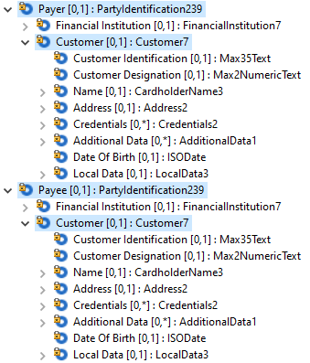

Change:
New CustomerX (was Customer7) which contains Contact6 structure, Nationality and Country of Birth used in PartyIdentification239 (Payer/ Payee)
Element name | Occurs | Type
Customer | [0..1] | CustomerX (was Customer7)
Customer Identification | [0..1] | Max35Text
Customer Designation | [0..1] | Max2NumericText
Name | [0..1] | CardholderName3
Address | [0..1] | Address2
Contact Information | [0..1] | Contact6
Nationality | [0..1] | ISO2or3ACountryCode
Country of Birth | [0..1] | ISO2or3ACountryCode
…

Descriptions:
Nationality: Nationality information (ISO 3166-1 alpha-2 or alpha-3).
Country of Birth: Country of Birth information (ISO 3166-1 alpha-2 or alpha-3).

Message Components | Message Definition
Environment17.PartyIdentification239.Customer7 | Authorisation Initiation V03
Environment21.PartyIdentification239.Customer7 | Charge Back Initiation V02
Environment22.PartyIdentification239.Customer7 | File Action Initiation V02
Environment22.PartyIdentification239.Customer7 | File Action Response V02
Environment17.PartyIdentification239.Customer7 | Financial Initiation V03
Environment21.PartyIdentification239.Customer7 | Retrieval Fulfilment Initiation V02
Environment21.PartyIdentification239.Customer7 | Retrieval Fulfilment Response V02
Environment21.PartyIdentification239.Customer7 | Retrieval Initiation V02
Environment21.PartyIdentification239.Customer7 | Retrieval Response V02
Environment19.PartyIdentification239.Customer7 | Reversal Initiation V03
Environment31.PartyIdentification239.Customer7 | Verification Initiation V02

CR0979-12: CreditIndicator element

Description
The following change is for the CreditIndicator <CdtInd> element. Replace the current structure of a true/false indicator with a code detailing “Credit or Debit”

For everywhere credit indicator exists:
Part 1). Change data type to use existing datatype CreditDebit3code
Part 2). Change the name of the data element from CreditIndicator to CreditDebit.
Existing:
AmountDetails2:
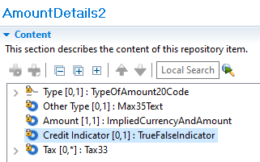
LodgingLineItem1:
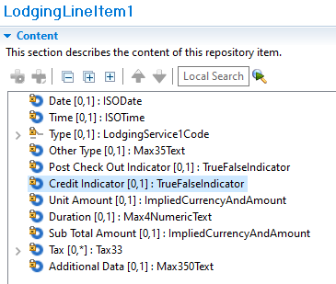
Amount10:
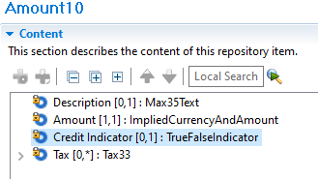
Amount11:
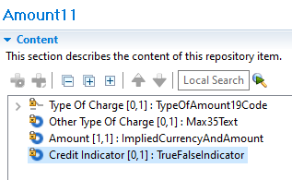
Adjustment11:
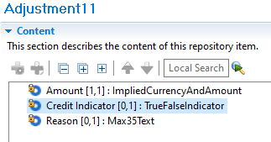
AccountStatementDetails1:
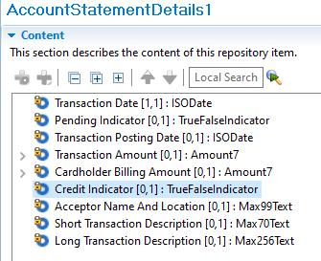

Change:
Element name | Occurs | Type
AmountDetails2
Type | [0..1] | TypeOfAmount20Code
…
Credit Debit | [0..1] | CreditDebit3Code
…

Element name | Occurs | Type
LodgingLineItem1
Date | [0..1] | ISODate
…
Credit Debit | [0..1] | CreditDebit3Code
…

Element name | Occurs | Type
Amount10
Description | [0..1] | Max35Text
…
Credit Debit | [0..1] | CreditDebit3Code
…

Element name | Occurs | Type
Amount11
Type Of Charge | [0..1] | TypeOfAmount19Code
…
Credit Debit | [0..1] | CreditDebit3Code
…

Element name | Occurs | Type
Adjustment11
Amount | [1..1] | ImpliedCurrencyAndAmount
…
Credit Debit | [0..1] | CreditDebit3Code
…

Element name | Occurs | Type
AccountStatementDetails1
Transaction Date | [1..1] | ISODate
…
Credit Debit | [0..1] | CreditDebit3Code
…

Impacts:
AmountDetails2:
Message Components | Message Definition
AddendumData3.PassengerTransport2.PassengerTransportSummary2.AmountDetails2  AddendumData3.PassengerTransport2.TripLeg2.AmountDetails2 | Addendum Initiation V02
AddendumData3.PassengerTransport2.PassengerTransportSummary2.AmountDetails2  AddendumData3.PassengerTransport2.TripLeg2.AmountDetails2 | Authorisation Initiation V03
AddendumData3.PassengerTransport2.PassengerTransportSummary2.AmountDetails2  AddendumData3.PassengerTransport2.TripLeg2.AmountDetails2 | Financial Initiation V03

LodgingLineItem1:
Message Components | Message Definition
AddendumData3.Lodging3.LodgingLineItem1 | Addendum Initiation V02
AddendumData3.Lodging3.LodgingLineItem1 | Authorisation Initiation V03
AddendumData3.Lodging3.LodgingLineItem1 | Financial Initiation V03

Amount10:
Message Components | Message Definition
AddendumData3.TelecomService.TelecomServicesSummary1.Amount10 | Addendum Initiation V02
AddendumData3.TelecomService.TelecomServicesSummary1.Amount10 | Authorisation Initiation V03
AddendumData3.TelecomService.TelecomServicesSummary1.Amount10 | Financial Initiation V03

Amount11:
Message Components | Message Definition
AddendumData3.TelecomService.TelecomServicesLineItem1.Amount11 | Addendum Initiation V02
AddendumData3.TelecomService.TelecomServicesLineItem1.Amount11 | Authorisation Initiation V03
AddendumData3.TelecomService.TelecomServicesLineItem1.Amount11 | Financial Initiation V03

Adjustment11:
Message Components | Message Definition
AddendumData3.Invoice2.InvoiceLineItem1.Adjustment11 | Addendum Initiation V02
AddendumData3.Invoice2.InvoiceLineItem1.Adjustment11 | Authorisation Initiation V03
AddendumData3.Invoice2.InvoiceLineItem1.Adjustment11 | Financial Initiation V03

AccountStatementDetails1:
Message Components | Message Definition
Transaction132.AccountStatementData.AccountStatementDetail1 | Inquiry Response V02

CR0979-13: Shipping Pack1 Container

Description
Add a new data element “PickupDate” to the ShippingPackage2 structure.
Existing:
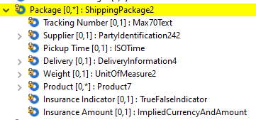

Updated:
Element name | Occurs | Type
ShippingPackage2
Tracking Number | [0..1] | Max70Text
Supplier | [0..1] | PartyItentification242
Pickup Time | [0..1] | ISOTime
Pickup Date | [0..1] | ISODate
…

Impact:
Message Components | Message Definition
AddendumData3.ShippingData2.ShippingPackage2 | Addendum Initiation V02
AddendumData3.ShippingData2.ShippingPackage2 | Authorisation Initiation V03
AddendumData3.ShippingData2.ShippingPackage2 | Financial Initiation V03

CR0979-14: VerificationEntity1Code

Description

Add two new codes to VerificationEntity1Code which is used in VerificationResult1.
Current Component
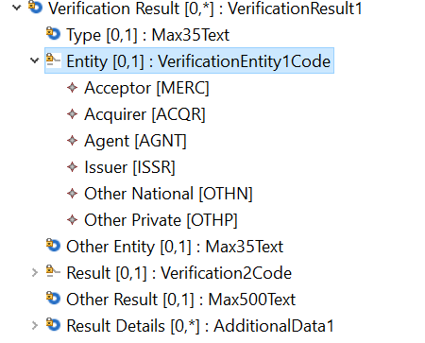
Component Modification – VerificationEntityX1Code
CodeName | Name | Description
MERC | Acceptor | Acceptor (for example signature verification by the attendant).
ACQR | Acquirer | Acquirer of the transaction.
AGNT | Agent | Entity providing card payment processing services acting as an intermediary between (or on behalf of) an acquirer and an issuer.
… | … | …
ICCA | CardApplication | Application in the smart card.
CDAD | AcceptanceDevice | Type of Device to accept payment

Impact
VerificationEntity1Code used in:
Component Trace Path | Messages
VerificationEntity1Code/VerificationResult1/Verification3/Context10/AuthorizationInitiation2 | Authorization Initiation V03 (cain.001.001.03)
VerificationEntity1Code/VerificationResult1/Verification4/Context13/AuthorizationResponse2 | Authorization Response V03 (cain.002.001.03)
VerificationEntity1Code/VerificationResult1/Verification3/Context10/FinancialnInitiation2 | Financial Initiation V03 (cain.003.001.03)
VerificationEntity1Code/VerificationResult1/Verification4/Context13/FinancialnResponse2 | Financial Response V03 (cain.004.001.03)
VerificationEntity1Code/VerificationResult1/Verification3/Context11/InquiryInitiation2 | Inquiry Initiation V02 (cain.016.001.02)
VerificationEntity1Code/VerificationResult1/Verification2/Context4/ InquiryResponse2 | Inquiry Response V02 (cain.017.001.02)
VerificationEntity1Code/VerificationResult1/Verification3/Context11/CardManagementInitiation2 | Card Management Initiation V02 (cain.023.001.02)
VerificationEntity1Code/VerificationResult1/Verification4/Context13/ CardManagementResponse2 | Card ManagementResponse V02 (cain.024.001.02)
VerificationEntity1Code/VerificationResult1/Verification4/Context12/OrginalTransaction2/RetrievalFulfilmentInitiation2 | Retrieval Fulfilment Initiation V02 (cain.014.001.02)
VerificationEntity1Code/VerificationResult1/Verification4/Context12/OrginalTransaction2/RetrievalInitiation2 | Retrieval Initiation V02 (cain.021.001.02)
VerificationEntity1Code/VerificationResult1/Verification4/Context12/OrginalTransaction2/ChargebackInitiation2 | Chargeback Initiation V02 (cain.027.001.02)
VerificationEntity1Code/VerificationResult1/Verification3/Context11/ VerificationInitiation2 | Verification Initiation V02 (cain.018.001.02)
VerificationEntity1Code/VerificationResult1/Verification4/Context13/ VerificationResponse2 | Verification Response V02 (cain.019.001.02)

CR0979-15: Cardholder17

Description
This change request is to add the container (Cardholder15) to the Environment 24, 25, 26, 32 in applicable Response Message because the Issuer information is required to provide additional information about the cardholder.
Current Component
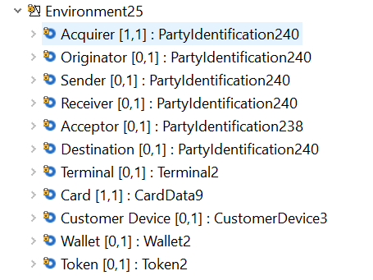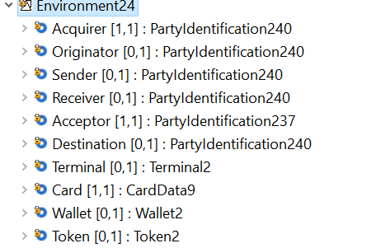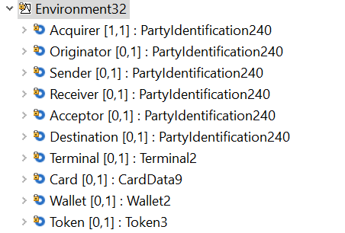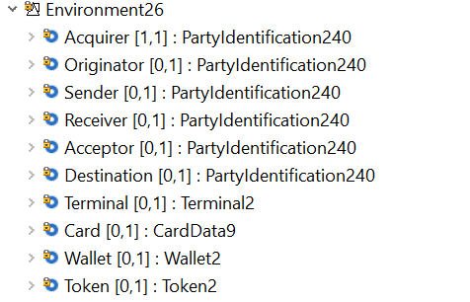
Component Modification
Add Cardholder (cardholder17) after Token (Token2) to Environment 24, 25, 26, 32

Environment 24
EnvironementXX | Occurs | Type
Acquirer | [1..1] | PartyIdentification240
Originator | [0..1] | PartyIdentification240
…
Token | [0..1] | Token2
Cardholder | [0..1] | Cardholder17

Environment 25
EnvironementXX | Occurs | Type
Acquirer | [1..1] | PartyIdentification240
Originator | [0..1] | PartyIdentification240
…
Token | [0..1] | Token2
Cardholder | [0..1] | Cardholder17

Environment 26
EnvironementXX | Occurs | Type
Acquirer | [1..1] | PartyIdentification240
Originator | [0..1] | PartyIdentification240
…
Token | [0..1] | Token2
Cardholder | [0..1] | Cardholder17

Environment 32
EnvironementXX | Occurs | Type
Acquirer | [1..1] | PartyIdentification240
Originator | [0..1] | PartyIdentification240
…
Token | [0..1] | Token2
Cardholder | [0..1] | Cardholder17

Impact

Environment 24, 25, 26, 32 used in
Component Trace Path | Messages
Environment26/AuthorizationResponse2 | Authorization Response V03 (cain.002.001.03)
Environment26/FinancialnResponse2 | Financial Response V03 (cain.004.001.03)
Environment24/ InquiryResponse2 | Inquiry Response V02 (cain.017.001.02)
Environment25/ CardManagementResponse2 | Card ManagementResponse V02 (cain.024.001.02)
Environment32/ VerificationResponse2 | Verification Response V02 (cain.019.001.02)

CR0979-16: Settlement Service Enhancement

Description
Add AdditionalSettlementInformation (Datatype, AdditionalData1) to the SettlementService1&2 to capture information not defined in structure
SettlementService1
Definition: Attributes of a settlement service.
Current Component
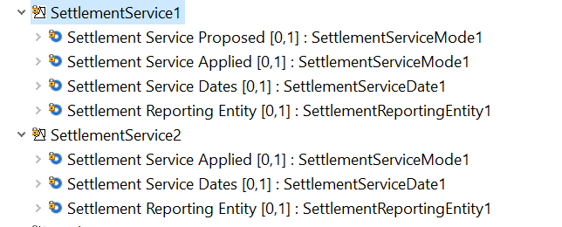
Component Modification
Settlement Service1
Settlement ServiceXX | Occurs | Type
Settlement Service Proposed | [0..1] | Settlement ServiceMode1
Settlement Service Applied | [0..1] | Settlement ServiceMode1
Settlement Service Dates | [0..1] | SettlementServiceDate1
Settlement Reporting Entity | [0..1] | SettlementReportingEntity
AdditionalSettlementInformation | [0..*] | AdditionalData1

Settlement Service2
Settlement ServiceXX | Occurs | Type
Settlement Service Applied | [0..1] | Settlement ServiceMode1
Settlement Service Dates | [0..1] | SettlementServiceDate1
Settlement Reporting Entity | [0..1] | SettlementReportingEntity
AdditionalSettlementInformation | [0..*] | AdditionalData1

Impact

SettlementService1 and SettlementService2 used in
Component Trace Path | Messages
SettlementService2/TransactionContext8/Context13/AddendumInitiation2 | Addendum Initiation V02 (cain.025.001.02)
SettlementService2/TransactionContext10/Context17/AddendumResponse2 | Addendum Response V02 (cain.026.001.02)
SettlementService2/TransactionContext6/Context6/Amendment10 | Amendment V01 (cain.020.001.01)
SettlementService1/TransactionContext7/Context10/AuthorizationInitiation2 | Authorization Initiation V03 (cain.001.001.03)
SettlementService2/TransactionContext8/Context13/AuthorizationResponse2 | Authorization Response V03 (cain.002.001.03)
SettlementService1/TransactionContext7/Context10/FinancialnInitiation2 | Financial Initiation V03 (cain.003.001.03)
SettlementService2/TransactionContext8/Context13/FinancialnResponse2 | Financial Response V03 (cain.004.001.03)
SettlementService1/TransactionContext7/Context11/InquiryInitiation2 | Inquiry Initiation V02 (cain.016.001.02)
SettlementService2/TransactionContext8/Context13/ InquiryResponse2 | Inquiry Response V02 (cain.017.001.02)
SettlementService1/TransactionContext7/Context11/CardManagementInitiation2 | Card Management Initiation V02 (cain.023.001.02)
SettlementService2/TransactionContext8/Context13/ CardManagementResponse2 | Card ManagementResponse V02 (cain.024.001.02)
SettlementService1/TransactionContext9/Context14/ReversalInitiation2 | Reversal Initiation V03 (cain.005.001.03)
SettlementService2/TransactionContext3/ReversalResponse4 | Reversal Response V03 (cain.006.001.03)
SettlementService1/TransactionContext7/Context12/OriginalTransaction2/ChargebackInitiation2  SettlementService1/TransactionContext4/Context7/ChargebackInitiation2 | Chargeback Initiation V02 (cain.027.001.02)
SettlementService1/TransactionContext7/Context12/OriginalTransaction2/RetrievalFulfilmentInitiation2  SettlementService2/TransactionContext8/Context15/ RetrievalFulfilmentInitiation2 | Retrieval Fulfilment Initiation V02 (cain.014.001.02)
SettlementService1/TransactionContext7/Context12/OriginalTransaction2/RetrievalInitiation2  SettlementService2/TransactionContext8/Context15/ RetrievalInitiation2 | Retrieval Initiation V02 (cain.021.001.02)
SettlementService2/TransactionContext8/Context16/ ChargebackResponse2 | Chargeback Response V02 (cain.028.001.02)
Environment21/ RetrievalFulfilmentInitiation2 | Retrieval Fulfilment Initiation V02 (cain.014.001.02)
SettlementService2/TransactionContext8/Context15/ RetrievalFulfilmentResponse2 | Retrieval Fulfilment Response V02 (cain.015.001.02)
SettlementService2/TransactionContext8/Context15/RetrievalResponse2 | Retrieval Response V02 (cain.022.001.02)
SettlementService2/TransactionContext10/Context17/ FileActionInitiation2 | File Action Initiation V02 (cafm.001.001.02)
SettlementService2/TransactionContext10/Context17/ FileActionResponse2 | Retrieval Response V02 (cafm.002.001.02)
SettlementService2/TransactionContext8/Context16/ FeeCollectionInitiation2 | Fee Collection Initiation V02 (cafc.001.001.02)
SettlementService2/TransactionContext8/Context16/FeeCollectionResponse2 | Fee Collection Response V02 (cafc.002.001.02)
SettlementService2/TransactionContext10/Context17/ SettlementReportingInitiation2 | Settlement Reporting Initiation V02 (carp.006.001.01)
SettlementService2/TransactionContext10/Context17/ SettlementReportingResponse2 | Settlement Reporting Response V02 (carp.007.001.01)
SettlementService2/TransactionContext10/Context17/ FraudReportingInitiation2 | Fraud Reporting Initiation V02 (carp.002.001.01)
SettlementService2/TransactionContext10/Context17/ FraudReportingResponse2 | Fraud Reporting Response V02 (carp.003.001.01)
SettlementService2/TransactionContext10/Context17/ FraudDispositionInitiation2 | Fraud Disposition Initiation V02 (carp.004.001.01)
SettlementService2/TransactionContext10/Context17/ FraudDispositionResponse2 | Fraud Disposition Response V02 (carp.005.001.01)
SettlementService2/TransactionContext7/Context11/ VerificationInitiation2 | Verification Initiation V02 (cain.018.001.02)
SettlementService2/TransactionContext8/Context13/ VerificationResponse2 | Verification Response V02 (cain.019.001.02)
SettlementService2/TransactionContext10/Context17 BatchManagementInitiation2 | Batch Management Initiation V02 (caad.001.001.02)
SettlementService2/TransactionContext10/Context17/ BatchManagementResponse2 | Batch Management Response V02 (caad.002.001.02)
SettlementService2/TransactionContext10/Context17 BatchTransferInitiation2 | Batch Transfer Initiation V02 (caad.003.001.02)
SettlementService2/TransactionContext10/Context17/ BatchTransferResponse2 | Batch Transfer Response V02 (caad.004.001.02)
SettlementService2/TransactionContext10/Context17/ Error2 | Error V03 (caad.007.001.03)
SettlementService2/TransactionContext10/Context17/ ReconciliationInitiation2 | Reconciliation Initiation V02 (caad.005.001.02)
SettlementService2/TransactionContext10/Context17/ ReconciliationResponse2 | Reconciliation Response V02 (caad.006.001.02)
SettlementService2/TransactionContext10/Context17/ CustomReport1 | Custom Resport V01 (carp.001.001.01)

Note: Key Exchange and Network Management message also have settlement service, which need to be removed.

CR0979-17: Amount15 and FeeAmount3

Description
Modify names of Exchange Rate and Quotation Date of Amount15 and FeeAmount3 to clarify the usage of the component.
Current Component
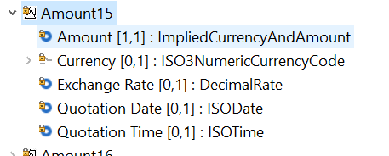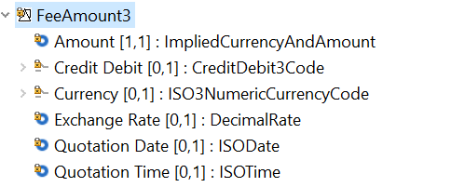
Component Modification
AmountXX | Occurs | Type
Amount | [0..1] | ImpliedCurrencyAndAmount
Currency | [0..1] | ISO3NumericCurrencyCode
Exchange Rate ->Effective Exchange Rate | [0..1] | DecimalRate
Quotation Date -> Conversion Date  Definition: Date and time at which the exchange rate effective. | [0..1] | ISODate
Quotation Time | [0..1] | ISOTime

FeeAmountXX | Occurs | Type
Amount | [0..1] | ImpliedCurrencyAndAmount
Credit Debit | [0..1] | CreditDebit3Code
Currency | [0..1] | ISO3NumericCurrencyCode
Exchange Rate ->Effective Exchange Rate | [0..1] | DecimalRate
Quotation Date -> Conversion Date  Definition: Date and time at which the exchange rate effective. | [0..1] | ISODate
Quotation Time | [0..1] | ISOTime

Impact
Amount15 and FeeAmount3 are used in:
Component Trace Path | Messages
FeeAmount3/AdditionalFee2/Transaction117/AddendumInitiation2 | Addendum Initiation V02 (cain.025.001.02)
FeeAmount3/AdditionalFee2/Transaction117/AddendumResponse2 | Addendum Response V02 (cain.026.001.02)
FeeAmount3/AdditionalFee2/Transaction142/AuthorizationInitiation2  Amount15/TransactionAmounts2/Transaction142/AuthorizationInitiation2 | Authorization Initiation V03 (cain.001.001.03)
FeeAmount3/AdditionalFee2/Transaction119//AuthorizationResponse2  Amount15/TransactionAmounts2/Transaction119/AuthorizationResponse2 | Authorization Response V03 (cain.002.001.03)
FeeAmount3/AdditionalFee2/Transaction114/FinancialnInitiation2  Amount15/TransactionAmounts2/Transaction114/FinancialInitiation2 | Financial Initiation V03 (cain.003.001.03)
FeeAmount3/AdditionalFee2/Transaction119/FinancialnResponse2  Amount15/TransactionAmounts2/Transaction119/FinancialResponse2 | Financial Response V03 (cain.004.001.03)
Amount15/Transaction131/ InquiryInitiation2 | Inquiry Initiation V02 (cain.016.001.02)
Amount15/Transaction131/ InquiryResponse2 | Inquiry Response V02 (cain.017.001.02)
FeeAmount3/AdditionalFee2/Transaction121/CardManagementInitiation2  Amount15/Transaction121/CardManagementInitiation2 | Card Management Initiation V02 (cain.023.001.02)
FeeAmount3/AdditionalFee2/Transaction122/ CardManagementResponse2  Amount15/Transaction121/CardManagementResponse2 | Card ManagementResponse V02 (cain.024.001.02)
FeeAmount3/AdditionalFee2/Transaction142/ReversalInitiation2  Amount15/TransactionAmounts2/Transaction142/AuthorizationResponse2 | Reversal Initiation V03 (cain.005.001.03)
FeeAmount3/AdditionalFee2/Transaction137//ReversalResponse4  Amount15/TransactionAmounts2/Transaction137/ReversalResponse2 | Reversal Response V03 (cain.006.001.03)
FeeAmount3/AdditionalFee2/Transaction116//OriginalTransaction2/ChargebackInitiation2  FeeAmount3/AdditionalFee2/Transaction123/ChargebackInitiation2  Amount15/TransactionAmounts2/Transaction123/ChargebackInitiation2  Amount15/OriginalTransactionAmounts2/Transaction123/ChargebackInitiation2  Amount15/TransactionAmounts2/Transaction116/OriginalTransaction2/ChargebackInitiation2 | Chargeback Initiation V02 (cain.027.001.02)
FeeAmount3/AdditionalFee2/Transaction116/OriginalTransaction2/RetrievalFulfilmentInitiation2  FeeAmount3/AdditionalFee2/Transaction136/RetrievalFulfilmentInitiation2  Amount15/TransactionAmounts2/Transaction116/OriginalTransaction2/RetrievalFulfilmentInitiation2 | Retrieval Fulfilment Initiation V02 (cain.014.001.02)
FeeAmount3/AdditionalFee2/Transaction116/OriginalTransaction2/RetrievalInitiation2  FeeAmount3/AdditionalFee2/Transaction136/RetrievalInitiation2 RetrievalInitiation2  Amount15/TransactionAmounts2/Transaction116/OriginalTransaction2/RetrievalInitiation2 | Retrieval Initiation V02 (cain.021.001.02)
FeeAmount3/AdditionalFee2/Transaction123/ChargebackResponse2  Amount15/TransactionAmounts2/Transaction123/ChargebackResponse2  Amount15/OriginalTransactionAmounts2/Transaction123/ChargebackResponse2 | Chargeback Response V02 (cain.028.001.02)
FeeAmount3/AdditionalFee2/Transaction136/OriginalTransaction2/RetrievalInitiation2RetrievalFulfilmentResponse2 | Retrieval Fulfilment Response V02 (cain.015.001.02)
FeeAmount3/AdditionalFee2/Transaction136/ RetrievalResponse2 | Retrieval Response V02 (cain.022.001.02)
FeeAmount3/AdditionalFee2/Transaction126/ FileActionInitiation2 | File Action Initiation V02 (cafm.001.001.02)
FeeAmount3/AdditionalFee2/Transaction127/ FileActionResponse2 | Retrieval Response V02 (cafm.002.001.02)
FeeAmount3/AdditionalFee2/Transaction125/FeeCollectionInitiation2  Amount15/TransactionAmounts2/Transaction125/FeeCollectionInitiation2  Amount15/OriginalTransactionAmounts2/Transaction125/FeeCollectionInitiation2 | Fee Collection Initiation V02 (cafc.001.001.02)
FeeAmount3/AdditionalFee2/Transaction125/FeeCollectionResponse2  Amount15/TransactionAmounts2/ FeeCollectionResponse2 | Fee Collection Response V02 (cafc.002.001.02)
FeeAmount3/AdditionalFee2/Transaction138/SettlementReportingInitiation2 | Settlement Reporting Initiation V02 (carp.006.001.01)
FeeAmount3/AdditionalFee2/Transaction139/SettlementReportingResponse2 | Settlement Reporting Response V02 (carp.007.001.01)
FeeAmount3/AdditionalFee2/Transaction130/ FraudReportingInitiation2 | Fraud Reporting Initiation V02 (carp.002.001.01)
FeeAmount3/AdditionalFee2/Transaction129/FraudReportingResponse2 | Fraud Reporting Response V02 (carp.003.001.01)
FeeAmount3/AdditionalFee2/Transaction128/FraudDispositionInitiation2 | Fraud Disposition Initiation V02 (carp.004.001.01)
FeeAmount3/AdditionalFee2/Transaction129/ FraudDispositionResponse2 | Fraud Disposition Response V02 (carp.005.001.01)
FeeAmount3/AdditionalFee2/Transaction115/VerificationInitiation2  Amount15/Transaction115/VerificationInitiation2 | Verification Initiation V02 (cain.018.001.02)
FeeAmount3/AdditionalFee2/Transaction140/VerificationResponse2  Amount15/Transaction140/VerificationInitiation2 | Verification Response V02 (cain.019.001.02)
FeeAmount3/AdditionalFee2/Transaction120/BatchManagementInitiation2 | Batch Management Initiation V02 (caad.001.001.02)
FeeAmount3/AdditionalFee2/Transaction120/Context17/ BatchManagementResponse2 | Batch Management Response V02 (caad.002.001.02)
FeeAmount3/AdditionalFee2/Transaction124/Error2 | Error V03 (caad.007.001.03)
FeeAmount3/AdditionalFee2/Transaction135/ReconciliationInitiation2 | Reconciliation Initiation V02 (caad.005.001.02)
FeeAmount3/AdditionalFee2/Transaction135/ReconciliationResponse2 | Reconciliation Response V02 (caad.006.001.02)
SettlementService2/TransactionContext10/Context17/ CustomReport1 | Custom Resport V01 (carp.001.001.01)

CR0979-18: AdditionalIdentification

Description
This change request is to make AdditionalIdentification a repeatable structure

Existing:
- Partyidentification240:
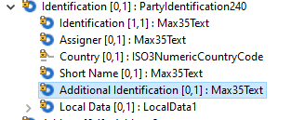
- Partyidentification237:
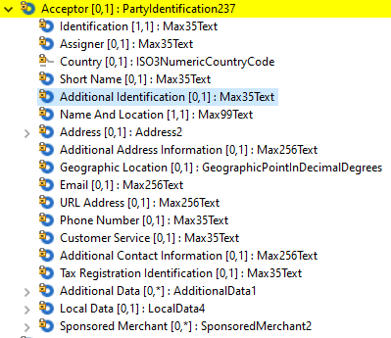
- Partyidentification238:
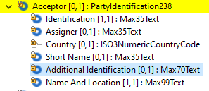

Change:
AdditionalIdentification
Or | MessageElement,<XML Tag> | Mult | Type
 | …
 | AdditionalIdentification<AddtlId> | [0..*] | AdditionalData1
 | …

Impact:
- Partyidentification240:

Message Components | Message Definition
Environment17.PartyIdentification237 | Authorisation Initiation V03
Environment18. .PartyIdentification237 | Card Management Initiation V02
Environment21.PartyIdentification237 | Charge Back Initiation V02
Environment23.PartyIdentification237 | Fee Collection Initiation V02
Environment23.PartyIdentification237 | Fee Collection Response V02
Environment17.PartyIdentification237 | Financial Initiation V03
Environment18.PartyIdentification240  Environment18.Wallet2.PartyIdentification240 | Inquiry Initiation V02
Environment24.PartyIdentification237 | Inquiry Response V02
Environment21.PartyIdentification237 | Retrieval Fulfilment Initiation V02
Environment21.PartyIdentification237 | Retrieval Fulfilment Response V02
Environment21.PartyIdentification237 | Retrieval Initiation V02
Environment21.PartyIdentification237 | Retrieval Response V02
Environment31.PartyIdentification237 | Verification Initiation V02

- Partyidentification237:
Message Components | Message Definition
Environment30.PartyIdentification240  AddendumData3.Invoice2.InvoiceSummary2.PartyIdentification241.PartyIdentification240  AddendumData3.PassengerTransport2.TripLeg2.Ticket2.PartyIdentification240  AddendumData3.VehicleRentalService2.VehicleRentalCompany2.PartyIdentification240  AddendumData3.Lodging3.LodgingSummary2.LodgingProperty2.PartyIdentification240  AddendumData3.ShippingData2.ShippingPackage2.PartyIdentification242.PartyIdentification240  AddendumData3.TemporaryServices2.TemporaryServicesCompany2.PartyIdentification240 | Addendum Initiation V02
Environment30.PartyIdentification240 | Addendum Response V02
Environment17.PartyIdentification240  Environment17.Wallet2.PartyIdentification240  AddendumData3.Invoice2.InvoiceSummary2.PartyIdentification241.PartyIdentification240  AddendumData3.PassengerTransport2.TripLeg2.Ticket2.PartyIdentification240  AddendumData3.VehicleRentalService2.VehicleRentalCompany2.PartyIdentification240  AddendumData3.Lodging3.LodgingSummary2.LodgingProperty2.PartyIdentification240  AddendumData3.ShippingData2.ShippingPackage2.PartyIdentification242.PartyIdentification240  AddendumData3.TemporaryServices2.TemporaryServicesCompany2.PartyIdentification240 | Authorisation Initiation V03
Environment26.PartyIdentification240  Environment26.Wallet2.PartyIdentification240 | Authorisation Response V03
Environment33.PartyIdentification240 | Batch Management Initiation V02
Environment33.PartyIdentification240 | Batch Management Response V02
Environment18.PartyIdentification240  Environment18.Wallet2.PartyIdentification240 | Card Management Initiation V02
Environment25.PartyIdentification240  Environment25.Wallet2.PartyIdentification240 | Card Management Response V02
Environment21.PartyIdentification240 | Charge Back Initiation V02
Environment29.PartyIdentification240 | Charge Back Response V02
Environment33.PartyIdentification240 | Custom Report V01
Environment23.PartyIdentification240 | Fee Collection Initiation V02
Environment23.PartyIdentification240 | Fee Collection Response V02
Environment22.PartyIdentification240  Environment22.Wallet2.PartyIdentification240 | File Action Initiation V02
Environment22.PartyIdentification240  Environment22.Wallet2.PartyIdentification240 | File Action Response V02
Environment17.PartyIdentification240  Environment17.Wallet2.PartyIdentification240  AddendumData3.Invoice2.InvoiceSummary2.PartyIdentification241.PartyIdentification240  AddendumData3.PassengerTransport2.TripLeg2.Ticket2.PartyIdentification240  AddendumData3.VehicleRentalService2.VehicleRentalCompany2.PartyIdentification240  AddendumData3.Lodging3.LodgingSummary2.LodgingProperty2.PartyIdentification240  AddendumData3.ShippingData2.ShippingPackage2.PartyIdentification242.PartyIdentification240  AddendumData3.TemporaryServices2.TemporaryServicesCompany2.PartyIdentification240 | Financial Initiation V03
Environment26.PartyIdentification240  Environment26.Wallet2.PartyIdentification240 | Financial Response V03
Environment28.PartyIdentification240 | Fraud Disposition Initiation V02
Environment28.PartyIdentification240 | Fraud Disposition Response V02
Environment28.PartyIdentification240 | Fraud Reporting Initiation V02
Environment28.PartyIdentification240 | Fraud Reporting Response V02
Environment18.PartyIdentification240  Environment18.Wallet2.PartyIdentification240 | Inquiry Initiation V02
Environment24.PartyIdentification240  Environment24.Wallet2.PartyIdentification240 | Inquiry Response V02
Environment33.PartyIdentification240 | Reconciliation Initiation V03
Environment33.PartyIdentification240 | Reconciliation Response V03
Environment21.PartyIdentification240  Environment21.Wallet2.PartyIdentification240 | Retrieval Fulfilment Initiation V02
Environment21.PartyIdentification240  Environment21.Wallet2.PartyIdentification240 | Retrieval Fulfilment Response V02
Environment21.PartyIdentification240  Environment21.Wallet2.PartyIdentification240 | Retrieval Initiation V02
Environment21.PartyIdentification240  Environment21.Wallet2.PartyIdentification240 | Retrieval Response V02
Environment27.PartyIdentification240  Environment27.Wallet2.PartyIdentification240 | Settlement Reporting Initiation V02
Environment27.PartyIdentification240  Environment27.Wallet2.PartyIdentification240 | Settlement Reporting Response V02
Environment31.PartyIdentification240  Environment31.Wallet2.PartyIdentification240 | Verification Initiation V02
Environment32.PartyIdentification240  Environment32.Wallet2.PartyIdentification240 | Verification Response V02

- Partyidentification238:
Message Components | Message Definition
Environment25.PartyIdentification238 | Card Management Response V02

CR0979-19: Sales Context Enhancement

Description
This change is to add the "AdditionalData" container to SalesContext7 structures to allow a user of ISO 20022 to capture additional data.
Current Component
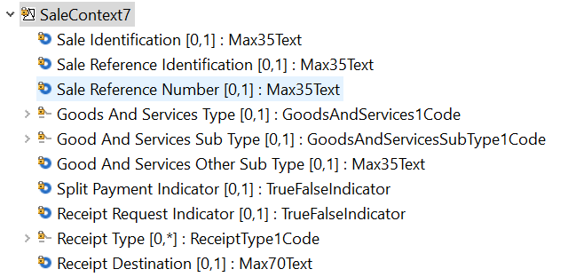
Component Modification
SaleContextXX | Occurs | Type
Sale Identification | [0..1] | Max35Text
….
Receipt Destination | [0..1] | Max70text
Additional Data | [0..*] | AdditionalData1

Impacts
SaleContext7 is used
Component Trace Path | Messages
SaleContext7/Context10/AuthorizationInitiation2 | Authorization Initiation V03 (cain.001.001.03)
SaleContext7/Context10/FinancialnInitiation2 | Financial Initiation V03 (cain.003.001.03)
SaleContext7//Context12/OrginalTransaction2/RetrievalFulfilmentInitiation2  SaleContext7//Context15/RetrievalFulfilmentInitiation2 | Retrieval Fulfilment Initiation V02 (cain.014.001.02)
SaleContext7//Context15/RetrievalFulfilmentResponse2 | Retrieval Fulfilment Response V02 (cain.015.001.02)
SaleContext7/Context12/OrginalTransaction2/RetrievalInitiation2  SaleContext7//Context15/RetrievalInitiation2 | Retrieval Initiation V02 (cain.021.001.02)
SaleContext7//Context15/RetrievalResponse2 | Retrieval Response V02 (cain.022.001.02)
SaleContext7/Context12/OrginalTransaction2/ChargebackInitiation2 | Chargeback Initiation V02 (cain.027.001.02)

CR0979-20: Alternate Message Reason Structure

Description
Add the description field to Alternate Message Reason which used in transaction component of message body
Current component (only use Transaction142 as example)
Component Modification
Alternate Message Reason | [0..*] | AlternateMessonReason1
Code | [0..1] | Max35Text
Description | [0..1] | Max256text

Impact
Component Trace Path | Messages
AlternateMessageReason/Transaction142/AuthorizationInitiation2 | Authorization Initiation V03 (cain.001.001.03)
AlternateMessageReason/Transaction114/FinancialnInitiation2 | Financial Initiation V03 (cain.003.001.03)
AlternateMessageReason/Transaction119/FinancialnResponse2 | Financial Response V03 (cain.004.001.03)
AlternateMessageReason/Transaction131/InquiryInitiation2 | Inquiry Initiation V02 (cain.016.001.02)
AlternateMessageReason/Transaction121/CardManagementInitiation2 | Card Management Initiation V02 (cain.023.001.02)
AlternateMessageReason/Transaction133/KeyExchangeInitiation2 | Key Exchange Initiation V03 (cain.003.001.03)
AlternateMessageReason/Transaction133/KeyExchangeResponse2 | Key Exchange Response V03 (cain.004.001.03)
AlternateMessageReason/Transaction134/NetworkManagementInitiation2 | Network Management Initiation V03 (cain.001.001.03)
AlternateMessageReason/Transaction133/KeyExchangeResponse2 | Key Exchange Response V03 (canm.002.001.03)
AlternateMessageReason/Transaction142/ReversalInitiation2 | Reversal Initiation V03 (cain.005.001.03)
AlternateMessageReason/Transaction137/ReversalResponse4 | Reversal Response V03 (cain.006.001.03)
AlternateMessageReason/Transaction123/ChargebackInitiation2 | Chargeback Initiation V02 (cain.027.001.02)
AlternateMessageReason/Transaction136/RetrievalFulfilmentInitiation2 | Retrieval Fulfilment Initiation V02 (cain.014.001.02)
AlternateMessageReason/Transaction136/ RetrievalInitiation2 | Retrieval Initiation V02 (cain.021.001.02)
AlternateMessageReason/Transaction123/ ChargebackResponse2 | Chargeback Response V02 (cain.028.001.02)
AlternateMessageReason/Transaction136/RetrievalFulfilmentResponse2 | Retrieval Fulfilment Response V02 (cain.015.001.02)
AlternateMessageReason/Transaction136/RetrievalResponse2 | Retrieval Response V02 (cain.022.001.02)
AlternateMessageReason/Transaction126/ FileActionInitiation2 | File Action Initiation V02 (cafm.001.001.02)
AlternateMessageReason/Transaction125/ FeeCollectionInitiation2 | Fee Collection Initiation V02 (cafc.001.001.02)
AlternateMessageReason/Transaction125/FeeCollectionResponse2 | Fee Collection Response V02 (cafc.002.001.02)
AlternateMessageReason/Transaction138/SettlementReportingInitiation2 | Settlement Reporting Initiation V02 (carp.006.001.01)
AlternateMessageReason/Transaction115/ VerificationInitiation2 | Verification Initiation V02 (cain.018.001.02)
AlternateMessageReason/Transaction140/ VerificationResponse2 | Verification Response V02 (cain.019.001.02)

CR0979-21: ISOResponseCode

Description
ISOResponseCode is replaced in ResultData1 component, the actual incorrect format is Exact2AplhaNumericText.

Component modification
Message Root | Occurs | Type
AddendumResponseV02V03 | [1..1]
Body | [1..1] | AddendumResponse23
ProcessingResult | [0..1] | ProcessingResult14  ProcessingResultXX
ResultData | [0..1] | ResultData10
Original Result Data | [0..1] | ResultData1  ResultDataX
Result | [0..1] | Response8Code
Other Result | [0..1] | Max35Text
Result Details | [1..1] | Exact2AlphaNumericText  ISOResponseCode
Other Result Details | [0..1] | Max35Text
Additional Result Information | [0..1] | AdditionalData1
AdditionalInformation | [0..*] | AdditionalInformation22

Message Root | Occurs | Type
AuthorisationInitiation V03V04 | [1..1]
Body | [1..1] | AuthorisationInitiation43
ProcessingResult | [0..1] | ProcessingResult9  ProcessingResultXX
ApprovalData | [0..1] | ApprovalData1
ResultData | [0..1] | ResultData7
Original Result Data | [0..1] | ResultData1  ResultDataX
Result | [0..1] | Response8Code
Other Result | [0..1] | Max35Text
Result Details | [1..1] | Exact2AlphaNumericText  ISOResponseCode
Other Result Details | [0..1] | Max35Text
Additional Result Information | [0..1] | AdditionalData1
ActionRequired | [0..1] | YesNoIndicator
Action | [0..*] | Action11
AdditionalAction | [0..*] | AdditionalAction1
AdditionalInformation | [0..*] | AdditionalInformation20

Message Root | Occurs | Type
AuthorisationResponse V03V04 | [1..1]
Body | [1..1] | AuthorisationResponse4
ProcessingResult | [1..1] | ProcessingResult10  ProcessingResultXX
ApprovalData | [0..1] | ApprovalData1
ResultData | [0..1] | ResultData7
Original Result Data | [0..1] | ResultData1  ResultDataX
Result | [0..1] | Response8Code
Other Result | [0..1] | Max35Text
Result Details | [1..1] | Exact2AlphaNumericText  ISOResponseCode
Other Result Details | [0..1] | Max35Text
Additional Result Information | [0..1] | AdditionalData1
ActionRequired | [0..1] | YesNoIndicator
Action | [0..*] | Action11
AdditionalAction | [0..*] | AdditionalAction1
AdditionalInformation | [0..*] | AdditionalInformation20

Message Root | Occurs | Type
BatchManagementResponse V02V03 | [1..1]
Body | [1..1] | BatchManagementResponse23
ProcessingResult | [0..1] | ProcessingResult13  ProcessingResultXX
ResultData | [0..1] | ResultData8
Original Result Data | [0..1] | ResultData1  ResultDataX
Result | [0..1] | Response8Code
Other Result | [0..1] | Max35Text
Result Details | [1..1] | Exact2AlphaNumericText  ISOResponseCode
Other Result Details | [0..1] | Max35Text
Additional Result Information | [0..1] | AdditionalData1

Message Root | Occurs | Type
BatchTransferInitiationV03 | [1..1]
Body | [1..1] | BatchTransferInitiation23
ProcessingResult | [0..1] | ProcessingResult13  ProcessingResultXX
ResultData | [0..1] | ResultData8
Original Result Data | [0..1] | ResultData1  ResultDataX
Result | [0..1] | Response8Code
Other Result | [0..1] | Max35Text
Result Details | [1..1] | Exact2AlphaNumericText  ISOResponseCode
Other Result Details | [0..1] | Max35Text
Additional Result Information | [0..1] | AdditionalData1

Message Root | Occurs | Type
BatchTransferResponse V02V03 | [1..1]
Body | [1..1] | BatchTransferResponse23
ProcessingResult | [0..1] | ProcessingResult13  ProcessingResultXX
ResultData | [0..1] | ResultData8
Original Result Data | [0..1] | ResultData1  ResultDataX
Result | [0..1] | Response8Code
Other Result | [0..1] | Max35Text
Result Details | [1..1] | Exact2AlphaNumericText  ISOResponseCode
Other Result Details | [0..1] | Max35Text
Additional Result Information | [0..1] | AdditionalData1

Message Root | Occurs | Type
CardManagementInitiation V02V03 | [1..1]
Body | [1..1] | CardManagementInitiation23
ProcessingResult | [0..1] | ProcessingResult9  ProcessingResultXX
ApprovalData | [0..1] | ApprovalData1
ResultData | [0..1] | ResultData7
Original Result Data | [0..1] | ResultData1  ResultDataX
Result | [0..1] | Response8Code
Other Result | [0..1] | Max35Text
Result Details | [1..1] | Exact2AlphaNumericText  ISOResponseCode
Other Result Details | [0..1] | Max35Text
Additional Result Information | [0..1] | AdditionalData1
ActionRequired | [0..1] | YesNoIndicator
Action | [0..*] | Action11
AdditionalAction | [0..*] | AdditionalAction1
AdditionalInformation | [0..*] | AdditionalInformation20

Message Root | Occurs | Type
CardManagementResponseV02V03 | [1..1]
Body | [1..1] | CardManagementResponse23
ProcessingResult | [0..1] | ProcessingResult9  ProcessingResultXX
ApprovalData | [0..1] | ApprovalData1
ResultData | [0..1] | ResultData7
Original Result Data | [0..1] | ResultData1  ResultDataX
Result | [0..1] | Response8Code
Other Result | [0..1] | Max35Text
Result Details | [1..1] | Exact2AlphaNumericText  ISOResponseCode
Other Result Details | [0..1] | Max35Text
Additional Result Information | [0..1] | AdditionalData1
ActionRequired | [0..1] | YesNoIndicator
Action | [0..*] | Action11
AdditionalAction | [0..*] | AdditionalAction1
AdditionalInformation | [0..*] | AdditionalInformation20

Message Root | Occurs | Type
ChargeBackInitiation V02V03 | [1..1]
Body | [1..1] | ChargeBackInitiation23
OriginalTransaction | [1..1] | OriginalTransaction2  OriginalTransactionX
Environment | [0..1] | Environment20
Context | [0..1] | Context12
Transaction | [0..1] | Transaction116
ProcessingResult | [0..1] | ProcessingResult10  ProcessingResultXX
ApprovalData | [0..1] | ApprovalData1
ResultData | [0..1] | ResultData7
OriginalResultData | [0..1] | ResultData1  ResultDataX
Result | [0..1] | Response8Code
Other Result | [0..1] | Max35Text
Result Details | [1..1] | Exact2AlphaNumericText  ISOResponseCode
Additional Result Information | [0..*] | AdditionalData1
ActionRequired | [0..1] | YesNoIndicator
Action | [0..*] | Action11
AdditionalAction | [0..*] | AdditionalAction 1
AdditionalResultInformation | [0..*] | AdditionalInformation20
ProcessingResult | [0..1] | ProcessingResult8  ProcessingResultXX
Result Data | [0..1] | ResultData1  ResultDataX
Result | [0..1] | Response8Code
Other Result | [0..1] | Max35Text
Result Details | [1..1] | Exact2AlphaNumericText  ISOResponseCode
Other Result Details | [0..1] | Max35Text
Additional Result Information | [0..*] | AdditionalData1
AdditionalInformation | [0..*] | AdditionalInformation20

Message Root | Occurs | Type
ChargeBackResponse V02V03 | [1..1]
Body | [1..1] | ChargeBackResponse23
ProcessingResult | [0..1] | ProcessingResult7  ProcessingResultXX
Result Data | [0..1] | ResultData1  ResultDataX
Result | [0..1] | Response8Code
Other Result | [0..1] | Max35Text
Result Details | [1..1] | Exact2AlphaNumericText  ISOResponseCode
Other Result Details | [0..1] | Max35Text
Additional Result Information | [0..*] | AdditionalData1
Original Result Data | [0..1] | ResultData1  ResultDataX
Result | [0..1] | Response8Code
Other Result | [0..1] | Max35Text
Result Details | [1..1] | Exact2AlphaNumericText  ISOResponseCode
Other Result Details | [0..1] | Max35Text
Additional Result Information | [0..*] | AdditionalData1
AdditionalInformation | [0..*] | AdditionalInformation20

Message Root | Occurs | Type
FeeCollectionInitiation V02V03 | [1..1]
Body | [1..1] | FeeCollectionInitiation23
ProcessingResult | [0..1] | ProcessingResult14  ProcessingResultXX
ResultData | [0..1] | ResultData10
OriginalResultData | [0..1] | ResultData1  ResultDataX
Result | [0..1] | Response8Code
Other Result | [0..1] | Max35Text
Result Details | [1..1] | Exact2AlphaNumericText  ISOResponseCode
Other Result Details | [0..1] | Max35Text
Additional Result Information | [0..*] | AdditionalData1
AdditionalInformation | [0..*] | AdditionalInformation22

Message Root | Occurs | Type
FeeCollectionResponse V02V03 | [1..1]
Body | [1..1] | FeeCollectionResponse23
ProcessingResult | [0..1] | ProcessingResult14  ProcessingResultXX
ResultData | [0..1] | ResultData10
OriginalResultData | [0..1] | ResultData1  ResultDataX
Result | [0..1] | Response8Code
Other Result | [0..1] | Max35Text
Result Details | [1..1] | Exact2AlphaNumericText  ISOResponseCode
Other Result Details | [0..1] | Max35Text
Additional Result Information | [0..*] | AdditionalData1
AdditionalInformation | [0..*] | AdditionalInformation22

Message Root | Occurs | Type
FinancialInitiation V03V04 | [1..1]
Body | [1..1] | FinancialInitiation23
ProcessingResult | [0..1] | ProcessingResult9  ProcessingResultXX
ApprovalData | [0..1] | ApprovalData1
ResultData | [0..1] | ResultData7
OriginalResultData | [0..1] | ResultData1  ResultDataX
Result | [0..1] | Response8Code
Other Result | [0..1] | Max35Text
Result Details | [1..1] | Exact2AlphaNumericText  ISOResponseCode
Other Result Details | [0..1] | Max35Text
Additional Result Information | [0..*] | AdditionalData1
ActionRequired | [0..1] | YesNoIndicator
Action | [0..*] | Action11
AdditionalAction | [0..*] | AdditionalAction1
AdditionalInformation | [0..*] | AdditionalInformation20

Message Root | Occurs | Type
FinancialResponse V03V04 | [1..1]
Body | [1..1] | FinancialResponse34
ProcessingResult | [1..1] | ProcessingResult10  ProcessingResultXX
ApprovalData | [0..1] | ApprovalData1
ResultData | [0..1] | ResultData7
OriginalResultData | [0..1] | ResultData1  ResultDataX
Result | [0..1] | Response8Code
Other Result | [0..1] | Max35Text
Result Details | [1..1] | Exact2AlphaNumericText  ISOResponseCode
Other Result Details | [0..1] | Max35Text
Additional Result Information | [0..*] | AdditionalData1
ActionRequired | [0..1] | YesNoIndicator
Action | [0..*] | Action11
AdditionalAction | [0..*] | AdditionalAction1
AdditionalInformation | [0..*] | AdditionalInformation20

Message Root | Occurs | Type
FraudDispositionResponse V02V03 | [1..1]
Body | [1..1] | FraudDispositionResponse23
ProcessingResult | [0..1] | ProcessingResult14  ProcessingResultXX
ResultData | [0..1] | ResultData10
OriginalResultData | [0..1] | ResultData1  ResultDataX
Result | [0..1] | Response8Code
Other Result | [0..1] | Max35Text
Result Details | [1..1] | Exact2AlphaNumericText  ISOResponseCode
Other Result Details | [0..1] | Max35Text
Additional Result Information | [0..*] | AdditionalData1
AdditionalInformation | [0..*] | AdditionalInformation22

Message Root | Occurs | Type
FraudReportingResponse V02V03 | [1..1]
Body | [1..1] | FraudReportingResponse23
ProcessingResult | [0..1] | ProcessingResult14  ProcessingResultXX
ResultData | [0..1] | ResultData10
OriginalResultData | [0..1] | ResultData1  ResultDataX
Result | [0..1] | Response8Code
Other Result | [0..1] | Max35Text
Result Details | [1..1] | Exact2AlphaNumericText  ISOResponseCode
Other Result Details | [0..1] | Max35Text
Additional Result Information | [0..*] | AdditionalData1
AdditionalInformation | [0..*] | AdditionalInformation22

Message Root | Occurs | Type
InquiryInitiationV02V03 | [1..1]
Body | [1..1] | InquiryInitiation23
ProcessingResult | [0..1] | ProcessingResult11  ProcessingResultXX
ResultData | [0..1] | ResultData7
OriginalResultData | [0..1] | ResultData1  ResultDataX
Result | [0..1] | Response8Code
Other Result | [0..1] | Max35Text
Result Details | [1..1] | Exact2AlphaNumericText  ISOResponseCode
Other Result Details | [0..1] | Max35Text
Additional Result Information | [0..*] | AdditionalData1
ActionRequired | [0..1] | YesNoIndicator
Action | [0..*] | Action11
AdditionalAction | [0..*] | AdditionalAction1
AdditionalInformation | [0..*] | AdditionalInformation20

Message Root | Occurs | Type
InquiryResponse V02V03 | [1..1]
Body | [1..1] | InquiryResponse23
ProcessingResult | [0..1] | ProcessingResult11  ProcessingResultXX
ResultData | [0..1] | ResultData7
OriginalResultData | [0..1] | ResultData1  ResultDataX
Result | [0..1] | Response8Code
Other Result | [0..1] | Max35Text
Result Details | [1..1] | Exact2AlphaNumericText  ISOResponseCode
Other Result Details | [0..1] | Max35Text
Additional Result Information | [0..*] | AdditionalData1
ActionRequired | [0..1] | YesNoIndicator
Action | [0..*] | Action11
AdditionalAction | [0..*] | AdditionalAction1
AdditionalInformation | [0..*] | AdditionalInformation20

Message Root | Occurs | Type
KeyExchangeResponse V03V04 | [1..1]
Body | [1..1] | KeyExchangeResponse23
ProcessingResult | [0..1] | ProcessingResult14  ProcessingResultXX
ResultData | [0..1] | ResultData10
OriginalResultData | [0..1] | ResultData1  ResultDataX
Result | [0..1] | Response8Code
Other Result | [0..1] | Max35Text
Result Details | [1..1] | Exact2AlphaNumericText  ISOResponseCode
Other Result Details | [0..1] | Max35Text
Additional Result Information | [0..*] | AdditionalData1
AdditionalInformation | [0..*] | AdditionalInformation22

Message Root | Occurs | Type
NetworkManagementInitiation V03V04 | [1..1]
Body | [1..1] | NetworkManagementInitiation44
ProcessingResult | [0..1] | ProcessingResult9  ProcessingResultXX
ApprovalData | [0..1] | ApprovalData1
ResultData | [0..1] | ResultData7
OriginalResultData | [0..1] | ResultData1  ResultDataX
Result | [0..1] | Response8Code
Other Result | [0..1] | Max35Text
Result Details | [1..1] | Exact2AlphaNumericText  ISOResponseCode
Other Result Details | [0..1] | Max35Text
Additional Result Information | [0..*] | AdditionalData1
ActionRequired | [0..1] | YesNoIndicator
Action | [0..*] | Action11
AdditionalAction | [0..*] | AdditionalAction1
AdditionalInformation | [0..*] | AdditionalInformation20

Message Root | Occurs | Type
NetworkManagementResponse V03V04 | [1..1]
Body | [1..1] | NetworkManagementResponse23
ProcessingResult | [0..1] | ProcessingResult9  ProcessingResultXX
ApprovalData | [0..1] | ApprovalData1
ResultData | [0..1] | ResultData7
OriginalResultData | [0..1] | ResultData1  ResultDataX
Result | [0..1] | Response8Code
Other Result | [0..1] | Max35Text
Result Details | [1..1] | Exact2AlphaNumericText  ISOResponseCode
Other Result Details | [0..1] | Max35Text
Additional Result Information | [0..*] | AdditionalData1
ActionRequired | [0..1] | YesNoIndicator
Action | [0..*] | Action11
AdditionalAction | [0..*] | AdditionalAction1
AdditionalInformation | [0..*] | AdditionalInformation20

Message Root | Occurs | Type
ReconciliationResponse V03V04 | [1..1]
Body | [1..1] | ReconciliationResponse34
ProcessingResult | [0..1] | ProcessingResult14  ProcessingResultXX
ResultData | [0..1] | ResultData10
OriginalResultData | [0..1] | ResultData1  ResultDataX
Result | [0..1] | Response8Code
Other Result | [0..1] | Max35Text
Result Details | [1..1] | Exact2AlphaNumericText  ISOResponseCode
Other Result Details | [0..1] | Max35Text
Additional Result Information | [0..*] | AdditionalData1
AdditionalInformation | [0..*] | AdditionalInformation22

Message Root | Occurs | Type
RetrievalFulfilmentInitiation V02V03 | [1..1]
Body | [1..1] | RetrievalFulfilmentInitiation23
OriginalTransaction | [0..1] | OriginalTransaction2  OriginalTransactionX
… | … | …
ProcessingResult | [0..1] | ProcessingResult10  ProcessingResultXX
ApprovalData | [0..1] | ApprovalData1
ResultData | [0..1] | ResultData7
Original Result Data | [0..1] | ResultData1  ResultDataX
Result | [0..1] | Response8Code
Other Result | [0..1] | Max35Text
Result Details | [1..1] | Exact2AlphaNumericText  ISOResponseCode
Other Result Details | [0..1] | Max35Text
Additional Result Information | [0..1] | AdditionalData1
ActionRequired | [0..1] | YesNoIndicator
Action | [0..*] | Action11
AdditionalAction | [0..*] | AdditionalAction1
AdditionalInformation | [0..*] | AdditionalInformation20

Message Root | Occurs | Type
RetrievalFulfilmentResponse V02V03 | [1..1]
Body | [1..1] | RetrievalFulfilmentResponse23
ProcessingResult | [0..1] | ProcessingResult14  ProcessingResultXX
ResultData | [0..1] | ResultData10
OriginalResultData | [0..1] | ResultData1  ResultDataX
AdditionalInformation | [0..*] | AdditionalInformation22
Result | [0..1] | Response8Code
Other Result | [0..1] | Max35Text
Result Details | [1..1] | Exact2AlphaNumericText  ISOResponseCode
Other Result Details | [0..1] | Max35Text
Additional Result Information | [0..1] | AdditionalData1

Message Root | Occurs | Type
RetrievalInitiation V02V03 | [1..1]
Body | [1..1] | RetrievalInitiation23
OriginalTransaction | [0..1] | OriginalTransaction2  OriginalTransactionX
… | … | …
ProcessingResult | [0..1] | ProcessingResult10  ProcessingResultXX
ApprovalData | [0..1] | ApprovalData1
ResultData | [0..1] | ResultData7
Original Result Data | [0..1] | ResultData1  ResultDataX
Result | [0..1] | Response8Code
Other Result | [0..1] | Max35Text
Result Details | [1..1] | Exact2AlphaNumericText  ISOResponseCode
Other Result Details | [0..1] | Max35Text
Additional Result Information | [0..1] | AdditionalData1
ActionRequired | [0..1] | YesNoIndicator
Action | [0..*] | Action11
AdditionalAction | [0..*] | AdditionalAction1
AdditionalInformation | [0..*] | AdditionalInformation20

RetrievalResponse V02V03 | [1..1]
Body | [1..1] | RetrievalResponse23
ProcessingResult | [0..1] | ProcessingResult14  ProcessingResultXX
ResultData | [0..1] | ResultData10
OriginalResultData | [0..1] | ResultData1  ResultDataX
Result | [0..1] | Response8Code
Other Result | [0..1] | Max35Text
Result Details | [1..1] | Exact2AlphaNumericText  ISOResponseCode
Other Result Details | [0..1] | Max35Text
Additional Result Information | [0..1] | AdditionalData1
AdditionalInformation | [0..*] | AdditionalInformation22

Message Root | Occurs | Type
ReversalInitiation V03V04 | [1..1]
Body | [1..1] | ReversalInitiation34
ProcessingResult | [0..1] | ProcessingResult9  ProcessingResultXX
ApprovalData | [0..1] | ApprovalData1
ResultData | [0..1] | ResultData7
OriginalResultData | [0..1] | ResultData1  ResultDataX
Result | [0..1] | Response8Code
Other Result | [0..1] | Max35Text
Result Details | [1..1] | Exact2AlphaNumericText  ISOResponseCode
Other Result Details | [0..1] | Max35Text
Additional Result Information | [0..*] | AdditionalData1
ActionRequired | [0..1] | YesNoIndicator
Action | [0..*] | Action11
AdditionalAction | [0..*] | AdditionalAction1
AdditionalInformation | [0..*] | AdditionalInformation20

Message Root | Occurs | Type
ReversalResponse V03V04 | [1..1]
Body | [1..1] | ReversalResponse34
ProcessingResult | [1..1] | ProcessingResult10  ProcessingResultXX
ApprovalData | [0..1] | ApprovalData1
ResultData | [0..1] | ResultData7
OriginalResultData | [0..1] | ResultData1  ResultDataX
Result | [0..1] | Response8Code
Other Result | [0..1] | Max35Text
Result Details | [1..1] | Exact2AlphaNumericText  ISOResponseCode
Other Result Details | [0..1] | Max35Text
Additional Result Information | [0..*] | AdditionalData1
ActionRequired | [0..1] | YesNoIndicator
Action | [0..*] | Action11
AdditionalAction | [0..*] | AdditionalAction1
AdditionalInformation | [0..*] | AdditionalInformation20

Message Root | Occurs | Type
SettlementReportingResponse V02V03 | [1..1]
Body | [1..1] | SettlementReportingResponse23
ProcessingResult | [0..1] | ProcessingResult13  ProcessingResultXX
ResultData | [0..1] | ResultData8
OriginalResultData | [0..1] | ResultData1  ResultDataX
Result | [0..1] | Response8Code
Other Result | [0..1] | Max35Text
Result Details | [1..1] | Exact2AlphaNumericText  ISOResponseCode
Other Result Details | [0..1] | Max35Text
Additional Result Information | [0..*] | AdditionalData1

Impacts

  - AddendumResponseV02 (cain.026.001.02)
  - AuthorisationInitiationV03 (cain.001.001.03)
  - AuthorisationResponseV03 (cain.002.001.03)
  - BatchManagementResponseV02 (caad.002.001.02)
  - BatchTransferInitiationV02 (caad.003.001.02)
  - BatchTransferResponseV02 (caad.004.001.02)
  - CardManagementInitiationV02 (cain.023.001.02)
  - CardManagementResponseV02 (cain.024.001.02)
  - ChargeBackInitiationV02 (cain.027.001.02)
  - ChargeBackResponseV02 (cain.028.001.02)
  - FeeCollectionInitiationV02 (cafc.001.001.02)
  - FeeCollectionResponseV02 (cafc.002.001.02)
  - FinancialInitiationV03 (cain.003.001.03)
  - FinancialResponseV03 (cain.004.001.03)
  - FraudDispositionResponseV02 (carp.005.001.01)
  - FraudReportingResponseV02 (carp.003.001.01)
  - InquiryInitiationV02 (cain.016.001.02)
  - InquiryResponseV02 (cain.017.001.02)
  - KeyExchangeResponseV03 (canm.004.001.03)
  - NetworkManagementInitiationV03 (canm.001.001.03)
  - NetworkManagementResponseV03 (canm.002.001.03)
  - ReconciliationResponseV03 (caad.006.001.03)
  - RetrievalFulfilmentInitiationV02 (cain.014.001.02)
  - RetrievalFulfilmentResponseV02 (cain.015.001.02)
  - RetrievalInitiationV02 (cain.021.001.02)
  - RetrievalResponseV02 (cain.022.001.02)
  - ReversalInitiationV03 (cain.005.001.03)
  - ReversalResponseV03 (cain.006.001.03)
  - SettlementReportingResponseV02 (carp.007.001.01)

Message Definition | Message Components
AddendumResponseV02 | AddendumResponse2.ProcessingResult14.ResultData1
AuthorisationInitiationV03 | AuthorisationInitiation2.ProcessingResult9.ResultData1
AuthorisationResponseV03 | AuthorisationResponse2.ProcessingResult10.ResultData1
BatchManagementResponseV02 | ProcessingResult13.ResultData1
BatchTransferInitiationV02 | ProcessingResult13.ResultData1
BatchTransferResponseV02 | ProcessingResult13.ResultData1
CardManagementInitiationV02 | ProcessingResult9.ResultData1
CardManagementResponseV02 | ProcessingResult9.ResultData1
ChargeBackInitiationV02 | ProcessingResult7.ResultData1  ResultData1
ChargeBackResponseV02
FeeCollectionInitiationV02
FeeCollectionResponseV02
FinancialInitiationV03
FinancialResponseV03
FraudDispositionResponseV02
FraudReportingResponseV02
InquiryInitiationV02
InquiryResponseV02
KeyExchangeResponseV03
NetworkManagementInitiationV03
NetworkManagementResponseV03
ReconciliationResponseV03
RetrievalFulfilmentInitiationV02
RetrievalFulfilmentResponseV02
RetrievalInitiationV02
RetrievalResponseV02
ReversalInitiationV03
ReversalResponseV03
SettlementReportingResponseV02

ATICA MCR-V4 CR0981 – Enhancement-Fields
for the update of ISO 20022 financial repository items
Note: the purpose of this document is to give guidelines to parties who want to introduce a request to change an existing ISO 20022 message(s), or update other items of the ISO 20022 financial repository. Such change requests are subject to the approval of the ISO 20022 Standards Evaluation Group(s) in charge of the related message/item or to the approval of the Technical Support Group (TSG), if the requested change relates to the Business Application Header (BAH). Please consult the iso20022.org website for additional details on the maintenance process. Change requests are to be sent to iso20022ra@iso20022.org. All change requests conforming to this template received by June 1st will be considered for development in the following yearly ISO 20022 maintenance cycle which completes with publication of new message versions in April/May of the following year.
- Origin of the request:
A.1 Submitter: ISO TC68/SC9/TG1
A.2 Contact person:
Douglas Frantz
DFrantz@visa.com
+1 (650) 432-4591
A.3 Sponsors: ISO TC68/SC9/TG1
- Related messages:
caad.001.001.02 BatchManagementInitiationV02
caad.002.001.02 BatchManagementResponseV02
caad.003.001.01 BatchTransferInitiationV01
caad.004.001.01 BatchTransferResponseV01
caad.005.001.03 ReconciliationInitiationV03
caad.006.001.03 ReconciliationResponseV03
caad.007.001.03 ErrorV03
cafc.001.001.02 FeeCollectionInitiationV02
cafc.002.001.02 FeeCollectionResponseV02
cafm.001.001.02 FileActionInitiationV02
cafm.002.001.02 FileActionResponseV02
cafr.001.001.02 FraudReportingInitiationV02
cafr.002.001.02 FraudReportingResponseV02
cafr.003.001.02 FraudDispositionInitiationV02
cafr.004.001.02 FraudDispositionResponseV02
cain.001.001.03 AuthorisationInitiationV03
cain.002.001.03 AuthorisationResponseV03
cain.003.001.03 FinancialInitiationV03
cain.004.001.03 FinancialResponseV03
cain.005.001.03 ReversalInitiationV03
cain.006.001.03 ReversalResponseV03
cain.014.001.02 RetrievalFulfilmentInitiationV02
cain.015.001.02 RetrievalFulfilmentResponseV02
cain.016.001.02 InquiryInitiationV02
cain.017.001.02 InquiryResponseV02
cain.018.001.02 VerificationInitiationV02
cain.019.001.02 VerificationResponseV02
cain.020.001.01 AmendmentV01
cain.021.001.02 RetrievalInitiationV02
cain.022.001.02 RetrievalResponseV02
cain.023.001.02 CardManagementInitiationV02
cain.024.001.02 CardManagementResponseV02
cain.025.001.02 AddendumInitiationV02
cain.026.001.02 AddendumResponseV02
cain.027.001.02 ChargeBackInitiationV02
cain.028.001.02 ChargeBackResponseV02
canm.001.001.03 NetworkManagementInitiationV03
canm.002.001.03 NetworkManagementResponseV03
canm.003.001.03 KeyExchangeInitiationV03
canm.004.001.03 KeyExchangeResponseV03
casr.001.001.02 SettlementReportingInitiationV02
casr.002.001.02 SettlementReportingResponseV02

.
- Description of the change request:

The following changes provide additional functionality to the ISO 20022 ATICA standard by introducing new codes, updating existing message structures, and existing data elements.

This change request provides message level support which is currently in use in the market as the current ATICA standard only provides batch or file support.

1). Create amount structure to capture healthcare specific details such as healthcare amount, prescription amount, etc.). Healthcare details are used in the market today and have regulatory implications that require more descriptive information.

Example: Additional codes are necessary for different types of healthcare specific amounts such as:
1. Healthcare Amount
2. Prescription Amount
3. Vision Rx Amount
4. Clinic/Other Medical Amount
5. Dental Amount
6. Co-payment Amount

2). Enhance existing message structure to provide additional details in the response for error messaging and processing entity. This enhancement will provide an implementor to send error details in a consistent manner as used in the market today. This provides flexibility for an implementor.

Example: Inclusion of additional data elements within existing response messages.

3). Update the current country codes field to use ISO 3166 format for 2- or 3-character alpha code only. Change datatype to (Min2max3alphatext).

- Purpose of the change:
These changes include corrections to support existing and evolving business practices, payment methods and services, inclusion of additional data to support these processes, regulatory requirements and compatibility with existing standards and implementations.
The card industry is evolving rapidly. These changes will enhance the ATICA message set to better support use of ISO 20022 ATICA messages within the card industry.
- Urgency of the request:
Normal Maintenance Cycle
- Business examples:
- Field type change for an existing data element.
  - Change data type for ISO 3166 alpha country codes.
- Enhance existing message structures.
  - Add error and processor detail.
- Create amount codes for Healthcare specific amount types.
- SEG/TSG recommendation:
This section is not to be taken care of by the submitter of the change request. It will be completed in due time by the SEG(s) in charge of the related ISO 20022 messages or the TSG for changes related to the BAH.

Consider |  |  | Timing
- Next yearly cycle: 2021/2022
(the change will be considered for implementation in the yearly maintenance cycle which starts in 2021 and completes with the publication of new message versions in the spring of 2022)
- At the occasion of the next maintenance of the messages
(the change will be considered for implementation, but does not justify maintenance of the messages in its own right – will be pending until more critical change requests are received for the messages)
- Urgent unscheduled
(the change justifies an urgent implementation outside of the normal yearly cycle)
 |  |  | - Other timing:
Comments:

Reject
Reason for rejection:

CR0981-1: CardProgrammeApplied add additional identification
Update CardProgrammeApplied to permit additional identification which has one or many elements

Existing component
Existing CardProgrammeMode1 component:

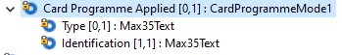

Component modification
Modified component of CardProgrammeMode1
Card Programme Applied | Occurs | Type
Type | [0..1] | Max35Text
Identification | [0..1] | Max35Text
Additional Identification | [0..*] | AdditionalData1

Impacts
- CardProgrammeMode1 component used in
Message Definition | Message Components
Addendum Initiation V02 | AddendumInitaition2.Context17.  TransactionContext10.CardProgrammeMode1
Addendum Response V02 | AddendumResponse2.Context17.  TransactionContext10.CardProgrammeMode1
Amendment V01 | Amendment1.Context6.  TransactionContext6.CardProgrammeMode1
Authorisation Initiation V03 | AuthorisationInitiation2.Context10.  TransactionContext7.CardProgrammeMode1
Authorisation Response V03 | AuthorisationResponse2.Context13.  TransactionContext8.CardProgrammeMode1
Batch Management Initiation V02 | BatchManagementIntiation2.Context17.  TransactionContext10.CardProgrammeMode1
Batch Management Response V02 | BatchManagementResponse2.Context17.  TransactionContext10.CardProgrammeMode1
Batch Transfer Initiation V02 | BatchTransferInitiation2.Context17.  TransactionContext10.CardProgrammeMode1
Batch Transfer Response V02 | BatchTransferResponse2.Context17.  TransactionContext10.CardProgrammeMode1
Card Management Initiation V02 | CardManagementInitiation2.Context11.  TransactionContext7.CardProgrammeMode1
Card Management Response V02 | CardManagementResponse2.Context13.  TransactionContext8.CardProgrammeMode1
Charge Back Initiation V02 | ChargeBackInitiation2.Context14.  TransactionContext9.CardProgrammeMode1
Charge Back Response V02 | ChargeBackResponse2.Context16.  TransactionContext8.CardProgrammeMode1
Error V03 | Error3.Context17.  TransactionContext10.CardProgrammeMode1
Fee Collection Initiation V02 | FeeCollectionInitiation2.Context16.  TransactionContext8.CardProgrammeMode1
Fee Collection Response V02 | FeeCollectionResponse2.Context16.  TransactionContext8.CardProgrammeMode1
File Action Initiation V02 | FileActionInitiation2.Context17.  TransactionContext10.CardProgrammeMode1
File Action Response V02 | FileActionResponse2.Context17.  TransactionContext10.CardProgrammeMode1
Financial Initiation V03 | FinancialInitiation2.Context10.  TransactionContext7.CardProgrammeMode1
Financial Response V03 | FinancialResponse2.Context13.  TransactionContext8.CardProgrammeMode1
Fraud Disposition Initiation V02 | FraudDispositionInitiation2.Context17.  TransactionContext10.CardProgrammeMode1
Fraud Disposition Response V02 | FraudDispositionResponse2.Context17.  TransactionContext10.CardProgrammeMode1
Fraud Reporting Initiation V02 | FraudReportingInitiation2.Context17.  TransactionContext10.CardProgrammeMode1
Fraud Reporting Response V02 | FraudReportingResponse2.Context17.  TransactionContext10.CardProgrammeMode1
Inquiry Initiation V02 | InquiryInitiation2.Context11.  TransactionContext7.CardProgrammeMode1
Inquiry Response V02 | InquiryResponse2.Context13.  TransactionContext8.CardProgrammeMode1
Key Exchange Initiation V03 | KeyExchangeInitiation2.Context17.  TransactionContext10.CardProgrammeMode1
Key Exchange Response V03 | KeyExchangeResponse2.Context17.  TransactionContext10.CardProgrammeMode1
Network Management Initiation V03 | NetworkManagementInitiation2.Context17.  TransactionContext10.CardProgrammeMode1
Network Management Response V03 | NetworkManagementResponse2.Context17.  TransactionContext10.CardProgrammeMode1
Reconciliation Initiation V03 | ReconciliationInitiation2.Context17.  TransactionContext10.CardProgrammeMode1
Reconciliation Response V03 | ReconciliationResponse5.Context17.  TransactionContext10.CardProgrammeMode1
Retrieval Fulfilment Initiation V02 | RetrievalFulfilmentInitiation2.Context15.  TransactionContext8.CardProgrammeMode1
Retrieval Fulfilment Response V02 | RetrievalFulfilmentResponse2.Context15.  TransactionContext8.CardProgrammeMode1
Retrieval Initiation V02 | RetrievalInitiation2.Context15.  TransactionContext8.CardProgrammeMode1
Retrieval Response V02 | RetrievalResponse4.Context15.  TransactionContext8.CardProgrammeMode1
Reversal Initiation V03 | ReversalInitiation2.Context14.  TransactionContext9.CardProgrammeMode
Reversal Response V03 | ReversalResponse2.TransactionContext3.CardProgrammeMode1
Settlement Reporting Initiation V02 | SettlementReportingInitiation2.Context17.  TransactionContext10.CardProgrammeMode1
Settlement Reporting Response V02 | SettlementReportingResponse2.Context17.  TransactionContext10.CardProgrammeMode1
Verification Initiation V02 | VerificationInitiation2.Context11.  TransactionContext7.CardProgrammeMode1
Verification Response V02 | VerificationResponse2.Context13.  TransactionContext8.CardProgrammeMode1

CR0981-2: Add new Deferred Instalment and Deferred Settlement Indicators

Description
Update Plan2 and SettlementServiceDate1 components to add deferred indicators.

Existing component
Existing Plan2 component:
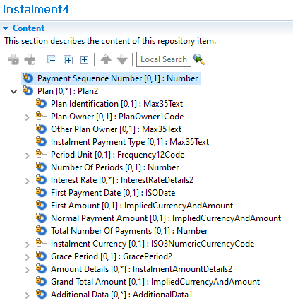

Existing SettlementServiceDate1 component:
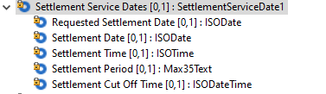

Component modification
Modified component of Plan2
Plan | Occurs | Type
Plan Identification | [0..1] | Max35Text
…
Deferred Installment Indicator | [0..1] | TrueFalseIndicator
…

Modified component of SettlementServiceDate1
SettlementServiceDate1 | Occurs | Type
Requested Settlement Date | [0..1] | ISODate
…
Deferred Settlement Indicator | [0..1] | TrueFalseIndicator
…

Impacts
- Plan2 component used in

Message Definition | Message Components
Addendum Initiation V02 | AddendumInitiation2.AddendumData3.Instalment4.Plan2
Authorisation Initiation V03 | AuthorisationInitiation2.AddendumData3.Instalment4.Plan2
Financial Initiation V03 | FinancialInitiation2.AddendumData3.Instalment4.Plan2

- SettlementServiceDate1 component used in
Message Definition | Message Components
Addendum Initiation V02 | AddendumInitaition2.Context17.TransactionContext10.  SettlementService2.SettlementServiceDate1
Addendum Response V02 | AddendumResponse2.Context17.TransactionContext10.  SettlementService2.SettlementServiceDate1
Amendment V01 | Amendment10.Context6.TransactionContext6.  SettlementService2.SettlementServiceDate1
Authorisation Initiation V03 | AuthorisationInitiation2.Context10.TransactionContext7.  SettlementService1.SettlementServiceDate1
Authorisation Response V03 | AuthorisationResponse2.Context13.TransactionContext8.  SettlementService2.SettlementServiceDate1
Batch Management Initiation V02 | BatchManagementIntiation2.Context17.TransactionContext10.  SettlementService2.SettlementServiceDate1
Batch Management Response V02 | BatchManagementResponse2.Context17.TransactionContext10.  SettlementService2.SettlementServiceDate1
Batch Transfer Initiation V02 | BatchTransferIntiation2.Context17.TransactionContext10.  SettlementService2.SettlementServiceDate1
Batch Transfer Response V02 | BatchTransferResponse2. Context17.TransactionContext10.  SettlementService2.SettlementServiceDate1
Card Management Initiation V02 | CardManagementInitiation2.Context11.TransactionContext7.  SettlementService1.SettlementServiceDate1
Card Management Response V02 | CardManagementResponse2.Context13.TransactionContext8.  SettlementService2.SettlementServiceDate1
Charge Back Initiation V02 | ChargeBackInitiation2.Context14.TransactionContext9.  SettlementService1.SettlementServiceDate1
Charge Back Response V02 | ChargeBackResponse2.Context16.TransactionContext8.  SettlementService2.SettlementServiceDate1
Custom Report V01 | CustomReport1.Context17.TransactionContext10.  SettlementService2.SettlementServiceDate1
Error V03 | Error3.Context17.TransactionContext10.  SettlementService2.SettlementServiceDate1
Fee Collection Initiation V02 | FeeCollectionInitiation2.Context16.TransactionContext8.  SettlementService2.SettlementServiceDate1
Fee Collection Response V02 | FeeCollectionResponse2.Context16.TransactionContext8.  SettlementService2.SettlementServiceDate1
File Action Initiation V02 | FileActionInitiation2.Context17.TransactionContext10.  SettlementService2.SettlementServiceDate1
File Action Response V02 | FileActionResponse2.Context17.TransactionContext10.  SettlementService2.SettlementServiceDate1
Financial Initiation V03 | FinancialInitiation2.Context10.TransactionContext7.  SettlementService1.SettlementServiceDate1
Financial Response V03 | FinancialResponse2.Context13.TransactionContext8.  SettlementService2.SettlementServiceDate1
Fraud Disposition Initiation V02 | FraudDispositionInitiation2.Context17.TransactionContext10.  SettlementService2.SettlementServiceDate1
Fraud Disposition Response V02 | FraudDispositionResponse2.Context17.TransactionContext10.  SettlementService2.SettlementServiceDate1
Fraud Reporting Initiation V02 | FraudReportingInitiation2.Context17.TransactionContext10.  SettlementService2.SettlementServiceDate1
Fraud Reporting Response V02 | FraudReportingResponse2.Context17.TransactionContext10.  SettlementService2.SettlementServiceDate1
Inquiry Initiation V02 | InquiryInitiation2.Context11.TransactionContext7.  SettlementService1.SettlementServiceDate1
Inquiry Response V02 | InquiryResponse2.Context13.TransactionContext8.  SettlementService2.SettlementServiceDate1
Key Exchange Initiation V03 | KeyExchangeInitiation2.Context17.TransactionContext10.  SettlementService2.SettlementServiceDate1
Key Exchange Response V03 | KeyExchangeResponse2.Context17.TransactionContext10.  SettlementService2.SettlementServiceDate1
Network Management Initiation V03 | NetworkManagementInitiation2.Context17.TransactionContext10.  SettlementService2.SettlementServiceDate1
Network Management Response V03 | NetworkManagementResponse2.Context17.TransactionContext10.  SettlementService2.SettlementServiceDate1
Reconciliation Initiation V03 | ReconciliationInitiation2.Context17.TransactionContext10.  SettlementService2.SettlementServiceDate1
Reconciliation Response V03 | ReconciliationResponse5.Context17.TransactionContext10.  SettlementService2.SettlementServiceDate1
Retrieval Fulfilment Initiation V02 | RetrievalFulfilmentInitiation2.Context15.TransactionContext8.  SettlementService2.SettlementServiceDate1
Retrieval Fulfilment Response V02 | RetrievalFulfilmentResponse2.Context15.TransactionContext8.  SettlementService2.SettlementServiceDate1
Retrieval Initiation V02 | RetrievalInitiation2.Context15.TransactionContext8.  SettlementService2.SettlementServiceDate1
Retrieval Response V02 | RetrievalResponse4.Context15.TransactionContext8.  SettlementService2.SettlementServiceDate1
Reversal Initiation V03 | ReversalInitiation2.Context14.TransactionContext9.  SettlementService1.SettlementServiceDate1
Reversal Response V03 | ReversalResponse2.TransactionContext3.  SettlementService2.SettlementServiceDate1
Settlement Reporting Initiation V02 | SettlementReportingInitiation2.Context17.TransactionContext10.  SettlementService2.SettlementServiceDate1
Settlement Reporting Response V02 | SettlementReportingResponse2.Context17.TransactionContext10.  SettlementService2.SettlementServiceDate1
Verification Initiation V02 | VerificationInitiation2.Context11.TransactionContext7.  SettlementService1.SettlementServiceDate1
Verification Response V02 | VerificationResponse2.Context13.TransactionContext8.  SettlementService2.SettlementServiceDate1

CR0981-3: Detail Amount Type and additional Amount Type

Add one amount type to DetailedAmount1Code

Description
Add new amount type-Base Amount, healthcare related amount, and EBT related amount to DetailedAmount1Code to indicate base amount which I used to calculate other amount, such tax, fee, etc.
Change to ISOAmountTypeCode for both AdditionalAmount and Detail Amount

Existing component
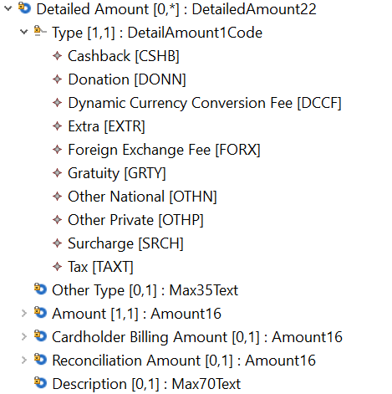
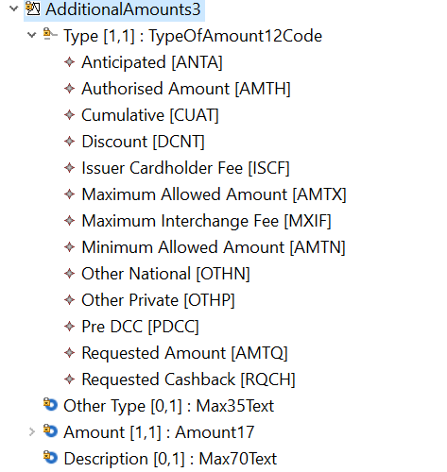

Component modification
Modified component that will replace all instances of DetailedAmount22:
DetailedAmountXX | Occurs
Type <Tp> | [1..1] | CodeSet ->ISOAmountTypeCode
OtherType <OthrTp> | [0..1] | Max35Text
CreditDebit |  | CreditDebit3Code
Amount <Amt> | [1..1] | Amount16 ImpliedCurrencyAndAmount
CardholderBillingAmount <CrdhldrBllgAmt> | [0..1] | Amount16 ImpliedCurrencyAndAmount
ReconciliationAmount <RcncltnAmt> | [0..1] | Amount16 ImpliedCurrencyAndAmount
Description< Desc> | [0..1] | Max70Text

AdditionalAmountXX | Occurs
Type <Tp> | [1..1] | CodeSet ->ISOAmountTypeCode
OtherType <OthrTp> | [0..1] | Max35Text
Amount <Amt> | [1..1] | Amount17
Description< Desc> | [0..1] | Max70Text

Impacts
- DetailedAmount22 and AdditionalAmounts3 component used in
Component Trace Path | Messages
DetailedAmount22/TransactionAmounts2/Transaction142/AuthoisationInitiation2  AdditionalAmounts3/Transaction142/ AuthoisationInitiation2 | Authorisation Initiation V03 (cain.001.001.03)
DetailedAmount22/TransactionAmounts2/Transaction119/AuthoisationResponse2  AdditionalAmounts3/Transaction119/ AuthoisationResponse2 | Authorisation Response V03 (cain.002.001.03)
DetailedAmount22/TransactionAmounts2/Transaction114/FinancialInitiation2  AdditionalAmount3/Transaction114/FinancialInitiation2 | Financial Initiation V03 (cain.003.001.03)
DetailedAmount22/TransactionAmounts2/Transaction119/FinancialResponse2  AdditionalAmount3/Transaction119/FinancialResponse2 | Financial Response V03 (cain.004.001.03)
AdditionalAmount3/Transaction121/CardManagementInitiation2 | Card Management Initiation V02 (cain.023.001.02)
AdditionalAmount3/Transaction122/ CardManagementResponse2 | Card Management Response V03 (cain.024.001.02)
AdditionalAmount3/Transaction131/InquiryInitiation2 | Inquiry Initiation V02 (cain.016.001.02)
AdditionalAmount3/Transaction132/InquiryResponse2 | Inquiry Response V03 (cain.017.001.02)
AdditionalAmount3/Transaction115/VerificationInitiation2 | Verification Initiation V02 (cain.018.001.02)
AdditionalAmount3/Transaction140/VerificationResponse2 | Verification Response V03 (cain.019.001.02)
DetailedAmount22/TransactionAmounts2/Transaction142/ReversalInitiation2  AdditionalAmounts/Transaction142/ReversalInitiation2 | Reversal Initiation V03 (cain.005.001.03)
DetailedAmount22/TransactionAmounts2/Transaction137/ReversalResponse4  AdditionalAmounts3/Transaction137/ReversalResponse4 | Reversal Response V03 (cain.006.001.03)
DetailedAmount22/TransactionAmounts2/Transaction116/OriginalTransaction2/Transaction136/RetrievalInitiation2  AdditionalAmounts3/Transaction116/OriginalTransaction2/Transaction136/RetrievalInitiation2 | Retrieval Initiation V02 (cain.021.001.02)
DetailedAmount22/TransactionAmounts2/Transaction116/OriginalTransaction2/Transaction136/RetrievalFulfilmentInitiation2  AdditionalAmounts3/Transaction116/OriginalTransaction2/Transaction136/RetrievalFulfilmentInitiation2 | Retrieval Fulfilment Initiation V02 (cain.014.001.02)
DetailedAmount22/TransactionAmounts2/Transaction116/OriginalTransaction2/Transaction136/ChargebackInitiation2  DetailedAmount22/TransactionAmounts2/Transaction123/ ChargebackInitiation2  AdditionalAmount3/Transaction123/ ChargebackInitiation2 | Chargeback Initiation V02 (cain.027.001.02)
DetailedAmount22/TransactionAmounts2/Transaction123/ChargebackResponse2 | Chargeback Response V02 (cain.028.001.02)
DetailedAmount22/TransactionAmounts2/Transaction125/FeeCollectionInitiation2  AdditionalAmount3/Transaction125/FeeCollectionInitiation2 | Fee Collection Initiation V02 (cafc.001.001.02)
DetailedAmount22/TransactionAmounts2/Transaction125/FeeCollectionResponse2  AdditionalAmount3/Transaction125/FeeCollectionResponse2 | Fee Collection Response V02 (cafc.002.001.02)

CR0981-4: Verification Type

Change to External Code list for Verification Type

Description
Because new verification types continue emerging, it is better to use external code so that won’t delay the new verification type launching in the market. Remove the current code list from AuthenticationMenthod12Code used in Verification3 and Verification4, refer to ISO 20022 external code list for Authentication Method.

Existing Component
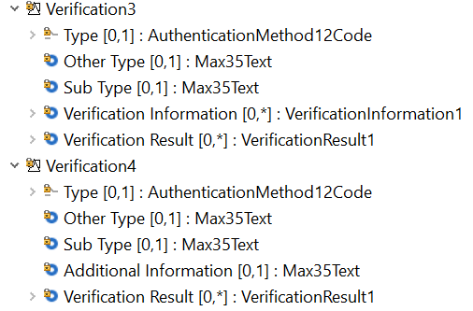
AuthenticationMethod12Code (only show partial list)
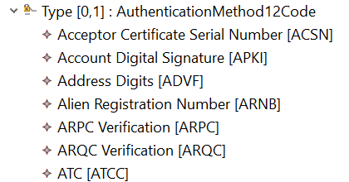

Component modification
Modified component that will replace all instances of Verification3:
VerificationXX | Occurs
Type <Tp> | [0..1] | CodeSet  External Code list
OtherType <OthrTp> | [0..1] | Max35Text
SubType <SubTp> | [0..1] | Max35Text
VerificationInformation <VrfctnInf> | [0..*] | VerificationInformation1
VerificationResult <VrfctnRslt> | [0..*] | VerificationResult1

Modified component that will replace all instances of Verification4:
VerificationXX | Occurs
Type <Tp> | [0..1] | CodeSet  External Code list
OtherType <OthrTp> | [0..1] | Max35Text
SubType <SubTp> | [0..1] | Max35Text
AdditionalInformation <AddtlInf> | [0..1] | Max35Text
VerificationResult <VrfctnRslt> | [0..*] | VerificationResult1

Impacts
- Verification3 and Verification4 component used in
Component Trace Path | Messages
AuthenticationMethod12Code/Verification3/Context10/AuthoisationInitiation2 | Authorisation Initiation V03 (cain.001.001.03)
AuthenticationMethod12Code/Verification4/Context13/AuthoisationResponse2 | Authorisation Response V03 (cain.002.001.03)
AuthenticationMethod12Code/Verification3/Context10/AuthoisationInitiation2/FinancialInitiation2 | Financial Initiation V03 (cain.003.001.03)
AuthenticationMethod12Code/Verification4/Context13/FinancialResponse2 | Financial Response V03 (cain.004.001.03)
AuthenticationMethod12Code/Verification3/Context11/InquiryInitiation2 | Inquiry Initiation V02 (cain.016.001.02)
AuthenticationMethod12Code/Verification4/Context13/InquiryResponse2 | Inquiry Response V03 (cain.017.001.02)
AuthenticationMethod12Code/Verification3/Context11/VerificationInitiation2 | Verification Initiation V02 (cain.018.001.02)
AuthenticationMethod12Code/Verification4/Context13/VerificationResponse2 | Verification Response V02 (cain.019.001.02)
AuthenticationMethod12Code/Verification3/Context11/CardManagementInitiation2 | Card Management Initiation V02 (cain.023.001.02)
AuthenticationMethod12Code/Verification4/Context13/CardManagementResponse2 | Card Management Response V02 (cain.024.001.02)
AuthenticationMethod12Code/Verification4/Context12/OriginationTransaction2/ChargebackInitiation2 | Chargeback Initiation V02 (cain.027.001.02)
AuthenticationMethod12Code/Verification4/Context12/OriginationTransaction2/RetrievalFulfilmentInitiation2 | Retrieval Fulfilment Response V02 (cain.014.001.02)
AuthenticationMethod12Code/Verification4/Context12/OriginationTransaction2/RetrievalInitiation2 | Retrieval Response V02 (cain.021.001.02)

CR0981-5: Fee Collection Message

Modify the solution for Fee Collection Message

Description
Current solution Fee collection message has below two issues to be addressed:
- Close the gap with ISO 8583 to support Fee Collection Cancellation and identify who initiated fee collection
- Fix Errors, remove Components not applicable to Fee Collection Messages

TransactionContext

Existing Component
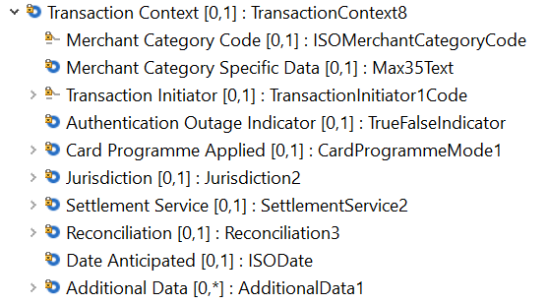

Component Modification
Modified component that will replace TransactionContext8 in Fee Collection with TransactionContextXX:
TransactionContextXX | Occurs
MerchantCategoryCode <MrchntCtgyCd> | [0,1] | ISOMerchantCategoryCCode
MerchantCategorySpecificData <<MrchntCtgySpcfcData>> | [0,1] | Max35Text
FeeCollectionInitiator <FeeColltnInitr> | [0,1] | FeeCollectionInitiator1Code  ACCP – Acquirer  CISS – CardIssuer  AGNT - Agent  OTHP – Other Private  OTHN – Other National
OtherFeeCollectionInitiator<OthrFeeColltnInitr> | [0,1] | Max35Text
AuthenticationOutageIndicator <AuthntchOutgInd > | [0,1] | TrueFalseIndicator
CardProgrammeApplied <CardPrgrmmApld> | [0,1] | CardProgrammeMode1
Jurisdiction<Jursdctn> | [0,1] | Jurisdiction2
SettlementService <SttlmSvc> | [0,1] | SettlementService2
Reconciliation <Rcncltn> | [0,1] | Reconciliation3
DataAnticipated<DtAntcptd> | [0,1] | ISODate
AdditionalData <AddtlData> | [0..*] | AdditionalData1

Transaction125

Existing Component
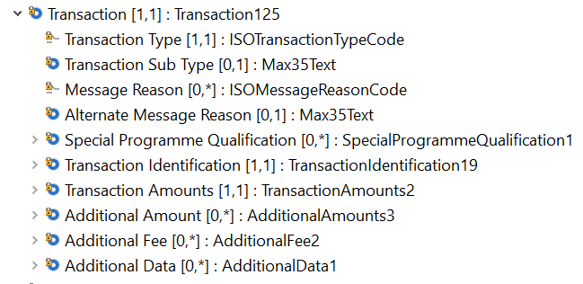

Component Modification
Modified component that will replace Transaction125 in Fee Collection with TransactionXX:
Transaction XX | Occurs
TransactionType <TxTp> | [1,1] | ISOTransactionTypeCode
TransactionSubType <TxSubTp> | [0,1] | Max35Text
CancellationIndicator<CxlInd> | [0,1] | TrueFalseIndicator
MessageReason <MsgRsn> | [0,*] | ISOMessageReasonCode
AlternateMessageReason <AltrnMsgRsn> | [0,*] | Max35Text
SpecialProgrammeQualification <SpclPrgrmmQlfctn> | [0,*] | SpecialProgrammeQualification1
TransactionIdentification <TxId> | [1,1] | TransactionIdentification19  TransactionIdentification15
TransactionAmounts <TxAmts> | [1,1] | TransactionAmounts2
AdditionalAmounts <AddtlAmts> | [0,*] | AdditionalAmounts3
AdditionalFees <AddtlFees> | [0,*] | AdditionalFees2
AdditionalData <AddtlData> | [0,*] | AdditionalData1
FeeCollectionCycle < > | [0..1] | Exact1NumericText
FeeCollectionReference < > | [0..1] | FeeCollectionReference

- Add "FeeCollectionCycle" (Exact1Number" [0..1])
  - 1=Initial Fee Collection
  - 2=Fee Collection Return
  - 3=Fee Collection Resubmission
  - 4=Fee Collection Arbitration Return
- Add "FeeCollectionReference" [0..1]
  - AssignerEntity[0..1]
  - OtherAssignerEntity[0..1]
  - FeeCollectionIdentification[1..1]"

Impacts
- TransactionContext8 and Transaction125 component used in
Component Trace Path | Messages
TransactionContext8/Context16/FeeCollectionInitiation2 | Fee Collection Initiation V02 (cafc.001.001.02)  Fee Collection Response V02 (cafc.002.001.02)
Transaction125/FeeCollectionInitiation2 | Fee Collection Initiation V02 (cafc.001.001.02)  Fee Collection Response V02 (cafc.002.001.02)

CR0981-6: File Action Size

Description
- Increase the size of the text data sent in the File Action Initiation message from 20000TEXT to 10MbText (Specifies a character string with a maximum length of 10,000,000 characters.), and consequently increase the binary size from Max10MbBinary to Max20MbBinary (Binary data of 20 megabytes (20 Mb) maximum).
- Add Format[0,1]: OutputFormat5Code to define the format of the data which is being sent
- Addition of FileActionDetail to FileActionResponse/Transaction <Tx> as it would allow an implementor the ability to add additional information of the transaction in the response message.
- The related CR is “CR#0979 Change 20” for FileActionResponse.

Component Modification

FileActionDetailsX2
Message Root | Occurs | Type
FileActionDetails | [1..1] | FileActionDetailsX2
Format | [0..1] | OutputFormat5Code
FileName | [0..1] | Max140Text
DataRecord | [1..1] | DataRecordX1Choice
Binary | [1..*] | Max10MbBinary Max20MbText
Text | [1..*] | Max20000Text  Max10MbText

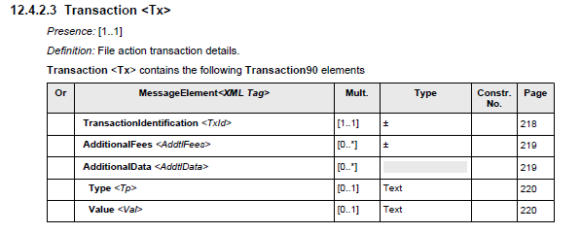
 | FileActionDetails<FileActnDtls> | [1..1]

Impacts
  - FileActionInitiationV02 (cafm.001.001.02)
  - FileActionResponseV02 (cafm.002.001.02)

CR0981-7: Dispute Data

Description
Add "Dispute Data" component under the Transaction structure of Retrieval Initiation and Retrieval Fulfilment Initiation messages.

Component Modification

RetrievalInitiationVXX02
Message Root | Occurs | Type
Body | [1..1] | RetrievalInitiationX2
Environment | [1..1] | Environment21
…
Transaction | [0..1] | TransactionXXX136
MessageReason | [0..*] | ISOMessageReasonCode
DisputeReference | [0..*] | DisputeReference1
DisputeData | [0..*] | DisputeData1
…
OriginalTransaction | [1..1] | OriginalTransaction2

RetrievalResponseVXX02
Message Root | Occurs | Type
Body | [1..1] | RetrievalResponseX2
Environment | [1..1] | Environment21
…
Transaction | [0..1] | TransactionXXX136
MessageReason | [0..*] | ISOMessageReasonCode
DisputeReference | [0..*] | DisputeReference1
DisputeData | [0..*] | DisputeData1
…
ProcessingResult | [1..1] | ProcessingResult14

RetrievalFulfilmentInitiationVXX02
Message Root | Occurs | Type
Body | [1..1] | RetrievalFulfilmentInitiationX2
Environment | [1..1] | Environment21
…
Transaction | [0..1] | TransactionXXX136
MessageReason | [0..*] | ISOMessageReasonCode
DisputeReference | [0..*] | DisputeReference1
DisputeData | [0..*] | DisputeData1
…
OriginalTransaction | [0..1] | OriginalTransaction2

RetrievalFulfilmentResponseVXX02
Message Root | Occurs | Type
Body | [1..1] | RetrievalFulfilmentResponseX2
Environment | [1..1] | Environment21
…
Transaction | [0..1] | TransactionXXX136
MessageReason | [0..*] | ISOMessageReasonCode
DisputeReference | [0..*] | DisputeReference1
DisputeData | [0..*] | DisputeData1
…
ProcessingResult | [1..1] | ProcessingResult14

Impacts
  - RetrievalInitiationV02 (cain.021.001.02)
  - RetrievalResponseV02 (cain.022.001.02)
  - RetrievalFulfilmentInitiationV02 (cain.014.001.02)
  - RetrievalFulfilmentResponseV02 (cain.015.001.02)

CR0981-8: Dispute Additional Data

Description
Change the type of Transaction/Dispute Data/Additional Dispute Data from Max1000Text to a "Type" and "Value" structure and make it iterative [0,*].

Component Modification

AuthorisationInitiationVXX03
Message Root | Occurs | Type
Body | [1..1] | AuthorisationInitiationX2
Environment | [1..1] | Environment17
…
Transaction | [1..1] | TransactionXXX142
TransactionType | [1..1] | ISOTransactionTypeCode
…
DisputeData | [0..*] | DisputeData1

ChargeBackInitiationVXX02
Message Root | Occurs | Type
Body | [1..1] | ChargeBackInitiationX2
Environment | [1..1] | Environment21
…
Transaction | [1..1] | TransactionXXX123
MessageReason | [0..*] | ISOMessageReasonCode
…
DisputeData | [1..1] | DisputeDataX1
AdditionalDisputeData | [0..*1] | Max1000Text AdditionalData1
Type | [0..1] | Max35Text
Value | [0..1] | Max2048Text
OriginalTransaction | [1..1] | OriginalTransactionX2
Environment | [0..1] | Environment20
…
Transaction | [0..1] | TransactionXXX116
TransactionType | [0..1] | ISOTransactionTypeCode
…
DisputeData | [0..*] | DisputeDataX1
AdditionalDisputeData | [0..*1] | Max1000Text AdditionalData1
Type | [0..1] | Max35Text
Value | [0..1] | Max2048Text

ChargeBackResponseVXX02
Message Root | Occurs | Type
Body | [1..1] | ChargeBackResponseX2
Environment | [1..1] | Environment29
…
Transaction | [1..1] | Transaction123
MessageReason | [0..*] | ISOMessageReasonCode
…
DisputeData | [1..1] | DisputeDataX1
AdditionalDisputeData | [0..*1] | Max1000Text AdditionalData1
Type | [0..1] | Max35Text
Value | [0..1] | Max2048Text

FinancialInitiationVXX03
Message Root | Occurs | Type
Body | [1..1] | FinancialInitiationX2
Environment | [1..1] | Environment17
…
Transaction | [1..1] | TransactionXXX114
TransactionType | [1..1] | ISOTransactionTypeCode
…
DisputeData | [0..*] | DisputeDataX1
AdditionalDisputeData | [0..*1] | Max1000Text AdditionalData1
Type | [0..1] | Max35Text
Value | [0..1] | Max2048Text

RetrievalFulfilmentInitiationVXX02
Message Root | Occurs | Type
Body | [1..1] | RetrievalFulfilmentInitiationX2
Environment | [1..1] | Environment21
…
Transaction | [0..1] | Transaction136
OriginalTransaction | [0..1] | OriginalTransactionX2
Environment | [0..1] | Environment20
…
Transaction | [0..1] | TransactionXXX116
TransactionType | [0..1] | ISOTransactionTypeCode
…
DisputeData | [0..*] | DisputeDataX1
AdditionalDisputeData | [0..*1] | Max1000Text AdditionalData1
Type | [0..1] | Max35Text
Value | [0..1] | Max2048Text

RetrievalInitiationVXX02
Message Root | Occurs | Type
Body | [1..1] | RetrievalInitiationX2
Environment | [1..1] | Environment21
…
Transaction | [0..1] | Transaction136
OriginalTransaction | [1..1] | OriginalTransactionX2
Environment | [0..1] | Environment20
…
Transaction | [0..1] | TransactionXXX116
TransactionType | [0..1] | ISOTransactionTypeCode
…
DisputeData | [0..*] | DisputeDataX1
AdditionalDisputeData | [0..*1] | Max1000Text AdditionalData1
Type | [0..1] | Max35Text
Value | [0..1] | Max2048Text

ReversalInitiationVXX03
Message Root | Occurs | Type
Body | [1..1] | ReversalInitiationX2
Environment | [1..1] | Environment19
…
Transaction | [1..1] | TransactionXXX142
TransactionType | [1..1] | ISOTransactionTypeCode
…
DisputeData | [0..*] | DisputeDataX1
AdditionalDisputeData | [0..*1] | Max1000Text AdditionalData1
Type | [0..1] | Max35Text
Value | [0..1] | Max2048Text

Impacts
  - AuthorisationInitiationV03 (cain.001.001.03)
  - ChargeBackInitiationV02 (cain.027.001.02)
  - ChargeBackResponseV02 (cain.028.001.02)
  - FinancialInitiationV03 (cain.003.001.03)
  - RetrievalFulfilmentInitiationV02 (cain.014.001.02)
  - RetrievalInitiationV02 (cain.021.001.02)
  - ReversalInitiationV03 (cain.005.001.03)

CR0981-9: POS Context Additional Data

Description
Though the structure of AdditionalData [0,*] : AdditionalData1 was changed in ATICA v3 and has been updated to the message component PointOfServiceContext for certain messages, the same structure of the following messages needs to be updated;
- ChargeBackInitiationV02 (cain.027.001.02)
- RetrievalFulfilmentInitiationV02 (cain.014.001.02)
- RetrievalInitiationV02 (cain.021.001.02)
- ReversalInitiationV03 (cain.005.001.03)

Component Modification

ChargeBackInitiationVXX02
Message Root | Occurs | Type
Body | [1..1] | ChargeBackInitiation2
Context | [0..1] | Context14
PointOfServiceContext | [0..1] | PointOfServiceContextX5
CardPresent | [0..1] | TrueFalseIndicator
…
SpecialConditions | [0..*] | SpecialConditions1
AdditionalData | [0..*] | AdditionalData1
Type | [0..1] | Max35Text
Value | [0..1] | Max2048Text

RetrievalFulfilmentInitiationVXX02
Message Root | Occurs | Type
Body | [1..1] | RetrievalFulfilmentInitiation2
Context | [1..1] | Context15
PointOfServiceContext | [0..1] | PointOfServiceContextX5
CardPresent | [0..1] | TrueFalseIndicator
…
SpecialConditions | [0..*] | SpecialConditions1
AdditionalData | [0..*] | AdditionalData1
Type | [0..1] | Max35Text
Value | [0..1] | Max2048Text

RetrievalInitiationVXX02
Message Root | Occurs | Type
Body | [1..1] | RetrievalInitiation2
Context | [1..1] | Context15
PointOfServiceContext | [0..1] | PointOfServiceContextX5
CardPresent | [0..1] | TrueFalseIndicator
…
SpecialConditions | [0..*] | SpecialConditions1
AdditionalData | [0..*] | AdditionalData1
Type | [0..1] | Max35Text
Value | [0..1] | Max2048Text

ReversalInitiationVXX03
Message Root | Occurs | Type
Body | [1..1] | ReversalInitiation2
Context | [0..1] | Context14
PointOfServiceContext | [0..1] | PointOfServiceContextX5
CardPresent | [0..1] | TrueFalseIndicator
…
SpecialConditions | [0..*] | SpecialConditions1
AdditionalData | [0..*] | AdditionalData1
Type | [0..1] | Max35Text
Value | [0..1] | Max2048Text

Impacts
- ChargeBackInitiationV02 (cain.027.001.02)
- RetrievalFulfilmentInitiationV02 (cain.014.001.02)
- RetrievalInitiationV02 (cain.021.001.02)
- ReversalInitiationV03 (cain.005.001.03)

CR0981-10: Adding Dispute related structures in Financial messages

Description
Financial Initiation and Response messages are used for Representment/2nd Presentment in the Dispute process. Financial message structure shall be updated to match the structure of the Chargeback message in order to pass dispute related data.

Component Modification

FinancialInitiationVXX03
Or | Message Root | Occurs | Type
 | Header | [1..1] | Header42
 | Body | [1..1] | FinancialInitiationX2
 | Environment | [1..1] | EnvironmentXX17
 | Acquirer | [1..1] | PartyIdentification240
 | Originator | [0..1] | PartyIdentification240
 | …
 | Card | [0..1] | CardDataX6
 | …
 | PAN Account Range | [0..1] | Max19NumericText
 | …
 | Wallet | [0..1] | Wallet2
 | Token | [0..1] | Token2
 | Cardholder | [0..1] | Cardholder17
 | Context | [1..1] | Context10
 | Transaction | [1..1] | Transaction1XXX114
 | …
 | Additional Information | [0..1] | AdditionalInformation20
 | Original Transaction | [0..1] | OriginalTransaction2
 | …

FinancialResponseVXX03
Or | Message Root | Occurs | Type
 | Header | [1..1] | Header42
 | Body | [1..1] | FinancialResponseX2
 | Environment | [1..1] | Environment26
 | Context | [1..1] | Context13
 | Transaction | [1..1] | Transaction1XXX119
 | …
 | Message Reason | [0..*] | ISOMessageReasponCode
 | Alternate Message Reason | [0..*] | Max35Text
 | Dispute Data | [1..1] | DisputeData1
 | Additional Information | [0..1] | AdditionalInformation20
 | …

ChargebackInitiationVXX02
Or | Message Root | Occurs | Type
 | Header | [1..1] | Header40
 | Body | [1..1] | ChargebacInitiationX2
 | Environment | [1..1] | Environment21
 | Context | [0..1] | Context14
 | Transaction | [1..1] | Transaction1XXX123
 | …
 | Transaction Identification | [1..1] | TransactionIdentificationXX17
 | …
 | Acquirer Reference Data | [0..1] | Max14099Text
 | …

ChargebackResponseVXX02
Or | Message Root | Occurs | Type
 | Header | [1..1] | Header40
 | Body | [1..1] | ChargebacResponseX2
 | Environment | [1..1] | Environment29
 | Context | [0..1] | Context16
 | Transaction | [1..1] | Transaction1XXX123
 | …
 | Transaction Identification | [1..1] | TransactionIdentificationXX17
 | …
 | Acquirer Reference Data | [0..1] | Max14099Text
 | …

Expand the length of Acquirer Reference Data in TransactionIdentification17, 18 from Max99Text to Max140 text

Impacts
- FinancialInitiationV03 (cain.003.001.03)
- FinancialResponseV03 (cain.004.001.03)
- ChargebackInitiationV02 (cain.027.001.02)
- ChargebackResponseV02 (cain.028.001.02)
- InquiryInitiation V02 (cain.016.001.02)
- InquiryResponse V02 (cain.017.001.02)
- RetrievalFulfilmentInitiation V02 (cain.014.001.02)
- RetrievalFulfilmentResponse V02 (cain.015.001.02)
- RetrivealInitiation V02 (cain.021.001.02)
- RetrievalResponse V02 (cain.022.001.02)
- VerificationInitiation V02 (cain.018.001.02)
- VerificationResponse V02 (cain.019.001.02)

CR0981-11: ICC Fallback

Description
The following changes related to ICC Fallback indicators shall be made to align with the 8583 message specification.
- PIN Entry Bypass – Add True/False indicator under Context/TransactionContext.
- ICC Fallback Reason – Add code list under Context/Transaction Context/ICC Fallback Indicator. Choices to be as below.
  - Choosing incorrect IC application
  - Error during IC app processing
  - Terminal error reading IC data

Component Modification

AuthorisationInitiationVXX03
Or | Message Root | Occurs | Type
 | Header | [1..1] | Header42
 | Body | [1..1] | AuthorisationInitiationX2
 | Environment | [1..1] | Environment17
 | Context | [1..1] | ContextXX10
 | …
 | Transaction Context | [1..1] | TransactionContextXX7
 | …
 | PIN Entry Bypass Indicator | [0..1] | TrueFalseIndicator
 | ICC Fallback Indicator | [0..1] | TrueFalseIndicator
 | ICC Fallback Reason Code | [0..1] | ICCFallbackReason1Code
 | Choosing incorrect IC application [CIIA]
 | Error during IC app processing [EDIP]
 | Terminal error reading IC data [TERI]
 | Other National [OTHN]
 | Other Private [OTHP]
 | Other ICC Fallback Reason Code | [0..1] | Max35Text
 | …

FinancialInitiationVXX03
Or | Message Root | Occurs | Type
 | Header | [1..1] | Header42
 | Body | [1..1] | FinancialInitiationX2
 | Environment | [1..1] | Environment17
 | Context | [1..1] | ContextXX10
 | …
 | Transaction Context | [1..1] | TransactionContextXX7
 | …
 | PIN Entry Bypass Indicator | [0..1] | TrueFalseIndicator
 | ICC Fallback Indicator | [0..1] | TrueFalseIndicator
 | ICC Fallback Reason Code | [0..1] | ICCFallbackReason1Code
 | Choosing incorrect IC application [CIIA]
 | Error during IC app processing [EDIP]
 | Terminal error reading IC data [TERI]
 | Other National [OTHN]
 | Other Private [OTHP]
 | Other ICC Fallback Reason Code | [0..1] | Max35Text
 | …

Impacts
- AuthorisationInitiationV03 (cain.001.001.03)
- FinancialInitiationV03 (cain.003.001.03)

CR0981-12: POS Data Code

Description
The following changes related to POS Data Code shall be made to align with the 8583 message specification.
- MOTO Indicator – Separate into three options of MO/TO/MOTO (Located under Context/Point of Service Context). Change from current True/False indicator to code list.
- Partial Shipment – Add option under Context/Transaction Context.

Component Modification

AuthorisationInitiationVXX03
Or | Message Root | Occurs | Type
 | Header | [1..1] | Header42
 | Body | [1..1] | AuthorisationInitiationX2
 | Environment | [1..1] | Environment17
 | Context | [1..1] | ContextXX10
 | Point Of Service Context | [1..1] | PointOfServiceContextX3
 | …
 | MOTO CodeIndicator | [0..1] | MOTO1Code
 | Mail Order [MAOR]
 | Telephone Order [TPOR]
 | MOTO [MOTO]
 | …
 | Transaction Context | [1..1] | TransactionContextXX7
 | …
 | Partial Shipment Indicator | [0..1] | TrueFalseIndicator
 | …

AuthorisationResponseVXX03
Or | Message Root | Occurs | Type
 | Header | [1..1] | Header42
 | Body | [1..1] | AuthorisationResponseX2
 | Environment | [1..1] | Environment26
 | Context | [0..1] | ContextXX13
 | Point Of Service Context | [0..1] | PointOfServiceContextX4
 | …
 | MOTO CodeIndicator | [0..1] | MOTO1Code
 | Mail Order [MAOR]
 | Telephone Order [TPOR]
 | MOTO [MOTO]
 | …
 | Transaction Context | [0..1] | TransactionContextXX8
 | …
 | Partial Shipment Indicator | [0..1] | TrueFalseIndicator
 | …

FinancialInitiationVXX03
Or | Message Root | Occurs | Type
 | Header | [1..1] | Header42
 | Body | [1..1] | FinancialInitiationX2
 | Environment | [1..1] | Environment17
 | Context | [1..1] | ContextXX10
 | Point Of Service Context | [1..1] | PointOfServiceContextX3
 | …
 | MOTO CodeIndicator | [0..1] | MOTO1Code
 | Mail Order [MAOR]
 | Telephone Order [TPOR]
 | MOTO [MOTO]
 | …
 | Transaction Context | [1..1] | TransactionContextXX7
 | …
 | Partial Shipment Indicator | [0..1] | TrueFalseIndicator
 | …

FinancialResponseVXX03
Or | Message Root | Occurs | Type
 | Header | [1..1] | Header42
 | Body | [1..1] | FinancialResponseX2
 | Environment | [1..1] | Environment26
 | Context | [1..1] | ContextXX13
 | Point Of Service Context | [0..1] | PointOfServiceContextX4
 | …
 | MOTO CodeIndicator | [0..1] | MOTO1Code
 | Mail Order [MAOR]
 | Telephone Order [TPOR]
 | MOTO [MOTO]
 | …
 | Transaction Context | [0..1] | TransactionContextXX8
 | …
 | Partial Shipment Indicator | [0..1] | TrueFalseIndicator
 | …

ReversalInitiationVXX03
Or | Message Root | Occurs | Type
 | Header | [1..1] | Header42
 | Body | [1..1] | ReversalInitiationX2
 | Environment | [1..1] | Environment19
 | Context | [0..1] | ContextXX14
 | Point Of Service Context | [0..1] | PointOfServiceContextX5
 | …
 | MOTO CodeIndicator | [0..1] | MOTO1Code
 | Mail Order [MAOR]
 | Telephone Order [TPOR]
 | MOTO [MOTO]
 | …
 | Transaction Context | [0..1] | TransactionContextXX9
 | …
 | Partial Shipment Indicator | [0..1] | TrueFalseIndicator
 | …

ReversalResponseVXX03
Or | Message Root | Occurs | Type
 | Header | [1..1] | Header42
 | Body | [1..1] | ReversalResponseX4
 | Environment | [1..1] | Environment29
 | Context | [1..1] | TransactionContextXX3
 | Context | [1..1] | ContextXX14
 | Point Of Service Context | [0..1] | PointOfServiceContextX5
 | …
 | MOTO CodeIndicator | [0..1] | MOTO1Code
 | Mail Order [MAOR]
 | Telephone Order [TPOR]
 | MOTO [MOTO]
 | …
 | Transaction Context | [0..1] | TransactionContextXX9
 | …
 | Partial Shipment Indicator | [0..1] | TrueFalseIndicator
 | …

RetrievalFulfilmentInitiationVXX02
Or | Message Root | Occurs | Type
 | Header | [1..1] | Header48
 | Body | [1..1] | RetrievalFulfilmentInitiationX2
 | Environment | [1..1] | Environment21
 | Context | [1..1] | ContextXX15
 | Point Of Service Context | [0..1] | PointOfServiceContextX5
 | …
 | MOTO CodeIndicator | [0..1] | MOTO1Code
 | Mail Order [MAOR]
 | Telephone Order [TPOR]
 | MOTO [MOTO]
 | …
 | Transaction Context | [1..1] | TransactionContextXX8
 | …
 | Partial Shipment Indicator | [0..1] | TrueFalseIndicator
 | …

RetrievalFulfilmentResponseVXX02
Or | Message Root | Occurs | Type
 | Header | [1..1] | Header48
 | Body | [1..1] | RetrievalFulfilmentResponseX2
 | Environment | [1..1] | Environment21
 | Context | [1..1] | ContextXX15
 | Point Of Service Context | [0..1] | PointOfServiceContextX5
 | …
 | MOTO CodeIndicator | [0..1] | MOTO1Code
 | Mail Order [MAOR]
 | Telephone Order [TPOR]
 | MOTO [MOTO]
 | …
 | Transaction Context | [1..1] | TransactionContextXX8
 | …
 | Partial Shipment Indicator | [0..1] | TrueFalseIndicator
 | …

RetrievalInitiationVXX02
Or | Message Root | Occurs | Type
 | Header | [1..1] | Header55
 | Body | [1..1] | RetrievalInitiationX2
 | Environment | [1..1] | Environment21
 | Context | [1..1] | ContextXX15
 | Point Of Service Context | [0..1] | PointOfServiceContextX5
 | …
 | MOTO CodeIndicator | [0..1] | MOTO1Code
 | Mail Order [MAOR]
 | Telephone Order [TPOR]
 | MOTO [MOTO]
 | …
 | Transaction Context | [1..1] | TransactionContextXX8
 | …
 | Partial Shipment Indicator | [0..1] | TrueFalseIndicator
 | …

RetrievalResponseVXX02
Or | Message Root | Occurs | Type
 | Header | [1..1] | Header55
 | Body | [1..1] | RetrievalResponseX2
 | Environment | [1..1] | Environment21
 | Context | [0..1] | ContextXX15
 | Point Of Service Context | [0..1] | PointOfServiceContextX5
 | …
 | MOTO CodeIndicator | [0..1] | MOTO1Code
 | Mail Order [MAOR]
 | Telephone Order [TPOR]
 | MOTO [MOTO]
 | …
 | Transaction Context | [1..1] | TransactionContextXX8
 | …
 | Partial Shipment Indicator | [0..1] | TrueFalseIndicator
 | …

ChargeBackInitiationVXX02
Or | Message Root | Occurs | Type
 | Header | [1..1] | Header40
 | Body | [1..1] | ChargeBackInitiationX2
 | Environment | [1..1] | Environment21
 | Context | [0..1] | ContextXX14
 | Point Of Service Context | [0..1] | PointOfServiceContextX5
 | …
 | MOTO CodeIndicator | [0..1] | MOTO1Code
 | Mail Order [MAOR]
 | Telephone Order [TPOR]
 | MOTO [MOTO]
 | …
 | Transaction Context | [0..1] | TransactionContextXX9
 | …
 | Partial Shipment Indicator | [0..1] | TrueFalseIndicator
 | …

ChargeBackResponseVXX02
Or | Message Root | Occurs | Type
 | Header | [1..1] | Header40
 | Body | [1..1] | ChargeBackResponseX2
 | Environment | [1..1] | Environment29
 | Context | [1..1] | ContextXX16
 | Point Of Service Context | [0..1] | PointOfServiceContextX5
 | …
 | MOTO CodeIndicator | [0..1] | MOTO1Code
 | Mail Order [MAOR]
 | Telephone Order [TPOR]
 | MOTO [MOTO]
 | …
 | Transaction Context | [0..1] | TransactionContextXX8
 | …
 | Partial Shipment Indicator | [0..1] | TrueFalseIndicator
 | …

Impacts
- AuthorisationInitiationV03 (cain.001.001.03)
- AuthorisationResponseV03 (cain.002.001.03)
- FinancialInitiationV03 (cain.003.001.03)
- FinancialResponseV03 (cain.004.001.03)
- ReversalInitiationV03 (cain.005.001.03)
- ReversalResponseV03 (cain.006.001.03)
- RetrievalFulfilmentInitiationV02 (cain.014.001.02)
- RetrievalFulfilmentResponseV02 (cain.015.001.02)
- RetrievalInitiationV02 (cain.021.001.02)
- RetrievalResponseV02 (cain.022.001.02)
- ChargeBackInitiationV02 (cain.027.001.02)
- ChargeBackResponseV02 (cain.028.001.02)

CR0981-13: Reversal Message Function

Description
When reversing a transaction, we need to be able to tell the message function of the transaction which you are reversing. (In 8583, this is identified by MTI)
For this purpose, “Message Function” will be added under Transaction/Transaction Identification/Original Data Elements.

Component Modification
Key:
ReversalInitiationVXX03
Or | Message Root | Occurs | Type
 | Body | [1..1] | ReversalInitiationX2
 | …
 | Transaction | [1..1] | TransactionXXX142
 | …
 | Transaction Identification | [1..1] | TransactionIdentificationXX15
 | …
 | Original Data Elements | [0..1] | OriginalDataElementsX2
 | …
 | Message Function | [0..1] | MessageFunction16Code
 | Advice [ADVC]
 | Capture Advice [CAAD]
 | Capture Notification [CANO]
 | Notification [NOTI]
 | Request [REQU]
 | …

ReversalResponseVXX03
Or | Message Root | Occurs | Type
 | Body | [1..1] | ReversalResponseX4
 | …
 | Transaction | [1..1] | TransactionXXX137
 | …
 | Transaction Identification | [1..1] | TransactionIdentificationXX15
 | …
 | Original Data Elements | [0..1] | OriginalDataElementsX2
 | …
 | Message Function | [0..1] | MessageFunction16Code
 | Advice [ADVC]
 | Capture Advice [CAAD]
 | Capture Notification [CANO]
 | Notification [NOTI]
 | Request [REQU]
 | …

Impacts
- ReversalInitiationV03 (cain.005.001.03)
- ReversalResponseV03 (cain.006.001.03)

CR0981-14: Processing Result – add Local Data for additional information

Description
This change request includes enhancements to existing, new and evolving payment methods, services and processes outlined below:
Supplemental fields in Local languages for Additional Information are added with the following enhancements:
- Add Local Data structure for Additional Information under the Processing Result structure.
- Add Additional Information and Local Data under Processing Result structure if Response messages do not have Additional Information structure in Processing Result.
- Additional Information in FraudDispositionInitiation is changed to multiple [0,,*] because the same field in FraudReportInitiation is multiple.

Component Modification

AddendumResponseVXX02
Message Root | Occurs | Type
Body | [1..1] | AddendumResponseX2
…
Processing Result | [1..1] | ProcessingResultXX14
…
Additional Information | [0..*] | AdditionalInformation22
LocalData | [0..*] | LocalDataX
Language | [1..1] | ISO2Or3ALaguageCode
Additional Information | [0..*] | AdditionalInformationXX
Type | [0..1] | Max70Text
Value | [0..1] | Max40KText
…

AuthorisationInitiationVXX03
Message Root | Occurs | Type
Body | [1..1] | AuthorisationInitiationX2
… | [1..1]
Processing Result | [0..1] | ProcessingResultX9
…
Additional Information | [0..*] | AdditionalInformation20
LocalData | [0..1] | LocalDataX
Language | [1..1] | ISO2Or3ALaguageCode
Additional Information | [0..*] | AdditionalInformationXX
Type | [0..1] | Max70Text
Value | [0..1] | Max40KText
…

AuthorisationResponseVXX03
Message Root | Occurs | Type
Body | [1..1] | AuthorisationResponseX2
… | [1..1]
Processing Result | [1..1] | ProcessingResultXX10
…
Additional Information | [0..*] | AdditionalInformation20
LocalData | [0..1] | LocalDataX
Language | [1..1] | ISO2Or3ALaguageCode
Additional Information | [0..*] | AdditionalInformationXX
Type | [0..1] | Max70Text
Value | [0..1] | Max40KText
…

BatchManagementResponseVXX02
Message Root | Occurs | Type
Body | [1..1] | BatchManagementResponseX2
… | [1..1]
Processing Result | [1..1] | ProcessingResultXX13
…
Additional Information | [0..*] | AdditionalInformationXX
LocalData | [0..1] | LocalDataX
Language | [1..1] | ISO2Or3ALaguageCode
Additional Information | [0..*] | AdditionalInformationXX
Type | [0..1] | Max70Text
Value | [0..1] | Max40KText
…

BatchTransferResponseVXX02
Message Root | Occurs | Type
Body | [1..1] | BatchTransferResponseX2
… | [1..1]
Processing Result | [1..1] | ProcessingResultXX13
…
Additional Information | [0..*] | AdditionalInformationXX
LocalData | [0..1] | LocalDataX
Language | [1..1] | ISO2Or3ALaguageCode
Additional Information | [0..*] | AdditionalInformationXX
Type | [0..1] | Max70Text
Value | [0..1] | Max40KText
…

CardManagementInitiationVXX02
Message Root | Occurs | Type
Body | [1..1] | CardManagementInitiationX2
…
Processing Result | [0..1] | ProcessingResultX9
…
Additional Information | [0..*] | AdditionalInformation20
LocalData | [0..1] | LocalDataX
Language | [1..1] | ISO2Or3ALaguageCode
Additional Information | [0..*] | AdditionalInformationXX
Type | [0..1] | Max70Text
Value | [0..1] | Max40KText
…

CardManagementResponseVXX02
Message Root | Occurs | Type
Body | [1..1] | CardManagementResponseX2
… | [1..1]
Processing Result | [1..1] | ProcessingResultX9
…
Additional Information | [0..*] | AdditionalInformation20
LocalData | [0..1] | LocalDataX
Language | [1..1] | ISO2Or3ALaguageCode
Additional Information | [0..*] | AdditionalInformationXX
Type | [0..1] | Max70Text
Value | [0..1] | Max40KText
…

ChargeBackInitiationVXX02
Message Root | Occurs | Type
Body | [1..1] | ChargeBackInitiationX2
…
Original Transaction | [1..1] | OriginalTransactionX2
Environment | [0..1] | Environment20
…
Processing Result | [0..1] | ProcessingResultXX10
…
Additional Information | [0..*] | AdditionalInformation20
LocalData | [0..1] | LocalDataX
Language | [1..1] | ISO2Or3ALaguageCode
Additional Information | [0..*] | AdditionalInformationXX
Type | [0..1] | Max70Text
Value | [0..1] | Max40KText
Processing Result | [0..1] | ProcessingResultX8
Additional Information | [0..*] | AdditionalInformation20
LocalData | [0..1] | LocalDataX
Language | [1..1] | ISO2Or3ALaguageCode
Additional Information | [0..*] | AdditionalInformationXX
Type | [0..1] | Max70Text
Value | [0..1] | Max40KText
…

ChargeBackResponseVXX02
Message Root | Occurs | Type
Body | [1..1] | ChargeBackResponseX2
…
Processing Result | [1..1] | ProcessingResultX7
Additional Information | [0..*] | AdditionalInformation20
LocalData | [0..1] | LocalDataX
Language | [1..1] | ISO2Or3ALaguageCode
Additional Information | [0..*] | AdditionalInformationXX
Type | [0..1] | Max70Text
Value | [0..1] | Max40KText
…

FeeCollectionInitiationVXX02
Message Root | Occurs | Type
Body | [1..1] | FeeCollectionInitiationX2
… | [1..1]
Processing Result | [0..1] | ProcessingResultXX14
…
Additional Information | [0..*] | AdditionalInformation22
LocalData | [0..1] | LocalDataX
Language | [1..1] | ISO2Or3ALaguageCode
Additional Information | [0..*] | AdditionalInformationXX
Type | [0..1] | Max70Text
Value | [0..1] | Max40KText
…

FeeCollectionResponseVXX02
Message Root | Occurs | Type
Body | [1..1] | FeeCollectionResponseX2
…
Processing Result | [1..1] | ProcessingResultXX14
…
Additional Information | [0..*] | AdditionalInformation22
LocalData | [0..1] | LocalDataX
Language | [1..1] | ISO2Or3ALaguageCode
Additional Information | [0..*] | AdditionalInformationXX
Type | [0..1] | Max70Text
Value | [0..1] | Max40KText
…

FileActionInitiationVXX02
Message Root | Occurs | Type
Body | [1..1] | FileActionInitiationX2
…
Processing Result | [0..1] | ProcessingResultX9
…
Additional Information | [0..*] | AdditionalInformationXX
LocalData | [0..1] | LocalDataX
Language | [1..1] | ISO2Or3ALaguageCode
Additional Information | [0..*] | AdditionalInformationXX
Type | [0..1] | Max70Text
Value | [0..1] | Max40KText
…

FileActionResponseVXX02
Message Root | Occurs | Type
Body | [1..1] | FileActionResponseX2
…
Processing Result | [1..1] | ProcessingResultX9
…
Additional Information | [0..*] | AdditionalInformationXX
LocalData | [0..1] | LocalDataX
Language | [1..1] | ISO2Or3ALaguageCode
Additional Information | [0..*] | AdditionalInformationXX
Type | [0..1] | Max70Text
Value | [0..1] | Max40KText
…

FinancialInitiationVXX03
Message Root | Occurs | Type
Body | [1..1] | FinancialInitiationX2
…
Processing Result | [0..1] | ProcessingResultX9
…
Additional Information | [0..*] | AdditionalInformation20
LocalData | [0..1] | LocalDataX
Language | [1..1] | ISO2Or3ALaguageCode
Additional Information | [0..*] | AdditionalInformationXX
Type | [0..1] | Max70Text
Value | [0..1] | Max40KText
…

FinancialResponseVXX03
Message Root | Occurs | Type
Body | [1..1] | FinancialResponseX2
…
Processing Result | [1..1] | ProcessingResultXX10
…
Additional Information | [0..*] | AdditionalInformation20
LocalData | [0..1] | LocalDataX
Language | [1..1] | ISO2Or3ALaguageCode
Additional Information | [0..*] | AdditionalInformationXX
Type | [0..1] | Max70Text
Value | [0..1] | Max40KText
…

FraudDispositionInitiationVXX02
Message Root | Occurs | Type
Body | [1..1] | FraudDispositionResponseX2
…
Fraud Disposition Status | [1..1] | FraudDispositionStatusX1
…
Additional Information | [0..*] | AdditionalInformation22
LocalData | [0..1] | LocalDataX
Language | [1..1] | ISO2Or3ALaguageCode
Additional Information | [0..*] | AdditionalInformationXX
Type | [0..1] | Max70Text
Value | [0..1] | Max40KText
…

FraudDispositionResponseVXX02
Message Root | Occurs | Type
Body | [1..1] | FraudDispositionResponseX2
…
Processing Result | [1..1] | ProcessingResultXX14
…
Additional Information | [0..*] | AdditionalInformation22
LocalData | [0..1] | LocalDataX
Language | [1..1] | ISO2Or3ALaguageCode
Additional Information | [0..*] | AdditionalInformationXX
Type | [0..1] | Max70Text
Value | [0..1] | Max40KText
…

FraudReportingResponseVXX02
Message Root | Occurs | Type
Body | [1..1] | FraudReportingResponseX2
…
Processing Result | [1..1] | ProcessingResultXX14
…
Additional Information | [0..*] | AdditionalInformation22
LocalData | [0..1] | LocalDataX
Language | [1..1] | ISO2Or3ALaguageCode
Additional Information | [0..*] | AdditionalInformationXX
Type | [0..1] | Max70Text
Value | [0..1] | Max40KText
…

InquiryInitiationVXX02
Message Root | Occurs | Type
Body | [1..1] | InquiryInitiationX2
…
Processing Result | [0..1] | ProcessingResultXX11
…
Additional Information | [0..*] | AdditionalInformation20
LocalData | [0..1] | LocalDataX
Language | [1..1] | ISO2Or3ALaguageCode
Additional Information | [0..*] | AdditionalInformationXX
Type | [0..1] | Max70Text
Value | [0..1] | Max40KText
…

InquiryResponseVXX02
Message Root | Occurs | Type
Body | [1..1] | InquiryResponseX2
…
Processing Result | [1..1] | ProcessingResultXX11
…
Additional Information | [0..*] | AdditionalInformation20
LocalData | [0..1] | LocalDataX
Language | [1..1] | ISO2Or3ALaguageCode
Additional Information | [0..*] | AdditionalInformationXX
Type | [0..1] | Max70Text
Value | [0..1] | Max40KText
…

KeyExchangeResponseVXX03
Message Root | Occurs | Type
Body | [1..1] | KeyExchangeResponseX2
…
Processing Result | [1..1] | ProcessingResultXX14
…
Additional Information | [0..*] | AdditionalInformation22
LocalData | [0..1] | LocalDataX
Language | [1..1] | ISO2Or3ALaguageCode
Additional Information | [0..*] | AdditionalInformationXX
Type | [0..1] | Max70Text
Value | [0..1] | Max40KText
…

NetworkManagementInitiationVXX03
Message Root | Occurs | Type
Body | [1..1] | NetworkManagementInitiationX2
…
Processing Result | [0..1] | ProcessingResultX9
…
Additional Information | [0..*] | AdditionalInformation20
LocalData | [0..1] | LocalDataX
Language | [1..1] | ISO2Or3ALaguageCode
Additional Information | [0..*] | AdditionalInformationXX
Type | [0..1] | Max70Text
Value | [0..1] | Max40KText
…

NetworkManagementResponseVXX03
Message Root | Occurs | Type
Body | [1..1] | NetworkanagementResponseX2
…
Processing Result | [1..1] | ProcessingResultX9
…
Additional Information | [0..*] | AdditionalInformation20
LocalData | [0..1] | LocalDataX
Language | [1..1] | ISO2Or3ALaguageCode
Additional Information | [0..*] | AdditionalInformationXX
Type | [0..1] | Max70Text
Value | [0..1] | Max40KText
…

ReconciliationResponseVXX03
Message Root | Occurs | Type
Body | [1..1] | ReconciliationResponseX5
…
Processing Result | [1..1] | ProcessingResultXX14
…
Additional Information | [0..*] | AdditionalInformation22
LocalData | [0..1] | LocalDataX
Language | [1..1] | ISO2Or3ALaguageCode
Additional Information | [0..*] | AdditionalInformationXX
Type | [0..1] | Max70Text
Value | [0..1] | Max40KText
…

RetrievalFulfilmentInitiationVXX02
Message Root | Occurs | Type
Body | [1..1] | RetrievalFulfilmentInitiationX2
…
Original Transaction | [0..1] | OriginalTransactionX2
…
Processing Result | [0..1] | ProcessingResultXX10
…
Additional Information | [0..*] | AdditionalInformation20
LocalData | [0..1] | LocalDataX
Language | [1..1] | ISO2Or3ALaguageCode
Additional Information | [0..*] | AdditionalInformationXX
Type | [0..1] | Max70Text
Value | [0..1] | Max40KText
…

RetrievalFulfilmentReponseVXX02
Message Root | Occurs | Type
Body | [1..1] | RetrievalFulfilmentReponseX2
…
Processing Result | [1..1] | ProcessingResultXX14
…
Additional Information | [0..*] | AdditionalInformationXX22
LocalData | [0..1] | LocalDataX
Language | [1..1] | ISO2Or3ALaguageCode
Additional Information | [0..*] | AdditionalInformationXX
Type | [0..1] | Max70Text
Value | [0..1] | Max40KText
…

RetrievalInitiationVXX02
Message Root | Occurs | Type
Body | [1..1] | RetrievalInitiationX2
…
Original Transaction | [1..1] | OriginalTransactionX2
…
Processing Result | [0..1] | ProcessingResultXX10
…
Additional Information | [0..*] | AdditionalInformation20
LocalData | [0..1] | LocalDataX
Language | [1..1] | ISO2Or3ALaguageCode
Additional Information | [0..*] | AdditionalInformationXX
Type | [0..1] | Max70Text
Value | [0..1] | Max40KText
…

RetrievalReponseVXX02
Message Root | Occurs | Type
Body | [1..1] | RetrievalReponseX2
…
Processing Result | [1..1] | ProcessingResultXX14
…
Additional Information | [0..*] | AdditionalInformation22
LocalData | [0..1] | LocalDataX
Language | [1..1] | ISO2Or3ALaguageCode
Additional Information | [0..*] | AdditionalInformationXX
Type | [0..1] | Max70Text
Value | [0..1] | Max40KText
…

ReversalInitiationVXX03
Message Root | Occurs | Type
Body | [1..1] | ReversalInitiationX2
…
Processing Result | [0..1] | ProcessingResultX9
…
Additional Information | [0..*] | AdditionalInformation20
LocalData | [0..1] | LocalDataX
Language | [1..1] | ISO2Or3ALaguageCode
Additional Information | [0..*] | AdditionalInformationXX
Type | [0..1] | Max70Text
Value | [0..1] | Max40KText
…

ReversalResponseVXX03
Message Root | Occurs | Type
Body | [1..1] | ReversalResponseX4
…
Processing Result | [1..1] | ProcessingResultXX10
…
Additional Information | [0..*] | AdditionalInformation20
LocalData | [0..1] | LocalDataX
Language | [1..1] | ISO2Or3ALaguageCode
Additional Information | [0..*] | AdditionalInformationXX
Type | [0..1] | Max70Text
Value | [0..1] | Max40KText
…

SettlementReportingResponseVXX02
Message Root | Occurs | Type
Body | [1..1] | SettlementReportingResponseX2
… | [1..1]
Processing Result | [1..1] | ProcessingResultXX13
…
Additional Information | [0..*] | AdditionalInformationXX
LocalData | [0..1] | LocalDataX
Language | [1..1] | ISO2Or3ALaguageCode
Additional Information | [0..*] | AdditionalInformationXX
Type | [0..1] | Max70Text
Value | [0..1] | Max40KText
…

VerificationInitiationVXX02
Message Root | Occurs | Type
Body | [1..1] | VerificationInitiationX2
…
Processing Result | [0..1] | ProcessingResultXX12
…
Additional Information | [0..*] | AdditionalInformation20
LocalData | [0..1] | LocalDataX
Language | [1..1] | ISO2Or3ALaguageCode
Additional Information | [0..*] | AdditionalInformationXX
Type | [0..1] | Max70Text
Value | [0..1] | Max40KText
…

VerificationResponseVXX02
Message Root | Occurs | Type
Body | [1..1] | VerificationResponseX2
…
Processing Result | [1..1] | ProcessingResultXX12
…
Additional Information | [0..*] | AdditionalInformation20
LocalData | [0..1] | LocalDataX
Language | [1..1] | ISO2Or3ALaguageCode
Additional Information | [0..*] | AdditionalInformationXX
Type | [0..1] | Max70Text
Value | [0..1] | Max40KText
…

Impacts
  - AddendumResponseV02 (cain.026.001.02)
  - AuthorisationInitiationV03 (cain.001.001.03)
  - AuthorisationResponseV03 (cain.002.001.03)
  - CardManagementInitiationV02 (cain.023.001.02)
  - CardManagementResponseV02 (cain.024.001.02)
  - ChargeBackInitiationV02 (cain.027.001.02)
  - ChargeBackResponseV02 (cain.028.001.02)
  - FeeCollectionInitiationV02 (cafm.001.001.02)
  - FeeCollectionResponseV02 (cafm.002.001.02)
  - FinancialInitiationV03 (cain.003.001.03)
  - FinancialResponseV03 (cain.004.001.03)
  - FraudDispositionInitiationV02 (carp.004.001.01)
  - FraudDispositionResponseV02 (carp.005.001.01)
  - FraudReportingInitiationV02 (carp.002.001.01)
  - FraudReportingResponseV02 (carp.003.001.01)
  - InquiryInitiationV02 (cain.016.001.02)
  - InquiryResponseV02 (cain.017.001.02)
  - KeyExchangeResponseV03 (canm.004.001.03)
  - NetworkManagementInitiationV03 (canm.001.001.03)
  - NetworkManagementResponseV03 (canm.002.001.03)
  - ReconciliationResponseV03 (caad.006.001.03)
  - RetrievalFulfilmentInitiationV02 (cain.014.001.02)
  - RetrievalFulfilmentReponseV02 (cain.015.001.02)
  - RetrievalInitiationV02 (cain.021.001.02)
  - RetrievalReponseV02 (cain.022.001.02)
  - ReversalInitiationV03 (cain.005.001.03)
  - ReversalResponseV03 (cain.006.001.03)
  - VerificationInitiationV02 (cain.018.001.02)
  - VerificationResponseV02 (cain.019.001.02)

CR0981-15: Transit Flag

Description
Transit is a unique transaction which requires a swift authorisation which would conclude within the short window of time it takes the cardholder to cross the gate or the turnstile. This requires the scheme and the issuers to be able to distinct transit transactions from the other normal contactless payments.
Also, because of its unique characteristics, merchants/acquirers are not always able to collect the full transaction amount on the first try after the transaction is completed. Merchants/acquirers are allowed to send a unique type of authorisation in order to recover any outstanding debt as allowed by each scheme.
For these purposes, “Transit transaction indicator” and “Debt recovery indicator” will be added.
Comments on 29/09/2021:
Name of indicator should be improved e.g. "Transaction resubmission" or "Financial resubmission" instead “Debt recovery indicator”.

Component Modification

AuthorisationInitiationVXX03
Or | Message Root | Occurs | Type
 | Header | [1..1] | Header42
 | Body | [1..1] | AuthorisationInitiationX2
 | Environment | [1..1] | Environment17
 | Context | [1..1] | ContextXX10
 | Point Of Service Context | [1..1] | PointOfServiceContextX3
 | Card Present | [0..1] | TrueFalseIndicator
 | …
 | MOTO Indicator | [0..1] | TrueFalseIndicator
 | Transit Indicator | [0..1] | TrueFalseIndicator
 | Partial Approval Supported | [0..1] | TrueFalseIndicator
 | …
 | Transaction Context | [1..1] | TransactionContext7
 | Verification | [0..*] | Verification3
 | Risk Context | [0..*] | RiskContext2
 | Sale Context | [0..1] | SaleContext7
 | Transaction | [1..1] | Transaction1XXX142
 | …
 | Transaction Attribute | [0..1] | TransactionAttributeX1Code
 | Aggregation [AGGR]
 | Cardless ATM Cash Disbursement [CADB]
 | Completion [CPLT]
 | Debt Recovery [DBRC]
 | Debt Repayment [DBRP]
 | Deferred Payment [DFRD]
 | …

AuthorisationResponseVXX03
Or | Message Root | Occurs | Type
 | Header | [1..1] | Header42
 | Body | [1..1] | AuthorisationResponseX2
 | Environment | [1..1] | Environment26
 | Context | [0..1] | ContextXX13
 | Point Of Service Context | [0..1] | PointOfServiceContextX4
 | Card Present | [0..1] | TrueFalseIndicator
 | …
 | MOTO Indicator | [0..1] | TrueFalseIndicator
 | Transit Indicator | [0..1] | TrueFalseIndicator
 | Partial Approval Supported | [0..1] | TrueFalseIndicator
 | …
 | Transaction Context | [0..1] | TransactionContext8
 | Verification | [0..*] | Verification4
 | Risk Context | [0..1] | RiskContext2
 | Transaction | [1..1] | Transaction1XXX119
 | …
 | Transaction Attribute | [0..1] | TransactionAttributeX1Code
 | Aggregation [AGGR]
 | Cardless ATM Cash Disbursement [CADB]
 | Completion [CPLT]
 | Debt Recovery [DBRC]
 | Debt Repayment [DBRP]
 | Deferred Payment [DFRD]
 | …

FinancialInitiationVXX03
Or | Message Root | Occurs | Type
 | Header | [1..1] | Header42
 | Body | [1..1] | FinancialInitiationX2
 | Environment | [1..1] | Environment17
 | Context | [1..1] | ContextXX10
 | Point Of Service Context | [1..1] | PointOfServiceContextX3
 | Card Present | [0..1] | TrueFalseIndicator
 | …
 | MOTO Indicator | [0..1] | TrueFalseIndicator
 | Transit Indicator | [0..1] | TrueFalseIndicator
 | Partial Approval Supported | [0..1] | TrueFalseIndicator
 | …
 | Transaction Context | [1..1] | TransactionContext7
 | Verification | [0..*] | Verification3
 | Risk Context | [0..*] | RiskContext2
 | Sale Context | [0..1] | SaleContext7
 | Transaction | [1..1] | Transaction1XXX114
 | …
 | Transaction Attribute | [0..1] | TransactionAttributeX1Code
 | Aggregation [AGGR]
 | Cardless ATM Cash Disbursement [CADB]
 | Completion [CPLT]
 | Debt Recovery [DBRC]
 | Debt Repayment [DBRP]
 | Deferred Payment [DFRD]
 | …

FinancialResponseVXX03
Or | Message Root | Occurs | Type
 | Header | [1..1] | Header42
 | Body | [1..1] | FinancialResponseX2
 | Environment | [1..1] | Environment26
 | Context | [1..1] | ContextXX13
 | Point Of Service Context | [0..1] | PointOfServiceContextX4
 | Card Present | [0..1] | TrueFalseIndicator
 | …
 | MOTO Indicator | [0..1] | TrueFalseIndicator
 | Transit Indicator | [0..1] | TrueFalseIndicator
 | Partial Approval Supported | [0..1] | TrueFalseIndicator
 | …
 | Transaction Context | [0..1] | TransactionContext8
 | Verification | [0..*] | Verification4
 | Risk Context | [0..1] | RiskContext2
 | Transaction | [1..1] | Transaction1XXX119
 | …
 | Transaction Attribute | [0..1] | TransactionAttributeX1Code
 | Aggregation [AGGR]
 | Cardless ATM Cash Disbursement [CADB]
 | Completion [CPLT]
 | Debt Recovery [DBRC]
 | Debt Repayment [DBRP]
 | Deferred Payment [DFRD]
 | …

Impacts
- AuthorisationInitiationV03 (cain.001.001.03)
- AuthorisationResponseV03 (cain.002.001.03)
- FinancialInitiationV03 (cain.003.001.03)
- FinancialResponseV03 (cain.004.001.03)

CR0981-16: New Codes for e-commerce

Description
This update is for creation of e-commerce identifiers : one for Unscheduled Card On File as a new transaction attribute and the following indicators in the transaction context : Partial shipment, Delayed charges, No-show, Reauthorisation, Resubmission.

Component Modification
The following modification is done for the code list :
 | Transaction Attribute | [0..1] | TransactionAttribute1Code  TransactionAtributeXCode
 | Aggregation [AGGR]
 | Cardless ATM Cash Disbursement [CADB]
 | Completion [CPLT]
 | Debt Repayment [DBRP]
 | Deferred Payment [DFRD]
 | First Recurring [FRCP]
 | Incremental [INCR]
 | Instalment [INST]
 | Other National [OTHN]
 | Other Private [OTHP]
 | Pre Authorisation [PAUT]
 | Pre Auhorisation Completion [PACP]
 | Pre Payment [PPYT]
 | Recurring Payment [RCPT]
 | Subsequent Recurring [SUBR]
 | Top Up [TPUP]
 | Unscheduled Card On File [UCOF]

Message Root | Occurs | Type
AuthorisationInitiation V03V04 | [1..1]
Body | [1..1] | AuthorisationInitiation43
…
Context | [1..1] | Context10  ContextXX
…
TransactionContext | [1..1] | TransactionContext7  TransactionContextXX
…
TransactionInitiator | [0..1] | TransactionInitiatorCode1
PartialShipmentIndicator | [0..1] | TrueFalseIndicator
DelayedChargesIndicator | [0..1] | TrueFalseIndicator
NoShowIndicator | [0..1] | TrueFalseIndicator
ReauthorisationIndicator | [0..1] | TrueFalseIndicator
ResubmissionIndicator | [0..1] | TrueFalseIndicator
…
Transaction | [1..1] | Transaction142  TransactionXX
…
TransactionAttribute | [0..1] | TransactionAttribute1Code  TransactionAtributeXCode
…

Message Root | Occurs | Type
AuthorisationResponse V03V04 | [1..1]
Body | [1..1] | AuthorisationResponse4
…
Context | [1..1] | Context13  ContextXX
…
TransactionContext | [1..1] | TransactionContext8  TransactionContextXX
…
TransactionInitiator | [0..1] | TransactionInitiatorCode1
PartialShipmentIndicator | [0..1] | TrueFalseIndicator
DelayedChargesIndicator | [0..1] | TrueFalseIndicator
NoShowIndicator | [0..1] | TrueFalseIndicator
ReauthorisationIndicator | [0..1] | TrueFalseIndicator
ResubmissionIndicator | [0..1] | TrueFalseIndicator
…
Transaction | [1..1] | Transaction119  TransactionXX
…
TransactionAttribute | [0..1] | TransactionAttribute1Code  TransactionAtributeXCode
…

Message Root | Occurs | Type
CardManagementInitiation V02V03 | [1..1]
Body | [1..1] | CardManagementInitiation23
…
Context | [1..1] | Context11  ContextXX
…
TransactionContext | [1..1] | TransactionContext7  TransactionContextXX
…
TransactionInitiator | [0..1] | TransactionInitiatorCode1
PartialShipmentIndicator | [0..1] | TrueFalseIndicator
DelayedChargesIndicator | [0..1] | TrueFalseIndicator
NoShowIndicator | [0..1] | TrueFalseIndicator
ReauthorisationIndicator | [0..1] | TrueFalseIndicator
ResubmissionIndicator | [0..1] | TrueFalseIndicator
…
…

Message Root | Occurs | Type
CardManagementResponseV02V03 | [1..1]
Body | [1..1] | CardManagementResponse23
…
Context | [1..1] | Context13  ContextXX
…
TransactionContext | [1..1] | TransactionContext8  TransactionContextXX
…
TransactionInitiator | [0..1] | TransactionInitiatorCode1
PartialShipmentIndicator | [0..1] | TrueFalseIndicator
DelayedChargesIndicator | [0..1] | TrueFalseIndicator
NoShowIndicator | [0..1] | TrueFalseIndicator
ReauthorisationIndicator | [0..1] | TrueFalseIndicator
ResubmissionIndicator | [0..1] | TrueFalseIndicator
…
…

Message Root | Occurs | Type
ChargeBackInitiation V02V03 | [1..1]
Body | [1..1] | ChargeBackInitiation23
…
Context | [1..1] | Context14  ContextXX
…
TransactionContext | [1..1] | TransactionContext9  TransactionContextXX
…
TransactionInitiator | [0..1] | TransactionInitiatorCode1
PartialShipmentIndicator | [0..1] | TrueFalseIndicator
DelayedChargesIndicator | [0..1] | TrueFalseIndicator
NoShowIndicator | [0..1] | TrueFalseIndicator
ReauthorisationIndicator | [0..1] | TrueFalseIndicator
ResubmissionIndicator | [0..1] | TrueFalseIndicator
…
…
OriginalTransaction | [1..1] | OriginalTransaction2  OriginalTransactionX
…
Context | [0..1] | Context12  ContextXX
…
TransactionContext | [1..1] | TransactionContext7  TransactionContextXX
…
TransactionInitiator | [0..1] | TransactionInitiatorCode1
PartialShipmentIndicator | [0..1] | TrueFalseIndicator
DelayedChargesIndicator | [0..1] | TrueFalseIndicator
NoShowIndicator | [0..1] | TrueFalseIndicator
ReauthorisationIndicator | [0..1] | TrueFalseIndicator
ResubmissionIndicator | [0..1] | TrueFalseIndicator
…
Transaction | [1..1] | Transaction116  TransactionXX
…
TransactionAttribute | [0..1] |  | TransactionAttribute1Code  TransactionAtributeXCode
…
…

Message Root | Occurs | Type
FinancialInitiation V03V04 | [1..1]
Body | [1..1] | FinancialInitiation23
…
Context | [1..1] | Context10  ContextXX
…
TransactionContext | [1..1] | TransactionContext7  TransactionContextXX
…
TransactionInitiator | [0..1] | TransactionInitiatorCode1
PartialShipmentIndicator | [0..1] | TrueFalseIndicator
DelayedChargesIndicator | [0..1] | TrueFalseIndicator
NoShowIndicator | [0..1] | TrueFalseIndicator
ReauthorisationIndicator | [0..1] | TrueFalseIndicator
ResubmissionIndicator | [0..1] | TrueFalseIndicator
…
Transaction | [1..1] | Transaction114  TransactionXX
…
TransactionAttribute | [0..1] | TransactionAttribute1Code  TransactionAtributeXCode
…

Message Root | Occurs | Type
FinancialResponse V03V04 | [1..1]
Body | [1..1] | FinancialResponse34
…
Context | [1..1] | Context13  ContextXX
…
TransactionContext | [1..1] | TransactionContext8  TransactionContextXX
…
TransactionInitiator | [0..1] | TransactionInitiatorCode1
PartialShipmentIndicator | [0..1] | TrueFalseIndicator
DelayedChargesIndicator | [0..1] | TrueFalseIndicator
NoShowIndicator | [0..1] | TrueFalseIndicator
ReauthorisationIndicator | [0..1] | TrueFalseIndicator
ResubmissionIndicator | [0..1] | TrueFalseIndicator
…
Transaction | [1..1] | Transaction119  TransactionXX
…
TransactionAttribute | [0..1] | TransactionAttribute1Code  TransactionAtributeXCode
…

Message Root | Occurs | Type
InquiryInitiationV02V03 | [1..1]
Body | [1..1] | InquiryInitiation23
…
Context | [1..1] | Context11  ContextXX
…
TransactionContext | [1..1] | TransactionContext7  TransactionContextXX
…
TransactionInitiator | [0..1] | TransactionInitiatorCode1
PartialShipmentIndicator | [0..1] | TrueFalseIndicator
DelayedChargesIndicator | [0..1] | TrueFalseIndicator
NoShowIndicator | [0..1] | TrueFalseIndicator
ReauthorisationIndicator | [0..1] | TrueFalseIndicator
ResubmissionIndicator | [0..1] | TrueFalseIndicator
…
…

Message Root | Occurs | Type
InquiryResponse V02V03 | [1..1]
Body | [1..1] | InquiryResponse23
…
Context | [1..1] | Context13  ContextXX
…
TransactionContext | [1..1] | TransactionContext8  TransactionContextXX
…
TransactionInitiator | [0..1] | TransactionInitiatorCode1
PartialShipmentIndicator | [0..1] | TrueFalseIndicator
DelayedChargesIndicator | [0..1] | TrueFalseIndicator
NoShowIndicator | [0..1] | TrueFalseIndicator
ReauthorisationIndicator | [0..1] | TrueFalseIndicator
ResubmissionIndicator | [0..1] | TrueFalseIndicator
…

Message Root | Occurs | Type
RetrievalFulfilmentInitiation V02V03 | [1..1]
Body | [1..1] | RetrievalFulfilmentInitiation23
…
OriginalTransaction | [1..1] | OriginalTransaction2  OriginalTransactionX
…
Context | [0..1] | Context12  ContextXX
…
TransactionContext | [1..1] | TransactionContext7  TransactionContextXX
…
TransactionInitiator | [0..1] | TransactionInitiatorCode1
PartialShipmentIndicator | [0..1] | TrueFalseIndicator
DelayedChargesIndicator | [0..1] | TrueFalseIndicator
NoShowIndicator | [0..1] | TrueFalseIndicator
ReauthorisationIndicator | [0..1] | TrueFalseIndicator
ResubmissionIndicator | [0..1] | TrueFalseIndicator
…
…
Transaction | [1..1] |  | Transaction116  TransactionXX
…
TransactionAttribute | [0..1] |  | TransactionAttribute1Code  TransactionAtributeXCode
…
…

Message Root | Occurs |  | Type
RetrievalInitiation V02V03 | [1..1]
Body | [1..1] |  | RetrievalInitiation23
…
OriginalTransaction |  | [1..1] | OriginalTransaction2  OriginalTransactionX
…
Context |  | [0..1] | Context12  ContextXX
…
TransactionContext |  | [1..1] | TransactionContext7  TransactionContextXX
…
TransactionInitiator |  | [0..1] | TransactionInitiatorCode1
PartialShipmentIndicator |  | [0..1] | TrueFalseIndicator
DelayedChargesIndicator |  | [0..1] | TrueFalseIndicator
NoShowIndicator |  | [0..1] | TrueFalseIndicator
ReauthorisationIndicator |  | [0..1] | TrueFalseIndicator
ResubmissionIndicator |  | [0..1] | TrueFalseIndicator
…
…
Transaction |  | [1..1] | Transaction116  TransactionXX
…
TransactionAttribute |  | [0..1] | TransactionAttribute1Code  TransactionAtributeXCode
…
…

Message Root | Occurs | Type
ReversalInitiation V03V04 | [1..1]
Body | [1..1] | ReversalInitiation34
…
Context | [1..1] | Context14  ContextXX
…
TransactionContext | [1..1] | TransactionContext9  TransactionContextXX
…
TransactionInitiator | [0..1] | TransactionInitiatorCode1
PartialShipmentIndicator | [0..1] | TrueFalseIndicator
DelayedChargesIndicator | [0..1] | TrueFalseIndicator
NoShowIndicator | [0..1] | TrueFalseIndicator
ReauthorisationIndicator | [0..1] | TrueFalseIndicator
ResubmissionIndicator | [0..1] | TrueFalseIndicator
…
Transaction | [1..1] | Transaction142  TransactionXX
…
TransactionAttribute | [0..1] | TransactionAttribute1Code  TransactionAtributeXCode
…

Message Root | Occurs | Type
ReversalResponse V03V04 | [1..1]
Body | [1..1] | ReversalResponse34
…
Transaction | [1..1] | Transaction137  TransactionXX
…
TransactionAttribute | [0..1] | TransactionAttribute1Code  TransactionAtributeXCode
…

Message Root | Occurs | Type
VerificationInitiationV02V03 | [1..1]
Body | [1..1] | VerificationInitiation23
…
Context | [1..1] | Context11  ContextXX
…
TransactionContext | [1..1] | TransactionContext7  TransactionContextXX
…
TransactionInitiator | [0..1] | TransactionInitiatorCode1
PartialShipmentIndicator | [0..1] | TrueFalseIndicator
DelayedChargesIndicator | [0..1] | TrueFalseIndicator
NoShowIndicator | [0..1] | TrueFalseIndicator
ReauthorisationIndicator | [0..1] | TrueFalseIndicator
ResubmissionIndicator | [0..1] | TrueFalseIndicator
…
…
Transaction | [1..1] | Transaction115  TransactionXX
…
TransactionAttribute | [0..1] | TransactionAttribute1Code  TransactionAtributeXCode
…

Message Root | Occurs | Type
VerificationResponse V02V03 | [1..1]
Body | [1..1] | VerificationResponse23
…
Context | [1..1] | Context13  ContextXX
…
TransactionContext | [1..1] | TransactionContext8  TransactionContextXX
…
TransactionInitiator | [0..1] | TransactionInitiatorCode1
PartialShipmentIndicator | [0..1] | TrueFalseIndicator
DelayedChargesIndicator | [0..1] | TrueFalseIndicator
NoShowIndicator | [0..1] | TrueFalseIndicator
ReauthorisationIndicator | [0..1] | TrueFalseIndicator
ResubmissionIndicator | [0..1] | TrueFalseIndicator
…

Impacts

Message Definition | Message Components
AuthorisationInitiationV03 | Context10.TransactionContext7  Transaction142. TransactionAttribute1Code
AuthorisationResponseV03 | Context13.TransactionContext8  Transaction119. TransactionAttribute1Code
CardManagementInitiationV02 | Context11.TransactionContext7
CardManagementResponseV02 | Context13.TransactionContext8
ChargeBackInitiationV02 | Context14.TransactionContext9  OriginalTransaction2. Context12.TransactionContext7  Transaction116. TransactionAttribute1Code
FinancialInitiationV03 | Context10.TransactionContext7  Transaction114. TransactionAttribute1Code
FinancialResponseV03 | Context13.TransactionContext8  Transaction119. TransactionAttribute1Code
InquiryInitiationV02 | Context11.TransactionContext7
InquiryResponseV02 | Context13.TransactionContext8
RetrievalFulfilmentInitiationV02 | OriginalTransaction2. Context12.TransactionContext7  Transaction 116. TransactionAttribute1Code
RetrievalInitiationV02 | OriginalTransaction2. Context12.TransactionContext7  Transaction 116. TransactionAttribute1Code
ReversalInitiationV03 | Context14.TransactionContext9  Transaction 142. TransactionAttribute1Code
ReversalResponseV03 | Transaction 137. TransactionAttribute1Code
VerificationInitiationV02 | Context11.TransactionContext7  Transaction115. TransactionAttribute1Code
VerificationResponseV02 | Context13.TransactionContext8

ATICA MCR-V3 CR0982 – Enhancement-Messages
- SEG/TSG recommendation:
This section is not to be taken care of by the submitter of the change request. It will be completed in due time by the SEG(s) in charge of the related ISO 20022 messages or the TSG for changes related to the BAH.

Consider |  | X | Timing
- Next yearly cycle: 2021/2022
(the change will be considered for implementation in the yearly maintenance cycle which starts in 2021 and completes with the publication of new message versions in the spring of 2022)
- At the occasion of the next maintenance of the messages
(the change will be considered for implementation, but does not justify maintenance of the messages in its own right – will be pending until more critical change requests are received for the messages)
- Urgent unscheduled
(the change justifies an urgent implementation outside of the normal yearly cycle)
 |  |  | - Other timing:
Comments:
The change requests is approved by the participants (see list above). This CR might be postponed by the submitter to the 2022/2023 release.

Reject

CR0982-1.1: Caad.008.001.01 AdministrativeInitiationV01

Message Definition Functionality
The AdministrativeInitiation message usually sent by any party (processor, clearing or settlement agent) to any party to inform anything that supports the business and technical infrastructure between parties
Outline
The AdministrativeInitiationV01 MessageDefinition is composed of 3 MessageBuildingBlocks:
A Header
Information related to the management of the protocol.
B Body
Information related to the initiation of the Administrative activity.
C SecurityTrailer
Trailer of the message containing a MAC

Message Definition Functionality
This section describes the MessageBuildingBlocks of this MessageDefinition.

Header<Hdr>
Presence: [1..1]
Definition: Information related to the management of the protocol.
Header <Hdr> contains the following elements (see "Header39" for details)

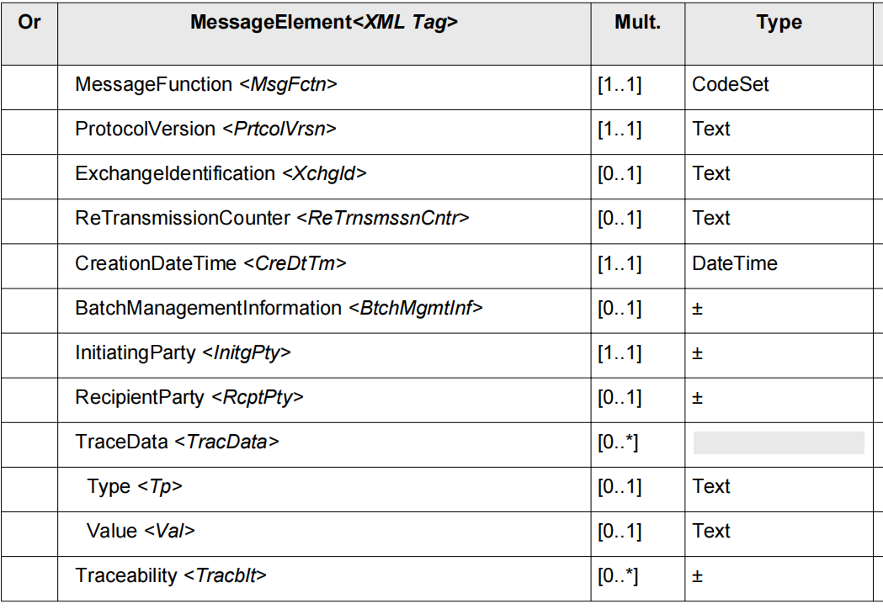

Body <Body>
Presence: [1..1]
Definition: Information related to the initiation of the settlement.
Body <Body> contains the following AdminstrativeInitiation1 elements

Or | MessageElement<XML Tag> | Mult. | Type
 | Environment <Envt> | [1..1] | EnvironmentXX
 | Acquirer | [0..1] | PartyIdentification240
 | Originator <Orgt> | [0..1] | PartyIdentification240
 | Sender <Sndr> | [0..1] | PartyIdentification240
 | Receiver <Rcvr> | [0..1] | PartyIdentification240
 | Destination <Dstn> | [0..1] | PartyIdentification240
 | Settlement Institution | [0..1] | PartyIdentification240
 | Payer | [0..1] | PartyIdentification239
 | Payee | [0..1] | PartyIdentification239
 | Terminal | [0..1] | Terminal4
 | Card <Card> | [0..1] | CardData6
 | Customer Device | [0..1] | CustomerDevice3
 | Token <Tkn> | [0..1] | Token2
 | Wallet | [0..1] | Wallet2
 | Cardholder | [0..1] | Cardholder17
 | Context <Cntxt> | [0..1] | Context17
 | TransactionContext <TxCntxt> | [0..1] | TransactionContext10
 | Transaction <Tx> | [1..1] | TransactionXXX
 | AdministrativeType<AdmTp>  TEXT - general text message  OTHP - Other Private  OTHN - Other National | [1..1] | CodeSet
 | OtherAdminstrativeType<OthrAdmTp> | [0..1] | Max35Text
 | MessageReason | [0..*] | ISOMessageReason
 | AlternateMessageReasons | [0..*] | AlternateMessageReason1
 | Code <Cd> | [0..1] | Max35Text
 | Description<Dspt> | [0..1] | Max256Text
 | TransactionIdentification <TxId> | [1..1] | TransactionIdentification12
 | SystemTraceAuditNumber <SysTracAudtNb> | [1..1] | Text
 | TransmissionDateTime <TrnsmssnDtTm> | [1..1] | ISODateTime
 | RetrievalReferenceNumber <RtrvlRefNb> | [0..1] | Text
 | LifeCycleTraceIdentificationData <LifeCyclTracIdData> | [0..1] | TransactionLifeCycleIdentification2
 | Identification <Id> | [1..1] | Text
 | TextMessage<TxtMsg> | [0..1] | Max100KText
 | AdministrativeData | [0..*] | AdministrativeData1
 | Type<Tp> | [0..1] | Max35Text
 | Data<Data> | [0..*] | AdditionalData1
 | ProtectData<PrtctdData> | [0..*] | ProtectedData1
 | SupplementaryData<SplmtryData> | [0..*] | SupplementaryData1

SecurityTrailer <SctyTrlr>
Presence: [0..1]
Definition: Trailer of the message containing a MAC.
SecurityTrailer <SctyTrlr> contains the following elements (see "ContentInformationType20" for details)
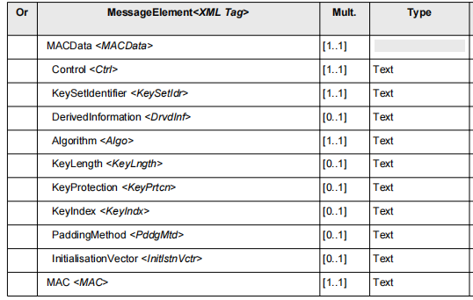

CR0982-1.2: Caad.009.001.01 AdministrativeResponseV01

Message Definition Functionality
The AdministrativeResponse message us usually sent by any party (processor, clearing or settlement agent) to any party in response to a AdministrativeInitiation Message.

Outline
The AdministrativeResposeV01 MessageDefinition is composed of 3 MessageBuildingBlocks:
A Header
Information related to the management of the protocol.
B Body
Information related to the initiation of the Administrative activity.
C SecurityTrailer
Trailer of the message containing a MAC

Message Definition Functionality
This section describes the MessageBuildingBlocks of this MessageDefinition.

Header<Hdr>
Presence: [1..1]
Definition: Information related to the management of the protocol.
Header <Hdr> contains the following elements (see "Header39" for details)

Body <Body>
Presence: [1..1]
Definition: Information related to the initiation of the settlement.
Body <Body> contains the following AdminstrativeResponse1 elements

Or | MessageElement<XML Tag> | Mult. | Type
 | Environment <Envt> | [1..1] | EnvironmentXX
 | Acquirer | [0..1] | PartyIdentification240
 | Originator <Orgt> | [0..1] | PartyIdentification240
 | Sender <Sndr> | [0..1] | PartyIdentification240
 | Receiver <Rcvr> | [0..1] | PartyIdentification240
 | Destination <Dstn> | [0..1] | PartyIdentification240
 | Settlement Institution | [0..1] | PartyIdentification240
 | Payer | [0..1] | PartyIdentification239
 | Payee | [0..1] | PartyIdentification239
 | Terminal | [0..1] | Terminal4
 | Card <Card> | [0..1] | CardData9
 | Customer Device | [0..1] | CustomerDevice3
 | Token <Tkn> | [0..1] | Token2
 | Wallet | [0..1] | Wallet2
 | Cardholder | [0..1] | Cardholder17
 | Context <Cntxt> | [0..1] | Context17
 | TransactionContext <TxCntxt> | [0..1] | TransactionContext10
 | Transaction <Tx> | [1..1] | TransactionXXX
 | AdministrativeType<AdmTp>  TEXT - general text message  OTHP - Other Private  OTHN - Other National | [1..1] | CodeSet
 | OtherAdminstrativeType<OthrAdmTp> | [0..1] | Max35Text
 | MessageReason | [0..*] | ISOMessageReason
 | AlternateMessageReasons | [0..*] | AlternateMessageReason1
 | Code <Cd> | [0..1] | Max35Text
 | Description<Dspt> | [0..1] | Max256Text
 | TransactionIdentification <TxId> | [1..1] | TransactionIdentification12
 | SystemTraceAuditNumber <SysTracAudtNb> | [1..1] | Text
 | TransmissionDateTime <TrnsmssnDtTm> | [1..1] | ISODateTime
 | RetrievalReferenceNumber <RtrvlRefNb> | [0..1] | Text
 | LifeCycleTraceIdentificationData <LifeCyclTracIdData> | [0..1] | TransactionLifeCycleIdentification2
 | Identification <Id> | [1..1] | Text
 | ProcessingResult <PrcgRslt> | [1..1] | ProcessingResultX
 | ProcessingEntity<PrcgNtty> | [0..1] | ApprovalEntity
 | ResultData <RsltData> | [1..1] | ResultData1
 | AdditionalInformation <AddtlInf> | [0..*] | AdditionalInformation20
 | ProtectData<PrtctdData> | [0..*] | ProtectedData1
 | SupplementaryData<SplmtryData> | [0..*] | SupplementaryData1

SecurityTrailer <SctyTrlr>
Presence: [0..1]
Definition: Trailer of the message containing a MAC.
SecurityTrailer <SctyTrlr> contains the following elements (see "ContentInformationType20" for details)

