**Business Justification**

**for the development of new ISO 20022 financial repository items**

1. **Name of the request:**

System Notification Messages

1. **Submitting organisation(s):**

Cross-Border Interbank Payment System (CIPS Co., Ltd.)

The Bund Square, 100 South Zhongshan Road,

Shanghai 200010,

China

1. **Scope of the new development:**

This submission is concerned with a set of messages related to the system notification of market infrastructure.

The following table outlines the financial instruments, business area and business process of this request.

|  |  |
| --- | --- |
| Financial Instruments | Administration |
| Business Area | Administration (admi) |
| Business Process | System Status Management |

In order to get the status notification of the system, we will submit the below seven messages:

* CCPSettlementNotification (Scenario 1）
* CCPSettlementNotification is sent from a market infrastructure to CCP to inform participants of market infrastructure about CCP settlement status such as accepted, pending etc. After receiving a RequestforCCPSettlement[1] message from CCP, the market infrastructure replies this message to CCP. The market infrastructure will also send a CCPSettlement[2] message to participants with more details about CCP settlement information such as bank transaction code, business type, transfer amount etc.
* AbandonNotification (Scenario 2)
* AbandonNotification is sent from a market infrastructure to a participant about any abandoned message and to inform the participant of the abandoned message information such as message header information. The abandoned message includes but not limited to unresolvable message content, non-exist initiator or receiver etc.
* SystemParametersChangeNotification (Scenario 3)
* SystemParametersChangeNotification is sent from a market infrastructure to all participants to inform any system parameter change, such as change type, common data type, common data code, common data value etc. After receiving the message, all Participants reply a ReceiptMessage[3] to the market infrastructure.
* AutomaticVerification (Scenario 4)
* AutomaticVerification is sent from a market infrastructure to all participants to inform them that the system connectivity checks are being performed. It is used to check the system connection between a market infrastructure and a participant. After receiving the message, all participants reply a ReceiptMessage to the market infrastructure.
* RequestForLogin/LogoffNotice (Scenario 5)
* RequestForLogin/LogoffNotice is sent from a participant to a market infrastructure for Login/Logoff operation. If a participant needs to perform system maintenance or is temporarily unable to send and receive business messages due to any other reason, the participant can send this message and set its status in the market infrastructure as Logoff for not sending and receiving business messages any longer. When ready to send and receive business messages after maintenance, the participant can log in the system again. After receiving the message, the market infrastructure replies an AnswerForLogin/Logoff message to the participant.
* AnswerForLogin/LogoffNotice (Scenario 6)
* AnswerForLogin/Logoff is sent from a market infrastructure to a participant after receiving a RequestForLogin/Logoff message from the participant and the market infrastructure conducts Login/Logoff operation for the participant.
* ForcedOfflineNotice (Scenario 7)
* ForcedOfflineNotice is used when the market infrastructure needs system maintenance. It is sent from a market infrastructure to a participant to inform that the participant has been forcibly logged off from the system. After receiving the message, the participants change their inner-bank system logging status to Logoff.

The following diagrams depict the System Notification messages flows:

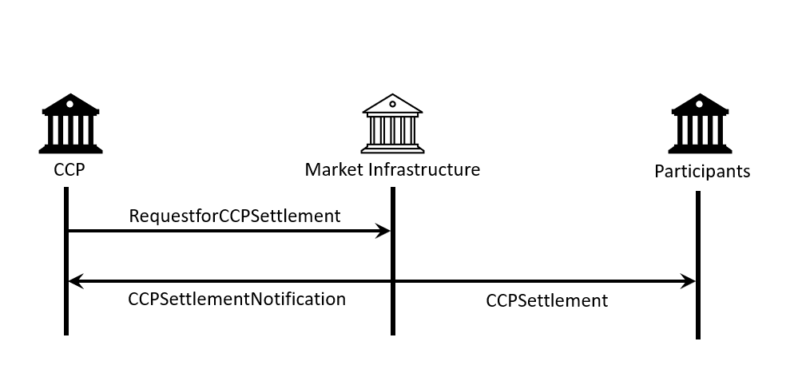

Scenario 1

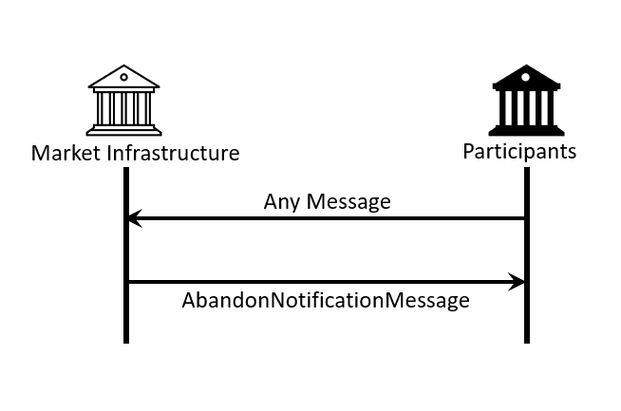

Scenario 2

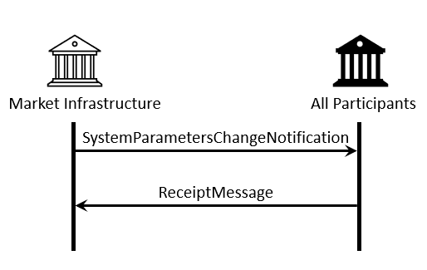

Scenario 3

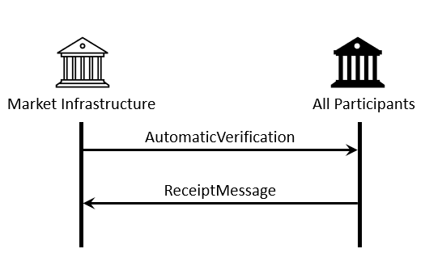

Scenario 4

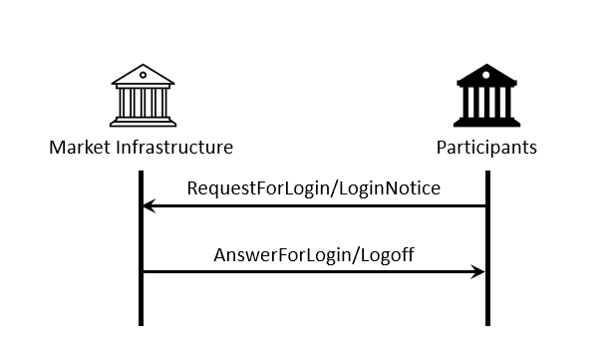

Scenario 5 & Scenario 6

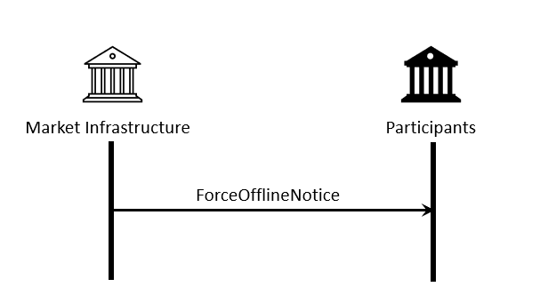

Scenario 7

CIPS proposes that the Payment SEG should be assigned the evaluation of the candidate ISO 20022 messages.

CIPS has considered not to use the ISO 20022 Business Application Header (BAH) and intends not to adopt the BAH with all of the proposed messages.

CIPS intends to deploy the future messages in the ISO 20022 XML syntax.

1. **Purpose of the new development:**

The purpose of developing new messages is to fulfil the lack of corresponding ISO 20022 message for system notice management. Currently, the need to get the notification of system cannot be satisfied because there is no corresponding ISO 20022 message to inform participants of any system change which also prohibits the implementation of ISO 20022 in the payment and settlement field. Thus, CIPS decides to pursue standardized and transparent messages to better manage the system.

Generic benefits to the industry are highlighted as follows:

* Standardise business process of system notification
* Satisfy the needs for specific business scenarios
* Develop ISO 20022 messages which can be implemented by market participants more easily and at a lower cost
* Ensure efficiency, accuracy and consistency of system notification

1. **Community of users and benefits:**

These messages are designed to address the needs of CIPS to inform participants of system notice but are designed to be capable of adoption in similar contexts by other organisations as well.

Benefits and savings:

* Participants: use of a common nomenclature and terminology among participants by adopting a single standard will enhance the efficiency and transparency of system notice when processing message in the field of payment and settlement.
* Market infrastructure: mediates communication between participants by providing system notice. Standardized format and business information will improve the efficiency and security of system notification.

Adoption scenario:

System Notification Messages were designed and successfully put into operation in CIPS system since 2015. They are currently being used by all CIPS participants. After this ISO 20022 submission has been approved, participants will continue to use these messages and the commonality of these messages will be improved.

Volumes:

As of December 2020, CIPS has more than a thousand participants using CIPS system for payment and settlement. More than 10,000 trades had been executed and use CIPS system for message transmissions on a daily basis. It is expected to be continued growth as the expanding scale of cross-border business and the growing demand for cross-border transactions.

Sponsors and adopters:

The adoption is advocated and designated as mandatory by CIPS and it is already deployed to all participants.

1. **Timing and development:**

CIPS plans to complete the message develop and registration process in Q3 2022.

The Business Justification will be submitted to the RA in October 2021 and seek approval by the RMG.

Candidate ISO 20022 message models and Message Definition Report will be developed and submitted to the RA in Q1 2022.

A pilot will be organized with CIPS participants to test the candidate message in May 2022. The purpose is to ensure that the documentation of the messages is accurate and consistent and to verify that the approved messages can be implemented with no adverse effects on communication infrastructures and applications.

Candidate ISO 20022 message models and Message Definition Report will be submitted for SEG(s) review and approval in June 2022.

We know that there is no other standard initiative involved in an effort to submit a Business Justification relating to system notification.

After the whole process is completed, this message can better serve participants and can be used in a more unified way.

1. **Commitments of the submitting organisation:**

CIPS confirms that it can and will:

* undertake the development of the candidate ISO 20022 business and message models that it will submit to the RA for compliance review and evaluation. The submission must be compliant with the [ISO 20022 Master Rules](http://www.iso20022.org/documents/general/ISO20022_MasterRules.ZIP) and include a draft Part 1 of the Message Definition Report (MDR) compliant with the [template for MDR part 1](http://www.iso20022.org/documents/general/ISO20022_MasterRules.ZIP) provided by the RA, the [ISO 20022 Message Transport Mode](http://www.iso20022.org/documents/general/MessageTransportModes.xls) (MTM) that CIPS recommends to consider with the submitted message set, and examples of valid instances of each candidate message;
* address any queries related to the description of the models and messages as published by the RA on the ISO 20022 website.

CIPS confirms that it will promptly inform the RA about any changes or more accurate information about the number of candidate messages and the timing of its submission to the RA. If CIPS does not submit the candidate messages within the timing announced in section F and does not inform the RA beforehand, the business justification may lapse and require re-submission of a new business justification for approval by the RMG.

CIPS confirms that it intends to organize any testing of the candidate messages once they have been reviewed and qualified by the RA and before its submission to the SEG(s) for approval. The testing is expected to complete in May 2022 and the candidate message will be re-submitted to the RA for SEG(s) approval. CIPS confirms that it will promptly inform the RA about any changes or more accurate information about the timing of this re-submission to the RA. If CIPS does not re-submit the candidate messages as announced and does not inform the RA beforehand, the business justification may lapse and require re-submission of a new business justification for approval by the RMG.

CIPS confirms that it is committed to undertake the future message maintenance.

CIPS confirms its knowledge and acceptance of the ISO 20022 Intellectual Property Rights policy for contributing organisations, as follows.

*“Organizations that contribute information to be incorporated into the ISO 20022 Repository shall keep any Intellectual Property Rights (IPR) they have on this information. A contributing organization warrants that it has sufficient rights on the contributed information to have it published in the ISO 20022 Repository through the ISO 20022 Registration Authority in accordance with the rules set in ISO 20022. To ascertain a widespread, public and uniform use of the ISO 20022 Repository information, the contributing organization grants third parties a non-exclusive, royalty-free license to use the published information”.*

1. **Contact persons:**

* Jiachen Xie xiejc@cips.com.cn

Staff- Standardization Department, CIPS

* Weiwei Shen sww@cips.com.cn +86 21 63120212

Assistant General Manager - Standardization Department, CIPS

1. **Comments from the RMG members and relevant SEG(s) or SubSEG(s) and disposition of comments by the submitting organisation:**

This section will include the comments received from RMG members and the SEG(s) or SubSEG(s), if any, and the response given to each of these comments by the submitting organisation.

1. RequestforCCPSettlement is sent from central counterparty to a market infrastructure after a deal is made between two participants of the market infrastructure. The message identifier of it is pacs.009.001.06.
2. CCPSettlement is sent from a market infrastructure to participants with settlement information such as bank transaction, transfer amount etc. The message identifier of it is camt.054.001.06.
3. ReceiptMessage is sent by the transaction administrator to a member of the system to acknowledge the receipt of one or multiple messages sent previously. The message identifier of it is camt.025.001.03(Receipt V05)