Maintenance Change Request
for fast track maintenance of existing message definitions
- Submitting organization(s):
European Securities and Markets Authority (ESMA)
201-203 rue de Bercy
F - 75012 Paris

- Related messages:
auth.016.001.01_FinancialInstrumentReportingTransactionReport

- Purpose of the change:
Based on request from National Competent Authorities (NCAs), in order to cope with the need to add new values in the field ExchangeReason using type AuthorityExchangeReason1Code, ESMA proposes the implementation of the following improvements in the messages and systems supporting the regulation:
- For the purpose of more complete transactions exchange between NCAs, new exchange reasons need to be added
- For ensuring easier future changes, the proposal is to change in the base message the field to a free text field defined as an external code set and published in an external list.
- Urgency of the request:
As this improvement will facilitate transaction reporting exchange between NCAs and allow them to enhance their quality checks, ESMA aims at providing the new schema end of Q2 for NCAs to implement the change in H2 and be ready for 01/01/2022, when new reporting system enters into force.
Since the optional Technical Attributes parent element that includes the ExchangeReason element is removed for the message sent by reporting entities, only NCAs and ESMA will be affected by the new schema.

- Commitments of the submitting organization:
The ESMA TREM project team confirms that it plans to develop a new version of the impacted systems in accordance to the changes proposed in this document.

- Contact persons:
Stephanie Gosso – stephanie.gosso@esma.europa.eu
Christophe Hasle – christophe.hasle@esma.europa.eu

Change requested

- Related messages:
auth.016.001.01_FinancialInstrumentReportingTransactionReport

- Description of the change and type of impact:
Based on request from National Competent Authorities (NCAs), in order to cope with the need to add new values in the element ExchangeReason, ESMA proposes the implementation of the following improvements in the messages and systems supporting the regulation:
In message auth.016.001.01_FinancialInstrumentReportingTransactionReport, element type for element “Exchange reason” is changed from AuthorityExchangeReason1Code to ExternalAuthorityExchangeReasonCode which is max 4 character text type.
Unlike other ISO 20022 code sets, these codes will not be included in the message schema with the message element they type. The purpose of externalising these codes is to be able to update the code sets (for example, add new codes) without impacting the messages themselves and, hence, without requiring the development of a new version of the messages that use these code sets. These codes will be published in a spreadsheet at https://www.iso20022.org/catalogue-messages/additional-content-messages/external-code-sets.

- Proposed implementation:
1/ Creation of new external code set ExternalAuthorityExchangeReasonCode derived into ExternalAuthorityExchangeReason1Code
Creation of RecordTechnicalData5 where Exchange Reason type is changed from AuthorityExchangeReason1Code to ExternalAuthorityExchangeReason1Code
Creation of SecuritiesTransactionReport6, using RecordTechnicalData5 instead of RecordTechnicalData1
Creation of ReportingTransactionType2Choice, using SecuritiesTransactionReport6 instead of SecuritiesTransactionReport4
Creation of FinancialInstrumentReportingTransactionReportV02, using ReportingTransactionType2Choice instead of ReportingTransactionType1Choice

Approved message | Proposed change
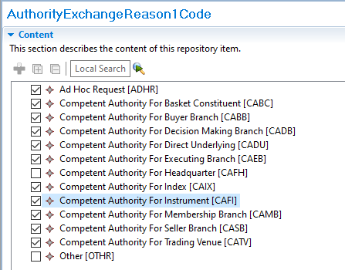  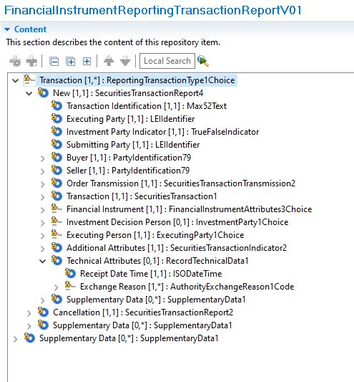 |  | 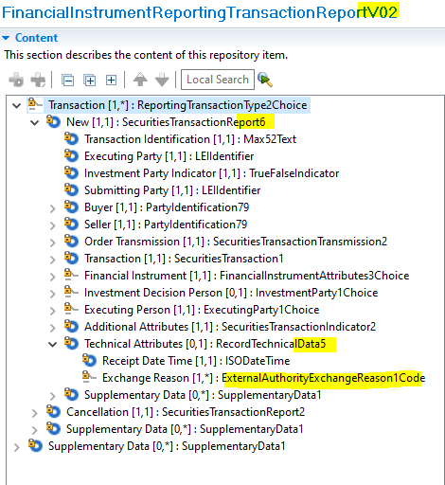  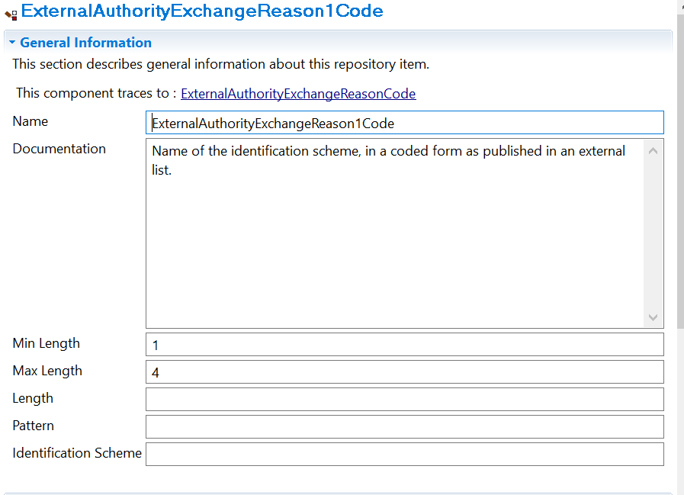

- Decision of the SEG(s):
This section is not to be taken care of by the submitting organization. It will be completed in due time by the SEG(s) in charge of the related ISO 20022 message definitions.

Change
approved
rejected
Comments:

Timing
- Fast track maintenance
(the change justifies an urgent implementation using the fast track maintenance process)
- At the occasion of the next maintenance of the messages
(the change will be considered for implementation, but does not justify an urgent implementation – will be pending until the next [yearly] maintenance of the messages)

