Standards
Standards MT Release 2020
ISO 20022 maintenance cycle 2019/2020
Maintenance Change Request – Maintenance Working Group DRAFT Minutes
Corporate Actions
Distribution: Corporate Actions Maintenance Working Group
Author: Jacques Littré

Date Issued: September 5, 2019
Meeting Date: August 21, 2019
Version: 1.0 (Final)
Table of Contents
1 Introduction 3
ISO 15022 – 20022 Maintenance Process 3
Standards Illustrations in this document 3
SR 2020 change requests 3
CR Title Colour notation (for minutes only) 3
Contact persons regarding this document 3
CA MWG Members for SR2020 3
2 Overview of User Change requests 5
2.1 CR 001530: Removal of Event PRII 5
2.2 CR 001518: Change Name & Definition of CDFI Code and Amount 10
2.3 CR 001529: Add Web Address Narrative for Corporate Actions notifications 22
2.4 CR 001531: Change character set to allow e-mail address details for BO 26
2.5 CR 001551: Add Tax Rate in Instruction for Tax Breakdown 29
2.6 CR 001533: Add code for OPTF in DTCH events 38
2.7 CR 001517: Add “Market Infrastructure Transaction Identification” (MITI) Reference in Confirmation 44
2.8 CR 001552: Add MCER Reason Code to Event Processing Status Pending (ISO20022 – CR0814) 50
2.9 CR 001553: Remove Meeting Option Types from CA Messages (ISO 20022 – CR0815) 52

Introduction

ISO 15022 – 20022 Maintenance Process
As from the year 2012, a joint maintenance process has been put in place for ISO 20022 and 15022 and Corporate Action messages with the support of the ISO 20022 RMG and of the SWIFT Board.
This joint maintenance will ensure interoperability between the two standards and a more efficient maintenance process.

Standards Illustrations in this document
Standards illustrations are provided by SWIFT Standards. They are not part of the original request.
Any standard illustrations (rules, codes, qualifiers, wordings) are only for illustration purposes. It does not mean SWIFT Standards is in agreement with the maintenance request or that the final standards solutions (for accepted maintenance requests) will be as shown in this document.
The MT Standards Release Guide (+ potential erratum) and the ISO 20022 message definition reports are the ONLY source of reliable information based on which implementation of changes should be made. Any other documentation (including this one) is subject to change.

SR 2020 change requests
This document contains all CA MT/MX CRs for MT category 5 and equivalent MX messages investigated this year for implementation in SR 2020.
The requests originator is indicated as follows:
  - Requesting Country; Country code of requesting NMPG or UG; eg. BE
  - Requesting Group: a SWIFT User Group or a National (Securities) Market Practice Group with the acknowledgement of the UGC or Recognized industry group eg. SMPG (the global Securities Market Practice Group)

CR Title Colour notation (for minutes only)
In GREEN are items that are approved or approved with comments or approved with alternative solution.
In RED are items that are rejected, postponed, withdrawn or linked to agreed items

Contact persons regarding this document
Jacques Littré – SWIFT Standards; jacques.littre@swift.com

CA MWG Members for SR2020
The following people are part of the CA MWG for SR2020.
- Narelle Rutter - AU
- Véronique Peeters - BE
- Michael Blumer - CH
- Daniel Schäfer - DE
- Jean-Pierre Klak – FR
- James Mullens - HK
- Catarina Marques - LU
- Jyi-Chen Chueh - SG
- Mariangela Fumagalli – UK
- Paul Fullam - US/ISITC
- Jean-Paul Lambotte – XS
- Jacques Littré – SWIFT, MWG Chair

Note also that the following people attend usually the CA MWG meeting as the representatives from the ISO 20022 Securities SEG:
- Christine Strandberg – ISO 20022 Securities SEG (SE)
- Steven Sloan – ISO 20022 Securities SEG (US)

Overview of User Change requests

CR 001530: Removal of Event PRII
Origin of request
Requesting Group: | SMPG
Sponsors
SMPG CA WG members
Message type(s) impacted
(CA) MT 564, MT 565, MT 566, MT 567, MT 568
(SnR) MT 508, MT 536, MT 537, MT 538, MT 575
(CA) seev.031, seev.032, seev.033, seev.034, seev.035, seev.036, seev.037, seev.039, seev.040, seev.041, seev.042, seev.044
(SnR) semt.015, semt.016, semt.017, semt.018
Complies with regulation
None
Business impact of this request
LOW
Commitment to implement the change
Number of messages sent and received: 3000000
Percentage of messages impacted: 1
Commits to implement and when: SMPG members previously using PRII 2020
Business context
The SMPG would like to remove the Interest Payment with Principal event type code (PRII: An event which consists of two components, the decrease of the amortized value of a pool factor security and an interest payment.) removed from the ISO 15022 / ISO 20022 standards. The SMPG has for many years recommended that markets not use this event type, and instead process an interest payment and a partial redemption in two separate events as this make processing and reconciliation of the event proceeds much easier - especially in markets where the interest payment may be subject to withholding tax, but not the capital repayment/partial redemption. The only SMPG member that has reported usage of this in its market practice has been the US. Now that the US CSD and market have stopped using the event type, we believe it should be removed.
Nature of change
Deletion of the Interest Payment with Principal event type code (PRII: An event which consists of two components, the decrease of the amortized value of a pool factor security and an interest payment.) from the ISO 15022 / ISO 20022 standards.
Workaround
N/A since we are proposing a deletion of a code.
Examples
N/A since we are proposing a deletion of a code. The US market was the last market (known to the global SMPG) that used to process interest payments and partial redemptions as combined events. All SMPG member countries report that their markets now process these events as separate events, i.e. one INTR event and one PCAL/PRED event.

SWIFT Comment

PRII usage on FIN between August 2018 and January 2019 reached about 1.5 Millions of occurrences. According to information from some SMPG members, usage should be primarily in NZ, AU and IL.

Standards Illustration

1. ISO 15022 Illustration
1. In all MT56x messages, in sequence A, in field 22F::CAEV, delete the code Interest Payment with Principal (PRII) as illustrated below:

MT 564 Field Specifications

5. Field 22F: Indicator

FORMAT
Option F | :4!c/[8c]/4!c | (Qualifier)(Data Source Scheme)(Indicator)

PRESENCE
Mandatory in mandatory sequence A

QUALIFIER
(Error code(s): T89)
Order | M/O | Qualifier | R/N | CR | Options | Qualifier Description
1 | O | CAEP | N |  | F | Corporate Action Event Processing
2 | M | CAEV | N | C4, C6, C10, C11 | F | Corporate Action Event Indicator
3 | M | CAMV | N |  | F | Mandatory/Voluntary Indicator

DEFINITION
This qualified generic field specifies:
CAEP | Corporate Action Event Processing | Type of processing involved by a Corporate Action.
CAEV | Corporate Action Event Indicator | Specifies the type of corporate event.
CAMV | Mandatory/Voluntary Indicator | Specifies whether the event is mandatory, mandatory with options or voluntary.

CODES
If Qualifier is CAEV and Data Source Scheme is not present, Indicator must contain one of the following codes (Error code(s): K22):
ACCU | Accumulation | Funds related event in which the income (for example accumulation units) that accrues during an accounting period is retained within the fund instead of being paid away to investors. The retained income is nonetheless deemed to have been distributed to investors for tax purposes.
…..
PPMT | Instalment Call | An instalment towards the purchase of equity capital, subject to an agreement between an issuer and a purchaser.
PRED | Partial Redemption With Pool Factor Reduction | Securities are redeemed in part before their scheduled final maturity date. The redemption is reflected in a pool factor reduction. No movement of securities occurs.
PRII | Interest Payment with Principal | An event which consists of two components, the decrease of the amortized value of a pool factor security and an interest payment.
PRIO | Priority Issue | Form of open or public offer where, due to a limited amount of securities available, priority is given to existing shareholders.
REDM | Final Maturity | The redemption of an entire issue outstanding of securities, for example, bonds, preferred equity, funds, by the issuer or its agent, for example, asset manager, at final maturity.
…..
XMET | Extraordinary or Special General Meeting | Extraordinary or special general meeting.

Apply the same change in the qualifier :22F::CAEV in the following messages:
- MT508 sequence B,
- MT536 subsequence B1a2
- MT537 subsequence B2b, C2
- MT538 subsequence B2a
- MT575 subsequence B1a2, B1a3, C2

2. ISO 20022 Illustration
Create new versions of the 5 following data type code lists in which the PRII code value has been removed:
CorporateActionEventType20Code,
CorporateActionEventType25Code,
CorporateActionEventType26Code,
CorporateActionEventType27Code,
CorporateActionEventType28Code

This will trigger the change in all seev messages from seev.031 to seev.044, (except in seev.038), in the data type of the CorporateActionGeneralInformation/EventType/Code elements (or of the AccountAndStatementDetails/CorporateActionEventAndBalance/GeneralIndformation/EventType/Code element for the seev.042.001.04 message) as well as in the MX messages semt.015, semt.016, semt.017, semt.018 where PRII is used.
Illustration of the removal in the seev.031 (CANO) message here below:
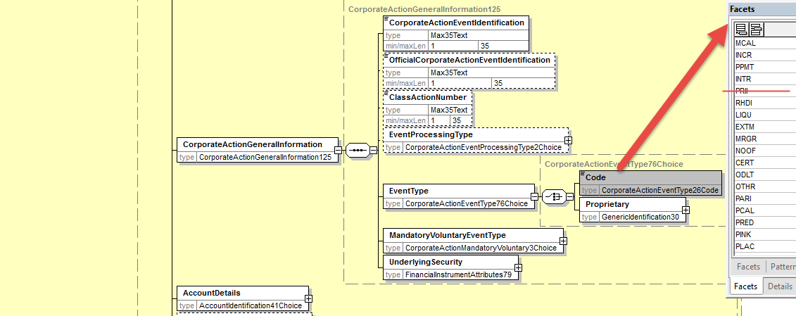

Working Group Meeting

Discussion
To the exception of Australia, the business case is fully supported by all countries and the ISO 20022 SEG representatives. Australia argues that there is still a substantial usage of the PRII event in AU and NZ, even though the event type is not official market practice, and therefore it should not be removed yet.
However, the rest of the MWG agrees that the SMPG market practice recommending to no longer use the PRII event and instead to use the 2 events (PCAL or PRED + INT) has been there for many years (at least for 7/8 years) and that the PRII event which was primarily a US event is no longer supported by ISITC in the US market practice either.
A big majority of the MWG members are in favour of enforcing the removal of the PRII event globally to be in line with the established market practice in the chain of intermediaries.
Since there is no consensus reached in the MWG meeting, the MWG resolves to go to a vote.
The MWG finally approves the removal of the PRII event by 10 votes in favour and 1 vote against (AU).
Decision
Approved.
Final decision of the Securities SEG regarding ISO 20022 messages:
Approve the MWG decision | approved
Comments:

Reject the MWG decision
Reason for rejection:

CR 001518: Change Name & Definition of CDFI Code and Amount
Origin of request
Requesting Country: | ZA South Africa
Requesting Group: | NMPG
Sponsors
SMPG, SMPG Tax Subgroup and Australia
Message type(s) impacted
MT 564, MT 566, seev.031, seev.035, seev.036
Complies with regulation
None
Business impact of this request
The impact will be minimal to none as the change request is for a definition change. The CDFI (Conduit Foreign Income) rate type and amount is already in use and the requested definition change broadens it to be more globally acceptable/applicable.
Commitment to implement the change
Number of messages sent and received: 30000
Percentage of messages impacted: 1
Commits to implement and when: ZA in 2020
Business context
The South African market has for some time now been exploring to identify an indicator that would allow for distinguishing between a foreign and local dividend. It is imperative to make this distinction as taxes withheld abroad on a foreign dividend could be allowed as a rebate on the shareholder’s South African tax obligation. Furthermore, a non-resident shareholder may file the required certification to be exempt from South African taxes on a foreign dividend.
A dividend will be classified as a foreign when it is paid from outside the borders of South Africa.
South Africa’s investigations began with the possible usage of the COIN qualifier (Country of Income Source) that was introduced in 2016. However, SMPG advised that the way South Africa was intending to use COIN did not align to the reason it was introduced. COIN can be used where there are multiple distributions and not where there is a single distribution as in a dividend distribution.
Australia, at the Sydney meeting, then suggested that South Africa consider CDFI (Conduit Foreign Income Amount) that was part of the SRG 2018 changes. The South African Workgroup considered usage of the CDFI code and agreed that the code meets the market’s requirements. However, there was a request to investigate the usage of ITYP (Income Type). This qualifier is being used by some countries and as far as investigations indicate due to the nature of the particular security in those markets, it makes sense to utilize these qualifiers. The usage of the ITYP qualifier also requires the applicable country to publish the codes to be used on the SMPG website. The requirement to distinguish between a foreign and local dividend would need a maximum of 2 codes, e.g. 1. Local dividend and 2. Foreign dividend.
South Africa is currently using the REES code (Real Estate Property Income Portion) to indicate that the distribution emanates from a REIT security (Real Estate Investment Trust). The CDFI code is on the same list. Therefore, the least impact route to distinguish between a foreign and local dividend would be to use CDFI. Furthermore, it would prove to be less costly and less effort from a maintenance perspective.
The CDFI code will enhance communication and enable tax and entitlement computation.
Nature of change
The CDFI code seems to align specifically to Australia. South Africa would thus like to propose a change to allow for the code to be used more widely.
Current Definition
CDFI - Conduit Foreign Income - Rate relating to a conduit foreign income type
Proposed Change
CDFI - Foreign Income - Rate relating to a foreign income type such as conduit foreign income.
Workaround
Currently there is no agreed identifier/indicator that allows for distinguishing between a local and foreign dividend. Thus this information is communicated in the narrative (ADTX) of the MT 564. It can also be argued that this piece of information is "hidden" in the narrative and therefore could be missed. The usage of the CDFI rate type and amount will immediately indicate on the MT 564 and MT 566 that the dividend is of a foreign nature.
Examples
Example 1
A company incorporated in South Africa with the same tax jurisdiction declares and pays a dividend. The cash dividend will be paid from South Africa; i.e. local dividend.

Security Firstrand Limited
ISIN ZAE000066304
Gross Rate ZAR1.36
Withholding Tax Rate (TAXR) 20%
Second Level Tax (WITL) 0
Net Rate ZAR1.088
Country from which dividend is being paid South Africa (ZA)
Eligibility 1,000

SWIFT SAMPLE
MT 564
:16R:CAOPTN
:13A::CAON//001
:22F::CAOP//CASH
:11A::OPTN//ZAR
:17B::DFLT//Y
:16R:CASHMOVE
:22H::CRDB//CRED
:98A::PAYD//2019XXXX
:92J::GRSS//ZAR1.36
:92J::NETT//ZAR1.088
:92A::TAXR//0,
:16S:CASHMOVE
:16S:CAOPTN

MT 566
16R:CACONF :
13A::CAON//001
:22F::CAOP//CASH
:11A::OPTN//ZAR
:16R:CASHMOVE
:22H::CRDB//CRED
:97A::CASH//1234XXXX
:19B::PSTA//ZAR1088,
::98A::POST//2019XXX
:98A::VALU//2019XXX
:98A::PAYD//2019XXX
::16S:CASHMOVE
:16S:CACONF

Example 2
A United Kingdom (UK) company has its primary listing on the London Stock Exchange and maintains a secondary listing on the JSE and declares a dividend. The dividend will be paid from the United Kingdom to shareholders on the South African register, i.e. dividend is foreign.

Security Investec Plc
ISIN GB00B17BBQ50

Gross Rate ZAR0.1998734
Withholding Tax Rate (TAXR) 0
Second Level Tax (WITL) 20%
Net Rate ZAR0.15989872
Country from which dividend is being paid United Kingdom (UK)
Foreign Dividend (paid from a source outside of South Africa) Yes
Eligibility 1,000

SWIFT SAMPLE
MT 564
:16R:CAOPTN
:13A::CAON//001 :22F::CAOP//CASH :11A::OPTN//ZAR
:17B::DFLT//Y
:16R:CASHMOVE
:22H::CRDB//CRED
:98A::PAYD//2019XXXX
:92J::GRSS//CDFI/ZAR0.1998734
:92J::NETT//CDFI/ZAR0.15989872
:92A::TAXR//0,
:92A::WITL//20,
:16S:CASHMOVE
:16S:CAOPTN

MT 566
16R:CACONF :
13A::CAON//001
:22F::CAOP//CASH
:11A::OPTN//ZAR
:16R:CASHMOVE
:22H::CRDB//CRED
:97A::CASH//1234XXXX
:19B::PSTA//ZAR159.90
:19B::CDFI//ZAR159.90
::98A::POST//2019XXX
:98A::VALU//2019XXX
:98A::PAYD//2019XXX
::16S:CASHMOVE
:16S:CACONF

Example 3
A United Kingdom (UK) company has its primary listing on the London Stock Exchange and maintains a secondary listing on the JSE and declares a dividend. The dividend will be paid from the United Kingdom to shareholders on the South African register, i.e. dividend is foreign.
DETAIL
Security Old Mutual Plc
ISIN GB00B77J0862

Gross Rate ZAR0.6535371
Withholding Tax Rate (TAXR) 15%
Second Level Tax (WITL) 5%
Net Rate ZAR0.5228297
Country from which dividend is being paid United Kingdom (UK)
Eligibility 1,000
Foreign Dividend (paid from a source outside of South Africa) Yes

SWIFT SAMPLE
MT 564
:16R:CAOPTN
:13A::CAON//001
:22F::CAOP//CASH
:11A::OPTN//ZAR
:17B::DFLT//Y
:16R:CASHMOVE
:22H::CRDB//CRED
:98A::PAYD//2019XXXX
:92J::GRSS//CDFI/ZAR0.6535371
:92J::NETT//CDFI/ZAR0.5228297
:92A::TAXR//15,
:92A::WITL//5,
:16S:CASHMOVE
:16S:CAOPTN

MT 566
16R:CACONF
:13A::CAON//001
:22F::CAOP//CASH
:11A::OPTN//ZAR
:16R:CASHMOVE
:22H::CRDB//CRED
:97A::CASH//1234XXXX
:19B::PSTA//ZAR522.83
:19B::CDFI//ZAR522.83
:98A::POST//2019XXX
:98A::VALU//2019XXX
:98A::PAYD//2019XXX
::16S:CASHMOVE
:16S:CACONF

Example 4
A company incorporated in the United Arab Emirates, maintains its primary listing on the London Stock Exchange with a secondary listing on the JSE, declares and pays a dividend. The dividend to shareholders on the South African register will be funded from two payment sources, firstly from South African operations and then a top up payment from the UK. The dividend in this case is being funded from two countries and thus one cash rate paid from the UK will be a foreign dividend and another from South Africa a local dividend. The market announcement must communicate the two countries from where the dividend is paid.

Security MEDICLINIC INTERNATIONAL PLC
ISIN GB00B8HX8Z88
Gross Rate ZAR2.25
Split ZAR1.2115385 (local)
ZAR1.0384615 (foreign)
Local component
Gross Rate ZAR1.2115385
Withholding Tax Rate (TAXR) 20%
Second Level Tax (WITL) 0
Net Rate ZAR0.9692308
Country from which dividend is being paid South Africa (ZA)
Foreign Dividend (paid from a source outside of South Africa) No

Foreign component
Gross Rate ZAR1.0384615
Withholding Tax Rate (TAXR) 0
Second Level Tax (WITL) 20%
Net Rate ZAR0.8307692
Country from which dividend is being paid United Kingdom (GB)
Foreign Dividend (paid from a source outside of South Africa) Yes
Eligibility 1,000

SWIFT SAMPLE (local)
MT 564
:16R:CAOPTN
:13A::CAON//001
:22F::CAOP//CASH
:11A::OPTN//ZAR
:17B::DFLT//Y
:16R:CASHMOVE
:22H::CRDB//CRED
:98A::PAYD//2019XXXX
:92J::GRSS//ZAR1.2115385
:92J::NETT//ZAR0.9692308
:92A::TAXR//20,
:16S:CASHMOVE
:16S:CAOPTN

MT 566
16R:CACONF :
13A::CAON//001
:22F::CAOP//CASH
:11A::OPTN//ZAR
:16R:CASHMOVE
:22H::CRDB//CRED
:97A::CASH//1234XXXX
:19B::PSTA//ZAR969.23
:98A::POST//2019XXX
:98A::VALU//2019XXX
:98A::PAYD//2019XXX
:16S:CASHMOVE
:16S:CACONF

SWIFT SAMPLE (foreign)
MT 564
:16R:CAOPTN
:13A::CAON//001
:22F::CAOP//CASH
:11A::OPTN//ZAR
:17B::DFLT//Y
:16R:CASHMOVE
:22H::CRDB//CRED
:98A::PAYD//2019XXXX
:92J::GRSS//CDFI/ZAR1.0384615
:92J::NETT//CDFI/ZAR0.8307692
:92A::TAXR//0,
:92A::WITL//20,
:16S:CASHMOVE
:16S:CAOPTN

MT 566
16R:CACONF :
13A::CAON//001
:22F::CAOP//CASH
:11A::OPTN//ZAR
:16R:CASHMOVE
:22H::CRDB//CRED
:97A::CASH//1234XXXX
:19B::PSTA//ZAR830,77
:19B::CDFI//ZAR830,77
:98A::POST//2019XXX
:98A::VALU//2019XXX
:98A::PAYD//2019XXX
:16S:CASHMOVE
:16S:CACONF

SWIFT Comment

Shouldn’t we change accordingly also the name and definition of the CDFI amount which is in the cash movement sequence ?

Standards Illustration

1. ISO 15022 Illustration
1. In the MT 564 in sequence E and E2 and in the MT 566 in sequence D and D2, amend the name and the definition of the Rate Type Code CDFI (Conduit Foreign Income) that can be used as a rate type code for the Gross Dividend Rate GRSS and Nett Dividend Rate NETT as illustrated here below:

MT 564 Field Specifications

64. Field 92a: Rate

FORMAT
Option A | :4!c//[N]15d | (Qualifier)(Sign)(Rate)
Option B | :4!c//3!a/3!a/15d | (Qualifier)(First Currency Code)(Second Currency Code)(Rate)
Option F | :4!c//3!a15d | (Qualifier)(Currency Code)(Amount)
Option H | :4!c//3!a15d/4!c | (Qualifier)(Currency Code)(Amount)(Rate Status)
Option J | :4!c/[8c]/4!c/3!a15d[/4!c] | (Qualifier)(Data Source Scheme)(Rate Type Code)(Currency Code)(Amount)(Rate Status)
Option K | :4!c//4!c | (Qualifier)(Rate Type Code)
Option R | :4!c/[8c]/4!c/15d | (Qualifier)(Data Source Scheme)(Rate Type Code)(Rate)

PRESENCE
Optional in optional sequence E

QUALIFIER
(Error code(s): T89)
Order | M/O | Qualifier | R/N | CR | Options | Qualifier Description
1 | O | GRSS | R | C7, C8 | F, H, J, or K | Gross Dividend Rate
2 | O | TAXR | R | C7, C8, C19 | A, F, K, or R | Withholding Tax Rate
3 | O | ATAX | N |  | A, F, or K | Additional Tax
4 | O | INDX | N |  | A, F, or K | Index Factor
5 | O | OVEP | N |  | A or K | Maximum Allowed Oversubscription Rate
6 | O | PROR | N |  | A or K | Pro-Ration Rate
7 | O | INTP | R |  | A, F, J, or K | Interest Rate Used for Payment
8 | O | TDMT | R |  | J | Taxable Income Per Dividend/Share
9 | O | NETT | R | C7, C8 | F, H, J, or K | Net Dividend Rate
10 | O | IDFX | N |  | B | Issuer Declared Exchange Rate
11 | O | TXIN | N |  | A, F, or K | Tax on Income
12 | O | WITL | R | C7, C8 | A, F, K, or R | Second Level Tax

DEFINITION
This qualified generic field specifies:
ATAX | Additional Tax | Rate used for additional tax that cannot be categorised.
GRSS | Gross Dividend Rate | Cash dividend amount per equity before deductions or allowances have been made.
IDFX | Issuer Declared Exchange Rate | Exchange rate (provided by the issuer) between the dividend or interest rate in the paid currency and the declared dividend or interest rate.
INDX | Index Factor | Public index rate applied to the amount paid to adjust it to inflation.
INTP | Interest Rate Used for Payment | The actual interest rate used for the payment of the interest for the specified interest period.
NETT | Net Dividend Rate | Cash dividend amount per equity after deductions or allowances have been made.
OVEP | Maximum Allowed Oversubscription Rate | A maximum percentage of shares available through the over subscription privilege, usually a percentage of the basic subscription shares, for example, an account owner subscribing to 100 shares may over subscribe to a maximum of 50 additional shares when the over subscription maximum is 50%.
PROR | Pro-Ration Rate | Percentage of securities accepted by the offeror/issuer.
TAXR | Withholding Tax Rate | Percentage of a cash distribution that will be withheld by the tax authorities of the jurisdiction of the issuer, for which a relief at source and/or reclaim may be possible.
TDMT | Taxable Income Per Dividend/Share | Amount included in the dividend/NAV that is identified as gains directly or indirectly derived from interest payments, for example, in the context of the EU Savings directive.
TXIN | Tax on Income | Overall tax withheld at source by fund managers prior to considering the tax obligation of each unit holder.
WITL | Second Level Tax | Rate at which the income will be withheld by a jurisdiction other than the jurisdiction of the issuer's country of tax incorporation, for which a relief at source and/or reclaim may be possible. It is levied in complement or offset of the withholding tax rate (TAXR) levied by the jurisdiction of the issuer's tax domicile.

CODES
In option J, if Qualifier is GRSS and Data Source Scheme is not present, Rate Type Code must contain one of the following codes (Error code(s): K92):
CAPO | Capital Portion | Rate relating to the underlying security for which capital is distributed.
CDFI | Conduit Foreign Income | Rate relating to a conduit foreign income type such as conduit foreign income.
FLFR | Fully Franked | Rate resulting from a fully franked dividend paid by a company; rate includes tax credit for companies that have made sufficient tax payments during fiscal period.
INCO | Income Portion | Rate relating to the underlying security for which income is distributed.
INTR | Interest | Rate relating to the underlying security for which interest is paid.
LTCG | Long Term Capital Gain | Long term capital gain.
REES | Real Estate Property Income Portion | Rate of income distribution originated by real estate investment.
SOIC | Sundry/Other Income | Rate relating to the underlying security for which other income is paid.
STCG | Short Term Capital Gain | Short term capital gain.
TXBL | Taxable Portion | Rate relating to the underlying security for which tax is charged.
TXDF | Tax Deferred | Rate relating to the underlying security for which tax is deferred.
TXFR | Tax Free | Rate relating to the underlying security which is not taxable.
UNFR | Unfranked | Unfranked.

2. In the MT 564 in sequence E2 and in the MT 566 sequence D2, amend the name and the definition of the CDFI (Conduit Foreign Income) amount as illustrated here below:

MT 564 Field Specifications

93. Field 19B: Amount

FORMAT
Option B | :4!c//3!a15d | (Qualifier)(Currency Code)(Amount)

PRESENCE
Conditional (see rule C2) in optional subsequence E2

QUALIFIER
(Error code(s): T89)
Order | M/O | Qualifier | R/N | CR | Options | Qualifier Description
1 | O | ENTL | N |  | B | Entitled Amount
2 | O | RESU | N |  | B | Resulting Amount
…..
45 | O | DEEM | N |  | B | Deemed Amount
46 | O | CDFI | N |  | B | Conduit Foreign Income Amount
….
49 | O | DEIT | N |  | B | Deemed Interest Amount
50 | O | DERY | N |  | B | Deemed Royalties Amount

DEFINITION
This qualified generic field specifies:
ACRU | Accrued Interest Amount | Amount of interest that has been accrued in between coupon payment periods.
ATAX | Additional Tax Amount | Amount of additional taxes that cannot be categorised.
BWIT | Back Up Withholding Tax Amount | Amount of tax related to back up withholding.
CAPG | Capital Gains Amount | Amount of money distributed as the result of a capital gain.
CDFI | Conduit Foreign Income Amount | Amount relating to a conduit foreign income such as a conduit foreign income.
CHAR | Charges/Fees Amount | Amount of money paid for the provision of financial services that cannot be categorised by another qualifier.
…..
WITL | Second Level Tax Amount | Amount of money withheld by the jurisdiction other than the jurisdiction of the issuer's country of tax incorporation, for which a relief at source and/or reclaim may be possible. It is levied in complement or offset of the withholding tax rate (TAXR) levied by the jurisdiction of the issuer's tax domicile.

2. ISO 20022 Illustration
1. In the seev.031 (CANO – CorporateActionNotification), in the element Code in sequence CorporateActionOptionDetails/RateAndAmountDetails/GrossDividendRate/RateTypeAndAmountAndRateStatus/RateType,

And in sequence CorporateActionOptionDetails/RateAndAmountDetails/NettDividendRate/RateTypeAndAmountAndRateStatus/RateType,

And in sequence CorporateActionOptionDetails/CashMovementDetails/RateAndAmountDetails/GrossDividendRate/RateTypeAndAmountAndRateStatus/RateType,

And in sequence CorporateActionOptionDetails/CashMovementDetails/RateAndAmountDetails/NettDividendRate/RateTypeAndAmountAndRateStatus/RateType,

And in the seev.035 (CAPA – CorporateActionMovementPreliminartyAdvice) in the element Code in sequence CorporateActionMovementDetails/RateAndAmountDetails/GrossDividendRate/RateTypeAndAmountAndRateStatus/RateType,

And in sequence CorporateActionMovementDetails/RateAndAmountDetails/NettDividendRate/RateTypeAndAmountAndRateStatus/RateType,

And in sequence CorporateActionMovementDetails/CashMovementDetails/RateAndAmountDetails/GrossDividendRate/RateTypeAndAmountAndRateStatus/RateType,

And in sequence CorporateActionMovementDetails/CashMovementDetails/RateAndAmountDetails/NettDividendRate/RateTypeAndAmountAndRateStatus/RateType,

and in the seev.036 (CACO – CorporateActionMovementConfirmation) message, in the element Code in sequence CorporateActionConfirmationDetails/RateAndAmountDetails/GrossDividendRate/RateTypeAndAmountAndRateStatus/RateType,

And in sequence CorporateActionConfirmationDetails/RateAndAmountDetails/NettDividendRate/RateTypeAndAmountAndRateStatus/RateType,

And in sequence CorporateActionConfirmationDetails/CashMovementDetails/RateAndAmountDetails/GrossDividendRate/RateTypeAndAmountAndRateStatus/RateType,

And in sequence CorporateActionConfirmationDetails/CashMovementDetails/RateAndAmountDetails/NettDividendRate/RateTypeAndAmountAndRateStatus/RateType,

amend the name and definition of the CDFI rate type code in the following code list:
GrossDividendRateType4Code
GrossDividendRateType5Code
NetDividendRateType4Code
NetDividendRateType5Code

as follows:
Conduit Foreign Income - Rate relating to a conduit foreign income type such as a Conduit foreign income.

2. In the seev.031 (CANO – CorporateActionNotification), in the sequence
CorporateActionOptionDetails/CashMovementDetails/AmountDetails,

And in the seev.035 (CAPA – CorporateActionMovementPreliminartyAdvice) in the sequence
CorporateActionMovementDetails/CashMovementDetails/AmountDetails,

and in the seev.036 (CACO – CorporateActionMovementConfirmation) message, in the sequence CorporateActionConfirmationDetails/CashMovementDetails/AmountDetails,

amend the name and definition of the element ConduitForeignIncomeAmount as follows:

ConduitForeignIncomeAmount: Amount relating to a conduit foreign income such as a conduit foreign income.

Working Group Meeting

Discussion
To the exception of France, the business case and the proposed solution is fully supported by all countries and the ISO 20022 SEG representatives.
The change request from South Africa had already been reviewed by the SMPG CA WG and tax subgroup in 2019 and there was a consensus within the SMPG CA WG with the proposed solution.
Although France agrees with the reality of the South African business case, France fears possible future misuse of a "Foreign Income" rate type code resulting in similar issues there was in the past with WITL and WITF.
The MWG therefore resolves to recommend to the SMPG to accompany the change request with a new market practice and clear guidance to be created by the Tax Subgroup so as to avoid any misuse scenario in the future.
The MWG finally reached consensus on the CR provided that an SMPG MP is created.
Decision
Approved
Final decision of the Securities SEG regarding ISO 20022 messages:
Approve the MWG decision | approved
Comments:

Reject the MWG decision
Reason for rejection:

CR 001529: Add Web Address Narrative for Corporate Actions notifications
Origin of request
Requesting Group: | Hong Kong CA Market Practice Group
Sponsors
Hong Kong Corporate Actions Market Practice Group
Message type(s) impacted
seev.031
Complies with regulation
None
Business impact of this request
medium
Commitment to implement the change
Number of messages sent and received: 9500000
Percentage of messages impacted: 50
Commits to implement and when: HK market practice group institutions in 2020
Business context
This request came up when the group, together with Hong Kong Exchange, was reviewing the HKEX and downmarket specs for the seev.031. For alignment and message flow the changes should be implemented in the MT564 as well for downstream compatibility without data loss. The challenge is that /Document/CorpActnNtfctn/CorpActnDtls/AddtlInf/URLAdr can be present only once, which is a hindrance for complete information reference, not only for the Hong Kong market. This is similar to the MT564, 70G::WEBB can also only be present once, and it should be repeatable.
In addition, it would be helpful for better information linking to have similar, dedicated URL fields for each of the Additional Information elements under /Document/CorpActnNtfctn/CorpActnOptnDtls/AddtlInf and in /Document/CorpActnNtfctn/AddtlInf, and in the corresponding MT564/566/seev.036 fields. This allows for easier linking or related URLs rather than embedding them in the narrative blocks; and in the MT 564/566 version, the use of a dedicated, repeatable WEBB field with G option for Z character set allows more flexibility for URLs than those that can be put in the current X character set narrative fields. And it is easier for processing as well to use a dedicated field.
Nature of change
Add Repetition for URL in seev.031 field /Document/CorpActnNtfctn/CorpActnDtls/AddtlInf/URLAdr
Add dedicated URL fields for all the Additional Information blocks in seev.031 under /Document/CorpActnNtfctn/CorpActnOptnDtls/AddtlInf , plus similar z-character set compatible fields in MT564
Workaround
Continuing to put urls in narrative, which hinders automation and with limitation of the x character set in MT
Examples
The HKEX will issue the market announcement for each event. Should there be any update to or additional information pertaining to the event terms, a subsequent announcement would be released. These would be separate documents with different URL's to access them. Clients would want to be provided with each URL to access the correct documents.

SWIFT Comment

- Note that the :70a: WEBB field does not exist in the MT 566
- In the MT564, adding a separate equivalent WEBB field for each of the narrative types seems to be the same as allowing the usage of character set z for each of the narrative fields themselves and to make each narrative field repeatable if they are not yet repeatable. Otherwise, creating a separate WEBB field for each of the individual narrative would require to create as many new qualifiers as we have today in each narrative fields which would be a very heavy implementation change. Therefore, only the former proposal is illustrated below for the MT564.
- If the changes are applied on narratives in the MT564, it would also be eventually logic to do the same in the MT566 narratives and therefore to allow z character set usage in the MT566 narratives ? Nevertheless, we all know that having narratives in the confirmation message is not at all desirable, let alone a webb address ?
- Note that in the MT568 Narrative message, all narrative fields are already enabled for the z character set and are all repeatable and therefore they all can already accommodate a webb addresses for all narrative types. Moreover a WEBB narrative qualifier is already present in the MT568 in sequence C Additional Information. Since the MT568 is meant to be linked to an MT 564, making the changes in the MT564 on the narrative fields is therefore questionable.

Standards Illustration

1. ISO 15022 Illustration
N/A
2. ISO 20022 Illustration
In the seev.031 (CANO - Corporate Action Notification) message, in sequence AdditionalInformation, add a new optional and repeatable URLAddress element as defined in ISO 15022 (“Provides the web address published for the event, that is the address for the Universal Resource Locator (URL), for example, used over the www (HTTP) service.”) with Max2048Text as the data type as illustrated below.

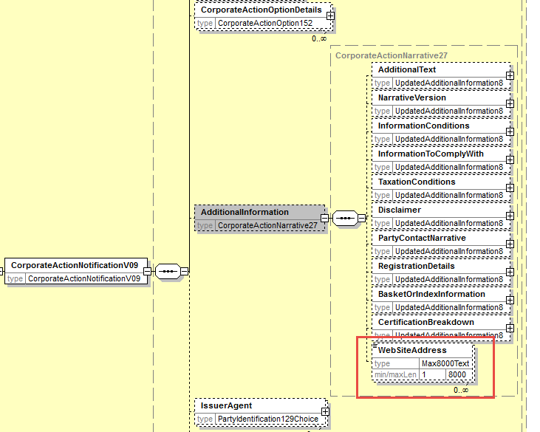

Working Group Meeting

Discussion
The MWG cannot reach consensus on the business case. There is more support for making the Webb address in the MT564 sequence D repeatable although the need is not shared by all countries either as a web address could very well point to a web page containing several web addresses, and that could have a similar result. This workaround is working well in other countries.
Singapore note that having too many placeholders for web addresses could increase confusion; a variable number of web links may create uncertainty about completeness certainty.
The need to introduce a specific web address field in each narrative in the MT messages is not much supported either since web addresses can already be provided in the narratives of the MT568 message as the “z” character set is well supported there.
Moreover, the need to have web addresses fields in the MT566 is not much shared.
Belgium mentions that there are already for MT messages existing workarounds that could be used like using “at” iso “@” or as recommended in the SWIFT documentation to use the following sequence of characters “??7C” to indicate a “@” character as well.
Nevertheless since some countries are inclined to share some of the HK requirements (on the repeatability of the web address more specifically), the WG agrees to recommend to the SMPG to better analyse what are the business needs globally and then look for the best solution and submit eventually a CR for SR 2021.
Nevertheless, SWIFT also discovered lately during a more in-depth analysis of the HK CR that the :70a::WEBB (Web Site Address) narrative field in the MT 568 was not mapped to the seev.031 (CANO) message as it should have been.
Since this change request is directly related to web addresses in the MX messages and since this gives us the opportunity to correct this mapping mistake, the MWG fully agrees to add a repeatable WebAddress in the “AdditionalInformation” sequence of the seev.031 and to wait for the SMPG in-depth analysis of the HK requirements to eventually submit a CR for SR2021.
This results in No changes in MT messages.
Decision
Approved with alternative solution with impact only on MX messages
Final decision of the Securities SEG regarding ISO 20022 messages:
Approve the MWG decision | approved
Comments:

Reject the MWG decision
Reason for rejection:

CR 001531: Change character set to allow e-mail address details for BO
Origin of request
Requesting Country: | UK United Kingdom
Requesting Group: | UK NMPG
Sponsors
UK NMPG
Message type(s) impacted
MT 565, seev.033
Complies with regulation
None
Business impact of this request
MEDIUM
The "@" sign is only allowed in the “Z” character set in 70F (568) and 70G (564 seq. D). We also would like to be added to the MT565 (BENODET sequence) to record the email address of the beneficial owner, if and when requested.
Commitment to implement the change
Number of messages sent and received: 700000
Percentage of messages impacted: 10
Commits to implement and when: UK 2020
Business context
The "@" sign is only allowed in the “Z” character set in 70F (568) and 70G (564 seq. D). We also would like to be added to the MT565 (BENODET sequence) to record the email address of the beneficial owner, if and when requested.
Nature of change
Add the "@" sign to the MT565 (BENODET sequence) to record the email address of the beneficial owner, if and when requested.
Workaround
The email address is reported using "at" instead of "@"
Examples
Not provided

SWIFT Comment

Standards Illustration

1. ISO 15022 Illustration
In the MT 565, in sequence C (BENODET), in field 70a, add format option G allowing for the z character set as illustrated here below:

MT 565 Field Specifications

35. Field 70Ea: Narrative: Certification/Breakdown Narrative

FORMAT
Option E | :4!c//10*35x | (Qualifier)(Narrative)
Option G | :4!c//10*35z | (Qualifier)(Narrative)

PRESENCE
Optional in optional sequence C

QUALIFIER
(Error code(s): T89)
Order | M/O | Qualifier | R/N | CR | Options | Qualifier Description
1 | O | CETI | R |  | E or G | Certification/Breakdown Narrative

DEFINITION
This qualified generic field specifies:
CETI | Certification/Breakdown Narrative | Provides additional information about the type of certification/breakdown required.

USAGE RULES
Unless bilaterally agreed, narrative field 70a must not contain information that can be provided in a structured field.

2. ISO 20022 Illustration
In the seev.033 (CAIN – CorporateActionInstruction) message, in sequence BeneficialOwnerDetails, set the element BeneficialOwnerDetails/CertificationBreakdown as repeatable (since it is the case in the MT565 for the same element) as illustrated below:

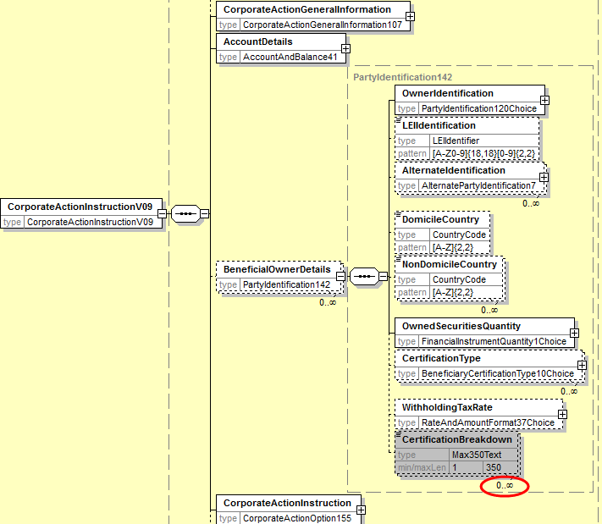

Working Group Meeting

Discussion
The MWG has reached consensus on the business case enabling the insertion of email address into the BENODET sequence, however the proposed solution to add a new 70a qualifier in the BENODET sequence was rejected by some countries.
Nevertheless, the MWG could finally reach consensus on the alternative implementation proposal from Germany i.e. adding the “z” character set to the :70a::CETI qualifier in the BENODET sequence. This solution avoids creating a new specific qualifier for emails and the existing status reason codes for the certification information can be reused.
In the seev.033 CAIN message, the BeneficialOwnerDetails/Certification element will be made repeatable similarly to the CETI qualifier in the MT 565.
Decision
Approved with alternative solution
Final decision of the Securities SEG regarding ISO 20022 messages:
Approve the MWG decision | approved
Comments:

Reject the MWG decision
Reason for rejection:

CR 001551: Add Tax Rate in Instruction for Tax Breakdown
Origin of request
Requesting Group: | SMPG
Sponsors
SMPG CA WG members
Message type(s) impacted
MT 565, MT 567, seev.033, seev.034
Complies with regulation
None
Business impact of this request
MEDIUM
When an income payment is due in an omnibus account in countries that require a tax breakdown with full disclosure of the beneficial owner (e.g. Italy), the recipient of the income can, in the BENODET sequence of a MT565, indicate the beneficial owner details. However, currently, there is no way to report the tax rate at which the beneficial owner is to be paid.
Commitment to implement the change
Number of messages sent and received: 35000
Percentage of messages impacted: 15
Commits to implement and when: SMPG 2020
Business context
When an income payment is due in an omnibus account in countries that require a tax breakdown with full disclosure of the beneficial owner (e.g. Italy), the omnibus account holder can, in the BENODET sequence of a MT565, provide the beneficial owner details to its account servicer. However, it is currently not possible to include the tax rate at which the beneficial owner is to be paid.
Since MT565s cannot be used for all details, users tend to rely on MT599, fax messages or excel spreadsheets. To improve STP processing, we would like to add the tax rate to be applied at beneficial owner level in the BENODET sequence. We would also like to add reason codes in the MT567 message to report possible issues with the instruction:
- a missing tax rate,
- an incorrect tax rate (e.g. outside the values acceptable for that investment country),
- a tax rate that is not consistent with the documentation in place
Nature of change
1. Add TAXR to sequence C (BENODET) of the MT 565
2. Add new reasons code to status PEND and REJT of the MT 567 to inform the recipient of:
- a missing tax rate,
- an incorrect tax rate (e.g. outside the values acceptable for that investment country),
- a tax rate that is not consistent with the documentation in place
Workaround
Fax messages, MT 599 and excel spreadsheet
Examples
Cash dividend events in multiple markets are affected by this. Examples include
IT0003497168 – Telecom Italia
FI0009000681 – Nokia Corporation shares
JP3885780001 – MIZUHO FINANCIAL GROUP INC

SWIFT Comment

Standards Illustration

1. ISO 15022 Illustration
1. In the MT 565, in sequence C Beneficial Owner Details, add a new optional 92a Rate field with the optional and non-repeatable qualifier TAXR (Withholding Tax Rate) with format options A, F or K and with the following definition:
“Requested percentage of a cash distribution that will be withheld by the tax authorities of the jurisdiction of the issuer, for which a relief at source and/or reclaim may be possible.” and as illustrated below:

MT 565 Format Specifications
MT 565 Corporate Action Instruction
Status | Tag | Qualifier | Generic Field Name | Detailed Field Name | Content/Options | No.
Mandatory Sequence A General Information
End of Sequence A General Information
-----> Optional Repetitive Sequence C Beneficial Owner Details
M | 16R |  |  | Start of Block | BENODET | 30
----->
M | 95a | 4!c | Party | (see qualifier description) | L, P, R, S, or V | 31
-----|
----->
O | 94C | 4!c | Place | (see qualifier description) | :4!c//2!a | 32
-----|
M | 36B | OWND | Quantity of Financial Instrument | Quantity of Securities Owned | :4!c//4!c/15d | 33
----->
O | 22F | CETI | Indicator | Certification Type Indicator | :4!c/[8c]/4!c | 34
-----|
O | 92a | TAXR | Rate | Withholding Tax Rate | A,F or K | 35
----->
O | 70E | CETI | Narrative | Certification/Breakdown Narrative | :4!c//10*35x | 35
-----|
M | 16S |  |  | End of Block | BENODET | 36
-----| End of Sequence C Beneficial Owner Details

O | 22F | CETI | Indicator | Certification Type Indicator | :4!c/[8c]/4!c | 34

MT 565 Field Specifications

35. Field 92a: Rate

FORMAT
Option A | :4!c//[N]15d | (Qualifier)(Sign)(Rate)
Option F | :4!c//3!a15d | (Qualifier)(Currency Code)(Amount)
Option K | :4!c//4!c | (Qualifier)(Rate Type Code)

PRESENCE
Optional in optional subsequence E2

QUALIFIER
(Error code(s): T89)
Order | M/O | Qualifier | R/N | CR | Options | Qualifier Description
1 | O | TAXR | N |  | A, F, or K | Withholding Tax Rate

DEFINITION
This qualified generic field specifies:
TAXR | Withholding Tax Rate | Requested percentage of a cash distribution that will be withheld by the tax authorities of the jurisdiction of the issuer, for which a relief at source and/or reclaim may be possible.

CODES
In option K, if Qualifier is TAXR, Rate Type Code must contain the following code (Error code(s): K92):
UKWN | Unknown Rate | Rate is unknown by the sender or has not been established.

NETWORK VALIDATED RULES
The integer part of Rate must contain at least one digit. A decimal comma is mandatory and is included in the maximum length (Error code(s): T40,T43).
If Rate is zero, Sign must not be present (Error code(s): T14).
Currency Code, must be valid ISO 4217 currency codes (Error code(s): T52).

USAGE RULES
Sign must be present when Rate is negative.

2. In the MT 567, in subsequence A2A, in field :24B: Reason Code, add the three new Reason code values TAXM (Missing Tax Rate), TAXI (Incorrect Tax Rate), TAXN (Inconsistent Tax Rate) for the Pending (PEND) and Reject (REJT) qualifier as defined and illustrated below:

MT 567 Field Specifications

13. Field 24B: Reason Code

FORMAT
Option B | :4!c/[8c]/4!c | (Qualifier)(Data Source Scheme)(Reason Code)

PRESENCE
Mandatory in optional subsequence A2a

QUALIFIER
(Error code(s): T89)
Order | M/O | Qualifier | R/N | CR | Options | Qualifier Description
1 | M | PEND | N | C1 | B | Pending Reason
 | or | REJT | N | C1 | B | Rejection Reason
 | or | CAND | N | C1 | B | Cancellation Reason
 | or | CANP | N | C1 | B | Cancellation Pending Reason
 | or | PACK | N | C1 | B | Accepted Reason

CODES
If Qualifier is PEND and Data Source Scheme is not present, Reason Code must contain one of the following codes (Error code(s): K24):
ADEA | Account Servicer Deadline Missed | Received after the account servicer's deadline. Processed on best effort basis.
AUTH | Sent to Tax Authorities | For tax reclaim, the event is pending because the reclaim is sent to the tax authorities.
CERT | Incorrect Certification | The provided certification is incorrect or incomplete.
DQCS | Disagreement on Cash Amount | Unrecognised or invalid instructed cash amount.
DQUA | Disagreement on Quantity | Unrecognised or invalid instructed quantity.
FULL | Pending Beneficiary Owner Details | Pending receipt of beneficiary owner details.
LACK | Lack of Securities | Insufficient financial instruments in your account.
LATE | Market Deadline Missed | Instruction was received after market deadline.
MCER | Missing or Invalid Certification | Awaiting receipt of adequate certification.
MONY | Insufficient Cash | Insufficient cash in your account.
NARR | Narrative Reason | See narrative field for reason.
NPAY | Payment Not Made | Payment has not been made by issuer.
NSEC | Securities Not Delivered | Financial instruments have not been delivered by the issuer.
PENR | Pending Receipt | The instruction is pending receipt of securities, for example, from a purchase, loan etc.
ITAX | Incorrect Tax Rate | Tax rate provided is incorrect. It falls outside the acceptable values for that investment country.
MTAX | Missing Tax Rate | Tax rate is missing.
NTAX | Inconsistent Tax Rate | Tax rate is not consistent with the documentation in place.
VLDA | Valid for Tax Authorities | For tax reclaim, the event is pending, the tax reclaim is valid for the tax authorities.

CODES
If Qualifier is REJT and Data Source Scheme is not present, Reason Code must contain one of the following codes (Error code(s): K24):
ADEA | Account Servicer Deadline Missed | Received after the account servicer's deadline.
CANC | Cancelled | Option is not valid; it has been cancelled by the market or service provider, and cannot be responded to. Any responses already processed against this option are considered void and new responses will be required.
CERT | Incorrect Certification | Instruction is rejected since the provided certification is incorrect or incomplete.
DCAN | Rejected Since Already Cancelled | Cancellation request was rejected since the instruction has already been cancelled.
DPRG | Rejected Since In Progress | Cancellation request has been rejected because the instruction process is in progress or has been processed.
DQAM | Instruction Type Rejection | Invalid use of instructed amount (QCAS) or of instructed quantity (QINS) qualifiers .
DQBI | Invalid Bid Increment | Bid price/basis points/percentage increments rejected due to invalid bid increment for the event (generally used in Dutch Auctions or Bid Tenders).
DQBV | Invalid Bid Value | Bid price/basis points/percentage falls outside of bid range for the event (generally used in Dutch Auctions or Bid Tenders).
DQCC | Currency Rejection | Invalid instructed currency.
DQCS | Amount Rejection | Unrecognised or invalid instructed cash amount.
DQUA | Quantity Rejection | Unrecognised or invalid instructed quantity.
DSEC | Security Rejection | Unrecognised or invalid financial instrument identification.
EVNM | Unrecognised Corporate Action Event Number Rejection | Unrecognised corporate action event number.
FULL | Missing Beneficiary Owner Details | Rejected due to missing beneficiary owner details.
INIR | Instruction Irrevocable | The instruction is irrevocable.
INTV | Inactive | Option is not active and can no longer be responded to. Any responses already processed against this option will remain valid, for example, expired option.
INVA | Invalid for Tax Authorities | For tax reclaim, the reclaim is invalid for the tax authorities.
IRDQ | Invalid Use Round Up Quantity | Instruction is rejected due to invalid use of additional round up quantity (RDUQ).
LACK | Lack of Securities | Instructed position exceeds the eligible balance.
LATE | Market Deadline Missed | Received after market deadline.
NARR | Narrative Reason | See narrative field for reason.
NMTY | Mismatch Option Number and Option Type Rejection | Mismatch between option number and option type.
OPNM | Option Number Rejection | Unrecognised option number.
OPTY | Option Type Rejection | Invalid option type.
REFT | Refused by the Tax Authorities | Reclaim is refused by the tax authorities.
SAFE | Safekeeping Account Rejection | Unrecognised or invalid message sender's safekeeping account.
SHAR | Shareholder Number Missing | Shareholder number or reference is missing.
ITAX | Incorrect Tax Rate | Tax rate provided is incorrect. It falls outside the acceptable values for that investment country.
MTAX | Missing Tax Rate | Tax rate is missing.
NTAX | Inconsistent Tax Rate | Tax rate is not consistent with the documentation in place.
ULNK | Unknown | Linked reference is unknown.

2. ISO 20022 Illustration
1. In the seev.033 (CAIN – CorporateActionInstruction) message, in sequence BeneficialOwnerDetails, add a new optional and non-repeatable element WithholdingTaxRate typed with RateAndAmountFormat37Choice providing the rate as a choice between a percentage rate, a unknown rate value as the code UKWN and a rate as an amount as illustrated here below and as defined in ISO 15022 above:

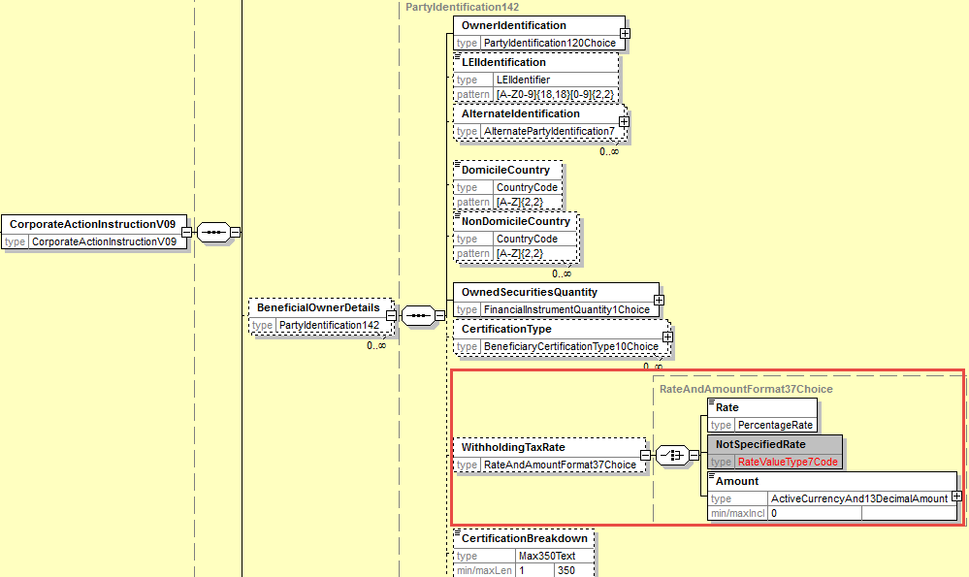

2. In the seev.034 (CAIS – CorporateActionInstructionStatusAdvice) message, add 3 new rejection reason code ITAX, MTAX, NTAX as defined in ISO 15022 above in the data type code list RejectedReason48Code typing the element “Code” in the sequence InstructionProcessingStatus/Rejected/Reason/ReasonCode and also in the data type code list PendingReason14code typing the element “Code” in sequence InstructionProcessingStatus/Pending/Reason/ReasonCode as illustrated here below:

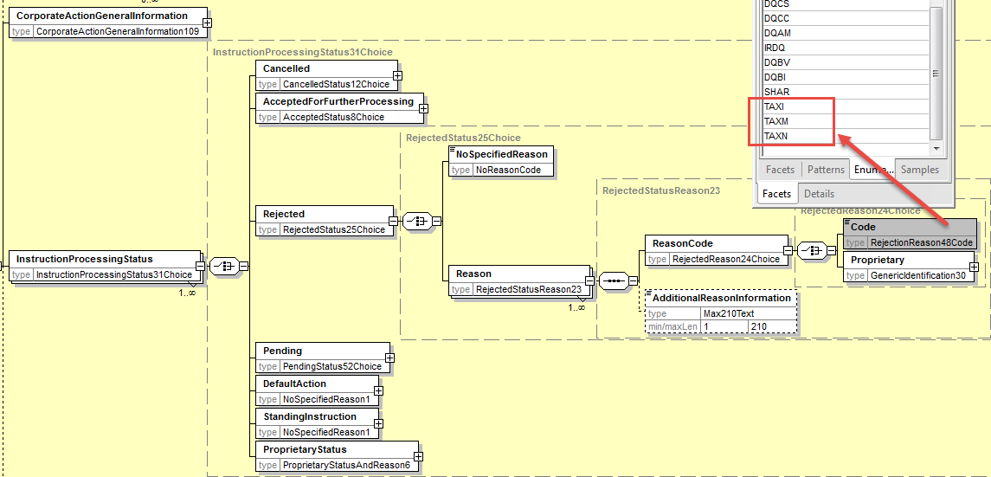

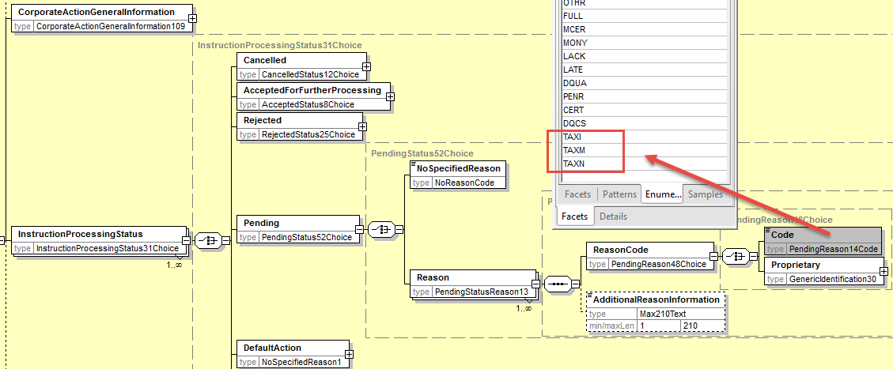

Working Group Meeting

Discussion
A majority of the countries agreed with the business case and some concerns raised by France and the US about the message flows and usage were clarified at the meeting.
The usage of the TAXR rates in the MT565 would be for specific use cases and it should not be used directly with income MAND event but rather in the context of WTRC events linked to mandatory income events.
Based on the above clarification, the MWG agrees with the business case and the proposed solution as illustrated above. However the MWG recommends to the SMPG to create a market practice to clarify the usage of the new TAXR element in the MT565 and the related message flows.
Decision
Approved
Final decision of the Securities SEG regarding ISO 20022 messages:
Approve the MWG decision | approved
Comments:

Reject the MWG decision
Reason for rejection:

CR 001533: Add code for OPTF in DTCH events
Origin of request
Requesting Country: | LU Luxembourg
Sponsors
CLEARSTREAM
Message type(s) impacted
MT 564, seev.031, seev.035
Complies with regulation
None
Business impact of this request
MEDIUM
Back-end and front-end systems will need to be adapted
Commitment to implement the change
Number of messages sent and received: 40
Percentage of messages impacted: 1
Commits to implement and when: LU in 2020
Business context
1. Will increase the transparency of MT 564 CAN messages for Dutch Action (DTCH) events.
2. The change is needed in order to inform the users whether an OFFR needs to be put in an MT 565 CA instruction (competitive option) or not (non-competitive option).
Business justification: increasing number of modified Dutch Auction events that include both competitive and non-competitive options.
Replacing that text by a structured field will increase the standardization and allows to further increase according system validations.
Nature of change
Add a code to the qualifier OPTF in MT 564 in case of DTCH competitive offer;
Offer price can be indicated in the existing field OFFR in MT 565 (no change), in case 564 CAON option expected a competitive offer price, an MT 567 rejects the received MT 565 if no price is indicated, with existing rejection code.
Workaround
Currently this has to be 'explained' by a narrative comment at option level (INCO).
Replacing that text by a structured field will increase the standardization and allows to further increase according system validations.
Examples
159907805 - XS1599078059 MONGOLIAN MINING Modified DTCH

Hereafter is a notification example of a modified DTCH
Option 1 is a competitive option: INCO currently at narrative level to be replaced by OPTF/CPTT; MT 565 with CAON 1 is rejected via MT 567 if no bid present in MT 565
Option 2 and 3 no competitive offer, therefore no validation on MT 565

:16R:GENL
:20C::CORP//0000000111111111
:20C::SEME//000000000000001S
:23G:NEWM
:22F::CAEV//DTCH
:22F::CAMV//VOLU
:98C::PREP//
:25D::PROC//COMP
:16S:GENL
:16R:USECU
:35B:ISIN XS1599078059
CMC 159907805
USD FL.R MONGOLIAN MINING CORP
(REGS) 17-XXXX
:16R:FIA
:11A::DENO//USD
:36B::MINO//FAMT/,
:16S:FIA
:16S:USECU
:16R:CADETL
:98A::ANOU//
:92F::BIDI//USD
:90B::MINP//ACTU/USD
:90B::MAXP//ACTU/USD
:36B::QTSO//FAMT/,
:36B::MQSO//FAMT/
:17B::ACIN//N
:70E::OFFO//MONGOLIAN MINING
:70G::WEBB//https://
:16S:CADETL
:16R:CAOPTN
:13A::CAON//001
:22F::CAOP//CASH
:11A::OPTN//USD
:17B::DFLT//N
:98C::EARD//
:98C::MKDT//
:98C::BORD//
:98C::DEPO//
:69A::PWAL//
:69A::REVO//
:36B::MIEX//FAMT/,
:36B::MILT//FAMT/,
:16R:SECMOVE
:22H::CRDB//DEBT
:35B:ISIN XS1599078059
CMC 159907805
USD FL.R MONGOLIAN MINING CORP
(REGS) 17-XXXX
:98A::PAYD//
:16S:SECMOVE
:16R:CASHMOVE
:22H::CRDB//CRED
[…]
:16S:CASHMOVE
:70E::INCO//COMPETITIVE OFFER PRIOR EARLY
DEADLINE - STATED BID PRICE SHOULD
INCLUDE PERPETUAL SECURITIES EARLY
TENDER PREMIUM
:16S:CAOPTN
:16R:CAOPTN
:13A::CAON//002
:22F::CAOP//CASH
:11A::OPTN//USD
:17B::DFLT//N
:98C::EARD//
:98C::MKDT//
:98C::BORD//
:98C::DEPO//
:69A::PWAL//
:69A::REVO//
:36B::MIEX//FAMT/,
:36B::MILT//FAMT/,
:16R:SECMOVE
:22H::CRDB//DEBT
:35B:ISIN XS1599078059
CMC 159907805
USD FL.R MONGOLIAN MINING CORP
(REGS) 17-XXXX
:98A::PAYD//
:16S:SECMOVE
:16R:CASHMOVE
:22H::CRDB//CRED
:98A::PAYD//
:98A::VALU//
:90A::OFFR//PRCT/,
:16S:CASHMOVE
:70E::INCO//NON-COMPETITIVE OFFER PRIOR TO
EARLY DEADLINE
:16S:CAOPTN

SWIFT Comment

Standards Illustration

1. ISO 15022 Illustration
In the MT 564, in sequence E, in field :22F: Indicator, add a new code value Competitive Option (CPTT) for qualifier OPTF Option Feature as illustrated here below for the MT564:

MT 564 Field Specifications

57. Field 22F: Indicator

FORMAT
Option F | :4!c/[8c]/4!c | (Qualifier)(Data Source Scheme)(Indicator)

PRESENCE
Mandatory in optional sequence E

QUALIFIER
(Error code(s): T89)
Order | M/O | Qualifier | R/N | CR | Options | Qualifier Description
1 | M | CAOP | N |  | F | Corporate Action Option Code Indicator
2 | O | DISF | N |  | F | Disposition of Fractions Indicator
3 | O | OFFE | R |  | F | Offer Type Indicator
4 | O | OPTF | R |  | F | Option Features Indicator
5 | O | OSTA | N |  | F | Option Status
6 | O | CETI | R |  | F | Certification/Breakdown Type Indicator

DEFINITION
This qualified generic field specifies:
CAOP | Corporate Action Option Code Indicator | Specifies the corporate action options available to the account owner.
CETI | Certification/Breakdown Type Indicator | Specifies the type of certification/breakdown.
DISF | Disposition of Fractions Indicator | Specifies how fractions resulting from derived securities will be processed or how prorated decisions will be rounding, if provided with a pro ration rate.
OFFE | Offer Type Indicator | Specifies the conditions that apply to the offer.
OPTF | Option Features Indicator | Specifies the features that may apply to a corporate action option.
OSTA | Option Status | Specifies the status of the option.

CODES
If Qualifier is OPTF and Data Source Scheme is not present, Indicator must contain one of the following codes (Error code(s): K22):
ASVO | Account Servicer Option | Option is offered by the account servicer only.
BOIS | Beneficiary Owner Instruction | Indicates that the holder needs to instruct at beneficiary owner level only.
CAOS | Corporate Action Option Applicability | The option applicability is not subject to the account owner decision but depends on the terms defined by the issuer, for example in the case of Equity Linked Notes or warrants.
COND | Conditional | Feature whereby the holder can elect to place a condition on the acceptance of the option.
CPTT | Competitive Option | Indicates that an offer price must be provided in the instruction phase of the event.
MAXC | Maximum Cash | Maximum cash option, may be subject to scaling, as such you may receive a combination of cash and securities outturn.
MAXS | Maximum Securities | Maximum stock option, may be subject to scaling, as such you may receive a combination of securities and cash outturn.
NOSE | No Service Offered Indicator | Feature whereby the holder must elect directly to the issuer's agent (issuer only supported option).
OPLF | Odd Lot Preference | Tender or Exchange with the Odd Lot Preference.
PINS | Previous Instruction Invalidity | Indicates that the previously sent instructions become invalid. It is only applicable after a market deadline extension.
PROR | Pro Ration | Feature whereby the option can be subject to pro ration in case, for example, of over-subscription.
QCAS | Instruct Cash Amount | Feature whereby the holder should only instruct a cash amount.
SHAR | Shareholder Number | Indicates usage of a reference number to identify an investor or a shareholder with the issuer or the registration provider (for instance allocation code).
VVPR | Reduced Withholding Tax | Reduced withholding tax rate applies to the option.

2. ISO 20022 Illustration
In the seev.031 (CANO – Corporate Action Notification) message, in the Code element in sequence CorporateActionOptionDetails/OptionFeatures, and

in the seev.035 (CANO – Corporate Action Movement Preliminary Advice) message, in the Code element in sequence CorporateActionMovementDetails/OptionFeatures,

add the new code value CPTT (Competitive Option) as defined in ISO 150222 above and as illustrated here below for the CANO:

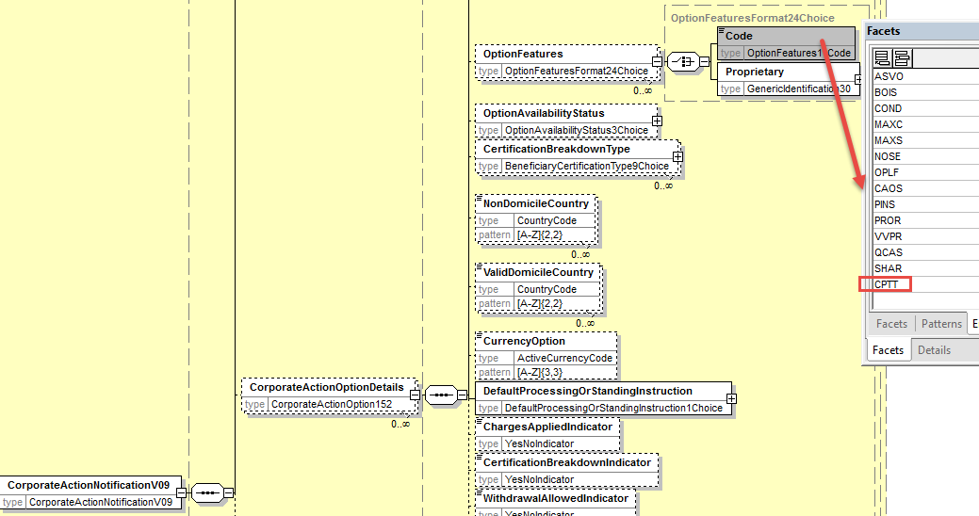

Working Group Meeting

Discussion
A majority of the countries finds that the message traffic volume concerned (40 events per year) is too low to justify a change with such a limited benefit for the cost it would generate.
The MWG agrees with the workaround suggested by the ISO 20022 SEG representatives to use the Price codes TBSP (To Be Specified) and UNSP (Unspecified) in order to make the distinction between both competitive and non-competitive options for Dutch auction (DTCH) events.
Therefore the MWG reject the CR and recommend to the SMPG to create a new market practice to specify the usage of the TBSP and UNSP price codes for DTCH events.
Decision
Rejected
Final decision of the Securities SEG regarding ISO 20022 messages:
Approve the MWG decision
Comments:

Reject the MWG decision | Rejected
Reason for rejection:

CR 001517: Add “Market Infrastructure Transaction Identification” (MITI) Reference in Confirmation
Origin of request
Requesting Country: | DE Germany
Sponsors
German National Market Practice Group
Message type(s) impacted
MT 566, seev.036, seev.037
Complies with regulation
None
Business impact of this request
MEDIUM
Commitment to implement the change
Number of messages sent and received: 5000000
Percentage of messages impacted: 25
Commits to implement and when: The German market is requesting the change with other T2S countries supporting it and SMPG also supporting the change request (SMPG Spring Meeting Frankfurt, April 2019) in SR 2020
Business context
The Target 2 Securities (T2S) “Market Infrastructure Transaction Identification” (MITI) will serve as a common and unique attribute for reconciliation activities in the cross-border business for T2S actors. It is also needed by DCPs for their interaction with T2S, because the DCA cash statement has only this reference.
The MITI will already be used and reported in MT54x settlement messages including market claims and transformations generated by CSDs and CCPs as suggested by the T2S Corporate Action Sub Group (CASG).
The MITI is required for all DCA T2S account holders, European CSDs and T2S participants.
Nature of change
A new optional reference qualifier in subsequence A1 called MITI should be added to the MT 566 similar to already existing reference fields in other security messages.

MITI - Market Infrastructure Transaction Identification
Identification of a transaction assigned by a market infrastructure other than a central securities depository, for example, Target2-Securities.
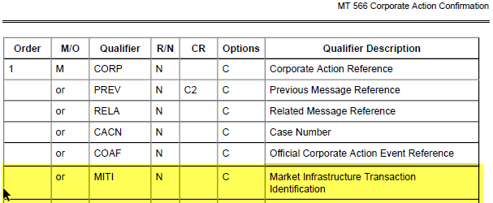
Workaround
Currently, the information is transmitted in 70E narrative

The CAMT.053 that we receive for our DCAs only contains the MITI Reference and an internal reference, there is no ISIN, CORP or SEME of the MT56n:
<Ntry>
<NtryRef>INTREF1234567890</NtryRef>
<Amt Ccy="EUR">150.99</Amt>
<CdtDbtInd>CRDT</CdtDbtInd>
<Sts>BOOK</Sts>
<BookgDt><DtTm>2016-09-06T18:58:11.437555</DtTm></BookgDt>
<BkTxCd><Prtry><Cd>SETT</Cd></Prtry></BkTxCd>
<NtryDtls><TxDtls><Refs>
<InstrId>MITI123456789012</InstrId>
<TxId>INTREF1234567890</TxId>
<MktInfrstrctrTxId>MITI123456789012</MktInfrstrctrTxId>
<PrcgId>INTREF1234567890</PrcgId></Refs>
<Amt Ccy="EUR">120.21</Amt>
<CdtDbtInd>CRDT</CdtDbtInd>
<RltdPties><Prtry><Tp>CSD</Tp>
<Pty><Id><OrgId><AnyBIC>NECINL2AXXX</AnyBIC></OrgId></Id></Pty></Prtry>

The MT54n settlement confirmation messages contain the reference in sequence A1 (LINKAGES):
MITI: Market Infrastructure Transaction Identification - Identification of a transaction assigned by a market infrastructure other than a central securities depository, for example, Target2-Securities.

Since the MT 566 does not contain the MITI reference in sequence A1, some actors (e.g. Clearstream) report the MITI in the free text of the message:

16R:ADDINFO
:70E::TXNR//INTRCRED IT0004965577 12MAR18 OIF
QTY 99.990 TRANO DATYP A/C 1234567
CASH CRED
T2S-ACTOR-REF C1234567890123AB
MITI MITI123456789012
:16S:ADDINFO
Examples
:16R:GENL
:20C::CORP//1212019101835900
:20C::SEME//KAD8101619657090
:23G:NEWM
:22F::CAEV//DVCA
:98C::PREP//20190308101600
16R:LINK
:20C::MITI//XXXXXXXXXXXXXXXX
:16S:LINK
:16S:GENL
:16R:USECU
:97A::SAFE//12345000
....

Reversal
:16R:GENL
:20C::CORP//1202019051835300
:20C::SEME//KAD2101637000203
:23G:REVR
:22F::CAEV//DVCA
:98C::PREP//20190102201600
:16R:LINK
:13A::LINK//566
:20C::RELA//KAD2101637000202
:16S:LINK
16R:LINK
:20C::MITI//XXXXXXXXXXXXXXXX
:16S:LINK
:16S:GENL
:16R:USECU
....

Market Claim:
:16R:GENL
:20C::CORP//1202019051835300
:20C::SEME//KAD2101637000203
:23G:NEWM
:22F::CAEV//DVCA
:98C::PREP//20190102101637
:16R:LINK
:13A::LINK//54x
:20C::RELA//YYYYYYYYYYYYYYY
:16S:LINK
16R:LINK
:20C::MITI//XXXXXXXXXXXXXXXX
:16S:LINK
:16S:GENL
:16R:USECU
....

SWIFT Comment

In ISO 20022, is this element also needed in the movement preliminary advice (seev.035)?

Standards Illustration

1. ISO 15022 Illustration
In sequence A1 of the MT 566, in field :20C: Reference, add the new optional and non-repeatable qualifier “Market Infrastructure Transaction Identification” (MITI) as illustrated below:

MT 566 Field Specifications

9. Field 20C: Reference

FORMAT
Option C | :4!c//16x | (Qualifier)(Reference)

PRESENCE
Mandatory in optional subsequence A1

QUALIFIER
(Error code(s): T89)
Order | M/O | Qualifier | R/N | CR | Options | Qualifier Description
1 | M | CORP | N |  | C | Corporate Action Reference
 | or | PREV | N | C2 | C | Previous Message Reference
 | or | RELA | N |  | C | Related Message Reference
 | or | CACN | N |  | C | Case Number
 | or | COAF | N |  | C | Official Corporate Action Event Reference
 | or | MITI | N |  | C | Market Infrastructure Transaction  Identification

DEFINITION
This qualified generic field specifies:
CACN | Case Number | Reference assigned by a court to a class action.
COAF | Official Corporate Action Event Reference | Official and unique reference assigned by the official central body/entity within each market at the beginning of a corporate action event.
CORP | Corporate Action Reference | Reference assigned by the account servicer to unambiguously identify a corporate action event.
PREV | Previous Message Reference | Message reference of the linked message which was previously sent.
RELA | Related Message Reference | Message reference of the linked message which was previously received.
MITI | Market  Infrastructure  Transaction  Identification | Identification of a transaction assigned by a market infrastructure other than a central securities depository, for example, Target2-Securities.

NETWORK VALIDATED RULES
Reference must not start or end with a slash '/' and must not contain two consecutive slashes '//' (Error code(s): T26).

2. ISO 20022 Illustration
In the seev.036 (CACO – CorporateActionMovementConfirmation) message and in the seev.037 (CARE – CorporateActionMovementReversalAdvice), add a new optional and non-repeatable building block TransactionIdentificationDetails containing the a mandatory element MarketInfrastructureTransactionIdentification typed by the data type Max35Text and defined as in the 15022 standards as illustrated below:

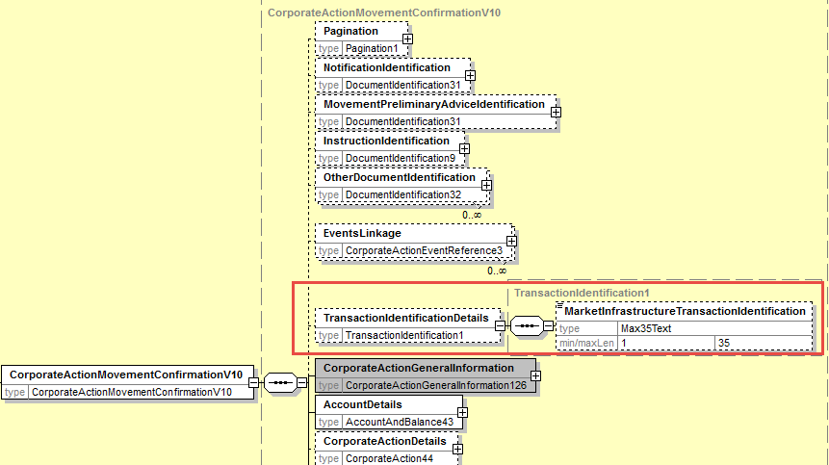

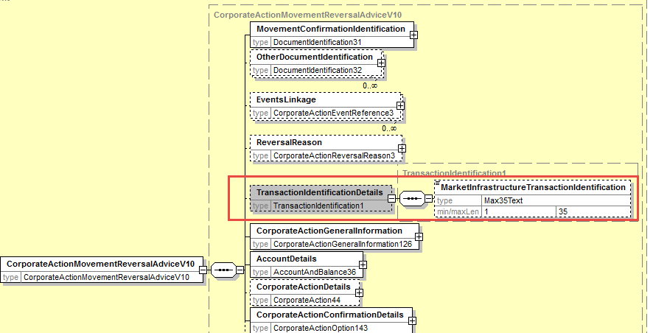

Working Group Meeting

Discussion
CH mentions that the DE CR was not sponsored by CH as it was indicated initially in the CR. CH requests that this indication be removed from the CR.
XS mentions that MITI can also be used for securities movements.
For CA on flows, with the addition of MITI in CA Confirmations, it can also be used in the context of market claims. MITI can already be used for transformations as these are sent using settlement messages.
The MWG finally fully agrees with the business case and with the proposed solution and recommends to the SMPG to create a new MP describing the MITI usage in CA.
Decision
Approved
Final decision of the Securities SEG regarding ISO 20022 messages:
Approve the MWG decision | approved
Comments:
Reject the MWG decision
Reason for rejection:

CR 001552: Add MCER Reason Code to Event Processing Status Pending (ISO20022 – CR0814)
Origin of request
Requesting Group: | SWIFT
Sponsors
None
Message type(s) impacted
seev.032
Complies with regulation
NA
Business impact of this request
LOW
Commitment to implement the change
Commits to implement and when: in 2020
Business context
The :24B::PEND//MCER (Missing or Invalid Certification) reason code is part of the SMPG CA WG MP part 3 and should be one of the reason code that can be provided for an event processing status “pending”.
The reason code MCER is available in ISO 15022 for the MT567 for the 24B::PEND//” field but is missing in the ISO 20022 equivalent “Pending” status in the seev.032 message for the event processing status.
Due to the coexistence between ISO 15022 and ISO20022, this misalignment should be corrected.
Nature of change
Add the reason code value “Missing or Invalid Certification” [MCER] as a pending reason code in the CA EventProcessingStatus message.
Workaround
None
Examples
None

SWIFT Comment

Standards Illustration

1. ISO 20022 Illustration
In the seev.032 (CAPS – CorporateActionEventProcessingStatusAdvice) message, add the code value MCER (Missing or Invalid Certification) as defined in ISO 15022 in the data type code list PendingReason4Code typing the element Code in the sequence EventProcessiongStatus/Pending/Reason/ReasonCode as illustrated below:

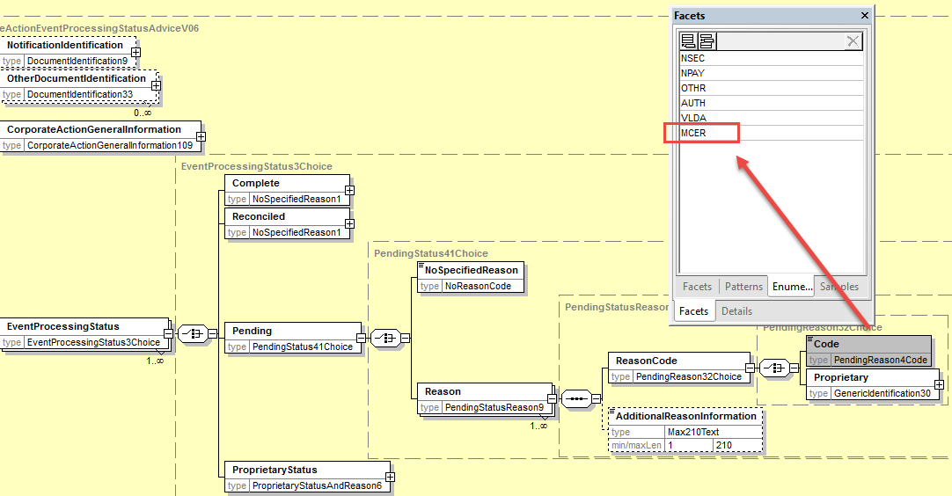

Working Group Meeting

Discussion
France requests that the change request specifies more clearly that it concerns the :24B::PEND//MCER reason code in the sequence A2a of the MT567 message.
SWIFT will update the CR accordingly.
Otherwise, the MWG agrees with the business case and proposed solution.
Decision
Approved
Final decision of the Securities SEG regarding ISO 20022 messages:
Approve the MWG decision | approved
Comments:

Reject the MWG decision
Reason for rejection:

CR 001553: Remove Meeting Option Types from CA Messages (ISO 20022 – CR0815)
Origin of request
Requesting Country:
Requesting Group: | SMPG
Sponsors
SMPG CA WG members
Message type(s) impacted
seev.031, seev.033, seev.034, seev.035, seev.036, seev.037, seev.040, seev.041, seev.042.
Complies with regulation
NA
Business impact of this request
LOW
Commitment to implement the change
Commits to implement and when: in 2020
Business context
The 4 option type code values listed above are specifically meant to be used for meeting events and are therefore supported in the ISO 20022 Proxy Voting messages.
These option types cannot be used consistently with the corporate action events defined in the ISO 20022 CA messages and therefore need to be removed to avoid any misuse or confusion.
Nature of change
In all corporate action messages listed above where an “option type” is included, remove the following predefined code values which are related to option types for meetings:
- SplitInstruction [SPLI]
- ProxyCard [PROX]
- VoteAgainstManagement [AMGT]
- VoteWithManagement [MNGT]
These code values are present in the following code lists:
- CorporateActionOption7Code
- CorporateActionOption8Code
- CorporateActionOption9Code
- CorporateActionOption10Code

Workaround
NA
Examples
NA

SWIFT Comment

Standards Illustration

1. ISO 20022 Illustration

In the four following data type code lists, CorporateActionOption7Code, CorporateActionOption8Code, CorporateActionOption9Code, CorporateActionOption10Code, remove the code values AMGT, MNGT, PROX, and SPLI.
This impact the OptionType/Code elements ion the 9 following seev messages: seev.031, seev.033, seev.034, seev.035, seev.036, seev.037, seev.040, seev.041, seev.042.
The illustration below shows the removal within the seev.031 as an example.
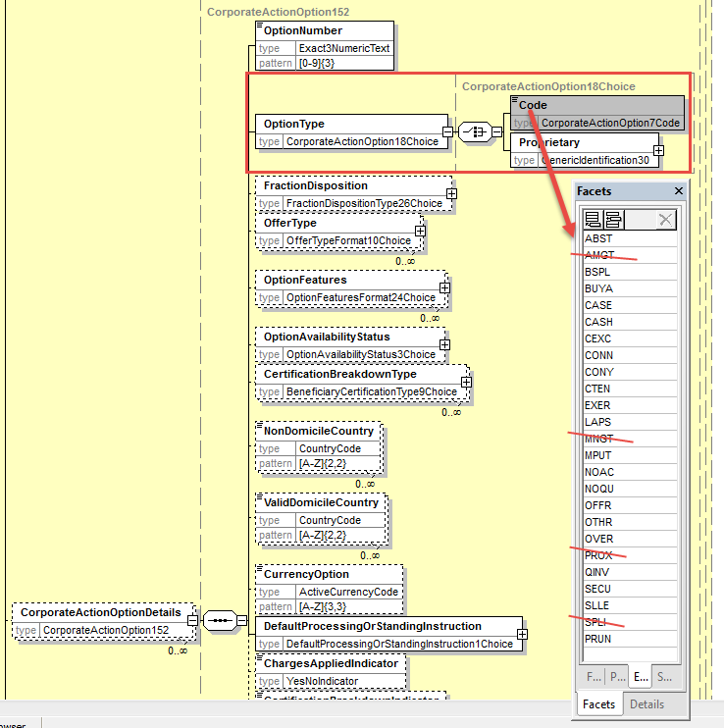

Working Group Meeting

Discussion
The MWG agrees with the business case and proposed solution.
Decision
Approved
Final decision of the Securities SEG regarding ISO 20022 messages:
Approve the MWG decision | approved
Comments:

Reject the MWG decision
Reason for rejection:

Legal Notices
Copyright

SWIFT SCRL © 2019. All rights reserved.
Disclaimer
The information in this publication may change from time to time. You must always refer to the latest available version.
SWIFT Standards Intellectual Property Rights (IPR) Policy - End-User License Agreement

SWIFT Standards are licensed subject to the terms and conditions of the SWIFT Standards IPR Policy -
End-User License Agreement, available at www.swift.com > About Us > Legal > IPR Policies > SWIFT Standards IPR Policy.
Translations
The English version of SWIFT documentation is the only official and binding version.
Trademarks
SWIFT is the trade name of S.W.I.F.T. SCRL. The following are registered trademarks of SWIFT:
3SKey, Innotribe, MyStandards, Sibos, SWIFT, SWIFTNet, SWIFT Institute, the Standards Forum logo, the SWIFT logo and UETR. Other product, service, or company names in this publication are trade names, trademarks, or registered trademarks of their respective owners.

MWG maintenance meeting minutes are distributed around first week of September.

