Maintenance Change Request
for fast track maintenance of existing message definitions

- Submitting organization(s):
European Securities and Markets Authority (ESMA)
201-203 rue de Bercy
75012 Paris
France

- Related messages:
auth.017.001.02 FinancialInstrumentReportingReferenceDataReport
auth.036.001.02 FinancialInstrumentReportingReferenceDataDeltaReport
auth.042.001.02 FinancialInstrumentReportingInvalidReferenceDataReport
auth.045.001.02 FinancialInstrumentReportingNonEquityTradingActivityResult

- Purpose of the change:
Based on input received from National Competent Authorities and from Reporting Entities reporting data to ESMA, ESMA proposes the implementation of the following improvements in the messages and systems supporting the regulation:
- For the purpose of regulatory reporting of financial instrument reference data (Regulatory Technical Standard 23), some reporting entities need to cancel data which has been reported by mistake, and ESMA needs to notify National Competent Authorities and market participants about cancellations.
- For market participants to have information about the asset classes and sub-classes involved in non-equity transparency calculation results, ESMA plans to include the necessary details, according to the segmentation criteria defined in Regulatory Technical Standard 2, in the non-equity transparency calculation results message.

- Urgency of the request:
As these improvements will facilitate reporting and improve data quality, ESMA aims at including changes in the next major maintenance release cycle of the systems, for which testing would start in Q1 2021.
To accommodate for sufficient lead time for the reporting entities to adapt to the changes, the updated XML Schema will need to be published in July 2020.

- Commitments of the submitting organization:
The ESMA MiFIR project team confirms that it plans to develop a new version of the impacted systems in accordance to the changes proposed in this document.

- Contact persons:
Cyril Minoux – cyril.minoux@esma.europa.eu
Konstantinos Kalomoiris – konstantinos.kalomoiris@esma.europa.eu
Krisztina Miklossy – krisztina.miklossy@esma.europa.eu

Change number #1

- Related messages:
auth.017.001.02 FinancialInstrumentReportingReferenceDataReport
auth.036.001.02 FinancialInstrumentReportingReferenceDataDeltaReport
auth.042.001.02 FinancialInstrumentReportingInvalidReferenceDataReport

- Description of the change and type of impact:
For the purpose of regulatory reporting of financial instrument reference data (Regulatory Technical Standard 23), some reporting entities need to cancel data which has been reported by mistake.
To support this process, reporting entities need a message allowing them to indicate just the ISIN and MIC of the instrument reference data that was sent by mistake, without the constraint to report other mandatory elements. To that end, a new version of the SecuritiesReferenceDataReport message component, SecuritiesReferenceDataReport7, is being created, where only the ISIN of the instrument and the MIC code of the trading venue are mandatory.
The SecuritiesReferenceDataReport message component is used in base messages auth.017, auth.036, and auth.042. Those messages will be updated to use the latest version of the message component SecuritiesReferenceDataReport7.
ESMA will generate daily information about new cancellations using a new branch in the auth.036 daily delta report generated by ESMA and distributed to market participants.

- Proposed implementation:
1/ Creation of SecuritiesReferenceDataReport7, where all elements are optional except the instrument and trading venue identifications (ISIN and MIC).

Approved message | Proposed change
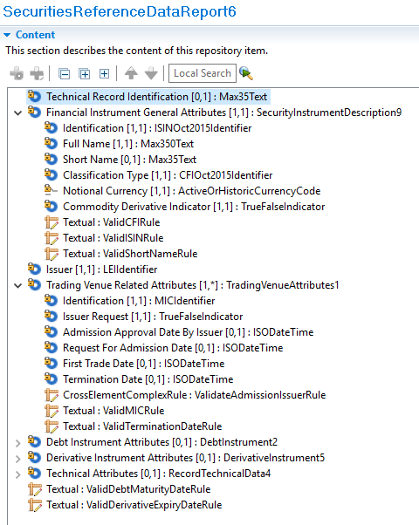 | 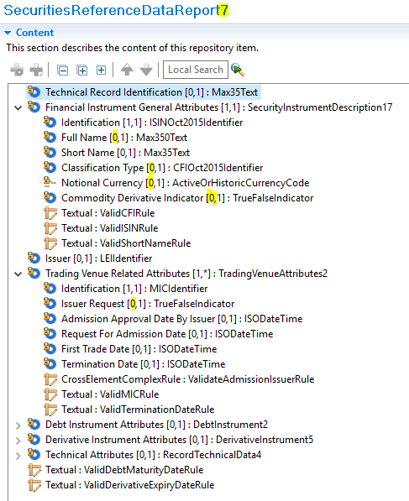
For information, the Commodity Derivative Indicator will be considered as not applicable in case it is not present.
2/ Creation of a “Cancelled Record” branch in FinancialInstrumentReportingReferenceDataDeltaReport (auth.036)
Approved message | Proposed change
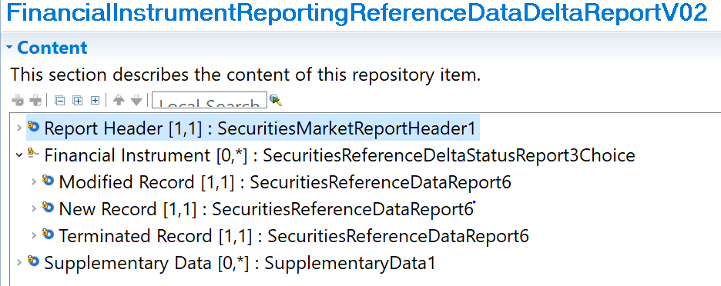 | 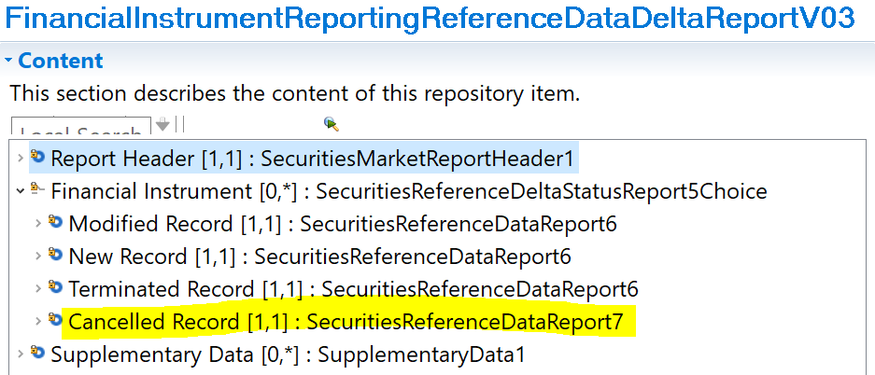

4/ The reporting of a cancellation to ESMA was initially envisaged as a change to an existing base message (auth.017). It was finally decided to create a new message, auth.102.001.01 FinancialInstrumentReportingCancellationReport, also using the new version of the message component SecuritiesReferenceDataReport7, so that the scope of the message is clearly dedicated to cancellations. This new message will be part of the package that will be evaluated along with this maintenance change request.

- Decision of the SEG(s):
This section is not to be taken care of by the submitting organization. It will be completed in due time by the SEG(s) in charge of the related ISO 20022 message definitions.

Change
 | approved | x
 | rejected
Comments:
CR # 1.1, 1.2 are approved
CR # 1.3 is rejected, the messages auth.017 and auth.042 remain unchanged
CR # 1.4 registration of auth.102 is approved

Timing
 | - Fast track maintenance  (the change justifies an urgent implementation using the fast track maintenance process) |  | x
- At the occasion of the next maintenance of the messages
(the change will be considered for implementation, but does not justify an urgent implementation – will be pending until the next [yearly] maintenance of the messages)

Change number #2
- Related messages:
auth.045.001.02 FinancialInstrumentReportingNonEquityTradingActivityResult

- Description of the change and type of impact:
For market participants to have information about the asset classes and sub-classes involved in non-equity transparency calculation results, ESMA plans to include the necessary details, according to the segmentation criteria defined in MiFIR Regulatory Technical Standard 2, in the non-equity transparency calculation results message.
Some non-equity transparency calculation results relate to instruments. It is requested that the details regarding its sub-class is provided, according to the segmentation criteria defined in MiFIR Regulatory Technical Standard 2.
Additionally, it is requested to publish the results which relate to sub-classes, and not instruments. The details regarding the sub-class should be provided, according to the segmentation criteria defined in MiFIR Regulatory Technical Standard 2.

- Proposed implementation:
The Identification element is changed from an ISIN to a choice structure, where either the ISIN and sub-class information can be provided, or asset class and sub-class information can be provided.
Sub-class information is provided as a combination of segmentation criteria name and corresponding value. The segmentation criteria are taken from MiFIR Regulatory Technical Standard 2 and are defined as a codelist.

Approved message | Proposed change
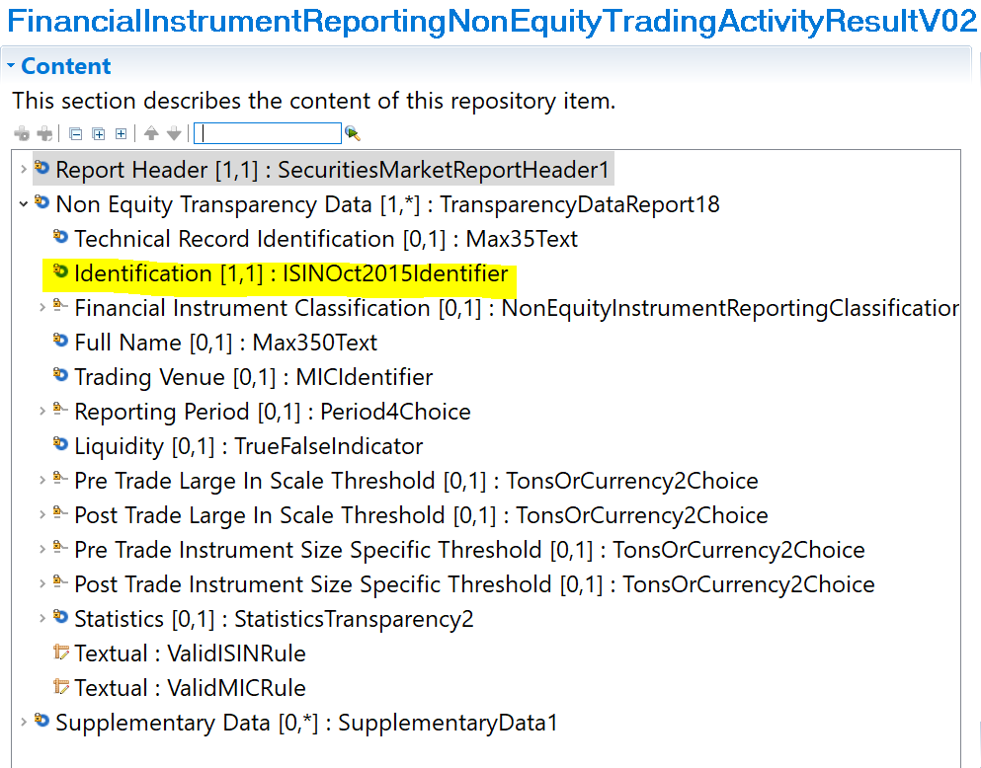 | 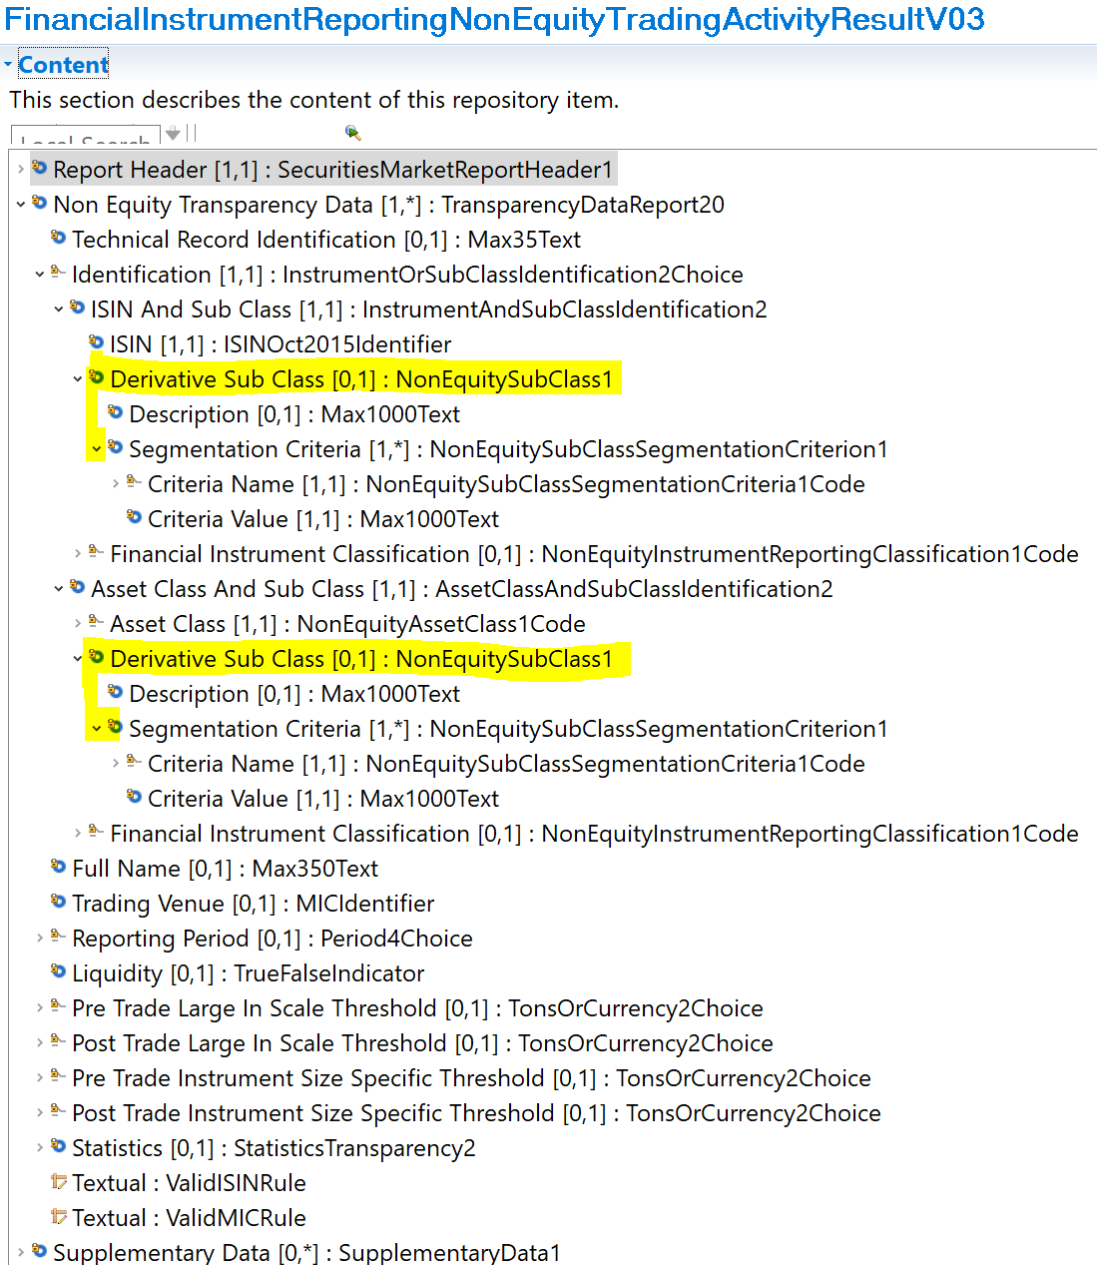
- Decision of the SEG(s):
This section is not to be taken care of by the submitting organization. It will be completed in due time by the SEG(s) in charge of the related ISO 20022 message definitions.

Change
 | approved | x
 | rejected
Comments:

Timing
 | - Fast track maintenance  (the change justifies an urgent implementation using the fast track maintenance process) |  | x
- At the occasion of the next maintenance of the messages
(the change will be considered for implementation, but does not justify an urgent implementation – will be pending until the next [yearly] maintenance of the messages)

