Maintenance Change Request Document

Investment Funds Messages (reda.004)
ISO 20022 Investment Funds Maintenance 2020-2021 'Draft 2'
This document provides the implementation proposals for the 2021 change requests for the fund reference data report message (reda.004).
24 July 2020

Table of Contents
Table of Contents 2
1 Maintenance Request 4
1.1 Maintenance Change Request (MCR) Documentation Set Draft 2 5
1.2 MCR Meetings and Document Review History 5
1.3 How to Read the Diagrams 5
2 Funds Reference Data Report Change Request 7
2.1 CR 0851 Updates for MiFID EMT V3 (ID 1696) 7
3 Section I Implementation Overview 9
3.1 Overview of impact 9
3.2 Summary of Changes 10
4 Section I Implementation Details 15
4.1 Message Scope/Usage - definition 15
4.2 Version - definition 15
4.3 Authorised Proxy - new element 15
4.4 General Reference Date - definition 15
4.5 Target Market Indicator - new element 15
4.6 Ex Ante Indicator - new element 16
4.7 Ex Post Indicator - new element 16
4.8 Security Identification/Legal Structure - renamed to Product Type 16
4.9 Security Identification/Product Type - new code 17
4.10 Security Identification/EMT Legal Structure Guideline - deletion 17
4.11 Security Identification/ Product Category - definition 18
4.12 Security Identification/Product Category Germany - new element 18
4.13 Security Identification/Notional Or Unit Based - new element 18
4.14 Security Identification/Quotation Type - definition update 19
4.15 Security Identification/No Retrocession Indicator - new element 19
4.16 Security Identification/Ex Post Cost Calculation Basis - new element 19
4.17 Security Identification/EMT Security Identification Guideline - deletion 20
4.18 Fund Details/May Be Terminated Early - new element 20
4.19 Fund Details/EMT Fund Details Guideline - deletion 20
4.20 Subscription Processing Characteristics + Local Market Annex - rule correction (ID 1697) 20
4.21 Target Market/Reference Date - new element 21
4.22 Target Market/Investor Type/Investor Type Professional - definition & new codes 21
4.23 Target Market/Investor Type/Investor Type Eligible Counterparty - definition, deletion code NEUT 22
4.24 Target Market/Ability To Bear Losses/ No Capital Loss - definition update 22
4.25 Target Market/Ability To Bear Losses/ Limited Capital Loss - definition update 23
4.26 Target Market/Ability To Bear Losses/ Limited Capital Loss Level - definition update 23
4.27 Target Market/Ability To Bear Losses/ No Capital Guarantee - definition update 23
4.28 Target Market/Ability To Bear Losses/ Loss Beyond Capital - definition update 23
4.29 Target Market/Client Objective And Needs/ Return Profile Preservation - definition update 23
4.30 Target Market/Client Objective And Needs/ Return Profile Growth - definition update 23
4.31 Target Market/Client Objective And Needs/ Return Profile Income - definition update 24
4.32 Target Market/Client Objective And Needs/ Return Profile Hedging - definition update 24
4.33 Target Market/Client Objective And Needs/ Option Or Leveraged Return Profile - definition update 24
4.34 Target Market/Client Objective And Needs/ Return Profile Other - deletion 24
4.35 Target Market/Client Objective And Needs/ Minimum Holding Period - Time Frame 24
4.36 Target Market/Client Objective And Needs/ Minimum Holding Period - guideline deletion 24
4.37 Target Market/Client Objectives And Needs/ May Be Terminated Early - moved 25
4.38 Target Market/Client Objective And Needs/ Specific Investment Need - deletion 25
4.39 Target Market/Client Objectives And Needs/ESG Preferences - new element 25
4.40 Target Market/Client Objectives And Needs/Other Specific Investment Need - new element 25
4.41 Target Market/Client Objectives And Needs/Specific Investment Need Guideline - deletion 26
4.42 Costs And Charges/Ex Ante Reference Date - deletion: restored 26
4.43 Costs And Charges/Ex Post Reference Date - deletion 26
4.44 Costs And Charges/Individual Cost Or Charge/Cost Type/Code - update 26
4.45 Costs And Charges/Individual Cost Or Charge/Sign - new element 32
4.46 Costs And Charges/Individual Cost Or Charge/Reference Period - renamed 32
4.47 Costs And Charges/Individual Cost Or Charge/ Sign Rule 1 32
4.48 Costs And Charges/Individual Cost Or Charge/ Sign Rule 2 33
4.49 Costs And Charges/EMT General Guideline - deletion 33
4.50 Costs And Charges/Ex Ante Reference Date Guideline - deletion: restored 33
5 Sections J and K of CR 0851 34
6 Message Schema Structure Diagrams 35
6.1 Report Details 35
6.2 Security Identification 36
6.3 Fund Details 37
6.4 Target Market 38
6.5 Target Market/Investor Type 38
6.6 Target Market/Ability To Bear Losses 39
6.7 Target Market/Client Objectives And Needs 39
6.8 Costs And Charges 40
End of Document 41

Maintenance Request

A. Name of the request
"Investment Funds Reference Data Report Message"
B. Submitting Organisation
SWIFT
C. Related Message
Under this project, the following ISO 20022 funds messages will be maintained:
 | Name | Identifier
1 | Fund Reference Data Report | reda.004.001.04
There is one message in scope of the 2020-2021 maintenance cycle.

D. Commitments of the submitting organisation
SWIFT confirms that it can and will:
- undertake the development of the new version of the candidate ISO 20022 message models that it will submit to the RA for compliance review and evaluation. For the ISO 20022 yearly maintenance cycle, new valid Message Definition models will be available to the RA by December 1.
- provide a new version of part 1 of the Message Definition Report (MDR) by December 1.
- address any queries related to the description of the new models and messages as published by the RA on the ISO 20022 website.
SWIFT confirms that it intends to organise the testing and the actual implementation of the new version of the messages once the related documentation has been published by the RA.
SWIFT confirms its knowledge and acceptance of the ISO 20022 Intellectual Property Rights policy for contributing organisations, as follows.
“Organisations that contribute information to be incorporated into the ISO 20022 Repository shall keep any Intellectual Property Rights (IPR) they have on this information. A contributing organisation warrants that it has sufficient rights on the contributed information to have it published in the ISO 20022 Repository through the ISO 20022 Registration Authority in accordance with the rules set in ISO 20022. To ascertain a widespread, public and uniform use of the ISO 20022 Repository information, the contributing organisation grants third parties a non-exclusive, royalty-free license to use the published information”.
E. Contact persons
- Janice Chapman – SWIFT Standards, mailto: janice.chapman@swift.com

Preliminary Note
Each change request is identified first with its ISO 20022 change request number, followed by a descriptive change request name, followed by the internal identification (ID) of the organisation (SWIFT) carrying out the maintenance (the SWIFT ID numbers have not yet been assigned). This is to facilitate cross referencing.

Maintenance Change Request (MCR) Documentation Set Draft 2
The documentation set comprises:
# | Document | Description
1 | MCR Funds Maintenance 2021_draft_2_2020-07-24 (this document) | A reference to all the change requests approved for the 2020-2021 maintenance cycle and their proposed implementations. Makes references to the message spreadsheet ' DRAFT2reda.004.001.05.xlsx' for definitions.
2 | DRAFT2reda.004.001.05.xsd | New message definition schema file
3 | DRAFT2reda.004.001.05.xlsx | Spreadsheet generated from the updated message model, a representation of the message with all the element definitions. A column is used to indicate what has changed.
4 | SR2021_maintenance overview_MX_v02_2020-07-24.pptx | An overview of the maintenance impacts on the messages. A handy summary.

MCR Meetings and Document Review History
1 | MCR 'DRAFT 1' meeting | Thursday 23 July 2020, 1pm CET.
IT NMPG review comments incorporated:
Section 1.3 diagram, section 3.1 diagram, section 3.2 table
Section 4.11 definition
Section 4.16 code names
Section 4.22 code names
Section 4.30: definition
Section 4.35: code
Section 4.42: restored
Section 4.44 code definitions
Section 4.47 + 48: new rules
Section 4.50: restored
Section 6.8 diagram
 | Deadline for review of draft 2: 31 August 2020

How to Read the Diagrams
In some cases, diagrams representing the message structures are used to illustrate the new version of the message formats and sequences. These diagrams are generated in a tool called Altova-XML Spy.
Understanding the Diagrams
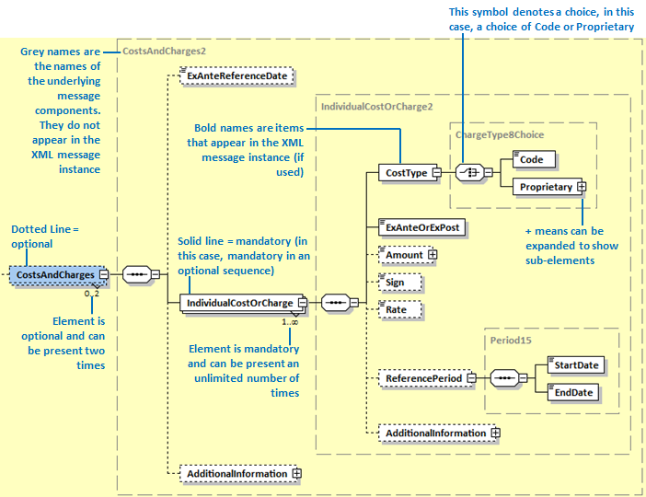
24 July 2020: Diagram above updated (ExAnteReferenceDate element added)
Thus, from the above message structure diagram, the following can be deduced:
The CostsAndCharges sequence is optional and may be present twice.
- If CostsAndCharges is used then the IndividualCostOrCharge sequence is mandatory and may be present an unlimited number of times.
- If CostsAndCharges/IndividualCostOrCharge is used, the CostType element is mandatory and must be present once. CostType is a choice of Code and Proprietary, either Code or Proprietary must be present.
- If CostsAndCharges/IndividualCostOrCharge is used, ExAnteOrExPost must be used.
- If CostsAndCharges/IndividualCostOrCharge is used, Amount is optional.
- And so on.

Funds Reference Data Report Change Request

CR 0851 Updates for MiFID EMT V3 (ID 1696)
A. Origin of the request:
A.1. | Submitter: | Janice Chapman, on behalf of SMPG IF & NMPG IT I.
A.2. | Contact Person: | janice.chapman@swift.com, amilanesio@pine3consulting.com
A.3. | Sponsors:
B. Related Messages:
# | Name | Message Identifier
1 | Fund Reference Data Report | reda.004.001.04
C. Description of the change request:
Update the message so that it supports version three of the MiFID II EMT template.
Details of the additional elements are provided in the annex ‘CR_EMTv3_Annex_2020-05-25_v1.docx’.
D. Purpose of the Change:
The Fund Reference Data Report message was significantly enhanced in the 2018-2019 (and subsequently updated in the 2019-2020) maintenance cycle to provide an ISO 20022 message that allows information concerning product governance, such as target market data, and a breakdown of the costs and fees, to be communicated and to provide a structured version equivalent to the MiFID II EMT spreadsheet template. The reda.004.001.04 version of the message allows compliance with both the EMT version 1 and EMT version 2 templates.
In December 2019, version three of the EMT template was released. The purpose of this change request is the addition of elements, modification of element definitions and (possibly) the deletion of non EMT version 3 elements, so that it complies with the MiFID II EMT version 3 template.
It is expected that all EMT users will migrate to EMT version 3 by December 2020 and some may migrate earlier. EMT users that need to comply to EMT version 1 and version 2, will continue to use version 4 of the Fund Reference Data Report (reda.004.001.04) message. EMT users that need to comply to EMT version 3 will use the new version of the Fund Reference Data Report (reda.004.001.05) message produced as a result of this maintenance change request.
E. Urgency of the request:
For the next maintenance.
F. Business examples:
G. SEG/TSG recommendation:
Consider |  |  | Timing
 |  |  | - Next yearly cycle: 2020/2021  (the change will be considered for implementation in the yearly maintenance cycle which starts in 2020 and completes with the publication of new message versions in the spring of 2021) |  | X
- At the occasion of the next maintenance of the messages
(the change will be considered for implementation, but does not justify maintenance of the messages in its own right – will be pending until more critical change requests are received for the messages)
- Urgent unscheduled
(the change justifies an urgent implementation outside of the normal yearly cycle)
 |  |  | - Other timing:
Comments:

I. Implementation
For the implementation proposals, see next sections.
J. Proposed timing
The submitting organisation confirms that it can implement the changes when requested.
Timing | 2020/2021 maintenance cycle
K. Final decision of the SEG(s)
Approve
Comments:
Reject
Reason for rejection:

Section I Implementation Overview

Overview of impact
This shows an overview of the message structure and the impacted sequences.
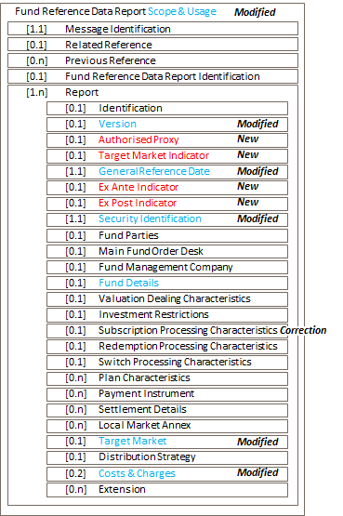
24 July 2020: diagram updated - CostsAndCharges [0.n] [0,2] (message model was correct)

Summary of Changes
New elements are shown in red. Modified elements are shown in blue.
# | Element |  |  |  |  |  |  |  | Type of Change | Status Draft 1 | Status Draft 2
1 | FundReferenceDataReportV05 |  |  |  |  |  |  |  | Scope definition | OK
 |  | MessageIdentification
 |  | PreviousReference
 |  | RelatedReference
 |  | FundReferenceDataReportIdentification
 |  | Report
 |  |  | Identification
2 |  |  | Version |  |  |  |  |  | Definition | OK
3 |  |  | AuthorisedProxy |  |  |  |  |  | New | OK
4 |  |  | GeneralReferenceDate |  |  |  |  |  | Definition | OK
5 |  |  | TargetMarketIndicator |  |  |  |  |  | New | OK
6 |  |  | ExAnteIndicator |  |  |  |  |  | New | OK
7 |  |  | ExPostIndicator |  |  |  |  |  | New | OK
 |  |  | Security Identification
 |  |  |  | Identification
 |  |  |  | Identification
 |  |  |  | Name
 |  |  |  | ShortName
 |  |  |  | ClassType
 |  |  |  | UmbrellaName
 |  |  |  | NewUmbrella
 |  |  |  | ClassificationType
 |  |  |  | BaseCurrency
 |  |  |  | CountryOfDomicile
 |  |  |  | RegisteredDistributionCountry
8 |  |  |  | ProductType (LegalStructure) |  |  |  |  | Definition
 |  |  |  |  | Code
9 |  |  |  |  |  | BOND |  |  | New
 |  |  |  |  |  | NUMM
 |  |  |  |  |  | UCMM
 |  |  |  |  |  | EXTC
 |  |  |  |  |  | UCIT
 |  |  |  |  |  | SSEC
 |  |  |  |  |  | SFUN
 |  |  |  |  |  | NUCI
 |  |  |  |  | Proprietary
10 |  |  |  |  | EMTLegalStructureGuideline |  |  |  | Deleted
 |  |  |  | Issuer
 |  |  |  | IssuerProductGovernanceProcess
11 |  |  |  | ProductCategory |  |  |  |  | Definition | Updated
12 |  |  |  | ProductCategoryGermany |  |  |  |  | New | OK
13 |  |  |  | NotionalOrUnitBased |  |  |  |  | New | OK
14 |  |  |  | QuotationType |  |  |  |  | Definition | OK
 |  |  |  | LeveragedOrContigentLiability
15 |  |  |  | NoRetrocessionIndicator |  |  |  |  | New | OK
16 |  |  |  | ExPostCostCalculationBasis |  |  |  |  | New | Updated
 |  |  |  | AdditionalInformation
17 |  |  |  | EMTSecurityIdentificationGuideline |  |  |  |  | Deleted | OK
 |  |  | Fund Parties
 |  |  | MainFundOrderDesk
 |  |  | FundManagementCompany
 |  |  | FundDetails
 |  |  |  | PhysicalBearerSecurities
 |  |  |  | DematerialisedBearerSecurities
 |  |  |  | PhysicalRegisteredSecurities
 |  |  |  | DematerialisedRegisteredSecurities
 |  |  |  | DividendPolicy
 |  |  |  | DividendFrequency
 |  |  |  | ReinvestmentFrequency
 |  |  |  | FrontEndLoad
 |  |  |  | BackEndLoad
 |  |  |  | SwitchFee
 |  |  |  | EUSavingsDirective
 |  |  |  | LaunchDate
 |  |  |  | FundEndDate
 |  |  |  | TerminationDate
 |  |  |  | InitialOfferEndDate
 |  |  |  | SuspensionStartDate
 |  |  |  | SuspensionEndDate
 |  |  |  | MaturityDate
18 |  |  |  | MayBeTerminatedEarly |  |  |  |  | New (moved) | OK
 |  |  |  | ClosedEndFund
 |  |  |  | Equalisation
 |  |  |  | TaxEfficientProductEligible
 |  |  |  | Authorised
 |  |  |  | RDRCompliant
 |  |  |  | ManagementFeeSource
 |  |  |  | PerformanceFee
 |  |  |  | AdditionalInformation
19 |  |  |  | EMTFundDetailsGuideline |  |  |  |  | Deleted
 |  |  | ValuationDealingCharacteristics
 |  |  | InvestmentRestrictions
20 |  |  | SubscriptionProcessingCharacteristics |  |  |  |  |  | Correction | OK
 |  |  | RedemptionProcessingCharacteristics
 |  |  | SwitchProcessingCharacteristics
 |  |  | PlanCharacteristics
 |  |  | PaymentInstrument
 |  |  | CashSettlementDetails
20 |  |  | LocalMarketAnnex |  |  |  |  |  | Correction | OK
 |  |  | TargetMarket
21 |  |  |  | ReferenceDate |  |  |  |  | New | OK
 |  |  |  | InvestorType
 |  |  |  |  | InvestorTypeRetail
 |  |  |  |  |  | YSCO
 |  |  |  |  |  | NEUT
 |  |  |  |  |  | NSCO
22 |  |  |  |  | InvestorTypeProfessional |  |  |  |  | Definition
 |  |  |  |  |  | Type
 |  |  |  |  |  |  | BOT3
 |  |  |  |  |  |  | NPRF |  | New | OK
 |  |  |  |  |  |  | PRF3 |  | New | Updated
 |  |  |  |  |  |  | PRF4 |  | New | OK
 |  |  |  |  |  | Other
 |  |  |  |  |  |  | YSCO
 |  |  |  |  |  |  | NEUT
 |  |  |  |  |  |  | NSCO
23 |  |  |  |  | InvestorTypeEligibleCounterparty |  |  |  | Definition.
 |  |  |  |  |  |  | YSCO
 |  |  |  |  |  |  | NEUT |  | Deletion
 |  |  |  |  |  |  | NSCO
 |  |  |  |  | Other
 |  |  |  | KnowledgeAndOrExperience
 |  |  |  |  | BasicInvestor
 |  |  |  |  | InformedInvestor
 |  |  |  |  | AdvancedInvestor
 |  |  |  |  | ExpertInvestorGermany
 |  |  |  |  | Other
 |  |  |  | AbilityToBearLosses
24 |  |  |  |  | NoCapitalLoss |  |  |  | Definition
25 |  |  |  |  | LimitedCapitalLoss |  |  |  | Definition
26 |  |  |  |  | LimitedCapitalLossLevel |  |  |  | Definition
27 |  |  |  |  | NoCapitalGuarantee |  |  |  | Definition
28 |  |  |  |  | LossBeyondCapital |  |  |  | Definition
 |  |  |  |  | Other
 |  |  |  | RiskTolerance
 |  |  |  |  | RiskTolerancePRIIPSMethodology
 |  |  |  |  | RiskToleranceUCITSMethodology
 |  |  |  |  | RiskToleranceInternal
 |  |  |  |  | RiskToleranceForNonPRIIPSAndNonUCITSSpain
 |  |  |  |  | NotForInvestorsWithTheLowestRiskToleranceGermany
 |  |  |  |  | Other
 |  |  |  | ClientObjectivesAndNeeds
29 |  |  |  |  | ReturnProfilePreservation |  |  |  | Definition
30 |  |  |  |  | ReturnProfileGrowth |  |  |  | Definition | Updated
31 |  |  |  |  | ReturnProfileIncome |  |  |  | Definition
32 |  |  |  |  | ReturnProfileHedging |  |  |  | Definition
33 |  |  |  |  | OptionOrLeveragedReturnProfile |  |  |  | Definition
34 |  |  |  |  | ReturnProfileOther |  |  |  | Deleted
 |  |  |  |  | ReturnProfilePensionSchemeGermany
 |  |  |  |  | MinimumHoldingPeriod
 |  |  |  |  |  | NumberOfYears
35 |  |  |  |  |  | TimeFrame |  |  |  | Updated
36 |  |  |  |  |  | EMTMinimumHoldingPeriodGuideline |  |  | Guideline deleted
37 |  |  |  |  | MayBeTerminatedEarly |  |  |  | Deleted (moved)
38 |  |  |  |  | SpecificInvestmentNeed |  |  |  | Deleted
39 |  |  |  |  | ESGPreferences |  |  |  | New
40 |  |  |  |  | OtherSpecificInvestmentNeed |  |  |  | New
 |  |  |  |  | Other
41 |  |  |  |  | SpecificInvestmentNeedGuideline
 |  |  |  | DistributionStrategy
 |  |  |  | CostsAndCharges
42 |  |  |  |  | Ex Ante Reference Date |  |  |  |  | Restored
43 |  |  |  |  | Ex Post Reference Date |  |  |  | Deleted
 |  |  |  |  | IndividualCostOrCharge
 |  |  |  |  |  | CostType
44 |  |  |  |  |  |  | Code
 |  |  |  |  |  |  |  | BORF | New
 |  |  |  |  |  |  |  | DIS2 | New
 |  |  |  |  |  |  |  | FES3 | Definition | Updated
 |  |  |  |  |  |  |  | FEND | Definition
 |  |  |  |  |  |  |  | FES2 | Definition
 |  |  |  |  |  |  |  | GOC1
 |  |  |  |  |  |  |  | GOCS | Definition
 |  |  |  |  |  |  |  | INCF
 |  |  |  |  |  |  |  | INCS
 |  |  |  |  |  |  |  | MNF1 | New
 |  |  |  |  |  |  |  | MANS | Definition
 |  |  |  |  |  |  |  | NET2 | New | Updated
 |  |  |  |  |  |  |  | NESF | New
 |  |  |  |  |  |  |  | NETO | Definition
 |  |  |  |  |  |  |  | NRAM | New
 |  |  |  |  |  |  |  | OOEA | New
 |  |  |  |  |  |  |  | OOSF | New
 |  |  |  |  |  |  |  | OOSS | New
 |  |  |  |  |  |  |  | BENS | Definition
 |  |  |  |  |  |  |  | ENAC
 |  |  |  |  |  |  |  | ENFX
 |  |  |  |  |  |  |  | EXAC
 |  |  |  |  |  |  |  | ENBX
 |  |  |  |  |  |  |  | BEND | Code name renamed
 |  |  |  |  |  |  |  | PENO | Definition
 |  |  |  |  |  |  |  | OTES | Definition
 |  |  |  |  |  |  |  | OCAS
 |  |  |  |  |  |  |  | RPSS | New | Updated
 |  |  |  |  |  |  |  | TRS1 | New
 |  |  |  |  |  |  | Proprietary
 |  |  |  |  |  | ExAnteOrExPost
 |  |  |  |  |  |  | ANTE
 |  |  |  |  |  |  | POST
 |  |  |  |  |  | Amount
45 |  |  |  |  |  | Sign |  |  | New | See47, 48
 |  |  |  |  |  | Rate
46 |  |  |  |  |  | ReferencePeriod |  |  | Renamed, definition
 |  |  |  |  |  |  | StartDate
 |  |  |  |  |  |  | EndDate
 |  |  |  |  |  | AdditionalInformation
 |  |  |  |  |  | ExAnteOrExPost1Guideline
 |  |  |  |  |  | ExAnteOrExPost2Guideline
47 |  |  |  |  |  | SignAmount1Rule |  |  |  | New
48 |  |  |  |  |  | SignAmount2Rule |  |  |  | New
49 |  |  |  |  | EMTGeneralGuideline |  |  |  | Guideline deleted
50 |  |  |  |  | ExAnteReferenceDateGuideline |  |  |  |  | Restored
 |  |  |  |  | IndividualCostAndCharge1Guideline
 |  |  |  |  | IndividualCostAndCharge2Guideline
 |  | Extension

Section I Implementation Details

Message Scope/Usage - definition
The message scope and usage definition is updated to remove the references to EMT v1 and V2. See spreadsheet 'DRAFT2reda.004.001.05.xlsx'.

Version - definition
The definition is updated to remove the references to EMT v1 and V2. See spreadsheet 'DRAFT2reda.004.001.05.xlsx'.

Authorised Proxy - new element
The new element is added after 'Version':
Element/Sub-Element |  | M/O | Definition | Data Type | EMT v3 Ref
NEW | Authorised Proxy | [0.1] | Party that reports the data on behalf of the issuer and the entry point e-mail address for contact. When used in reference to MiFID, this is in the scope of the European MiFID Template (EMT) references 00002, 00003 and 00004. | New version of Contact Attributes 5 | 00002 + 00003 + 00004
ContactAttributes5 - New Version
New | Authorised Proxy |  | [0.1]
 |  | Name | [0.1]
 |  | Postal Address | [0.1]
 |  | Phone Number | [0.1]
 |  | Fax Number | [0.1]
 |  | Email Address | [0.1]
 |  | URL Address | [0.1]
 |  | Any BIC | [0.1]
 |  | LEI | [0.1]

General Reference Date - definition
The definition is updated to remove the references to EMT v1 and V2. See spreadsheet 'DRAFT2reda.004.001.05.xlsx'.

Target Market Indicator - new element
The new element is added after 'General Reference Date':
Element/Sub-Element |  | M/O | Definition | Data Type | EMT v3 Ref
NEW | Target Market Indicator | [0.1] | Indicates whether target market data is included in the report. When used in reference to MiFID, this is in the scope of the European MiFID Template (EMT) reference 00006. | Yes No Indicator | 00006

Ex Ante Indicator - new element
The new element is added after the new element 'Target Market Indicator':
Element/Sub-Element |  | M/O | Definition | Data Type | EMT v3 Ref
NEW | Ex Ante Indicator | [0.1] | Indicates whether ex ante costs and charges are included in the report. When used in reference to MiFID, this is in the scope of the European MiFID Template (EMT) reference 00007. | Yes No Indicator | 00007

Ex Post Indicator - new element
The new element is added after the new element 'Ex Ante Indicator':
Element/Sub-Element |  | M/O | Definition | Data Type | EMT v3 Ref
NEW | Ex Post Indicator | [0.1] | Indicates whether ex post costs and charges are included in the report. When used in reference to MiFID, this is in the scope of the European MiFID Template (EMT) reference 00008. | Yes No Indicator | 00008

Security Identification/Legal Structure - renamed to Product Type
The element 'Legal Structure' is renamed. The definition is updated accordingly. The code list is updated.
Element/Sub-Element |  | M/O | Definition |  | Data Type | EMT v3 Ref
 | Legal Structure Product Type | [0.1] | Current Definition: | Legal structure of the financial instrument. When used in reference to MiFID, this is in the scope of the European MiFID Template (EMT) reference 00060. | Code or Proprietary | 00060
 |  |  | New Definition | Classification of the financial instrument. When used in reference to MiFID, this is in the scope of the European MiFID Template (EMT) reference 00060.

Security Identification/Product Type - new code
The previous named 'Legal Structure' element, which is now called 'Product Type', needs an additional code. A new code list is created:
Name of new code list | Definition on code list
Product Structure Code | Specifies the product structure of a financial instrument as defined in the scope of European MiFID Template (EMT) reference 00060.
Code List
 |  | Code | Code Name | Definition
1 |  | NUCI | NonUCITS | Product is a not an Undertaking for Collective Investment in Transferable Securities (UCITS).
2 |  | SFUN | StructuredFund | Product is a structured fund.
3 |  | SSEC | StructuredSecurity | Product is a structured security.
4 |  | UCIT | UCITS | Product is an Undertaking for Collective Investment in Transferable Securities (UCITS).
5 |  | EXTC | ExchangeTradedCommodity | Product is an exchange traded commodity.
6 |  | UCMM | UCITSMoneyMarketFund | Product is an Undertaking for Collective Investment in Transferable Securities (UCITS) money market fund.
7 |  | NUMM | NonUCITSMoneyMarketFund | Product is a money market fund that is not an Undertaking for Collective Investment in Transferable Securities (UCITS).
8 | NEW | BOND | Bond | Product is a bond.

Security Identification/EMT Legal Structure Guideline - deletion
The guideline is deleted since the guideline explains usage for EMT v1 or v2 and is no longer relevant.

Security Identification/ Product Category - definition
Previously there was a single element 'Product Category' to cover both the non-German and the German EMT items. The definition of Product Category is updated to provide a clearer differentiation (and a new element is added for the German scenario, see below). The definition is also updated to remove the references to EMT v1 and V2. See spreadsheet 'DRAFT2reda.004.001.05.xlsx'.
24 July 2020: Definition to be updated
Element/Sub-Element |  | Curent Definition | New Definition | EMT v3 Ref
 | Product Category | Designation of the product category or nature, for example, Pacific Equity, Equity Fund, Money Market Fund. When used in reference to MiFID, this is in the scope of the European MiFID Template (EMT) reference 00090. If the product is a structured security product, the European Structured Investment Products Association (EUSIPA) code should be used as defined in the scope of European MiFID Template (EMT) reference 00095. | Designation of the product category or nature, for example, Pacific Equity, Equity Fund, Money Market Fund. If the product is a structured security product, the European Structured Investment Products Association (EUSIPA) code should be used as defined in the scope of European MiFID Template (EMT) reference 00095. | 00095

Security Identification/Product Category Germany - new element
The new element is added below 'Product Category':
Element/Sub-Element |  | M/O | Definition | Data Type | EMT v3 Ref
NEW | Product Category Germany | [0.1] | Designation of the respective product category or nature for Germany. If the financial instrument is distributed in the German market, then the German classification of financial instruments code should be used. When used in reference to MiFID, this is in the scope of the European MiFID Template (EMT) reference 00090. | Text | 00090

Security Identification/Notional Or Unit Based - new element
The new element is added below 'Product Category Germany':
Element/Sub-Element |  | M/O | Definition | Data Type | EMT v3 Ref
NEW | Notional Or Unit Based | [0.1] | Specifies whether the financial instrument is unit based or notional (nominal). When used in reference to MiFID, this is in the scope of the European MiFID Template (EMT) reference 00085. | Choice Code or Proprietary | 00085
Data Type
Choice between code and proprietary.
Code list name → |  | NotionalOrUnitBased1Code | Code list definition → | Specifies the unit basis of a financial instrument.
 | Code | Code Name | Definition
1 | UNIT | Unit | Basis of a financial instrument is unit.
2 | NOTI | Notional | Basis of a financial instrument is notional.

Security Identification/Quotation Type - definition update
The definition is updated to remove the references to EMT v1 and v2. See spreadsheet 'DRAFT2reda.004.001.05.xlsx'.

Security Identification/No Retrocession Indicator - new element
The new element added after the new element 'Notional Or Unit Based':
Element/Sub-Element |  | M/O | Definition | Data Type | EMT v3 Ref
NEW | No Retrocession Indicator | [0.1] | Indicates whether the share class does not pay retrocession fees and commissions. When used in reference to MiFID, this is in the scope of the European MiFID Template (EMT) reference 00110. | Yes No Indicator | 00110

Security Identification/Ex Post Cost Calculation Basis - new element
The new element is added after the new element 'No Retrocession Indicator':
Element/Sub-Element |  | M/O | Definition | Data Type | EMT v3 Ref
NEW | Ex Post Cost Calculation Basis | [0.1] | Specifies the basis for ex post calculations. When used in reference to MiFID, this is in the scope of the European MiFID Template (EMT) reference 00120. | Code or proprietary | 00120
Ex Post Cost Calculation Basis Code List
Code list name → |  | ExPostCostCalculationBasis | Code list definition → | Specifies the basis for an ex post cost calculation.
 | Code | Code Name | Definition
1 | ROLL | RollingBasis | Basis for cost calculation is rolling, that is, the last twelve months
2 | FIXB | FixedBasedBasis | Basic for cost calculation is fixed, that is calendar year.
24 July 2020: code names aligned with similar element in ISO 20022. Updated in message model.

Security Identification/EMT Security Identification Guideline - deletion
The guideline is deleted since the guideline explains usage for EMT v1 or v2 and is no longer relevant.

Fund Details/May Be Terminated Early - new element
This element is moved from Target Market/ ClientObjectivesAndNeeds sub-sequence and the definition is updated to reflect the new EMT v3 reference number.
Element/Sub-Element |  | M/O | Definition | Data Type | EMT v3 Ref
NEW | May Be Terminated Early | [0.1] | Specifies whether the product may be terminated early. When used in reference to MiFID, this is in the scope of the European MiFID Template (EMT) reference 00067. | Code or proprietary | 00067

Fund Details/EMT Fund Details Guideline - deletion
The guideline is deleted since the guideline explains usage for EMT v1 or v2 and is no longer relevant.

Subscription Processing Characteristics + Local Market Annex - rule correction (ID 1697)
This change is not part of the EMT v3 updates. An error was reported by a user of the message.
Correction of the textual description of 'NonWorkingDayAdjustmentRule' in the following sequences:
[1] SubscriptionProcessingCharacteristics/ DealConfirmationTimeFrame
[2] LocalMarketAnnex/ SubscriptionProcessingCharacteristics/ DealConfirmationTimeFrame
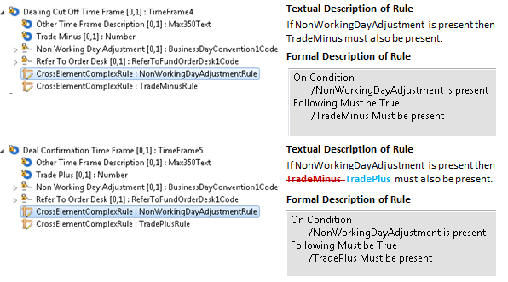

Current | Proposed
If NonWorkingDayAdjustment is present then TradeMinus must also be present. | If NonWorkingDayAdjustment is present then TradeMinus TradePlus must also be present.

Target Market/Reference Date - new element
This new element is added as first element in the Target Market sequence.
Element/Sub-Element |  | M/O | Definition | Data Type | EMT v3 Ref
NEW | Reference Date | [0.1] | Date to which the target market data refers. When used in reference to MiFID, this is in the scope of the European MiFID Template (EMT) reference 01000. | ISO Date | 01000

Target Market/Investor Type/Investor Type Professional - definition & new codes
The definition is updated, according to the new EMT v3 specification.
Current Definition | New Definition
Specifies how the product is aimed at the professional investor. If neutral, the manufacturer estimates that there is neither a negative nor a positive target market. Professional per se or elective professional should only be used if the distinction is done in the prospectus. When used in reference to MiFID, this is in the scope of the European MiFID Template (EMT) reference 01020. | Specifies how the product is aimed at the professional investor. When used in reference to MiFID, this is in the scope of the European MiFID Template (EMT) reference 01020.  24 July 2020: definition now applied in message model.
The codes are also updated.
Updated code list: InvestorTypeV2Code
 |  | Code | Code Name | Definition
1 |  | BOT3 | BothProfessionalPerSe AndElectiveProfessional | Professional per se and elective professional.
2 | New | NPRF | NotProfessionalPerSe ElectiveProfessional | Investor is neither professional per se or elective professional
3 | New | PRF3 | ProfessionalPerSeNot ElectiveProfessional | Investor is professional per se but not elective professional
4 | New | PRF4 | ElectiveProfessionalNot ProfessionalPerSe | Investor is an elective professional but not professional per se.
24 July 2020: code name corrected. Updated in message model.

Target Market/Investor Type/Investor Type Eligible Counterparty - definition, deletion code NEUT
The definition is updated, according to the new EMT v3 specification.
Current Definition | New Definition
Specifies whether the product is aimed at the eligible counterparty. If neutral, the manufacturer estimates that there is neither a negative nor a positive target market. When used in reference to MiFID, this is in the scope of the European MiFID Template (EMT) reference 01030. | Specifies whether the product is aimed at the eligible counterparty. When used in reference to MiFID, this is in the scope of the European MiFID Template (EMT) reference 01030.
Code list
The data type TargetMarket1Code, with codes YSCO, NEUT, NSCO, is replaced by the existing TargetMarket3Code list, with codes YSCO and NSCO.

Target Market/Ability To Bear Losses/ No Capital Loss - definition update
The definition is updated to remove the references to EMT v1 and v2. See spreadsheet 'DRAFT2reda.004.001.05.xlsx'.

Target Market/Ability To Bear Losses/ Limited Capital Loss - definition update
The definition is updated to remove the references to EMT v1 and v2. See spreadsheet 'DRAFT2reda.004.001.05.xlsx'.

Target Market/Ability To Bear Losses/ Limited Capital Loss Level - definition update
The definition is updated to remove the references to EMT v1 and v2. See spreadsheet 'DRAFT2reda.004.001.05.xlsx'.

Target Market/Ability To Bear Losses/ No Capital Guarantee - definition update
The definition is updated to remove the references to EMT v1 and v2. See spreadsheet 'DRAFT2reda.004.001.05.xlsx'.

Target Market/Ability To Bear Losses/ Loss Beyond Capital - definition update
The definition is updated to remove the references to EMT v1 and v2. See spreadsheet 'DRAFT2reda.004.001.05.xlsx'.

Target Market/Client Objective And Needs/ Return Profile Preservation - definition update
The definition is updated to remove the references to EMT v1 and v2. See spreadsheet 'DRAFT2reda.004.001.05.xlsx'.

Target Market/Client Objective And Needs/ Return Profile Growth - definition update
The definition is updated to remove the references to EMT v1 and v2. See spreadsheet 'DRAFT2reda.004.001.05.xlsx'.
24 July 2020: Definition to be updated
Element/Sub-Element |  | Curent Definition | New Definition | EMT v3 Ref
 | ReturnProfileGrowth | Specifies whether the product is compatible with a client looking for capitalisation growth. | Specifies whether the product is compatible with a client looking for capitalisation growth.  When used in reference to MiFID, this is in the scope of the European MiFID Template (EMT) reference 05020. | 05020

Target Market/Client Objective And Needs/ Return Profile Income - definition update
The definition is updated to remove the references to EMT v1 and v2. See spreadsheet 'DRAFT2reda.004.001.05.xlsx'.

Target Market/Client Objective And Needs/ Return Profile Hedging - definition update
The definition is updated to remove the references to EMT v1 and v2. See spreadsheet 'DRAFT2reda.004.001.05.xlsx'.

Target Market/Client Objective And Needs/ Option Or Leveraged Return Profile - definition update
The definition is updated to remove the references to EMT v1 and v2. See spreadsheet 'DRAFT2reda.004.001.05.xlsx'.

Target Market/Client Objective And Needs/ Return Profile Other - deletion
This element is not part of EMT v3 and is deleted.

Target Market/Client Objective And Needs/ Minimum Holding Period - Time Frame
The code 'Neutral' (NEUT) is deleted since the code is for EMT v1 or v2 and is no longer relevant.

Target Market/Client Objective And Needs/ Minimum Holding Period - guideline deletion
The guideline 'EMTMinimumHoldingPeriodGuideline' is deleted since the guideline explains usage for EMT v1 or v2 and is no longer relevant.

Target Market/Client Objectives And Needs/ May Be Terminated Early - moved
The element May Be Terminated Early is moved from the Client Objectives And Needs subsequence to the Fund Details sequence. The definition is also updated.

Target Market/Client Objective And Needs/ Specific Investment Need - deletion
This element is not part of EMT v3 and is deleted.

Target Market/Client Objectives And Needs/ESG Preferences - new element
The new element added as last element, below 'Minimum Holding Period'.
Element/Sub-Element |  | M/O | Definition | Data Type | EMT v3 Ref
NEW | ESG Preferences | [0.1] | Specifies whether the product is compatible with investors that have Environmental, Social and Governance (ESG) preferences. When used in reference to MiFID, this is in the scope of the European MiFID Template (EMT) reference 05105. | TargetMarket2Code (already exists)

Target Market/Client Objectives And Needs/Other Specific Investment Need - new element
This new element added below the new element 'ESG Preferences'.
Element/Sub-Element |  | M/O | Definition | Data Type | EMT v3 Ref
NEW | Other Specific Investment Need | [0.n] | Specifies other specific investment needs. When used in reference to MiFID, this is in the scope of the European MiFID Template (EMT) reference 05115. | Choice Code or Proprietary
Other Specific Investment Need Code List
Code list name → |  | InvestmentNeed2Code | Code list definition → | Other specific investment need expressed as a code.
 | Code | Code Name | Definition
1 | NONE | NoOther | Other specific investment need expressed as a code.
2 | ISLB | Islamic Banking | No other specific investment need.
3 | OTHR | Other | There are requirement for Islamic banking.

Target Market/Client Objectives And Needs/Specific Investment Need Guideline - deletion
The guideline is deleted since the guideline explains usage for EMT v1 or v2 and is no longer relevant.

Costs And Charges/Ex Ante Reference Date - deletion: restored
This element is not part of EMT v3 and is deleted. 24 July 2020. This is an error in the MCR, this element is not removed.

Costs And Charges/Ex Post Reference Date - deletion
This element is not part of EMT v3 and is deleted.

Costs And Charges/Individual Cost Or Charge/Cost Type/Code - update
A new version of the cost type codes has been created, with the following codes:
 | Code | Code Name | Definition | EMT v3 element
1 | FEND | GrossOneOffMaximumEntryCostNonAcquired | Gross one-off maximum entry cost not acquired to the fund. When used in reference to MiFID, this is in the scope of the European MiFID Template (EMT) reference 07020 and is a percentage of the amount to be invested. This fee is paid by the investor to the fund or fund management company. This is indicative and should be adapted by the distributor according to the agreement with the asset manager. | 07020_Gross_One-off_Cost_Financial_Instrument_Maximum_Entry_Cost_Non_Acquired: Funds
2 | FES2 | GrossOneOffMaximumEntryCostStructured | Gross maximum one-off entry cost for a structured product. When used in reference to MiFID, this is in the scope of the European MiFID Template (EMT) reference 07020 and is the 'ask price' or 'fair value'. It may be specified as an actual amount or a percentage of the reference value, EMT reference 07150, and should only incorporate manufacturer costs (that is, the cost of the financial instrument) and distributor costs upfront when known by the manufacturer. It should, however, not include distribution fees added on top of the product price by distributors that are out of control of the manufacturer. | 07020_Gross_One-off_Cost_Financial_Instrument_Maximum_Entry_Cost_Non_Acquired: Structured Security
3 | FES3 | GrossOneOffEntryCostStructured | Gross one-off entry cost for a structured product. When used in reference to MiFID, this is in the scope of the European MiFID Template (EMT) reference 08010 and may be specified as an actual amount or a percentage of the reference value, EMT reference 08110 or 08120, and should only incorporate manufacturer costs (that is, the cost of the financial instrument) and distributor costs upfront when known by the manufacturer. It should, however, not include distribution fees added on top of the product price by distributors that is out of control of the manufacturer.  24 July 2020: definition updated in message model. | 08010_Gross_One-off_Cost_Structured_Securities_Entry_Cost_Ex_Post: Structured Security
4 | NESF | NetOneOffEntryCostNonAcquiredStructuredFund | Net one-off entry cost for a structured fund. When used in reference to MiFID, this is in the scope of the European MiFID Template (EMT) reference 07025. This is expressed as a percentage of the amount to be invested. | 07025_Net_One-off_Cost_Structured_Products_Entry_Cost_Non_Acquired: Structured Funds
5 | NETO | NetOneOffEntryCostStructuredNonAcquired | Net one-off entry cost for a structured product. When used in reference to MiFID, this is in the scope of the European MiFID Template (EMT) reference 07025 and is minus the upfront distribution fee. The cost reported is a net disclosure and therefore the upfront distributor fee is equal to the difference between the one-off entry cost (EMT reference 07020) and the net one-off entry (EMT reference 07025).  24 July 2020: Definition updated in message model. | 07025_Net_One-off_Cost_Structured_Products_Entry_Cost_Non_Acquired: Structured
6 | NET2 | Net One Off Entry Cost Ex Post Structured | Net one-off entry cost for a structured product. When used in reference to MiFID, this is in the scope of the European MiFID Template (EMT) reference 08015 and is minus the upfront distribution fee. The cost reported is a net disclosure and therefore the upfront distributor fee is equal to the difference between the gross one-off entry cost (EMT reference 08010) and the net one-off entry (EMT reference 08015).  24 July 2020: Definition updated in message model. | 08015_Net_One-off_Cost_Structured_Securities_Entry_Cost_Ex_Post
7 | ENFX | OneOffMaximumEntryCostFixedAmountItaly | Maximum one-off entry cost fixed amount. When used in reference to MiFID, this is in the scope of the European MiFID Template (EMT) reference 07030 and is a flat fee defined by the fund or fund management company. This is indicative and should be adapted by the distributor according to the relationship been the fund and the distribution. This cost is not taken into account in the gross one-off maximum entry cost (FEND), EMT reference 07020. | 07030_One-off_Cost_Financial_Instrument_Maximum_Entry_Cost_Fixed_Amount_Italy
8 | ENAC | OneOffMaximumEntryCostAcquired | Maximum cost of the one-off entry fee. When used in reference to MiFID, this is in the scope of the European MiFID Template (EMT) reference 07040 and is the subscription fees acquired to the fund. It is not included in the one off entry cost 07020. This maximum one-off entry cost acquired to the fund is specified as a percentage of the amount to be invested. | 07040_One-off_Cost_Financial_Instrument_Maximum_Entry_Cost_Acquired
9 | BEND | OneOffMaximumExitCostNonAcquired | Maximum cost of the one-off exit fee not acquired to the fund that could happen at a certain time during the life of the product. This is a percentage of the NAV. When used in reference to MiFID, this is in the scope of the European MiFID Template (EMT) reference 07050. | 07050_One-off_Costs_Financial_Instrument_Maximum_Exit_Cost_Non_Acquired
10 | ENBX | OneOffMaximumExitCostFixedAmountItaly | Maximum one-off exit cost, a maximum fixed amount per redemption. When used in reference to MiFID, this is in the scope of the European MiFID Template (EMT) reference 07060 and is flat fee defined by the fund or fund management company. It is indicative and should be adapted distributor according to the relationship been the fund and the distribution. This cost is not taken in account in the one-off maximum exit cost EMT reference 07050. | 07060_One-off_Costs_Financial_Instrument_Maximum_Exit_Cost_Fixed_Amount_Italy
11 | EXAC | OneOffMaximumExitCostAcquired | Maximum cost of the one-off exit fee acquired to the fund. When used in reference to MiFID, this is in the scope of the European MiFID Template (EMT) reference 07070. It is not included in the one off maximum exit cost EMT reference 07050. This is paid by the investor to the fund or fund management company. This is a percentage of the NAV. | 07070_One-off_Costs_Financial_Instrument_Maximum_Exit_Cost_Acquired
12 | PENO | OneOffTypicalExitCost | One-off typical exit current exit cost linked to the recommended holding period (RHP) or time to maturity. When used in reference to MiFID, this is in the scope of the European MiFID Template (EMT) reference 07080 and are the ‘normal’ fees if the client holds the product until maturity or during the RHP.  Example: a product with a 5 year maturity has exit costs of:  - 4% after 1 and 2 years  - 3% after 3 years  - 1% after 4 years  - 0 at maturity  Then maximum exit cost: 4%.  Typical cost : 0 | 07080_One-off_Costs_Financial_Instrument_Typical_Exit_Cost: Funds
13 | OTES | OneOffTypicalExitCostsStructured | One-off typical exit cost linked to the recommended holding period (RHP) for a structured product. When used in reference to MiFID, this is in the scope of the European MiFID Template (EMT) reference 07080 and may be specified as an actual amount or a percentage of the reference value, EMT reference 07150 or 07155. | 07080_One-off_Costs_Financial_Instrument_Typical_Exit_Cost: Structured
14 | OOSF | One Off Exit Cost Prior Structured Product Fund | One-off exit cost prior to the recommended holding period (RHP). When used in reference to MiFID, this is in the scope of the European MiFID Template (EMT) reference 07090 and may be specified as a percentage of the amount to be divested. | 07090_One-off_Cost_Financial_Instrument_Exit_Cost_Structured_Products_Prior_RHP: Structured Funds
15 | OOSS | One Off Exit Cost Prior Structured Securities | One-off exit cost prior to the recommended holding period (RHP). When used in reference to MiFID, this is in the scope of the European MiFID Template (EMT) reference 07090 and is specified as an actual amount or a percentage of the reference value, EMT reference 07150 or 07155. | 07090_One-off_Cost_Financial_Instrument_Exit_Cost_Structured_Products_Prior_RHP: Structured Security
16 | GOC1 | GrossOngoingCosts | Gross on-going costs. When used in reference to MiFID, this is in the scope of the European MiFID Template (EMT) reference 07100 and 08030 and is a percentage of the NAV of the financial product, expressed in annualised terms (rate of cost deduction to be applied). This includes management fees and distribution fees and excludes all transaction costs, incidental costs and performance fees. Costs reported should reflect current running ongoing costs. The gross on-going costs is expressed as a percentage of the NAV of the financial instrument per annum. | 07100_Financial_Instrument_Gross_Ongoing_Costs: Funds  +  08030_Financial_Instrument_Ongoing_Costs_Ex_Post: Funds
17 | GOCS | GrossOngoingCostsStructured | Gross on-going costs for a structured product. When used in reference to MiFID, this is in the scope of the European MiFID Template (EMT) reference 07100 and 08030 and is expressed as a percentage of the NAV or currency and amount for an absolute quotation of the financial product in annualised terms related to the reference value, EMT reference 07150 or 07155 or 08110. | 07100_Financial_Instrument_Gross_Ongoing_Costs: Structured  +  08030_Financial_Instrument_Ongoing_Costs_Ex_Post: Structured Security
18 | BORF | Borrowing Cost Fund | Financing costs related to borrowing for the purposes of gearing expressed as a percentage of the NAV. When used in reference to MiFID, this is in the scope of the European MiFID Template (EMT) reference 07105 and 08045. | 07105_Financial_Instrument_Borrowing_Costs_Ex_Ante_UK: Funds  +  08045_Financial_Instrument_Borrowing_Costs_Ex_Post_UK: Funds
19 | MNF1 | ManagementFee | Management fee paid to an investment manager for services. When used in reference to MiFID, this is in the scope of the European MiFID Template (EMT) reference 07110 and 08050 and is a percentage of the NAV of the financial product expressed in annualised terms (rate of cost deduction to be applied). These fees are included in total ongoing costs and are fees used by distributors to calculate retrocession fees. The costs reported should reflect current running management costs. | 07110_Financial_Instrument_Management_Fee: Funds  +  08050_Financial_Instrument_Management_Fee_Ex_Post: Funds
20 | MANS | ManagementFeeStructured | Management fee for a structured product. When used in reference to MiFID, this is in the scope of the European MiFID Template (EMT) reference 07110 and 08050 and is expressed as a percentage of the NAV or a currency and amount for an absolute quotation of the financial product in annualised terms related to the reference value, EMT reference 07150 or 07155 or 08110. | 07110_Financial_Instrument_Management_Fee: Structured Securities  +  08050_Financial_Instrument_Management_Fee_Ex_Post: Structured Security
21 | DIS2 | DistributionFee | Distribution fee. This fee is included in the total on going costs and is not included in the management fee. It is only applicable if the product has this feature. The cost reported should reflect the current running distribution fee. When used in reference to MiFID, this is in the scope of the European MiFID Template (EMT) reference 07120 and 08060 and this a percentage of the NAV of the financial instrument expressed in annualised terms (rate of cost deduction to be applied). | 07120_Financial_Instrument_Distribution_Fee: Funds  +  08060_Financial_Instrument_Distribution_Fee_Ex_Post: Funds
22 | TRS1 | Transaction Cost | Cost associated with the transaction. When used in reference to MiFID, this is in the scope of the European MiFID Template (EMT) reference 07130 and 08070 and this is a percentage of the NAV of the financial instrument expressed in annualised terms (rate of cost deduction to be applied). | 07130_Financial_Instrument_Transaction_Costs_Ex_Ante: Funds  +  08070_Financial_Instrument_Transaction_Costs_Ex_Post: Funds
23 | INCF | IncidentalCosts | Fee that covers incidental costs. When used in reference to MiFID, this is in the scope of the European MiFID Template (EMT) reference 07140 and 08080 and is expressed as a percentage of the NAV. Includes performance fees and other costs. | 07140_Financial_Instrument_Incidental_Costs_Ex_Ante: Funds  +  08080_Financial_Instrument_Incidental_Costs_Ex_Post
24 | INCS | IncidentalCostsStructured | Fee that covers incidental costs for a structured product. When used in reference to MiFID, this is in the scope of the European MiFID Template (EMT) reference 07140 and 08080 and is expressed as a percentage of the NAV or a currency and amount for an absolute quotation of the financial product in annualised terms related to the reference value, EMT reference 07150 or 07155 and 08110. | 07140_Financial_Instrument_Incidental_Costs_Ex_Ante: Structured Security  +  08080_Financial_Instrument_Incidental_Costs_Ex_Post: Structured Security
25 | RPSS | ReferencePrice | Reference Price. When used in reference to MiFID, this is in the scope of the European MiFID Template (EMT) reference 07150 and 08110 and is the instrument price to which a unit disclosed ex-post cost is based and to which a percentage disclosed cost should be multiplied in order to retrieve the unit cost.  24 July 2020: Definition updated in message model. | 07150_Structured_Securities_Reference_Price_Ex_Ante
26 | NRAM | Notional Reference Amount | Notional reference amount. When used in reference to MiFID, this is in the scope of the European MiFID Template (EMT) reference 07155 and 08120. This is the amount expressed as a number of currency units to which a unit disclosed ex-post cost is based and to which a percentage disclosed cost should be multiplied in order to retrieve the unit cost. | 07155_Structured_Securities_Notional_Reference_Amount_Ex_Ante: Structured Security
27 | BENS | OneOffExitCostStructured | One off exit cost for a structured product. When used in reference to MiFID, this is in the scope of the European MiFID Template (EMT) reference 08020 and when expressed as a percentage, this is a percentage of the reference value, EMT reference 08110 or 08120. | 08020_One-off_Costs_Structured_Securities_Exit_Cost_Ex_Post: Structured Security
28 | OOEA | OneOffEntryCostAcquired | Percentage of the NAV. When used in reference to MiFID, this is in the scope of the European MiFID Template (EMT) reference 08025. | 08025_One-off_Cost_Financial_Instrument_Entry_Cost_Acquired: Funds
29 | OCAS | OngoingCostsAccumulatedStructured | Sum of daily recurring product costs accumulated during the year until the ex post reference date. This is typically specified as an actual amount. When used in reference to MiFID, this is in the scope of the European MiFID Template (EMT) reference 08040. | 08040_Structured_Securities_Ongoing_Costs_Ex_Post_Accumulated: Structured Security
CODES IN PREVIOUS EMT CODE LIST NOT USED IN v3 - SPECIFED HERE FOR THE RECORD
These are codes whose definitions in v3 are sufficiently different from v2 to necessitate new codes in v3 and to leave v2/v2 definitions untouched.
 | DIST | DistributionFee | Distribution fee. This fee is included in the total on going costs and is not included in the management fee. When used in reference to MiFID, this is in the scope of the European MiFID Template (EMT) reference 07120 and 08060 and this a percentage of the NAV or the reference value, EMT reference 07150 and 08110, of the financial instrument expressed in annualised terms (rate of cost deduction to be applied). | 07120_Financial_Instrument_Distribution_fee: Funds  +  08060_Financial_Instrument_Distribution_Fee_Ex_Post: Funds
 | GEAR | GearingCost | Financing costs related to borrowing for the purposes of gearing expressed as a percentage of the NAV. When used in reference to MiFID, this is in the scope of the European MiFID Template (EMT) reference 07135 and 08075. | 07135_Financial_Instrument_Gearing_costs_ex_ante: Funds  + 08075_Financial_Instrument_Gearing_costs_ex_post: Funds
 | GOCF | GrossOngoingCosts | Gross on-going costs. When used in reference to MiFID, this is in the scope of the European MiFID Template (EMT) reference 07100 and 08030 and is a percentage of the NAV or the reference value, EMT reference 07150, of the financial product, expressed in annualised terms (rate of cost deduction to be applied). This includes management fees and distribution fees and is expressed as a percentage of the NAV of the financial instrument per annum. | 07100_Financial_Instrument_Gross_Ongoing_costs: Funds  +  08030_Financial_Instrument_Ongoing_costs_ex_post: Funds
 | MANF | ManagementFee | Management fee paid to an investment manager for services. When used in reference to MiFID, this is in the scope of the European MiFID Template (EMT) reference 07110 and 08050 and is a percentage of the NAV or reference value (EMT reference 07150 and 08110) of the financial product expressed in annualised terms (rate of cost deduction to be applied). These fees are included in total ongoing costs and are fees used by distributors to calculate retrocession fees. | 07110_Financial_Instrument_Management_fee: Funds  +  08050_Financial_Instrument_Management_fee_ex_post: Funds
 | OOES | OneOffExitCostPriorStructured | One-off exit cost prior to the recommended holding period (RHP). When used in reference to MiFID, this is in the scope of the European MiFID Template (EMT) reference 07090 and may be specified as an actual amount or a percentage of the reference value, EMT reference 07150. | 07090_One-off_cost_Financial_Instrument_exit_cost_structured_securities_prior_RHP
 | PERF | PerformanceFee | Performance fee. When used in reference to MiFID, this is in the scope of the European MiFID Template (EMT) reference 07145 and 08085 and is a percentage of the NAV or the reference value, EMT reference 07150 and 08110, of the financial instrument expressed in annualised terms (rate of cost deduction to be applied). This fee is included in the total incidental costs.  In EMT v1, this is not supported. | 07145_Financial_Instrument_Performance_Fee_costs_ex_ante: Funds  +  08085_Financial_Instrument_Performance_Fee_costs_ex_post: Funds
 | PERS | PerformanceFeeStructured | Performance fee for a structured product. When used in reference to MiFID, this is in the scope of the European MiFID Template (EMT) reference 07145 and 08085 and is expressed as a percentage of the NAV or a currency and amount for an absolute quotation of the financial product in annualised terms related to the reference value, EMT reference 07150 and 08110. In EMT v1, this is not supported. | 07145_Financial_Instrument_Performance_Fee_costs_ex_ante: Structured Security  +  08085_Financial_Instrument_Performance_Fee_costs_ex_post: Structured Securities
 | REFV | ReferenceValue | Reference value. When used in reference to MiFID, this is in the scope of the European MiFID Template (EMT) reference 07150 and 08110 and is the percentage of the NAV of the financial product expressed in annualised terms (rate of cost deduction to be applied). | 07150_Structured_Securities_Reference_Value_ex_ante: Structured Security  +  08110_Structured_Securities_Reference_Value_ex_post: Structured Security
 | TRSF | TransactionCost | Cost associated with the transaction. When used in reference to MiFID, this is in the scope of the European MiFID Template (EMT) reference 07130 and 08070 and this is a percentage of the NAV or the reference value, EMT reference 07150 and 08110, of the financial instrument expressed in annualised terms (rate of cost deduction to be applied). | 07130_Financial_Instrument_Transaction_costs_ex_ante: Funds  +  08070_Financial_Instrument_Transaction_costs_ex_post: Funds

Costs And Charges/Individual Cost Or Charge/Sign - new element
This new element is added below 'Amount'.
Element/Sub-Element |  | M/O | Definition | Data Type | EMT v3 Ref
NEW | Sign | [0.1] | Indicates a negative amount. | Plus Or Minus Indicator | --

Costs And Charges/Individual Cost Or Charge/Reference Period - renamed
This element was previously named 'CalculationPeriod'. The definition has been updated accordingly. See spreadsheet 'DRAFT2reda.004.001.05.xlsx'.

Costs And Charges/Individual Cost Or Charge/ Sign Rule 1
Rule |  | Definition | Rule Type
NEW | SignAmount1Rule | If Amount is not present, then Sign is not allowed. | Can be validated on network

Costs And Charges/Individual Cost Or Charge/ Sign Rule 2
Rule |  | Definition | Rule Type
NEW | SignAmount2Rule | Sign must only be used to express a negative value for Amount. | Textual

Costs And Charges/EMT General Guideline - deletion
The guideline is deleted since the guideline explains usage for EMT v1 or v2 and is no longer relevant.

Costs And Charges/Ex Ante Reference Date Guideline - deletion: restored
The guideline is deleted since the guideline explains usage for EMT v1 or v2 and is no longer relevant.
24 July 2020. This is an error in the MCR, this guideline is not removed.

Sections J and K of CR 0851
J. Proposed timing
The submitting organisation confirms that it can implement the changes when requested.
Timing | 2020/2021 maintenance cycle
K. Final decision of the SEG(s)
Approve
Comments:
Reject
Reason for rejection:

Message Schema Structure Diagrams

Report Details
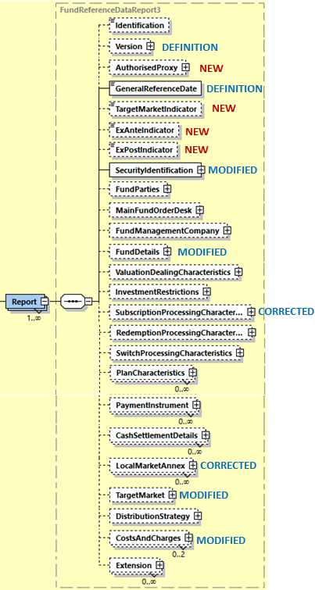

Security Identification
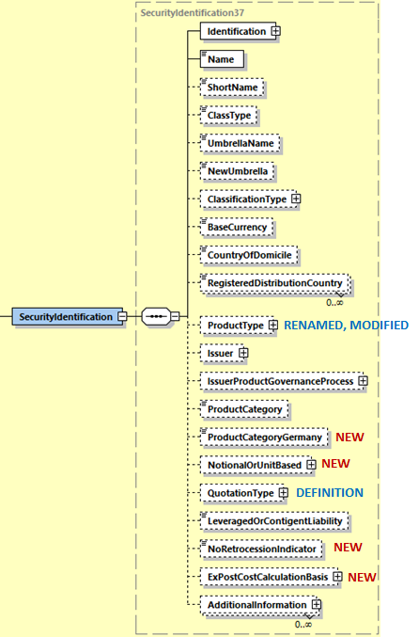

Fund Details
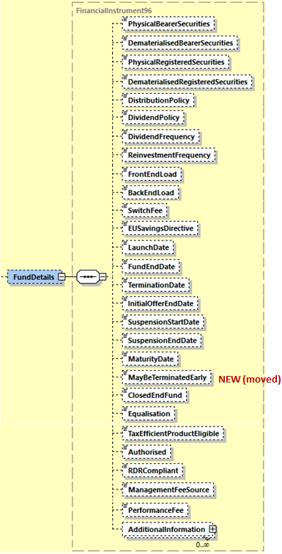

Target Market
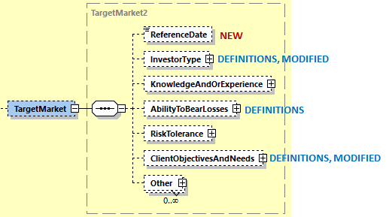

Target Market/Investor Type

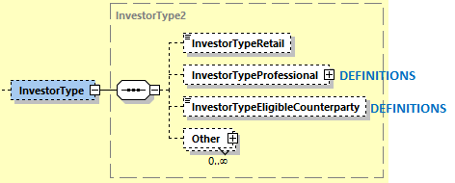

Target Market/Ability To Bear Losses
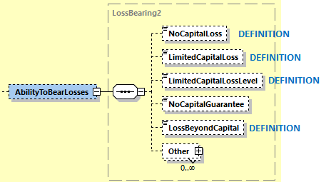

Target Market/Client Objectives And Needs
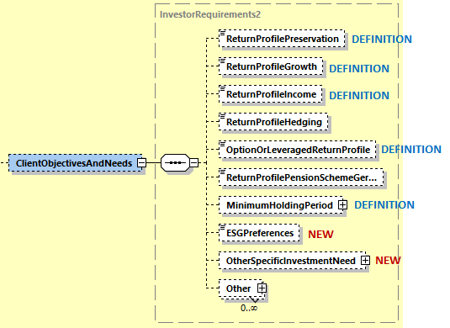
DELETIONS
ReturnProfileOther, MayBeTerminatedEarly (moved to Fund Details), SpecificInvestmentNeed

Costs And Charges
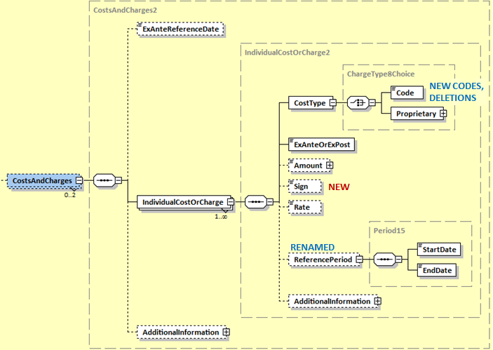
24 July 2020: Diagram above updated (ExAnteReferenceDate element added)
DELETIONS
Ex Post Reference Date

End of Document

Previously named Fund Processing Passport ‘FPP’

