Maintenance Change Request

Note: the purpose of this document is to give guidelines to submitting organisations that will develop a new version of existing ISO 20022 messages based on change requests screened by the Standards Evaluation Group(s). Such development is subject to the approval of a Maintenance Change Request which must include a detailed description of the impact of each change on the related messages. The Maintenance Change Request must start with a general chapter covering topics related to the whole maintenance effort and a specific chapter for each change request, as described below. Please consult the iso20022.org website for additional details on the maintenance process.
The Maintenance Change Requests for this ISO 20022 maintenance will follow the fast track process and will be sent to iso20022ra@iso20022.org by end of August 2019.

- Name of the request:
Shareholder Identification Disclosure Messages Maintenance for year 2020/2021
- Submitting organization(s):
SWIFT, SMPG
- Related messages:
Under this project, all the following ISO 20022 Shareholder Identification Disclosure messages would be maintained:
 | Message Name | Identifier
1 | ShareholderIdentificationDisclosureRequestV02 | seev.045.001.02
2 | ShareholderIdentificationDisclosureResponseV01 | seev.047.001.01
- Commitments of the submitting organization:
SWIFT and SMPG confirm that it can and will:
- undertake the development of the new version of the candidate ISO 20022 message models that it will submit to the RA for compliance review and evaluation by September 2020.
- provide a new version of part 1 of the Message Definition Report (MDR) and new examples of valid message instances of each message by October 2020 at the latest.
- address any queries related to the description of the new models and messages as published by the RA on the ISO 20022 website.
SWIFT confirms that it intends to organize the actual implementation of the new version of the messages on its SWIFTNet network once the related documentation has been published by the RA.

The submitting organisations confirm their knowledge and acceptance of the ISO 20022 Intellectual Property Rights policy for contributing organisations, as follows.
“Organisations that contribute information to be incorporated into the ISO 20022 Repository shall keep any Intellectual Property Rights (IPR) they have on this information. A contributing organisation warrants that it has sufficient rights on the contributed information to have it published in the ISO 20022 Repository through the ISO 20022 Registration Authority in accordance with the rules set in ISO 20022. To ascertain a widespread, public and uniform use of the ISO 20022 Repository information, the contributing organisation grants third parties a non-exclusive, royalty-free license to use the published information”.

- Contact persons:
Christine Strandberg – christine.strandberg@seb.se – phone: +46 8 763 6074
Mari Fumagalli – mariangela.fumagalli@bnpparibas.com – phone: +44 207 595 4988
Jacques Littré – jacques.littre@swift.com – phone: +32 2 655 43 35
ISO 20022 Proxy Voting Messages Maintenance 2020/2021

Table of Contents

1 CR0908: Add Previous Disclosure Request Identification in Request 4
2 CR0918: Add New Year of Incorporation for Legal Person in Disclosure Response 7

CR0908: Add Previous Disclosure Request Identification in Request
- Origin of the request:
A.1 Submitter: SMPG (Securities Market Practice Group)
A.2 Contact person:
Christine Strandberg: christine.strandberg@seb.se - +46 (8) 763 60 74
Mariangela Fumagalli: mariangela.fumagalli@bnpparibas.com - +442075954988
Jacques Littré: jacques.littre@swift.com - +3226554335
A.3 Sponsors:
Securities Market Practice Group

- Related messages:
seev.045.001.02

- Description of the change request:
Add in the root of the message a new optional and non repeatable element named “PreviousDisclosureRequestIdentification” as well as a new cross element complex rule named “PreviousDisclosureRequestIdentificationRule” to condition the presence of the new element “PreviousDisclosureRequestIdentification” with the REPL request type.

- Purpose of the change:
To be able to refer to the previous issuer identification disclosure request message sent when sending the seev.045 message with a disclosure request type “Replacement” (REPL).

- Urgency of the request:
For SR2021.
- Business examples:
N/A
- SEG/TSG recommendation:
This section is not to be taken care of by the submitter of the change request. It will be completed in due time by the SEG(s) in charge of the related ISO 20022 messages or the TSG for changes related to the BAH.

Consider |  |  | Timing
- Next yearly cycle: 2018/2019
(the change will be considered for implementation in the yearly maintenance cycle which starts in 2018 and completes with the publication of new message versions in the spring of 2019)
- At the occasion of the next maintenance of the messages
(the change will be considered for implementation, but does not justify maintenance of the messages in its own right – will be pending until more critical change requests are received for the messages)
- Urgent unscheduled
(the change justifies an urgent implementation outside of the normal yearly cycle)
 |  |  | - Other timing:
Comments:

Reject
Reason for rejection:
- Impact analysis:
This change request impacts only the following messages:
seev.045.001.02

- Proposed implementation:

- In the seev.045 (ShareholderIdentificationDisclosureRequest) message, add the new message building block named PreviousDisclosureRequestIdentification and typed by the data type Max35Text.

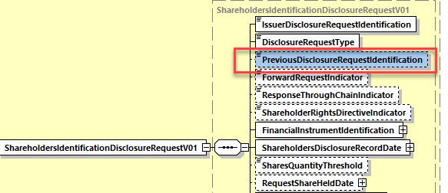

- In the seev.045 (ShareholderIdentificationDisclosureRequest) message, add a new cross element complex rule PreviousDisclosureRequestIdentificationRule at the root of the message with the following description:
“If DisclosureRequestType is REPL (Replacement), then PreviousDisclosureRequestIdentification must be present.”
- Proposed timing:
The submitting organization confirms that it can implement the requested changes in the requested timing

Timing | - As requested

- Final decision of the SEG(s):

Approve | X
Comments:

Reject
Reason for rejection:

CR0918: Add New Year of Incorporation for Legal Person in Disclosure Response
- Origin of the request:
A.1 Submitter: identity of the company, organization, group, initiative or community that submits the change request.
Broadridge Financial Solutions Ltd
ICS – Shareholder Disclosure Hub
A.2 Contact person: Namuun Chuluunbaatar +447747478854
Namuun.chuluunbaatar@broadridge.com
A.3 Sponsors: N/A

- Related messages:
seev.047.001.01

- Description of the change request:
Add new field for Year of Incorporation for Legal Persons.

- Purpose of the change:
The purpose of the change is to accommodate market level data elements in Shareholder Disclosure Response messages.
Year of Incorporation – This is mandatory data element for France to be disclosed for legal entities in the seev.047 when sending shareholder disclosure response message – seev.047 does not have a structured field (France).

- Urgency of the request:
For SR2021

- Business examples:
N/A

- SEG/TSG recommendation:
This section is not to be taken care of by the submitter of the change request. It will be completed in due time by the SEG(s) in charge of the related ISO 20022 messages or the TSG for changes related to the BAH.

Consider |  |  | Timing
- Next yearly cycle: 2020/2021
(the change will be considered for implementation in the yearly maintenance cycle which starts in 2018 and completes with the publication of new message versions in the spring of 2019)
- At the occasion of the next maintenance of the messages
(the change will be considered for implementation, but does not justify maintenance of the messages in its own right – will be pending until more critical change requests are received for the messages)
- Urgent unscheduled
(the change justifies an urgent implementation outside of the normal yearly cycle)
 |  |  | - Other timing:
Comments:

Reject
Reason for rejection:
- Impact analysis:
This change request impacts only the following messages:
seev.047.001.01

- Proposed implementation:
In the seev.047 (ShareholderIdentificationDisclosureResponse) message, in the Disclosure message building block, add a new optional and non-repeatable message element named YearOfIncorporation and typed by the data type ISOYear in the sequence SafekeepingAccountAndHoldings/AccountSubLevel/Disclosure/AccountHolder/LegalPerson with the following definition: “Year during which the legal entity was officially created and incorporated.”
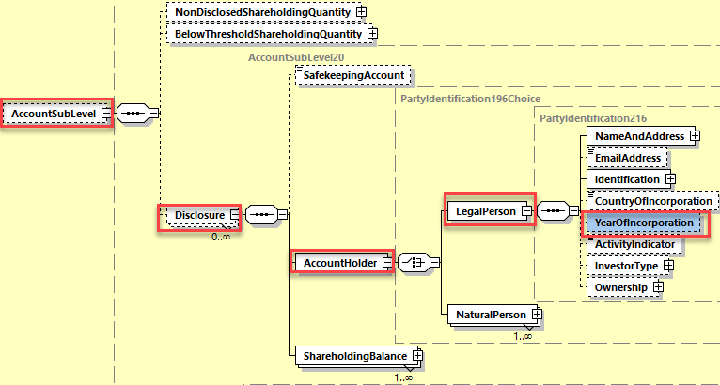

- Proposed timing:
The submitting organization confirms that it can implement the requested changes in the requested timing

Timing | - As requested

- Final decision of the SEG(s):

Approve | X
Comments:

Reject
Reason for rejection:

