Maintenance Change Request
for fast track maintenance of existing message definitions

- Submitting organization(s):
European Securities and Markets Authority (ESMA)
201-203 rue de Bercy
75012 Paris
France

- Related messages:
auth.029.001.01 DerivativesTradeReportQuery
auth.092.001.01 DerivativesTradeRejectionStatisticalReport

- Purpose of the change:
Based on input received from National Competent Authorities (NCA) and from Trade Repositories (TR), ESMA proposes the implementation of the following improvements in the above-mentioned messages supporting the EMIR regulation and its implementation in the TRACE system:
- For auth.029 the proposed change is related to the execution frequency of the queries submitted by the authorities to Trade Repositories in TRACE system, by introducing the additional frequency code (ADHO) that would allow the authorities to request the reports to be executed on multiple specific days of the week. This will enable more precise querying of the EMIR data stored within TRs databases.
- For auth.092 the proposed change is related to the counterparty identification for the purposes of the rejection statistical report submitted by TRs to the authorities. The purpose of the change is to provide a solution for an existing scenario for this report where the counterparties are identified with other means than LEI and therefore the TRs have issues with submitting a schema-valid report to the authorities.
We have also investigated whether our proposed changes are in line with both the ongoing IOSCO CDE work, and the EMIR Refit consultation that are targeting the review and update of the auth.030 message (DerivativesTradeReport), which belongs to the same message set and for which a change will be submitted at a later stage.

- Urgency of the request:
There is no structural modification in the proposed solution, the changes in the messages are limited to updates of fields by adding or changing the type of the elements in the existing components.
The modifications will not have major impact on parties (NCAs and TRs) already using the messages but will enable the full and proper reporting of the elements involved which would result a significant improvement in the quality of the submitted data.
According to the business needs the targeted implementation is in September/October 2021.
ESMA aims at including changes in the Q1 2021 maintenance release cycle of the TRACE system, for which testing would start in Q2 2021.
To accommodate for sufficient lead time for the NCAs, NCBs and the Trade Repositories to adapt to the changes, the updated XML Schemas need to be registered in December 2020.

- Commitments of the submitting organization:
The ESMA TRACE project team confirms that it plans to develop a new version of the impacted messages according to the changes proposed in this document.

- Contact persons:
Krisztina Miklossy – Krisztina.Miklossy@esma.europa.eu
Michal Zubrycki - Michal.Zubrycki-ext@esma.europa.eu

Change number #1

- Related messages:
auth.029.001.01 DerivativesTradeReportQuery

- Description of the change and type of impact:

We propose to modify the Derivatives Trade Report Query message in terms of allowed execution frequency of the recurrent reports. Currently the schema allows for a selection of either daily, weekly and monthly frequencies.
Based on the request of the market participants we propose to introduce an additional hybrid/mixed frequency approach that would allow the authorities to request reports to be delivered on multiple specific days of the week.

Alignment with the ongoing IOSCO CDE work, and the EMIR Refit consultation that will impact the auth.030 message:
The frequency component in the auth.030 has a different business meaning as it relates to the interest rates terms, while in auth.029 the change is related to the execution frequency of the queries. As there is no direct correlation between the two fields, the proposed solution in the auth.029 message does not depend on or impacts the auth.030.

- Proposed implementation:
We propose to change the currently applied TradeQueryExecutionFrequency1Choice to a newly created message component TradeQueryExecutionFrequence2 to include the following:
- Frequency Type (1,1) - with new Frequency14Code code set to include ADHO, DAIL, MNTH and WEEK codes. ADHO is already present in the parent FrequencyCode element
- Delivery Day (0,*) - with WeekDay3Code to allow authorities to select multiple days of the week for query execution in case of ADHO requests and to allow authorities to select a single delivery day in case of WEEK requests (multiplicity of this element to be controlled through a formal rule applied on the Usage Guideline).
- Day Of Month (0,*) – with Max3Number to maintain the currently used application of day of the month indication in case of monthly queries

We would also apply additional restrictive rule on the base message level and in the Usage Guideline to ensure that the optional element Delivery Day is only reported when a specific Frequency Type code is selected (WEEK/ADHO) and not used for other selections from the Frequency type codes. Similar rule would be applied for the Day Of Month to be only allowed for reporting when Frequency Type code is provided with MNTH code.

The comparison of the existing (approved) message and the proposed updated message presented below:

Approved message | Proposed change
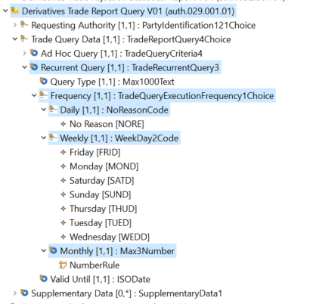 | 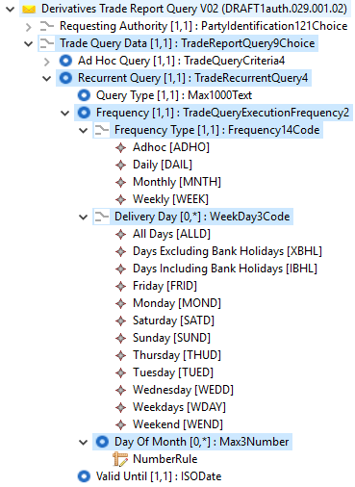

- Decision of the SEG(s):
This section is not to be taken care of by the submitting organization. It will be completed in due time by the SEG(s) in charge of the related ISO 20022 message definitions.
Change
approved
rejected
Comments:

Timing
- Fast track maintenance
(the change justifies an urgent implementation using the fast track maintenance process)
- At the occasion of the next maintenance of the messages
(the change will be considered for implementation, but does not justify an urgent implementation – will be pending until the next [yearly] maintenance of the messages)

Change number #2

- Related messages:
auth.092.001.01 DerivativesTradeRejectionStatisticalReport

- Description of the change and type of impact:

Currently the counterparty identification in auth.092 rejection statistics report only allows to submit LEI code for both the Report Submitting Entity and Reporting Counterparty.
Pursuant to the Article 3 of the CIR (EU) No 1247/2012 as amended by the CIR (EU) 2017/105 the Report Submitting Entity and Reporting Counterparty shall be identified with LEI code. In some instances, however these entities are incorrectly identified with other means than LEI (e.g. these fields are populated with an internal client ID or left blank). Such reports are not compliant with the above-mentioned requirement and are therefore rejected by the TRs in accordance with the validation rules, however the details of the rejections cannot be reported properly in the current version of the auth.092. Therefore, we propose to add other elements to the Report Submitting Entity and Reporting Counterparty fields in the auth.092 message in order to provide solution for this scenario.

Alignment with the ongoing IOSCO CDE work, and the EMIR Refit consultation that will impact the auth.030 message:
The counterparty identification component in auth.092 is limited in scope to what is needed in terms of the counterparty data in message auth.030. In case of auth.092 we only need to identify a pair of a report submitting entity and the reporting counterparty hence CounterpartyData36 message component was used instead of the TradeCounterpartyReport13 used in auth.030 (which is way more comprehensive element – including many mandatory counterparts, their nature, trading capacity, etc.). To better align with the auth.030, we propose to align auth.092 with CounterpartyData but at a lower level and apply the message component- OrganisationIdentification10Choice.

- Proposed implementation:
We propose replacing the current data type of the two counterparties elements (Reporting Submitting Entity, Reporting Counterparty) with OrganisationIdentification10Choice data type to better align with the counterparty identification applied in the auth.030.
This will require creating a new version of the DetailedStatisticsPerCounterparty and CounterpartyData message components.

The comparison of the existing (approved) message and the proposed updated message presented below:

Approved message  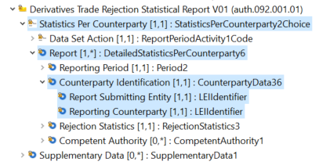 | Proposed change  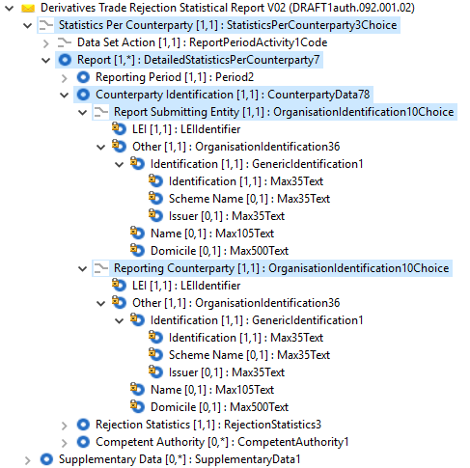
- Decision of the SEG(s):
This section is not to be taken care of by the submitting organization. It will be completed in due time by the SEG(s) in charge of the related ISO 20022 message definitions.
Change
approved
rejected

Comments:

Timing
- Fast track maintenance
(the change justifies an urgent implementation using the fast track maintenance process)
- At the occasion of the next maintenance of the messages
(the change will be considered for implementation, but does not justify an urgent implementation – will be pending until the next [yearly] maintenance of the messages)

https://eur-lex.europa.eu/legal-content/EN/TXT/PDF/?uri=CELEX:32017R0105&from=EN

