ISO 20022 Governance and Registration Process for API Resources.

Background
Financial Institutions (FIs) traditionally faced their customers directly. By opening up banking services and introducing new technologies such as web-based APIs, micro-services and new types of players fragmented the market. What used to be services only provided by FIs has now become an ecosystem where FIs only play a part in.
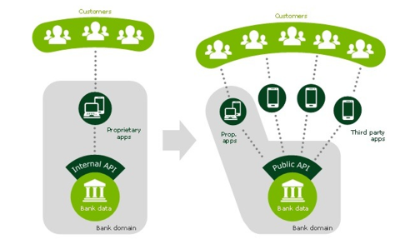
The lack of a common standardisation approach in this API ecosystem results in players having to support and implement differing implementations of the same services. This uncoordinated development expands fraud risks, creates friction and further increases interoperability costs.

Benefits of using ISO 20022
The ISO 20022 business model is the central repository containing the business elements, business components, message elements, message components and message definitions. The re-use of the ISO 20022 business model for API resources will ensure consistency of business data between APIs as well as with ISO 20022 messages. This standardised approach guarantees straight-through-processing throughout the entire financial transaction life cycle.
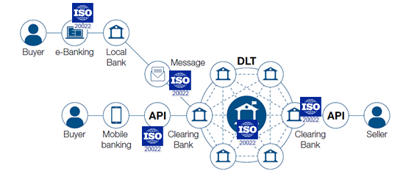
ISO 20022 to foster interoperability independently of the underlying technology

Scope
Standardising the API development consists of two steps:
- Standardising the API Resources: API Resources represent data elements that a service provider exposes to its clients via API methods. Using registered standardised API resources will ease the integration of the APIs for the service provider and its clients with other standardised (API) services and with standardised ISO 20022 messages.
- Standardising the APIs: This step relates to the design of the API calls that manage the resources (read, change, create, etc.).
Whilst this second step is out of scope for this document, re-using standardised ISO 20022 registered API resources as the first step of developing ISO 20022 compliant APIs, constitutes the main scope of this document.

Registration process
The ISO 20022 Registration Authority (RA) is responsible for the registration and publication of the ISO 20022 business model.
An organisation wishing to register ISO 20022 compliant API resources must submit its request to the RA following the processes described hereafter. These processes comprise the registration of API resources for which the pertinent business processes are already present in the ISO 20022 business model, the registration of new API resources for which no existing business processes exist in the ISO 20022 business model and the maintenance of existing API resources.
This registration process addresses the requirements for a flexible and agile API development environment. Developers can design and maintain their resources and APIs at their own pace, based on registered ISO 20022 API resources.
The ISO 20022 Business Model contains MessageComponents. A MessageComponent is a collection of MessageElements with their data types. These are closely aligned to the concept of API resources and can therefore be used as a basis to define API resources. Examples are provided in Annex 4.
API resources are a collection of existing MessageElements used in existing MessageComponents, regrouped in one or more new MessageComponents. These resources are either not but re-using and regrouping existing MessageElements for the purpose of API Resource design or creating new business content in the ISO 20022 Business Model.
When new content is to be created in the ISO 20022 Business Model, the responsible ISO 20022 registration bodies entrusted with the evaluation defined in this registration process will ensure a more thorough review of the request.

Governance and registration process for development of new ISO 20022 compliant resources

Request for registration
An organisation (‘submitting organisation’) wishing to develop a new ISO 20022 compliant resource must submit an API Resource Business Justification (API BJ) on the iso20022.org website. The API BJ is checked for completeness by the ISO 20022 RA, logged on the website and confirmed to the submitting organisation within the next five business days.
The API BJ should explain the purpose of the development, the applicable business processes, business transactions (business areas) involved and include a committed timeline for the development.
The RA will first verify that the content is not a duplicate of a similar BJ and second that it could not be achieved through amendments of existing API resources, i.e. the maintenance process, and will thereafter forward the BJ to the responsible ISO 20022 registration bodies as defined in this process for them to provide comments.
In case of comments, the submitting organisation will address those in, if need be multiple, updated versions of the BJ until all justified and reasonable comments have been addressed. Final BJ approval is implicit, if the responsible ISO 20022 registration bodies have no further justified and reasonable comments within four weeks following the last version of BJ.

Development
Following approval of the API BJ, the RA will provide the tools that allow for easy access to the latest version of the ISO 20022 Repository to the submitting organisation with detailed instructions on the deliverables required (see 5.3 below). The tool is provided free of charge.
The RA provides the submitting organisation with a clear description of the required deliverables, the materials necessary to set up the required modelling environment and a 'compliance checklist' of rules to observe to develop ISO 20022 compliant API resources.
The submitting organisation wishing to register resources selects the relevant ISO 20022 message elements in the ISO 20022 Repository to design the API resources. If the desired elements are not available, new elements are created following the ISO 20022 API modelling guidelines.
The submitting organisation develops the ISO 20022 compliant API resources and part 1 of the Resource Definition Report within the timeframe indicated in its request for registration (API BJ). If a delay is expected, the submitting organisation promptly informs the RA with a new submission date.
The resources and the report are submitted to the RA that checks the compatibility according to the ISO 20022 modelling guidelines before submission to the responsible ISO 20022 registration bodies for evaluation. Upon detection of non-compliance, the RA returns to the submitting organisation with a quality report and works with the submitting organisation that is responsible for applying correcting measures until a compliant submission is achieved.
The APIs themselves are out of scope of this process.

Evaluation
When the submission is compliant and complete, the API resource components are registered by the RA before evaluation and appear as ‘provisionally registered’ in the Repository on the iso20022.org website.
The RA generates the evaluation documentation and sends it to the responsible ISO 20022 registration bodies. The documentation consists of:
- A Resource Definition Report (RDR) describing the resources. The RDR is made of three parts:
  - Part I is provided by the submitting organisation to describe the business transactions (state diagram, interaction diagram…) for which the proposed resources will be used.
  - Part II is a detailed description of the contents of each resource and its definition. It is generated by the RA.
  - Part III is a description of the business model components used to create the API resource components. It is generated by the RA.
- JSON Schemas (and ideally a Microsoft Excel spreadsheet) as an equivalent specification of RDR part 1 in a machine-readable format describing the resources.
On top of the evaluation documentation provided by the RA, the submitting organisation is expected to give an introductory presentation to the ISO 20022 registration bodies entrusted with the evaluation and may propose additional documentation to further facilitate the evaluation.
The responsible ISO 20022 registration bodies evaluate each submission. Any correction needs identified during the evaluation cycle will be returned to the submitting organisation. The submitting organisation shall decide either to motivate its decision if changes proposed by the evaluating ISO 20022 registration bodies are not retained, or otherwise to correct and resubmit, potentially, through repeated evaluation cycles, if needed.
The responsible ISO 20022 registration bodies verify that the submission is within the scope expressed in the corresponding request and evaluate the candidate ISO 20022 compliant API resources from a business standpoint before they are officially accepted and published as ISO 20022 compliant resources. The responsible ISO 20022 registration bodies proceed with the evaluation and approve the API resources in maximum one calendar month from receipt of their submission.

Publication
Following the positive evaluation and approval, the RA publishes the ISO 20022 compliant API resources on www.iso20022.org as JSON Schemas together with the Resource Definition Reports.

Withdrawal
At any time during the registration process and until the resources are approved by the responsible ISO 20022 registration bodies, the submitting organisation may decide to withdraw or suspend its submission by informing the RA and providing the reason for such decision.

Governance and registration process for the maintenance of existing ISO 20022 compliant resources

Request for update of ISO 20022 financial repository items (aka maintenance)
An organisation (‘CR submitter’) wishing to change (enhance or amend) an existing ISO 20022 compliant API resource must submit an API Resource Change Request (API CR) on the iso20022.org website. The API CR is checked for completeness by the ISO 20022 RA, logged on the website and the RA informs the submitting organisation who had originally submitted the BJ for the development of the API resource within the next five business days following the receipt of the API CR.
The API CR should explain the purpose of the change, the business transactions (business area) involved and include a proposed timeline for availability of the proposed change. The RA will forward the API CR to the ISO 20022 registration bodies responsible for the review and acceptance.
The API CR approval is implicit. If the responsible ISO 20022 registration bodies have no comments within four weeks of the submission of the API CR, it is considered ‘approved’. An approved API CR is subsequently referred to as ‘candidate API CR’.
Next, the RA forwards the candidate API CR to the submitting organisation.

Development
If not already available, the RA provides the submitting organisation with a clear description of the required deliverables, the materials necessary to set up the required modelling environment and a 'compliance checklist' of rules to observe to develop ISO 20022 compliant API resources.
The submitting organisation wishing to maintain API resources selects from the dedicated tool the relevant ISO 20022 message components in the ISO 20022 Repository to amend and re-design the API resources.
The submitting organisation selects and maintains the ISO 20022 compliant API resources and updates part 1 of the Resource Definition Report (as necessary) within the proposed timeframe indicated in the API CR. If a delay is expected, the submitting organisation promptly informs the RA with a new submission date.
The API resources and the report are submitted to the RA that checks the compatibility according to the ISO 20022 modelling guidelines before submission to the ISO 20022 registration bodies responsible for the evaluation. Upon detection of non-compliance, the RA returns to the submitting organisation with a quality report and works with the submitting organisation that is responsible for applying correcting measures until a compliant submission is achieved.
As indicated before for the original development process, the maintenance of APIs themselves is out of scope of this process.

Evaluation
When the submission is compliant, API resource components are registered by the RA before evaluation and appear as ‘provisionally registered’ in the Repository on the iso20022.org website. The API resource evaluation process follows the same steps as in the corresponding process described earlier in the section on the original development of API resources (cf. chapter 5.3).

Publication
Following the positive evaluation and approval, the RA publishes the updated ISO 20022 compliant API resources on www.iso20022.org as JSON Schemas together with the updated Resource Definition Reports.

Withdrawal
At any time during the registration or maintenance process and until the resources are approved by the responsible ISO 20022 registration bodies, the submitting organisation may decide to withdraw or suspend its submission, by informing the RA and providing the reason for such decision.

ANNEX

Annex 1 ISO 20022 API Resource Registration Process: new BJ approval sub-process
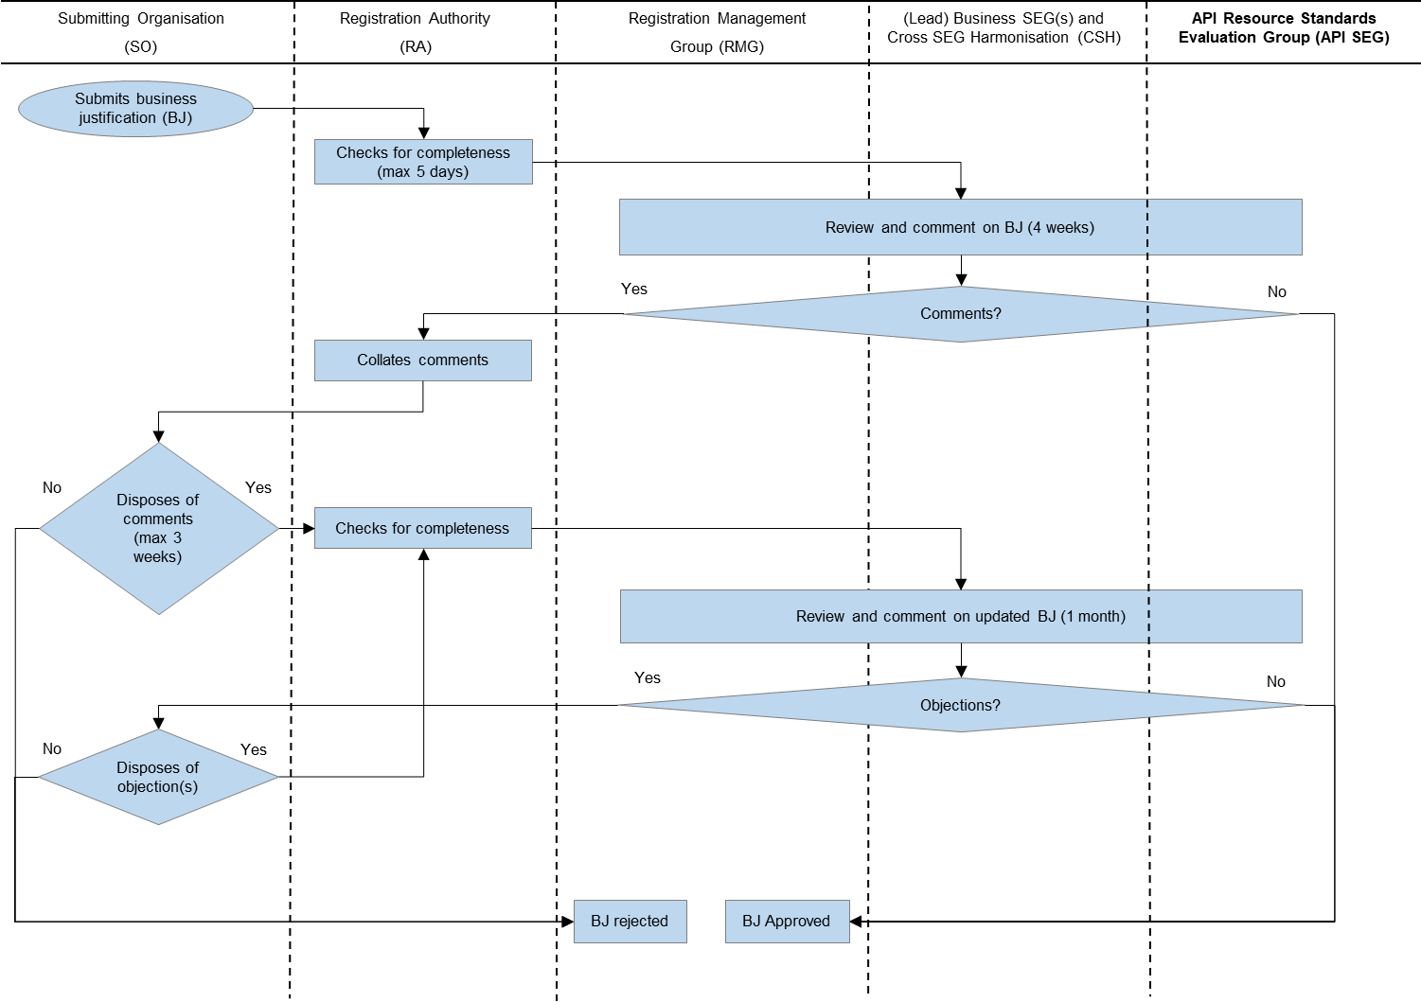

Annex 2 ISO 20022 API Resource Registration Process: API Resource development sub-process

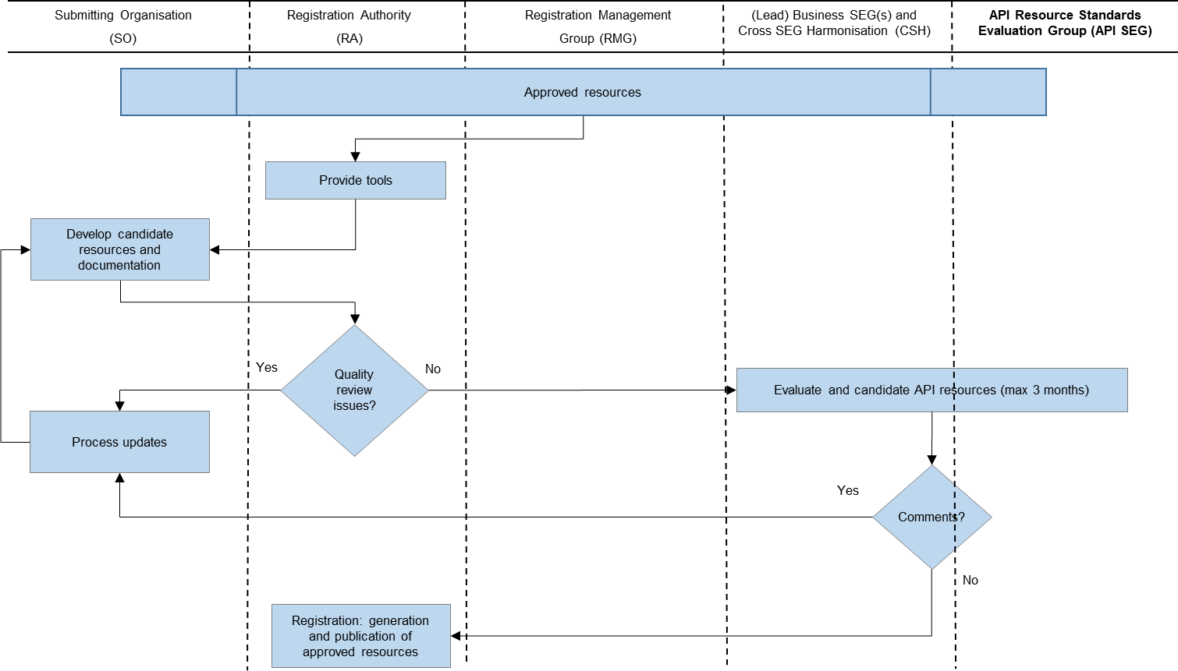

Annex 3 ISO 20022 API Resource Registration Process: Resource maintenance sub-process
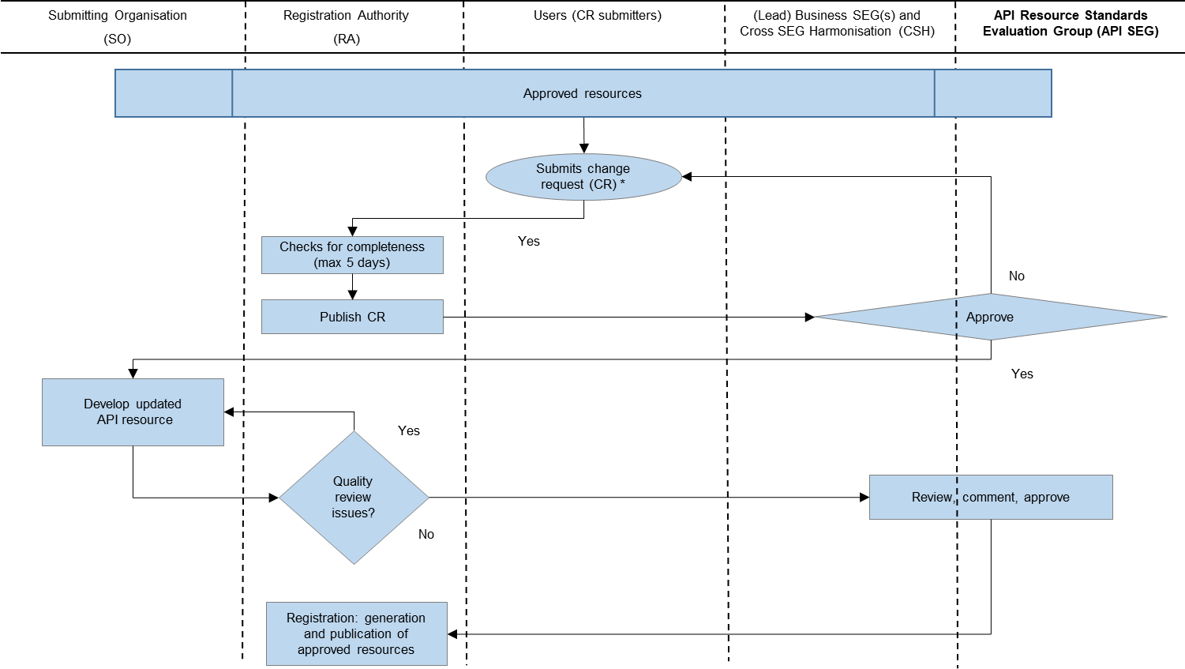

Annex 4 Examples of MessageElements and MessageComponents

Payments cash account
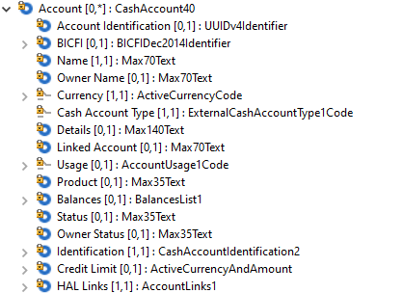

Payments cash balance
