ISO 20022
Request To Pay (RTP) Service
For final review by the Payments SEG

Message Definition Report - Part 1

September 2020

Table of contents
1. Introduction 3
1.1 Terms and definitions 3
1.2 Abbreviations and Acronyms 3
1.3 Document Scope and Objectives 4
1.4 References 4
2. Scope and Functionality 5
2.1 Background 5
2.2 Scope 5
2.3 Groups of candidate MessageDefinitions and Functionality 5
2.3.1 Creditor Enrolment MessageDefinitions 5
2.3.2 Debtor Activation MessageDefinitions 5
3. BusinessRoles and Participants 7
3.1 Participants and BusinessRoles Definitions 7
3.2 BusinessRoles and Participants Table 7
4. BusinessProcess Description 9
4.1 BusinessProcess Diagram 9
5. Description of BusinessActivities 11
5.1 BusinessProcess – Creditor Enrolment 12
5.2 BusinessProcess – Debtor Activation 14
6. BusinessTransactions 16
6.1 RTP Creditor Enrolment BusinessTransaction 16
6.2 RTP Debtor Activation BusinessTransaction 17
7. Revision Record 17

Preliminary note:
The Message Definition Report (MDR) is made of three parts:
- MDR - Part 1 describes the contextual background required to understand the functionality of the proposed message set. Part 1 is produced by the submitting organisation that developed or maintained the message set in line with a MDR Part1 template provided by the ISO 20022 Registration Authority (RA) on www.iso20022.org
- MDR – Part 2 is the detailed description of each message definition of the message set. Part 2 is produced by the RA using the model developed by the submitting organisation.
- MDR – Part 3 is an extract of the ISO 20022 Business Model describing the business concepts used in the message set. Part 3 is an Excel document produced by the RA.

Introduction

Terms and definitions
The following terms are reserved words defined in ISO 20022 Edition 2013 – Part1. When used in this document, the UpperCamelCase notation is followed.
Term | Definition
BusinessRole | Functional role played by a business actor in a particular BusinessProcess or BusinessTransaction.
Participant | Involvement of a BusinessRole in a BusinessTransaction.
BusinessProcess | Definition of the business activities undertaken by BusinessRoles within a BusinessArea whereby each BusinessProcess fulfils one type of business activity and whereby a BusinessProcess may include and extend other BusinessProcesses.
BusinessTransaction | Particular solution that meets the communication requirements and the interaction requirements of a particular BusinessProcess and BusinessArea.
MessageDefinition | Formal description of the structure of a message instance.
When a MessageDefinition or message identifier is specified, it should include the variant and version number. However, in this document (except in the business examples section, if present), variant and version numbers are not included. In order to know the correct variant and version number for a MessageDefinition, the related Message Definition Report Part 2 document should be consulted.

Abbreviations and Acronyms
The following is a list of abbreviations and acronyms used in the document.
Abbreviation/Acronyms | Definition
EPC | European Payments Council
EIPP | Electronic Invoice Presentment and Payment
RTP | Request To Pay
MSG | Multi-Stakeholder Group
XML | eXtensible Mark-up Language

Document Scope and Objectives
This document is the first part of the ISO 20022 Message Definition Report (MDR) that describes the BusinessTransactions and underlying message set. For the sake of completeness, the document may also describe BusinessActivities that are not in the scope of the project.
This document sets:
- The BusinessProcess scope (business processes addressed or impacted by the project)
- The BusinessRoles involved in these BusinessProcesses

The main objectives of this document are:
- To explain what BusinessProcesses and BusinessActivities these candidate MessageDefinitions have addressed
- To give a high level description of BusinessProcesses and the associated BusinessRoles
- To document the BusinessTransactions and their Participants (sequence diagrams)
- To list the candidate MessageDefinitions

References

Document | Version | Date | Author
ISO 20022 Business Justification – E-invoice Presentment and Payment (EIPP) Services | 1.0 | 20 November 2019 | EPC RTP MSG
Report from the EIPP Multi-Stakeholder Group - November 2018 | 1.0 | 28 November 2018 | EPC RTP MSG

Scope and Functionality

Background
This Message Definition Report covers a set of 8 candidate ISO 20022 MessageDefinitions developed by EPC RTP MSG in close collaboration with SWIFT and submitted to the approval of the Payments Standards Evaluation Group (SEG).

Scope
These candidate messages are specifically designed to support the RTP “servicing messages”, which enable:
- Payees (creditors) to register in the RTP eco-system (enrolment messages)
- Payers (debtors) to activate the RTP service with a given Payee (creditor) (activation messages).
Complementary unenrolment, amendment, deactivation and responses to the abovementioned messages should also be created.

Groups of candidate MessageDefinitions and Functionality

The messages have been developed to fill gaps in the range of existing ISO 20022 messages to support the service requirement and exchanges in the scope of the RTP.
These messages are to be used with the ISO 20022 Business Application Header (head.001). The schema and more information about the Business Application Header (BAH) can be found on the www.iso20022.org web site

Creditor Enrolment MessageDefinitions
The creditor enrolment MessageDefinitions are used to manage the enrolment of a creditor. The purpose of these MessageDefinitions is to inform the RTP Solution Providers in the eco-system that a new Payee has been registered. It is sent by the Payee RTP Providers to the RTP Directory Providers. The instruction message definition is completed with amendment, cancellation and status report message definitions.

MessageDefinition | Message Identifier
RequestToPayCreditorEnrolmentRequest | reda.066
RequestToPayCreditorEnrolmentAmendmentRequest | reda.067
RequestToPayCreditorEnrolmentCancellationRequest | reda.068
RequestToPayCreditorEnrolmentStatusReport | reda.069

Debtor Activation MessageDefinitions
The debtor activation MessageDefinitions are used to manage the RTP service activation between a Payer and a Payee. The Activation request message is sent by the Payer tgrough its RTP provider to request the activation of the RTP service from a given Payee. The Activation request message expresses the consent of the Payer to receive RTP from the Payee.

MessageDefinition | Message Identifier
RequestToPayDebtorActivationRequest | reda.070
RequestToPayDebtorActivationAmendmentRequest | reda.071
RequestToPayDebtorActivationCancellationRequest | reda.072
RequestToPayDebtorActivationStatusReport | reda.073

BusinessRoles and Participants
A BusinessRole represents an entity (or a class of entities) of the real world, physical or legal, a person, a group of persons, a corporation. Examples of BusinessRoles: “Financial Institution”, “ACH”, “CSD”.
A Participant is a functional role performed by a BusinessRole in a particular BusinessProcess or BusinessTransaction: for example the “user” of a system, “debtor”, “creditor”, “investor” etc.
The relationship between BusinessRoles and Participants is many-to-many. One BusinessRole (that is, a person) can be involved as different Participants at different moments in time or at the same time: "user", "debtor”, "creditor", "investor", etc. Different BusinessRoles can be involved as the same Participant.
In the context of RTP Service, the high-level BusinessRoles and typical Participants can be represented as follows.

Participants and BusinessRoles Definitions
Participants
Description | Definition
EISP (E-invoicing solution provider) | Company offering e-invoicing solutions and services, such as creation, delivery, routing of e-invoices and requests-to-pay, automatic reconciliation of e-invoices with payment data, conversion services, interfaces with ERP applications, etc.
RTP Solution Provider | Company offering RTP solutions and services to payees and payers
RTP Registry/Directory Provider | Company offering Registry/Directory services to RTP providers
Supplier/Payee/Issuer/  Creditor | Provider of the goods and services and the beneficiary of the funds transferred in the payment flow.
Consumer/Payer/Debtor/  Buyer | Party receiving the goods and services and the originator of the funds transferred in the payment flow.
Ultimate Debtor | Ultimate party that owes an amount of money to the (ultimate) creditor.
Ultimate Creditor | Ultimate party to which an amount of money is due.
PSP | Payment Service Provider
BusinessRoles
Description | Definition
E-Invoice Originator | Originator of the e-invoice.
E-Invoice Recipient | Recipient of the e-invoice.
Service Provider | Entity providing RTP services.
Directory Provider | Entity providing RTP directory services.
Payment Provider | Entity providing payment services.

BusinessRoles and Participants Table
Participants | BusinessRole  E-Invoice Originator | BusinessRole  E-Invoice Recipient | BusinessRole  Service Provider | BusinessRole  Directory Provider | BusinessRole  Payment Provider
EISP (E-invoicing solution provider) |  |  | X
RTP Solution Provider |  |  | X
RTP Registry / Directory Provider |  |  |  | X
Supplier / Payee / Issuer / Creditor | X
Consumer / Payer / Debtor / Buyer |  | X
Ultimate Debtor |  | X
Ultimate Creditor | X
PSP |  |  |  |  | X

BusinessProcess Description

BusinessProcess Diagram
This diagram pictures the high level BusinessProcesses covered by this project. The aim of the below is to describe the high-level scope of the project, not to be exhaustive.
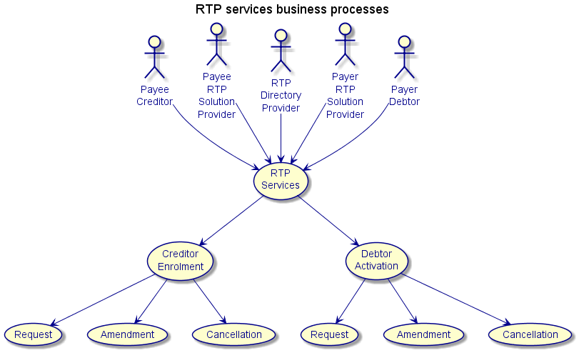

Process RTP Services
This BusinessProcess comprises all underlying sub-processes, which are all related to the handling of RTP services. The RTP services are based on a set of harmonised additional (or servicing) functions to form a “common language” for communication between different RTP providers.
The sub-processes of the RTP services may be split into two parts as following:
- a creditor enrolment sub-process,
- a debtor activation sub-process.
Each sub-process will allow for the initiation, amendment and cancellation of the specific request.

Creditor enrolment
Item | Description
Definition | The enrolment, initiated by a Payee/Creditor via its RTP providers to distribute in the RTP eco-system the information about the enrolment (registration) of this Payee/Creditor.
Trigger | Creditor decides to support the request-to-pay for RTP.
Pre-conditions | The required (enrolment) information is available to initiate the enrolment.
Post-conditions | The Creditor is ready to send request-to-pay messages to any Debtor who has activated the service.
Role | Creditor
Debtor activation
Item | Description
Definition | The Activation, initiated by a Payer/Debtor to a Payee/Creditor to establish an RTP link between these parties allowing the Creditor to send requests to pay and e-invoices to the Debtor
Trigger | The Debtor wants to activate the receipt of request-to-pay messages from a given Payee/Creditor.
Pre-conditions | The required (activation) information is available to initiate the activation, and the Creditor has previously been enrolled in the RTP services.
Post-conditions | The request-to-pay is activated between the debtor and the creditor.
Role | Debtor

Description of BusinessActivities
This section presents the different BusinessActivities within each BusinessProcess. BusinessActivities of a process are described in swim lane diagrams and are referred in this document as activity diagrams.
The development of an activity diagram is part of the ISO 20022 modelling process and allows capturing the requirements.
The activity diagram provides a zoom-in on the BusinessActivities taking place during each of the BusinessProcesses described in Section 4. It also shows the BusinessActivities that are triggered when another BusinessActivity has a negative result.
Both in-scope and out-of-scope activities are included, with a different level of details. There are no information requirements for out-of-scope activities, except that they should be clearly identified in the diagram.
Activity diagrams are always accompanied with a text describing the BusinessActivities and their interactions.

BusinessProcess – Creditor Enrolment
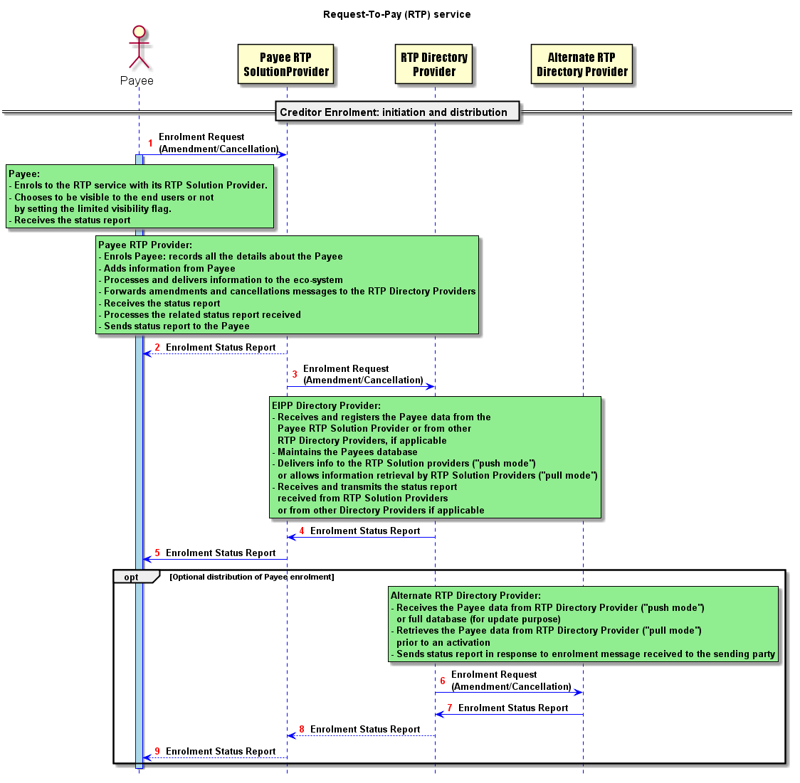

Description of the BusinessActivities
 | Initiator
- Enrols to the RTP service with its RTP Solution Provider.  - The Payee may choose to be visible to the end users or not by setting the limited visibility flag. When not limited, the payee is visible through the look up in the RTP Directory and is reachable by payer’s activation requests through the scheme. When limited, the payer needs a Dedicated Activation Code to send an activation request through the scheme.  - Receives the status report | Payee
- Enrols Payees: records the details about the Payee  - Adds information  - Delivers info into the eco-system  - Forwards amendments and cancellations messages to the RTP Directory Providers  - Receives status reports  - Processes the related status reports received  - Forwards status reports to the Payee | Payee RTP Solution Provider
- Receives and registers Payee information from RTP Solution Provider or from other RTP Directory Providers if applicable  - Manages the database of Payees  - Delivers info to RTP Solution (“push mode”) or allows information retrieval by RTP Solution Providers (“pull mode”)  - Receives and transmits the status report received from RTP Solution Providers or from alternate Directory Providers if applicable | RTP Directory Provider
- Receives information from RTP Directory Providers (“push mode”) or retrieves full database (for update purposes)  - Retrieves information from RTP Directory Providers (“pull mode”) prior to an activation  - Sends status reports in response to enrolment messages receiver | Alternate RTP Directory Provider

BusinessProcess – Debtor Activation
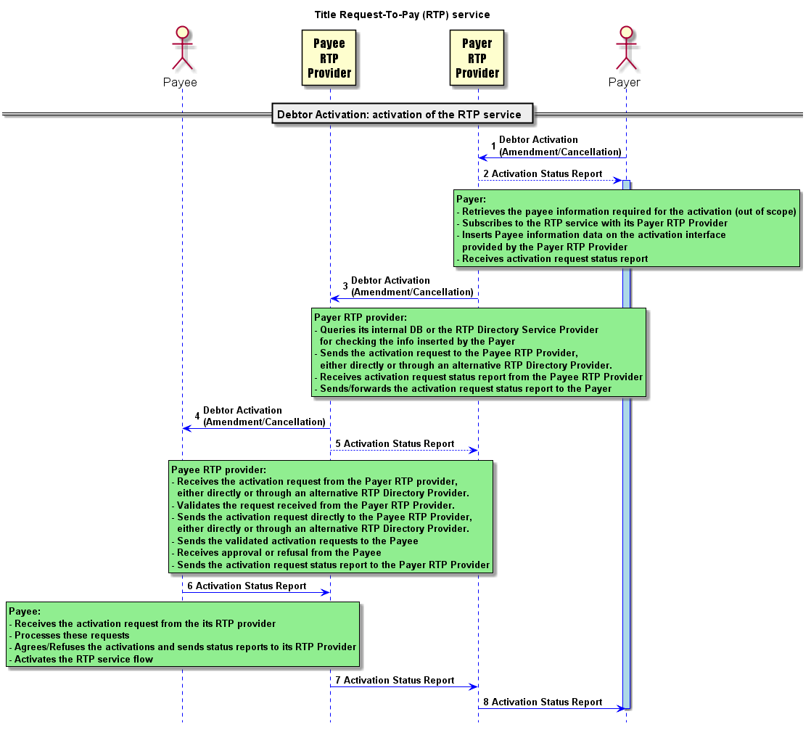

Description of the BusinessActivities
 | Initiator
- Retrieves from the Payee the information needed for activation  - Subscribes to the RTP service with its Payer RTP Solution Provider  - Insert Payee data into its activation interface  - Receives the activation request status report | Payer
- Queries its internal DB or the RTP Directory Provider for checking the info inserted by the Payer  - Sends activation request to the RTP Solution Provider of the Payee, either directly or through a forwarding RTP Solution Provider  - Receives the status report | Payer RTP Provider
- Receives activation request from the RTP Solution Provider of the Payer, either directly or through a forwarding RTP Solution Provider  - Validates the request received  - Sends validated activation request to the Payee  - Receives approval or refusal from the Payee  - Sends related status report to RTP Solution Provider of the Payer | Payee RTP Provider
- Receives activation request from its RTP Solution Provider  - Processes the request  - Agrees/refuses the activation and sends the status report to its RTP Solution Provider  - Activates the RTP service flow | Payee

BusinessTransactions
This section describes the message flows based on the activity diagrams documented above. It shows the typical exchanges of information in the context of a BusinessTransaction.

RTP Creditor Enrolment BusinessTransaction
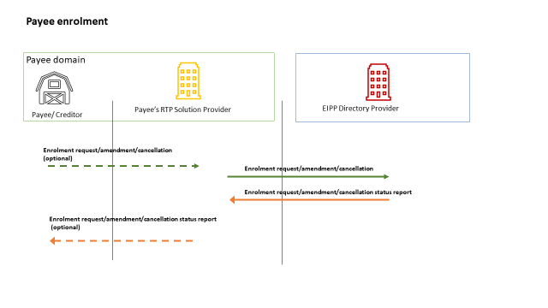
The above illustrates all three messages flows in a single diagram:
- The creditor enrolment request (the initiation of the creditor enrolment)
- The creditor enrolment amendment request (an existing creditor enrolment is amended with new data)
- The creditor enrolment cancellation request (an existing creditor enrolment is cancelled).
The CreditorEnrolmentRequest is sent by the Creditor (or any authorised initiating party) to the creditor RTP Solution Provider which will register the creditor enrolment and distribute it further in the ecosystem.

RTP Debtor Activation BusinessTransaction

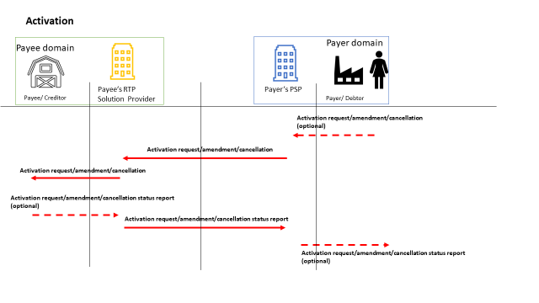 The above illustrated all three messages flows in a single diagram:
- The debtor activation request (the initiation of the debtor activation)
- The debtor activation amendment request (an existing debtor activation is amended with new data)
- The debtor activation cancellation request (a debtor activation is cancelled).
The DebtorActivationRequest is sent by the Debtor (or any authorised initiating party) to the debtor RTP Solution Provider which will register the debtor activation and distribute it further in the ecosystem until the creditor.

Revision Record

Revision | Date | Author | Description | Sections affected
0.2 | 22-10-2019 | EIPP MSG | Initial version | All
0.3 | 28-10-2019 | EIPP MSG | Updated version | 2-6
0.4 | 30-10-2019 | EIPP MSG | Updated version | 2-6
0.5 | 15-05-2020 | ISO 20022 RA | Cosmetic changes | All
0.6 | 31-08-2020 | EIPP MSG | Rename of EIPP to RTP | All

Disclaimer:
Although the Registration Authority has used all reasonable efforts to ensure accuracy of the contents of the iso20022.org website and the information published thereon, the Registration Authority assumes no liability whatsoever for any inadvertent errors or omissions that may appear thereon. Moreover, the information is provided on an "as is" basis. The Registration Authority disclaims all warranties and conditions, either express or implied, including but not limited to implied warranties of merchantability, title, non-infringement and fitness for a particular purpose.
The Registration Authority shall not be liable for any direct, indirect, special or consequential damages arising out of the use of the information published on the iso20022.org website, even if the Registration Authority has been advised of the possibility of such damages.

Intellectual Property Rights:
The ISO 20022 MessageDefinitions described in this document were contributed by the EPC. The ISO 20022 IPR policy is available at www.ISO20022.org > About ISO 20022 > Intellectual Property Rights.

