Maintenance Change Request

- Name of the request:
General Meeting Messages Maintenance for year 2026/2027

- Submitting organization(s):
SMPG and Swift

- Related messages:
Under this project, the following ISO 20022 General Meeting messages highlighted in blue below would be maintained in the context of the General Meeting messages maintenance for year 2026/2027 – pending approval of the proposed implementation solutions (which will be reviewed on the 19th of August 2026, with implementation subject to consensus being reached among the SEG/ET members):
 | Message Name | Abbreviated Name | Identifier
1 | MeetingNotificationV13 | MENO | seev.001.001.13
2 | MeetingCancellationV10 | MECN | seev.002.001.10
3 | MeetingEntitlementNotificationV10 | MENT | seev.003.001.10
4 | MeetingInstructionV11 | MEIN | seev.004.001.11
5 | MeetingInstructionCancellationRequestV10 | MEIC | seev.005.001.10
6 | MeetingInstructionStatusV12 | MEIS | seev.006.001.12
7 | MeetingVoteExecutionConfirmationV12 | MECO | seev.007.001.12
8 | MeetingResultDisseminationV10 | MERD | seev.008.001.10
9 | Securities Message Rejection |  | semt.001.001.04

- Commitments of the submitting organization:
Swift confirms that it can and will:
- undertake the development of the new version of the candidate ISO 20022 message models that it will submit to the RA for compliance review and evaluation by December 1st, 2026.
- provide a new version of part 1 of the Message Definition Report (MDR) and new examples of valid message instances of each message by May 1st, 2027, at the latest.
- address any queries related to the description of the new models and messages as published by the RA on the ISO 20022 website.

Swift confirms their knowledge and acceptance of the ISO 20022 Intellectual Property Rights policy for contributing organisations, as follows:

“Organisations that contribute information to be incorporated into the ISO 20022 Repository shall keep any Intellectual Property Rights (IPR) they have on this information. A contributing organisation warrants that it has sufficient rights on the contributed information to have it published in the ISO 20022 Repository through the ISO 20022 Registration Authority in accordance with the rules set in ISO 20022. To ascertain a widespread, public and uniform use of the ISO 20022 Repository information, the contributing organisation grants third parties a non-exclusive, royalty-free license to use the published information”.

- Contact persons:
Christine Strandberg – christine.strandberg@seb.se – phone: +46 8 763 6074
Mari Fumagalli – mariangela.fumagalli@bnpparibas.com – phone: +44 207 595 4988
Miriam Ortseifen – miriam.ortseifen@swift.com – phone: +34 91 4251317

Table of Contents

CR3272 (ISO CR #1599): Add or amend reason codes in Meeting Instruction Status 4
CR3273 (ISO CR #1598): Meeting Resolution Requirements 8
CR3276 (ISO CR #1593): Minimum Securities Required for Attendance 15
CR3280 (ISO CR #1589): Changes to Meeting IDs 18
CR3275 (ISO CR #1594): Add Cumulative Voting Multiplier to Meeting Notification and Instruction 21
CR3274 (ISO CR #1595): Changes to Meeting Attendance block 28

CR3272 (ISO CR #1599): Add or amend reason codes in Meeting Instruction Status
A. Origin of the request:
A.1 Submitter: SMPG CA-WG
A.2 Contact persons:
Christine Strandberg
Mariangela Fumagalli
A.3 Sponsors:
SMPG CA WG members
B. Related messages:
seev.006.001.12 (Meeting Instruction Status)
C. Description of the change request:
Add new seev.006 status codes to reduce the use of OTHR.
Amend some of the existing seev.006 status codes.

Code | Description | Documentation | Change | Comment
RIRE | Reconfirmation Of Instructions Required | Instruction rejected due to a change to the agenda and/or resolutions. | New
CARJ | Cancellation Already Rejected | The instruction to be cancelled is already rejected. | New
EMDM | Enrolment Market Deadline Missed | Received after enrolment market deadline. | New
ENDM | Enrolment Deadline Missed | Instruction received after the account servicer's specified deadline. | New
RAIM | Rights Holder Account Identification is missing | Rights holder account identification at the last intermediary is missing. | New
SAFE | Safekeeping Account/ Wallet Rejection | Unrecognised or invalid message sender's safekeeping account, Blockchain address or wallet. | Amend | OLD Descr.: Safekeeping Account Rejection  OLD Docum.: Unrecognised or invalid message sender's safekeeping account
NPOS | Not Sufficient Registered Position | Insufficient registered position | Amend | OLD Descr.: No Registered Position  OLD Docum.: Insufficient or no registered position.
NOSL | Not Registered In Stock Ledger | Invalid instruction as the shareholder or its delegate is not registered in the company stock ledger book. | Amend | OLD Descr.: Not Registered In In Stock Ledger
OPTY | Invalid Vote Instruction Type Code | Invalid Vote Instruction Type Code | Amend | OLD Descr.: Invalid Option Type  OLD Docum.: Invalid Option Type
ICMT | Incorrect Meeting Type | The meeting type specified in the instructions differs from the type specified in the meeting notification. | New
IRID | Incorrect Details for the Participation Method | The instruction is rejected because the provided Registration, Voting, Proxy, or Meeting Attendee details do not correspond to the selected participation method. | New
NOSE | No Service Offered | No Service Offered | New | MT567 has no rejection code NOSE. The description comes from the MT564 feature.  “Feature whereby the holder must elect directly to the issuer's agent.”

D. Purpose of the change:
To reduce the use of OTHR.
E. Urgency of the request:
SR2027
Note: the ISO 20022 maintenance results in the publication of a new version of an ISO 20022 message. The actual implementation of such new version on networks and in user installations is not within the purview of ISO.
F. Business examples:
N/A
G. SEG/TSG recommendation:
This section is not to be taken care of by the submitter of the change request. It will be completed in due time by the SEG(s) in charge of the related ISO 20022 messages or the TSG for changes related to the BAH.
Consider:
Timing:
- Next yearly cycle: 2026/2027:
(the change will be considered for implementation in the yearly maintenance cycle which starts in 2026 and completes with the publication of new message versions in the spring of 2027)
- At the occasion of the next maintenance of the messages:
(the change will be considered for implementation, but does not justify maintenance of the messages in its own right – will be pending until more critical change requests are received for the messages)
- Urgent unscheduled:
(the change justifies an urgent implementation outside of the normal yearly cycle)
- Other timing:

Comments: N/A
H. Impact analysis:
This change request impacts the following General meeting message: seev.006.
I. Proposed implementation solution:
1) In the seev.006, there is a need to extend the Rejection Reason Code element within the Instruction Type Status building block, with the following additional codes:
Instruction Type Status | Instruction Status | Code | Description | Documentation | Change | Comment
Instruction Status | Rejected | RIRE | Resubmission Of Instructions Required | Instruction rejected due to a change to the agenda and/or resolutions. | New
Cancellation Status | Rejected | DRJT | Rejected Since Already Rejected | The cancellation request has been rejected since the instruction has already been rejected. | New
Instruction Status | Rejected | EMDM | Enrolment Market Deadline Missed | Received after enrolment market deadline. | New
Instruction Status | Rejected | ERDM | Enrolment Deadline Missed | Instruction received after the account servicer's specified deadline. | New
Instruction Status | Rejected | RAIM | Rights Holder Account Identification is missing | Rights holder account identification at the last intermediary is missing. | New
Instruction Status | Rejected | ICMT | Incorrect Meeting Type | The meeting type specified in the instructions differs from the type specified in the meeting notification. | New
Instruction Status | Rejected | IRID | Incorrect Details for the Participation Method | The instruction is rejected because the provided Registration, Voting, Proxy, or Meeting Attendee details do not correspond to the selected participation method. | New
Instruction Status | Rejected | NOSE | No Service Offered | No Service Offered | New | MT567 has no rejection code NOSE. The description comes from the MT564 feature. Probably to be amended.

Instruction Type Status | Instruction Status | Code | Description | Documentation | Change | Comment
Cancellation Status/Global Cancellation Status | Rejected | DRJT | Rejected Since Already Rejected | The cancellation request has been rejected since the instruction has already been rejected. | New
Cancellation Status/Detailed Cancellation Status | Rejected | DRJT | Rejected Since Already Rejected | The cancellation request has been rejected since the instruction has already been rejected. | New

2) In the seev.006, in message building block Instruction Type Status, the following Instruction and/or Cancellation status reason codes should be amended as described below:
Instruction Type Status | Instruction Status | Code | Description (SR2027) | Documentation (SR2027) | Description (SR2026) | Documentation (SR2026)
Instruction Status | Rejected | SAFE | Safekeeping Account/ Wallet Rejection | Unrecognised or invalid message sender's safekeeping account, Blockchain address or wallet. | Safekeeping Account Rejection | Unrecognised or invalid message sender's safekeeping account
Cancellation Status/Global Cancellation Status | Rejected | SAFE | Safekeeping Account/ Wallet Rejection | Unrecognised or invalid message sender's safekeeping account, Blockchain address or wallet. | Safekeeping Account Rejection | Unrecognised or invalid message sender's safekeeping account
Cancellation Status/Detailed Instruction Cancellation Status | Rejected | SAFE | Safekeeping Account/ Wallet Rejection | Unrecognised or invalid message sender's safekeeping account, Blockchain address or wallet. | Safekeeping Account Rejection | Unrecognised or invalid message sender's safekeeping account
Instruction Status | Rejected | NPOS | Not Sufficient Registered Position | Insufficient registered position | No Registered Position | Insufficient or no registered position.
Instruction Status | Pending | NPOS | Not Sufficient Registered Position | Insufficient registered position | No Registered Position | Insufficient or no registered position.
Instruction Status | Rejected | NOSL | Not Registered In Stock Ledger | Unchanged | Not Registered In In Stock Ledger | Invalid instruction as the shareholder or its delegate is not registered in the company stock ledger book.
Instruction Status | Rejected | OPTY | Invalid Vote Instruction Type Code | Invalid Vote Instruction Type Code | Invalid Option Type | Invalid Option Type

J. Proposed timing:
The submitting organization confirms that it can implement the requested changes in the requested timing.
Timing | As requested

K. Final decision of the SEG(s):
☒ Approve

Comments:
Approved with amendments. The Securities SEG endorsed the Evaluation Team’s recommendation and the amended implementation solution for seev.006. The approved solution includes:
The change request was supported subject to the amendments agreed during the meeting, including
- the revised wording for the resubmission reason,
- replacement of ENDM with ERDM,
- removal of the proposed rejection code for incorrect participation-method details,
- creation of a new cancellation rejection reason for an instruction that has already been rejected, and
- the agreed corrections to the amended rejection-reason definitions.

Reason for rejection: Not applicable.

CR3273 (ISO CR #1598): Meeting Resolution Requirements
A. Origin of the request:
A.1 Submitter:
SMPG CA-WG
A.2 Contact person:
Christine Strandberg
Mariangela Fumagalli
Miriam Ortseifen
A.3 Sponsors:
SMPG CA WG members
B. Related messages:
seev.001.001.12 (Meeting Notification)
seev.004.001.11 (Meeting Instruction)
seev.006.001.12 (Meeting Instruction Status)
C. Description of the change request:
REQUIREMENT 1: The sender of the seev.001 cannot indicate whether voting on meeting resolutions during the meeting is possible, although seev.004 is designed to support such instructions. As a result, the current model can be interpreted as a general allowance for investors, but it remains unclear whether the issuer or its agent actually offers or supports the option in a given event.
There are numerous cases where issuers clearly state this possibility in their voting form templates, and investor relations teams actively encourage larger shareholders to submit such instructions, to avoid unexpected outcomes during the meeting. This is typically used when the management anticipates sensitive motions or amendments.
In some countries this possibility is always given, but the type to vote (e.g. for, against, abstain, with/against management, etc.) is restricted.
A simple yes/no indicator might not be precise enough, as the issuer may wish to specify the type, as they do for regular agenda resolutions. This detail is also available in seev.004.
A new section in the seev.001 is preferred.
Proposal:
/Document/MtgNtfctn/MtgRsltn
/Document/MtgNtfctn/MtgRsltn/Desc/Lang
/Document/MtgNtfctn/MtgRsltn/Desc/Desc
/Document/MtgNtfctn/MtgRsltn/VoteInstrTp/VoteInstrTpCd/Tp
Abstain [ABST], Against [CAGS], Against Management [AMGT], Blank [BLNK], Chairman [CHRM], Discretionary [DISC], For [CFOR], No Action [NOAC], With Management [WMGT], Withhold [WTHH]
/Document/MtgNtfctn/MtgRsltn/MgmtRcmmndtn
Abstain [ABST], Against [CAGS], Against Management [AMGT], Blank [BLNK], Chairman [CHRM], Discretionary [DISC], For [CFOR], No Action [NOAC], With Management [WMGT], Withhold [WTHH]
/Document/MtgNtfctn/MtgRsltn/NtifngPtyRcmmndtn
Abstain [ABST], Against [CAGS], Against Management [AMGT], Blank [BLNK], Chairman [CHRM], Discretionary [DISC], For [CFOR], No Action [NOAC], With Management [WMGT], Withhold [WTHH]
/Document/MtgNtfctn/MtgRsltn/URLAdr
REQUIREMENT 2: In seev.004 it is possible to send Vote Instruction for Meeting Resolutions (/Document/MtgInstr/Instr/VoteDtls/VoteInstrForMtgRsltn) “Vote instructions for the resolutions that may arise or may be amended at the meeting but were not previously provided in the agenda.”
The following types are possible in the seev.004:
- Abstain [ABST]
- Against [CAGS]
- Against Management [AMGT]
- Blank [BLNK]
- Chairman [CHRM]
- Discretionary [DISC]
- For [CFOR]
- No Action [NOAC]
- One Year [ONEY]
- Three Years [THRY]
- Two Years [TWOY]
- With Management [WMGT]
- Withhold [WTHH]

The codes ONEY, TWOY and THRY should be removed, as they are not applicable to meeting resolutions. They relate to 'say on pay', which cannot be raised at a meeting.
REQUIREMENT 3:
The rejection code “Invalid Option Type [OPTY]” could be used to inform senders in case the meeting resolution is not accepted.
or
a new code “Meeting Resolution not supported” could be created to inform the sender that their voting for meeting resolution is not accepted.
D. Purpose of the change:
Currently, it is not possible to display the type to vote (e.g. for, against, abstain, with/against management, etc.) for meeting resolutions within the seev.001 message. However, it is possible to vote on meeting resolutions via seev.004.
E. Urgency of the request:
For next release (SR2027).
Note: the ISO 20022 maintenance results in the publication of a new version of an ISO 20022 message. The actual implementation of such new version on networks and in user installations is not within the purview of ISO.
F. Business examples:
Examples illustrating the change request.
Nestle AG (CH) or Bayer AG (DE).
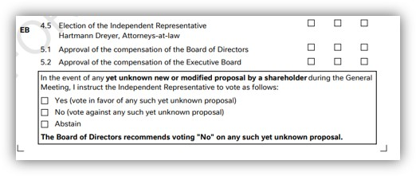
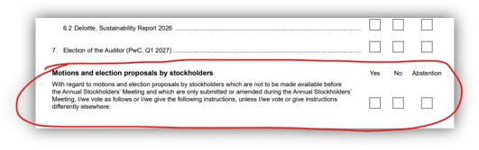
G. SEG/TSG recommendation:
Consider: X
Timing:
- Next yearly cycle: 2026/2027:
(the change will be considered for implementation in the yearly maintenance cycle which starts in 2026 and completes with the publication of new message versions in the spring of 2027)
- At the occasion of the next maintenance of the messages:
(the change will be considered for implementation, but does not justify maintenance of the messages in its own right – will be pending until more critical change requests are received for the messages)
- Urgent unscheduled:
(the change justifies an urgent implementation outside of the normal yearly cycle)
- Other timing:

Comments: N/A
H. Impact analysis:
This change request impacts the following General meeting messages: seev.001, seev.004, seev.006.
I. Implementation solution proposal
a. In the seev.001 (MeetingNotification), add new message building block MeetingResolution, defined as: “Identifies one or more resolutions that may be introduced or amended during the meeting and not previously communicated as part of the meeting agenda.”, and including the following components and elements:
- /Document/MtgNtfctn/MeetingResolution/IssuerLabel (1…1), typed by datatype Max35Text
- /Document/MtgNtfctn/MeetingResolution/Description (0…*), typed by datatype ItemDescriptionX
- /Document/MtgNtfctn/MtgRsltn/Desc/Language (1…1), typed by datatype ISO2ALanguageCode
- /Document/MtgNtfctn/MtgRsltn/Desc/Description (0…*), typed by datatype Max8000text
- Document/MtgNtfctn/MtgRsltn/VoteInstrTp (1...*), typed by VoteInstructionTypeX
- /Document/MtgNtfctn/Rsltn/VoteInstrTp/VoteInstrTpCd (1…1)
- /Document/MtgNtfctn/Rsltn/VoteInstrTp/VoteInstrTpCd/Tp (1…)
        - Abstain [ABST],
        - Against [CAGS],
        - Against Management [AMGT],
        - Blank [BLNK],
        - Chairman [CHRM],
        - Discretionary [DISC],
        - For [CFOR],
        - No Action [NOAC],
        - With Management [WMGT],
        - Withhold [WTHH]

- /Document/MtgNtfctn/Rsltn/MgmtRcmmndtn (0...1), typed by VoteInstruction5Code
        - Abstain [ABST],
        - Against [CAGS],
        - Against Management [AMGT],
        - Blank [BLNK],
        - Chairman [CHRM],
        - Discretionary [DISC],
        - For [CFOR],
        - No Action [NOAC],
        - With Management [WMGT],
        - Withhold [WTHH]

- /Document/MtgNtfctn/Rsltn/NtifngPtyRcmmndtn (0...1), typed by VoteInstruction5Code
        - Abstain [ABST],
        - Against [CAGS],
        - Against Management [AMGT],
        - Blank [BLNK],
        - Chairman [CHRM],
        - Discretionary [DISC],
        - For [CFOR],
        - No Action [NOAC],
        - With Management [WMGT],
        - Withhold [WTHH]

- /Document/MtgNtfctn/Rsltn/URLAdr (0...1), typed by Max2048Text

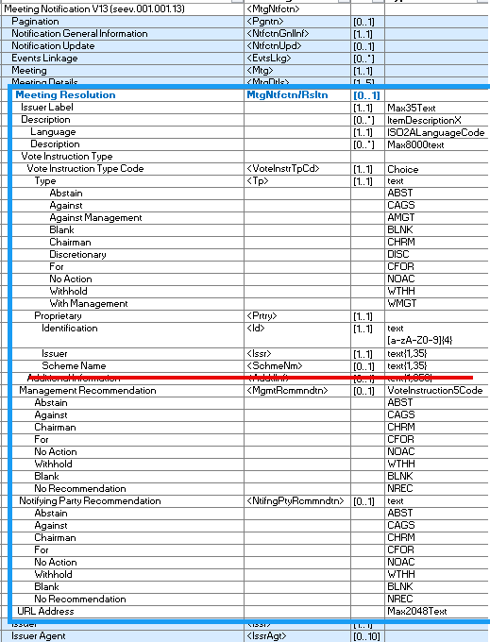
b. In the seev.004 (MeetingInstruction), in message building block Instruction, within message component VoteDetails/VoteInstructionForMeetingResolution/VoteIndication/Type, remove the following Vote Instruction types:
        - Abstain [ABST],
        - Against [CAGS],
        - Against Management [AMGT],
        - Blank [BLNK],
        - Chairman [CHRM],
        - Discretionary [DISC],
        - For [CFOR],
        - No Action [NOAC],
        - One Year [ONEY],
        - Three Years [THRY],
        - Two Years [TWOY],
        - With Management [WMGT],
        - Withhold [WTHH]

c. In the seev.006 (MeetingInstructionStatus), in message building block InstructionTypeStatus, within message component InstructionStatus/InstructionStatus/Rejected/Reason/ReasonCode, add new reason code “Vote Instruction For Meeting Resolution Not Allowed” (VOMT).
J. Proposed timing:
The submitting organization confirms that it can implement the requested changes in the requested timing.
Timing | As requested

K. Final decision of the SEG(s):
☒ Approve
Comments: Approved with amendments. The Securities SEG endorsed the Evaluation Team’s recommendation and the amended implementation solution, subject to the following changes:
- remove Issuer Label from the new Meeting Resolution block,
- keep the Description optional,
- make the Vote Instruction Type mandatory when the Meeting Resolution block is present,
- use a common code list to maintain consistency between seev.001 and seev.004,
- remove the one-year (ONEY), two-year (TWOY)and three-year(THRY) options from the meeting resolution voting context,
- add a dedicated rejection reason code for cases for voting instructions for meeting resolutions that are not allowed
- retain the name “Meeting Resolution” for consistency between seev.001 and seev.004; and
- keep the change scoped to seev.001, seev.004 and seev.006, without extending the implementation to seev.007 or seev.008.

The ISO SEG ET agreed to retain the proposed name "Meeting Resolution" for the new message building block, in order to preserve consistency between seev.001 and seev.004. However, the concerns regarding terminology were acknowledged, and the group agreed that certain documentation and code descriptions referencing "meeting resolution" should be reviewed and, where appropriate, made more generic to avoid ambiguity.
The group further discussed the related rejection logic in seev.006. It was agreed that a new rejection reason code should be created to indicate that voting instructions for meeting resolutions are not allowed, while the already amended OPTY code should be used where the meeting resolution voting is supported but the vote instruction type submitted is not valid for that meeting.
Moreover, it was agreed to keep the current CR scoped to seev.001 and to not extend it to seev.007 and seev.008. At the same time, it was clarified that the existing vote instruction type code list should kept in seev.007 for regular meeting resolutions.
☐ Reject
Reason for rejection:
Not applicable.

CR3276 (ISO CR #1593): Minimum Securities Required for Attendance
A. Origin of the request:
A.1 Submitter: SMPG CA-WG
A.2 Contact persons:
Christine Strandberg
Mariangela Fumagalli
A.3 Sponsors:
SMPG CA WG members
B. Related messages:
seev.001.001.12 (Meeting Notification)
seev.006.001.12 (Meeting Instruction Status)
C. Description of the change request:
1) In seev.001, in message building block Meeting, within message component Attendance/Admission Conditions, add new optional and non-repetitive element “Minimum Securities Required for Attendance”, defined as FinancialInstrumentQuantity18Choice.
2) In seev.006, add new rejection reason code “ISRA” (Insufficient Securities Required for Attendance), defined as: Insufficient quantity of securities held to meet the minimum requirement for attendance.
D. Purpose of the change:
Currently, many Spanish issuers announce in their General Meeting notice a requirement of a minimum of shares in order to attend physically the meeting. This information is not populated in the Seev.001 message since there is no structured field for this purpose (the field Securities Quantity Required To Vote is not valid for this purpose).
Therefore, the creation of a new optional field "Minimum Securities Required for Attendance" inside the Attendance/Admission Conditions block is required.
Moreover, a new rejection code in the seev.006 messages is required, to inform a rejection of a seev.004 instruction sent for an attendance request whether the position of the securities account is less than the minimum required for the issuer.
E. Urgency of the request:
SR2027
Note: the ISO 20022 maintenance results in the publication of a new version of an ISO 20022 message. The actual implementation of such new version on networks and in user installations is not within the purview of ISO.
F. Business examples:
Examples illustrating the change request.
N/A
G. SEG/TSG recommendation:
This section is not to be taken care of by the submitter of the change request. It will be completed in due time by the SEG(s) in charge of the related ISO 20022 messages or the TSG for changes related to the BAH.
Consider:
Timing:
- Next yearly cycle: 2026/2027:
(the change will be considered for implementation in the yearly maintenance cycle which starts in 2026 and completes with the publication of new message versions in the spring of 2027)
- At the occasion of the next maintenance of the messages:
(the change will be considered for implementation, but does not justify maintenance of the messages in its own right – will be pending until more critical change requests are received for the messages)
- Urgent unscheduled:
(the change justifies an urgent implementation outside of the normal yearly cycle)
- Other timing:

Comments: N/A
H. Impact analysis:
This change request impacts the following General meeting messages: seev.001, seev.006.
I. Proposed implementation solution:
As described above under C and as illustrated below:
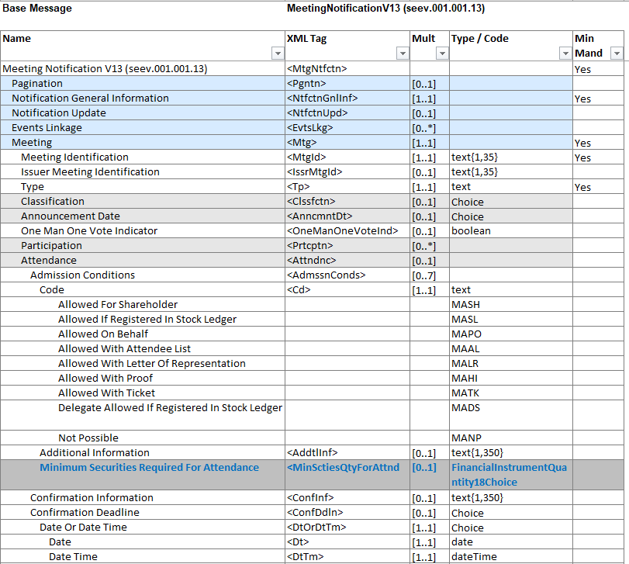
J. Proposed timing:
The submitting organization confirms that it can implement the requested changes in the requested timing.
Timing | As requested

K. Final decision of the SEG(s):
☒ Approve
Comments: Approved as proposed. The Securities SEG endorsed the Evaluation Team’s recommendation to add the optional and non-repetitive “Minimum Securities Required for Attendance” element to seev.001 and to introduce the associated rejection reason code in seev.006, using the proposed definition.
☐ Reject
Reason for rejection: Not applicable.

CR3280 (ISO CR #1589): Changes to Meeting IDs
A. Origin of the request:
A.1 Submitter: SMPG CA-WG
A.2 Contact persons:
Christine Strandberg
Mariangela Fumagalli
A.3 Sponsors:
SMPG CA WG members
B. Related messages:
seev.001, seev.002, seev.003, seev.004, seev.005, seev.006, seev.007, seev.008
C. Description of the change request:
- Change the definition of IssuerMeetingIdentifier to make it clear a reference should be assigned per combination of meeting and financial instrument.
Current definition: Identification assigned to the meeting by the issuer. It must be unique for the issuer.
Proposed definition: Identification assigned to the meeting by the issuer. It must be unique for the issuer, meeting and underlying financial instrument.
- Change the definition of MeetingIdentifier to make it clear a reference should be assigned per combination of meeting and financial instrument.
Current definition: Identification assigned to the general meeting by the party that provides the meeting notification. It must be unique to the party providing the notification.
Proposed definition: Identification assigned to the general meeting by the party that provides the meeting notification. It must be unique to the party providing the notification, meeting and underlying financial instrument.
- Add a new meeting identifier, CommonIssuerMeetingIdentifier, with the definition: Identification assigned to the meeting by the issuer. It must be unique for the issuer and meeting. Only to be used when the issuer holds a meeting where holders of two or more financial instruments are allowed to attend and vote.
D. Purpose of the change:
The SMPG CA WG decided at its spring 2026 meeting to make clarifications and changes to the meaning and use of IssuerMeetingIdentifier and MeetingIdentifier, in order to have one identifier per meeting and financial instrument, and to add a new identifier, CommonIssuerMeetingIdentifier, for meetings where holders of more than financial instrument of the issuer are allowed to attend and vote. These changes will allow harmonisation with the similar corporate action message identifiers, OfficialCorporateActionEventIdentification and CorporateActionEventIdentification, whilst at the same time allow issuers of e.g. two share classes to identify the meeting with an issuer identifier common for both instruments.
E. Urgency of the request:
SR2027
Note: the ISO 20022 maintenance results in the publication of a new version of an ISO 20022 message. The actual implementation of such new version on networks and in user installations is not within the purview of ISO.
F. Business examples: N/A
G. SEG/TSG recommendation:
This section is not to be taken care of by the submitter of the change request. It will be completed in due time by the SEG(s) in charge of the related ISO 20022 messages or the TSG for changes related to the BAH.
Consider:
Timing:
- Next yearly cycle: 2026/2027:
(the change will be considered for implementation in the yearly maintenance cycle which starts in 2026 and completes with the publication of new message versions in the spring of 2027)
- At the occasion of the next maintenance of the messages:
(the change will be considered for implementation, but does not justify maintenance of the messages in its own right – will be pending until more critical change requests are received for the messages)
- Urgent unscheduled:
(the change justifies an urgent implementation outside of the normal yearly cycle)
- Other timing:

Comments: N/A
H. Impact analysis:
This change request impacts the following General meeting messages: seev.001 – seev.008.
I. Proposed implementation solution:
1) In seev.001, in message building block Meeting,
And in seev.002 – seev.008, in message building block Meeting Reference,
amend the description for element “Issuer Meeting Identification”, as follows:
Identification assigned to the meeting by the issuer. It must be unique for the issuer.
NEW: Identification assigned to the meeting by the issuer. It must be unique for the issuer, meeting and underlying financial instrument.
2) In seev.001, in message building block Meeting,
And in seev.002 – seev.008, in message building block Meeting Reference,
amend the description for element “Meeting Identification”, as follows:
Identification assigned to the general meeting by the party that provides the meeting notification. It must be unique to the party providing the notification.
NEW: Identification assigned to the general meeting by the party that provides the meeting notification. It must be unique to the party providing the notification, meeting and underlying financial instrument.
Swift Standards comment: The proposed definition introduces a uniqueness requirement at meeting and underlying financial instrument level, whilst the current seev.001 message structure supports the reporting of multiple financial instruments within a single meeting notification. Therefore, the ISO SEG GM ET should assess whether the proposed wording is fully consistent with the current business and message model, or whether additional modelling changes or usage constraints would be required to support the proposed identifier concept.

- In seev.001, in message building block Meeting,
And in seev.002 – seev.008, in message building block Meeting Reference,
add the following optional and non-repetitive element “CommonIssuerMeetingIdentifier”, defined as: Identification assigned to the meeting by the issuer. It must be unique for the issuer and meeting. Only to be used when the issuer holds a meeting where holders of two or more financial instruments are allowed to attend and vote.
J. Proposed timing:
The submitting organization confirms that it can implement the requested changes in the requested timing.
Timing | As requested

K. Final decision of the SEG(s):
☐ Approve
Comments:
☒ Reject
Reason for rejection: The proposal was not approved because sufficient consensus was not reached on the proposed identifier model. The request will be returned to the SMPG for further discussion.
Alternative approaches, including market-practice clarifications and reconsideration of the current capability to report multiple financial instruments for a meeting, before any future resubmission.

CR3275 (ISO CR #1594): Add Cumulative Voting Multiplier to Meeting Notification and Instruction
A. Origin of the request:
A.1 Submitter: Eurobonds market / XS NMPG
A.2 Contact person: Hatem Soliman (hatem.soliman@euroclear.com, +32 2 326 5107)
A.3 Sponsors: ICSDs
B. Related messages:
seev.001.001.12 (Meeting Notification)
seev.004.001.11 (Meeting Instruction)
C. Description of the change request:
In the seev.001 meeting notification message,
- In message building block Meeting, add a new optional and non-repetitive element “Cumulative Voting Indicator”, typed by a YesNoIndicator, to indicate that cumulative voting is applicable to specific resolution(s).
XML path </Document/MtgNtfctn/ Cumulative Voting Indicator >
Definition: “Indicates if a cumulative voting applies to one or more resolution.”
- In message building block Resolution, add a new optional and non-repetitive element “Cumulative Voting Multiplier”, to indicate the multiplier to be applied to the resolution eligible to cumulative voting.
XML path < /Document/MtgNtfctn/Rsltn/CumVoteMultiplier>
Definition: “Multiplier to be applied on the eligible balance to determine the maximum number of votes accepted on resolutions flagged for cumulative voting”).
The element shall be defined using a numeric datatype constrained to integer values (fractionDigits = 0) with a minimum value of 1 (Min inclusive: 1).
- In message building block Resolution, add a new optional and repetitive (0….1000) element “Subresolution”, typed by Max35Text, to list the subresolutions where the cumulative voting and the multiplier to be applied to.
XML path < /Document/MtgNtfctn/Rsltn/subRsltn>
Definition: “list of the sub-resolutions where the cumulative voting and the multiplier to be applied to”
In the seev.004 meeting instruction message,
- In message building block Instruction, within message component “Vote Details/VoteInstructionForAgendaResolution/VotePerAgendaResolution/VoteInstruction/Subresolution”, add a new optional and repetitive (0….1000) element “Subresolution”, typed by Max35Text, to list the subresolutions where the cumulative voting and the multiplier to be applied to.
XML path </Document/MtgInstr/Instr/VoteDtls/VoteInstrForAgndRsltn/VotePerAgndRsltn/VoteInstr//subRsltn)
Definition: same as defined above under (3).
- Add 2 cross-element rules:
- If the Cumulative voting flag = Y, then there must be a least one CumVoteMultiplier.
- If a CumulativeVotingMultiplier is present, then the CumulativeVotingIndicator must be equal to “true”.
D. Purpose of the change:
There are meeting events for which cumulative voting applies for specific resolution(s).
It means that for a number of resolutions for a meeting event, clients can vote for an amount of the eligible balance multiplied by the number of sub-resolutions for which cumulative voting applies.
The sum of the votes by the client for the applicable sub-resolutions should not exceed the eligible balance multiplied by the number of sub-resolutions with cumulative voting.
It must be possible to announce the multiplier when cumulative voting applies to specific sub-resolution(s) as decided by the issuer.
The account servicer receiving a meeting instruction will compare the instruction quantity with the position multiplied by the “cumulative voting multiplier” to either accept (“PACK”), reject (“rejected/LACK”) or keep instruction recycling (“pending/LACK”). (Rejecting or keeping instruction pending to be decided based on account servicer SLA, as for other meeting instructions). There is no need to define a new reason for this specific case.
E. Urgency of the request:
SR2027
Note: the ISO 20022 maintenance results in the publication of a new version of an ISO 20022 message. The actual implementation of such new version on networks and in user installations is not within the purview of ISO.
F. Business examples:
Around 40 meeting events with cumulative voting announced over the last 6 months, mainly on EURO instruments, Finnish, HK and US markets (mainly for depository receipts).
Example 1:
CUMULATIVE VOTING APPLIES TO RESOLUTION 4
2 DIRECTORS ARE TO BE ELECTED TO THE BOARD.
TO INSTRUCT, MULTIPLY YOUR ELIGIBLE POSITION BY THE NUMBER OF
DIRECTORS TO BE ELECTED. IF YOU WANT TO SPLIT YOUR VOTE, ASSIGN
AN AMOUNT TO EACH DIRECTOR UNTIL YOUR TOTAL CUMULATED POSITION IS ACCOUNTED FOR.
FOR EXAMPLE, IF YOU HAVE 10 ADRS ON RECORD DATE, YOU ARE ENTITLED
TO VOTE ON 2 (NUMBER OF NOMINATED DIRECTORS) X 10, EQUALLING 20
VOTES TO DISTRIBUTE AMONG THE NUMBER OF PROPOSED DIRECTORS.

Example 2:
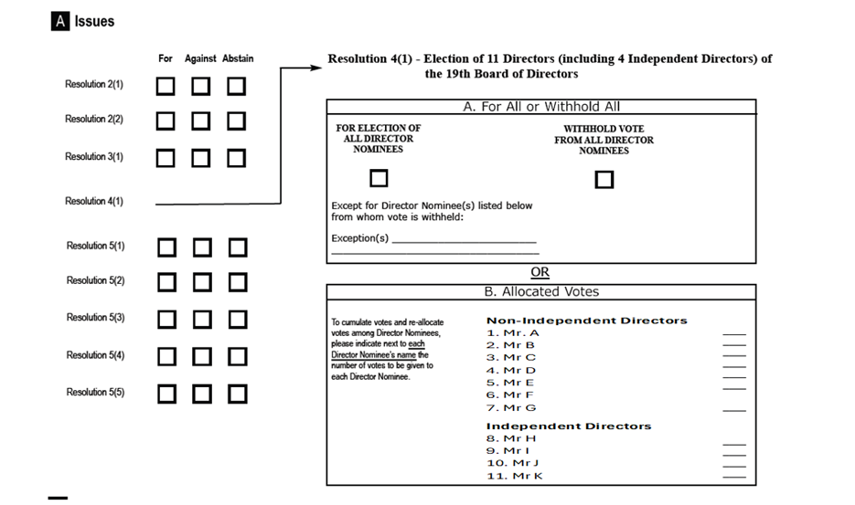
The notification should have the below structure for resolution 4
For resolution 4, you can either instruct on resolution 4.a. or 4.b. and 4.c.
Resolution 4.a.: you have the option to vote for all Director nominees or withhold vote for all Director nominees with possibility to note exceptions.

Resolution 4.b.
CUMULATIVE VOTING APPLIES TO RESOLUTION 4.b.
7 NON-INDEPENDENT DIRECTORS ARE TO BE ELECTED TO THE BOARD (7 sub-resolutions).
TO INSTRUCT, MULTIPLY YOUR ELIGIBLE POSITION BY THE NUMBER OF NON-INDEPENDENT DIRECTORS (sub-resolutions) TO BE ELECTED.
IF YOU WANT TO SPLIT YOUR VOTE, ASSIGN AN AMOUNT TO EACH DIRECTOR UNTIL YOUR TOTAL CUMULATED POSITION IS ACCOUNTER FOR.
FOR EXAMPLE, IF YOU HAVE 10 ADRS ON RECORD DATE, YOU ARE ENTITLED
TO VOTE ON 7 (NUMBER OF NOMINATED NON-INDEPENDENT DIRECTORS) X 10, EQUALLING 70
VOTES TO DISTRIBUTE AMONG THE NUMBER OF PROPOSED NON-INDEPENDENT DIRECTORS.

Resolution 4.C.
CUMULATIVE VOTING APPLIES TO RESOLUTION 4.c.
4 INDEPENDENT DIRECTORS (sub-resolutions ) ARE TO BE ELECTED TO THE BOARD.
TO INSTRUCT, MULTIPLY YOUR ELIGIBLE POSITION BY THE NUMBER OF
INDEPENDENT DIRECTORS (sub-resolutions ) TO BE ELECTED. IF YOU WANT TO SPLIT YOUR VOTE, ASSIGN
AN AMOUNT TO EACH DIRECTOR UNTIL YOUR TOTAL CUMULATED POSITION IS ACCOUNTED FOR.
FOR EXAMPLE, IF YOU HAVE 10 ADRS ON RECORD DATE, YOU ARE ENTITLED
TO VOTE ON 4 (NUMBER OF NOMINATED INDEPENDENT DIRECTORS) X 10, EQUALLING 40
VOTES TO DISTRIBUTE AMONG THE NUMBER OF PROPOSED INDEPENDENT DIRECTORS.

At Meeting level:
- Document/MtgNtfctn/ Cumulative Voting Indicator – CumulativeVotingIndicator - (YesNoIndicator) [0..1] — indicates that cumulative voting applies to one or more resolutions.

At Resolution level:
- /Document/MtgNtfctn/Rsltn – Resolution 4.b.
- /Document/MtgNtfctn/Rsltn/IssrLabl – Issuer Label – Non-Independent Directors
- /Document/MtgNtfctn/Rsltn/ListgGrpRsltnLabl – Listing Group Resolution Label - Identifies under the same label a group of agenda resolutions for which a vote in favour can be assigned to only one, more or all resolutions of that group.
- Document/MtgNtfctn/Rsltn/CumVoteMultiplier - Cumulative Voting Multiplier - (Number / integer ≥ 1) [0..1] = 7

- /Document/MtgNtfctn/Rsltn – Resolution 4.c.
- /Document/MtgNtfctn/Rsltn/IssrLabl – Issuer Label – Independent Directors
- /Document/MtgNtfctn/Rsltn/ListgGrpRsltnLabl – Listing Group Resolution Label - Identifies under the same label a group of agenda resolutions for which a vote in favour can be assigned to only one, more or all resolutions of that group.
- Document/MtgNtfctn/Rsltn/CumVoteMultiplier - Cumulative Voting Multiplier - (Number / integer ≥ 1) [0..1] = 4

G. SEG/TSG recommendation:
This section is not to be taken care of by the submitter of the change request. It will be completed in due time by the SEG(s) in charge of the related ISO 20022 messages or the TSG for changes related to the BAH.
Consider:
Timing:
- Next yearly cycle: 2026/2027:
(the change will be considered for implementation in the yearly maintenance cycle which starts in 2026 and completes with the publication of new message versions in the spring of 2027)
- At the occasion of the next maintenance of the messages:
(the change will be considered for implementation, but does not justify maintenance of the messages in its own right – will be pending until more critical change requests are received for the messages)
- Urgent unscheduled:
(the change justifies an urgent implementation outside of the normal yearly cycle)
- Other timing:
Comments: N/A
H. Impact analysis:
This change request impacts the following General meeting message: seev.001.
I. Proposed implementation solution (replaced by the updated solution presented by Hatem during the ISO SEG ET review call held on 26th August):
- In the seev.001 (MeetingNotification), in message building block Meeting, add a new optional and non-repetitive element “Cumulative Voting Indicator”, typed by a YesNoIndicator, to indicate that cumulative voting is applicable to specific resolution(s).
XML path </Document/MtgNtfctn/ Cumulative Voting Indicator >
Definition: “Indicates if a cumulative voting applies to one or more resolution.”
- In the seev.001 (MeetingNotification), in message building block Resolution, add a new optional and non-repetitive element “Cumulative Voting Multiplier”, to indicate the multiplier to be applied to the resolution eligible to cumulative voting.

XML path < /Document/MtgNtfctn/Rsltn/CumVoteMultiplier>
Definition: “Multiplier to be applied on the eligible balance to determine the maximum number of votes accepted on resolutions flagged for cumulative voting”).
The element shall be defined using a numeric datatype constrained to integer values (fractionDigits = 0) with a minimum value of 1 (Min inclusive: 1).
- In message building block Resolution, add a new optional and repetitive (0….100) element “Subresolutions”, , to list the subresolutions where the cumulative voting and the multiplier to be applied to.
XML path < /Document/MtgNtfctn/Rsltn/subRsltn>
Definition: “list of the sub-resolutions where the cumulative voting and the multiplier to be applied to”
- In message building block Resolution, within message component VoteInstrTp/VoteInstrTpCd/Tp, remove the following Vote Instruction types (in red):

  - Abstain [ABST],
  - Against [CAGS],
  - Against Management [AMGT],
  - Blank [BLNK],
  - Chairman [CHRM],
  - Discretionary [DISC],
  - For [CFOR],
  - No Action [NOAC],
  - One Year [ONEY],
  - Three Years [THRY],
  - Two Years [TWOY],
  - With Management [WMGT],
  - Withhold [WTHH]

- In message building block Resolution, in the new element “Subresolution”, add a new mandatory and non-repetitive component Type VoteInstrTp/VoteInstrTpCd/Tp, with the following Vote Instruction type code types:

  - For [CFOR],
  - Against [CAGS],
- In Message building block Subresolution add two new mandatory and repetitive (0…20) elements Issuer Label - Max35Text (based on string) - and Description - Max8000Text (based on string).

- In the seev.001, add two cross-element rules:

a. If the Cumulative voting flag = Y, then there must be at least one CumVoteMultiplier.
b. If a CumulativeVotingMultiplier is present, then the CumulativeVotingIndicator must be equal to “true”.
In the seev.004 meeting instruction message,
- In the message BlockVote Details/Vote Instruction for agenda resolution/ Vote Instruction/Issuer Label add a new element Cumulative Quantity with the subelements Unit/Face amount and Vote Type with values as per 4. above.:
Issuer label
Cumulative Quantity
Unit
Face amount
Vote Instruction type
Abstain [ABST],
Against [CAGS],
Against Management [AMGT],
Blank [BLNK],
Chairman [CHRM],
Discretionary [DISC],
For [CFOR],
No Action [NOAC],
With Management [WMGT],
Withhold [WTHH]

- In message building block Instruction, within message component “Vote Details/VoteInstructionForAgendaResolution/VotePerAgendaResolution/VoteInstruction/ResolutionSubresolution”, add a new optional and repetitive (0….100) element “Subresolutions”, to list the subresolutions where the cumulative voting and the multiplier to be applied to.
XML path </Document/MtgInstr/Instr/VoteDtls/VoteInstrForAgndRsltn/VotePerAgndRsltn/VoteInstr//subRsltn)
Definition: same as defined above under (3).
- In message building block Instruction, in the new element “Subresolutions”, add a new mandatory and repetitive subelement “Issuer Label” with two new mandatory and non-repetitive components – “Type” with subvalues “For” and “Against” and Quantity” element with subelements “Unit” and “Face amount” to advise the type of vote and the cumulative quantity voted for.

- Add two new rules:

Add textual rule: When Cumulative Voting is applicable, a voter's total voting entitlement “Cumulative Quantity” shall be calculated as Voting Entitlement × Cumulative Voting Multiplier, and the voter may allocate this entitlement either on the resolution level or across one or more subresolutions, provided the total votes assigned does not exceed the calculated entitlement. The rule to be added within message component “Vote Details / VoteInstructionForAgendaResolution / VotePerAgendaResolution/. In such scenarios, Listing Group Resolution Label cannot be used.
Add a Cross Element Complex Rule: When a resolution includes sub-resolutions and cumulative voting should apply, the GlobalVoteInstruction element shall not be present. Vote instructions must be specified under Vote Details / VoteInstructionForAgendaResolution / VotePerAgendaResolution/.
- In the seev.004 (MeetingInstruction), in message building block “Instruction”, add new optional and non-repetitive element “Cumulative Voting Instruction Information”, typed by Max8000Text and defined as: “Additional information on cumulative voting allocations when required.”
- In the seev.004 (MeetingInstruction), add new cross element rule: If Cumulative Voting Instruction Information is present, then Global Vote Instruction and Vote For All Agenda Resolutions are not allowed (must be absent).
J. Proposed timing:
The submitting organization confirms that it can implement the requested changes in the requested timing.
Timing | As requested

K. Final decision of the SEG(s):
☒ Approve
Comments: Approved with a substantially revised implementation approach. The Securities SEG endorsed the Evaluation Team’s recommendation to:
- retain the optional Cumulative Voting Indicator at meeting level in seev.001;
- retain the optional Cumulative Voting Multiplier at resolution level in seev.001;
- retain the associated cross-element rules linking the indicator and multiplier;
- remove the complete sub-resolution model and its associated message changes;
- introduce a dedicated narrative field in seev.004, “Cumulative Voting Information”, for additional information on cumulative-voting allocations; and
- define detailed operational handling and usage through market-practice documentation.

No new rejection reason code will be introduced at this stage. Existing OTHR functionality should be used when rejection information must be communicated.

The ISO SEG ET agreed to retain only the cumulative-voting indicator and multiplier in SEEV.001 (i.e. section 1. and 2. of the proposed implementation solution described above under I.), and to replace the complex sub-resolution solution with a dedicated narrative-based solution in SEEV.004 (see section 5 under changes described for seev.004). All other sections, i.e. section 3, 4, 5, 6 described for seev.001 and sections 1, 2, 3 and 4 described for seev.004 were rejected and will therefore not be part of the implementation solution.
Detailed operational guidance will be addressed through market practice.
Amendments agreed:
Retained (for seev.001):
- New cumulative voting indicator at meeting level
- New cumulative voting multiplier at resolution level

Removed: Entire sub-resolution model, including associated changes to seev.004 based on sub-resolutions and associated impacts on seev.007 and seev.008.
New Approach: Introduce a dedicated narrative field in seev.004 called “Cumulative Voting Information” to communicate cumulative voting allocations when required.
Operational handling and usage rules will be defined in market practice documentation.
No new rejection code will be introduced at this stage. Existing OTHR functionality should be used if rejection information must be communicated.

☐ Reject
Reason for rejection: Not applicable.

CR3274 (ISO CR #1595): Changes to Meeting Attendance block

A. Origin of the request:
A.1 Submitter: SMPG CA-WG
A.2 Contact persons:
Christine Strandberg
Mariangela Fumagalli
A.3 Sponsors:
SMPG CA WG members
B. Related messages:
seev.001 Meeting Notification
seev.006.001.12 Meeting Instruction Status
C. Description of the change request:
Create a new indicator in the seev.001 to state whether voting instructions should be submitted along with the attendance request or not.
D. Purpose of the change:
The SMPG CA WG decided at its spring 2026 meeting to create an element in the seev.001, in the Attendance block, to state that votes need to be submitted via the chain of intermediaries even if the rightsholder attends in person.
E. Urgency of the request:
SR2027
Note: the ISO 20022 maintenance results in the publication of a new version of an ISO 20022 message. The actual implementation of such new version on networks and in user installations is not within the purview of ISO.
F. Business examples:
N/A
G. SEG/TSG recommendation:
This section is not to be taken care of by the submitter of the change request. It will be completed in due time by the SEG(s) in charge of the related ISO 20022 messages or the TSG for changes related to the BAH.
Consider:
Timing:
- Next yearly cycle: 2026/2027: X
(the change will be considered for implementation in the yearly maintenance cycle which starts in 2026 and completes with the publication of new message versions in the spring of 2027)
- At the occasion of the next maintenance of the messages:
(the change will be considered for implementation, but does not justify maintenance of the messages in its own right – will be pending until more critical change requests are received for the messages)
- Urgent unscheduled:
(the change justifies an urgent implementation outside of the normal yearly cycle)
- Other timing:

Comments: N/A
H. Impact analysis:
This change request impacts the following General meeting messages: seev.001, seev.006.
I. Proposed implementation solution:
a) In the seev.001 (MeetingNotification), in message building block Attendance, add new optional and non-repetitive indicator “VotingInstructionRequiredWithAttendanceIndicator”, typed by YesNoIndicator and defined as: “Indicates whether voting instructions must be submitted in conjunction with an attendance request.”
b) In seev.006, add new rejection reason code “Voting Instruction Missing” (VIMI), defined as: “Voting instructions required with the attendance request are missing.”

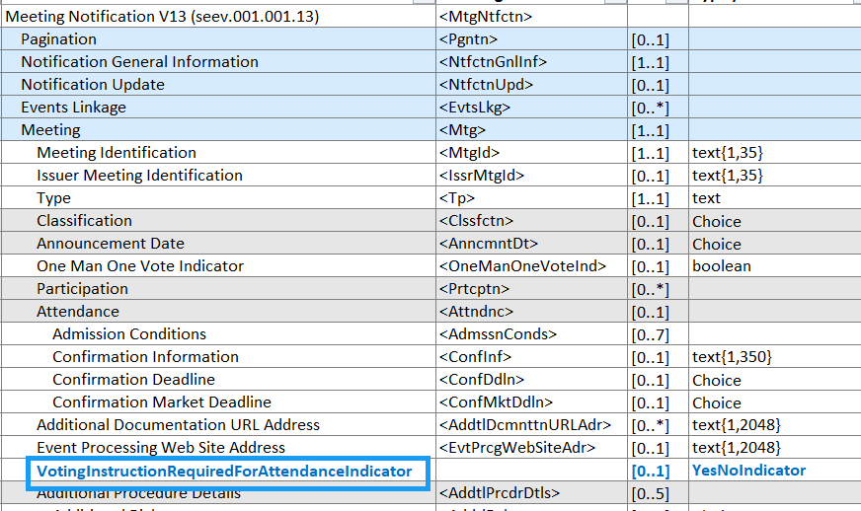
J. Proposed timing:
The submitting organization confirms that it can implement the requested changes in the requested timing.
Timing | As requested

K. Final decision of the SEG(s):
☒ Approve
Comments: Approved with amendments. The Securities SEG endorsed the Evaluation Team’s recommendation to:
- add the optional and non-repetitive “VotingInstructionRequiredWithAttendanceIndicator” to the Attendance block in seev.001
- introduce a new rejection reason code in seev.006 when required voting instructions are missing.

No pending status will be introduced. Market-practice guidance must clarify the use of the indicator, including the expectation that it is reported only when its value is “Yes”.
The proposed implementation solution was approved with the addition of a new rejection reason code in seev.006 for missing voting instructions and without introducing any pending status.
It was further noted that market practice guidance is required to clarify the usage of the new indicator, including the expectation that it would only be reported when set to "Yes".
☐ Reject
Reason for rejection: Not applicable.

End of document

