Standards
Standards MT Release 2027
Discussion paper – FINAL MINUTES
Settlement and Reconciliation
Distribution: Settlement and Reconciliation Standards Working Group
Author: Karine Taquet
Date Issued: September 2026
Version: v 1.0
Meeting Date: 24th August 2026

Table of Contents
1 Introduction 3
2 Overview of User Change requests 5
2.1 CR 003204: Addition of Presented to Settlement codes in the Settlement Transaction Condition Indicator for the MT548 and the MT537 5
2.2 CR 003206: Add New Blocked Balance Types for Digital Assets 11
2.3 CR 003223: Addition of new Resolution Reason Code PATM for PATD Scenarios to qualifiers PEND and PENF in field 24B 22
2.4 CR 003229: Reporting of instructions eligible to the gating event 32
2.5 CR 003239: Add Corporate Action Event Type Indicator to the Settlement Confirmation Messages 38
2.6 CR 003241: Gating event modification via MT530/sese.030 42
3 Overview of User Change requests ISO20022 49
3.1 CR 003258: Reinstate NCON Pending Confirmation code (ISO 20022 CR 1602) 49
3.2 CR 003263: Align From and To Balance code lists in semt.014 to semt.013 and semt.15 (ISO 20022 CR 1615) 54
3.3 CR 003264: Add Exposure Type to Balance Breakdown in semt.002 and semt.003 (ISO 20022 CR 1614) 59

Introduction

ISO 15022 – 20022 Maintenance Process
As from the year 2012, a joint maintenance process has been put in place for ISO 20022 and 15022 and Settlement & Reconciliation messages with the support of the ISO 20022 RMG and of the SWIFT Board.
This joint maintenance will ensure interoperability between the two standards and a more efficient maintenance process.
Standards Illustrations in this document
Standards illustrations are provided by SWIFT Standards. They are not part of the original request.
Any standard illustrations (rules, codes, qualifiers, wordings) are only for illustration purposes. It does not mean SWIFT Standards is in agreement with the maintenance request or that the final standards solutions (for accepted maintenance requests) will be as shown in this document.
The MT Standards Release Guide (+ potential erratum) and the ISO 20022 message definition reports are the ONLY source of reliable information based on which implementation of changes should be made. Any other documentation (including this one) is subject to change.
SR 2025 change requests
This document contains all S&R MT/MX CRs for MT category 5 and equivalent MX messages investigated this year for implementation in SR 2027.
The requests originator is indicated as follows:
  - Requesting Country; Country code of requesting NMPG or UG; eg. BE
  - Requesting Group: a SWIFT User Group or a National (Securities) Market Practice Group with the acknowledgement of the UGC or Recognized industry group eg. SMPG (the global Securities Market Practice Group)
Contact persons regarding this document
Karine Taquet – SWIFT Standards, Karine.Taquet@swift.com, +32 655 3784
CR Title Colour notation (for minutes only)
In GREEN are items that are approved or approved with comments or approved with alternative solution.
In RED are items that are rejected, withdrawn or linked to agreed items
In GREY are items that are postponed for review and implementation at the next release.

S&R SWG Members for SR2027
The following people are part of the S&R SWG for SR2027.

Maintenance working group members: | Representing: | Present
Vacant | Australia
Karen Weaver, - BNYMellon | Belgium | karen.l.weaver@bny.com
Xavier Filion Simon - BNC  Daniel Valance – RBC  Laurent Lallemand – RBC | Canada | Xavier.filionsimon@bnc.ca  daniel.vallance@rbc.com laurent.f.lallemand@rbc.com
Jørgen Nielsen - Danske Bank A/S | Denmark | j.nielsen@danskebank.dk
Charles Bichemin – Societe Generale | France | Charles.Bichemin@socgen.com
Denis Andrejew – Deutch Bank | Germany | denis.andrejew@db.com
Vacant | Hong Kong
David Wouters – Euroclear | ICSD | david.wouters@euroclear.com
Robin Leary – Citibank | Ireland | robin.leary@citi.com
Paola De Antoni - Deloitte | Italy | pdeantoni@deloitte.it
Ryosuke Abiko - MUFG Bank | Japan | riyousuke_abiko@mufg.jp
Vacant | Republic of Korea
Arnaud Jochems – Clearstream | Luxembourg / ICSD | arnaud.jochems@clearstream.com
Marc Griffioen – ABN Amro | The Netherland | marc.griffioen@abnamroclearing.com
Vacant | Singapore
Brett Kotze – A2X | South Africa | brett.kotze@a2x.co.za
Vacant | Spain
Christine Strandberg - SEB | Sweden | christine.strandberg@seb.se
Caroline Spangvall - SEB | Sweden | caroline.spangvall@seb.se
Philipp Auf der Maur – Six-Group | Switzerland | philipp.aufdermaur@six-group.com
Robin Leary – Citibank | United Kingdom | robin.leary@citi.com
Shereef Zedan – Northern Trust | United States of America | sz2@ntrs.com

Overview of User Change requests

CR 003204: Addition of Presented to Settlement codes in the Settlement Transaction Condition Indicator for the MT548 and the MT537
Origin of request
Requesting Country:
Requesting Group: | Securities Market Practice Group (SMPG)
Sponsors
Message type(s) impacted
MT 537, MT 548
Complies with regulation
None
Business impact of this request
LOW
Commitment to implement the change
Number of messages sent and received: 1
Percentage of messages impacted: 1
Commits to implement and when: Switzerland 2027
Business context
Settlement transactions can be controlled by the owner through the hold/release functionality. Transactions that are placed 'on hold' are eligible for matching but are not yet released for settlement.
Within the ISO 20022 standard, the status advice message (sese.024) provides a dedicated field to indicate whether a transaction is 'on hold' or not. An equivalent indicator is currently missing in ISO 15022. Due to this gap, the industry has often used field :22F::SETR//PREA as a workaround.
However, according to the SMPG Market Practice SMPG_MP_SR_Hold_Release, this usage is not compliant, as SETR is intended to describe the type of settlement transaction and must not be used as a hold/release indicator.
This change request aims to align ISO 15022 with ISO 20022 by introducing a dedicated hold/release indicator in the MT548 and MT537 status advice messages.
Nature of change
The hold/release indicator qualifies as a Settlement Transaction Condition and must therefore be reported in field :22F::STCO//.
The following codes shall be introduced:
- :22F::STCO//NPRE -> indicates that the transaction is 'on hold' and NOT to be presented for settlement
- :22F::STCO//YPRE -> indicates that the transaction has been 'released' and is now presented for settlement
Examples

Workaround

Use of proprietary code in STCO

SWIFT Comment

Standards Illustration

ISO 15022 Illustrations

MT 548 – Settlement Status and Processing Advice

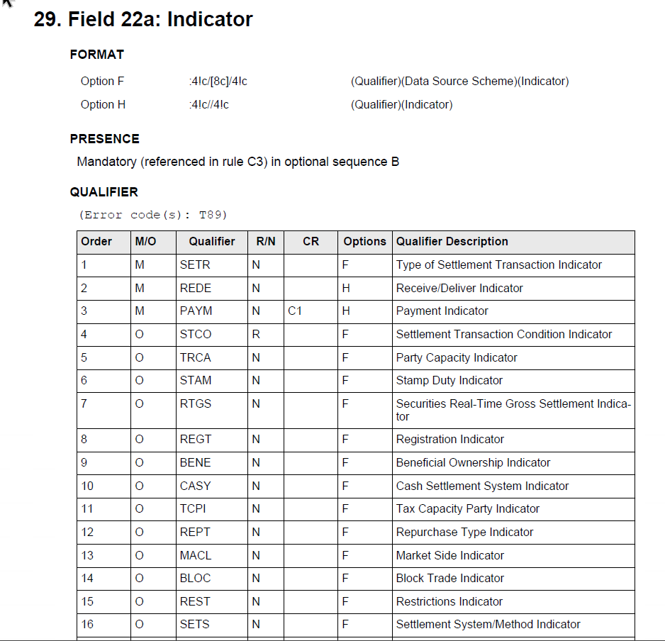

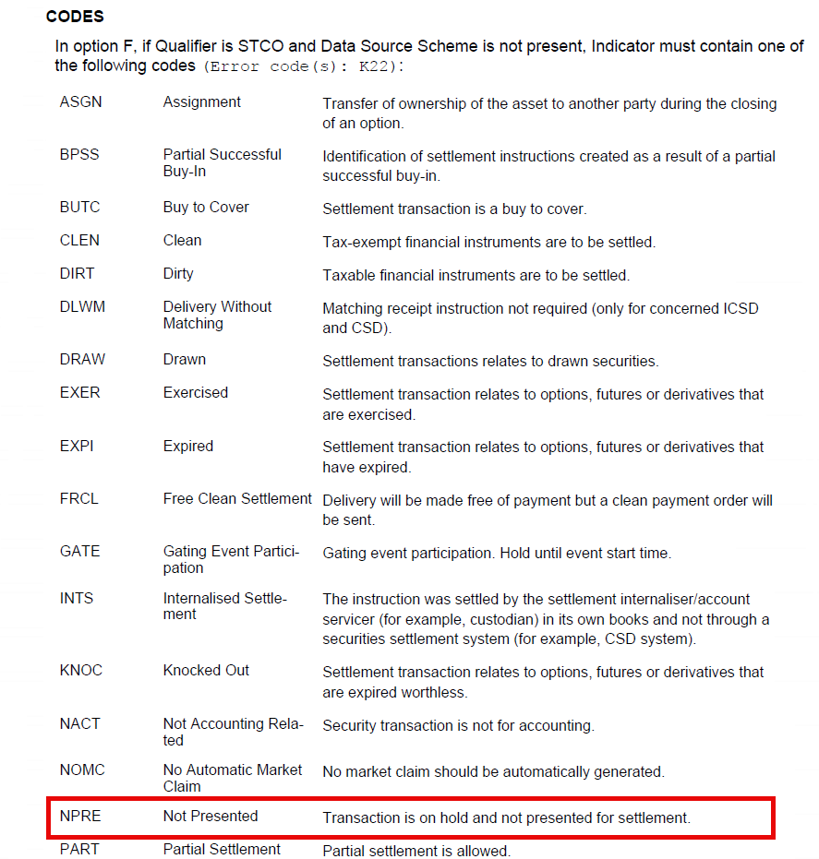
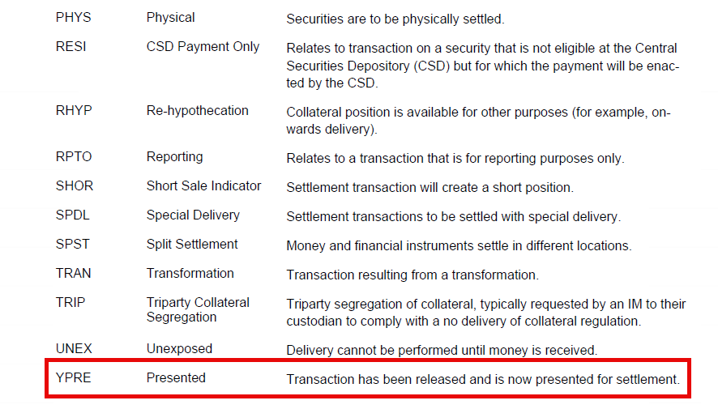

Working Group Meeting

Discussion
The CR was submitted to address a long-standing gap between ISO 15022 and ISO 20022 regarding the reporting of hold/release status on settlement instructions. In ISO 20022, a dedicated indicator already exists allowing participants to know whether an instruction is on hold or released. ISO 15022 currently lacks such functionality.
As a result, many market participants have historically used:22F::SETR//PREA as a workaround to indicate that an instruction is not presented for settlement. However, several participants noted that this usage is inconsistent with SMPG market practice because SETR is intended to describe the transaction type, not a hold/release condition.
The proposal therefore suggested removing the misuse of PREA from SETR and introducing two dedicated codes under STCO (Settlement Transaction Condition Indicator):
- NPRE = transaction is on hold and not presented for settlement.
- YPRE = transaction has been released and is presented for settlement.
The discussion focused on whether introducing dedicated standard codes was preferable to continuing with existing workarounds or using pending reason codes. Supporters argued that the proposal provides a clean standards-based solution, improves transparency, aligns MT messages with ISO 20022, and removes reliance on non-standard implementations.
Some community feedback questioned the need to add PREA semantics in STCO, arguing that existing reason codes in field 24B could potentially be used instead. Nevertheless, the overall business objective of eliminating incorrect use of SETR and providing an explicit hold/release indicator was broadly recognized but required further discussions that will take place at the Securities Market Practice Group level.
As there was no consensus, a vote had to take place where the majority was in favour of rejecting the CRs. All participants present were against except 3 votes in favour. Therefore CR was rejected.
Decision
REJECTED

CR 003206: Add New Blocked Balance Types for Digital Assets
Origin of request
Requesting Country: | United Kingdom
Requesting Group:
Sponsors
Message type(s) impacted
MT 508, MT 524, MT 535, MT 538
semt.002, semt.003, semt.013, semt.014, semt.015, semt.016, semt.018, semt.028, semt.029, semt.033, semt.034
Complies with regulation
None
Business impact of this request
LOW
Commitment to implement the change
Number of messages sent and received: 1
Percentage of messages impacted: 1
Commits to implement and when: Securities Market Practice Group - 2027
Business context
As part of the Digital Asset roll out, digital assets can be blocked and in quarantine before becoming available. However, there is no specific balance code to that allows the indication of this and the general BLOV or BLOC codes need to be used to reflect this. However, these codes may also be needed for other purposes. It would be useful to have a specific Blocked, In Quarantine code to reflect this position.
Nature of change
Add a new BLOQ (or similar) Blocked, in Quarantine balance code to relevant messages
Examples

Workaround

SWIFT Comment

Review the definition.

Standards Illustration

ISO 15022 Illustrations

MT 524 – Intra-position instruction

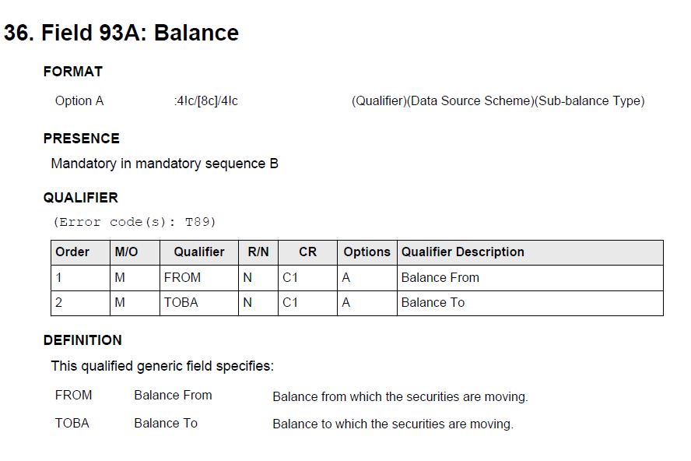
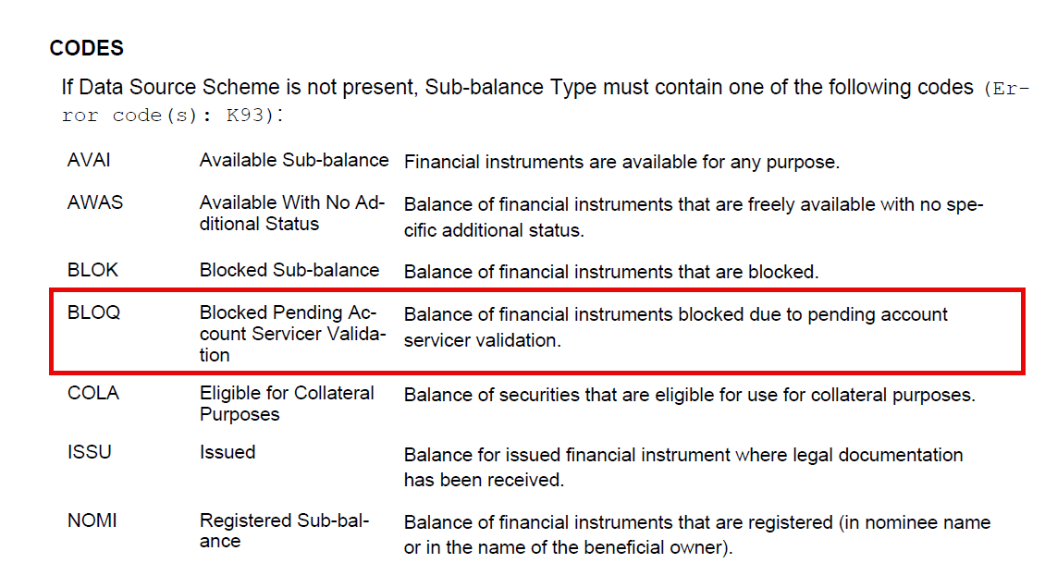

MT 535 – Statement of Holdings
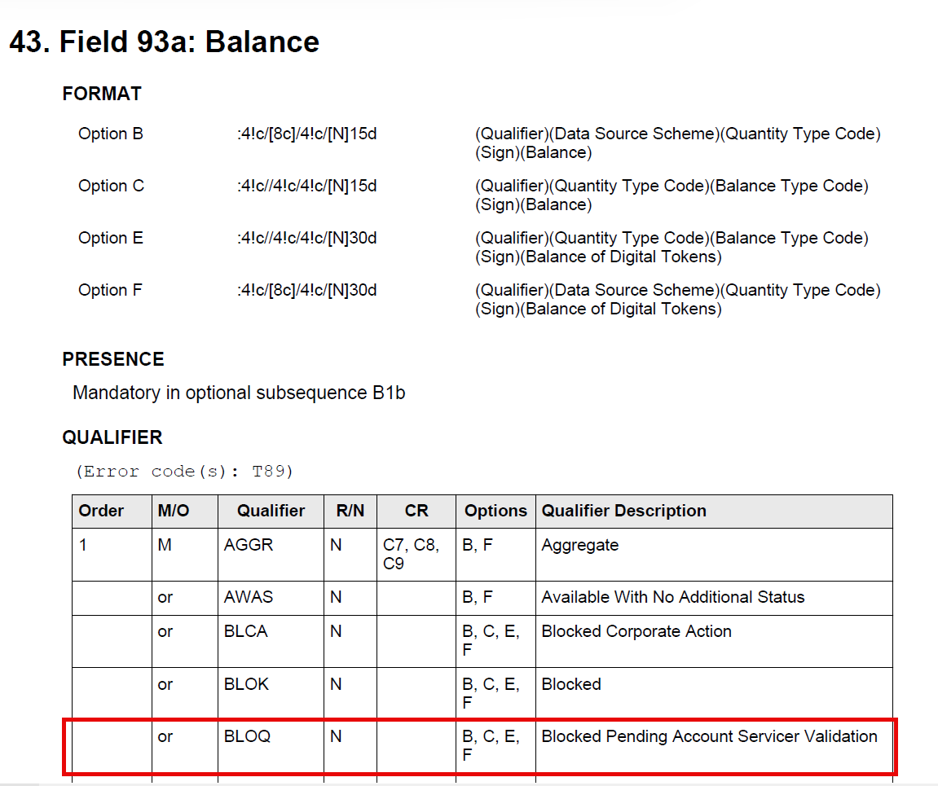
………

…….

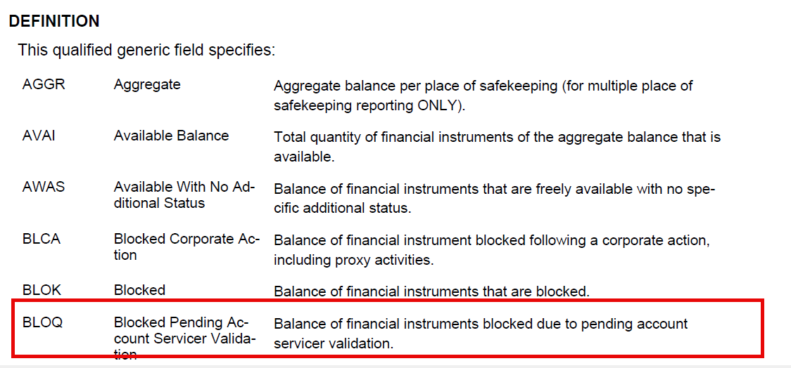

ISO 200022 Illustrations

semt.013 – Intra Position Movement Instruction

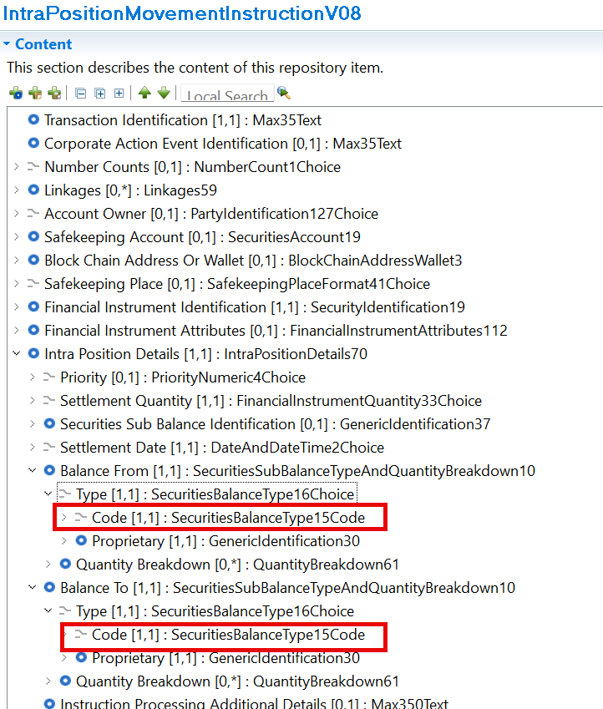

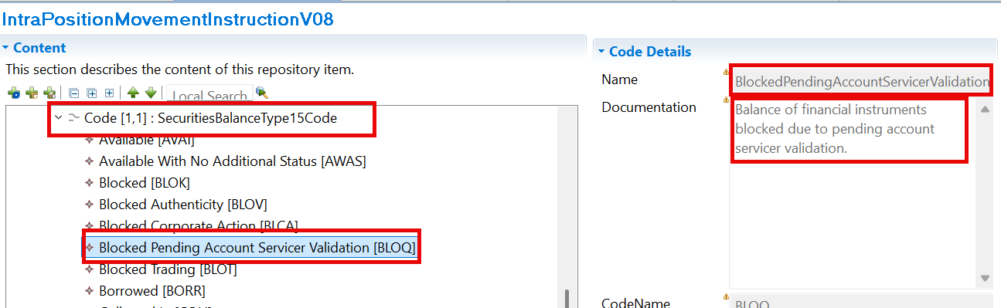

semt.002 – Securities Balance Custody Report

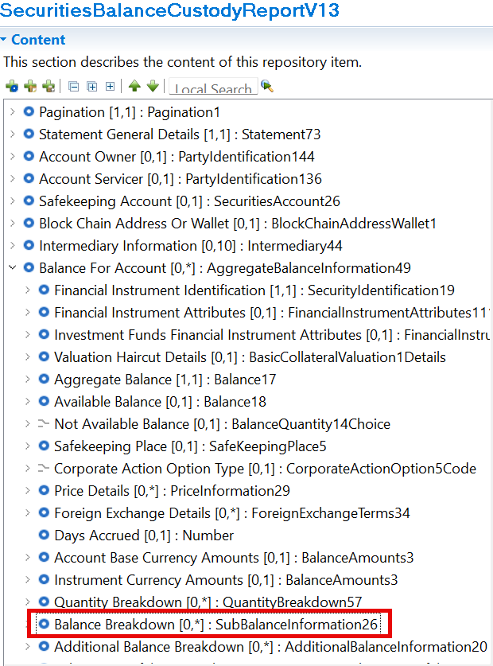
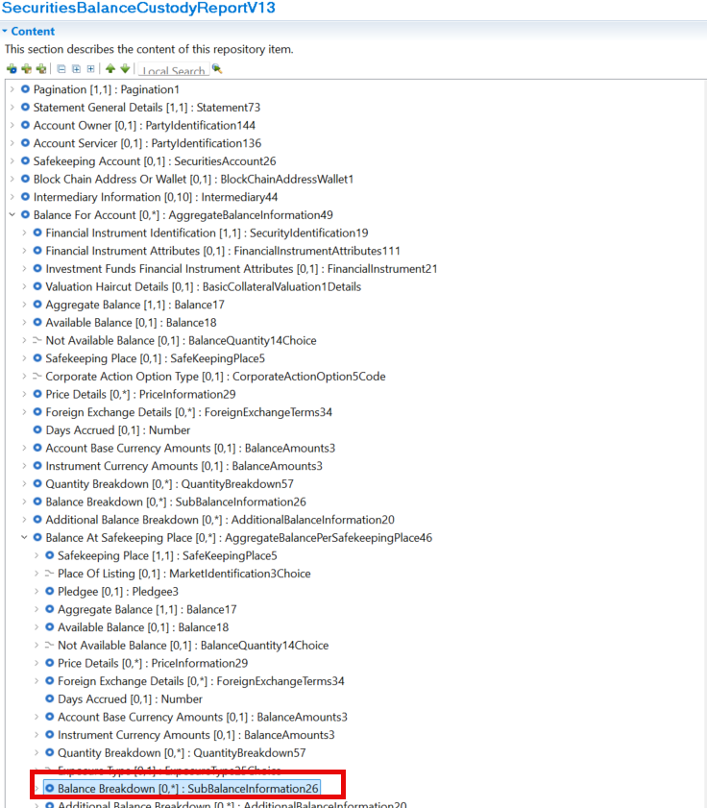

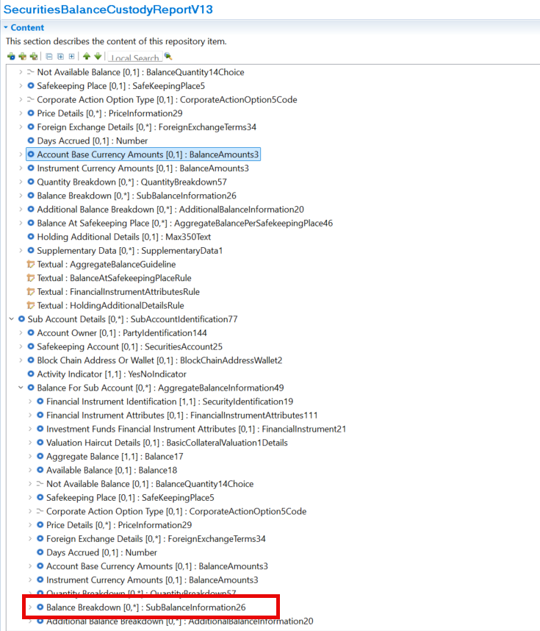

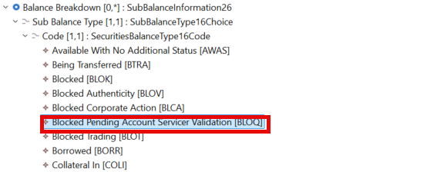
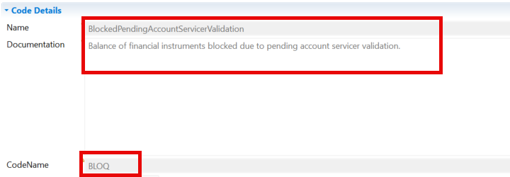

Working Group Meeting

Discussion
SWG acknowledged that digital assets introduce new operational states that are not adequately represented by existing balance codes.
A dedicated quarantine code provides better visibility and reporting accuracy.
The CR removes this ambiguity by introducing an explicit code
One point raised was the need to review and potentially refine the wording of the definition

SWG supported the creation of a dedicated quarantine balance code because:
- it addresses a genuine digital asset use case;
- it increases clarity;
- it avoids proprietary implementations;
Several participants questioned whether quarantine was an industry-wide business term or simply terminology used by a specific provider. The issue was not really that the asset was quarantined because it was a digital asset. Instead, the underlying business reason was: the account servicer has received an asset but is waiting for validation, reconciliation, or client instruction before releasing it.
- The asset is not blocked on the DLT itself.
- The asset is blocked within the account servicer's processing environment.
- Different wallets could hold the same instrument while only one position is blocked.
This led to concerns that the label "quarantine" might be too specific and potentially misleading.
Another point of disagreement was whether the code should explicitly refer to DLT or digital assets. Participants noted that the real business behaviour was broader than DLT and could potentially occur in other environments where validation is pending.
The concern was that a code named specifically around "quarantine digital assets" might become too narrow and less reusable over time.

Some participants also questioned whether existing block codes could be reused. Submitter explained that:
- Existing block indicators are already being used for multiple unrelated reasons.
- Different block situations are currently distinguished through narrative text.
- Quarantine/validation scenarios therefore cannot be identified in a structured way.

Consensus: redefine the business meaning
The discussion gradually moved away from a digital asset quarantine concept toward a more generic business status.
The most supported proposal was to describe the positions as:
"Blocked pending account servicer validation"
The reasoning was:
- It describes the actual business condition.
- It avoids dependence on DLT terminology.
- It can be understood by all markets.
- It remains valid even if future use cases are not strictly digital asset related.

Conclusion
The group ultimately accepted the change request in principle, but not with the original "quarantine digital assets" framing.
The conclusion recorded by the chair was:
- A new block balance code is justified.
- The business definition should be revised.
- Keep the new code.
- Avoid DLT-specific wording.
- This better reflects the real business reason and is more future-proof.
- The preferred direction is a definition along the lines of:

Blocked pending account servicer validation rather than a specific "quarantine digital assets" definition.
Decision
APPROVED

CR 003223: Addition of new Resolution Reason Code PATM for PATD Scenarios to qualifiers PEND and PENF in field 24B
Origin of request
Requesting Country:
Requesting Group: | SMPG Securities Market Practice Group
Sponsors
Message type(s) impacted
MT 537, MT 548, semt.018, sese.024, sese.032, sese.034, semt.018 semt.022 semt.026 semt.027, semt.044
Complies with regulation
None
Business impact of this request
LOW
Commitment to implement the change
Number of messages sent and received: 1
Percentage of messages impacted: 1
Commits to implement and when: SMPG SnR 2027
Business context
Who will benefit from the change
The entire custody chain will benefit from the change, aka, investors, global custodians, local custodians, CSDs, ICSDs, T2S.
Why is the change needed
Within settlement lifecycle messaging, the SWIFT reason code PATD (Partial Differ) is commonly used in status messages (e.g., MT548 and ISO 20022 sese.024) to indicate that a transaction may remain pending or failing due to a mismatch in partial settlement indicators between counterparties.
In all European markets where partial settlement is offered, partial settlement is only possible where both counterparties have aligned their partial settlement flags. When a discrepancy exists (e.g., one counterparty sets NPAR while their counterparty sets PART / PARC / PARQ), a PATD status is generated and the (i)CSD platform will prevent partial settlement (if trade is fully covered securities and cash and is matching, the PATD, if sent by the market*, will not prevent its settlement).
- e.g., T2S only sends the PATD as of first settlement attempt. Euroclear Bank starts sending the PATD upon matching.
Under these conditions:
- The transaction remains pending/failing.
- In multiple markets, any Partial Release request submitted is systematically rejected by the CSD/T2S, and new attempts are submitted till finally both parties align on PART.
- The industry misses a data point to provide transparency and to optimize the chances for a partial release request to be accepted and rapidly followed by a settlement confirmation.
Problem Statement:
The current issue arises once the counterparty corrects its instruction and aligns the partial settlement indicator (e.g., updates to PART).
At this stage:
- The original discrepancy is resolved at CSD platform level
- The transaction may proceed toward settlement
- However, no specific SWIFT reason code exists to indicate that the PATD condition has been resolved
As a result:
- The disappearance of the PATD status is implicit rather than explicit
- Market participants have no visibility to clearly identify that the root cause has been resolved nor when
- There is no standardised event or status reason confirming alignment of partial settlement instructions to allow the deliverer to only then triggers their partial release request.
This change will highly reduce the volume of unnecessary partial request instructions and rejection responses across the custody chain by allowing the deliverer to only trigger a partial release request if they match on the partial settlement indicator with the receiver. On top of reducing the unnecessary noise, it will significantly reduce the increase of messaging, system and operational costs linked to partial settlement.
Partial release request volumes will increase with October 2027 T1 in Europe, as the EEA regulators are mandating their CSDs to support it and encouraging industry usage to protect and increase the liquidity by reducing the fails (including the CSDR cash penalties) as the settlement cycle further reduces.

Nature of change
It is proposed to introduce a new SWIFT status reason code with the following characteristics:
Value (short code) Reason Code Description Reason Code Definition
PATM Partial Match Resolution of disagreement on partial indicator preventing partial settlement.
Description Field
Status of the Instruction ::25D::SETT//PEND(PENF)
Partial Indicator Match ::24B::PEND(PENF)//PATM
The PATM should only be provided in case there was initially a discrepancy reported via the PATD. aka, if both counterparties initial instructions match on the STCO PART/NPAR field, no PATM reason code should apply. If later, one counterparty adjusts its STCO PART/NPART, a PATD should be sent and once it is resolved a PATM should be sent. The same logic should be repeated in case later the STCO PART/NPART is amended again by one of the counterparties.

Examples

Workaround

Standards Illustration

ISO 15022 illustrations

MT 548 – Settlement Status and Processing Advice

- Field 16R: Start of Block

FORMAT
Option R 16c

PRESENCE

Mandatory in optional subsequence A2a

DEFINITION

This field specifies the start of a block and the name of that block.

CODES

This field must contain the following code (Error code(s): T92):
REAS Reason

- Field 24B: Reason Code

FORMAT
Option B :4!c/[8c]/4!c (Qualifier)(Data Source Scheme)(Reason Code)

PRESENCE

Mandatory (referenced in rule C6) in optional subsequence A2a

QUALIFIER

(Error code(s): T89)

Order | M/O | Qualifier | R/N | CR | Options | Qualifier Description
1 | M | CAND | N | C6 | B | Cancellation Reason
 | or | CANP | N | C6 | B | Pending Cancellation Reason
…
 | or | PEND | N | C6 | B | Pending Reason
 | or | PENF | N | C6 | B | Pending/Failing Reason
 | or | REPR | N | C6 | B | Repair Reason

DEFINITION

This qualified generic field specifies:

CACK Repo Call Acknowl-edgement Reason
…
Specifies additional information on the repo call request acknowl-edgement.

PEND Pending Reason Specifies the reason why the instruction has a pending status.

PENF Pending/Failing Rea-son

…

CODES

If Qualifier is PEND and Data Source Scheme is not present, Reason Code must contain one of the following codes (Error code(s): K24):

ADEA Account Servicer Deadline Missed

Instruction was received after the account servicer's deadline. It will be managed as per the bilateral service agreement between the ac-count servicer and account owner.

AWMO Awaiting Money Financial instruments are delivered, but still awaiting money from the
counterparty.

…

PATA Partial Settlement Agreement

PART Trade Settles in Parti-als

Resolution of disagreement on the partial settlement indicator.

Trade will settle in partials.

…

CODES

If Qualifier is PENF and Data Source Scheme is not present, Reason Code must contain one of the following codes (Error code(s): K24):

ADEA Account Servicer Deadline Missed

Instruction was received after the account servicer's deadline. Processed on best effort basis.

AWMO Awaiting Money Financial instruments are delivered, but still awaiting money from the
counterparty.

…

PATA Partial Settlement Agreement

PART Trade Settles in Parti-als

Resolution of disagreement on the partial settlement indicator.

Trade will settle in partials.

AWMO Awaiting Money Financial instruments are delivered, but still awaiting money from the
counterparty.

ISO 20022 illustrations

sese.024 – Securities Settlement Transaction Status Advice

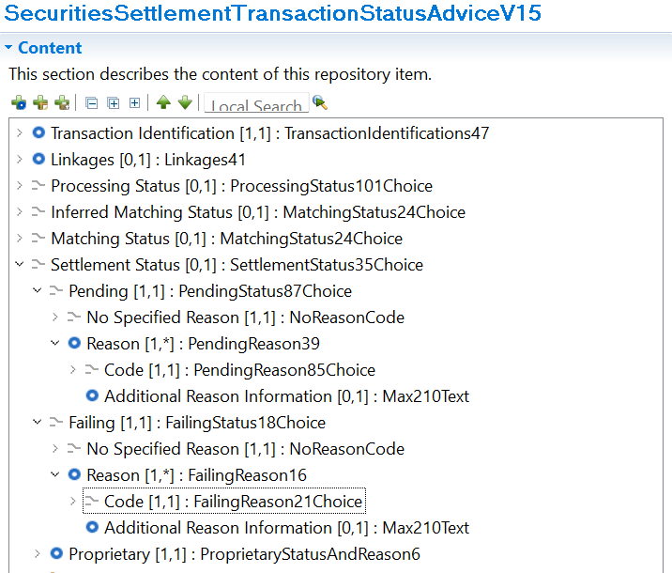

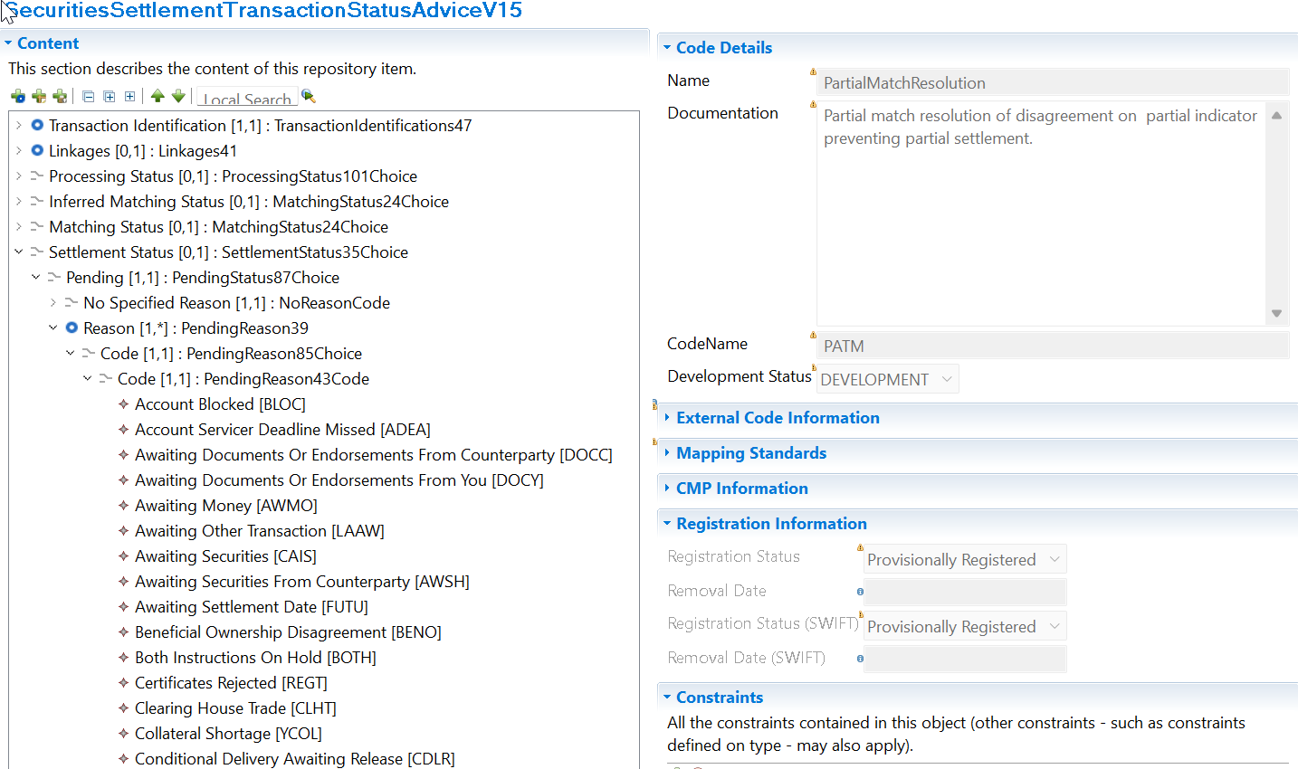

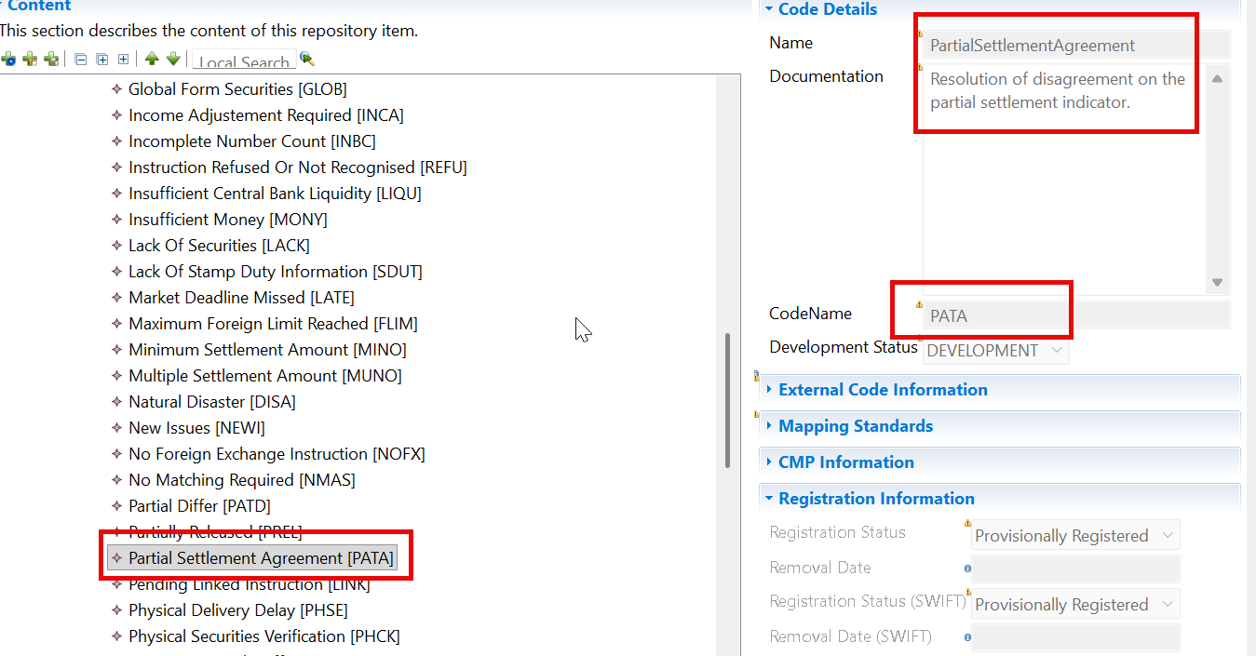

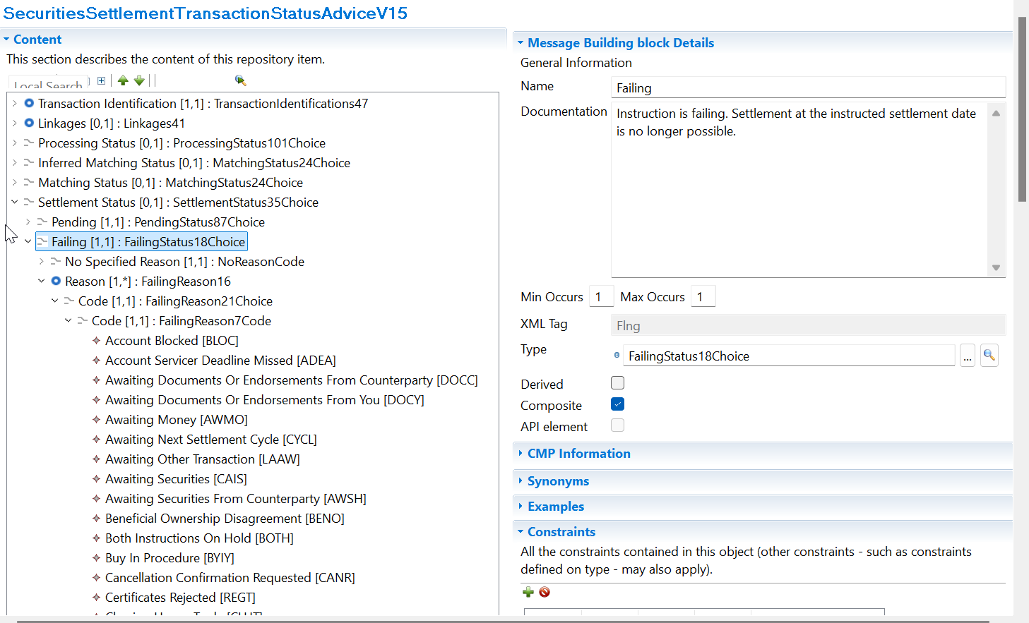

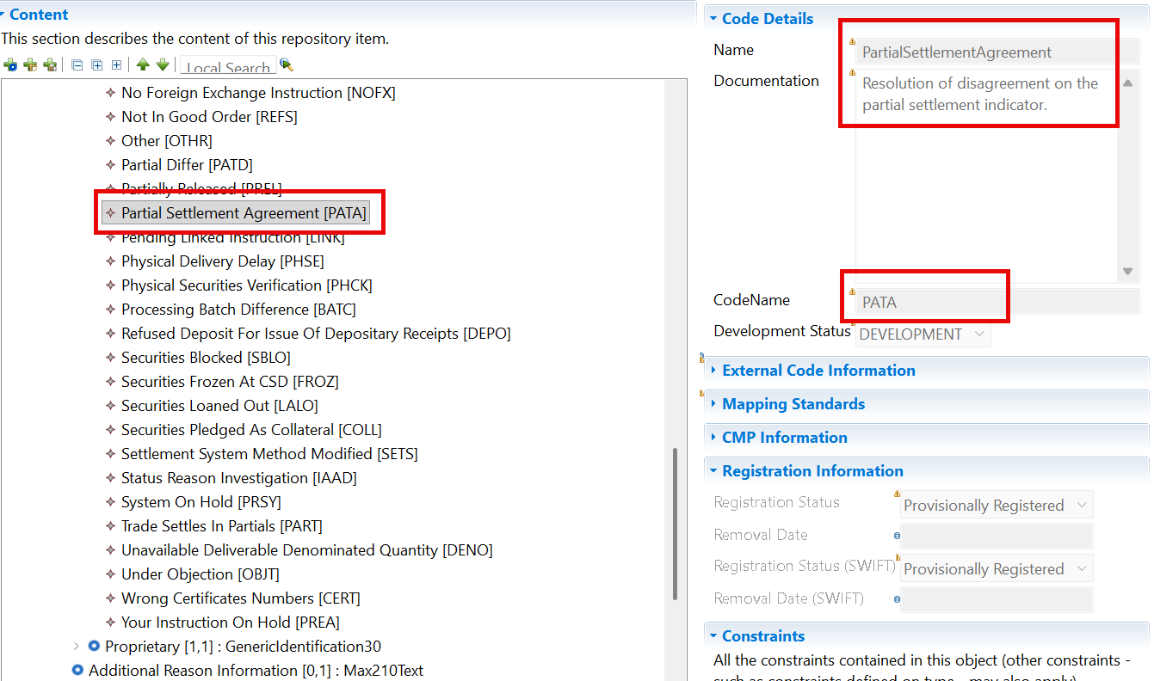

SWIFT Comment

Working Group Meeting

Discussion
The SWG concluded that there is a genuine gap in the standards because PATD can be reported but its resolution cannot. The new code should therefore be introduced to indicate that counterparties have resolved the disagreement on the partial settlement indicator and that the transaction can continue normally. The exact wording of the definition will be refined as the SWG wants to avoid describing the situation as a "match" and rather refer to “agreement”. However, the underlying business requirement was accepted unanimously.
SWG approved the following definition: “Resolution of disagreement on the partial settlement indicator”. The code used will be PATA – Partial Settlement Agreement
The Partial Settlement market practice will have to be updated accordingly to cater for this new reason code and business process.
Decision
APPROVED

CR 003229: Reporting of instructions eligible to the gating event
Origin of request
Requesting Country: | United Kingdom
Requesting Group:
Sponsors
Message type(s) impacted
MT 537, MT 548, semt.018, semt.022, sese.024, semt.027
Complies with regulation
None
Business impact of this request
MEDIUM
Commitment to implement the change
Number of messages sent and received: 1000000
Percentage of messages impacted: 5
Commits to implement and when: SMPG, ICSDs and T2S in 2027
Business context
The transition to T+1 settlement in Europe, effective 11 October 2027, introduces significant operational challenges for Securities Financing Transactions (SFTs), in particular bilateral repo activity. Industry analysis indicates a substantial increase in late-day T+0 settlement traffic, including repo roll transactions where the closing leg settles before the opening leg of the new repo is instructed. This dynamic removes the ability to synchronise settlement flows under current processes.
In the absence of an automated solution, market participants would be required to manually delay large volumes of closing-leg instructions until the corresponding opening legs-and potentially related cash transactions-are received. Such a manual approach is operationally unfeasible in light of the expected increase in volumes and would introduce significant operational risk. Failure to ensure synchronised settlement would lead to increased gross funding requirements, heightened liquidity risk, and a higher likelihood of settlement fails, thereby undermining market stability during and beyond the T+1 transition.
To address this, the industry-through SMPG and SWIFT initiatives-has introduced a gating event mechanism supported by new identifiers, namely the ISO 15022 code (:22F::STCO//GATE) and the equivalent ISO 20022 settlement transaction condition (GATE). This mechanism enables participants to flag instructions for inclusion in a coordinated settlement window, effectively acting as an 'automatic hold and release' process to support synchronised settlement and liquidity optimisation.
However, while the introduction of the GATE indicator enables identification of instructions intended for the gating process, no standardised approach currently exists to inform participants, via settlement status messaging (e.g. MT548), whether an instruction is effectively subject to a gating event and pending release. This creates a transparency gap for market participants, who are not able to clearly distinguish between instructions delayed due to standard settlement conditions and those intentionally held as part of the gating event.
This lack of visibility is particularly critical given that participation in the gating event is unilateral and determined on a trade-by-trade basis. Without appropriate status reporting, counterparties may not be aware of the settlement eligibility and expected behaviour of instructions, potentially leading to misinterpretation, operational inefficiencies, and increased risk during the T+1 settlement cycle.
Nature of change
This change introduces a standardised approach for reporting the applicability of the gating event through settlement status messaging (MT548), by leveraging the existing PEND (Pending) status code framework and extending it with dedicated status reason codes.
Under this proposal, instructions identified as being subject to the gating event will be reported using the PEND status, indicating that the instruction is pending settlement due to its participation in a coordinated settlement mechanism. Additional granularity will be provided through the introduction of three new status reason codes, allowing participants to clearly identify the origin of the gating event instruction in a manner consistent with existing HOLD and release logic (e.g. PREA, PRCY, BOTH).
The following status reason codes are introduced:
GATE: Indicates that the instruction is pending due to gating event eligibility initiated by the instructing party
GATC: Indicates that the instruction is pending due to gating event eligibility initiated by the counterparty
GATB: Indicates that the instruction is pending due to gating event eligibility initiated by both parties
This approach ensures alignment with existing market practices by reusing the established pending status model, while providing enhanced transparency on the application of the gating event.
By distinguishing the origin of the gating instruction, the proposed enhancement enables market participants to better understand the settlement status of their transactions, reduces ambiguity in bilateral reconciliation, and supports consistent operational handling in a T+1 environment where gating participation is optional and may be applied unilaterally.
Examples

Workaround

Use of proprietary code with DSS.

Standards Illustration

ISO 15022 illustrations

MT 548 – Settlement Status and Processing Advice

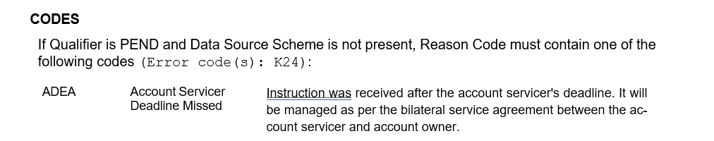

…

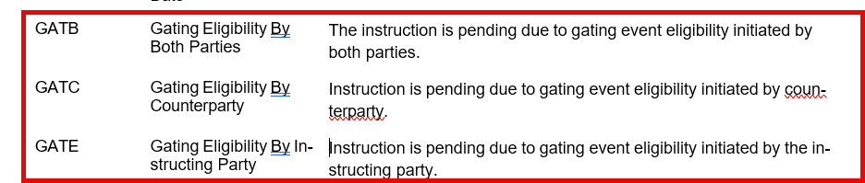

ISO 20022 illustrations

sese.024 – Securities Settlement Transaction Status Advice

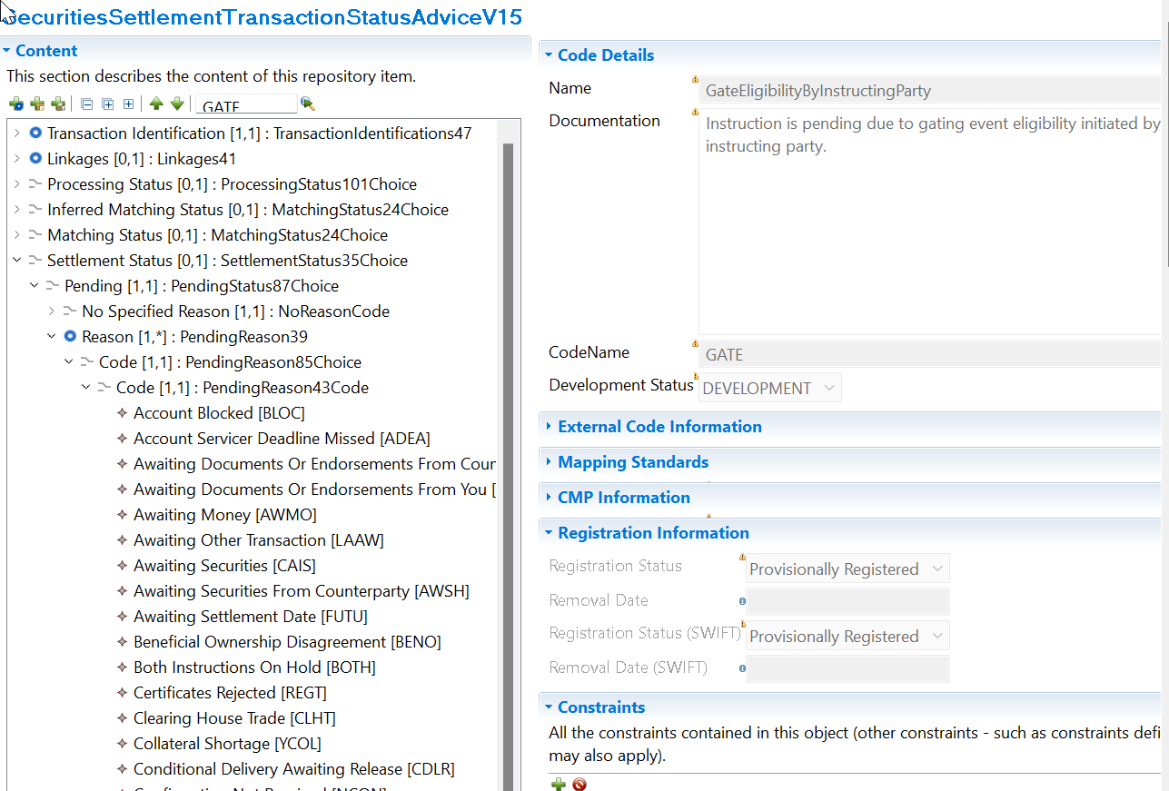

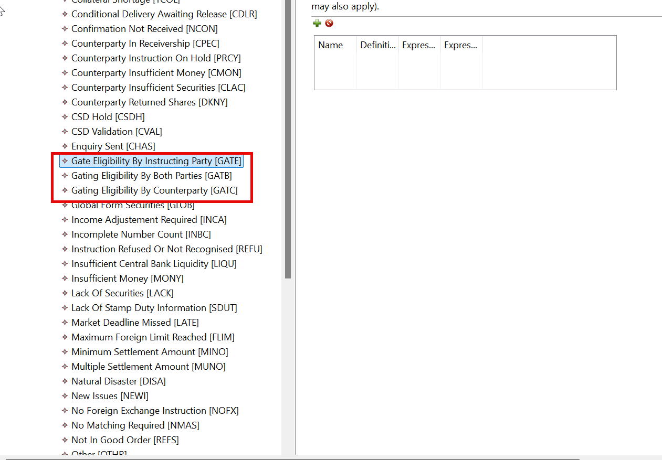

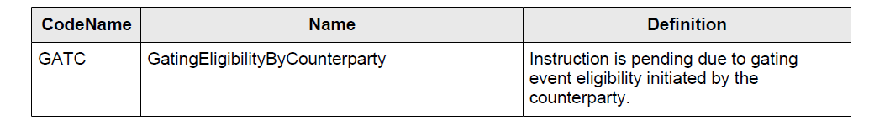
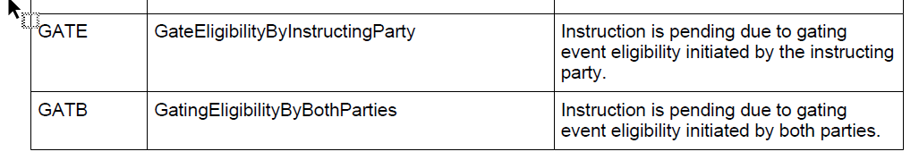

SWIFT Comment

Standards Working Group Meeting

Discussion
The SWG considered that the market already needed a gating-event mechanism to support the European T+1 operating model. Once that mechanism exists, participants also need visibility when instructions are being held in the gating process. The change request therefore closes a reporting gap by introducing standard status reason codes that clearly explain why an instruction remains pending. The proposal was viewed as operationally useful, aligned with existing status-reporting principles, and supportive of T+1 liquidity-management objectives.

Decision
APPROVED

CR 003239: Add Corporate Action Event Type Indicator to the Settlement Confirmation Messages

Origin of request
Requesting Country: | Securities Market Practice Group ( SMPG)
Requesting Group:
Sponsors
Message type(s) impacted
MT 544, MT 545, MT 546, MT 547, sese.025, sese.026
Complies with regulation
None
Business impact of this request
LOW
Commitment to implement the change
Number of messages sent and received: 1
Percentage of messages impacted: 1
Commits to implement and when: SMPG 2027
Business context
The MT536 and semt.017 statements of transactions contain a Corporate Action Event Type Indicator but the MT544-7 and sese.025 settlement confirmation messages, that lead to the creation of the MT536 / semt.017, do not.
Nature of change
Add the Corporate Action Event Type Indicator to the MT544-7 and sese.025 settlement confirmation messages.
Examples

Workaround

Use of Settlement Instruction Processing Additional Details in Trade Details.

Standards Illustration

ISO 15022 illustrations

MT 547 – Delivery Against Payment Confirmation

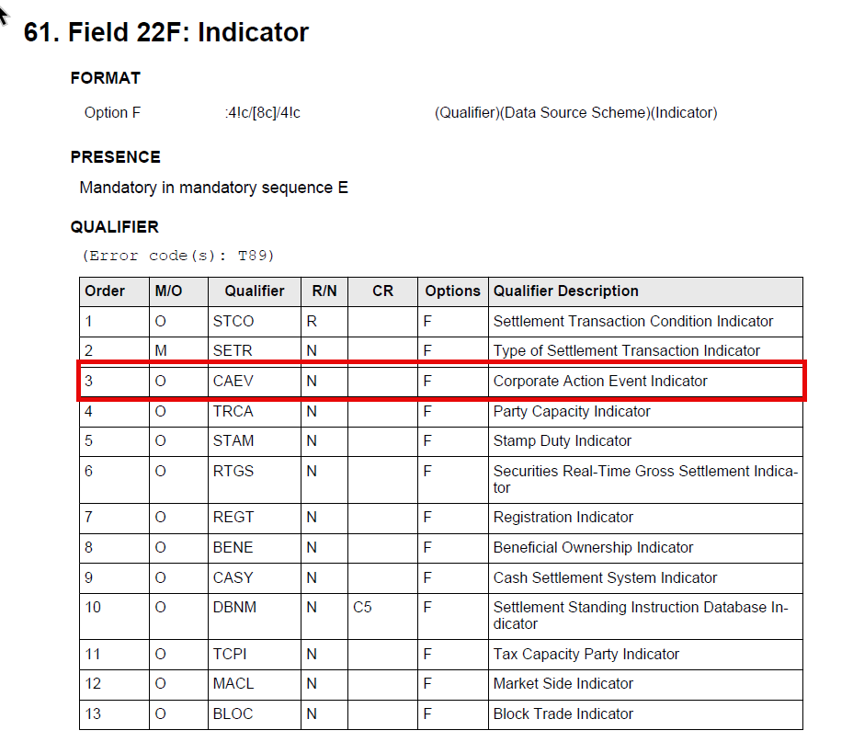
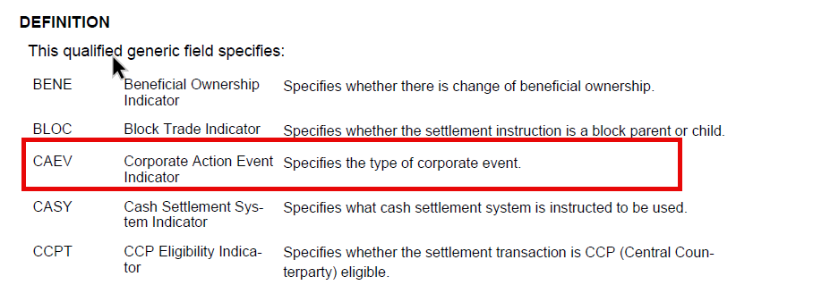

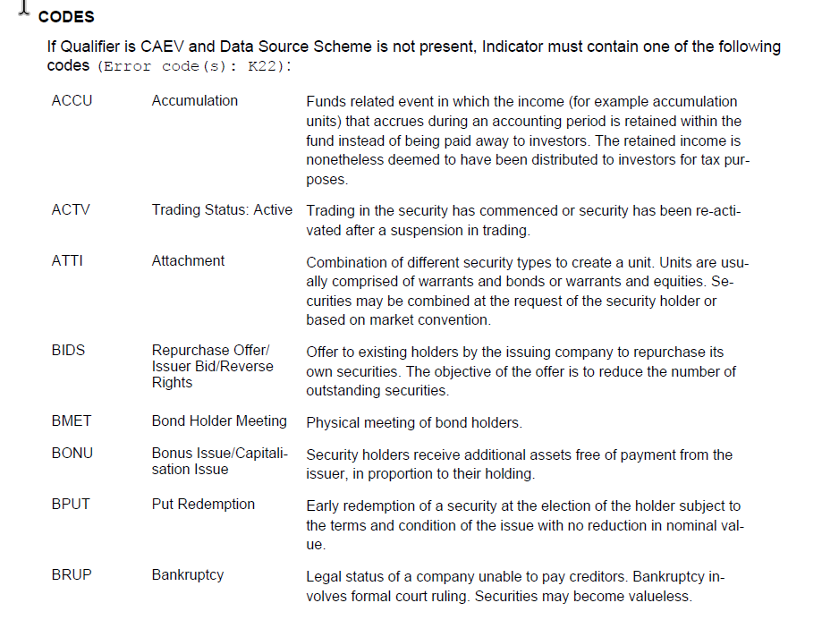
…..

ISO 20022 illustrations

sese.025 – Securities Settlement Transaction Confirmation

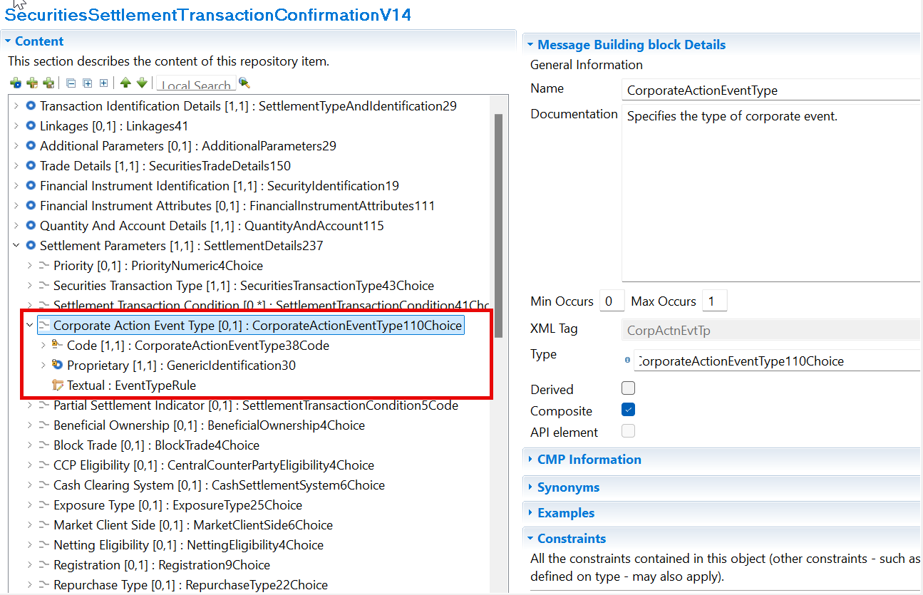

SWIFT Comment

The location of the Corporate Action Event Type must be confirmed.

Standards Working Group Meeting

Discussion
The proposal aimed to add the Corporate Action Event Type indicator to settlement confirmations because it already exists in transaction statements.
Corporate Action experts challenged the underlying assumption, explaining that many Corporate Action movements are generated directly from Corporate Action processing and not from settlement confirmations. They further argued that transaction statements aggregate information from multiple sources and therefore cannot be used as a justification for extending settlement confirmations. The group concluded that no clear functional gap or operational problem had been demonstrated.
Why CA experts were against:
- Incorrect assumption that confirmations are the source of CA information.
- Risk of duplicating Corporate Action information across flows.
- Potential impact and confusion in Corporate Action processing.
- No proven business benefit

The submitter acknowledged the concerns and agreed to withdraw the request.

Decision
WITHDRAWN

CR 003241: Gating event modification via MT530/sese.030

Origin of request
Requesting Country:
Requesting Group: | Securities Market Practice Group (SMPG)
Sponsors
Message type(s) impacted
MT 530, sese.030
Complies with regulation
None
Business impact of this request
MEDIUM
Commitment to implement the change
Number of messages sent and received: 10000
Percentage of messages impacted: 5
Commits to implement and when: ICMA members 2027
Business context
The current MT530 does not allow clients to add or remove a gating event on an existing settlement instruction, limiting their ability to adapt to evolving post-trade conditions. This constraint forces clients to cancel and reinstruct instructions, increasing operational risk and inefficiency. Enhancing MT530 to support gating event modification would provide greater flexibility and improve Straight Through Processing.
Nature of change
The proposed change consists of enhancing the MT530 functionality to allow clients to modify the presence of a gating event on an existing settlement instruction. The approach is to leverage the existing MT530 modification framework, in line with the current hold and release mechanism already supported. Today, clients can control the settlement process by sending an MT530 with the settlement indicator 22F::SETT using codes YPRE (release) or NPRE (hold), which respectively release or block an instruction.
Building on this existing logic, the enhancement would introduce a similar usage pattern for gating events. Clients would be able to send an MT530 to either add or remove a gating event using clearly defined indicator values, ensuring consistency with current market practices. As with other MT530 modifications, each message would trigger a single change on the instruction, maintaining the current design principle
This approach avoids the need for instruction cancellation and re-creation, while providing a simple, intuitive, and harmonised way to manage gating events dynamically. It also ensures that clients can benefit from a familiar mechanism, reducing implementation complexity and supporting seamless integration into existing workflows.
Here is the proposal
YGAT -> Gating event enabled / present on the instruction
NGAT -> Gating event disabled / not present on the instruction
Examples

Workaround

Use of the Other Processing Indicator in Request Details with proprietary codes.

Standards Illustration

ISO 15022 illustrations

MT 530 – Transaction Processing Command

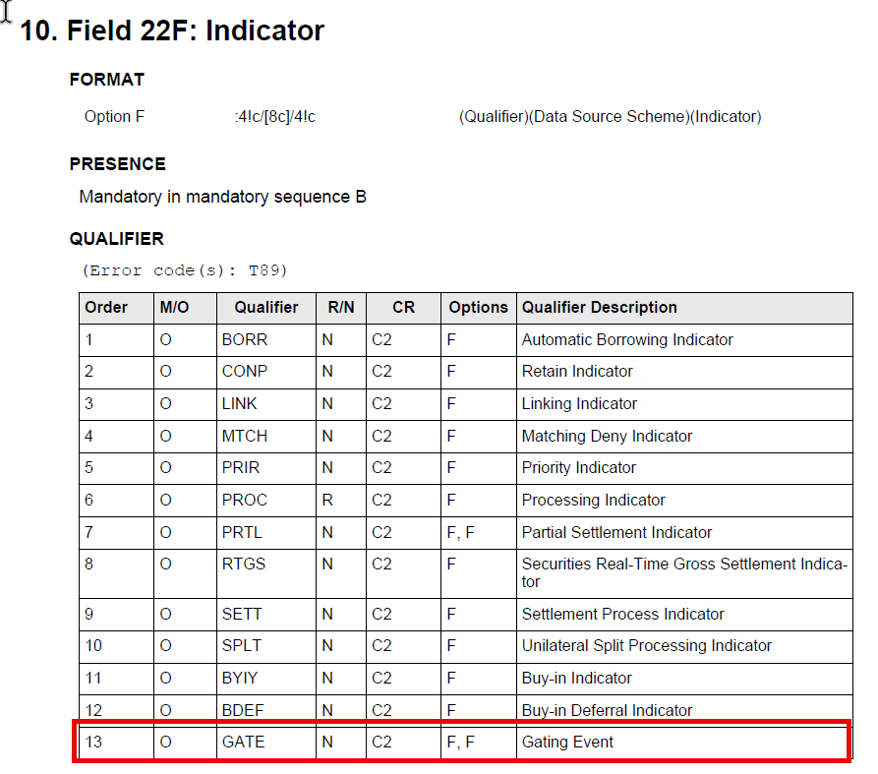

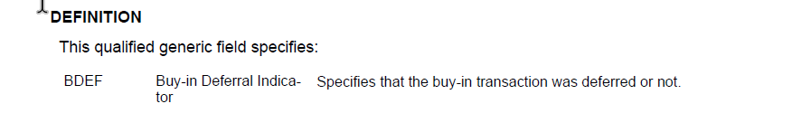
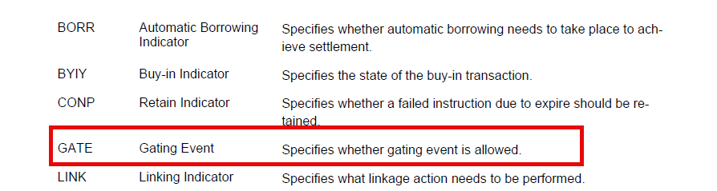

CODES
If Qualifier GATE and Data Source Scheme is not present, Indicator must contain one of the following codes (Error code(s): K22):

YGAT | Gating Event | Gating event enabled.
NGAT | No Gating Event | Gating event disabled.

ISO 20022 illustrations

sese.030 – Securities Settlement Conditions Modification Request

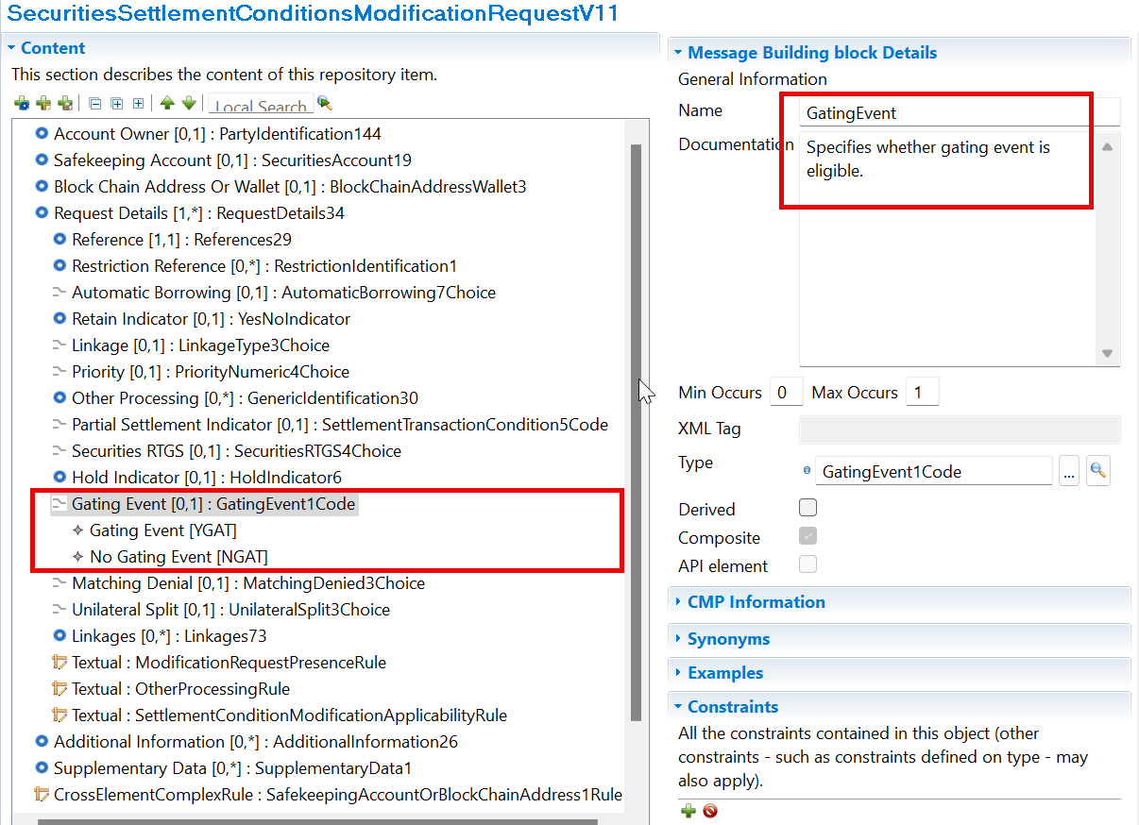

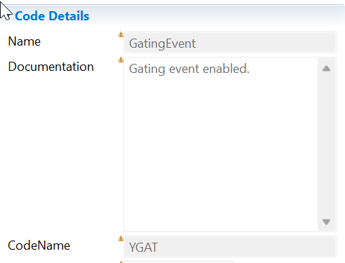

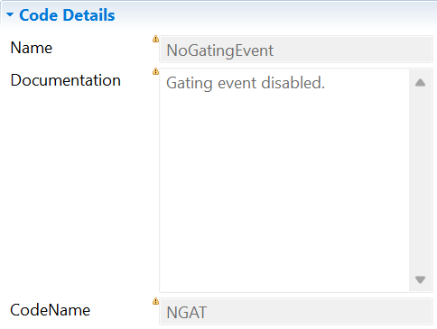

SWIFT Comment

Standards Working Group Meeting

Discussion
The SWG acknowledges the European Banking Federation and the EU T+1 Industry Committee concerns.
“Even though the proposed change is consistent with the Securities Financing Transactions Workstream Optimisation Task Force where the ability to amend the indicator is identified as a desirable flag management tool, some concerns were about the safe delivery of this change in the time available, and hence about whether it should be treated as a priority for the November 2027 release.
Points raised:
(i) Cost and complexity. Introducing this change carries additional cost and complexity, in particular for CSDs.
(ii) Uncertain usage. In the absence of a cost-benefit analysis, the concrete adoption and usage rate of the functionality remains uncertain. The principal use case appears to be remedial: a party that has instructed with the GATE indicator by mistake and wishes to correct it. For the party "receiving" the GATE flag, by contrast, the flag would not be visible before the start of the settlement window, and in practice there may be no time to act on it.
(iii) Consequences for the settlement instruction lifecycle. Most importantly, it was flagged that supporting the safe implementation of this functionality entails considering potentially significant consequences for the lifecycle of the instruction. By way of example, a unilateral change to the status of the flag by either party could alter the priority level at which the instruction would otherwise have settled, with knock-on effects on other instructions – including instructions marked as top priority, such as lending recalls and other SFT instructions.”

The consensus was therefore that this additional functionality should only be considered after real market usage has been observed, even if this means that temporary workarounds will need to be used until a standard solution is implemented in a future release, should a genuine business need emerge following the T+1 implementation in October 2027.

The sponsor therefore agreed to withdraw the CR and revisit it in a future release if market demand is proven.

Decision
WITHDRAWN

Overview of User Change requests ISO20022

CR 003258: Reinstate NCON Pending Confirmation code (ISO 20022 CR 1602)
Origin of request
Requesting Country:
Requesting Group: | ASX CHESS (Clearing House Electronic Subregister System)
Sponsors
A.1 Submitter: ASX – CHESS (Clearing House Electronic Subregister System)
Australian Securities Exchange (ASX)
39 Martin Place
Sydney NSW 2000
A.2 Contact person: Priscilla Ferri de Barros; priscilla.ferridebarros@asx.com.au;
+ 61 (02) 9227 0543
A.3 Sponsors:
Message type(s) impacted
Securities Management
semt.014 - Intra Position Movement Status Advice
semt.025 – Securities Account Position Query
camt.067 - Intra Balance Movement Status Advice (NCON still included as SR 2026 CR 3149 Removal of reason codes in the intra-position movement status not yet implemented in the message)
camt.079 - Intra Balance Movement Query Response (NCON still included as SR 2026 CR 3149 not yet implemented in the message)
camt.085 - Intra Balance Movement Pending Report (NCON still included as SR 2026 CR 3149 not yet implemented in the message).
Complies with regulation
None
Business impact of this request
Low
Commitment to implement the change
Number of messages sent and received: 1
Percentage of messages impacted: 1
Commits to implement and when: ASX- CHESS in 2027
Business context
The Australian Securities Exchange (ASX) has initiated a project to replace the current Australian equities clearing and settlement market infrastructure system (CHESS).
CHESS (Clearing House Electronic Subregister System) is the system operated by ASX to manage the clearing and settlement of equity market transactions, and to record current security holdings (and the holders) on a name on a register basis. The implementation of the replacement system will provide the existing core functionality and services as well as service enhancements. The current proprietary CHESS messaging standards will be replaced with ISO 20022 standards.
The purpose of this Change Request is to fully align the ISO messages used in CHESS to avoid using supplementary data for required elements
Nature of change
re-introduce the code NCON (Pending Confirmation)
There is one code, however, that ASX would like to reinstate: NCON
This change is required to support collateral management scenarios, specifically intra position movements initiated by a Controlling Participant (Settlement Participant or Custodian) in the CSD. When a Controlling Participant submits an intra position movement request in the CSD, if the Clearing Member is different from the Controlling Participant, the Clearing Member must also provide approval. Additionally, the CSD must obtain approval from ASX Clear (CCP) within the collateral management system.
During this approval phase, the transaction is neither accepted nor rejected; it is awaiting confirmation from one or more external parties. In this scenario, the correct ISO 20022 status is Pending Confirmation (NCON), and semt.014 is the appropriate message to communicate this state. If NCON is retained, no additional message changes or workarounds are required, which aligns with standard clearing and collateral workflows and helps avoid unnecessary future updates.

Examples

Workaround

Balance NCON as proprietary code.

Standards Illustration

ISO20022 Illustration

semt.014 – Intra-Position Movement Status Advice

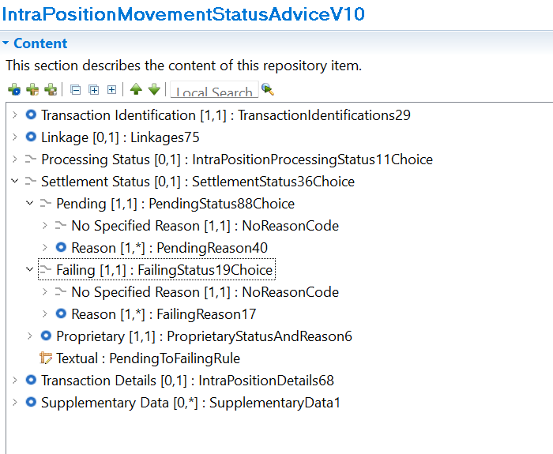

Settlement Pending Reason

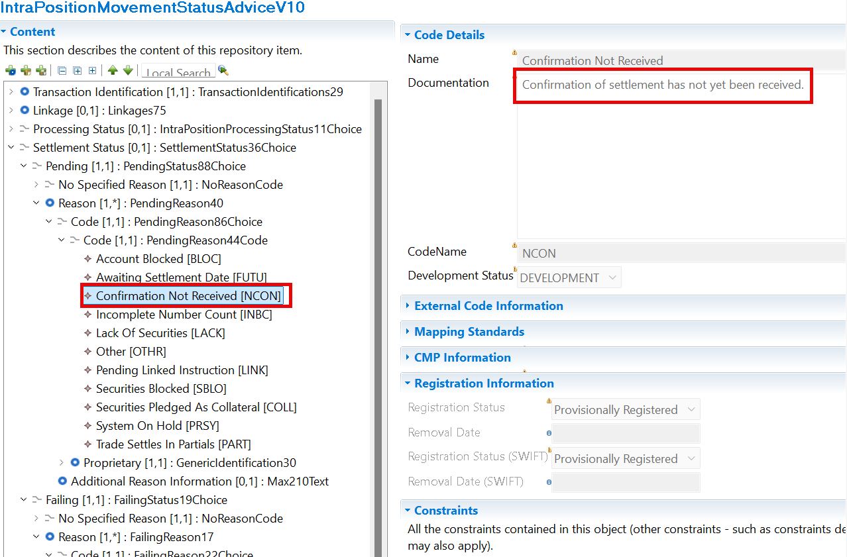
Settlement Failing Reason

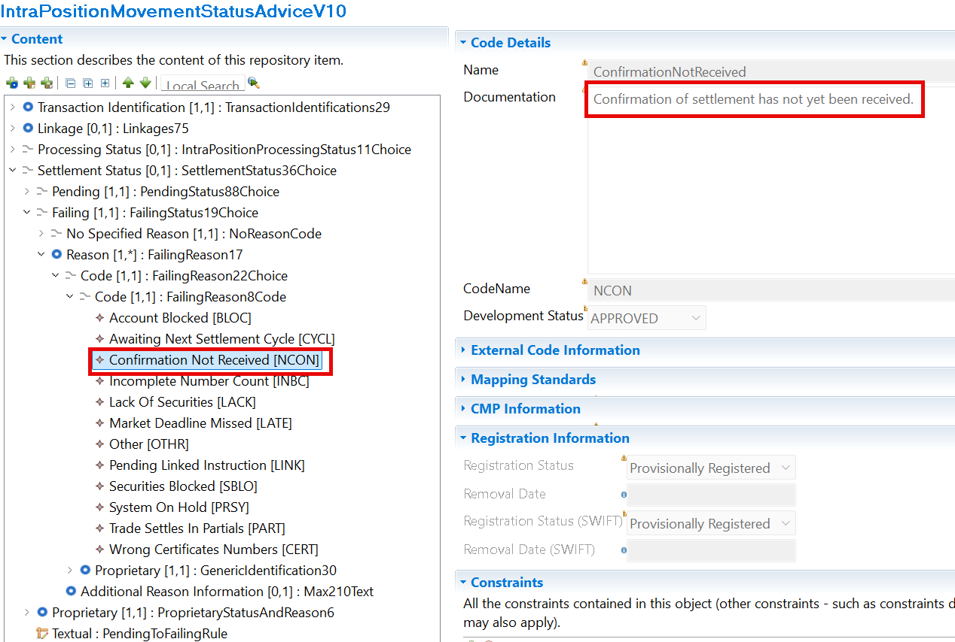

SWIFT Comment

Working Group Meeting

Discussion
This CR originated from the ASX/CHESS migration project. Following a previous ISO 20022 cleanup exercise, the code NCON (Pending Confirmation) had been removed, but ASX identified that it remains necessary for collateral management and intra-position movement scenarios. The discussion was very straightforward and generated no objections from participants. The group acknowledged that reinstating the code was effectively correcting an earlier removal rather than introducing a new business concept. The impact on multiple messages, including T2S-related messages, was recognised but considered manageable. Participants noted that the change would restore an existing business capability required to represent situations where a transaction is awaiting approval from external parties and is neither accepted nor rejected.
The SWG considered the business case valid and uncontroversial. The reinstatement of NCON was viewed as necessary to support collateral management workflows and to avoid proprietary workarounds.
Decision
APPROVED

CR 003263: Align From and To Balance code lists in semt.014 to semt.013 and semt.15 (ISO 20022 CR 1615)
Origin of request
Requesting Country:
Requesting Group: | UK NMPG
Sponsors
A.1 Submitter: UK NMPG
A.2 Contact person:
- Robin Leary; robin.leary@citi.com
A.3 Sponsors: SMPG
semt.014 – Intra Position Movement Status Advice
Complies with regulation
None
Business impact of this request
Low
Commitment to implement the change
Number of messages sent and received: 1
Percentage of messages impacted: 1
Commits to implement and when: SMPG
Business context
The From and To Balance element code list in the semt.014 does not align to the semt.013 and semt.015. The semt.014 therefore cannot be used to provide an update on all semt.013 intra-position movement requests
Nature of change
Update the From and To Balance element code list in the semt.014 to align with the semt.013 and semt.015
Examples

Workaround

Balance as proprietary codes.

Standards Illustration

ISO20022 Illustration

semt.013 - Intra-Position Movement Instruction

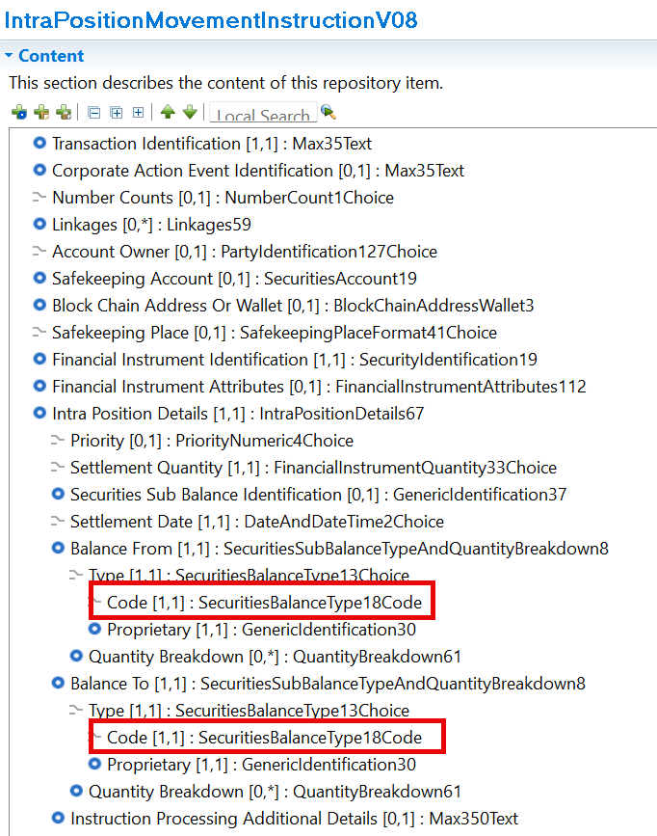

semt.014 – Intra-Position Movement Status Advice

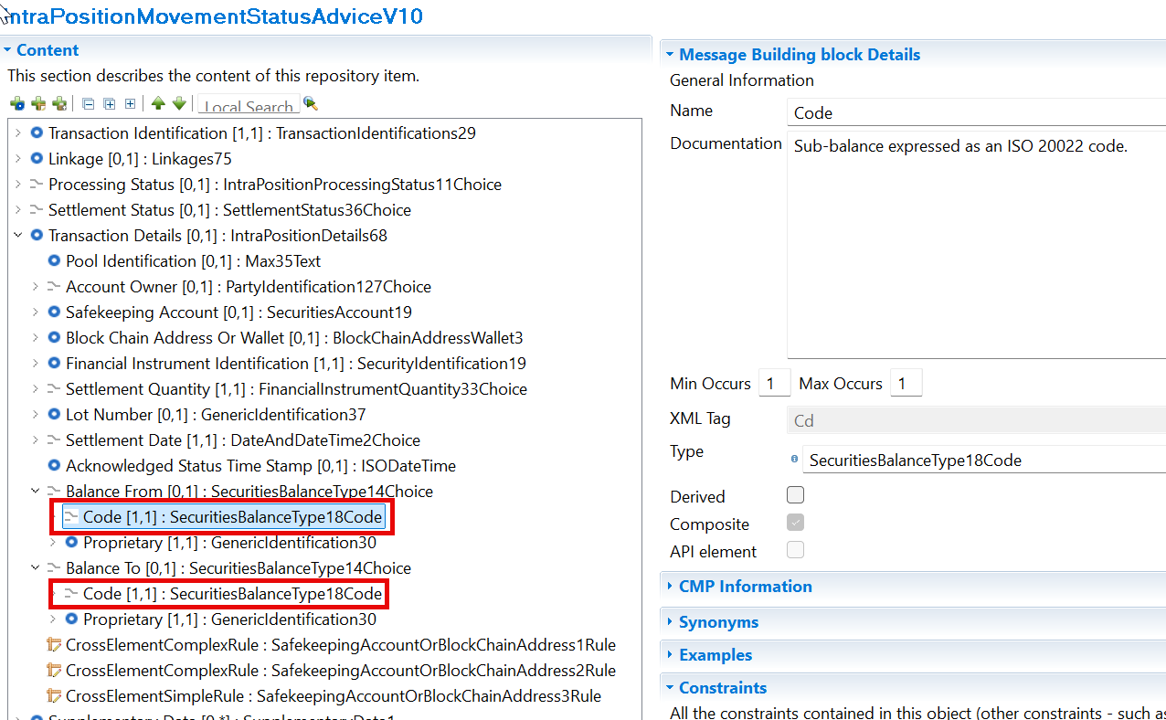

semt.015 – Intra-Position Movement Confirmation

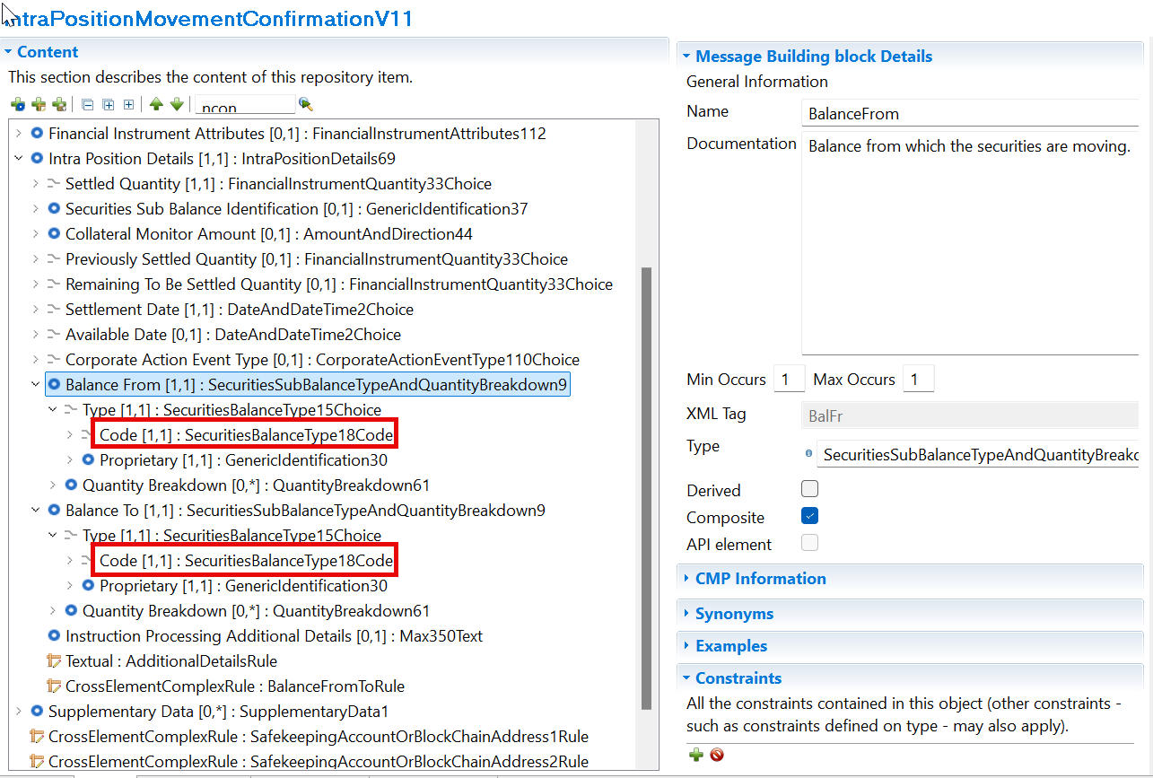

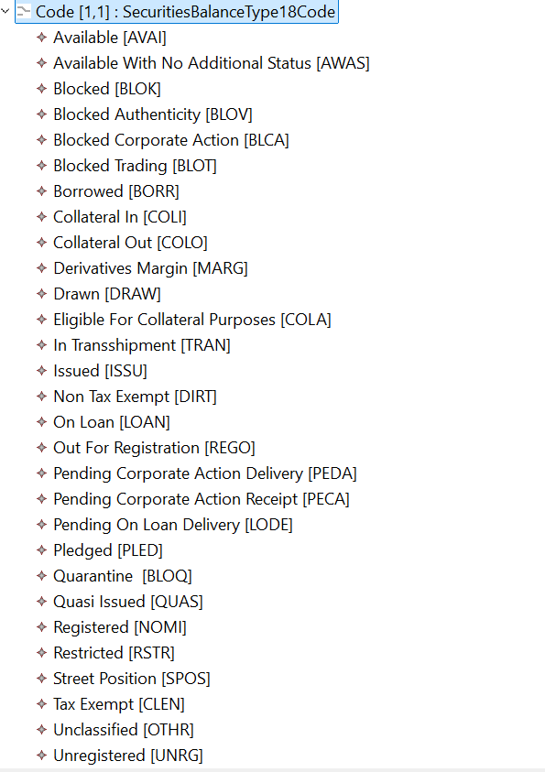

SWIFT Comment

Use of the Settlement Transaction Condition indicator with proprietary codes.

Working Group Meeting

Discussion
This CR was described as a consistency and maintenance improvement rather than a new business requirement. Citi, while performing MT/MX mapping reviews, identified that the Balance From and Balance To code lists were not aligned between:
- semt.013 (Instruction)
- semt.014 (Status)
- semt.015 (Confirmation)
The discussion highlighted that the same business concept was represented differently across the three messages, creating unnecessary mapping and translation issues. The proposal was therefore to standardise the messages by using the most complete balance code list across all three message definitions. Participants considered this logical because the balance information is core data and should remain consistent throughout the instruction, status and confirmation lifecycle.
Decision
APPROVED

CR 003264: Add Exposure Type to Balance Breakdown in semt.002 and semt.003 (ISO 20022 CR 1614)
Origin of request
Requesting Country:
Requesting Group: | UK NMPG
Sponsors
A.1 Submitter: UK NMPG
A.2 Contact person:
- Robin Leary; robin.leary@citi.com
A.3 Sponsors: SMPG
semt.002 – SecuritiesBalanceCustodyReport
semt.003 - SecuritiesBalanceAccountingReport
Complies with regulation
None
Business impact of this request
MEDIUM
Commitment to implement the change
Number of messages sent and received: 1
Percentage of messages impacted: 1
Commits to implement and when: SMPG - 2027
Business context
The Exposure Type indicator field is present in the subbalance sequence of the MT535 and allows for further identification of collateral related subbalances, eg repos, where generic COLO and COLI balance codes are used for multiple collateral purposes.
However, in the semt.002 and semt.003, the Exposure Type Indicator is not within the Balance Breakdown sequence and, hence, cannot be used in the same way.
Nature of change
Add a new Exposure Type element and associated codes / proprietary elements to the Balance Breakdown sequence in the semt.002 and semt.003.
Workaround

Narrative in Holding Additional Details

Standards Illustration

ISO20022 Illustration

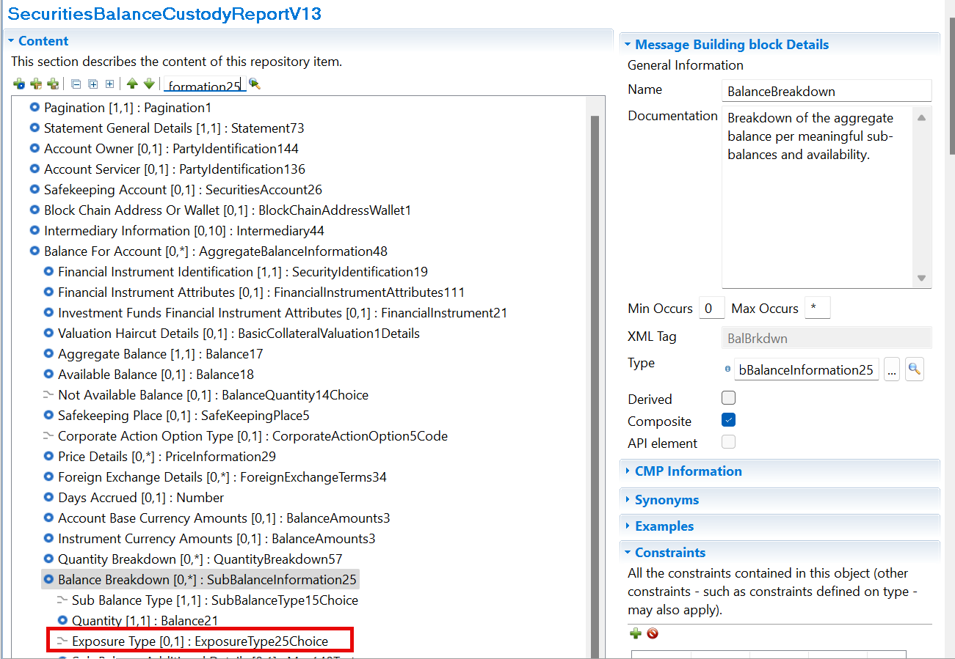

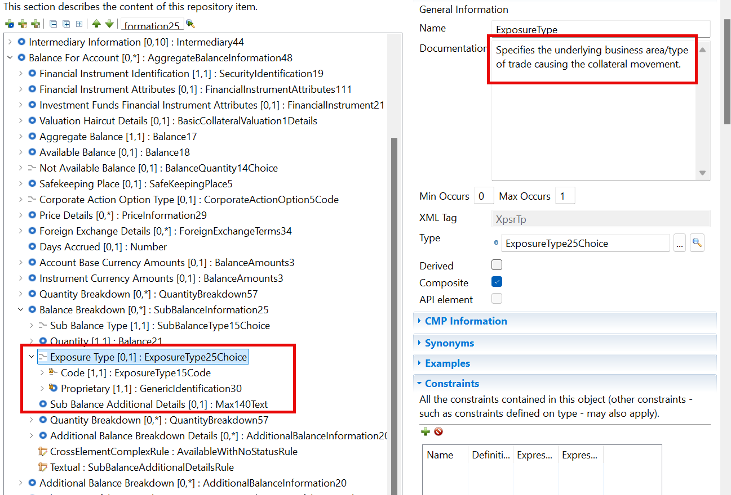

SWIFT Comment

Use of the Settlement Transaction Condition indicator with proprietary codes.

Working Group Meeting

Discussion
The submitter argued that in MT535 the Exposure Type Indicator can be associated with collateral-related sub-balances, allowing users to distinguish different collateral exposures such as repos. In ISO 20022 semt.002 and semt.003, exposure type exists only at a higher aggregation level and not within the balance breakdown itself. As a result, users cannot identify collateral exposures with the same level of precision as in MT messages.
SWG members agreed that the business requirement was legitimate. Several participants stated that adding exposure type at the balance breakdown level was intuitively correct and aligned with how collateral information is used in practice. The request was therefore seen as valid from a business perspective.
However, the discussion quickly expanded into broader architectural questions:
- Why was Exposure Type originally placed at the higher level in ISO 20022?
- Does the current MX structure still serve a purpose?
- How does the proposal interact with the ongoing discussions regarding Place of Safekeeping?
- Should the issue be addressed through a wider review of balance reporting structures rather than an isolated enhancement?
Some participants believed the proposal should proceed immediately because the business case was strong. Others preferred a broader consistency review before approving structural changes. Concerns were raised that changing one element without analysing the overall balance representation model could create inconsistencies elsewhere
The group eventually reached a compromise. They acknowledged that the request itself was valid and that they understood the business need, but they felt further analysis was required regarding the overall representation of balances, exposure type and place of safekeeping. The topic was therefore linked to future discussions planned with SMPG and other stakeholders.
The SWG agreed that the business requirement is legitimate and that the requested functionality makes sense. However, the proposal raised wider modelling questions regarding the placement of Exposure Type within the message structure. The group therefore preferred to conduct a broader review before introducing the change.
The SWG decided to postpone the CR as further discussions (not rejected). The request was recognised as valid, but implementation was deferred pending a more comprehensive analysis of balance representation, exposure type usage and related place-of-safekeeping discussions.
Decision
POSTPONED

End of document

SWG maintenance meeting minutes are distributed around second week of September.

