Maintenance Change Request
for the update of ISO 20022 financial repository items

Name of the request:
“ISO 20022 Securities Clearing Maintenance 2026/2027”

Submitting organisation(s):
ASX – CHESS (Clearing House Electronic Subregister System)
Australian Securities Exchange (ASX)
20 Bridge Street
Sydney NSW 2000

Related messages:

Under this maintenance, below existing ISO 20022 message definitions will be maintained (resulting from the impact analysis performed on each CR).

Collateral Management message set:

- secl.004.001.04 – TradeLegStatementV04

Message sets impacted are under responsibility of SWIFT:
Please note that the Collateral Management message set is under the responsibility of SWIFT.

Commitments of the submitting organisation:

The submitting organisations confirm that they can and will:
- Undertake the development of the new version of the candidate ISO 20022 message models that it will submit to the RA for compliance review and evaluation. New valid Message Definition models will be made available to the RA by December 1.
- provide a new version of part 1 of the related Message Definition Reports (MDR) by December 1, and new examples of valid message instances of each candidate message (only when valid samples were published for current version) by May 1 at the latest.
- Address any queries related to the description of the new models and messages as published by the RA on the ISO 20022 website.

SWIFT intends to implement most of the above new versions on its SWIFTNet network once the related documentation has been published by the RA.

The submitting organisations confirm their knowledge and acceptance of the ISO 20022 Intellectual Property Rights policy for contributing organisations, as follows.
“Organisations that contribute information to be incorporated into the ISO 20022 Repository shall keep any Intellectual Property Rights (IPR) they have on this information. A contributing organisation warrants that it has sufficient rights on the contributed information to have it published in the ISO 20022 Repository through the ISO 20022 Registration Authority in accordance with the rules set in ISO 20022. To ascertain a widespread, public and uniform use of the ISO 20022 Repository information, the contributing organisation grants third parties a non-exclusive, royalty-free license to use the published information”.

Contact persons:

Priscilla Ferri de Barros – ASX, priscilla.ferridebarros@asx.com.au
Sigrid Wiley – ASX, sigrid.wiley@asx.com.au
Karine Taquet – SWIFT Standards, karine.taquet@swift.com

Securities Clearing SEG ET members for SR 2027:

Securities Clearing SEG ET | Representing | Present
Priscilla Ferri de Barros | ASX
Harry McAllister | BNP Paribas
Lisa Taikitsadaporn | Brookpath
Hanno Klein | FIX
Marcin Zawistowki | KDPW
Aine Hester | LSEG
Jonathan Armitage | LSEG
Grace Charlesworth | LSEG
Mike Jones | LSEG
Ciro Tomeo | LSEG
Marek Kozok | ECB
Javier Martinez | ECB
Karine Taquet | SWIFT

Change request CR01516 ( SWIFT CR 003202):
Add Original Settlement Date and Update Reason to secl.004

Origin of the request:
A.1 Submitter: ASX – CHESS (Clearing House Electronic Subregister System)
A.2 Contact person: Priscilla Ferri de Barros; priscilla.ferridebarros@asx.com.au;
+ 61 (02) 9227 0543
A.3 Sponsors: it is highly recommended that a submitter of a Change Request gain the agreement and support from as many additional organisations, groups, initiatives or communities of users as possible, thus demonstrating as wide as possible a consultation of the relevant stakeholders. All organisations, groups, initiatives or communities supporting the change request should be identified as sponsors along with a contact person, if possible. This community involvement is intended to help avoid delays and/or subsequent amendments to the change request.

Related messages: secl.004.001.04 – Net Position 04

Description of the change request:
A specific change request form must be completed for each particular change requested (for example, adding, deleting, modifying, renaming, changing the cardinality, moving an element/component, or changing the type of an element, changing a code set).
If the change request consists, for example, of adding new functionality which requires several changes which would not make sense if not performed all together, then all these related changes should be described on the same form.
Change requests may not lead to creation of new messages. In such cases, a 'business justification' for development of new candidate ISO 20022 messages must be introduced by a submitting organization that is ready to develop the new messages.
Acting as a Central counterparty, ASX intends to use the secl.004 Net Position Report as anticipated: to confirm the net position of all trade legs reported during the day to its clearing members.
However, this message will replace a legacy message that today allows for the notification to the clearing members of changes during the clearing process. More precisely, in the case of an impending Corporate Action, the legacy message would send an updated Net Position Report with the previous security code, the original settlement date as well as the reason why the settlement needs to be rescheduled.

ASX is requesting the addition of 2 new elements:

- Original Settlement Date, in ISO date format. Specifies the settlement date of a settlement instruction before it was altered.

ISO 20022 proposed implementation:
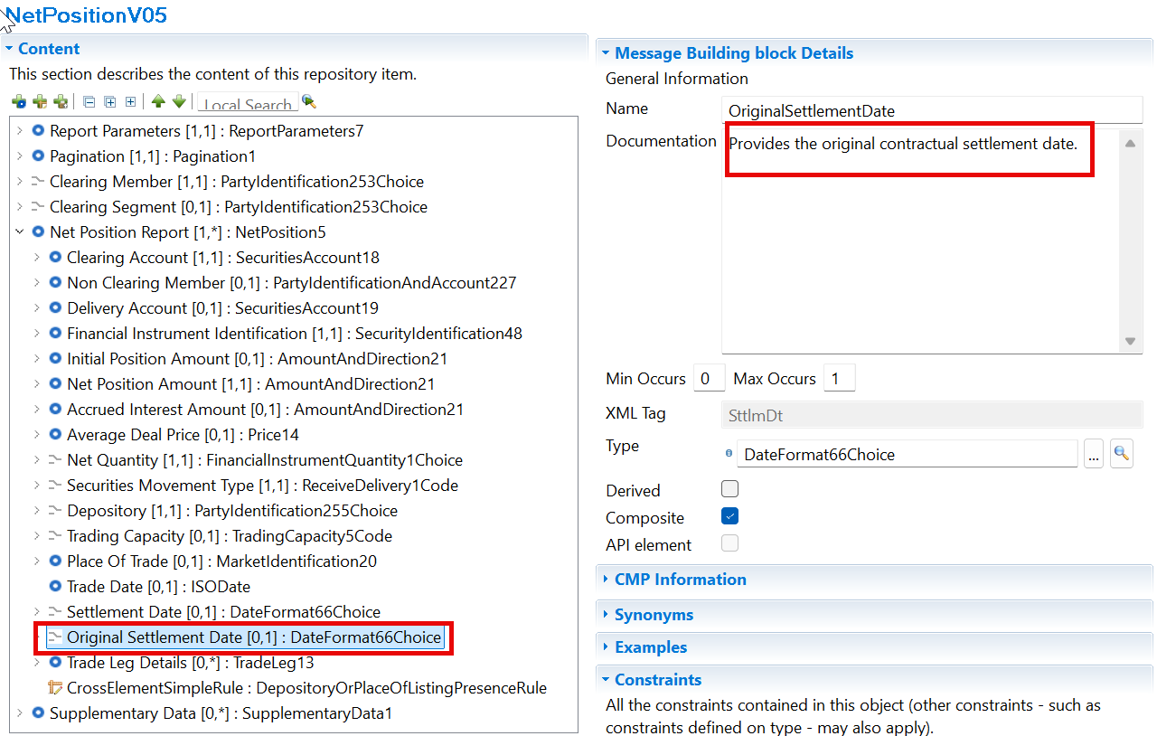
- Update Reason (to be used in combination with “Update Type”, already present in the message): A code list to express the reason for rescheduling the settlement. As it is mainly related to Corporate Actions, we suggest adding the Corporate Action Event Type code list (CAEV).

ISO 20022 proposed implementation:

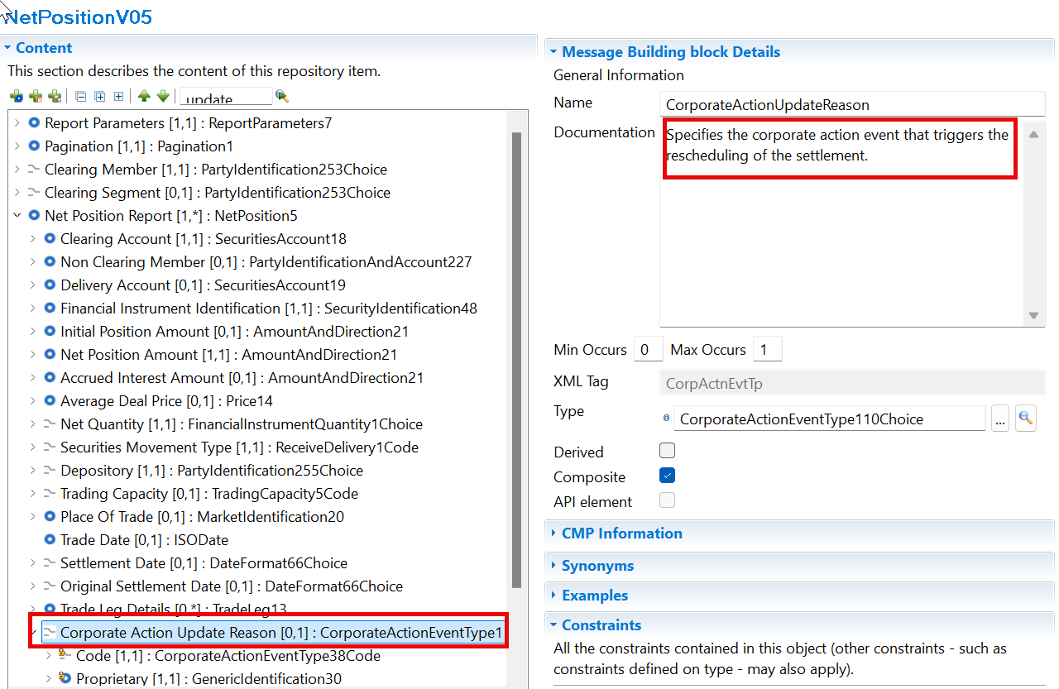

Purpose of the change:
The Australian Securities Exchange (ASX) has initiated a project to replace the current Australian equities clearing and settlement market infrastructure system (CHESS).
CHESS (Clearing House Electronic Subregister System) is the system operated by ASX to manage the clearing and settlement of equity market transactions, and to record current security holdings (and the holders) on a name on a register basis. The implementation of the replacement system will provide the existing core functionality and services as well as service enhancements. The current proprietary CHESS messaging standards will be replaced with ISO 20022 standards.
The purpose of this Change Request is to fully align the ISO messages used in CHESS to avoid using supplementary data for required elements.

Urgency of the request:
To be included as part of the annual maintenance cycle.

Business examples: /

Meeting Minutes
The meeting reviewed a maintenance change request for the Net Position Report (secl.004), driven by an ASX business requirement to better manage situations where an existing net position report must be cancelled and replaced following a corporate action-related event. The proposal introduces two new data elements:
- Original Settlement Date
- Update Reason
Only a few participants attended the meeting, and none were regular users of the message apart from the requester, which limited the breadth of feedback

1. Original Settlement Date

Business Need
ASX explained that when a corporate action causes a settlement date or security identifier to change, the existing net position report is cancelled (by sending a zero position) and replaced with a new one. The new report contains the revised settlement date, but there is currently no way to indicate what the settlement date was before the change.
Discussion Points:
Arguments in favor
- Helps recipients reconcile the replacement report with the original report previously received.
- Provides context explaining why a position report was cancelled and reissued.
- Replicates functionality already available in ASX's legacy message environment.
- Adds transparency without changing the actual net position.

Terminology discussion
- The group discussed whether the field should be called:
  - Original Settlement Date
  - Intended Settlement Date
  - Expected Settlement Date
- "Original Settlement Date" was preferred because:
  - It is more generic.
  - It can accommodate situations where the original settlement date is already in the past.
  - "Intended" could incorrectly imply that settlement has not yet occurred.
  - It avoids constraining future use cases.

Implementation concern
- Participants recognised that users might misinterpret the field.
- Therefore, additional textual guidance or a usage rule should be added to explain precisely when the field should be populated and how it should be interpreted.

Conclusion
✅ Supported
The group agreed to:
- Keep the name Original Settlement Date.
- Add explanatory documentation/usage guidance to avoid ambiguity.
- Make the field optional as proposed.

2. Update Reason
Business Need
ASX currently replaces a position report mainly for:
- A corporate action leading to a security code change.
- A deferred settlement scenario.
The new field would explain why the position report is being reissued
Discussion Points
Generic versus Corporate Action Specific
The original proposal was focused on corporate actions.
However, participants argued that:
- Position reports may be updated for reasons other than corporate actions.
- Other CCPs or infrastructures may use the message differently.
- Restricting the field to corporate actions would unnecessarily limit the message's future usability.
As a result:
✅ The field should be called Update Reason, not Corporate Action Update Reason.

Free Text versus Code List
The group discussed whether the field should:
- Use free-format text.
- Use a controlled code list.
The preference was for a controlled code list because:
- It supports straight-through processing.
- It ensures consistency across implementations.
- Additional codes can be added later when new use cases emerge.

Reuse of Existing Corporate Action Event Codes
The team noted that the existing CAEV corporate action code list is too broad and tightly linked to corporate actions.
However:
- Some of those codes remain useful.
- A new generic Update Reason code list should be created.
- Only the relevant corporate action-related reasons should be reused.
- A proprietary option should remain available.

Initial Candidate Codes Discussed
Examples considered:
- CHAN (Security Code Change)
- MRGR (Merger)
- PARI (Pari Passu)
- SPLF (Forward Split)
- SPLR (Reverse Split)
- OTHR (Other Event)
- Proprietary option retained
The list was considered only a starting point and may need additional reasons if other market users identify broader use cases.

Key Concern Raised During the Meeting
The main concern was not the business justification of the change itself.
The concern was that:
- Very few participants attended the screening and evaluation meetings.
- Most attendees were not active users of the SCCL004 message.
- The group therefore lacked sufficient representation from actual message users.
Several participants explicitly noted that it is difficult to determine:
- Who currently uses the message.
- Whether there are additional update scenarios beyond those identified by ASX.
- Whether additional update reason codes are required.

Overall Conclusion
✅ The proposed change is supported and can move forward.
The evaluation team agreed on:
- Adding an Original Settlement Date field.
- Naming it "Original Settlement Date".
- Adding descriptive usage guidance.
- Introducing an Update Reason field.
- Making the Update Reason generic rather than corporate-action specific.
- Creating a dedicated Update Reason code list.
- Reusing a limited set of relevant corporate action codes plus a proprietary option.
- Seeking additional market feedback before finalising the code set

SEG/TSG recommendation:

Consider |  | X | Timing
 |  |  | - Next yearly cycle: 2026/2027  (the change will be considered for implementation in the yearly maintenance cycle which starts in 2026 and completes with the publication of new message versions in the spring of 2027) |  | X
- At the occasion of the next maintenance of the messages
(the change will be considered for implementation, but does not justify maintenance of the messages in its own right – will be pending until more critical change requests are received for the messages)
- Urgent unscheduled
(the change justifies an urgent implementation outside of the normal yearly cycle)
 |  |  | - Other timing:

Comments:
- The purpose and the business case for the original settlement date must be clarified.
- The position of the Update Reason must be discussed based on the business case

Proposed implementation:

- Original Settlement Date, in ISO date format. Specifies the settlement date of a settlement instruction before it was altered.

ISO 20022 proposed implementation:

- Update Reason (to be used in combination with “Update Type”, already present in the message): A code list to express the reason for rescheduling the settlement.

ISO 20022 proposed implementation:
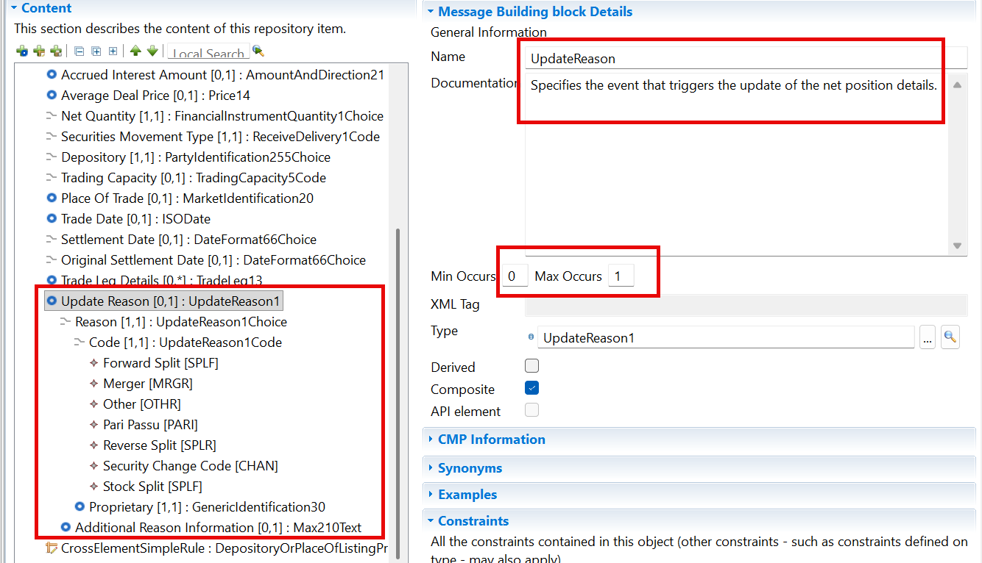

Proposed timing:
The submitting organisation confirms that it can implement the requested changes in the requested timing.

Timing | Next maintenance cycle

Final decision of the SEG(s):
☒ Approve

Comments:
The Evaluation Team supported the change and agreed to:
- Add an optional Original Settlement Date.
- Retain the name Original Settlement Date.
- Add explanatory documentation or usage guidance to avoid ambiguity.
- Add a generic Update Reason.
- Create a dedicated Update Reason code list, including the relevant corporate-action-related reasons and a proprietary option.
The Securities SEG endorsed the Evaluation Team’s recommendation and implementation solution during the MCR review meeting of 22 September 2026.
End of document

