Maintenance Change Request

- Name of the request:
Issuer Agent Communication Messages Maintenance for year 2026/2027

- Submitting organization(s):
Euroclear
ISITC/US (CR submitters)

- Related messages:
Under this project, the following ISO 20022 Issuer Agent Communication (IAC) messages highlighted in blue below would be maintained in the context of the IAC messages maintenance for year 2026/2027 – pending approval of the proposed implementation solutions (which will be reviewed on the 18th of August 2026):

 | Message Name | Identifier
1 | AgentCANotificationAdviceV03 | seev.009.001.03
2 | Agent CA Notification Cancellation Request V01 | seev.010.001.01
3 | Agent CA Notification Status Advice V04 | seev.011.001.04
4 | Agent CA Election Advice V01 (seev.012.001.01) | seev.012.001.01
5 | Agent CA Election Amendment Request V01 (seev.013.001.01) | seev.013.001.01
6 | Agent CA Election Cancellation Request V01 | seev.014.001.01
 | Agent CA Election Status Advice V01 | seev.015.001.01
 | Agent CA Distribution Breakdown Advice V01 | seev.016.001.01
 | Agent CA Global Distribution Authorisation Request V01 | seev.017.001.01
 | Agent CA Global Distribution Status Advice V01 | seev.018.001.01
 | Agent CA Movement Instruction V01 | seev.019.001.01
 | Agent CA Movement Cancellation Request V01 | seev.020.001.01
 | Agent CA Movement Confirmation V01 | seev.021.001.01
 | Agent CA Movement Status Advice V01 | seev.022.001.01
 | Agent CA Information Advice V01 | seev.023.001.01
 | Agent CA Information Status Advice V01 | seev.024.001.01
 | Agent CA Standing Instruction Request V01 | seev.025.001.01
 | Agent CA Standing Instruction Cancellation Request V01 | seev.026.001.01
 | Agent CA Standing Instruction Status Advice V01 | seev.027.001.01
 | Agent CA Deactivation Instruction V01 | seev.028.001.01
 | Agent CA Deactivation Cancellation Request V01 | seev.029.001.01
 | Agent CA Deactivation Status Advice V01 | seev.030.001.01

- Commitments of the submitting organization:

Ownership transition

Euroclear, the historical sponsor and maintainer of the Issuer Agent Communication message set, is transferring ownership and maintenance responsibility for these messages to DTCC.

DTCC becomes the sponsoring organisation responsible for the current and future maintenances, industry coordination, and evolution of the message set.

The submitting organization confirms that it can and will:
- undertake the development of the new version of the candidate ISO 20022 message models that it will submit to the RA for compliance review and evaluation. For the ISO 20022 yearly maintenance cycle, new valid Message Definition models must be available to the RA by December 1.
- provide a new version of part 1 of the Message Definition Report (MDR) by December 1, and, optionally, new examples of valid and invalid message instances of each candidate message by May 1 at the latest.
- address any queries related to the description of the new models and messages as published by the RA on the ISO 20022 website.
The submitting organization does not intend to organize testing of the new version of the messages once the related documentation has been published by the RA.
The submitting organization confirms its knowledge and acceptance of the ISO 20022 Intellectual Property Rights policy for contributing organizations, as follows.
“Organizations that contribute information to be incorporated into the ISO 20022 Repository shall keep any Intellectual Property Rights (IPR) they have on this information. A contributing organization warrants that it has sufficient rights on the contributed information to have it published in the ISO 20022 Repository through the ISO 20022 Registration Authority in accordance with the rules set in ISO 20022. To ascertain a widespread, public and uniform use of the ISO 20022 Repository information, the contributing organization grants third parties a non-exclusive, royalty-free license to use the published information”.

- Contact persons:
Steve Sloan – ssloan@dttc.com – phone: +1 (972) 471 5262
Hatem Soliman – hatem.soliman@euroclear.com – phone: + (32) 2 326 51 07

Table of Contents

003268 (ISO CR 1604) – Enhancements to seev.009 Agent CA Notification for Reorganization Events 4
003267 (ISO CR 1605) – Enhancements to seev.010 Agent CA Cancellation Request to align with seev.009 and seev.011 functionality 12
003266 (ISO CR 1606) – Enhancements to seev.011 Agent CA Status Advice for extended status codes and alignment with seev.009 structure 14

003268 (ISO CR 1604) – Enhancements to seev.009 Agent CA Notification for Reorganization Events
A. Origin of the request:
A.1 Submitter: ISITC
A.2 Contact persons: Steve Sloan, DTCC, +1972-471-5262 ssloan@dtcc.com
A.3 Sponsors: ISITC
B. Related messages:
AgentCANotificationAdviceV03 - seev.009.001.03
C. Description of the change request:
Please see attached spreadsheet detailing changes for the seev.009 document.
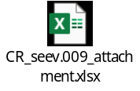
D. Purpose of the change:
Changes are being requested within the seev.009 Agent CA Notification message based on further progress within the US market related to the agent automation of Corporate Action notifications. Changes being proposed for SR2027 detail additional elements for Reorganization Events which are currently being reviewed by DTCC. These attributes have been determined based on event questionnaires to which are being made applicable to the seev.009. It is hoped by enhancing this message, Agents will be able to send a seev.009 message in lieu of the spreadsheet currently being considered.
• Supplementary Indicators (Corporate Action Details / Supplementary Indicators) needs to be changed from (0,1) to (0,*)
• Refer to the attached spreadsheet for new fields to be added to the seev.009 schema.
E. Urgency of the request:
SR2027
Note: the ISO 20022 maintenance results in the publication of a new version of an ISO 20022 message. The actual implementation of such new version on networks and in user installations is not within the purview of ISO.
F. Business examples:
N/A
G. SEG/TSG recommendation:
This section is not to be taken care of by the submitter of the change request. It will be completed in due time by the SEG(s) in charge of the related ISO 20022 messages or the TSG for changes related to the BAH.
Consider:
Timing:
- Next yearly cycle: 2026/2027:
(the change will be considered for implementation in the yearly maintenance cycle which starts in 2026 and completes with the publication of new message versions in the spring of 2027)
- At the occasion of the next maintenance of the messages:
(the change will be considered for implementation, but does not justify maintenance of the messages in its own right – will be pending until more critical change requests are received for the messages)
- Urgent unscheduled:
(the change justifies an urgent implementation outside of the normal yearly cycle)
- Other timing:

Comments: N/A
H. Impact analysis:
This change request impacts the following Issuer Agent Communication messages: seev.009
I. Proposed implementation solution:
A. In the seev.009 (AgentCANotificationAdvice) message, in building block CorporateActionDetails, in sequence SupplementaryIndicators, change multiplicity from 0…1 to 0…* (make repetitive).

B. In the seev.009 (AgentCANotificationAdvice) message, in building block CorporateActionDetails, add the following new elements:
- In sequence Event Balance Details, add new optional and non-repetitive element “Depository Holding”, typed by BalanceFormat11Choice, including the following sub-elements: Balance, Eligible Balance, Non Eligible Balance.
Definition: Indicates the total balance held at DTC (Cede & Co positions).
- In sequence Event Balance Details, add new optional and non-repetitive element “Depository Non Entitlement Quantity”, typed by FinancialInstrumentQuantity33Choice.
Definition: Treasury Shares which need to be excluded from payment. A share amount will be required if applicable.
- In sequence Rate And Amount Details, add new optional and non-repetitive element “ADR Cancellation Fee Rate”, typed as RateAndAmountFormat57Choice.
Definition: The ADR fee will be represented by a rate to charge per participant.
- In sequence Amount Details, add new optional and non-repetitive element “Issuer Cancellation Amount”, typed as RestrictedFINActiveCurrencyAndAmount.
Definition: Agent fee required for inventory cancellation of Target Security. Represented by a total dollar amount.
- In sequence Amount Details, add new optional and non-repetitive element “ADR Issuance Fee Amount”, typed as RestrictedFINActiveCurrencyAndAmount.
Definition: If a new entitlement is issued, agent fee represented by a total dollar amount, if applicable.
- In sequence Additional Information, add new optional and non-repetitive element “Baby Bond Narrative”, defined as: Provides additional information on the handling of baby bonds, and typed as Max350Text.
- Add new optional and repetitive element “Redemption Rights Disposition of Units”, definition: Represents a breakdown of what the UNIT is comprised of (Common Stock, Warrant, Right); typed by RedemptionRightsDisposition1Code, including the following values:
  - Common Stock (COMS) - Disposition of Common Stock
  - Warrant (WARR)- Disposition of Warrant
  - Right (RGHT)- Disposition of Rights
- In sequence Additional Information, add new optional and non-repetitive element “Dissenters Rights Delivery Address”, typed as PostalAddress27.
Definition: Specifies the address of the agent to which documentation related to dissenters’ rights should be delivered.
- In sequence SupplementaryIndicators, add the following new optional and non-repetitive elements, all typed as YesNoIndicator:
  - Share Reduction Indicator, defined as: Indicates whether fractional shares will be dropped.
  - Business Combination Event Indicator, defined as: Indicates if a corporate action is related to a SPAC / Business combination.
  - Early Waiver of Dissent Indicator: Indicates if Waiver of dissent feature is applicable.
  - Contingent Value Rights Indicator: Indicates if CVR CUSIP is applicable.
  - Escrow or CVR Transferability Indicator: Indicates whether participant position movement is allowed on CVR or Escrow.
  - ACAT Eligible Indicator: Indicates whether ACAT eligible.
  - Frozen Letter Indicator: Indicates whether event allows for Participant position movement when issue is Non-Transferrable.
  - Gross Amount Indicator: Indicates that a cash payment will be received in full (not withholding any related tax). Will be represented by an amount.
  - Letter of Guaranteed Delivery Indicator: Indicates if there is a Guaranteed Delivery on the offer.
  - Tender In Full Indicator: Indicates if holder must tender in all positions held.
  - Deemed Dividend Indicator: Indicates the holder if there will be deemed dividends in the offer.
  - Canadian Tax Withholding Indicator: Indicates the holder if there will be Canadian tax withheld.
  - Bulk Odd Lot Instructions Indicator: Indicates the ability for holders to bulk their odd lot instructions.
  - Odd Lot Tender In Full Indicator: Notifies the holder they must tender all odd lot positions held.
  - Odd Lot Fee Indicator: Indicates the holder that there will be an odd lot fee.
  - Random Lot Preference Indicator: Indicates the holder that positions will be accepted for random lot.
  - Contingent Value Rights Indicator: Indicates the holder that a Continent Value Right (CVR) will be allocated as part of the offer.
  - Escrow Indicator: Indicates the holder that an escrow will be allocated as part of the offer.
  - Escrow or CVR Transferability Indicator: Indicates the holder if the escrow they receive in allocation may be traded or transferred.
  - Escrow / CVR - ACAT Indicator: Indicates the holder if the escrow or CVR they received in allocation account transfers (ACAT) are allowed.
  - Proration Applied To Tendered Amount Indicator: Indicates that proration will take place on the Target security, or tender amount.
  - US Withholding Tax Indicator: Indicates the event is subject to US Tax Withholding.
  - IRS Section 302 Indicator: Indicates the event is subject to IRS Section 302.
  - Equity Interest In Partnership Indicator: Indicates whether security is classified as an equity interest in a partnership for US federal income tax purposes.
  - Make Whole Premium Conversion Rate Adjustment Indicator: Indicates whether there is a make whole premium conversion rate adjustment.
  - Fundamental Change Make Whole Premium Indicator: Indicates if there is a Fundamental Change Make Whole Premium offered.
  - Make Whole Premium Payment Only During Fundamental Change Indicator: Indicates if the Make Whole Period is only payable during the Fundamental Change period.
  - Security Convertible After Fundamental Change Expiration Indicator: Indicates that the security remains convertible after the Fundamental Change period.
  - Agent Wire Instruction Form Indicator: Indicates acknowledgement that wire form has been submitted for forfeiture of interest.
  - Deemed Record Date Holder of Underlying Security Indicator: Indicates if converting holders will be deemed record date holders of new entitled shares.
  - Exchange In Lieu Option Indicator: Indicates confirmation on whether there is an Exchange in Lieu of the conversion option.
  - Debit Authorization Letter Indicator: Indicates confirmation that a debit authorization letter will be provided under Exchange in Lieu of Conversion.
  - Buy In Privilege Indicator: Indicates a "Buy-In" privilege offered by the issuer if the underlying shares are not delivered timely.
  - Current Settlement Method Notice Indicator: Indicates if the company has issued a Notice of Settlement method for Current Conversion Period.
  - Final Conversion Period Settlement Terms Change Indicator: Indicates if final settlement terms change during final Conversion period.
  - Underlying Stock Depository Current Eligibility Indicator: Indicates if the underlying security is currently DTC eligible.
  - Wiring Subscription Fees Timing Indicator: Indicates agreement on subscription fees collected by 2:15pm on expiration date will be wired out the following business day.
  - Wiring Subscription Fees For Late Window Opening Indicator: Indicates agreement on subscription fees collected between 3:30-5:00PM on expiration date will be wired out two business days later.
  - Step-Up Privilege Indicator: Indicates whether a step-up privilege applies in a rights offering, allowing holders with fewer rights than required to subscribe for a full entitlement.
  - Step-Up Oversubscription Privilege Indicator: Indicates if holders of the Step-Up feature eligible can oversubscribe.
  - Rights Entitlement Single Security Indicator: Indicates if the entitlement is one security or multiple securities; if multiple CONTRA CUSIP is to be utilized.
  - Entitlement CUSIP Depository Eligible Indicator: Indicates whether entitlement CUSIP is DTC Eligible.
  - Oversubscription Refund Priority Indicator: Indicates which requests are prioritized when additional shares are issued instead of cash refunds, such as oversubscription elections or final stock refund positions.
  - Oversubscription Refund Cash In Lieu Indicator: Indicates if additional shares are allocated from Assumed price, that holders will receive a refund in cash, if additional whole shares cannot be purchased.
  - Subscription Price Other Payment Type Indicator: Indicates whether the exercise price can be paid in other than cash.
  - Rights Declared Worthless Indicator: Indicates whether expired rights are deemed null, void, and worthless.
  - Extended Window Period For SELL Option Indicator: Indicates if DTC can reopen the sell window from 3:30-5:00pm on Agent Sell Expiration date.
  - New Security Equity Interest in Partnership Indicator: Indicates whether new security is an equity interest for US tax purposes.
  - Warrant Currently Exercisable Indicator: Indicates if warrant exercise currently on DTC's WARR program.
  - Jurisdiction Restrictions Indicator: Indicates that there are jurisdiction restrictions.
  - Certification Restrictions Indicator: Indicates that there are certification restrictions.
  - Fundamental Change Conversion Trigger Indicator: Indicates if the fundamental change triggers the conversion.
  - Warrant Guarantee Of Delivery Type Indicator: Indicates that agent agrees on the following related to Warrant Guarantees: (1) reopening of Protect Window, (2) submitting funds two days following protect expiration date and (3) Agent agrees to receive letter of instructions the following day after reopening of window.
- In sequence DateDetails, add new optional and non-repetitive element “Dissenters Rights Expiration Date”, defined as: The date by which holders can object to the offer, and typed as DateFormat43Choice.
- Add new optional and non-repetitive element “Declared Dividend Currency Code”, typed by ActiveCurrencyCode. Definition: The currency in which the declared dividend will be paid.
- Add new optional and non-repetitive element “Fundamental Change Make Whole Period Conversion Type”, definition: Specifies what the security converts into during the Fundamental Change period, typed as FundamentalChangeMakeWholePeriodConversationType1Code, incl. the following values:
  - Cash (CASH): holder to receive cash.
  - Securities (SECU): holder to receive securities.
  - Cash and Security (CASE): Holder to receive a combination of cash and securities.
- Add new optional and non-repetitive element “Buy In Request Contact”, defined as: Buy In Request contact information, and typed as ContactIdentification1;
- Add new optional and non-repetitive element “Minimum Note Quantity To Retain”, defined as: Minimum number of notes to be retained after conversion instruction submission, and typed as DecimalNumber (18 digits, no fractions);
- Add new optional and non-repetitive element “Conversion Physical Settlement Day Count”, defined as: Number of days between the conversion instruction and the physical settlement date, and typed as DecimalNumer (4 digits);
- Add new optional and non-repetitive element “Post Conversion Instruction Settlement Method Day Count”, defined as: Number of days between the conversion instruction and the notification of the method of settlement by the issuer, and typed as DecimalNumer (4 digits);
- Add new optional and non-repetitive element “VWAP Observation Period Day Count”, defined as: Number of days in VWAP Observation period, and typed as DecimalNumer (4 digits);
- Add new optional and non-repetitive element “Default Settlement Method”, defined as: Specifies default settlement if Company does not provide method of settlement, and typed as DefaultSettlementCode1, including code values: Cash (CASH), Stock (SECU), Combination Cash and Stock (CASE);
- Add new optional and non-repetitive element “Final Period Conversion Type”, defined as: Specifies what security converts into during the Final Conversion Period
- , and typed as DefaultSettlementCode1, including code values: Cash (CASH), Stock (SECU), Combination Cash and Stock (CASE);
- In sequence Date Details, add new optional and non-repetitive element “Rights Distribution Record Date”, defined as: Record date for holders to be entitled to the rights distribution, and typed as DateFormat30Choice;
- In sequence Securities Quantity, add new optional and non-repetitive element “Total Rights Distribution Quantity”, defined as: Total number of rights to be issued including rights outside of DTC, and typed as FinancialInstrumentQuantity35Choice;
- In sequence Securities Quantity, add new optional and non-repetitive elements “Share Available For Purchase”, defined as: Quantity of shares available for purchase as part of the subscription offer, and typed as FinancialInstrumentQuantity35Choice;
- Add new optional and non-repetitive element “Uncovered Protect Liability Code”, typed as UncoveredProtectLiabilityType1Code, incl. values:
  - Held Liable - Uncovered Protects will receive no refund HELD
  - Refunded - Uncovered Protects will be refunded REFU
Definition: Specifies whether participants will be held liable or be refunded for Uncovered Protects.
- Add new optional and non-repetitive element “Remarketing Details”, typed as CorporateActionNarrative2. Definition: Information related to a corporate action event which will have remarketing.
- Add new sequence “Remarketing Details”, Definition: Information related to a corporate action event which will have remarketing, typed as CorporateActionNarrative, including the following elements:
  - Remarketing Indicator: Indicates whether CUSIP will be remarketed.
  - Remarketed CUSIP into Same CUSIP Indicator: Indicates whether CUSIP will be remarketed into same CUSIP Number.
  - Add new optional and non-repetitive element “Remarketing Account Number With Unknown Indicator”, typed as Max35Text. Definition: Indicates the account number the remarked bonds will be applied to.
  - Add new optional and non-repetitive element “Remarketed Quantity”, typed as FinancialInstrumentQuantity35Choice. Definition: The total quantity being remarketed.

C. In the seev.009 (AgentCANotificationAdvice) message, in message building block CorporateActionOptionDetails, add the following new elements:

- In sequence Date Details, add new optional and non-repetitive element “Redemption Rights Expiration Date Time”, defined as: Redemptions rights expiration date, and typed as DateFormat43Choice.
- In sequence Date Details, add new optional and non-repetitive element “Dissenters Rights Expiration Date Time”, defined as: Dissenters rights expiration date, and typed as DateFormat43Choice.
- In sequence Date Details, add new optional and non-repetitive element “CVR Expiration Date”, defined as: Expiration Date of Contingent Value Rights, and typed as DateFormat43Choice.
In sequence Cash Movement Details, add new optional and non-repetitive element “Distribution Classification Type”, definition: Taxable classification of the distribution, typed as DistributionClassificationTypeX, incl. the following values:
  - Income (INCO) - Distribution Portion Income
  - Interest (INTR) - Distribution Portion Interest
  - Taxable Deemed Dividend (DEEM) - Distribution Portion Taxable Deemed Dividend
  - Paid Up Capital (PCAP) - Distribution Portion Paid Up Capital
- In sequence Cash Movement Details/RateAndAmountDetails, add new optional and non-repetitive element “Paid Up Capital Rate”, typed as RateAndAmountFormat57Choice.
Definition: Rate related to Paid Up Capital.
- In sequence Cash Movement Details/Amount Details, add new optional and non-repetitive element “Paid Up Capital Amount”, typed as RestrictedFINActiveCurrencyAndAmount.
Definition: The amount of allocation that represents the paid-up capital.
- In sequence Cash Movement Details/RateAndAmountDetails, add new optional and non-repetitive element “Interest Make Whole Conversion Rate”, defined as: Interest rate holders are eligible to receive during the make whole period, and typed as RateAndAmountFormat57Choice.
- In sequence Price Details, add new optional and non-repetitive element “Conversion Price”, typed as PriceFormat46Choice. Definition: Specifies the price used to determine the number of shares received upon conversion of a security.
- Add new optional and non-repetitive element “Payment Frequency Type”, defined as: Frequency of payment on Israeli tax and FIRTPA events, and typed as PaymentFrequencyTypeCodeX, incl. the following values:
  - Weekly (WEEK) - Payment made weekly
  - Bi-Weekly (BIWK) - Payment made bi-weekly
  - Monthly (MNTH) - Payment made monthly
- In sequence Period Details, add new optional and non-repetitive element “Conversion Rate Adjustment Period”, typed as Period12Choice. Definition: Provide Beginning date for Interest Make Whole Period, and
- In sequence Period Details, add new optional and non-repetitive element “VWAP Calculation Period”, defined as: Start and End date of the VWAP calculation, and typed as Period12Choice.
- In sequence Period Details, add new optional and non-repetitive element “Interest Make Whole Conversion Type”, defined as: Indicates type of payment to be made during Interest Make Whole period, and typed as InterestMakeWholeConversion1Code, incl. values
  - Cash (CASH): holder to receive cash.
  - Securities (SECU): holder to receive securities.
  - Cash and Security (CASE): Holder to receive a combination of cash and securities.
- Add new optional and non-repetitive element “Interest Make Whole Conversion Adjustment Rate Type”, defined as: Specifies whether the make whole conversion rate period is based on a VWAP or Defined rate, and typed as InterestMakeWholeConversion2Code, incl. values
  - VWAP – Variable Weigthed Average Price
  - Defined Rate – Fixed Rate
- Add new optional and non-repetitive element “Conversion Type”, defined as: Specifies method or terms under which a security is convertible, and typed as ConversionTypeXCode, incl. values:
  - Ongoing
  - Temporary
  - Quarterly
- In sequence Securities Movement Details/RateDetails, add new optional and non-repetitive element “Conversion Rate Post Fundamental Change”, defined as: Conversion rate after the Fundamental Change expiration date, and typed by RateFormat24Choice;
- In sequence Securities Movement Details/Date Details, add new optional and non-repetitive element “Final Conversion Period Settlement Default Date”, defined as: Date when conversion settlement defaults to all holders during the final conversion period, and typed as DateFormat30Choice;
- In sequence Securities Movement Details, add new optional and non-repetitive element “Conversion Rate Price Calculation Type”, defined as: VWAP-conversion based on VW Fixed Rate, and typed as ConversionRatePriceCalculation1Code, including values:
  - VWAP (VWAP) - Conversion based on VWAP
  - Fixed Rate (FIXR) Conversion based on fixed rate
- In sequence Securities Movement Details/RateDetails, add new optional and non-repetitive element “Final Conversion Period Fixed Conversion Rate”, defined as: Conversion rate during final conversion period, and typed by RateFormat24Choice;
- In sequence Period Details, add new optional and non-repetitive element “Final Conversion VWAP Observation Period Day Count”, defined as: Specifies the number of days in VWAP Observation period during the final conversion period, and typed by Period12Choice;
- Add new optional and non-repetitive element “Final Conversion Settlement Day Count After Observation Period”, defined as: Specifies the number of days after the observation period to settlement, and typed as Max3Decimals;
- Add new optional and non-repetitive element “Underlying Share Type Code”, defined as: Specifies if the underlying security is restricted or freely transferable, and typed as UnderlyingShareType1Code, incl. code value: Restricted (RSTR), Freely Transferable (FREE);
- Add new optional and non-repetitive element “Rights Entitlement Allocation Type”, defined as: Indicate whether Unit or Underlying components will be allocated on payment date, and typed as RightEntitlementAllocationType1Code, including values Unit (UNIT) and Underlying Component (UNCO);
- In sequence Date Details, add new optional and non-repetitive element “Final Price Determination Date”, defined as: Provides date when Final price is made known (if assumed), and typed as DateFormat30Choice;
- Add new optional and non-repetitive element “Refund Type”, defined as: Provide refund type, if Subscription Price is assumed, and typed as RefundType1Code, including values: Cash (CASH), Stock (SECU), holder option for cash or shares (HOLD);
- Add new optional and non-repetitive element “Rights Sell Price Type”, typed as RightsSellPriceType1Code, incl. values:
  - Sale Price Per Day (SALE) - Rights Sell Price based on sale price per day
  - Average Price (AVRG) - Rights Sell price based on average price
Definition: Rights sell price based on a daily average or a price per day.
- In sequence Price Details, add new optional and non-repetitive element “Warrant Redemption Price”, typed as PriceFormat61Choice. Definition: Provide warrant redemption price per 1 warrant.
- In sequence Date Details, add new optional and non-repetitive element “Uncovered Protect Refund Date”, typed by DateFormat30Choice. Definition: Provide date of Refund of Uncovered Protects.
- Add new optional and non-repetitive element “Cashless Or Alternative Cashless Warrant Exercise Option Type”, typed CashlessOrAlternativeCashlessType1Code, incl. values
  - CASL - Cashless Warrant Exercise Option
  - ALTN - Alternative warrant exercise option
Definition: Is there a Cashless or Alternative cashless warrant exercise triggered by Redemption.
- In sequence Date Details, add new optional and non-repetitive element “Deemed Record Holder of Underlying Security Date Code”, typed as DeemedRecordHolderUnderlyingSecurityDateType1Code, incl. values:
  - EXER - exercise date
SETT - settlement date
OTHR - other date
Definition: Confirm when exercising holder is deemed record holder of underlying security.
- In sequence Date Details, add new optional and non-repetitive element “Next Anticipated Put Date”, typed as DateFormat30Choice. Definition: Date to which the next put will occur.
- In sequence Rate Details, add new optional and non-repetitive element “Gainshare Rate”, typed as RateFormat24Choice. Definition: Rate related to gainshare which generally refers to contractual, risk-reward clauses designed to divide financial benefits, cost savings, or profits among specific stakeholders.

D. In the seev.009 (AgentCANotificationAdvice) message, in message building block Additional Information, add the following new elements:
- Jurisdiction Restrictions Narrative: Narrative related to jurisdiction restrictions
- Certification Restriction Narrative: Narrative related to certification restrictions

E. In the seev.009 (AgentCANotificationAdvice) message, add new optional and repetitive message building block “Concurrent Event Linkage”, defined as: Used to determine if a Concurrent event will impact this event. This can be a Cash/Stock Dividend, another mandatory event, Spin off, or Voluntary event, and including the following elements:
- Event Type (1…1), typed as CorporateActionEventType35Code
- Sub Event Type (0…1), typed as DTCCSubEventType9Code
- Entitlement CUSIP (0…1), typed as SecurityIdentification19; defined as: The CUSIP of the disbursed security of the original corporate action.
- Key Dates (1…1), typed as DateXXChoice, including the following sub-elements:
  - Effective Date (0…1), typed as DateFormat30Choice
  - Record Date (0…1), typed as DateFormat30Choice
  - Payment Date (0…1), typed as DateFormat30Choice
  - Results Publication Date (0…1), typed as DateFormat30Choice
  - Instruction Expiration Date (0…1), typed as DateFormat30Choice
- Corporate Action Event Identification (0…1), typed as RestrictedFINXMax16Text

J. Proposed timing:
The submitting organization confirms that it can implement the requested changes in the requested timing.
Timing | As requested

K. Final decision of the SEG(s):
☒ Approve
Comments:
Approved as proposed, without comments. The Securities SEG endorsed the Evaluation Team’s recommendation and implementation solution during the MCR review meeting of 16 September 2026.
☐ Reject
Reason for rejection:
Not applicable.

003267 (ISO CR 1605) – Enhancements to seev.010 Agent CA Cancellation Request to align with seev.009 and seev.011 functionality
A. Origin of the request:
A.1 Submitter: ISITC
A.2 Contact persons: Steve Sloan, DTCC, +1972-471-5262 ssloan@dtcc.com
A.3 Sponsors: ISITC
B. Related messages:
Agent CA Notification Cancellation Request V01 - seev.010.001.01
C. Description of the change request:
Please see attached spreadsheet detailing changes for the seev.010 document.
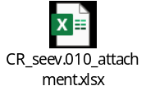
D. Purpose of the change:
Changes are being requested within the seev.010 Agent CA Cancellation Request message to align this message to the current message functionality which was created within the seev.009 and seev.011 messages in previous change requests. Please see attached spreadsheet for proposed layout of the seev.010 message.

• Refer to the attached spreadsheet for new fields to be added to the seev.010 schema.

E. Urgency of the request:
For next release (SR2027).
Note: the ISO 20022 maintenance results in the publication of a new version of an ISO 20022 message. The actual implementation of such new version on networks and in user installations is not within the purview of ISO.
F. Business examples:
N/A

G. SEG/TSG recommendation:
☒ Consider
Timing:
☒ Next yearly cycle: 2026/2027
☐ At the occasion of the next maintenance of the messages
☐ Urgent unscheduled
☐ Other timing:

☐ Reject
Reason for rejection:
Comments: N/A

H. Impact analysis:
This change request impacts the following Issuer Agent Communication messages: seev.010
I. Implementation solution proposal
A. In the seev.010 (Agent CA Notification Cancellation Request) message, add a new mandatory and non-repetitive message building block “Cancellation General Information” (1…1), using the same structure as “Cancellation General Information” in seev.039, including the following mandatory and non-repetitive element:
- “Cancellation Reason Code” (1…1), including the following code values:
  - Processing (CANC): Notification requesting the cancellation of a previously sent notification.
  - Withdrawal (WITH): Notification sent to void a previously sent notification due to the withdrawal of the event by the issuer.
B. In the seev.010 (Agent CA Notification Cancellation Request) message, add a new mandatory and repetitive message building block “Agent Information” (1…*), typed as CorporateActionAgent2.
The new building block shall support all agents available in the seev.009
C. In the seev.010 (Agent CA Notification Cancellation Request) message, in the existing message building block “Corporate Action General Information”, add or amend the following elements:
- Add new optional and non-repetitive element “Official Corporate Action Event Identification” (0…1), typed as RestrictedFINXMax16Text.
- Add new mandatory and non-repetitive element “Corporate Action Event Identification” (1…1), typed as RestrictedFINXMax16Text.
- Add new optional and non-repetitive element “Agent Corporate Action Event Identification” (0…1), typed as RestrictedFINXMax16Text.
- Change the type of the existing mandatory and non-repetitive element “Event Processing Type” (1…1) to CorporateActionEventProcessingType2Code.
- Remove the existing “Event Type” element and replace it with the mandatory and non-repetitive “Event Type” choice (1…1), typed as CorporateActionEventType127Choice, containing:
  - “Plain Corporate Action Type” (1…1), typed as CorporateActionEventType35Code;
  - “Extended Corporate Action Type” (1…1), typed as ExtendedEventType8Code;
  - “Proprietary” (1…1), typed as ExtendedEventType8Code.
- Add new optional and non-repetitive element “Sub Event Type” (0…1), typed as DTCCSubEventType9Code.
- Change the type of the existing mandatory and non-repetitive element “Mandatory Voluntary Event Type” (1…1) to CorporateActionMandatoryVoluntary3Choice.
- Change the type of the existing mandatory element “Underlying Security” to FinancialInstrumentAttributes126 and make repetitive (1…*), consistently with the corresponding structure in seev.009.
D. In the seev.010 (Agent CA Notification Cancellation Request) message, add a new message building block “Corporate Action Details”, including the following elements and sequences:
- Add new optional and non-repetitive sequence “Date Details” (0…1), including the following optional and non-repetitive elements:
  - “Record Date” (0…1), typed as DateFormat43Choice;
  - “Ex Dividend Date” (0…1), typed as DateFormat43Choice;
  - “Official Announcement Publication Date” (0…1), typed as DateFormat43Choice;
  - “Results Publication Date” (0…1), typed as DateFormat43Choice;
  - “Payment Date” (0…1), typed as DateFormat43Choice.
- Add new optional and non-repetitive element “Additional Business Process Indicator” (0…1), typed as AdditionalBusinessProcessFormat25Choice.
E. In the seev.010 (Agent CA Notification Cancellation Request) message, add a new optional and non-repetitive message building block “Additional Text” (0…1), using a structure similar to the corresponding building block in seev.039 and typed as RestrictedFINZMax8000Text.

Swift comment: Activating and maintaining the seev.010 is not limited to the implementation of the current request submitted by ISITIC. Since the message has neither been used nor maintained since its initial development, a comprehensive analysis of the changes introduced in related Corporate Action and Issuer Agent Communication messages over previous maintenance cycles would be required to determine whether corresponding enhancements should also be incorporated into the seev.010 in order to maintain consistency across the message set and with current market practice.
J. Proposed timing:
The submitting organization confirms that it can implement the requested changes in the requested timing.
Timing | As requested

K. Final decision of the SEG(s):
☒ Approve
Comments:
Approved as proposed, without comments. The Securities SEG endorsed the Evaluation Team’s recommendation and implementation solution during the MCR review meeting of 16 September 2026.
☐ Reject
Reason for rejection:
Not applicable.

003266 (ISO CR 1606) – Enhancements to seev.011 Agent CA Status Advice for extended status codes and alignment with seev.009 structure
A. Origin of the request:
A.1 Submitter: ISITC
A.2 Contact persons: Steve Sloan, DTCC, +1972-471-5262 ssloan@dtcc.com
A.3 Sponsors: ISITC
B. Related messages:
Agent CA Notification Status Advice V04 - seev.011.001.04
C. Description of the change request:
Please see attached spreadsheet detailing changes for the seev.011 document.
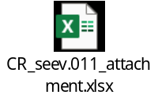
D. Purpose of the change:
• Changes are being requested within the seev.011 Agent CA Status Advice message to incorporate additional code values for Rejected Status, Pending Status and Accepted with Warning Status aligning with the US usage by DTCC for Redemption Events including Full Call (MCAL) Partial Call (DRAW), Final Paydown, Default (DFLT), Prefunding (PDEF) and Final Maturity (REDM). Please see attached spreadsheet detailing these codes.
• Additionally, please see attached spreadsheet concerning the Status mapping within Agent CA Notification Advice Identification And Status. The Choice Component needs to be revised so that revised so that Accepted with Warning is renamed “Agent Review”and the Reason code will allow for multiple reason codes. The Pending Status should also be changed to allow for multiple reason codes.
• Also, two additional elements Agent Corporate Action Event Identification and Sub Event type are being requested within the Corporate Action General Information to conform to the layout of the seev.009.

E. Urgency of the request:
For next release (SR2027).
Note: the ISO 20022 maintenance results in the publication of a new version of an ISO 20022 message. The actual implementation of such new version on networks and in user installations is not within the purview of ISO.
F. Business examples:
N/A

G. SEG/TSG recommendation:
☒ Consider
Timing:
☒ Next yearly cycle: 2026/2027
☐ At the occasion of the next maintenance of the messages
☐ Urgent unscheduled
☐ Other timing:

☐ Reject
Reason for rejection:
Comments: /
H. Impact analysis:
This change request impacts the following Issuer Agent Communication messages: seev.011
I. Implementation solution proposal
A. In the seev.011 (AgentCANotificationStatusAdvice) message, in building block AgentCANotificationAdviceIdentificationAndStatus,
- remove element “Processed Status” from sequence Status;
- add the following elements to Status sequence:
- Accepted Status (1…1), typed as NoSpecifiedReason1
- Received Status (1…1), typed as NoSpecifiedReason1
- Sent To Market Status (1…1), typed as NoSpecifiedReason1
- System Not Available Status (1…1), typed as NoSpecifiedReason1

- rename element “Accepted With Warning Status” to “Agent Review Status” and amend definition as follows: The announcement needs to be reviewed by the Agent due to processing issue.
- type element “Agent Review Status” as AgentReviewReasonXFormatXChoice, as described and illustrated below;
- type element “Pending Status” as PendingReasonXFormatXChoice, as described and illustrated below;
- change multiplicity for element AcceptedWithWarning Status to 1…* (make repetitive).
- change multiplicity for element Pending Status to 1…* (make repetitive).
- change multiplicity for element Rejected Status to 1…* (make repetitive).
- rename status element “Sent To Market (SENT)” to “Published (PUBL)” and amend definition as follows: Announcement has been published to the market.

B. In message building block CorporateActionGeneralInformation, add two new optional and non-repetitive elements:
- “Agent Corporate Action Event Identification”, typed as Max35Text;
Definition: Reference assigned by the account servicer to unambiguously identify a corporate action event.
- “Sub Event Type”, typed as DTCCSubEventType9Code;
Definition: DTCC (The Depository Trust and Clearing Corporation) native corporate action sub event type name further defines the event type.
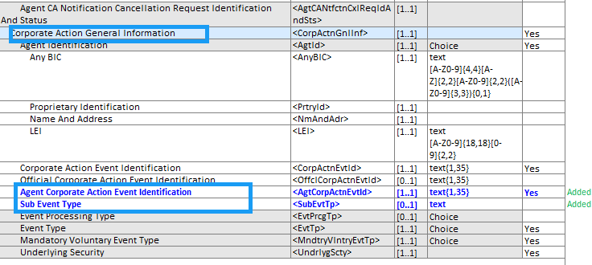

C. In message building block AgentCANotificationAdviceIdentificationAndStatus, in sequence Status, add the following new status codes:

- To Pending Status:

- Pending Review by Agent Maker (PENM): Pending Review by Agent Maker
- Pending Review by Agent Checker (PENC): Pending Review by Agent Checker
- Pre-Publication Announcement (PRPU): Event is in pre-publication status
- Pending Minimum / Multiple Review (MNML): Called amount does not adhere to the minimum / multiple denomination
- Depository Called Amount must equal Securities Called Amoun (DEPO): Depository Called Amount must be greater than zero and must be equal to Security Called Amount
- Zero Coupon Bond Interest must be zero (ZINT): Zero Coupon Bond Interest must be zero
- Zero Coupon Bond Premium Must be Zero (ZPRE): Zero Coupon Bond Premium must be zero

- To Agent Review Status:

- Position Discrepancy POSD: Position discrepancy. Potential Partial Call.
- Maturing Issue (MATU): Maturing Issue. Redemption Date is greater than or equal to Maturity Date.
- Duplicate Event (DUPL): Duplicate event exists.
- Concurrent Reorganization event exists (CNRE): Concurrent Reorganization event exists.
- Concurrent Redemption event exists (CNRD): Concurrent Redemption event exists.
- Missing Default Indicator (DFLI): Missing Default Indicator
- CERI: Certificate Position Mismatch
- Certificate Not Found: (CERN): Certificate Not Found
- Certificate Position Mismatch (CERI): Certificate Position Mismatch
- Duplicate certificate exists (DUPC): Duplicate certificate exists in vault
- Late Announcement (LATE): Late Announcement. The Declared Payment Date is > 45 Calendar Days in the Past.
- Payable Date outside of applicable date range (PAYD): Payable Date outside of applicable date range. (Description update only)
- Security Called Amount differs from inventory (INVT): Security Called Amount differs from inventory.
- Verify Rate. On-Cycle Redemption (VRON): Verify Rate. On-Cycle Redemption
- Unable to Calculate Accrued Interest (ACCR): Unable to Calculate Accrued Interest. Missing payment details.
- Potential conflicting Partial Call exists (CNPC): Potential conflicting Partial Call exists

- To Rejected Status:

- Concurrent Full Call event exists (CNFC): Concurrent Full Call event exists
- Concurrent Redemption event exists (CNRD): Concurrent Redemption event exists.
- Invalid Security Called Amount (SCAL): Invalid Security Called Amount.
- Cash Rate must be Less Than $1,000.00 (VRZC): Zero Coupon Bond. Principal / Cash Rate must be Less Than $1,000.00.
- System Not Available (SNAC): System Not Available.
- Fractional CUSIP cannot be announced (FRAC): Fractional CUSIP cannot be announced (Description update only)
- Ongoing Conversion Event Exists (ONGO): Ongoing Conversion Event Exists. (Description update only)

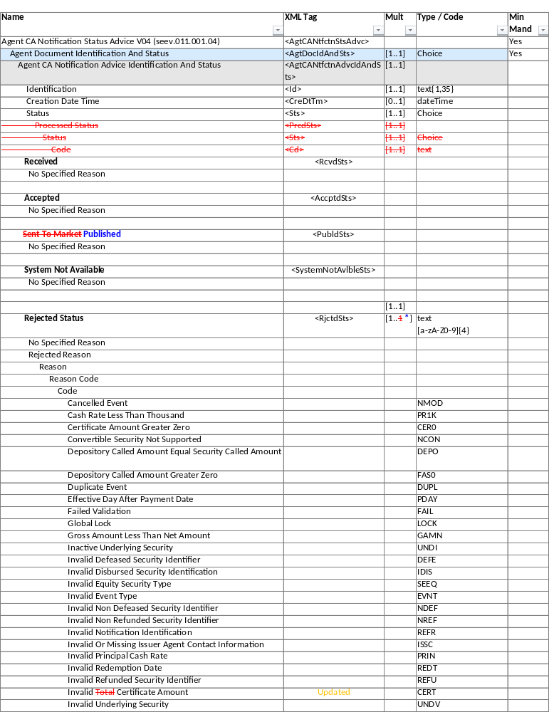

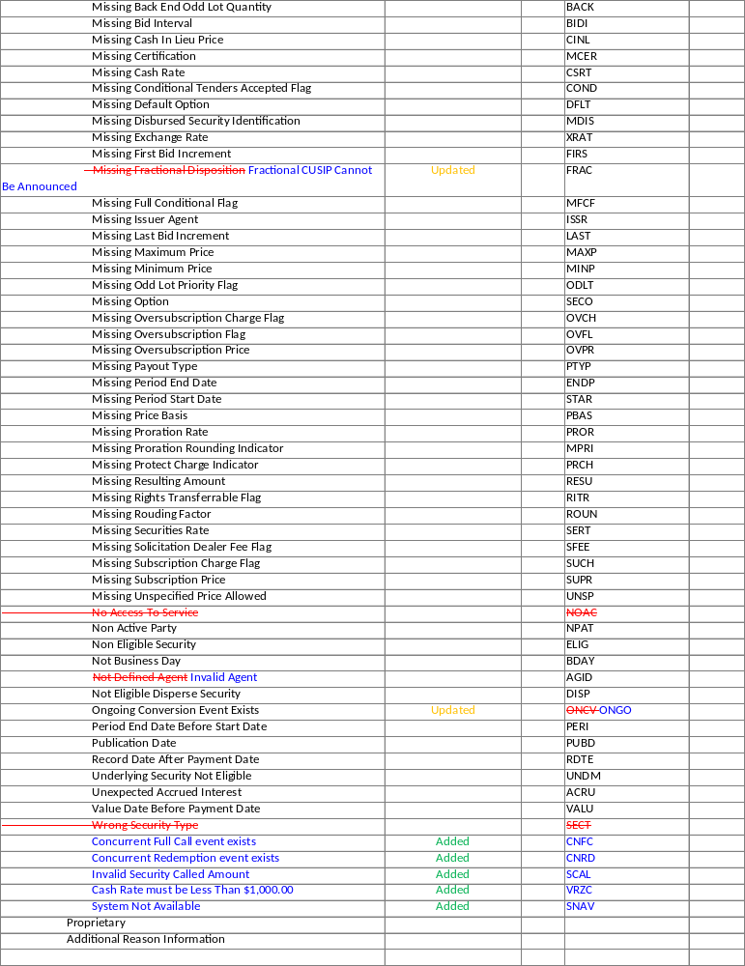
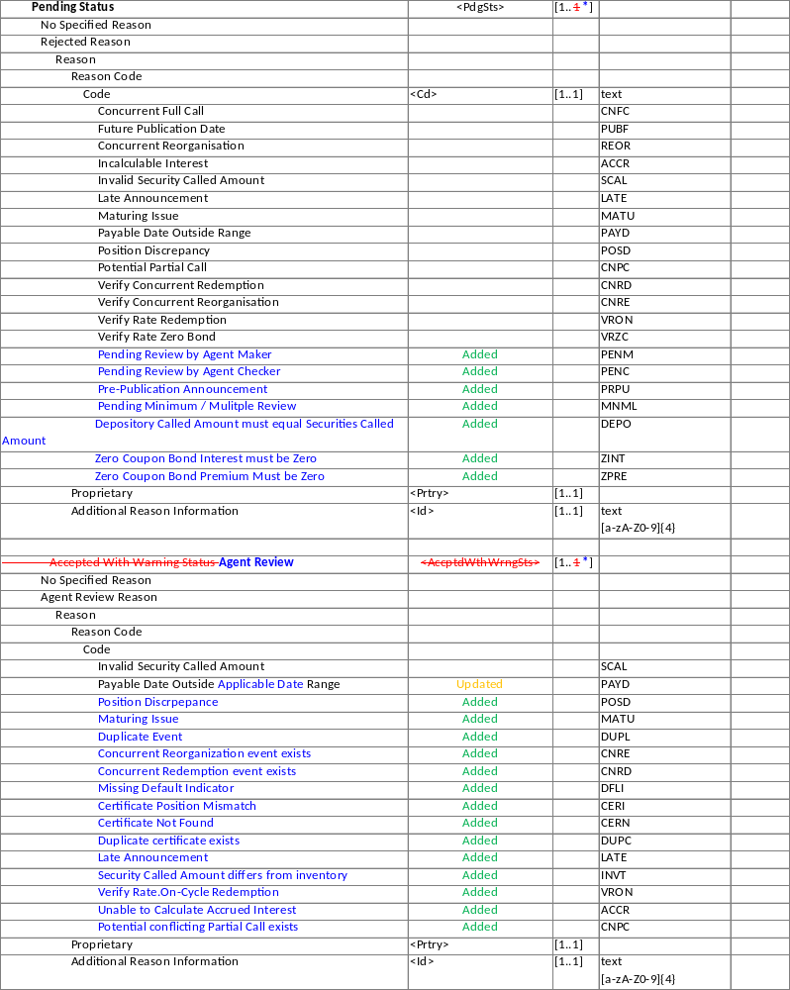

J. Proposed timing:
The submitting organization confirms that it can implement the requested changes in the requested timing.
Timing | As requested

K. Final decision of the SEG(s):
☒ Approve
Comments:
Approved as proposed, without comments. The Securities SEG endorsed the Evaluation Team’s recommendation and implementation solution during the MCR review meeting of 16 September 2026.
☐ Reject
Reason for rejection:
Not applicable.

End of document

