Maintenance Change Request
for the update of ISO 20022 financial repository items

- Name of the request:
CCP Supervisory Reporting 2026/2027
- Submitting organization(s):
Bank of England
- Related messages:
auth.063.001.01 CCPLiquidityStresstestingResultReport01
auth.069.001.03 ClearedProductReportV03
- Commitments of the submitting organization:
The submitting organization must confirm that it can and will:
- undertake the development of the new version of the candidate ISO 20022 message models that it will submit to the RA for compliance review and evaluation. For the ISO 20022 yearly maintenance cycle, new valid Message Definition models must be available to the RA by December 1.
- provide a new version of part 1 of the Message Definition Report (MDR) by December 1, and, optionally, new examples of valid and invalid message instances of each candidate message by May 1 at the latest.
- address any queries related to the description of the new models and messages as published by the RA on the ISO 20022 website.
If the submitting organization cannot develop all or part of the changes included in this Maintenance Change Request in the timeframe agreed by the SEG, it must propose an alternative solution for the change requests it cannot develop in time (eg postpone to a later date or to the next yearly maintenance cycle).
The submitting organization must confirm whether it intends or not to organize any testing or the actual implementation of the new version of the messages once the related documentation has been published by the RA. The purpose is to ensure that the documentation of the new version of the messages is accurate and consistent and to verify that these approved messages can be implemented with no adverse effects on communication infrastructures and/or applications.
The submitting organization must confirm its knowledge and acceptance of the ISO 20022 Intellectual Property Rights policy for contributing organizations, as follows.
“Organizations that contribute information to be incorporated into the ISO 20022 Repository shall keep any Intellectual Property Rights (IPR) they have on this information. A contributing organization warrants that it has sufficient rights on the contributed information to have it published in the ISO 20022 Repository through the ISO 20022 Registration Authority in accordance with the rules set in ISO 20022. To ascertain a widespread, public and uniform use of the ISO 20022 Repository information, the contributing organization grants third parties a non-exclusive, royalty-free license to use the published information”.
The Bank of England agrees to undertake its commitments as submitting organization under ISO 20022

- Contact persons:
John Aveson john.aveson@bankofengland.co.uk
Stephanie Hingston stephanie.hingston@bankofengland.co.uk

Change request number 1608
Copy of the approved change request:
This is a copy of sections A to G of the change request approved by the SEG for further consideration as communicated to the submitting organization by the RA.
- Origin of the request:
A.1 Submitter: Bank of England
A.2 Contact person: John Aveson (john.aveson@bankofengland.co.uk)
A.3 Sponsors: /

- Related messages:
auth.069.001.03 ClearedProductReportV03

- Description of the change request:
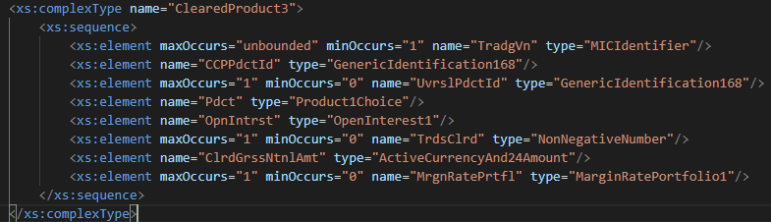
The proposed change is to add to the existing ClearedProduct3 (shown) complex type a new field Backtesting result. This would contain a mandatory Boolean field to indicate if the account is in breach, and if TRUE, the size of the exception. There would additionally be a Description field to elucidate the nature of the portfolio that should be processed for backtesting in order to populate the result.

- Purpose of the change:
Background, business context, community of users interested by the change and expected benefits/savings.
This section must explain why the existing ISO 20022 messages need to be changed. The reason for the update may be a business reason (e.g., evolution of market practice, or creation of new financial instruments), a technical reason (e.g., automation of the business process, or switch from a batch to a real time process), a regulatory reason (introduction, generally mandatory, of new rule/law) or the extension of the user community (newly identified business requirements).
The intent behind the proposed change is to gain visibility of products cleared by the CCP that are particularly prone to backtesting breaches and thus identify potential areas where margin models could be improved.

- Urgency of the request:
Regular

- Business examples:
Examples illustrating the change request.

Cleared Product ID | Is backtesting breach | Exception amount and currency | Description
3M Brent Crude Future | FALSE |  | 1000 barrels
3M Copper Option | TRUE | 10000USD | 25 tonnes

- SEG/TSG recommendation:

☒ Consider
Timing:
☒ Next yearly cycle: 2026/2027
☐ At the occasion of the next maintenance of the messages
☐ Urgent unscheduled
☐ Other timing:

☐ Reject
Reason for rejection:

Comments:

- Impact analysis and type of impact:
This section should describe whether the impact of the change requested will actually be as described in the approved change request. Any additional findings from the submitting organization when analysing the change request should be mentioned here. For example, additional impacted messages, not mentioned in the original change request, or additional required amendments that would have to be made to implement the requested change correctly, or complementary changes proposed by the submitting organisation at the occasion of this maintenance.
The severity of the impact of the proposed change for the message users should be indicated in the table below (either “no impact”, “conditional’ or “mandatory”).

Type of impact
 | No impact | The change(s) will not impact the schema (the version number will not change) and will not impact the business applications of any users, e.g. the clarification of a definition
 | Conditional | The change(s) will impact the schema (at least the version number) and the business applications of certain users but not all, e.g. the addition of an optional component
X | Mandatory | The change(s) will impact the schema and the business applications of all users, e.g. addition of a mandatory component.

- Proposed implementation:
The proposed implementation of this change is shown below:

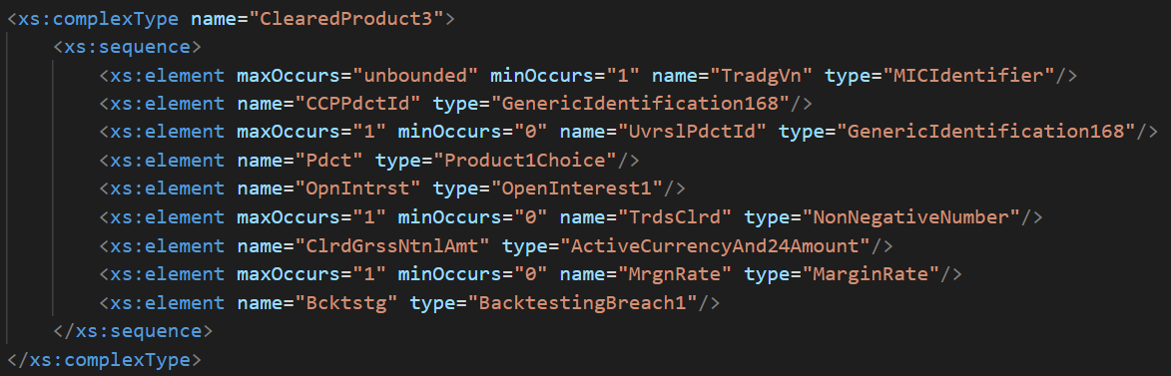

Where the newly introduced BacktestingBreach1 type is as follows:

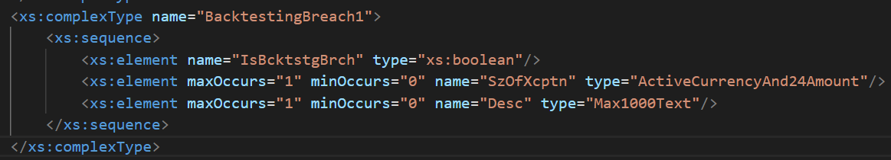
If the product shows a backtesting breach, then the size of the exception and the description of the example position account under test should be populated.

- Proposed timing:

Timing | - As requested
 | - Other:

- Final decision of the SEG(s):
The Securities SubSEG reviewed the implementation proposal and recommends the approval of the CR.

☒ Approve
Comments: The Securities SEG endorsed the Securities SubSEG recommendation and approved the CR for implementation as part of the 2026/2027 maintenance cycle.

Reject
Reason for rejection:

Change request number 1609
Copy of the approved change request:
This is a copy of sections A to G of the change request approved by the SEG for further consideration as communicated to the submitting organization by the RA.
- Origin of the request:
A.1 Submitter: Bank of England
A.2 Contact person: John Aveson
A.3 Sponsors: /

- Related messages:
CCPClearedProductReport (auth.069.001)

- Description of the change request:
The proposed change is to the Position1 element which looks as follows in the present implementation:

<xs:complexType name="Position1">
<xs:sequence>
<xs:element name="PdctId" type="Max256Text"/>
<xs:element maxOccurs="1" minOccurs="0" name="RskRqrmnt" type="EndOfDayRequirement1"/>
<xs:element name="GrssNtnl" type="ActiveCurrencyAnd24Amount"/>
<xs:element name="NetNtnl" type="AmountAndDirection102"/>
<xs:element maxOccurs="1" minOccurs="0" name="GrssDltaEqvtVal" type="ActiveCurrencyAndAmount"/>
<xs:element maxOccurs="1" minOccurs="0" name="NetDltaEqvtVal" type="AmountAndDirection102"/>
<xs:element maxOccurs="1" minOccurs="0" name="GrssDltaEqvtQty" type="NonNegativeFraction5DecimalNumber"/>
<xs:element maxOccurs="1" minOccurs="0" name="NetDltaEqvtQty" type="Fraction5DecimalNumber"/>
<xs:element name="GrssMktVal" type="ActiveCurrencyAndAmount"/>
</xs:sequence>
</xs:complexType>

In order to accommodate a breakdown of the delta information then the proposed change adds a new complex type of DeltaBucket
<xs:complexType name = “DeltaBucket1”>
<xs:element maxOccurs="1" minOccurs="0" name="GrssDltaEqvtVal" type="ActiveCurrencyAndAmount"/>
<xs:element maxOccurs="1" minOccurs="0" name="NetDltaEqvtVal" type="AmountAndDirection102"/>
<xs:element maxOccurs="1" minOccurs="0" name="GrssDltaEqvtQty" type="NonNegativeFraction5DecimalNumber"/>
<xs:element maxOccurs="1" minOccurs="0" name="NetDltaEqvtQty" type="Fraction5DecimalNumber"/>
<xs:element maxOccurs="1" minOccurs="1" name="BucketLabel" type="Max350Text"/>

</xs:complexType>
The updated Position2 would then look as follows:

<xs:complexType name="Position1">
<xs:sequence>
<xs:element name="PdctId" type="Max256Text"/>
<xs:element maxOccurs="1" minOccurs="0" name="RskRqrmnt" type="EndOfDayRequirement1"/>
<xs:element name="GrssNtnl" type="ActiveCurrencyAnd24Amount"/>
<xs:element name="NetNtnl" type="AmountAndDirection102"/>
<xs:element minOccurs="0" name=" DeltaBreakdown" type="DeltaBucket"/>
<xs:element name="GrssMktVal" type="ActiveCurrencyAndAmount"/>
</xs:sequence>
</xs:complexType>

- Purpose of the change:
The proposed change adds the optionality to break down the contributions to gross and net delta of a portfolio by for example the maturity profile of the underlying contracts within the portfolio. This is important for conducting stress testing exercises where steepening or flattening of the yield curve necessitates information broken down by maturity in order to calculate profit and loss experienced by the reported portfolio.

- Urgency of the request:
Regular

- Business examples:
Examples illustrating the change request.

The present implementation, when tabularised looks as follows (for brevity only one set of deltas is shown
PositionAccountId | ProductId | Gross notional | Net notional | Gross delta | Net delta
Acct_1 | Brent_crude_3M | 1000USD | 100USD | 500USD | 200USD

In the proposed implementation, the delta breakdown would be tabularised as follows, with the gross and net delta recovered by summing the breakdown:
PositionAccountId | ProductId | Breakdown label | Gross delta | Net delta
Acct_1 | Brent_crude_3M | 1 month | 200USD | 100USD
Acct_2 | Brent_crude_3M | 3 months | 200USD | 50USD
Acct_3 | Brent_crude_3M | 6 months | 100USD | 50USD

- SEG/TSG recommendation:
☒ Consider
Timing:
☒ Next yearly cycle: 2026/2027
☐ At the occasion of the next maintenance of the messages
☐ Urgent unscheduled
☐ Other timing:

☐ Reject
Reason for rejection:

Comments:

- Impact analysis and type of impact:
This section should describe whether the impact of the change requested will actually be as described in the approved change request. Any additional findings from the submitting organization when analysing the change request should be mentioned here. For example, additional impacted messages, not mentioned in the original change request, or additional required amendments that would have to be made to implement the requested change correctly, or complementary changes proposed by the submitting organisation at the occasion of this maintenance.
The severity of the impact of the proposed change for the message users should be indicated in the table below (either “no impact”, “conditional’ or “mandatory”).

Type of impact
 | No impact | The change(s) will not impact the schema (the version number will not change) and will not impact the business applications of any users, e.g. the clarification of a definition
 | Conditional | The change(s) will impact the schema (at least the version number) and the business applications of certain users but not all, e.g. the addition of an optional component
X | Mandatory | The change(s) will impact the schema and the business applications of all users, e.g. addition of a mandatory component.
- Proposed implementation:
The proposed changes are in line with the change request; the following implementation in the SWIFT Standards Editor tool is as follows:
The DeltaBreakdown1 is a container for the delta information that has been broken down into buckets.
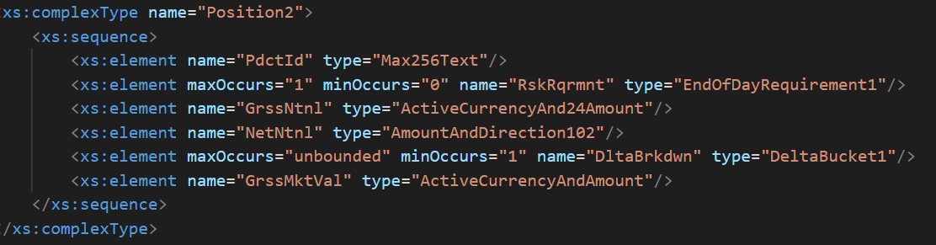
With the new DeltaBucket1 complex type as follows
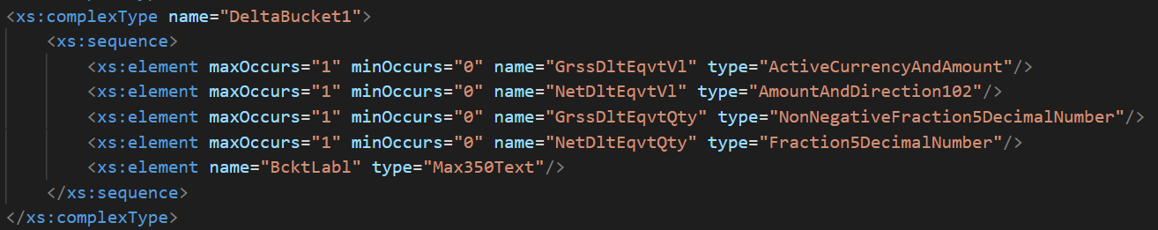
The BcktLabl field is used to enable labelling of the breakdown by categorical groups; the intended purpose is to use this for discrete maturity tenors.
- Proposed timing:

Timing | - As requested
 | - Other:

- Final decision of the SEG(s):
The Securities SubSEG reviewed the implementation proposal and recommends the approval of the CR.

☒ Approve
Comments: The Securities SEG endorsed the Securities SubSEG recommendation and approved the CR for implementation as part of the 2026/2027 maintenance cycle.

Reject
Reason for rejection:

Change request number 1610
Copy of the approved change request:
This is a copy of sections A to G of the change request approved by the SEG for fur
- Origin of the request:
A.1 Submitter: Bank of England
A.2 Contact person: John Aveson
A.3 Sponsors: /

- Related messages:
CCPLiquidityStresstestingResultReport01 (auth.063.001.01)

- Description of the change request:
<xs:complexType name="LiquidityStressTestResult1">
<xs:sequence>
<xs:element name="Id" type="Max256Text"/>
<xs:element name="ScnroDfltrs" type="CoverTwoDefaulters1"/>
<xs:element maxOccurs="6" minOccurs="6" name="LqdtyReqrdAndAvlbl" type="LiquidityRequiredAndAvailable1"/>
</xs:sequence>
</xs:complexType>

The proposed change is to add an optional result description field to this report, so that the results can be labelled to express whether the results correspond to the most severe scenario in terms of liquidity coverage ratio or absolute coverage.

- Purpose of the change:
In the usage of the templates to date, the reporters have included the scenario that provides either the most severe scenario in terms of either liquidity coverage ratio or absolute coverage. However, there are situations where reporters would like to include both results, and so this change enables the result sets to be labelled in terms of which condition they have been included.

- Urgency of the request:
Regular
- Business examples:
Examples illustrating the change request.
 | ScenarioDfltrs
Liquidity Scenario ID | Cover1 | Cover2 | Result type label
Scenario1 | LEI1 | LEI2 | Liquidity Coverage Ratio
Scenario23 | LEI7 | LEI3 | Coverage

- SEG/TSG recommendation:
☒ Consider
Timing:
☒ Next yearly cycle: 2026/2027
☐ At the occasion of the next maintenance of the messages
☐ Urgent unscheduled
☐ Other timing:

☐ Reject
Reason for rejection:

Comments: /

- Impact analysis and type of impact:
The severity of the impact of the proposed change for the message users should be indicated in the table below (either “no impact”, “conditional’ or “mandatory”).

Type of impact
 | No impact | The change(s) will not impact the schema (the version number will not change) and will not impact the business applications of any users, e.g. the clarification of a definition
 | Conditional | The change(s) will impact the schema (at least the version number) and the business applications of certain users but not all, e.g. the addition of an optional component
X | Mandatory | The change(s) will impact the schema and the business applications of all users, e.g. addition of a mandatory component.
- Proposed implementation:
This change is comparatively straightforward and adds a free text field to enable description of the liquidity stress test result set. The proposed implementation is shown below:
Updated implementation: the former v1 implementation diagram is replaced by the revised diagrams below.
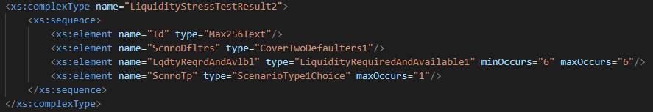
The result set type is expected to correspond either to the scenario that generates the most onerous absolute coverage amount (represented by Coverage) or to the scenario that generates the most onerous liquidity coverage ratio (represented by CoverageRatio). These are enumerated in the ScenarioType2Code.
ScenarioType1Choice complex type offers the option of a text field should another type of scenario be required.
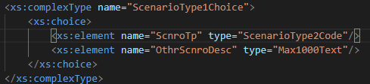
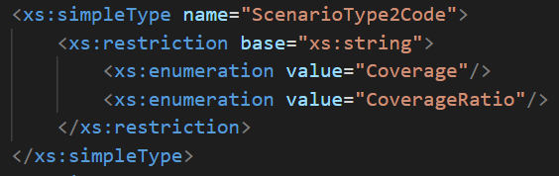

- Proposed timing:
The submitting organization confirms that it can implement the requested changes in the requested timing, or, if not, proposes another timing.

Timing | - As requested
 | - Other:

- Final decision of the SEG(s):
The Securities SubSEG reviewed the implementation proposal and recommends the approval of the CR.

☒ Approve
Comments: The Securities SEG endorsed the Securities SubSEG recommendation and approved the CR for implementation as part of the 2026/2027 maintenance cycle.

Reject
Reason for rejection:

