Maintenance Change Request
for the update of ISO 20022 financial repository items

Table of contents
Change request CR1597: nexo ACQ Add Additional Externally Defined Data 6
Change request CR1611: nexo RET Support Other Merchant Identifiers 12

- Name of the request:
CAPE Maintenance for 2026-2027

- Submitting organization(s):
nexo A.I.S.B.L. formerly (EPASOrg).

- Related messages:
The precise identification of the ISO 20022 messages that will be impacted by the changes included in this Maintenance Change Request, including the Message Ids as shown in the Catalogue of ISO 20022 messages.

Under this maintenance, below existing ISO 20022 message definitions will be maintained (resulting from the impact analysis performed on each CR).

Messages as listed in the CRs submitted originally
Card Payments Exchange – Acceptor to Acquirer message set:
- AcceptorCompletionAdviceResponse V14 (caaa.004.001.14)
- AcceptorCancellationRequest V15 (caaa.005.001.15)
- AcceptorCancellationResponse V14 (caaa.006.001.14)
- AcceptorCancellationAdvice V15 (caaa.007.001.15)
- AcceptorCancellationAdviceResponse V14 (caaa.008.001.14)
- AcceptorBatchTransfer V15 (caaa.011.001.15)
- AcceptorCurrencyConversionAdviceResponse V09 (caaa.019.001.09)
- TransactionAdviceResponse V07 (caaa.021.001.07)
- AcceptorToAcquirerBatchFileExchange V03 (caaa.026.001.03)
- AcquirerToAcceptorBatchFileExchange V03 (caaa.027.001.03)

Messages as listed in the CRs submitted originally but obsoleted due to CR widthdrawal
Card Payments Exchange – Acceptor to Acquirer message set:
- AcceptorAuthorisationRequestV15 (caaa.001.001.15)
- AcceptorAuthorisationResponseV15 (caaa.002.001.15)
- AcceptorCompletionAdviceV15 (caaa.003.001.15)
- AcceptorCompletionAdviceResponseV14 (caaa.004.001.14)
- AcceptorCancellationRequestV15 (caaa.005.001.15)
- AcceptorCancellationResponseV14 (caaa.006.001.14)
- AcceptorCancellationAdviceV15 (caaa.007.001.15)
- AcceptorCancellationAdviceResponseV14 (caaa.008.001.14)
- AcceptorReconciliationRequestV14 (caaa.009.001.14)
- AcceptorReconciliationResponseV13 (caaa.010.001.13)
- AcceptorBatchTransferV15 (caaa.011.001.15)
- AcceptorBatchTransferResponseV14 (caaa.012.001.14)
- AcceptorDiagnosticRequestV14 (caaa.013.001.14)
- AcceptorDiagnosticResponseV13 (caaa.014.001.13)
- AcceptorCurrencyConversionRequestV13 (caaa.016.001.13)
- AcceptorCurrencyConversionResponseV13 (caaa.017.001.13)
- AcceptorCurrencyConversionAdviceV10 (caaa.018.001.10)
- AcceptorCurrencyConversionAdviceResponseV09 (caaa.019.001.09)
- TransactionAdviceV07 (caaa.020.001.07)
- TransactionAdviceResponseV07 (caaa.021.001.07)
- AcceptorNonFincancialRequestV06 (caaa.022.001.06)
- AcceptorNonFincancielResponseV06 (caaa.023.001.06)
- AcceptorTransactionLogReportRequestV06 (caaa.024.001.06)
- AcceptorTransactionLogReportResponseV06 (caaa.025.001.06)
- AcceptorToAcquirerBatchFileExchangeV03 (caaa.026.001.03)
- AcquirerToAcceptorBatchFileExchangeV03 (caaa.027.001.03)

Card Payments Exchange – Terminal Management message set:
- StatusReportV15 (catm.001.001.15)
- ManagementPlanReplacementV14 (catm.002.001.14)
- MaintenanceDelegationRequestV12 (catm.005.001.12)

Card Sale to POI – Merchant to Acceptor message set:
- SaleToPOIServiceRequestV08 (casp.001.001.08)
- SaleToPOIServiceResponseV08 (casp.002.001.08)
- SaleToPOIReconciliationRequestV08 (casp.003.001.08)
- SaleToPOIReconciliationResponseV08 (casp.004.001.08)
- SaleToPOISessionManagementRequestV08 (casp.005.001.08)
- SaleToPOISessionManagementResponseV08 (casp.006.001.08)
- SaleToPOIAdministrativeRequestV08 (casp.007.001.08)
- SaleToPOIAdministrativeResponseV08 (casp.008.001.08)
- SaleToPOIReportRequestV08 (casp.009.001.08)
- SaleToPOIReportResponseV08 (casp.010.001.08)
- SaleToPOIAbortV08 (casp.011.001.08)
- SaleToPOIEventNotificationV08 (casp.012.001.08)
- SaleToPOIMessageStatusRequestV08 (casp.014.001.08)
- SaleToPOIMessageStatusResponseV08 (casp.015.001.08)
- SaleToPOIDeviceRequestV08 (casp.016.001.08)
- SaleToPOIDeviceResponseV08 (casp.017.001.08)

No new messages introduced with this Maintenance Change Request.

- Commitments of the submitting organization:
nexo confirms that it can and will:
- undertake the development of the new version of the candidate ISO 20022 message models that it will submit to the RA for compliance review and evaluation.
- provide a new version of part 1 of the Message Definition Report (MDR) by December 1, and, optionally, new examples of valid and invalid message instances of each candidate message by May 1 at the latest.
- address any queries related to the description of the new models and messages as published by the RA on the ISO 20022 website.
nexo intends to support any testing or the actual implementation of the new version of the messages once the related documentation has been published by the RA. The purpose is to ensure that the documentation of the new version of the messages is accurate and consistent and to verify that these approved messages can be implemented with no adverse effects on communication infrastructures and/or applications.
nexo confirms its knowledge and acceptance of the ISO 20022 Intellectual Property Rights policy for contributing organizations, as follows.
“Organizations that contribute information to be incorporated into the ISO 20022 Repository shall keep any Intellectual Property Rights (IPR) they have on this information. A contributing organization warrants that it has sufficient rights on the contributed information to have it published in the ISO 20022 Repository through the ISO 20022 Registration Authority in accordance with the rules set in ISO 20022. To ascertain a widespread, public and uniform use of the ISO 20022 Repository information, the contributing organization grants third parties a non-exclusive, royalty-free license to use the published information”.

In the analysis made on the following pages, nexo highlights ripple effect through a graphic and component changed by a previous Change Request or by a previous analysis is highlighted in green in every impact analysis.

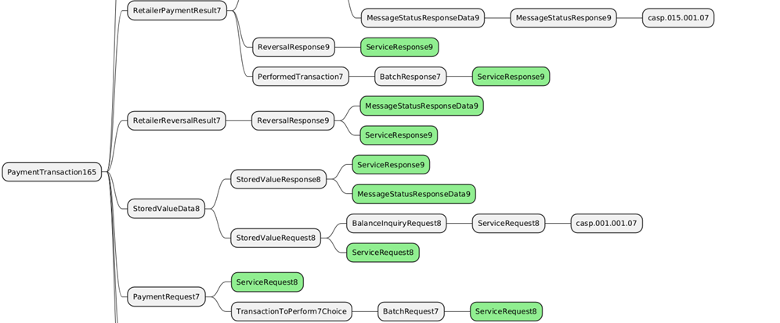
If a ripple effect must not be taken into account, the component will be highlighted in pink as in the following example.
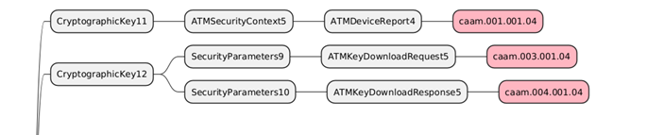
In each chapter devoted to the implementation study, nexo presents the resulting implementation of all Change Request with respect to the legend presented below.
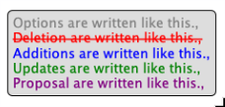

- Contact persons:
To get additional information on this Maintenance Change Request you can contact.
- Catherine BOUNDJIA (catherine.boundjia@nexo-standards.org)

Change request CR1597: nexo ACQ Add Additional Externally Defined Data

- Origin of the request:
A.1 Submitter: nexo A.I.S.B.L.
A.2 Contact person:
- Catherine BOUNDJIA (catherine.boundjia@nexo-standards.org)
- Evelyne de JONGHE (evelyne.de-jonghe@frenchsys.com)
- Philippe MERMOUD (philippe.mermoud@bpce.fr)
A.3 Sponsors: nexo A.I.S.B.L.

- Related messages:
- AcceptorCompletionAdviceResponse V14 (caaa.004.001.14)
- AcceptorCancellationRequest V15 (caaa.005.001.15)
- AcceptorCancellationResponse V14 (caaa.006.001.14)
- AcceptorCancellationAdvice V15 (caaa.007.001.15)
- AcceptorCancellationAdviceResponse V14 (caaa.008.001.14)
- AcceptorBatchTransfer V15 (caaa.011.001.15)
- AcceptorCurrencyConversionAdviceResponse V09 (caaa.019.001.09)
- TransactionAdviceResponse V07 (caaa.021.001.07)
- AcceptorToAcquirerBatchFileExchange V03 (caaa.026.001.03)
- AcquirerToAcceptorBatchFileExchange V03 (caaa.027.001.03)

- Description of the change request:
The change request consists in adding an element Additional Information (type ExternallyDefinedData5) to all Acceptor to Acquirer messages containing the components CardPaymentTransactionAdviceResponse8 and CardPaymentTransactionDetails50.

Update to message component CardPaymentTransactionAdviceResponse8:
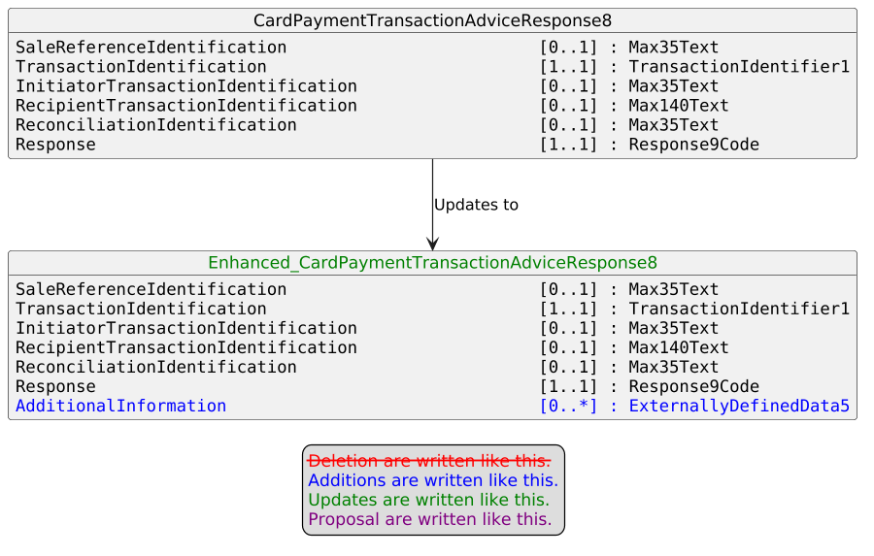

Update to message component CardPaymentTransactionDetails50:
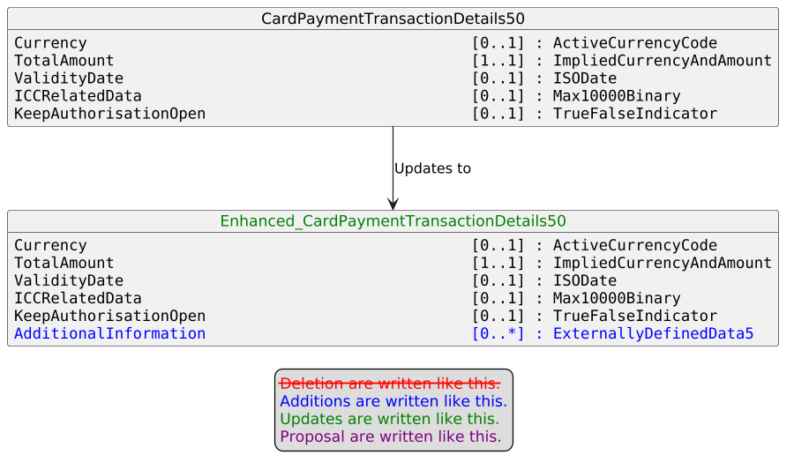

- Purpose of the change:
The change aims to allow the transmission of Additional Information related to the transaction, such as an invoice or industry data (for example, hospitality, lodging, transportation) exchanged according to an external standard.

- Urgency of the request:
Urgent.

- Business examples:
Examples illustrating the change request.

- SEG/TSG recommendation:
This section is not to be taken care of by the submitter of the change request. It will be completed in due time by the SEG(s) in charge of the related ISO 20022 messages or the TSG for changes related to the BAH.

Consider |  | X | Timing
 |  |  | - Next yearly cycle: 2026/2027  (the change will be considered for implementation in the yearly maintenance cycle which starts in 2026 and completes with the publication of new message versions in the spring of 2027) |  | X
- At the occasion of the next maintenance of the messages
(the change will be considered for implementation, but does not justify maintenance of the messages in its own right – will be pending until more critical change requests are received for the messages)
- Urgent unscheduled
(the change justifies an urgent implementation outside of the normal yearly cycle)
 |  |  | - Other timing:
Comments:

Reject
Reason for rejection:

- Impact analysis and type of impact:
No additional messages are impacted on top of those listed in the CR submitted originally.
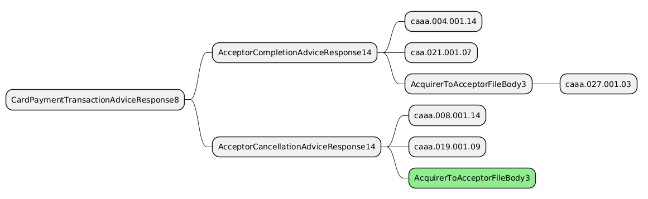

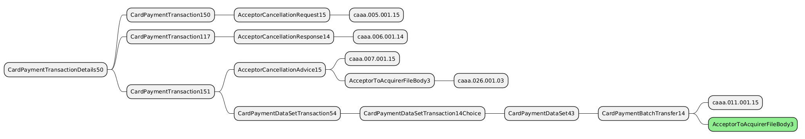
The severity of the impact of the proposed change for the message users should be indicated in the table below (either “no impact”, “conditional’ or “mandatory”).
Type of impact
 | No impact | The change(s) will not impact the schema (the version number will not change) and will not impact the business applications of any users, e.g. the clarification of a definition
X | Conditional | The change(s) will impact the schema (at least the version number) and the business applications of certain users but not all, e.g. the addition of an optional component
 | Mandatory | The change(s) will impact the schema and the business applications of all users, e.g. addition of a mandatory component.

- Proposed implementation:
The modification will be done accordingly to the description provided by the Change Request.

Update to message component CardPaymentTransactionAdviceResponse8:

Update to message component CardPaymentTransactionDetails50:

- Proposed timing:
The submitting organization proposes that the requested changes be implemented within the requested timing, or, if not, proposes another timing.

Timing | - As requested
 | - Other:

- Final decision of the SEG(s):
This section is not to be taken care of by the submitting organization. It will be completed in due time by the SEG(s) in charge of the related ISO 20022 messages.
Approve
Comments:

Reject
Reason for rejection:

Change request CR1611: nexo RET Support Other Merchant Identifiers

- Origin of the request:
A.1 Submitter: nexo A.I.S.B.L.
A.2 Contact person:
- Catherine BOUNDJIA (catherine.boundjia@nexo-standards.org)
- Normand PROVOST (normand.provost@nexo-standards.org)
A.3 Sponsors: nexo A.I.S.B.L.

- Related messages:

Acceptor to Acquirer:
- AcceptorAuthorisationRequestV15 (caaa.001.001.15)
- AcceptorAuthorisationResponseV15 (caaa.002.001.15)
- AcceptorCompletionAdviceV15 (caaa.003.001.15)
- AcceptorCompletionAdviceResponseV14 (caaa.004.001.14)
- AcceptorCancellationRequestV15 (caaa.005.001.15)
- AcceptorCancellationResponseV14 (caaa.006.001.14)
- AcceptorCancellationAdviceV15 (caaa.007.001.15)
- AcceptorCancellationAdviceResponseV14 (caaa.008.001.14)
- AcceptorReconciliationRequestV14 (caaa.009.001.14)
- AcceptorReconciliationResponseV13 (caaa.010.001.13)
- AcceptorBatchTransferV15 (caaa.011.001.15)
- AcceptorBatchTransferResponseV14 (caaa.012.001.14)
- AcceptorDiagnosticRequestV14 (caaa.013.001.14)
- AcceptorDiagnosticResponseV13 (caaa.014.001.13)
- AcceptorCurrencyConversionRequestV13 (caaa.016.001.13)
- AcceptorCurrencyConversionResponseV13 (caaa.017.001.13)
- AcceptorCurrencyConversionAdviceV10 (caaa.018.001.10)
- AcceptorCurrencyConversionAdviceResponseV09 (caaa.019.001.09)
- TransactionAdviceV07 (caaa.020.001.07)
- TransactionAdviceResponseV07 (caaa.021.001.07)
- AcceptorNonFincancialRequestV06 (caaa.022.001.06)
- AcceptorNonFincancielResponseV06 (caaa.023.001.06)
- AcceptorTransactionLogReportRequestV06 (caaa.024.001.06)
- AcceptorTransactionLogReportResponseV06 (caaa.025.001.06)
- AcceptorToAcquirerBatchFileExchangeV03 (caaa.026.001.03)
- AcquirerToAcceptorBatchFileExchangeV03 (caaa.027.001.03)

Terminal Management:
- StatusReportV15 (catm.001.001.15)
- ManagementPlanReplacementV14 (catm.002.001.14)
- MaintenanceDelegationRequestV12 (catm.005.001.12)

Sale to POI:
- SaleToPOIServiceRequestV08 (casp.001.001.08)
- SaleToPOIServiceResponseV08 (casp.002.001.08)
- SaleToPOIReconciliationRequestV08 (casp.003.001.08)
- SaleToPOIReconciliationResponseV08 (casp.004.001.08)
- SaleToPOISessionManagementRequestV08 (casp.005.001.08)
- SaleToPOISessionManagementResponseV08 (casp.006.001.08)
- SaleToPOIAdministrativeRequestV08 (casp.007.001.08)
- SaleToPOIAdministrativeResponseV08 (casp.008.001.08)
- SaleToPOIReportRequestV08 (casp.009.001.08)
- SaleToPOIReportResponseV08 (casp.010.001.08)
- SaleToPOIAbortV08 (casp.011.001.08)
- SaleToPOIEventNotificationV08 (casp.012.001.08)
- SaleToPOIMessageStatusRequestV08 (casp.014.001.08)
- SaleToPOIMessageStatusResponseV08 (casp.015.001.08)
- SaleToPOIDeviceRequestV08 (casp.016.001.08)
- SaleToPOIDeviceResponseV08 (casp.017.001.08)

- Description of the change request:

The change request aims to enable the identification of the merchant performing a payment transaction using a unique and unambiguous identification assigned by a recognized identification scheme.

We want to update to the message component GenericIdentification192 used to define the Environment.Merchant.Identification data element.
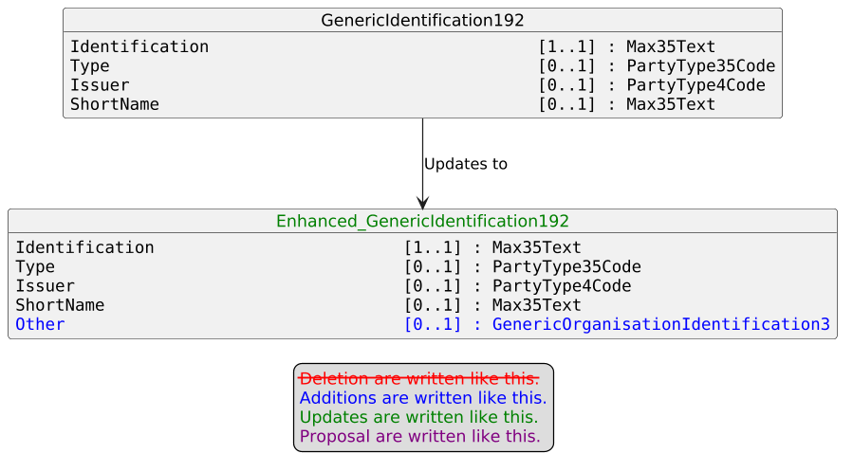

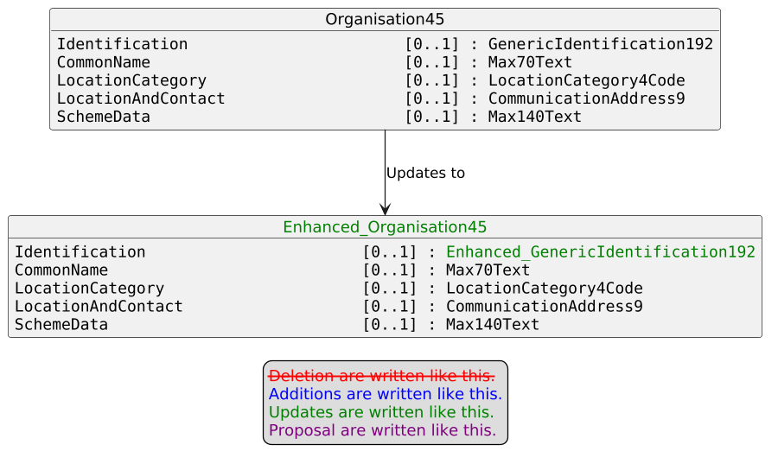

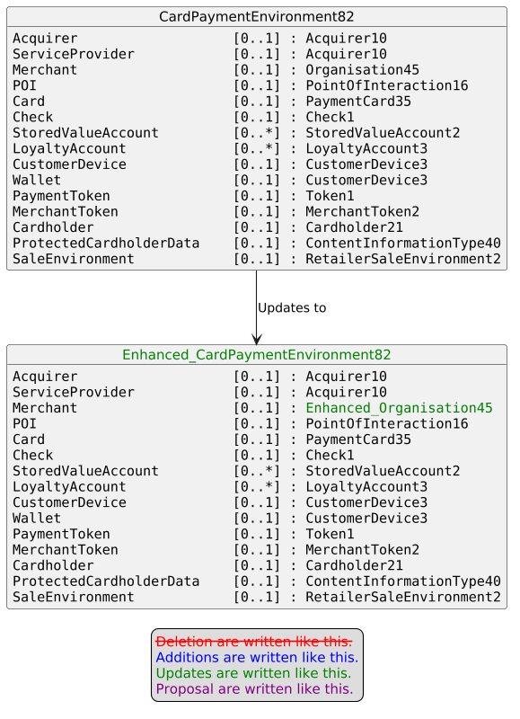

- Purpose of the change:

nexo A.I.S.B.L. is an international organization whose mission is to define, publish and promote global payment acceptance standards based on ISO 20022 and supporting services that ensure interoperability between acceptance and acquiring solutions, integrated retail and terminal management systems.
nexo is working closely with major retail industry players to address their challenges and bridge the gap for the adoption of ISO 20022. More specifically, a need has been identified to the GLN (Global Location Number) to identify the merchant performing the payment transaction. The GLN is an identifier defined by the global standards organization GS1 and is commonly used in many industries to uniquely identify physical locations and functional entities (e.g., stores, warehouses, delivery addresses, legal entities or business functions).
The change request allows a merchant to be identified using an organisation identification assigned by an identification scheme, such as GS1. The proposed approach aligns with common practice in other ISO 20022 business domains — for example, FinancialInstitutionIdentification supports the BIC, the LEI or other identifiers) — and ensures interoperability, traceability and data quality.

We want to reuse the existing message component GenericOrganisationIdentification3 defined as follows:
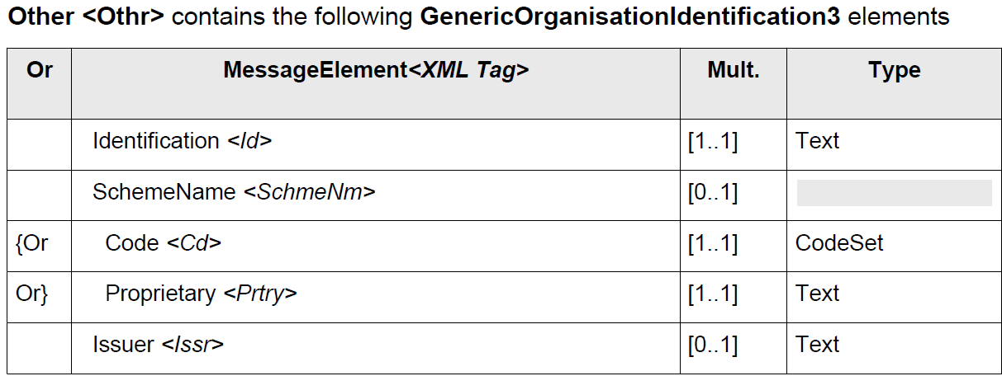

The ISO 20022 Inventory of External Code Sets provides a standardized definition of identification scheme using the ExternalOrganisationIdentification1Coded (see example below).

Code Value | Code Name | Code Definition
GS1G | GS1GLNIdentifier | Global Location Number. A non-significant reference number used to identify legal entities, functional entities, or physical entities according to GS1 numbering scheme rules. The number is used to retrieve detailed information that is linked to it.

- Urgency of the request:
Urgent.

- Business examples:
Examples illustrating the change request.

- SEG/TSG recommendation:
This section is not to be taken care of by the submitter of the change request. It will be completed in due time by the SEG(s) in charge of the related ISO 20022 messages or the TSG for changes related to the BAH.

Consider |  | X | Timing
 |  |  | - Next yearly cycle: 2026/2027  (the change will be considered for implementation in the yearly maintenance cycle which starts in 2026 and completes with the publication of new message versions in the spring of 2027) |  | X
- At the occasion of the next maintenance of the messages
(the change will be considered for implementation, but does not justify maintenance of the messages in its own right – will be pending until more critical change requests are received for the messages)
- Urgent unscheduled
(the change justifies an urgent implementation outside of the normal yearly cycle)
 |  |  | - Other timing:
Comments:

Reject
Reason for rejection:

- Impact analysis and type of impact:
No additional messages are impacted on top of those listed in the CR submitted originally.
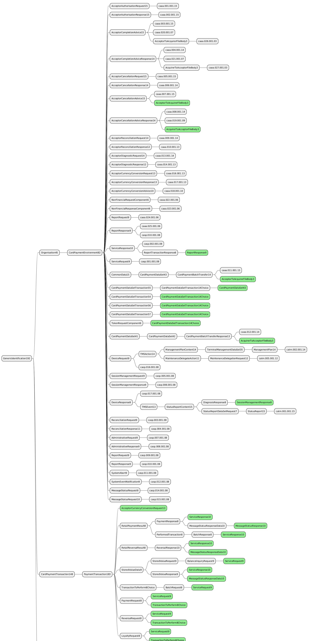
- Proposed implementation:
The submitting organization has decided to withdraw the Change Request from the current yearly maintenance cycle (2026–2027).

- Proposed timing:
The submitting organization proposes that the requested changes be implemented within the requested timing, or, if not, proposes another timing.

Timing | - As requested
 | - Other: Postponed to a future maintenance cycle.

- Final decision of the SEG(s):
This section is not to be taken care of by the submitting organization. It will be completed in due time by the SEG(s) in charge of the related ISO 20022 messages.
Approve
Comments:

Reject
Reason for rejection:

