Maintenance Change Requests
for the update of ISO 20022 financial repository items

Name of the request:
Payments Maintenance 2026/2027

Submitting organization(s):
Swift

Standards Department,
Avenue Adele, 1
1310 La Hulpe – Belgium

Related messages:
Under this maintenance, below existing ISO 20022 message definitions will be maintained (resulting from the impact analysis performed on each CR).

Bank Account Management:

acmt.007.001.05  acmt.008.001.05  acmt.009.001.04  acmt.010.001.04  acmt.011.001.04  acmt.012.001.04  acmt.013.001.04  acmt.014.001.05  acmt.015.001.05  acmt.016.001.05  acmt.017.001.05  acmt.018.001.05  acmt.019.001.04  acmt.020.001.04  acmt.021.001.04 | AccountOpeningRequestV05  AccountOpeningAmendmentRequestV05  AccountOpeningAdditionalInformationRequestV04  AccountRequestAcknowledgementV04  AccountRequestRejectionV04  AccountAdditionalInformationRequestV04  AccountReportRequestV04  AccountReportV05  AccountExcludedMandateMaintenanceRequestV05  AccountExcludedMandateMaintenanceAmendmentRequestV05  AccountMandateMaintenanceRequestV05  AccountMandateMaintenanceAmendmentRequestV05  AccountClosingRequestV04  AccountClosingAmendmentRequestV04  AccountClosingAdditionalInformationRequestV04

Bank-to-Customer Cash Management (previously under the responsibility of ISTH):
camt.052.001.14 | BankToCustomerAccountReportV14
camt.053.001.14 | BankToCustomerStatementV14
camt.054.001.14  camt.060.001.07 | BankToCustomerDebitCreditNotificationV14  AccountReportingRequestV07

Cash Management:
camt.003.001.08  camt.004.001.10  camt.005.001.11  camt.006.001.11  camt.007.001.10  camt.008.001.11  camt.009.001.08  camt.010.001.09  camt.011.001.08  camt.012.001.08  camt.024.001.08  camt.025.001.09  camt.046.001.08  camt.047.001.08  camt.048.001.07  camt.049.001.07  camt.050.001.07  camt.051.001.07 | GetAccountV08  ReturnAccountV10  GetTransactionV11  ReturnTransactionV11  ModifyTransactionV10  CancelTransactionV11  GetLimitV08  ReturnLimitV09  ModifyLimitV08  DeleteLimitV08  ModifyStandingOrderV08  ReceiptV09  GetReservationV08  ReturnReservationV08  ModifyReservationV07  DeleteReservationV07  LiquidityCreditTransferV07  LiquidityDebitTransferV07

Cash Deposit and Cash Withdrawal Requests:
camt.113.001.01 | CashDepositRequestV01
camt.114.001.01 | CashWithdrawalRequestV01
camt.115.001.01  camt.116.001.01 | CashDepositOrWithdrawalStatusUpdateV01  CashDepositOrWithdrawalCancellationRequest V01

Charges Management:
camt.105.001.03 | ChargesPaymentNotificationV03
camt.106.001.03 | ChargesPaymentRequestV03
Cheques Management:
camt.107.001.02 | ChequePresentmentNotificationV02
camt.108.001.02  camt.109.001.02 | ChequeCancellationOrStopRequestV02  ChequeCancellationOrStopReportV02

Exceptions and Investigation:
camt.029.001.14  camt.055.001.13 | ResolutionOfInvestigationV14  CustomerPaymentCancellationRequestV13
camt.056.001.12 | FIToFIPaymentCancellationRequestV12

Multilateral Settlement:
pacs.002.001.16 FIToFIPaymentStatusReportV16

Notification Of Correspondence
admi.024.001.01 NotificationOfCorrespondenceV01

Notification To Receive
camt.057.001.09 | NotificationToReceiveV09
camt.058.001.10 | NotificationToReceiveCancellationAdviceV10
camt.059.001.09 | NotificationToReceiveStatusReportV09

Payments, Clearing and Settlement:
pacs.002.001.16 | FIToFIPaymentStatusReportV16
pacs.003.001.12 | FIToFICustomerDirectDebitV12
pacs.004.001.15 | PaymentReturnV15
pacs.007.001.14 | FIToFIPaymentReversalV14
pacs.008.001.14 | FIToFICustomerCreditTransferV14
pacs.009.001.13  pacs.010.001.06 | FinancialInstitutionCreditTransferV13  FinancialInstitutionDirectDebitV06
pacs.028.001.07 | FIToFIPaymentStatusRequestV07
Payment Initiation:
pain.001.001.13 | CustomerCreditTransferInitiationV13
pain.002.001.15 | CustomerPaymentStatusReportV15
pain.007.001.13 | CustomerPaymentReversalV13
pain.008.001.12 | CustomerDirectDebitInitiationV12

Payment Mandates:
pain.009.001.08 | MandateInitiationRequestV08
pain.010.001.08 | MandateAmendmentRequestV08
pain.011.001.08 | MandateCancellationRequestV08
pain.012.001.08  pain.017.001.04  pain.018.001.04 | MandateAcceptanceReportV08  MandateCopyRequestV04  MandateSuspensionRequestV04

Payment Tracking:
trck.001.001.05 | PaymentStatusTrackerUpdateV05
trck.002.001.04 | PaymentStatusTrackerReportV04
trck.004.001.04 | PaymentStatusCustomerTrackerReportV04

Message sets impacted not under responsibility of Swift:

Account Switching message set (under the responsibility of Payments UK):
acmt.027.001.06 | AccountSwitchInformationRequestV06
acmt.028.001.06 | AccountSwitchInformationResponseV06
acmt.029.001.06  acmt.030.001.04 | AccountSwitchCancelExistingPaymentV06  AccountSwitchRequestRedirectionV04
acmt.031.001.06 | AccountSwitchRequestBalanceTransferV06
acmt.032.001.06 | AccountSwitchBalanceTransferAcknowledgementV06
acmt.034.001.06 | AccountSwitchRequestPaymentV06

Authorities Financial Investigations message set (under the responsibility of Finance Finland):
auth.001.001.02  auth.002.001.02 | InformationRequestOpeningV02  InformationRequestResponseV02

Change/Verify Account Identification message set (under the responsibility of GUF):
acmt.022.001.04 IdentificationModificationAdviceV04
acmt.023.001.04 IdentificationVerificationRequestV04
acmt.024.001.04 IdentificationVerificationReportV04

Creditor Payment Activation Request message set (under the responsibility of CBI):
pain.013.001.12 | CreditorPaymentActivationRequestV12
pain.014.001.12 | CreditorPaymentActivationRequestStatusReportV12

Note: SWIFT will implement the changes on behalf of CBI for this message set, if accepted.
Cross-Border Transaction Currency Control Reporting message set (under the responsibility of RU-CMPG):
auth.018.001.04  auth.019.001.04  auth.020.001.04  auth.021.001.04  auth.022.001.04  auth.023.001.04  auth.024.001.04  auth.025.001.04  auth.026.001.04  auth.027.001.04 | ContractRegistrationRequestV04  ContractRegistrationConfirmationV04  ContractRegistrationClosureRequestV04  ContractRegistrationAmendmentRequestV04  ContractRegistrationStatementV04  ContractRegistrationStatementRequestV04  PaymentRegulatoryInformationNotificationV04  CurrencyControlSupportingDocumentDeliveryV04  CurrencyControlRequestOrLetterV04  CurrencyControlStatusAdviceV04

Exceptions and Investigation – Modernisation (under the responsibility of
PaySEG E&I work group):
camt.110.001.02 | InvestigationRequestV02
camt.111.001.03 | InvestigationResponseV03

Note: SWIFT will implement the changes on behalf of PaySEG E&I work group for this message set, if accepted.

Multilateral Settlement message set (under the responsibility of Bank of England):
pacs.029.001.02 | MultilateralSettlementV02

Request To Pay (RTP) Service (under the responsibility of EPC):
reda.066.001.02  reda.067.001.02  reda.068.001.02  reda.069.001.02  reda.070.001.02  reda.071.001.02  reda.072.001.02  reda.073.001.02 | RequestToPayCreditorEnrolmentRequestV02  RequestToPayCreditorEnrolmentAmendmentRequestV02  RequestToPayCreditorEnrolmentCancellationRequestV02  RequestToPayCreditorEnrolmentStatusReportV02  RequestToPayDebtorActivationRequestV02  RequestToPayDebtorActivationAmendmentRequestV02  RequestToPayDebtorActivationCancellationRequestV02  RequestToPayDebtorActivationStatusReportV02

Stand-Alone Remittance Advice (under the responsibility of IFX/OAGi):
remt.001.001.06  remt.002.001.03 | RemittanceAdviceV06  RemittanceLocationAdviceV03

Commitments of the submitting organization:
The submitting organization must confirm that it can and will:
- undertake the development of the new version of the candidate ISO 20022 message models that it will submit to the RA for compliance review and evaluation. For the ISO 20022 yearly maintenance cycle, new valid Message Definition models must be available to the RA by December 1.
- provide a new version of part 1 of the Message Definition Report (MDR) by December 1, and, optionally, new examples of valid and invalid message instances of each candidate message by May 1 at the latest.
- address any queries related to the description of the new models and messages as published by the RA on the ISO 20022 website.
If the submitting organization cannot develop all or part of the changes included in this Maintenance Change Request in the timeframe agreed by the SEG, it must propose an alternative solution for the change requests it cannot develop in time (e.g. postpone to a later date or to the next yearly maintenance cycle).
The submitting organization must confirm whether it intends or not to organize any testing or the actual implementation of the new version of the messages once the related documentation has been published by the RA. The purpose is to ensure that the documentation of the new version of the messages is accurate and consistent and to verify that these approved messages can be implemented with no adverse effects on communication infrastructures and/or applications.
The submitting organization must confirm its knowledge and acceptance of the ISO 20022 Intellectual Property Rights policy for contributing organizations, as follows.
“Organizations that contribute information to be incorporated into the ISO 20022 Repository shall keep any Intellectual Property Rights (IPR) they have on this information. A contributing organization warrants that it has sufficient rights on the contributed information to have it published in the ISO 20022 Repository through the ISO 20022 Registration Authority in accordance with the rules set in ISO 20022. To ascertain a widespread, public and uniform use of the ISO 20022 Repository information, the contributing organization grants third parties a non-exclusive, royalty-free license to use the published information”.

Contact persons:
The contacted to get additional information on this Maintenance Change Request.

Rochell Ntow - SWIFT Standards, rochell.ntow@swift.com
Gregory Mestdag – SWIFT Standards, gregory.mestdag@swift.com

Change request number 1577
Multiplicity Changes to Date & Place of Birth

Origin of the request
A.1 Submitter: European Payments Council.

A.2 Contact person: Christophe Godefroi, Christophe.godefroi@epc-cep.eu, + 32 2 739 16 93

A.3 Sponsors: The payment service providers (PSPs) community of SEPA (Single Euro Payments Area)

Related messages
camt.029.001.14  camt.052.001.14  camt.053.001.14  camt.054.001.14  camt.056.001.12  pacs.002.001.16  pacs.003.001.12  pacs.004.001.15  pacs.007.001.14  pacs.008.001.14  pacs.028.001.07  pain.001.001.13  pain.002.001.15  pain.007.001.13  pain.008.001.12  pain.009.001.08  pain.010.001.08  pain.011.001.08  pain.012.001.08 | ResolutionOfInvestigationV14  BankToCustomerAccountReportV14  BankToCustomerStatementV14  BankToCustomerDebitCreditNotificationV14  FIToFIPaymentCancellationRequestV12  FIToFIPaymentStatusReportV16  FIToFICustomerDirectDebitV12  PaymentReturnV15  FIToFIPaymentReversalV14  FIToFICustomerCreditTransferV14  FIToFIPaymentStatusRequestV07  CustomerCreditTransferInitiationV13  CustomerPaymentStatusReportV15  CustomerPaymentReversalV13  CustomerDirectDebitInitiationV12  MandateInitiationRequestV08  MandateAmendmentRequestV08  MandateCancellationRequestV08  MandateAcceptanceReportV08

Description of the change request
The change request relates to the ‘Date And Place Of Birth’ message element and is, in principle, limited to the Debtor element in line with the updated Recommendation 16 of the Financial Action Task Force (FATF) on Payment Transparency (please see section D).
Currently if ‘Date and Place of Birth’ is used under ‘Private Identification’, the elements ‘Birth Date’, ‘City of Birth’ and ‘Country of Birth’ are all mandatory (please see below – based on pacs.008.001.14).

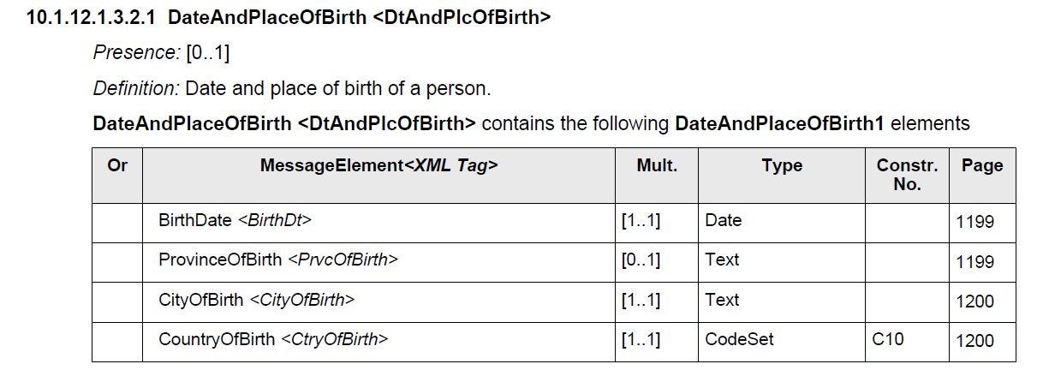

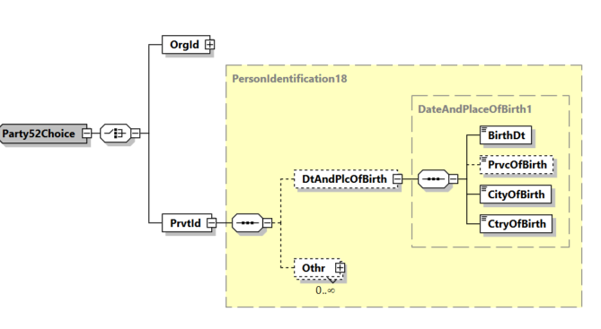
This change request proposes to make elements ‘City of Birth’ and ‘Country of Birth‘ optional under ‘Debtor/Identification/PrivateIdentification/DateAndPlaceOfBirth’ as follows (changes are highlighted in green) and to include a new rule related to ‘Country of Birth’.

DateAndPlaceOfBirth <DtAndPlcOfBirth>
Presence: [0..1]
Definition: Date and place of birth of a person.
DateAndPlaceOfBirth <DtAndPlcOfBirth> contains the following DateAndPlaceOfBirth1 elements

Or | MessageElement<XML Tag> | Mult. | Type | Constr. No. | Page
 | BirthDate <BirthDt> | [1..1] | Date |  | 1199
 | ProvinceOfBirth <PrvcOfBirth> | [0..1] | Text |  | 1199
 | CityOfBirth <CityOfBirth> | [0..1] | Text |  | 1200
 | CountryOfBirth <CtryOfBirth> | [0..1] | CodeSet | C10, CDD | 1200

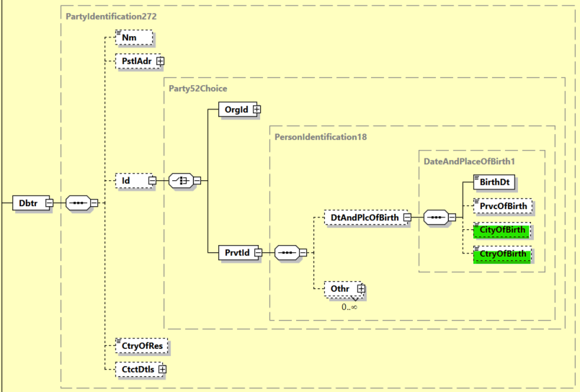
New rule CDD: CtryOfBirth
If ‘City of Birth’ is present, then ‘Country of Birth’ must be present.

Purpose of the change:

The updated Recommendation 16 of the Financial Action Task Force (FATF) on Payment Transparency stipulates that cross-border payments and value transfers above a de minimis threshold (of USD/EUR 1.000) must always contain the Date Of Birth (DoB) of the originator (but no longer a Place of Birth) when the originator is a natural person.
In view of the aforementioned FATF Recommendation, the request is to make elements ‘City of Birth’ and ‘Country of Birth‘ optional under ‘Debtor/Identification/Private Identification/Date And Place Of Birth’.

Further information about FATF Recommendation 16 can be found here: https://www.fatf-gafi.org/en/publications/Fatfrecommendations/update-Recommendation-16-payment-transparency-june-2025.html

Urgency of the request:
The change request is to be included in the 2026-2027 maintenance cycle.

Business Examples:
The Debtor Agent sends a pacs.008 message to the Creditor Agent, in which the Debtor is a natural person ‘John Doe’ from Brussels, born on 1 January 1985 :

<Dbtr>
<Nm>John Doe</Nm>
<PstlAdr>
<TwnNm>Brussels</TwnNm>
<Ctry>BE</Ctry>
</PstlAdr>
<Id>
<PrvtId>
<DtAndPlcOfBirth>
<BirthDt>1985-01-01</BirthDt>
</DtAndPlcOfBirth>
</PrvtId>
</Id>
</Dbtr>

SEG/TSG recommendation:
This section is not to be taken care of by the submitter of the change request. It will be completed in due time by the SEG(s) in charge of the related ISO 20022 messages or the TSG for changes related to the BAH.

Consider |  | X | Timing
 |  |  | - Next yearly cycle: 2026/2027  (the change will be considered for implementation in the yearly maintenance cycle which starts in 2026 and completes with the publication of new message versions in the spring of 2027) |  | X
- At the occasion of the next maintenance of the messages
(the change will be considered for implementation, but does not justify maintenance of the messages in its own right – will be pending until more critical change requests are received for the messages)
- Urgent unscheduled
(the change justifies an urgent implementation outside of the normal yearly cycle)
 |  |  | - Other timing:
Comments:

Reject
Reason for rejection:

Impact analysis and type of impact:
The following Message Identifiers will be impacted –
acmt.007.001.05  acmt.008.001.05  acmt.009.001.04  acmt.010.001.04  acmt.011.001.04  acmt.012.001.04  acmt.013.001.04  acmt.014.001.05  acmt.015.001.05  acmt.016.001.05  acmt.017.001.05  acmt.018.001.05  acmt.019.001.04  acmt.020.001.04  acmt.021.001.04  acmt.022.001.04  acmt.023.001.04  acmt.024.001.04  acmt.027.001.06  acmt.028.001.06  acmt.029.001.06  acmt.030.001.04  acmt.031.001.06  acmt.032.001.06  acmt.033.001.02  acmt.034.001.06  auth.001.001.02  auth.002.001.02  auth.018.001.04  auth.019.001.04  auth.020.001.04  auth.021.001.04  auth.022.001.04  auth.023.001.04  auth.024.001.04  auth.025.001.04  auth.026.001.04  auth.027.001.04  camt.003.001.08  camt.004.001.10  camt.005.001.11  camt.006.001.11  camt.008.001.11  camt.025.001.09  camt.029.001.14  camt.052.001.14  camt.053.001.14  camt.054.001.14  camt.055.001.13  camt.056.001.12  camt.057.001.09  camt.058.001.10  camt.059.001.09  camt.060.001.07  camt.105.001.03  camt.106.001.03  camt.107.001.02  camt.108.001.02  camt.109.001.02  camt.110.001.02  camt.111.001.03  camt.113.001.01  camt.114.001.01  camt.115.001.01  camt.116.001.01  pacs.002.001.16  pacs.003.001.12  pacs.004.001.15  pacs.007.001.14  pacs.008.001.14  pacs.009.001.13  pacs.028.001.07  pacs.029.001.02  pain.001.001.14  pain.002.001.16  pain.007.001.14  pain.008.001.13  pain.009.001.09  pain.010.001.09  pain.011.001.09  pain.012.001.09  pain.013.001.13  pain.014.001.13  pain.017.001.05  pain.018.001.05  reda.066.001.02  reda.067.001.02  reda.068.001.02  reda.069.001.02  reda.070.001.02  reda.071.001.02  reda.072.001.02  reda.073.001.02  remt.001.001.07  remt.002.001.03  trck.001.001.05  trck.002.001.04  trck.004.001.04 | AccountOpeningRequestV05  AccountOpeningAmendmentRequestV05  AccountOpeningAdditionalInformationRequestV04  AccountRequestAcknowledgementV04  AccountRequestRejectionV04  AccountAdditionalInformationRequestV04  AccountReportRequestV04  AccountReportV05  AccountExcludedMandateMaintenanceRequestV05  AccountExcludedMandateMaintenanceAmendmentRequestV05  AccountMandateMaintenanceRequestV05  AccountMandateMaintenanceAmendmentRequestV05  AccountClosingRequestV04  AccountClosingAmendmentRequestV04  AccountClosingAdditionalInformationRequestV04  IdentificationModificationAdviceV04  IdentificationVerificationRequestV04  IdentificationVerificationReportV04  AccountSwitchInformationRequestV06  AccountSwitchInformationResponseV06  AccountSwitchCancelExistingPaymentV06  AccountSwitchRequestRedirectionV04  AccountSwitchRequestBalanceTransferV06  AccountSwitchBalanceTransferAcknowledgementV06  AccountSwitchNotifyAccountSwitchCompleteV02  AccountSwitchRequestPaymentV06  InformationRequestOpeningV02  InformationRequestResponseV02  ContractRegistrationRequestV04  ContractRegistrationConfirmationV04  ContractRegistrationClosureRequestV04  ContractRegistrationAmendmentRequestV04  ContractRegistrationStatementV04  ContractRegistrationStatementRequestV04  PaymentRegulatoryInformationNotificationV04  CurrencyControlSupportingDocumentDeliveryV04  CurrencyControlRequestOrLetterV04  CurrencyControlStatusAdviceV04  GetAccountV08  ReturnAccountV10  GetTransactionV11  ReturnTransactionV11  CancelTransactionV11  ReceiptV09  ResolutionOfInvestigationV14  BankToCustomerAccountReportV14  BankToCustomerStatementV14  BankToCustomerDebitCreditNotificationV14  CustomerPaymentCancellationRequestV13  FIToFIPaymentCancellationRequestV12  NotificationToReceiveV09  NotificationToReceiveCancellationAdviceV10  NotificationToReceiveStatusReportV09  AccountReportingRequestV07  ChargesPaymentNotificationV03  ChargesPaymentRequestV03  ChequePresentmentNotificationV02  ChequeCancellationOrStopRequestV02  ChequeCancellationOrStopReportV02  InvestigationRequestV02  InvestigationResponseV03  CashDepositRequestV01  CashWithdrawalRequestV01  CashDepositOrWithdrawalStatusUpdateV01  CashDepositOrWithdrawalCancellationRequestV01  FIToFIPaymentStatusReportV16  FIToFICustomerDirectDebitV12  PaymentReturnV15  FIToFIPaymentReversalV14  FIToFICustomerCreditTransferV14  FinancialInstitutionalCreditTransferV13  FIToFIPaymentStatusRequestV07  MultilateralSettlementRequestV02  CustomerCreditTransferInitiationV14  CustomerPaymentStatusReportV16  CustomerPaymentReversalV14  CustomerDirectDebitInitiationV13  MandateInitiationRequestV09  MandateAmendmentRequestV09  MandateCancellationRequestV09  MandateAcceptanceReportV09  CreditorPaymentActivationRequestV13  CreditorPaymentActivationRequestStatusReportV13  MandateCopyRequestV05  MandateSuspensionRequestV05  RequestToPayCreditorEnrolmentRequestV02  RequestToPayCreditorEnrolmentAmendmentRequestV02  RequestToPayCreditorEnrolmentCancellationRequestV02  RequestToPayCreditorEnrolmentStatusReportV02  RequestToPayDebtorActivationRequestV02  RequestToPayDebtorActivationAmendmentRequestV02  RequestToPayDebtorActivationCancellationRequestV02  RequestToPayDebtorActivationStatusReportV02  RemittanceAdviceV07  RemittanceLocationAdviceV03  PaymentStatusTrackerUpdateV05  PaymentStatusTrackerReportV04  PaymentStatusCustomerTrackerReportV04

Proposed implementation:

New proposed scope for DateAndPlaceOfBirth where:

- BirthDate has been changed from Mandatory to Optional
- BirthYear element has been added and made Optional
- CityOfBirth and CountryOfBirth have been changed from Mandatory to Optional

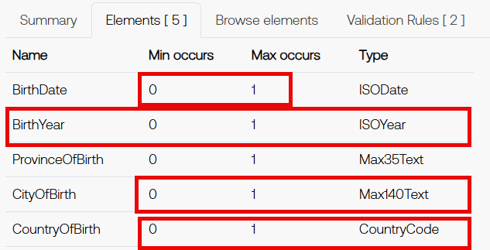

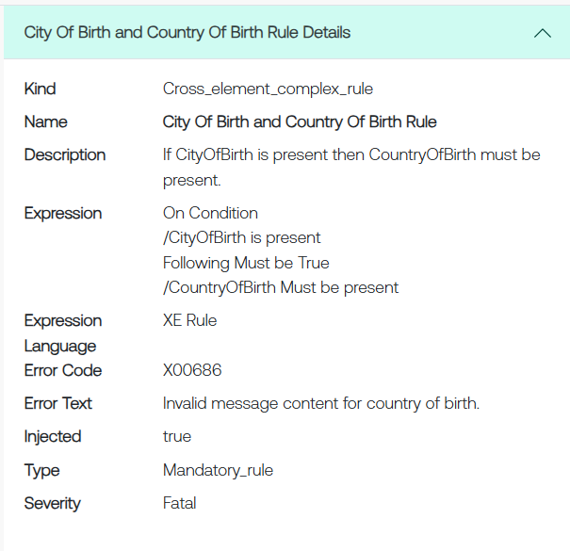
New CityOfBirth and CountryOfBirth Rule:

New BirthDate and BirthYear Rule:

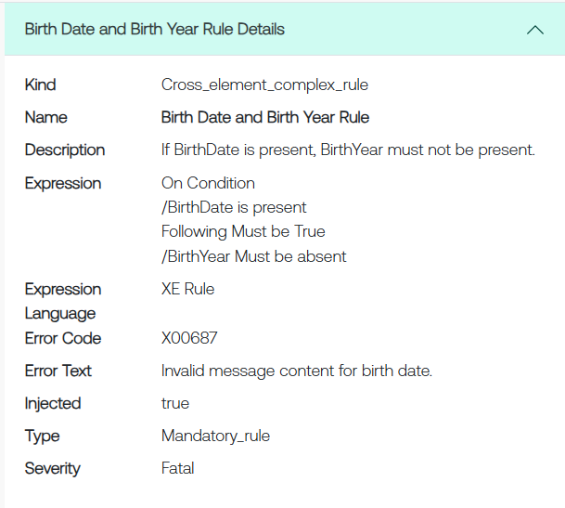

Proposed timing:
The submitting organization confirms that it can implement the requested changes in the requested timing, or, if not, proposes another timing.

Timing

Final decision of the SEG(s):
This section is not to be taken care of by the submitting organization. It will be completed in due time by the SEG(s) in charge of the related ISO 20022 messages.
Approve
Comments:

Reject
Reason for rejection

Change request number 1626
Increase length of Name Element (to Max150Text DataType)

Origin of the request

A.1 Submitter:
Banco Central do Brasil (BCB - Central Bank of Brazil)

A.2 Contact person:
Liliane Dutra: liliane.dutra@ipmfglobal.com.br + 55 11 98542-4421
Fernanda Pedroso: fernanda.pedroso@bcb.gov.br +55 61 3414-4975
Edson Seiiti Higuti: edson.higuti@bcb.gov.br +55 11 3491-6585

A.3 Sponsors:
ABNT CEE-112 Brazilian Standards Committee

Related messages
The change applies to the element Name <Nm> in the following ISO 20022 Payments messages:

Business Domain Payments, Group Payments Initiation:
pain.001.001.13 ( CustomerCreditTransferInitiationV13 )
pain.002.001.15 ( CustomerPaymentStatusReportV15 )

Business Domain Payments, Group Payments Mandates:
pain.009.001.08 ( MandateInitiationRequestV08 )
pain.010.001.08 ( MandateAmendmentRequestV08 )
pain.011.001.08 ( MandateCancellationRequestV08 )
pain.012.001.08 ( MandateAcceptanceReportV08 )
pain.017.001.04 ( MandateCopyRequestV04 )

Business Domain Payments, Group Creditor Payment Activation Request:
pain.013.001.12 ( CreditorPaymentActivationRequestV12 )
pain.014.001.12 ( CreditorPaymentActivationRequestStatusReportV12 )

Business Domain Payments, Group Payments Clearing and Settlement:
pacs.002.001.16 ( FIToFIPaymentStatusReportV16 )
pacs.004.001.15 ( PaymentReturnV15 )
pacs.008.001.14 ( FIToFICustomerCreditTransferV14 )
pacs.009.001.13 ( FinancialInstitutionCreditTransferV13 )

Business Domain Payments, Group Bank-to-Customer Cash Management:
camt.052.001.13 ( BankToCustomerAccountReportV13 )
camt.053.001.13 ( BankToCustomerStatementV13 )
camt.054.001.13 ( BankToCustomerDebitCreditNotificationV13 )

Business Domain Payments, Group Exceptions & Investigations:
camt.029.001.14 ( ResolutionOfInvestigationV14 )
camt.055.001.13 ( CustomerPaymentCancellationRequestV13 )

Description of the change request
Increase the maximum length of the element Name <Nm> from 140 characters to 150 characters by adopting the Max150Text datatype in the pacs, pain and camt messages mentioned in item B.
This change is required to allow official names of Brazilian legal entities to be fully conveyed in ISO 20022 messages when such names exceed 140 characters and contain up to 150 characters, in line with the current length applicable to the official Brazilian registry of legal entities.

Purpose of the change:
The purpose of this change is to allow the official names of Brazilian legal entities to be fully transported in ISO 20022 messages used in the Brazilian instant payment ecosystem.
In Brazil, legal entities are identified through the National Registry of Legal Entities, known as CNPJ (Cadastro Nacional de Pessoas Jurídicas). The CNPJ is the official national registry of companies and other legal entities in Brazil. It is administered by the Brazilian Federal Revenue Service, known as RFB (Receita Federal do Brasil), which is the Brazilian federal tax authority.
RFB Normative Instruction No. 2119, dated 6 December 2022, introduced a new requirement for the registration of legal entity information, allowing legal entity names to contain up to 150 characters. As a result, systems that rely on the official legal entity name registered in the CNPJ must be able to store, process and transmit that name using the same maximum length.
This requirement affects Pix, the Brazilian instant payment scheme regulated by the Central Bank of Brazil. Pix enables real-time funds transfers between transaction accounts held at different payment service providers. To ensure the correct identification of the parties involved in transactions, certain Pix flows use official registration data maintained by the RFB, including the legal entity name as registered in the CNPJ.
Within the Pix ecosystem, two central infrastructures are relevant to this change request:
- DICT — Transactional Account Identifier Directory: DICT is the central directory for Pix, managed and operated by the Central Bank of Brazil, which stores Pix keys and the data associated with those keys. This data includes the name of the holder of the transaction account linked to the Pix key. When the account holder is a legal entity, the name registered in DICT must match the official name recorded in the CNPJ.
- SPI — Instant Payments System: SPI is the centralised settlement infrastructure for Pix, also managed by the Central Bank of Brazil. It is used to settle Pix transactions between different payment service providers.
In this context, Pix is the payment scheme, DICT supports the identification of transaction account holders through Pix keys, and SPI performs the settlement of transactions between participants in the scheme.
In 2025, additional operational rules were specified to strengthen security and fraud prevention in Pix. These rules require greater consistency between the names used within the Pix ecosystem and the official records maintained by the RFB. For legal entities, this means that the name associated with a Pix key must be filled in exactly as it appears in the CNPJ.
Since the CNPJ now allows legal entity names of up to 150 characters, the current 140-character limit of the ISO 20022 element Name <Nm> may prevent the full transmission of the official name in ISO 20022 messages. When the official name contains between 141 and 150 characters, a field limited to 140 characters may result in truncation and in a mismatch between the data conveyed in the message and the official data registered with the RFB.
This requirement also applies to Automatic Pix, a payment service in which Pix payments are initiated from the payer’s transaction account on the basis of recurring payment instructions received from the payee’s payment service provider, subject to the payer’s prior and specific authorisation.
In flows related to Automatic Pix, payment service providers must use the information contained in the CNPJ, as registered with the RFB, to fill in the identification fields of the payee and the ultimate debtor in payment instructions. Therefore, the pain.009, pain.011, pain.012 e pain.013, used for Automatic Pix, the name fields for the payee and the ultimate debtor must allow the complete legal entity name to be provided exactly as registered in the CNPJ, including when that name contains up to 150 characters.
The same requirement applies to settlement messages used in SPI. The pacs.008 message, used for the settlement of Pix transactions between different payment service providers, must allow the payer’s name to be provided in full, as registered in the CNPJ, when the payer is a legal entity.
Therefore, in order to ensure consistency between the official RFB registry, the data registered in DICT, the Automatic Pix flows and the settlement messages processed in SPI, it is necessary to increase the limit of the relevant name fields from 140 to 150 characters, by adopting the type Max150Text.
This change will allow the official names of Brazilian legal entities to be fully conveyed in the applicable ISO 20022 messages, avoiding truncation and reducing the risk of registration data inconsistencies between the systems involved in the Pix ecosystem.

Urgency of the request:
We request that this change be considered for the next ISO 20022 yearly maintenance cycle, corresponding to the 2026/2027 cycle.
This change is required to align the ISO 20022 messages used in the Brazilian instant payments ecosystem with the 150-character limit applicable to legal entity names in the official registry maintained by the Brazilian Federal Revenue Service.
Implementation in the 2026/2027 cycle will allow Pix participants to maintain consistency between the official CNPJ data, the records maintained in DICT, the Automatic Pix flows and the settlement messages processed in SPI.

Business Examples:
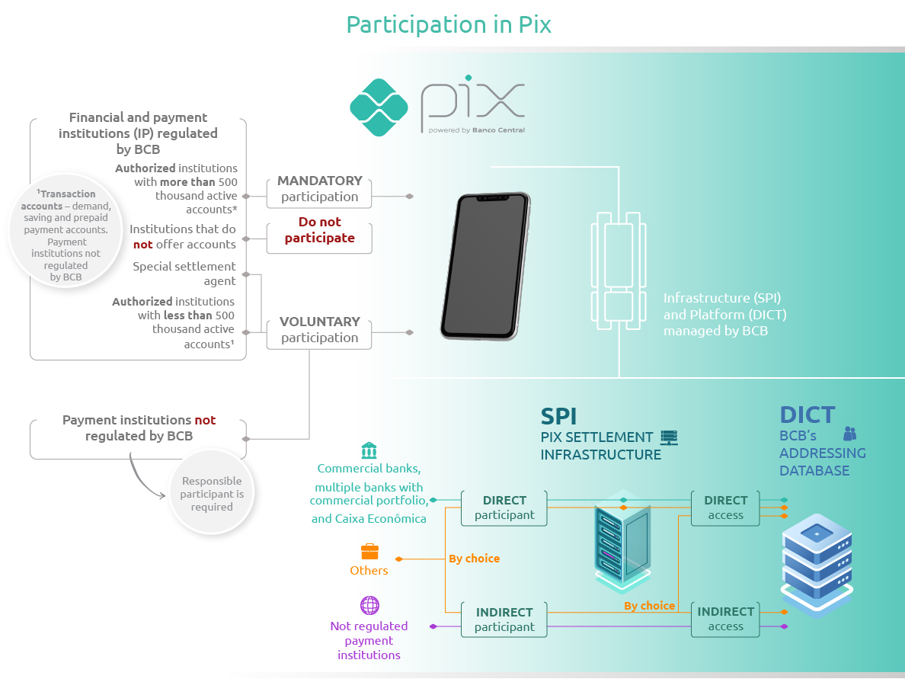Source: Central Bank of Brazil

Pix is the Brazilian instant payment scheme regulated by the Central Bank of Brazil. It enables real-time funds transfers between transaction accounts held at different payment service providers.
For its operation, Pix relies on two central infrastructures managed by the Central Bank of Brazil:
- DICT — Transactional Account Identifier Directory: DICT is the central directory that stores Pix keys and the data associated with those keys, including identification information related to the holders of transaction accounts. For legal entities, the name associated with the Pix key must match the official name registered in the CNPJ.
- SPI — Instant Payments System: SPI is the centralised settlement infrastructure for Pix, used to settle transactions between participants.
In simplified terms, Pix is the payment scheme; DICT supports the identification of transaction account holders through Pix keys; and SPI performs the settlement of transactions between participants in the scheme.
Pix participants may act as direct or indirect participants in SPI:
- Direct participants settle Pix transactions directly in the SPI: commercial banks, multiple banks with a commercial portfolio and saving banks that participate in Pix must be direct participants in SPI. Other institutions authorised to operate by the Central Bank of Brazil may choose to be direct or indirect participants in the SPI.
- Indirect participants have their Pix transactions settled through a direct participant or a special settlement agent. Payment institutions not regulated by the Central Bank of Brazil, when participating in Pix, must necessarily be indirect participants in the SPI.
Pix participants also need to access DICT. Direct participants in SPI may access DICT directly. Institutions not authorised by the Central Bank of Brazil must access DICT indirectly, through an agreement with a Pix participant that has direct access to DICT.
In this context, consistency between the names registered in the CNPJ, the names stored in DICT and the names conveyed in the ISO 20022 messages used in Pix flows is essential. When the official name of a Brazilian legal entity contains between 141 and 150 characters, the current 140-character limit of the element Name <Nm> prevents the full transmission of the name. For this reason, the limit needs to be increased to 150 characters.

SEG/TSG recommendation:
This section is not to be taken care of by the submitter of the change request. It will be completed in due time by the SEG(s) in charge of the related ISO 20022 messages or the TSG for changes related to the BAH.

Consider |  | X | Timing
 |  |  | - Next yearly cycle: 2026/2027  (the change will be considered for implementation in the yearly maintenance cycle which starts in 2026 and completes with the publication of new message versions in the spring of 2027) |  | X
- At the occasion of the next maintenance of the messages
(the change will be considered for implementation, but does not justify maintenance of the messages in its own right – will be pending until more critical change requests are received for the messages)
- Urgent unscheduled
(the change justifies an urgent implementation outside of the normal yearly cycle)
 |  |  | - Other timing:
Comments:

Reject
Reason for rejection:

Impact analysis and type of impact:
The following Message Identifiers will be impacted –

acmt.007.001.05 | AccountOpeningRequestV06
acmt.008.001.05 | AccountOpeningAmendmentRequestV06
acmt.009.001.04 | AccountOpeningAdditionalInformationRequestV05
acmt.010.001.04 | AccountRequestAcknowledgementV05
acmt.011.001.04 | AccountRequestRejectionV05
acmt.012.001.04 | AccountAdditionalInformationRequestV05
acmt.013.001.04 | AccountReportRequestV04
acmt.014.001.05 | AccountReportV05
acmt.015.001.05 | AccountExcludedMandateMaintenanceRequestV05
acmt.016.001.05 | AccountExcludedMandateMaintenanceAmendmentRequestV05
acmt.017.001.05 | AccountMandateMaintenanceRequestV05
acmt.018.001.05 | AccountMandateMaintenanceAmendmentRequestV05
acmt.019.001.04 | AccountClosingRequestV04
acmt.020.001.04 | AccountClosingAmendmentRequestV04
acmt.021.001.04 | AccountClosingAdditionalInformationRequestV04
acmt.022.001.04 | IdentificationModificationAdviceV04
acmt.023.001.04 | IdentificationVerificationRequestV04
acmt.024.001.04 | IdentificationVerificationReportV04
acmt.027.001.06 | AccountSwitchInformationRequestV06
acmt.028.001.06 | AccountSwitchInformationResponseV06
acmt.029.001.06 | AccountSwitchCancelExistingPaymentV06
acmt.030.001.04 | AccountSwitchRequestRedirectionV04
acmt.031.001.06 | AccountSwitchRequestBalanceTransferV06
acmt.032.001.06 | AccountSwitchBalanceTransferAcknowledgementV06
admi.024.001.01 | NotificationOfCorrespondenceV01
auth.001.001.02 | InformationRequestOpeningV02
auth.002.001.02 | InformationRequestResponseV02
auth.018.001.04 | ContractRegistrationRequestV04
auth.019.001.04 | ContractRegistrationConfirmationV04
auth.020.001.04 | ContractRegistrationClosureRequestV04
auth.021.001.04 | ContractRegistrationAmendmentRequestV04
auth.022.001.04 | ContractRegistrationStatementV04
auth.023.001.04 | ContractRegistrationStatementRequestV04
auth.024.001.04 | PaymentRegulatoryInformationNotificationV04
auth.025.001.04 | CurrencyControlSupportingDocumentDeliveryV04
auth.026.001.04 | CurrencyControlRequestOrLetterV04
camt.003.001.08  camt.004.001.10  camt.005.001.11  camt.006.001.11  camt.007.001.10  camt.008.001.11  camt.009.001.08  camt.010.001.09  camt.011.001.08  camt.012.001.08 | GetAccountV08  ReturnAccountV10  GetTransactionV11  ReturnTransactionV11  ModifyTransactionV10  CancelTransactionV11  GetLimitV08  ReturnLimitV09  ModifyLimitV08  DeleteLimitV08
camt.024.001.08 | ModifyStandingOrderV08
camt.025.001.09  camt.029.001.15  camt.046.001.08  camt.047.001.08  camt.048.001.07  camt.049.001.07  camt.050.001.07  camt.051.001.07  camt.052.001.14  camt.053.001.14  camt.054.001.14  camt.055.001.13  camt.056.001.12  camt.057.001.09  camt.058.001.10  camt.059.001.09  camt.060.001.07 | ReceiptV09  ResolutionOfInvestigationV15  GetReservationV08  ReturnReservationV08  ModifyReservationV07  DeleteReservationV07  LiquidityCreditTransferV07  LiquidityDebitTransferV07  BankToCustomerAccountReportV14  BankToCustomerStatementV14  BankToCustomerDebitCreditNotificationV14  CustomerPaymentCancellationRequestV13  FIToFIPaymentCancellationRequestV12  NotificationToReceiveV09  NotificationToReceiveCancellationAdviceV10  NotificationToReceiveStatusReportV09  AccountReportingRequestV07
camt.113.001.01 | CashDepositRequestV01
camt.114.001.01 | CashWithdrawalRequestV01
camt.115.001.01 | CashDepositOrWithdrawalStatusUpdateV01
camt.116.001.01 | CashDepositOrWithdrawalCancellationRequestV01
pacs.002.001.16  pacs.003.001.12  pacs.004.001.15  pacs.007.001.14  pacs.008.001.14  pacs.009.001.13  pacs.010.001.06  pacs.028.001.07  pacs.029.001.02 | FIToFIPaymentStatusReportV16  FIToFICustomerDirectDebitV12  PaymentReturnV15  FIToFIPaymentReversalV14  FIToFICustomerCreditTransferV14  FinancialInstitutionalCreditTransferV13  FinancialInstitutionDirectDebitV06  FIToFIPaymentStatusRequestV07  MultilateralSettlementV02
pain.001.001.13  pain.002.001.15  pain.007.001.13  pain.008.001.12  pain.009.001.08  pain.010.001.08  pain.011.001.08  pain.012.001.08  pain.013.001.12  pain.014.001.12  pain.017.001.04  pain.018.001.04 | CustomerCreditTransferInitiationV13  CustomerPaymentStatusReportV15  CustomerPaymentReversalV13  CustomerDirectDebitInitiationV12  MandateInitiationRequestV08  MandateAmendmentRequestV08  MandateCancellationRequestV08  MandateAcceptanceReportV08  CreditorPaymentActivationRequestV12  CreditorPaymentActivationRequestStatusReportV12  MandateCopyRequestV04  MandateSuspensionRequestV04
remt.001.001.07 | RemittanceAdviceV07
remt.002.001.03 | RemittanceLocationAdviceV03
trck.001.001.05 | PaymentStatusTrackerUpdateV05
trck.002.001.04 | PaymentStatusTrackerReportV04
trck.004.001.04 | PaymentStatusCustomerTrackerReportV04

Proposed implementation:

The proposed implementation is to have a maximum length of 350 characters to accommodate longer names.

According to GLEIF the following are details pertaining to the different type of organisation names and their character lengths:

The LEI reference data contains the legal name in local language, other names (previous names, trade names etc.) and transliterated names:

- Legal names: most legal entities have their legal name between 16-20 characters.
There are 230 entities with over 200 characters and 16 entities with over 300 characters.
However, the longest recorded legal name has 307 characters.

- Other names: A majority of entities do not report other names (~3 million) however, there is an entity with a name of 429 characters.

- Transliterated names: The majority do not report transliterated names (most already have the legal name in Latin characters). Among the reported transliterated names, the maximum number of characters is 288. 20 entities report a transliterated name with over 200 characters.

A length of 350 characters also aligns with ISO 20022 messages used by the Securities industry.

The new proposed implementation for the NameAndAddress component:

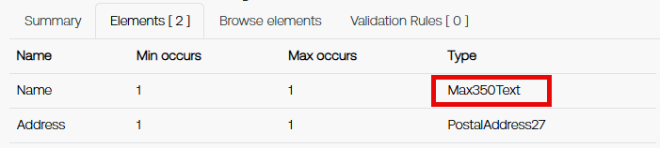

The new proposed implementation for PartyIdentification components:

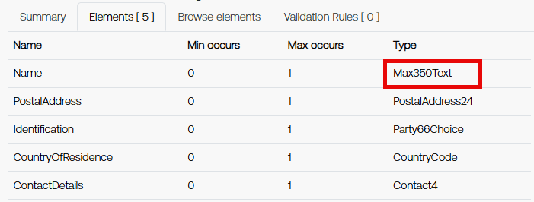

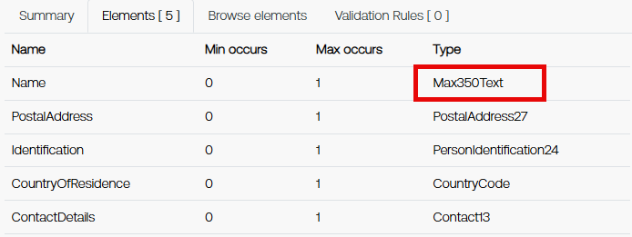

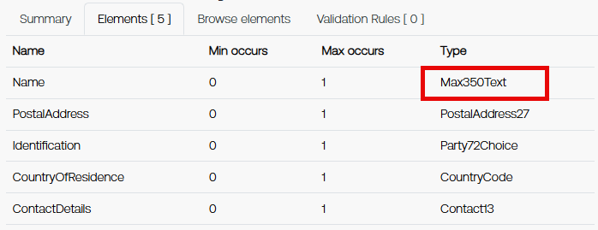

The new proposed implementation for BranchAndFinancialInstitutionIdentification/FinancialInstituionIdentification:

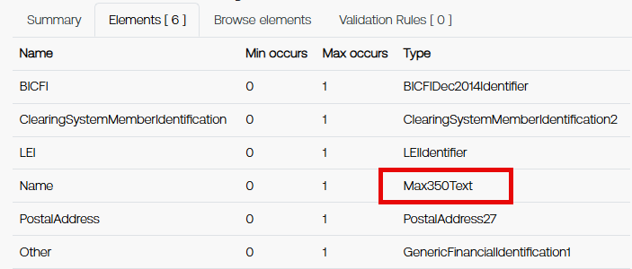

Proposed timing:
The submitting organization confirms that it can implement the requested changes in the requested timing, or, if not, proposes another timing.

Timing

Final decision of the SEG(s):
This section is not to be taken care of by the submitting organization. It will be completed in due time by the SEG(s) in charge of the related ISO 20022 messages.
Approve
Comments:

Reject
Reason for rejection:

Change request number 1578
Alignment of E&I Modernisation Messages

Origin of the request:
A.1 Submitter: Swift

A.2 Contact person:

HERREBOUT Pieter Pieter.HERREBOUT@swift.com
BELFORD David David.BELFORD@swift.com
KOMAR Monika Monika.KOMAR@swift.com

A.3 Sponsors:

Related messages:
camt.110.001.02
camt.111.001.03

Description of the change request:
The camt.110 and camt.111 form the heartbeat of Swift’s Case solution. This is planned to become mandatory for all Swift users sending cross border investigations as of November 2027. As part of November 2027 the cross-border payment (pacs) and reporting messages (camt) are also planned to migrate to the 2025 ISO 20022 base message versions.
As the camt.110 and camt.111 provide investigation messaging related to the cross border payment and reporting messages all messages should ideally be aligned and using common components.
One example of potential misalignment is Structured Remittance Information, under current plans November 2027 onwards would see the cross-border payment (pacs) and reporting messages (camt) using StructuredRemittanceInformation22 but the investigation messages using StructuredRemittanceInformation16.
We would like the camt.110 and camt.111 upgraded and aligned with the current pacs messages so potential misalignments can be addressed as part of future Swift implementations.
The following components will all be updated to later versions to align with the underlying pacs, pain and camt messages on which camt.110 and camt.111 often refer to –
- OriginalTransactionReference48 > OriginalTransactionReference45
- Document12 > Document15
- RelatedInvestigationData1 > Create new version and update postal address
- Party40Choice > Party50Choice
- StructuredRemittanceInformation16 > StructuredRemittanceInformation22
- AdjustmentCompensation1 > Create new version and update postal address
- BookingConfirmation8 > Create new version and update postal address
- StatusReasonInformation12 > StatusReasonInformation14
- PartyIdentification135 > PartyIdentification272
- BranchAndFinancialInstitutionIdentification6 > BranchAndFinancialInstitutionIdentification8

Purpose of the change:
Current versions of the camt.110 and camt.111 are closely aligned with the pacs, pain and camt messages available as of 2019.
Since this point the pacs, pain and camt messages have continued to evolve with many new versions of these messages being implemented with improved components and data types within.
The camt.110 and camt.111 should be enhanced to align with the 2025 and/or 2026 and/or 2027 versions of the pacs, pain and camt messages.

Urgency of the request:
Next maintenance cycle

Business examples:
N/A

SEG/TSG recommendation:
This section is not to be taken care of by the submitter of the change request. It will be completed in due time by the SEG(s) in charge of the related ISO 20022 messages or the TSG for changes related to the BAH.

Consider |  | X | Timing
 |  |  | - Next yearly cycle: 2026/2027  (the change will be considered for implementation in the yearly maintenance cycle which starts in 2026 and completes with the publication of new message versions in the spring of 2027) |  | X
- At the occasion of the next maintenance of the messages
(the change will be considered for implementation, but does not justify maintenance of the messages in its own right – will be pending until more critical change requests are received for the messages)
- Urgent unscheduled
(the change justifies an urgent implementation outside of the normal yearly cycle)
 |  |  | - Other timing:
Comments:

Reject
Reason for rejection:

Impact analysis and type of impact:
camt.110.001.02  camt.111.001.03 | InvestigationRequestV02  InvestigationResponseV03

Proposed implementation:

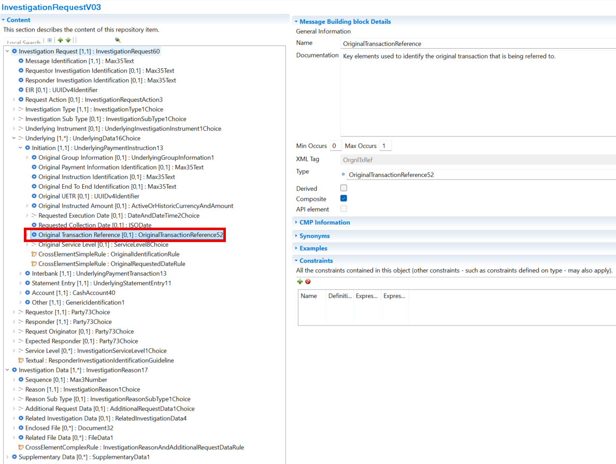
- OriginalTransactionReference52

- Document32

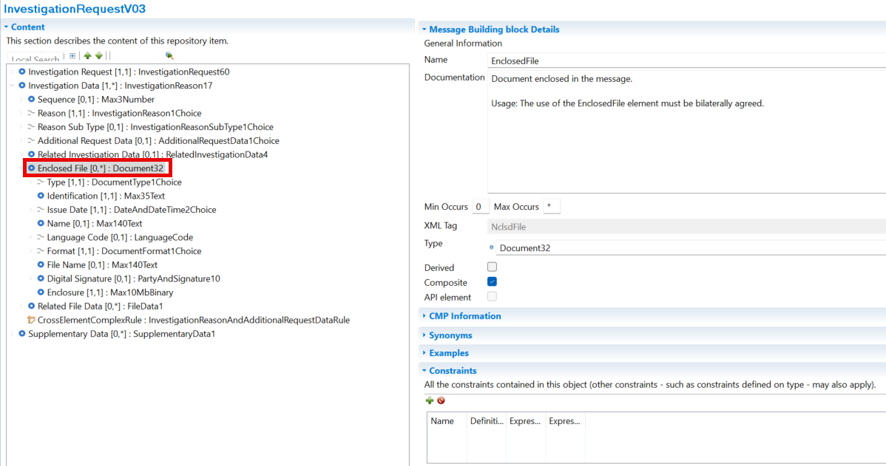
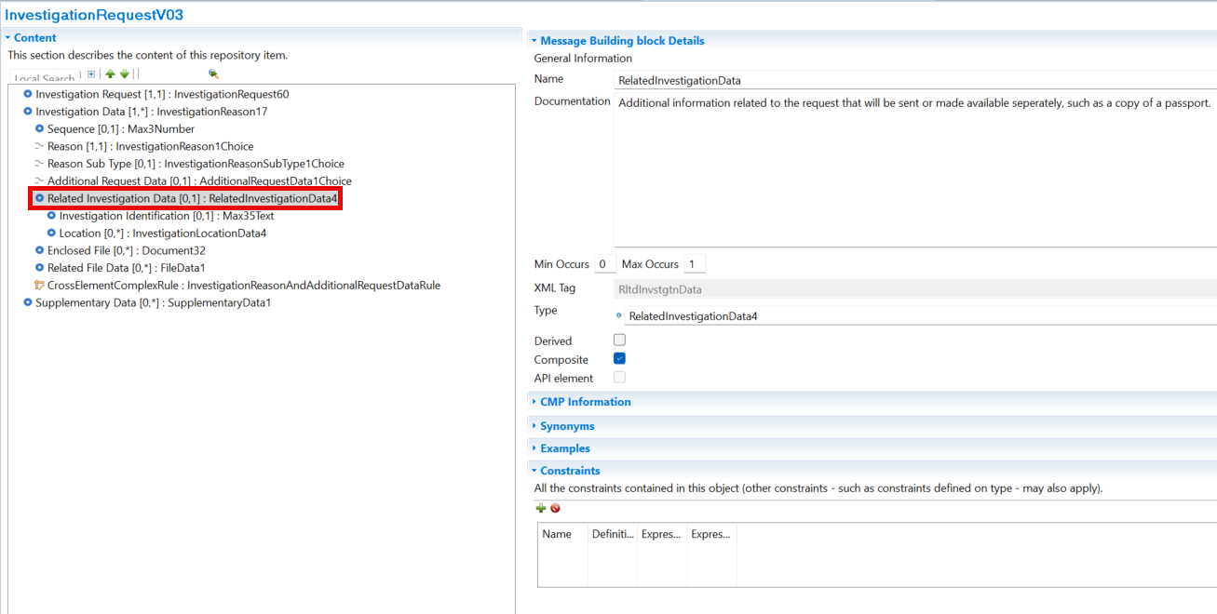
- RelatedInvestigationData4

- Party73Choice

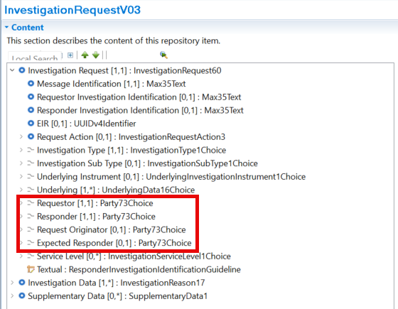
- StructuredRemittanceInformation29
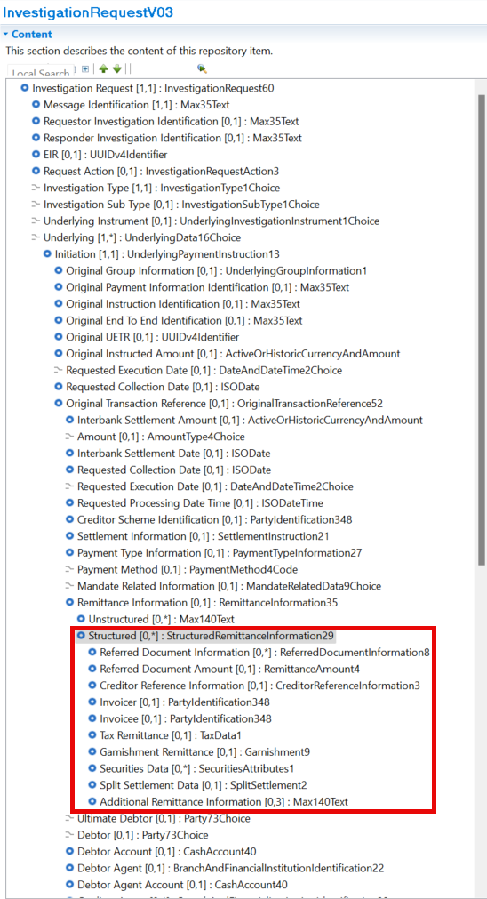
- AdjustmentCompensation4

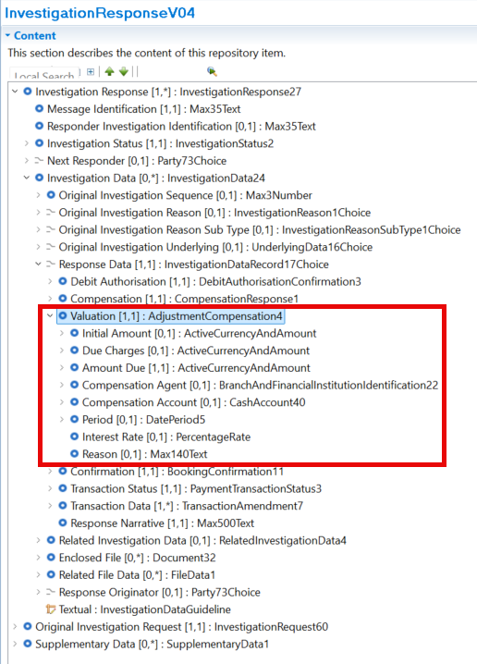

- BookingConfirmation11
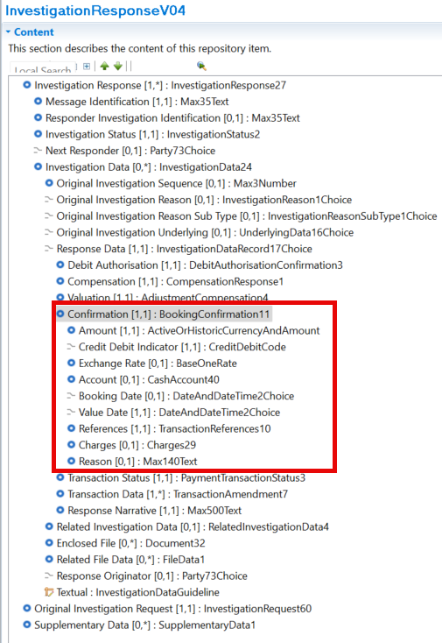
- StatusReasonInformation18
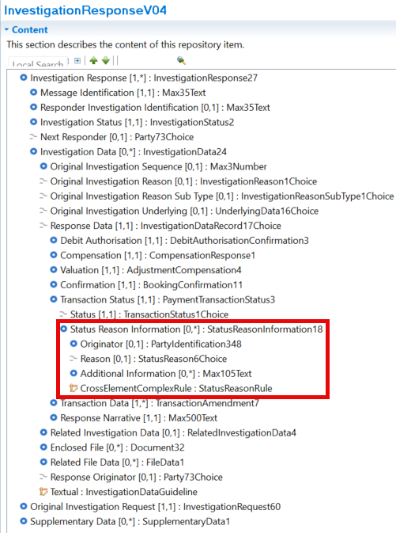
- PartyIdentification348

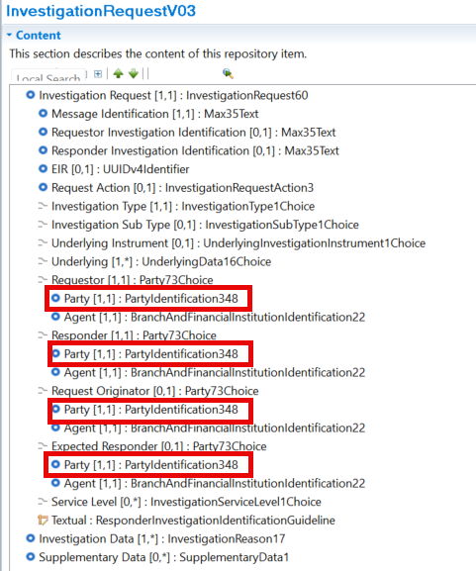

- BranchAndFinancialInstitutionIdentification22

Proposed timing:
The submitting organization confirms that it can implement the requested changes in the requested timing, or, if not, proposes another timing.

Timing

Final decision of the SEG(s):
This section is not to be taken care of by the submitting organization. It will be completed in due time by the SEG(s) in charge of the related ISO 20022 messages.
Approve
Comments:

Reject
Reason for rejection:

Change request number 1579
Addition of Payment Information Identification Elements

Origin of the request
A.1 Submitter:

Australian Payments Plus
255 George St, Sydney NSW 2000

This Change Request originates from Australian Payments Plus (AP+), the operator of Australia’s national instant and bulk payment infrastructure (NPP – New Payment Platform), as part of ongoing enhancement of ISO 20022 usage to support evolving clearing and settlement models.
Australian Payments Plus - About us
AP+ is Australia’s domestic payments organisation, established to strengthen and modernise the nation’s payments ecosystem through secure, resilient, and future-ready infrastructure and services. Operating in the public interest, AP+ brings together key national payment capabilities and works collaboratively across industry, government, regulators, financial institutions, merchants, fintechs, and payment service providers to support Australia’s evolving economic and digital needs.

A.2 Contact person:
Shriram Suriyanarayanan (Shriram.Suri@auspayplus.com.au)
Meg Ravikumar (meg.ravikumar@auspayplus.com.au)
A.3 Sponsors:
Swift
Nicole Jollifee (nicole.jolliffe@swift.com)
Kenneth Leung (kenneth.leung@swift.com)

Related messages
- pacs.008.001.14 – FIToFICustomerCreditTransfer
- pacs.004.001.15 – PaymentReturn
- pacs.002.001.16 – FIToFIPaymentStatusReport
- camt.056.001.12 – FI To FI Payment Cancellation Request
- camt.029.001.14 – Resolution Of Investigation
- camt.110.001.02 – InvestigationRequest
- camt.111.001.03 – InvestigationResponse

Description of the change request
Addition of PmtInfId in pacs.008 and OrgnlPmtInfId in pacs.004, pacs.002, camt.056, camt.029 and camt.110/111 messages

Introduce a Payment Information Identification (PmtInfId) at Credit Transfer Transaction level in pacs.008, and ensure corresponding propagation and reference through OriginalPaymentInformationIdentification (OrgnlPmtInfId) elements in pacs.004 and pacs.002 as well as investigation messages (camt.110,111), aligned in name and semantics with the PaymentInformationIdentification element used in payment initiation messages (e.g. pain.001, pain.013).
Specifically:
- in pacs.008, add PmtInfId under
/Document/FIToFICstmrCdtTrf/CdtTrfTxInf/PmtId
- in pacs.004, add OrgnlPmtInfId under
/Document/PmtRtr/TxInf (propose position before OrgnlInstrId)
- in pacs.002, add OrgnlPmtInfId under
/Document/FIToFIPmtStsRpt/TxInfAndSts (propose position before OrgnlInstrId)
- in camt.056, add OrgnlPmtInfId under
/Document/FIToFIPmtCxlReq/Undrlyg/TxInf (propose position before OrgnlInstrId)
- in camt.029, add OrgnlPmtInfId under
/Document/RsltnOfInvstgtn/CxlDtls/TxInfAndSts (propose position before OrgnlInstrId)
- in camt.110, add OrgnlPmtInfId under
/Document/InvstgtnReq/InvstgtnReq/Undrlyg/IntrBk (propose position before OrgnlInstrId)
- in camt.111, add OrgnlPmtInfId under
/Document/InvstgtnRspn/OrgnlInvstgtnReq/Undrlyg/IntrBk (propose position before OrgnlInstrId)

Business Justification / Market Practice
In current ISO 20022 modelling, pacs messages provide identification at message and transaction level only. In high‑volume and instant payment environments, bulk payment initiation instructions are frequently split into multiple interbank messages, resulting in the loss of the original batch‑level payment initiation context across clearing, status reporting, and returns.

ISO 20022 does not currently provide a standardised mechanism to originate a batch‑level payment initiation identifier in pacs.008 and to consistently reference that identifier in pacs.002 and pacs.004 messages. As a result, market infrastructures and participants rely on proprietary or bilateral correlation techniques, limiting interoperability and increasing operational complexity.

The proposed change introduces an explicit, end‑to‑end mechanism to originate and reference the payment‑instruction identifier across initiation, clearing, status reporting, and returns. This aligns ISO 20022 with common market practice and improves reconciliation, investigation, and recovery processes, without introducing new business semantics.

Purpose of the change:
To enable the end‑to‑end propagation of batch or payment instruction grouping identifiers from payment initiation through clearing and settlement messages, particularly where a single originating batch is split across multiple interbank messages.

Urgency of the request:
High – driven by the Australia New Payment Platform (NPP) to support multi-credit transfer by 2028, and also the increasing use of bulk, multi‑credit, and instant payment processing; delay forces continued use of non‑standard correlation mechanisms.

Business Examples:
A bulk salary file submitted as one pain.001 payment information block is split into multiple pacs.008 messages for clearing.
Downstream participants need to identify that all messages relate to the same original batch for reconciliation and recovery.

SEG/TSG recommendation:
This section is not to be taken care of by the submitter of the change request. It will be completed in due time by the SEG(s) in charge of the related ISO 20022 messages or the TSG for changes related to the BAH.

Consider |  | X | Timing
 |  |  | - Next yearly cycle: 2026/2027  (the change will be considered for implementation in the yearly maintenance cycle which starts in 2026 and completes with the publication of new message versions in the spring of 2027) |  | X
- At the occasion of the next maintenance of the messages
(the change will be considered for implementation, but does not justify maintenance of the messages in its own right – will be pending until more critical change requests are received for the messages)
- Urgent unscheduled
(the change justifies an urgent implementation outside of the normal yearly cycle)
 |  |  | - Other timing:
Comments:

Reject
Reason for rejection:

Impact analysis and type of impact:
The following Message Identifiers will be impacted –

camt.029.001.14  camt.056.001.12  camt.110.001.02  camt.111.001.03  pacs.002.001.16  pacs.003.001.12  pacs.004.001.15  pacs.008.001.14  pacs.009.001.13 | ResolutionOfInvestigationV14  FIToFIPaymentCancellationRequestV12  InvestigationRequestV02  InvestigationResponseV03  FIToFIPaymentStatusReportV16  FIToFICustomerDirectDebitV12  PaymentReturnV15  FIToFICustomerCreditTransferV14  FinancialInstitutionCreditTransferV13

Proposed implementation:

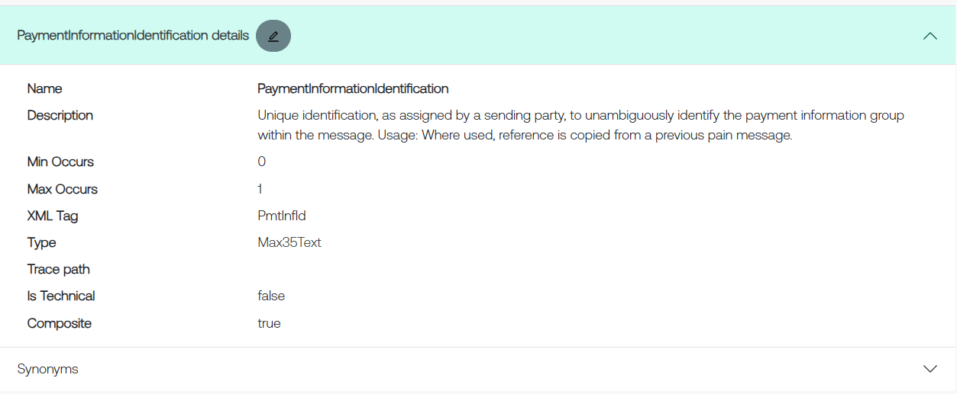
PaymentInformationIdentification component:

OriginalPaymentInformationIdentification component:
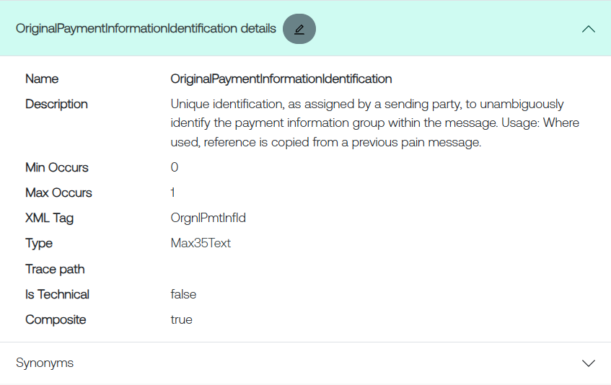

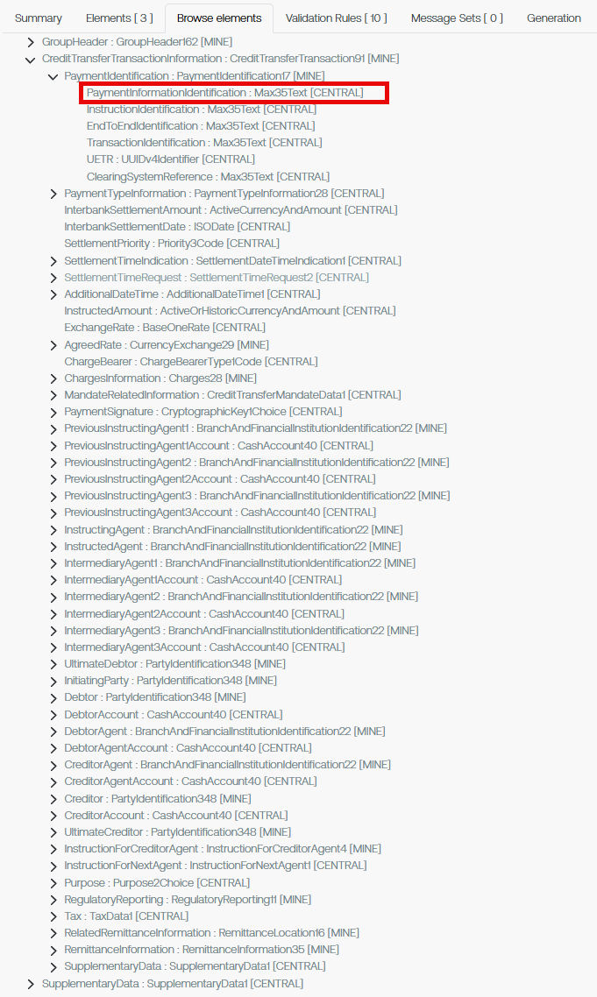
The proposed implementation for the pacs.008:

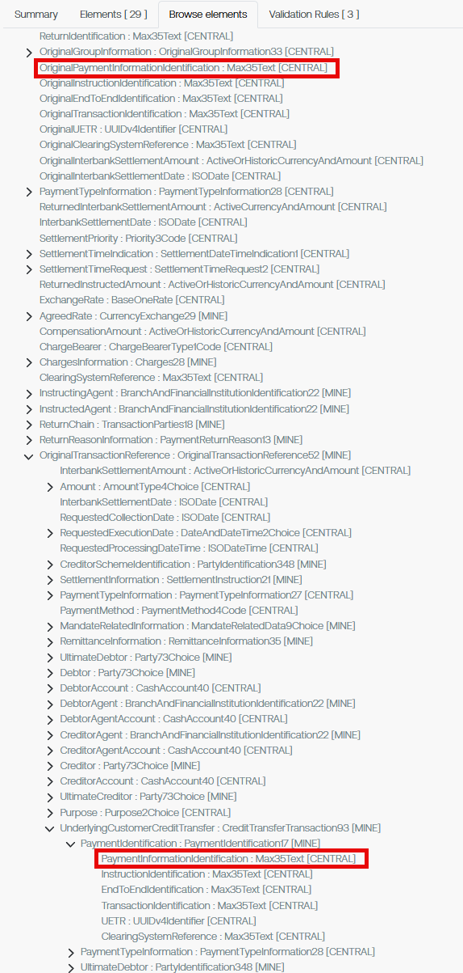
The proposed implementation in pacs.004:
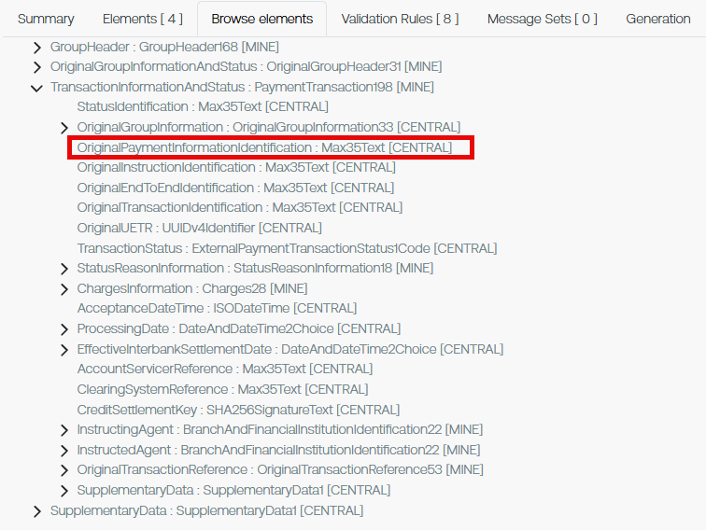
The proposed implementation for pacs.002:

The proposed implementation for camt.056:

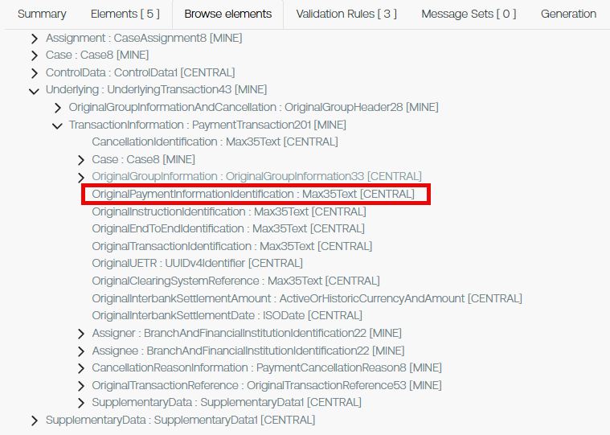
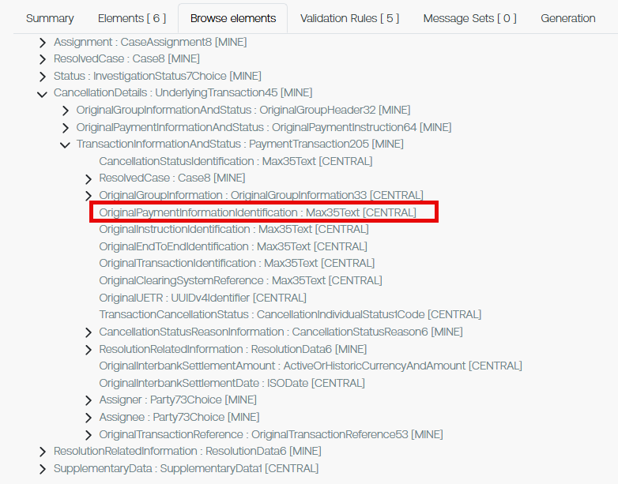
The proposed implementation for camt.029:

The proposed implementation for camt.110:

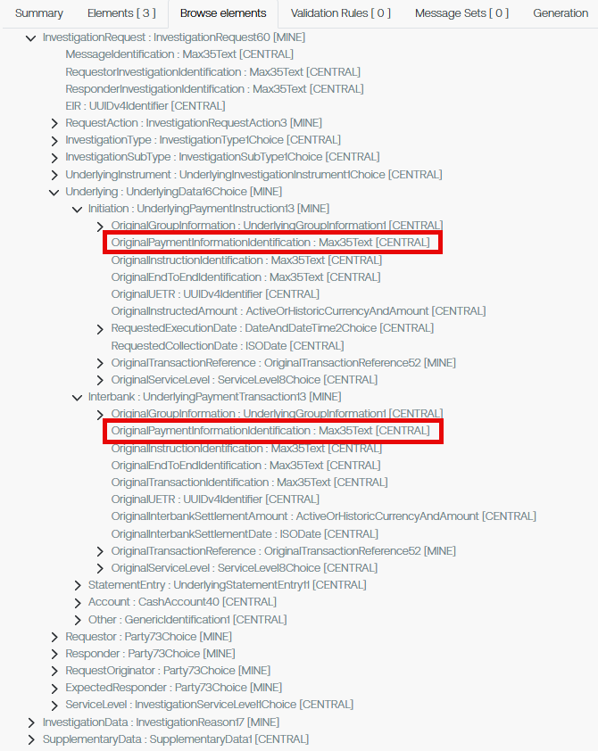

The proposed implementation for camt.111:

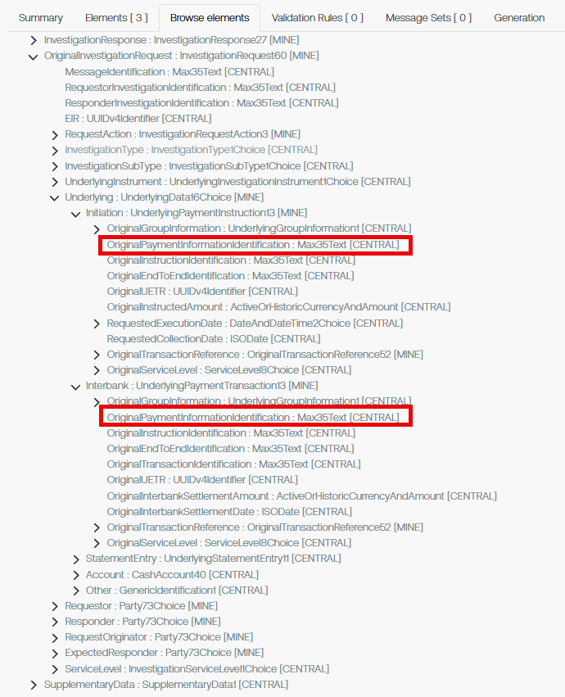

Proposed timing:
The submitting organization confirms that it can implement the requested changes in the requested timing, or, if not, proposes another timing.

Timing

Final decision of the SEG(s):
This section is not to be taken care of by the submitting organization. It will be completed in due time by the SEG(s) in charge of the related ISO 20022 messages.
Approve
Comments:

Reject
Reason for rejection:

Change request number 1569
FX Splits in Payments

Origin of the request
A.1 Submitter: GFMAs Global FX Division (GFXD), https://www.gfma.org/foreign-exchange/

A.2 Contact person: Andrew Harvey, email: aharvey@eu.gfma.org, tel: +44 (0) 203 828 2694

A.3 Sponsors: This change request is sponsored by our members: Bank of America, Bank of New York, Barclays, BBVA, BNP Paribas, Citi, Credit Agricole, Deutsche Bank, Goldman Sachs, HSBC, ING, JP Morgan, Lloyds, Mizuho, Morgan Stanley, MUFG, NatWest Markets, Nomura, Northern Trust, RBC, Standard Chartered Bank, State Street, UBS, US Bank and Wells Fargo

Related messages
We request changes to:
- pacs.008.001.14
- pacs.009.001.13
- pain.001.001.13

Description of the change request
We request the addition of 2 new fields in which market participants can include details of:
• The sequencing of split or shaped payment messages e.g. 1 of 5.
• Total amount before splitting e.g. USD 10,000,000,000.00

Purpose of the change:
The GFXD Operations Committee has recently published a paper on FX payment splitting/shaping, and how this can help to i) reduce FX Settlement Risk ii) improve the flow of settlement liquidity iii) support the evolution towards shorter settlement cycles. The paper is available here: https://www.gfma.org/wp-content/uploads/2026/04/fx-payment-splitting-shaping-apr2026.pdf
The paper makes 3 recommendations:
- Market participants adopt automated FX payment split/shaping/reconciliation processes to achieve consistency, scale and efficiency.

- Market participants adopt automated methods when notifying that a payment has been split/shaped. This will ensure that both parties support and can successfully manage the process, avoiding any returns of funds and associated Settlement Risk.

- Market participants include in their communication message the number/sequence (e.g. 1 of 5) and full amount being exchanged (e.g. 100). This will enable the recipient to easily reconcile that all messages have been received and that the full amount has also been received.
Current industry practices on splitting/shaping payments are not harmonised, largely based on proprietary systems or via repurposing the ISO pacs.008/pacs.009 message Unstructured Remittance information field to include information notifying the sequencing of the payments e.g. ‘payment 1 of 3’.
If the recipient of the split/shaped payment is unable to reconcile the incoming messages to the expected receipt amount, then there is risk that funds will be returned, leading to increased Settlement Risk.
There is considerable focus within the global FX industry on reducing FX Settlement Risk, defined in the BCBS FX Supervisory Guidance (https://www.bis.org/publ/bcbs241.htm (“BCBS FX Supervisory Guidance”)) as: The risk of outright loss of the full value of a transaction resulting from the counterparty’s failure to settle. This can arise from paying away the currency being sold but failing to receive the currency being bought. (Also referred to as “Herstatt Risk”).
Since 2019, the BIS Triennial Central Bank Surveys of FX ( https://www.bis.org/statistics/rpfx25.htm) have included questions to shape the amount of FX settling outside of PvP mechanisms, with an increased focus on those settling on a gross-bilateral basis i.e. having the highest level of Settlement Risk. This data has shaped public sector/industry engagement to better understand FX Settlement Risk, for instance through the creation of the Global Foreign Exchange Committees (GFXC’s) FX Settlement Risk Working Group (https://www.globalfxc.org/) – the GFXC being established in 2017 to bring together central banks and the private sector, initially resulting in the publication of the FX Global Code. Hence our continued engagement to support the widespread reduction in FX Settlement Risk.
Our expectation is that through the addition of a new field in the ISO i) pacs.008.001.14 ii) pacs.009.001.13 and iii) pain.001.001.13 messages, where market participants can populate standardised information informing the recipient that a payment has been split/shaped, will promote harmonisation in the exchange of information and result in a reduction in funds being returned due to reconciliation challenges, a failed receipt, and an associated increase in Settlement Risk.

Urgency of the request:
Whilst urgent, we are happy for this request to be factored into the current maintenance cycle.

Business Examples:
Sell USD 10,000,000,000.00 (USD 10 billion), which is subsequently split into x 20 amounts of USD 500,000,000.00 (USD 500 million). Updates in messages to reflect:
- New field to contain sequencing e.g. 1 of 20, 2 of 20 etc
- New field to contain total amount before splitting e.g. USD 10,000,000,000.00

SEG/TSG recommendation:
This section is not to be taken care of by the submitter of the change request. It will be completed in due time by the SEG(s) in charge of the related ISO 20022 messages or the TSG for changes related to the BAH.

Consider |  | X | Timing
 |  |  | - Next yearly cycle: 2026/2027  (the change will be considered for implementation in the yearly maintenance cycle which starts in 2026 and completes with the publication of new message versions in the spring of 2027) |  | X
- At the occasion of the next maintenance of the messages
(the change will be considered for implementation, but does not justify maintenance of the messages in its own right – will be pending until more critical change requests are received for the messages)
- Urgent unscheduled
(the change justifies an urgent implementation outside of the normal yearly cycle)
 |  |  | - Other timing:
Comments:

Reject
Reason for rejection:

Impact analysis and type of impact:
The following Message Identifiers will be impacted –

acmt.027.001.06  acmt.028.001.06  acmt.029.001.06  acmt.031.001.06  acmt.032.001.06  acmt.034.001.06  camt.029.001.14  camt.052.001.14  camt.053.001.14  camt.054.001.14  camt.055.001.13  camt.056.001.12  camt.057.001.09  camt.058.001.10  camt.059.001.09  camt.110.001.02  camt.111.001.03  pacs.002.001.16  pacs.003.001.12  pacs.004.001.15  pacs.007.001.14  pacs.008.001.14  pacs.009.001.13  pacs.028.001.07  pain.001.001.13  pain.002.001.15  pain.007.001.13  pain.008.001.12  pain.013.001.12  pain.014.001.12  remt.001.001.07  trck.005.001.03 | AccountSwitchInformationRequestV06  AccountSwitchInformationResponseV06  AccountSwitchCancelExistingPaymentV06  AccountSwitchRequestBalanceTransferV06  AccountSwitchBalanceTransferAcknowledgementV06  AccountSwitchRequestPaymentV06  ResolutionOfInvestigationV14  BankToCustomerAccountReportV14  BankToCustomerStatementV14  BankToCustomerDebitCreditNotificationV14  CustomerPaymentCancellationRequestV13  FIToFIPaymentCancellationRequestV12  NotificationToReceiveV09  NotificationToReceiveCancellationAdviceV10  NotificationToReceiveStatusReportV09  InvestigationRequestV02  InvestigationResponseV03  FIToFIPaymentStatusReportV16  FIToFICustomerDirectDebitV12  PaymentReturnV15  FIToFIPaymentReversalV14  FIToFICustomerCreditTransferV14  FinancialInstitutionCreditTransferV13  FIToFIPaymentStatusRequestV07  CustomerCreditTransferInitiationV13  CustomerPaymentStatusReportV15  CustomerPaymentReversalV13  CustomerDirectDebitInitiationV12  CreditorPaymentActivationRequestV12  CreditorPaymentActivationRequestStatusReportV12  RemittanceAdviceV07  TrackerInvestigationStatusNotificationV03

Proposed implementation:

Please note that as part of this and other implementations Structured Remittance will now be available in the pacs.009.

Proposed implementation of SplitSettlementData:
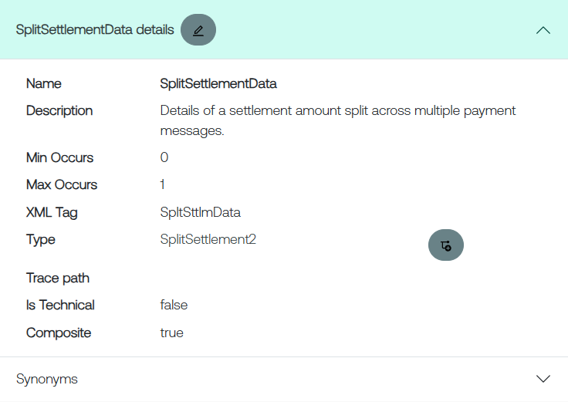
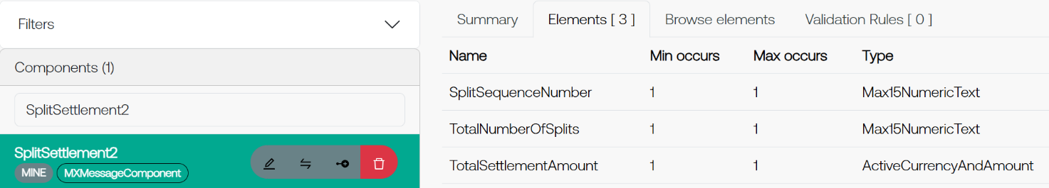
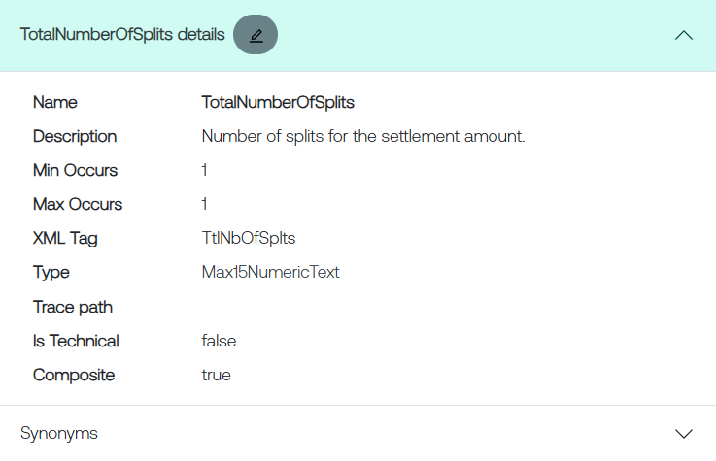
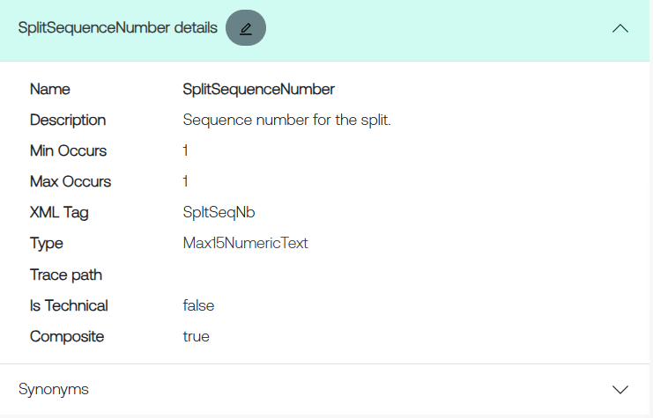
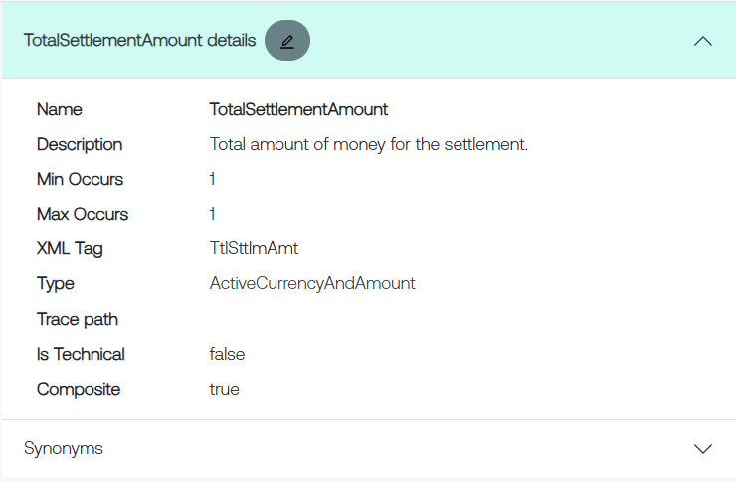

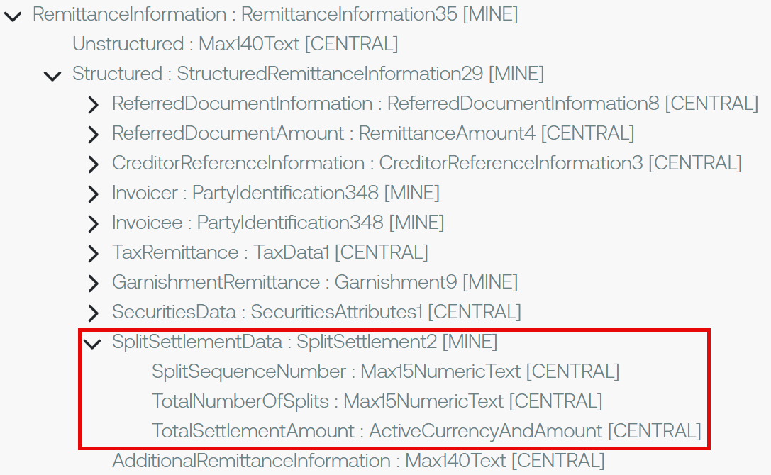

Proposed implementation in pacs.008:
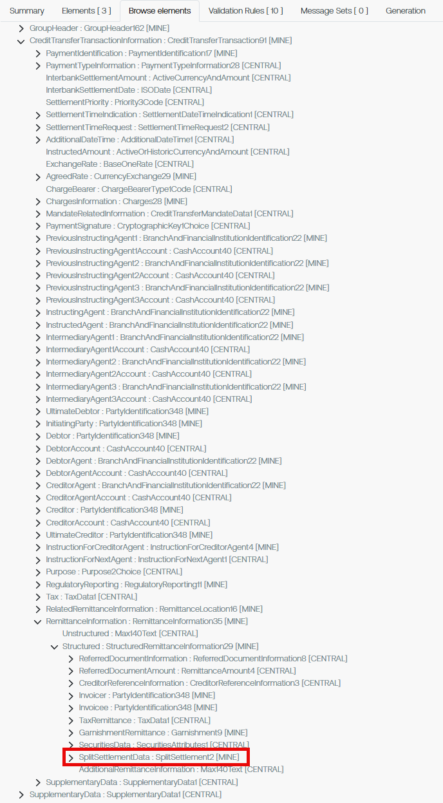

Proposed timing:
The submitting organization confirms that it can implement the requested changes in the requested timing, or, if not, proposes another timing.

Timing

Final decision of the SEG(s):
This section is not to be taken care of by the submitting organization. It will be completed in due time by the SEG(s) in charge of the related ISO 20022 messages.
Approve
Comments:

Reject
Reason for rejection:
Change request number 1574
Addition of UTI

Origin of the request:
A.1 Submitter: Swift

A.2 Contact person: Dean Chard dean.chard@swift.com

A.3 Sponsors:

Related messages:
pacs.009.001.13 | FinancialInstitutionCreditTransferV13

Description of the change request:

As part of the 2025/2026 Maintenance Change Request the PAYSEG agreed to add the Unique Transaction Identifier (UTI) to the pacs.009 under change requests 1405 and 1408.
Whilst this was implemented the UTI was only added to the Underlying block. The securities business uses many pacs.009s where the Underlying block is not used, the UTI needs to be implemented correctly in the main body of the message.

Purpose of the change:
Add the UTI to the main body of the pacs.009 message.
The PAYSEG must consider whether this is best achieved by adding the entire Structured remittance component (StructuredRemittanceInformation22) to the pacs.009 main body or just the SecuritiesAttributes1 component.
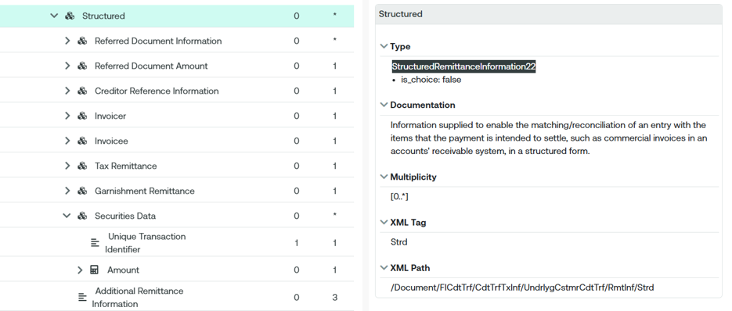

Urgency of the request:
2026/2027 maintenance cycle

Business examples:
n/a

SEG/TSG Recommendation:
This section is not to be taken care of by the submitter of the change request. It will be completed in due time by the SEG(s) in charge of the related ISO 20022 messages or the TSG for changes related to the BAH.

Consider |  | X | Timing
 |  |  | - Next yearly cycle: 2026/2027  (the change will be considered for implementation in the yearly maintenance cycle which starts in 2026 and completes with the publication of new message versions in the spring of 2027) |  | X
- At the occasion of the next maintenance of the messages
(the change will be considered for implementation, but does not justify maintenance of the messages in its own right – will be pending until more critical change requests are received for the messages)
- Urgent unscheduled
(the change justifies an urgent implementation outside of the normal yearly cycle)
 |  |  | - Other timing:
Comments:

Reject
Reason for rejection:

Impact analysis and type of impact:
The following Message Identifiers will be impacted –

pacs.009.001.13 | FinancialInstitutionCreditTransferV13

Proposed implementation:

Please note that as part of this and other implementations Structured Remittance will now be available in the pacs.009.

This is the proposed implementation –

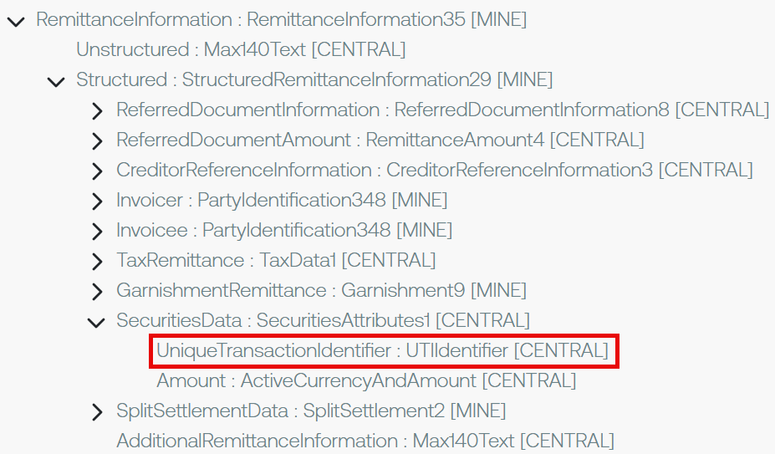

Proposed timing:
The submitting organization confirms that it can implement the requested changes in the requested timing, or, if not, proposes another timing.

Timing

Final decision of the SEG(s):
This section is not to be taken care of by the submitting organization. It will be completed in due time by the SEG(s) in charge of the related ISO 20022 messages.
Approve
Comments:

Reject
Reason for rejection:

Change request number 1576
Removal of Cross Element Complex Rule

Origin of the request:
A.1 Submitter: CBPR+ Group

A.2 Contact person: Dean Chard dean.chard@swift.com

A.3 Sponsors:

Related messages:
Notification To Receive
camt.057.001.09 NotificationToReceiveV09
camt.058.001.10 NotificationToReceiveCancellationAdviceV10
camt.059.001.09 NotificationToReceiveStatusReportV09

Description of the change request:
Several custodians and financial institutions have reported difficulties adhering to the Cross Element Complex Rule : Intermediary Agent And Debtor Agent Rule in the camt.057.
This rule forces the user to provide the Debtor Agent if the Intermediary Agent is present. No such rule existed in the MT210 message which is considered the equivalent of the camt.057 by the industry.
Users report that whilst senders of the message have the Intermediary Agent data to populate they do not have, nor is it reasonable to expect them to have the Debtor Agent data. By removing this rule it should improve the usability of this message and the quality of data that is provided.
This change request will also allow users to more easily translate a MT210 to a camt.057.

Purpose of the change:
Remove the “Cross Element Complex Rule : Intermediary Agent And Debtor Agent Rule” from both levels of the message.
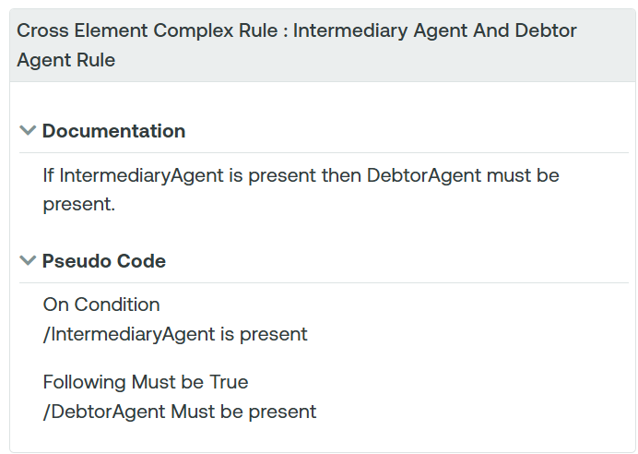

Urgency of the request:
2026/2027 maintenance cycle

Business examples:
n/a

SEG/TSG recommendation:
This section is not to be taken care of by the submitter of the change request. It will be completed in due time by the SEG(s) in charge of the related ISO 20022 messages or the TSG for changes related to the BAH.

Consider |  | X | Timing
 |  |  | - Next yearly cycle: 2026/2027  (the change will be considered for implementation in the yearly maintenance cycle which starts in 2026 and completes with the publication of new message versions in the spring of 2027) |  | X
- At the occasion of the next maintenance of the messages
(the change will be considered for implementation, but does not justify maintenance of the messages in its own right – will be pending until more critical change requests are received for the messages)
- Urgent unscheduled
(the change justifies an urgent implementation outside of the normal yearly cycle)
 |  |  | - Other timing:
Comments:

Reject
Reason for rejection:

Impact analysis and type of impact:
The following Message Identifiers will be impacted –

camt.057.001.09 NotificationToReceiveV09
camt.058.001.10 NotificationToReceiveCancellationAdviceV10
camt.059.001.09 NotificationToReceiveStatusReportV09

Proposed implementation:
Current:
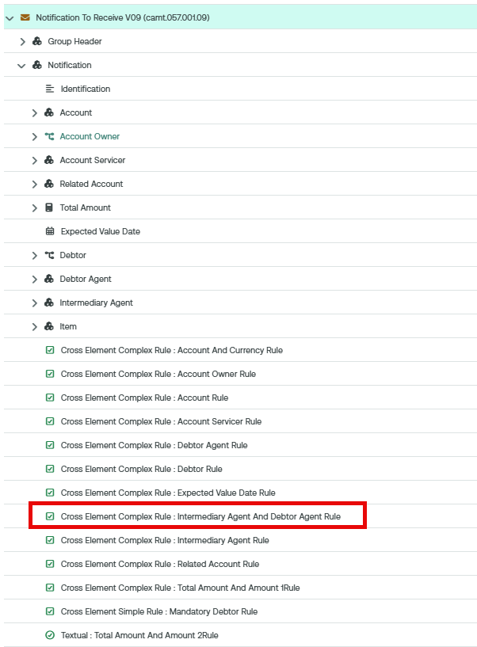

Proposed implementation where the rule has been removed:

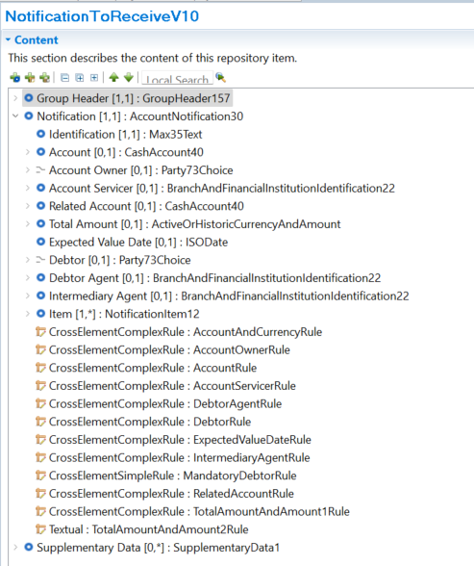

Proposed timing:
The submitting organization confirms that it can implement the requested changes in the requested timing, or, if not, proposes another timing.

Timing

Final decision of the SEG(s):
This section is not to be taken care of by the submitting organization. It will be completed in due time by the SEG(s) in charge of the related ISO 20022 messages.
Approve
Comments:

Reject
Reason for rejection:

Change request number 1582
Addition of Optional Message Pagination Component

Origin of the request:
A.1 Submitter:

Australian Payments Plus
255 George St, Sydney NSW 2000
This Change Request originates from Australian Payments Plus (AP+), the operator of Australia’s national instant and bulk payment infrastructure (NPP – New Payment Platform), as part of ongoing enhancement of ISO 20022 usage to support evolving clearing and settlement models.
Australian Payments Plus - About us
AP+ is Australia’s domestic payments organisation, established to strengthen and modernise the nation’s payments ecosystem through secure, resilient, and future-ready infrastructure and services. Operating in the public interest, AP+ brings together key national payment capabilities and works collaboratively across industry, government, regulators, financial institutions, merchants, fintechs, and payment service providers to support Australia’s evolving economic and digital needs.

A.2 Contact person:
Shriram Suriyanarayanan (Shriram.Suri@auspayplus.com.au)
Meg Ravikumar (meg.ravikumar@auspayplus.com.au)
A.3 Sponsors:
Swift
Nicole Jollifee (nicole.jolliffe@swift.com)
Kenneth Leung (kenneth.leung@swift.com)

Related messages:
- pain.001.001.13 – CustomerCreditTransferInitiation
- pain.013.001.12 – CreditorPaymentActivationRequest
- pacs.008.001.14 – FIToFICustomerCreditTransfer
- pacs.004.001.15 – PaymentReturn

Description of the change request:
Addition of Message Pagination for Bulk Payment Initiation and Clearing and Settlement Messages
Introduce an optional Message Pagination component at Group Header level in payment initiation and clearing/settlement messages, including pain.001, pain.013, pacs.008, and pacs.004, to support structured segmentation of bulk submissions.
The proposed structure enables:
- identification of multiple physical messages sharing the same Payment Information Identification or equivalent of batch level identification as parts of a single logical bulk submission, and
- explicit sequencing of each message within that submission through pagination indicators (e.g. page number and last page indicator).
The Message Pagination component shall include the following sub-elements:
- Page Number
- Last Page Indicator

This allows each message instance to represent a distinct “page” of a larger bulk payment dataset.
Business Justification / Market Practice
This enhancement addresses use cases where large bulk payment files must be split into multiple messages to comply with technical constraints such as message size limitations, while preserving business integrity.
Specifically, the proposed capability ensures:

- maintenance of a single logical business submission context across all message segments, and
- consistent use of batch level identification across all related messages to support traceability and reconciliation.
The pagination concept is aligned with existing ISO 20022 design principles and is comparable to sequencing approaches already applied in certain camt reporting messages.

Purpose of the change:
To provide a standard mechanism to indicate sequencing and completeness when bulk payment submissions are split into multiple messages solely to control message size, while using the same message type and Message ID across payment initiation (pain.001 / pain.013) and clearing/settlement (pacs.008 / pacs.004).

This enables participants to reliably determine whether all segments of a logical bulk submission have been received, without relying on proprietary conventions.

Urgency of the request:
High – bulk and high‑volume payment processing increasingly requires size‑driven splitting of batches across multiple messages.

Split parts of the same bulk are linked only via a common batch-level identifier (e.g. PaymentInformationIdentification).

Without a standard pagination mechanism, participants cannot reliably detect missing or incomplete bulk submissions, increasing reconciliation risk and operational complexity.

Business examples:
Example 1 – Size‑driven splitting at payment initiation stage
An initiating party (corporate or Fintech) submits a very large bulk payment file that exceeds maximum message size limits.

The file is split into multiple pain.001 messages, each carrying a portion of the Payment Information blocks. Split parts of the same bulk are linked via a common batch-level identifier (e.g. PaymentInformationIdentification).

The Message Pagination structure indicates page sequence and total pages, allowing the receiving bank to verify that the complete bulk submission has been received before processing.

Example 2 – End‑to‑end bulk payment processing
The same bulk submission is later split again at the clearing stage into multiple pacs.008 messages due to size constraints.
Pagination information allows downstream participants to:

* confirm receipt of all parts,
* detect missing segments, and
* process the submission consistently from initiation through settlement.

SEG/TSG recommendation:
This section is not to be taken care of by the submitter of the change request. It will be completed in due time by the SEG(s) in charge of the related ISO 20022 messages or the TSG for changes related to the BAH.

Consider |  | X | Timing
 |  |  | - Next yearly cycle: 2026/2027  (the change will be considered for implementation in the yearly maintenance cycle which starts in 2026 and completes with the publication of new message versions in the spring of 2027) |  | X
- At the occasion of the next maintenance of the messages
(the change will be considered for implementation, but does not justify maintenance of the messages in its own right – will be pending until more critical change requests are received for the messages)
- Urgent unscheduled
(the change justifies an urgent implementation outside of the normal yearly cycle)
 |  |  | - Other timing:
Comments:

Reject
Reason for rejection:

Impact analysis and type of impact:

pacs.004.001.15 | PaymentReturnV15
pacs.008.001.14 | FIToFICustomerCreditTransferV14
pacs.009.001.13 | FinancialInstitutionCreditTransferV13
pain.013.001.12  pain.014.001.12 | CreditorPaymentActivationRequestV12  CreditorPaymentActivationRequestStatusReportV12

Proposed implementation:

It should be noted that Message Pagination has also been added to the pacs.009 as this message uses the same group header as the pacs.008.

Proposed implementation:

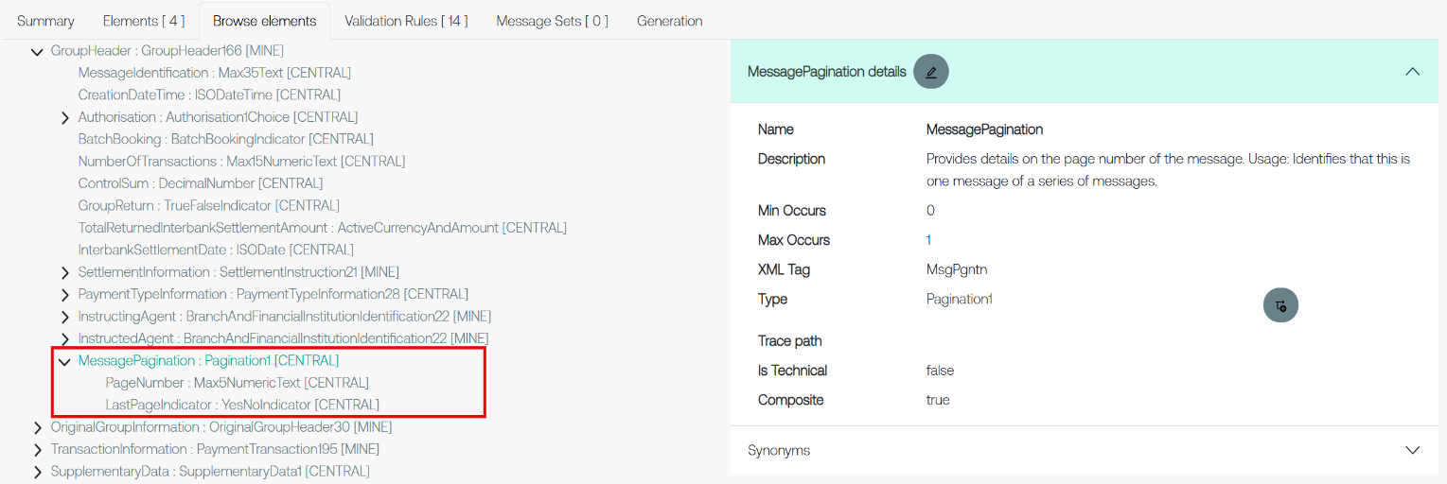
pacs.004

pacs.008

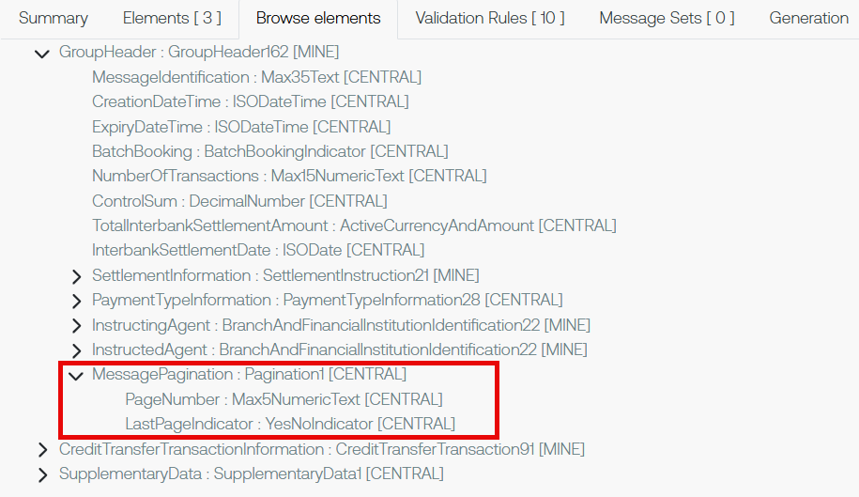
pacs.009

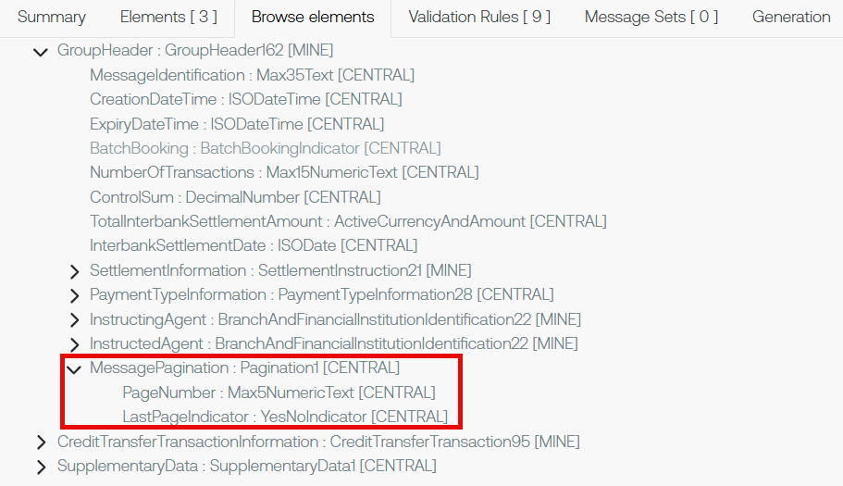

pain.001

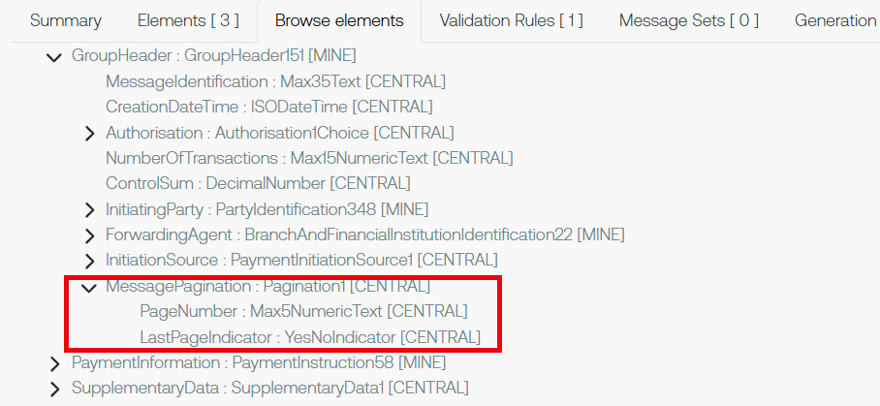

pain.013

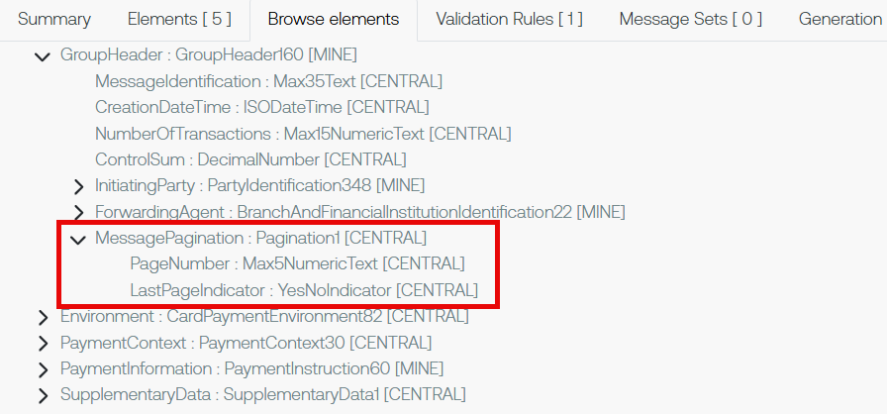

Proposed timing:
The submitting organization confirms that it can implement the requested changes in the requested timing, or, if not, proposes another timing.

Timing

Final decision of the SEG(s):
This section is not to be taken care of by the submitting organization. It will be completed in due time by the SEG(s) in charge of the related ISO 20022 messages.
Approve
Comments:

Reject
Reason for rejection:

Change request number 1583
Changes of Multiplicity and Addition of Optional Component

Origin of the request
A.1 Submitter:

Australian Payments Plus
255 George St, Sydney NSW 2000
This Change Request originates from Australian Payments Plus (AP+), the operator of Australia’s national instant and bulk payment infrastructure (NPP – New Payment Platform), as part of ongoing enhancement of ISO 20022 usage to support evolving clearing and settlement models.
Australian Payments Plus - About us
AP+ is Australia’s domestic payments organisation, established to strengthen and modernise the nation’s payments ecosystem through secure, resilient, and future-ready infrastructure and services. Operating in the public interest, AP+ brings together key national payment capabilities and works collaboratively across industry, government, regulators, financial institutions, merchants, fintechs, and payment service providers to support Australia’s evolving economic and digital needs.

A.2 Contact person:
Shriram Suriyanarayanan (Shriram.Suri@auspayplus.com.au)
Meg Ravikumar (meg.ravikumar@auspayplus.com.au)
A.3 Sponsors:
Swift
Nicole Jollifee (nicole.jolliffe@swift.com)
Kenneth Leung (kenneth.leung@swift.com)

Related messages
- camt.110.001.02 – InvestigationRequest
- camt.111.001.03 – InvestigationResponse

Description of the change request
- Modification of Multiplicity for Underlying Component to Support Multiple Instances in camt.110/111

Current state:
The Underlying element (Undrlyg) is currently limited to a single occurrence per message: camt.110.001.02 /Document/InvstgtnReq/InvstgtnReq/Undrlyg is [1..1] and camt.111.001.03 /Document/InvstgtnRspn/OrgnlInvstgtnReq/Undrlyg is [0..1]. This constrains an investigation case to at most one underlying transaction reference.

Proposed change:
Update the multiplicity of Undrlyg to [1..*] in camt.110 and [0..*] in camt.111, enabling a single investigation request/response to include multiple underlying transaction references when they share the same case context. No new message definitions are introduced; the change extends the existing structure to support bulk-related scenarios.

Business Justification / Market Practice
Payment systems increasingly support bulk and high‑volume processing, where a single logical submission may contain multiple related transactions. In such environments, investigations are often raised at batch or group level, particularly for operational incidents, screening, or regulatory reviews.

Current ISO 20022 modelling restricts each investigation case (camt.110 / camt.111) to a single underlying transaction reference. This does not align with market practice, where one investigation case may logically apply to multiple related transactions. As a result, implementers are forced to create multiple parallel cases with identical context and manually correlate them, increasing message volumes, operational complexity, and risk of inconsistent resolution.

Updating the multiplicity of the existing Underlying element to allow multiple occurrences enables ISO 20022 messages to accurately represent real investigation workflows in bulk payment environments. This change improves efficiency, consistency, and auditability, without introducing new structures or altering existing semantics.

- Addition of Transaction-Level Investigation Response Structure in camt.111

Enable camt.111 (Investigation Response) to report investigation status at the underlying transaction level when a single investigation case references multiple underlying transactions (as enabled by NPP008).
Specifically, introduce a new optional repeating component block:
TransactionInvestigationResponse [0..*]
Proposed structure:
- InvestigationStatus [1..1] – the investigation outcome/status applicable to the referenced underlying transaction (with sub-elements Status and Status Reason); same data type as the Investigation Status as one at Message level.
- InvestigationData [0..1] – optional additional investigation information applicable to the referenced underlying transaction, using the same data type and semantics as the existing InvestigationData element at message level.
- Underlying [1..1] – reference to the specific underlying transaction to which the reported status applies; same data type as the Underlying element in the same message and camt.110.
The component is proposed to be placed as sub-element under /Document/InvstgtnRspn after element /Document/InvstgtnRspn/InvstgtnRspn.

This new component allows a single camt.111 message to convey distinct investigation outcomes per underlying transaction, while remaining within a single investigation case context.

Purpose of the change:
Improve reconciliation and reduce queries from customers.

Urgency of the request:
High – required for communities and market infrastructures supporting bulk payment processing and investigations (including compliance screening or batch-related incidents). If delayed, implementers must open multiple parallel cases and manually correlate them, increasing operational load and risk.

Business Examples:
Example 1 (screening/regulatory): A sanctions or regulatory investigation is raised for a group of related transactions from the same bulk submission; one case is opened and multiple underlying transactions are referenced within Undrlyg.

Example 2 (batch incident): A processing incident impacts several transactions in a batch (e.g., duplicate submission or partial rejection); a single investigation request references all impacted transactions to obtain a consolidated response.

Example 3 – Batch incident response
A processing incident affects multiple transactions within the same bulk submission. An investigation is opened referencing all impacted transactions.

In the response:
- some transactions are confirmed as duplicated,
- others are confirmed as pending and successfully reprocessed.

The camt.111 includes multiple TransactionInvestigationResponse blocks, each reporting the appropriate InvestigationStatus for its referenced underlying transaction.

Example 4 – Compliance screening investigation
A sanctions screening investigation is raised for several related transactions in one case.

In the response:
- some transactions are cleared,
- others are rejected or escalated.

Transaction‑level investigation response statuses are reported in a single camt.111 message, ensuring precise, auditable outcomes without opening parallel cases.

SEG/TSG recommendation:
This section is not to be taken care of by the submitter of the change request. It will be completed in due time by the SEG(s) in charge of the related ISO 20022 messages or the TSG for changes related to the BAH.

Consider |  | X | Timing
 |  |  | - Next yearly cycle: 2026/2027  (the change will be considered for implementation in the yearly maintenance cycle which starts in 2026 and completes with the publication of new message versions in the spring of 2027) |  | X
- At the occasion of the next maintenance of the messages
(the change will be considered for implementation, but does not justify maintenance of the messages in its own right – will be pending until more critical change requests are received for the messages)
- Urgent unscheduled
(the change justifies an urgent implementation outside of the normal yearly cycle)
 |  |  | - Other timing:
Comments:

Reject
Reason for rejection:

Impact analysis and type of impact:
The following Message Identifiers will be impacted –

camt.110.001.03  camt.111.001.02 | InvestigationRequestV03  InvestigationResponseV02

Proposed implementation:

Modification of Multiplicity for Underlying Component to Support Multiple Instances in camt.110/111

Current implementation of camt.110:

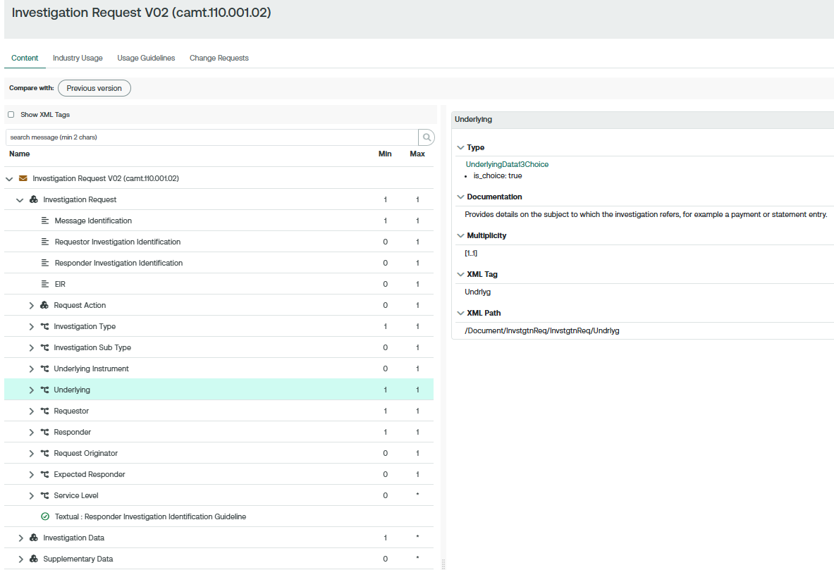

Current implementation of camt.111:

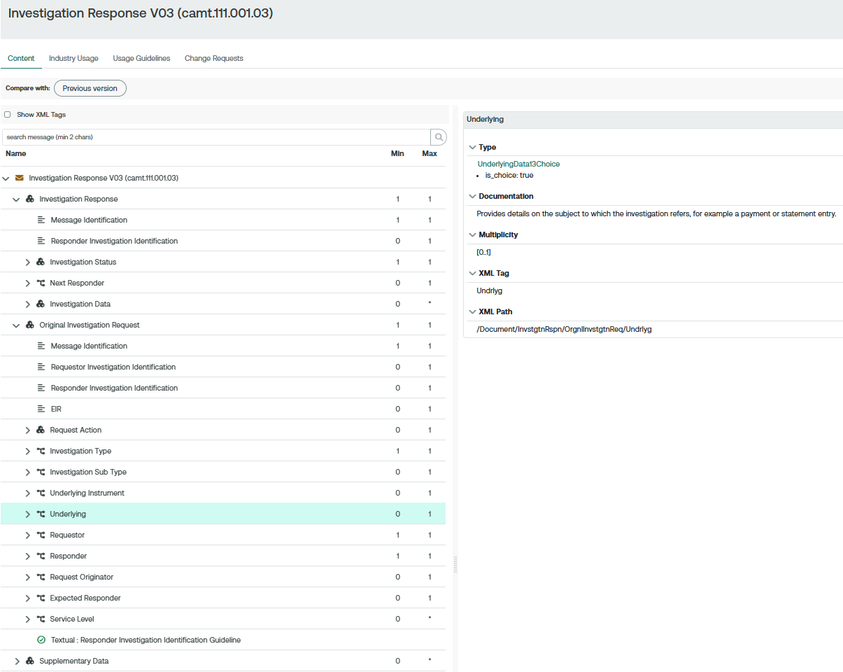
Proposed implementation of camt.110:
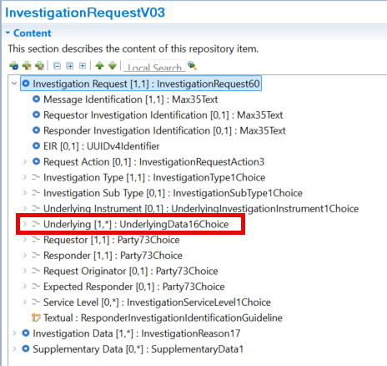

Proposed implementation of camt.111:
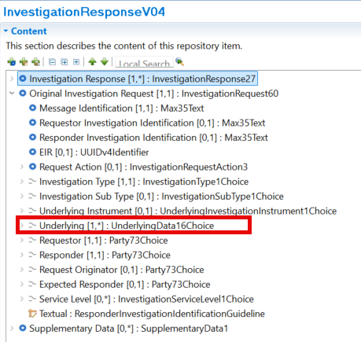
Addition of Transaction-Level Investigation Response Structure in camt.111

We recommend a different implementation from the original change request. We suggest the Investigation Status component is left unchanged with a new “Original Investigation Underlying” component added to the Investigation Data block.

Current implementation:

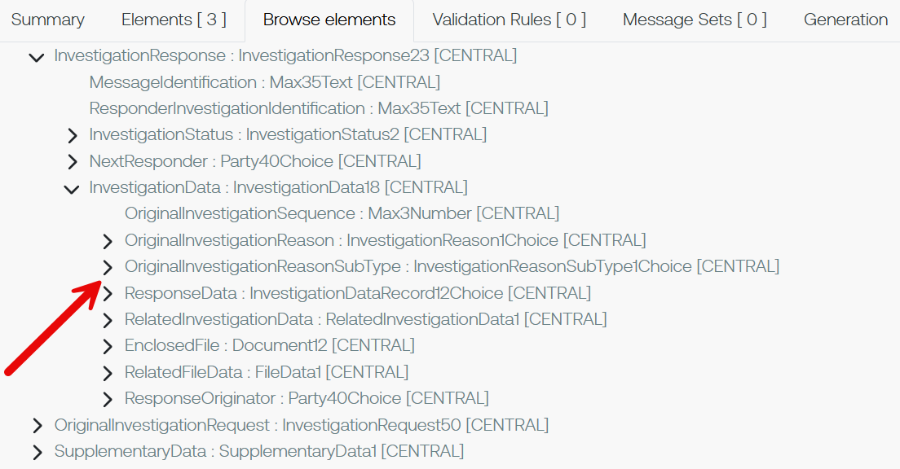

Proposed implementation:

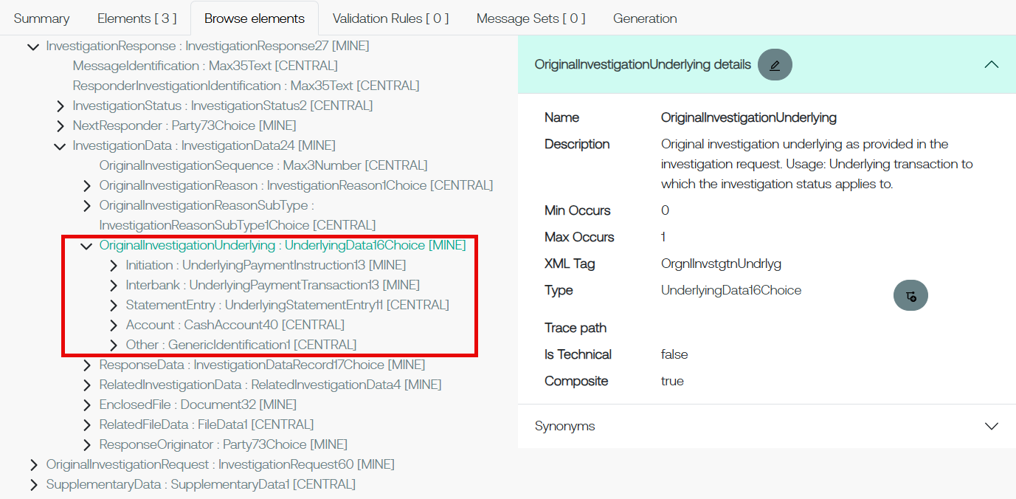

Proposed timing:
The submitting organization confirms that it can implement the requested changes in the requested timing, or, if not, proposes another timing.

Timing

Final decision of the SEG(s):
This section is not to be taken care of by the submitting organization. It will be completed in due time by the SEG(s) in charge of the related ISO 20022 messages.
Approve
Comments:

Reject
Reason for rejection:

Change request number 1584
Addition of Mandate Related Information Component

Origin of the request
A.1 Submitter:

Australian Payments Plus
255 George St, Sydney NSW 2000
This Change Request originates from Australian Payments Plus (AP+), the operator of Australia’s national instant and bulk payment infrastructure (NPP – New Payment Platform), as part of ongoing enhancement of ISO 20022 usage to support evolving clearing and settlement models.
Australian Payments Plus - About us
AP+ is Australia’s domestic payments organisation, established to strengthen and modernise the nation’s payments ecosystem through secure, resilient, and future-ready infrastructure and services. Operating in the public interest, AP+ brings together key national payment capabilities and works collaboratively across industry, government, regulators, financial institutions, merchants, fintechs, and payment service providers to support Australia’s evolving economic and digital needs.

A.2 Contact person:
Shriram Suriyanarayanan (Shriram.Suri@auspayplus.com.au)
Meg Ravikumar (meg.ravikumar@auspayplus.com.au)
A.3 Sponsors:
Swift
Nicole Jollifee (nicole.jolliffe@swift.com)
Kenneth Leung (kenneth.leung@swift.com)

Related messages
- pain.001.001.13 – CustomerCreditTransferInitiation
- pain.013.001.12 – CreditorPaymentActivationRequest

Description of the change request
Addition of MandateRelatedInformation at Payment Information level in pain.001 and pain.013

Introduce an optional MandateRelatedInformation (MndtRltdInf) component at the Payment Information level in pain.001 and pain.013. This component is added as an additional block, supplementing the existing transaction-level MandateRelatedInformation, and is not mutually exclusive with it.

The group-level MndtRltdInf enables mandate information to be provided once where all underlying transactions relate to the same mandate, while retaining the ability to specify mandate details individually at transaction level where required.

The MndtRltdInf is proposed to be added and placed:
- before Debtor element under pain.001 /Document/CstmrCdtTrfInitn/PmtInf
- before Debtor element under pain.013 /Document/CdtrPmtActvtnReq/PmtInf

Business Justification / Market Practice
In bulk payment environments, multiple credit transfers may originate from a single mandate. Current ISO 20022 modelling requires mandate information, including electronic signatures where applicable, to be repeated at transaction level, resulting in increased message size and reduced processing efficiency without additional semantic value.
The proposed enhancement reflects common market practice by allowing mandate information to be provided at group level while preserving existing transaction-level structures. This improves efficiency, maintains auditability, and avoids unnecessary data repetition without altering existing business semantics.

Purpose of the change:
To improve efficiency and scalability of bulk credit transfer messages involving a common mandate.

Urgency of the request:
High – particularly relevant for bulk and instant payment schemes with large transaction volumes.

Business Examples:
A bulk direct credit file where all transactions are governed by the same mandate currently requires repeated mandate data per transaction.

SEG/TSG recommendation:
This section is not to be taken care of by the submitter of the change request. It will be completed in due time by the SEG(s) in charge of the related ISO 20022 messages or the TSG for changes related to the BAH.

Consider |  | X | Timing
 |  |  | - Next yearly cycle: 2026/2027  (the change will be considered for implementation in the yearly maintenance cycle which starts in 2026 and completes with the publication of new message versions in the spring of 2027) |  | X
- At the occasion of the next maintenance of the messages
(the change will be considered for implementation, but does not justify maintenance of the messages in its own right – will be pending until more critical change requests are received for the messages)
- Urgent unscheduled
(the change justifies an urgent implementation outside of the normal yearly cycle)
 |  |  | - Other timing:
Comments:

Reject
Reason for rejection:

Impact analysis and type of impact:
The following Message Identifiers will be impacted –

pain.001.001.13 CustomerCreditTransferInitiationV13
pain.013.001.12 CreditorPaymentActivationRequestV12

Proposed implementation:
Current:

pain.001
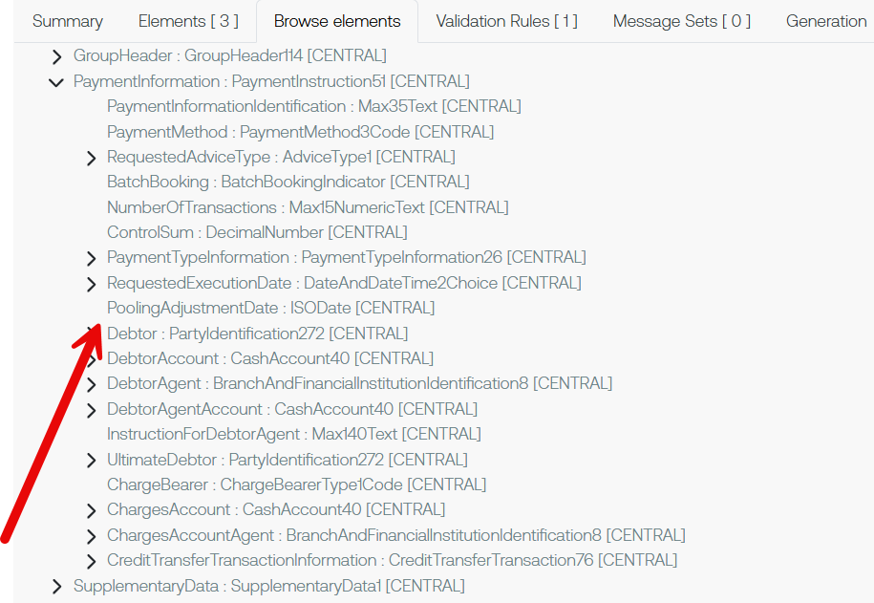

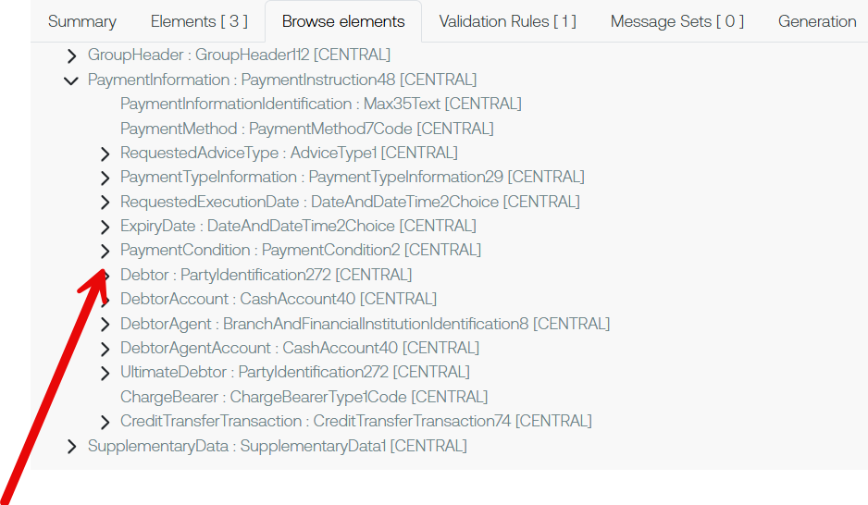
pain.013
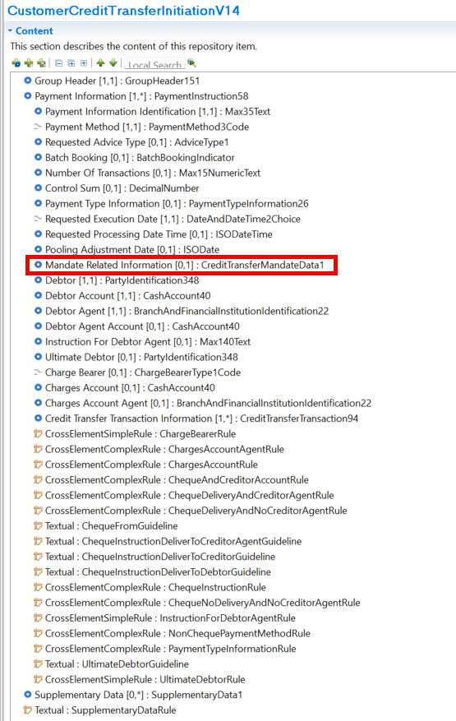
Proposed implementation pain.001:

Proposed implementation pain.013:

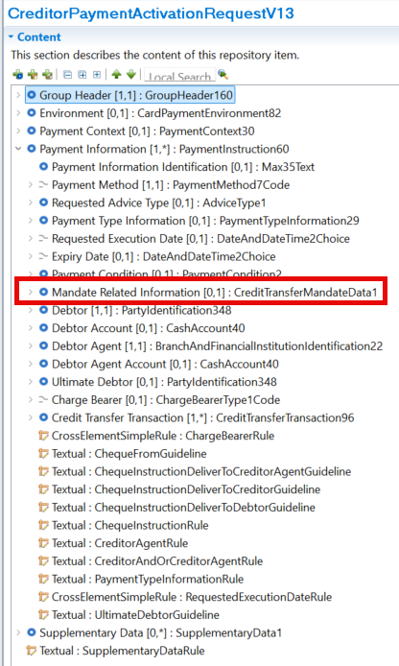

Proposed timing:
The submitting organization confirms that it can implement the requested changes in the requested timing, or, if not, proposes another timing.

Timing

Final decision of the SEG(s):
This section is not to be taken care of by the submitting organization. It will be completed in due time by the SEG(s) in charge of the related ISO 20022 messages.
Approve
Comments:

Reject
Reason for rejection:

Change request number 1581
Addition of Optional Element

Origin of the request
A.1 Submitter:

Australian Payments Plus
255 George St, Sydney NSW 2000
This Change Request originates from Australian Payments Plus (AP+), the operator of Australia’s national instant and bulk payment infrastructure (NPP – New Payment Platform), as part of ongoing enhancement of ISO 20022 usage to support evolving clearing and settlement models.
Australian Payments Plus - About us
AP+ is Australia’s domestic payments organisation, established to strengthen and modernise the nation’s payments ecosystem through secure, resilient, and future-ready infrastructure and services. Operating in the public interest, AP+ brings together key national payment capabilities and works collaboratively across industry, government, regulators, financial institutions, merchants, fintechs, and payment service providers to support Australia’s evolving economic and digital needs.

A.2 Contact person:
Shriram Suriyanarayanan (Shriram.Suri@auspayplus.com.au)
Meg Ravikumar (meg.ravikumar@auspayplus.com.au)
A.3 Sponsors:
Swift
Nicole Jollifee (nicole.jolliffe@swift.com)
Kenneth Leung (kenneth.leung@swift.com)

Related messages
- pain.001.001.13 – CustomerCreditTransferInitiation

Description of the change request
Addition of Requested Debit Booking Date/DateTime element in pain.001

Introduce an optional RequestedDebitBookingDate element at the Payment Information level in pain.001. The element enables the specification of the account booking (posting) date independently from the execution date.
The RequestedDebitBookingDate element is defined as a component with a choice of Date or DateTime.
Consequently, the definition of RequestedExecutionDate in pain.001 should be clarified to indicate that it represents the execution timing, while the actual debit booking date may be provided via RequestedDebitBookingDate when present.

Business Justification / Market Practice
Current ISO semantics define RequestedExecutionDate as the date the debtor’s account is to be debited. In modern payment processing, execution timing and account booking timing may differ due to operational, liquidity, regulatory, or resilience considerations. Overloading RequestedExecutionDate to represent both concepts leads to ambiguity.

The proposed element provides semantic clarity while preserving existing behaviour when the element is omitted, reflecting common market practices in real‑time and bulk payment environments.

Purpose of the change:
To support business cases where clear distinction is required between execution timing and debtor account booking timing in payment initiation.

Urgency of the request:
Medium – driven by real‑time and bulk payments, resilience use cases, and recovery scenarios.

Business Examples:
Payments are executed immediately but booked to the debtor’s account at a later agreed time; bulk payments require deferred posting following system recovery.

SEG/TSG recommendation:
This section is not to be taken care of by the submitter of the change request. It will be completed in due time by the SEG(s) in charge of the related ISO 20022 messages or the TSG for changes related to the BAH.

Consider |  | X | Timing
 |  |  | - Next yearly cycle: 2026/2027  (the change will be considered for implementation in the yearly maintenance cycle which starts in 2026 and completes with the publication of new message versions in the spring of 2027) |  | X
- At the occasion of the next maintenance of the messages
(the change will be considered for implementation, but does not justify maintenance of the messages in its own right – will be pending until more critical change requests are received for the messages)
- Urgent unscheduled
(the change justifies an urgent implementation outside of the normal yearly cycle)
 |  |  | - Other timing:
Comments:

Reject
Reason for rejection:

Impact analysis and type of impact:
The following Message Identifiers will be impacted –

pain.001.001.13 CustomerCreditTransferInitiationV13

Proposed implementation:
Current:

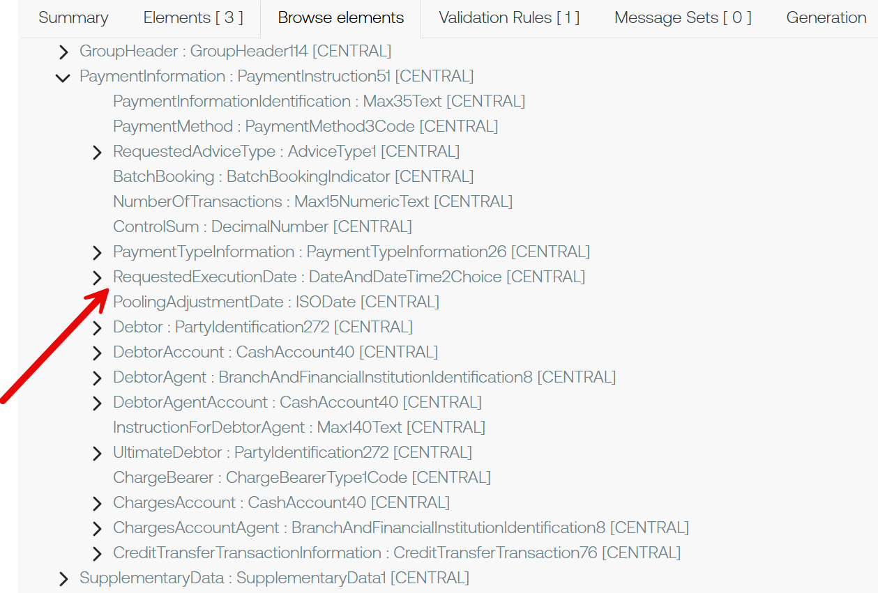

Proposed implementation:

Question to the SEG: Is Requested Processing Date Time an appropriate name? Our recommendation is to leave the current Requested Execution Date component as-is to avoid impacting implementors who use this with no issue today.

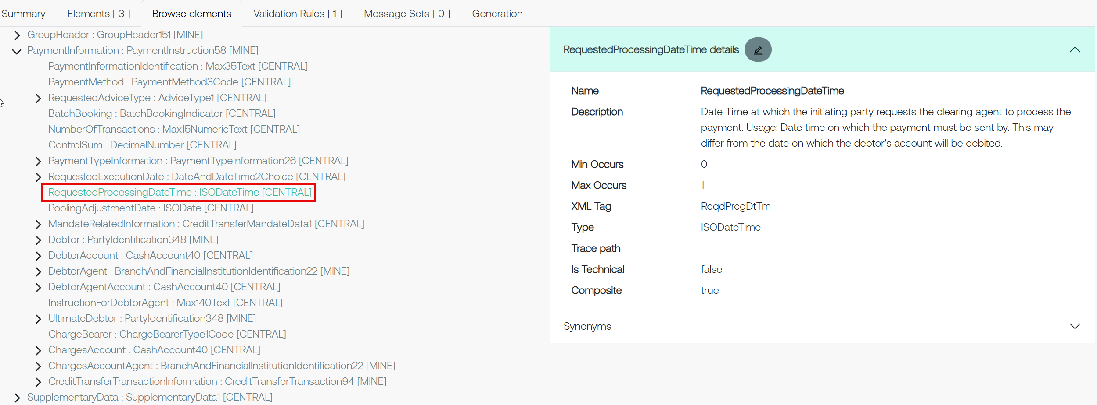

Proposed timing:
The submitting organization confirms that it can implement the requested changes in the requested timing, or, if not, proposes another timing.

Timing

Final decision of the SEG(s):
This section is not to be taken care of by the submitting organization. It will be completed in due time by the SEG(s) in charge of the related ISO 20022 messages.
Approve
Comments:

Reject
Reason for rejection:

Change request number 1586
Addition of Optional Element

Origin of the request
A.1 Submitter:

Australian Payments Plus
255 George St, Sydney NSW 2000
This Change Request originates from Australian Payments Plus (AP+), the operator of Australia’s national instant and bulk payment infrastructure (NPP – New Payment Platform), as part of ongoing enhancement of ISO 20022 usage to support evolving clearing and settlement models.
Australian Payments Plus - About us
AP+ is Australia’s domestic payments organisation, established to strengthen and modernise the nation’s payments ecosystem through secure, resilient, and future-ready infrastructure and services. Operating in the public interest, AP+ brings together key national payment capabilities and works collaboratively across industry, government, regulators, financial institutions, merchants, fintechs, and payment service providers to support Australia’s evolving economic and digital needs.

A.2 Contact person:
Shriram Suriyanarayanan (Shriram.Suri@auspayplus.com.au)
Meg Ravikumar (meg.ravikumar@auspayplus.com.au)
A.3 Sponsors:
Swift
Nicole Jollifee (nicole.jolliffe@swift.com)
Kenneth Leung (kenneth.leung@swift.com)

Related messages
- pain.001.001.13 – CustomerCreditTransferInitiation
- pain.013.001.12 – CreditorPaymentActivationRequest
- pacs.008.001.14 – FIToFICustomerCreditTransfer

Description of the change request
Addition of Requested Credit Booking Date for pain.001, pain.013 and pacs.008

Current state:
In payment initiation and activation messages (pain.001/pain.013), RequestedExecutionDate represents requested execution timing from the payer perspective. There is no standard ISO 20022 element to carry, end‑to‑end, a payer‑provided instruction for the expected booking (posting) date/time of the credit on the beneficiary side, nor to ensure that this instruction is available to the creditor agent when the transaction is carried in interbank clearing and settlement messages (pacs.008). Implementations therefore overload execution/settlement dates or rely on proprietary conventions, and the creditor agent may not receive the original booking instruction.

Proposed change:
Introduce an optional RequestedCreditBookingDate element (ReqstdCdtBookgDt) with a Date or DateTime choice to indicate the requested (target) booking/posting date‑time for the credit to the beneficiary account(s) for all transactions within a PaymentInformation block, and enable its propagation into pacs.008. Specifically:
- pain.001.001.13: add ReqstdCdtBookgDt [0..1] under /Document/CstmrCdtTrfInitn/PmtInf;
- pain.013.001.12: add ReqstdCdtBookgDt [0..1] under /Document/CstmrPmtActvtnReq/PmtInf;
- pacs.008.001.14: add ReqstdCdtBookgDt [0..1] under /Document/FIToFICstmrCdtTrf/GrpHdr and /Document/FIToFICstmrCdtTrf/CdtTrfTxInf/ to carry forward the value received in pain.001/pain.013 for the corresponding batch (including when the batch is split across multiple pacs.008 messages).

Business Justification / Market Practice
Debtor‑side booking and creditor‑side booking are distinct. While RequestedDebitBookingDate is relevant to the debtor agent only, many schemes and bulk/instant processes require a payer‑provided expectation for when beneficiaries should see funds posted (credit booking). This expectation must be available to the creditor agent and, where applicable, the market infrastructure.

Providing a dedicated RequestedCreditBookingDate avoids overloading RequestedExecutionDate with beneficiary posting semantics. It improves predictability for beneficiaries, supports batch booking and resilience/recovery processing, and reduces reliance on proprietary conventions. Where DateTime is used, the value can be expressed in UTC.

Purpose of the change:
To enable end‑to‑end propagation of a payer‑provided requested credit booking date/time from payment initiation (pain.001) and payment activation (pain.013) into clearing and settlement (pacs.008), so that creditor agents can align beneficiary posting with scheme/customer expectations. This is distinct from debtor‑only booking date use cases, as it explicitly targets the creditor‑side posting timeline.

Urgency of the request:
Medium – driven by real‑time and bulk payments, resilience use cases, and recovery scenarios.

Business Examples:
Batch booking / expiry style use case
A scheme supports batch booking where credits are held and then posted together. The initiator provides ReqstdCdtBookgDt as a DateTime representing the requested booking moment for the batch. If the batch is split into multiple pacs.008 messages for clearing, each message carries the same ReqstdCdtBookgDt to preserve the batch‑level booking instruction end‑to‑end.

SEG/TSG recommendation:
This section is not to be taken care of by the submitter of the change request. It will be completed in due time by the SEG(s) in charge of the related ISO 20022 messages or the TSG for changes related to the BAH.

Consider |  | X | Timing
 |  |  | - Next yearly cycle: 2026/2027  (the change will be considered for implementation in the yearly maintenance cycle which starts in 2026 and completes with the publication of new message versions in the spring of 2027) |  | X
- At the occasion of the next maintenance of the messages
(the change will be considered for implementation, but does not justify maintenance of the messages in its own right – will be pending until more critical change requests are received for the messages)
- Urgent unscheduled
(the change justifies an urgent implementation outside of the normal yearly cycle)
 |  |  | - Other timing:
Comments:

Reject
Reason for rejection:

Impact analysis and type of impact:
The following Message Identifiers will be impacted –

acmt.027.001.06 AccountSwitchInformationRequestV06
acmt.028.001.06 AccountSwitchInformationResponseV06
acmt.029.001.06 AccountSwitchCancelExistingPaymentV05
acmt.031.001.06 AccountSwitchRequestBalanceTransferV06
acmt.032.001.06 AccountSwitchBalanceTransferAcknowledgementV06
acmt.034.001.06 AccountSwitchRequestPaymentV06

camt.110.001.02 InvestigationRequestV02
camt.111.001.03 InvestigationResponseV03

pacs.004.001.15 PaymentReturnV15
pacs.008.001.14 FIToFICustomerCreditTransferV14
pacs.009.001.13 FinancialInstitutionCreditTransferV1
pacs.010.001.06 FinancialInstitutionDirectDebitV06

pain.001.001.13 CustomerCreditTransferInitiationV13
pain.013.001.12 CreditorPaymentActivationRequestV12

trck.001.001.05 PaymentStatusTrackerUpdateV05
trck.002.001.04 PaymentStatusTrackerReportV04
trck.004.001.04 PaymentStatusCustomerTrackerReportV04
trck.005.001.03 TrackerInvestigationStatusNotificationV03

Proposed implementation:

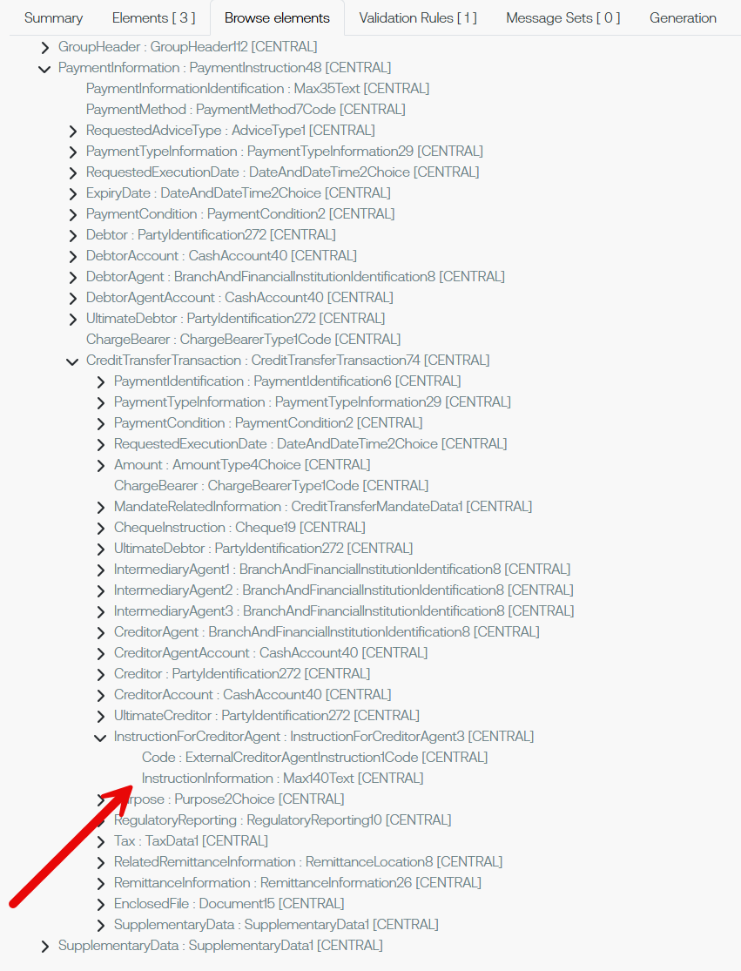
Current:
Proposed implementation:
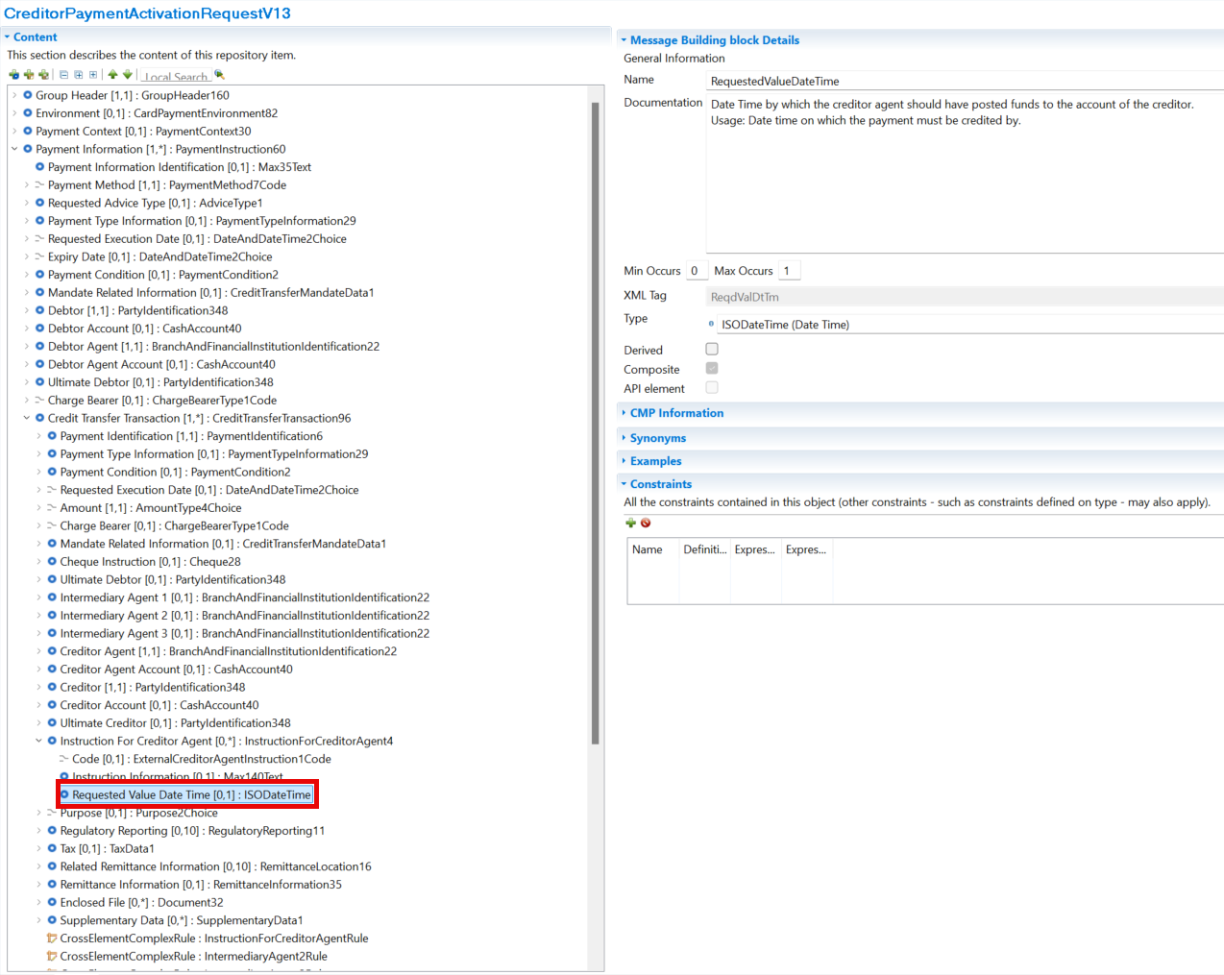

Proposed timing:
The submitting organization confirms that it can implement the requested changes in the requested timing, or, if not, proposes another timing.

Timing

Final decision of the SEG(s):
This section is not to be taken care of by the submitting organization. It will be completed in due time by the SEG(s) in charge of the related ISO 20022 messages.
Approve
Comments:

Reject
Reason for rejection:

Change request number 1581
Addition of Optional Element

Origin of the request
A.1 Submitter: nexo A.I.S.B.L.

A.2 Contact person:
- Catherine BOUNDJIA (catherine.boundjia@nexo-standards.org)
- Rober FARGIER (robert.fargier@istium.pro)

A.3 Sponsors: nexo A.I.S.B.L.

Related messages
- CreditorPaymentActivationRequestV12 (pain.013.001.12)
- CreditorPaymentActivationRequestStatusReportV12 (pain.014.001.12)

Description of the change request
The change request aims to allow the Creditor sending party (Creditor or Payee) to provide Environment and Context information inside a payment initiation request message used to request movement of funds from a debtor account to the creditor account.
Update to message CreditorPaymentActivationRequestV12:
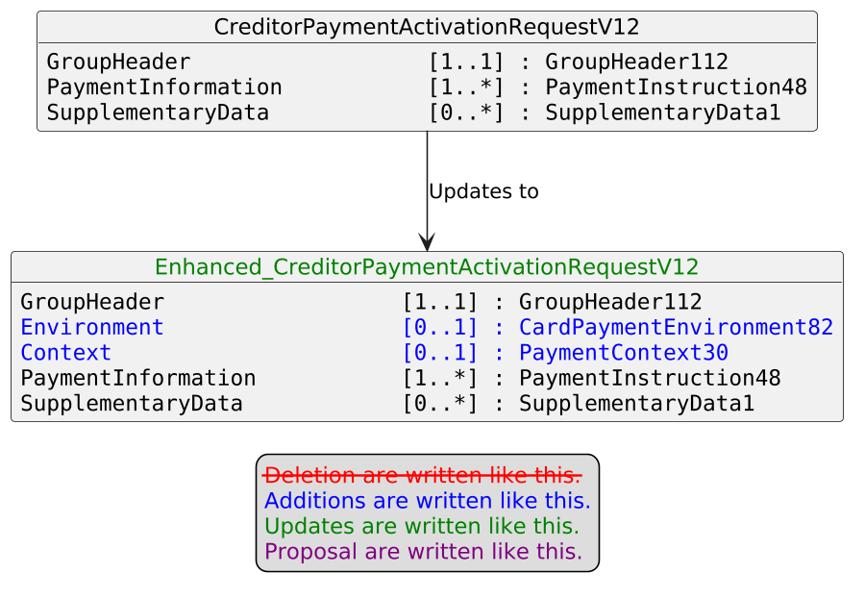

Update to message CreditorPaymentActivationRequestStatusReportV12:
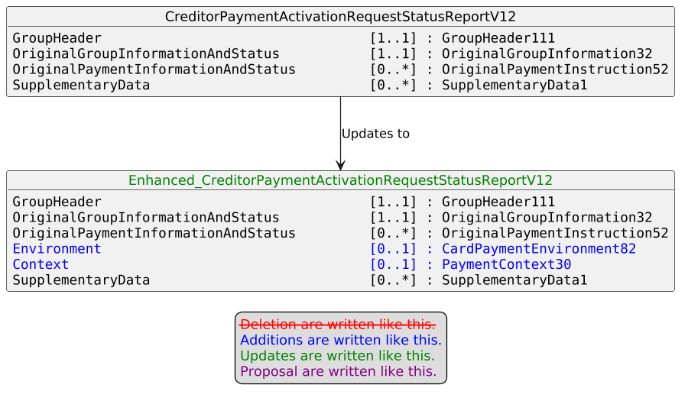

Purpose of the change:
nexo A.I.S.B.L. is the international organization dedicated to standardizing the exchange of payment acceptance data between merchants, acquirers, payment service providers, and other payment stakeholders. In 2025, nexo established the Instant Payment Acceptance Specification (IPAS) Technical Working Group, responsible for defining, developing, maintaining, and publishing specifications and guidelines to facilitate instant payment acceptance at the Point of Interaction (POI).
In this context, nexo IPAS TWG has identified the need to enable the Creditor sending party to embed Environment and Context information — including POI details — directly within the payment initiation request message. This information is intended to allow the Credit Agent to identify the POI system that should be notified upon completion of the instant credit transfer, a capability that is essential in Consumer-to-Business (C2B) "instant payment at the POI" scenarios, where the payment outcome must be communicated back to the originating terminal or system in real time.
By incorporating this information directly into the payment initiation request message, the end-to-end payment flow is streamlined, eliminating the need for separate notification mechanisms and improving the overall reliability and traceability of instant payment confirmations.

Urgency of the request:
Urgent.

Business Examples:
n/a

SEG/TSG recommendation:
This section is not to be taken care of by the submitter of the change request. It will be completed in due time by the SEG(s) in charge of the related ISO 20022 messages or the TSG for changes related to the BAH.

Consider |  | X | Timing
 |  |  | - Next yearly cycle: 2026/2027  (the change will be considered for implementation in the yearly maintenance cycle which starts in 2026 and completes with the publication of new message versions in the spring of 2027) |  | X
- At the occasion of the next maintenance of the messages
(the change will be considered for implementation, but does not justify maintenance of the messages in its own right – will be pending until more critical change requests are received for the messages)
- Urgent unscheduled
(the change justifies an urgent implementation outside of the normal yearly cycle)
 |  |  | - Other timing:
Comments:

Reject
Reason for rejection:

Impact analysis and type of impact:
The following Message Identifiers will be impacted –

pain.013.001.12 CreditorPaymentActivationRequestV12
pain.014.001.12 CreditorPaymentActivationRequestStatusReportV12

Proposed implementation:

Current:

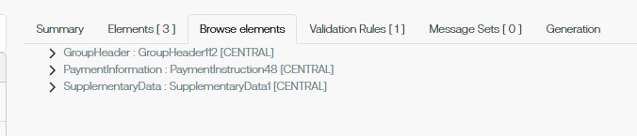

Proposed implementation:

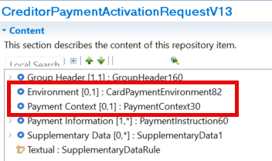

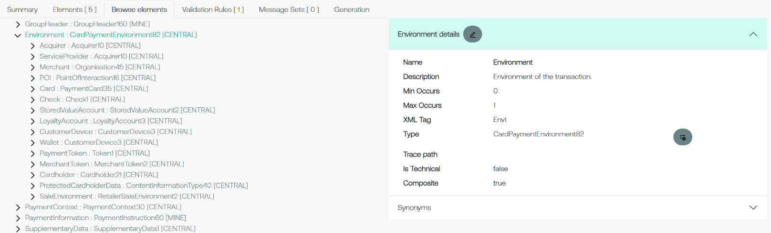

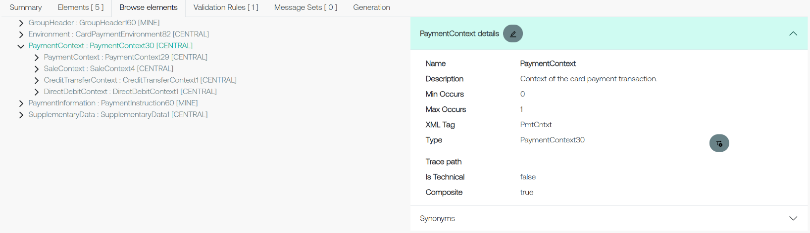

Proposed timing:
The submitting organization confirms that it can implement the requested changes in the requested timing, or, if not, proposes another timing.

Timing

Final decision of the SEG(s):
This section is not to be taken care of by the submitting organization. It will be completed in due time by the SEG(s) in charge of the related ISO 20022 messages.
Approve
Comments:

Reject
Reason for rejection:

Additional technical adjustments in the ISO 20022 rules identified during the maintenance (standing change request)
As part of the implementation, we have identified a number of technical errors in the description of the rules defined in the messages. Below is the exhaustive list of corrections as applied to the messages:

 | Issue in rule or data type | Description of the change required
1. | Longstanding misalignment in XML tags for Financial Institution Identification | Across the ISO message suite there is currently a misalignment when it comes to a standard XML tag (abbreviation) for Financial Institution Identification.  In some places this is noted as FinInstnId whilst in others it is FIId.  Under current ISO standards the preferred XML tag (abbreviation) is FIId. As such this has been consistently applied within the BranchAndFinancialInstitutionIdentification22 component.  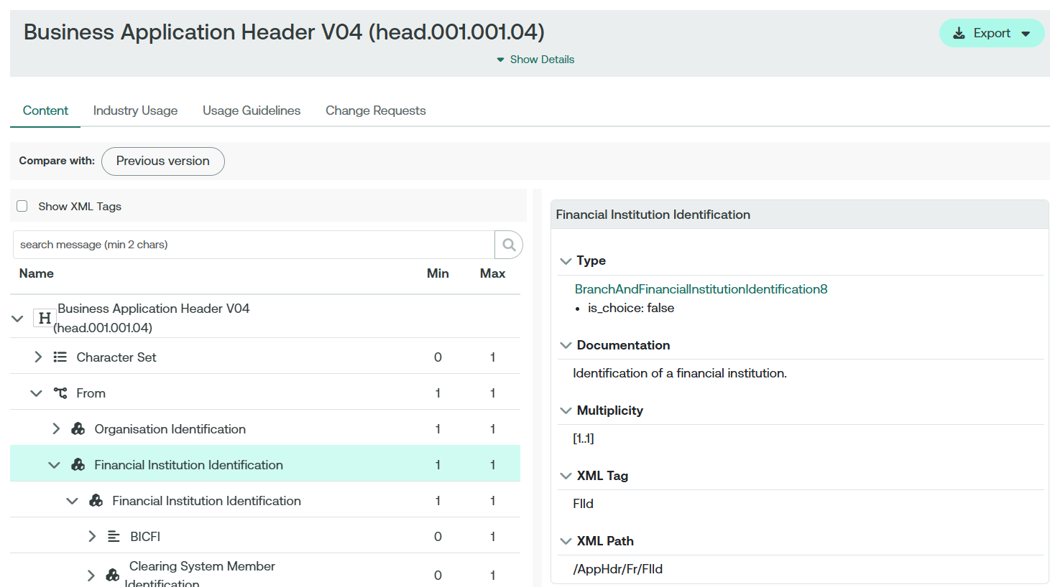  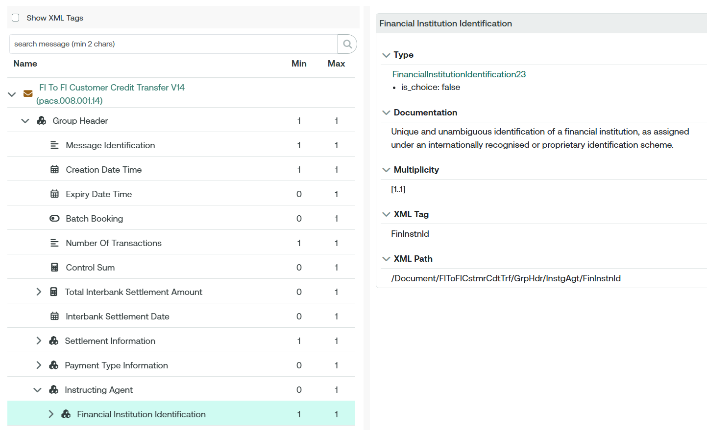  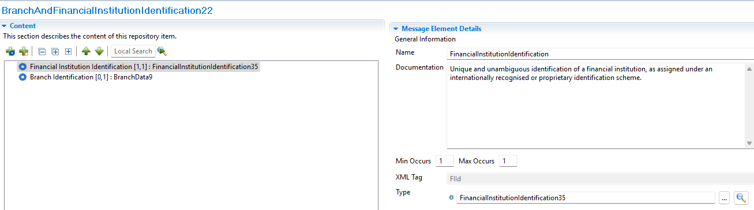

« DD » is a placeholder for any appropriate digits assigned upon registration of the rule.

