Maintenance Change Request
for the update of ISO 20022 financial repository items

Name of the request:
“ISO 20022 Securities Clearing Maintenance 2026/2027”

Submitting organisation(s):
ASX – CHESS (Clearing House Electronic Subregister System)
Australian Securities Exchange (ASX)
20 Bridge Street
Sydney NSW 2000

Related messages:

Under this maintenance, below existing ISO 20022 message definitions will be maintained (resulting from the impact analysis performed on each CR).

Collateral Management message set:

- secl.004.001.04 – TradeLegStatementV04

Message sets impacted are under responsibility of SWIFT:
Please note that the Collateral Management message set is under the responsibility of SWIFT.

Commitments of the submitting organisation:

The submitting organisations confirm that they can and will:
- Undertake the development of the new version of the candidate ISO 20022 message models that it will submit to the RA for compliance review and evaluation. New valid Message Definition models will be made available to the RA by December 1.
- provide a new version of part 1 of the related Message Definition Reports (MDR) by December 1, and new examples of valid message instances of each candidate message (only when valid samples were published for current version) by May 1 at the latest.
- Address any queries related to the description of the new models and messages as published by the RA on the ISO 20022 website.

SWIFT intends to implement most of the above new versions on its SWIFTNet network once the related documentation has been published by the RA.

The submitting organisations confirm their knowledge and acceptance of the ISO 20022 Intellectual Property Rights policy for contributing organisations, as follows.
“Organisations that contribute information to be incorporated into the ISO 20022 Repository shall keep any Intellectual Property Rights (IPR) they have on this information. A contributing organisation warrants that it has sufficient rights on the contributed information to have it published in the ISO 20022 Repository through the ISO 20022 Registration Authority in accordance with the rules set in ISO 20022. To ascertain a widespread, public and uniform use of the ISO 20022 Repository information, the contributing organisation grants third parties a non-exclusive, royalty-free license to use the published information”.

Contact persons:

Priscilla Ferri de Barros – ASX, priscilla.ferridebarros@asx.com.au
Sigrid Wiley – ASX, sigrid.wiley@asx.com.au
Karine Taquet – SWIFT Standards, karine.taquet@swift.com

Securities Clearing SEG ET members for SR 2027:

Securities Clearing SEG ET | Representing | Present
Priscilla Ferri de Barros | ASX
Harry McAllister | BNP Paribas
Lisa Taikitsadaporn | Brookpath
Hanno Klein | FIX
Marcin Zawistowki | KDPW
Aine Hester | LSEG
Jonathan Armitage | LSEG
Grace Charlesworth | LSEG
Mike Jones | LSEG
Ciro Tomeo | LSEG
Marek Kozok | ECB
Javier Martinez | ECB
Karine Taquet | SWIFT

Change request CR01516 ( SWIFT CR 003202):
Add Original Settlement Date and Update Reason to secl.004

Origin of the request:
A.1 Submitter: ASX – CHESS (Clearing House Electronic Subregister System)
A.2 Contact person: Priscilla Ferri de Barros; priscilla.ferridebarros@asx.com.au;
+ 61 (02) 9227 0543
A.3 Sponsors: it is highly recommended that a submitter of a Change Request gain the agreement and support from as many additional organisations, groups, initiatives or communities of users as possible, thus demonstrating as wide as possible a consultation of the relevant stakeholders. All organisations, groups, initiatives or communities supporting the change request should be identified as sponsors along with a contact person, if possible. This community involvement is intended to help avoid delays and/or subsequent amendments to the change request.

Related messages:
The list of ISO 20022 messages which would be impacted by the change, including the Message IDs as shown in the Catalogue of ISO 20022 messages. Only the latest version of a message definition can be maintained.
The submitter is invited to carefully examine whether the change may have an impact on other messages that come into play earlier or later in the transaction chain or on other messages that also use message components that this change request may impact.
Related messages:

- secl.004.001.04 – Net Position 04

Description of the change request:

A specific change request form must be completed for each particular change requested (for example, adding, deleting, modifying, renaming, changing the cardinality, moving an element/component, or changing the type of an element, changing a code set).
If the change request consists, for example, of adding new functionality which requires several changes which would not make sense if not performed all together, then all these related changes should be described on the same form.
Change requests may not lead to creation of new messages. In such cases, a 'business justification' for development of new candidate ISO 20022 messages must be introduced by a submitting organization that is ready to develop the new messages.
Acting as a Central counterparty, ASX intends to use the secl.004 Net Position Report as anticipated: to confirm the net position of all trade legs reported during the day to its clearing members.
However, this message will replace a legacy message that today allows for the notification to the clearing members of changes during the clearing process. More precisely, in the case of an impending Corporate Action, the legacy message would send an updated Net Position Report with the previous security code, the original settlement date as well as the reason why the settlement needs to be rescheduled.

ASX is requesting the addition of 2 new elements:

- Original Settlement Date, in ISO date format. Specifies the settlement date of a settlement instruction before it was altered.

ISO 20022 proposed implementation:
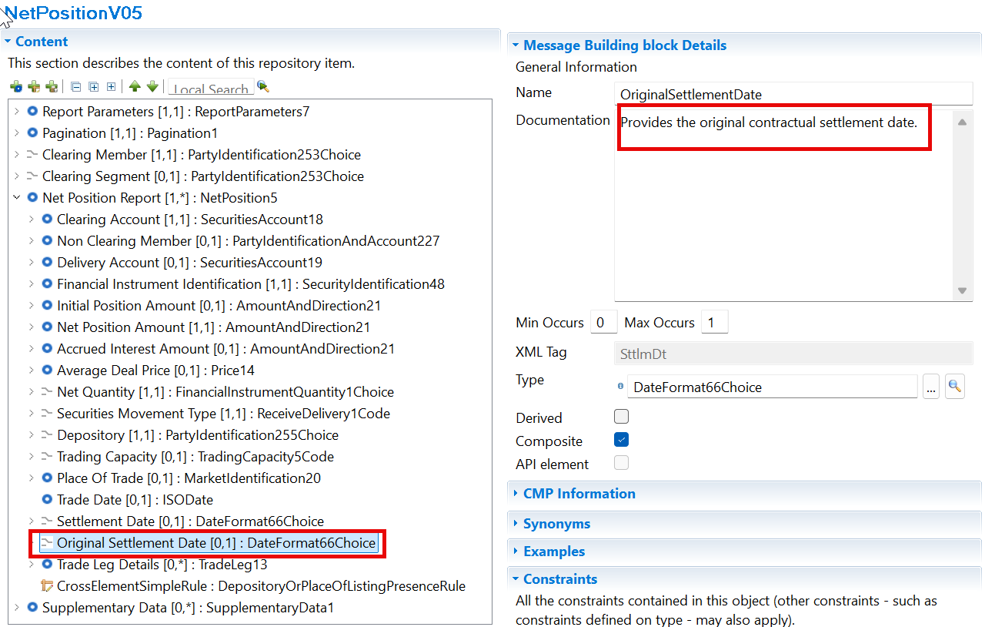
- Update Reason (to be used in combination with “Update Type”, already present in the message): A code list to express the reason for rescheduling the settlement. As it is mainly related to Corporate Actions, we suggest adding the Corporate Action Event Type code list (CAEV).

ISO 20022 proposed implementation:

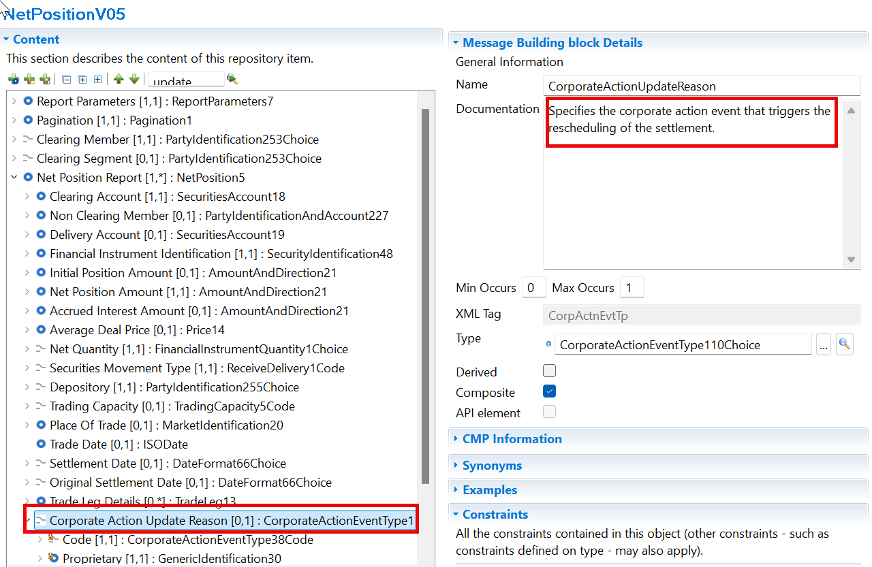

Purpose of the change:
The Australian Securities Exchange (ASX) has initiated a project to replace the current Australian equities clearing and settlement market infrastructure system (CHESS).
CHESS (Clearing House Electronic Subregister System) is the system operated by ASX to manage the clearing and settlement of equity market transactions, and to record current security holdings (and the holders) on a name on a register basis. The implementation of the replacement system will provide the existing core functionality and services as well as service enhancements. The current proprietary CHESS messaging standards will be replaced with ISO 20022 standards.
The purpose of this Change Request is to fully align the ISO messages used in CHESS to avoid using supplementary data for required elements.

Urgency of the request:
To be included as part of the annual maintenance cycle.

Business examples:

SEG/TSG recommendation:

Consider |  | X | Timing
 |  |  | - Next yearly cycle: 2026/2027  (the change will be considered for implementation in the yearly maintenance cycle which starts in 2026 and completes with the publication of new message versions in the spring of 2027) |  | X
- At the occasion of the next maintenance of the messages
(the change will be considered for implementation, but does not justify maintenance of the messages in its own right – will be pending until more critical change requests are received for the messages)
- Urgent unscheduled
(the change justifies an urgent implementation outside of the normal yearly cycle)
 |  |  | - Other timing:

Comments:
- The purpose and the business case for the original settlement date must be clarified.
- The position of the Update Reason must be discussed based on the business case

- Impact analysis and type of impact:

See CR section B

- Proposed implementation:

Same as documented in the CR.

Proposed timing:
The submitting organisation confirms that it can implement the requested changes in the requested timing.

Final decision of the SEG(s):

Accepted

Comments:

