Contents
A. Name of the request: 2
B. Submitting organisation(s): 2
C. Related messages: 2
D. Commitments of the submitting organisation: 2
E. Contact persons: 3
F. TARGET2- Securities SEG ET members for SR 2027: 3
Change request CR 1588 ( SWIFT CR 003281): Replace Securities Transaction Condition with Settlement Transaction Condition in semt.026 and semt.027Inclusion of the Gating Event Condition code in semt.027 5
Change request CR 1556 ( SWIFT CR 003297): Change SystemSecuritiesAccountType1Code data type with ExternalSecuritiesAccountType1Code 16
Change request CR 1562 ( SWIFT CR 003298): Add Default Link flag to reda.012 21

Maintenance Change Request
for the update of ISO 20022 financial repository items

Name of the request:
ISO 20022 TARGET2-Securities Maintenance 2026/2027

Submitting organisation(s):
- Deutsche Bundesbank on behalf of 4CB
- TARGET2-Securities (T2S)

Related messages:

Under this maintenance, below existing ISO 20022 message definitions will be maintained (resulting from the impact analysis performed on each CR).

TARGET2-Securities - Securities Reference Data message set
Message Identifier | MessageDefinition
reda.012.001.01 | Security ReportV01
reda.018.001.01 | Securities Account Creation RequestV01
reda.019.001.01 | Securities Account QueryV01
reda.021.001.01 | Securities Account ReportV01

TARGET2-Securities - Securities Settlement message set
Message Identifier | MessageDefinition
semt.026.001.01 | Securities Settlement Transaction QueryV01
semt.027.001.01 | Securities Settlement Transaction Query ResponseV01

Message sets impacted are under responsibility of Swift:
Please note that the Collateral Management message set is under the responsibility of SWIFT.

Commitments of the submitting organisation:

The submitting organisations confirm that they can and will:
- Undertake the development of the new version of the candidate ISO 20022 message models that it will submit to the RA for compliance review and evaluation. New valid Message Definition models will be made available to the RA by December 1.
- provide a new version of part 1 of the related Message Definition Reports (MDR) by December 1, and new examples of valid message instances of each candidate message (only when valid samples were published for current version) by May 1 at the latest.
- Address any queries related to the description of the new models and messages as published by the RA on the ISO 20022 website.

SWIFT intends to implement most of the above new versions on its SWIFTNet network once the related documentation has been published by the RA.

The submitting organisations confirm their knowledge and acceptance of the ISO 20022 Intellectual Property Rights policy for contributing organisations, as follows.
“Organisations that contribute information to be incorporated into the ISO 20022 Repository shall keep any Intellectual Property Rights (IPR) they have on this information. A contributing organisation warrants that it has sufficient rights on the contributed information to have it published in the ISO 20022 Repository through the ISO 20022 Registration Authority in accordance with the rules set in ISO 20022. To ascertain a widespread, public and uniform use of the ISO 20022 Repository information, the contributing organisation grants third parties a non-exclusive, royalty-free license to use the published information”.

Contact persons:
To get additional information on this Maintenance Change Request you can contact.
- Stéphanie Radet , stephanie.radet@bundesbank.de, +49 69 9566-33528
- Sigrid Wiley – SWIFT, sigrid.wiley@swift.com
- Karine Taquet – SWIFT Standards, karine.taquet@swift.com

TARGET2- Securities SEG ET members for SR 2027:
Securities Clearing SEG ET | Representing | Present
Beiermann, Dirk | Bundesbank
Topel, Alexander | Bundesbank
Radet, Stéphanie | Bundesbank
Ghul, Daniela | Bundesbank
Braeuer, Fabian | Bundesbank
Lohle, Julia | Bundesbank
Müller, Kea | Bundesbank
Coco, Mario | Banca d’Italia
Del Vecchio , Andrea | Banca d’Italia
Sarcinelli, Alessio | Banca d’Italia
Mancini, Riccardo | Banca d’Italia
Caro, Pablo | Banco de Espana
Varela, Alberto | Banco de Espana
Vila, Maria | Banco de Espana
Mariscal, Cristina | Banco de Espana
Stal, Ronnie | Banque de France
Jraied, Ons | Banque de France
Sakalian, Patrick | Banque de France
Wouters, David | Euroclear
Loose, Annemie | Euroclear
Bichemin, Charles | Societé Générale
Clark Fischer, Stephanie | BNP Paribas
Fisher-Taylor, Anne-Marie | BNP Paribas
Deantoni, Paola | Deloitte
Ferri de Barros, Priscilla | ASX
Javier Martinez | ECB
Strandberg, Christine | SEB
Strasser, Heike | Unifits
Griffioen, Marc | ABN AMRO
Webb, Karen | ASX
Marques, Catarina | Clearstream
Hoogervorst, Peter | CA-CIB
Inui, Taiji
John, Baby | SGX
Lohle, Julia | Bundesbank
Taquet, Karine | SWIFT
Steeno, Aurelie | SWIFT
Wiley, Sigrid | SWIFT
Chard, Dean | SWIFT

Change request CR 1588 ( SWIFT CR 003281):
Replace Securities Transaction Condition with Settlement Transaction Condition in semt.026 and semt.027Inclusion of the Gating Event Condition code in semt.027

- Origin of the request:
A.1 Submitter: Banque de France on behalf of the Eurosystem / 4CB
A.2 Contact person:
- Ons Jraied Ons, Ons.JRAIED.external@banque-france.fr
- Ronnie Stal, ronnie.stal@banque-France.fr
- t2s-fam@bundesbank.de
A.3 Sponsors: SWIFT (Karine TAQUET)

- Related messages:
Impacted messages:
semt.026 Securities Settlement Transaction Query
semt.027 Securities Settlement Transaction Query Response

- Description of the change request:
In the context of T+1 (shorten the settlement cycle in the EU from two days (so‑called “T+2”) to one day (“T+1”)), a new ISO CR (CR-003189) introduced a structured indicator to flag settlement instructions that must be automatically held until a specific point in time on the requested settlement day (gating event), at which the Securities Financing instructions will be automatically released.
The requester was SMPG, with the support of Swift Standards.
A new code <Cd>GATE</Cd> was added in the element <SttlmTxCond> – Settlement Transaction Condition:
GATE, standing for ‘Gating Event participation’.

A series of messages were impacted but T2S registered messages semt.026 and semt.027 were not included as both messages were undergoing registration.
This ISO CR is requesting to add the equivalent ISO 20022 element to represent the Gating Event condition code also in T2S registered messages semt.026 and semt.027.
In this regard, two changes seem necessary to make the schema of semt.026 and semt.027 registered messages compliant with the ones already updated regarding the Gating event condition code:
- Removal of element <SctiesTxCond> from T2S semt.026 registered message
For harmonization purposes, the element Securities Transaction Condition - <SctiesTxCond> need to be replaced with the element Settlement Transaction Condition - <SttlmTxCond> and all its nested element (<Cd> and <Prtry>). As a result, the element <SctiesTxCond> is removed and all its nested elements (<Cd> and <Prtry>). New XML path is /Document/SctiesSttlmTxQry/QryDef/SchCrit/SttlmTxCond
Element | Old XML-Path | New XML-Path
Settlement Transaction Condition | /Document/SctiesSttlmTxQry/QryDef/SchCrit/SctiesTxCond | /Document/SctiesSttlmTxQry/QryDef/SchCrit/SttlmTxCond
Code | /Document/SctiesSttlmTxQry/QryDef/SchCrit/SctiesTxCond/Cd | /Document/SctiesSttlmTxQry/QryDef/SchCrit/SttlmTxCond/Cd
Proprietary | /Document/SctiesSttlmTxQry/QryDef/SchCrit/SctiesTxCond/Prtry | /Document/SctiesSttlmTxQry/QryDef/SchCrit/SttlmTxCond/Prtry

  - SettlementTransactionCondition <SttlmTxCond>

Message Element <XML Tag> | Mult. | Data Type
Settlement Transaction Condition <SttlmTxCond> | [0..*] | SettlementTransactionCondition41Choice  is_choice: true
- Presence: [0..*]
- Definition: Indicates the conditions under which the order/trade is to be executed.
SettlementTransactionCondition <SttlmTxCond> contains one of the following elements

Or | Message Element <XML Tag> | Mult. | Data Type
{Or | Code <Cd> | [1..1] | SettlementTransactionCondition16Code
Or} | Proprietary <Prtry> | [1..1] | GenericIdentification30  is_choice: false

    - Code <Cd>
- Presence: [1..1]
- Definition: Settlement conditions expressed as an ISO 20022 code.
- Datatype: “SettlementTransactionCondition16Code”

Code | Value | Definition
ADEA | Accept After Regular Settlement Deadline | Settlement is on a bilaterally accepted  transaction that is to be accepted  beyond the regular settlement deadline.
ASGN | Assignement | Transfer of ownership of the asset to  another party during the closing of an  option.
BUTC | Buy to Cover | Transaction is a buy to cover.
CLEN | Clean | Tax-exempt financial instruments are to  be settled.
DLWM | Delivery Without Matching | Matching receipt instruction not required  (only for concerned international or  national central securities depositories).
DIRT | Dirty | Taxable financial instruments are to be  settled.
DRAW | Drawn | Settlement transactions relate to drawn  securities.
EXER | Exercised | Settlement transaction relates to options,  futures or derivatives that are exercised.
EXPI | Expired | Settlement transaction relates to options,  futures or derivatives that have expired.
FRCL | Free Clean Settlement | Delivery will be made free of payment  but a clean payment order will be sent.
GATE | Gating Event Participation | Gating event participation. Hold until event start time.
INTS | Internalised Settlement | The instruction was settled by the  settlement internaliser/account servicer  (eg custodian) in its own books and not  through a securities settlement system  (e.g. CSD system)
KNOC | Knocked Out | Settlement transaction relates to options,  futures or derivatives that are expired  worthless.
NOMC | No Automatic Market Claim | No market claim should be automatically  generated.
NACT | Not Accounting Related | Security transaction is not for  accounting.
BPSS | Partial Successful Buy In | Identification of settlement instructions  created as a result of a partial successful  buy-in.
PENS | Pending Sale | Position to cover the pending sale will be  available by contractual settlement date  (accounting information).
PHYS | Physical | Securities are to be physically settled.
RHYP | Rehypothecation | Collateral position is available for other  purposes (for example, onwards  delivery).
RPTO | Reporting | Relates to a transaction that is for  reporting purposes only.
RESI | Residual | Relates to transaction on a security that  is not eligible at the Central Security  Depository (CSD) but for which the  payment will be enacted by the central  securities depository.
SHOR | ShortSell | Account is used for short sale orders.
SPDL | Special Delivery | Settlement transactions to be settled  with special delivery.
SPST | Split Settlement | Money and financial instruments settle in  different locations.
TRAN | Transformation | Transaction resulting from a  transformation.
TRIP | Triparty Segregation | Securities are not be delivered but  segregated following triparty collateral  transaction.
UNEX | Unexposed | Delivery cannot be performed until  money is received.

    - Proprietary <Prtry>
- Presence: [1..1]
- Definition: Settlement conditions expressed as a proprietary code.
- Datatype: “GenericIdentification30”
Proprietary <Prtry> contains the following elements:

Or | Message Element <XML Tag> | Mult. | Data Type | Definition
 | Identification <Id> | [1..1] | Exact4AlphaNumericText | Proprietary information, often a code, issued by the data source scheme issuer.
 | Issuer <Issr> | [1..1] | Max4AlphaNumericText | Entity that assigns the identification.
 | SchemeName <SchmeNm> | [0..1] | Max4AlphaNumericText | Short textual description of the scheme.

ISO 20022 proposed implementation:
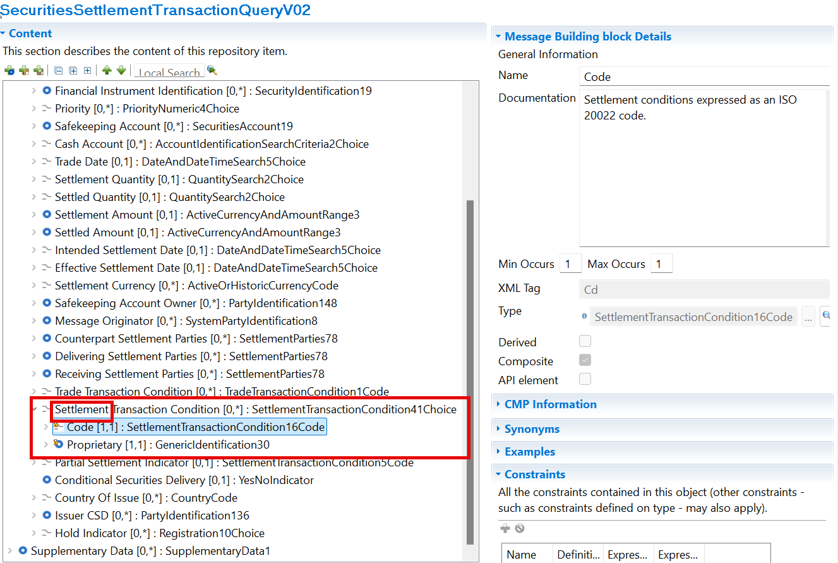

- Inclusion of the Gating event condition code <Cd>GATE</Cd> in T2S semt.027 registered message

- XML - Path : /Document/SctiesSttlmTxQryRspn/Txs/Tx/TxDtls/SttlmParams/SttlmTxCond/Cd
- Message Element <XML Tag> : Code <Cd>
- Datatype: “SettlementTransactionCondition16Code”
New code [GATE] within the CodeSet list:
Code | Value | Definition
GATE | Gating Event Participation | Gating event participation. Hold until event start time.

ISO 20022 proposed implementation:
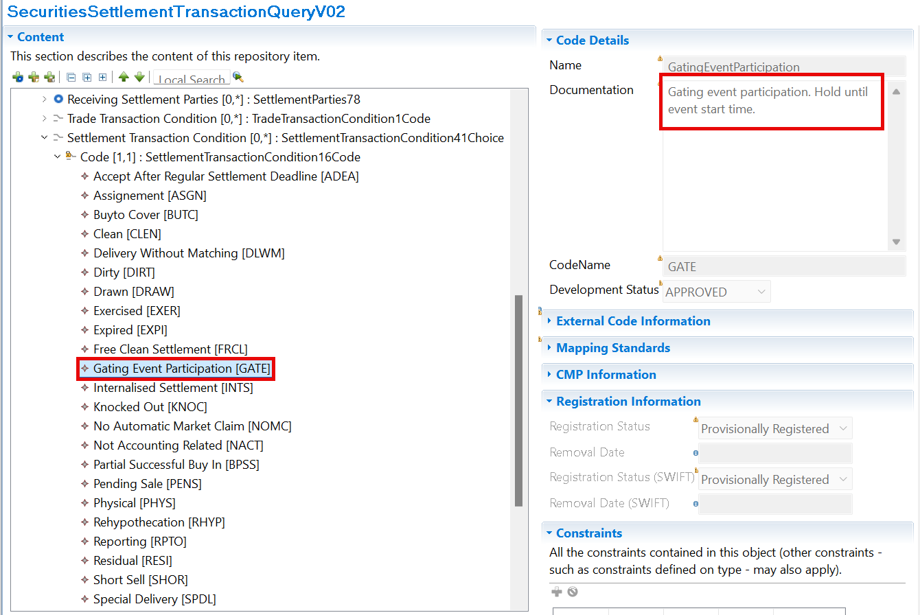

- Purpose of the change:
The inclusion of the Gating event condition code <Cd>GATE</Cd> – Gating Event participation within element <SttlmTxCond> - Settlement Transaction Condition in semt.026 and semt.027 registered messages aligns the messages with the ones already updated regarding the Gating event condition code and ensures that the registered messages can be used by the market as expected. In this regard, two changes seem necessary:

- Urgency of the request:
We request the securities SEG to consider this change request for the next maintenance cycle (2026/2027). It may allow the semt.026 and semt.027 schema compliant.

- Business examples:
The Securities Settlement Transaction Query message (semt.026) allows Central Securities Depositories or directly connected T2S participants acting as the instruction party to query all settlement instructions satisfying a set of criteria and which covers several message usages depending on the type of query:
- Settlement Instruction Query (corresponding query type - 'Instruction').
- Settlement Instruction Current Status Query (corresponding query type - 'Status').
- Settlement Instruction Status Audit Trail Query (corresponding query type - 'Status Period').
The Settlement Infrastructure/Executing party will return in response to the Securities Settlement Transaction Query message (semt.026) the Securities Settlement Transaction Query Response via semt.027 providing all current attributes and latest statuses for all settlement instructions as selected in the search criteria defined in the query message.

Communication flow
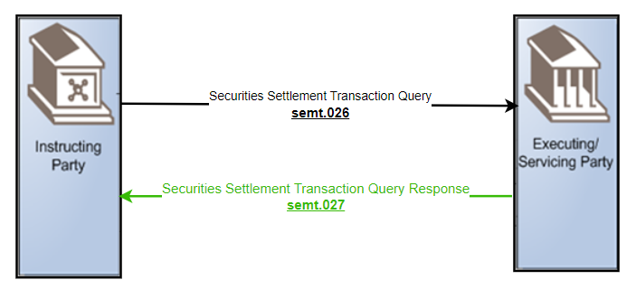

Examples illustrating the change request
Semt.026 - Query Type Example: Settlement Instruction Current Status QuerySettlement Instruction Current Status Query
In this example a Direct Connected Participant (DCP) sends to the Settlement Infrastructure Platform a Settlement Instruction Current Status Query requesting all settlement instructions for securities account ‘1000000123’ where the settlement status is pending awaiting a gating event on business date 05-05-2026.
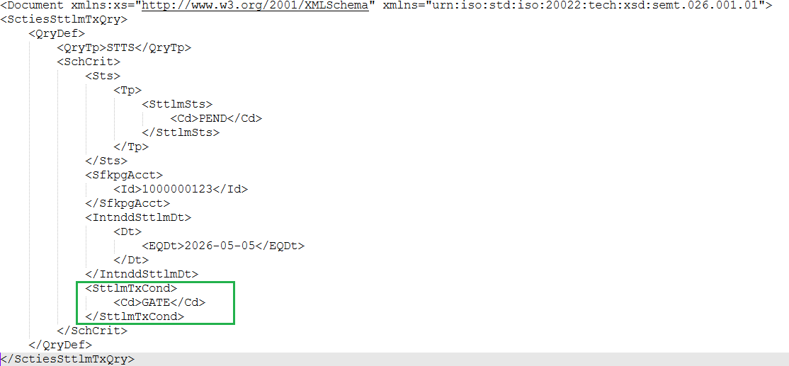

Semt.027 - Query Response Example: Settlement Instruction Current Status Query Response
In this example the Settlement Infrastructure Platform sends a Settlement Instruction Current Status Query Response containing one instruction matching the query criteria which querying all pending settlement instructions awaiting a gating event on business date 05-05-2026 where the securities account is ‘1000000123’.

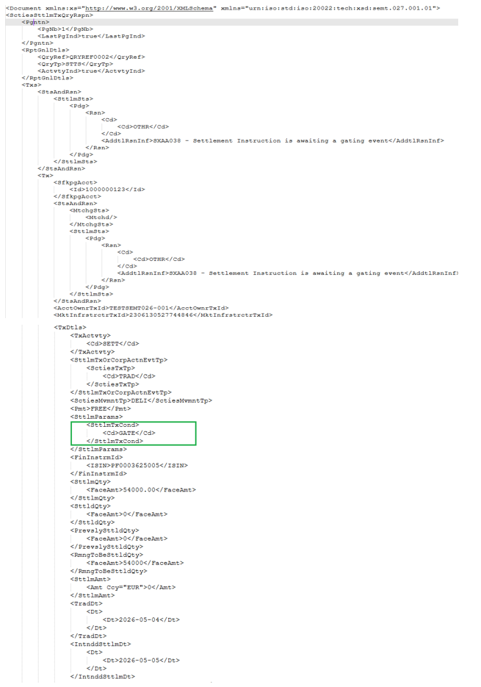
- SEG/TSG recommendation:
This section is not to be taken care of by the submitter of the change request. It will be completed in due time by the SEG(s) in charge of the related ISO 20022 messages or the TSG for changes related to the BAH.

Consider |  | X | Timing
 |  |  | - Next yearly cycle: 2026/2027  (the change will be considered for implementation in the yearly maintenance cycle which starts in 2026 and completes with the publication of new message versions in the spring of 2027) |  | X
- At the occasion of the next maintenance of the messages
(the change will be considered for implementation, but does not justify maintenance of the messages in its own right – will be pending until more critical change requests are received for the messages)
- Urgent unscheduled
(the change justifies an urgent implementation outside of the normal yearly cycle)
 |  |  | - Other timing:
Comments:

Reject
Reason for rejection:

- Impact analysis and type of impact:
See CR

- Proposed implementation:
Same as described in the CR.

- Proposed timing:
Same as proposed in the CR.

- Final decision of the SEG(s):
This section is not to be taken care of by the submitting organization. It will be completed in due time by the SEG(s) in charge of the related ISO 20022 messages.
Approve
Comments:

Reject
Reason for rejection:

Change request CR 1556 ( SWIFT CR 003297):
Change SystemSecuritiesAccountType1Code data type with ExternalSecuritiesAccountType1Code

- Origin of the request:
A.1 Submitter: Banca d’Italia on behalf of the Eurosystem / 4CB
A.2 Contact person:
- Riccardo Mancini, +39 06 4792 6024
- riccardo.mancini@bancaditalia.it
- t2s-fam@bundesbank.de
A.3 Sponsors: SWIFT (Karine TAQUET)

- Related messages:
Impacted messages:
reda.018 Securities Account Creation Request
reda.019 Securities Account Query
reda.021 Securities Account Report

- Description of the change request:
Currently, the Securities Account Type element is implemented with the SystemSecuritiesAccountType1Code data type. This approach is not following the ISO RA recommendation to use External Code Lists whenever possible.
The objective of this change request is to change the current data type with the ExternalSecuritiesAccountType1Code.

This request proposes to adapt the following changes:

- In the reda.018 message, Data Type for Element Document/SctiesAcctCreReq/SctiesAcct/Tp/Cd should be changed into ExternalSecuritiesAccountType1Code
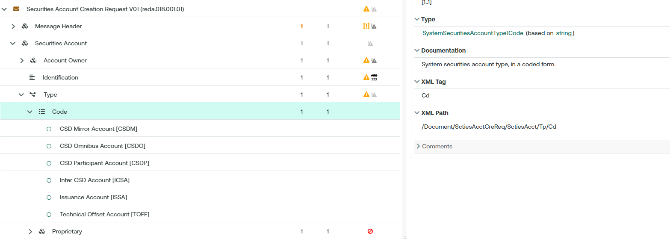

Proposed ISO 20022 Illustration:

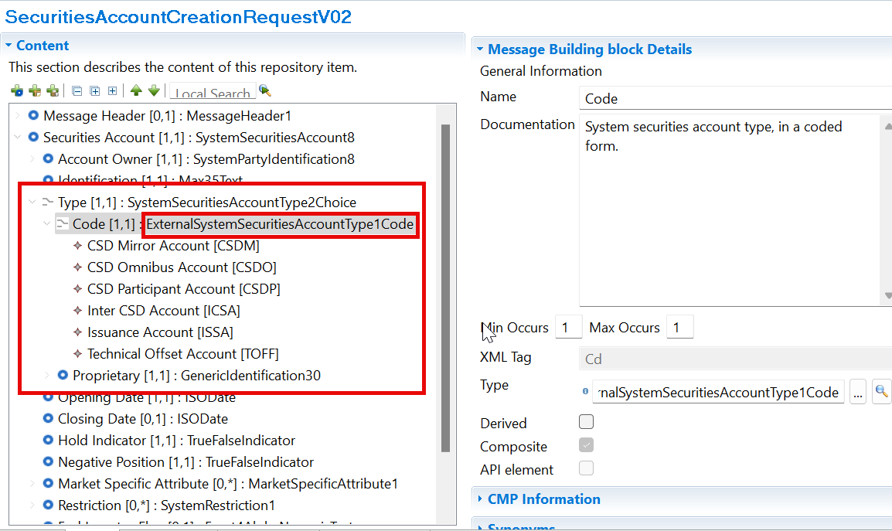
- In the reda.019 message, Data Type for Element /Document/SctiesAcctQry/SchCrit/AcctTp/Cd should be changed into ExternalSecuritiesAccountType1Code
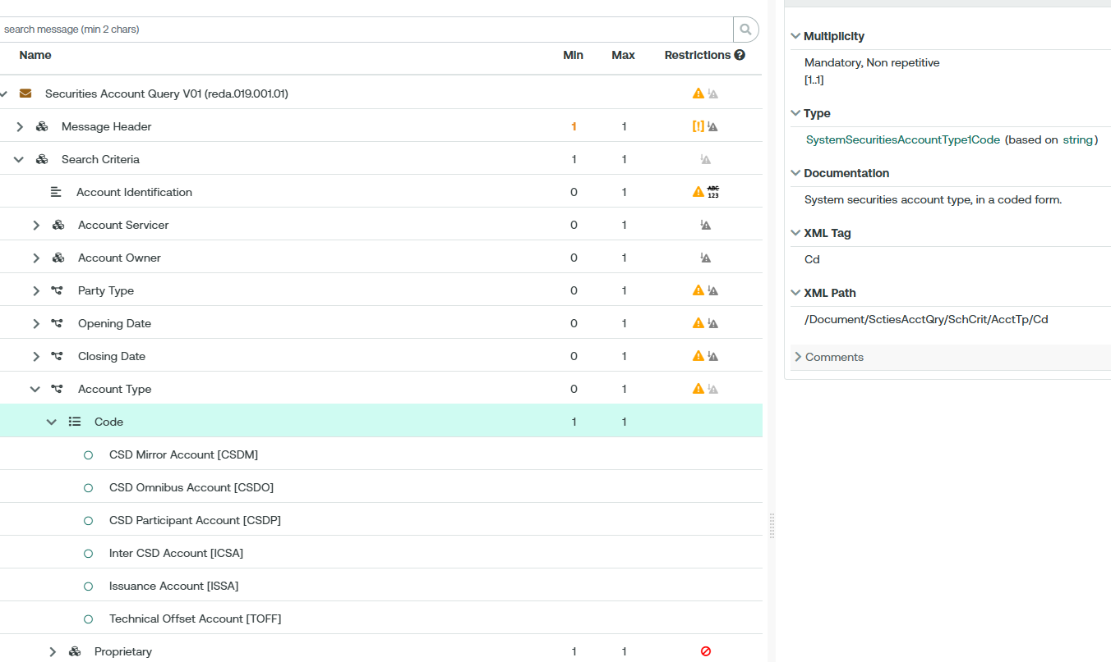

Proposed ISO 20022 Illustration: similar to reda.018

- In the reda.021 message, Data Type for Element /Document/SctiesAcctRpt/RptOrErr/SctiesAcctRpt/SctiesAcctOrErr/SctiesAcct/Tp/Cd should be changed into ExternalSecuritiesAccountType1Code
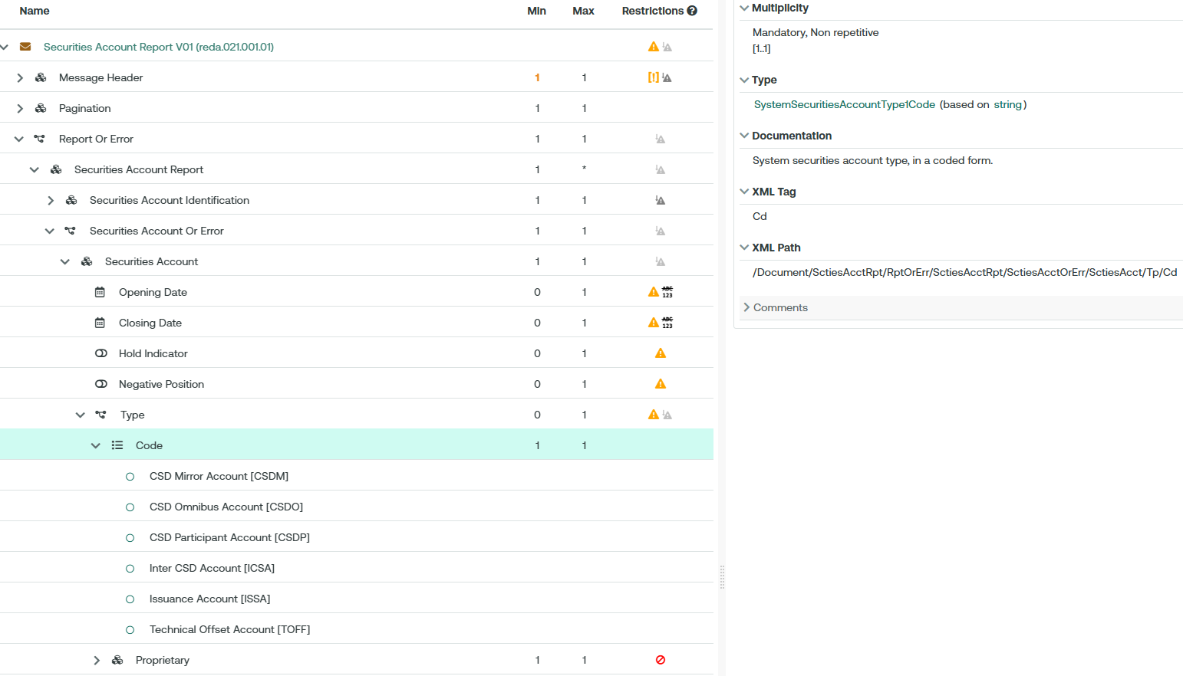

Proposed ISO 20022 Illustration: similar to reda.018

- Purpose of the change:
The usage of the External Code List provides with more flexibility in maintaining the content of the list in line with the workflow adopted by the ISO Registration Authority.

- Urgency of the request:
The Securities SEG is requested to consider this change request for the next maintenance cycle.

- Business examples:
Examples illustrating the change request.

- SEG/TSG recommendation:

Consider |  | X | Timing
 |  |  | - Next yearly cycle: 2026/2027  (the change will be considered for implementation in the yearly maintenance cycle which starts in 2026 and completes with the publication of new message versions in the spring of 2027) |  | X
- At the occasion of the next maintenance of the messages
(the change will be considered for implementation, but does not justify maintenance of the messages in its own right – will be pending until more critical change requests are received for the messages)
- Urgent unscheduled
(the change justifies an urgent implementation outside of the normal yearly cycle)
 |  |  | - Other timing:
Comments:

Reject

- Impact analysis and type of impact:
See CR

- Proposed implementation:
Same as described in the CR.

- Proposed timing:
Same as proposed in the CR.

- Final decision of the SEG(s):
This section is not to be taken care of by the submitting organization. It will be completed in due time by the SEG(s) in charge of the related ISO 20022 messages.
Approve
Comments:

Reject
Reason for rejection:

Change request CR 1562 ( SWIFT CR 003298):
Add Default Link flag to reda.012

- Origin of the request:
A.1 Submitter: Banca d’Italia on behalf of the Eurosystem / 4CB
A.2 Contact person:
- Andrea Del Vecchio, +39 06 4792 6827
- andrea.delvecchio@bancaditalia.it
- t2s-fam@bundesbank.de
A.3 Sponsors: SWIFT (Karine TAQUET)

- Related messages:
- reda.012.001.01 - Security Report V01

- Description of the change request:
A 2025 change request added the technical possibility to have multiple settlement paths per ISIN within T2S, so that cross-border settlement can follow the most appropriate CSD link to the counterparty rather than a single pre-defined default, significantly broadening which cross-border trades can be settled on the platform
At present, alternative Security CSD links are only accessible via U2A (GUI) channel, and 4CB plans to make this query functionality available through messaging as well.
This means adding a new flag in the reda.012 message.

When sending a reda.010 Security Query to T2S, it is possible to define query option “CSDL” to request Security CSD Links.
T2S replies with a reda.012 message listing Security CSD Links that match the search criteria. This message shall be updated to also list, in addition to the current attributes, the “Default Link” Flag of a Security CSD Link.
This request proposes to adapt the following changes:

- XSD of reda.012 message to be updated to introduce an additional optional attribute “Default Link” into the sequence where Security CSD Links are reported
e.g., after Security Maintenance Flag)
- : /Document/SctyRpt/SctyRptOrErr/SctyRptOrBizErr/SctyRpt/FinInstrmAttrbts/SctyCSDLk/DfltLnk.
- Similar to Security Maintenance flag, this new attribute is aYesNoIndicator with possible value “true” or “false”. Value “true” meaning this is a default link, while “false” reports an alternative link.
- CRDM will report this attribute with the search results for Security CSD Links, whenever an Investor Link is reported. For Issuer Links, the attribute is not filled.

- The following mapping logic shall be applied: If a reda.012 is generated to reply to a query for Security CSD Links, then the following logic is applied if an Investor Link is being reported:
  - In case the Security CSD Link is a default link, the “Default Link” flag is filled as “true”.
  - In case the Security CSD Link is an alternative link, then “Default Link” flag is reported as “false”

Proposed ISO 20022 Illustation:

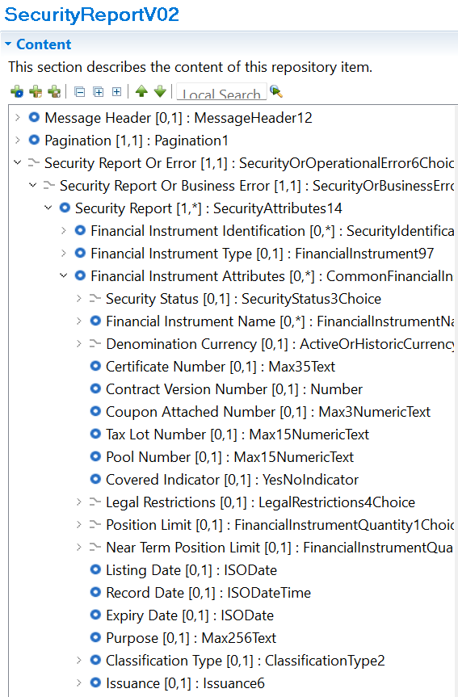

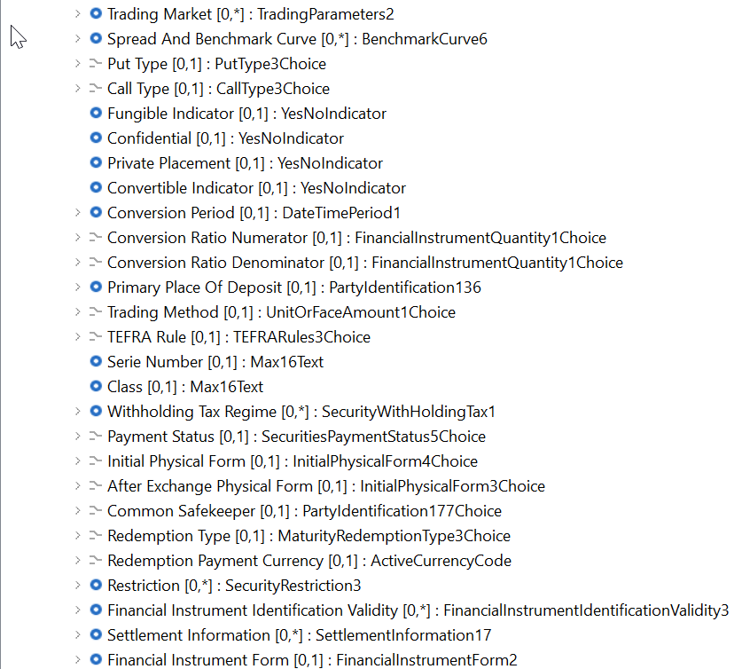

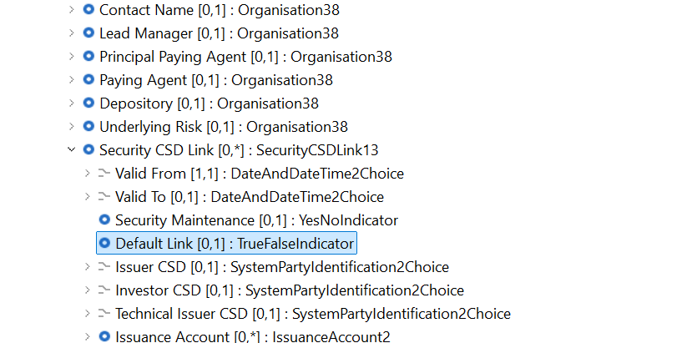

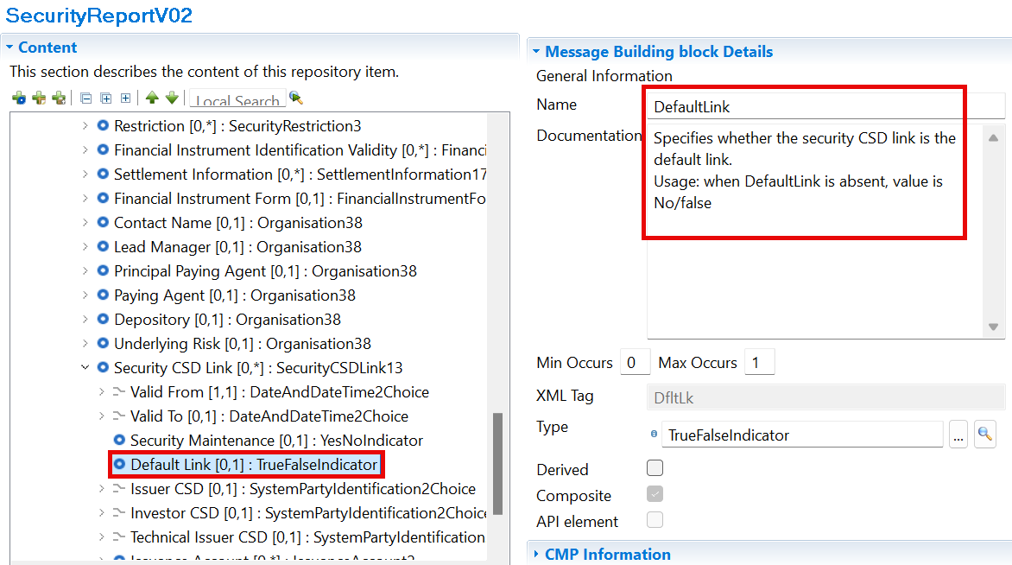

- Purpose of the change:
The newly inserted tag will allow the system to report information about the default/alternative links when customers query information via reda.010.001.01 (CSDL). This tag will not be displayed for Issuer Links. It will be reported only for Investor type links and will have values depending on the nature of the link (“true” for default and “false” for alternative).

- Urgency of the request:
The Securities SEG is requested to consider this change request for the next maintenance cycle.

- Business examples:
New xml message reporting the new field.
<SctyRpt>
<FinInstrmId>
<ISIN>XXABCDEFGHI1</ISIN>
</FinInstrmId>
<FinInstrmAttrbts>
<SctyCSDLk>
<VldFr>
<Dt>2024-06-01</Dt>
</VldFr>
<VldTo>
<Dt>9999-12-31</Dt>
</VldTo>
<SctyMntnc>false</SctyMntnc>
<DfltLnk>true</DfltLnk>
<InvstrCSD>
<OrgId>
<Id>
<AnyBIC>CSDAXXYYAAA</AnyBIC>
</Id>
</OrgId>
</InvstrCSD>
<TechIssrCSD>
<OrgId>
<Id>
<AnyBIC>CSDBXXYYBBB</AnyBIC>
</Id>
</OrgId>
</TechIssrCSD>
</SctyCSDLk>
<SctyCSDLk>
<VldFr>
<Dt>2024-06-01</Dt>
</VldFr>
<VldTo>
<Dt>9999-12-31</Dt>
</VldTo>
<SctyMntnc>false</SctyMntnc>
<DfltLnk>false</DfltLnk>
<InvstrCSD>
<OrgId>
<Id>
<AnyBIC>CSDAXXYYAAA</AnyBIC>
</Id>
</OrgId>
</InvstrCSD>
<TechIssrCSD>
<OrgId>
<Id>
<AnyBIC>CSDCXXYYCCC</AnyBIC>
</Id>
</OrgId>
</TechIssrCSD>
</SctyCSDLk>
</FinInstrmAttrbts>
</SctyRpt>

- SEG/TSG recommendation:
This section is not to be taken care of by the submitter of the change request. It will be completed in due time by the SEG(s) in charge of the related ISO 20022 messages or the TSG for changes related to the BAH.

Consider |  | X | Timing
 |  |  | - Next yearly cycle: 2026/2027  (the change will be considered for implementation in the yearly maintenance cycle which starts in 2026 and completes with the publication of new message versions in the spring of 2027) |  | X
- At the occasion of the next maintenance of the messages
(the change will be considered for implementation, but does not justify maintenance of the messages in its own right – will be pending until more critical change requests are received for the messages)
- Urgent unscheduled
(the change justifies an urgent implementation outside of the normal yearly cycle)
 |  |  | - Other timing:
Comments:

Reject
Reason for rejection:

- Impact analysis and type of impact:
See CR

- Proposed implementation:
Same as described in the CR.

- Proposed timing:
Same as proposed in the CR.

- Final decision of the SEG(s):
This section is not to be taken care of by the submitting organization. It will be completed in due time by the SEG(s) in charge of the related ISO 20022 messages.
Approve
Comments:

Reject
Reason for rejection:

