Change Request
for the update of ISO 20022 financial repository items

- Origin of the request:
A.1 Submitter: nexo A.I.S.B.L.
A.2 Contact person:
- Catherine BOUNDJIA (catherine.boundjia@nexo-standards.org)
- Normand PROVOST (normand.provost@nexo-standards.org)
A.3 Sponsors: nexo A.I.S.B.L.

- Related messages:
Acceptor to Acquirer:
- AcceptorAuthorisationRequestV15 (caaa.001.001.15)
- AcceptorAuthorisationResponseV15 (caaa.002.001.15)
- AcceptorCompletionAdviceV15 (caaa.003.001.15)
- AcceptorCompletionAdviceResponseV14 (caaa.004.001.14)
- AcceptorCancellationRequestV15 (caaa.005.001.15)
- AcceptorCancellationResponseV14 (caaa.006.001.14)
- AcceptorCancellationAdviceV15 (caaa.007.001.15)
- AcceptorCancellationAdviceResponseV14 (caaa.008.001.14)
- AcceptorReconciliationRequestV14 (caaa.009.001.14)
- AcceptorReconciliationResponseV13 (caaa.010.001.13)
- AcceptorBatchTransferV15 (caaa.011.001.15)
- AcceptorBatchTransferResponseV14 (caaa.012.001.14)
- AcceptorDiagnosticRequestV14 (caaa.013.001.14)
- AcceptorDiagnosticResponseV13 (caaa.014.001.13)
- AcceptorCurrencyConversionRequestV13 (caaa.016.001.13)
- AcceptorCurrencyConversionResponseV13 (caaa.017.001.13)
- AcceptorCurrencyConversionAdviceV10 (caaa.018.001.10)
- AcceptorCurrencyConversionAdviceResponseV09 (caaa.019.001.09)
- TransactionAdviceV07 (caaa.020.001.07)
- TransactionAdviceResponseV07 (caaa.021.001.07)
- AcceptorNonFincancialRequestV06 (caaa.022.001.06)
- AcceptorNonFincancielResponseV06 (caaa.023.001.06)
- AcceptorTransactionLogReportRequestV06 (caaa.024.001.06)
- AcceptorTransactionLogReportResponseV06 (caaa.025.001.06)
- AcceptorToAcquirerBatchFileExchangeV03 (caaa.026.001.03)
- AcquirerToAcceptorBatchFileExchangeV03 (caaa.027.001.03)

Terminal Management:
- StatusReportV15 (catm.001.001.15)
- ManagementPlanReplacementV14 (catm.002.001.14)
- MaintenanceDelegationRequestV12 (catm.005.001.12)

Sale to POI:
- SaleToPOIServiceRequestV08 (casp.001.001.08)
- SaleToPOIServiceResponseV08 (casp.002.001.08)
- SaleToPOIReconciliationRequestV08 (casp.003.001.08)
- SaleToPOIReconciliationResponseV08 (casp.004.001.08)
- SaleToPOISessionManagementRequestV08 (casp.005.001.08)
- SaleToPOISessionManagementResponseV08 (casp.006.001.08)
- SaleToPOIAdministrativeRequestV08 (casp.007.001.08)
- SaleToPOIAdministrativeResponseV08 (casp.008.001.08)
- SaleToPOIReportRequestV08 (casp.009.001.08)
- SaleToPOIReportResponseV08 (casp.010.001.08)
- SaleToPOIAbortV08 (casp.011.001.08)
- SaleToPOIEventNotificationV08 (casp.012.001.08)
- SaleToPOIMessageStatusRequestV08 (casp.014.001.08)
- SaleToPOIMessageStatusResponseV08 (casp.015.001.08)
- SaleToPOIDeviceRequestV08 (casp.016.001.08)
- SaleToPOIDeviceResponseV08 (casp.017.001.08)

- Description of the change request:
The change request aims to enable the identification of the merchant performing a payment transaction using a unique and unambiguous identification assigned by a recognized identification scheme.

We want to update to the message component GenericIdentification192 used to define the Environment.Merchant.Identification data element.
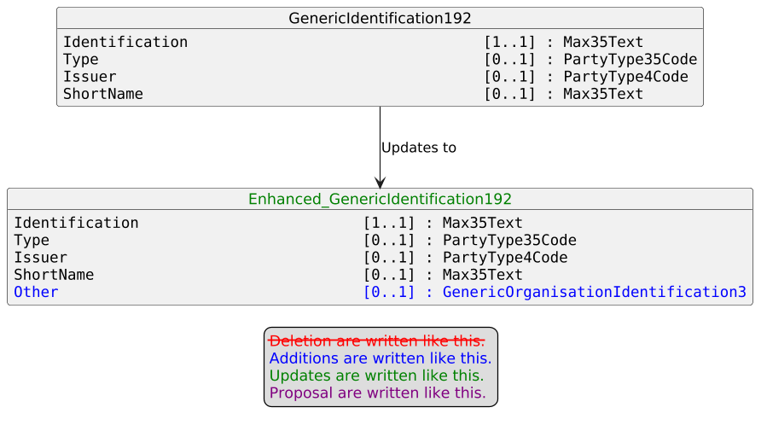

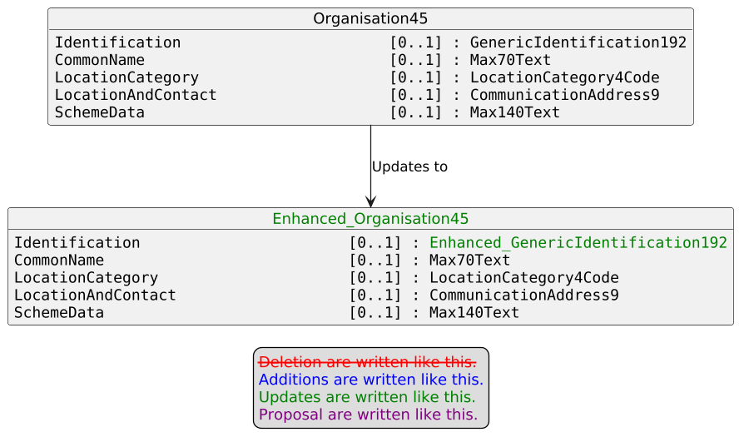

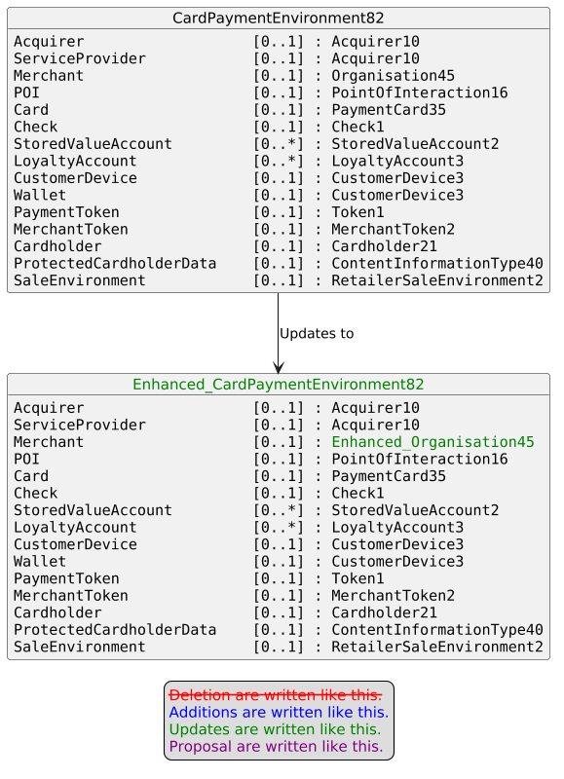
- Purpose of the change:
nexo A.I.S.B.L. is an international organization whose mission is to define, publish and promote global payment acceptance standards based on ISO 20022 and supporting services that ensure interoperability between acceptance and acquiring solutions, integrated retail and terminal management systems.
nexo is working closely with major retail industry players to address their challenges and bridge the gap for the adoption of ISO 20022. More specifically, a need has been identified to the GLN (Global Location Number) to identify the merchant performing the payment transaction. The GLN is an identifier defined by the global standards organization GS1 and is commonly used in many industries to uniquely identify physical locations and functional entities (e.g., stores, warehouses, delivery addresses, legal entities or business functions).
The change request allows a merchant to be identified using an organisation identification assigned by an identification scheme, such as GS1. The proposed approach aligns with common practice in other ISO 20022 business domains — for example, FinancialInstitutionIdentification supports the BIC, the LEI or other identifiers) — and ensures interoperability, traceability and data quality.

We want to reuse the existing message component GenericOrganisationIdentification3 defined as follows:
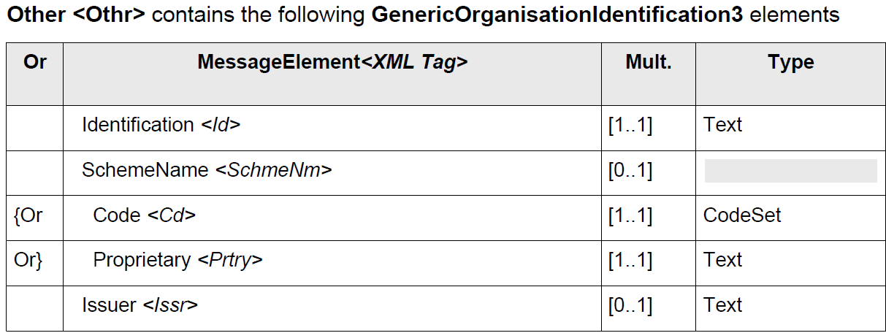

The ISO 20022 Inventory of External Code Sets provides a standardized definition of identification scheme using the ExternalOrganisationIdentification1Coded (see example below).

Code Value | Code Name | Code Definition
GS1G | GS1GLNIdentifier | Global Location Number. A non-significant reference number used to identify legal entities, functional entities, or physical entities according to GS1 numbering scheme rules. The number is used to retrieve detailed information that is linked to it.

- Urgency of the request:
Urgent.
- Business examples:
Examples illustrating the change request.
- SEG/TSG recommendation:
This section is not to be taken care of by the submitter of the change request. It will be completed in due time by the SEG(s) in charge of the related ISO 20022 messages or the TSG for changes related to the BAH.

Consider |  |  | Timing
- Next yearly cycle: 2026/2027
(the change will be considered for implementation in the yearly maintenance cycle which starts in 2026 and completes with the publication of new message versions in the spring of 2027)
- At the occasion of the next maintenance of the messages
(the change will be considered for implementation, but does not justify maintenance of the messages in its own right – will be pending until more critical change requests are received for the messages)
- Urgent unscheduled
(the change justifies an urgent implementation outside of the normal yearly cycle)
 |  |  | - Other timing:
Comments:

Reject
Reason for rejection:

