Change Request
for the update of ISO 20022 financial repository items

- Origin of the request:
A.1 Submitter: nexo A.I.S.B.L.
A.2 Contact person:
- Catherine BOUNDJIA (catherine.boundjia@nexo-standards.org)
- Evelyne de JONGHE (evelyne.de-jonghe@frenchsys.com)
- Philippe MERMOUD (philippe.mermoud@bpce.fr)
A.3 Sponsors: nexo A.I.S.B.L.

- Related messages:
- AcceptorCompletionAdviceResponse V14 (caaa.004.001.14)
- AcceptorCancellationRequest V15 (caaa.005.001.15)
- AcceptorCancellationResponse V14 (caaa.006.001.14)
- AcceptorCancellationAdvice V15 (caaa.007.001.15)
- AcceptorCancellationAdviceResponse V14 (caaa.008.001.14)
- AcceptorBatchTransfer V15 (caaa.011.001.15)
- AcceptorCurrencyConversionAdviceResponse V09 (caaa.019.001.09)
- TransactionAdviceResponse V07 (caaa.021.001.07)
- AcceptorToAcquirerBatchFileExchange V03 (caaa.026.001.03)
- AcquirerToAcceptorBatchFileExchange V03 (caaa.027.001.03)

- Description of the change request:
The change request consists in adding an element Additional Information (type ExternallyDefinedData5) to all Acceptor to Acquirer messages containing the components CardPaymentTransactionAdviceResponse8 and CardPaymentTransactionDetails50.

Update to message component CardPaymentTransactionAdviceResponse8:
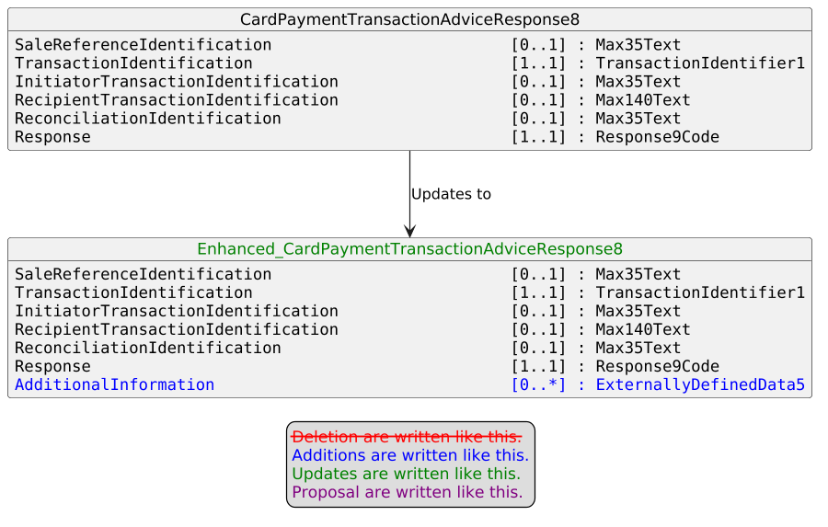

Update to message component CardPaymentTransactionDetails50:
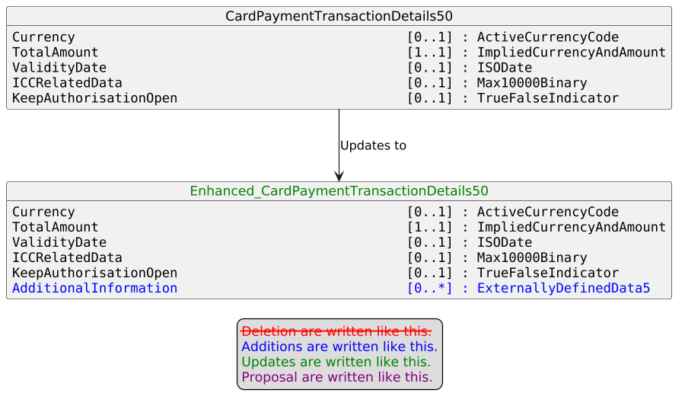
- Purpose of the change:
The change aims to allow the transmission of Additional Information related to the transaction, such as an invoice or industry data (for example, hospitality, lodging, transportation) exchanged according to an external standard.

- Urgency of the request:
Urgent.

- Business examples:
Examples illustrating the change request.
- SEG/TSG recommendation:
This section is not to be taken care of by the submitter of the change request. It will be completed in due time by the SEG(s) in charge of the related ISO 20022 messages or the TSG for changes related to the BAH.

Consider |  |  | Timing
- Next yearly cycle: 2026/2027
(the change will be considered for implementation in the yearly maintenance cycle which starts in 2026 and completes with the publication of new message versions in the spring of 2027)
- At the occasion of the next maintenance of the messages
(the change will be considered for implementation, but does not justify maintenance of the messages in its own right – will be pending until more critical change requests are received for the messages)
- Urgent unscheduled
(the change justifies an urgent implementation outside of the normal yearly cycle)
 |  |  | - Other timing:
Comments:

Reject
Reason for rejection:

