Change Request
for the update of ISO 20022 financial repository items

- Origin of the request:
A.1 Submitter: identity of the company, organization, group, initiative or community that submits the change request.
Bank of England
A.2 Contact person: person(s) who can be contacted to get additional information on the request (name, e-mail, telephone)
John Aveson (john.aveson@bankofengland.co.uk)
A.3 Sponsors: it is highly recommended that a submitter of a Change Request gain the agreement and support from as many additional organisations, groups, initiatives or communities of users as possible, thus demonstrating as wide as possible a consultation of the relevant stakeholders. All organisations, groups, initiatives or communities supporting the change request should be identified as sponsors along with a contact person, if possible. This community involvement is intended to help avoid delays and/or subsequent amendments to the change request.

- Related messages:
The list of ISO 20022 messages which would be impacted by the change, including the Message IDs as shown in the Catalogue of ISO 20022 messages. Only the latest version of a message definition can be maintained.
The submitter is invited to carefully examine whether the change may have an impact on other messages that come into play earlier or later in the transaction chain or on other messages that also use message components that this change request may impact.

auth.069.001.03 ClearedProductReportV03

- Description of the change request:
A specific change request form must be completed for each particular change requested (for example, adding, deleting, modifying, renaming, changing the cardinality, moving an element/component, or changing the type of an element, changing a code set).
If the change request consists, for example, of adding new functionality which requires several changes which would not make sense if not performed all together, then all these related changes should be described on the same form.
Change requests may not lead to creation of new messages. In such cases, a 'business justification' for development of new candidate ISO 20022 messages must be introduced by a submitting organization that is ready to develop the new messages.

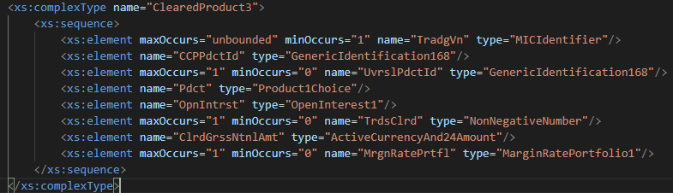
The proposed change is to add to the existing ClearedProduct3 (shown) complex type a new field Backtesting result. This would contain a mandatory Boolean field to indicate if the account is in breach, and if TRUE, the size of the exception. There would additionally be a Description field to elucidate the nature of the portfolio that should be processed for backtesting in order to populate the result.

- Purpose of the change:
Background, business context, community of users interested by the change and expected benefits/savings.
This section must explain why the existing ISO 20022 messages need to be changed. The reason for the update may be a business reason (e.g., evolution of market practice, or creation of new financial instruments), a technical reason (e.g., automation of the business process, or switch from a batch to a real time process), a regulatory reason (introduction, generally mandatory, of new rule/law) or the extension of the user community (newly identified business requirements).
The intent behind the proposed change is to gain visibility of products cleared by the CCP that are particularly prone to backtesting breaches and thus identify potential areas where margin models could be improved.

- Urgency of the request:
By default, valid change requests introduced by June 1st and subsequently approved by the SEG/TSG will be included in the following yearly maintenance cycle which completes with the publication of new message versions by April/May of the following year, unless decided otherwise by the SEG/TSG.
If there is a need to have the new version of the related messages published earlier, the reason for the urgency of the maintenance and the expected consequences of a delay should be described here. Acceptance of such an unscheduled maintenance for the BAH is subject to approval by TSG. Acceptance of an unscheduled maintenance for messages other than the BAH is subject to the approval of the SEG and availability of a submitting organization to develop the new version of the messages.

- Business examples:
Examples illustrating the change request.

Cleared Product ID | Is backtesting breach | Exception amount and currency | Description
3M Brent Crude Future | FALSE |  | 1000 barrels
3M Copper Option | TRUE | 10000USD | 25 tonnes

- SEG/TSG recommendation:

☒ Consider
Timing:
☒ Next yearly cycle: 2026/2027
☐ At the occasion of the next maintenance of the messages
☐ Urgent unscheduled
☐ Other timing:

☐ Reject
Reason for rejection:

Comments:

