Change Request
for the update of ISO 20022 financial repository items

- Origin of the request:
A.1 Submitter: SMPG CA WG
A.2 Contact person: Miriam Ortseifen, Standards Development (Product) | Asset Servicing, Tel: +34 91 4251317, Miriam.ORTSEIFEN@swift.com
Christine Strandberg: christine.strandberg@seb.se, +46 (8) 763 60 74
Mariangela Fumagalli: mariangela.fumagalli@bnpparibas.com, +442075954988
A.3 Sponsors: SMPG CA WG

- Related messages:
seev.001 - MeetingNotification
seev.004 - MeetingInstruction
seev.006 - MeetingInstructionStatus

- Description of the change request:
REQUIREMENT 1: seev.001
The sender of the seev.001 cannot indicate whether voting on meeting resolutions during the meeting is possible, although seev.004 is designed to support such instructions. As a result, the current model can be interpreted as a general allowance for investors, but it remains unclear whether the issuer or its agent actually offers or supports the option in a given event.
There are numerous cases where issuers clearly state this possibility in their voting form templates, and investor relations teams actively encourage larger shareholders to submit such instructions to avoid unexpected outcomes during the meeting. This is typically used when the management anticipates sensitive motions or amendments.
In some countries this possibility is always given, but the type to vote (e.g. for, against, abstain, with/against management, etc.) is restricted.

A simple yes/no indicator might not be precise enough, as the issuer may wish to specify the type, as they do for regular agenda resolutions. This detail is also available in seev.004.
A new section in the seev.001 is preferred.

Proposal:
/Document/MtgNtfctn/MtgRsltn
/Document/MtgNtfctn/MtgRsltn/Desc/Lang
/Document/MtgNtfctn/MtgRsltn/Desc/Desc
/Document/MtgNtfctn/MtgRsltn/VoteInstrTp/VoteInstrTpCd/Tp
Abstain [ABST], Against [CAGS], Against Management [AMGT], Blank [BLNK], Chairman [CHRM], Discretionary [DISC], For [CFOR], No Action [NOAC], With Management [WMGT], Withhold [WTHH]
/Document/MtgNtfctn/MtgRsltn/MgmtRcmmndtn
Abstain [ABST], Against [CAGS], Against Management [AMGT], Blank [BLNK], Chairman [CHRM], Discretionary [DISC], For [CFOR], No Action [NOAC], With Management [WMGT], Withhold [WTHH]
/Document/MtgNtfctn/MtgRsltn/NtifngPtyRcmmndtn
Abstain [ABST], Against [CAGS], Against Management [AMGT], Blank [BLNK], Chairman [CHRM], Discretionary [DISC], For [CFOR], No Action [NOAC], With Management [WMGT], Withhold [WTHH]
/Document/MtgNtfctn/MtgRsltn/URLAdr

REQUIREMENT 2: seev.004
In seev.004 it is possible to send Vote Instruction for Meeting Resolutions (/Document/MtgInstr/Instr/VoteDtls/VoteInstrForMtgRsltn) “Vote instructions for the resolutions that may arise or may be amended at the meeting but were not previously provided in the agenda.”
The following types are possible in the seev.004:
Abstain [ABST] | Chairman [CHRM] | One Year [ONEY] | Withhold [WTHH]
Against [CAGS] | Discretionary [DISC] | Three Years [THRY]
Against Management [AMGT] | For [CFOR] | Two Years [TWOY]
Blank [BLNK] | No Action [NOAC] | With Management [WMGT]

The codes ONEY, TWOY and THRY should be removed, as they are not applicable to meeting resolutions. They relate to 'say on pay', which cannot be raised at a meeting.

REQUIREMENT 3: seev.006
The rejection code “Invalid Option Type [OPTY]” could be used to inform senders in case the meeting resolution is not accepted
or
a new code “Meeting Resolution not supported” could be created to inform the sender that their voting for meeting resolution is not accepted.

- Purpose of the change:
Currently, it is not possible to display the type to vote (e.g. for, against, abstain, with/against management, etc.) for meeting resolutions within the seev.001 message. However, it is possible to vote on meeting resolutions via seev.004.

- Urgency of the request:
For next release.

- Business examples:
Nestle AG (CH) or Bayer AG (DE).
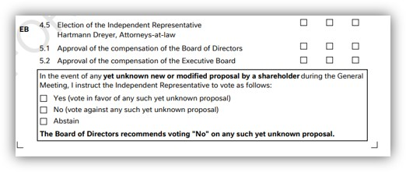
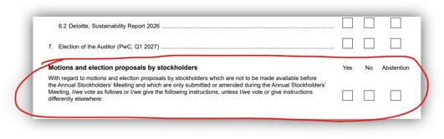
- SEG/TSG recommendation:

☒ Consider
Timing:
☒ Next yearly cycle: 2026/2027
☐ At the occasion of the next maintenance of the messages
☐ Urgent unscheduled
☐ Other timing:

☐ Reject
Reason for rejection:

Comments:

