Standards
Standards Release 2027
Discussion Paper
Common Standards Working Group

Distribution: Corporate Action MWG & Settlement and Reconciliation MWG
Author: Miriam Ortseifen & Karine Taquet
Date Issued: 1st July 2026
Version: v1.0
MWG Meeting Date: August 27th, 2026
Table of Contents

1 003255 - Removal of Cross Element Complex Rule Requiring ONLY Safekeeping Account or Block Chain Address 5
1.1 Analysis 6
1.1.1 ISO 15022 Illustration 6
1.1.2 ISO 20022 Illustration 7
1.2 SWG Decision 8
2 003232 - Removal of RHTS and INTSEC sequence 9
2.1 Analysis 10
2.1.1 ISO 15022 Illustration 10
2.1.2 ISO 20022 Illustration 15
2.2 SWG Decision 18
3 003236 - Add Event Indicator "RWTH - Rights of Withdrawal Events" 19
3.1 Analysis 20
3.1.1 ISO 15022 Illustration 20
3.1.2 ISO 20022 Illustration 22
3.2 SWG Decision 22

SWG Members for SR2027

Settlement and Reconciliation
Standards working group members: | Representing: | Attendance Meeting 27th August
Vacant | Australia
Karen Weaver, - BNYMellon | Belgium
Xavier Filion Simon - BNC  Daniel Valance – RBC  Laurent Lallemand – RBC | Canada
Jørgen Nielsen - Danske Bank A/S | Denmark
Charles Bichemin – Societe Generale | France
Denis Andrejew – Deutsche Bank | Germany
Vacant | Hong Kong
David Wouters – Euroclear | ICSD
Robin Leary – Citibank | Ireland
Paola De Antoni – Societe Generale | Italy
Hitoshi Tanaka - Mitsubishi Bank | Japan
Vacant | Republic of Korea
Arnaud Jochems – Clearstream | Luxembourg / ICSD
Ton Van Andel/Marc – ABN Amro | The Netherland
Vacant | Singapore
Brett Kotze – A2X | South Africa
Vacant | Spain
Christine Strandberg - SEB | Sweden
Philipp Auf der Maur – Six-Group | Switzerland
Robin Leary – Citibank | United Kingdom
Shereef Zedan – Northern Trust | United States of America
Karine Taquet - Swift | S&R SWG

Trade and Confirmation
Standards working group members: | Representing: | Attendance Meeting 27th August
Ton Van Andel, ABN Amro | Netherlands
Armin Borries, Clearstream | Germany
Position Vacant | Belgium
Position Vacant | Luxembourg
Ms. Laura Hannan, Bank of New York Mellon | United States of America
Mr Ewen Henderson, UK Payments | United Kingdom
Mr. Christian Pinetz – OEKB | Austria
Mr. Andres Wernli – UBS | Switzerland
Position Vacant | France
Mr. Brett Kotze – A2X | South Africa

Corporate Action
Maintenance working group members | Representing | Attendance Meeting 27th August
Wayne Murphy | AU
Hakim Akka (BNY) | BE
Ariane Bienvenu | CA
Michael Blumer (UBS) | CH
Daniel Schäfer (HSBC)/Hendrik Melchior | DE
Diego Garcia (DB) | ES
Stephane Peard (SG) | FR
James Mullens (Nomura) | HK
Shiori Ikeda (Mizuho) | JP
Catarina Marques (Clearstream) | LU
Paola De Antoni (SG) | IT
Huseyin Boler (ABN Amro) | NL
Mariangela Fumagalli (BNP) | UK & IRE
Paul Fullam (FIS) | US / ISITC
Sanjeev Jayram (RMB) | ZA
Vacant | India
Vacant | Singapore
Vacant | Denmark
Vacant | Republic of Korea
Hatem Soliman (Euroclear) | XS
Christine Strandberg (SEB) | ISO 20022 Securities SEG (SE)
Steve Sloan (DTCC) | ISO 20022 Securities SEG (US)
Miriam Ortseifen (Swift) | CA SWG

003255 - Removal of Cross Element Complex Rule Requiring ONLY Safekeeping Account or Block Chain Address
Requesting Country: | US
Sponsors
ISITC
Message type(s) impacted
MT 564 MT 565 MT 566 MT 567 MT 568
MX seev.001 MX seev.002 MX seev.009 MX seev.010 MX seev.031 MX seev.032 MX seev.033 MX seev.034 MX seev.035 MX seev.036 MX seev.037 MX seev.038 MX seev.039 MX seev.040 MX seev.041 MX seev.042 MX seev.043 MX seev.044 MX
General Meeting Messages: seev.001, seev.002, seev.003, seev.004, seev.005, seev.006, seev.008

S&R messages impacted:
MT524, MT530, MT535, MT536, MT537, MT538, MT540, MT541, MT542, MT543, MT544, MT545, MT546, MT547, MT548, MT549, MT575, MT576, MT578, MT586
sese.020, sese.021, sese.022, sese.023, sese.024, sese.025, sese.026, sese.027, sese.028, sese.029, sese.030, sese.031, sese.032, sese.033, sese.034, sese.035, sese.036 sese.037, sese.038, sese.039, sese.040, semt.002; semt.003, semt.013, semt.014, semt.015, semt.016, semt.017, semt.018, semt.019, semt.020, semt.022, semt.025, semt.040

TIC messages impacted
MT502, MT504, MT 505, MT513, MT514, MT515, MT518, MT519

CM messages Impacted
MT507, MT508, MT509, MT510, MT527, MT558, MT569
colr.003, colr.004, colr.005, colr.006, colr.007, colr.008, colr.009, colr.010, colr.011, colr.012, colr.013, colr.014, colr.015, colr.016

Reference Data impacted
reda.012, reda.045, reda.049, reda.050, reda.051

Funds (under analysis)

Required for regulatory reasons
No
Business impact of this request
MEDIUM
Commitment to implement the change
Number of messages sent and received: 10000
Percentage of messages impacted: 100
US Market – DTCC / 2027
Business context
DTCC in implementing its tokenization processing solution is seeking to output messaging which can display both the Participant Account Number and the BlockChain Adddress or Wallet ID. This is necessary in that DTCC uses the Account Number for all ISO messaging-based subscriptions. The Block Chain ID or Wallet is an additional detail related to the message and should not be restricted from being used within a SWIFT Validation Rule.
Nature of change
Removal of Cross Element Complex Rule Safekeeping Account or Block Chain Address within all corporate action (seev) and settlement (sese)messages in both MT and MX messages. This is currently a Fatal error over the SWIFT Network. This would cover Address1Rule, Address2Rule and Address3Rule.
Within MT messages, the Choice structure needs to be removed within :97a: Account so that Both Safekeeping Account and BlockChain Address or Wallet can be displayed for a given event.
Also, it appears that Settlement Messages (sese) were not implemented in the same manner in that the Safekeeping Account, Account Owner and Block Chain Address or Wallet fields are all optional elements within the block NOT a choice element.
Workaround
The only possibility is to output the Blockchain Address within Account Owner / Proprietary Identification.

Analysis
Standards Illustration

1.1.1 ISO 15022 Illustration
A. In the MT564, in sequence B2,
B. And in the MT565, in sequence B1,
C. And in the MT566, in sequence B and sequence D1B,
D. And in the MT567, in sequence B,
E. And in the MT568, in sequence B,
remove choice between qualifiers SAFE (Safekeeping Acount) and BCAW (Blockchain Address or Wallet) in field :97a:Account, as illustrated below for MT564.

A. MT 564 Field Specifications
31. Field 97a: Account

FORMAT
Option A | :4!c//35x | (Qualifier)(Account Number)
Option C | :4!c//4!c | (Qualifier)(Account Code)
Option D | :4!c/[8c]/140x | (Qualifier)(Data Source Scheme)(Identification of Blockchain or Wallet)
PRESENCE
Mandatory in mandatory subsequence B2

QUALIFIER
(Error code(s): T89)
Order | M/O | Qualifier | R/N | CR | Options | Qualifier Description
1 | M O | SAFE | N | C2 | A or C | Safekeeping Account
 | Or O | BCAW | N |  | D | Blockchain Address or Wallet

DEFINITION
This qualified generic field specifies:
BCAW | Blockchain Address or Wallet | Blockchain address or wallet where digital assets are maintained. This is the equivalent of safekeeping account for digital assets.
SAFE | Safekeeping Account | Account where financial instruments are maintained.

CODES
In option C, if Qualifier is SAFE, Account Code must contain the following code (Error code(s): K97):
GENR | General | Announcement applies to all safekeeping accounts that own underlying financial instrument. (Used for general or preliminary announcements).

1.1.2 ISO 20022 Illustration
A. In the seev.031 (CANO – CorporateActionNotification) message, in sequence AccountDetails/AccountListAndBalanceDetails,
B. In the seev.033 (CANO – CorporateActionInstruction) message, in building block AccountDetails/AccountListAndBalanceDetails,
C. In the seev.034 (CANO – CorporateActionInstructionStatusAdvice) message, in building block Corporate Action Instruction, in sequence Account Owner,
D. In the seev.035 (CANO – CorporateActionMovementPreliminaryAdvice) message, in building block AccountDetails/AccountListAndBalanceDetails,
E. In the seev.036 (CANO – CorporateActionMovementConfirmation) message, in building block AccountDetails/Balance,
And in message building block CorporateActionConfirmationDetails, in sequence SecuritiesMovementDetails/DeliveringSettlementParties, within elements Party 1, 2, 3,
And in message building block CorporateActionConfirmationDetails, in sequence SecuritiesMovementDetails/ReceivingSettlementParties, within elements Party 1, 2, 3,
F. In the seev.037 (CANO – CorporateActionMovementReversalAdvice) message, in building block AccountDetails/ConfirmedBalance,
G. In the seev.038 (CANO – CorporateActionNarrative) message, in building block AccountListAndBalanceDetails,
H. In the seev.039 (CANO – CorporateActionCancellationAdvice) message, in building block AccountList,
I. In the seev.040 (CANO – CorporateActionInstructionCancellationRequest) message, in building block AccountDetails,
J. In the seev.041 (CANO – CorporateActionCancellationRequestStatusAdvice) message, in building block Corporate Action Instruction, in sequence Account Owner,
K. In the seev.042 (CANO – CorporateActionInstructionStatementReport) message, in building block AccountAndStatementDetails, in sequence Corporate Action Event And Balance,
L. In the seev.044 (CANO – CorporateActionMovementPreliminaryAdviceCancellationAdvice) message, in building block AccountList,
Remove the following Cross element rules, as illustrated below:
- Cross Element Complex Rule: Safekeeping Account Or Block Chain Address 2Rule
- Cross Element Complex Rule: Safekeeping Account Or Block Chain Address 3Rule
- Cross Element Simple Rule: Safekeeping Account Or Block Chain Address 1Rule

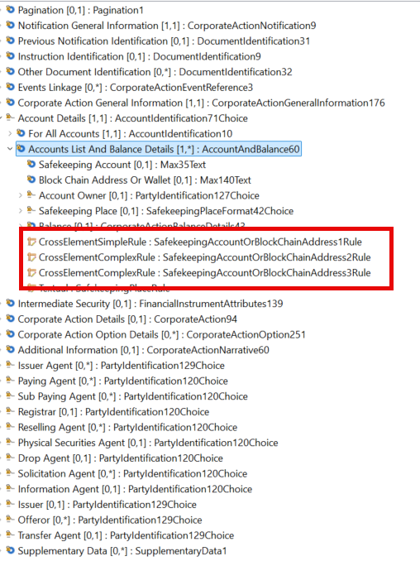

SWG Decision
XXX

SWIFT Comment

This change will impact nearly all securities messages in both ISO 15022 and ISO 20022.
In 2021, the SnR SMPG introduced a requirement to use either the Safekeeping Account (SAFE) or the Blockchain Account Wallet (BCAW), but not both. The simultaneous presence of both identifiers does not allow the account servicer to reliably determine whether they refer to the same account holder. Allowing both elements without clear rules may therefore introduce ambiguity and operational risk.
DTCC is requested to clarify the specific business cases that require the simultaneous use of SAFE and BCAW. In such cases, rules ensuring consistency should be defined, including alignment with the Cash Wallet (BCCW), where applicable.
In addition, the Payments SEG should be consulted regarding any implications for the Cash Account representation.

003232 - Removal of RHTS and INTSEC sequence
Requesting Group: | SMPG
Sponsors
SMPG & major custodians
Message type(s) impacted
MT 564, 565, 566, 567, 569
seev.009, seev.011, seev.010, seev.031, seev.032, seev.033, seev.034, seev.035, seev.036, seev.037, seev.039, seev.040, seev.041, seev.042, seev.044
S&R messages: MT508, MT536, MT537, MT538, MT548, MT 575.
semt.015 semt.016, semt.017, semt.018, semt.027, semt.029, semt.034, semt.044
Impact of Removal of RHTS, NO impact of removal of INTSEC sequence on SnR and TIC
Required for regulatory reasons
No
Business impact of this request
MEDIUM
Commitment to implement the change
Number of messages sent and received: 20000000
Percentage of messages impacted: 10
Major global custodians, sub/local custodians and CSDs / 2027
Business context
The SMPG CA WG proposes to remove the corporate action event code RHTS, Rights Issue/Subscription Rights/Rights Offer, as global market practice for rights issues has for many years recommended to use two events, RHDI and EXRI, instead of one event. All SMPG member countries have moved to two (or in certain countries, three) events for processing events with rights or similar interim instruments as including the details on the distribution of rights/interim securities in one event and the exercise/use of them in another event greatly simplifies the communication of event terms, options and movements.The volume of withdrawal‑triggering resolutions is expected to continue increasing due to the widespread adoption of multiple‑vote share structures in the Italian market.
Without a dedicated event type in ISO 20022 messages, the whole custodian chain (Issuers, CSD, Custodians, etc.) cannot process these events in an STP and standardized way leading to an increases operational risk and processing delays.
Nature of change
Removal of CAEV code RHTS from all applicable messages.
Removal of the optional Intermediate Securities (INTSEC) sequence from the MT564 and MT566 (seev.031, seev.035 and seev.036).

Analysis
Standards Illustration

ISO 15022 Illustration
A. In the MT564, in sequence A,
B. And in the MT565, in sequence A,
C. And in the MT566, in sequence A,
D. And in the MT567, in sequence A,
E. And in the MT568, in sequence A,
remove event type code “RHTS - Rights Issue/Subscription Rights/Rights Offer” from qualifier CAEV in field 22F:Indicator, as described and illustrated below for MT564:
D. In the MT564,
E. And in the MT566,
remove sequence C “Intermediate Securities” (INTSEC), as described and illustrated below for MT564.
A. MT 564 Field Specifications
5. Field 22F: Indicator

FORMAT
Option F | :4!c/[8c]/4!c | (Qualifier)(Data Source Scheme)(Indicator)

PRESENCE
Mandatory in mandatory sequence A

QUALIFIER
(Error code(s): T89)
Order | M/O | Qualifier | R/N | CR | Options | Qualifier Description
1 | O | CAEP | N |  | F | Corporate Action Event Processing
2 | M | CAEV | N | C4, C6, C10, C11, C22, C25, C28 | F | Corporate Action Event Indicator
3 | M | CAMV | N |  | F | Mandatory/Voluntary Indicator

DEFINITION
This qualified generic field specifies:
CAEP | Corporate Action Event Processing | Type of processing involved by a Corporate Action.
CAEV | Corporate Action Event Indicator | Specifies the type of corporate event.
CAMV | Mandatory/Voluntary Indicator | Specifies whether the event is mandatory, mandatory with options or voluntary.

CODES
If Qualifier is CAEV and Data Source Scheme is not present, Indicator must contain one of the following codes (Error code(s): K22):
ACCU | Accumulation | Funds related event in which the income (for example accumulation units) that accrues during an accounting period is retained within the fund instead of being paid away to investors. The retained income is nonetheless deemed to have been distributed to investors for tax purposes.
ACTV | Trading Status: Active | Trading in the security has commenced or security has been re-activated after a suspension in trading.
ATTI | Attachment | Combination of different security types to create a unit. Units are usually comprised of warrants and bonds or warrants and equities. Securities may be combined at the request of the security holder or based on market convention.
BIDS | Repurchase Offer/Issuer Bid/Reverse Rights | Offer to existing holders by the issuing company to repurchase its own securities. The objective of the offer is to reduce the number of outstanding securities.
BMET | Bond Holder Meeting | Physical meeting of bond holders.
…
RHDI | Intermediate Securities Distribution | The distribution of intermediate securities that gives the holder the right to take part in a future event.
RHTS | Rights Issue/Subscription Rights/Rights Offer | Offer to holders of a security to subscribe for additional securities via the distribution of an intermediate security. Both processes are included in the same event.
SHPR | Shares Premium Dividend | This corporate event pays shareholders an amount in cash issued from the shares premium reserve. It is similar to a dividend but with different tax implications.
SMAL | Smallest Negotiable Unit | Modification of the smallest negotiable unit of shares in order to obtain a new negotiable unit.
…
XMET | Extraordinary or Special General Meeting | Extraordinary or special general meeting.

D. MT 564 Field Specifications

MT 564 Corporate Action Notification
Status | Tag | Qualifier | Generic Field Name | Detailed Field Name | Content/Options | No.
Mandatory Sequence A General Information
M | 16R |  |  | Start of Block | GENL | 1
O | 28E |  |  | Page Number/Continuation Indicator | 5n/4!c | 2
----->
M | 20C | 4!c | Reference | (see qualifier description) | :4!c//16x | 3
-----|
M | 23G |  |  | Function of the Message | 4!c[/4!c] | 4
----->
M | 22F | 4!c | Indicator | (see qualifier description) | :4!c/[8c]/4!c | 5
-----|
O | 98a | PREP | Date/Time | Preparation Date/Time | A, C, or E | 6
M | 25D | PROC | Status Code | Processing Status | :4!c/[8c]/4!c | 7
-----> Optional Repetitive Subsequence A1 Linkages
M | 16R |  |  | Start of Block | LINK | 8
O | 22F | LINK | Indicator | Linkage Type Indicator | :4!c/[8c]/4!c | 9
O | 13a | LINK | Number Identification | Linked Message | A or B | 10
M | 20C | 4!c | Reference | (see qualifier description) | :4!c//16x | 11
M | 16S |  |  | End of Block | LINK | 12
-----| End of Subsequence A1 Linkages
Optional Subsequence A2 Reversal Reason
M | 16R |  |  | Start of Block | REVR | 13
M | 24B | REVR | Reason Code | Reversal Reason | :4!c/[8c]/4!c | 14
O | 70D | REVR | Narrative | Reversal Reason Narrative | :4!c//6*35x | 15
M | 16S |  |  | End of Block | REVR | 16
End of Subsequence A2 Reversal Reason
M | 16S |  |  | End of Block | GENL | 17
End of Sequence A General Information
Mandatory Sequence B Underlying Securities
M | 16R |  |  | Start of Block | USECU | 18
M | 35B |  |  | Identification of the Financial Instrument | [ISIN1!e12!c]  [4*35x] | 19
Optional Subsequence B1 Financial Instrument Attributes
M | 16R |  |  | Start of Block | FIA | 20
O | 94B | PLIS | Place | Place of Listing | :4!c/[8c]/4!c[/30x] | 21
O | 22F | MICO | Indicator | Method of Interest Computation Indicator | :4!c/[8c]/4!c | 22
----->
O | 12a | 4!c | Type of Financial Instrument | (see qualifier description) | A, B, or C | 23
-----|
O | 11A | DENO | Currency | Currency of Denomination | :4!c//3!a | 24
----->
O | 98A | 4!c | Date/Time | (see qualifier description) | :4!c//8!n | 25
-----|
----->
O | 92a | 4!c | Rate | (see qualifier description) | A, D, or K | 26
-----|
----->
O | 36a | 4!c | Quantity of Financial Instrument | (see qualifier description) | B or D | 27
-----|
M | 16S |  |  | End of Block | FIA | 28
End of Subsequence B1 Financial Instrument Attributes
-----> Mandatory Repetitive Subsequence B2 Account Information
M | 16R |  |  | Start of Block | ACCTINFO | 29
O | 95a | ACOW | Party | Account Owner | P or R | 30
M | 97a | 4!c | Account | (see qualifier description) | A, C, or D | 31
O | 94a | SAFE | Place | Place of Safekeeping | B, C, F, or T | 32
----->
O | 93a | 4!c | Balance | (see qualifier description) | B, C, E, or F | 33
-----|
M | 16S |  |  | End of Block | ACCTINFO | 34
-----| End of Subsequence B2 Account Information
M | 16S |  |  | End of Block | USECU | 35
End of Sequence B Underlying Securities
Optional Sequence C Intermediate Securities
M | 16R |  |  | Start of Block | INTSEC | 36
M | 35B |  |  | Identification of the Financial Instrument | [ISIN1!e12!c]  [4*35x] | 37
O | 36a | QINT | Quantity of Financial Instrument | Quantity of Intermediate Securities | B, D, or E | 38
----->
O | 93a | 4!c | Balance | (see qualifier description) | B, C, or E | 39
-----|
----->
O | 22F | 4!c | Indicator | (see qualifier description) | :4!c/[8c]/4!c | 40
-----|
O | 92D | RTUN | Rate | Intermediate Securities to Underlying | :4!c//15d/15d | 41
O | 90B | MRKT | Price | Market Price | :4!c//4!c/3!a15d | 42
----->
M | 98a | 4!c | Date/Time | (see qualifier description) | A, B, or E | 43
-----|
O | 69a | TRDP | Period | Trading Period | A, C, or E | 44
M | 16S |  |  | End of Block | INTSEC | 45
End of Sequence C Intermediate Securities
Optional Sequence D Corporate Action Details
M | 16R |  |  | Start of Block | CADETL | 46
----->
O | 98a | 4!c | Date/Time | (see qualifier description) | A, B, C, or E | 47
-----|
…

ISO 20022 Illustration
A. In the seev.031 (CANO – CorporateActionNotification) message, in building block CorporateActionGeneralInformation,
B. In the seev.032 (CANO – CorporateActionEventProcessingStatusAdvice) message, in building block CorporateActionGeneralInformation,
C. In the seev.033 (CANO – CorporateActionInstruction) message, in building block CorporateActionGeneralInformation,
D. In the seev.034 (CANO – CorporateActionInstructionStatusAdvice) message, in building block CorporateActionGeneralInformation,
E. In the seev.035 (CANO – CorporateActionMovementPreliminaryAdvice) message, in building block CorporateActionGeneralInformation,
F. In the seev.036 (CANO – CorporateActionMovementConfirmation) message, in building block CorporateActionGeneralInformation,
G. In the seev.037 (CANO – CorporateActionMovementReversalAdvice) message, in building block CorporateActionGeneralInformation,
H. In the seev.038 (CANO – CorporateActionNarrative) message, in building block CorporateActionGeneralInformation,
I. In the seev.039 (CANO – CorporateActionCancellationAdvice) message, in building block CorporateActionGeneralInformation,
J. In the seev.040 (CANO – CorporateActionInstructionCancellationRequest) message, in building block CorporateActionGeneralInformation,
K. In the seev.041 (CANO – CorporateActionCancellationRequestStatusAdvice) message, in building block CorporateActionGeneralInformation,
L. In the seev.042 (CANO – CorporateActionInstructionStatementReport) message, in building block CorporateActionGeneralInformation,
M. In the seev.044 (CANO – CorporateActionMovementPreliminaryAdviceCancellationAdvice) message, in building block CorporateActionGeneralInformation,
N. In the seev.009 (AgentCANotificationAdvice) message, in building block CorporateActionGeneralInformation,
O. In the seev.010 (AgentCANotificationCancellationRequest) message, in building block CorporateActionGeneralInformation,
P. In the seev.011 (AgentCANotificationStatusAdvice) message, in building block CorporateActionGeneralInformation,
Remove code “RHTS – Rights Issue” from element Event Type, as illustrated below for seev.031:
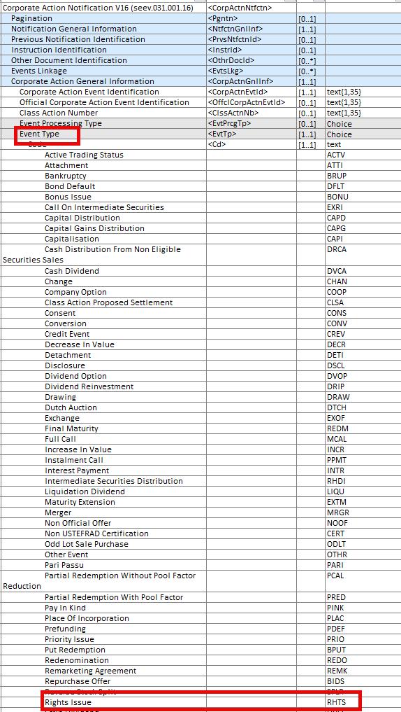
Q. In the seev.031 (CANO – CorporateActionNotification) message, remove message building block “Intermediate Security” and related Intermediate Security Rule 1 & 2, as illustrated below:
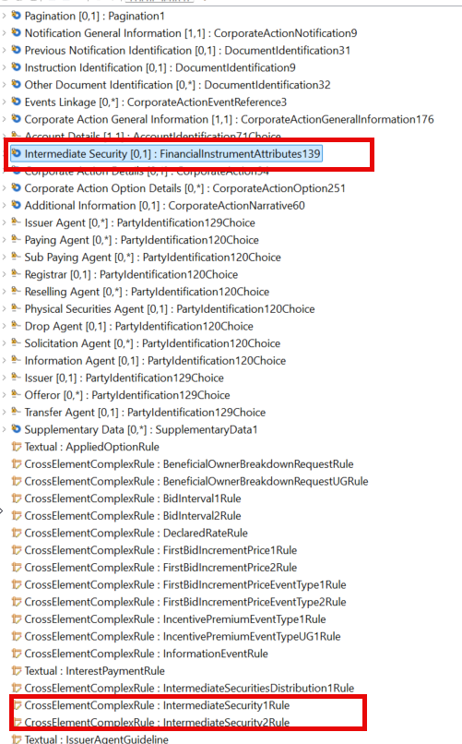

SWG Decision
XXX

SWIFT Comment

N/A

003236 - Add Event Indicator "RWTH - Rights of Withdrawal Events"
Requesting Country: | IT
Sponsors
IT NMG, Euronext Securities Milan
Message type(s) impacted
MT 564, 565, 566, 567, 569
seev.009, seev.011, seev.010, seev.031, seev.032, seev.033, seev.034, seev.035, seev.036, seev.037, seev.039, seev.040, seev.041, seev.042, seev.044

S&R messages: MT508, MT536, MT537, MT538, MT548, MT 575.
semt.015 semt.016, semt.017, semt.018; semt.015, semt.016, semt.027, semt.029, semt.034, semt.044

Required for regulatory reasons
No
Business impact of this request
MEDIUM
Commitment to implement the change
Number of messages sent and received: 11111
Percentage of messages impacted: 60
Commits to implement and when: NMG Italy / 2027
Business context
In recent years, the Italian securities market has experienced a significant increase in withdrawal (Recesso) events, primarily as a consequence of national legislation enabling issuers to assign enhanced voting rights or multiple‑vote shares to existing shareholders.
This regulatory evolution above has given the right to shareholders of exercising the withdrawal at the time when the multiple-vote shares has been decided by the company. Currently in Italy 77 of the major companies already decided of assigning multiple-vote rights to their shareholders.
Under Italian law, when a shareholder did not vote in favour of specific resolutions that affect their rights (including resolutions enabling or modifying multiple‑voting share structures), the shareholder is legally entitled to exercise a right of withdrawal. This leads to a growing number of post‑meeting withdrawal corporate action events, initiated as a direct consequence of resolutions approved during general assemblies.
However, current ISO 20022 message standards do not foresee a specific event type for this event, and this prevents the definition of standards for processing them.
The volume of withdrawal‑triggering resolutions is expected to continue increasing due to the widespread adoption of multiple‑vote share structures in the Italian market.
Without a dedicated event type in ISO 20022 messages, the whole custodian chain (Issuers, CSD, Custodians, etc.) cannot process these events in an STP and standardized way leading to an increases operational risk and processing delays.
Nature of change
Add a new Event Type for Rights of withdrawal events occurring in the Italian market.
The Event Indicator should be: RWTH

Analysis
Standards Illustration

ISO 15022 Illustration
A. In the MT564, in sequence A,
B. And in the MT565, in sequence A,
C. And in the MT566, in sequence A,
D. And in the MT567, in sequence A,
E. And in the MT568, in sequence A,
add new event type code “RWTH - Right of withdrawal events” to qualifier CAEV in field 22F:Indicator, as described and illustrated below for MT564:
MT 564 Field Specifications
5. Field 22F: Indicator

FORMAT
Option F | :4!c/[8c]/4!c | (Qualifier)(Data Source Scheme)(Indicator)

PRESENCE
Mandatory in mandatory sequence A

QUALIFIER
(Error code(s): T89)
Order | M/O | Qualifier | R/N | CR | Options | Qualifier Description
1 | O | CAEP | N |  | F | Corporate Action Event Processing
2 | M | CAEV | N | C4, C6, C10, C11, C22, C25, C28 | F | Corporate Action Event Indicator
3 | M | CAMV | N |  | F | Mandatory/Voluntary Indicator

DEFINITION
This qualified generic field specifies:
CAEP | Corporate Action Event Processing | Type of processing involved by a Corporate Action.
CAEV | Corporate Action Event Indicator | Specifies the type of corporate event.
CAMV | Mandatory/Voluntary Indicator | Specifies whether the event is mandatory, mandatory with options or voluntary.

CODES
If Qualifier is CAEV and Data Source Scheme is not present, Indicator must contain one of the following codes (Error code(s): K22):
ACCU | Accumulation | Funds related event in which the income (for example accumulation units) that accrues during an accounting period is retained within the fund instead of being paid away to investors. The retained income is nonetheless deemed to have been distributed to investors for tax purposes.
ACTV | Trading Status: Active | Trading in the security has commenced or security has been re-activated after a suspension in trading.
ATTI | Attachment | Combination of different security types to create a unit. Units are usually comprised of warrants and bonds or warrants and equities. Securities may be combined at the request of the security holder or based on market convention.
BIDS | Repurchase Offer/Issuer Bid/Reverse Rights | Offer to existing holders by the issuing company to repurchase its own securities. The objective of the offer is to reduce the number of outstanding securities.
BMET | Bond Holder Meeting | Physical meeting of bond holders.
…
RHDI | Intermediate Securities Distribution | The distribution of intermediate securities that gives the holder the right to take part in a future event.
RHTS | Rights Issue/Subscription Rights/Rights Offer | Offer to holders of a security to subscribe for additional securities via the distribution of an intermediate security. Both processes are included in the same event.
RWTS | Right of Withdrawal Events | Event by which shareholders are entitled to exercise the right of withdrawal from a security following a corporate resolution that affects their rights, typically allowing redemption or compensation of their holdings.
SHPR | Shares Premium Dividend | This corporate event pays shareholders an amount in cash issued from the shares premium reserve. It is similar to a dividend but with different tax implications.
SMAL | Smallest Negotiable Unit | Modification of the smallest negotiable unit of shares in order to obtain a new negotiable unit.
…
XMET | Extraordinary or Special General Meeting | Extraordinary or special general meeting.

ISO 20022 Illustration
A. In the seev.031 (CANO – CorporateActionNotification) message, in building block CorporateActionGeneralInformation,
B. In the seev.032 (CANO – CorporateActionEventProcessingStatusAdvice) message, in building block CorporateActionGeneralInformation,
C. In the seev.033 (CANO – CorporateActionInstruction) message, in building block CorporateActionGeneralInformation,
D. In the seev.034 (CANO – CorporateActionInstructionStatusAdvice) message, in building block CorporateActionGeneralInformation,
E. In the seev.035 (CANO – CorporateActionMovementPreliminaryAdvice) message, in building block CorporateActionGeneralInformation,
F. In the seev.036 (CANO – CorporateActionMovementConfirmation) message, in building block CorporateActionGeneralInformation,
G. In the seev.037 (CANO – CorporateActionMovementReversalAdvice) message, in building block CorporateActionGeneralInformation,
H. In the seev.038 (CANO – CorporateActionNarrative) message, in building block CorporateActionGeneralInformation,
I. In the seev.039 (CANO – CorporateActionCancellationAdvice) message, in building block CorporateActionGeneralInformation,
J. In the seev.040 (CANO – CorporateActionInstructionCancellationRequest) message, in building block CorporateActionGeneralInformation,
K. In the seev.041 (CANO – CorporateActionCancellationRequestStatusAdvice) message, in building block CorporateActionGeneralInformation,
L. In the seev.042 (CANO – CorporateActionInstructionStatementReport) message, in building block CorporateActionGeneralInformation,
M. In the seev.044 (CANO – CorporateActionMovementPreliminaryAdviceCancellationAdvice) message, in building block CorporateActionGeneralInformation,
N. In the seev.009 (AgentCANotificationAdvice) message, in building block CorporateActionGeneralInformation,
O. In the seev.010 (AgentCANotificationCancellationRequest) message, in building block CorporateActionGeneralInformation,
P. In the seev.011 (AgentCANotificationStatusAdvice) message, in building block CorporateActionGeneralInformation,
Add new code “RWTS - Right of Withdrawal Events” to element Event Type, as described and illustrated above for ISO 15022.

SWG Decision
XXX

SWIFT Comment

N/A

