Change Request
for the update of ISO 20022 financial repository items

- Origin of the request:
A.1 Submitter: nexo A.I.S.B.L.
A.2 Contact person:
- Catherine BOUNDJIA (catherine.boundjia@nexo-standards.org)
- Rober FARGIER (robert.fargier@istium.pro)
A.3 Sponsors: nexo A.I.S.B.L.

- Related messages:
- CreditorPaymentActivationRequestV12 (pain.013.001.12)
- CreditorPaymentActivationRequestStatusReportV12 (pain.014.001.12)

- Description of the change request:
The change request aims to allow the Creditor sending party (Creditor or Payee) to provide Environment and Context information inside a payment initiation request message used to request movement of funds from a debtor account to the creditor account.
Update to message CreditorPaymentActivationRequestV12:
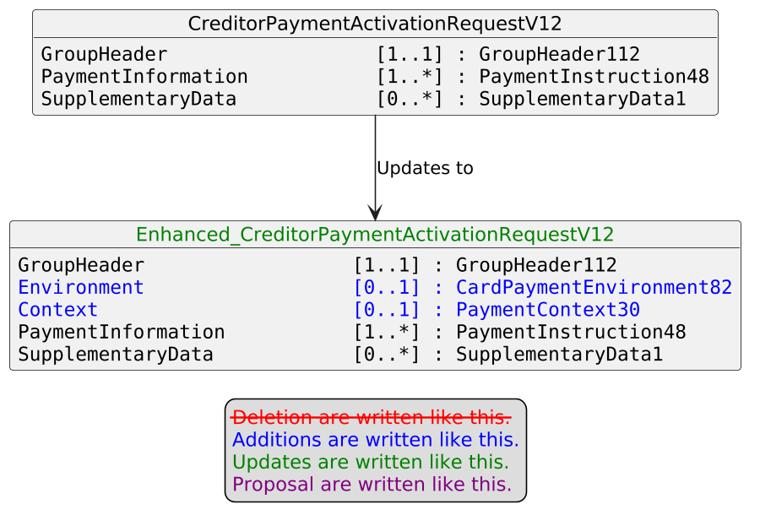

Update to message CreditorPaymentActivationRequestStatusReportV12:
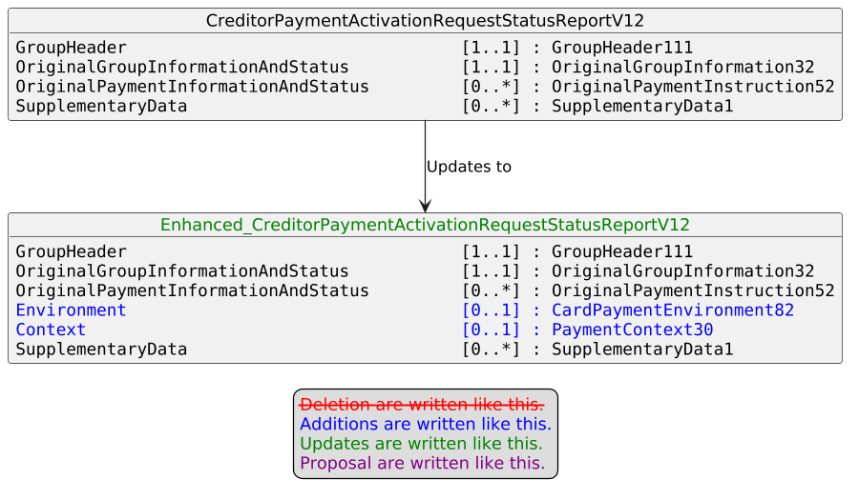
- Purpose of the change:
nexo A.I.S.B.L. is the international organization dedicated to standardizing the exchange of payment acceptance data between merchants, acquirers, payment service providers, and other payment stakeholders. In 2025, nexo established the Instant Payment Acceptance Specification (IPAS) Technical Working Group, responsible for defining, developing, maintaining, and publishing specifications and guidelines to facilitate instant payment acceptance at the Point of Interaction (POI).
In this context, nexo IPAS TWG has identified the need to enable the Creditor sending party to embed Environment and Context information — including POI details — directly within the payment initiation request message. This information is intended to allow the Credit Agent to identify the POI system that should be notified upon completion of the instant credit transfer, a capability that is essential in Consumer-to-Business (C2B) "instant payment at the POI" scenarios, where the payment outcome must be communicated back to the originating terminal or system in real time.
By incorporating this information directly into the payment initiation request message, the end-to-end payment flow is streamlined, eliminating the need for separate notification mechanisms and improving the overall reliability and traceability of instant payment confirmations.

- Urgency of the request:
Urgent.
- Business examples:
Examples illustrating the change request.
- SEG/TSG recommendation:
This section is not to be taken care of by the submitter of the change request. It will be completed in due time by the SEG(s) in charge of the related ISO 20022 messages or the TSG for changes related to the BAH.

Consider |  | X | Timing
 |  |  | - Next yearly cycle: 2026/2027  (the change will be considered for implementation in the yearly maintenance cycle which starts in 2026 and completes with the publication of new message versions in the spring of 2027) |  | X
- At the occasion of the next maintenance of the messages
(the change will be considered for implementation, but does not justify maintenance of the messages in its own right – will be pending until more critical change requests are received for the messages)
- Urgent unscheduled
(the change justifies an urgent implementation outside of the normal yearly cycle)
 |  |  | - Other timing:
Comments:

Reject
Reason for rejection:

