Maintenance Change Request

- Name of the request:
General Meeting Messages Maintenance for year 2026/2027

- Submitting organization(s):
SMPG and Swift

- Related messages:
Under this project, the following ISO 20022 General Meeting messages highlighted in blue below would be maintained in the context of the General Meeting messages maintenance for year 2026/2027 – pending approval of the proposed implementation solutions (which will be reviewed on the 19th of August 2026, with implementation subject to consensus being reached among the SEG/ET members):
 | Message Name | Abbreviated Name | Identifier
1 | MeetingNotificationV13 | MENO | seev.001.001.13
2 | MeetingCancellationV10 | MECN | seev.002.001.10
3 | MeetingEntitlementNotificationV10 | MENT | seev.003.001.10
4 | MeetingInstructionV11 | MEIN | seev.004.001.11
5 | MeetingInstructionCancellationRequestV10 | MEIC | seev.005.001.10
6 | MeetingInstructionStatusV12 | MEIS | seev.006.001.12
7 | MeetingVoteExecutionConfirmationV12 | MECO | seev.007.001.12
8 | MeetingResultDisseminationV10 | MERD | seev.008.001.10
9 | Securities Message Rejection |  | semt.001.001.04

- Commitments of the submitting organization:
Swift confirms that it can and will:
- undertake the development of the new version of the candidate ISO 20022 message models that it will submit to the RA for compliance review and evaluation by December 1st, 2026.
- provide a new version of part 1 of the Message Definition Report (MDR) and new examples of valid message instances of each message by May 1st, 2027, at the latest.
- address any queries related to the description of the new models and messages as published by the RA on the ISO 20022 website.

Swift confirms their knowledge and acceptance of the ISO 20022 Intellectual Property Rights policy for contributing organisations, as follows:

“Organisations that contribute information to be incorporated into the ISO 20022 Repository shall keep any Intellectual Property Rights (IPR) they have on this information. A contributing organisation warrants that it has sufficient rights on the contributed information to have it published in the ISO 20022 Repository through the ISO 20022 Registration Authority in accordance with the rules set in ISO 20022. To ascertain a widespread, public and uniform use of the ISO 20022 Repository information, the contributing organisation grants third parties a non-exclusive, royalty-free license to use the published information”.

- Contact persons:
Christine Strandberg – christine.strandberg@seb.se – phone: +46 8 763 6074
Mari Fumagalli – mariangela.fumagalli@bnpparibas.com – phone: +44 207 595 4988
Miriam Ortseifen – miriam.ortseifen@swift.com – phone: +34 91 4251317

Table of Contents

CR3272 (ISO CR #1599): Add or amend reason codes in Meeting Instruction Status 4
CR3273 (ISO CR #1598): Meeting Resolution Requirements 8
CR3276 (ISO CR #1593): Minimum Securities Required for Attendance 15
CR3280 (ISO CR #1589): Changes to Meeting IDs 18
CR3275 (ISO CR #1594): Add Cumulative Voting Multiplier to Meeting Notification and Instruction 21
CR3274 (ISO CR #1595): Changes to Meeting Attendance block 28

CR3272 (ISO CR #1599): Add or amend reason codes in Meeting Instruction Status
A. Origin of the request:
A.1 Submitter: SMPG CA-WG
A.2 Contact persons:
Christine Strandberg
Mariangela Fumagalli
A.3 Sponsors:
SMPG CA WG members
B. Related messages:
seev.006.001.12 (Meeting Instruction Status)
C. Description of the change request:
1) In the seev.006, there is a need to extend the Rejection Reason Code element within the Instruction Type Status building block, with the following additional codes:
Instruction Type Status | Instruction Status | Code | Description | Documentation | Change | Comment
Instruction Status | Rejected | RIRE | Reconfirmation Of Instructions Required | Instruction rejected due to a change to the agenda and/or resolutions. | New
Instruction Status | Rejected | CARJ | Cancellation Already Rejected | The instruction to be cancelled is already rejected. | New
Instruction Status | Rejected | EMDM | Enrolment Market Deadline Missed | Received after enrolment market deadline. | New
Instruction Status | Rejected | ENDM | Enrolment Deadline Missed | Instruction received after the account servicer's specified deadline. | New
Instruction Status | Rejected | RAIM | Rights Holder Account Identification is missing | Rights holder account identification at the last intermediary is missing. | New
Instruction Status | Rejected | ICMT | Incorrect Meeting Type | The meeting type specified in the instructions differs from the type specified in the meeting notification. | New
Instruction Status | Rejected | IRID | Incorrect Details for the Participation Method | The instruction is rejected because the provided Registration, Voting, Proxy, or Meeting Attendee details do not correspond to the selected participation method. | New
Instruction Status | Rejected | NOSE | No Service Offered | Feature whereby the holder must elect directly to the issuer's agent.  (issuer only supported option). | New | MT567 has no rejection code NOSE. The description comes from the MT564 feature. Probably to be amended.

2) In the seev.006, in message building block Instruction Type Status, the following Instruction and/or Cancellation status reason codes should be amended as described below:
Instruction Type Status | Instruction Status | Code | Description (SR2027) | Documentation (SR2027) | Description (SR2026) | Documentation (SR2026)
Instruction Status | Rejected | SAFE | Safekeeping Account/ Wallet Rejection | Unrecognised or invalid message sender's safekeeping account, Blockchain address or wallet. | Safekeeping Account Rejection | Unrecognised or invalid message sender's safekeeping account
Cancellation Status/Global Cancellation Status | Rejected | SAFE | Safekeeping Account/ Wallet Rejection | Unrecognised or invalid message sender's safekeeping account, Blockchain address or wallet. | Safekeeping Account Rejection | Unrecognised or invalid message sender's safekeeping account
Cancellation Status/Detailed Instruction Cancellation Status | Rejected | SAFE | Safekeeping Account/ Wallet Rejection | Unrecognised or invalid message sender's safekeeping account, Blockchain address or wallet. | Safekeeping Account Rejection | Unrecognised or invalid message sender's safekeeping account
Instruction Status | Rejected | NPOS | Not Sufficient Registered Position | Insufficient registered position | No Registered Position | Insufficient or no registered position.
Instruction Status | Pending | NPOS | Not Sufficient Registered Position | Insufficient registered position | No Registered Position | Insufficient or no registered position.
Instruction Status |  | NOSL | Not Registered In Stock Ledger | Invalid instruction as the shareholder or its delegate is not registered in the company stock ledger book. | Not Registered In Stock Ledger | UNCHANGED
Instruction Status |  | OPTY | Invalid Vote Instruction Type Code | Invalid Vote Instruction Type Code | Invalid Option Type | Invalid Option Type

D. Purpose of the change:
To reduce the use of OTHR.
E. Urgency of the request:
SR2027
Note: the ISO 20022 maintenance results in the publication of a new version of an ISO 20022 message. The actual implementation of such new version on networks and in user installations is not within the purview of ISO.
F. Business examples:
N/A
G. SEG/TSG recommendation:
☒ Consider
Timing:
☒ Next yearly cycle: 2026/2027
☐ At the occasion of the next maintenance of the messages
☐ Urgent unscheduled
☐ Other timing:
☐ Reject
Reason for rejection:
Comments: N/A
H. Impact analysis:
This change request impacts the following General meeting message: seev.006.
I. Proposed implementation:
As described above under C.
J. Proposed timing:
The submitting organization confirms that it can implement the requested changes in the requested timing.
Timing | As requested

K. Final decision of the SEG(s):
This section is not to be taken care of by the submitting organization. It will be completed in due time by the SEG(s) in charge of the related ISO 20022 messages.
Approve
Comments:
Reject
Reason for rejection:

CR3273 (ISO CR #1598): Meeting Resolution Requirements
A. Origin of the request:
A.1 Submitter:
SMPG CA-WG
A.2 Contact person:
Christine Strandberg
Mariangela Fumagalli
Miriam Ortseifen
A.3 Sponsors:
SMPG CA WG members
B. Related messages:
seev.001.001.12 (Meeting Notification)
seev.004.001.11 (Meeting Instruction)
seev.006.001.12 (Meeting Instruction Status)
C. Description of the change request:
REQUIREMENT 1: The sender of the seev.001 cannot indicate whether voting on meeting resolutions during the meeting is possible, although seev.004 is designed to support such instructions. As a result, the current model can be interpreted as a general allowance for investors, but it remains unclear whether the issuer or its agent actually offers or supports the option in a given event.
There are numerous cases where issuers clearly state this possibility in their voting form templates, and investor relations teams actively encourage larger shareholders to submit such instructions, to avoid unexpected outcomes during the meeting. This is typically used when the management anticipates sensitive motions or amendments.
In some countries this possibility is always given, but the type to vote (e.g. for, against, abstain, with/against management, etc.) is restricted.
A simple yes/no indicator might not be precise enough, as the issuer may wish to specify the type, as they do for regular agenda resolutions. This detail is also available in seev.004.
A new section in the seev.001 is preferred:
/Document/MtgNtfctn/MtgRsltn
/Document/MtgNtfctn/Rsltn/Desc/Lang
/Document/MtgNtfctn/Rsltn/Desc/Desc
/Document/MtgNtfctn/MtgRsltn/VoteInstrTp/VoteInstrTpCd/Tp
Abstain [ABST], Against [CAGS], Against Management [AMGT], Blank [BLNK], Chairman [CHRM], Discretionary [DISC], For [CFOR], No Action [NOAC], One Year [ONEY], Three Years [THRY], Two Years [TWOY], With Management [WMGT], Withhold [WTHH]
/Document/MtgNtfctn/Rsltn/MgmtRcmmndtn
Abstain [ABST], Against [CAGS], Against Management [AMGT], Blank [BLNK], Chairman [CHRM], Discretionary [DISC], For [CFOR], No Action [NOAC], One Year [ONEY], Three Years [THRY], Two Years [TWOY], With Management [WMGT], Withhold [WTHH]
/Document/MtgNtfctn/Rsltn/NtifngPtyRcmmndtn
Abstain [ABST], Against [CAGS], Against Management [AMGT], Blank [BLNK], Chairman [CHRM], Discretionary [DISC], For [CFOR], No Action [NOAC], One Year [ONEY], Three Years [THRY], Two Years [TWOY], With Management [WMGT], Withhold [WTHH]
/Document/MtgNtfctn/Rsltn/URLAdr
REQUIREMENT 2: In seev.004 it is possible to send Vote Instruction for Meeting Resolutions (/Document/MtgInstr/Instr/VoteDtls/VoteInstrForMtgRsltn) “Vote instructions for the resolutions that may arise or may be amended at the meeting but were not previously provided in the agenda.”
The following types are possible in the seev.004:
- Abstain [ABST]
- Against [CAGS]
- Against Management [AMGT]
- Blank [BLNK]
- Chairman [CHRM]
- Discretionary [DISC]
- For [CFOR]
- No Action [NOAC]
- One Year [ONEY]
- Three Years [THRY]
- Two Years [TWOY]
- With Management [WMGT]
- Withhold [WTHH]

The codes ONEY, TWOY and THRY should be removed, as they are not applicable to meeting resolutions. They relate to 'say on pay', which cannot be raised at a meeting.
REQUIREMENT 3:
The rejection code “Invalid Option Type [OPTY]” could be used to inform senders in case the meeting resolution is not accepted.
or
a new code “Meeting Resolution not supported” could be created to inform the sender that their voting for meeting resolution is not accepted.
D. Purpose of the change:
Currently, it is not possible to display the type to vote (e.g. for, against, abstain, with/against management, etc.) for meeting resolutions within the seev.001 message. However, it is possible to vote on meeting resolutions via seev.004.
E. Urgency of the request:
For next release (SR2027).
Note: the ISO 20022 maintenance results in the publication of a new version of an ISO 20022 message. The actual implementation of such new version on networks and in user installations is not within the purview of ISO.
F. Business examples:
Examples illustrating the change request.
Nestle AG (CH) or Bayer AG (DE).
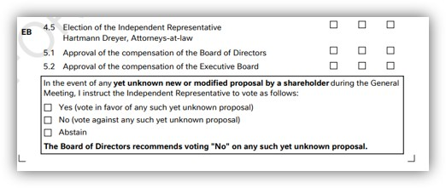
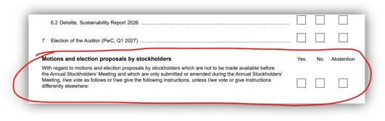
G. SEG/TSG recommendation:
☒ Consider
Timing:
☒ Next yearly cycle: 2026/2027
☐ At the occasion of the next maintenance of the messages
☐ Urgent unscheduled
☐ Other timing:
☐ Reject
Reason for rejection:
Comments: N/A
H. Impact analysis:
This change request impacts the following General meeting messages: seev.001, seev.004, seev.006.
I. Proposed implementation:
a. In the seev.001 (MeetingNotification), add new message building block MeetingResolution, including the following components and elements:
- /Document/MtgNtfctn/MeetingResolution/IssuerLabel (1…1), typed by datatype Max35Text
- /Document/MtgNtfctn/MeetingResolution/Description (0…*), typed by datatype ItemDescriptionX
- /Document/MtgNtfctn/MtgRsltn/Desc/Language (1…1), typed by datatype ISO2ALanguageCode
- /Document/MtgNtfctn/MtgRsltn/Desc/Description (0…*), typed by datatype Max8000text
- Document/MtgNtfctn/MtgRsltn/VoteInstrTp (0...*), typed by VoteInstructionType1
- /Document/MtgNtfctn/Rsltn/VoteInstrTp/VoteInstrTpCd (1…1)
- /Document/MtgNtfctn/Rsltn/VoteInstrTp/VoteInstrTpCd/Tp (1…)
        - Abstain [ABST],
        - Against [CAGS],
        - Against Management [AMGT],
        - Blank [BLNK],
        - Chairman [CHRM],
        - Discretionary [DISC],
        - For [CFOR],
        - No Action [NOAC],
        - One Year [ONEY], (Not applicable to Meeting Resolutions?)
        - Three Years [THRY], (Not applicable to Meeting Resolutions?)
        - Three Years [THRY], (Not applicable to Meeting Resolutions?)
        - With Management [WMGT],
        - Withhold [WTHH]

- /Document/MtgNtfctn/Rsltn/MgmtRcmmndtn (0...1), typed by VoteInstruction5Code
        - Abstain [ABST],
        - Against [CAGS],
        - Against Management [AMGT],
        - Blank [BLNK],
        - Chairman [CHRM],
        - Discretionary [DISC],
        - For [CFOR],
        - No Action [NOAC],
        - One Year [ONEY],
        - Three Years [THRY],
        - Two Years [TWOY],
        - With Management [WMGT],
        - Withhold [WTHH]

- /Document/MtgNtfctn/Rsltn/NtifngPtyRcmmndtn (0...1), typed by VoteInstruction5Code
        - Abstain [ABST],
        - Against [CAGS],
        - Against Management [AMGT],
        - Blank [BLNK],
        - Chairman [CHRM],
        - Discretionary [DISC],
        - For [CFOR],
        - No Action [NOAC],
        - One Year [ONEY],
        - Three Years [THRY],
        - Two Years [TWOY],
        - With Management [WMGT],
        - Withhold [WTHH]

- /Document/MtgNtfctn/Rsltn/URLAdr (0...1), typed by Max2048Text
b. In the seev.004 (MeetingInstruction), in message building block Instruction, within message component VoteDetails/VoteInstructionForMeetingResolution/VoteIndication/Type, remove the following Vote Instruction types:
        - Abstain [ABST],
        - Against [CAGS],
        - Against Management [AMGT],
        - Blank [BLNK],
        - Chairman [CHRM],
        - Discretionary [DISC],
        - For [CFOR],
        - No Action [NOAC],
        - One Year [ONEY],
        - Three Years [THRY],
        - Two Years [TWOY],
        - With Management [WMGT],
        - Withhold [WTHH]

c. In the seev.006 (MeetingInstructionStatus), in message building block InstructionTypeStatus, within message component InstructionStatus/InstructionStatus/Rejected/Reason/ReasonCode, add new reason code “Meeting Resolution not supported”.
Alternatively, OPTY could be used to inform sender in case the meeting resolution is not accepted.

J. Proposed timing:
The submitting organization confirms that it can implement the requested changes in the requested timing.
Timing | As requested

K. Final decision of the SEG(s):
This section is not to be taken care of by the submitting organization. It will be completed in due time by the SEG(s) in charge of the related ISO 20022 messages.
Approve
Comments:

Reject
Reason for rejection:

CR3276 (ISO CR #1593): Minimum Securities Required for Attendance
A. Origin of the request:
A.1 Submitter: SMPG CA-WG
A.2 Contact persons:
Christine Strandberg
Mariangela Fumagalli
A.3 Sponsors:
SMPG CA WG members
B. Related messages:
seev.001.001.12 (Meeting Notification)
seev.006.001.12 (Meeting Instruction Status)
C. Description of the change request:
1) In seev.001, in message building block Meeting, within message component Attendance/Admission Conditions, add new optional and non-repetitive element “Minimum Securities Required for Attendance”, defined as FinancialInstrumentQuantity18Choice.
2) In seev.006, add new rejection reason code “ISRA” (Insufficient Securities Required for Attendance), defined as: Insufficient quantity of securities held to meet the minimum requirement for attendance.
Alternatively, the current existing code IPOS could be used for this reason (to be decided during ET review meeting).
D. Purpose of the change:
Currently, many Spanish issuers announce in their General Meeting notice a requirement of a minimum of shares in order to attend physically the meeting. This information is not populated in the Seev.001 message since there is no structured field for this purpose (the field Securities Quantity Required To Vote is not valid for this purpose).
Therefore, the creation of a new optional field "Minimum Securities Required for Attendance" inside the Attendance/Admission Conditions block is required.
Moreover, a new rejection code in the seev.006 messages is required, to inform a rejection of a seev.004 instruction sent for an attendance request whether the position of the securities account is less than the minimum required for the issuer.
E. Urgency of the request:
SR2027
Note: the ISO 20022 maintenance results in the publication of a new version of an ISO 20022 message. The actual implementation of such new version on networks and in user installations is not within the purview of ISO.
F. Business examples:
Examples illustrating the change request.
N/A
G. SEG/TSG recommendation:
☒ Consider
Timing:
☒ Next yearly cycle: 2026/2027
☐ At the occasion of the next maintenance of the messages
☐ Urgent unscheduled
☐ Other timing:
☐ Reject
Reason for rejection:
Comments: N/A
H. Impact analysis:
This change request impacts the following General meeting messages: seev.001, seev.006.
I. Proposed implementation:
As described above under C and as illustrated below:
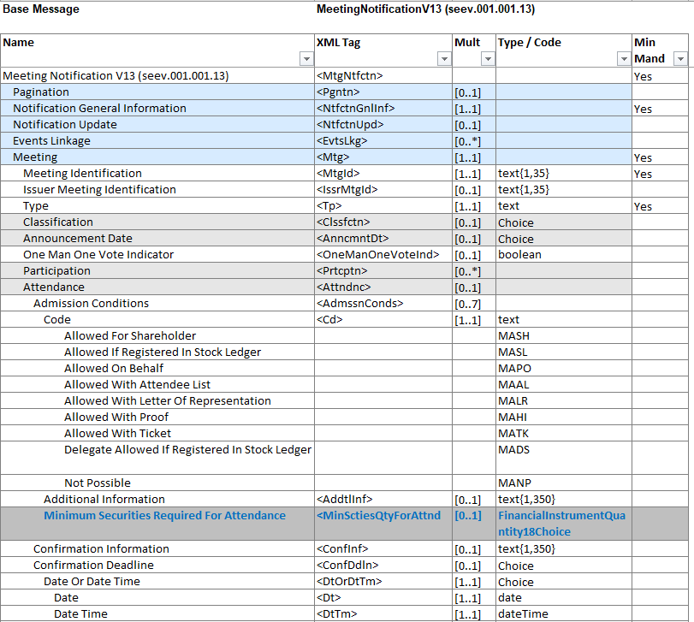
J. Proposed timing:
The submitting organization confirms that it can implement the requested changes in the requested timing.
Timing | As requested

K. Final decision of the SEG(s):
This section is not to be taken care of by the submitting organization. It will be completed in due time by the SEG(s) in charge of the related ISO 20022 messages.
Approve
Comments:
Reject
Reason for rejection:

CR3280 (ISO CR #1589): Changes to Meeting IDs
A. Origin of the request:
A.1 Submitter: SMPG CA-WG
A.2 Contact persons:
Christine Strandberg
Mariangela Fumagalli
A.3 Sponsors:
SMPG CA WG members
B. Related messages:
seev.001, seev.002, seev.003, seev.004, seev.005, seev.006, seev.007, seev.008
C. Description of the change request:
- Change the definition of IssuerMeetingIdentifier to make it clear a reference should be assigned per combination of meeting and financial instrument.
Current definition: Identification assigned to the meeting by the issuer. It must be unique for the issuer.
Proposed definition: Identification assigned to the meeting by the issuer. It must be unique for the issuer, meeting and underlying financial instrument.
- Change the definition of MeetingIdentifier to make it clear a reference should be assigned per combination of meeting and financial instrument.
Current definition: Identification assigned to the general meeting by the party that provides the meeting notification. It must be unique to the party providing the notification.
Proposed definition: Identification assigned to the general meeting by the party that provides the meeting notification. It must be unique to the party providing the notification, meeting and underlying financial instrument.
- Add a new meeting identifier, CommonIssuerMeetingIdentifier, with the definition: Identification assigned to the meeting by the issuer. It must be unique for the issuer and meeting. Only to be used when the issuer holds a meeting where holders of two or more financial instruments are allowed to attend and vote.
D. Purpose of the change:
The SMPG CA WG decided at its spring 2026 meeting to make clarifications and changes to the meaning and use of IssuerMeetingIdentifier and MeetingIdentifier, in order to have one identifier per meeting and financial instrument, and to add a new identifier, CommonIssuerMeetingIdentifier, for meetings where holders of more than financial instrument of the issuer are allowed to attend and vote. These changes will allow harmonisation with the similar corporate action message identifiers, OfficialCorporateActionEventIdentification and CorporateActionEventIdentification, whilst at the same time allow issuers of e.g. two share classes to identify the meeting with an issuer identifier common for both instruments.
E. Urgency of the request:
SR2027
Note: the ISO 20022 maintenance results in the publication of a new version of an ISO 20022 message. The actual implementation of such new version on networks and in user installations is not within the purview of ISO.
F. Business examples: N/A
G. SEG/TSG recommendation:
☒ Consider
Timing:
☒ Next yearly cycle: 2026/2027
☐ At the occasion of the next maintenance of the messages
☐ Urgent unscheduled
☐ Other timing:
☐ Reject
Reason for rejection:
Comments: N/A
H. Impact analysis:
This change request impacts the following General meeting messages: seev.001 – seev.008.
I. Proposed implementation:
1) In seev.001, in message building block Meeting,
And in seev.002 – seev.008, in message building block Meeting Reference,
amend the description for element “Issuer Meeting Identification”, as follows:
Identification assigned to the meeting by the issuer. It must be unique for the issuer.
NEW: Identification assigned to the meeting by the issuer. It must be unique for the issuer, meeting and underlying financial instrument.
2) In seev.001, in message building block Meeting,
And in seev.002 – seev.008, in message building block Meeting Reference,
amend the description for element “Meeting Identification”, as follows:
Identification assigned to the general meeting by the party that provides the meeting notification. It must be unique to the party providing the notification.
NEW: Identification assigned to the general meeting by the party that provides the meeting notification. It must be unique to the party providing the notification, meeting and underlying financial instrument.
- In seev.001, in message building block Meeting,
And in seev.002 – seev.008, in message building block Meeting Reference,
add the following optional and non-repetitive element “CommonIssuerMeetingIdentifier”, defined as: Identification assigned to the meeting by the issuer. It must be unique for the issuer and meeting.
Textual Rule: Only to be used when the issuer holds a meeting where holders of two or more financial instruments are allowed to attend and vote.
J. Proposed timing:
The submitting organization confirms that it can implement the requested changes in the requested timing.
Timing | As requested

K. Final decision of the SEG(s):
This section is not to be taken care of by the submitting organization. It will be completed in due time by the SEG(s) in charge of the related ISO 20022 messages.
Approve
Comments:
Reject
Reason for rejection:

CR3275 (ISO CR #1594): Add Cumulative Voting Multiplier to Meeting Notification and Instruction
A. Origin of the request:
A.1 Submitter: Eurobonds market / XS NMPG
A.2 Contact person: Hatem Soliman (hatem.soliman@euroclear.com, +32 2 326 5107)
A.3 Sponsors: ICSDs
B. Related messages:
seev.001.001.12 (Meeting Notification)
seev.004.001.11 (Meeting Instruction)
C. Description of the change request:
In the seev.001 meeting notification message,
- In message building block Meeting, add a new optional and non-repetitive element “Cumulative Voting Indicator”, typed by a YesNoIndicator, to indicate that cumulative voting is applicable to specific resolution(s).
XML path </Document/MtgNtfctn/ Cumulative Voting Indicator >
Definition: “Indicates if a cumulative voting applies to one or more resolution.”
- In message building block Resolution, add a new optional and non-repetitive element “Cumulative Voting Multiplier”, to indicate the multiplier to be applied to the resolution eligible to cumulative voting.
XML path < /Document/MtgNtfctn/Rsltn/CumVoteMultiplier>
Definition: “Multiplier to be applied on the eligible balance to determine the maximum number of votes accepted on resolutions flagged for cumulative voting”).
The element shall be defined using a numeric datatype constrained to integer values (fractionDigits = 0) with a minimum value of 1 (Min inclusive: 1).
- In message building block Resolution, add a new optional and repetitive (0….1000) element “Subresolution”, typed by Max35Text, to list the subresolutions where the cumulative voting and the multiplier to be applied to.
XML path < /Document/MtgNtfctn/Rsltn/subRsltn>
Definition: “list of the sub-resolutions where the cumulative voting and the multiplier to be applied to”
In the seev.004 meeting instruction message,
- In message building block Instruction, within message component “Vote Details/VoteInstructionForAgendaResolution/VotePerAgendaResolution/VoteInstruction/Subresolution”, add a new optional and repetitive (0….1000) element “Subresolution”, typed by Max35Text, to list the subresolutions where the cumulative voting and the multiplier to be applied to.
XML path </Document/MtgInstr/Instr/VoteDtls/VoteInstrForAgndRsltn/VotePerAgndRsltn/VoteInstr//subRsltn)
Definition: same as defined above under (3).
- Add 2 cross-element rules:
- If the Cumulative voting flag = Y, then there must be a least one CumVoteMultiplier.
- If a CumulativeVotingMultiplier is present, then the CumulativeVotingIndicator must be equal to “true”.
D. Purpose of the change:
There are meeting events for which cumulative voting applies for specific resolution(s).
It means that for a number of resolutions for a meeting event, clients can vote for an amount of the eligible balance multiplied by the number of sub-resolutions for which cumulative voting applies.
The sum of the votes by the client for the applicable sub-resolutions should not exceed the eligible balance multiplied by the number of sub-resolutions with cumulative voting.
It must be possible to announce the multiplier when cumulative voting applies to specific sub-resolution(s) as decided by the issuer.
The account servicer receiving a meeting instruction will compare the instruction quantity with the position multiplied by the “cumulative voting multiplier” to either accept (“PACK”), reject (“rejected/LACK”) or keep instruction recycling (“pending/LACK”). (Rejecting or keeping instruction pending to be decided based on account servicer SLA, as for other meeting instructions). There is no need to define a new reason for this specific case.
E. Urgency of the request:
SR2027
Note: the ISO 20022 maintenance results in the publication of a new version of an ISO 20022 message. The actual implementation of such new version on networks and in user installations is not within the purview of ISO.
F. Business examples:
Around 40 meeting events with cumulative voting announced over the last 6 months, mainly on EURO instruments, Finnish, HK and US markets (mainly for depository receipts).
Example 1:
CUMULATIVE VOTING APPLIES TO RESOLUTION 4
2 DIRECTORS ARE TO BE ELECTED TO THE BOARD.
TO INSTRUCT, MULTIPLY YOUR ELIGIBLE POSITION BY THE NUMBER OF
DIRECTORS TO BE ELECTED. IF YOU WANT TO SPLIT YOUR VOTE, ASSIGN
AN AMOUNT TO EACH DIRECTOR UNTIL YOUR TOTAL CUMULATED POSITION IS ACCOUNTED FOR.
FOR EXAMPLE, IF YOU HAVE 10 ADRS ON RECORD DATE, YOU ARE ENTITLED
TO VOTE ON 2 (NUMBER OF NOMINATED DIRECTORS) X 10, EQUALLING 20
VOTES TO DISTRIBUTE AMONG THE NUMBER OF PROPOSED DIRECTORS.

Example 2:
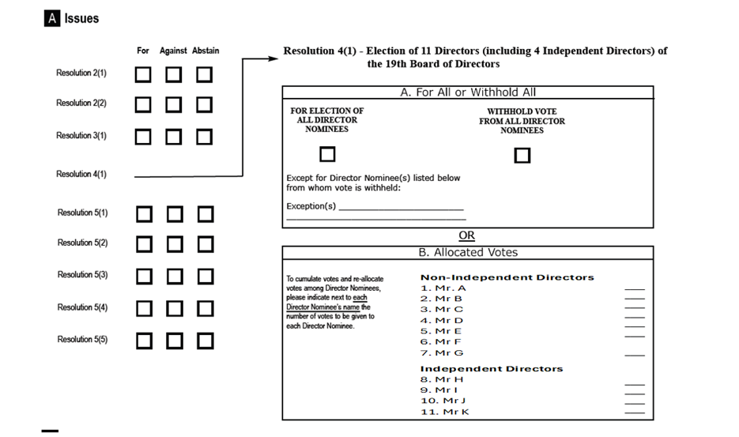
The notification should have the below structure for resolution 4
For resolution 4, you can either instruct on resolution 4.a. or 4.b. and 4.c.
Resolution 4.a.: you have the option to vote for all Director nominees or withhold vote for all Director nominees with possibility to note exceptions.

Resolution 4.b.
CUMULATIVE VOTING APPLIES TO RESOLUTION 4.b.
7 NON-INDEPENDENT DIRECTORS ARE TO BE ELECTED TO THE BOARD (7 sub-resolutions).
TO INSTRUCT, MULTIPLY YOUR ELIGIBLE POSITION BY THE NUMBER OF NON-INDEPENDENT DIRECTORS (sub-resolutions) TO BE ELECTED.
IF YOU WANT TO SPLIT YOUR VOTE, ASSIGN AN AMOUNT TO EACH DIRECTOR UNTIL YOUR TOTAL CUMULATED POSITION IS ACCOUNTER FOR.
FOR EXAMPLE, IF YOU HAVE 10 ADRS ON RECORD DATE, YOU ARE ENTITLED
TO VOTE ON 7 (NUMBER OF NOMINATED NON-INDEPENDENT DIRECTORS) X 10, EQUALLING 70
VOTES TO DISTRIBUTE AMONG THE NUMBER OF PROPOSED NON-INDEPENDENT DIRECTORS.

Resolution 4.C.
CUMULATIVE VOTING APPLIES TO RESOLUTION 4.c.
4 INDEPENDENT DIRECTORS (sub-resolutions ) ARE TO BE ELECTED TO THE BOARD.
TO INSTRUCT, MULTIPLY YOUR ELIGIBLE POSITION BY THE NUMBER OF
INDEPENDENT DIRECTORS (sub-resolutions ) TO BE ELECTED. IF YOU WANT TO SPLIT YOUR VOTE, ASSIGN
AN AMOUNT TO EACH DIRECTOR UNTIL YOUR TOTAL CUMULATED POSITION IS ACCOUNTED FOR.
FOR EXAMPLE, IF YOU HAVE 10 ADRS ON RECORD DATE, YOU ARE ENTITLED
TO VOTE ON 4 (NUMBER OF NOMINATED INDEPENDENT DIRECTORS) X 10, EQUALLING 40
VOTES TO DISTRIBUTE AMONG THE NUMBER OF PROPOSED INDEPENDENT DIRECTORS.

At Meeting level:
- Document/MtgNtfctn/ Cumulative Voting Indicator – CumulativeVotingIndicator - (YesNoIndicator) [0..1] — indicates that cumulative voting applies to one or more resolutions.

At Resolution level:
- /Document/MtgNtfctn/Rsltn – Resolution 4.b.
- /Document/MtgNtfctn/Rsltn/IssrLabl – Issuer Label – Non-Independent Directors
- /Document/MtgNtfctn/Rsltn/ListgGrpRsltnLabl – Listing Group Resolution Label - Identifies under the same label a group of agenda resolutions for which a vote in favour can be assigned to only one, more or all resolutions of that group.
- Document/MtgNtfctn/Rsltn/CumVoteMultiplier - Cumulative Voting Multiplier - (Number / integer ≥ 1) [0..1] = 7

- /Document/MtgNtfctn/Rsltn/subRsltn – “Sub-Resolution 4.b.1 – Mr. A”
- /Document/MtgNtfctn/Rsltn/subRsltn – “Sub-Resolution 4.b.2 – Mr. B”
- /Document/MtgNtfctn/Rsltn/subRsltn – “Sub-Resolution 4.b.3 – Mr. C”
- /Document/MtgNtfctn/Rsltn/subRsltn – ”Sub-Resolution 4.b.4 – Mr. D”
- /Document/MtgNtfctn/Rsltn/subRsltn – ”Sub-Resolution 4.b.5 – Mr. E”
- /Document/MtgNtfctn/Rsltn/subRsltn – ”Sub-Resolution 4.b.6 – Mr. F”
- /Document/MtgNtfctn/Rsltn/subRsltn – ”Sub-Resolution 4.b.7 – Mr. G”

- /Document/MtgNtfctn/Rsltn – Resolution 4.c.
- /Document/MtgNtfctn/Rsltn/IssrLabl – Issuer Label – Independent Directors
- /Document/MtgNtfctn/Rsltn/ListgGrpRsltnLabl – Listing Group Resolution Label - Identifies under the same label a group of agenda resolutions for which a vote in favour can be assigned to only one, more or all resolutions of that group.
- Document/MtgNtfctn/Rsltn/CumVoteMultiplier - Cumulative Voting Multiplier - (Number / integer ≥ 1) [0..1] = 4

- /Document/MtgNtfctn/Rsltn/subRsltn – ”Sub-Resolution 4.c.1 – Mr. H”
- /Document/MtgNtfctn/Rsltn/subRsltn – ”Sub-Resolution 4.c.2 – Mr. K”
- /Document/MtgNtfctn/Rsltn/subRsltn – ”Sub-Resolution 4.c.3 – Mr. L”
- /Document/MtgNtfctn/Rsltn/subRsltn – ”Sub-Resolution 4.c.4 – Mr. M”

G. SEG/TSG recommendation:
☒ Consider
Timing:
☒ Next yearly cycle: 2026/2027
☐ At the occasion of the next maintenance of the messages
☐ Urgent unscheduled
☐ Other timing:
☐ Reject
Reason for rejection:
Comments: N/A
H. Impact analysis:
This change request impacts the following General meeting message: seev.001.
I. Proposed implementation:
- In the seev.001 (MeetingNotification), in message building block Meeting, add new optional and non-repetitive element “Cumulative Voting Indicator”, typed by a YesNoIndicator and defined as: “Indicates if a cumulative voting applies to one or more resolutions”.
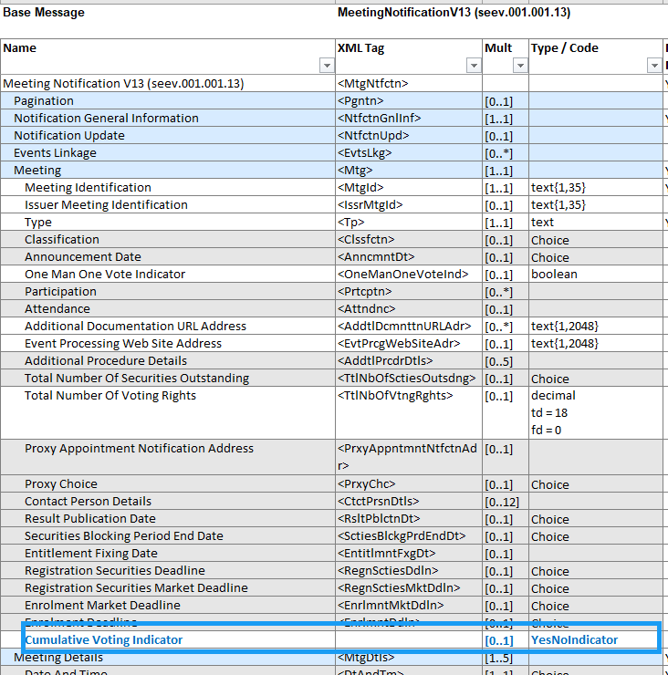
- In the seev.001 (MeetingNotification), in message building block Resolution, add new optional and non-repetitive element “Cumulative Voting Multiplier”, defined as: “Multiplier to be applied on the eligible balance to determine the maximum number of votes accepted on the resolutions flagged for cumulative voting”. The element shall be defined using a numeric datatype constrained to integer values (fractionDigits = 0) with a minimum value of 1 (Min inclusive: 1).

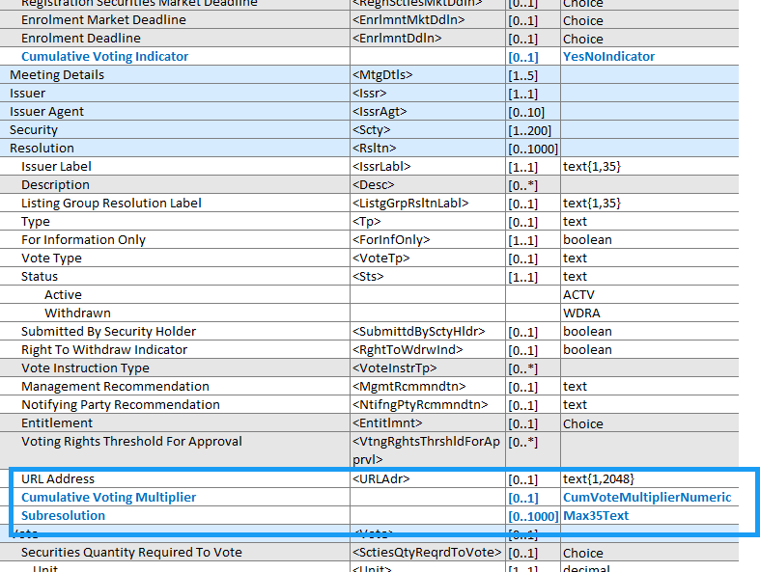
- In the seev.001, add 2 cross-element rules:
- If the Cumulative voting indicator is set to “true”, then at least one CumVoteMultiplier must be present (in at least one resolution).
- If a CumulativeVotingMultiplier is present (in any resolution), then the CumulativeVotingIndicator (in the Meeting building block) must be equal to “true”.
- In the seev.001 (MeetingNotification), in message building block Resolution, add new optional and repetitive (0…1000) element “Subresolution”, typed by Max35Text and defined as: “List of the sub-resolutions where the cumulative voting and the multiplier to be applied to.”
- In the seev.004, in the message building block Instruction, within message component “Vote Details/VoteInstructionForAgendaResolution/VotePerAgendaResolution/VoteInstruction”, add new optional and repetitive (0…1000) element “Subresolution”, as defined above under 3) and typed by Max35Text.
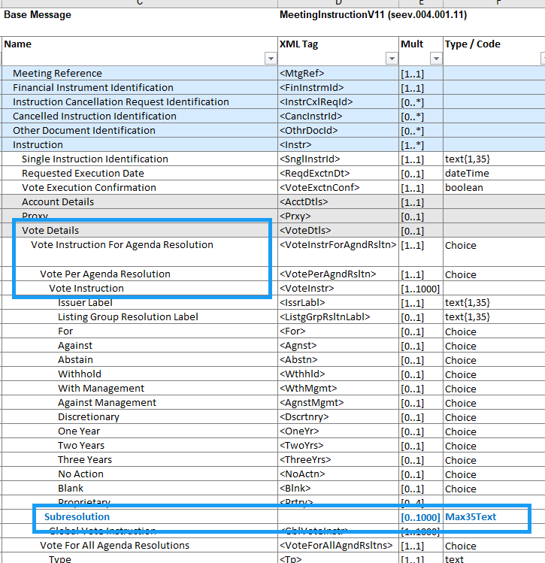
J. Proposed timing:
The submitting organization confirms that it can implement the requested changes in the requested timing.
Timing | As requested

K. Final decision of the SEG(s):
This section is not to be taken care of by the submitting organization. It will be completed in due time by the SEG(s) in charge of the related ISO 20022 messages.
Approve
Comments:
Reject
Reason for rejection:

CR3274 (ISO CR #1595): Changes to Meeting Attendance block

A. Origin of the request:
A.1 Submitter: SMPG CA-WG
A.2 Contact persons:
Christine Strandberg
Mariangela Fumagalli
A.3 Sponsors:
SMPG CA WG members
B. Related messages:
seev.001 Meeting Notification
C. Description of the change request:
Create a new indicator in the seev.001 to state whether voting instructions should be submitted along with the attendance request or not.
D. Purpose of the change:
The SMPG CA WG decided at its spring 2026 meeting to create an element in the seev.001, in the Attendance block, to state that votes need to be submitted via the chain of intermediaries even if the rightsholder attends in person.
E. Urgency of the request:
SR2027
Note: the ISO 20022 maintenance results in the publication of a new version of an ISO 20022 message. The actual implementation of such new version on networks and in user installations is not within the purview of ISO.
F. Business examples:
N/A
G. SEG/TSG recommendation:
☒ Consider
Timing:
☒ Next yearly cycle: 2026/2027
☐ At the occasion of the next maintenance of the messages
☐ Urgent unscheduled
☐ Other timing:
☐ Reject
Reason for rejection:
Comments: N/A
H. Impact analysis:
This change request impacts the following General meeting messages: seev.001, seev.004, seev.006.
I. Proposed implementation:
a. In the seev.001 (MeetingNotification), in message building block Attendance, add new optional and non-repetitive indicator “VotingThroughIntermediaryIndicator”, typed by YesNoIndicator and defined as: “Indicates whether voting instructions must be submitted through the chain of intermediaries, regardless of the attendance mode of the rightsholder.
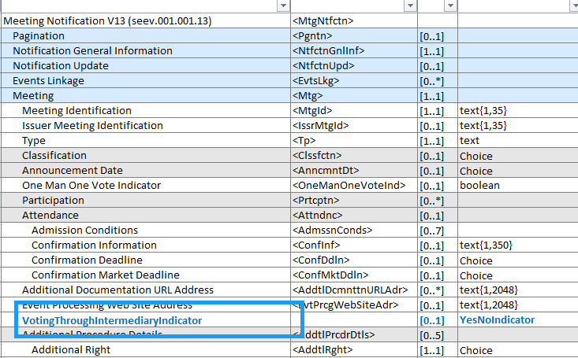
J. Proposed timing:
The submitting organization confirms that it can implement the requested changes in the requested timing.
Timing | As requested

K. Final decision of the SEG(s):
This section is not to be taken care of by the submitting organization. It will be completed in due time by the SEG(s) in charge of the related ISO 20022 messages.
Approve
Comments:
Reject
Reason for rejection:

End of document

