Change Request
for the update of ISO 20022 financial repository items
Note: the purpose of this document is to give guidelines to parties who want to introduce a request to change an existing ISO 20022 message(s), or update other items of the ISO 20022 financial repository. Such change requests are subject to the approval of the ISO 20022 Standards Evaluation Group(s) in charge of the related message/item or to the approval of the Technical Support Group (TSG), if the requested change relates to the Business Application Header (BAH). Please consult the iso20022.org website for additional details on the maintenance process. Change requests are to be sent to iso20022ra@iso20022.org. All change requests conforming to this template received by June 1st will be considered for development in the following yearly ISO 20022 maintenance cycle which completes with publication of new message versions in April/May of the following year.
- Origin of the request:
A.1 Submitter: Banca d’Italia on behalf of the Eurosystem / 4CB
A.2 Contact person:
- Riccardo Mancini, +39 06 4792 6024
- riccardo.mancini@bancaditalia.it
- t2s-fam@bundesbank.de
A.3 Sponsors: SWIFT (Karine TAQUET)

- Related messages:
Impacted messages:
reda.018 Securities Account Creation Request
reda.019 Securities Account Query
reda.021 Securities Account Report

- Description of the change request:
Currently, the Securities Account Type element is implemented with the SystemSecuritiesAccountType1Code data type. This approach is not following the ISO RA recommendation to use External Code Lists whenever possible.
The objective of this change request is to change the current data type with the ExternalSecuritiesAccountType1Code.

This request proposes to adapt the following changes:

- In the reda.018 message, Data Type for Element Document/SctiesAcctCreReq/SctiesAcct/Tp/Cd should be changed into ExternalSecuritiesAccountType1Code
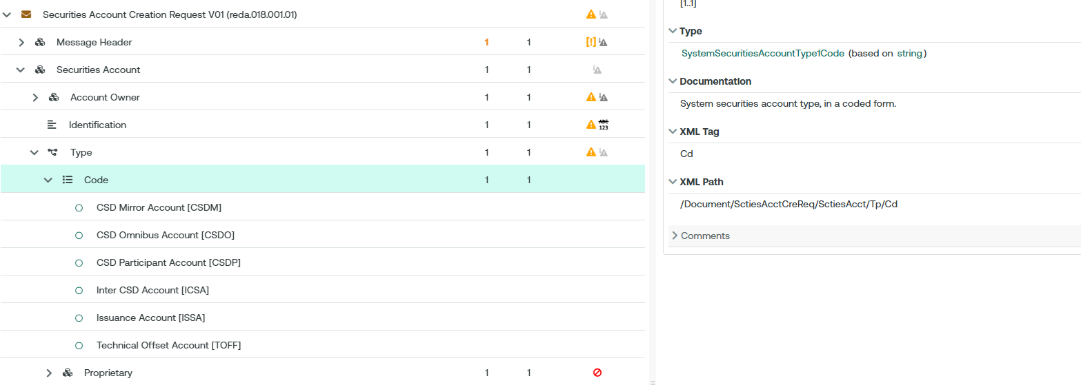

- In the reda.019 message, Data Type for Element /Document/SctiesAcctQry/SchCrit/AcctTp/Cd should be changed into ExternalSecuritiesAccountType1Code
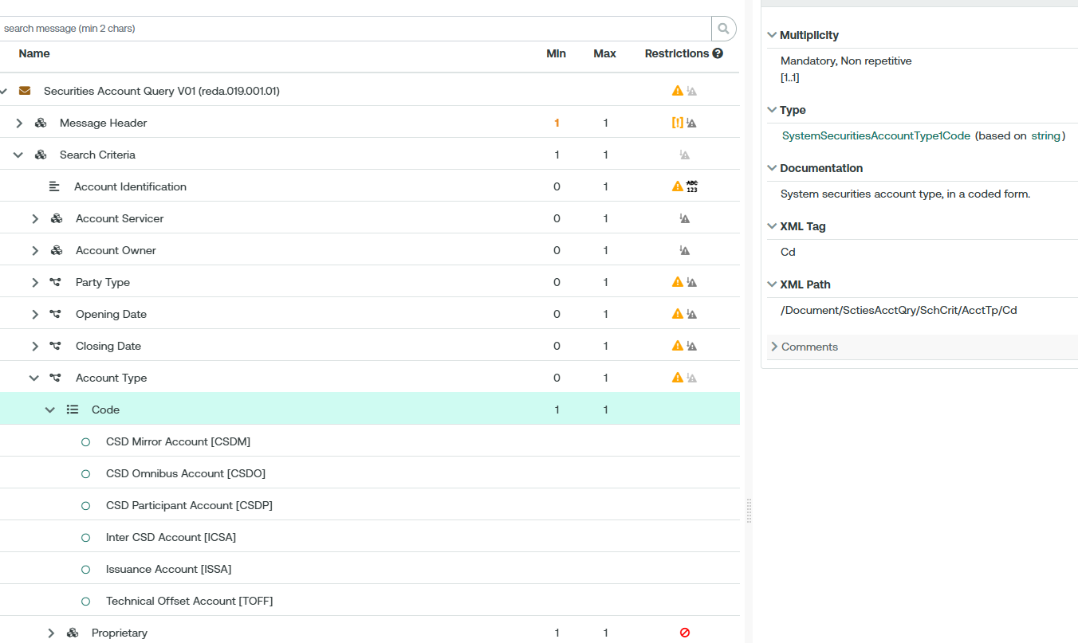

- In the reda.021 message, Data Type for Element /Document/SctiesAcctRpt/RptOrErr/SctiesAcctRpt/SctiesAcctOrErr/SctiesAcct/Tp/Cd should be changed into ExternalSecuritiesAccountType1Code
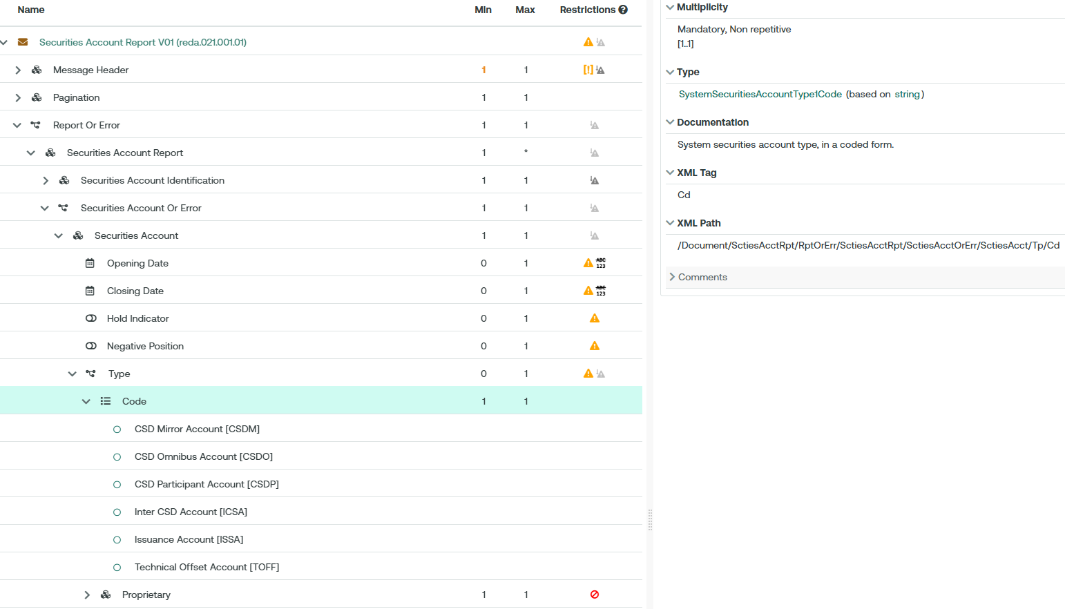
- Purpose of the change:
The usage of the External Code List provides with more flexibility in maintaining the content of the list in line with the workflow adopted by the ISO Registration Authority.

- Urgency of the request:
The Securities SEG is requested to consider this change request for the next maintenance cycle.

- Business examples:
Examples illustrating the change request.

- SEG/TSG recommendation:
This section is not to be taken care of by the submitter of the change request. It will be completed in due time by the SEG(s) in charge of the related ISO 20022 messages or the TSG for changes related to the BAH.

Consider |  |  | Timing
- Next yearly cycle: 2026/2027
(the change will be considered for implementation in the yearly maintenance cycle which starts in 2026 and completes with the publication of new message versions in the spring of 2027)
- At the occasion of the next maintenance of the messages
(the change will be considered for implementation, but does not justify maintenance of the messages in its own right – will be pending until more critical change requests are received for the messages)
- Urgent unscheduled
(the change justifies an urgent implementation outside of the normal yearly cycle)
 |  |  | - Other timing:
Comments:

Reject
Reason for rejection:

