Change Request
for the update of ISO 20022 financial repository items
Note: the purpose of this document is to give guidelines to parties who want to introduce a request to change an existing ISO 20022 message(s), or update other items of the ISO 20022 financial repository. Such change requests are subject to the approval of the ISO 20022 Standards Evaluation Group(s) in charge of the related message/item or to the approval of the Technical Support Group (TSG), if the requested change relates to the Business Application Header (BAH). Please consult the iso20022.org website for additional details on the maintenance process. Change requests are to be sent to iso20022ra@iso20022.org. All change requests conforming to this template received by June 1st will be considered for development in the following yearly ISO 20022 maintenance cycle which completes with publication of new message versions in April/May of the following year.
- Origin of the request:
A.1 Submitter: Banque de France on behalf of the Eurosystem / 4CB
A.2 Contact person:
- Ons Jraied Ons, Ons.JRAIED.external@banque-france.fr
- Ronnie Stal, ronnie.stal@banque-France.fr
- t2s-fam@bundesbank.de
A.3 Sponsors: SWIFT (Karine TAQUET)

- Related messages:
Impacted messages:
semt.026 Securities Settlement Transaction Query
semt.027 Securities Settlement Transaction Query Response

- Description of the change request:
In the context of T+1 (shorten the settlement cycle in the EU from two days (so‑called “T+2”) to one day (“T+1”)), a new ISO CR (CR-003189) introduced a structured indicator to flag settlement instructions that must be automatically held until a specific point in time on the requested settlement day (gating event), at which the Securities Financing instructions will be automatically released.
The requester was SMPG, with the support of Swift Standards.
A new code <Cd>GATE</Cd> was added in the element <SttlmTxCond> – Settlement Transaction Condition:
GATE, standing for ‘Gating Event participation’.

A series of messages were impacted but T2S registered messages semt.026 and semt.027 were not included as both messages were undergoing registration.
This ISO CR is requesting to add the equivalent ISO 20022 element to represent the Gating Event condition code also in T2S registered messages semt.026 and semt.027.
In this regard, two changes seem necessary to make the schema of semt.026 and semt.027 registered messages compliant with the ones already updated regarding the Gating event condition code:
- Removal of element <SctiesTxCond> from T2S semt.026 registered message
For harmonization purposes, the element Securities Transaction Condition - <SctiesTxCond> need to be replaced with the element Settlement Transaction Condition - <SttlmTxCond> and all its nested element (<Cd> and <Prtry>). As a result, the element <SctiesTxCond> is removed and all its nested elements (<Cd> and <Prtry>). New XML path is /Document/SctiesSttlmTxQry/QryDef/SchCrit/SttlmTxCond

Element | Old XML-Path | New XML-Path
Settlement Transaction Condition | /Document/SctiesSttlmTxQry/QryDef/SchCrit/SctiesTxCond | /Document/SctiesSttlmTxQry/QryDef/SchCrit/SttlmTxCond
Code | /Document/SctiesSttlmTxQry/QryDef/SchCrit/SctiesTxCond/Cd | /Document/SctiesSttlmTxQry/QryDef/SchCrit/SttlmTxCond/Cd
Proprietary | /Document/SctiesSttlmTxQry/QryDef/SchCrit/SctiesTxCond/Prtry | /Document/SctiesSttlmTxQry/QryDef/SchCrit/SttlmTxCond/Prtry

  - SettlementTransactionCondition <SttlmTxCond>

Message Element <XML Tag> | Mult. | Data Type
Settlement Transaction Condition <SttlmTxCond> | [0..*] | SettlementTransactionCondition41Choice  is_choice: true
- Presence: [0..*]
- Definition: Indicates the conditions under which the order/trade is to be executed.
SettlementTransactionCondition <SttlmTxCond> contains one of the following elements

Or | Message Element <XML Tag> | Mult. | Data Type
{Or | Code <Cd> | [1..1] | SettlementTransactionCondition16Code
Or} | Proprietary <Prtry> | [1..1] | GenericIdentification30  is_choice: false

    - Code <Cd>
- Presence: [1..1]
- Definition: Settlement conditions expressed as an ISO 20022 code.
- Datatype: “SettlementTransactionCondition16Code”

Code | Value | Definition
ADEA | Accept After Regular Settlement Deadline | Settlement is on a bilaterally accepted  transaction that is to be accepted  beyond the regular settlement deadline.
ASGN | Assignement | Transfer of ownership of the asset to  another party during the closing of an  option.
BUTC | Buy to Cover | Transaction is a buy to cover.
CLEN | Clean | Tax-exempt financial instruments are to  be settled.
DLWM | Delivery Without Matching | Matching receipt instruction not required  (only for concerned international or  national central securities depositories).
DIRT | Dirty | Taxable financial instruments are to be  settled.
DRAW | Drawn | Settlement transactions relate to drawn  securities.
EXER | Exercised | Settlement transaction relates to options,  futures or derivatives that are exercised.
EXPI | Expired | Settlement transaction relates to options,  futures or derivatives that have expired.
FRCL | Free Clean Settlement | Delivery will be made free of payment  but a clean payment order will be sent.
GATE | Gating Event Participation | Gating event participation. Hold until event start time.
INTS | Internalised Settlement | The instruction was settled by the  settlement internaliser/account servicer  (eg custodian) in its own books and not  through a securities settlement system  (e.g. CSD system)
KNOC | Knocked Out | Settlement transaction relates to options,  futures or derivatives that are expired  worthless.
NOMC | No Automatic Market Claim | No market claim should be automatically  generated.
NACT | Not Accounting Related | Security transaction is not for  accounting.
BPSS | Partial Successful Buy In | Identification of settlement instructions  created as a result of a partial successful  buy-in.
PENS | Pending Sale | Position to cover the pending sale will be  available by contractual settlement date  (accounting information).
PHYS | Physical | Securities are to be physically settled.
RHYP | Rehypothecation | Collateral position is available for other  purposes (for example, onwards  delivery).
RPTO | Reporting | Relates to a transaction that is for  reporting purposes only.
RESI | Residual | Relates to transaction on a security that  is not eligible at the Central Security  Depository (CSD) but for which the  payment will be enacted by the central  securities depository.
SHOR | ShortSell | Account is used for short sale orders.
SPDL | Special Delivery | Settlement transactions to be settled  with special delivery.
SPST | Split Settlement | Money and financial instruments settle in  different locations.
TRAN | Transformation | Transaction resulting from a  transformation.
TRIP | Triparty Segregation | Securities are not be delivered but  segregated following triparty collateral  transaction.
UNEX | Unexposed | Delivery cannot be performed until  money is received.

    - Proprietary <Prtry>
- Presence: [1..1]
- Definition: Settlement conditions expressed as a proprietary code.
- Datatype: “GenericIdentification30”
Proprietary <Prtry> contains the following elements:

Or | Message Element <XML Tag> | Mult. | Data Type | Definition
 | Identification <Id> | [1..1] | Exact4AlphaNumericText | Proprietary information, often a code, issued by the data source scheme issuer.
 | Issuer <Issr> | [1..1] | Max4AlphaNumericText | Entity that assigns the identification.
 | SchemeName <SchmeNm> | [0..1] | Max4AlphaNumericText | Short textual description of the scheme.

- Inclusion of the Gating event condition code <Cd>GATE</Cd> in T2S semt.027 registered message

- XML - Path : /Document/SctiesSttlmTxQryRspn/Txs/Tx/TxDtls/SttlmParams/SttlmTxCond/Cd
- Message Element <XML Tag> : Code <Cd>
- Datatype: “SettlementTransactionCondition16Code”
New code [GATE] within the CodeSet list:
Code | Value | Definition
GATE | Gating Event Participation | Gating event participation. Hold until event start time.

- Purpose of the change:
The inclusion of the Gating event condition code <Cd>GATE</Cd> – Gating Event participation within element <SttlmTxCond> - Settlement Transaction Condition in semt.026 and semt.027 registered messages aligns the messages with the ones already updated regarding the Gating event condition code and ensures that the registered messages can be used by the market as expected. In this regard, two changes seem necessary:

- Urgency of the request:
We request the securities SEG to consider this change request for the next maintenance cycle (2026/2027). It may allow the semt.026 and semt.027 schema compliant.

- Business examples:
The Securities Settlement Transaction Query message (semt.026) allows Central Securities Depositories or directly connected T2S participants acting as the instruction party to query all settlement instructions satisfying a set of criteria and which covers several message usages depending on the type of query:
- Settlement Instruction Query (corresponding query type - 'Instruction').
- Settlement Instruction Current Status Query (corresponding query type - 'Status').
- Settlement Instruction Status Audit Trail Query (corresponding query type - 'Status Period').
The Settlement Infrastructure/Executing party will return in response to the Securities Settlement Transaction Query message (semt.026) the Securities Settlement Transaction Query Response via semt.027 providing all current attributes and latest statuses for all settlement instructions as selected in the search criteria defined in the query message.

Communication flow
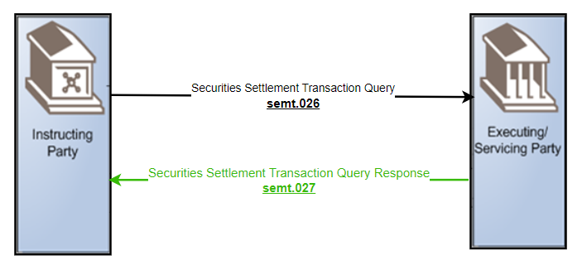

Examples illustrating the change request
Semt.026 - Query Type Example: Settlement Instruction Current Status QuerySettlement Instruction Current Status Query
In this example a Direct Connected Participant (DCP) sends to the Settlement Infrastructure Platform a Settlement Instruction Current Status Query requesting all settlement instructions for securities account ‘1000000123’ where the settlement status is pending awaiting a gating event on business date 05-05-2026.
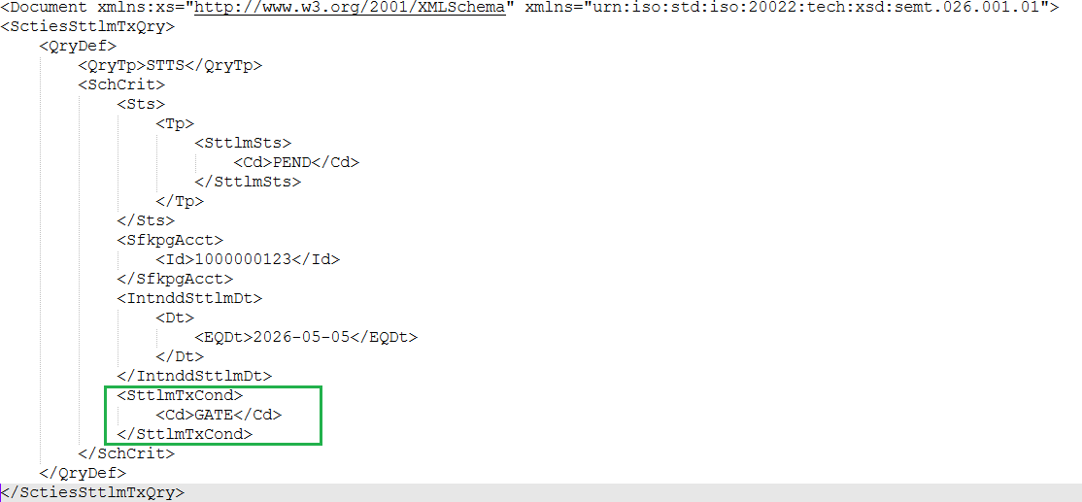

Semt.027 - Query Response Example: Settlement Instruction Current Status Query Response
In this example the Settlement Infrastructure Platform sends a Settlement Instruction Current Status Query Response containing one instruction matching the query criteria which querying all pending settlement instructions awaiting a gating event on business date 05-05-2026 where the securities account is ‘1000000123’.

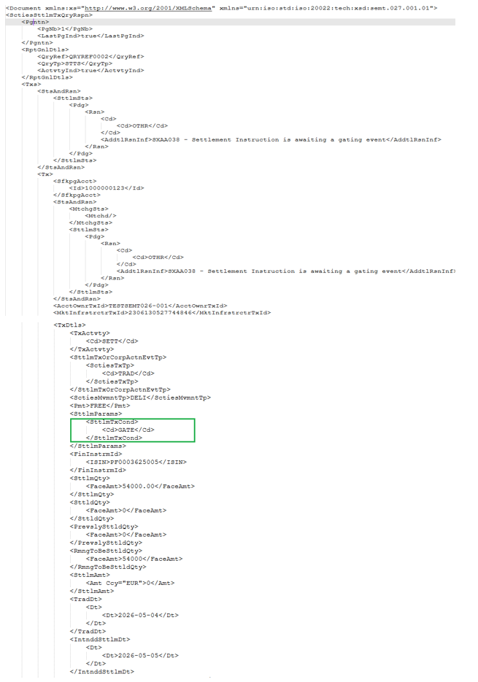
- SEG/TSG recommendation:
This section is not to be taken care of by the submitter of the change request. It will be completed in due time by the SEG(s) in charge of the related ISO 20022 messages or the TSG for changes related to the BAH.

Consider |  |  | Timing
 |  |  | - Next yearly cycle: 2026/2027  (the change will be considered for implementation in the yearly maintenance cycle which starts in 2026 and completes with the publication of new message versions in the spring of 2027) |  | x
- At the occasion of the next maintenance of the messages
(the change will be considered for implementation, but does not justify maintenance of the messages in its own right – will be pending until more critical change requests are received for the messages)
- Urgent unscheduled
(the change justifies an urgent implementation outside of the normal yearly cycle)
 |  |  | - Other timing:
Comments:

Reject
Reason for rejection:

