Change Request
for the update of ISO 20022 financial repository items

Note: the purpose of this document is to give guidelines to parties who want to introduce a request to change an existing ISO 20022 message(s), or update other items of the ISO 20022 financial repository. Such change requests are subject to the approval of the ISO 20022 Standards Evaluation Group(s) in charge of the related message/item or to the approval of the Technical Support Group (TSG), if the requested change relates to the Business Application Header (BAH). Please consult the iso20022.org website for additional details on the maintenance process. Change requests are to be sent to iso20022ra@iso20022.org. All change requests conforming to this template received by June 1st will be considered for development in the following yearly ISO 20022 maintenance cycle which completes with publication of new message versions in April/May of the following year.

A. Origin of the request:
A.1 Submitter: Eurobonds market / XS NMPG
A.2 Contact person: Hatem Soliman (hatem.soliman@euroclear.com, +32 2 326 5107)
A.3 Sponsors: ICSDs

B. Related messages:
seev.001.001.12 (Meeting Notification)
seev.004.001.11 (Meeting Instruction)

C. Description of the change request:
In the seev.001 meeting notification message,
- In message building block Meeting, add a new optional and non-repetitive element “Cumulative Voting Indicator”, typed by a YesNoIndicator, to indicate that cumulative voting is applicable to specific resolution(s).
XML path </Document/MtgNtfctn/ Cumulative Voting Indicator >
Definition: “Indicates if a cumulative voting applies to one or more resolution.”
- In message building block Resolution, add a new optional and non-repetitive element “Cumulative Voting Multiplier”, to indicate the multiplier to be applied to the resolution eligible to cumulative voting.
XML path < /Document/MtgNtfctn/Rsltn/CumVoteMultiplier>
Definition: “Multiplier to be applied on the eligible balance to determine the maximum number of votes accepted on resolutions flagged for cumulative voting”).
The element shall be defined using a numeric datatype constrained to integer values (fractionDigits = 0) with a minimum value of 1 (Min inclusive: 1).
- In message building block Resolution, add a new optional and repetitive (0….1000) element “Subresolution”, typed by Max35Text, to list the subresolutions where the cumulative voting and the multiplier to be applied to.
XML path < /Document/MtgNtfctn/Rsltn/subRsltn>
Definition: “list of the sub-resolutions where the cumulative voting and the multiplier to be applied to”
In the seev.004 meeting instruction message,

- In message building block Instruction, within message component “Vote Details/VoteInstructionForAgendaResolution/VotePerAgendaResolution/VoteInstruction/Subresolution”, add a new optional and repetitive (0….1000) element “Subresolution”, typed by Max35Text, to list the subresolutions where the cumulative voting and the multiplier to be applied to.
XML path </Document/MtgInstr/Instr/VoteDtls/VoteInstrForAgndRsltn/VotePerAgndRsltn/VoteInstr//subRsltn)
Definition: same as defined above under (3).
- Add 2 cross-element rules::
- If the Cumulative voting flag = Y, then there must be a least one CumVoteMultiplier.
- If a CumulativeVotingMultiplier is present, then the CumulativeVotingIndicator must be equal to “true”.
D. Purpose of the change:
There are meeting events for which cumulative voting applies for specific resolution(s).
It means that for a number of resolutions for a meeting event, clients can vote for an amount of the eligible balance multiplied by the number of sub-resolutions for which cumulative voting applies.
The sum of the votes by the client for the applicable sub-resolutions should not exceed the eligible balance multiplied by the number of sub-resolutions with cumulative voting.
It must be possible to announce the multiplier when cumulative voting applies to specific sub-resolution(s) as decided by the issuer.
The account servicer receiving a meeting instruction will compare the instruction quantity with the position multiplied by the “cumulative voting multiplier” to either accept (“PACK”), reject (“rejected/LACK”) or keep instruction recycling (“pending/LACK”). (Rejecting or keeping instruction pending to be decided based on account servicer SLA, as for other meeting instructions). There is no need to define a new reason for this specific case.
E. Urgency of the request:
SR2027
Note: the ISO 20022 maintenance results in the publication of a new version of an ISO 20022 message. The actual implementation of such new version on networks and in user installations is not within the purview of ISO.
F. Business examples:
Around 40 meeting events with cumulative voting announced over the last 6 months, mainly on EURO instruments, Finnish, HK and US markets (mainly for depository receipts).
Example 1:
CUMULATIVE VOTING APPLIES TO RESOLUTION 4
2 DIRECTORS ARE TO BE ELECTED TO THE BOARD.
TO INSTRUCT, MULTIPLY YOUR ELIGIBLE POSITION BY THE NUMBER OF
DIRECTORS TO BE ELECTED. IF YOU WANT TO SPLIT YOUR VOTE, ASSIGN
AN AMOUNT TO EACH DIRECTOR UNTIL YOUR TOTAL CUMULATED POSITION IS ACCOUNTED FOR.
FOR EXAMPLE, IF YOU HAVE 10 ADRS ON RECORD DATE, YOU ARE ENTITLED
TO VOTE ON 2 (NUMBER OF NOMINATED DIRECTORS) X 10, EQUALLING 20
VOTES TO DISTRIBUTE AMONG THE NUMBER OF PROPOSED DIRECTORS.

Example 2:
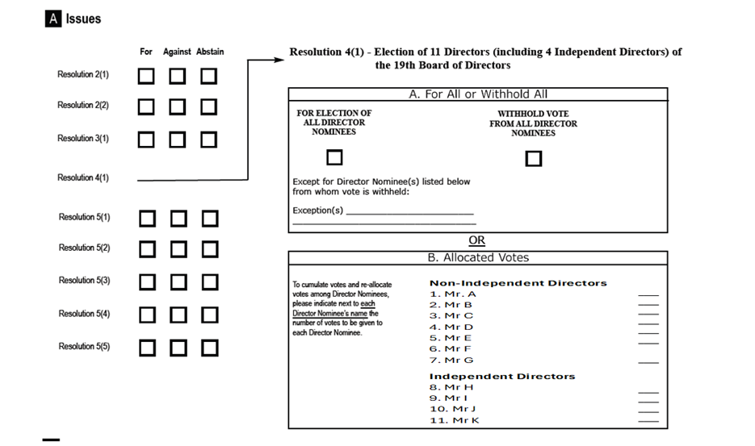
The notification should have the below structure for resolution 4
For resolution 4, you can either instruct on resolution 4.a. or 4.b. and 4.c.
Resolution 4.a.: you have the option to vote for all Director nominees or withhold vote for all Director nominees with possibility to note exceptions.

Resolution 4.b.
CUMULATIVE VOTING APPLIES TO RESOLUTION 4.b.
7 NON-INDEPENDENT DIRECTORS ARE TO BE ELECTED TO THE BOARD (7 sub-resolutions).
TO INSTRUCT, MULTIPLY YOUR ELIGIBLE POSITION BY THE NUMBER OF NON-INDEPENDENT DIRECTORS (sub-resolutions) TO BE ELECTED.
IF YOU WANT TO SPLIT YOUR VOTE, ASSIGN AN AMOUNT TO EACH DIRECTOR UNTIL YOUR TOTAL CUMULATED POSITION IS ACCOUNTER FOR.
FOR EXAMPLE, IF YOU HAVE 10 ADRS ON RECORD DATE, YOU ARE ENTITLED
TO VOTE ON 7 (NUMBER OF NOMINATED NON-INDEPENDENT DIRECTORS) X 10, EQUALLING 70
VOTES TO DISTRIBUTE AMONG THE NUMBER OF PROPOSED NON-INDEPENDENT DIRECTORS.

Resolution 4.C.
CUMULATIVE VOTING APPLIES TO RESOLUTION 4.c.
4 INDEPENDENT DIRECTORS (sub-resolutions) ARE TO BE ELECTED TO THE BOARD.
TO INSTRUCT, MULTIPLY YOUR ELIGIBLE POSITION BY THE NUMBER OF
INDEPENDENT DIRECTORS (sub-resolutions) TO BE ELECTED. IF YOU WANT TO SPLIT YOUR VOTE, ASSIGN
AN AMOUNT TO EACH DIRECTOR UNTIL YOUR TOTAL CUMULATED POSITION IS ACCOUNTED FOR.
FOR EXAMPLE, IF YOU HAVE 10 ADRS ON RECORD DATE, YOU ARE ENTITLED
TO VOTE ON 4 (NUMBER OF NOMINATED INDEPENDENT DIRECTORS) X 10, EQUALLING 40
VOTES TO DISTRIBUTE AMONG THE NUMBER OF PROPOSED INDEPENDENT DIRECTORS.

At Meeting level:
- Document/MtgNtfctn/ Cumulative Voting Indicator – CumulativeVotingIndicator - (YesNoIndicator) [0..1] — indicates that cumulative voting applies to one or more resolutions.

At Resolution level:
- /Document/MtgNtfctn/Rsltn – Resolution 4.b.
- /Document/MtgNtfctn/Rsltn/IssrLabl – Issuer Label – Non-Independent Directors
- /Document/MtgNtfctn/Rsltn/ListgGrpRsltnLabl – Listing Group Resolution Label - Identifies under the same label a group of agenda resolutions for which a vote in favour can be assigned to only one, more or all resolutions of that group.
- Document/MtgNtfctn/Rsltn/CumVoteMultiplier - Cumulative Voting Multiplier - (Number / integer ≥ 1) [0..1] = 7

- /Document/MtgNtfctn/Rsltn/subRsltn – “Sub-Resolution 4.b.1 – Mr. A”
- /Document/MtgNtfctn/Rsltn/subRsltn – “Sub-Resolution 4.b.2 – Mr. B”
- /Document/MtgNtfctn/Rsltn/subRsltn – “Sub-Resolution 4.b.3 – Mr. C”
- /Document/MtgNtfctn/Rsltn/subRsltn – ”Sub-Resolution 4.b.4 – Mr. D”
- /Document/MtgNtfctn/Rsltn/subRsltn – ”Sub-Resolution 4.b.5 – Mr. E”
- /Document/MtgNtfctn/Rsltn/subRsltn – ”Sub-Resolution 4.b.6 – Mr. F”
- /Document/MtgNtfctn/Rsltn/subRsltn – ”Sub-Resolution 4.b.7 – Mr. G”

- /Document/MtgNtfctn/Rsltn – Resolution 4.c.
- /Document/MtgNtfctn/Rsltn/IssrLabl – Issuer Label – Independent Directors
- /Document/MtgNtfctn/Rsltn/ListgGrpRsltnLabl – Listing Group Resolution Label - Identifies under the same label a group of agenda resolutions for which a vote in favour can be assigned to only one, more or all resolutions of that group.
- Document/MtgNtfctn/Rsltn/CumVoteMultiplier - Cumulative Voting Multiplier - (Number / integer ≥ 1) [0..1] = 4

- /Document/MtgNtfctn/Rsltn/subRsltn – ”Sub-Resolution 4.c.1 – Mr. H”
- /Document/MtgNtfctn/Rsltn/subRsltn – ”Sub-Resolution 4.c.2 – Mr. K”
- /Document/MtgNtfctn/Rsltn/subRsltn – ”Sub-Resolution 4.c.3 – Mr. L”
- /Document/MtgNtfctn/Rsltn/subRsltn – ”Sub-Resolution 4.c.4 – Mr. M”

Note: the ISO 20022 maintenance results in the publication of a new version of an ISO 20022 message. The actual implementation of such new version on networks and in user installations is not within the purview of ISO.
- SEG/TSG recommendation:
This section is not to be taken care of by the submitter of the change request. It will be completed in due time by the SEG(s) in charge of the related ISO 20022 messages or the TSG for changes related to the BAH.

Consider |  |  | Timing
- Next yearly cycle: 2026/2027
(the change will be considered for implementation in the yearly maintenance cycle which starts in 2026 and completes with the publication of new message versions in the spring of 2027)
- At the occasion of the next maintenance of the messages
(the change will be considered for implementation, but does not justify maintenance of the messages in its own right – will be pending until more critical change requests are received for the messages)
- Urgent unscheduled
(the change justifies an urgent implementation outside of the normal yearly cycle)
 |  |  | - Other timing:
Comments:

Reject
Reason for rejection:

