Change Request
for the update of ISO 20022 financial repository items
Note: the purpose of this document is to give guidelines to parties who want to introduce a request to change an existing ISO 20022 message(s) or update other items of the ISO 20022 financial repository. Such change requests are subject to the approval of the ISO 20022 Standards Evaluation Group(s) in charge of the related message/item or to the approval of the Technical Support Group (TSG), if the requested change relates to the Business Application Header (BAH). Please consult the iso20022.org website for additional details on the maintenance process. Change requests are to be submitted using the electronic form here: Maintenance of ISO 20022 message definitions request | ISO20022. All change requests conforming to this template received by June 1st will be considered for development in the following yearly ISO 20022 maintenance cycle which completes with publication of new message versions in April/May of the following year.
- Origin of the request:
A.1 Submitter: Tempo Labs Inc, with input from Swift, Standard Chartered, and ANZ.
A.2 Contact person: Ninad Nirgudkar (ninad@tempo.xyz), Jevgenijs Kazanins (jev@tempo.xyz).
A.3 Sponsors:
- Related messages:
The affiliated parties have identified the following non-comprehensive set of messages that may be relevant for the business purpose of this change request. Should this change request be approved the affiliated parties recognize and expect that additional messages may be in scope and/or the following messages may not be in scope when upgrading the ISO20022 data model.

Payments, Clearing and Settlement:
pacs.002.001.13 | FIToFIPaymentStatusReportV13
pacs.008.001.11 | FIToFICustomerCreditTransferV11
pacs.009.001.10 | FinancialInstitutionCreditTransferV10

Bank-to-Customer Cash Management:
camt.052.001.11 | BankToCustomerAccountReportV11
camt.053.001.11 | BankToCustomerStatementV11
camt.054.001.11 | BankToCustomerDebitCreditNotificationV11

Payments Initiation:
pain.001.001.11 | CustomerCreditTransferInitiationV11
pain.002.001.13 | CustomerPaymentStatusReportV13

- Description of the change request:
Institutional on-chain settlement may support various digital asset architectures and settlement assets in the future. The use of ISO 20022 payments messages to support such arrangements is considered critically important to facilitate standardization and institutional adoption. Privately issued money (e.g. tokenized deposits and stablecoins), and tokenized public money (e.g., central bank digital currencies) are expected to co-exist and serve a range of use cases.
This change request specifically focuses on addressing the immediate market requirements for stablecoin-based settlement given perceived current gaps. It also aims to serve as a catalyst for establishing broader industry efforts to drive the adoption and development of standards for tokenized money.

This change enables ISO 20022 payment messages to describe an institutional settlement leg effected on a public permissionless, public permissioned, or private distributed ledger using a stablecoin (herein defined as a digital token that maintains a stable value via peg to underlying high-quality liquid asset reserves held one to one under an appropriate regulatory regime).
It describes in-scope scenarios, the data elements relevant for stablecoin settlement, and a non-comprehensive assessment of in-scope messages.
In-Scope Scenarios
- Account-to-account (A2A, the 'sandwich' pattern): customer instructs a fiat payment with its sending bank; sending and receiving institutions settle on-chain in a stablecoin; receiving bank credits the beneficiary in fiat.
- Wallet-to-wallet (W2W): customer instructs a stablecoin payment; sending and receiving institutions settle in the same stablecoin on the same chain; beneficiary is credited in the same stablecoin. No fiat conversion at any leg. Consequently, the traditional Interbank Settlement Amount block is entirely omitted from the message lifecycle in this scenario.
- Hybrid account-to-wallet or wallet-to-account (A2W / W2A): one customer-facing leg is fiat and the other is the same stablecoin used for institutional settlement.
Standard Set of Information Added
The additions below form a standard set of information for describing a stablecoin settlement leg in ISO 20022 payment messages. They fall into four groups, and the relevant affected messages may carry to subset relevant to their role in the final update to the ISO20022 data model.
Sender and Recipient Wallet Addresses
- Address (the on-chain wallet address; variable-length text, supporting hex / base58 / base64 encodings).
- Wallet Identification may sit on either PartyIdentification (for Debtor / Creditor when the wallet is held by, or on behalf of, those parties) or BranchAndFinancialInstitutionIdentification (for the originating or receiving Agent when the institution holds the wallet on its own balance sheet). Placement is determined by the scenario.
- Chain context: the chain on which the wallet operates is identified via Chain Identification in the Chain Information component (see below).

Chain Information
A new component carrying chain and token metadata for the on-chain settlement leg.
- Chain Identification (the chain on which settlement occurs; registered DLT identifier where available, or proprietary).
- Digital Token Identifier (DTI per ISO 24165, where available). Where DTI is populated, it is the canonical identifier of the token used for settlement; Smart Contract Address and Chain Identification remain populated as supplementary identifiers.
- Issuer Identification. The Legal Entity Identifier (LEI) of the legal entity issuing the token used for settlement (the issuer entity), or a proprietary identifier where no LEI is available. With optional sub-fields:
  - Attestation Identification (optional; reference to issuer attestation: reserves, redemption rights, supervisory licensing).
  - Regulatory Supervision Status (optional; jurisdiction tag identifying the supervisory regime under which the token used for settlement is issued; taxonomy to be defined by the SEG).
- Token Standard (token interface specification, e.g. TIP-20 or ERC-20).
- Smart Contract Address (token contract address on the identified chain).

Fees
- Maximum Fee Amount (a cap on the on-chain gas fee the originator will accept; distinct from existing ChargesInformation / ChargeAmount semantics).
- Fee Currency Identification (the unit in which the fee is paid; choice between an ISO 4217 currency code and a Digital Token Identifier per ISO 24165, to support both chain-native and fiat-pegged gas).

Settlement, Acceptance, and Status
- Settlement Method extended with a new code (proposed 4-char code ONCH) to indicate on-chain settlement.
- Interbank Settlement Amount Modification: Propose modifying the core ISO 20022 message schema constraints to make the traditional Interbank Settlement Amount (denominated in ISO 4217 currencies) an optional field only when the Settlement Method is set to ONCH.
- On-Chain Mandatory Rule: Where Settlement Method = ONCH and the existing Interbank Settlement Amount is omitted from a message instance, the On-Chain Settlement Amount and the canonical Digital Token Identifier within the Chain Information component MUST be treated as mandatory elements to ensure message schema and data validation integrity.
- Instructed Amount Alignment: For consistency across pure digital asset flows (such as the Wallet-to-Wallet scenario), propose that the core message schemas modify the customer-facing Instructed Amount currency block to uniquely utilize the Digital Token Identifier (DTI per ISO 24165) instead of an ISO 4217 currency code, or allow it to be completely bypassed in favor of the On-Chain Settlement Amount to prevent schema validation failures at customer inception.
- Reporting Amount Alignment: To ensure accurate reporting of on-chain balances and transaction entries, propose modifying the core cash management message schemas to expand all relevant currency/amount components to accept the canonical Digital Token Identifier (DTI per ISO 24165) alongside or instead of existing ISO 4217 currency codes, eliminating schema validation rejections for ledger native postings.
- On-Chain Settlement Amount (new amount element denominated in the token used for settlement).
- On-Chain Transaction Reference (new component carrying the settlement Transaction Hash; populated on inclusion; carried at the relevant transaction-level placement to be confirmed by the SEG).
- Finality Status, Confirmation Count, and Expected Finality Duration — for status reporting messages.
- FEEX (fee-breach) reason code, carried in existing notification messages. Behavior: where the executed on-chain fee would exceed the Maximum Fee Amount stated in the originating instruction, the originating institution rejects the instruction in pre-flight (before any on-chain submission). In this case the on-chain transaction does not proceed and no funds move.
Description of Message Change
Each affected message carries the relevant subset of the standard information above. Final element placement and data types to be confirmed by the SEG.
- Initiation Messages (e.g., pain001) – will carry or reference digital asset information such as sender/recipient wallet address, Chain Information, Settlement Method (ONCH), On-Chain Settlement Amount
- Clearing & Settlement Messages (e.g., pacs.008, pacs.009, pacs.002): will have the same information propagated from the initiation message (if customer originated) or included by the initiating bank directly. Because the bank-to-bank leg utilizes on-chain stablecoin settlement across all in-scope scenarios, these clearing messages will universally apply the modified schema constraints when Settlement Method = ONCH. This allows the omission or bypass of the existing, fiat-restricted Interbank Settlement Amount element in favor of mandating the On-Chain Settlement Amount and Digital Token Identifier (DTI) to represent the true interbank movement.
- Bank to Customer Cash Management (e.g., camt.052, camt.053, camt.054): Will confirm successful settlement and carry the On-Chain Transaction Reference (with Transaction Hash) so customers can independently reference transactions on-chain. To support this functionality, the amount fields inside these reporting messages will utilize the modified schema constraints to cleanly accept the DTI standard for on-chain balances and posting entries.
Scope Notes
The initial scope of this change request is limited to business scenarios that are observed or expected to be observed in the market today. However, these proposed data element updates to the ISO20022 data model are likely to be fit for future use cases not contemplated here.
- Same-chain, same-token transfers only. Cross-chain bridging is deferred to a future cycle.
- Foreign exchange and cross-token conversion at the institutional settlement leg are out of scope. Fiat-to-token and token-to-fiat conversion at the customer-facing legs is handled by the originating or receiving institution outside the scope of these messages.
- If a token is classified as a security, under appropriate regulatory regimes, rather than a payment instrument, the transaction routes to the ISO 20022 securities-domain messages and is out of scope here. The Regulatory Supervision Status field signals this classification but does not determine it.
- Finality Status = FINL indicates the receiving institution's determination that the transaction is sufficiently confirmed for settlement purposes under its own policies. On chains with probabilistic finality, chain reorganisation that may invalidate a previously reported FINL is out of scope for this change request.
- Element design is neutral on settlement pattern.
All new elements are optional. Existing message instances that do not use Settlement Method = ONCH are unaffected.
- Purpose of the change:
The current ISO 20022 payments message suite cannot describe payments where the institutional settlement leg is affected on a public or permissioned distributed ledger using a stablecoin. Concretely, today's messages may not have the appropriate fields to identify fields relating to sender/recipient wallet addresses, chain and token information, fee information, and/or have the appropriate data fields to identify onchain settlement.
Institutions are seeing demand for stablecoin-settled cross-border payments from three distinct corporate profiles, each with materially different relationship and counterparty dynamics:
- Stablecoin-native corporates that hold treasury and conduct commercial activity in stablecoins; the wallet-to-wallet scenario is dominant in their flow.
- Fiat-only corporates that hold and settle exclusively in fiat but instruct their banks to use stablecoin settlement to achieve faster or cheaper cross-border outcomes; the A2A sandwich scenario is dominant in their flow.
- Hybrid corporates that hold treasury in a mix of fiat and stablecoins and settle in whichever asset suits the counterparty; the hybrid A2W / W2A scenarios are dominant in their flow.
- Urgency of the request:
2026/2027 Maintenance Cycle
- Business examples:
Example 1 — Account-to-account sandwich (fiat in, on-chain settlement, fiat out)
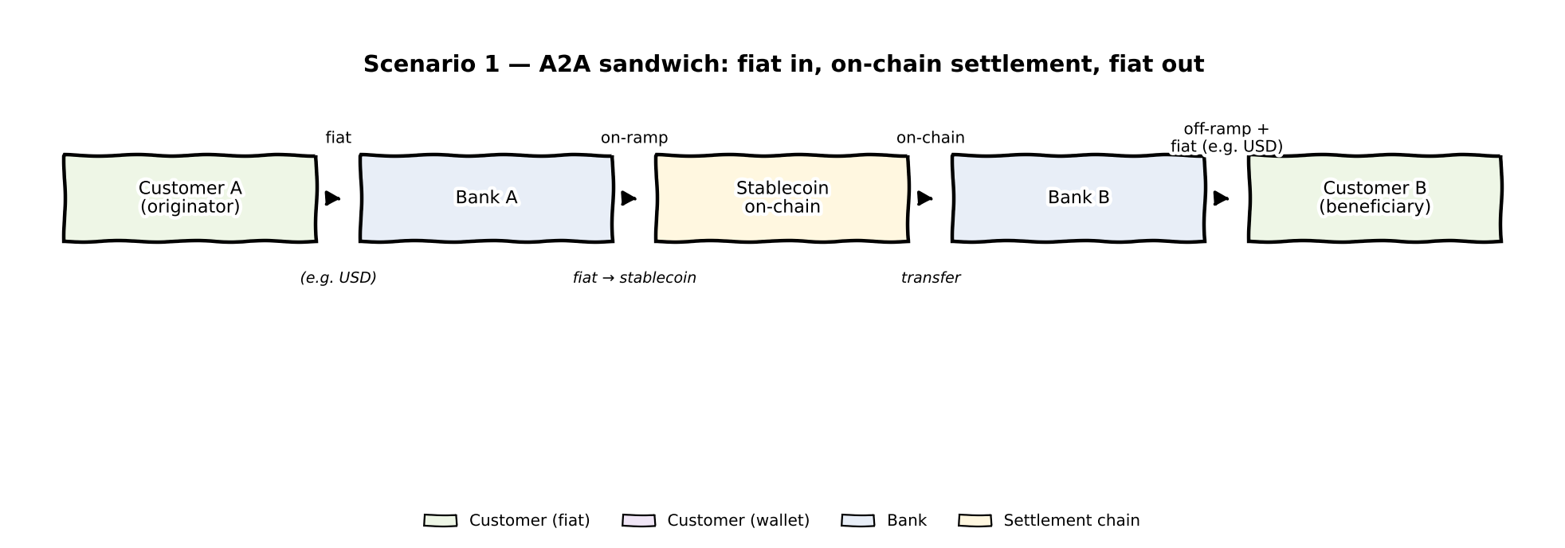
A corporate in the United Kingdom instructs Bank A to pay USD 1,000,000.00 to a counterparty at Bank B in the United States. Bank A acquires a MiCA (Markets in Crypto-Assets Regulation)-supervised USD-denominated stablecoin and settles with Bank B on-chain; Bank B off-ramps to USD and credits the beneficiary.
The messages would identify Settlement Method = ONCH and an On-Chain Settlement Amount denominated in the stablecoin. It is populated as follows:
- Chain Information: Chain Identification, Digital Token Identifier (per ISO 24165 where available), Issuer Identification, Token Standard, Smart Contract Address, Attestation Identification, and Regulatory Supervision Status = MICA.
- Fees: Maximum Fee Amount and Fee Currency Identification.
- Wallet Identification: DebtorAgent (Bank A) and CreditorAgent (Bank B) — the institutional wallets on the settlement chain.
Bank A's clearing and settlement messages carry the same elements. On settlement, the messages would return Finality Status = FINL with the Transaction Hash in the On-Chain Transaction Reference, and camt.054 carries the On-Chain Transaction Reference (with Transaction Hash) and Chain Information so the customer can independently verify the settlement on-chain. If the executed on-chain fee would exceed the stated Maximum Fee Amount, the originating institution rejects in pre-flight: the customer is notified with reason code FEEX, no on-chain transaction is submitted, and no funds move.

Example 2 — Wallet-to-wallet (same stablecoin throughout)
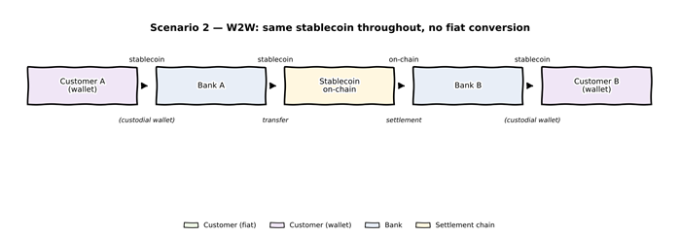
A stablecoin-native corporate instructs Bank A to pay 500,000.00 of a MiCA-supervised USD-denominated stablecoin from its wallet (custodied via Bank A) to its counterparty's wallet (custodied via Bank B). Both customer-facing legs and the institutional settlement leg are denominated in the same stablecoin on the same chain; no fiat conversion occurs.
The message carries Settlement Method = ONCH and an On-Chain Settlement Amount denominated in the stablecoin. The existing Interbank Settlement Amount field is omitted from the message instance, as no traditional fiat currency moves, clears, or requires conversion through this transaction. It is populated as follows:
- Chain Information: Identifies the chain and the token contract, carrying the mandatory canonical Digital Token Identifier (DTI per ISO 24165).
- Fees: Maximum Fee Amount in the chain's gas-fee unit.
- Wallet Identification: Debtor and Creditor — wallets held by the corporates (with Bank A and Bank B providing custodial infrastructure).
Bank A's clearing and settlement messages carry the same elements and effects the on-chain transfer; Upon completion reports Finality Status = FINL with the Transaction Hash; Credit messages references the Transaction Hash and Chain Information.

Example 3 — Hybrid account-to-wallet
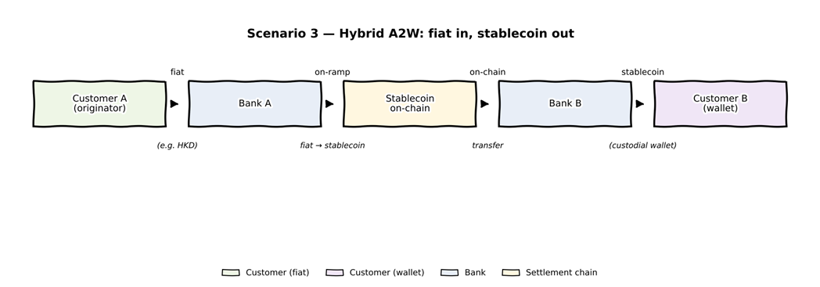
A corporate in Hong Kong instructs Bank A to pay the HKD equivalent of 250,000.00 to a beneficiary holding a custodial wallet at Bank B. The beneficiary receives the equivalent in an HKMA (Hong Kong Monetary Authority)-supervised HKD-denominated stablecoin.
The customer-facing legs are fiat at the sending side and on-chain at the receiving side; the institutional settlement leg is in the same stablecoin throughout. The initiating message carries Settlement Method = ONCH and an On-Chain Settlement Amount in the receiving stablecoin. It is populated as follows:
- Chain Information: Regulatory Supervision Status = HKMA.
- Wallet Identification: DebtorAgent (Bank A's institutional sending wallet) and Creditor (the beneficiary's custodial wallet at Bank B).
The flow is as described Example 1 (with the beneficiary credited in the stablecoin rather than fiat).

- SEG/TSG recommendation:
This section is not to be taken care of by the submitter of the change request. It will be completed in due time by the SEG(s) in charge of the related ISO 20022 messages or the TSG for changes related to the BAH.

Consider |  |  | Timing
- Next yearly cycle: 2026/2027
(the change will be considered for implementation in the yearly maintenance cycle which starts in 2026 and completes with the publication of new message versions in the spring of 2027)
- At the occasion of the next maintenance of the messages
(the change will be considered for implementation, but does not justify maintenance of the messages in its own right – will be pending until more critical change requests are received for the messages)
- Urgent unscheduled
(the change justifies an urgent implementation outside of the normal yearly cycle)
 |  |  | - Other timing:
Comments:

Reject
Reason for rejection:

