Change Request
for the update of ISO 20022 financial repository items
Note: the purpose of this document is to give guidelines to parties who want to introduce a request to change an existing ISO 20022 message(s), or update other items of the ISO 20022 financial repository. Such change requests are subject to the approval of the ISO 20022 Standards Evaluation Group(s) in charge of the related message/item or to the approval of the Technical Support Group (TSG), if the requested change relates to the Business Application Header (BAH). Please consult the iso20022.org website for additional details on the maintenance process. Change requests are to be sent to iso20022ra@iso20022.org. All change requests conforming to this template received by June 1st will be considered for development in the following yearly ISO 20022 maintenance cycle which completes with publication of new message versions in April/May of the following year.
- Origin of the request:

A.1 Submitter:
Banco Central do Brasil (BCB - Central Bank of Brazil)

A.2 Contact person:
Liliane Dutra: liliane.dutra@ipmfglobal.com.br + 55 11 98542-4421
Fernanda Pedroso: fernanda.pedroso@bcb.gov.br +55 61 3414-4975
Edson Seiiti Higuti: edson.higuti@bcb.gov.br +55 11 3491-6585

A.3 Sponsors:
ABNT CEE-112 Brazilian Standards Committee

- Related messages:
The change applies to the element Name <Nm> in the following ISO 20022 Payments messages:
Business Domain Payments, Group Payments Initiation:
pain.001.001.12 ( CustomerCreditTransferInitiationV12 )
pain.002.001.14 ( CustomerPaymentStatusReportV14 )

Business Domain Payments, Group Payments Mandates:
pain.009.001.08 ( MandateInitiationRequestV08 )
pain.010.001.08 ( MandateAmendmentRequestV08 )
pain.011.001.08 ( MandateCancellationRequestV08 )
pain.012.001.08 ( MandateAcceptanceReportV08 )
pain.017.001.04 ( MandateCopyRequestV04 )

Business Domain Payments, Group Creditor Payment Activation Request:
pain.013.001.11 ( CreditorPaymentActivationRequestV11 )
pain.014.001.11 ( CreditorPaymentActivationRequestStatusReportV11 )

Business Domain Payments, Group Payments Clearing and Settlement:
pacs.002.001.15 ( FIToFIPaymentStatusReportV15 )
pacs.004.001.14 ( PaymentReturnV14 )
pacs.008.001.13 ( FIToFICustomerCreditTransferV13 )
pacs.009.001.12 ( FinancialInstitutionCreditTransferV12 )

Business Domain Payments, Group Bank-to-Customer Cash Management:
camt.052.001.13 ( BankToCustomerAccountReportV13 )
camt.053.001.13 ( BankToCustomerStatementV13 )
camt.054.001.13 ( BankToCustomerDebitCreditNotificationV13 )

Business Domain Payments, Group Exceptions & Investigations:
camt.029.001.13 ( ResolutionOfInvestigationV13 )
camt.055.001.12 ( CustomerPaymentCancellationRequestV12 )

- Description of the change request:
Increase the maximum length of the element Name <Nm> from 140 characters to 150 characters by adopting the Max150Text datatype in the pacs, pain and camt messages mentioned in item B.
This change is required to allow official names of Brazilian legal entities to be fully conveyed in ISO 20022 messages when such names exceed 140 characters and contain up to 150 characters, in line with the current length applicable to the official Brazilian registry of legal entities.

- Purpose of the change:
The purpose of this change is to allow the official names of Brazilian legal entities to be fully transported in ISO 20022 messages used in the Brazilian instant payment ecosystem.
In Brazil, legal entities are identified through the National Registry of Legal Entities, known as CNPJ (Cadastro Nacional de Pessoas Jurídicas). The CNPJ is the official national registry of companies and other legal entities in Brazil. It is administered by the Brazilian Federal Revenue Service, known as RFB (Receita Federal do Brasil), which is the Brazilian federal tax authority.
RFB Normative Instruction No. 2119, dated 6 December 2022, introduced a new requirement for the registration of legal entity information, allowing legal entity names to contain up to 150 characters. As a result, systems that rely on the official legal entity name registered in the CNPJ must be able to store, process and transmit that name using the same maximum length.
This requirement affects Pix, the Brazilian instant payment scheme regulated by the Central Bank of Brazil. Pix enables real-time funds transfers between transaction accounts held at different payment service providers. To ensure the correct identification of the parties involved in transactions, certain Pix flows use official registration data maintained by the RFB, including the legal entity name as registered in the CNPJ.
Within the Pix ecosystem, two central infrastructures are relevant to this change request:
- DICT — Transactional Account Identifier Directory: DICT is the central directory for Pix, managed and operated by the Central Bank of Brazil, which stores Pix keys and the data associated with those keys. This data includes the name of the holder of the transaction account linked to the Pix key. When the account holder is a legal entity, the name registered in DICT must match the official name recorded in the CNPJ.
- SPI — Instant Payments System: SPI is the centralised settlement infrastructure for Pix, also managed by the Central Bank of Brazil. It is used to settle Pix transactions between different payment service providers.
In this context, Pix is the payment scheme, DICT supports the identification of transaction account holders through Pix keys, and SPI performs the settlement of transactions between participants in the scheme.
In 2025, additional operational rules were specified to strengthen security and fraud prevention in Pix. These rules require greater consistency between the names used within the Pix ecosystem and the official records maintained by the RFB. For legal entities, this means that the name associated with a Pix key must be filled in exactly as it appears in the CNPJ.
Since the CNPJ now allows legal entity names of up to 150 characters, the current 140-character limit of the ISO 20022 element Name <Nm> may prevent the full transmission of the official name in ISO 20022 messages. When the official name contains between 141 and 150 characters, a field limited to 140 characters may result in truncation and in a mismatch between the data conveyed in the message and the official data registered with the RFB.
This requirement also applies to Automatic Pix, a payment service in which Pix payments are initiated from the payer’s transaction account on the basis of recurring payment instructions received from the payee’s payment service provider, subject to the payer’s prior and specific authorisation.
In flows related to Automatic Pix, payment service providers must use the information contained in the CNPJ, as registered with the RFB, to fill in the identification fields of the payee and the ultimate debtor in payment instructions. Therefore, the pain.009, pain.011, pain.012 e pain.013, used for Automatic Pix, the name fields for the payee and the ultimate debtor must allow the complete legal entity name to be provided exactly as registered in the CNPJ, including when that name contains up to 150 characters.
The same requirement applies to settlement messages used in SPI. The pacs.008 message, used for the settlement of Pix transactions between different payment service providers, must allow the payer’s name to be provided in full, as registered in the CNPJ, when the payer is a legal entity.
Therefore, in order to ensure consistency between the official RFB registry, the data registered in DICT, the Automatic Pix flows and the settlement messages processed in SPI, it is necessary to increase the limit of the relevant name fields from 140 to 150 characters, by adopting the type Max150Text.
This change will allow the official names of Brazilian legal entities to be fully conveyed in the applicable ISO 20022 messages, avoiding truncation and reducing the risk of registration data inconsistencies between the systems involved in the Pix ecosystem.

- Urgency of the request:
We request that this change be considered for the next ISO 20022 yearly maintenance cycle, corresponding to the 2026/2027 cycle.
This change is required to align the ISO 20022 messages used in the Brazilian instant payments ecosystem with the 150-character limit applicable to legal entity names in the official registry maintained by the Brazilian Federal Revenue Service.
Implementation in the 2026/2027 cycle will allow Pix participants to maintain consistency between the official CNPJ data, the records maintained in DICT, the Automatic Pix flows and the settlement messages processed in SPI.
- Business examples:
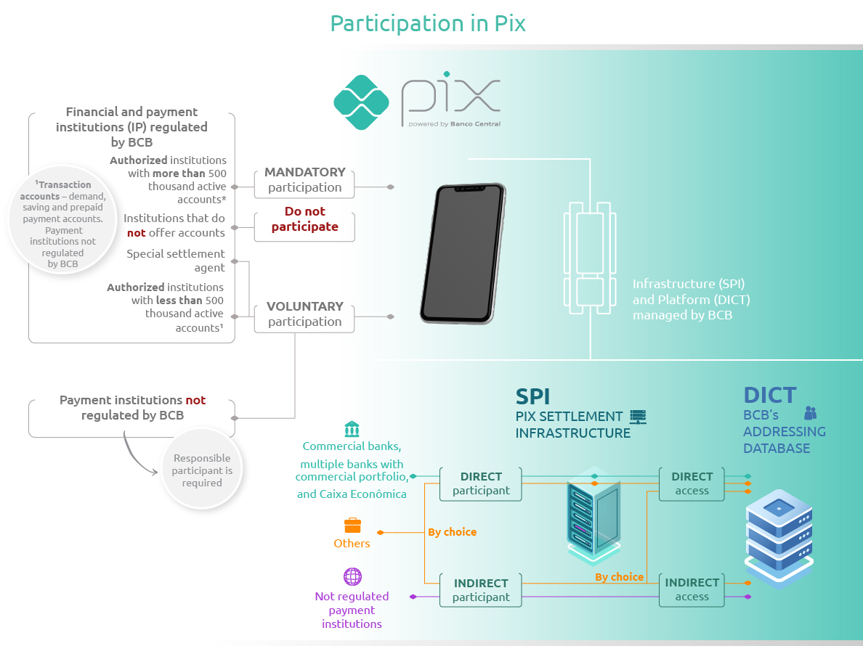
Source: Central Bank of Brazil
Pix is the Brazilian instant payment scheme regulated by the Central Bank of Brazil. It enables real-time funds transfers between transaction accounts held at different payment service providers.
For its operation, Pix relies on two central infrastructures managed by the Central Bank of Brazil:
- DICT — Transactional Account Identifier Directory: DICT is the central directory that stores Pix keys and the data associated with those keys, including identification information related to the holders of transaction accounts. For legal entities, the name associated with the Pix key must match the official name registered in the CNPJ.
- SPI — Instant Payments System: SPI is the centralised settlement infrastructure for Pix, used to settle transactions between participants.
In simplified terms, Pix is the payment scheme; DICT supports the identification of transaction account holders through Pix keys; and SPI performs the settlement of transactions between participants in the scheme.
Pix participants may act as direct or indirect participants in SPI:
- Direct participants settle Pix transactions directly in the SPI: commercial banks, multiple banks with a commercial portfolio and saving banks that participate in Pix must be direct participants in SPI. Other institutions authorised to operate by the Central Bank of Brazil may choose to be direct or indirect participants in the SPI.
- Indirect participants have their Pix transactions settled through a direct participant or a special settlement agent. Payment institutions not regulated by the Central Bank of Brazil, when participating in Pix, must necessarily be indirect participants in the SPI.
Pix participants also need to access DICT. Direct participants in SPI may access DICT directly. Institutions not authorised by the Central Bank of Brazil must access DICT indirectly, through an agreement with a Pix participant that has direct access to DICT.
In this context, consistency between the names registered in the CNPJ, the names stored in DICT and the names conveyed in the ISO 20022 messages used in Pix flows is essential. When the official name of a Brazilian legal entity contains between 141 and 150 characters, the current 140-character limit of the element Name <Nm> prevents the full transmission of the name. For this reason, the limit needs to be increased to 150 characters.

- SEG/TSG recommendation:
This section is not to be taken care of by the submitter of the change request. It will be completed in due time by the SEG(s) in charge of the related ISO 20022 messages or the TSG for changes related to the BAH.

Consider |  |  | Timing
- Next yearly cycle: 2026/2027
(the change will be considered for implementation in the yearly maintenance cycle which starts in 2026 and completes with the publication of new message versions in the spring of 2027)
- At the occasion of the next maintenance of the messages
(the change will be considered for implementation, but does not justify maintenance of the messages in its own right – will be pending until more critical change requests are received for the messages)
- Urgent unscheduled
(the change justifies an urgent implementation outside of the normal yearly cycle)
 |  |  | - Other timing:
Comments:

Reject
Reason for rejection:

