Change Request
for the update of an External Code Set
Note: this document is to be completed by parties that request to either add new codes or clarify the definition of existing codes or replace existing codes by new one(s) or expire existing codes in one of the External Code Sets used in ISO 20022 messages. All change requests conforming to this template that are received prior to the end of a quarter (31 March, 30 June, 30 September, 31 December) will be evaluated by the SEG and, if approved, incorporated in the following quarterly publication cycle of the External Code Sets (respectively, by end of May, August, November and February), unless otherwise specified by the SEG.

Origin of the request:

A.1 Submitter:

Name of the company, organization, group, initiative or community that submits the change request. | CGI-MP Working Group 1

A.2 Contact person:
Person that can be contacted for additional information on the request

A.2.1. First name, Last name | Kerstin Schoenwitz
A.2.2. Email address | kerstin.schoenwitz@db.com
A.2.3. Telephone | +49 173 6570315

A.3 Sponsors:
If the submitter acts on behalf of or has gained support from other organisations, groups, initiatives or communities, these should be listed as sponsors.

Description of the change request:
Specify the request type: creation of new code set, update of existing code set, deletion of existing code set.
For the creation of a new code set or for updating an existing code set, also complete the table in section H below. For the addition of new codes, all the details must be specified, including a proposed code, a proposed code name, a clear definition, and any other indications, such as an example or format to be published with the code set.

Request type: creation, update, deletion | Update

Related External Code Set:
For updating or deleting an existing code set, indicate the exact name of the code set as indicated in the External Code Sets documents on iso20022.org. For creating a new code set, indicate a proposed name for the new code set.
A specific change request form must be completed for each code set to be updated.

ExternalProxyAccountType1Code

Purpose of the change:
Background, business context, community of users interested by the change and expected benefits/savings.
This section must explain why the existing code set needs to be changed. The reason for the update may be a business reason (e.g., evolution of market practice, or creation of new financial instruments), a technical reason (e.g., automation of the business process, or switch from a batch to a real time process), a regulatory reason (introduction, generally mandatory, of new rule/law) or the extension of the user community (newly identified business requirements).

One of the India instant payment schemes has identified a need for a secondary scheme ID to allow differentiation with the most common primary ID. As this can be understood from another change request where additional Local Instrument codes are requested, India has a more complex environment, with multiple ACH and Instant payment schemes. The current challenge is providing a consistent way for the corporate and banking community to indicate the UPI identification code as a form of proxy. Given the VPA (Virtual Payment Address) is the most common ID used as the proxy ID, the requirement is to consider a secondary scheme ID in order to differentiate the validation of the proxy value compared to the primary ID (VPA). We suggest applying a generic code as opposed to an India country specific code. The table below provides additional clarity on the current proxy options in India.
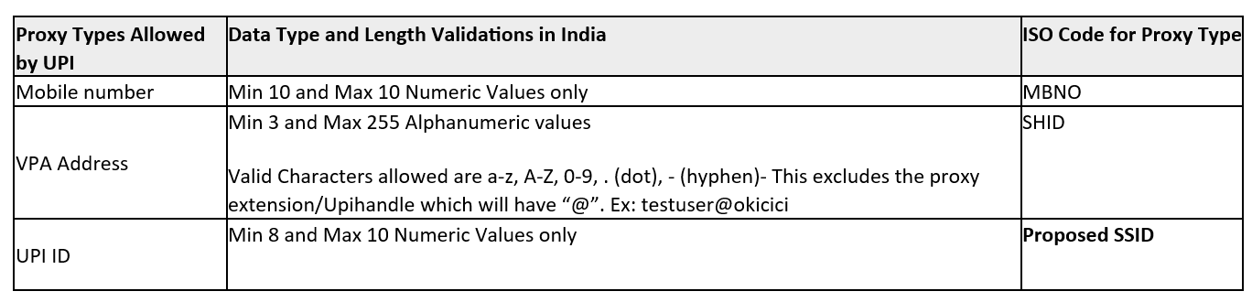
The existing code list options for reference.
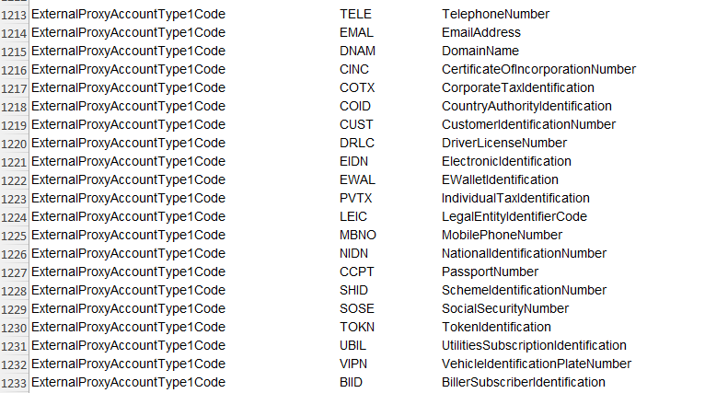

- Additional proxy code requested to be added as a more generic code
SSID = Secondary Scheme Identification Number

Urgency of the request:
By default, valid change requests, subsequently approved by the SEG will be included in the following quarterly publication of External Code Sets, unless decided otherwise by the SEG.
If there is a need to have the new version of the related code set published earlier, the reason for the urgency and the expected consequences of a delay should be described here. Acceptance of such an unscheduled publication is subject to approval by the SEG.

Business examples:
Provide examples illustrating usage of the code set and indicate messages where the code set may be used.

SEG recommendation:
This section will be completed by the SEG in charge of the related External Code Set.

Accept |  |  | Timing
 |  |  | Next possible quarterly release
 |  |  | Urgent request

Comments:

Reject

Reason for rejection:

DESCRIPTION OF THE CHANGE REQUEST

Type | Code Value | Code Name | Code Definition | Replaced By | Additional Information
Addition | SSID | Secondary Scheme Identification Number | Additional scheme identifier used to complement the primary scheme identification so that banks can apply respective validations of the proxy value as per the Type code provided.

