Change Request
for the update of ISO 20022 financial repository items
Note: the purpose of this document is to give guidelines to parties who want to introduce a request to change an existing ISO 20022 message(s), or update other items of the ISO 20022 financial repository. Such change requests are subject to the approval of the ISO 20022 Standards Evaluation Group(s) in charge of the related message/item or to the approval of the Technical Support Group (TSG), if the requested change relates to the Business Application Header (BAH). Please consult the iso20022.org website for additional details on the maintenance process. Change requests are to be sent to iso20022ra@iso20022.org. All change requests conforming to this template received by June 1st will be considered for development in the following yearly ISO 20022 maintenance cycle which completes with publication of new message versions in April/May of the following year.
- Origin of the request:
A.1 Submitter: European Payments Council.
A.2 Contact person: Christophe Godefroi, Christophe.godefroi@epc-cep.eu, + 32 2 739 16 93
A.3 Sponsors: The payment service providers (PSPs) community of SEPA (Single Euro Payments Area)
- Related messages:
This change request impacts the following ISO 20022 message definitions used in the EPC SEPA payment schemes:
- pain.001.001.12 CustomerCreditTransferInitiationV12
- pain.002.001.14 CustomerPaymentStatusReportV14
- pain.007.001.12 CustomerPaymentReversalV12
- pain.008.001.11 CustomerDirectDebitInitiationV11
- pain.009.001.08 MandateInitiationRequestV08
- pain.010.001.08 MandateAmendmentRequestV08
- pain.011.001.08 MandateCancellationRequestV08
- pain.012.001.08 MandateAcceptanceReportV08

- pacs.002.001.15 FIToFIPaymentStatusReportV14
- pacs.003.001.11 FIToFICustomerDirectDebitV11
- pacs.004.011.14 PaymentReturnV13
- pacs.007.001.13 FIToFIPaymentReversalV13
- pacs.008.001.13 FIToFICustomerCreditTransferV12
- pacs.028.001.06 FIToFIPaymentStatusRequestV06

- camt.029.001.13 ResolutionOfInvestigationV13
- camt.052.001.12 BankToCustomerAccountReportV12
- camt.053.001.12 BankToCustomerStatementV12
- camt.054.001.12 BankToCustomerDebitCreditNotificationV12
- camt.056.001.11 FIToFIPaymentCancellationRequestV11
The following messages are also used by the SEPA PSP community, but they are no longer maintained by ISO 20022:
- camt.027.001.10 ClaimNonReceiptV10
- camt.087.001.09 RequestToModifyPaymentV09
The above listed messages are the ones that are currently used by the SEPA PSP community. It is to be noted that additional ISO 20022 messages may be impacted by this Change Request.

- Description of the change request:
The change request relates to the ‘Date And Place Of Birth’ message element and is, in principle, limited to the Debtor element in line with the updated Recommendation 16 of the Financial Action Task Force (FATF) on Payment Transparency (please see section D).
Currently if ‘Date and Place of Birth’ is used under ‘Private Identification’, the elements ‘Birth Date’, ‘City of Birth’ and ‘Country of Birth’ are all mandatory (please see below – based on pacs.008.001.14).

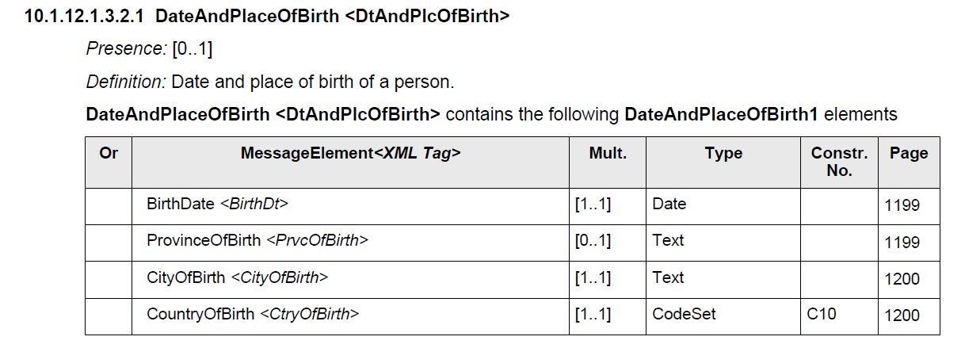

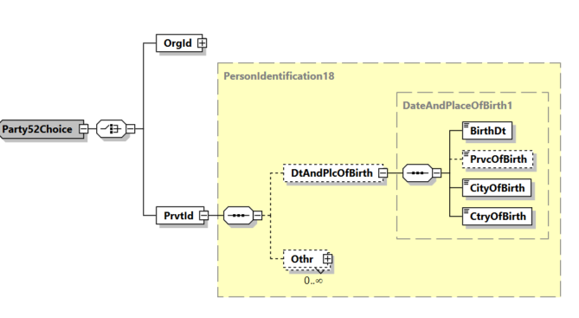
This change request proposes to make elements ‘City of Birth’ and ‘Country of Birth‘ optional under ‘Debtor/Identification/PrivateIdentification/DateAndPlaceOfBirth’ as follows (changes are highlighted in green) and to include a new rule related to ‘Country of Birth’.

DateAndPlaceOfBirth <DtAndPlcOfBirth>
Presence: [0..1]
Definition: Date and place of birth of a person.
DateAndPlaceOfBirth <DtAndPlcOfBirth> contains the following DateAndPlaceOfBirth1 elements

Or | MessageElement<XML Tag> | Mult. | Type | Constr. No. | Page
 | BirthDate <BirthDt> | [1..1] | Date |  | 1199
 | ProvinceOfBirth <PrvcOfBirth> | [0..1] | Text |  | 1199
 | CityOfBirth <CityOfBirth> | [0..1] | Text |  | 1200
 | CountryOfBirth <CtryOfBirth> | [0..1] | CodeSet | C10, CDD | 1200

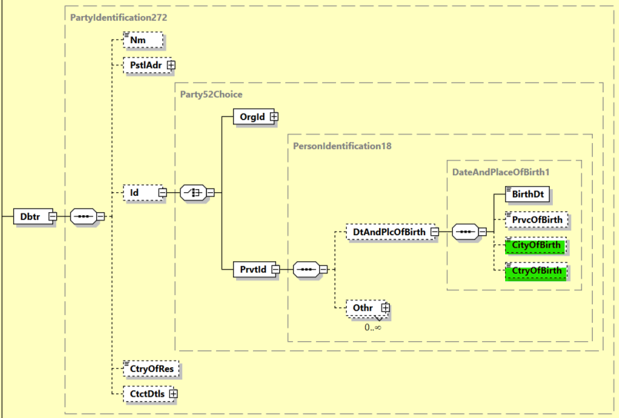
New rule CDD: CtryOfBirth
If ‘City of Birth’ is present, then ‘Country of Birth’ must be present.

- Purpose of the change:
The updated Recommendation 16 of the Financial Action Task Force (FATF) on Payment Transparency stipulates that cross-border payments and value transfers above a de minimis threshold (of USD/EUR 1.000) must always contain the Date Of Birth (DoB) of the originator (but no longer a Place of Birth) when the originator is a natural person.
In view of the aforementioned FATF Recommendation, the request is to make elements ‘City of Birth’ and ‘Country of Birth‘ optional under ‘Debtor/Identification/Private Identification/Date And Place Of Birth’.
Further information about FATF Recommendation 16 can be found here: https://www.fatf-gafi.org/en/publications/Fatfrecommendations/update-Recommendation-16-payment-transparency-june-2025.html

- Urgency of the request:
The change request is to be included in the 2026-2027 maintenance cycle.

- Business examples:
The Debtor Agent sends a pacs.008 message to the Creditor Agent, in which the Debtor is a natural person ‘John Doe’ from Brussels, born on 1 January 1985 :

<Dbtr>
<Nm>John Doe</Nm>
<PstlAdr>
<TwnNm>Brussels</TwnNm>
<Ctry>BE</Ctry>
</PstlAdr>
<Id>
<PrvtId>
<DtAndPlcOfBirth>
<BirthDt>1985-01-01</BirthDt>
</DtAndPlcOfBirth>
</PrvtId>
</Id>
</Dbtr>
- SEG/TSG recommendation:
This section is not to be taken care of by the submitter of the change request. It will be completed in due time by the SEG(s) in charge of the related ISO 20022 messages or the TSG for changes related to the BAH.

Consider |  |  | Timing
- Next yearly cycle: 2026/2027
(the change will be considered for implementation in the yearly maintenance cycle which starts in 2026 and completes with the publication of new message versions in the spring of 2027)
- At the occasion of the next maintenance of the messages
(the change will be considered for implementation, but does not justify maintenance of the messages in its own right – will be pending until more critical change requests are received for the messages)
- Urgent unscheduled
(the change justifies an urgent implementation outside of the normal yearly cycle)
 |  |  | - Other timing:
Comments:

Reject
Reason for rejection:

« DD » is a placeholder for any appropriate digits assigned upon registration of the rule.

