Change Request
for the update of ISO 20022 financial repository items
Note: the purpose of this document is to give guidelines to parties who want to introduce a request to change an existing ISO 20022 message(s), or update other items of the ISO 20022 financial repository. Such change requests are subject to the approval of the ISO 20022 Standards Evaluation Group(s) in charge of the related message/item or to the approval of the Technical Support Group (TSG), if the requested change relates to the Business Application Header (BAH). Please consult the iso20022.org website for additional details on the maintenance process. Change requests are to be sent to iso20022ra@iso20022.org. All change requests conforming to this template received by June 1st will be considered for development in the following yearly ISO 20022 maintenance cycle which completes with publication of new message versions in April/May of the following year.
- Origin of the request:
A.1 Submitter: CBPR+ Group

A.2 Contact person: Dean Chard dean.chard@swift.com

A.3 Sponsors:

- Related messages:
Notification To Receive
camt.057.001.08 | NotificationToReceiveV08
camt.058.001.09 | NotificationToReceiveCancellationAdviceV09
camt.059.001.08 | NotificationToReceiveStatusReportV08

- Description of the change request:
Several custodians and financial institutions have reported difficulties adhering to the Cross Element Complex Rule : Intermediary Agent And Debtor Agent Rule in the camt.057.
This rule forces the user to provide the Debtor Agent if the Intermediary Agent is present. No such rule existed in the MT210 message which is considered the equivalent of the camt.057 by the industry.
Users report that whilst senders of the message have the Intermediary Agent data to populate they do not have, nor is it reasonable to expect them to have the Debtor Agent data. By removing this rule it should improve the usability of this message and the quality of data that is provided.
This change request will also allow users to more easily translate a MT210 to a camt.057.

- Purpose of the change:
Remove the “Cross Element Complex Rule : Intermediary Agent And Debtor Agent Rule” from both levels of the message.
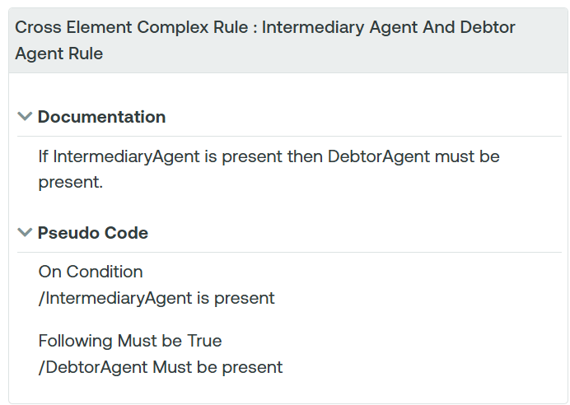

- Urgency of the request:
2026/2027 maintenance cycle
- Business examples:
n/a

- SEG/TSG recommendation:
This section is not to be taken care of by the submitter of the change request. It will be completed in due time by the SEG(s) in charge of the related ISO 20022 messages or the TSG for changes related to the BAH.

Consider |  |  | Timing
- Next yearly cycle: 2026/2027
(the change will be considered for implementation in the yearly maintenance cycle which starts in 2022 and completes with the publication of new message versions in the spring of 2027)
- At the occasion of the next maintenance of the messages
(the change will be considered for implementation, but does not justify maintenance of the messages in its own right – will be pending until more critical change requests are received for the messages)
- Urgent unscheduled
(the change justifies an urgent implementation outside of the normal yearly cycle)
 |  |  | - Other timing:
Comments:

Reject
Reason for rejection:

