Change Request
for the update of ISO 20022 financial repository items
Note: the purpose of this document is to give guidelines to parties who want to introduce a request to change an existing ISO 20022 message(s), or update other items of the ISO 20022 financial repository. Such change requests are subject to the approval of the ISO 20022 Standards Evaluation Group(s) in charge of the related message/item or to the approval of the Technical Support Group (TSG), if the requested change relates to the Business Application Header (BAH). Please consult the iso20022.org website for additional details on the maintenance process. Change requests are to be sent to iso20022ra@iso20022.org. All change requests conforming to this template received by June 1st will be considered for development in the following yearly ISO 20022 maintenance cycle which completes with publication of new message versions in April/May of the following year.
- Origin of the request:
A.1 Submitter: Swift

A.2 Contact person: Dean Chard dean.chard@swift.com

A.3 Sponsors:

- Related messages:

pacs.009.001.13 | FinancialInstitutionCreditTransferV13

- Description of the change request:
As part of the 2025/2026 Maintenance Change Request the PAYSEG agreed to add the Unique Transaction Identifier (UTI) to the pacs.009 under change requests 1405 and 1408.
Whilst this was implemented the UTI was only added to the Underlying block. The securities business uses many pacs.009s where the Underlying block is not used, the UTI needs to be implemented correctly in the main body of the message.

- Purpose of the change:
Add the UTI to the main body of the pacs.009 message.
The PAYSEG must consider whether this is best achieved by adding the entire Structured remittance component (StructuredRemittanceInformation22) to the pacs.009 main body or just the SecuritiesAttributes1 component.
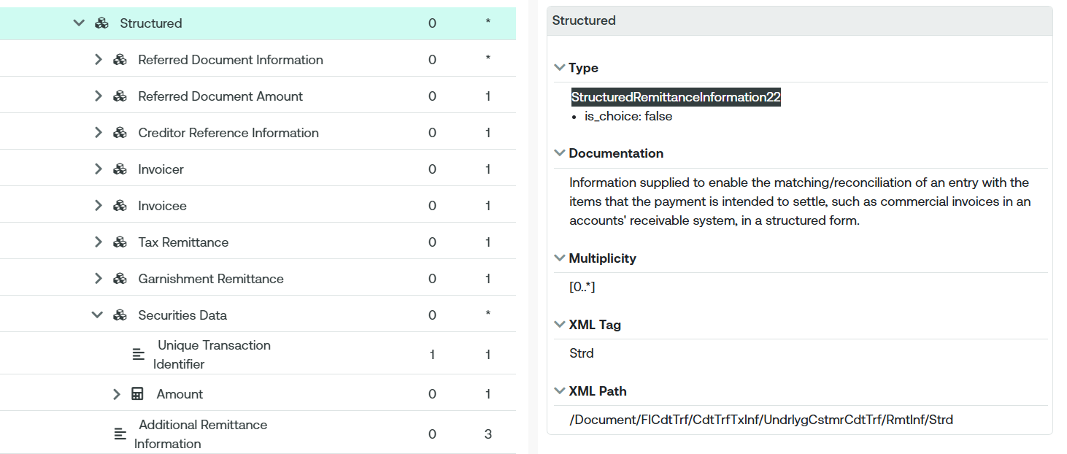

- Urgency of the request:
2026/2027 maintenance cycle
- Business examples:
n/a
SEG/TSG recommendation:
This section is not to be taken care of by the submitter of the change request. It will be completed in due time by the SEG(s) in charge of the related ISO 20022 messages or the TSG for changes related to the BAH.

Consider |  |  | Timing
- Next yearly cycle: 2026/2027
(the change will be considered for implementation in the yearly maintenance cycle which starts in 2026 and completes with the publication of new message versions in the spring of 2027)
- At the occasion of the next maintenance of the messages
(the change will be considered for implementation, but does not justify maintenance of the messages in its own right – will be pending until more critical change requests are received for the messages)
- Urgent unscheduled
(the change justifies an urgent implementation outside of the normal yearly cycle)
 |  |  | - Other timing:
Comments:

Reject
Reason for rejection:

