Change Request
for the update of an External Code Set
Note: this document is to be completed by parties that request to either add new codes or clarify the definition of existing codes or replace existing codes by new one(s) or expire existing codes in one of the External Code Sets used in ISO 20022 messages. All change requests conforming to this template that are received prior to the end of a quarter (31 March, 30 June, 30 September, 31 December) will be evaluated by the SEG and, if approved, incorporated in the following quarterly publication cycle of the External Code Sets (respectively, by end of May, August, November and February), unless otherwise specified by the SEG.

Origin of the request:

A.1 Submitter:

Name of the company, organization, group, initiative or community that submits the change request. | Swift

A.2 Contact person:
Person that can be contacted for additional information on the request

A.2.1. First name, Last name | Dhanasekaran SHANMUGAM
A.2.2. Email address | Dhanasekaran.SHANMUGAM@swift.com
A.2.3. Telephone | +447448024107

A.3 Sponsors:
If the submitter acts on behalf of or has gained support from other organisations, groups, initiatives or communities, these should be listed as sponsors.

N/A

Description of the change request:
Specify the request type: creation of new code set, update of existing code set, deletion of existing code set.
For the creation of a new code set or for updating an existing code set, also complete the table in section H below. For the addition of new codes, all the details must be specified, including a proposed code, a proposed code name, a clear definition, and any other indications, such as an example or format to be published with the code set.

Request type: creation, update, deletion | Update of existing code set

Related External Code Set:
For updating or deleting an existing code set, indicate the exact name of the code set as indicated in the External Code Sets documents on iso20022.org. For creating a new code set, indicate a proposed name for the new code set.
A specific change request form must be completed for each code set to be updated.

ExternalStatusReason1Code

Purpose of the change:
Background, business context, community of users interested by the change and expected benefits/savings.
This section must explain why the existing code set needs to be changed. The reason for the update may be a business reason (e.g., evolution of market practice, or creation of new financial instruments), a technical reason (e.g., automation of the business process, or switch from a batch to a real time process), a regulatory reason (introduction, generally mandatory, of new rule/law) or the extension of the user community (newly identified business requirements).

The Network Interoperability (NI) Framework aims to address the interoperability challenges between Swift and non-Swift networks, specifically in tracking of off-Swift network payments between Banks, Non-Bank Payment Service Providers (NBPSP), Payment Market Infrastructures (PMI) and other financial service providers.

When a payment message is sent through a non-Swift network, it becomes harder to track the message and see what fees are being charged and confirm how much has been credited. These networks systems often lack full visibility, making it difficult for the parties involved to monitor the transaction or understand which fees are deducted by Intermediaries and Creditor Agents. Differences in market practices can also lead to a loss of data accuracy during the process.

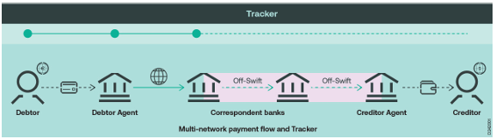

The main objective of the Network Interoperability Framework service is to leverage the existing infrastructure of Swift messaging and GPI Tracking services, extending them to Financial Institutions (including NBPSPs, Wallet Providers and other financial service providers) and PMIs to track payment sent over off-Swift networks. Therefore, creating a more agnostic network, all the while ensuring that speed, transparency, and visibility are achieved through tracking services.

The request is to add four new status reason codes that support these network interoperability flows. These codes will be used in both trck.001 and trck.002 ISO registered messages. See here the 4 new status reason codes and their usage (in combination with statuses ACCC and ACSP:

Code Set | Code Value | Code Name | Code Definition
ExternalStatusReason1Code | OBO1 | AcceptedSettlementCompletedCreditorAccountWithTransparency | Settlement with Creditor is confirmed on behalf of the Creditor Agent with full transparency on the amount credited.
ExternalStatusReason1Code | OBO2 | AcceptedSettlementCompletedCreditorAccountWithoutTransparency | Settlement to Creditor is confirmed on behalf of the Creditor Agent without transparency on the amount credited.
ExternalStatusReason1Code | G007 | PMITransferredPayment | The Payment Market Infrastructure has sent the payment to the receiving PMI participant.
ExternalStatusReason1Code | G008 | PMITransferredPaymentAndReceived | The Payment Market Infrastructure has sent the payment and successfully delivered to the receiving PMI participant.

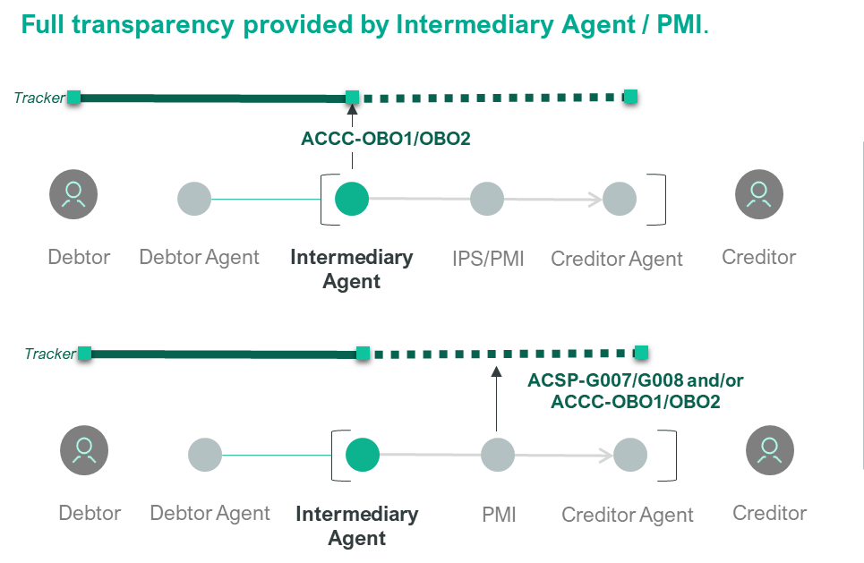

Urgency of the request:
By default, valid change requests, subsequently approved by the SEG will be included in the following quarterly publication of External Code Sets, unless decided otherwise by the SEG.
If there is a need to have the new version of the related code set published earlier, the reason for the urgency and the expected consequences of a delay should be described here. Acceptance of such an unscheduled publication is subject to approval by the SEG.

SR2026

Business examples:
Provide examples illustrating usage of the code set and indicate messages where the code set may be used.

SEG recommendation:
This section will be completed by the SEG in charge of the related External Code Set.

Accept |  |  | Timing
 |  |  | Next possible quarterly release
 |  |  | Urgent request

Comments:

Reject

Reason for rejection:

DESCRIPTION OF THE CHANGE REQUEST

Type | Code Value | Code Name | Code Definition | Replaced By | Additional Information
Addition | OBO1 | AcceptedSettlementCompletedCreditorAccountWithTransparency | Settlement with Creditor is confirmed on behalf of the Creditor Agent with full transparency on the amount credited. | N/A | N/A
Addition | OBO2 | AcceptedSettlementCompletedCreditorAccountWithoutTransparency | Settlement with Creditor is confirmed on behalf of the Creditor Agent without transparency on the amount credited. | N/A | N/A
Addition | G007 | PMITransferredPayment | The Payment Market Infrastructure has sent the payment to the receiving PMI participant. | N/A | N/A
Addition | G008 | PMITransferredPaymentAndReceived | The Payment Market Infrastructure has sent the payment and successfully delivered it to the receiving PMI participant. | N/A | N/A

