Standards
Standards MT Release 2026 – Exceptional Fast Track
Settlement and Reconciliation
Distribution: Settlement and Reconciliation Standards Working Group
Author: Karine Taquet
Date Issued: December 2025
Version: v 0.1
Feedback Deadline Date: January 7 2026

Table of Contents
1 Introduction 3
2 Overview of User Change requests 5
2.1 CR 003189: Structured Indicator for Gating Event in Settlement Instructions (T+1) 5

Introduction

ISO 15022 – 20022 Maintenance Process
As from the year 2012, a joint maintenance process has been put in place for ISO 20022 and 15022 and Settlement & Reconciliation messages with the support of the ISO 20022 RMG and of the SWIFT Board.
This joint maintenance will ensure interoperability between the two standards and a more efficient maintenance process.
Standards Illustrations in this document
Standards illustrations are provided by SWIFT Standards. They are not part of the original request.
Any standard illustrations (rules, codes, qualifiers, wordings) are only for illustration purposes. It does not mean SWIFT Standards is in agreement with the maintenance request or that the final standards solutions (for accepted maintenance requests) will be as shown in this document.
The MT Standards Release Guide (+ potential erratum) and the ISO 20022 message definition reports are the ONLY source of reliable information based on which implementation of changes should be made. Any other documentation (including this one) is subject to change.
SR 2025 change requests
This document contains all S&R MT/MX CRs for MT category 5 and equivalent MX messages investigated this year for implementation in SR 2026.
The requests originator is indicated as follows:
  - Requesting Country; Country code of requesting NMPG or UG; eg. BE
  - Requesting Group: a SWIFT User Group or a National (Securities) Market Practice Group with the acknowledgement of the UGC or Recognized industry group eg. SMPG (the global Securities Market Practice Group)

Contact persons regarding this document
Arnaud Jochems: arnaud.jochems@clearstream.com
Paola Deantoni : paola-maria.deantoni@socgen.com
Karine Taquet : karine.taquet@swift.com

CR Title Colour notation (for minutes only)
In GREEN are items that are approved or approved with comments or approved with alternative solution.
In RED are items that are rejected, withdrawn or linked to agreed items
In GREY are items that are postponed for review and implementation at the next release.

S&R SWG Members for SR2026

The following people are part of the S&R SWG for SR2026.
Maintenance working group members: | Representing: | Approval
Vacant | Australia
Karen Weaver- BNYMellon | Belgium
Xavier Filion Simon - BNC  Daniel Valance – RBC  Laurent Lallemand – RBC | Canada
Jørgen Nielsen - Danske Bank A/S | Denmark
Charles Bichemin – Societe Generale | France
Denis Andrejew – Deutch Bank | Germany
Vacant | Hong Kong
David Wouters – Euroclear | ICSD
Robin Leary – Citibank | Ireland
Paola De Antoni – Societe Generale | Italy
Hitoshi Tanaka - Mitsubishi Bank | Japan
Vacant | Republic of Korea
Arnaud Jochems – Clearstream | Luxembourg / ICSD
Ton Van Andel – ABN Amro  Marc Griffioen – ABN Amro | The Netherland
Vacant | Singapore
Brett Kotze – A2X | South Africa
Vacant | Spain
Christine Strandberg - SEB | Sweden
Philipp Auf der Maur – Six-Group | Switzerland
Robin Leary – Citibank | United Kingdom
Shereef Zedan – Northern Trust | United States of America

Overview of User Change requests

CR 003189: Structured Indicator for Gating Event in Settlement Instructions (T+1)
Origin of request
Requesting Country:
Requesting Group: | SMPG Securities Market Practice Group
Sponsors
EUT1 Task Force
Message type(s) impacted
ISO 15022 messages:
MT502; MT513; MT514; MT515; MT518; MT536; MT537; MT540; MT541; MT542; MT543; MT544; MT545; MT546; MT547; MT548; MT575; MT578; MT586

ISO 20022 messages:
sese.023, sese.024, sese.025, sese.026, sese.028, sese.032, sese.033, sese.034, sese.035, sese.036, sese037, sese.038, semt.017, semt.018, semt.019
Complies with regulation
Business impact of this request
LOW
Commitment to implement the change
Number of messages sent and received: 1000000
Percentage of messages impacted: 5%
Commits to implement and when: All EU Countries
Business context
The transition to T+1 settlement in Europe (effective 11 October 2027) introduces significant operational challenges for Securities Financing Transactions (SFTs), particularly bilateral repos. Industry analysis indicates a substantial increase in late-day T+0 traffic, including repo rolls where the closing leg settles before the opening leg of the new repo is instructed, eliminating the possibility of settlement synchronisation under current processes.

Without an automated mechanism, stakeholders would need to manually hold thousands of closing-leg instructions until corresponding opening legs of the new repos and potentially their related cash trades are received—an approach that is operationally unfeasible given the expected surge in volumes. Failure to synchronise the settlement of these transactions will result in gross funding requirements, increased liquidity risk, and potential settlement fails, undermining market stability during, and after, the critical T+1 transition.

To mitigate these risks, the industry—through SMPG and SWIFT consultations—requests the creation of a structured field in settlement instructions to indicate participation in a defined “gating event” period. This period would start later in the day to allow Treasury desks to finalize SFT activity. Enable opening and closing to be released at the same time with potential netting effects reduce funding pressure and operational complexity. If this change is not fast-tracked, the solution will only be available one month after T+1 go-live, forcing the industry to rely on temporary DSS workarounds that lack standardization and automation. A fast-track CR ensures readiness by October 2027, supporting market efficiency and compliance with regulatory timelines.

Nature of change
Objective:
In the context of T+1, introduce a structured indicator to flag settlement instructions that must be automatically held until a specific point in time on the requested settlement day (gating event), at which the Securities Financing instructions will be automatically released.

Change Type:
Add a new code to the ISO 15022 Field 22F (Indicator), qualifier STCO and the equivalent ISO 20022 element to represent the Gating Event condition.
1) ISO 15022 (MT Category 5 – Settlement)
Field / Qualifier
Field: 22F – Indicator
Qualifier: STCO – Settlement Transaction Condition
New Code
Code: GATE – Gating Event participation (hold until event start time)
Illustration
…
:16R:SETDET
:22F::SETR//REPU
:22F::STCO//GATE
…
2) ISO 20022 (sese.*, semt.* families)
Element
<SttlmTxCond> – Settlement Transaction Condition
New Code
<Cd>GATE</Cd> – Gating Event participation

Illustration :
<n1:SttlmTxCond>
<n1:Cd>GATE</n1:Cd>
</n1:SttlmTxCond>

Examples

Workaround

Going for a DSS (e.g., :22F::STCO/SMPG/GATE) could be an alternative but then it will be a permanent solution, because the industry will not adapt twice (first to the DSS and then to the structured field).
The preference is to introduce a structured field from the start of T+1 in Europe (planned for October 11, 2027) and avoid DSS altogether.

Illustration 15022

:16R:GENL
:20C::SEME//123
:23G:NEWM
:16S:GENL
:16R:TRADDET
:98A::TRAD//20220314
:98A::SETT//20220314
:35B: ISIN XT9W5C49FJV7
:16S:TRADDET
:16R:FIAC
:36B::SETT//UNIT/10000,
:97A::SAFE//AccountA
:16S:FIAC
:16R:SETDET
:22F::SETR//REPU
:22F::STCO/SMPG/GATE
:16R:SETPRTY
:95P::REAG//FORGFRPPXXX
:16S:SETPRTY
:16R:SETPRTY
:95P::BUYR//IRVTBEBBXXX
:16S:SETPRTY
:16R:SETPRTY
:95P::PSET//PSET BIC
:16S:SETPRTY
:16R:AMT
:19A::SETT//EUR100000,
:16S:AMT
:16S:SETDET

Illustration 20022

<SttlmParams>
<SctiesTxTp>
<Cd>REPU</Cd>
</SctiesTxTp>
<SttlmTxCond>
<Prtry>
<Id>GATE</Id>
<Issr>SMPG</Issr>
</Prtry>
</SttlmTxCond>
</SttlmParams>

Standards Illustration

ISO 15022 illustrations

MT 543 – Delivery Versus Payment

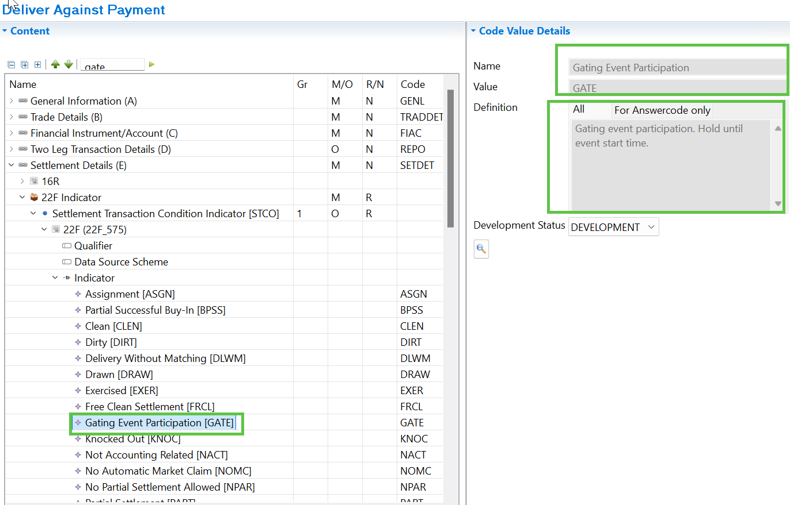

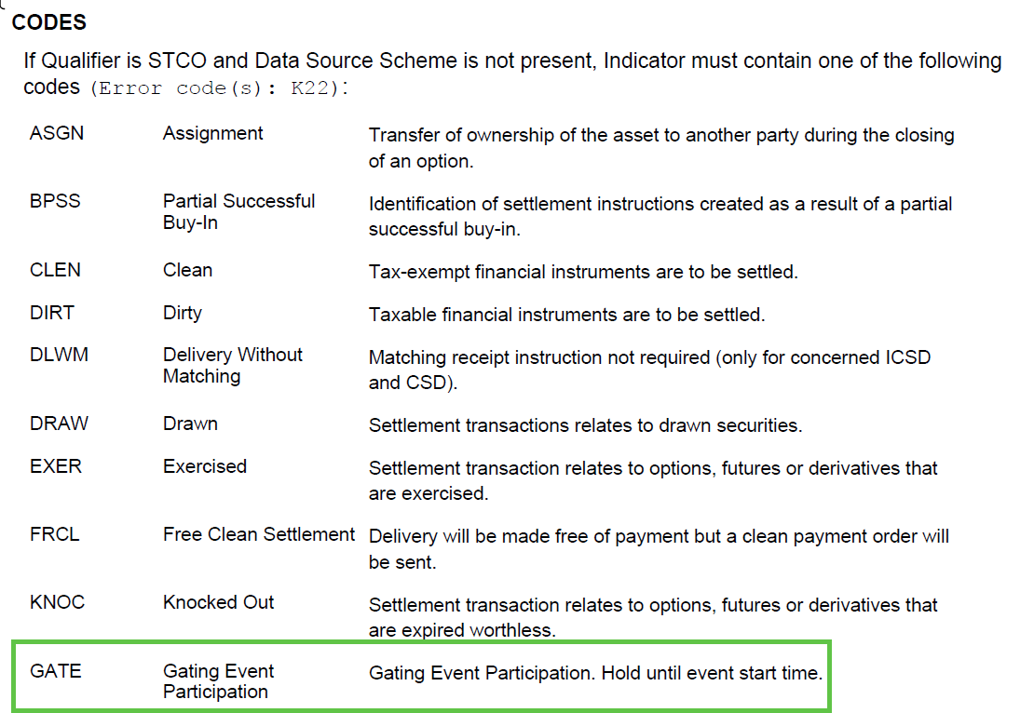

ISO 20022 illustrations

sese.023 – Securities Settlement Transaction Instruction

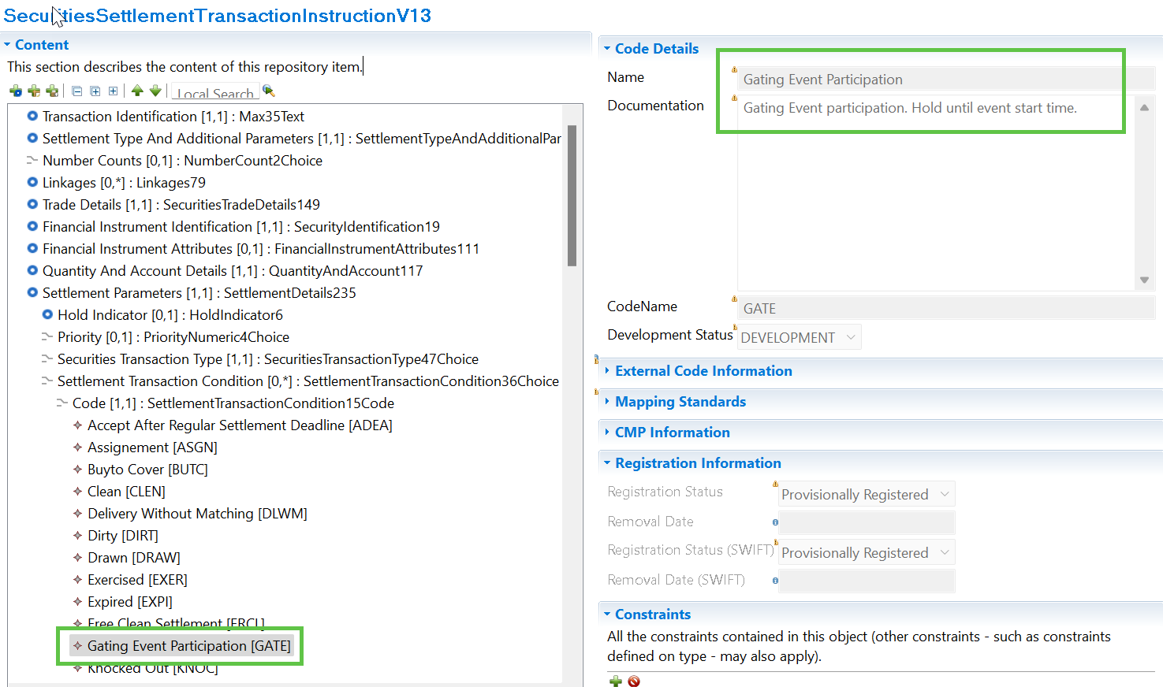

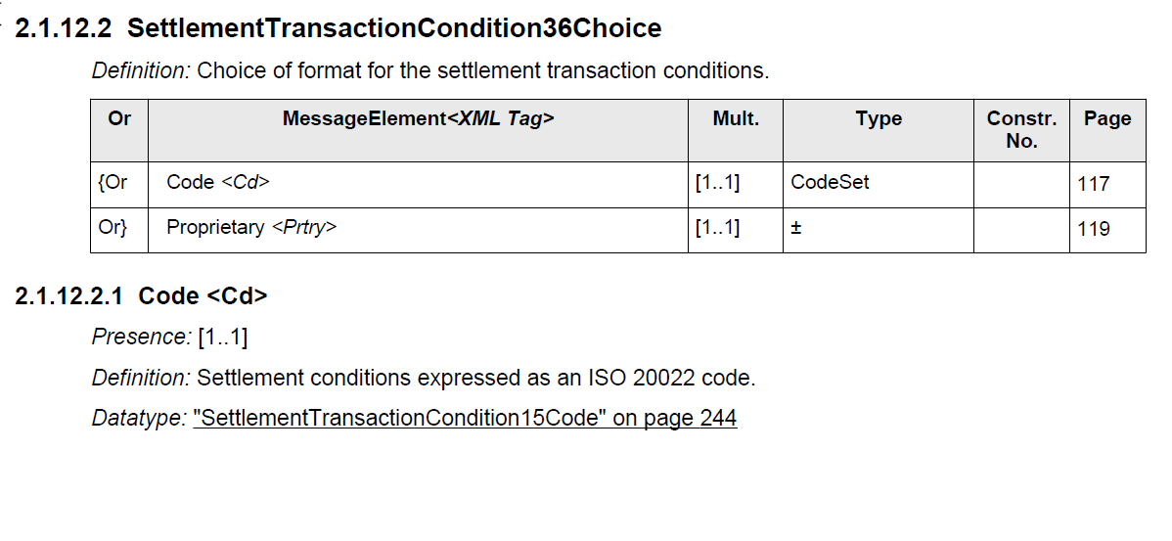
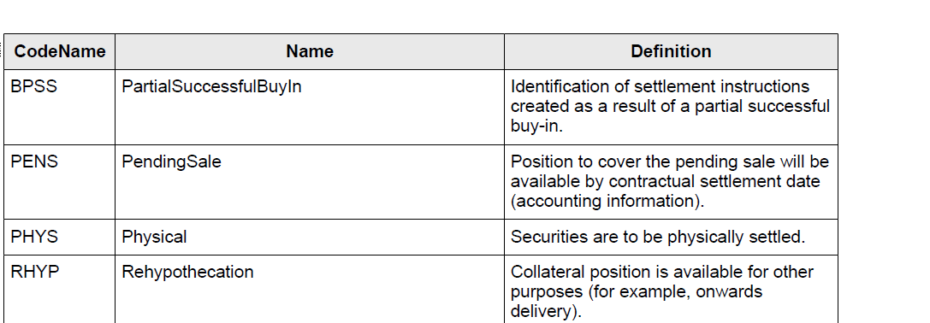

…

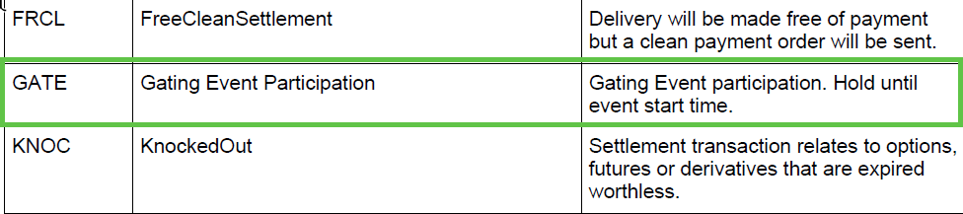

SWIFT Comment

Working Group Meeting

Discussion
Decision
End of document

